## **Scenario 1 - Snow, Single Car, Traffic Light Crash**

## **Storyline:** Driver failed to stop at the red light due to snow, making the road very slippery, they could not stop and crashed into the traffic light on the other side. Your uniform patrol car call sign is 11-2-10

## **Speed at point of impact - ~35km**

## **Road conditions: Wet, slippery Weather conditions - Snow,** **Date and Time** - Jan 21, 7:15 AM 2022

**Name of offense**

Disobey Red Light – Fail to Stop

**Dispatch Call**: 11-2-10 can you respond to a single motor vehicle collision at Grand River Street and Service Road 67. A vehicle has slid into a traffic light pole

**Potential Evidence:**

* SUV damage
* Skidmarks from attempted stop
* Debris from accident
* Airbags

|  | **Michelle E. Oliverio, Driver** | |
| --- | --- | --- |
| **Driver Statement:**  “It was dark and I didn’t see the intersection coming up. When I saw the red light, I tried stopping but it was too late. It was slippery, and I slid right through the light. I couldn’t stop, and I hit the traffic light pole.” | |
| **Question** | | **Answer** |
| Are you feeling alright? | | I’m fine thank you. |
| May I have your driver’s license, ownership and insurance slip please. | | Sure, my name is Michelle E. Oliverio. |
| Can you tell me exactly what happened? | | It was dark and I didn’t see the intersection coming up. When I saw the red light, I tried stopping but it was too late. It was slippery, and I slid right through the light. I couldn’t stop, and I hit the traffic light pole. |
| ABC Towing will be towing your vehicle | | Okay, thank you. |
| Do you have winter tires on your vehicle? | | Unfortunately, not, I just haven’t had the time for that before winter. I’m really kicking myself now. |
| *(unlocked if airbags are photographed)I* noticed that your airbags were deployed - are you feeling ok, do you require any medical attention? | | Oh, I’m ok. Thank you for asking. Just a little shaken up and embarrassed. |

## **Scenario 2 - Rear End Collision**

**Storyline**: Driver in hatchback was texting while driving, did not notice car stopped in front at stop sign, hit the SUV from behind. Veered slightly to the left before impact. The SUV moved slightly into the intersection after impact. There was a jogger going through the intersection. Your uniform patrol car call-sign is T2-100

**Road Conditions: Bare and Dry**

**Speed at point of impact - ~42km**

**Weather conditions – clear and warm Afternoon**

**Date and Time -** June 17, 12:05 PM 2022

**Name of offense**

Careless Driving,

Follow Too Closely

Distracted Driving

**Dispatch Call:** Attention T2-100 There has been a rear end collision at the intersection of Grand River Street and Service Road 67. Reported in the Municipality of Waterloo. Can you respond?

**Potential Evidence:**

* SUV rear damage
* Hatchback front damage
* Skidmarks from attempted stop (hatchback)
* Debris from accident
* Phone on seat

|  | **Lisa W. Pena, SUV driver** | |
| --- | --- | --- |
| **Driver Statement:** “I was just stopped at the stop sign, waiting for a jogger to clear the intersection, getting ready to make my left when this idiot smashed into me! Probably on their phone or something.” | |
| **Question** | | **Answer** |
| Are you alright? Do you require any medical attention? | | No I’m fine thank you |
| May I have your driver’s license, ownership and insurance slip please. | | Sure, my name is Lisa Pena. |
| Can you tell me exactly what happened? | | I was just stopped at the stop sign, waiting for a jogger to clear the intersection, getting ready to make my left when this idiot smashed into me! Probably on their phone or something. |
| Did you happen to notice if the other driver was following you for a while? If so, were they keeping an appropriate distance? | | He’s been behind me since we both turned left onto Grand River at Pearson Ave – but he was fairly well back until I stopped and waited for the jogger to clear the intersection. |
| *(unlocked if phone is photographed)* What happened next? | | The driver got out of his car and he was talking loudly on his cellphone to his wife saying he had been involved in an accident |
| ABC Towing will be towing your vehicle. | | Okay thank you. |

:

| - | **Kyle F. Evans, AUDI Driver** | |
| --- | --- | --- |
| **Driver Statement:** “I literally didn’t even see the car in front of me! The stop sign came up so fast, I didn't expect it.” | |
| **Question** | | **Answer** |
| Are you alright? Do you require any medical attention? | | No, I’m fine thank you. |
| May I have your driver’s license, ownership and insurance slip please. | | Sure, my name is Kyle Evans. |
| Can you tell me exactly what happened? | | Unfortunately, I rear-ended that SUV. I’m sorry.I literally didn’t even see the car in front of me! The stop sign came up so fast, I didn't expect it. Uh, I guess I was daydreaming a bit. |
| *(unlocked if phone is photographed)* You said that you were daydreaming. What do you mean by that? | | Okay, I was talking on my cellphone to my wife, and I went onto my email to find an email that she had sent me, and I hit the car in front of me. I wasn’t paying attention, it’s my fault. |
| ABC Towing will be towing your vehicle | | Okay thank you . |
| Have you consumed any drugs or alcohol before getting behind the wheel today? | | No, no. I would never do that then drive. |
| So did you see the jogger. | | What jogger? |

|  | **Jules Dunkerly, Witness** | |
| --- | --- | --- |
| **Witness Statement:** “I was reading my book on the porch, when this jogger went by and said hello, I started reading again and that is when I heard a loud bang. I looked up and saw these two cars had collided”. | |
| **Question** | | **Answer** |
| Can I get your name please? | | Of course, my name is Jules Dunkerly. |
| Can you tell me exactly what happened? | | I was reading my book on the porch, when this jogger went by and said hello, I started reading again and that is when I heard a loud bang. I looked up and saw these two cars had collided”. |
| Did you see the moment of collision? | | No, but I saw the lady stop and that is when the jogger waved, then I started reading and then I looked up right after it happened. |
| *(unlocked if phone is photographed)* Did you see or hear anything else? | | Oh, yes dear, the man got out of his car on the driver’s side and was talking really loudly to someone. He had something in his hand. |

## **Scenario 3 - Head On Collision**

**Storyline**: SUV Driver applying makeup in mirror, not paying attention to an approaching intersection. The SUV slightly veers to the left and collides with incoming cars. The AUDI reacts and slightly moves to their right but does not move out of the way in time and still collides. Your uniform patrol car call-sign is 1-G1-N.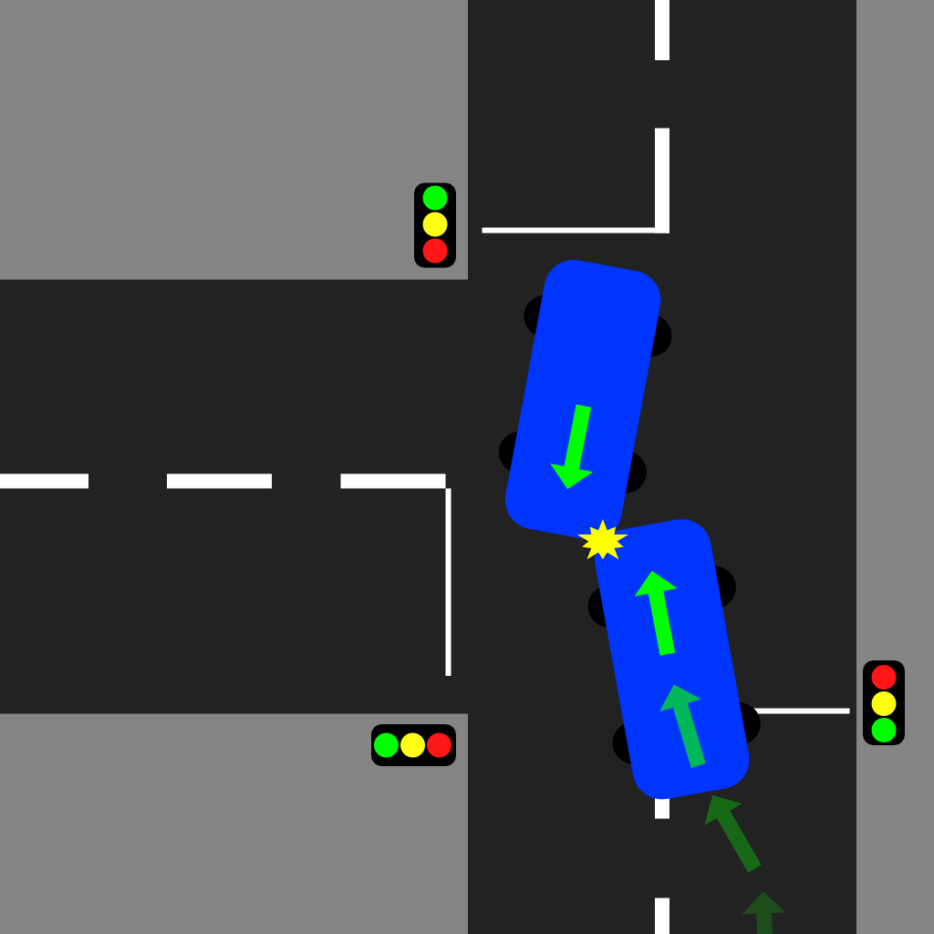

**Posted Speed limit: 60 km/hr  
Speed at point of impact - ~60km**

**Weather conditions - Clear,**

**Road Condition: Bare, dry**

**Date and Time -** September 05, 8:30 AM 2022

**Name of offense -** Careless Driving

**Dispatch Call:** 1-G1-N, there has been a head on collision involving 2 vehicles at the intersection of Grand River Street and South Service Road 67. MVC-PI Personal injury reported with both drivers transported to Hospital with serious injuries. 1G2-N is attending the hospital

**Potential Evidence**:

Debris from accident

Skid marks

Airbag deployed in both vehicles

Airbag has make smeared on it in the SUV

SUV front left damage

AUDI front left damage

Makeup on front passenger seat of SUV

| *Note: Witnesses on the scene are interviewed for this scenario as both drivers were taken to hospital.* | | |
| --- | --- | --- |
|  | **David Short, Witness** | |
| **Witness Statement:**  I was out for my morning run and was waiting at the light to cross the street when it happened - I watched the person in the Audi try to veer out of the way at the last minute, but it was too late. The SUV hit the Audi. | |
| **Question** | | **Answer** |
| Can I get your name please? | | Sure, my name is David Short. |
| Can you tell me exactly what happened? | | The woman in the SUV was definitely not paying attention. She started to veer into on-coming traffic. As she entered the intersection, the other driver tried to swerve out of the way, but they hit each other. |
| *(unlocked if make-up is photographed)* What makes you think the woman was not paying attention? | | I saw a her visor was flipped down and she appeared to have something in her hand. |
| How fast would you say both vehicles were traveling? | | I would say the speed limit. |
| Did either vehicle honk their horn prior to impact? | | No, they didn’t - I think it all just happened so fast. I think the person in the Audi may have assumed that the SUV driver was going to turn left after they passed, but misread the situation. |

|  | **Katie Singh, Witness** | |
| --- | --- | --- |
| **Witness Statement:** I was walking to work, and was a few steps away from the intersection when the crash happened. I swear I saw the woman in the SUV doing her hair or something. I noticed she was weaving in her lane a bit, but there was nothing I could do, before I knew it, bang, they hit each other. | |
| **Question** | | **Answer** |
| Did you see what happened? | | The SUV was coming up to the intersection and she didn’t seem to notice that she wasn’t in her lane. The Audi was also coming into the intersection - it looked as though she was going to swerve to avoid hitting the SUV but it was too late. |
| Can I get your name please? | | Sure, my name is Katie Singh. |
| How fast would you say they were traveling? | | I don’t know, it was honestly hard for me to tell. |

| **Information from the hospital from the other officer** |
| --- |
| *The driver of the Audi,* ***Bob Smith****, was driving to work. He saw a vehicle approaching and it suddenly swerved into his lane, he tried to avoid a collision, but the other vehicle kept coming and the female driver hit Smith.* |
| *A cautioned statement from the driver of the SUV, a* ***Lucy Channel****. She basically told me that she was driving to a meeting and was running late. She went to put on some makeup and ended up in the other lane and struck the other car.* |

## **Scenario 4 - Rain, T-Bone Collision**

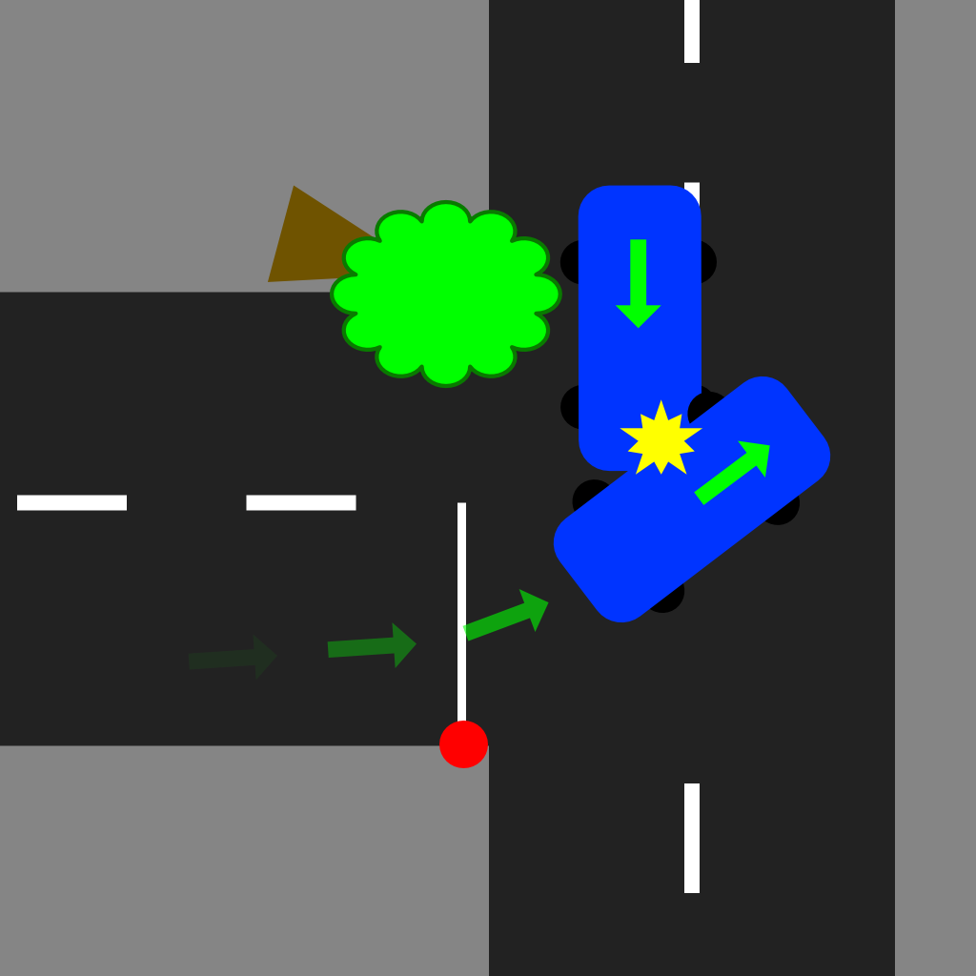

**Storyline:** Driver is obstructed by a tree that has fallen at the corner of the intersection, blocking the vision of the through road. The SUV is stopped at the stop sign and decides to go, even though they can’t see well enough to safely make the turn. The AUDI reaches the tree and decides to veer around it. T-bone collision occurs in the intersection. It is raining heavily and the vision is obstructed by the tree. Your uniform patrol car call-sign is 1-FO-AD.

**Speed of SUV at point of impact - ~15km**

**Speed of AUDI at point of impact - ~50km**

**Weather conditions – Heavy rain, overcast, dark**

**Road conditions: bare and wet**

**Date and Time -** April 23, 7:15 PM 2022

**Name of offense:**

Fail to Yield to Traffic on Through Highway

Improper left-hand Turn

**Dispatch Call:** 1-FO-AD, could you proceed to a two vehicle collision at the intersection of Grand River Street and South Service Road 67. Personal injury reported with one driver transported to Hospital with serious injuries. The other involved driver is at the scene. 2-F0-AD is attending at the hospital

**Evidence:**

SUV Left Side Damage

AUDI Front Left Damage

Debris from collision

Skid marks

Airbag deployed

Tree in the through lane

|  | **Garry Hiram, Hatchback Driver** | |
| --- | --- | --- |
| **Driver Statement: “** I was coming along the sideroad when I saw the tree down on the road. I checked behind me and maneuvered around the tree. As I moved around the tree the other driver peeled out in front of me last second! I had no time to stop or swerve, and did not see the car coming out of that intersection. **”** | |
| **Information received from the officer at the hospital.** | | |
| **Question** | | **Answer** |
| Can I get your name please? As well as your license, registration and insurance? | | Sure, I’m Garry Hiram. |
| Can you tell me exactly what happened? | | I was coming along the sideroad when I saw the tree down on the road. I checked behind me and maneuvered around the tree. As I moved around the tree the other driver peeled out in front of me last second! I had no time to stop or swerve, and I didn’t see the car coming out of that intersection. |
| Have you consumed any drugs or alcohol today? | | No way. I would never do that and drive. |
| How fast were you traveling? | | I was driving slow as it was raining. |
| How fast was the other driver traveling? | | I think he was going too fast for the weather conditions as he pulled out in front of me quickly. |
| ABC Towing will be towing your vehicle | | OK, thank you. |

| **Information from the hospital from the other officer** |
| --- |
| *A caution statement from the driver of the SUV, a* ***Rodger Vossen****. He basically told me that he was turning out of his neighbourhood onto the sideroad when he noticed a fallen tree in the intersection. He claims to have looked both ways and couldn't see any cars coming. He noticed the tree was down but he couldn't see any car coming behind it. When he took the left onto the sideroad the other vehicle came out of nowhere and took him out! I'm not sure how fast he was going but it must've been over the limit as he said he had little time to react.* |

## **Scenario 5 - Night, Pedestrian Hit**

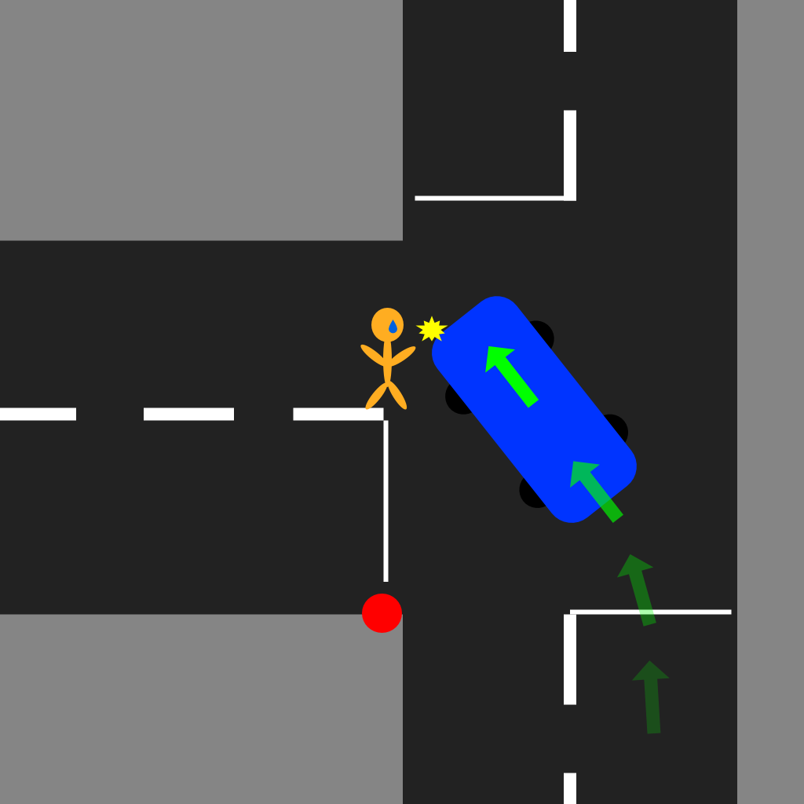

**Storyline:** A night time collision involving a single motor vehicle and a pedestrian. Your uniform patrol car call-sign is 11-4-30.

**Speed of SUV at point of impact - ~30km**

**Weather conditions – Warm and clear**

**Road conditions - Bare and dry**

**Date and Time -** August 27, 9:00 PM 2022

**Name of offense:**

Improper Left Turn,

Careless Driving

**Dispatch Call:** 11-4-30 please attend for a single vheicle and pedestrian MVC at the intersection of Grand River Street and South Service road 67. Paramedics have taken the pedestrian to Grand River Hospital. Pedestrian is in stable condition. 11-2-20 will attend the hospital  
  
**Potential Evidence:**

Debris from accident

Skid marks

Blood on ground

Blood on car

Shoe

| *Note: Witness on the scene is interviewed for this scenario as the pedestrian was taken to hospital.* | | |
| --- | --- | --- |
|  | **Carlton Bentley, Witness** | |
| **Witness Statement:**  I heard tires squealing while I was putting the dishes away, I quickly ran outside and saw the pedestrian on the ground. I asked if they needed help and offered to call 911. That's when I made the call and waited here for the paramedics to arrive. | |
| **Question** | | **Answer** |
| Can I get your name please? | | Yup. I’m Carlton Bentley. |
| Sir, did you see what happened? | | I heard tires squealing while I was putting the dishes away, I quickly ran outside and saw the pedestrian on the ground. I asked if they needed help and offered to call 911. That's when I made the call and waited here for the paramedics to arrive. I checked on the driver of the vehicle at the scene. |
| How responsive was the pedestrian when you asked if they needed help? | | To be honest, not very. They were breathing, but their eyes were closed and could barely open. |
| How was the driver when you checked on him? | | He was trapped in his seatbelt and was a little panicked. He told me his name was Bryan and kept saying I’m so sorry. |

| *Note; driver needs glasses* | | |
| --- | --- | --- |
|  | **Bryan Almers, SUV Driver (Cautioned)** | |
| **Driver Statement:** I came up to my turn and took the left onto Grand River when the person came out of nowhere. They must’ve been on a run or something because I didn't see anyone when I was approaching the intersection, and by the time I saw them in my headlights it was too late! | |
| **Question** | | **Answer** |
| Can I get your name please? As well as your license, registration and insurance? | | Sure, my name is Bryan Almers. |
| Can you tell me exactly what happened? | | It all happened so fast, I didn’t see anyone as I approached the intersection, so I thought I was clear to make a left turn, but by the time I saw her in my headlights it was too late and I…I hit her….I hope she’s ok. I feel just terrible. |
| Have you consumed any drugs or alcohol before getting behind the wheel today? | | No no, None whatsoever. |
| I see on your license that you require glasses or contact lens while driving - were you wearing glasses when the accident occurred? | | Admittedly, no. I forgot them at home - I didn’t think it would be a big deal since I was just going out to run a quick errand. Oh gosh, maybe if I had them on, this would not have happened. I feel so terrible. I don’t wear contacts. |
| ABC Towing is here and they are taking your vehicle | | Oh. Ok, thank you. |
| *Information from the officer at the hospital. The pedestrian suffered a broken left leg. The officer noticed the pedestrian’s clothes were all black and that she was listening to music on her earbuds.* | | |

## 

## **Scenario 6 - Single Car, Dawn, Collided with guardrail**

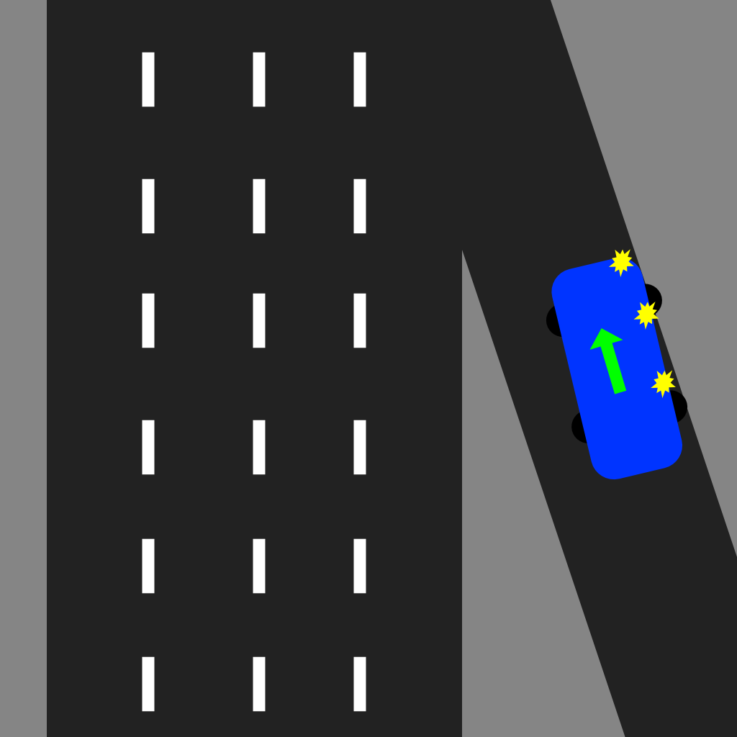

**Storyline:** Early morning (just after dawn), a single Driver falls asleep at the wheel whilst traveling to work along the on-ramp . This results in a loss of control and an impact/collision with the guardrail. Thankfully, no injuries have occurred. Small stretch of highway as well as on-ramp temporarily closed. Your uniform patrol car call-sign is 6L601.

**Speed at point of impact - ~50km/hr**

**Weather conditions – hot and humid**

**Road Conditions - bare and dry**

**Date and Time -** July 2nd, 6:10 AM 2022

**Name of offense:**

Careless driving, DUI

**Dispatch Call:** 6L-01 please attend at the on-ramp at King Street heading 86 South, a driver has collided with the guardrail. No injuries reported. Vehicle remains on the on-ramp.

**Potential Evidence:**

Debris from collision

Damage to vehicle’s complete right side

Damage to guardrail

Tire marks

Empty can of beer in front passenger footwell

|  | **Shawn Boateng, Driver** | |
| --- | --- | --- |
| **Driver Statement:** “I’m not exactly sure how this happened, Officer, to be completely honest with you. One minute I’m driving to work, the next minute I’m trying to pull my vehicle away from the guardrail. It’s like I lost control of the steering somehow? Now I’m not too knowledgeable about mechanics, though maybe the brakes or steering are broken somehow?” | |
| **Question** | | **Answer** |
| Can you tell me exactly what happened? | | I’m not exactly sure how this happened, Officer, to be completely honest with you. One minute I’m driving to work, the next minute I’m trying to pull my vehicle away from the guardrail. It’s like I lost control of the steering somehow? Now I’m not too knowledgeable about mechanics, though maybe the brakes or steering are broken somehow? |
| Can I get your name please? As well as your license, registration and insurance? | | Uh, yeah. I’m Shawn. Last name, Boateng. |
| I noticed there is an empty can of beer in the front passenger of your vehicle. Did you drink that beer? | | Well, I haven’t been drinking this morning, that was from last night |
| ABC Towing will take your vehicle to the impound lot. | | Ok thanks, I will need a ride though. |
| *An approved roadside screening device test is administered and the driver has registered in the WARN range.* | | |

## **Scenario 7 - High Speed sideswipe, Snow/Black ice**

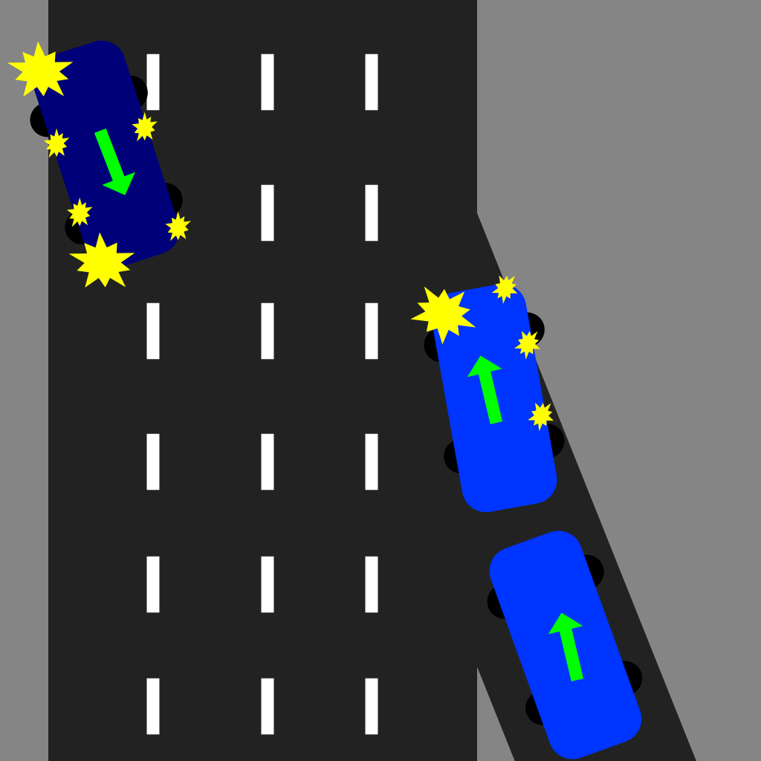

Storyline: An SUV driver traveling over the speed limit down the on-ramp, hits black ice. This causes it to merge unintentionally. This results in a pickup truck clipping the driver side of the SUV’s nose which sends the pickup barreling down the freeway, crossing many lanes with the pickup ending up into the guardrail on the opposite side of the roadway. The pickup driver was rushed to hospital in critical condition The SUV driver has just finished some medical checks and will not require further medical treatment. Your uniform patrol car call-sign is 6C-601

**Speed at point of impact - ~85km**

**Weather conditions – Light snow, dark**

**Road Conditions – bare with some drifted light snow**

**Date and Time -** Jan 28th, 6:15 AM 2022

**Name of offense** Fail to yield

Fail to drive marked lane

Careless driving

**Dispatch Call:** 6c-601 canyou respond to a two-car vehicle collision on the on- ramp at King Street heading 86 South. Note: one vehicle is upside down. One driver in critical condition on route to Grand River ER. 6C-602 will proceed to the hospital to check on the other involved driver.

**Potential Evidence:**  
Skidmarks

All airbags deployed

Damage to SUV  
Damage to Pick Up

Damage to Guardrails

|  | **Mary-Ann M. Kovacs, Driver (Cautioned)** | |
| --- | --- | --- |
| **Driver Statement:** “I was coming down the on-ramp at…*pause*...normal speeds I’d say and then all of a sudden I’m sliding and drifting towards a pickup in my blindspot! I feel terrible about the poor man in the truck. I really hope he’s going to be okay, do you think that he’s going to be okay?! Please I don’t know what happened, I’m just so scared and confused!” | |
| **Question** | | **Answer** |
| Can I get your name please? As well as your license, registration and insurance? | | Yes of course. My name is Mary-Ann Kovacs. |
| Can you tell me exactly what happened? | | I was coming down the on-ramp at…*pause*...normal speeds I’d say and then all of a sudden I’m sliding and drifting towards a pickup in my blindspot! I feel terrible about the poor man in the truck. I really hope he’s going to be okay, do you think that he’s going to be okay?! Please I don’t know what happened, I’m just so scared and confused! |
| When you say ‘normal’ speed, how fast do you think you were going? | | I was matching the speed of traffic, so probably like….85 k, maximum. |
| Do you need assistance calling for a tow, or arranging transportation? | | I’ll be ok, I’ve got CAA, they’re enroute to help. |
| *(unlocked if airbags are photographed)I* noticed that your airbags were deployed - are you feeling ok, do you require any medical attention? | | I’m feeling a little sore, and a bit dizzy, but I’m okay. |
| Have you consumed any drugs or alcohol before getting behind the wheel today? | | No, no, nothing like that at all |
| *(Q unlocked if skid marks are photographed)*. Do you remember breaking, or swerving before or after the collision? | | I don’t remember having any control over the vehicle at all. It was really scary! |

|  | ***Karen Stevens, Witness*** | |
| --- | --- | --- |
| ***Witness Statement:*** *“I saw everything. Oh, please tell me that young man is going to be okay! I saw his Licence plate, he’s from out of province I think. Please tell me you’re going to arrest that reckless asshole! I’m sorry, it’s just that some people don’t know not to drive stupid, especially when there is black ice everywhere!”* | |
| ***Question*** | | ***Answer*** |
| *Can I get your name please?* | | *Of course officer. I’m Karen, Karen Stevens.* |
| *Can you tell me exactly what happened?* | | *Yes - saw everything. The SUV driver was going way too fast, and I swear they were trying to merge before clearing their lane, so bang! That’s when she hit that poor young man in the pick-up! Such recklessness!* |
| *Are you feeling ok after witnessing the accident; do you require any support resources?* | | *I’m ok - it was scary, but I’ll be fine. I just hope that young man is ok!* |
| *How fast do you think the SUV was traveling?* | | *I’d say they were going close to 100 km! So unsafe! Especially with the black ice being everywhere! People need to be more careful!* |
| *Did the pick-up driver remain in his lane?* | | *Yes, he did. The SUV driver is to blame here!* |
| *Information from the officer at the hospital. The Pickup driver,* ***John Walsh****, is in critical condition. Doctors believe he may have suffered a back and/or neck injury. The driver should be alright but recovery is going to take some time. John is from out of province and not much is known about where he was traveling and why.* | | |

## 

## 

## **Scenario 8 - Rear End, Evening, Distracted driving**

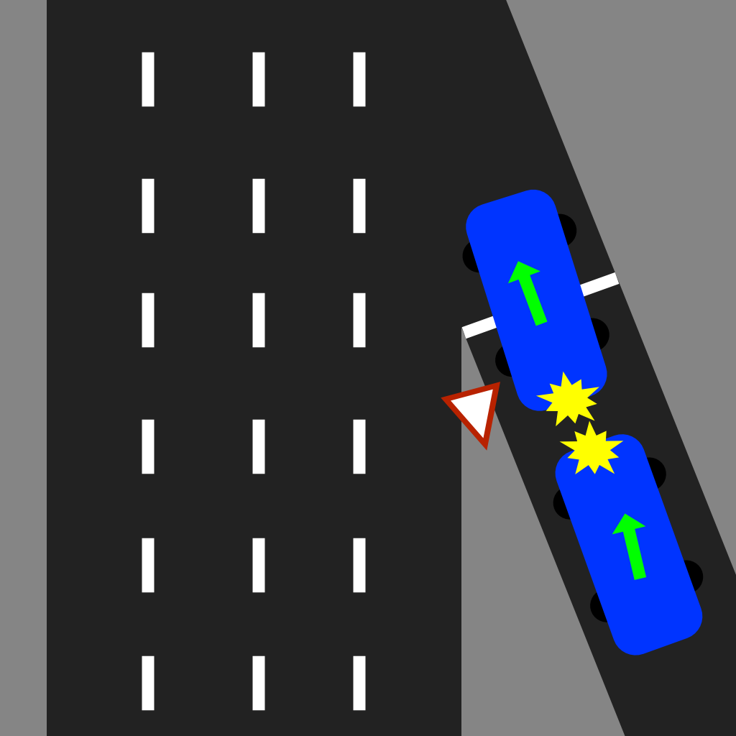

**Storyline:** A Hatchback driver travels over the speed limit down the on-ramp while eating food and texting. They do not notice a pickup truck yielding and waiting to merge. Hatchback rear ended the pickup truck. Both drivers are recovering from shock. The pickup truck driver experienced slight whiplash and is irritated. Your patrol car call-sign is 1G-232.

**Speed at point of impact - ~55km**

**Weather conditions - Sunny, warm**

**Road Conditions – Bare and dry**

**Date and Time -** Aug 18th, 12:15 PM 2022

**Name of offense:**

Distracted driving

**Dispatch Call:** 1G-232, can you respond to a two-car collision on the on- ramp at King Street heading 86 South. A hatchback has rear ended a pickup truck yielding to merge. The pickup truck driver is experiencing neck pains. Both vehicles are in park along the on-ramp and please approach with caution.

**Potential Evidence:**

Skidmarks

All airbags deployed

Damage to Hatchback  
Damage to Pickup

Food, cell phone, and wireless earbuds scattered in drivers footwell

Cannabis Edible Packaging in front seat

Damage to guard rail

Note: There is a smell of cannabis in the air around the collision (red herring)

|  | **Sebastian Gomez, Driver (Cautioned)** | |
| --- | --- | --- |
| **Driver Statement:**  “I was heading down the on-ramp when all of a sudden an old water bottle rolled underneath my pedals and when I got back up from grabbing it all I saw was the truck’s tailgate. I didn’t even see the truck before that man I swear!” | |
| **Question** | | **Answer** |
| Can I get your name please? As well as your license, registration and insurance? | | Of course. I’m Sebastian Gomez. |
| Can you tell me exactly what happened? | | I was heading down the on-ramp when all of a sudden an old water bottle rolled underneath my pedals and when I got back up from grabbing it all I saw was the truck’s tailgate. I didn’t even see the truck before that man I swear! |
| Have you consumed any drugs or alcohol before getting behind the wheel today? | | Umm. I consumed some weed gummies a few nights ago. |
| Would you describe yourself as a safe driver? | | I’d like to think so, yeah. I know I don’t always follow the rules of the road to a T, but I’m not reckless by any means! |
| ABC Towing will be towing your vehicle | | Oh, OK, thanks. |
| *(Q unlocked if debris in vehicle (food wrappers, earbuds, etc) are tagged as evidence)*. Were you eating while driving today? | | Umm, yes. But nothing elaborate, just a sandwich. I drive and eat all the time, I’m confident enough to do it safely. |
| *(Q unlocked if photo of Cannabis packaging is tagged as evidence)*. I noticed the opened consumable cannabis wrapper on your passenger seat. When is that from? | | Oh yeah, that’s from a few nights ago. Not today. |
| The vehicle and driver were searched under the Cannabis Control Act. No further cannabis was located. The packaging was seized. The driver was summoned to appear in court, charged with consuming cannabis in a vehicle contrary to the Smoke Free Ontario Act. | | |

|  | **Chin Yang, Driver (irritable)** | |
| --- | --- | --- |
| ***Driver Statement:*** *“He was texting and eating. I saw him in my rear view mirror right before the asshole hit me. My neck and face are killing me, I just want this to be over with! This is my side of the story, so please take your statement and let me get home or to a doctor or something…and take that asshole’s license away please. Do something to fix this!”* | |
| ***Question*** | | ***Answer*** |
| *Can I get your name please? As well as your license, registration and insurance?* | | *I’m Chin Yang, I’ll get those other things.* |
| *Can you tell me exactly what happened?* | | *This asshole was eating while driving, not paying attention, and rear-ended me. Now I’m in pain, and this person better be held accountable for my injuries and damage to my car!* |
| *(unlocked if airbags are photographed)I noticed that the other driver’s airbags were deployed - are you feeling ok, do you require any medical attention?* | | *My neck is quite sore, though no ambulance is necessary, thank you. I can take myself to a doctor as soon as we’re done here.* |
| *Your vehicle does not appear to be damaged, are you comfortable with driving it, or do you need assistance sourcing a tow?* | | *It’ll be ok to drive; as long as all the photos were taken for insurance and court purposes. I’ll take this unsafe asshole driver to court if I have to, he’ll pay for this!* |
| *(Q unlocked if debris in the vehicle (food wrappers etc) is tagged as evidence). Can you confirm that you saw the driver eating when he hit you?* | | *One hundred percent! I saw him eating in my rearview mirror; I looked when I could feel that he was approaching too quickly.* |