## **Scenario 1 - Snow, Single Car, Traffic Light Crash**

## **Storyline:** Driver failed to stop at the red light due to snow, making the road very slippery, they could not stop and crashed into the traffic light on the other side. The uniform patrol car call sign is 11-2-10

## **Speed at point of impact - ~35km**

## **Road conditions: Wet, slippery Weather conditions - Snow,** **Date and Time** - Jan 21, 7:15 AM 2020

**Name of offense**

Red Light – Fail to Stop

**Dispatch Call**: 11-2-10 can you respond to a single motor vehicle collision at Grand River Street and Service Road 67. A vehicle has slid into a traffic light pole

|  | **Michelle E. Oliverio, Driver** | |
| --- | --- | --- |
| **Driver Statement:**  “It was dark and I didn’t see the intersection coming up. When I saw the red light, I tried stopping but it was too late. It was slippery, and I slid right through the light. I couldn’t stop, and I hit the traffic light pole.” | |
| **Question** | | **Answer** |
| Are you feeling alright? ~~Do you require any medical attention?~~ | | ~~No~~ I am fine thank you |
| May I have your driver’s license, ownership and insurance slip please. | | **Sure**, My name is Michelle E. Oliverio. |
| Can you tell me exactly what happened? | | It was dark and I didn’t see the intersection coming up. When I saw the red light, I tried stopping but it was too late. It was slippery, and I slid right through the light. I couldn’t stop, and I hit the traffic light pole. |
| ABC Towing will be towing your vehicle | | Okay thank you |
| Do you have winter tires on your vehicle? | | ~~Unfortunately, not, I neglected to find the time for that before winter. I’m really kicking myself now.~~  Unfortunately not, I just haven’t had the time for that before winter. I’m really kicking myself right now! |

## **Scenario 2 - Rear End Collision**

**Storyline**: Driver in Hatchback was texting while driving, did not notice car stopped in front at stop sign, hit SUV from behind. Veered slightly to the left before impact. The SUV moved slightly into the intersection after impact. There was a jogger going through the intersection

**Road Conditions: Bare and Dry**

**Speed at point of impact - ~42km**

**Weather conditions – bare, clear, Afternoon**

**Date and Time -** June 17, 12:05 PM 2020

**Name of offense**

Careless Driving,

Follow Too Closely

Distracted Driving

Distracted Driving

**Dispatch Call:** Attention T2-100 There has been a rear end collision at the intersection of Grand River Street and Service Road 67. Reported at Municipality of Waterloo,

**Potential Evidence:**

* SUV rear damage
* Hatchback front damage
* Skidmarks from attempted stop (hatchback)
* Debris from accident

|  | **Lisa W. Pena, SUV driver** | |
| --- | --- | --- |
| **SUV Driver Statement:** “I was just stopped at the stop sign, waiting for a jogger to clear the intersection, getting ready to make my left when this idiot smashed into me! Probably on their phone or something.” | |
| **Question** | | **Answer** |
| Are you alright? Do you require any medical attention. | | No I’m fine thank you |
| May I have your driver’s license, ownership and insurance slip please. | | ~~My name is Michelle E. Oliverio.~~ **Sure, my name is Lisa Pena.** |
| ABC Towing will be towing your vehicle | | Okay, thank you. |
| Did you happen to notice if other driver was following you for a while? If so were they keeping appropriate distance? | | He’s been behind me since we both turned left onto Grand River at Pearson Ave – but he was fairly well back **until** I stopped and waited for the jogger to clear the intersection. |
| What happened next | | ~~The driver got out of the driver’s seat and he was talking loudly on his phone to his wife saying he had been involved in an accident~~  The driver got out of his car and was talking loudly on his cellphone to his wife saying he had been involved in an accident |

:

|  | **Kyle F. Evans, AUDI Driver** | |
| --- | --- | --- |
| **Audi Driver Statement:** “I literally didn’t even see the car in front of me! The stop sign came up so fast, I didn't expect it.” | |
| **Question** | | **Answer** |
| Are you alright? Do you require any medical attention. | | No, I am fine thank you |
| May I have your driver’s license, ownership and insurance slip please. | | Sure, My name is Kyle Evans |
| Can you tell me exactly what happened? | | Unfortunately, I rear-ended that SUV. I’m sorry.I literally didn’t even see the car in front of me! The stop sign came up so fast, I didn't expect it. Uh, I guess I was daydreaming a bit. |
| ABC Towing will be towing your vehicle | | Okay thank you |
| Have you consumed any drugs or alcohol before getting behind the wheel today? | | No, no. I would never do that then drive. |
| So did you see the jogger | | What jogger? |
| ~~So where were you on your cellphone when the accident happened?~~ | | ~~Yes I was talking to my wife and I went to find something in my e-mail and then I hit the other car~~ |
| You said that you were daydreaming. What do you mean by that? | | Okay, I was talking on my cellphone to my wife, and I went onto my email to find an email she had sent me, and I hit the car in front of me. I wasn’t paying attention, its my fault |

|  | **Jules Dunkerly, Witness** | |
| --- | --- | --- |
| **Witness Statement:** “I was reading my book on the porch, when this jogger went by and said hello, I started reading again and that is when I heard a loud bang. I looked up and saw these two cars collided”. | |
| **Question** | | **Answer** |
| Can I get your name please? | | Of course, my name is Jules Dunkerly. |
| Can you tell me exactly what happened? | | I was reading my book on the porch, when this jogger went by and said hello, I started reading again and that is when I heard a loud bang. I looked up and saw these two cars collided”. |
| Did you see the moment of collision? | | no, but I saw the lady stop and that is when the jogger waved then I started reading and then I looked up right after it happened. |
| Did you see or hear anything else | | Oh, yes dear, the man got out of his car on the driver’s side and was talking really loudly to someone. **He had something in his hand** |

## 

## **Scenario 3 - Head On Collision**

**Storyline**: SUV Driver applying makeup in mirror, not paying attention to the onCOMING intersection. The SUV slightly veers to the left and collides with incoming cars. The AUDI reacts and slightly moves to their right but does not move out of the way in time and still collides. 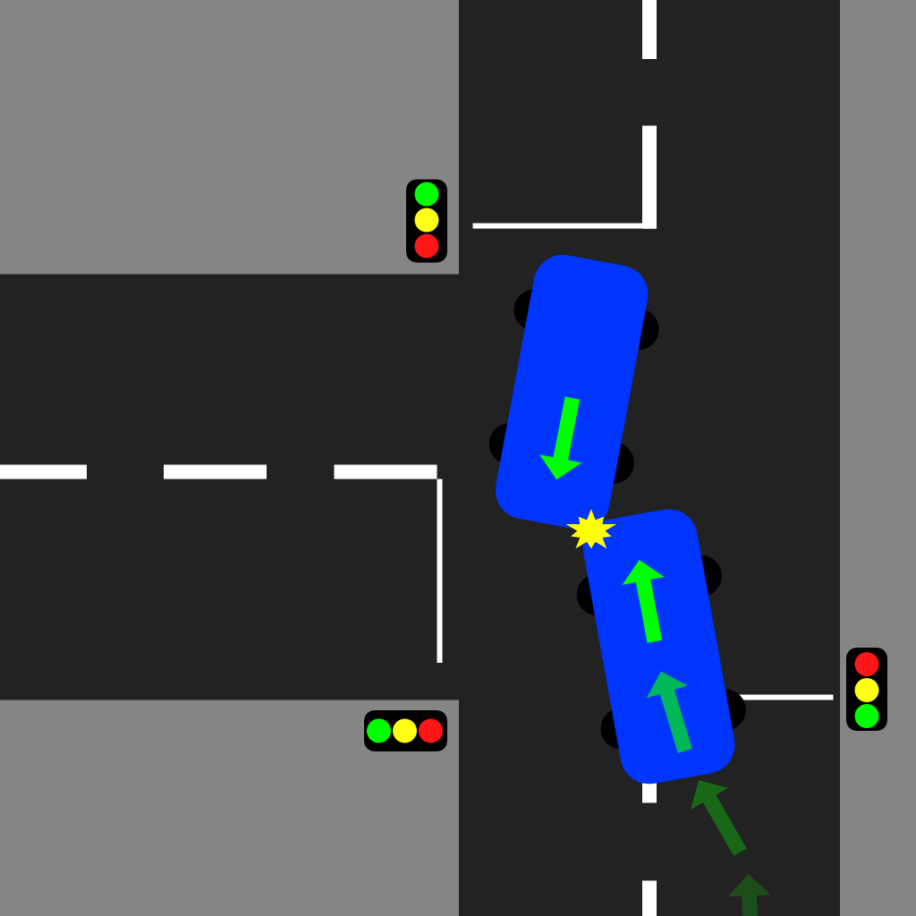

**Posted Speed limit: 60 km/hr  
Speed at point of impact - ~60km**

**Weather conditions - Clear,**

**Road Condition: Bare, dry**

**Date and Time -** September 05, 8:30 AM 2020

**Name of offense**

Careless Driving

**Dispatch Call:** 1-G1-N, there has been a head on collision involving 2 vehicles at the intersection of Grand River Street and South Service road 67. MVC-PI Personal injury reported with both drivers transported to Hospital with serious injuries. 1G2-N has attended the hospital

**Potential Evidence**:

Debris from accident

Skid marks

Airbag deployed in both vehicles

Airbag has make up on Katies vehicle

SUV front left damage

AUDI front left damage

Makeup in car in SUV (on seat?)

| *Note: Witnesses on the scene are interviewed for this scenario as both drivers were taken to hospital.* | | |
| --- | --- | --- |
|  | **David Short, Witness** | |
| **Witness David Short Statement:**  I was out for my morning run and was waiting at the light to cross the street when it happened - I watched the person in the Audi try to veer out of the way at the last minute, but it was too late. | |
| **Question** | | **Answer** |
| Can I get your name please? | | **Sure,** My name is David Short. |
| Can you tell me exactly what happened? | | The woman in the SUV was definitely not paying attention. She started to veer into on-coming traffic. As she entered the intersection, the other driver tried to swerve out of the way, but they hit each other. |
| What make you think the woman was not paying attention | | I saw a her visor was flipped down and she appeared to have something in her hand |
| How fast would you say both vehicles were traveling? | | **I would say** The speed limit |
| Did either vehicle honk their horns prior to impact? | | No, they didn’t - I think it all just happened so fast. I think the person in the Audi may have assumed that the SUV driver was going to turn left after they passed, but misread the situation. |
|  | |  |

|  | **Katie Singh, Witness** | |
| --- | --- | --- |
| **Witness Statement:** I was walking my dog a few steps away from the intersection when the crash happened. I swear I saw the woman in the SUV doing her hair or something. I noticed she was weaving in her lane a bit, but there was nothing I could do, before I knew it, bang, they hit each other. | |
| **Question** | | **Answer** |
|  | |  |
| Did you see what happened? | | The SUV was coming up to the intersection and she didn’t seem to notice that she wasn’t in her lane. The Audi was also coming into the intersection - it looked as though she was going to swerve to avoid hitting the SUV but it was too late. |
| Can I get your name please? | | **Sure,** my name is Katie Singh. |
| How fast would you say they were traveling? | | I don’t know ~~I was walking my dog~~ It was honestly hard for me to tell. |

| Information from the hospital from the other officer |
| --- |
| The driver of the Audi, Bob Smith, was driving to work. He saw a vehicle approaching and suddenly swerved into his lane, he tried to avoid but the other vehicle kept coming and she hit me |
| A cautioned statement from Lucy Channel. She was driving to a meeting and was running late. I went to put on some makeup and ended up in the other lane and struck the car |

## **Scenario 4 - Rain, T-Bone Collision**

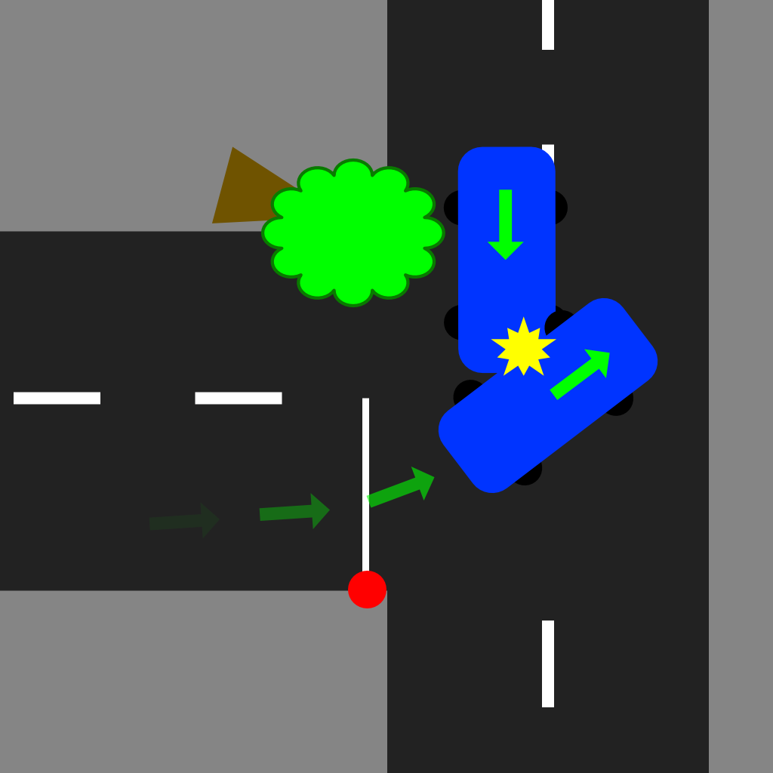

**Storyline:** Driver is obstructed by a tree that has fallen at the corner of the intersection, blocking the vision of the through road. The SUV is stopped at the stop sign and decides to go, even though they can’t see well enough to safely make the turn. The AUDI reaches the tree and decides to veer around it. T-bone collision occurs in the intersection. It is raining heavily and the vision is obstructed by the tree.

**Speed of SUV at point of impact - ~15km**

**Speed of AUDI at point of impact - ~50km**

**Weather conditions - Rain, Evening**

**Road conditions: bare and wet**

**Date and Time -** April 23, 7:15 PM 2020

**Name of offense:**

Fail to Yield to Traffic on Through Highway

Improper left hand Turn

**Dispatch Call:** 1-FO-AD Attention all units, could you proceed to a two vehicle collision at the intersection of Grand River Street and South Service Road 67. Personal injury reported with one driver transported to Hospital with serious injuries. The other involved driver is at the scene. 2-F0-AD is attending at the hospital

**Evidence:**

SUV Left Side Damage

AUDI Front Left Damage

Debris from collision

Skid marks

Airbag deployed

Tree in the through lane

|  | **Rodger Vossen, SUV Driver** | |
| --- | --- | --- |
| **Witness Statement: “**I was turning out of my neighbourhood onto the sideroad. I looked both ways and couldn’t see any cars coming. I noticed the tree was down but I couldn’t see any car coming behind it. When I took the left onto the sideroad the car came out of nowhere and took me out! I’m not sure how fast he was going but it must’ve been over the limit as I had no time to react. **”** | |
| **Question** | | **Answer** |
| Can I get your name please? As well as your license, registration and insurance? | | I’m Rodger Vossen |
| Can you tell me exactly what happened? | | I was turning out of my neighbourhood onto the sideroad. I looked both ways and couldn't see any cars coming. I noticed the tree was down but I couldn't see any car coming behind it. When I took the left onto the sideroad the car came out of nowhere and took me out! I'm not sure how fast he was going but it must've been over the limit as I had no time to react. |
| Have you consumed any drugs or alcohol today? | | No, I have not. Why would you ask that? I’m the victim here! |
| How fast were you traveling? | | ~~I was inching out trying to turn left onto the side road, but I had to come further out into the intersection to see past the tree~~  **I couldnt have been going more than 15-20km into that turn since I was just stropped.** |
| Roughly how fast was the other driver traveling? | | ~~I don’t know he came out of no where~~  **I’d say atleast 70km, which is 20 over the limit for this road.** |

|  | **Garry Hiram, Hatchback Driver** | |
| --- | --- | --- |
| **Witness Statement: “** I was coming along the sideroad when I saw the tree down on the road. I checked behind me and maneuvered around the tree. As I moved around the tree the other driver peeled out in front of me last second! I had no time to stop or swerve, and did not see the car coming out of that intersection. **”** | |
| **Information received from the officer at the hospital.** | | |
| **Question** | | **Answer** |
| Can you tell me exactly what happened? | | I was coming along the sideroad when I saw the tree down on the road. I checked behind me and maneuvered around the tree. As I moved around the tree the other driver peeled out in front of me last second! I had no time to stop or swerve, and did not see the car coming out of that intersection. |
| Can I get your name please? As well as your license, registration and insurance? | | **Sure** I’m ~~Garry~~. Garry Hiram. |
| Have you consumed any drugs or alcohol today? | | No way. I would never do that and drive. |
| ~~How fast were you traveling?~~ | | ~~I was driving slow as it was raining~~ |
| ~~How fast was the other driver traveling?~~ | | ~~I think he was going to fast for the weather conditions as he pulled out infront of me quickly.~~ |
| **ABC Towing will be towing your vehicle** | | **Okay, Thank you.** |

## **Scenario 5 - Night, Pedestrian Hit**

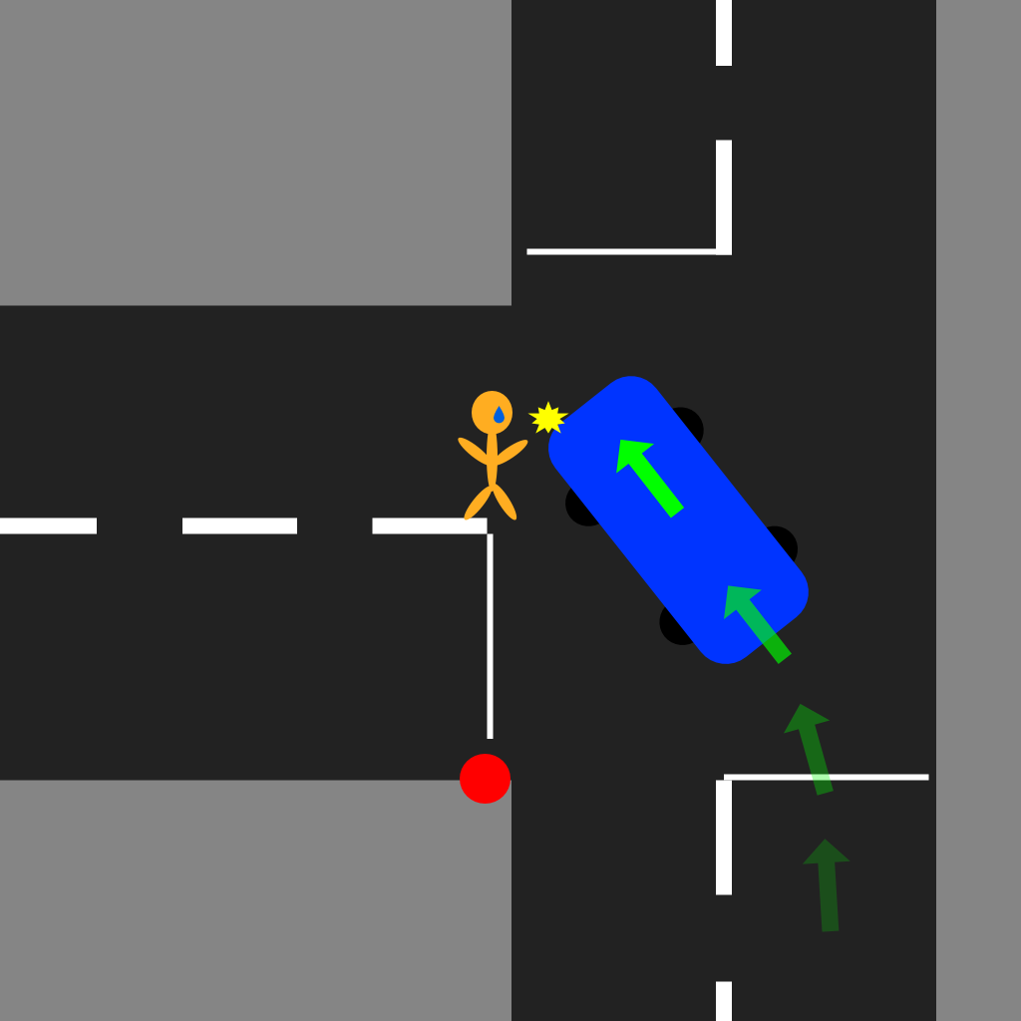

**Storyline:** A night time collision involving a single motor vehicle and a pedestrian.

**Speed of SUV at point of impact - ~30km**

**Weather conditions – Bare and dry**

**Date and Time -** August 27, 9:00 PM 2020

**Name of offense:**

Improper Left Turn,

Careless Driving

**Dispatch Call:** 11-4-30 please attend for a single vheicle and pedestrian MVC at the intersection of Grand River Street and South Service road 67. Paramedics have taken the pedestrian to Grand River Hospital. Pedestrian is in stable condition.

11-2-20 will attend the hospital

**Potential Evidence:**

Debris from accident

Skid marks

Blood on ground

Blood on car

Shoe

| *Note: Witness on the scene is interviewed for this scenario as the pedestrian was taken to hospital.* | | |
| --- | --- | --- |
|  | **Carlton Bentley, Witness** | |
| **Witness Statement:**  I heard tires squealing while I was putting the dishes away, I quickly ran outside and saw the pedestrian on the ground. I asked if they needed help and offered to call 911. That's when I made the call and waited here for the paramedics to arrive. | |
| **Question** | | **Answer** |
| Sir, did you see what happened? | | I heard tires squealing while I was putting the dishes away, I quickly ran outside and saw the pedestrian on the ground. I asked if they needed help and offered to call 911. That's when I made the call and waited here for the paramedics to arrive. I checked on the driver of the vehicle at the scene |
| Can I get your name please? | | Yup. I’m Carlton Bentley. |
| How responsive was the pedestrian when you asked if they needed help? | | To be honest, not very. They were breathing, but their eyes were closed and could barely open. |
| ~~You checked on the driver and what happened~~  **How was the driver when you checked on him?** | | He was trapped in his seatbelt and was a little panicked. ~~The driver,~~ He told me his name was Bryan and kept saying I am sorry |

| *Note; driver needs glasses* | | |
| --- | --- | --- |
|  | **Bryan Almers, SUV Driver (Cautioned)** | |
| **Witness Statement:** I came up to my turn and took the left onto Grand River when the person came out of nowhere. They must’ve been on a run or something because I didn't see anyone when I was approaching the intersection, and by the time I saw them in my headlights it was too late! | |
| **Question** | | **Answer** |
| Can I get your name please? As well as your license, registration and insurance? | | **Sure,** My name is Bryan Almers. |
| Can you tell me exactly what happened? | | It all happened so fast, I didn’t see anyone as I approached the intersection, so I thought I was clear to make a left turn, but by the time I saw her in my headlights it was too late and I…I hit her….I hope she’s ok. I feel just terrible. |
| Have you consumed any drugs or alcohol before getting behind the wheel today? | | No no, None whatsoever. |
| I see on your license that you require glasses or contact lens while driving - were you wearing glasses when the accident occurred? | | Admittedly, no. I forgot them at home - I didn’t think it would be a big deal since I was just going out to run a quick errand. Oh gosh, maybe if i had them on, this would not have happened. I feel so terrible. I don’t wear contacts. |
| ABC Towing is here and they are taking your vehicle | | **Oh,** ok thank you. |
| Information from the officer at the hospital the pedestrian suffered a broken left leg. The officer noticed the pedestrian’s clothes were all black and that she was listening to her airbuds. | | |

## **Scenario 6 - Single Car, Dawn, Collided with guardrail**

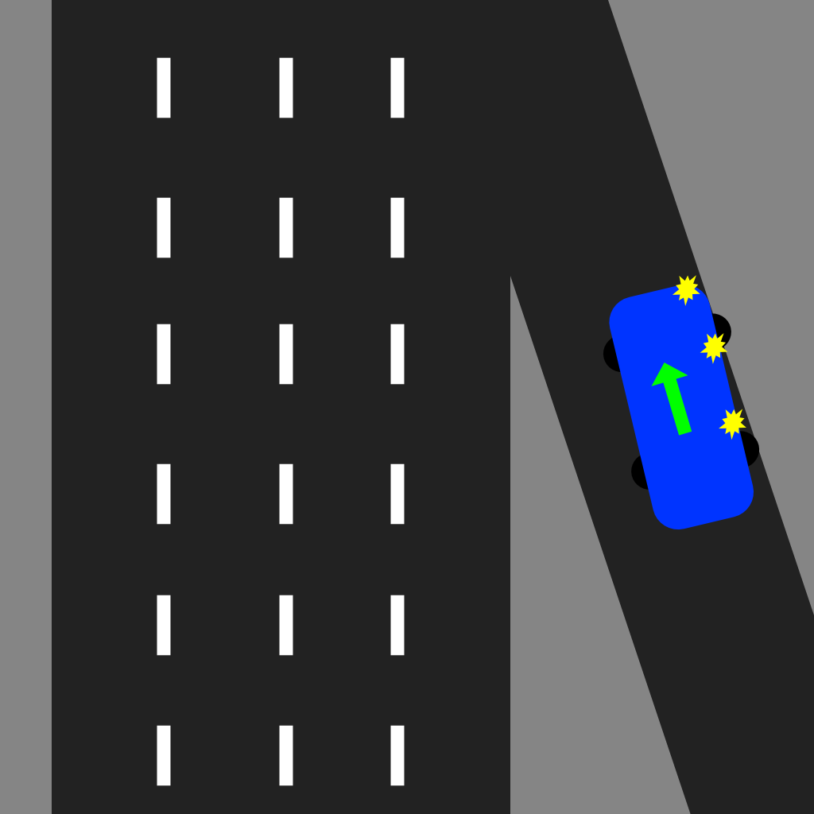

**Storyline:** Early morning (just after dawn), a single Driver falls asleep at the wheel whilst travelling to work along the on-ramp . This results in a loss of control and an impact/collision with the guardrail. Thankfully, no injuries have occured. Small stretch of highway as well as on-ramp temporarily closed.

**Speed at point of impact - ~50km/hr**

**Weather conditions - Clear,**

**Road Conditions: bare and dry**

**Date and Time -** July 2nd, 6:10 AM 2020

**Name of offense:**

Careless driving,

**Dispatch Call:** 6-L-601 please attend at the on-ramp at King Street heading 86 South, a driver has collided with the guardrail. No injuries reported. Vehicle remains on the on-ramp.

**Potential Evidence:**

Debris from collision

Damage to vehicle’s complete right side

Damage to guardrail

Tire marks

Empty can of beer in footwell

|  | **Shawn Boateng, Driver** | |
| --- | --- | --- |
|  | **Witness Statement of Shawn:**: “I’m not exactly sure how this happened Officer, to be completely honest with you. One minute I’m driving to work, the next minute I’m trying to pull my vehicle away from the guardrail. It’s like I lost control of the steering somehow? Now I’m not too knowledgeable about mechanics, though maybe the brakes or steering are broken somehow?” | |
|  | NOTE: Driver suffers from Insomnia (apart of unlockable CMT dialogue) | |
| **Question** | | **Answer** |
| Can you tell me exactly what happened? | | I’m not exactly sure how this happened Officer, to be completely honest with you. One minute I’m driving to work, the next minute I’m trying to pull my vehicle away from the guardrail. It’s like I lost control of the steering somehow? Now I’m not too knowledgeable about mechanics, though maybe the brakes or steering are broken somehow? |
| Can I get your name please? As well as your license, registration and insurance? | | Uh, yeah. I’m Shawn. Last name Boateng. |
| I noticed there is an empty can of beer in the front passenger of your vehicle. Did you drink that beer? | | Well, I haven’t been drinking this morning, that was from last night |
| ~~I can smell alcohol on your breath, your eyes are watery and there is an open beer can~~ | | ~~I had something to drink last evening, and I have not been drinking this morning~~ |
| ABC Towing is taking your vehicle to the~~ir~~ **im**pound **lot** | | Ok, **thanks** I will need a ride **though** |
| A roadside test is administered and registered in the warn range. | | |

## **Scenario 7 - High Speed sideswipe, Snow/Black ice**

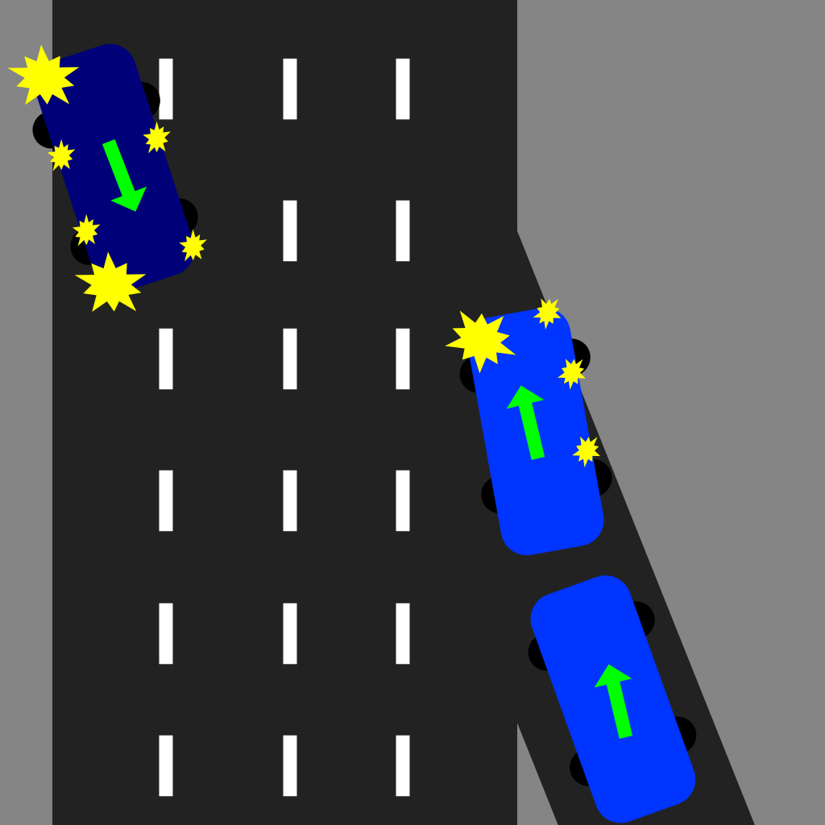

Storyline: An SUV driver traveling over the speed limit down the on-ramp, hits black ice. This causes it to merge unintentionally. This results in a pick up truck clipping the driver side of the SUV’s nose which sends it barreling down the freeway, many lanes across, towards the express lane’s guardrail. The pickup driver was rushed to hospital in critical condition, the SUV driver has just finished medical checks.

**Speed at point of impact - ~85km**

**Weather conditions - Snow, Morning**

**Date and Time -** Jan 28th, 6:15 AM 2020

**Name of offense**

Failed to drive marked lane, reckless driving

**Dispatch Call:** Attention all units, we need you to respond to a two-car vehicle collision on the on- ramp at King Street heading 86 South. Note: one vehicle is upside down. One driver in critical condition on route to Grand River ER.

**Potential Evidence:**  
Skidmarks

All airbags deployed

Damage to SUV  
Damage to Pick Up

Damage to Guardrails

|  | **Mary-Ann M. Kovacs, Driver (Cautioned)** | |
| --- | --- | --- |
| **Witness Statement:** “I was coming down the on-ramp at…*pause*...normal speeds I’d say and then all of a sudden I’m sliding and drifting towards a pickup in my blindspot! I feel terrible about the poor man in the truck. I really hope he’s going to be okay, do you think that he’s going to be okay?! Please I don’t know what happened, I’m just so scared and confused!” | |
| **Question** | | **Answer** |
| Can I get your name please? As well as your license, registration and insurance? | | Yes of course. My name is Mary-Ann Kovacs. |
| Can you tell me exactly what happened? | | I was coming down the on-ramp at…*pause*...normal speeds I’d say and then all of a sudden I’m sliding and drifting towards a pickup in my blindspot! I feel terrible about the poor man in the truck. I really hope he’s going to be okay, do you think that he’s going to be okay?! Please I don’t know what happened, I’m just so scared and confused! |
| When you say ‘normal’ speed, how fast do you think you were going? | | I was matching the speed of traffic, so probably like….85 k, maximum. |
| Do you need assistance calling for a tow, or arranging transportation? | | I’ll be ok, I’ve got CAA, they’re en route to help. |
| (Q unlocked if airbags are tagged as evidence) ~~Are you experiencing any dizziness or blurred vision?~~  **I noticed that your airbags were deployed - are you feeling ok, do you require any medical attention?** | | I’m feeling a little sore, and a bit dizzy, but ~~my vision is fine.~~ **Im okay** |
| Do you remember breaking, or swerving before or after the collision. | | I don’t remember having any control over the vehicle at all. It was really scary! |

|  | **Karen Stevens, Witness** | |
| --- | --- | --- |
| **Witness Statement:** “I saw everything. Oh, please tell me that young man is going to be okay! I saw his Licence plate, he’s from out of province I think. Please tell me you’re going to arrest that reckless asshole! I’m sorry, it’s just that some people don’t know not to drive stupid, especially when there is black ice everywhere!” | |
| **Question** | | **Answer** |
| Can I get your name please? | | Of course officer. I’m Karen, Karen Stevens. |
| Can you tell me exactly what happened? | | Yes - saw everything. The SUV driver was going way too fast, and I swear they were trying to merge before clearing their lane, so bang! That’s when she hit that poor young man in the pick-up! Such recklessness! |
| Are you feeling ok after witnessing the accident; do you require any support resources? | | I’m ok - it was scary, but I’ll be fine. I just hope that young man is ok! |
| How fast do you think the SUV was traveling? | | I’d say they were going close to 100 km! So unsafe! Especially with the black ice being everywhere! People need to be more careful! |
| Did the pick-up driver remain in his lane? | | Yes, he did. The SUV driver is to blame here! |

## 

## 

## **Scenario 8 - Rear End, Evening, Distracted driving**

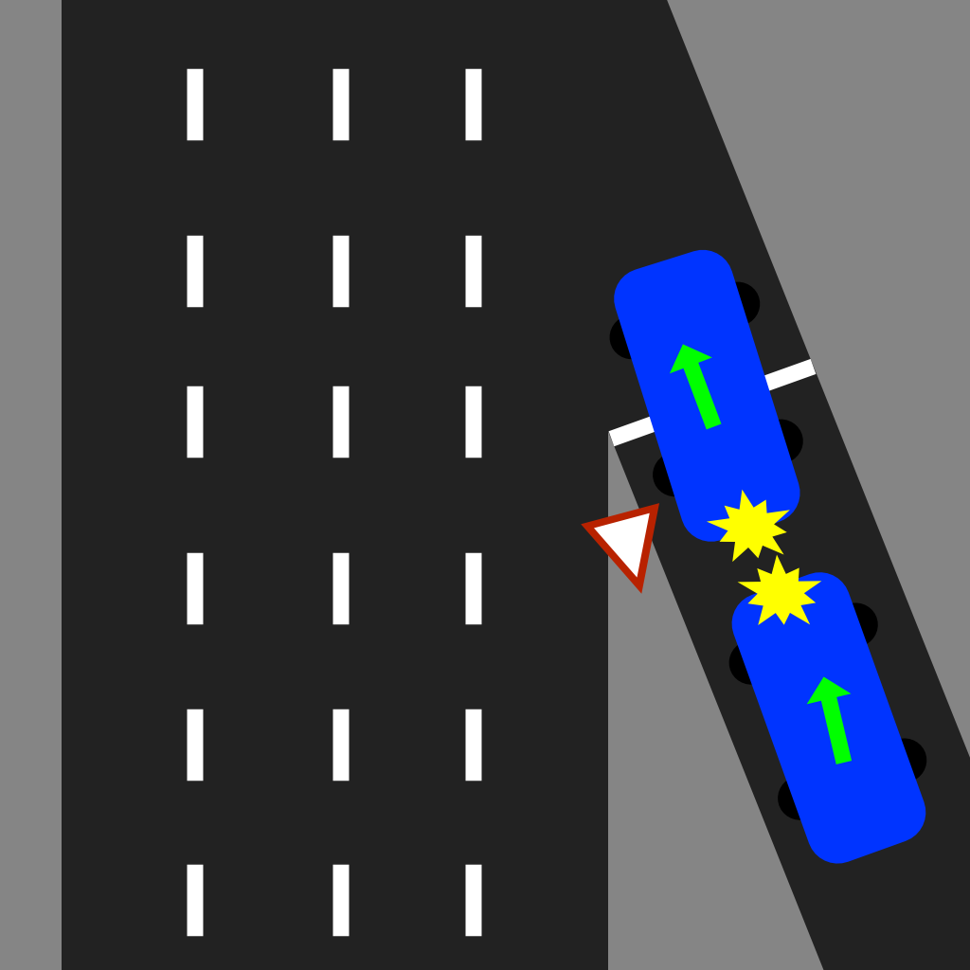

**Storyline:** A Hatchback driver travels over the speed limit down the on-ramp while eating food and texting. They do not notice a pick up truck yielding and waiting to merge. Hatchback rear ended the pick up truck. Both drivers are recovering from shock. The pick up truck driver experienced slight whiplash and is irritated.

**Speed at point of impact - ~55km**

**Weather conditions - Sunny, Noon**

**Date and Time -** Aug 18th, 12:15 PM 2020

**Name of offense:**

Distracted driving, Reckless Driving

**Dispatch Call:** Attention all units, please respond to a two-car collision on the on- ramp at King Street heading 86 South. A hatchback has rear ended a pick up truck yielding to merge. The pick up truck driver is experiencing neck pains. Both vehicles are in park along the on-ramp and please approach with caution.

**Potential Evidence:**

Skidmarks

All airbags deployed

Damage to Hatchback  
Damage to Pick Up

Food, cell phone, and wireless earbuds scattered in drivers footwell

Damage to guard rail

Note: There is a smell of cannabis in the air around the collision (red herring)

|  | **Sebastian Gomez, Driver (Cautioned)** | |
| --- | --- | --- |
| **Witness Statement:**  “I was heading down the on-ramp when all of a sudden an old water bottle rolled underneath my pedals and when I got back up from grabbing it all I saw was the truck’s tailgate. I didn’t even see the truck before that man I swear!” | |
| **Question** | | **Answer** |
| Can I get your name please? As well as your license, registration and insurance? | | Of course. I’m Sebastian Gomez |
| Can you tell me exactly what happened? | | I was heading down the on-ramp when all of a sudden an old water bottle rolled underneath my pedals and when I got back up from grabbing it all I saw was the truck’s tailgate. I didn’t even see the truck before that man I swear! |
| Have you consumed any drugs or alcohol before getting behind the wheel today? | | ~~No I haven’t, I swear!~~  **Um, I consumed some weed gummies, a few nights ago.** |
| Would you describe yourself as a safe driver? | | I’d like to think so, yeah. I know i don’t always follow the rules of the road to a T, but I’m not reckless by any means! |
| ~~(Q unlocked airbag is tagged as evidence) are you experiencing any dizziness or blurred vision?~~  **(Q unlocked if cannabis bag is tagged as evidence)**  **I noticed the opened consumable cannabis wrapper on your passenger seat. When is that from?** | | ~~Now that you mention it, yeah, I’m feeling a bit dizzy and am struggling to focus my eyes.~~  **Oh yah, thats from a few nights ago, not today.** |
| **ABC Towing will be towing your vehicle.** | | **Oh, okay Thanks** |
| ~~(Q unlocked if debris in vehicle (food wrappers etc) is tagged as evidence). Were you eating while driving today?~~ | | ~~Umm, yes. But nothing elaborate, just a sandwich. I drive and eat all the time, I’m confident enough to do it safely.~~ |

|  | **Chin Yang, Driver (irritable)** | |
| --- | --- | --- |
| **Witness Statement:** “He was texting and eating. I saw him in my rear view mirror right before the asshole hit me. My neck and face are killing me, I just want this to be over with! This is my side of the story, so please take your statement and let me get home or to a doctor or something…and take that asshole’s license away please. Do something to fix this!” | |
| **Question** | | **Answer** |
| Can I get your name please? As well as your license, registration and insurance? | | I’m Chin Yang. **Ill get those other things** |
| Can you tell me exactly what happened? | | This asshole was eating while driving, not paying attention, and rear-ended me. Now I’m in pain, and this person better be held accountable for my injuries and damage to my car! |
| ~~Do you require medical assistance, would you like me to call an ambulance?~~  **I noticed that the other driver’s airbags were deployed - are you feeling ok, do you require medical attention?** | | **My neck is quite sore,** no ambulance necessary, thank you. I can take myself to a doctor as soon as we’re done here. |
| **Your vehicle does not appear to be damaged** Are you comfortable with driving your vehicle in it’s current state, or do you need assistance sourcing a tow? | | It’ll be ok to drive; as long as all the photos were taken for insurance and case purposes. I’ll take this unsafe asshole driver to court if I have to, he’ll pay for this! |
| ~~(Q unlocked if airbag is tagged as evidence) are you experiencing any dizziness or blurred vision?~~ | | ~~Not at all. I’m fine, just angry.~~ |
| ~~(Q unlocked if debris in vehicle (food wrappers etc) is tagged as evidence). Can you confirm that you saw the driver eating when he hit you?~~ | | ~~One hundred percent! I saw him eating in my rearview mirror, when I looked when I could feel that he was approaching too quickly.~~ |