|  |
| --- |
| Short Report: Welcome to Bloom |

|  |
| --- |
| VAR Labs  Email: hnsheikh@conestogac.on.ca  Website: [VARLab Linkedin Page](https://www.linkedin.com/company/varlab-virtual-and-augmented-reality-lab/mycompany/) |

|  |  |
| --- | --- |
| Humza Sheikh, Project Assistant  Email: hnsheikh@conestogac.on.ca |  |



Table of Contents

Summary 2

Welcome To Bloom2

Problems ………………………………………………………………………………………………………………3-4

Conclusion5

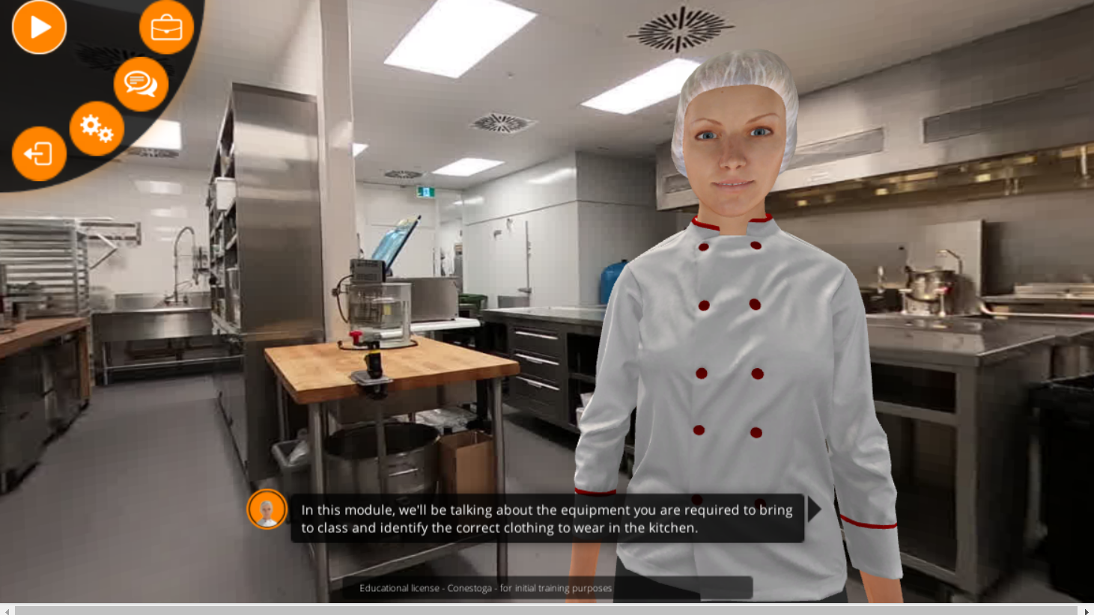

|  |
| --- |
| Summary |

|  |  |  |
| --- | --- | --- |
| Summary This short report will summarize my review of the Welcome to Bloom DLX (digital learning experience). Summarizing my findings and the problems that I ran while I was reviewing it.  Welcome To Bloom:  Welcome to Bloom is a digital learning experience that helps students in Conestoga's culinary programs get familiar with Bloom's kitchen. There are 13 modules in total, and in each module, there is a virtual teaching assistant avatar that guides the student through each module and will provide an overview and discuss the various stations, tools and operations.  A person in a kitchen with a chef's head  Description automatically generated  Modules:  Welcome To Bloom   * Module 1 – Bloom Orientation * Module 2 – Personal Equipment * Module 3 – Food Safety and Labelling * Module 4 – Basics of Sanitation * Module 5 – Small Appliances Part 1 * Module 6 – Small Appliances Part 2 * Module 7 – Small Appliances Part 3 * Module 8 – Garde Manger * Module 9 – Entremetier * Module 10 – Grill * Module 11 – Pastry * Module 12 – Expo * Module 13 – Kitchen Stewardship   Problems:   1. Text too small, there no option to adjust 2. When you select ‘view content in new window’ option, it restarts the lesson instead of continue where you are 3. In the parameters settings, the interface language, subtitles, sound options needs to be in a bigger size 4. There should be dedicated skip button instead of tedious clicking on the subtitle to get to certain parts of the lesson, the button should be there regardless if you have subtitles on or off 5. In Module 6 - Small Appliances Part 2, the video that is talking about the vacuum sealer, the audio has lip-syncing issue where the instructor mouth is not moving but you can hear them talking.   Problems   1. In Module 7- Small Appliances Part 3, where it talks about countertop mixers, the next button covers the last part of the word in the last sentence. 2. In the quiz, it should state how many questions are in the quiz. 3. There should be a dedicate back button in case you accidently press the wrong section. 4. There is glitch in Module 2,3,4,7,8,9,10,11,12,13 where if you a get a question correct, an error message pops up and prevents you from moving forward in the quiz. More Error pictures are listed on my confluence.   A screenshot of a computer error | | |
| Conclusion: I enjoyed the welcome to Bloom dlx; I enjoyed learning about the different parts of the kitchen and the various stations. I liked how the material was brief and to the point, and there were videos integrated into each module talking about the different equipment and tools you will use in the kitchen.  But there were a lot of problems that made it hard to enjoy the welcome to Bloom dlx, like the error message that prevented you from continuing the quiz, no option to make the text and buttons bigger, an accessibility issue, and many more can ruin the experiences.   I suggest having a green check mark after you finish the station you just learned about, and when you press to view the image in full screen, it should be a consistent size. Once these problems are sorted, the sim will be even better. | | |
|  |  |  |

Conclusion