|  |
| --- |
| Short Report: Search and Rescue (SAR) |

|  |
| --- |
| VAR Labs  Email: hnsheikh@conestogac.on.ca  Website: [VARLab Linkedin Page](https://www.linkedin.com/company/varlab-virtual-and-augmented-reality-lab/mycompany/) |

|  |  |
| --- | --- |
| Humza Sheikh, Project Assistant  Email: hnsheikh@conestogac.on.ca |  |



Contents

Summary 2

Search And Rescure (SAR)…………………….2-5

Problems And Suggestions 6

Conclusion: 7

|  |
| --- |
| Summary |

This short report will summarize my review of the Search and Rescue (SAR) internal developed simulator. Summarizing my findings and problems I encounter while reviewing it. SAR is only available as VR only Simulator.

## Search and Rescue (SAR):

The Search and rescue simulator prepares students to tackle a house fire and is tasked to save as many lives as possible in the safest and most efficient way. They are given a range of tools to use in the situation.

* Flashlight
* Halligan
* Speaker Module
* Control Module

# Search And Rescue (SAR)

# Search And Rescue (SAR)

There three modes:

* Student: To get started and practice
* Commander: I believe is like a final exam
* Tutorial: To get familiar with the controls

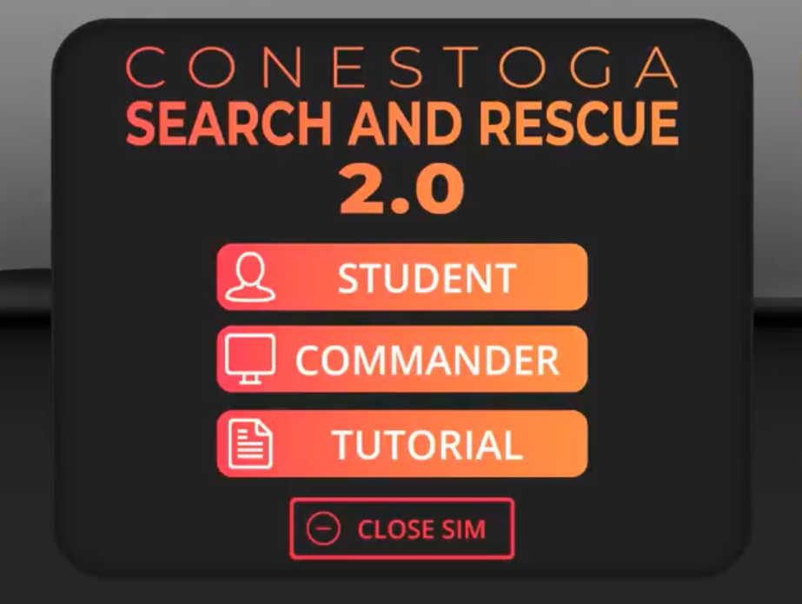

For my testing did both tutorial and student mode, when you select student mode you are present with two scenarios to choose from. After you chose one of the following scenarios there are two modes: Pre-made and Custom which are self-explanatory and then press start.

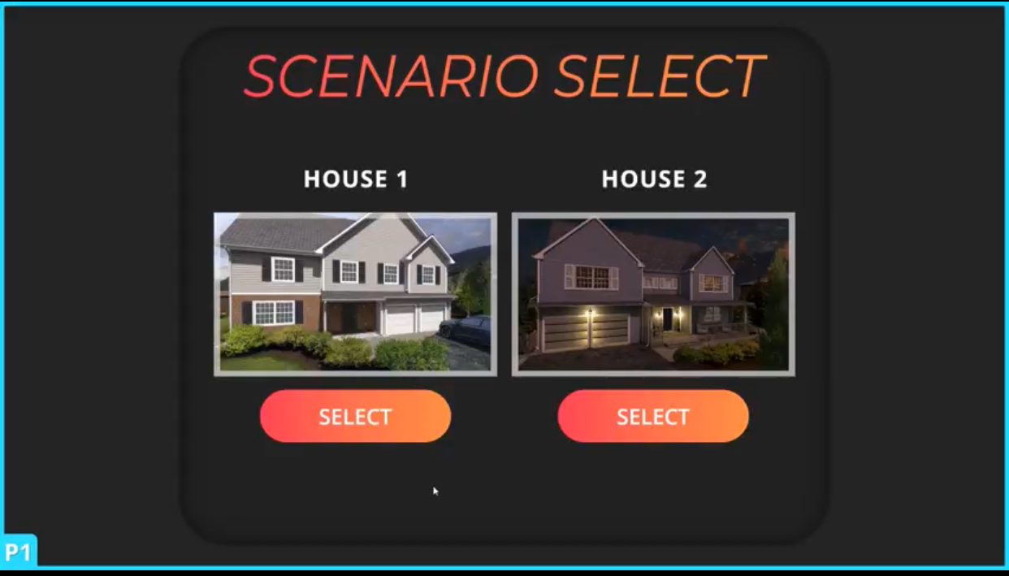

# Search And Rescue (SAR)

* There should be a status bar that tells you how many victims there are and how many of them need to be  saved

# Problems And Suggestions

* Long set up process
* Hardware issues with some of the stations
* Rip tear
* Details needs to be more accurate such as the fires should spread across area and not stay in one area and your oxygen tank should be depleted after carrying a large person
* Should not be able to carry four people at once
* Inaccurate count of number of victims in total and found
* I encounter a problem in multiplayer mode where I could not pick up any of the victims
* Most the information I have gather is from Jack
* Jack has tested and has more experience with this sim than I do if you have any question, please ask him
* Jack has reported the issues as well

Suggestions:

* Able to communicate to victims, for example: User should be able to yell, “Anybody need help” or “Follow me” or “Are you ok”.
* Guide the victim, example grab their hand and guide them to safety

# Conclusion:

The SAR is an impressive and immersive sim. I enjoy learning each of the tools and immersing myself in the sim. I felt like I was a firefighter trying to find the victims in this life-and-death situation. The controls were intuitive and easy to use. Some problems need to be addressed, such as the lengthy setup process, inaccurate count of the number of victims in total and found, and many more, which you can find under the problem section. I suggest that the developers implement features such as communicating with the victims, carrying them out or grabbing their hands, and guiding them to safety. Once the problems are ironed out and implementing new features, this sim has endless possibilities.