***Simple Layout for VR gaming market analysis***

1. **Introduction:**
   * Provide a brief overview of VR gaming.
   * State the purpose and objectives of the market analysis.

**HS: Introduction: Virtual reality, or VR, is one of the most popular and innovative technologies in the last decade. VR can be applied to multiple applications such as architecture and urban design, industrial design, etc. The most popular and well-known application is video games, has risen to the forefront, being one of the most recognizable applications to utilize VR technology significantly. We will be diving into the video game segment,**

* **Market Overview of the consumer side of the VR and more closely the gaming sector**
* **Market Sizes and growth**
* **Top 10 VR headset**
* **Top 10 VR Companies**
* **Top 10 VR Titles and most popular Title**
* **Best selling VR titles**
* **Market Trends and so much more**

**This analysis will help us understand the VR video game market; I will read articles, watch VR gaming videos, and try VR sims to help me understand the VR gaming landscape and use it to help me create the best market analysis.**

1. **Market Overview:**
   * Define the VR gaming market, including its scope (consumer VR gaming).
   * Highlight the significance and growth potential of the market.

**HS: VR gaming is experiencing a tremendous growth within the VR market space. In 2020 alone, the global VR market was valued between 17.25** (Phil, 2023) **in 19.44 billion U.S. dollars. Sources suggest that the market will sit to continue its expansion with the expectation to reach approximately $25.11 billion** (Virtual Reality [VR] Market Size, Growth, Share: Report, 2030, 2023)**. The primary sector that's been growing the VR industry is Gaming and entertainment sector. The gaming and entertainment holds a 24.6% market share in the U.S. Virtual Reality Market segment in 2022** (Virtual Reality [VR] Market Size, Growth, Share: Report, 2030, 2023)**. Companies like Meta have alone invested an eye watering $36 billion into the metaverse and VR business** (Dean, 2022) **is to give us an idea how much faith in the VR technology they have.**

**Global Virtual Reality Market Share, By Industry, 2022
** (Virtual Reality [VR] Market Size, Growth, Share: Report, 2030, 2023) (Pie Chart)

1. **Market Size and Growth:**
   * Present data on the current market size in terms of revenue or units sold.
   * Discuss historical growth trends and future growth projections.

**HS: The VR gaming market is, in 2022 alone, the global VR gaming market size attained a value of USD $27.25 billion** (Expert Market Reasearch , n.d.)**. According to the EMR website, it is estimated that the market will witness healthy growth in the forecast period of 2023-2028 to reach around USD 130.05 billion by 2028** (Expert Market Reasearch , n.d.)**.**

**There are a couple of factors why the market has grown because of: the rapid popularity of the VR gaming genre, more gaming consoles supporting VR like the Sony PlayStation 5, and more and more VR headsets flooding the market. I will touch more on that point later in the report. Big companies like Sony, Microsoft, Meta/Oculars, Valve significantly investing in research and development division in their VR/AR department. Sony announces to invest $2 billion into extended reality research by the end of March 2024** (Rees, 2023)**.**

**Fun Facts:**

* **Oculars/Meta Quest 2 is currently the best-selling VR headset, selling around 18 and more units. Generating around $7 billion in revenue.**
* **Beat Sauber is currently the best-selling VR game to date. Selling is around 4 million units and generating $255 USD in revenue by October 2022** (MKAI, 2023)

1. **Key Players:**
   * Identify and profile the top VR gaming companies or developers.
   * Mention their notable VR game titles and market influence.

Here is the top ten VR Game development Companies:

1. Valve Corporation: Valve is one of the well-known game and publisher in the gaming industry. Famous for the Half-Life, Portal, Left 4 dead, Team-Fortress 2 franchise that have made a huge and lasting impact in the gaming industry. Valve has been a well-know player in VR industry by investing heavily in the VR space, creating their own VR headset the index and at the same time collaborating with hp and HTC on their respective headsets. Valve also developed VR games including: The Lab, Aperture, Half-Life: Alyx, etc. (Vionix , 2023).
2. Oculus Studios: Is a division of Oculus a subsidiary of Meta (Facebook) and focuses on developing reality games, applications, and experiences for the Oculus Rift and Oculus Quest headsets (Vionix , 2023). Studio is responsible for developing games such as Jurassic World Aftermath, Lone Echoe 2, Marvel Powers United VR (Giant Bomb, n.d.). The Studio helps other developers and companies to bring their titles on Meta/Oculus platform.
3. Cloudhead Games: Is a Canadian based developer located in Vancouver, founded in 2012. Cloudhead Games has established a reputation for its focus on narrative-driven VR experiences that are both engaging and immersive (Vionix , 2023). The Gallery and Pistol Whip are one of many notable games that the company have develop. They use the unity engine for development their games.
4. ILMxLAB: Is studio founded in 2015 by the biggest visual companies in the business, Industrial Light & Magic (ILM). The studio is dedicated to creating visual stunning, immersive game with their famous Ip’s, Star Wars, Marvel and more, using the Unreal engine that allows them to create highly realistic environments and characters (Vionix , 2023). Vader Immortal: A Star Wars VR Series and Tales from the Galaxy’s Edge are most notable and successful titles from the studio.
5. Polyarc: Is a Seattle-based game development studio founded in 2015 by a team comprised of industry veterans work on icon titles like Halo, Destiny, and Red Dead Redemption (Vionix , 2023). Polyarc create groundbreaking player experiences (Polyarc, n.d.)and their main goal for VR is push the boundaries of what is possible in VR. By creating immersive and unique gameplay and story, using the least and greatness cutting edge technology. Moss was their debut VR title in 2018 and put the studio on the map, winning multiple rewards since its release (Vionix , 2023).
6. Survios: Another leading company that leading the way and has been the forefront in VR gaming development since the early days of VR gaming space back in 2013 (Vionix , 2023). Know for creating highly immersive and acclaimed games like Creed: Rise to Glory, The Walking Dead Onslaught, and many more. Have bought many awards to studio doorstep and in 2020, they hit one million units sold, you find at least 1 out 8 VR devices (Survious, 2022).
7. Archiact: Another VR development company based in Vancouver, Canada. Archiact has quickly made a name in the industry by creating high-quality, immersive games and experiences. The company is known for Evasion, Waddle Home, Doom 3: VR Edition (Archiact, n.d.) and have games cover a wide range of genres, from action-packed shooters to puzzle games and escape rooms (Vionix , 2023).
8. Schell Games: Founded in 2002, has made a made name for themselves by creating games with a strong focus on user experience. Their games are designed to be intuitive and engaging, with a focus on delivering an immersive experience for players. Among Us VR (Valve, n.d.), I expected You to Die are the most popular VR games by Schell Games. They have experience working with different headsets including Oculus Rift, HTC Vive, and PlayStation VR (Vionix , 2023).
9. Read at Dawn: Founded in 2003 and company has developed various games on various platforms such as PlayStation, Xbox, and Oculus. Their VR department have produced the critically acclaimed title Lone Echo and its sequel Lone Echo two r and was developed exclusively for Oculus Rift headsets. They use the unreal engine and motion capture and least technologies to create their games (Vionix , 2023).
10. Fast Travel Games: Swedish VR game development company founded in 2016 with a mission creating amazing VR experiences. Their committed using cutting-edge VR technologies and they offer vr gaming development services for businesses that are interest incorporate VR in their products or services. Popular title is Apex Construct, and their notable titles are Vampire: The Masquerade – Justice and Ghost Signal: A Stellaris Game.
11. **Popular VR Gaming Genre/ Games:**

The most popular gaming genres in no particular order, simulation, action/adventure, horror, rhythm games like beat saber (Braintekh, 2023). A new type of multiplayer interactive genre that is been emerging is VR chat, VR chat is online world where people interact with each other in virtually world.

From my experience I see a lot of players learn more towards simulation genre or VR chat. Take a look at the most popular VR games on steam (SteamDB, n.d.):

|  |  |  |  |  |
| --- | --- | --- | --- | --- |
| # | Name | Current | 24h Peak | All-Time Peak |
| 1. | War Thunder | 75,136 | 79,313 | 113,250 |
| 2. | Phasmophobia | 22,825 | 30,453 | 112,717 |
| 3. | VRChat | 18,294 | 23,922 | 46,814 |
| 4. | No Man’s Sky | 15,233 | 17,083 | 212,613 |
| 5. | Soundpad | 13,804 | 15,162 | 21,920 |
| 6. | Assetto Corsa | 11,504 | 13,186 | 17,513 |
| 7. | OBS Studio | 8,092 | 9,951 | 11,693 |
| 8. | Microsoft Flight Simulator | 6,445 | 6,920 | 61,829 |
| 9. | F1 23 | 4,798 | 5,952 | 13,302 |
| 10. | Fishing Planet | 3,870 | 4,050 | 6,709 |

*Be advised that list does change on a daily basis*

5 out of ten games are from the simulator genre. It really depends on player interest.

1. **Consumer Demographics:**
   * Analyze the target audience for VR gaming.
   * Provide data on age groups, gender, and geographic distribution of VR gamers.

HS: According to 99 Firms, of two big age demographic groups for VR is that are more likely to use and own virtual reality headset are users who are between the ages of 16-24 years old and 25-34 years old (Blagojević, 2023).

63% of user who own VR headsets are men while the other 37% of are women but for user who did not own headset the split even between men and women. Do expect that more are women are going buy VR headsets in time. The gender balance will change when the technology is more accessible and affordable able. The largest market for VR in general is North America and the fastest growing market is Aisa Pacific (Mordor Intelligence, n.d.).

**7.Competitive Analysis:**

* + Compare and contrast major VR gaming platforms or devices (headsets).
  + Evaluate the strengths and weaknesses of competing VR gaming companies.

I am going to compare the top 5 VR headsets that you can currently available to buy.

* + - 1. Oculus Quest 2 / Meta Quest 2

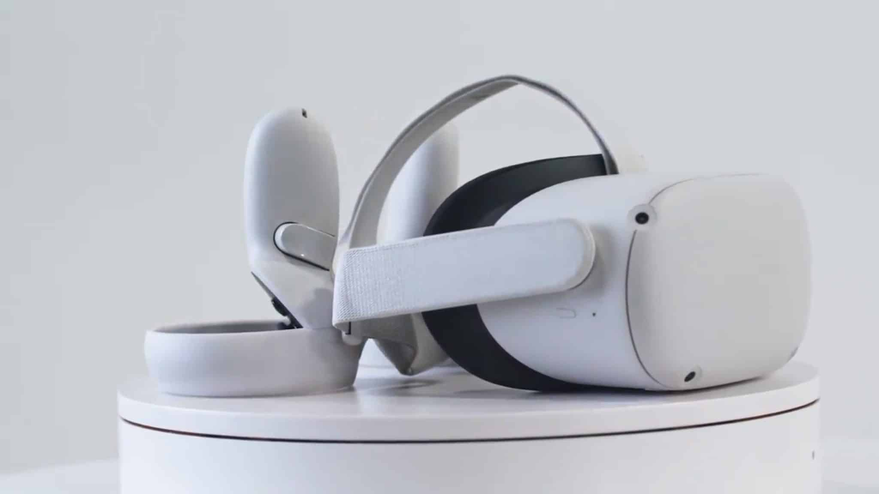

[This Photo](https://www.wired.it/gadget/accessori/2020/09/15/oculus-quest-2-visore-4k/) by Unknown Author is licensed under [CC BY-NC-ND](https://creativecommons.org/licenses/by-nc-nd/3.0/)

The Oculus quest 2 / Meta Quest 2 is one the best all-around VR headsets on the market because it is one the most accessible you can get for true VR experiences out of the box without spending an exorbitant amount of money. The quest two does not require you to own a PC or console; the user only needs a smartphone with the Quest app installed. Another benefit of the headset is its wireless, unlike its rivals like Sony PSVR2 and Valve Index, which is wired and could be challenging to manage the wires. The headset is back with an incredible backlog of titles, such as Half-life: Alyx, Resident Evil 4 VR, Beat Saber, SUPERHOT VR, and etc.

|  |  |
| --- | --- |
| Price | Spec |
| [$419.99 (128 GB)](https://www.bestbuy.ca/en-ca/product/meta-quest-2-128gb-vr-headset-with-touch-controllers/15490835?source=collection&adSlot=2), [$489.99 (256GB)](https://www.meta.com/ca/quest/products/quest-2/) | [Resolution: 1832 x 1920 (per eye) Field of View: 89 degrees Refresh: 90Hz](https://www.meta.com/ca/quest/products/quest-2/tech-specs/#tech-specs) |

## ***Pros:***

* Accessible, requires no PC or Console
* Easy to set up, require the quest app, headset is wireless.
* Affordable compared to its competitors (example: PlayStation VR2 requires the user to own PS5, combine cost of buying PS5 (Disc version) and VR2 is $1,581.98 before tax compared to the quest 2 with the biggest storage (256GB)

is $489.99

* Great library and you can also play your steam VR library.
* Comes with controllers and all you need to set up.

## ***Cons:***

* Requires a Facebook/Meta account.
* Poor head strap
* Can’t upgrade ram and storage.
  + - 1. Sony PlayStation VR2

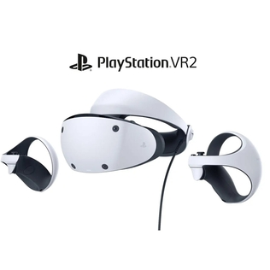

[This Photo](https://en.wikipedia.org/wiki/PlayStation_VR2) by Unknown Author is licensed under [CC BY-SA](https://creativecommons.org/licenses/by-sa/3.0/)

|  |  |
| --- | --- |
| Price | Spec |
| [PSVR2: $749.99,](https://www.bestbuy.ca/en-ca/product/playstation-vr2/16593426)  [PSVR2 Horizon Call of the Mountain VR Bundle: $819.99](https://www.bestbuy.ca/en-ca/product/playstation-vr2-horizon-call-of-the-mountain-vr-bundle/16593427) | [Resolution: 2000 x 2040 (per eye) Field of View: 110 degrees Refresh: 120Hz](https://www.techradar.com/news/the-best-vr-headset#section-the-best-headset-for-console) |

The sequel to the successful PlayStation VR, this model has better to high performance and visuals then it’s predecessor thanks to higher frame rates of up to 120fps and resolution of 2000x2040 (per eye). The vr2 setup is another bigger improvement thanks to one simple wire connecting to the console unlike its predecessor which was mess to set up thank’s to multiple wires. Horizon dawn V and gran turismo 7 show it VR2 true capabilities. Lack of killer titles, not backwards, compatible VRone library and requiring ps5 are some of the flaws of the head. The PSVR2 is the ultimate console VR accessory.

## ***Pros:***

* Great performance
* Exclusive Sony titles such as titles as Horizon Call of The Mountain, Gran Turismo 7
* Easy to setup compared to it’s predecessor
* Excellent controllers

## ***Cons:***

* Expensive
* Not back compatible of VR1 library
* Lack of killer titles
* Require PS5
  + - 1. Valve Index

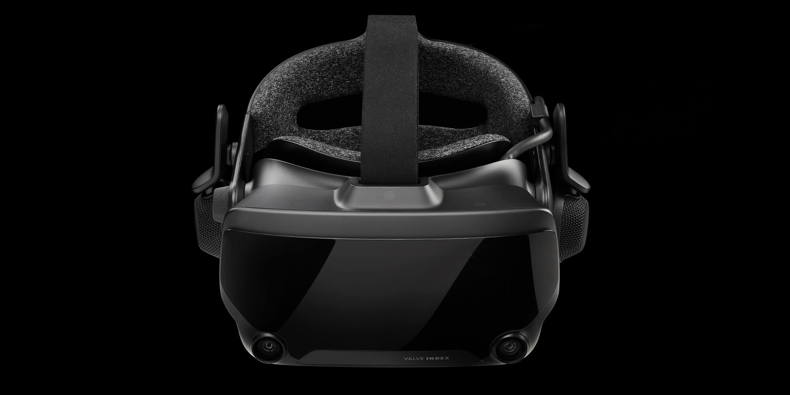

[This Photo](https://generacionxbox.com/valve-index-realidad-virtual-oficla-packs/) by Unknown Author is licensed under [CC BY](https://creativecommons.org/licenses/by/3.0/)

|  |  |
| --- | --- |
| Price | Spec |
| [Index headset: $659.00,](https://store.steampowered.com/sub/354231/) [Headset + Controllers,](https://store.steampowered.com/sub/354233/) [Index VR Kit: $1,319.00](https://store.steampowered.com/sub/354231/) | [Resolution:1440x1600 (per eye) Field of View: 130 degrees Refresh: 144Hz](https://www.techradar.com/news/the-best-vr-headset#section-the-best-headset-for-PC-gaming) |

Valve index is valve first successful headset in the VR headspace, one the best headset on the market. The while other headsets like PSVR2 and Pimax Crytal offer better resolutions than the index, index resolution of 1440x1600 (per eye) and up 144 fps (frames per second) is nothing to scoff at for headset that was released in 2016. Also, its controllers are quite impressive with it’s immersive figure-tracking and another great feature, it has great quality build in headphones and mic.

Index can leverage from the steam vr library and platform. Downside its too expensive and inconvenient wire connection.

***Pros:***

* Comfortable
* Great visuals
* Great Performance
* Immersive controllers
* Steam platform

## ***Cons:***

* Expensive
* Inconvenient wired connection
* No eye tracking
* Bulit quality

4.HP Reverb G2

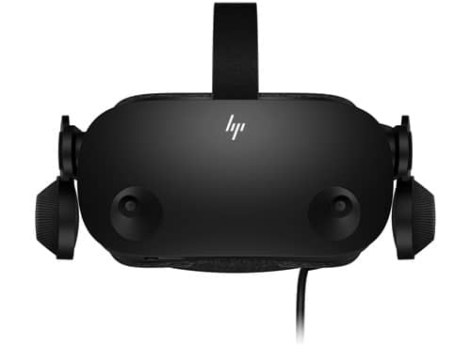

[This Photo](https://www.wikivirtualreality.com/es/comparacion-los-mejores-auriculares-de-realidad-virtual-2021) by Unknown Author is licensed under [CC BY-NC-ND](https://creativecommons.org/licenses/by-nc-nd/3.0/)

|  |  |
| --- | --- |
| Price | Spec |
| [HP Reverb G2 Virtual Reality Headset: $849.00](https://www.hp.com/ca-en/shop/product.aspx?id=1G5U1AA&opt=ABA&sel=ACC&utm_source=US_Store&utm_medium=referral&utm_campaign=canada_popup) | [Resolution: 2160 x 2160 (per eye) Field of View: 98degrees Refresh: 90Hz](https://www.techradar.com/news/the-best-vr-headset#section-the-best-headset-for-console) |

HP Reverb G2 is great middle ground between the high-end index and the low-end quest 2 headsets. The headset was developed by HP and Valve, so its compatible with Steam VR library, it has great performance and visuals for its price point. The G2 also share similar built in headphones and mic as the index but its also easier to set up compared to the index. Grab one if its on sale, rumor has it the G2 is going to be discounted.

***Pros:***

* Comfortable
* Great visuals
* Great Performance
* Immersive controllers
* Compatible with Steam VR

***Cons:***

* Motion tracking lacks precision
* Lacks figure tracking
* Tracking and FOV needs to be improved.

5.HTC Vive Pro 2

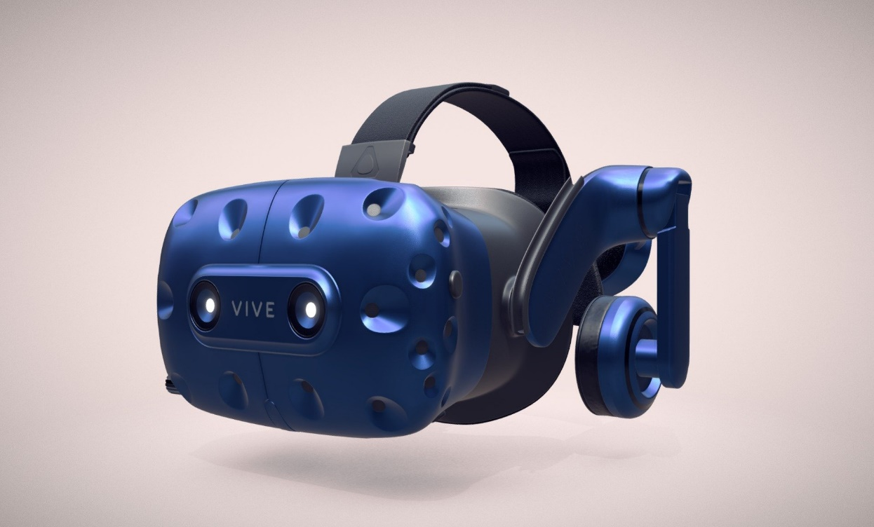

[This Photo](https://sketchfab.com/3d-models/htc-vive-pro-af619eda9b594ca280e35ca4ee1d3a3b) by Unknown Author is licensed under [CC BY](https://creativecommons.org/licenses/by/3.0/)

|  |  |
| --- | --- |
| Price | Spec |
| [VIVE Pro 2 Headset: $1,079.00,](https://www.vive.com/ca/product/vive-pro2/overview/) [VIVE Pro 2 Full Kit: $1,849.00](https://www.vive.com/ca/product/vive-pro2-full-kit/overview/) | [Resolution: 2448 x 2448 (per eye) Field of View: 120 degrees Refresh: 120Hz](https://www.techradar.com/news/the-best-vr-headset#section-the-best-headset-for-console) |

HTC Vive Pro 2 is the headset for ultimate VR enthusiasts and professionals with its incredible leading class resolution of 2448 x 2448 (5k per eye) and great 120 fps. HTC Vive pro 2 is compatible not alone with the steam vr library, its compatible with the index controllers and other accessories. While the resolution is great it comes at cost of cooling because of that 5k resolution also it does not help that this headset alone is incredibly expensive at $1,079.00. It’s the most expensive headset of the list, recommend for ultimate VR enthusiast.

***Pros:***

* Great visuals
* Great Performance
* Compatible with the index’s controllers and accessories
* Compatible with Steam VR library

***Cons:***

* Quite Expensive
* Cooling of the headset needs to be improved.
* Doesn't include necessary base stations or controllers.

1. **Market Trends:**
   1. Highlight current and emerging trends in VR gaming (e.g., new technologies, gaming experiences).
   2. Discuss the impact of VR hardware advancements on the market.

**HS: the current trend is to improves the hardware of the headset such as improving eye-tracking, motion-tracking, visuals, performance while at the same time make them lighter which will improve overall comfortable. Trying to make the headsets more accessible by trying to reduce the price (Full Scale, 2023, 1. Increased Focus on Accessibility, para. 5.).**

**Integrating AI and machine learning in games which will create more realistic and engaging virtual environments according to full scale (Full Scale, 2023, 5. The Future of VR Gaming, para. 2.) and developing of advanced haptic feedback and more cross-platform experiences (Full Scale, 2023, 5. The Future of VR Gaming, para. 3.).**

**The volume of VR headsets has increased in the past couple of years and this trend is expected to continue in the next 5 years. From 2023 to 2028 the volume will increase by 25.28% (~5.5M units)(Alsobs,2023, Volume of VR headsets worldwide 2018-2028, para.1.) . Remember the gaming sector is one of the primary drivers of VR industry Full Scale, 2023, 5. The Future of VR Gaming, para. 1.).**

1. **Consumer Preferences:**
   1. Explore what consumers look for in VR gaming experiences (graphics, gameplay, immersion).
   2. Include findings from user reviews and surveys if available.

HS: Users look for these key aspects when considering buy vr headset:

1. Graphics and framerate: high resolution to have realistic and immersive experiences and faster the refresh rates will make the VR feel more natural and smoother (Arango, 2023, Pros section, para.3.).
2. Library: Great library full of killer titles that will give the user immersion experiences complement with amazing gameplay and graphics. A catalogue of titles that show the capabilities of the headset.
3. Accessibility: a headset that is affordable and that is lighter that will help us overall comfortability, and reliability. These factors alone will help make it more accessible to the user.

Oculus ran a study on segmentation in the VR market. Seven groups they identify that relate to VR and the three out of seven groups are more relevant, the dedicated gamers, play to win gamers, steady gamers according to vrCave (Bromsgrove, 2021, The Home VR Market Section, para.2.). Here is the link [for the study](https://developer.oculus.com/blog/understanding-the-vr-gaming-market/) and another link to the [full report](https://scontent-ord5-2.xx.fbcdn.net/v/t39.2365-6/10000000_405379400874824_3513592104975627542_n.pdf?_nc_cat=100&ccb=1-7&_nc_sid=ad8a9d&_nc_ohc=rXvdXF4U4RgAX8W_xP0&_nc_ht=scontent-ord5-2.xx&oh=00_AfA8fOP3zXsVlzaUrg5hUX6G-WeqdapUgV86wxNdo8pC7Q&oe=653D5A8E).

1. **Market Opportunities and Challenges:**
   1. Identify growth opportunities in the VR gaming market (e.g., untapped demographics, new technologies).
   2. Discuss challenges such as hardware costs, motion sickness, or competition from traditional gaming platforms.

HS: The virtual reality market is not limited to gaming and entertainment; it is experiencing widespread adoption in various sectors, including healthcare, manufacturing, and more. This diversification is evident in the increasing use of VR technology across countries, including the USA, Canada, China, and beyond.

As technology evolves and becomes more affordable, barriers such as high pricing, motion sickness, and comfort issues are gradually being resolved. This trend is expected to lead to a substantial increase in the global adoption of VR technology.

The broader acceptance of VR in diverse industries and the ongoing efforts to enhance affordability and user comfort suggest a promising future for the VR market, with continued growth and innovation on the horizon.

1. **Conclusion:**
   1. Summarize key findings and insights.
   2. Provide recommendations or predictions for the future of VR gaming.

HS: In conclusion, VR gaming is one of the fastest and most profitable sectors of the VR market, thanks to the advancement of technology, the ever-growing consumer demand, and big companies like Meta, Sony, Valve, and many more. Making massive investments in the sector, creating successful headsets using cutting-edge technology that immerses the user in the environment, completing with excellent graphics, gameplay, and the ever-growing catalogue of titles. The trends toward affordability, comfort, and broader accessibility will continuously drive the industry forward.

I consider the valve index model and meta-model line because there is the most successful VR headset, and these headsets are usually brought up when someone talks about the best VR headset. The meta-model is probably the most accessible headset ever, not requiring a PC or console, and Index is an excellent headset if you want a much more powerful headset without breaking the bank.

VAR labs have plenty of experience with the Index and Steam by developing their learning simulators.

See the sales figures for the Meta Quest 2 alone, which is around 17 million units. The one vendor we should focus on is Steam; most VR headsets are compatible with Steam VR, and Steam is one of the most significant online vendors for games and VR and has a huge install base that we cannot ignore.

1. **References:**
   1. List all sources and references used in the analysis.

# References

(n.d.).

Alsop, T. (2023, August 8). *Volume of VR headsets worldwide 2018-2028*. Retrieved from Statista: https://www.statista.com/forecasts/1331896/vr-headset-sales-volume-worldwide

Archiact. (n.d.). *Blazing The Trail of Virtual Reality*. Retrieved from Archiact: https://www.archiact.com/about

Armstrong, M. (2023, February 28). *Meta Leads the Way in VR Headsets*. Retrieved from statista: https://www.statista.com/chart/29398/vr-headset-kpis/#:~:text=The%20Californian%20company's%20investments%20are,from%20Statista%20Company%20Insights%20shows.

Blagojević, I. (2023, May 19). *Virtual Reality Statistics*. Retrieved from 99 Firms : https://99firms.com/blog/virtual-reality-statistics/#gref

Braintekh. (2023, February 15). *The 10 Most Popular VR Gaming Genres in 2023*. Retrieved from Braintekh: https://braintekh.com/blog%2Fnews/f/the-10-most-popular-vr-gaming-genres

Bromsgrove, R. (2021, September 22). *Here's What VR Customers Are Looking For*. Retrieved from vrCave: https://blog.vrcave.ca/blog/heres-what-vr-customers-are-looking-for

Dean, G. (2022, October 29). *Meta has pumped $36 billion into its metaverse and VR businesses since 2019. These 4 charts show the scale of its extreme spending — and huge losses.* Retrieved from Insider: https://www.businessinsider.com/charts-meta-metaverse-spending-losses-reality-labs-vr-mark-zuckerberg-2022-10#:~:text=Meta%20has%20pumped%20%2436%20billion,extreme%20spending%20%E2%80%94%20and%20huge%20losses.&text=Meta%20has%20pumped%20%2436%20billion%20

Expert Market Reasearch . (n.d.). *Global Virtual Reality Gaming Market*. Retrieved from Expert Market Reasearch : https://www.expertmarketresearch.com/reports/virtual-reality-gaming-market#:~:text=The%20global%20virtual%20reality%20gaming,USD%20130.05%20billion%20by%202028.

Full Scale. (2023, May 18). *Full Scale*. Retrieved from 2023 Virtual Reality Development Trends, The Future is Now: https://fullscale.io/blog/virtual-reality-development-trends-2023/#:~:text=Some%20of%20these%20hardware%20improvements,%2Dcomputer%20interfaces%20(BCIs).

Giant Bomb. (n.d.). *Oculus Studios Published Games*. Retrieved from Giant Bomb: https://www.giantbomb.com/oculus-studios/3010-11718/published/

Lutkevich, B. (2023, January ). *virtual reality gaming (VR gaming)*. Retrieved from TechTarget: https://www.techtarget.com/whatis/definition/virtual-reality-gaming-VR-gaming

MKAI. (2023, April 15). *Report: Beat Saber Reached $255 Million In Revenue*. Retrieved from MKIA: https://mkai.org/report-beat-saber-reached-255-million-in-revenue/#:~:text=One%20of%20VR's%20flagship%20games,platform%20alone%20the%20following%20October.

Mordor Intelligence. (n.d.). *Mordor Intelligence*. Retrieved from VR MARKET SIZE & SHARE ANALYSIS - GROWTH TRENDS & FORECASTS (2023 - 2028): https://www.mordorintelligence.com/industry-reports/virtual-reality-market

Phil. (2023, July 2). *What Is The Future Of VR? 2023 Edition*. Retrieved from Draw & Code: https://drawandcode.com/learning-zone/what-is-the-future-of-vr/#:~:text=Consumer%20Adoption,for%20VR%20products%20and%20experiences.

Polyarc. (n.d.). *Our Studio*. Retrieved from Polyarc: https://www.polyarcgames.com/about/studio

Rees, L. (2023, July 13). *Sony to invest $2 billion into extended reality research*. Retrieved from Pocket Gamer: https://www.pocketgamer.biz/news/81972/sony-to-invest-2-billion-into-extended-reality-research/

SteamDB. (n.d.). *Most Played VR Games*. Retrieved from SteamDB: https://steamdb.info/charts/?tagid=21978

Survious. (2022, January 5). *Learn More About Our Company*. Retrieved from Survious : https://survios.com/studio/company/

*The global virtual reality market size was valued at $19.44 billion in 2022 & is projected to grow from $25.11 billion in 2023 to $165.91 billion by 2030... Read More at:- https://www.fortunebusinessinsights.com/industry-reports/virtual-reality-market-10*. (n.d.).

Valve. (n.d.). *Among Us VR*. Retrieved from Steam: https://store.steampowered.com/app/1849900/Among_Us_VR/

Vionix . (2023, May 19). *Top 10 VR game development companies in 2023*. Retrieved from Vionix : https://vionixstudio.com/2023/05/05/top-10-vr-game-development-companies-in-2023/#Valve_Corporation

*Virtual Reality [VR] Market Size, Growth, Share: Report, 2030*. (2023, June). Retrieved from Forture Business Insights: https://www.fortunebusinessinsights.com/industry-reports/virtual-reality-market-101378