Dataverse Bootcamp for M365 Makers
Lab Manual
Author: Wes Preston
Contacting Wes:
- Via blog: http://www.idubbs.com/blog/
- Via Twitter: Follow @idubbs
- wes@trecstone.com

Note:
Users can set up a trial M365 account and Power Apps Developer license to create an environment where the following activities can be completed.
The “Environment Setup” document in the downloads location walks through steps to set up the tenant and license.

Contents
Create a Table 2
Create a Model-driven app (single table) 8
Create a Table from a SharePoint List 12
Create a list in SharePoint 12
Create a Dataverse table from the list 12
Add a Relationship 16
Update a Model-driven app form 20

Create a Table
Create a table manually.
- Navigate to the Power Apps environment. https://powerapps.microsoft.com
- Select the developer environment
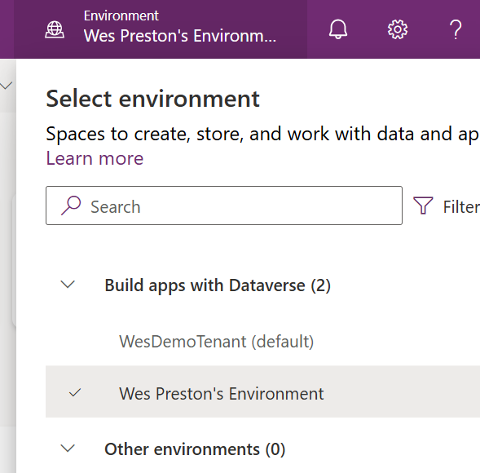
Note: If the environment name doesn’t indicate which environment in the list is the Developer environment, you can go to the Power Apps Admin center to see details:
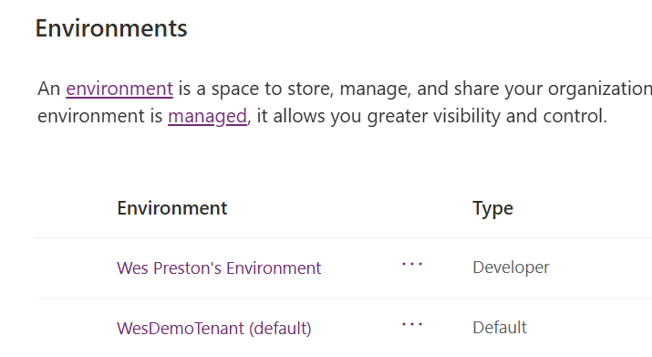
- In the Power Apps Select Tables and filter the list to “Custom” tables.
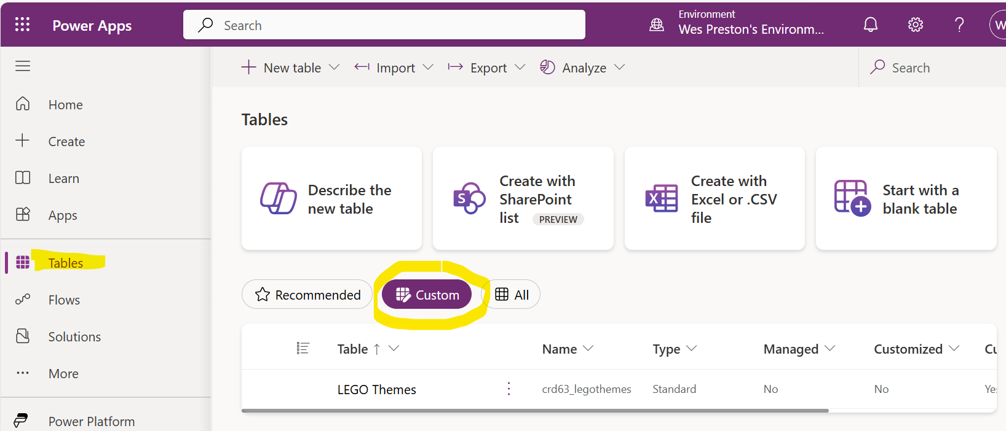
- Select New table, then Table (advanced properties)
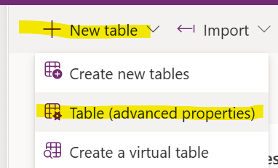
- New table panel opens:
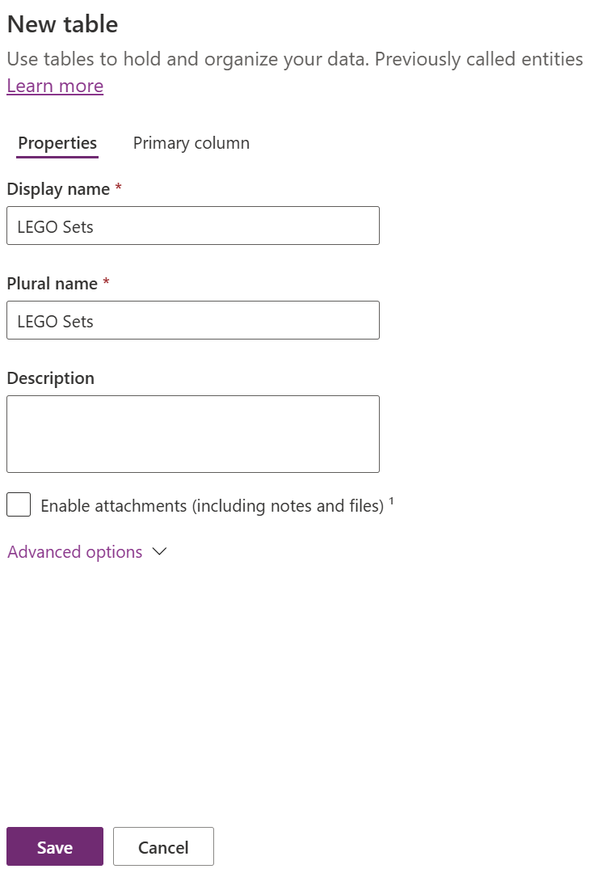
- Set Display name and Plural name to:
“LEGO Sets”.
- Click “Primary column”.
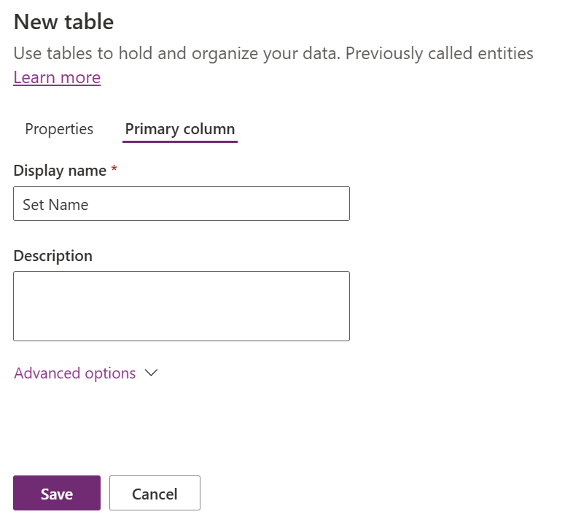
- Change Display name to “Set Name”.
- Click “Save”.
- Add another column to the table.
Select “New” and “Column”
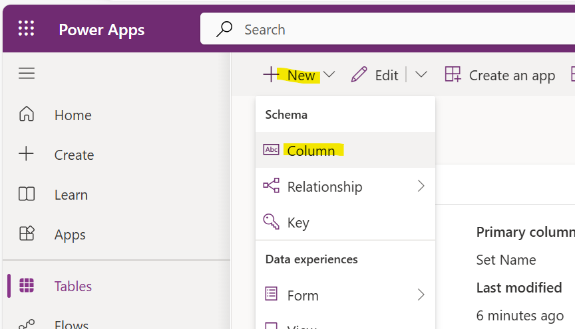
- Complete the new column details:
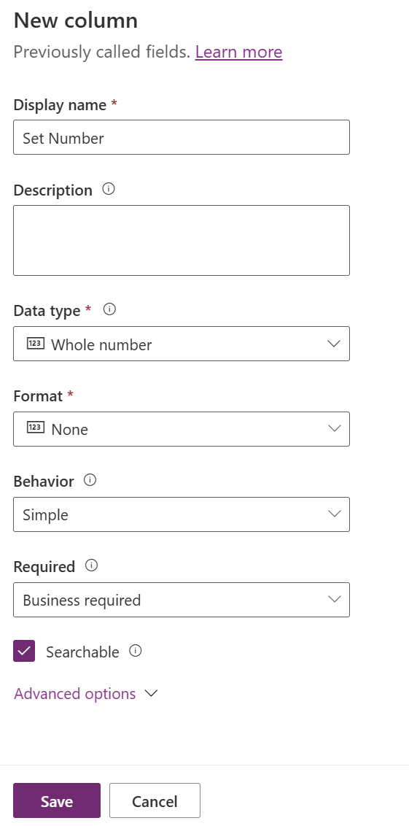
- Click “Save”.
- Add a few records of data
NOTE: The LEGO Sets field does not need to be displayed. It’s the table ID column we won’t be setting manually.
Click “Edit”.
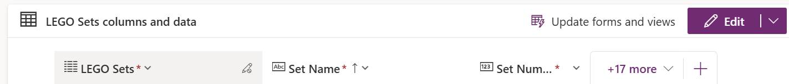
- In the grid view, add a few records by adding Set Name and Set Numbers
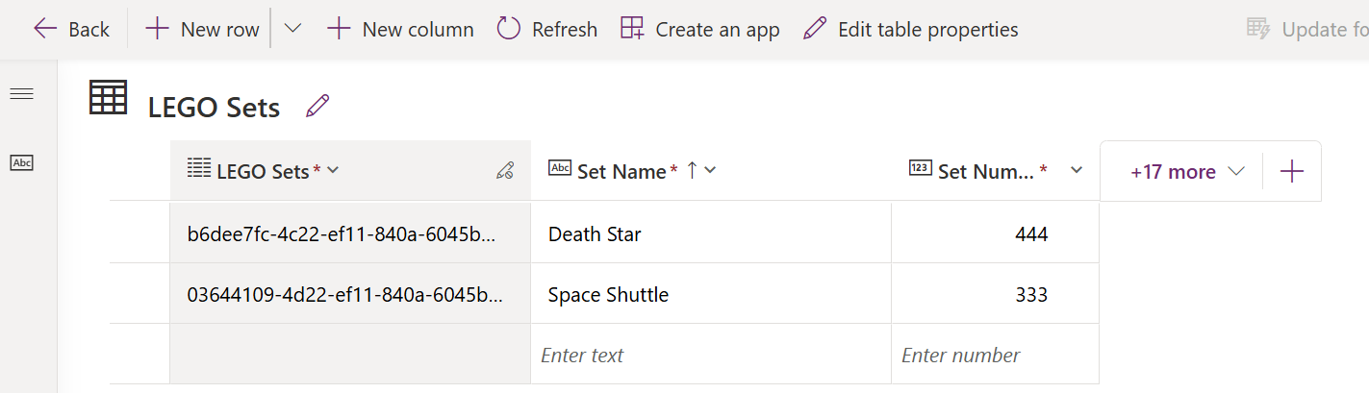

- Click “Back” when done.

Create a Model-driven app (single table)
Create a canvas app connected to the table
- Open the new LEGO Sets table.
- In the Power Apps environment, select “Create”
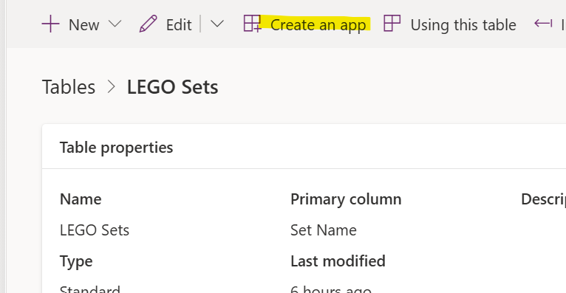
- Give the app a name and click Create
Note: For most, the next steps are optional. The wizard should have already created a LEGO Sets page.
- Click “Add page”
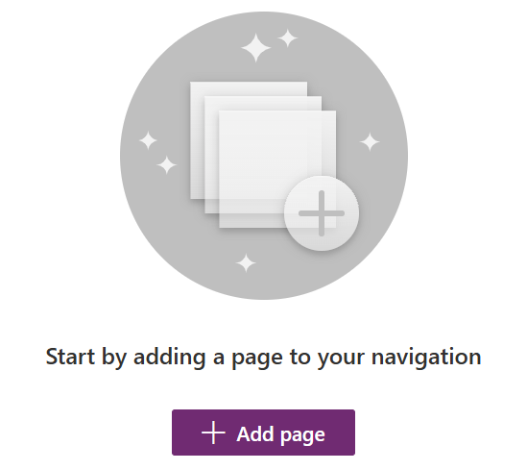
- Select “Dataverse table”.
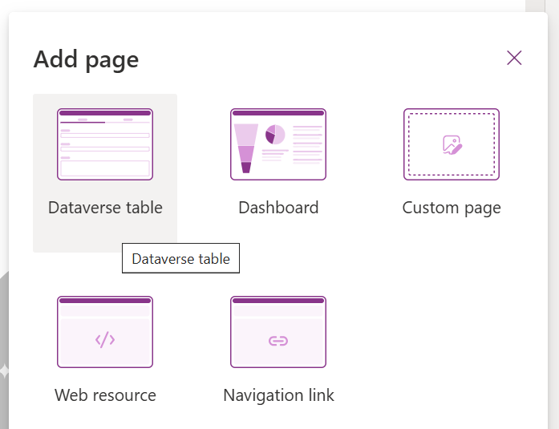
- Select the search icon
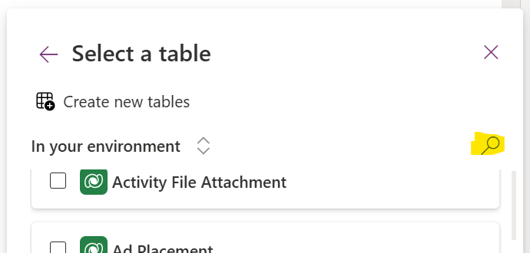
- Enter a search term for your table (“LEGO”)
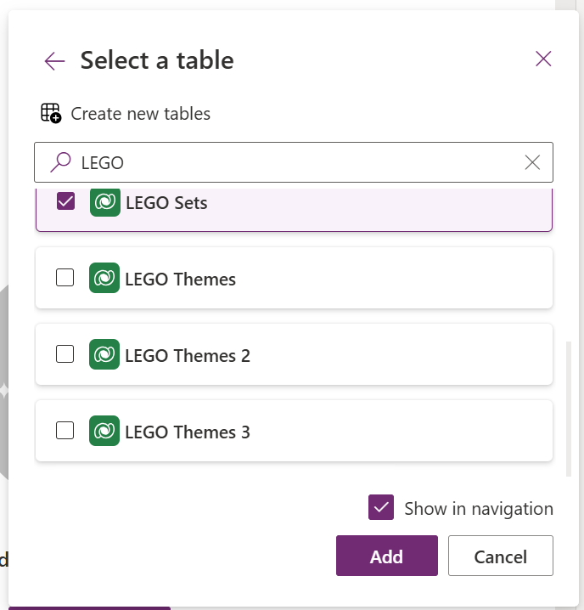
- Select the “LEGO Sets” table and click “Add”.
- Click “Save”.
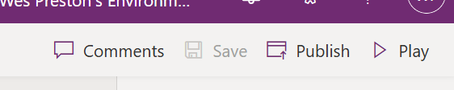
- Click “Publish”

- Click “Play” to explore the app.

Create a Table from a SharePoint List

Create a list in SharePoint
Note: Assumption here that anyone attending the session is already familiar with creating a list.
- In the trial tenant, navigate to a SharePoint site.
- Create a new list called “LEGO Themes”.
- Add a Description multi-line text column.
- Add several records.

Create a Dataverse table from the list
Note: This new capability is still in Preview mode.
- Navigate to the Power Apps environment. https://powerapps.microsoft.com
- Verify you are in the developer environment.
- In Power Apps Select Tables and filter the list to “Custom” tables.
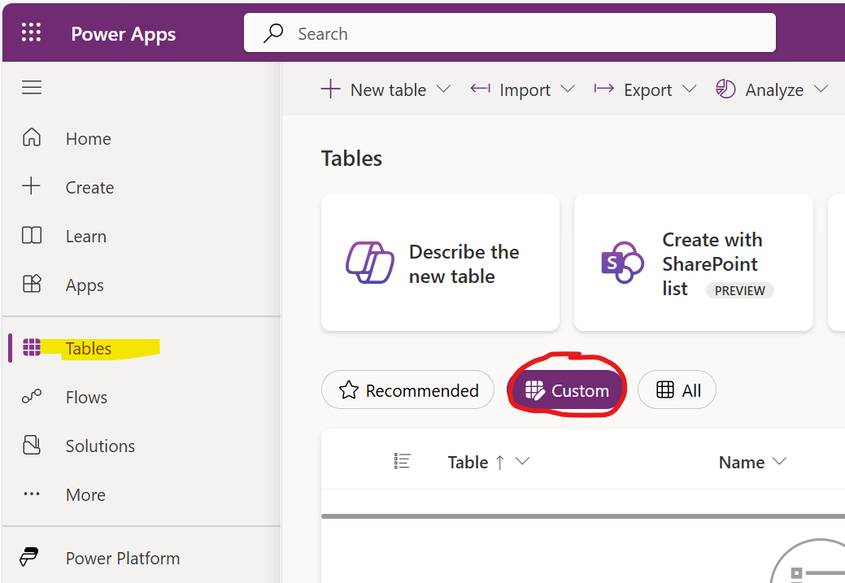
- Select New table and then Create new tables.
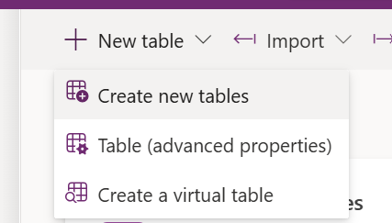
- Select “Import a SharePoint list”.
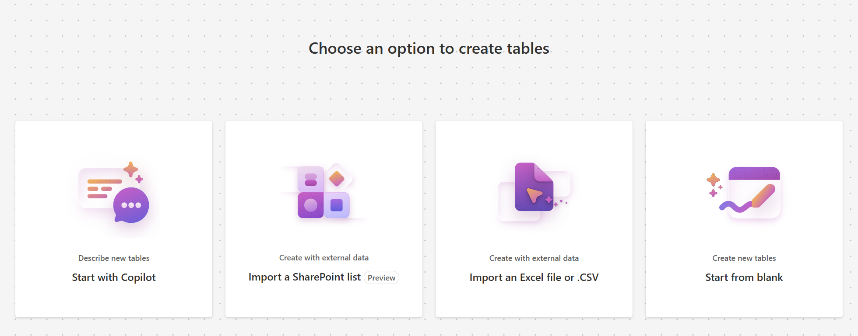
- You may need to wait a few seconds for the connections and sites to populate.
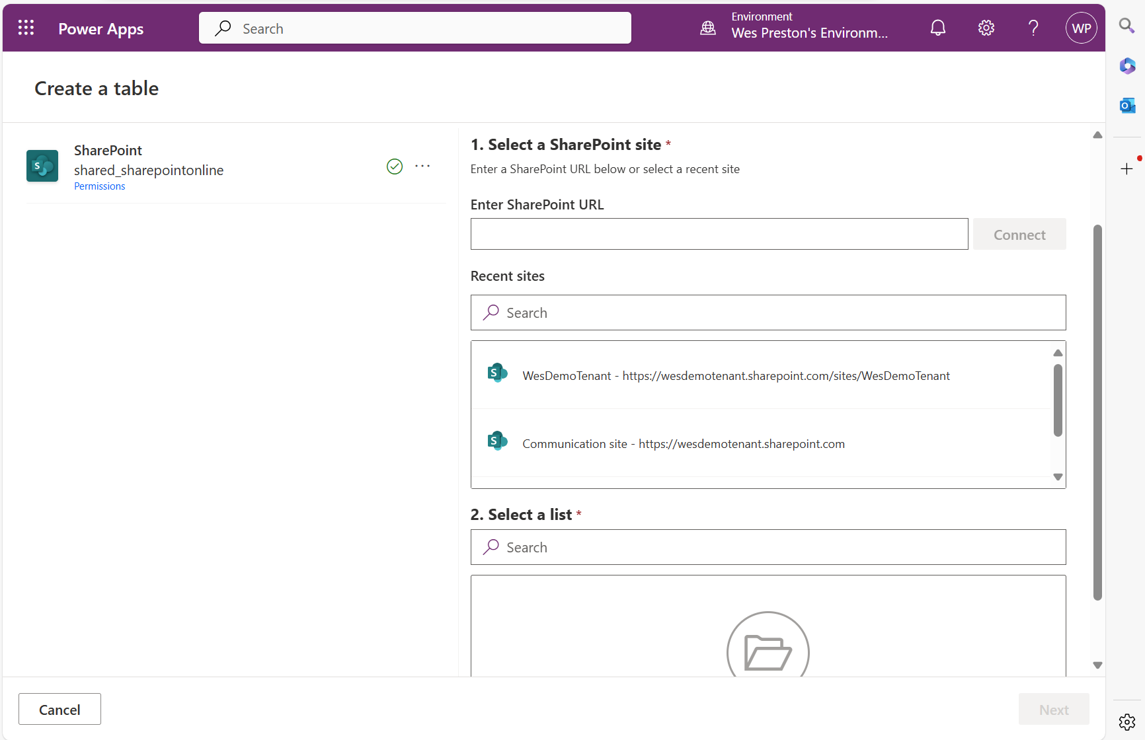
- Select the site where you created the SharePoint list.
If the site is not listed, enter the URL for the site.
- Select the “LEGO Themes” list.
- Select “Import”
The list may take a few seconds to import and update the page
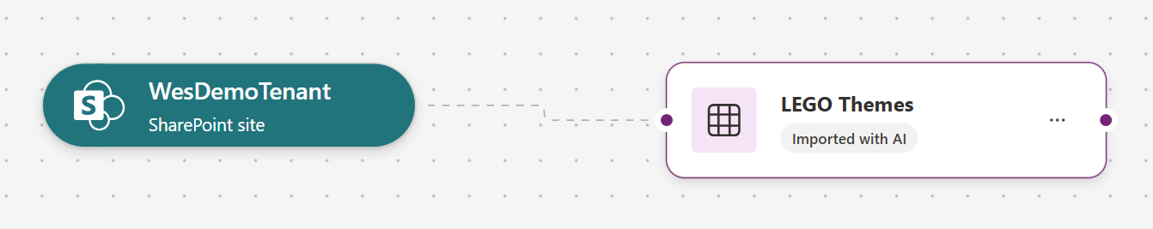
The “LEGO Themes” table should have been created with any content you previously populated in the list.
- Select View data and Properties to see what was imported.
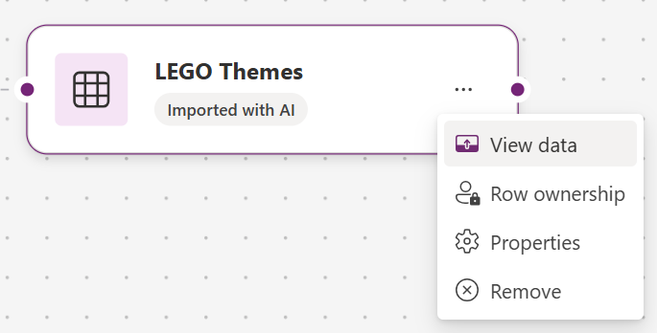
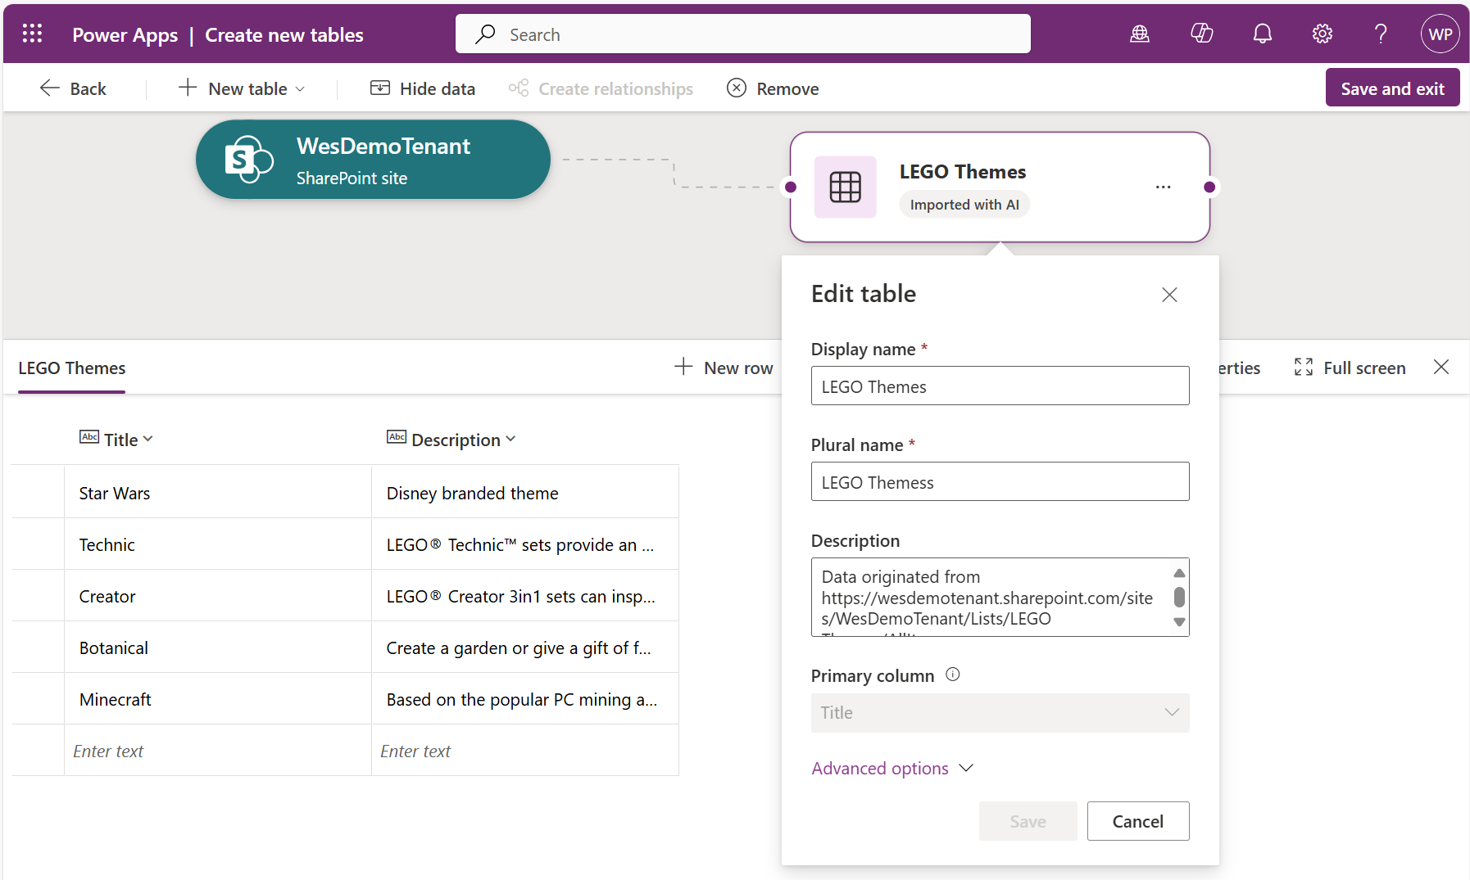

- Update any fields as necessary.
(I changed the plural name from “Themess” to “Themes”.)
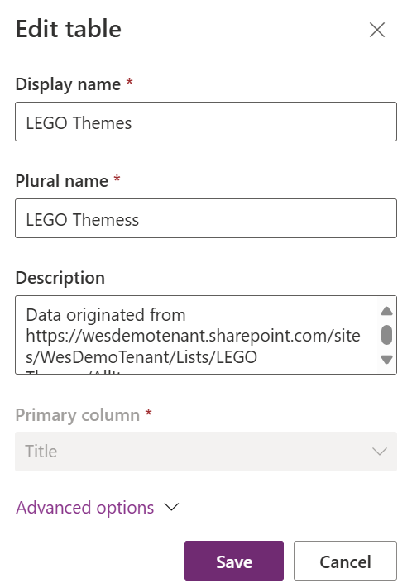
- Click Save.
- Click Save and Exit.

Add a Relationship
Between the LEGO table and the Themes (list) table
- In Power Apps, select the Tables in the left navigation. Filter to “Custom”.
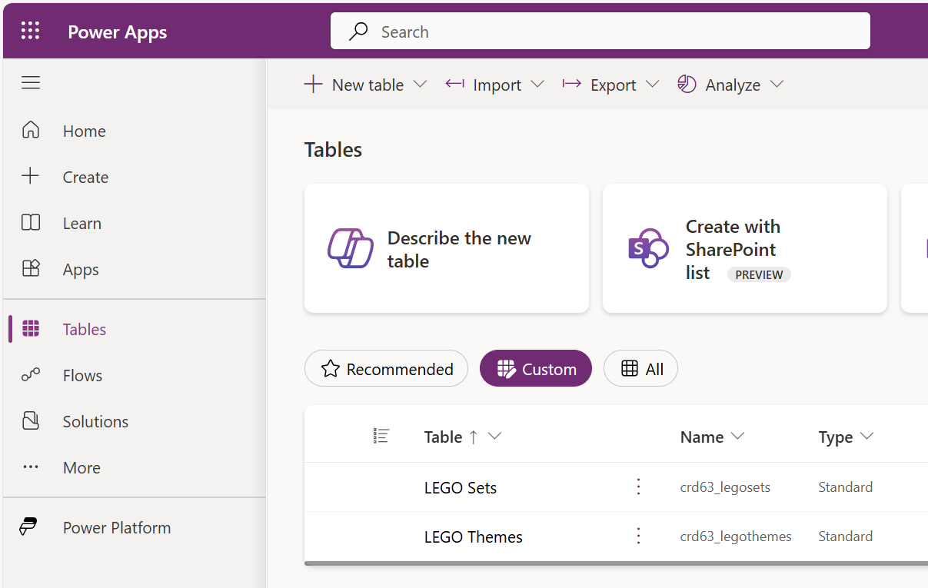
- Click on “LEGO Sets”.
- Click “Relationships”.
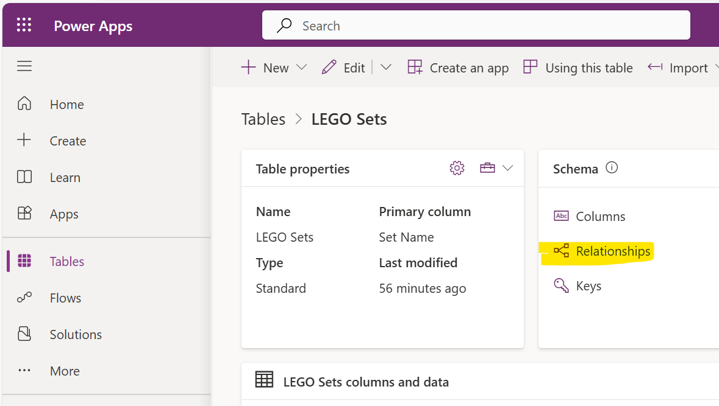
- In the Relationships page, select “New relationship” and “Many-to-one”.
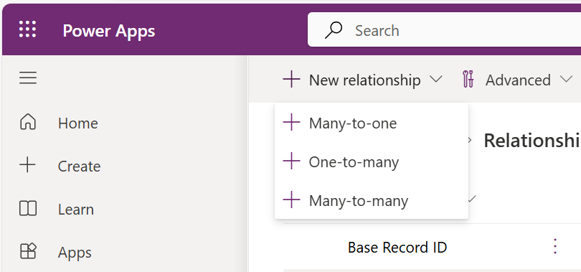
- In the “Related” dropdown, select the “LEGO Themes” table.
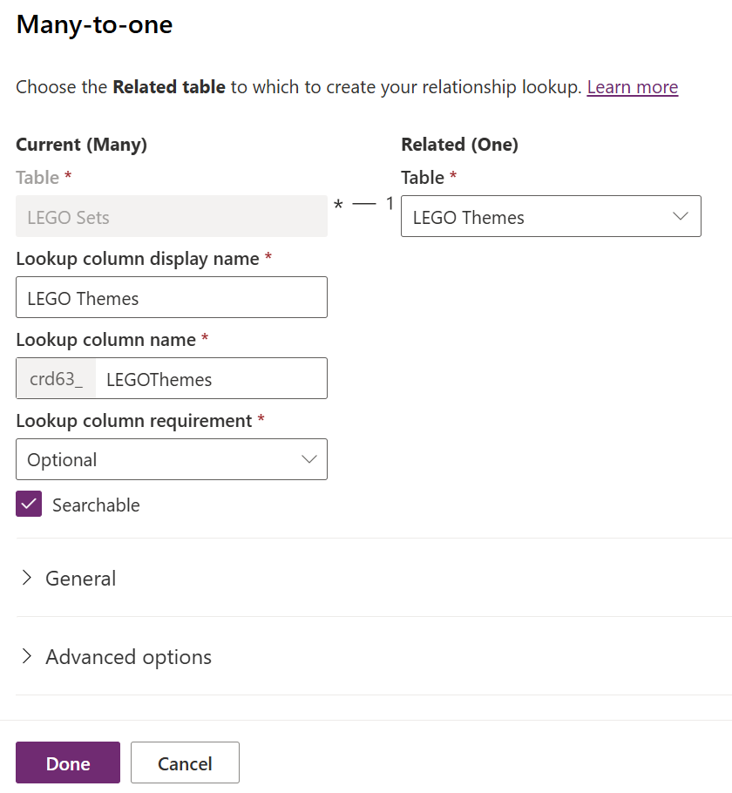
- Click “Done”.
- In Power Apps, select the Tables in the left navigation. Filter to “Custom”.
- Select “LEGO Sets”.
- Add the “LEGO Themes” column to the view.
Select the dropdown of existing columns and select “LEGO Themes”.
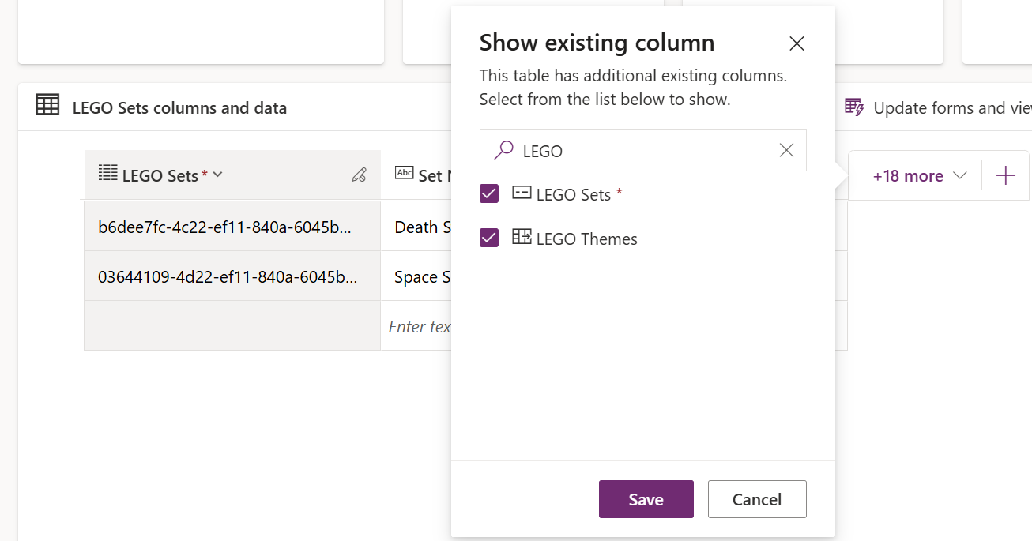
- Click “Save”.
- Click “Edit” to update existing records to add LEGO Theme values.
- In the “LEGO Themes” fields, start typing a theme to get options to select
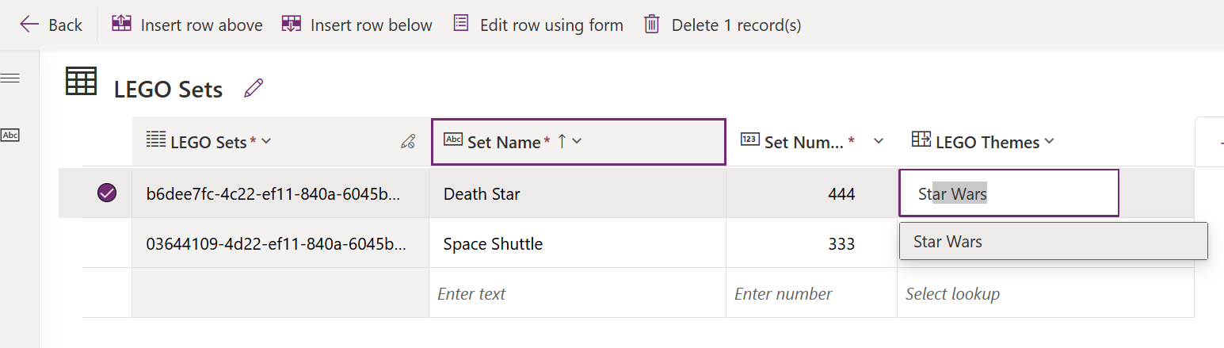

Update a Model-driven app form
Show the new relationship data in the existing app.
- In Power Apps, select the Tables in the left navigation. Filter to “Custom”.
- Select the “LEGO Sets” table.
- In the “Data Experiences” section, select “Forms”.
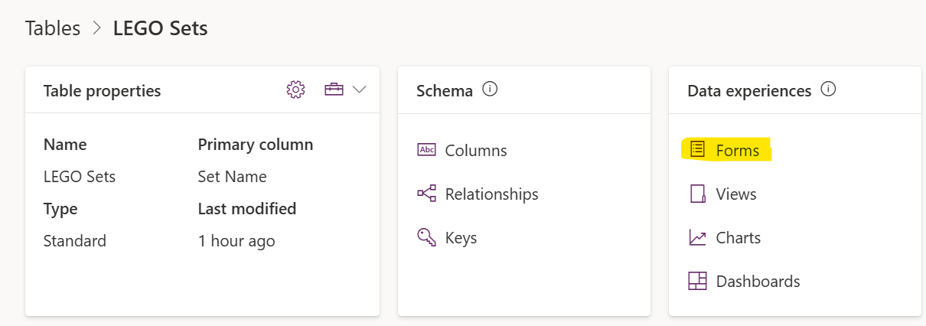
- Select the “Main” form and click “Edit”.
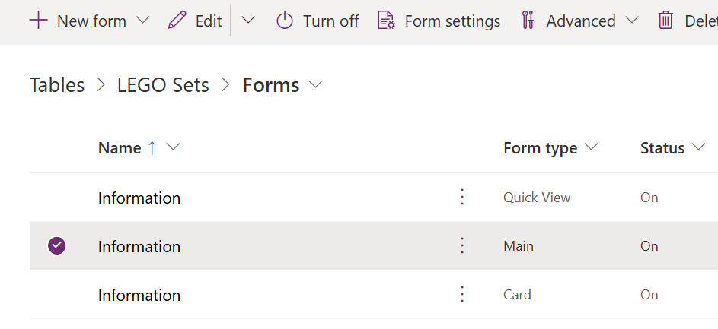
- On the form page, select the “LEGO Theme” field from the left column to add it to the form.
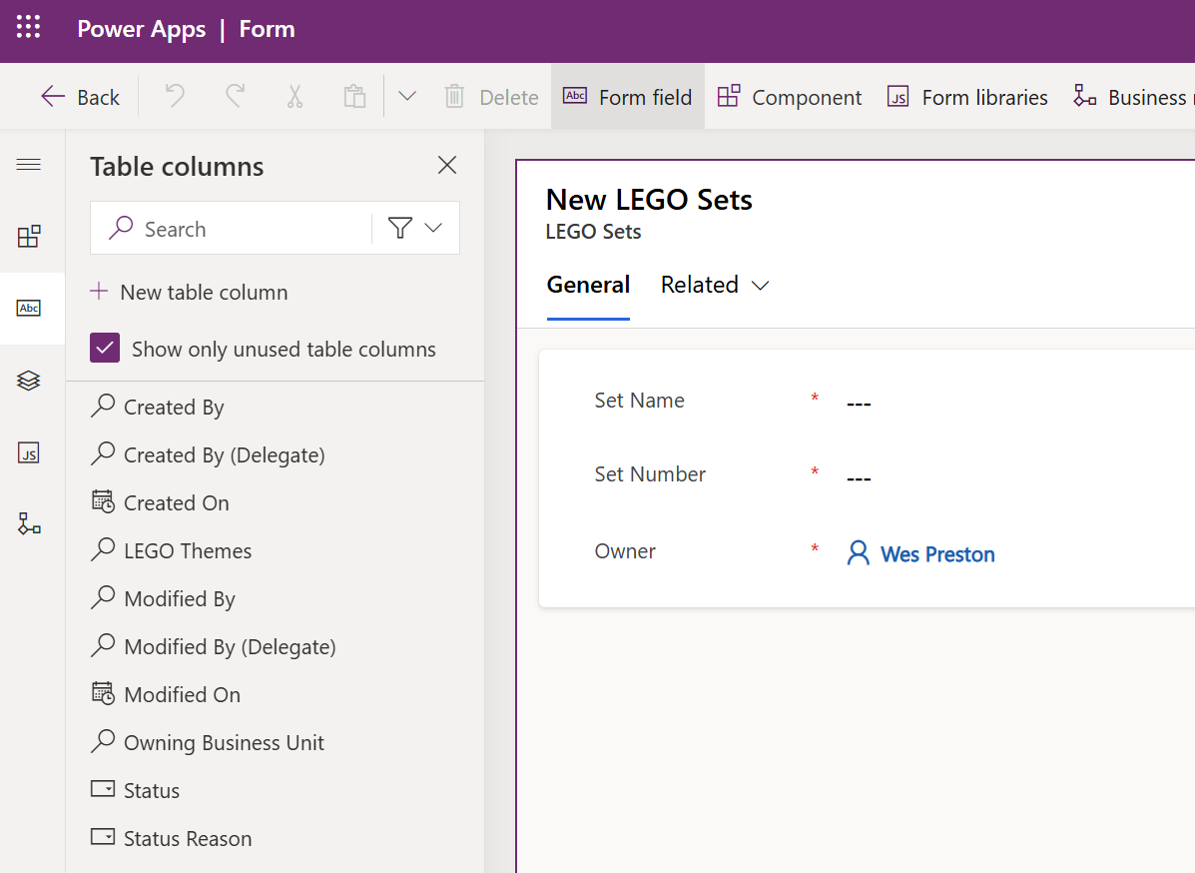
- In the form display, drag the LEGO Theme field up, above the Owner field.
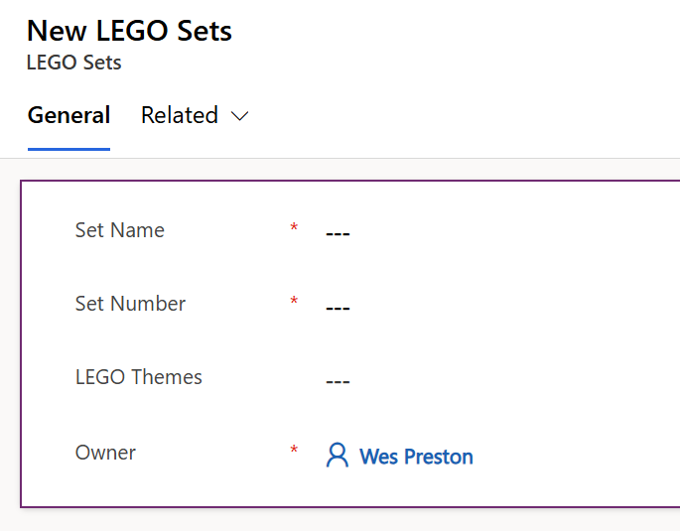
- Click “Save and Publish”.
- Click “Back”.
- In the left navigation, select “Apps”.
- In the apps listing, select your Model-driven app (“1 Table Model Driven”) and click the “Play” icon to test it.

