1. 目标与范围
2. 前置条件
3. 目录与路由
4. 接口约定（前端侧）
- 4.1 产品族 API
- 4.2 产品 API（latest=true 查询）
5.页面开发步骤（产品族）
- 5.1 JS 的API调用
- 5.2 查询区
- 5.3 表格与分页
- 5.4 新增/修改弹窗
- 5.5 JS方法区
6.页面开发步骤（产品：含生命周期与检入/检出）
- 6.1 JS的API调用
- 6.2 查询区
- 6.3 表格与分页
- 6.4 新增/修改弹窗包含生命周期创建联动区
- 6.5 检出/检入/更新生命周期状态的弹窗
- 6.6 附件上传与校验（单文件）
- 6.7 生命周期（核心）——新增页（create 流程）
- 6.8 生命周期（核心）——检出/检入弹窗
- 6.9 生命周期（核心）——更新状态（edit 流程）
- 6.10 JS方法区
- 6.11 CSS样式渲染区
7. 关键 UI/交互规范
8. 运行与联调
9. 测试用例
- 9.1 产品族
- 9.2 产品（生命周期）
10. 常见问题排查（Troubleshooting）
11. 验收标准

1. 目标与范围
- 完成“产品族管理、产品管理”两个业务模块的页面开发、联调与测试。
- 重点掌握生命周期管理：模板选择、业务操作（create/edit）、目标状态获取、检出/检入与状态更新全链路前端实现。
- 实现附件上传（单文件，白名单与 5MB 校验）、下载链接拼装、批量删除保护等细节。

2. 前置条件
- Node.js 18+，npm/yarn/pnpm 任一包管理器；Vite + Vue3 + Element Plus。
- 已配置 axios 拦截器与后端网关 /manufacture/**；能携带 token。
- 后端模块已启用 lifecycle、productfamily、product 相关接口；可从 Postman 验证 200。

3. 目录与路由
建议目录：
src/views/manufacture/productfamily/index.vue
src/views/manufacture/product/index.vue
src/api/manufacture/productfamily.js
src/api/manufacture/product.js
路由菜单：制造管理/产品族管理、制造管理/产品管理。
运行前后端代码，在菜单管理中添加产品族管理和产品管理的路由的组件路径：
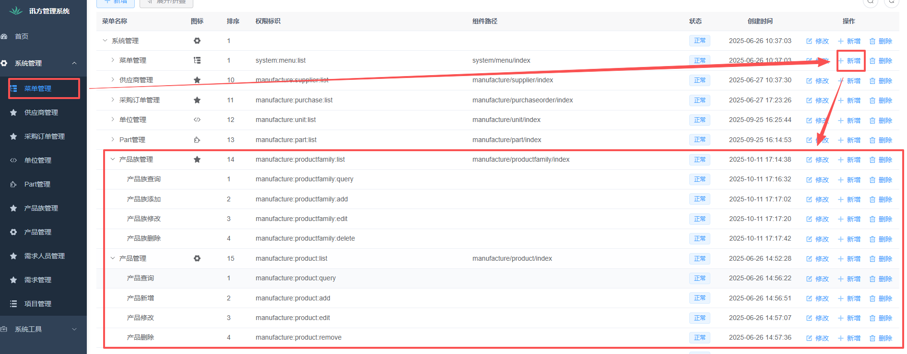
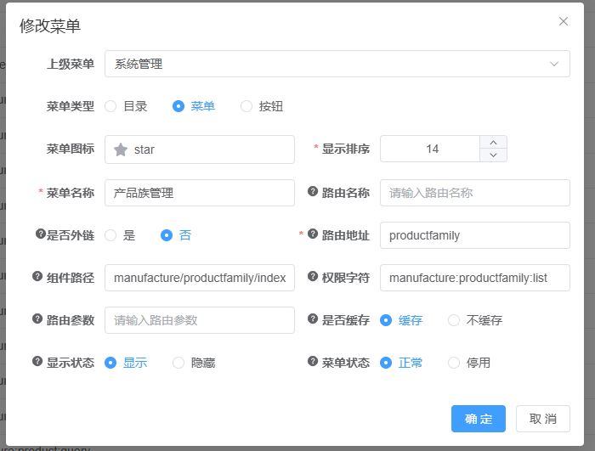
在 views/manufacture/productfamily/index.vue 下编写代码（若没有则自行创建）；运行前端代码后，在菜单中配置到该路由，确保可访问。
新建单位管理主页面文件
在代码包的目录文件夹src\views\manufacture下新建productfamily文件夹：
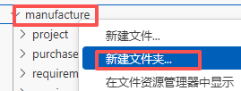
接着在productfamily文件夹下创建index.vue文件
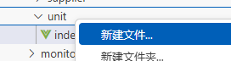
在index.vue文件中编写基本框架：
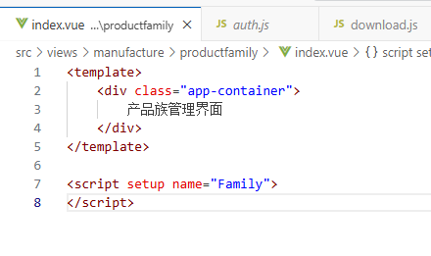
接着在src\api\manufacture\productfamily.js新建路由文件：
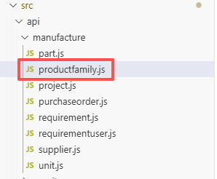
此时新建终端，运行代码：
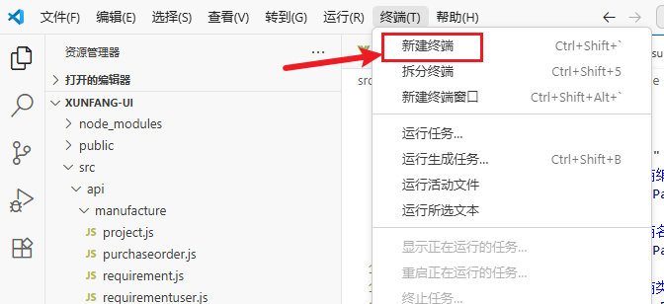
并在菜单中添加按钮：
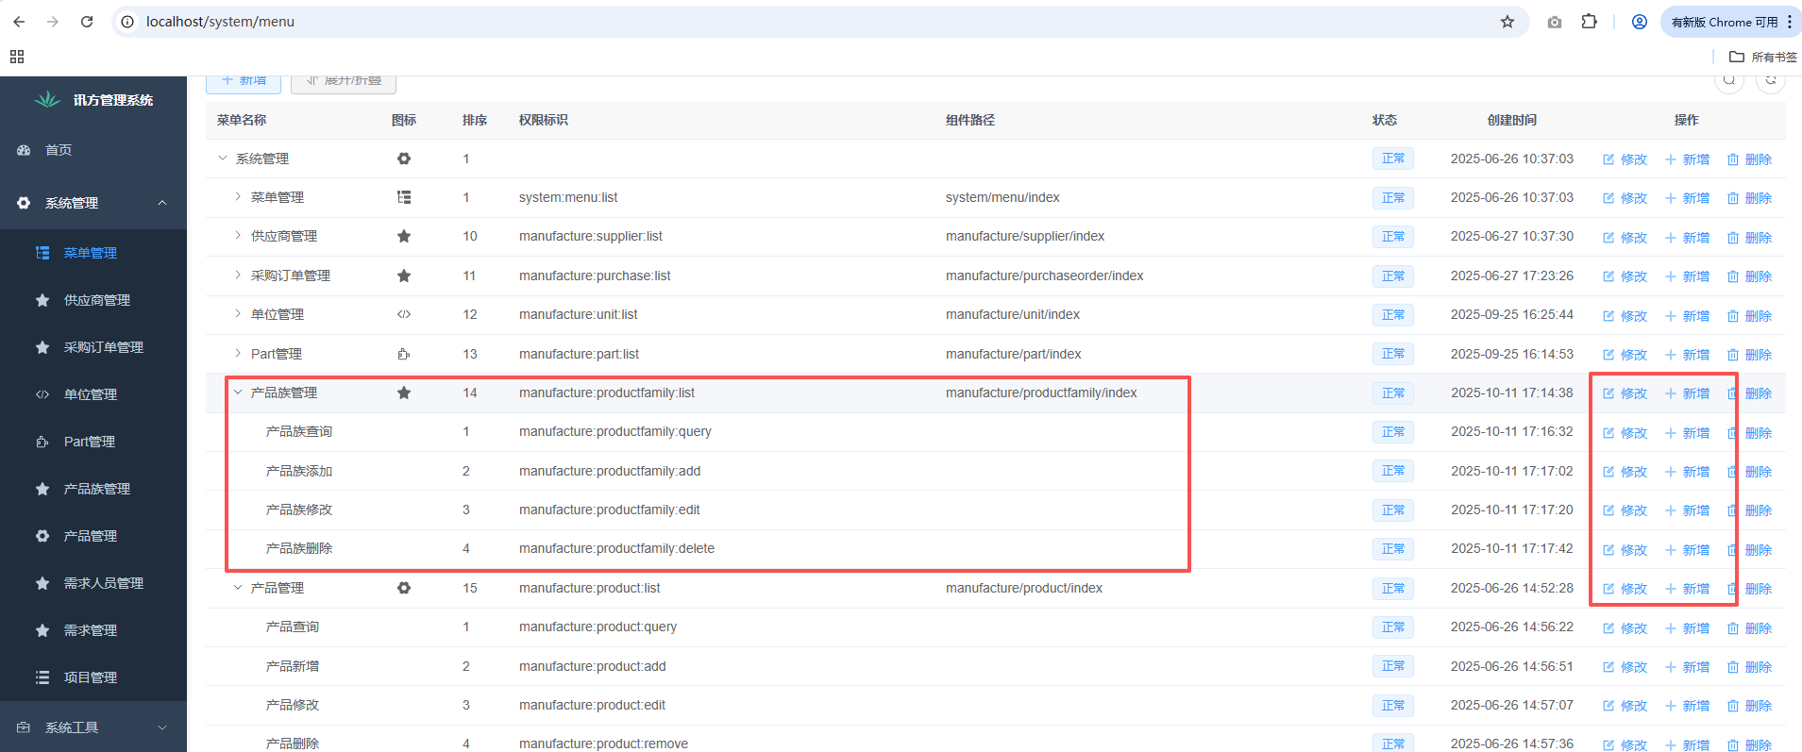
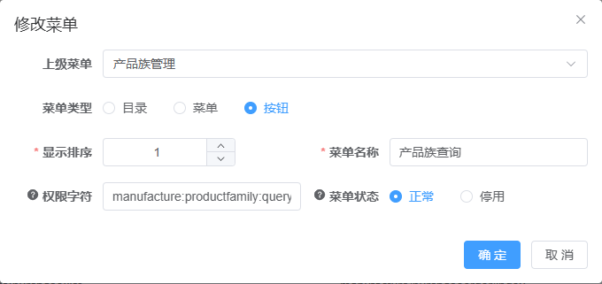
来到产品族管理界面，就会有一行“产品族主界面”的文字，如图：
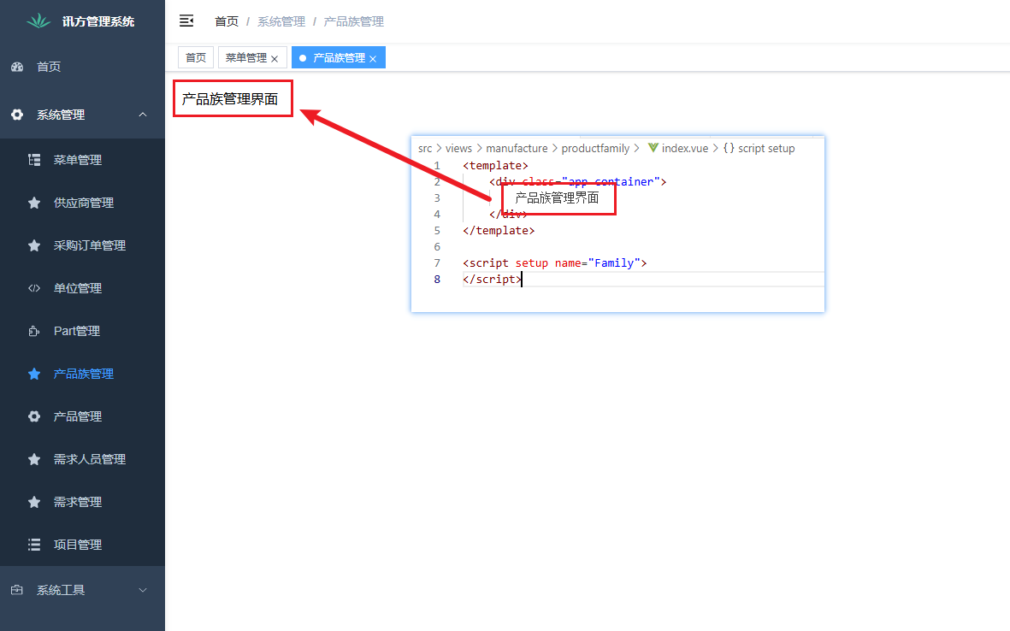
接着继续在src\api\manufacture创建product.js文件
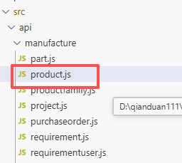
接下来进行product的主页面绘制，回到src\views\manufacture\product\index.vue，没有则自行创建
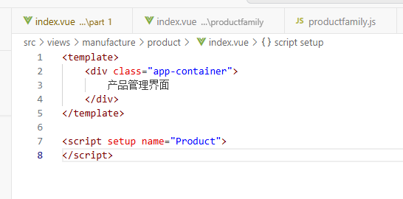
此时新建终端，运行代码：

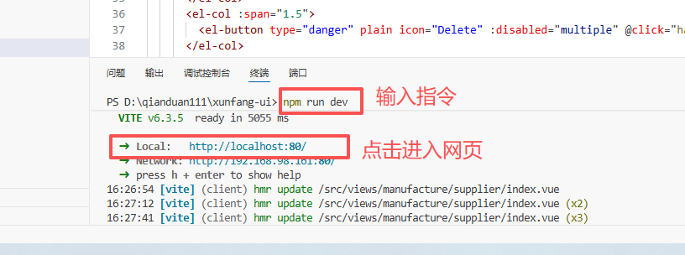
来到产品管理界面，就会有一行“产品管理主界面”的文字，如图：
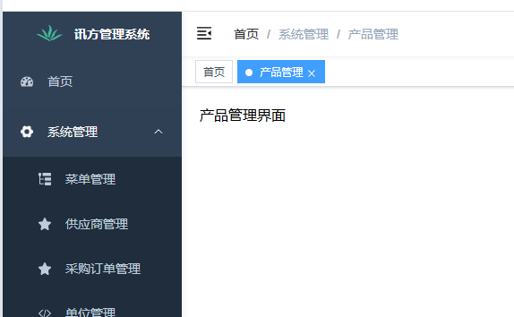

4. 接口约定（前端侧）

4.1 产品族 API
功能 | METHOD | PATH | 入参/说明
分页查询 | GET | /manufacture/family/list | pageNum,pageSize,productFamilyNameCn like, productFamilyNameEn like
详情 | GET | /manufacture/family/{id} | id
新增 | POST | /manufacture/family | 表单 JSON
修改 | PUT | /manufacture/family | 表单 JSON（含 id）
批量删除 | DELETE | /manufacture/family/{ids} | 英文逗号分隔 ids

4.2 产品 API（latest=true 查询）
功能 | METHOD | PATH | 入参/说明
分页查询 | GET | /manufacture/product/list | pageNum,pageSize,productName like,productFamily like,category =
详情 | GET | /manufacture/product/{id} | id（版本对象 id）
新增 | POST | /manufacture/product | multipart：FormData[data JSON + file?]
修改 | PUT | /manufacture/product | multipart：FormData[data JSON + file?/clearFile]
单删 | DELETE | /manufacture/product/deleteXfProductByProductId/{id} | id=masterId
批删 | DELETE | /manufacture/product/{ids} | 逗号分隔 masterIds
检出 | PUT | /manufacture/product/checkout | {masterId,lifecycleTemplate:{id},lifecycleState:{id},workCopyType?}
检入 | PUT | /manufacture/product/checkin | {masterId,lifecycleTemplate:{id},lifecycleState:{id},viewNo?}
状态更新 | PUT | /manufacture/product/updateStatus | {id/ master.id,workingState,lifecycleTemplate:{id},lifecycleState:{id}}

5.页面开发步骤（产品族）
接着回到productfamily.js文件中，先写JS调用后端的api接口，这样在进行前端页面中要调用的功能方法的编写时可直接调用，调用产品族管理的全部后端接口，具体代码如下：

5.1 JS 的API调用
import request from '@/utils/request'
// 查询产品族列表
export function listFamily(query) {
return request({
url: '/manufacture/family/list',
method: 'get',
params: query
})
}
1.export function listFamily(query)：定义并导出一个名为 listFamily的函数，接收一个 query 参数，query 是包含查询条件（如分页参数、筛选条件等）的对象。
2.return request({…})：调用封装的 request 方法发送请求，并返回请求的 Promise（方便后续用 async/await 或 .then() 处理响应）。
(1)url: ‘/manufacture/family/list’：指定请求的后端接口路径。
(2)method: ‘get’：设置请求方法为 GET。
(3)params: query：将 query 对象中的键值对作为 URL 的查询参数
其他函数以此类推
// 查询产品族详细
export function getFamily(id) {
return request({
url: '/manufacture/family/' + id,
method: 'get'
})
}
// 新增产品族
export function addFamily(data) {
return request({
url: '/manufacture/family',
method: 'post',
data: data
})
}
// 修改产品族
export function updateFamily(data) {
return request({
url: '/manufacture/family',
method: 'put',
data: data
})
}
// 单个删除产品族
export function delFamily(id) {
return request({
url: '/manufacture/family/delete/' + id,
method: 'delete'
})
}
// 批量删除产品族（
export function batchDelFamily(ids) {
if (!Array.isArray(ids)) ids = [ids]
const safeIds = ids.map(i => (i === null || i === undefined ? '' : String(i).trim())).filter(Boolean)
if (safeIds.length === 0) {
return Promise.reject(new Error('没有可删除的 id'))
}
return request({
url: '/manufacture/family/' + safeIds.join(','),
method: 'delete'
})
}

5.2 查询区
接着回到unit.vue文件中编写查询部分代码：
- 字段：中文名称、英文名称；回车/按钮触发 handleQuery；resetQuery 重置并 pageNum=1。
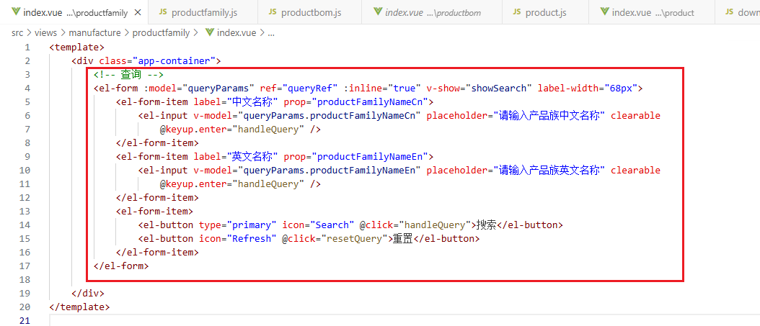
<!-- 查询 -->
<el-form :model="queryParams" ref="queryRef" :inline="true" v-show="showSearch" label-width="68px">
<el-form-item label="中文名称" prop="productFamilyNameCn">
<el-input v-model="queryParams.productFamilyNameCn" placeholder="请输入产品族中文名称" clearable @keyup.enter="handleQuery" />
</el-form-item>
<el-form-item label="英文名称" prop="productFamilyNameEn">
<el-input v-model="queryParams.productFamilyNameEn" placeholder="请输入产品族英文名称" clearable @keyup.enter="handleQuery" />
</el-form-item>
<el-form-item>
<el-button type="primary" icon="Search" @click="handleQuery">搜索</el-button>
<el-button icon="Refresh" @click="resetQuery">重置</el-button>
</el-form-item>
</el-form>
- 接着进行交互部分的代码编写，只需将查询区所用到的参数及调用到的方法先进行编写，如图，具体代码在5.5中可查看：
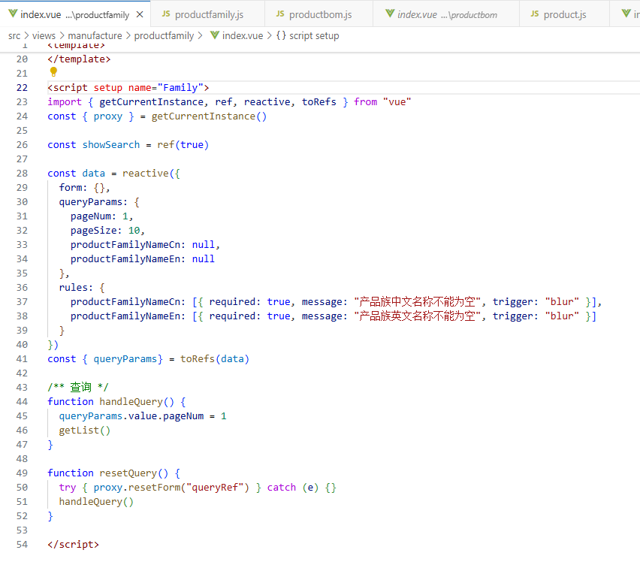
此时运行代码，可以看到产品族管理界面最上面会有查询区域，可以查询产品族的中英文名称、并有搜索和重置按钮，点击重置按钮后，输入在搜索框中的信息会一键删除：
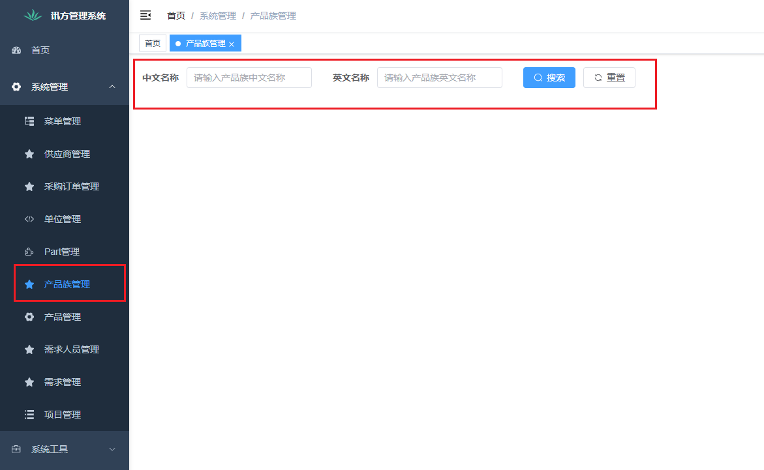

5.3 表格与分页
- PF{id} 作为产品族编码显示；列包含中文名/英文名/描述；操作列支持修改/删除。

分页组件 pagination 与 queryParams.pageNum/pageSize 双向绑定。
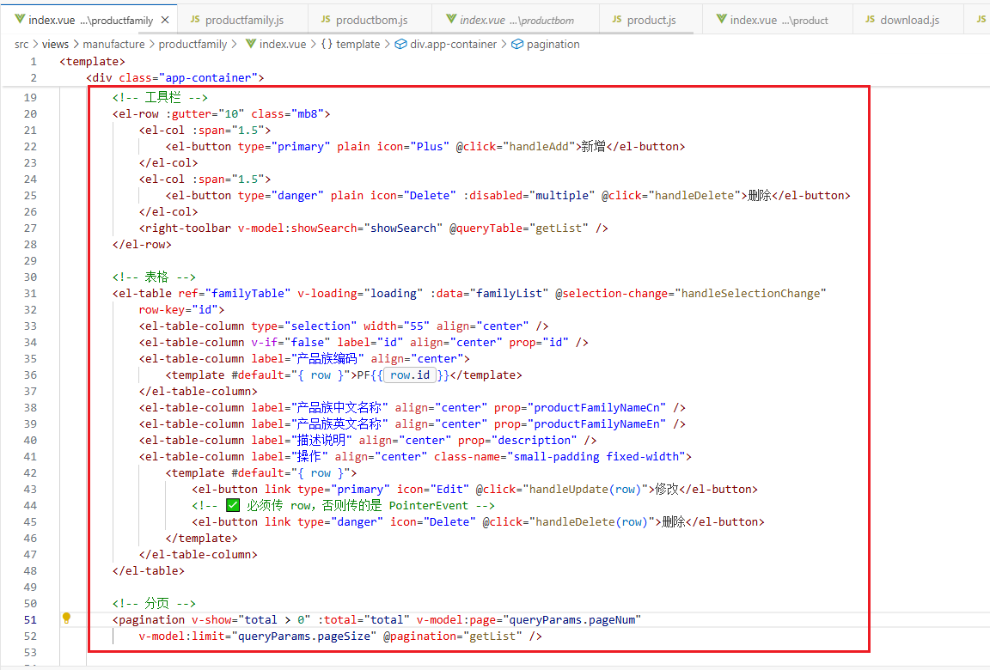

<!-- 工具栏 -->
<el-row :gutter="10" class="mb8">
<el-col :span="1.5">
<el-button type="primary" plain icon="Plus" @click="handleAdd">新增</el-button>
</el-col>
<el-col :span="1.5">
<el-button type="danger" plain icon="Delete" :disabled="multiple" @click="handleDelete">删除</el-button>
</el-col>
<right-toolbar v-model:showSearch="showSearch" @queryTable="getList" />
</el-row>

<!-- 表格 -->
<el-table
ref="familyTable"
v-loading="loading"
:data="familyList"
@selection-change="handleSelectionChange"
row-key="id"
>
<el-table-column type="selection" width="55" align="center" />
<el-table-column v-if="false" label="id" align="center" prop="id" />
<el-table-column label="产品族编码" align="center">
<template #default="{ row }">PF{{ row.id }}</template>
</el-table-column>
<el-table-column label="产品族中文名称" align="center" prop="productFamilyNameCn" />
<el-table-column label="产品族英文名称" align="center" prop="productFamilyNameEn" />
<el-table-column label="描述说明" align="center" prop="description" />
<el-table-column label="操作" align="center" class-name="small-padding fixed-width">
<template #default="{ row }">
<el-button link type="primary" icon="Edit" @click="handleUpdate(row)">修改</el-button>
<el-button link type="danger" icon="Delete" @click="handleDelete(row)">删除</el-button>
</template>
</el-table-column>
</el-table>

<!-- 分页 -->
<pagination
v-show="total > 0"
:total="total"
v-model:page="queryParams.pageNum"
v-model:limit="queryParams.pageSize"
@pagination="getList"
/>

接着进行交互部分的代码编写，只需将工具栏、表格及分页区所用到的参数及调用到的方法先进行编写，如图，具体代码在5.5中可查看：
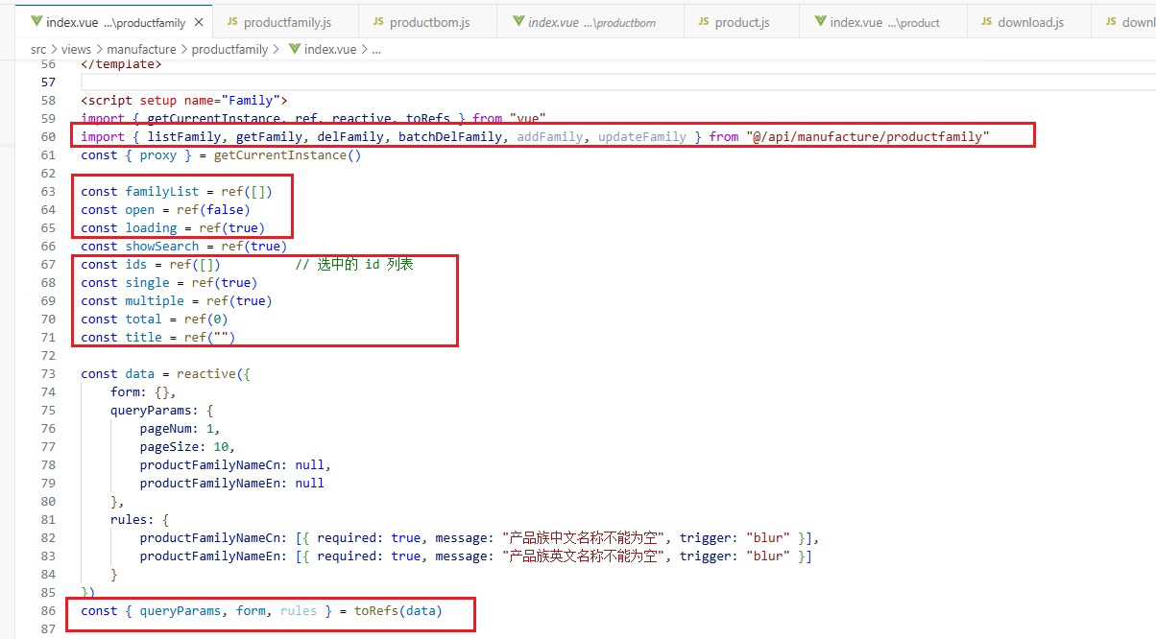
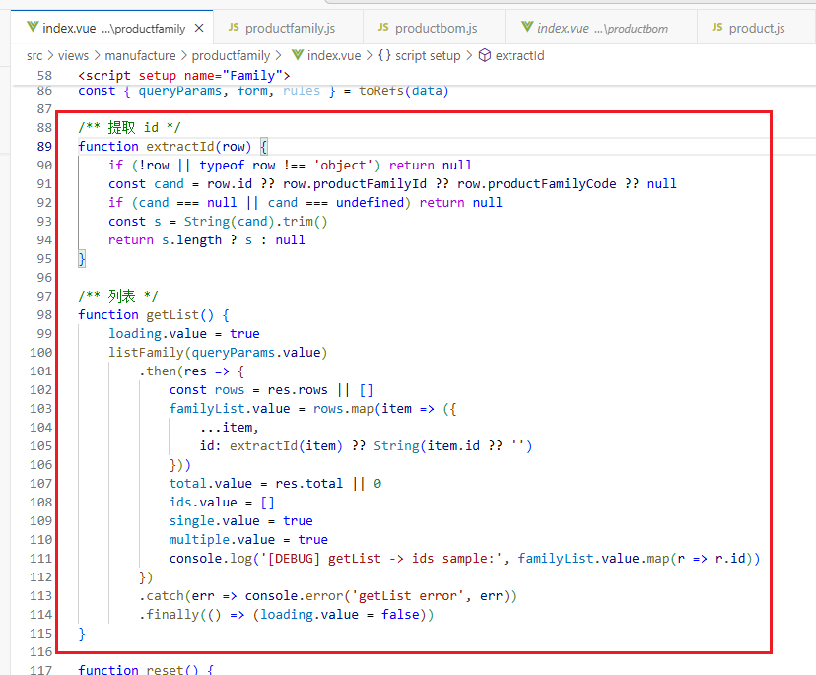
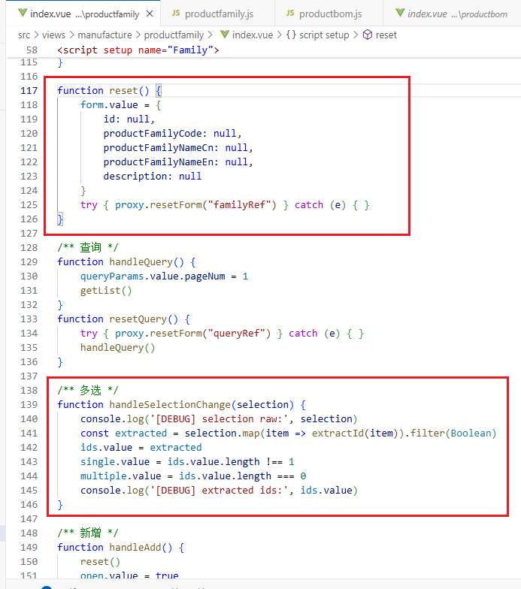
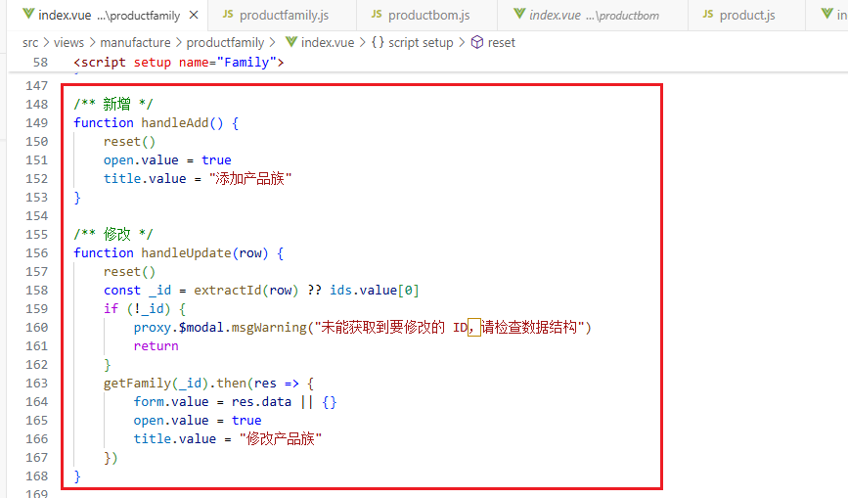
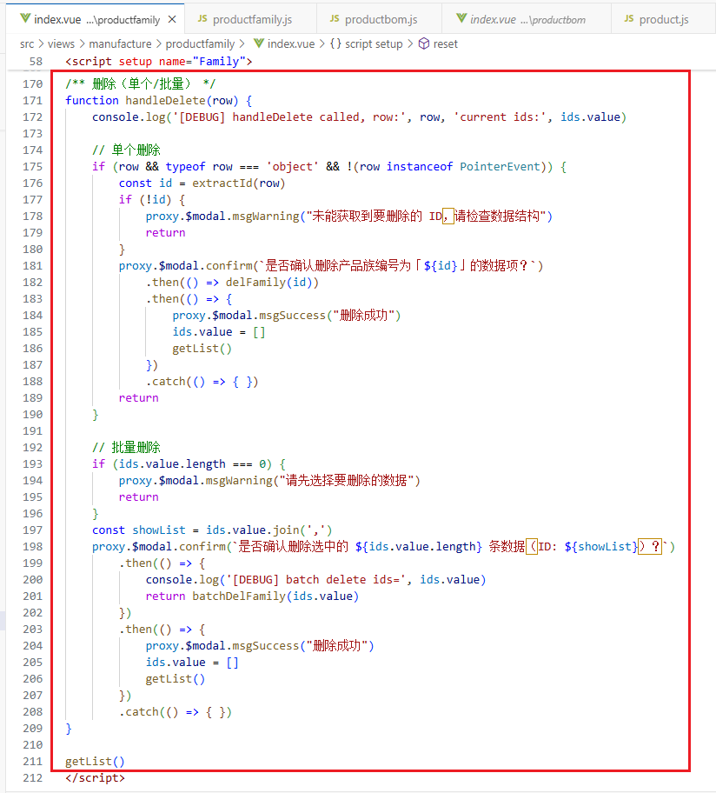
此时运行代码，可以看到产品族管理界面出现表格显示，可以显示我们添加的产品族，在左上角会有新增和删除按钮，没有勾选条目时，删除按钮时灰色的，但勾选条目后，删除按钮就可以点击，在最右侧还有删除和修改按钮，点击删除即可删除产品族实例，但点击修改按钮和新增按钮不会有反应，因为还没有绘制修改和新增的弹窗，表格右下角还有分页效果：
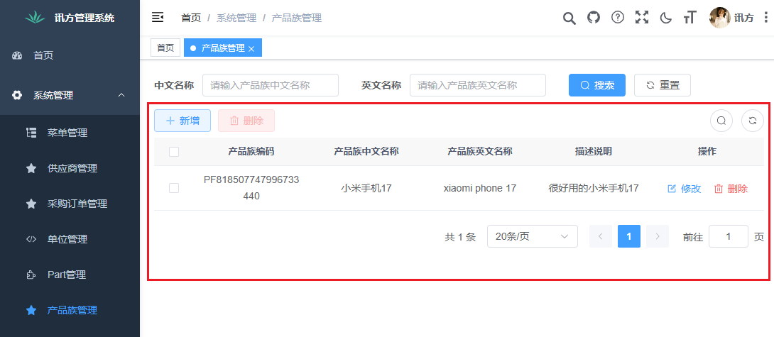

5.4 新增/修改弹窗
- 必填：productFamilyNameCn、productFamilyNameEn；其余选填；提交前 el-form validate。
- 提交：根据 form.id 选择 addFamily / updateFamily；成功后关闭弹窗并刷新列表。
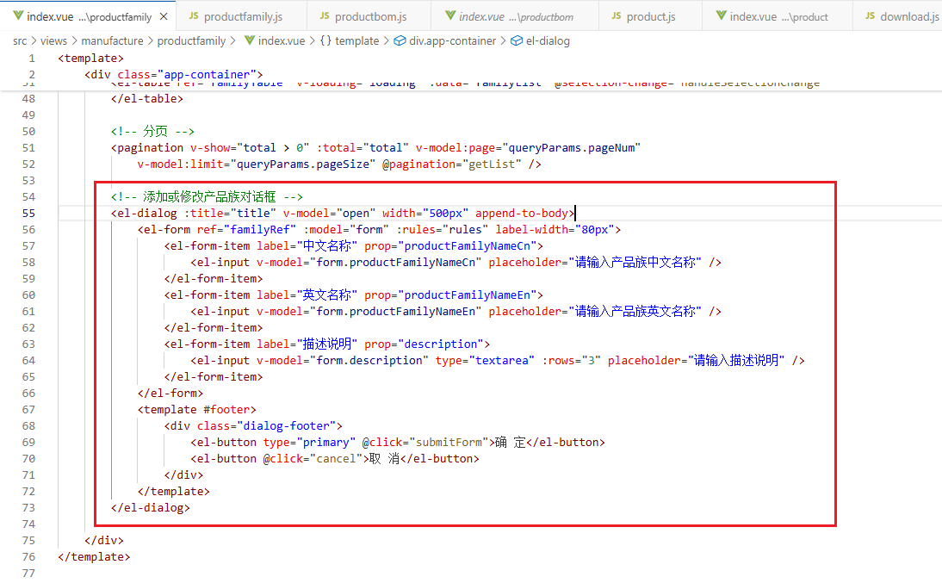
<!-- 添加或修改产品族对话框 -->
<el-dialog :title="title" v-model="open" width="500px" append-to-body>
<el-form ref="familyRef" :model="form" :rules="rules" label-width="80px">
<el-form-item label="中文名称" prop="productFamilyNameCn">
<el-input v-model="form.productFamilyNameCn" placeholder="请输入产品族中文名称" />
</el-form-item>
<el-form-item label="英文名称" prop="productFamilyNameEn">
<el-input v-model="form.productFamilyNameEn" placeholder="请输入产品族英文名称" />
</el-form-item>
<el-form-item label="描述说明" prop="description">
<el-input v-model="form.description" type="textarea" :rows="3" placeholder="请输入描述说明" />
</el-form-item>
</el-form>
<template #footer>
<div class="dialog-footer">
<el-button type="primary" @click="submitForm">确 定</el-button>
<el-button @click="cancel">取 消</el-button>
</div>
</template>
</el-dialog>
- 接着进行交互部分的代码编写，只需将弹窗所用到的参数及调用到的方法先进行编写，如图，具体代码在5.5中可查看：
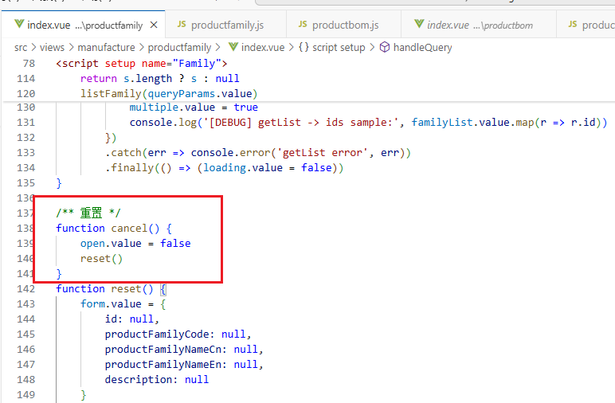
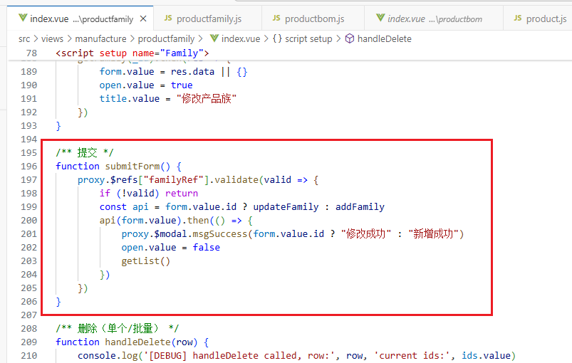
此时运行代码，在产品族管理界面点击新增按钮或修改按钮，可以看到会弹出弹窗，填入信息后点击确定即可添加产品族，点击取消则取消添加，如图：
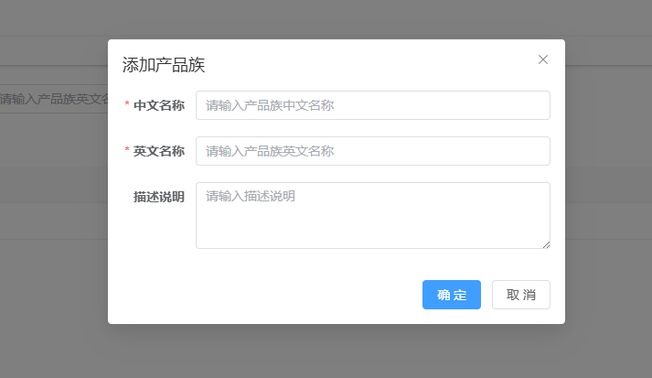
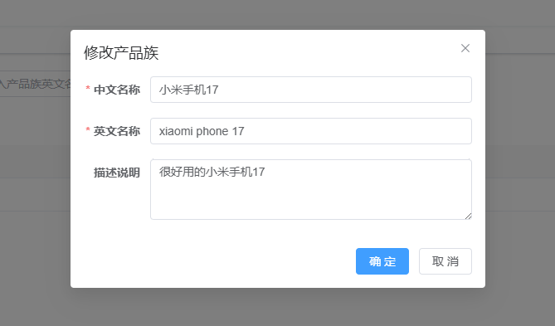

5.5 JS方法区
<script setup name="Family">
import { getCurrentInstance, ref, reactive, toRefs } from "vue"
import { listFamily, getFamily, delFamily, batchDelFamily, addFamily, updateFamily } from "@/api/manufacture/productfamily"
const { proxy } = getCurrentInstance()

const familyList = ref([])
const open = ref(false)
const loading = ref(true)
const showSearch = ref(true)
const ids = ref([]) // 选中的 id 列表
const single = ref(true)
const multiple = ref(true)
const total = ref(0)
const title = ref("")

const data = reactive({
form: {},
queryParams: {
pageNum: 1,
pageSize: 10,
productFamilyNameCn: null,
productFamilyNameEn: null
},
rules: {
productFamilyNameCn: [{ required: true, message: "产品族中文名称不能为空", trigger: "blur" }],
productFamilyNameEn: [{ required: true, message: "产品族英文名称不能为空", trigger: "blur" }]
}
})
const { queryParams, form, rules } = toRefs(data)

/** 提取 id */
function extractId(row) {
if (!row || typeof row !== 'object') return null
const cand = row.id ?? row.productFamilyId ?? row.productFamilyCode ?? null
if (cand === null || cand === undefined) return null
const s = String(cand).trim()
return s.length ? s : null
}

/** 列表 */
function getList() {
loading.value = true
listFamily(queryParams.value)
.then(res => {
const rows = res.rows || []
familyList.value = rows.map(item => ({
...item,
id: extractId(item) ?? String(item.id ?? '')
}))
total.value = res.total || 0
ids.value = []
single.value = true
multiple.value = true
console.log('[DEBUG] getList -> ids sample:', familyList.value.map(r => r.id))
})
.catch(err => console.error('getList error', err))
.finally(() => (loading.value = false))
}

/** 重置 */
function cancel() {
open.value = false
reset()
}
function reset() {
form.value = {
id: null,
productFamilyCode: null,
productFamilyNameCn: null,
productFamilyNameEn: null,
description: null
}
try { proxy.resetForm("familyRef") } catch (e) {}
}

/** 查询 */
function handleQuery() {
queryParams.value.pageNum = 1
getList()
}
function resetQuery() {
try { proxy.resetForm("queryRef") } catch (e) {}
handleQuery()
}

/** 多选 */
function handleSelectionChange(selection) {
console.log('[DEBUG] selection raw:', selection)
const extracted = selection.map(item => extractId(item)).filter(Boolean)
ids.value = extracted
single.value = ids.value.length !== 1
multiple.value = ids.value.length === 0
console.log('[DEBUG] extracted ids:', ids.value)
}

/** 新增 */
function handleAdd() {
reset()
open.value = true
title.value = "添加产品族"
}

/** 修改 */
function handleUpdate(row) {
reset()
const _id = extractId(row) ?? ids.value[0]
if (!_id) {
proxy.$modal.msgWarning("未能获取到要修改的 ID，请检查数据结构")
return
}
getFamily(_id).then(res => {
form.value = res.data || {}
open.value = true
title.value = "修改产品族"
})
}

/** 提交 */
function submitForm() {
proxy.$refs["familyRef"].validate(valid => {
if (!valid) return
const api = form.value.id ? updateFamily : addFamily
api(form.value).then(() => {
proxy.$modal.msgSuccess(form.value.id ? "修改成功" : "新增成功")
open.value = false
getList()
})
})
}

/** 删除（单个/批量） */
function handleDelete(row) {
console.log('[DEBUG] handleDelete called, row:', row, 'current ids:', ids.value)

// 单个删除
if (row && typeof row === 'object' && !(row instanceof PointerEvent)) {
const id = extractId(row)
if (!id) {
proxy.$modal.msgWarning("未能获取到要删除的 ID，请检查数据结构")
return
}
proxy.$modal.confirm(`是否确认删除产品族编号为「${id}」的数据项？`)
.then(() => delFamily(id))
.then(() => {
proxy.$modal.msgSuccess("删除成功")
ids.value = []
getList()
})
.catch(() => {})
return
}

// 批量删除
if (ids.value.length === 0) {
proxy.$modal.msgWarning("请先选择要删除的数据")
return
}
const showList = ids.value.join(',')
proxy.$modal.confirm(`是否确认删除选中的 ${ids.value.length} 条数据（ID: ${showList}）？`)
.then(() => {
console.log('[DEBUG] batch delete ids=', ids.value)
return batchDelFamily(ids.value)
})
.then(() => {
proxy.$modal.msgSuccess("删除成功")
ids.value = []
getList()
})
.catch(() => {})
}

getList()
</script>

6.1 JS的API调用 :
// src/api/manufacture/product.js
import request from '@/utils/request'

// 小工具：判断是否 FormData
const isFormData = (v) => typeof FormData !== 'undefined' && v instanceof FormData

// 列表
export function listProduct(query) {
return request({
url: '/manufacture/product/list',
method: 'get',
params: query
})
}

// 详情
export function getProduct(id) {
return request({
url: '/manufacture/product/' + id,
method: 'get'
})
}

/**
* 新增（支持两种用法）
* 1) addProduct(formData) // 直接传 FormData（index.vue 当前做法）
* 2) addProduct(jsonData, rawFile) // 传普通对象 + 文件，函数自动拼 FormData
*/
export function addProduct(data, file) {
return sendWithOptionalFile({
url: '/manufacture/product',
method: 'post',
data,
file
})
}

/**
* 修改（支持两种用法）
* 1) updateProduct(formData)
* 2) updateProduct(jsonData, rawFile)
*/
export function updateProduct(data, file) {
return sendWithOptionalFile({
url: '/manufacture/product',
method: 'put',
data,
file
})
}

/**
* 单个删除
*/
export function delProduct(masterId) {
return request({
url: '/manufacture/product/delete/' + masterId,
method: 'delete'
})
}

/**
* 批量删除 —— 后端：
* 传英文逗号分隔的 masterId 列表
*/

export function delProductBatch(masterIds) {
return request({
url: '/manufacture/product/batch/' + masterIds, // masterIds 逗号分隔
method: 'delete'
})
}

/**
* 检出（接收完整对象）
* data 形如：
* {
* masterId: '8068465...',
* workCopyType: 'BOTH',
* lifecycleTemplate: { id: '8043797...' },
* lifecycleState: { id: '8043748...' },
* modifier: 'xxx 可选'
* }
*/
export function checkOut(data) {
return request({
url: '/manufacture/product/checkout',
method: 'put',
data
})
}

/**
* 检入（接收完整对象）
* data 形如：
* {
* viewNo: '',
* masterId: '8068465...',
* lifecycleTemplate: { id: '...' },
* lifecycleState: { id: '...' },
* modifier: 'xxx 可选'
* }
*/
export function checkIn(data) {
return request({
url: '/manufacture/product/checkin',
method: 'put',
data
})
}

/**
* data = {
* id: '8069...',
* workingState: 'INWORK' | 'CHECKED_IN' | ... // ★ 当前数据的工作状态
* lifecycleTemplate: { id: '8043797...' },
* lifecycleState: { id: '8043760...' }
* }
* 注意：顶层，不包 params
*/
export function updateStatus(data) {
return request({
url: '/manufacture/product/updateStatus',
method: 'put',
data
})
}

/** 统一工具：有文件或已是 FormData 就走 multipart；否则走 JSON */
function sendWithOptionalFile({ url, method, data, file }) {
// 1) 已经是 FormData：直接发
if (isFormData(data)) {
return request({ url, method, data })
}

// 2) 传了原始文件：拼 FormData
if (file) {
const fd = new FormData()
fd.append('data', new Blob([JSON.stringify(data || {})], { type: 'application/json' }))
fd.append('file', file, file.name)
return request({ url, method, data: fd })
}

// 3) 纯 JSON
return request({ url, method, data })
}

// src/api/manufacture/lifecycle.js
import request from "@/utils/request"

// 生命周期模板列表
export function listLifecycleTemplates(params) {
return request({
url: "/manufacture/lifecycle/lifecycleTemplateList",
method: "get",
params
})
}

/**
* 获取业务操作列表（你给的接口）
* @param {string} templateId
* @param {string} operation create / edit / checkout / checkin
* @param {string} stateId 可选
*/
export function getLifecycleBusiness({ templateId, operation = "create", stateId = "" }) {
return request({
url: "/manufacture/lifecycle/lifeBusinessList",
method: "get",
params: { templateId, operation, stateId }
})
}

/**
* 获取生命周期状态列表（按模板 + 业务操作ID + 可选当前状态 + 操作类型）
*/
export function getLifecycleStates({ templateId, businessOperationId, stateId = "", operation }) {
return request({
url: "/manufacture/lifecycle/lifeState",
method: "get",
params: { templateId, businessOperationId, stateId, operation }
})
}

6.2 查询区
- 查询字段：产品名称、产品族（远程下拉）、类别（CU/定制；ST/标准）。
- 列表特别列：工作状态图标（CHECKED_OUT 显示红锁）、生命周期状态（标签显示）。
- 操作列：CHECKED_IN 显示“检出/删除”；CHECKED_OUT 显示“修改/检入”；“更新状态”始终可见。

仅展示 latest=true 的版本，按 lastUpdateTime DESC。
接着回到product.vue文件中编写查询部分代码：
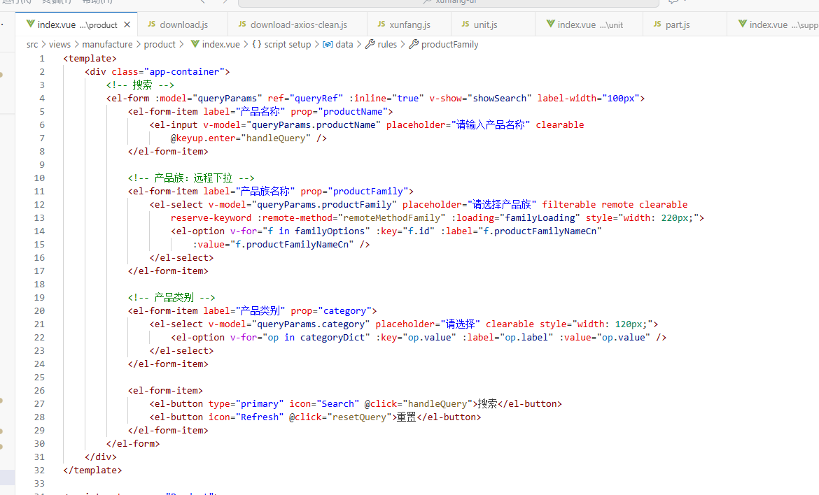

<!-- 搜索 -->
<el-form :model="queryParams" ref="queryRef" :inline="true" v-show="showSearch" label-width="100px">
<el-form-item label="产品名称" prop="productName">
<el-input v-model="queryParams.productName" placeholder="请输入产品名称" clearable @keyup.enter="handleQuery" />
</el-form-item>

<!-- 产品族：远程下拉 -->
<el-form-item label="产品族名称" prop="productFamily">
<el-select
v-model="queryParams.productFamily"
placeholder="请选择产品族"
filterable remote clearable reserve-keyword
:remote-method="remoteMethodFamily"
:loading="familyLoading"
style="width: 220px;"
>
<el-option
v-for="f in familyOptions"
:key="f.id"
:label="f.productFamilyNameCn"
:value="f.productFamilyNameCn"
/>
</el-select>
</el-form-item>

<!-- 产品类别 -->
<el-form-item label="产品类别" prop="category">
<el-select v-model="queryParams.category" placeholder="请选择" clearable style="width: 120px;">
<el-option v-for="op in categoryDict" :key="op.value" :label="op.label" :value="op.value" />
</el-select>
</el-form-item>

<el-form-item>
<el-button type="primary" icon="Search" @click="handleQuery">搜索</el-button>
<el-button icon="Refresh" @click="resetQuery">重置</el-button>
</el-form-item>
</el-form>

接着进行交互部分的代码编写，只需将查询区所用到的参数及调用到的方法先进行编写，如图，具体代码在6.9中可查看：
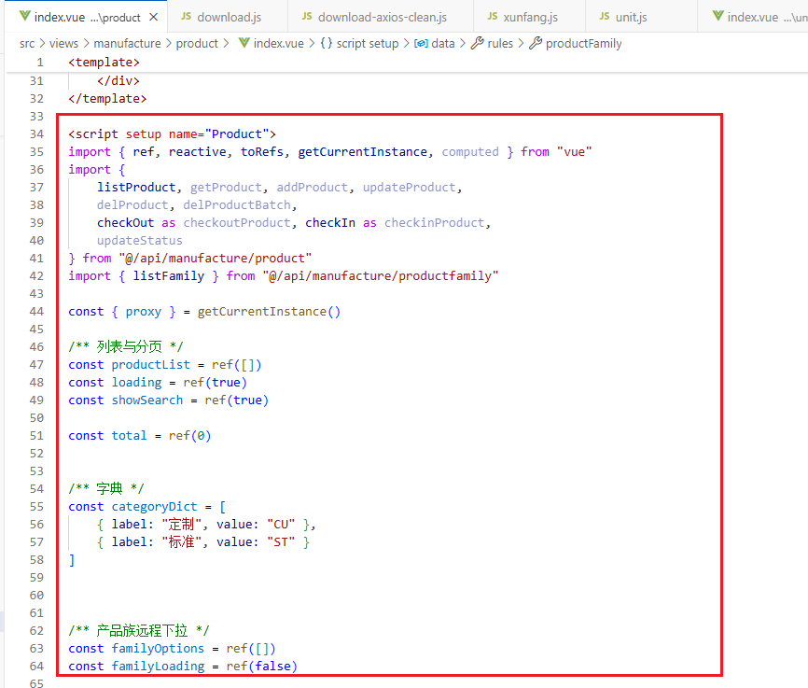
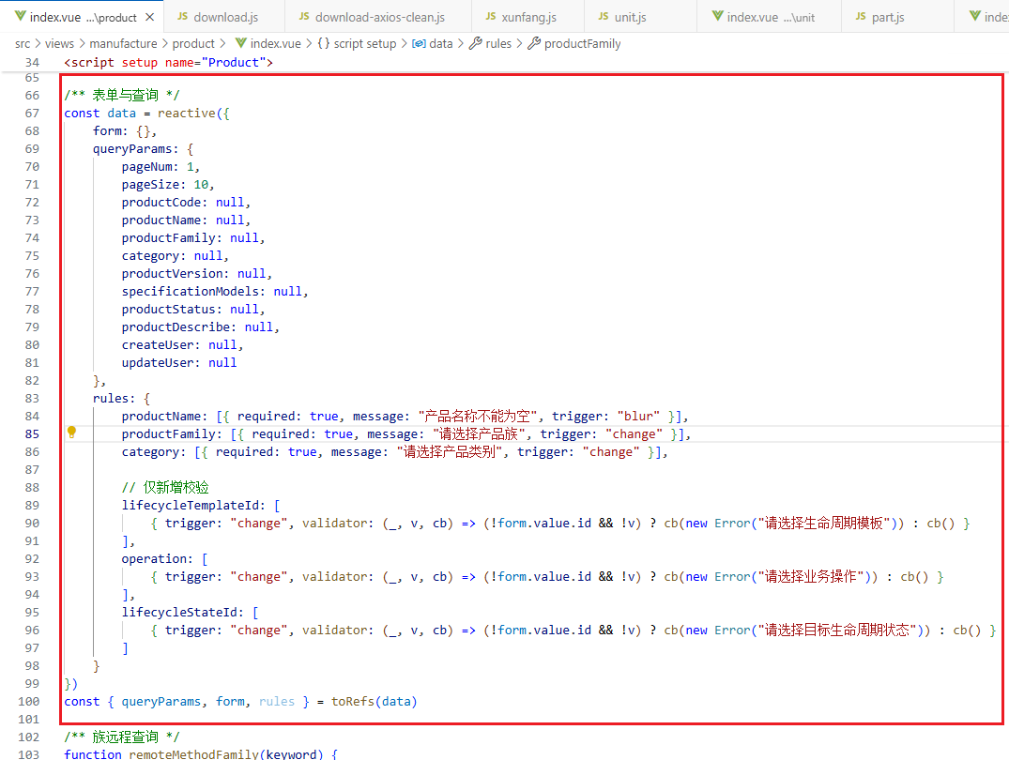
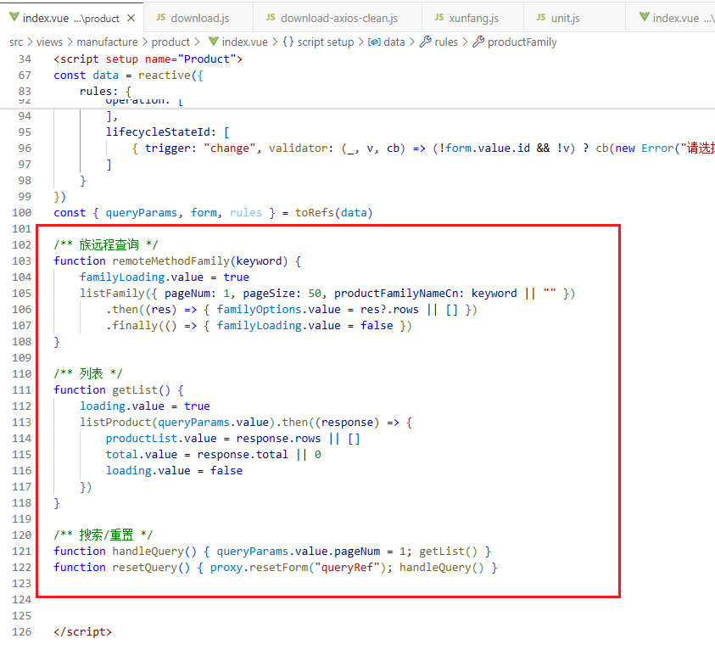

此时运行代码，可以看到product管理界面最上面会有查询区域，可以查询产品名称、产品类别、且关联产品族种类，后两者可以下拉选择（因为产品类别是枚举，其中的枚举值是根据创建实体所引用的枚举来编写的），并有搜索和重置按钮，点击重置按钮后，输入在搜索框中的信息会一键删除：
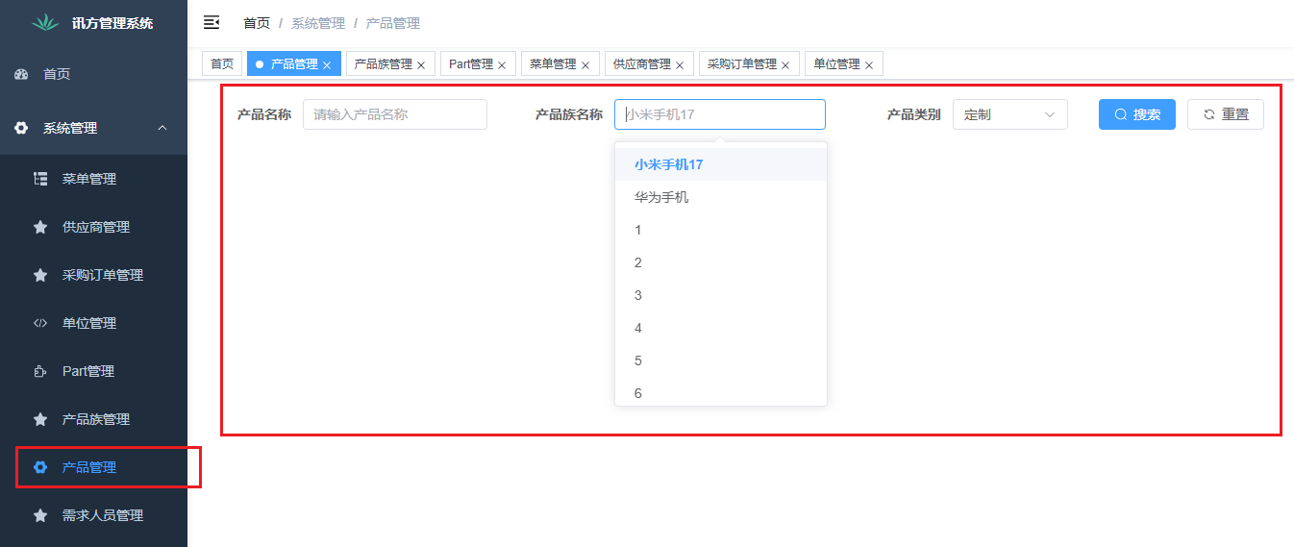

6.3 表格与分页
- 方法：remoteMethodFamily(keyword) → GET /manufacture/family/list?pageNum=1&pageSize=50&productFamilyNameCn=keyword
- el-select 开启 filterable + remote + clearable；label 使用中文名，value 传中文名与后端匹配。
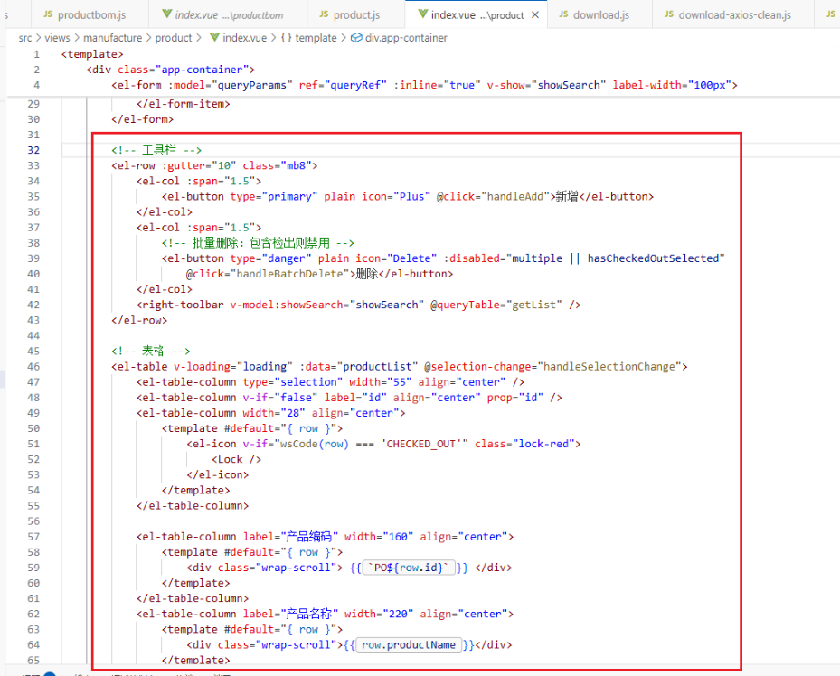
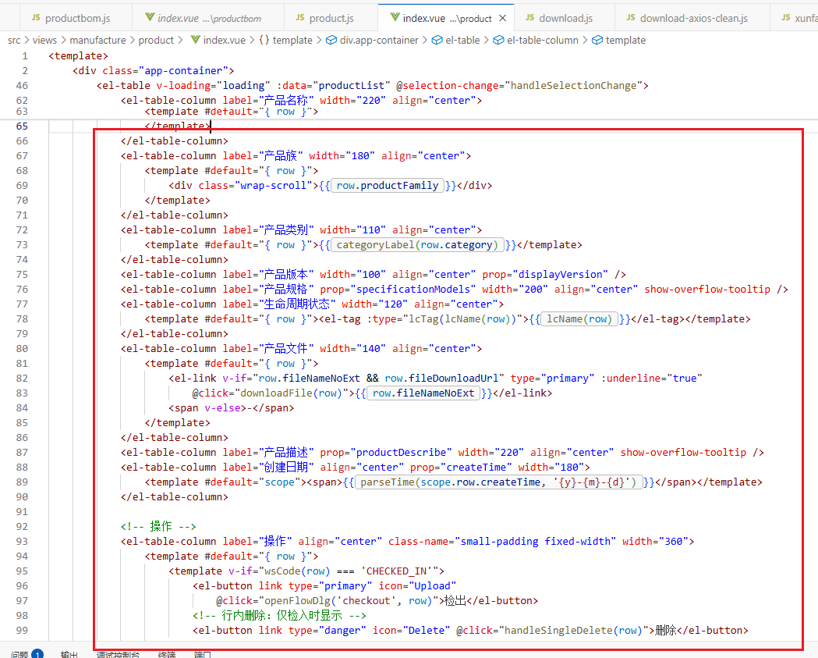
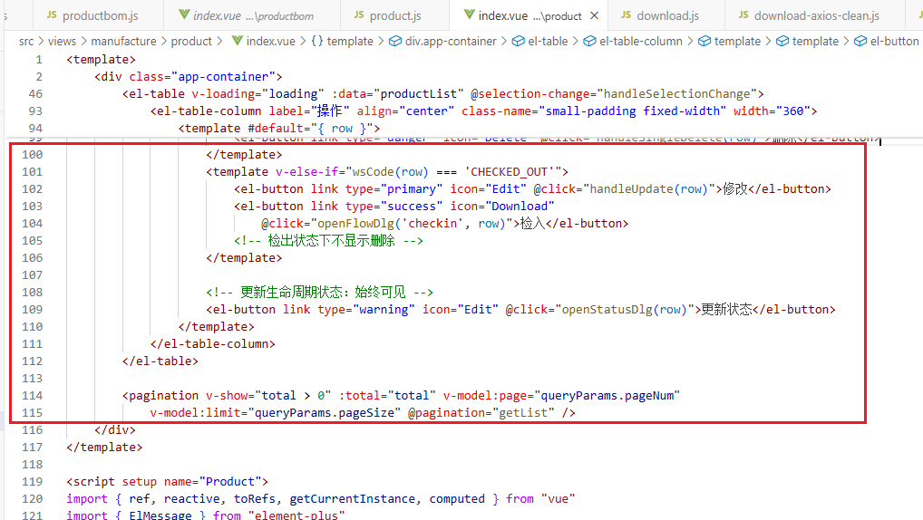
<!-- 工具栏 -->
<el-row :gutter="10" class="mb8">
<el-col :span="1.5">
<el-button type="primary" plain icon="Plus" @click="handleAdd">新增</el-button>
</el-col>
<el-col :span="1.5">
<!-- 批量删除：包含检出则禁用 -->
<el-button
type="danger"
plain
icon="Delete"
:disabled="multiple || hasCheckedOutSelected"
@click="handleBatchDelete"
>删除</el-button>
</el-col>
<right-toolbar v-model:showSearch="showSearch" @queryTable="getList" />
</el-row>

<!-- 表格 -->
<el-table v-loading="loading" :data="productList" @selection-change="handleSelectionChange">
<el-table-column type="selection" width="55" align="center" />
<el-table-column v-if="false" label="id" align="center" prop="id" />
<el-table-column width="28" align="center">
<template #default="{ row }">
<el-icon v-if="wsCode(row)==='CHECKED_OUT'" class="lock-red"><Lock /></el-icon>
</template>
</el-table-column>

<el-table-column label="产品编码" width="160" align="center">
<template #default="{ row }"><div class="wrap-scroll"> {{ `PO${row.id}` }} </div></template>
</el-table-column>
<el-table-column label="产品名称" width="220" align="center">
<template #default="{ row }"><div class="wrap-scroll">{{ row.productName }}</div></template>
</el-table-column>
<el-table-column label="产品族" width="180" align="center">
<template #default="{ row }"><div class="wrap-scroll">{{ row.productFamily }}</div></template>
</el-table-column>
<el-table-column label="产品类别" width="110" align="center">
<template #default="{ row }">{{ categoryLabel(row.category) }}</template>
</el-table-column>
<el-table-column label="产品版本" width="100" align="center" prop="displayVersion" />
<el-table-column label="产品规格" prop="specificationModels" width="200" align="center" show-overflow-tooltip />
<el-table-column label="生命周期状态" width="120" align="center">
<template #default="{ row }"><el-tag :type="lcTag(lcName(row))">{{ lcName(row) }}</el-tag></template>
</el-table-column>
<el-table-column label="产品文件" width="140" align="center">
<template #default="{ row }">
<el-link
v-if="row.fileNameNoExt && row.fileDownloadUrl"
type="primary"
:underline="true"
@click="downloadFile(row)"
>{{ row.fileNameNoExt }}</el-link>
<span v-else>-</span>
</template>
</el-table-column>
<el-table-column label="产品描述" prop="productDescribe" width="220" align="center" show-overflow-tooltip />
<el-table-column label="创建日期" align="center" prop="createTime" width="180">
<template #default="scope"><span>{{ parseTime(scope.row.createTime, '{y}-{m}-{d}') }}</span></template>
</el-table-column>

<!-- 操作 -->
<el-table-column label="操作" align="center" class-name="small-padding fixed-width" width="360">
<template #default="{ row }">
<template v-if="wsCode(row)==='CHECKED_IN'">
<el-button link type="primary" icon="Upload" @click="openFlowDlg('checkout', row)">检出</el-button>
<!-- 行内删除：仅检入时显示 -->
<el-button link type="danger" icon="Delete" @click="handleSingleDelete(row)">删除</el-button>
</template>
<template v-else-if="wsCode(row)==='CHECKED_OUT'">
<el-button link type="primary" icon="Edit" @click="handleUpdate(row)">修改</el-button>
<el-button link type="success" icon="Download" @click="openFlowDlg('checkin', row)">检入</el-button>
<!-- 检出状态下不显示删除 -->
</template>

<!-- 更新生命周期状态：始终可见 -->
<el-button link type="warning" icon="Edit" @click="openStatusDlg(row)">更新状态</el-button>
</template>
</el-table-column>
</el-table>

<pagination
v-show="total>0"
:total="total"
v-model:page="queryParams.pageNum"
v-model:limit="queryParams.pageSize"
@pagination="getList"
/>
接着进行交互部分的代码编写，只需将工具栏、表格及分页区所用到的参数及调用到的方法先进行编写，具体代码在6.9中可查看，且可根据自己的喜好渲染样式，具体代码参考6.10。
此时运行代码，可以看到产品管理界面出现表格显示，可以显示我们添加的产品,，且点击产品文件列的蓝色链接可以下载对应的文件，在左上角会有新增和删除按钮，没有勾选条目或者勾选到已检出的条目时，删除按钮是灰色的，但勾选未检出的条目后，删除按钮就可以点击。
在最右侧还有删除、修改、检入、检出和更新状态的按钮，点击删除即可删除产品实例，但点击修改、新增、检入和检出不会有反应，因为还没有绘制对应的弹窗，且可以看到已检出的条目最前面有红色锁头且可以修改，但未检出的没有锁头且不可修改，表格右下角还有分页效果：
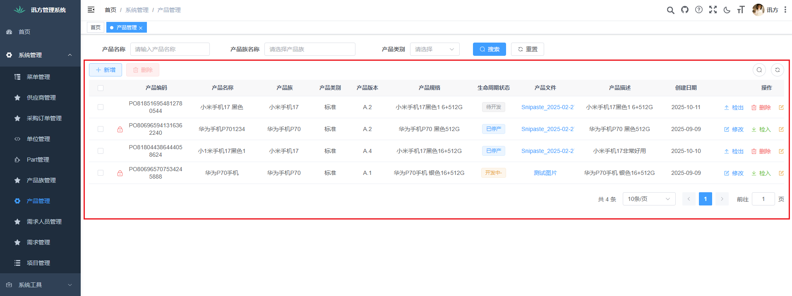

6.4 新增/修改弹窗(包含生命周期创建联动区)

字典：[{label:’定制’,value:’CU’},{label:’标准’,value:’ST’}]；展示使用 categoryLabel() 做映射；提交前使用 codeOfCategory() 取代码。
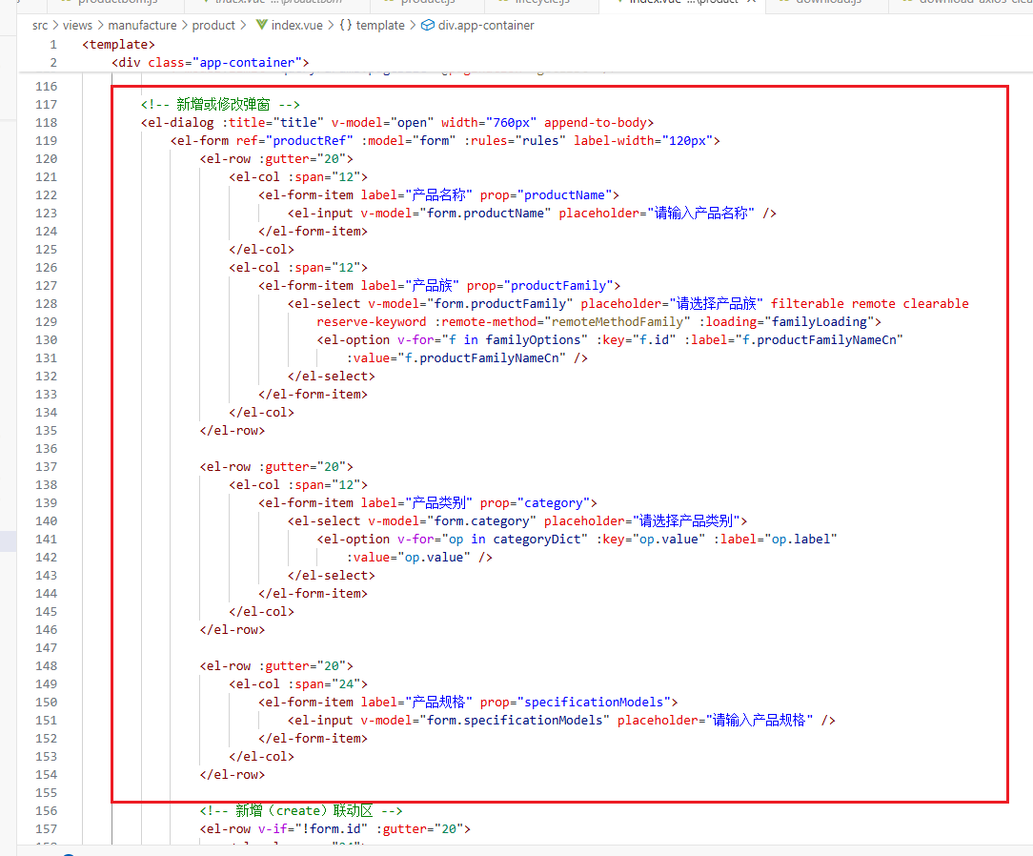
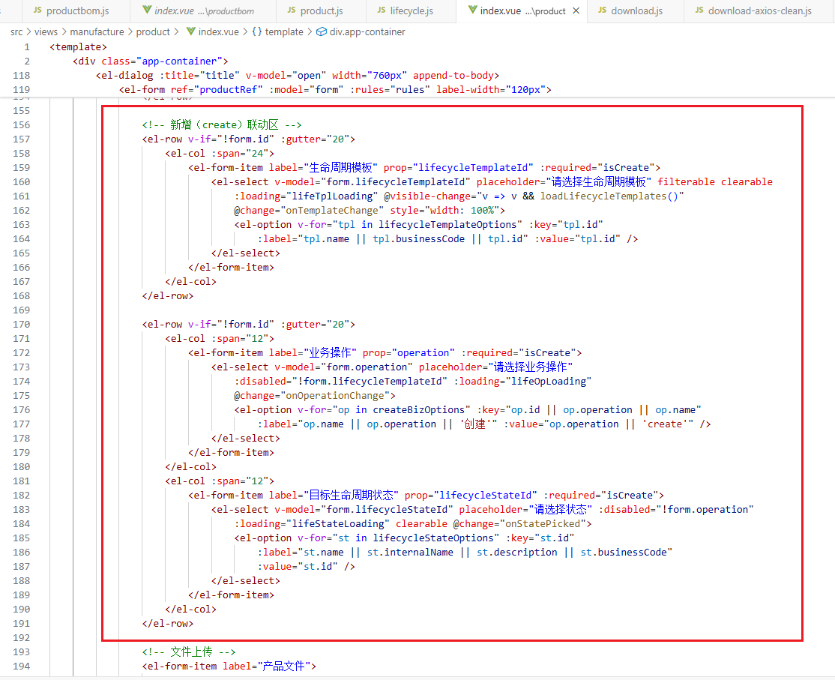
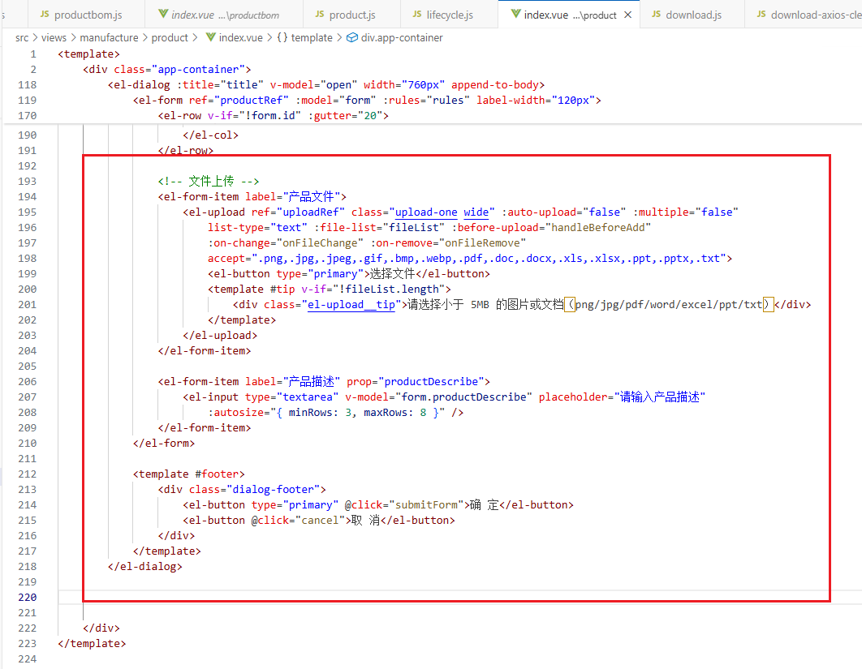

<!-- 新增或修改弹窗 -->
<el-dialog :title="title" v-model="open" width="760px" append-to-body>
<el-form ref="productRef" :model="form" :rules="rules" label-width="120px">
<el-row :gutter="20">
<el-col :span="12">
<el-form-item label="产品名称" prop="productName">
<el-input v-model="form.productName" placeholder="请输入产品名称" />
</el-form-item>
</el-col>
<el-col :span="12">
<el-form-item label="产品族" prop="productFamily">
<el-select
v-model="form.productFamily"
placeholder="请选择产品族"
filterable remote clearable reserve-keyword
:remote-method="remoteMethodFamily"
:loading="familyLoading"
>
<el-option
v-for="f in familyOptions"
:key="f.id"
:label="f.productFamilyNameCn"
:value="f.productFamilyNameCn"
/>
</el-select>
</el-form-item>
</el-col>
</el-row>

<el-row :gutter="20">
<el-col :span="12">
<el-form-item label="产品类别" prop="category">
<el-select v-model="form.category" placeholder="请选择产品类别">
<el-option v-for="op in categoryDict" :key="op.value" :label="op.label" :value="op.value" />
</el-select>
</el-form-item>
</el-col>
</el-row>

<el-row :gutter="20">
<el-col :span="24">
<el-form-item label="产品规格" prop="specificationModels">
<el-input v-model="form.specificationModels" placeholder="请输入产品规格" />
</el-form-item>
</el-col>
</el-row>

<!-- 新增（create）联动区 -->
<el-row v-if="!form.id" :gutter="20">
<el-col :span="24">
<el-form-item label="生命周期模板" prop="lifecycleTemplateId" :required="isCreate">
<el-select
v-model="form.lifecycleTemplateId"
placeholder="请选择生命周期模板"
filterable clearable
:loading="lifeTplLoading"
@visible-change="v => v && loadLifecycleTemplates()"
@change="onTemplateChange"
style="width: 100%"
>
<el-option
v-for="tpl in lifecycleTemplateOptions"
:key="tpl.id"
:label="tpl.name || tpl.businessCode || tpl.id"
:value="tpl.id"
/>
</el-select>
</el-form-item>
</el-col>
</el-row>

<el-row v-if="!form.id" :gutter="20">
<el-col :span="12">
<el-form-item label="业务操作" prop="operation" :required="isCreate">
<el-select
v-model="form.operation"
placeholder="请选择业务操作"
:disabled="!form.lifecycleTemplateId"
:loading="lifeOpLoading"
@change="onOperationChange"
>
<el-option
v-for="op in createBizOptions"
:key="op.id || op.operation || op.name"
:label="op.name || op.operation || '创建'"
:value="op.operation || 'create'"
/>
</el-select>
</el-form-item>
</el-col>
<el-col :span="12">
<el-form-item label="目标生命周期状态" prop="lifecycleStateId" :required="isCreate">
<el-select
v-model="form.lifecycleStateId"
placeholder="请选择状态"
:disabled="!form.operation"
:loading="lifeStateLoading"
clearable
@change="onStatePicked"
>
<el-option
v-for="st in lifecycleStateOptions"
:key="st.id"
:label="st.name || st.internalName || st.description || st.businessCode"
:value="st.id"
/>
</el-select>
</el-form-item>
</el-col>
</el-row>

<!-- 文件上传 -->
<el-form-item label="产品文件" >
<el-upload
ref="uploadRef"
class="upload-one wide"
:auto-upload="false"
:multiple="false"
list-type="text"
:file-list="fileList"
:before-upload="handleBeforeAdd"
:on-change="onFileChange"
:on-remove="onFileRemove"
accept=".png,.jpg,.jpeg,.gif,.bmp,.webp,.pdf,.doc,.docx,.xls,.xlsx,.ppt,.pptx,.txt"
>
<el-button type="primary">选择文件</el-button>
<template #tip v-if="!fileList.length">
<div class="el-upload__tip">请选择小于 5MB 的图片或文档（png/jpg/pdf/word/excel/ppt/txt）</div>
</template>
</el-upload>
</el-form-item>

<el-form-item label="产品描述" prop="productDescribe">
<el-input
type="textarea"
v-model="form.productDescribe"
placeholder="请输入产品描述"
:autosize="{ minRows: 3, maxRows: 8 }"
/>
</el-form-item>
</el-form>

<template #footer>
<div class="dialog-footer">
<el-button type="primary" @click="submitForm">确 定</el-button>
<el-button @click="cancel">取 消</el-button>
</div>
</template>
</el-dialog>

接着进行交互部分的代码编写，只需将所用到的参数及调用到的方法先进行编写，具体代码在6.9中可查看，且可根据自己的喜好渲染样式，具体代码参考6.10：
此时运行代码，点击添加/修改按钮，可以看到新增产品/修改产品的弹窗，其中新增时产品族、产品类别、生命周期模板是可下拉选择的，但业务操作和目标生命周期状态在新增时会初始化，默认业务操作为立项、目标生命周期状态为待开发，且产品族关联的是产品族管理中我们添加过的产品族条目，同时，可以选择文件进行上传，点击确定即可成功创建条目（但文件的上传不可超过5MB），修改时只有未检入的条目可进行修改：
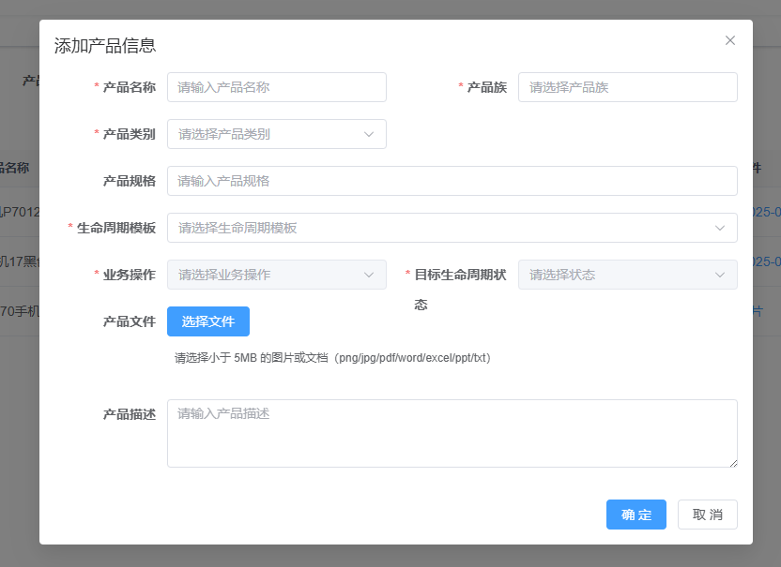
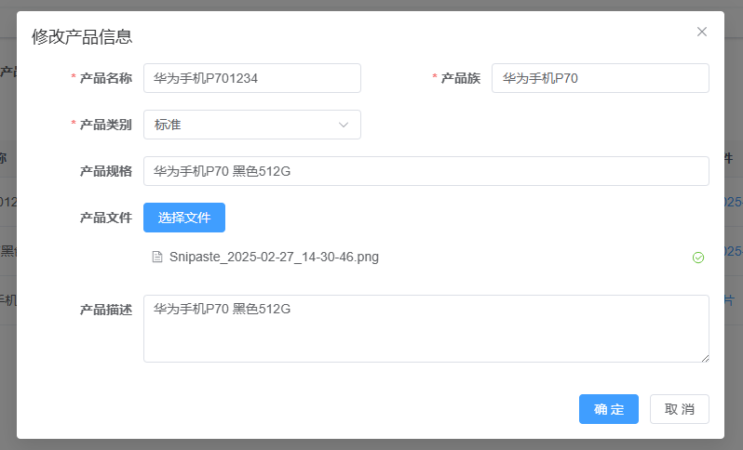
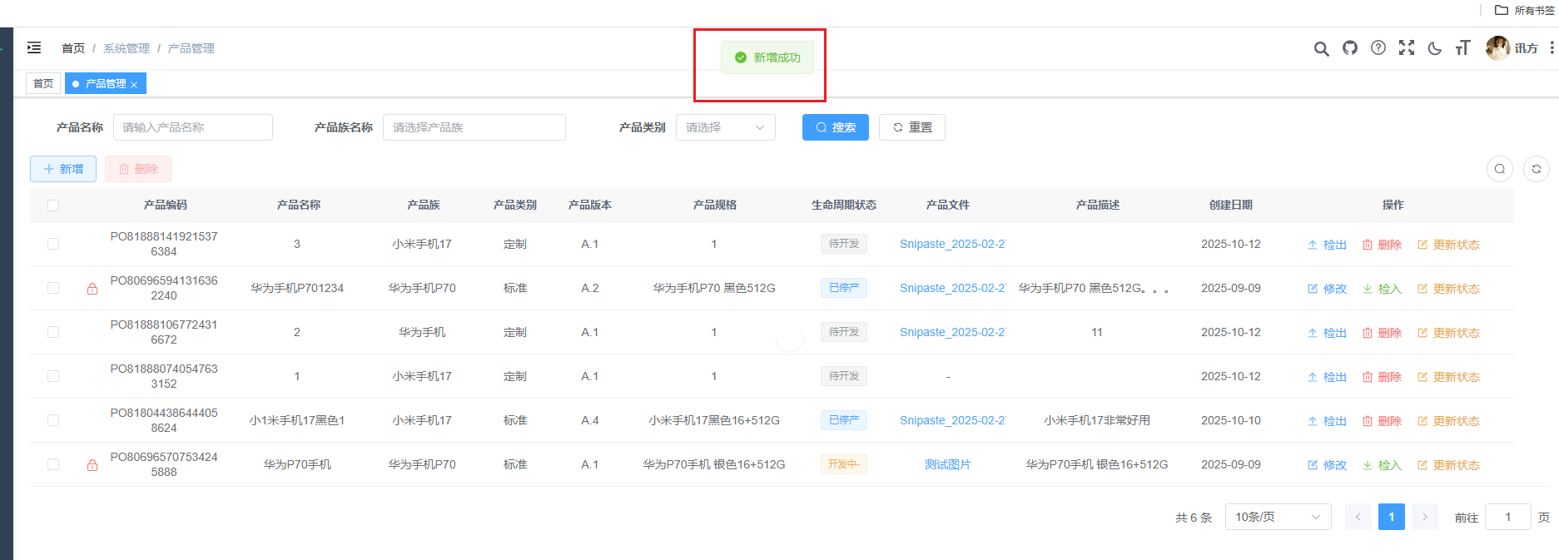
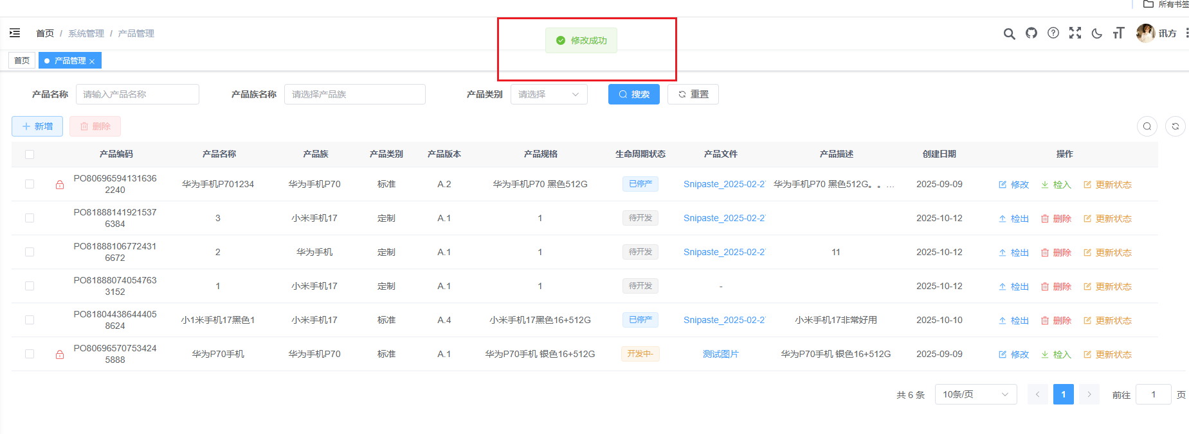

6.5 检出/检入/更新生命周期状态的弹窗
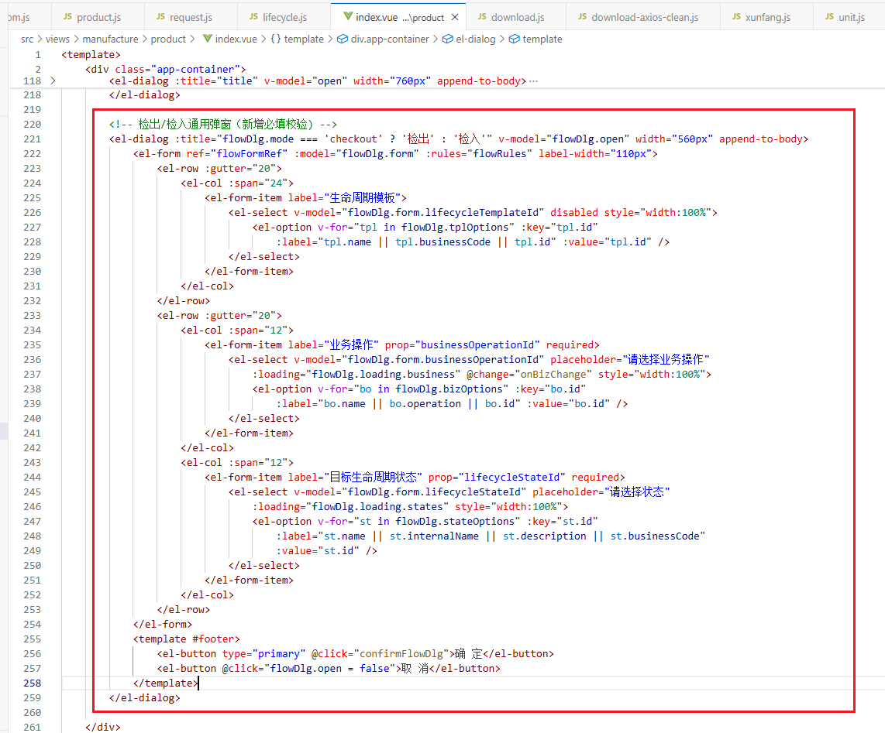
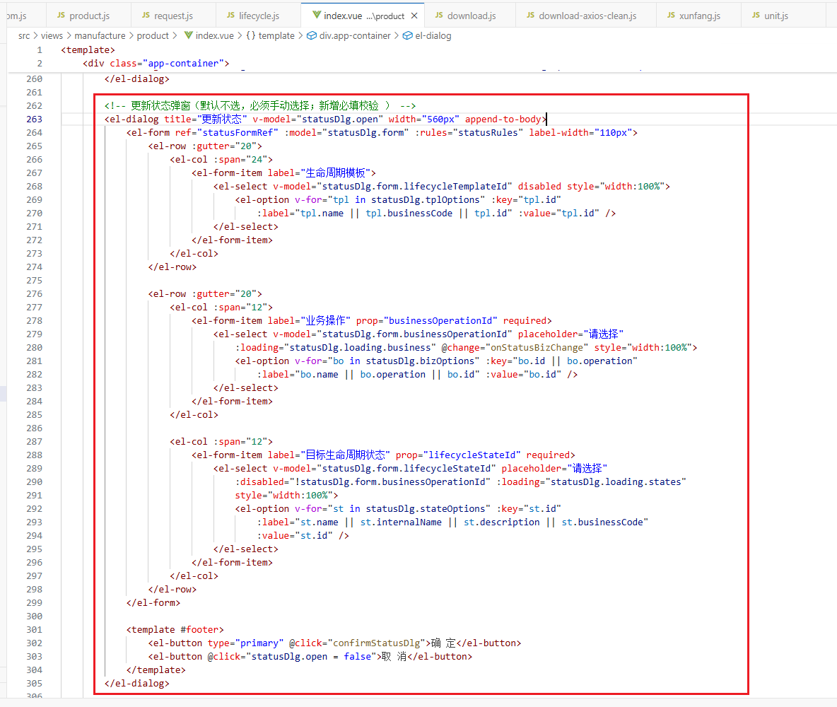
<!-- 检出/检入通用弹窗（新增必填校验) -->
<el-dialog :title="flowDlg.mode==='checkout' ? '检出' : '检入'" v-model="flowDlg.open" width="560px" append-to-body>
<el-form ref="flowFormRef" :model="flowDlg.form" :rules="flowRules" label-width="110px">
<el-row :gutter="20">
<el-col :span="24">
<el-form-item label="生命周期模板">
<el-select v-model="flowDlg.form.lifecycleTemplateId" disabled style="width:100%">
<el-option
v-for="tpl in flowDlg.tplOptions"
:key="tpl.id"
:label="tpl.name || tpl.businessCode || tpl.id"
:value="tpl.id"
/>
</el-select>
</el-form-item>
</el-col>
</el-row>
<el-row :gutter="20">
<el-col :span="12">
<el-form-item label="业务操作" prop="businessOperationId" required>
<el-select
v-model="flowDlg.form.businessOperationId"
placeholder="请选择业务操作"
:loading="flowDlg.loading.business"
@change="onBizChange"
style="width:100%"
>
<el-option
v-for="bo in flowDlg.bizOptions"
:key="bo.id"
:label="bo.name || bo.operation || bo.id"
:value="bo.id"
/>
</el-select>
</el-form-item>
</el-col>
<el-col :span="12">
<el-form-item label="目标生命周期状态" prop="lifecycleStateId" required>
<el-select
v-model="flowDlg.form.lifecycleStateId"
placeholder="请选择状态"
:loading="flowDlg.loading.states"
style="width:100%"
>
<el-option
v-for="st in flowDlg.stateOptions"
:key="st.id"
:label="st.name || st.internalName || st.description || st.businessCode"
:value="st.id"
/>
</el-select>
</el-form-item>
</el-col>
</el-row>
</el-form>
<template #footer>
<el-button type="primary" @click="confirmFlowDlg">确 定</el-button>
<el-button @click="flowDlg.open=false">取 消</el-button>
</template>
</el-dialog>

<!-- 更新状态弹窗（默认不选，必须手动选择；新增必填校验 ） -->
<el-dialog title="更新状态" v-model="statusDlg.open" width="560px" append-to-body>
<el-form ref="statusFormRef" :model="statusDlg.form" :rules="statusRules" label-width="110px">
<el-row :gutter="20">
<el-col :span="24">
<el-form-item label="生命周期模板">
<el-select v-model="statusDlg.form.lifecycleTemplateId" disabled style="width:100%">
<el-option
v-for="tpl in statusDlg.tplOptions"
:key="tpl.id"
:label="tpl.name || tpl.businessCode || tpl.id"
:value="tpl.id"
/>
</el-select>
</el-form-item>
</el-col>
</el-row>

<el-row :gutter="20">
<el-col :span="12">
<el-form-item label="业务操作" prop="businessOperationId" required>
<el-select
v-model="statusDlg.form.businessOperationId"
placeholder="请选择"
:loading="statusDlg.loading.business"
@change="onStatusBizChange"
style="width:100%"
>
<el-option
v-for="bo in statusDlg.bizOptions"
:key="bo.id || bo.operation"
:label="bo.name || bo.operation || bo.id"
:value="bo.id"
/>
</el-select>
</el-form-item>
</el-col>

<el-col :span="12">
<el-form-item label="目标生命周期状态" prop="lifecycleStateId" required>
<el-select
v-model="statusDlg.form.lifecycleStateId"
placeholder="请选择"
:disabled="!statusDlg.form.businessOperationId"
:loading="statusDlg.loading.states"
style="width:100%"
>
<el-option
v-for="st in statusDlg.stateOptions"
:key="st.id"
:label="st.name || st.internalName || st.description || st.businessCode"
:value="st.id"
/>
</el-select>
</el-form-item>
</el-col>
</el-row>
</el-form>

<template #footer>
<el-button type="primary" @click="confirmStatusDlg">确 定</el-button>
<el-button @click="statusDlg.open=false">取 消</el-button>
</template>
</el-dialog>
接着进行交互部分的代码编写，只需将所用到的参数及调用到的方法先进行编写，具体代码在6.9中可查看，且可根据自己的喜好渲染样式，具体代码参考6.10：
此时运行代码，点击检入/检出按钮，可以看到检入/检出的弹窗，其中检入和检出时，只会出现下一个业务操作的下拉选项，选中时目标生命周期状态会对应填入相应的数据，点击确定即可检入/检出成功。
检入成功后，条目前的锁头会消失，条目可进行删除、检出，信息（产品版本和生命周期状态）也会相应更新。
点击检出时，条目前会出现红色锁头，条目可进行修改，但不可删除，检出成功后信息（生命周期状态）会相应更新，但产品版本不变。
点击更新状态时，会出现更新状态的弹窗，可选择产品生命周期模板里面任意一个周期进行更新产品条目的状态，下拉选择业务操作后，目标生命周期状态会相应更新，不需要选择。
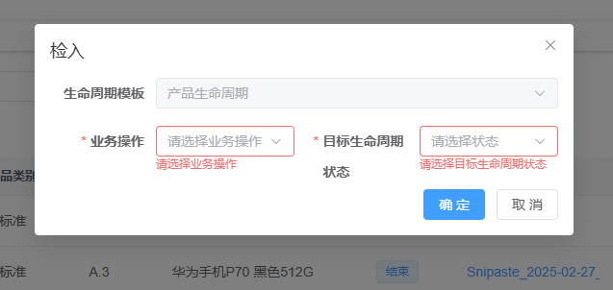
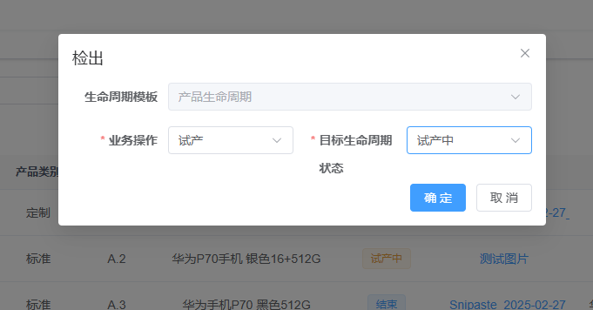
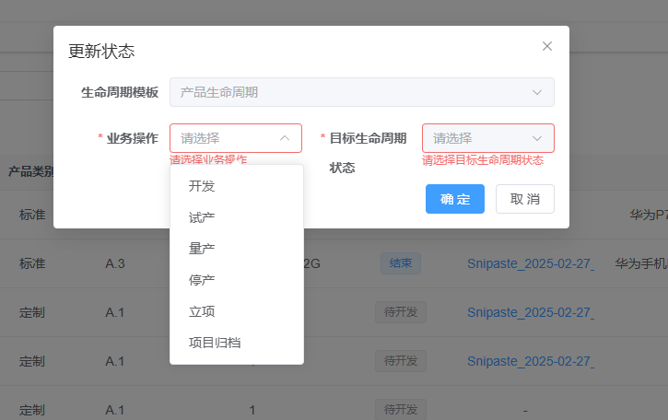
以下是其中的核心代码：

6.6 附件上传与校验（单文件）
- 白名单：png/jpg/jpeg/gif/bmp/webp/pdf/doc/docx/xls/xlsx/ppt/pptx/txt；大小 ≤ 5MB。
- 新增/修改共用：FormData 中 data 为 JSON Blob，file 为选中的 raw 文件；修改时支持 clearFile（删除原文件）。
- 下载：点击文件名用 downloadByStream(url, filename) 拉流保存。
<!-- 文件上传 -->
<el-form-item label="产品文件" >
<el-upload
ref="uploadRef"
class="upload-one wide"
:auto-upload="false"
:multiple="false"
list-type="text"
:file-list="fileList"
:before-upload="handleBeforeAdd"
:on-change="onFileChange"
:on-remove="onFileRemove"
accept=".png,.jpg,.jpeg,.gif,.bmp,.webp,.pdf,.doc,.docx,.xls,.xlsx,.ppt,.pptx,.txt"
>
<el-button type="primary">选择文件</el-button>
<template #tip v-if="!fileList.length">
<div class="el-upload__tip">请选择小于 5MB 的图片或文档（png/jpg/pdf/word/excel/ppt/txt）</div>
</template>
</el-upload>
</el-form-item>

6.7 生命周期（核心）——新增页（create 流程）
1.打开弹窗时调用 loadLifecycleTemplates()：GET /lifecycle/lifecycleTemplateList，过滤 businessCode 与 latest=true。
2.选择“生命周期模板”后，refreshBusinessAndStates()：GET /lifecycle/lifeBusiness（operation=create）拿到业务操作列表。
3.自动/手动选中某个业务操作后，refreshStatesOnly()：GET /lifecycle/lifeState 获取目标状态集合。
4.提交 addProduct(FormData)：仅传 {lifecycleTemplateId, lifecycleStateId}（后端自动组装 {id} 对象）。
<!-- 新增（create）联动区 -->
<el-row v-if="!form.id" :gutter="20">
<el-col :span="24">
<el-form-item label="生命周期模板" prop="lifecycleTemplateId" :required="isCreate">
<el-select
v-model="form.lifecycleTemplateId"
placeholder="请选择生命周期模板"
filterable clearable
:loading="lifeTplLoading"
@visible-change="v => v && loadLifecycleTemplates()"
@change="onTemplateChange"
style="width: 100%"
>
<el-option
v-for="tpl in lifecycleTemplateOptions"
:key="tpl.id"
:label="tpl.name || tpl.businessCode || tpl.id"
:value="tpl.id"
/>
</el-select>
</el-form-item>
</el-col>
</el-row>

<el-row v-if="!form.id" :gutter="20">
<el-col :span="12">
<el-form-item label="业务操作" prop="operation" :required="isCreate">
<el-select
v-model="form.operation"
placeholder="请选择业务操作"
:disabled="!form.lifecycleTemplateId"
:loading="lifeOpLoading"
@change="onOperationChange"
>
<el-option
v-for="op in createBizOptions"
:key="op.id || op.operation || op.name"
:label="op.name || op.operation || '创建'"
:value="op.operation || 'create'"
/>
</el-select>
</el-form-item>
</el-col>
<el-col :span="12">
<el-form-item label="目标生命周期状态" prop="lifecycleStateId" :required="isCreate">
<el-select
v-model="form.lifecycleStateId"
placeholder="请选择状态"
:disabled="!form.operation"
:loading="lifeStateLoading"
clearable
@change="onStatePicked"
>
<el-option
v-for="st in lifecycleStateOptions"
:key="st.id"
:label="st.name || st.internalName || st.description || st.businessCode"
:value="st.id"
/>
</el-select>
</el-form-item>
</el-col>

6.8 生命周期（核心）——检出/检入弹窗
1.检出 openFlowDlg(‘checkout’,row)：预填 row.lifecycleTemplateId；getLifecycleBusiness(operation=’checkout’ 实际复用 create/edit 规则) → getLifecycleStates；confirmFlowDlg() → PUT /product/checkout。
2.检入 openFlowDlg(‘checkin’,row)：同上，confirmFlowDlg() → PUT /product/checkin；viewNo 可空串。
- UI 工作状态：iDME 的 INWORK 在前端映射为 CHECKED_OUT；CHECKED_IN 保持。
- 保护：CHECKED_OUT 禁止删除；修改仅在 CHECKED_OUT。
<!-- 检出/检入通用弹窗（新增必填校验) -->
<el-dialog :title="flowDlg.mode==='checkout' ? '检出' : '检入'" v-model="flowDlg.open" width="560px" append-to-body>
<el-form ref="flowFormRef" :model="flowDlg.form" :rules="flowRules" label-width="110px">
<el-row :gutter="20">
<el-col :span="24">
<el-form-item label="生命周期模板">
<el-select v-model="flowDlg.form.lifecycleTemplateId" disabled style="width:100%">
<el-option
v-for="tpl in flowDlg.tplOptions"
:key="tpl.id"
:label="tpl.name || tpl.businessCode || tpl.id"
:value="tpl.id"
/>
</el-select>
</el-form-item>
</el-col>
</el-row>
<el-row :gutter="20">
<el-col :span="12">
<el-form-item label="业务操作" prop="businessOperationId" required>
<el-select
v-model="flowDlg.form.businessOperationId"
placeholder="请选择业务操作"
:loading="flowDlg.loading.business"
@change="onBizChange"
style="width:100%"
>
<el-option
v-for="bo in flowDlg.bizOptions"
:key="bo.id"
:label="bo.name || bo.operation || bo.id"
:value="bo.id"
/>
</el-select>
</el-form-item>
</el-col>
<el-col :span="12">
<el-form-item label="目标生命周期状态" prop="lifecycleStateId" required>
<el-select
v-model="flowDlg.form.lifecycleStateId"
placeholder="请选择状态"
:loading="flowDlg.loading.states"
style="width:100%"
>
<el-option
v-for="st in flowDlg.stateOptions"
:key="st.id"
:label="st.name || st.internalName || st.description || st.businessCode"
:value="st.id"
/>
</el-select>
</el-form-item>
</el-col>
</el-row>
</el-form>
<template #footer>
<el-button type="primary" @click="confirmFlowDlg">确 定</el-button>
<el-button @click="flowDlg.open=false">取 消</el-button>
</template>
</el-dialog>

6.9 生命周期（核心）——更新状态（edit 流程）
1.openStatusDlg(row)：固定 operation=’edit’，先 GET /lifecycle/lifeBusiness 再 GET /lifecycle/lifeState。
2.用户必须手选业务操作与目标状态，confirmStatusDlg() → PUT /product/updateStatus。
<!-- 更新状态弹窗（默认不选，必须手动选择；新增必填校验 ） -->
<el-dialog title="更新状态" v-model="statusDlg.open" width="560px" append-to-body>
<el-form ref="statusFormRef" :model="statusDlg.form" :rules="statusRules" label-width="110px">
<el-row :gutter="20">
<el-col :span="24">
<el-form-item label="生命周期模板">
<el-select v-model="statusDlg.form.lifecycleTemplateId" disabled style="width:100%">
<el-option
v-for="tpl in statusDlg.tplOptions"
:key="tpl.id"
:label="tpl.name || tpl.businessCode || tpl.id"
:value="tpl.id"
/>
</el-select>
</el-form-item>
</el-col>
</el-row>

<el-row :gutter="20">
<el-col :span="12">
<el-form-item label="业务操作" prop="businessOperationId" required>
<el-select
v-model="statusDlg.form.businessOperationId"
placeholder="请选择"
:loading="statusDlg.loading.business"
@change="onStatusBizChange"
style="width:100%"
>
<el-option
v-for="bo in statusDlg.bizOptions"
:key="bo.id || bo.operation"
:label="bo.name || bo.operation || bo.id"
:value="bo.id"
/>
</el-select>
</el-form-item>
</el-col>

<el-col :span="12">
<el-form-item label="目标生命周期状态" prop="lifecycleStateId" required>
<el-select
v-model="statusDlg.form.lifecycleStateId"
placeholder="请选择"
:disabled="!statusDlg.form.businessOperationId"
:loading="statusDlg.loading.states"
style="width:100%"
>
<el-option
v-for="st in statusDlg.stateOptions"
:key="st.id"
:label="st.name || st.internalName || st.description || st.businessCode"
:value="st.id"
/>
</el-select>
</el-form-item>
</el-col>
</el-row>
</el-form>

<template #footer>
<el-button type="primary" @click="confirmStatusDlg">确 定</el-button>
<el-button @click="statusDlg.open=false">取 消</el-button>
</template>
</el-dialog>

6.10 JS方法区
<script setup name="Product">
import { ref, reactive, toRefs, getCurrentInstance, computed } from "vue"
import { ElMessage } from "element-plus"
import {
listProduct, getProduct, addProduct, updateProduct,
delProduct, delProductBatch,
checkOut as checkoutProduct, checkIn as checkinProduct,
updateStatus
} from "@/api/manufacture/product"
import { listFamily } from "@/api/manufacture/productfamily"
import { downloadByStream } from "@/utils/download"
import {
listLifecycleTemplates,
getLifecycleBusiness,
getLifecycleStates
} from "@/api/manufacture/lifecycle"

const { proxy } = getCurrentInstance()

/** 列表与分页 */
const productList = ref([])
const loading = ref(true)
const showSearch = ref(true)
const ids = ref([])
const single = ref(true)
const multiple = ref(true)
const total = ref(0)
const title = ref("")
const open = ref(false)

/** 选择集里是否包含检出数据（用于批量删除禁用） */
const hasCheckedOutSelected = ref(false)

// 新增一个 ref 保存选中的整行数据
const selectedRows = ref([])

/** 生命周期（创建用） */
const lifecycleTemplateOptions = ref([])
const lifecycleStateOptions = ref([])
const lifeTplLoading = ref(false)
const lifeOpLoading = ref(false)
const lifeStateLoading = ref(false)

/** 仅新增用：create 操作返回 */
const createBizOptions = ref([])

/** 字典 */
const categoryDict = [
{ label: "定制", value: "CU" },
{ label: "标准", value: "ST" }
]

/** ------- 工具函数 ------- **/
const parseMaybeJson = (val) => {
if (typeof val === "string") {
const s = val.trim()
if ((s.startsWith("{") && s.endsWith("}")) || (s.startsWith("[") && s.endsWith("]"))) {
try { return JSON.parse(s) } catch (e) {}
}
}
return val
}
const codeOfCategory = (val) => {
const v = parseMaybeJson(val)
if (!v) return null
if (typeof v === "string") return v
return v.alias || v.code || v.value || null
}
const categoryLabel = (val) => {
const v = parseMaybeJson(val)
if (v && typeof v === "object") {
const code = v.alias || v.code
const hit = categoryDict.find(x => x.value === code)
return hit ? hit.label : (v.cnName || v.enName || code || "-")
} else {
const hit = categoryDict.find(x => x.value === v)
return hit ? hit.label : (v || "-")
}
}
const lcName = (row) => {
if (row.lifecycleStateName) return row.lifecycleStateName
const v = parseMaybeJson(row.lifecycleState)
if (v && typeof v === "object") {
return v.name || v.internalName || v.nameEn || v.businessCode || v.id || "-"
}
return v || "-"
}
const lcTag = (name) => {
const k = (name || "").toLowerCase()
if (k.includes("待开发") || k.includes("tobedeveloped")) return "info"
if (k.includes("开发中") || k.includes("indevelopment")) return "warning"
if (k.includes("试产中") || k.includes("trial")) return "warning"
if (k.includes("量产中") || k.includes("volume")) return "success"
if (k.includes("停产中") || k.includes("cease")) return "danger"
return ""
}

/** ========= 工作状态解析（展示） ========= */
const wsCode = (row) => {
const norm = (s) => {
if (!s) return ''
let x = String(s).trim().toUpperCase().replace(/[\s\-]+/g, '_')
if (x === 'CHECKEDIN') x = 'CHECKED_IN'
if (x === 'CHECKEDOUT') x = 'CHECKED_OUT'
if (x === 'INWORK') x = 'CHECKED_OUT'
return x
}
if (row && row.uiWorkingState) return norm(row.uiWorkingState)
const ws = row?.workingState
if (ws && typeof ws === 'object') return norm(ws.alias || ws.code || ws.value)
if (typeof ws === 'string') {
const s = ws.trim()
if ((s.startsWith('{') && s.endsWith('}')) || (s.startsWith('[') && s.endsWith(']'))) {
try { const obj = JSON.parse(s); return norm(obj.alias || obj.code || obj.value) } catch {}
}
return norm(s)
}
if (row?.workingStateAlias) return norm(row.workingStateAlias)
if (row?.workingStateCode) return norm(row.workingStateCode)
return ''
}

/** ★ 原始工作状态（用于提交到后端） */
const wsRaw = (row) => {
const norm = (s) => {
if (!s) return ''
let x = String(s).trim().toUpperCase().replace(/[\s\-]+/g, '_')
if (x === 'CHECKEDIN') x = 'CHECKED_IN'
if (x === 'CHECKEDOUT') x = 'CHECKED_OUT'
return x
}
const ws = row?.workingState
if (ws && typeof ws === 'object') return norm(ws.alias || ws.code || ws.value)
if (typeof ws === 'string') {
const s = ws.trim()
if ((s.startsWith('{') && s.endsWith('}')) || (s.startsWith('[') && s.endsWith(']'))) {
try { const obj = JSON.parse(s); return norm(obj.alias || obj.code || obj.value) } catch {}
}
return norm(s)
}
if (row?.workingStateCode) return norm(row.workingStateCode)
if (row?.uiWorkingState) return norm(row.uiWorkingState)
return ''
}

/** 产品族远程下拉 */
const familyOptions = ref([])
const familyLoading = ref(false)

/** 上传 */
const uploadRef = ref(null)
const fileList = ref([])
let selectedRawFile = null

/** 表单与查询 */
const data = reactive({
form: {},
queryParams: {
pageNum: 1,
pageSize: 10,
productCode: null,
productName: null,
productFamily: null,
category: null,
productVersion: null,
specificationModels: null,
productStatus: null,
productDescribe: null,
createUser: null,
updateUser: null
},
rules: {
productName: [{ required: true, message: "产品名称不能为空", trigger: "blur" }],
productFamily: [{ required: true, message: "请选择产品族", trigger: "change" }],
category: [{ required: true, message: "请选择产品类别", trigger: "change" }],

// 仅新增校验
lifecycleTemplateId: [
{ trigger: "change", validator: (_, v, cb) => (!form.value.id && !v) ? cb(new Error("请选择生命周期模板")) : cb() }
],
operation: [
{ trigger: "change", validator: (_, v, cb) => (!form.value.id && !v) ? cb(new Error("请选择业务操作")) : cb() }
],
lifecycleStateId: [
{ trigger: "change", validator: (_, v, cb) => (!form.value.id && !v) ? cb(new Error("请选择目标生命周期状态")) : cb() }
]
}
})
const { queryParams, form, rules } = toRefs(data)
const isCreate = computed(() => !form.value.id)

/** 族远程查询 */
function remoteMethodFamily(keyword) {
familyLoading.value = true
listFamily({ pageNum: 1, pageSize: 50, productFamilyNameCn: keyword || "" })
.then((res) => { familyOptions.value = res?.rows || [] })
.finally(() => { familyLoading.value = false })
}

/** 列表 */
function getList() {
loading.value = true
listProduct(queryParams.value).then((response) => {
productList.value = response.rows || []
total.value = response.total || 0
loading.value = false
})
}

/** 下载 */
function downloadFile(row) {
if (!row.fileDownloadUrl) { ElMessage.error("无下载地址"); return }
const filename = row.fileName || "download"
const sep = row.fileDownloadUrl.includes("?") ? "&" : "?"
const url = row.fileDownloadUrl + (filename ? `${sep}filename=${encodeURIComponent(filename)}` : "")
downloadByStream(url, filename).catch((e) => ElMessage.error(e?.message || "下载失败"))
}

/** 弹窗控制：新增/修改 */
function cancel() { open.value = false; reset() }
function handleAdd() {
reset()
open.value = true
title.value = "添加产品信息"
remoteMethodFamily("")
}
function handleUpdate(row) {
if (wsCode(row) !== 'CHECKED_OUT') {
ElMessage.warning('请先检出，再进行修改')
return
}
reset()
const _id = row.id || ids.value
getProduct(_id).then((response) => {
form.value = response.data || {}
form.value.category = codeOfCategory(form.value.category)
fileList.value = response.data?.fileName ? [{ name: response.data.fileName, url: "", status: "success" }] : []
form.value.fileId = response.data?.fileId || null
form.value.fileName = response.data?.fileName || null
form.value.fileDownloadUrl = response.data?.fileDownloadUrl || null
form.value.clearFile = false
selectedRawFile = null
open.value = true
title.value = "修改产品信息"
remoteMethodFamily(form.value.productFamily || "")
})
}

/** 重置表单 */
function reset() {
form.value = {
id: null,
productCode: null,
productName: null,
productFamily: null,
category: null,
productVersion: null,
specificationModels: null,
productStatus: null,
productDescribe: null,
createUser: null,
updateUser: null,

lifecycleTemplateId: null,
operation: null,
lifecycleStateId: null,
lifecycleStateName: null,
createTime: null,

clearFile: false,
fileId: null,
fileName: null,
fileDownloadUrl: null
}
uploadRef.value?.clearFiles?.()
selectedRawFile = null
fileList.value = []
proxy.resetForm("productRef")

lifecycleTemplateOptions.value = []
lifecycleStateOptions.value = []
createBizOptions.value = []
}

// 选择变化
function handleSelectionChange(selection) {
selectedRows.value = selection // 保存整行
ids.value = selection.map(item => item.masterId || item.id)
single.value = selection.length != 1
multiple.value = !selection.length
// 只要包含检出记录就禁用批量删除
hasCheckedOutSelected.value = selection.some(item => wsCode(item) === 'CHECKED_OUT')
}

// 批量删除
function handleBatchDelete() {
const rows = selectedRows.value
if (!rows.length) return ElMessage.warning('请先选择要删除的数据')
if (rows.some(r => wsCode(r) === 'CHECKED_OUT')) {
ElMessage.warning('包含检出状态的数据，不能删除')
return
}
const idsToDelete = rows.map(r => r?.masterId || r?.id).filter(Boolean)
if (!idsToDelete.length) return ElMessage.error('所选数据缺少 masterId')
const tip = idsToDelete.length === 1 ? idsToDelete[0] : `${idsToDelete.length} 条`
proxy.$modal.confirm(`是否确认批量删除（${tip}）？`)
.then(() => delProductBatch(idsToDelete))
.then(() => { proxy.$modal.msgSuccess('批量删除成功'); getList() })
.catch(() => {})
}

/** 搜索/重置 */
function handleQuery() { queryParams.value.pageNum = 1; getList() }
function resetQuery() { proxy.resetForm("queryRef"); handleQuery() }

/** 上传校验 */
const MAX_SIZE = 5 * 1024 * 1024
const ALLOWED_EXT = /\.(png|jpe?g|gif|bmp|webp|pdf|docx?|xlsx?|pptx?|txt)$/i
function validateFile(file) {
if (!ALLOWED_EXT.test(file.name)) { ElMessage.error("仅支持图片/文档：png、jpg、jpeg、gif、bmp、webp、pdf、doc/docx、xls/xlsx、ppt/pptx、txt"); return false }
if (file.size > MAX_SIZE) { ElMessage.error("文件大小不能超过 5MB"); return false }
return true
}
function handleBeforeAdd(file) {
if (fileList.value.length) { uploadRef.value?.clearFiles?.(); fileList.value = []; selectedRawFile = null }
return validateFile(file)
}
function onFileChange(file) {
if (!file?.raw) return
if (!validateFile(file.raw)) { uploadRef.value?.clearFiles?.(); fileList.value = []; selectedRawFile = null; return }
selectedRawFile = file.raw
fileList.value = [file]
form.value.clearFile = false
}
function onFileRemove() { selectedRawFile = null; fileList.value = []; form.value.clearFile = true }

/** 提交（新增/修改 + 可选附件） */
async function submitForm() {
const formVm = proxy.$refs["productRef"]
if (!formVm) return
const ok = await formVm.validate().catch(() => false)
if (!ok) return

const isAdd = !form.value.id
const payload = { ...form.value }
payload.category = codeOfCategory(payload.category)

const fd = new FormData()
fd.append("data", new Blob([JSON.stringify(payload)], { type: "application/json" }))
if (selectedRawFile) fd.append("file", selectedRawFile)

try {
if (isAdd) {
await addProduct(fd)
proxy.$modal.msgSuccess("新增成功")
} else {
await updateProduct(fd)
proxy.$modal.msgSuccess("修改成功")
}
open.value = false
getList()
} catch (e) {
ElMessage.error(e?.msg || e?.message || "提交失败")
}
}

/** 删除 */
function handleRowDelete(row) {
// 兜底保护：检出状态不允许删除
if (wsCode(row) === 'CHECKED_OUT') {
ElMessage.warning('检出状态不可删除，请先检入')
return
}
const masterId = row?.masterId || row?.id
if (!masterId) return
proxy.$modal.confirm(`是否确认删除产品（masterId: "${masterId}"）？`)
.then(() => delProduct(masterId))
.then(() => { proxy.$modal.msgSuccess("删除成功"); getList() })
.catch(() => {})
}

/** 单个删除 */
function handleSingleDelete(row) {
if (wsCode(row) === 'CHECKED_OUT') {
ElMessage.warning('检出状态的数据不能删除')
return
}
if (!row?.masterId) return ElMessage.error('缺少 masterId，无法删除')
const tip = `PN${row.id || ''}`
proxy.$modal.confirm(`是否确认删除（${tip}）？`)
.then(() => delProduct(row.masterId))
.then(() => { proxy.$modal.msgSuccess('删除成功'); getList() })
.catch(() => {})
}

function handleDeleteSelected() {
if (hasCheckedOutSelected.value) {
ElMessage.warning('选中的记录包含检出状态，无法批量删除')
return
}
if (!ids.value?.length) { ElMessage.warning("请先选择要删除的记录"); return }
proxy.$modal.confirm(`是否确认删除选中的 ${ids.value.length} 条数据？`)
.then(() => delProductBatch(ids.value))
.then(() => { proxy.$modal.msgSuccess("删除成功"); getList() })
.catch(() => {})
}

/** ================= 检出 / 检入 ================= */
const flowDlg = reactive({
open: false,
mode: 'checkout',
row: null,
form: {
masterId: '',
operation: 'checkout',
lifecycleTemplateId: '',
businessOperationId: '',
lifecycleStateId: '',
currentStateId: ''
},
tplOptions: [],
bizOptions: [],
stateOptions: [],
loading: { templates: false, business: false, states: false }
})

const flowFormRef = ref(null)
const flowRules = {
businessOperationId: [{ required: true, message: '请选择业务操作', trigger: 'change' }],
lifecycleStateId: [{ required: true, message: '请选择目标生命周期状态', trigger: 'change' }]
}

function openFlowDlg(mode, row) {
flowDlg.mode = mode
flowDlg.open = true
flowDlg.row = row
flowDlg.form.operation = mode
flowDlg.form.masterId = row.masterId || row.id
flowDlg.form.currentStateId =
(row?.lifecycleState && row.lifecycleState.id) || row?.lifecycleStateId || ""
const tplId = row?.lifecycleTemplate?.id || row?.lifecycleTemplateId || ''
flowDlg.form.lifecycleTemplateId = tplId
loadFlowTemplates(tplId).then(() => { pickNextBusinessAndStates() })
}
async function loadFlowTemplates(prefillId) {
flowDlg.loading.templates = true
try {
const res = await listLifecycleTemplates({
"master.businessCode": "LCT00000009",
latest: true, pageNum: 1, pageSize: 50
})
flowDlg.tplOptions = res?.rows || res?.data || []
if (prefillId && !flowDlg.tplOptions.some(t => t.id === prefillId)) {
flowDlg.tplOptions.unshift({ id: prefillId, name: '' })
}
} finally { flowDlg.loading.templates = false }
}
async function pickNextBusinessAndStates() {
const tplId = flowDlg.form.lifecycleTemplateId
const op = flowDlg.form.operation
const curStateId = flowDlg.form.currentStateId || undefined
if (!tplId || !op) return
flowDlg.loading.business = true
try {
const bizRes = await getLifecycleBusiness({ templateId: tplId, operation: op, stateId: curStateId })
const list = Array.isArray(bizRes?.data) ? bizRes.data : (bizRes?.data ? [bizRes.data] : [])
flowDlg.bizOptions = list
let picked = null, targets = []
for (const bo of list) {
const r = await getLifecycleStates({
templateId: tplId, businessOperationId: bo.id, stateId: curStateId, operation: op
})
const arr = r?.data || r?.rows || []
if (Array.isArray(arr) && arr.length) { picked = bo; targets = arr; break }
}
if (!picked) { flowDlg.stateOptions = []; flowDlg.form.businessOperationId=''; flowDlg.form.lifecycleStateId=''; return }
flowDlg.form.businessOperationId = picked.id
flowDlg.stateOptions = targets
flowDlg.form.lifecycleStateId = targets[0]?.id || ''
} finally { flowDlg.loading.business = false }
}
function onBizChange() { flowDlg.form.lifecycleStateId = ''; loadFlowStates() }
async function loadFlowStates() {
const tplId = flowDlg.form.lifecycleTemplateId
const boId = flowDlg.form.businessOperationId
if (!tplId || !boId) { flowDlg.stateOptions = []; return }
flowDlg.loading.states = true
try {
const stateRes = await getLifecycleStates({
templateId: tplId, businessOperationId: boId,
stateId: flowDlg.form.currentStateId || undefined, operation: flowDlg.form.operation
})
const arr = stateRes?.data || stateRes?.rows || []
flowDlg.stateOptions = Array.isArray(arr) ? arr : (arr ? [arr] : [])
flowDlg.form.lifecycleStateId = flowDlg.stateOptions.length ? flowDlg.stateOptions[0].id : ''
} finally { flowDlg.loading.states = false }
}
async function confirmFlowDlg() {
const ok = await flowFormRef.value?.validate().catch(() => false)
if (!ok) return

const { masterId, lifecycleTemplateId, lifecycleStateId } = flowDlg.form
const payload = {
masterId,
lifecycleTemplate: { id: lifecycleTemplateId },
lifecycleState: { id: lifecycleStateId }
}
try {
if (flowDlg.mode === 'checkout') {
await checkoutProduct({ ...payload, workCopyType: 'BOTH' })
proxy.$modal.msgSuccess('检出成功')
} else {
await checkinProduct({ ...payload, viewNo: '' })
proxy.$modal.msgSuccess('检入成功')
}
flowDlg.open = false
getList()
} catch (e) { ElMessage.error(e?.msg || e?.message || '操作失败') }
}

/** ============ 新增页：生命周期（create） ============ */
function loadLifecycleTemplates() {
if (lifeTplLoading.value) return
lifeTplLoading.value = true
listLifecycleTemplates({
"master.businessCode": "LCT00000009",
latest: true, pageNum: 1, pageSize: 50
})
.then((res) => { lifecycleTemplateOptions.value = (res?.rows || res?.data || []) })
.finally(() => (lifeTplLoading.value = false))
}
function onTemplateChange() {
form.value.operation = null
form.value.lifecycleStateId = null
form.value.lifecycleStateName = null
lifecycleStateOptions.value = []
createBizOptions.value = []
refreshBusinessAndStates()
}
function onOperationChange() {
form.value.lifecycleStateId = null
form.value.lifecycleStateName = null
lifecycleStateOptions.value = []
refreshStatesOnly()
}
function refreshBusinessAndStates() {
const tplId = form.value.lifecycleTemplateId
const op = form.value.operation || "create"
if (!tplId) return
lifeOpLoading.value = true
getLifecycleBusiness({ templateId: tplId, operation: op })
.then((res) => {
const list = Array.isArray(res?.data) ? res.data : (res?.data ? [res.data] : [])
createBizOptions.value = list.length ? list : [{ operation: 'create', name: '创建' }]
if (!form.value.operation && createBizOptions.value.length) {
form.value.operation = createBizOptions.value[0].operation || 'create'
}
return refreshStatesOnly()
})
.finally(() => (lifeOpLoading.value = false))
}
function refreshStatesOnly() {
const tplId = form.value.lifecycleTemplateId
const chosen = createBizOptions.value.find(op => (op.operation || 'create') === (form.value.operation || 'create'))
const businessOperationId = chosen?.id
if (!tplId || !businessOperationId) return
lifeStateLoading.value = true
return getLifecycleStates({ templateId: tplId, businessOperationId })
.then((res2) => {
const arr = res2?.data || res2?.rows || []
lifecycleStateOptions.value = Array.isArray(arr) ? arr : (arr ? [arr] : [])
form.value.lifecycleStateId = lifecycleStateOptions.value.length ? lifecycleStateOptions.value[0].id : null
})
.finally(() => (lifeStateLoading.value = false))
}
function onStatePicked(val) {
const st = lifecycleStateOptions.value.find((x) => x.id === val)
form.value.lifecycleStateName = st?.name || st?.internalName || st?.description || null
}

/** ================= ★ 更新状态（operation 固定 edit） ================= */
const statusDlg = reactive({
open: false,
row: null,
form: {
id: '',
lifecycleTemplateId: '',
businessOperationId: '',
lifecycleStateId: '',
workingState: '' // 当前行真实工作状态
},
tplOptions: [],
bizOptions: [],
stateOptions: [],
loading: { business: false, states: false }
})

const statusFormRef = ref(null)
const statusRules = {
businessOperationId: [{ required: true, message: '请选择业务操作', trigger: 'change' }],
lifecycleStateId: [{ required: true, message: '请选择目标生命周期状态', trigger: 'change' }]
}

function openStatusDlg(row) {
statusDlg.open = true
statusDlg.row = row
statusDlg.form.id = row.id || row.masterId || ''
statusDlg.form.workingState = wsRaw(row) || '' // 真实工作状态
const tplId = row?.lifecycleTemplate?.id || row?.lifecycleTemplateId || ''
statusDlg.form.lifecycleTemplateId = tplId
statusDlg.tplOptions = tplId ? [{ id: tplId, name: row?.lifecycleTemplate?.name || '' }] : []

// 重置选择为空，要求用户手动选择
statusDlg.form.businessOperationId = ''
statusDlg.form.lifecycleStateId = ''
statusDlg.stateOptions = []
loadStatusBusiness()
}

async function loadStatusBusiness() {
const tplId = statusDlg.form.lifecycleTemplateId
if (!tplId) { statusDlg.bizOptions = []; statusDlg.stateOptions = []; return }
statusDlg.loading.business = true
try {
// 获取业务操作列表（edit）
const res = await getLifecycleBusiness({ templateId: tplId, operation: 'edit', stateId: '' })
const list = (res?.rows || res?.data || [])
statusDlg.bizOptions = Array.isArray(list) ? list : (list ? [list] : [])
// 不自动选择，等待用户点击
} finally { statusDlg.loading.business = false }
}
function onStatusBizChange() {
statusDlg.form.lifecycleStateId = ''
loadStatusStates()
}

async function loadStatusStates() {
const tplId = statusDlg.form.lifecycleTemplateId
const boId = statusDlg.form.businessOperationId
if (!tplId || !boId) { statusDlg.stateOptions = []; return }
statusDlg.loading.states = true
try {
const r = await getLifecycleStates({ templateId: tplId, businessOperationId: boId, operation: 'edit', stateId: '' })
const arr = r?.data || r?.rows || []
statusDlg.stateOptions = Array.isArray(arr) ? arr : (arr ? [arr] : [])
// 不自动选择，等待用户点击
} finally { statusDlg.loading.states = false }
}

async function confirmStatusDlg() {
const ok = await statusFormRef.value?.validate().catch(() => false)
if (!ok) return

const { id, lifecycleTemplateId, lifecycleStateId, workingState } = statusDlg.form
const payload = {
id,
workingState: workingState || '',
lifecycleTemplate: { id: lifecycleTemplateId },
lifecycleState: { id: lifecycleStateId }
}

try {
await updateStatus(payload)
proxy.$modal.msgSuccess('更新成功')
statusDlg.open = false
getList()
} catch (e) {
ElMessage.error(e?.msg || e?.message || '更新失败')
}
}

getList()
</script>

6.11 CSS样式渲染区
<style scoped>
:deep(.el-table .cell) {
white-space: nowrap;
overflow: hidden;
text-overflow: ellipsis;
max-width: 100%;
}
.lock-red { color: #F56C6C; font-size: 16px; vertical-align: middle; }
.wrap-scroll {
white-space: normal !important;
word-break: break-all;
line-height: 18px;
max-height: 54px;
overflow-y: auto;
padding-right: 4px;
}
.upload-one.wide { width: 100%; }
.upload-one.wide .el-upload-list,
.upload-one.wide .el-upload-list__item,
.upload-one.wide .el-upload-list__item-name { max-width: none; width: 100%; }
.upload-one.wide .el-upload-list__item-name { white-space: normal; word-break: break-all; }
.upload-one.wide .el-upload__tip { margin-left: 8px; }
</style>

7. 关键 UI/交互规范
- 编码展示：产品族编码 PF{id}，产品编码 PO{id}。
- 操作按钮显隐与禁用：基于 wsCode(row) 与 hasCheckedOutSelected。
- 分页序号计算：index = (pageNum-1)*pageSize + index + 1（若需要）。
- 表格单元支持 wrap-scroll 与 tooltip，避免内容溢出。

8. 运行与联调
步骤 | 命令/动作 | 说明
安装依赖 | pnpm i / npm i / yarn | 首次拉代码执行
启动前端 | pnpm dev / npm run dev | 浏览器访问 /manufacture/** 路由
获取 token | 登录或 Postman | 写入本地缓存，axios 拦截器自动带上
联调接口 | 打开“产品族/产品”页面做 CRUD | Network 观察入参与状态码，校验生命周期链路

9. 测试用例

9.1 产品族
用例 | 前置 | 步骤 | 期望
新增必填校验 | 进入新增弹窗 | 留空中文名/英文名提交 | 红字提示，接口不发起
模糊查询 | 已有多条数据 | 按中文名关键词查询 | 仅返回命中记录
批量删除 | 选择多条记录 | 点击删除确认 | 成功提示，列表刷新

9.2 产品（生命周期）
用例 | 前置 | 步骤 | 期望
新增（create） | 可获取模板/业务/状态 | 依次选择模板→业务→目标状态→提交 | 新增成功，列表出现新记录
检出→修改→检入 | 一条 CHECKED_IN 的记录 | 检出→修改名称→检入 | 状态切换正确，修改生效
更新状态（edit） | 有一条记录 | 打开“更新状态”弹窗选择业务与目标状态并提交 | 状态更新成功
删除保护 | 一条 CHECKED_OUT 记录 | 尝试删除 | 弹警告：检出状态不可删除
附件三策略 | 已有附件记录 | 保持/替换/清除分别提交 | 下载链接正确、文件行为符合预期

10. 常见问题排查（Troubleshooting）
现象 | 可能原因 | 处理建议
生命周期状态列表为空 | 未先请求业务操作/未传 businessOperationId | 先 GET lifeBusiness 再 GET lifeState
修改按钮不显示 | uiWorkingState 未解析为 CHECKED_OUT | 检查 wsCode()/setWorkingStateFlex() 映射
下载链接 404 | fileId 或 instanceId 缺失 | 确认 extractFileName() 是否成功与下载 URL 参数拼装
批量删除按钮被禁用 | 选择集中含 CHECKED_OUT | 取消选中检出中的记录
上传报错 | 文件超限或后缀不在白名单 | 遵循 5MB 与扩展名白名单

11. 验收标准
- “产品族/产品”页面可完成查询、分页、增删改；类别字典显示正确。
- 生命周期链路：新增（create）、检出/检入、更新状态（edit）全打通。
- 附件三策略与下载可用；删除/修改保护逻辑生效。
- 至少通过本手册所列 90%+ 手工用例。

