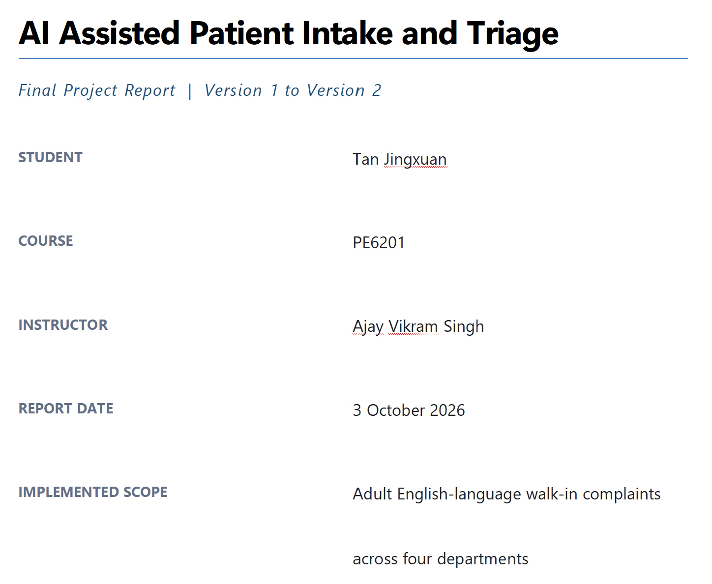

Abstract
This project evaluates a rule-constrained retrieval-augmented system that converts an adult's English walk-in complaint and age into emergency escalation, a provisional department, or human review. Version 1 established an auditable baseline and safety-first architecture but achieved 48.33% routine accuracy, reviewed 51.33% of cases, and missed 6/20 emergencies. Version 2 expanded red-flag expressions, removed the single-department keyword gate, retrieved across four departments, and increased the traceable weak-label corpus from 10 to 33 records while retaining evidence validation. On the same 150-case development regression set, routine accuracy rose to 99.17%, review fell to 6.67%, dangerous misses fell to 0/20, and false escalations remained zero. Because Version 1 outcomes informed Version 2, this result demonstrates correction of known failures rather than independent generalisation. One gait complaint was misrouted, and two emergencies still relied on the model instead of deterministic rules.

1 Project Scope and Decision Logic
Given an adult's English complaint and age, the system checks hard-coded red flags before returning EMERGENCY_ESCALATION, ROUTE_DEPARTMENT, or HUMAN_REVIEW. It does not diagnose or treat. The implemented scope is Dermatology, Neurology, Orthopedics and Urology; the original eight-department scope was reduced because reviewed evidence was insufficient and source specialties were not intake ground truth.

2 Response to Feedback
The final design responds to the feedback by naming the baseline, preserving rule-first escalation, documenting specialty mapping before indexing, bounding review at 12%, and reporting dangerous misses separately from routing accuracy.
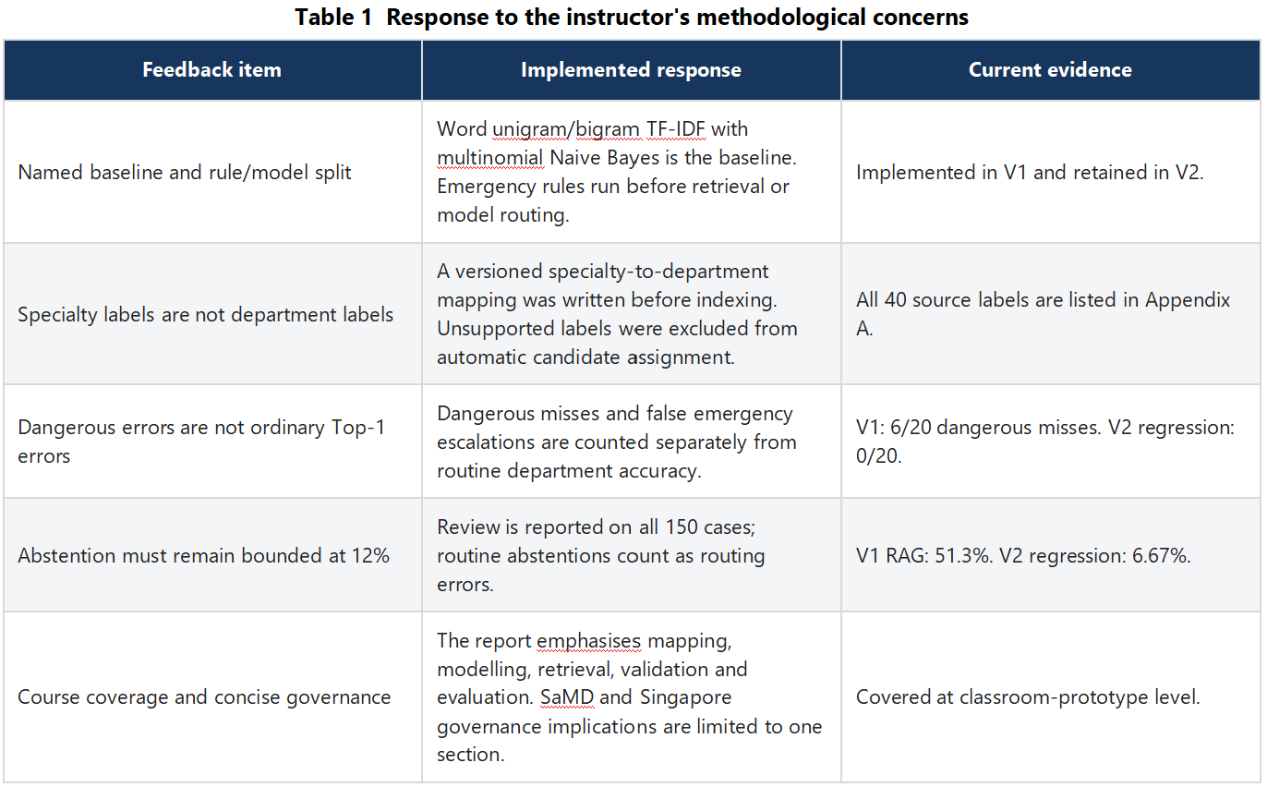

3 Data Preparation and Department Mapping
The source contains 4,999 medical transcriptions with 40 specialty labels. Because a source specialty is not necessarily the correct walk-in destination, mapping was treated as a project decision rather than ground truth. Appendix A records the complete pre-index mapping; four departments were retained for implementation.
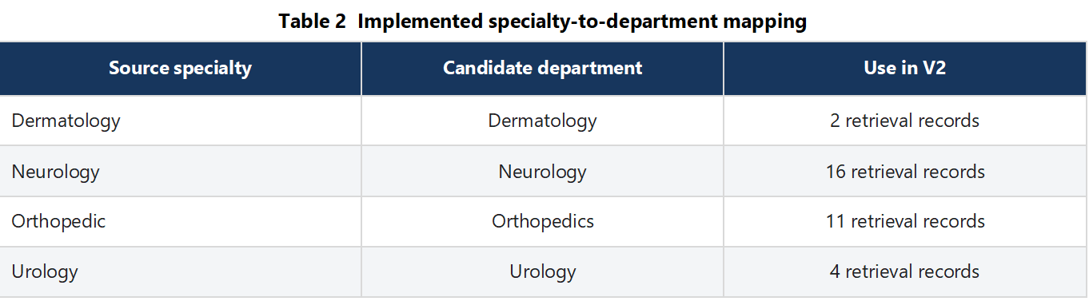
Cleaning retained source text, duplicate groups, extraction spans and exclusion reasons. Complaints came from identified chief-complaint, history-of-present-illness or subjective sections; the full chart did not replace a missing complaint. Pediatric, procedure-only and administrative visits were excluded. Follow-ups with a current symptom could remain, while ambiguous multi-symptom cases required review.
Version 2 combined the 10 Version 1 examples with 23 screened, source-traceable candidates, producing 33 group-deduplicated retrieval records. Their specialty-derived labels remain weak development labels rather than independently approved clinical ground truth.

4 System Design and Targeted Version 2 Changes
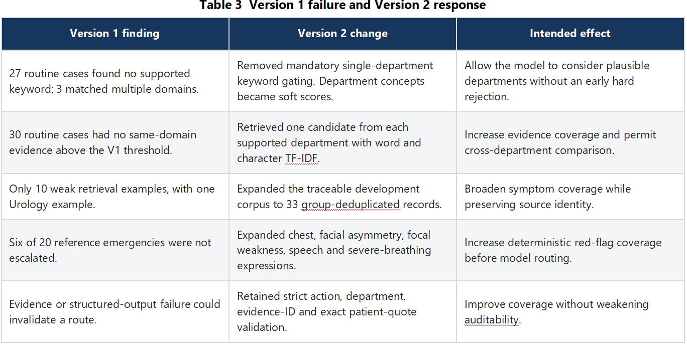

4.1 Baseline
The transparent baseline uses word unigram/bigram TF-IDF with multinomial Naive Bayes and shares Version 1's emergency and scope layer. It was not redefined for the Version 2 comparison.

4.2 Version 2 Retrieval and Generation
Version 2 combines word TF-IDF similarity (0.55) with character 3-5-gram TF-IDF similarity (0.45) and retrieves one qualifying example per department. Department concepts are soft scores, not routing rules. Complaint, age and retrieved weak examples are sent through OpenRouter to openai/gpt-4.1-mini; freezing local code cannot freeze future provider behaviour.

4.3 Safety, Scope and Validation
Emergency expressions run before the model. Scope and input guards can send cases directly to review. A model route is accepted only when its action and department are valid, evidence IDs were retrieved in that call, patient quotations occur in the complaint, and a department route cites same-department evidence. API or validation failure leads to human review.

5 Evaluation Design and Metrics
The frozen set contains 120 routine, 20 emergency and 10 review/scope cases with references fixed before prediction. It is synthetic and was not independently clinician-reviewed. Version 2 reused it after Version 1 failures had informed development, so the second run is a before/after regression comparison, not an independent test of generalisation or clinical validity.
Version 2 achieved 99.17% routine accuracy on this development regression set versus 48.33% for Version 1. The improvement supports the targeted changes to domain gating, retrieval coverage and red-flag expressions. However, reuse of inspected cases can bias performance upward; independent generalisation requires a newly frozen test set that did not influence development.
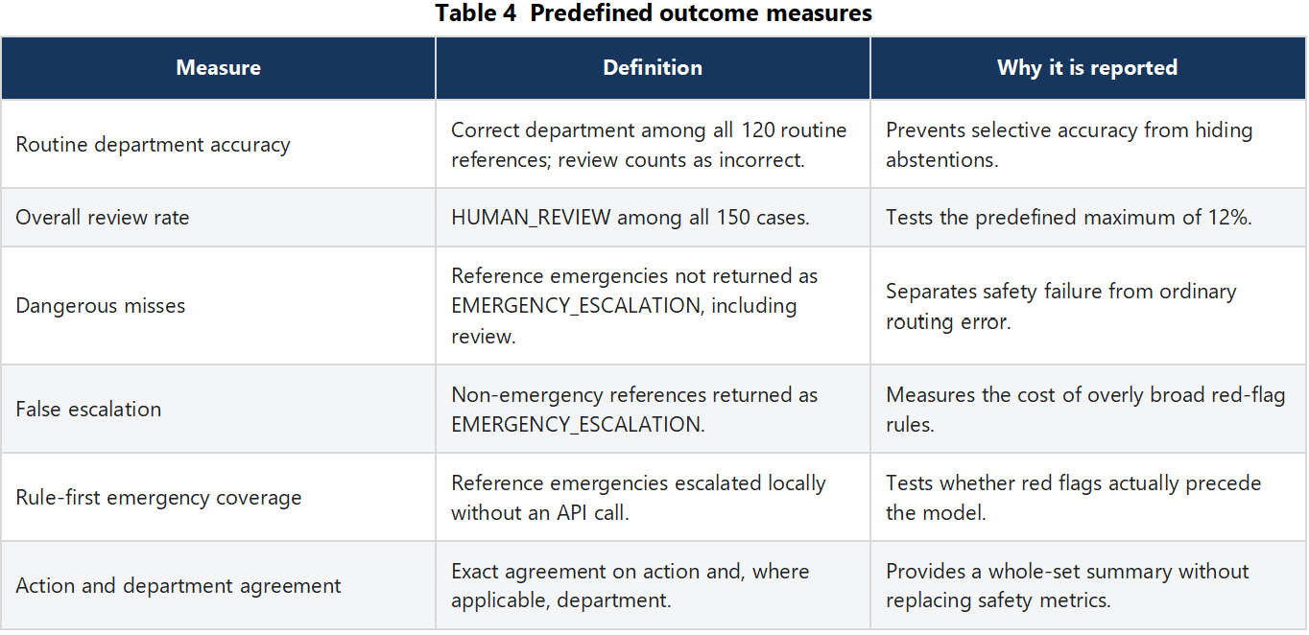

6 Version 1 Results and Failure Analysis
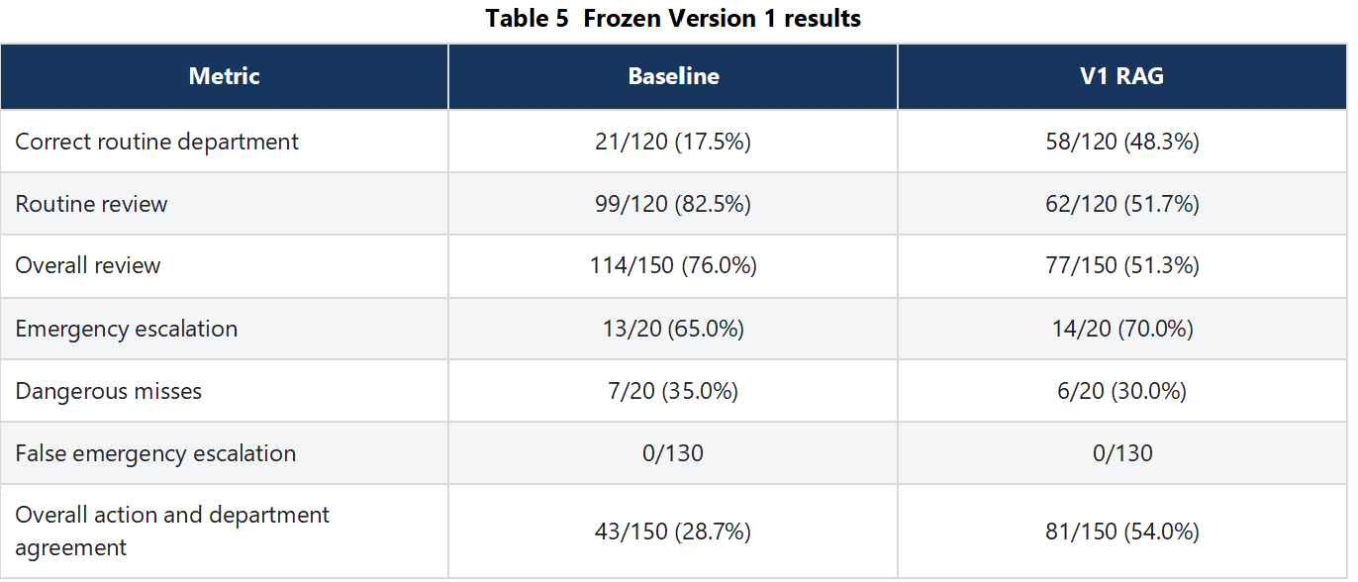
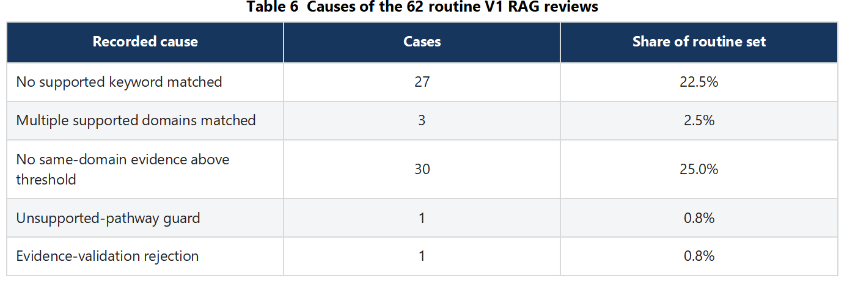
Version 1 failed mainly because keyword and same-domain retrieval gates rejected routine complaints before useful routing. Its six dangerous misses are reported separately, as required: a safety failure cannot be averaged away as one ordinary Top-1 error.

7 Version 2 Development Regression Results
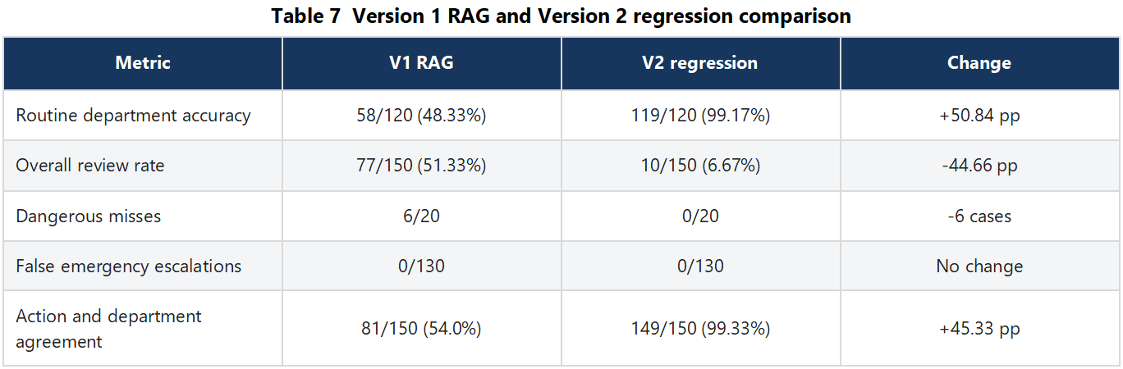
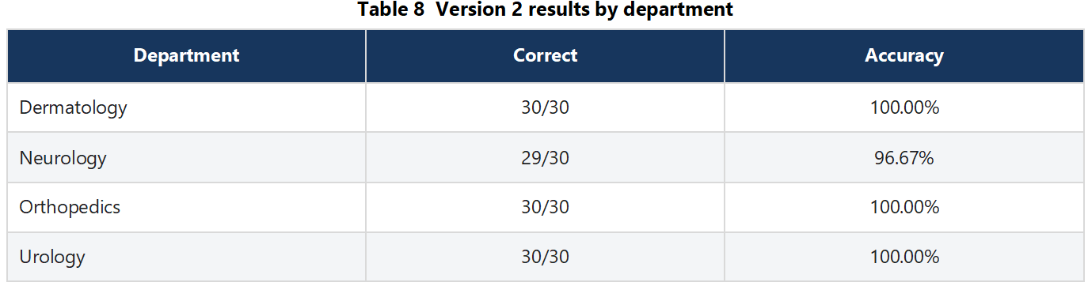
All 126 API outputs passed validation. The run used 147,809 tokens and cost USD 0.0726176, about USD 0.000576 per call. Median API-path latency was 1.183 seconds; this excludes staff entry time and is not total workflow duration.

8 Version 2 Failure Cases and Residual Risk

8.1 Routine misclassification
N048 was the only routine error: a complaint that the feet hesitated before the first step was routed to Orthopedics instead of Neurology. Generic foot and gait signals outweighed gait-initiation meaning. Future tuning should add freezing and difficulty-starting concepts while reducing generic foot influence when pain or injury is absent, then test unseen paraphrases.

8.2 Emergency cases that still depended on the model
All 20 emergencies were escalated, but hard-coded rules intercepted only 18. N132 described transient inability to raise one arm and N135 described transient slurred speech; both required the model. These symptoms should trigger deterministic escalation. The correct claim is therefore zero dangerous misses with 18/20 rule-first coverage, not 20/20 rule coverage.

8.3 Data and evaluation limitations
- The 33 retrieval records use weak specialty-derived labels and are department-imbalanced.
- Some source narratives exceed a concise walk-in complaint.
- The synthetic references were not independently clinician-reviewed.
- Reuse of inspected cases makes 99.17% vulnerable to development-set overfitting.
- The four-department adult English scope does not establish eight-department performance.

9 Objective Status
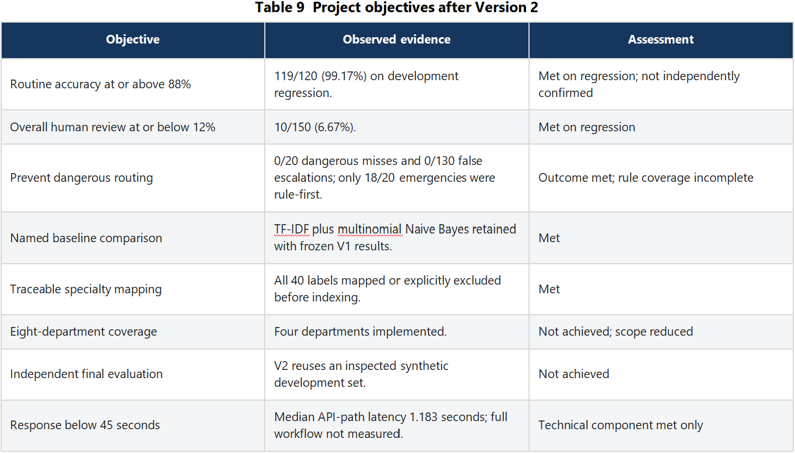

10 Course Coverage, Governance and Conclusion
The project covers problem framing, data preparation, feature representation, a named baseline, RAG, validation and evaluation. It shows why safety-sensitive assessment must combine accuracy with coverage, review, dangerous misses, false escalation, traceability, cost and latency.
This educational prototype is not presented as Software as a Medical Device and has not undergone clinical, privacy, cybersecurity, IMDA or deployment assessment. Real use would require verified labels, accountable human oversight, security controls, monitoring, incident review and assessment against applicable Singapore requirements.
Cross-department retrieval and a larger traceable corpus corrected most known Version 1 failures: accuracy increased from 48.33% to 99.17%, review fell from 51.33% to 6.67%, and dangerous misses fell from six to zero. The next path is to extend deterministic transient-neurology rules, address gait initiation without case-specific lookup, freeze the system, and evaluate a new independently reviewed set once.

Appendix A Original Specialty Mapping Before Indexing
Appendix A records every pre-index specialty decision. Excluded labels did not create automatic candidates; their raw records were not deleted. The initial eight-department mapping was later reduced to four implemented departments.
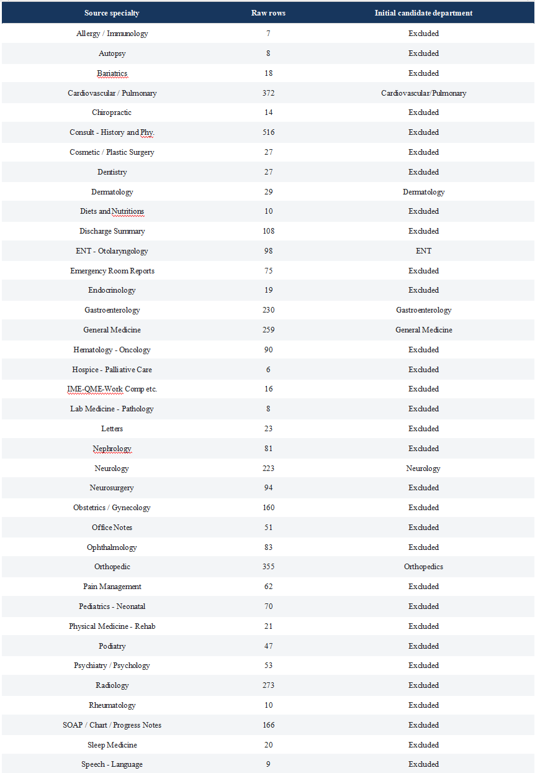

Appendix B Reproducibility and Artifact Integrity
Version 1 and Version 2 remain separate observations. The Version 2 archive contains the 33-record corpus, build diagnostics, all 150 predictions and aggregate metrics; the accompanying hashes identify the exact inputs.
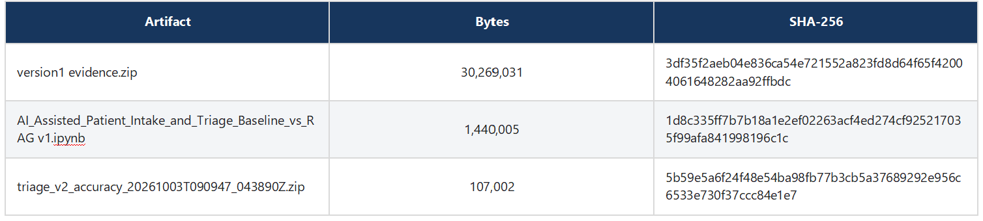
Version 2 used configuration intake_rag_v2_cross_department and completed 150 cases with 126 API attempts, 126 validated outputs and no stored API or validation errors. Full source and corpus hashes are shown above.

