Append Data
The Append Data feature enables you to append custom data to a selection in the model on the fly, providing the option to use pre-saved templates for enhanced simplicity and consistency. You can use existing templates or create a new one.
Follow the steps below to append data to the elements of a model.
- From Standard Tools, select Append Data.
- To use an existing template, select one from the Template drop-down. To create a new one, select .
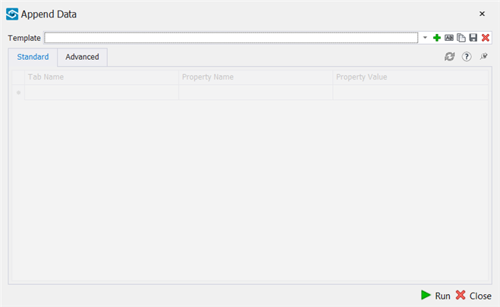
- Enter a name for the new template.
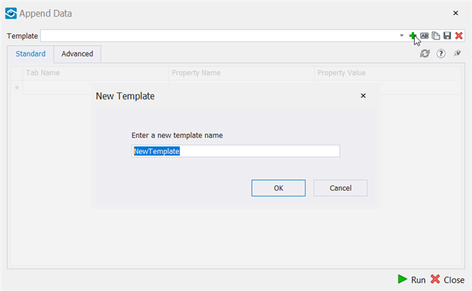
- In the Standard tab, enter Tab Name, Property Name and Property Value.
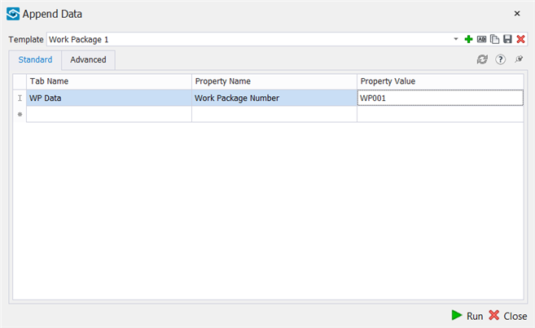
You can add multiple tabs and properties to a template.
- In the Advanced tab, provide the following details:
  - Apply Property To - Select the level to which you want to append the property. You can apply to groups or items or both.
  - Create New Tab If Non-Existent - Select to create a new tab for the properties and property values you enter. If this checkbox is not selected, new tab will not be created.
  - Keep Existing User Tabs - Select to retain the existing user tabs after appending the data.
  - Delete Property If Value is Blank - Select to delete a property that is blank.
  - Delete Target Tab If Value Is Blank - Select to delete the tab which has all the property(ies) with null values.
  - Apply Color / Transparency Overrides - Select to apply a color and transparency to the elements to which the data will be appended.
  - Transparency - Set the transparency to be applied to the elements to which the data will be appended.
  - Color - Select a color to be applied to the elements to which the data will be appended.
  - Save Viewpoint As - Select to save a viewpoint for the Append Data, and enter a prefix to the viewpoint in the adjacent textbox.
  - Choose Icon - Select an icon to be displayed for the Append Data template you create.
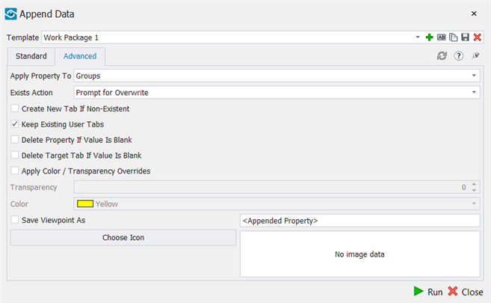
Transparency and Color options are activated only if Apply Color / Transparency Overrides is selected.
- Save the template. If you have the items selected you can select Run to append data or close the dialogue and run the tool later from saved templates.
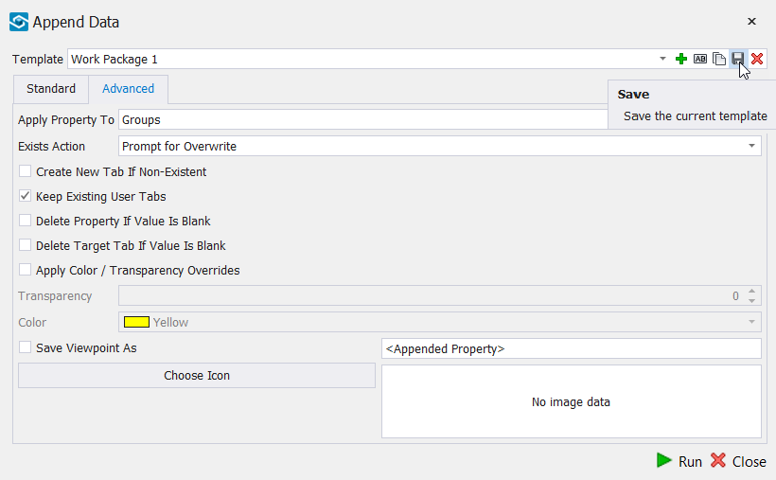
Append Advanced Values
With Append Data feature you can also append advanced values like XYZ coordinates, date, length, width, height, GUID, Selection Tree path and more to the items in a model.
Follow the steps below to append advanced values:
- Follow steps 1 to 3 mentioned above.
- In the Standard tab, enter Tab Name, Property Name. Right click in the Property Value field and select a value from the list available.
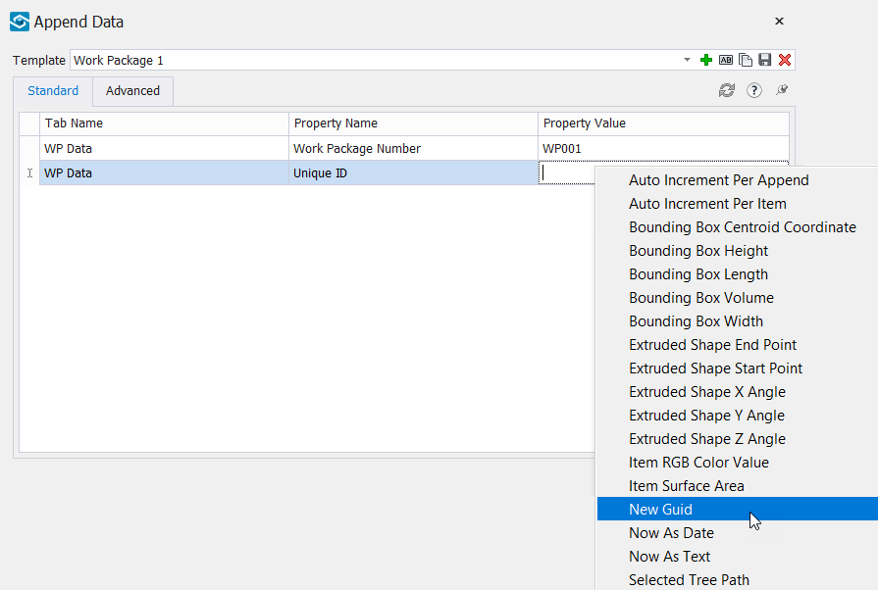
- Follow steps 5 and 6 mentioned above.
After you run the template, the properties appended will be shown in the relevant tab in the Properties pane of the elements.

Integrator
Integrator allows users to create their own custom data tab within Navisworks and takes data from one or more read-only data tabs and combines them into a custom data tab.
This is used in situations where companies may want standardisation of what data they want displayed when selecting an object in a model and or to reduce the hassle of having to need to look in different tabs and different properties for the required information.
Integrator is key to using iConstruct successfully as it takes the user from using read-only data in the models to being able to add data from several sources as the models are shared through the project.
Configuration
The following steps will show you how to set up the Integrator configuration.
- From General Configuration, select Integrator Configuration.
- Select to create a new template.
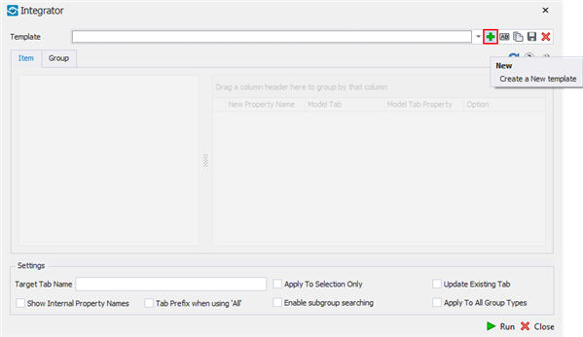
- Select an item in the background and click on Refresh button.
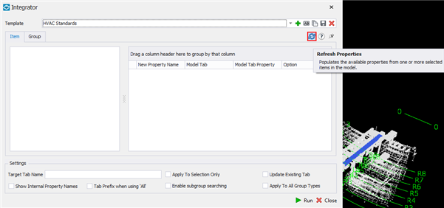
- On the Item and/or Group tab, select the properties you want to pull to your own user defined tab.
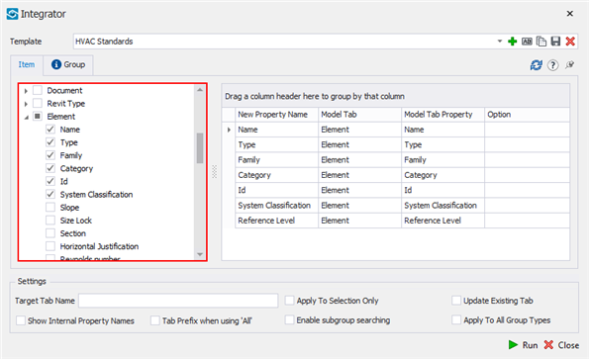
- If needed, you can edit the name that is given to the property inside of the custom user tab by editing the name under New Property Name column.
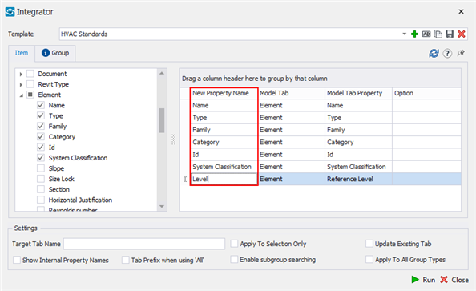
- Define Target Tab Name.
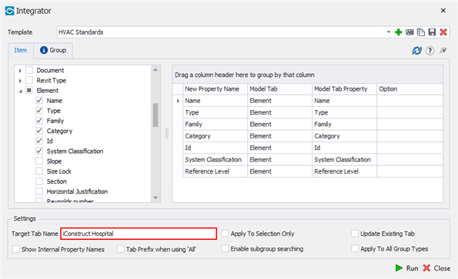
- Save a template. If you have the items selected you can click Run or close the dilaogue and run the tool later from saved templates.
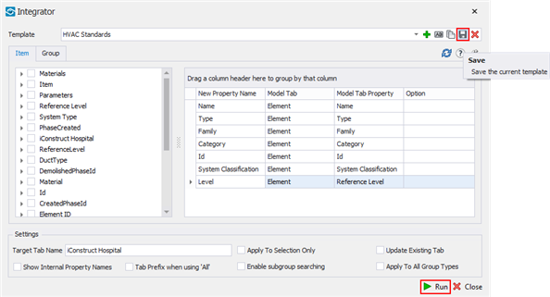
Integrator Settings
There are a number of items on this configuration window, here is the detailed description of it.
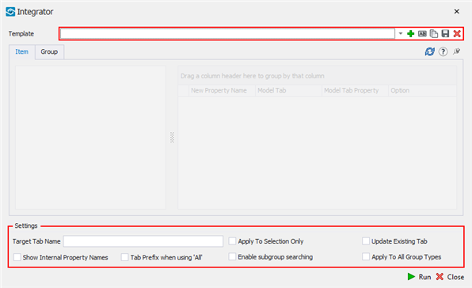
- New: Creates new template.
- Rename: You can rename a current template that has already been created.
- Copy: You can copy a template and give it a new name.
- Save: Save the current configuration to a new template or update existing.
- Delete: Delete a saved Integrator Configuration templates.
- Refresh: Collects the data from the selected sample Item or Group data to be used in Integrator in setting up your custom user tabs.
- Target Tab Name: Will be the display name of the customised data tab inside of Navisworks when the Integrator command is run.
- Apply to Selection Only: Only intergrates the selected items otherwise it does the whole model
- Update Existing Tab: Updates the current user data tab rather than removing it and starting again
- Show Internal Property Names: Will display a read-only column in the configuration grid of the internal property names of items selected within the model. This can be used If you have renamed the Standard Name in the configuration grid to a standard terminology, and still need to check what property it relates too.
- Tab Prefix when using 'All': When using the ‘All function’ it will prefix the property with the tab (‘Item – Name’ rather and ‘Name’)
- Enable Subgroup Searching: If it is looking for the property on the group, but it doesnt exsist on the group but exists on the item, it will take the proeprty from the item and map it to the group.
- Apply to All Group Types: Normally, iConstruct only applies at the group level what Navisworks classifies as a group. This option allows for every type other than ‘Geometry’ to be classified as a group
- Run: Runs selected tamplate.
- Close: Closes the Integrator Configuration dialogue.
After the sample properties have been retrieved from the model, you can now begin to set up your custom user tab using Integrator’s configuration grid. There are a number of columns in this section which will assist with the process.
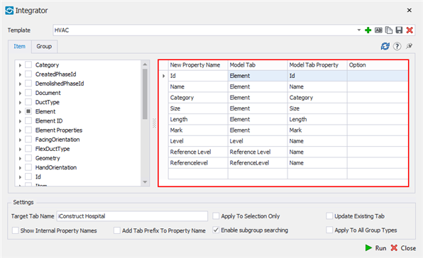
- New Property Name: The name that is given to the property inside of the custom user tab. This can be used to create a standardisation in terminologies for properties within models.
- Model Tab: The internal Navisworks attribute that Integrator will be collecting the data from to include on the custom user tab.
- Model Tab Property: The internal Navisworks property that Integrator will be collecting the data from to include on the custom user tab.
- Option: There are a few keywords that can be used with Integrator to perform extra functions on the data as it is being transferred and therefore maximize efficiency as well as sanitize data. Keywords are now available in an easy-to-use drop down list.
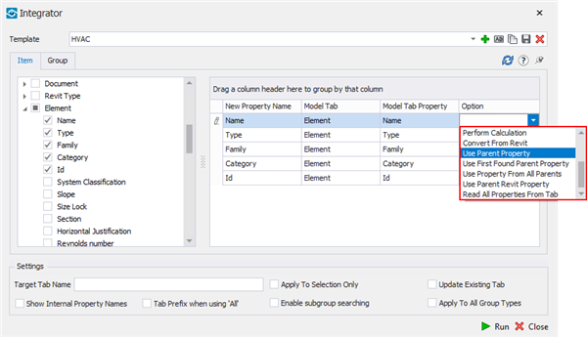
- Convert To Decimal: Attempts to convert the property to a decimal number, stripping away any text from the property value. If the property cannot be converted to a number, then the default ‘0’ is used.
- Convert To Integer: As above but converts to a whole number instead of a decimal.
- Convert To Date: Attempts to convert the value to a date format. Note that Navisworks does not currently support date formatting or time zone information so use this carefully.
- Format As Text: Takes the existing value and converts it to text.
- Sum Group Property: Use with ‘Enable subgroup searching’ to add the item field as a total for the group node.
- Perform Calculation: Displays the calculations stored in the profile for the user to select to run when processing the property. Good for converting metric to imperial measurements.
- Convert From Revit: Converts from the native Revit data type (volume, length etc.) to a decimal number. Also removes any extraneous text from text fields.
- Use Parent Property: When processing an item field, first looks in the parent node for the same field and uses that instead, like ‘Enable Subgroup Searching’ (see 5.3) in reverse except the parent property takes precedence. Useful when processing Revit models so all unique identifiers are at the same hierarchical level.
- Use Parent Revit Property: Same as ‘Use Parent Property’ except ‘Convert From Revit’ is applied at the same time.
- Read All Properties From Tab: Will call all property fields from the tab when assigned to the one property selected from the tab.
- Parse Excel Formula: Allows you to use excel formulas combined with Navisworks properties.
Example 1: =PROPER("[Element].[Category]" & " - " & "[Item].[Name]")
Example 2: =MID("[Item].[Name]",1,6)&"-"&MID("[Item].[Icon]",1,5)

