Zone Tools
Zone Tool uses intelligent bounding geometry to isolate intersecting and enclosed objects and stamp information to them. This is often used for allocating location-based information.
Pre-requisites:
Zone Tools is written with the main intention of using the CUDA platform from nVidia™ for GPU – accelerated geometric calculations. While Zone Tools will run in Normal mode without requiring the pre-requisites listed below, it will be far more accurate when leveraging the power of your nVidia video card.
- An nVidia video card supporting compute 2.0 or above. See Supported Cards.
- Microsoft Visual 2013 C++ runtime
- nVidia Driver version 340.29 or higher
Configuration
The following steps will show you how to set up the Zone Tools configuration.
- From General Configuration, select ZoneTools Configuration.
- Create New template and define a Template Name for your configuration.
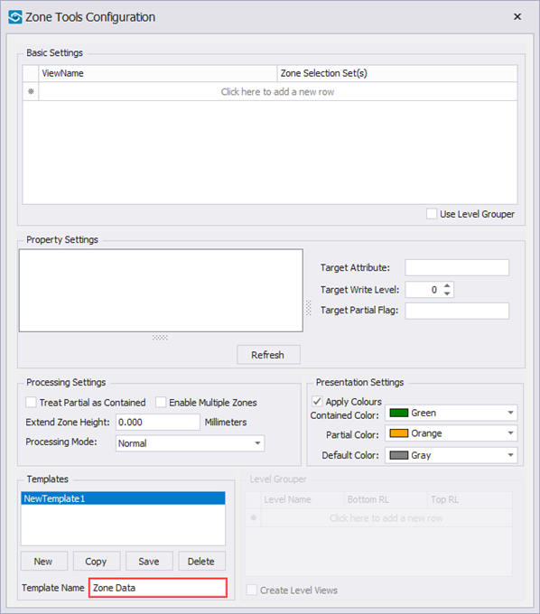
- Click into blank area under ViewName and choose the view ({Current View} in this example). All visible objects in your Current View that are intersecting or enclosed within the zone will get the zone's information.
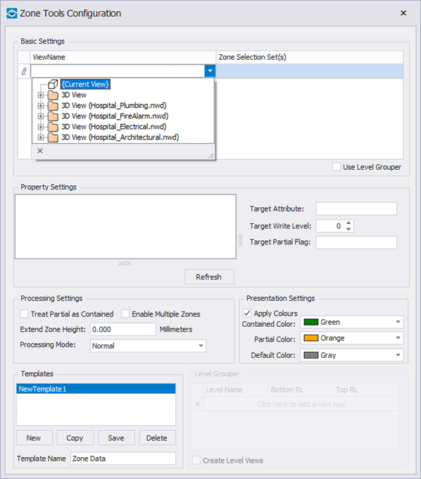
- Click into blank area under Zone Selections Set(s) and choose the Selection Set that is selecting your zones (Zones in our example).
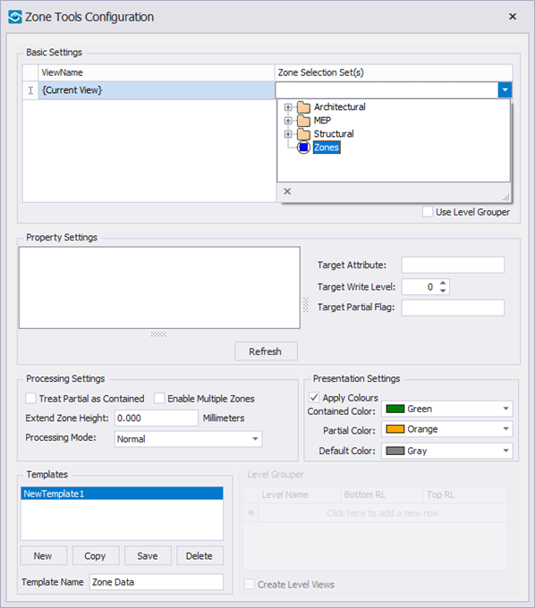
- Select a Zone in the background model and click Refresh button to pull in the data from the zones.
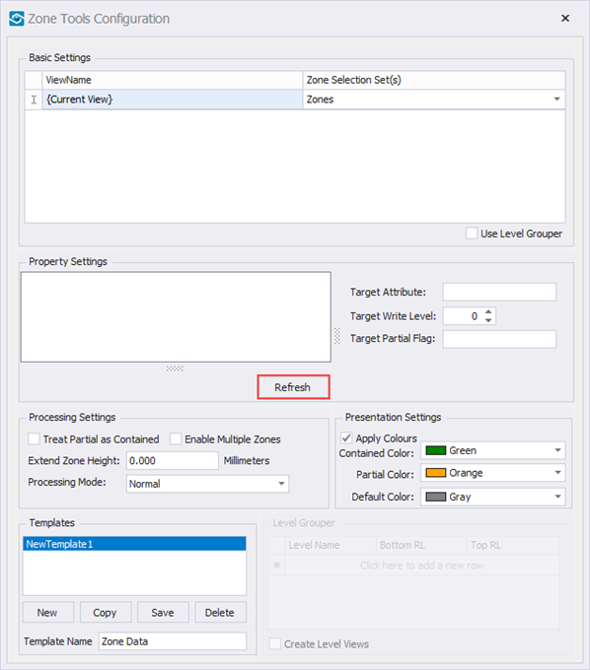
- Select the information from the zones which you wish to transfer on to objects. In our example we are appending Layer information from the Item tab.
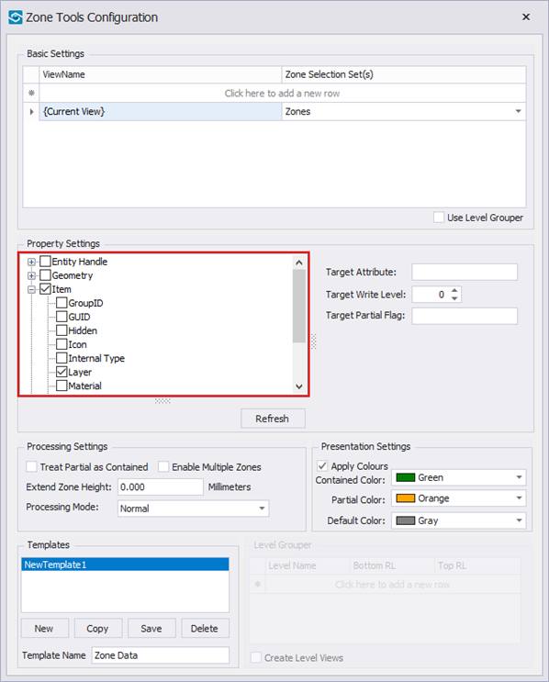
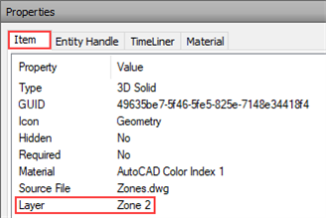
You can select multiple properties.
- Define a Target Attribute (Zone Info in our example). This is a name of your new user tab that will contain the zone information’s.
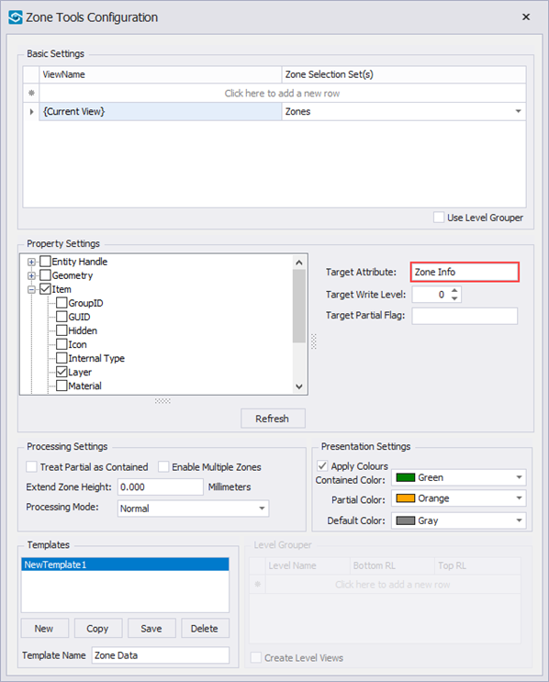
- Nominate the Target Write Level. In our example we are appending Layer information’s to Doors (Single-Flush) that are two levels above geometry, in the level 2.
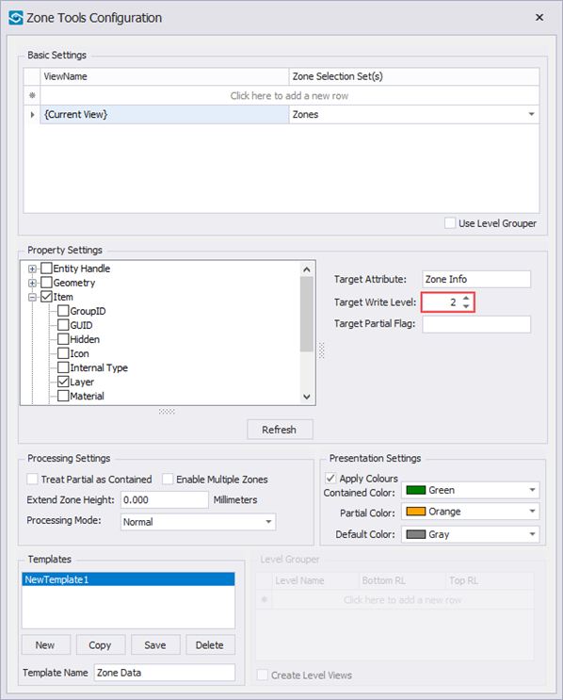
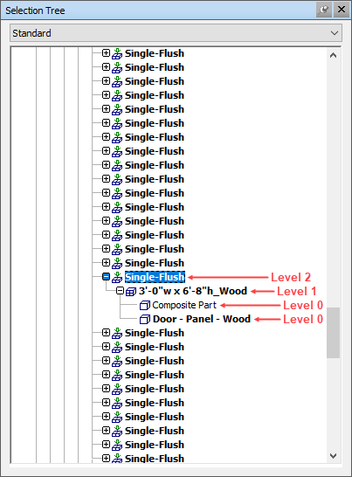
- Tag anything that’s partially contained within the zone as Partial.
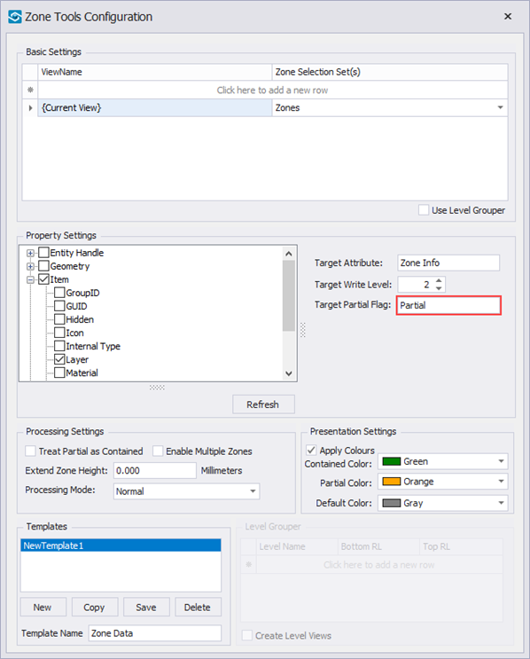
- Treat anything that is partially contained within the zone as Contained.
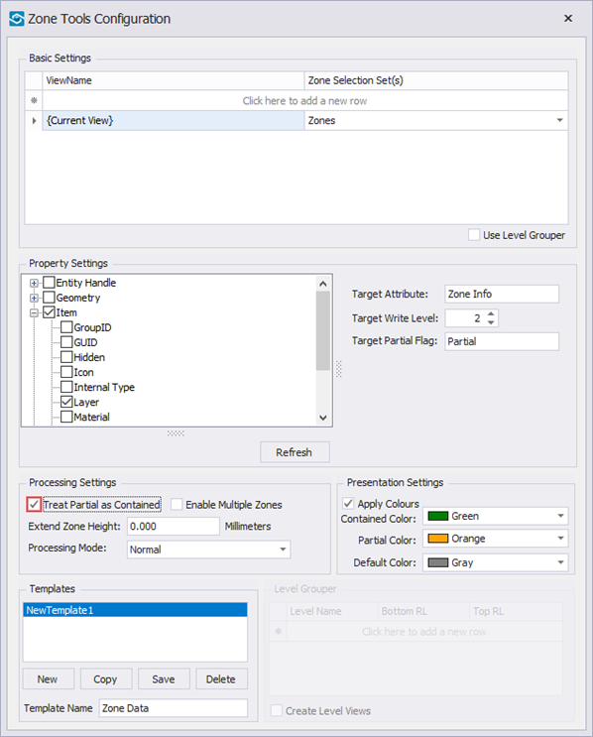
- Nominate the Processing Mode. In our example we go with GPUIntensive which takes the longest, however it’s the most accurate.
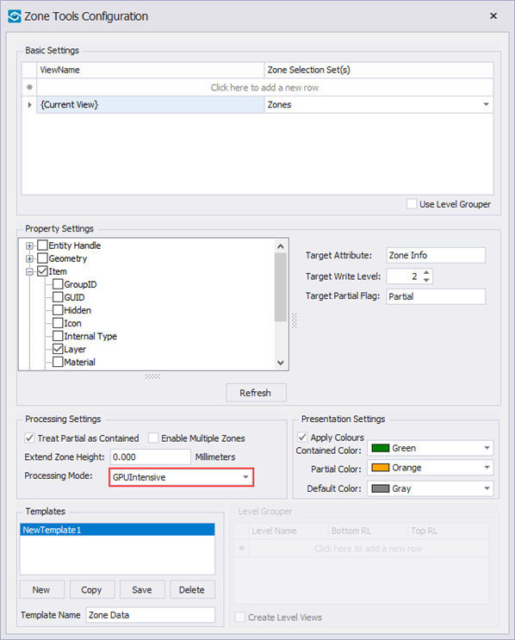
Normal: Processes objects that have at least one point (vertex) within the bounding object. Runs on the CPU. Note that this will not pick up objects that are larger than the zone and that don’t have at least one point ie some flooring may have this configuration. This is ideal for systems without an nVidia card and where geometry is mostly contained within the zone.
GPU Quick: Similar algorithm to Normal but runs on GPU so slightly quicker and more accurate.
GPU Intensive: Algorithm runs on the GPU and does full face-face intersection tests. Runs 2-3x slower than Normal but most accurate of the three. Ideal for cases where large objects cross the zone such as flooring, long piping.
- Click Save.
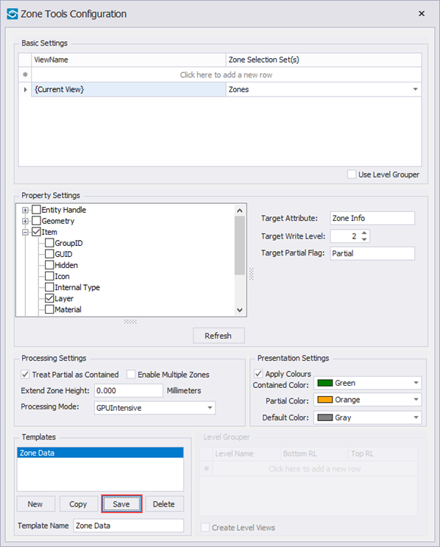
Usage
The following steps will show you how to run the Zone Tools.
- If using Current View in the configuration, leave visible only the zones and elements which you want to apply the properties from the zones for.
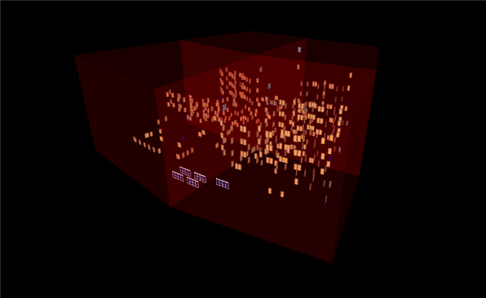
- From the iConstruct panel, select Zone Tools.
- Select the configured button (Zone Data in our example).
- Wait for the process to finish. Once it is completed a small window will pop-up. Click OK.

