**一．Spring-事务管理--业务层**

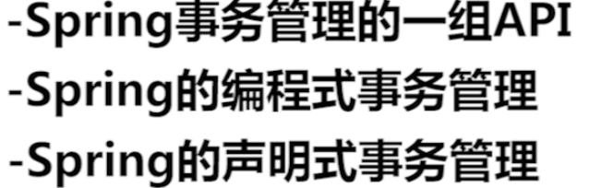













**Spring提供了3个高层抽象的接口**

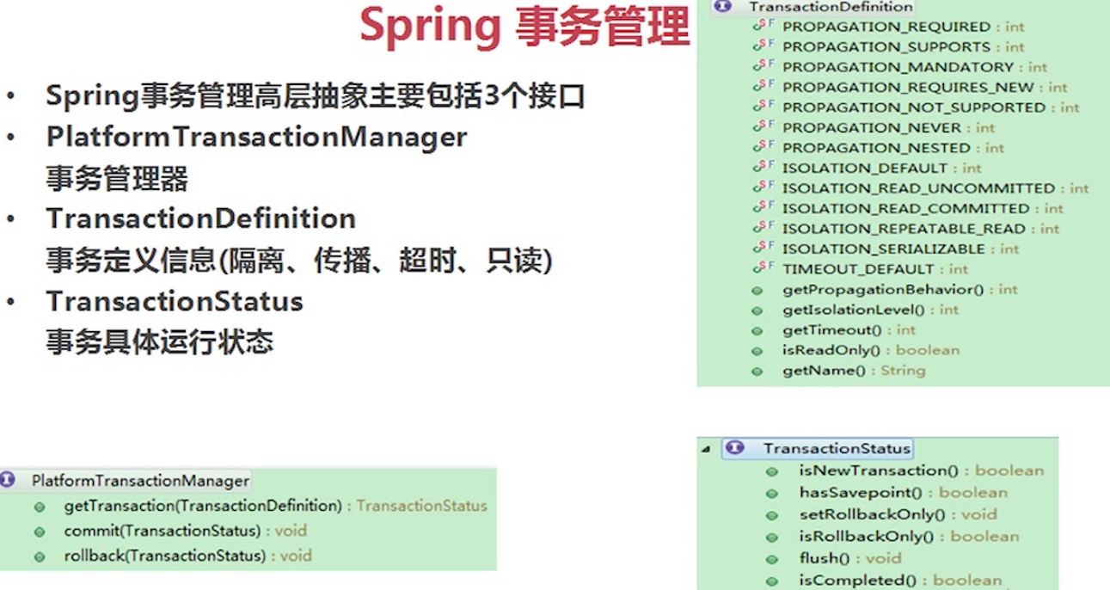

**事务管理器是真正用来管理事务的一个接口，里面包含了事务的提交、回滚.....**

**事务定义信息主要包含了隔离级别、传播行为、是否超时、只读的信息**

**运行状态包含是否提交、有保存点、是否新的事务的...状态**

**三个接口之间有相互联系：Spring在进行事务管理的时候，会先根据事务定义TransactionDefinition的信息，然后由平台管理器Platform TransactionManager来进行真正的事务管理，在进行管理的当中事务会产生相应的状态【产生了保存点、是新的事务】并保存在第三个接口TransactionStatus对象当中**

**-----------------------------------------------------------------------------------------------------------------------------**

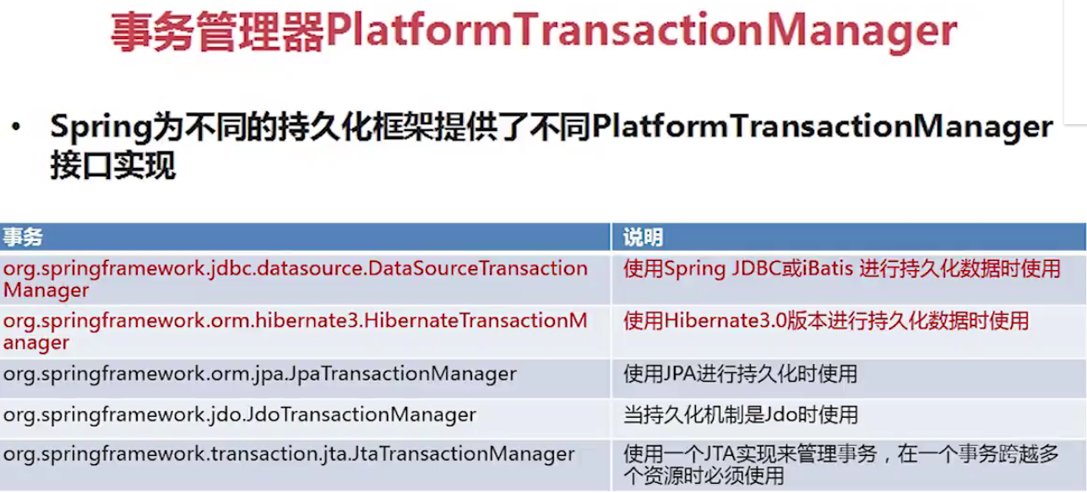

**一般使用前两者**

**-----------------------------------------------------------------------------------------------------------------------------**

## **Interface TransactionDefinition事务定义信息**

**隔离级别**

|  |  |
| --- | --- |
| static int | **[ISOLATION\_DEFAULT](mk:@MSITStore:C:\\Users\\ClearC\\Desktop\\spring3.0%20API.chm::/spring-3.0.0/api/org/springframework/transaction/../../../org/springframework/transaction/TransactionDefinition.html" \l "ISOLATION_DEFAULT)**            Use the default isolation level of the underlying datastore. |
| static int | **[ISOLATION\_READ\_COMMITTED](mk:@MSITStore:C:\\Users\\ClearC\\Desktop\\spring3.0%20API.chm::/spring-3.0.0/api/org/springframework/transaction/../../../org/springframework/transaction/TransactionDefinition.html" \l "ISOLATION_READ_COMMITTED)**            Indicates that dirty reads are prevented; non-repeatable reads and phantom reads can occur. |
| static int | **[ISOLATION\_READ\_UNCOMMITTED](mk:@MSITStore:C:\\Users\\ClearC\\Desktop\\spring3.0%20API.chm::/spring-3.0.0/api/org/springframework/transaction/../../../org/springframework/transaction/TransactionDefinition.html" \l "ISOLATION_READ_UNCOMMITTED)**            Indicates that dirty reads, non-repeatable reads and phantom reads can occur. |
| static int | **[ISOLATION\_REPEATABLE\_READ](mk:@MSITStore:C:\\Users\\ClearC\\Desktop\\spring3.0%20API.chm::/spring-3.0.0/api/org/springframework/transaction/../../../org/springframework/transaction/TransactionDefinition.html" \l "ISOLATION_REPEATABLE_READ)**            Indicates that dirty reads and non-repeatable reads are prevented; phantom reads can occur. |
| static int | **[ISOLATION\_SERIALIZABLE](mk:@MSITStore:C:\\Users\\ClearC\\Desktop\\spring3.0%20API.chm::/spring-3.0.0/api/org/springframework/transaction/../../../org/springframework/transaction/TransactionDefinition.html" \l "ISOLATION_SERIALIZABLE)**            Indicates that dirty reads, non-repeatable reads and phantom reads are prevented. |

隔离级别解决这些问题







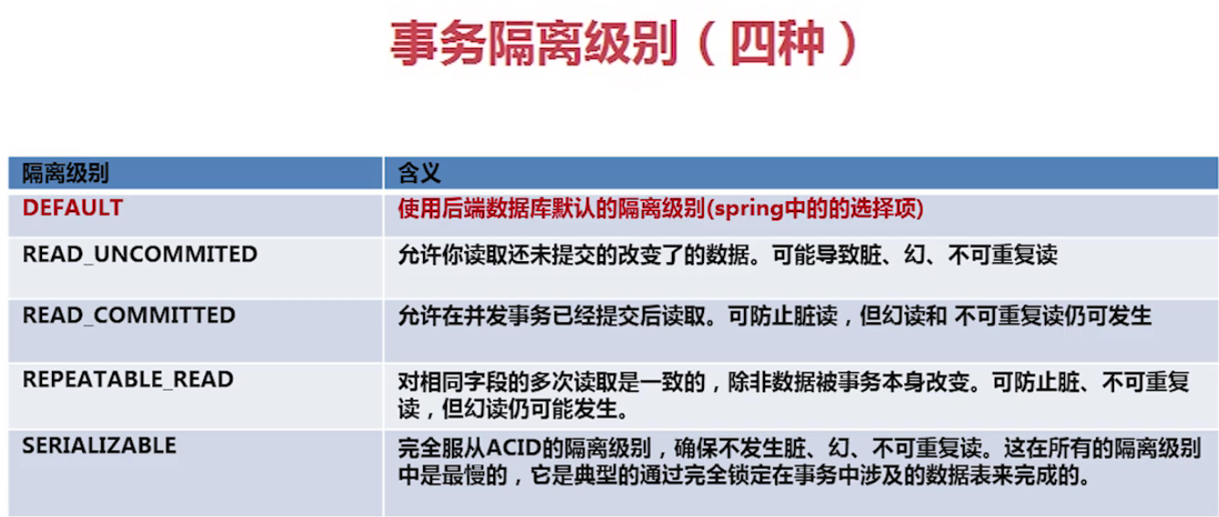





**-----------------------------------------------------------------------------------------------------------------------------**

**传播行为：解决业务层方法之间的相互调用产生的事务如何传递的问题**

|  |  |
| --- | --- |
| static int | **[PROPAGATION\_MANDATORY](mk:@MSITStore:C:\\Users\\ClearC\\Desktop\\spring3.0%20API.chm::/spring-3.0.0/api/org/springframework/transaction/../../../org/springframework/transaction/TransactionDefinition.html" \l "PROPAGATION_MANDATORY)**            Support a current transaction; throw an exception if no current transaction exists. |
| static int | **[PROPAGATION\_NESTED](mk:@MSITStore:C:\\Users\\ClearC\\Desktop\\spring3.0%20API.chm::/spring-3.0.0/api/org/springframework/transaction/../../../org/springframework/transaction/TransactionDefinition.html" \l "PROPAGATION_NESTED)**            Execute within a nested transaction if a current transaction exists, behave like [PROPAGATION\_REQUIRED](mk:@MSITStore:C:\\Users\\ClearC\\Desktop\\spring3.0%20API.chm::/spring-3.0.0/api/org/springframework/transaction/../../../org/springframework/transaction/TransactionDefinition.html" \l "PROPAGATION_REQUIRED) else. |
| static int | **[PROPAGATION\_NEVER](mk:@MSITStore:C:\\Users\\ClearC\\Desktop\\spring3.0%20API.chm::/spring-3.0.0/api/org/springframework/transaction/../../../org/springframework/transaction/TransactionDefinition.html" \l "PROPAGATION_NEVER)**            Do not support a current transaction; throw an exception if a current transaction exists. |
| static int | **[PROPAGATION\_NOT\_SUPPORTED](mk:@MSITStore:C:\\Users\\ClearC\\Desktop\\spring3.0%20API.chm::/spring-3.0.0/api/org/springframework/transaction/../../../org/springframework/transaction/TransactionDefinition.html" \l "PROPAGATION_NOT_SUPPORTED)**            Do not support a current transaction; rather always execute non-transactionally. |
| static int | **[PROPAGATION\_REQUIRED](mk:@MSITStore:C:\\Users\\ClearC\\Desktop\\spring3.0%20API.chm::/spring-3.0.0/api/org/springframework/transaction/../../../org/springframework/transaction/TransactionDefinition.html" \l "PROPAGATION_REQUIRED)**            Support a current transaction; create a new one if none exists. |
| static int | **[PROPAGATION\_REQUIRES\_NEW](mk:@MSITStore:C:\\Users\\ClearC\\Desktop\\spring3.0%20API.chm::/spring-3.0.0/api/org/springframework/transaction/../../../org/springframework/transaction/TransactionDefinition.html" \l "PROPAGATION_REQUIRES_NEW)**            Create a new transaction, suspending the current transaction if one exists. |
| static int | **[PROPAGATION\_SUPPORTS](mk:@MSITStore:C:\\Users\\ClearC\\Desktop\\spring3.0%20API.chm::/spring-3.0.0/api/org/springframework/transaction/../../../org/springframework/transaction/TransactionDefinition.html" \l "PROPAGATION_SUPPORTS)**            Support a current transaction; execute non-transactionally if none exists. |

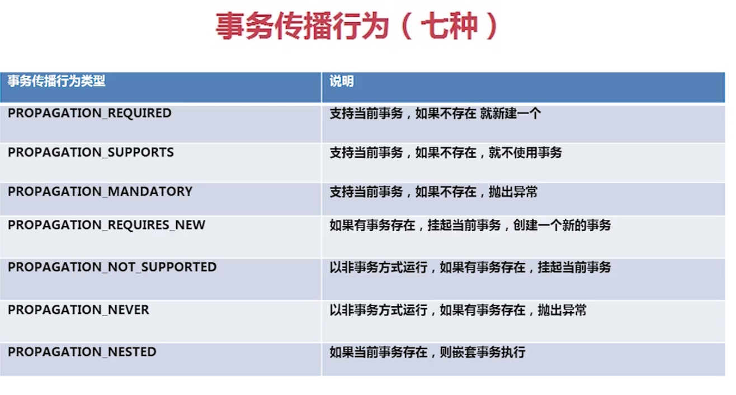

**前三个为一类，重点是第一个；中间三个是第二类，重点是第一个；第三类最后一个**

传播属性主要是Required，RequiresNew，Nested这三个  
1.一个事务的方法A，一个标记事务传播属性为Required的方法B，B如果在方法A内，则方法B的事务只能用作回滚并且跟方法A是同一个事务  
2.标记事务传播属性为RequiresNew的方法B，B如果在方法A内，则方法B的事务完全独立于方法A的事务，方法B的事务具有提交以及回滚性，即使方法A之后有回滚都不影响方法B的事务  
3.标记事务传播属性为Nested的方法B，B如果在方法A内，则方法B的事务则具有多个保存点的回滚，但这不影响A的事务的进行，这个设置通常映射到JDBC保存点,所以只在jdbc的事务中有效。

**-----------------------------------------------------------------------------------------------------------------------------**



