**Guide for Donors : Transferring Digital Files to the CCA Archives**

Canadian Centre for Architecture

November 2015

To ensure the continued integrity of your archive, it is important that neither the files themselves nor their metadata (creation and modification dates, embedded ‘Properties’ metadata, etc.) are changed when transferring files to CCA. To make sure nothing is altered, we ask that you use one of the following utilities when copying files:

**7-zip**

CCA’s preferred method for the transfer of files is through the use of archive packages in the *.7z format. [7-zip](http://www.7-zip.org/) is a free utility that is used for creating such archive packages.

From the 7-zip interface, right-click on the folder (or folders) you would like to package, select ‘7-Zip’, and then select ‘Add to archive…’.

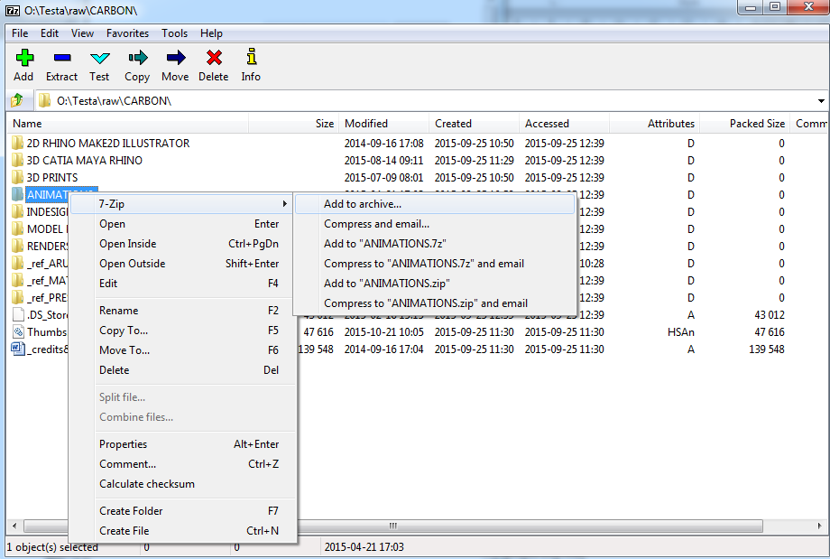

In the ‘Add to Archive’ screen, save a name for the archive (replacing TEST_NAME in the example below), and select the following settings:

* Archive format: 7z
* Compression level: Normal
* Compression method: LZMA
* Dictionary size: 16 MB
* Word size: 32
* Solid Block size: 4 GB
* Number of CPU threads: 2

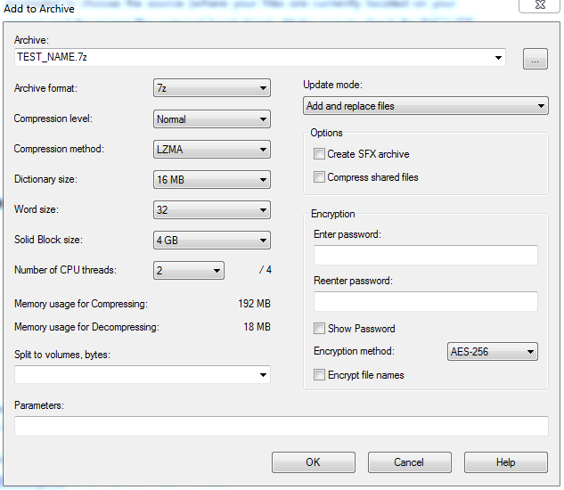

Once all of the settings have been verified, select ‘OK’ to begin the process.

When completed, this will result in one or several losslessly compressed .7z files (split at 4 GB as necessary to facilitate file transfer over network connections and between file systems with different limitations) that capture the files and their metadata just as they existed on your server or local machine. These .7z files can then be sent to CCA via a network transfer service such as DropBox or WeTransfer, or on removable media such as a USB external hard drive.

Please note that for large quantities of material and certain file types, compression can be a lengthy procedure. In some cases you may need to leave this utility running overnight.

*Note: Although 7-Zip is a Windows utilities, a command-line version of 7-zip known as p7zip is available for Linux machines. A list of downloads and packages can be found [here](http://www.7-zip.org/download.html).

**Copying files to an external hard drive in Windows using Robocopy**

Another alternative for transferring your files to CCA is to copy them to an external hard drive from a Windows machine using **Robocopy**. Robocopy is a command line utility included in newer versions of Windows that copies folders without changing files or their associated metadata.

To use Robocopy, open a Terminal (Start menu -> All programs -> Accessories ->Command Prompt in Windows 7) and enter the following command, replacing [SOURCE] and [DESTINATION] with the locations of the files on your server and the mounted external hard drive, respectively:

Robocopy [SOURCE] [DESTINATION] /COPYALL /E /R:0 /DCOPY:T

For example, to copy everything from a network drive that has been mounted as G:\ to the external drive (in this example, mounted as E:\), the full command would be:

Robocopy G:\ E:\ /COPYALL /E /R:0 /DCOPY:T

If you are not comfortable using the command line, you may also choose to use **TeraCopy**, a graphical interface for Robocopy. TeraCopy is available for purchase or free trial at <http://www.codesector.com/teracopy>.

**Copying files to an external hard drive in Mac OS X or Linux using rsync**

On UNIX-like systems (such as Mac or Linux machines), **rsync** is a simple command line utility that will copy files to an external device such as an external hard drive while retaining original dates. If you use rsync, be sure to use the flag **–av** to ensure that everything is copied over and all dates are preserved whenever possible. This command has a similar structure to Robocopy. In a terminal, enter:

rsync –av [source] [destination]

*Note: rsync may need to be run with admin credentials. For example:

sudo rsync –av /home/my_home/ /media/backup/my_home/

If you have any trouble or questions, please don’t hesitate to get in touch with Tim Walsh, CCA Digital Archivist, at [twalsh@cca.qc.ca](mailto:twalsh@cca.qc.ca) or (514) 939-7001 x1532.