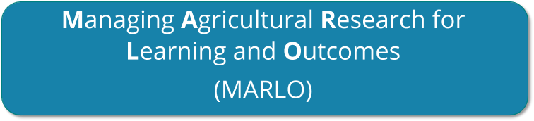

**INTRODUCTION TO MARLO**

### Updated Oct, 2020

# Table of Contents

1. INTRODUCTION 3
   1. WHAT IS MARLO? 3
   2. PURPOSE OF THIS DOCUMENT 3
   3. KEY MARLO CONCEPTS 3
2. USING MARLO 4
   1. HOW TO LOGIN 4
   2. IMPORTANT TIPS BEFORE STARTING 4
   3. ENTERING AND VIEWING INFORMATION ABOUT FUNDING SOURCES 5
   4. ENTERING AND VIEWING INFORMATION ABOUT PROJECTS 7
   5. GENERATING SUMMARIES 10
   6. EVALUATING PROJECTS 10

4. SUPPORT FOR MARLO USERS 10

* 1. TECHNICAL SUPPORT 10
  2. FUNCTIONAL SUPPORT 10

# INTRODUCTION

## 1.1 WHAT IS MARLO?

Welcome to **MARLO** - **M**anaging **A**gricultural **R**esearch for **L**earning and **O**utcomes. MARLO is an online platform designed to assist CRPs, Platforms and Centers in planning, monitoring, reporting on, and evaluating their research portfolios and their contributions to outcomes.

MARLO is the result of joint work by several CRPs to improve a tool developed by CCAFS in Phase 1 and adapt it to the needs of the CRPs in Phase 2.

## PURPOSE OF THIS DOCUMENT

This document is an introductory guide for MARLO users. It is not intended as a detailed user guide. The roles and responsibilities of the different MARLO users vary by CRP, Platforms, Centers and are not covered in this document. Contact your Management Unit for more detailed guidance as needed.

## KEY MARLO CONCEPTS

In MARLO, a **project** is a body of research1 to which corresponds a set of deliverables. MARLO is designed to monitor and evaluate the CRP portfolio at the **project level.**

Each research project belongs to at least one **flagship** (major structural component of a CRP) or **module** (major structural component of a Platform), and at least one **cluster** (smaller aggregation unit within a flagship/module).

Each project is funded through a collection of Window 1-2, Window 3, and bilateral funds (some projects can also be funded through Center funds). In MARLO, each W1-2 allocation or W3/bilateral grant is called a **funding source**. The deliverables of a project are associated with one or several funding source(s).

In MARLO, **impact pathways** describe the relationships between key outputs, outcomes/milestones, and the CGIAR sub-Intermediate Development Outcomes (sub-IDOs). The **deliverables** of a project (i.e., tangible, specific products to be delivered in a certain year, such as a publication or a database) are mapped to **key outputs** (i.e., aggregated statements of products to be delivered, worded in general terms without a reference to a timeframe), which in turn are mapped to a flagship’s/module’s **outcomes** (i.e, applications of outputs resulting in a change in policy/program/investment). Outcomes are supposed to be reached in 2022, which is the end of Phase 2 of the CRPs. For each outcome, a set of annual **milestones** are defined for years between 2017 and 2021 to reflect progress toward outcomes. Each outcome contributes to one or more **sub-IDOs**.

*Note: Impact pathways are defined at flagship/cluster level. This process happens before information can be entered at project level, and is not covered in this document.*

MARLO is used at planning stage and at reporting stage. Planning usually occurs in the period November-January and consists in entering updated information about project plans for the coming year. Reporting occurs in the first quarter of a year and consists in entering updated information about achievements of the past year. The processes of updating MARLO at planning and reporting stages are referred to as **planning cycle** and **reporting cycle**.

1 MARLO also includes a small number of “management projects” managed by the CRPs’ Program Management Units.

# USING MARLO

## HOW TO LOGIN

Go to MARLO: [**https://marlo.cgiar.org/**](https://marlo.cgiar.org/). Please note that MARLO works best with Chrome and Firefox; please use one of these browsers if possible.

Select the CRP, Platform or Center. Enter your CGIAR credentials (full CGIAR e-mail address and password). If you do not have a CGIAR email address, login credentials will be sent to you.

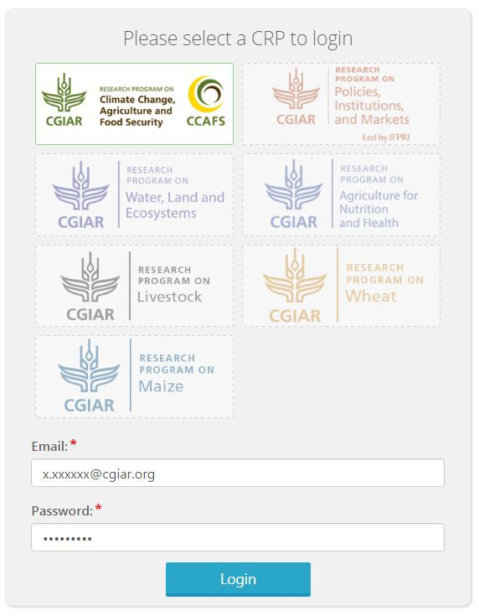

## IMPORTANT TIPS BEFORE STARTING

### Saving changes

Click the ‘Save’ button before moving to another section.

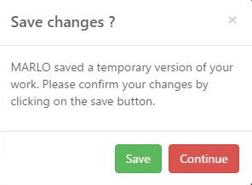

If you change section without clicking on the ‘Save’ button, MARLO asks whether you want to confirm the changes you have made before leaving that section.

In order to prevent loss of data, MARLO is equipped with an auto-save function which automatically saves information every 7 seconds. When this happens, a notification appears at the top of the screen (“Draft Saved”). Information saved through this function remains as draft and is not available in other sections. Therefore, do not move to another section without clicking on ‘Save’.

### Multiple users working simultaneously

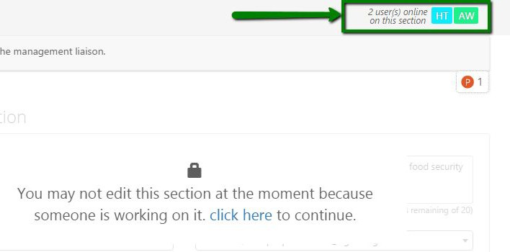

Only one user at a time can edit a given section in MARLO. When someone else is editing a section, a message appears and the initials of the current users appear at the top of the screen.

## ENTERING AND VIEWING INFORMATION ABOUT FUNDING SOURCES

*Only certain MARLO users have permission to add and edit funding sources. Check the email you received from MARLO upon creation of your MARLO profile to see which tasks are accessible to you. Generally, funding sources are entered before information about projects is entered.*

To add or edit funding sources, click on ‘Funding sources’ in the top menu.

Click on ‘Add funding source’ at the bottom of the page and fill in the required fields.

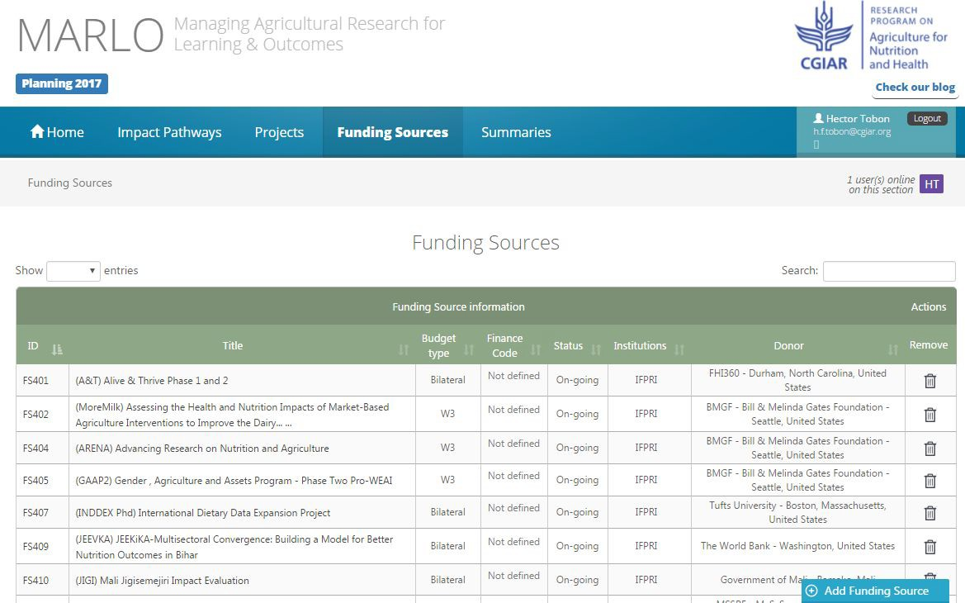

### Editing a funding source

To find a funding source, enter part of the funding source title or the funding source ID in the Search field. In addition, the table of funding sources can be sorted (click on the header of the column you want to use for sorting).

Open the funding source by clicking on its title or ID.

### Assigning a funding source to a project

This is done as part of entering information about a project (see Section 2.4).

A funding source budget can be assigned entirely to a project or split between several projects. Once the funding source has been assigned to a project, the project and the amount of the funding source budget allocated to this project appear at the bottom of the funding source window, as well as the funding source budget that remains available to allocate to other projects.

### Viewing a funding source

Click on ‘Funding sources’ in the top menu.

To find a funding source, enter part of the funding source title or the funding source ID in the Search field. In addition, the table of funding sources can be sorted (click on the header of the column you want to use for sorting).

Open the funding source by clicking on its title or ID.

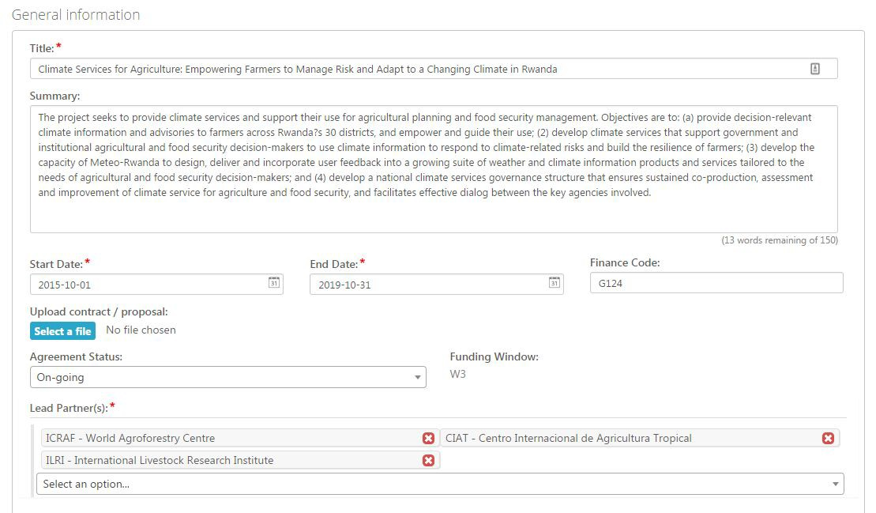

### Tips for working on funding sources

* + - Mandatory fields are indicated by asterisks (*).
    - When working on a funding source, the funding source ID appears in the top right corner of the screen. Hover your mouse over the funding source ID to see the full title of the funding source.

## ENTERING AND VIEWING INFORMATION ABOUT PROJECTS

*Only certain MARLO users have permission to add, edit, or submit projects. Check the email you received from MARLO upon creation of your MARLO profile to see which of these tasks are accessible to you.*

### Adding a project

*Adding a project is done during the planning cycle.*

Click on ‘Enter a new project’ on the Home page, or click on ‘Projects’ in the top menu and then on ‘Create a project’ at the bottom of the page.

You will be prompted to add basic information about the project’s **description, partners, and budget**. This step is called **Pre-setting** a project in MARLO, and it may be performed by different categories of users depending on the CRP.

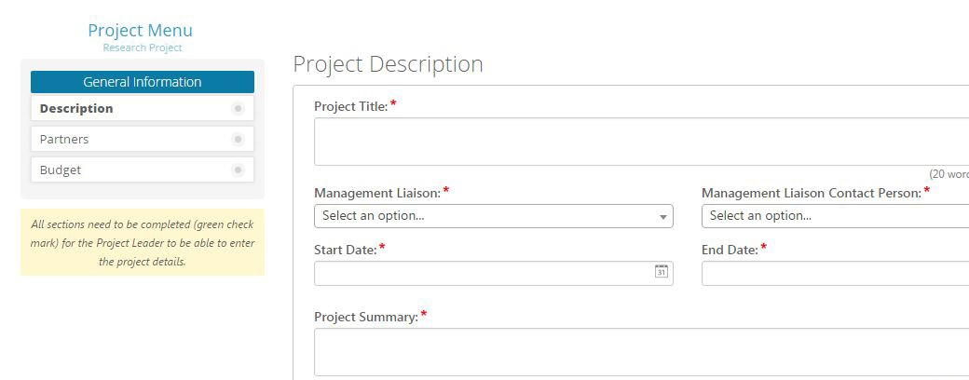

The Project Menu on the left-hand side shows the sections that need to be

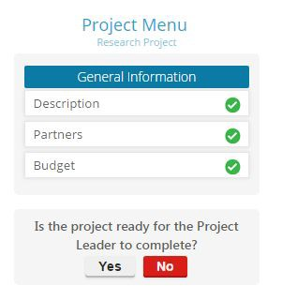

completed (Description, Partners, Budget) for the project to become “ready for the project leader to complete”.

The budget of a project is made up of the budgets (or part of the budgets) of the funding sources assigned to this project.

Once information has been entered about the project’s description, partners, and budget, click ‘Yes” next to the question ‘Is the project ready for the Project Leader to complete?’ If information is missing, you will be prompted to complete the missing fields before clicking ‘Yes’ again.

### Editing a project

*Editing a project occurs both during the planning cycle and during the reporting cycle. During the planning cycle, after a project is added, more details about what the project plans to accomplish in a given year are added. During the reporting cycle, updates are provided about the actual project accomplishments.*

Click on ‘Update an ongoing project’ on the Home page, or click on ‘Projects’ in the top menu.

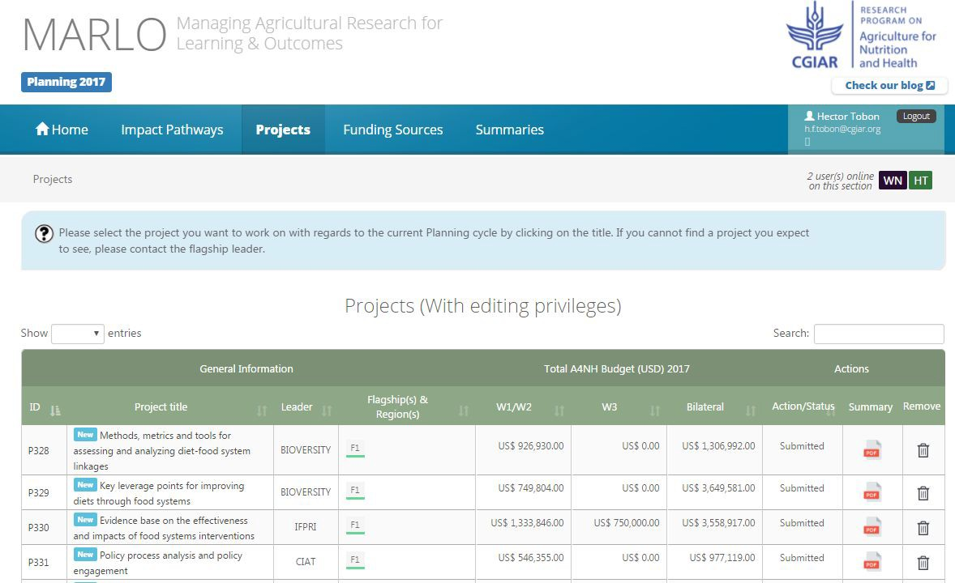

To find a project, enter part of the project title or the project ID in the Search field. In addition, the table of projects can be sorted (click on the header of the column you want to use for sorting).

Open the project by clicking on its title or ID.

At planning stage, after the project has been pre-set, more detailed information needs to be provided about the project’s **location, contribution to outcomes, and deliverables** (see Project Menu on left-hand side). **Additional partners** that were not added during pre-setting can also be entered at this stage. Usually these steps are performed by the project leader.

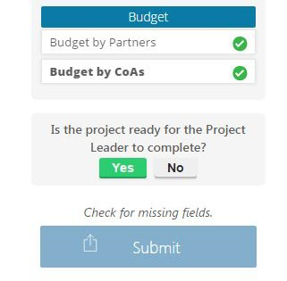

### Submitting a project

Once all project information has been entered and the project is ready for review, click on ‘Submit” on the left-hand side menu. The ‘Submit’ button does not appear if information is missing.

When a project is submitted, the users who have responsibility over this project receive an email from MARLO. The project summary (pdf) is attached to this email.

If a project is returned to the project leader, the user who is returning the project is prompted to explain why. The justification is included in an email from MARLO to the users who have responsibility over this project. Once the issues have been addressed and the project has been re-submitted, MARLO sends another email to the users who have responsibility over this project.

### Viewing a project

Click on ‘Projects’ in the top menu.

To find a project, enter part of the project title or the project ID in the Search field. In addition, the table of projects can be sorted (click on the header of the column you want to use for sorting).

Open the project by clicking on its title or ID. You can also click on the ‘Summary’ column in the table of projects to access a project summary including all the information entered on the project.

### Status of a project

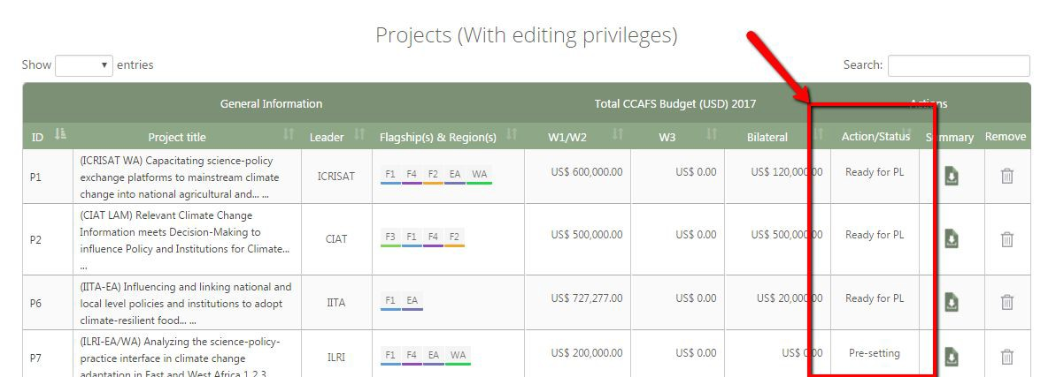

The status of the project can be:

* + - **Pre-setting:** basic information about the project’s description, partners, and budget should be entered;
    - **Ready for PL**: more detailed information about the project’s location, contribution to outcomes, deliverables, and in some cases partners, should be entered - usually by the project leader;
    - **Submitted**: all project information has been entered and the project is ready for review (the review process depends on the CRP). A submitted project is not available for editing by the project leader until a new planning or reporting cycle begins, or until it is returned to the project leader following the review process.

### Tips for working on projects

* + - It is recommended to fill in project sections in the order that they appear in in the left-hand side Project Menu.
    - Mandatory fields are indicated by asterisks (*).
    - When all mandatory fields in a project section have been completed, a green checkmark appears next to this section in the left-hand side Project Menu.
    - You can check which sections are still incomplete by clicking on the ‘Check’ button at the bottom of the Project Menu.
    - Upon clicking ‘Save’, a yellow flag appears next to the missing fields.
    - When working on a project, the project ID appears in the top right corner of the screen. Hover your mouse over the project ID to see the full project title.

## GENERATING SUMMARIES

Click on ‘Summaries’ in the top menu for access to various types of standard summaries (in pdf or Excel format) about the information entered in MARLO.

## EVALUATING PROJECTS

Project evaluation functionalities will be added to MARLO later.

# 4. SUPPORT FOR MARLO USERS

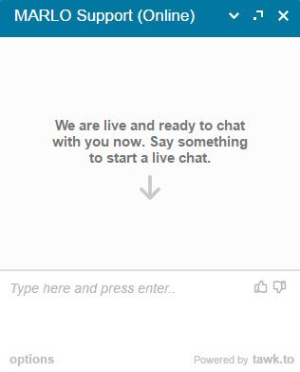

## TECHNICAL SUPPORT

### Online support

Use the online support chat which is located at the bottom left of the screen. The chat it monitored by the technical team based at CIAT in Colombia during business hours. Messages sent by users through the chat outside business hours (Colombia time) will be answered via email.

### Email

[**MARLOSupport@cgiar.org**](mailto:MARLOSupport@cgiar.org)

## FUNCTIONAL SUPPORT

**CRPs - CGIAR Research Programs**

|  |  |
| --- | --- |
| **A4NH** | Amanda Wyatt, [a.wyatt@cgiar.org](mailto:a.wyatt@cgiar.org) |
| **CCAFS** | Tonya Schuetz, [t.schuetz@cgiar.org](mailto:t.schuetz@cgiar.org) David Abreu, [d.abreu@cgiar.org](mailto:d.abreu@cgiar.org) |
| **FTA** | Monika Kiczkajlo, [m.kiczkajlo@cgiar.org](mailto:m.kiczkajlo@cgiar.org) Bethany Charlotte Davies [b.cdavies@cgiar.org](mailto:b.cdavies@cgiar.org) |
| **LIVESTOCK** | Jane Poole, [j.poole@cgiar.org](mailto:j.poole@cgiar.org) Helen Altshul, [h.altshul@cgiar.org](mailto:h.altshul@cgiar.org) |

|  |  |
| --- | --- |
| **MAIZE** | Shaylyn Gaffney, [s.gaffney@cgiar.org](mailto:s.gaffney@cgiar.org) Claudia Elisa Velasco, [c.e.velasco@cgiar.org](mailto:c.e.velasco@cgiar.org) |
| **PIM** | Pascale Sabbagh, [p.sabbagh@cgiar.org](mailto:p.sabbagh@cgiar.org) Frank Place, [f.place@cgiar.org](mailto:f.place@cgiar.org) |
| **RICE** | Bas Bouman, [b.bouman@irri.org](mailto:b.bouman@irri.org) Berta Miro, [b.miro@irri.org](mailto:b.miro@irri.org) |
| **WHEAT** | Shaylyn Gaffney, [s.gaffney@cgiar.org](mailto:s.gaffney@cgiar.org)  Hamish Gordon Dunsford, [h.dunsford@cgiar.org](mailto:h.dunsford@cgiar.org) |
| **WLE** | Emma Greatrix, [e.greatrix@cgiar.org](mailto:e.greatrix@cgiar.org) |

**CGIAR Platforms**

|  |  |
| --- | --- |
| **BIGDATA** | Mathilde Overduin, [m.overduin@cgiar.org](mailto:m.overduin@cgiar.org) |
| **GENEBANK** | Nelissa Jamora, [nelissa.jamora@croptrust.org](mailto:nelissa.jamora@croptrust.org) |
| **EiB** | Shaylyn Gaffney, [s.gaffney@cgiar.org](mailto:s.gaffney@cgiar.org) Brenda Lizet Bautista, [b.l.bautista@cgiar.org](mailto:b.l.bautista@cgiar.org) |