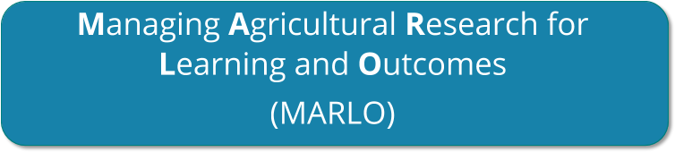

INTRODUCTION TO MARLO

Updated June, 2021

Table of Contents

1. INTRODUCTION 3
   1. WHAT IS MARLO-AICCRA 3
   2. WHAT IS THE PORPUSE OF THIS DOCUMENT 3
   3. KEY MARLO-AICCRA CONCEPTS 3
2. USING MARLO-AICCRA 4
   1. HOW TO LOG IN 4
   2. IMPORTANT TIPS 4
   3. ENTERING AND VIEWING INFORMATION ABOUT CLUSTERS 5
   4. ENTERING AND VIEWING INFORMATION ABOUT SUMMARIES 9
   5. ENTERING AND VIEWING INFORMATION ABOUT BUSINESS INTELLIGENCE 9
3. SUPPORT FOR MARLO-AICCRA USERS 9

# INTRODUCTION

## WHAT IS MARLO-AICCRA

Welcome to **MARLO** - **M**anaging **A**gricultural **R**esearch for **L**earning and **O**utcomes. MARLO is an online platform designed to assist Platforms in planning, monitoring, reporting on, and evaluating their research portfolios and their contributions to outcomes.

MARLO is the result of joint work by several CRPs to improve a tool developed by CCAFS in Phase 1 and adapt it to the needs of the CRPs in Phase 2.

## WHAT IS THE PORPUSE OF THIS DOCUMENT

This document is an introductory guide for MARLO users. It is not intended as a detailed user guide. The roles and responsibilities of the different MARLO users vary by Clusters and are not covered in this document. Contact your Management Unit for more detailed guidance as needed.

## KEY MARLO-AICCRA CONCEPTS

MARLO is designed to monitor and evaluate the platform portfolio at the cluster and overall project level.

Each cluster is funded through a collection of funds which in the system are called as **funding sources**. The deliverables of a cluster are associated with one or several funding source(s).

What is a Cluster?

A cluster is defined as the group of AICCRA main activities led by each AICCRA Country Leader (Ghana, Mali, Senegal, Ethiopia, Kenya, and Zambia), AICCRA Regional Leaders (Western Africa and Eastern & Southern Africa) and AICCRA-CCAFS Flagship Leaders (FP1, FP2 and FP4). In each cluster, participants are involved as leader, coordinators, and collaborators with specific budget allocations for each AICCRA main activity with a set of deliverables and contributions towards our performance

In MARLO, all clusters may indicate their own contributions to each of the predefined **performance indicators**.

The **deliverables** of a cluster (i.e., tangible, specific products to be delivered in a certain year, such as a publication or a dataset) are mapped to **performance indicators** (i.e., CCAFS partners and stakeholders in the project area are increasingly accessing enhanced climate information services and /or validated climate-smart agriculture technologies), partners and stakeholders, and to enhance access to climate information services and validated climate-smart agriculture technologies in IDA-eligible countries in Africa. Our performance indicators are supposed to be reached in 2023, which is the end of AICCRA project. For each indicator, a set of intermediate targets are defined for years between 2021 and 2023 to reflect progress.

*Note: The performance indicators are set-up by the admins of MARLO-AICCRA. This process happened before information can be entered at cluster level and is not covered in this document.*

MARLO-AICCRA is used at planning stage, mid-year progress and ends-year reporting stage. Planning usually occurs in the period November-January and consists in entering updated information about cluster plans for the coming year. Reporting will happen twice a year and consists in entering updated information

about achievements. The processes of updating MARLO-AICCRA at every stage are referred to as **planning, progress, and reporting cycles.**

# USING MARLO-AICCRA

## HOW TO LOG IN

Go to MARLO: <https://aiccra.marlo.cgiar.org/>

Note: MARLO-AICCRA works best with Chrome and Firefox; please use one of these browsers if possible.

Enter your CGIAR credentials (full CGIAR e-mail address and password). If you do not have a CGIAR email address, login credentials will be sent to you

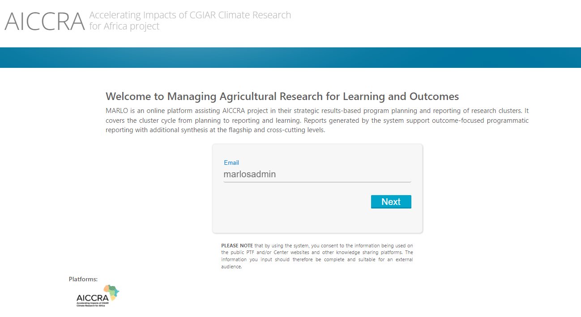

## IMPORTANT TIPS

### Saving changes

Click the ‘Save’ button before moving to another section.

### Multiple users working simultaneously:

Only one user at a time can edit a given section in MARLO. When someone else is editing a section, a message appears, and the initials of the current users appear at the top of the screen.

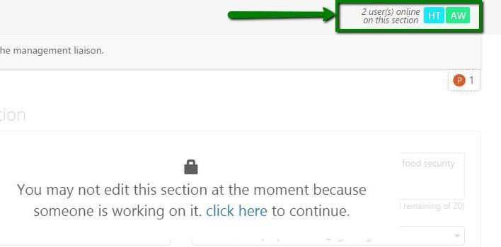

## ENTERING AND VIEWING INFORMATION ABOUT CLUSTERS

### Editing a cluster

Editing a cluster occurs during the planning cycle, mid-year report and the ends-year reporting cycle. During the planning cycle, after a cluster is added, more details about what the cluster plans to accomplish each year are added. During the reporting cycles, updates are provided about the actual cluster accomplishments.

To find a cluster, enter part of the cluster title or the cluster ID in the Search field. In addition, the table of clusters can be sorted (click on the header of the column you want to use for sorting).

The status of the cluster can be:

**Pre-setting:** basic information about the cluster’s description, partners, and budget should be entered. This happens when a new cluster is created for the first time.

**Ready for CL**: more detailed information about the cluster’s location, contribution to performance indicator, deliverables, and in some cases partners, should be entered - usually by the cluster leader.

**Submitted:** the cluster was successfully submitted and is no longer enabled to be edited. This status will be accessible during ends year report.

Open the cluster by clicking on its title or ID.

At planning stage, after the cluster has been pre-set, more detailed information needs to be provided about the cluster’s **location, contribution performance indicators, and deliverables** (see Cluster Menu on left-hand side). **Additional partners** that were not added during pre-setting can also be entered at this stage. Usually, these steps are performed by the cluster leader.

### Tips for working on clusters:

* It is recommended to fill in cluster sections in the order that they appear in the left-hand side Menu.
* Mandatory fields are indicated by red asterisks (*).
* When all mandatory fields in a section have been completed, a green checkmark appears next to this section in the left-hand side Menu.
* You can check which sections are still incomplete by clicking on the ‘Check’ button at the bottom of the left Menu.
* Upon clicking ‘Save’, a yellow flag should appear next to the missing fields.
* Text

  Description automatically generatedWhen working on a cluster, the cluster acronym appears in the top right corner of the screen. Hover your mouse over the cluster acronym to see the full cluster title.

To enter the contribution to the components per cluster it must done from the left menu in Contribution to performance Indicator section and complete the information.

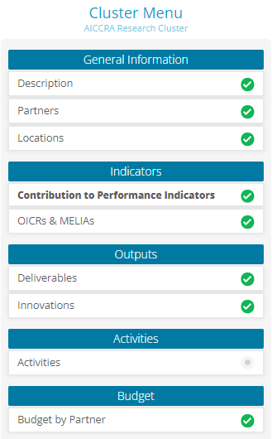In this section you will find all the information related to the performance indicator, the intermediate targets, and the expected values that you will accomplish each year compare with the overall target. Also, at Progress 20XX you will find the questions for the progress report.

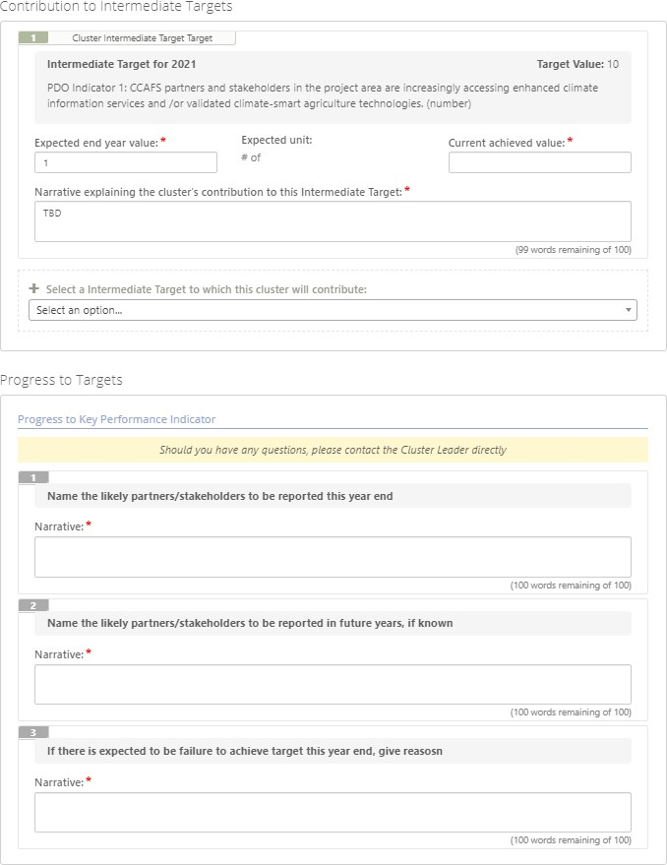

For the activities sections please validate that all the main activities that you have budget allocations are mapped to the cluster and relate all the deliverables that are contributing to each activity.

## ENTERING AND VIEWING INFORMATION ABOUT SUMMARIES

Click on ‘Summaries’ in the top menu for access to various types of standard summaries (in pdf or Excel format) about the information entered in MARLO

## ENTERING AND VIEWING INFORMATION ABOUT BUSINESS INTELLIGENCE

Click on “BI” in the top menu for access to access to the Business Intelligence dashboards to see all the

graphics that we have design for you

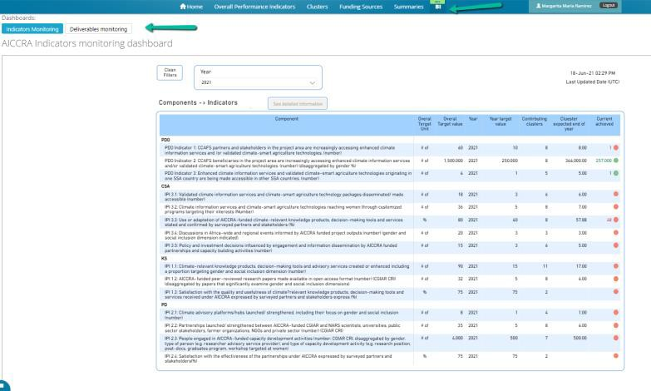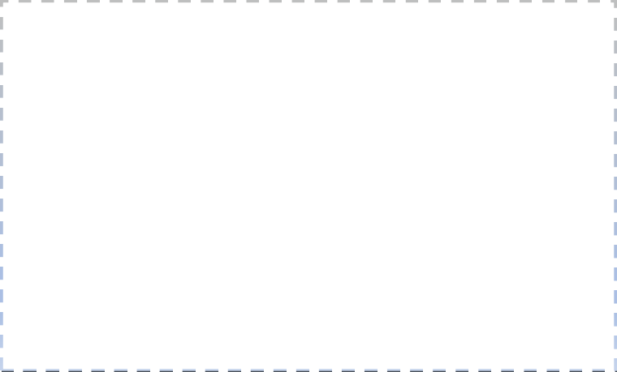

# SUPPORT FOR MARLO-AICCRA USERS

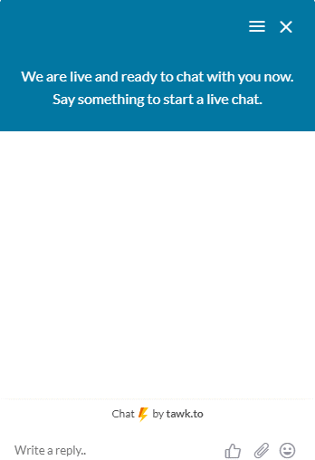Use the online support chat which is located at the bottom left of the screen. The chat it monitored by the technical team based at CIAT in Colombia during business hours. Messages sent by users through the chat outside business hours (Colombia time) will be answered via email

Or contact us through [**MARLOSupport@cgiar.org**](mailto:MARLOSupport@cgiar.org)