Content

Built-in Monitoring and Evaluation Tools

PROGRESS BAROMETER 2
AFTER ACTION REVIEW 3
PROJECT DOCUMENT FILING STRUCTURE 4
MILESTONE PLAN 5
MONITORING COMMITTEE (MoCo) 6
MOOD BAROMETER 7
MONITORING LEARNING OUTCOMES 8
EVALUATION WHEEL 9
STAND TO SCORE 10
GRADIENTS OF AGREEMENT 10
EARS AND EYES TECHNIQUE 11
SHOPPING TROLLEY 11
AFTER MEETING EVALUATION 12
OTHER MONITORING AND EVALUATION TOOLS 15
Useful references 15

PROGRESS BAROMETER

example

Please fill in % of completion of each activity

Region:
Milestones/ Activities | Date: e.g. December 2006
Train of dry season vegetable farmers on organic farming practices

Train of farmer association leadership on group formation and group dynamics

Compile Vacant land register and assess the suitable of the vacant lands to support agricultural development and environmental protection in the Tamale metropolis

Campaign for land tenure schemes such as land trusts, leases Land grants

Train of urban farmers on quality seed production seed management and handling

Train of vegetable farmers on post harvest handling, processing and marketing of vegetable produce

Baseline survey on food security and household income levels and gender involvement in agriculture

Monitoring and evaluation

AFTER ACTION REVIEW

The US Armed Forces originally developed After Action Review (AAR). AAR’s main purpose is learning by talking and thinking about a completed activity or project. Its goal is simply to state lessons learned, rather than to solve problems or criticize. AAR must be done in-house. If possible, it must be done right after the activity discussed. The exercise aims to capture the lessons before they are forgotten. All stakeholders in the process, and they alone, are invited to join the discussion group. Everyone must take part with an open mind. The success of this exercise depends on the participants’ good will.

Basic rules for AAR:
• Focus on constructive feedback. Recognize positive contributions.
• See all participants as equals.
• The group must think about the questions below:
1- What was supposed to happen? → Why?
2- What actually happened? → Why?
3- What is the difference? → Why?
4- What went well? → Why?
5- What could have gone better? → Why?
6- What lessons can we learn?

Benefits and strengths
• Applies to any activity with a preset goal. It doesn’t matter how long the activity took. It doesn’t matter how many people were involved.
• Used as part of a long process, AAR can be applied as soon as each phase is completed.
• Gives all participants the chance to share their ideas and to be heard.
• Allows people to realize what they have learned.
• Creates a climate of confidence in the team.
• Can be applied at any point in a project cycle.

Other key points
• Remember: AAR focuses on process, not individual performance.
• This exercise does not produce any formal report. No formal report is officially entered into the system.
• AAR results can be documented informally and shared with other interested groups. Participants must thus ask themselves what other teams could benefit. Participants must not hesitate to share AAR results.
• It must be ensured that participants can eventually see the impact of the lessons learned.

References
Collison & Parcell 2001; Dixon 2000; National Health Service (UK) 2001; New York State 2002; TEARFUND.

PROJECT DOCUMENT FILING STRUCTURE
Example

- Project Development
  - Concept Note: approved Concept Note or if this is not available, any other document which describes the original project idea.
  - Proposal: approved Proposal if available.

- Project Implementation
- Project documents
    - Project Document: This could be any document developed at the start of the project, used as the basis for project implementation, e.g. a Revised Proposal or an Inception Report.
    - Donor Agreements.
    - Amendments - Extensions: Amendments and extensions to original donor agreements.
    - Partner Agreements – MoUs - ToRs: Partner agreements / MoUs and any other documents related to the agreement such as ToRs.
    - Consultants’ contracts - ToRs: Consultants’ contracts and any other documents related to the contract such as ToRs.
    - Students/interns: documentation and correspondence related to students / interns working on the project
    - Work plan: Overall work plan for the project and / or annual work plans, with related time schedules, excel sheets, etc.
    - Budget.
- Progress Reports
    - Donor Progress Reports: e.g. half annual progress reports to IWMI.
    - Financial statements: any financial statements other than the summary presented in the Quarterly Progress Report.
- Correspondence: Essential correspondence, in particular referring to adjustments / changes in project, should be filed here.
- Internal Project Documents: Any internal project documents, trip reports etc.
- Project Feedback File: correspondence etc. related to feedback from users, partners, donors (will be used for impact assessment at later stage).
- Capacity Building Record Sheet: Form given by Capacity Building Office.
- Outputs: Documents, articles, etc.

- Project Closure
  - Project Closure Report – Project Evaluations: Project Closure Report. Project evaluations: External (by donors) evaluations such as mid-term review of evaluation.
  - Final Income and Expenditure Statement: will be done with Accounts
  - Final Project Report: Final project report which is usually produced at project closure.

MILESTONE PLAN

Example

Milestone Plan |  |  |  |  |  |  |  |  | Updated last:
Project Title:
Starting Date: |  |  |  |  |  | Completion Date:
Partner City:
Contact/ responsible partner:
Year | Qarter | Activity  No. | Type of milestone |  | Description |  | Dead-line | Date of completion |  | Means of Verification |  | Comments/ Reference |  |  | Evaluation | Costs to reach milestone
1 | 1 | 1.1 | Output |  | Inception report drafted |  | 06/09/15 |  |  | Report |  |  |  |  | Accepted | 100,00
1 | 1 | 1.2 | Output |  | Milestone plan developed |  | 06/09/15 |  |  | Milestone plan available |  |  |  |  | Submitted | 400,00
1 | 1 | 1.3 | Output |  | E-list created |  | 06/09/15 |  |  | List available |  |  |  |  | Accepted | 50,00
1 | 1 | 1.4 | Activity |  | Partner network matrix structure developed |  | 06/09/15 |  |  | Matrix |  |  |  |  | Review
1 | 2 | 1.5 | Output |  | Brochure printed |  | 06/12/15 |  |  | Broschure availabe
1 | 2 | 2.1 | Input |  | Purchase digital camera |  | 06/12/15 |  |  | Receipt
1 | 1 | 1.4 | Activity |  | Outcome journal developed |  | 06/09/15 |  |  | Outcome journals listed

MONITORING COMMITTEE (MoCo)

A team of approx. three people (appointed trainees) form a Monitoring Committee (MoCo). This committee will e.g. link up to the mood barometer results from the previous day and reflect every morning especially on the following four criteria:

- Activities
- What went well
- What needs to be improved
- What action needs to be taken

MOOD BAROMETER

Objective: The mood barometer or happiness index measures the participants’ subjective assessment of a training session or activity. It can encompass reactions to the training content, methodologies, training aids and materials, trainers/moderators, as well as the overall learning environment.

Instructions:
- Give your personal assessment (very unhappy, unhappy, no strong opinion, happy or very happy) about:
- the classroom (atmosphere, facilities),
- the food and rooms,
- the time schedule,
- module 1 content and
- the training approach/methodology used thusfar.
- You can either just indicate if you r personal feeling by writing an X or sticking a post-it in the different columns, or
- You also write on the flip-chart or post-its why you are content or discontent (the latter providing the organisers concrete inputs to make necessary changes).

Issues | ☹☹ | ☹ | 😐 | ☺ | ☺☺
The classroom (atmosphere, facilities)

The food and rooms

The time schedule

Module 1 content

The training approach/methodology used

MONITORING LEARNING OUTCOMES

Objective: Scoring sessions of workshops is common and convenient way to evaluate the content of workshop session. Each session will need to define clearly expected outputs to be achieved and explain those to the participants.

Instructions:
- Please rate in the table below your initial level of confidence (before the beginning of a workshop session) in performing the learning outcomes listed below (1= low: 5 = high).
- Please rate in the table below your current level of confidence level (after having gone through the session) in performing the learning outcomes listed below (1= low: 5 = high).

Name: _____________________________________________________________________

Initial level of confidence |  |  |  |  | Knowledge , skills and attitudes (expected learning outcomes) | Current level of confidence
1 | 2 | 3 | 4 | 5 | EXPECTED OUTCOME 1 | 1 | 2 | 3 | 4 | 5
 |  |  |  |  | EXPECTED OUTCOME 2
 |  |  |  |  | EXPECTED OUTCOME 3
 |  |  |  |  | EXPECTED OUTCOME 4
 |  |  |  |  | EXPECTED OUTCOME 5
 |  |  |  |  | EXPECTED OUTCOME 6
 |  |  |  |  | EXPECTED OUTCOME 7
 |  |  |  |  | EXPECTED OUTCOME 8
 |  |  |  |  | EXPECTED OUTCOME 9
 |  |  |  |  | EXPECTED OUTCOME 10

EVALUATION WHEEL

Objective: The purpose of this technique is to evaluate different aspects in a visual way. The Evaluation Wheel help participants and facilitators to consolidate their lesson learned and share their learning experiences. This technique is useful since it helps to brainstorm and establish topics to be evaluated in a visual way.

Instructions:
- Decide upon criteria for evaluating (not too many)
- Draw a large circle in a flip chart or flip charts joined together.
- Divide the circle in equal sized sectors by drawing lines (or spokes) from the centre to the circumference.
- Write at the end of the spoke each aspect of the evaluation (i.e. logistics, food, facilitation, fieldwork).
- Indicate to participants to do likewise on a piece of paper (replicate the wheel).
- Indicate to participants to assess the various criteria by marking a little circle on the spoke. The spokes represent a scale with low or zero at the centre and high or 10 at the edge. No mark at all indicates dismal beyond despair.
- Join the circles to create a spider diagram (see graphic below).
- Ask participants, when they have finished, to draw their evaluations in the big chart. This ends up with many lines in each sector, giving a clear visual evaluation.

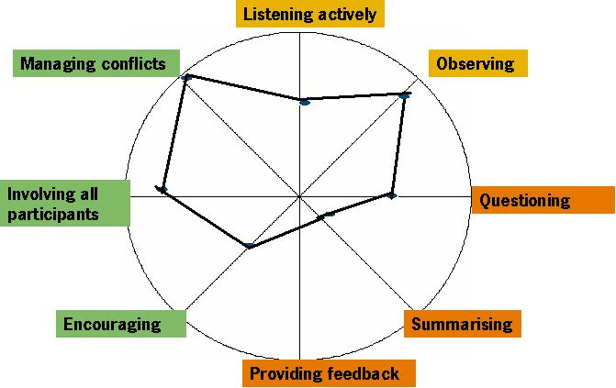
Tips:
- Brainstorm at the beginning to establish the categories of each sector and how many they should be.

STAND TO SCORE

Objective: This active, flexible and quick evaluation technique is useful when workshop participants are tired at the end of the day.

Instructions:
- Decide upon criteria for evaluating.
- Select two physical elements (i.e. two walls) to represent a zero to ten scale.
- Assess one criteria at the time
- Ask participants to stand between the two physical elements to indicate their evaluation of particular criteria.
- Ask why people have chosen their position.

Tips:
- Positions and scores are likely to be influenced by others’ movements and by the awareness of the facilitators, if they are watching. All the same, those at the low ends usually have good insights to share, which provide valuable feedback.

GRADIENTS OF AGREEMENT

Objective: This technique aims to poll individuals around a specific issue. It is based on a scale that makes it easier for workshop participants to be honest. Using it, participants can register less-than-whole-hearted support without fearing that their statement will be interpreted as a veto.

Instructions:
- Define the question or issue the participants will be polling. For instance, do you find this workshop session relevant or useful?
- Discuss an agreement scale to work with. Together, participants could create a gradient that goes from not useful to extremely useful. An example of a gradient of agreement is the following:
- Endorse - I like it
- Agree with reservation - I can live with it
- Abstain - it does not matter to me
- Stand aside - don't like but won't block
- Serious objection – veto
- Write the participants’ gradients in a flipchart and hang it where everybody can see it.
- Draw a scorecard. To do this draw vertical lines between the different gradients of agreements.
- Record the results of the poll. You can find out where people stand by asking them to raise their hands and then counted for each one of the gradients of agreement. You can also ask participants to write where they stand on a piece of paper and then collect the papers.
- Record the results of the poll on the flipchart.

EARS AND EYES TECHNIQUE

Objective: The idea of this technique is to get some general comments (what were people saying, were they confused, were there many heads nodding in agreement, etc.) and some ideas on how the sessions could be improved.

Instructions:
- Designate one person on each group to be the Ears. This person will listen all day attentively and will report back at the end of the day on what she/he heard.
- Designate one person on each group to be the Eyes. This person will watch all day attentively and will report back at the end of the day on what she/he saw.
- Report to the workshop participants what they saw or heard during the day.

SHOPPING TROLLEY

Instructions:
- Draw on a paper a person with 2 shopping trolleys (one in front and one behind the person)
- Ask each participant to write down on a piece of paper two or three words about what they liked, what they will take with them and what they leave behind.
- Place the comments on the drawing following this order:
  - What they liked: On the person’s belly.
  - What they will take with them: In the trolley in front of the person.
  - What they leave behind: In the trolley behind the person.
  - What they didn’t like

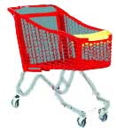

AFTER MEETING EVALUATION

Dear … Meeting Participants

Please help us in our efforts to evaluate our last … Meeting and improve the coming meeting by filling in this questionnaire.

Please send the completed questionnaire to xxx.

Thank you in advance!

1. PREPARATION

Issues | ☹☹ | ☹ | 😐 | ☺ | ☺☺
e.g. Logistical preparation and information

Observations and recommendations for improvement
……………………………………………………………………………………………………………
……………………………………………………………………………………………………………………………………………………………………………………………………………………………………

Issues | ☹☹ | ☹ | 😐 | ☺ | ☺☺
e.g. …

Observations and recommendations for improvement
……………………………………………………………………………………………………………
……………………………………………………………………………………………………………………………………………………………………………………………………………………………………

2. IMPLEMENTATION

Issues | ☹☹ | ☹ | 😐 | ☺ | ☺☺
e.g. The overall program: duration and content

Observations and recommendations for improvement. Please identify any missing sessions/topics that you would like to have tackled.
……………………………………………………………………………………………………………
……………………………………………………………………………………………………………………………………………………………………………………………………………………………………

Issues | ☹☹ | ☹ | 😐 | ☺ | ☺☺
e.g. …

Observations and recommendations for improvement ……………………………………………………………………………………………………………
……………………………………………………………………………………………………………………………………………………………………………………………………………………………………

3. RESULTS

Issues | ☹☹ | ☹ | 😐 | ☺ | ☺☺
e.g. Have your expectations and needs for training, information and support been met?

Please indicate and specify un-met needs for training, information or support ……………………………………………………………………………………………………………
……………………………………………………………………………………………………………………………………………………………………………………………………………………………………

Issues | ☹☹ | ☹ | 😐 | ☺ | ☺☺

Please indicate in which fields/themes you still feel not fully confident or highlight remaining questions you may have
……………………………………………………………………………………………………………
……………………………………………………………………………………………………………………………………………………………………………………………………………………………………

4. FURTHER SUPPORT/ INFORMATION/TRAINING NEEDS

Do you see any gaps?
……………………………………………………………………………………………………………
……………………………………………………………………………………………………………………………………………………………………………………………………………………………………

Do you have any further specific support or information needs?
……………………………………………………………………………………………………………
……………………………………………………………………………………………………………………………………………………………………………………………………………………………………

Do you have any further training needs?
……………………………………………………………………………………………………………
……………………………………………………………………………………………………………………………………………………………………………………………………………………………………

5. FINAL OBSERVATIONS/ RECOMMENDATIONS
……………………………………………………………………………………………………………
……………………………………………………………………………………………………………………………………………………………………………………………………………………………………

NAME (OPTIONAL):
DART BOARD EVALUATION

The evaluation dartboard is a quick and simple method for participants to rate the delivery of a workshop, training session or similar activity. For example used at the end of an event to check for achievement by 4-8 different criteria/ questions, which should/could cover ideally content, process and logistics.
Questions can include:
- Extent to which the workshop (or other) met participants’ learning needs
- Extent to which the workshop (or other) inspired participants to take action
- Level of enjoyment
- Level of interaction
- Extent to which questions were answered
- Quality of speakers
- Quality of facilitation
- Quality of handouts, preparatory materials
- Quality of logistics (accommodation, venue, catering)

Ranking cam be in percent of achieved, or categorized in
  - exceeded expectations
  - met expectations
  - missed the mark

See examples below:
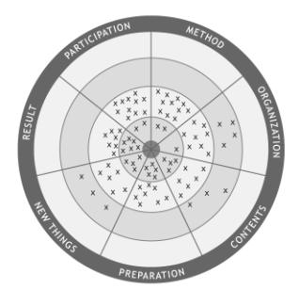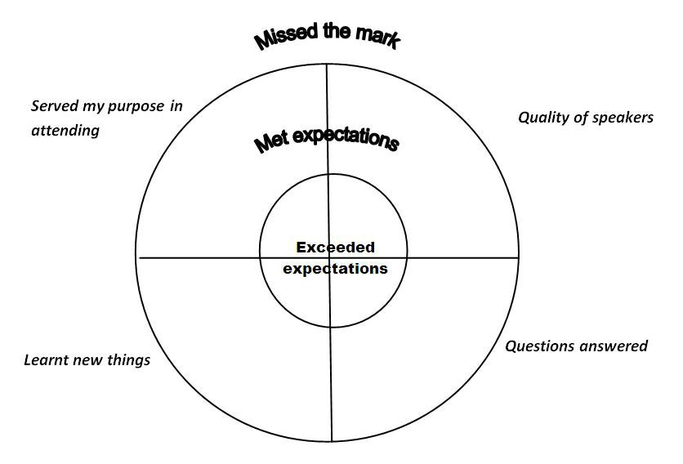

OTHER MONITORING AND EVALUATION TOOLS

- Background questionnaire

- Training Needs Assessment (TNA)

- Participants list

- 6-months after-workshop evaluation

- Pictures

- Financial monitoring

- Reflection within the team

- Check-in morning => e.g. 1 word how every participant feels

- End-of-day go-around => e.g. 1 word or 1 sentence - depending on how much time you want to spend on this - 'How was today for you?'

- ….

Useful references

Community Sustainability Engagement Evaluation Toolbox

