## Reflection Workshop

Location, Date

# Background and Rationale

Description of Program, scope, what, and why …

[…] is a program bridging from research to developmental impact. In doing so it focuses on reflection, learning and adaptive management in implementing research for development programs. Reflection is a key part of the programs Monitoring and Evaluation. It involves project staff and key stakeholders taking stock of what has happened and revisiting basic assumptions. Reflecting on whether outcome pathways are unfolding as expected provides a mechanism for adaptive management for projects and basin programs as a whole.

This workshop allows projects self-evaluation with respect to progress. New information, feedback from stakeholders, experience, and learning, all feed into this reflection. Our research questions, outcome targets may change, becoming more precise, more ambitious or more realistic. Outcome pathways and related changes to activities, actors and milestones will be made. The vision remains unchanged, but the impact narratives explaining how achievement of the program outcome targets will contribute to achieving the vision, evolve see figure 1 below.

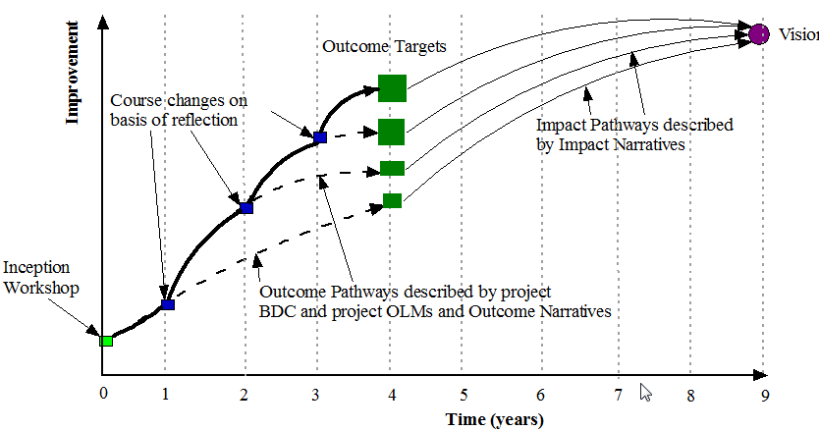

Figure 1 Evolution of reflection on theories of change and impact pathways trajectories

The reflection meeting will contribute to the coherence and integration of the [number] projects; ensure progress toward delivery of high quality research outputs; and identify opportunities to improve our approach. The meeting will allow teams to identify outputs and plan how best to target, package, and roll them out to next users.

## Objectives

The meeting aims to meet the following objectives:

1. Assess whether or not we are working in line with our plans and whether or not this gets us where we need to be for delivery and impact;
2. Maximize the benefit of partnerships within and around the program;
3. Assess where best to focus our efforts with the time remaining in the program.

## Outputs

Expected outputs include:

* Revised project level Theories of Change, Gantt Charts and Milestone plans
* Updated project interdependencies
* Emerging key messages at project and basin levels
* Milestones to Communication plans at project level
* Schedule of events

## Key Questions

1. How relevant is the program’s/ flagship’s/ regional program’s research to emerging issues and regional initiatives?
2. Are our project, flagship/ program level theories of change still appropriate and applicable?
3. In what way do we need to revise our assumptions? Has evidence for our assumptions evolved?

# Key activities

1. Refine the program/ flagship research questions, toward which all projects contribute;
2. Clearly articulate how each project contributes to the program/ flagship research questions;
3. Strengthen linkages between the flagship and the program teams to magnify learning

# 6. Process

The project teams represent implementation on the ground and our best chance for successful research for impact. The workshop process and agenda are currently open for discussion. We expect a very busy and productive five days. The time will be planned roughly as follows:

* Day One: Individual project team work; update from the program
* Day Two: Science/project presentations (2 projects; ½ day each)
* Day Three: Science/project presentations (2 projects; ½ day each)
* Day Four: Field trip
* Day Five: Ways forward; expert feedback

# 7. What to prepare

We expect participants to be prepared and contribute actively during the sessions. Each project should prepare the following:

Project Update:

1. Progress to date=Key Outputs listed and available on cd;
2. Link each of these outputs with the appropriate flagship outcomes and theories of change
3. How has this changed from the original plan?
4. Emerging stories/issues from the work to date;
5. Project interdependencies
6. Issues of gender relevance emerging in your project

# 8. Participants

Each project has a $10,000 dedicated budget for your team’s participation in the Reflection Workshop. Therefore, projects are responsible for all of your participants’ travel, accommodation, conferencing and meals. Please give careful consideration to which team members you want to include in the Reflection workshop and use the time productively.

# 9. Logistical information

The meeting will be held in [city, country], exact venue to be determined. The meeting begins Monday morning, March 26th so please arrive on Sunday, March 25th. We will finish around 17.00 on Friday, March 30th. […] is taking care of logistics with help from […] so please let us know flight details, room and dietary needs as well as questions on visas or logistics.

**Reflection Workshop**:

Coordination project/ flagship will present at the beginning of each day and at the closing of each day as needed. Issues to be covered include Data Management System, Reporting, Communications, and upcoming events.

*All projects will be asked to provide a list of outputs and actual outputs on CD for sharing with others.

**Things that need to be done:**

* TORs for external consultants to provide external perspectives
* Compiled research questions
* Use milestones to link to the communication pathway.
* Put all documents on the wiki, relevant to the reflection on CD for distribution. *(This can be done every 3months).*
* *Define field trip where and purpose what do we want to get out of this day …*

# Emerging Agenda

|  |  |  |  |  |  |
| --- | --- | --- | --- | --- | --- |
|  | Day 1:  Project Team Work | Day 2:  Project Presentations Q & A | Day 3  Project Presentations Q & A | Day 4  Field Trip | Day 5 |
| Session 1 | Project team working session | **Reflection Opening**  **Research Questions   * **Project 1**   Reflection on outputs and progress to date. Plans versus reality (link outputs to outcome, Impact Pathways) | **Reflection** on day 1  **Topical discussions   * **Project 3**   Reflection on outputs and progress to date. Plans versus reality (link outputs to outcomes, Impact Pathways) | Define purpose and that we try and get some task done there, e.g. interviews snap shots captions | **Reflection** to date   * Refine project to program level research questions |
| Coffee |  |  |  |  |  |
| Session 2 | Project team working session | * **Contd.** | * **Contd.** |  | * Linking Milestones to Communication plans * Reporting |
| Lunch |  |  |  |  |  |
| Session 3 | Bilaterals—project to project meetings | **Data management; M & E   * **Project 2**   Reflection on outputs and progress to date. Plans versus reality (link outputs to outcomes, Impact Pathways) | ** Gender   * **Project 4**   Reflection on outputs and progress to date. Plans versus reality (link outputs to outcomes, Impact Pathways) | Field Trip | * Planning * Activity Calendar * Evaluation   Closing |
| Session 4 | Welcome, Introductions  Reflection Road map  Update from the program | * **Contd.** | * **Contd.** |  |  |
| Wrap ups | Critical issues to be covered during Reflection | Daily evaluation  Emerging key messages  Interdependencies | Daily evaluation  Emerging key messages  Interdependencies |  |  |
| Evening | Dinner |  |  |  |  |
| Outputs | Project Updates  Student Matrices  Updated inter-dependencies | Updated stakeholder maps  Updated TOCs, outcomes, plans | Updated stakeholder maps  Updated TOCs, outcomes, plans |  |  |

**mini-sessions on selected topics.