MEMORANDUM

TO : Sam Goshorn, Elmer Masters
FROM : John Mayer, Executive Director, CALI
DATE : May 24, 2014
Update January 17, 2015
RE : Design for Document Assembly in A2J5

This is a first attempt at designing the document assembly features into A2J Author. I include screenshots for user experience purposes and discussion about present and future goals. It is key to note that the requirements for the current grant are quite modest, however, we do have to design with the future in mind.

The basic idea is that interviews produce DOCUMENTS and DOCUMENTS are made up of CLAUSES.

The CLAUSE tab lists all the clauses that have been created for this interview and the list includes such details as the CLAUSE_ID (important later on), a comment/note/description of the clause for authors to document what a clause is all about, the size of the clause in word count and a list of the variables and functions inside a clause.

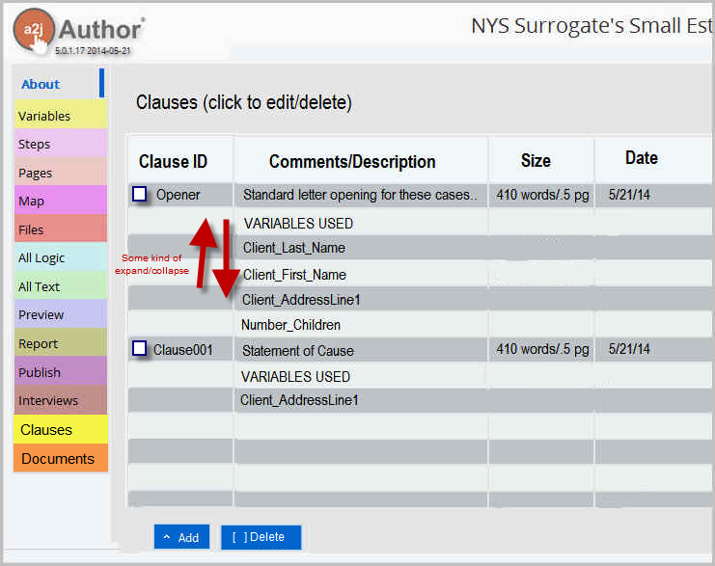
Clicking on the Add button brings up a popup where a new clause can be created.

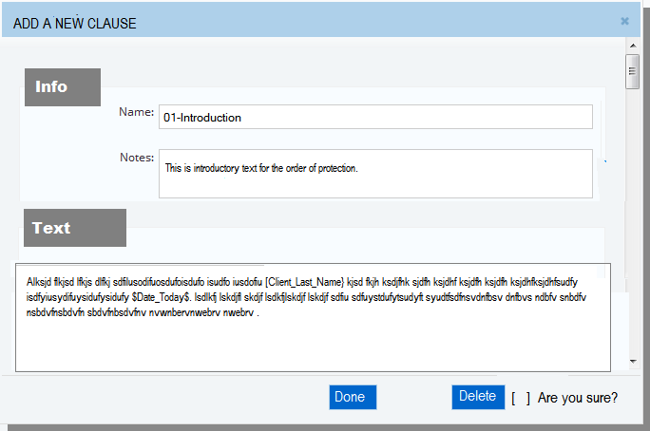
CLAUSES contain the text that appears in documents including replaceable variables and conditional statements. The idea behind CLAUSES is that these are movable or optional chunks of text that might be in a document in different places or in different orders depending on the answers from the A2J Guided Interview (hereafter GI). If there is permanent text that always appears in the document in the same place, then the author can, if they want, put that into a DOCUMENT and use INCLUDE statements to insert CLAUSES into the DOCUMENT around any permanent text.

The DOCUMENTS tab brings up a list of DOCUMENTS.

DOCUMENTS determine what actually gets produced when the user finishes a GI. On the final page of the GI, the author uses a new program control statement or primitive ASSEMBLE <document name> to actually initiative the document assembly process. The author can have as many of these as they want and can place them inside conditionals if they want to assemble different sets of documents based on variables set during the GI.

Here's a mockup of the DOCUMENTs tab...

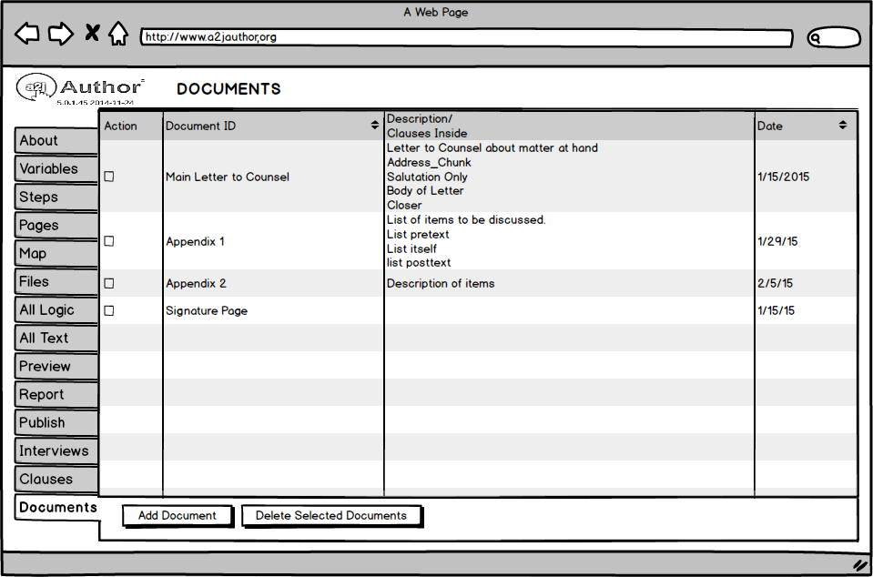

In summary

- Two new tabs will be added to main A2J Author interface – CLAUSES and DOCUMENTS.
- Under CLAUSES will be a list of items that contain text and programming code (conditionals and loops) and variables
- A new primitive INCLUDE can insert CLAUSES inside of other CLAUSES.
- Under the DOCUMENTS tab will be a list of items that produce complete documents which can have headers, footers, page numbers, etc. as well as programming code such as conditionals, loops and INCLUDE statements for inserting CLAUSES.
- You cannot INCLUDE DOCUMENTS inside other DOCUMENTS or CLAUSES. You can INCLUDE CLAUSES inside CLAUSES and DOCUMENTS.
- Another programming statement – ASSEMBLE tells the GI to perform the assembly of the DOCUMENT and can be placed anywhere inside the GI, but will only be invoked at the successful completion of an interview. The ASSEMBLE statement can be inside conditionals and loops as well and each invocation will produce a new document. This makes it possible to produce multiple copies of the exact same document with a minor change like letters that have to be copied to muliple parties at different addresses. [NOTE: THIS IMPLIES MAKING A COPY OF THE VARIABLES THAT INSIDE A DOCUMENT AT THE TIME OF THE ASSEMBLE STATEMENT].

SOME THOUGHTS
- Why not eliminate DOCUMENTS as an item and just make them a special case of a CLAUSE that has additional properties like page numbering, headers and footers, etc.?
- It might be better to require the author to put all the ASSEMBLE statements in one place, like at the end of the interview so that it's easier to optimize assembly all at once. Otherwise, we will have to remember the ASSEMBLE “state” when saving/resuming.
- I suspect that looping through ASSEMBLE statements and changing some variables can get tricky. We might have to start out by not allowing looped ASSEMBLEs at all. Each ASSEMBLE has to work with the state of the variables at that moment in time in the execution of the code.
- Some features should be pushed into later versions since they are not part of a Minimally Viable Product like headers, footers, page numbering, etc. Maybe DOCUMENTS can only have INCLUDE statements and nothing else at first and later we can add conditionals and looping.

