Per user score is weighted sum of 3 scores

$${score}_{user}=100-100 X (w_{a}.{agescore}_{user}+w_{d}.{duplication}_{user}+w_{o}.{occupancy}_{user})$$

And

$$w_{a}+w_{d}+w_{o}=1$$

1. agescore is average per byte agescore

$${agescore}_{user}=\sum_{file=1}^{n}{{{nbytes}_{file} X agescore}_{file}}$$

To calculate per file agescore using function like this:

getScore<-function(age){

s1=0.1

s2=0.8

if (age<(30*6)){

score=age/(30*6)*s1

}

else if (age<(30*24)){

age2=age-(30*6)

score=s1+age2/(30*(24-6))*s2

}

else if (age<1000){

age2=age-(30*24)

score=s1+s2+age2/(1000-30*24)*(1-(s1+s2))

}

else {

score=1

}

return(score)

}

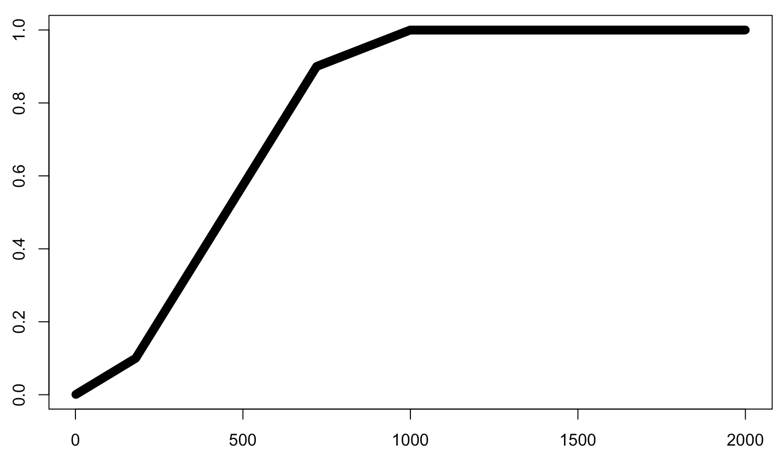

1. Duplicate score per user. Self explanatory
$${dupscore}_{user}=\frac{duplicate bytes}{total bytes}$$

2. Occupancy or hogging of the allocated 200TB:

If $total bytes<10\% of 200TB$

$${occscore}_{user}={total bytes}/{10\% of 200TB}$$

Else

${occscore}_{user}=1$

Weights: Suggested values $w_{a}=0.25, w_{d}=0.4, w_{o}=0.35$

|  |  |  |
| --- | --- | --- |
| $$score$$ | **Min** | **Max** |
| $${agescore}_{user}$$ | 0=all files are new | 1=all files are older than 2 years |
| $${dupscore}_{user}$$ | 0=no duplication | 1=all files are duplicates |
| $${occscore}_{user}$$ | 0=using no  shared storage space | 1=single handedly using 10% or more of shared space |
| $${score}_{user}$$ | 0=worst user | 100=best user |