



This document has the intention of presenting Living Environment Regents Prep better known as LERP.

INDEX

Introduction…………………………………. Pg 1

How to use LERP…………….……………....Pg 2

Resources for Teachers…………………..…...Pg 6

About CCCLXIX….…………………...……...Pg 14

[1]

INTRODUCTION

Welcome.

LERP (Living Environment Regents Prep) it's an application with educational purposes. The intention of this app is to help New York State students in their Living Environment Regents. LERP carries many resources for the student to get prepared for the test, such resources are going to be listed in 'How to use LERP' Pg 2. All personal information that the user provides in this app are going to be stored in the individual's own phone and nowhere else. Interactions (Pressing a button, taking quizzes, etc.) the user may have with the application are going to be sent anonymously thru Google Analytics for study in order to improve LERP. CCCLXIX it's a non-profit stamp and it's not going to obtain profit for any of the interactions the users may have with the application.

LERP complies with all Google Analytics privacy policies.

From a student to a student.

J. Marcos Hernandez Q.

[2]

HOW TO USE LERP

LERP has been designed to be user friendly, intuitive from the first run. In this section of the presentation, I'm going to explain the utilities and advantages of using LERP.

Lets being with the first Activity:

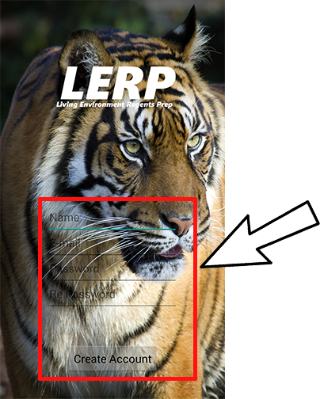This is the first activity that the user is going to encounter right after the presentation. LERP gives the user the ability to have a more personalized experience by asking the user to provide the information inside the red box. In care the user doesn't want to provide the information, it is possible to just tap 'Create Account' and the application will give access as a normal user would.

[3]

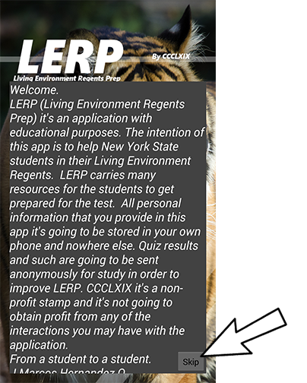The following activity would be the welcoming of the user. This activity only happens once right after the user registers.

The 'Skip' button it's going to take the user to the Main Menu activity which is next.

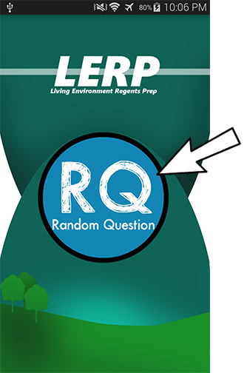The Main Menu activity displays all the functionality of LERP, which are the following:

1) Random Question (RQ) gives the user the ability to practice some regents questions that are being selected randomly by the application.

Next page…..

[4]

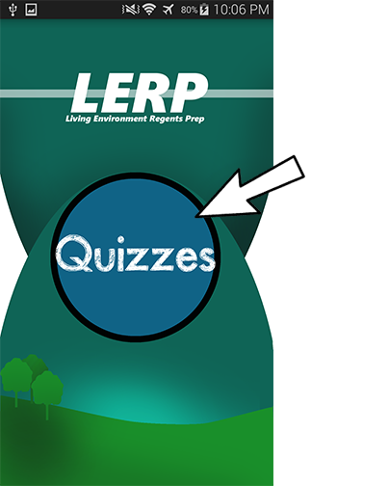2) Quizzes gives the user the ability to test himself by taking one of the three currently provided quizzes by LERP. The app displays the score and saves it. The questions that LERP uses were took from <http://www.nysedregents.org/livingenvironment/>

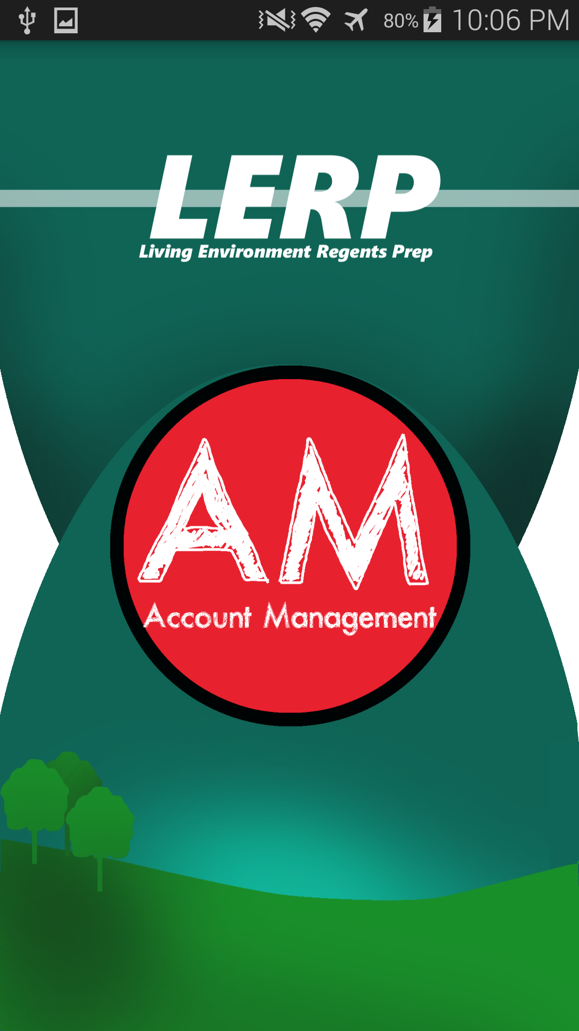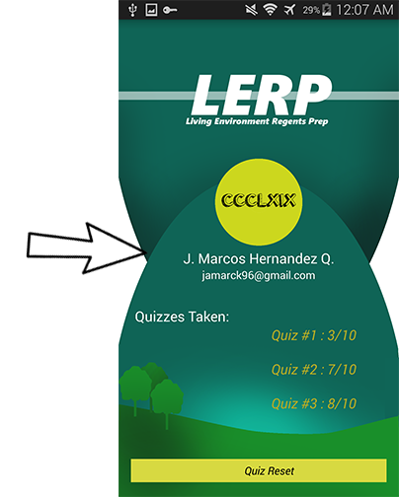The answer key for these quizzes are provided in 'Resources for Teachers'

3) Account Management (AM) this activity gives the user information about the quizzes he/she has taken and the opportunity to Reset them to take them again.

[5]

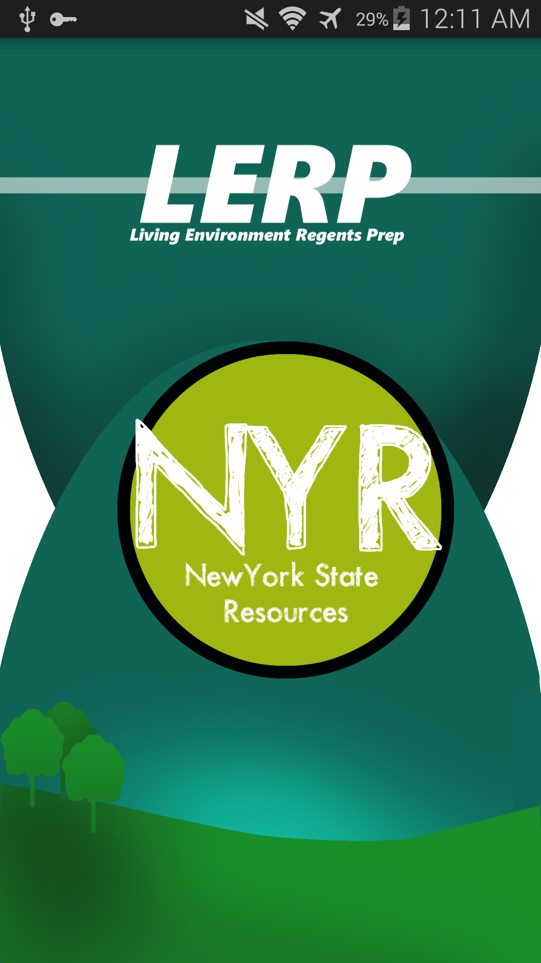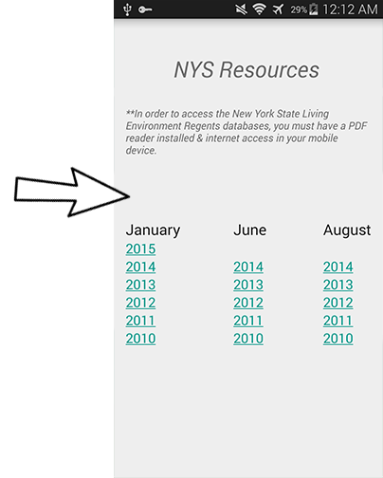

4) New York State Resources (NYR) facilitates the user the links of past Living Environment Regents.

[6]

Resources for Teachers

----------------------------------------------START QUIZ ONE-----------------------------------------------------------

Jan 2015 Regents

QUIZ #1: Q1;#1 | Q2;#4 | Q3;#7 | Q4;#19 | Q5;#18 | Q6;#25 | Q7;#27 | Q8;#33 | Q9;#35 | Q10;#13 |

----------------------------------------------Question 1---------------------------------------------------------------

Which observation could lead to the conclusion that an object is nonliving? </string>

(1) It passes on hereditary information only through asexual reproduction.</string>

2) It carries out synthesis.</string>

(3) It cannot perform metabolic processes.</string>

(4) It is composed of a cell, but does not have tissues.</string>

----------------------------------------------Question 2---------------------------------------------------------------

Which sequence best represents increasing complexity? </string>

(1) tissues → cells → organelles → organs</string>

(2) cells → organelles → organs → organism</string>

(3) organelles → cells → tissues → organs</string>

(4) organism → cells → tissues → organelles</string>

----------------------------------------------Question 3---------------------------------------------------------------

The cytoplasm in a single-celled organism and the circulatory system in a human both </string>

(1) break down molecules into smaller components</string>

(2) release energy to be used by the organism</string>

(3) transport substances throughout the organism</string>

(4) distribute blood to all of the parts of the organism</string>

[7]

----------------------------------------------Question 4---------------------------------------------------------------

The reproductive cycle in females is regulated primarily by </string>

(1) estrogen and testosterone</string>

(2) estrogen and progesterone</string>

(3) progesterone and insulin</string>

(4) progesterone and testosterone</string>

----------------------------------------------Question 5---------------------------------------------------------------

Photosynthesis and respiration are alike in that they both </string>

(1) require the Sun as a direct source of energy</string>

(2) result in the production of glucose molecules</string>

(3) require specific catalysts</string>

(4) occur within mitochondria</string>

----------------------------------------------Question 6---------------------------------------------------------------

Nicotine is only one of the many toxic chemicals inhaled while smoking. What effect can such toxic chemicals have on the body? </string>

(1) They stimulate an increase in height.</string>

(2) They stimulate uncontrolled cell division.</string>

(3) They eliminate carbon dioxide from cells.</string>

(4) They eliminate chromosomes from many cells.</string>

----------------------------------------------Question 7---------------------------------------------------------------

Which process uses energy to combine inorganic molecules to synthesize organic molecules? </string>

(1) respiration</string>

(2) digestion</string>

(3) photosynthesis</string>

(4) decomposition</string>

----------------------------------------------Question 8---------------------------------------------------------------

The inability of an organism to produce certain proteins can occur when an organism is lacking an enzyme needed to

[8]

combine </string>

(1) oxygen molecules</string>

(2) simple sugars</string>

(3) amino acids</string>

(4) biological catalysts</string>

----------------------------------------------Question 9---------------------------------------------------------------

A cell begins to produce a new type of protein. This is most likely due to an alteration of the </string>

(1) structure of the cell membrane</string>

(2) sequence of bases in a section of a chromosome</string>

(3) chemical makeup of the cytoplasm</string>

(4) shape of the antibodies produced by the nucleus</string>

----------------------------------------------Question 10---------------------------------------------------------------

Information in segments of human DNA can be expressed by a bacterial cell as a result of </string>

(1) sexual reproduction</string>

(2) random mutation</string>

(3) genetic variability</string>

(4) genetic engineering</string>

----------------------------------------------END QUIZ ONE-------------------------------------------------------------

----------------------------------------------START QUIZ TWO-----------------------------------------------------------

June 2013 Regents

QUIZ #1: Q1;#2 | Q2;#11 | Q3;#9 | Q4;#13 | Q5;#8 | Q6;#14 | Q7;#16 | Q8;#18 | Q9;#15 | Q10;#25 |

----------------------------------------------Question 1---------------------------------------------------------------

In New York State, small farms that were abandoned many years ago have become hardwood forests. This is an example of </string>

(1) local deforestation</string>

(2) biotechnology</string>

[9]

(3) ecological succession</string>

(4) habitat loss</string>

----------------------------------------------Question 2---------------------------------------------------------------

In a multicellular organism, organs carry out a variety of life functions. In a single-celled organism, these functions are performed by </string>

(1) tissues </string>

(2) organelles </string>

(3) organ systems</string>

(4) organs</string>

----------------------------------------------Question 3---------------------------------------------------------------

Before starch can enter a cell, it must be </string>

(1) absorbed by simple sugars</string>

(2) diffused into simple sugars</string>

(3) digested to form simple sugars</string>

(4) actively transported by simple sugars</string>

----------------------------------------------Question 4---------------------------------------------------------------

In order for the human body to maintain homeostasis, the breakdown of glucose to release energy must be followed by the

(1) production of oxygen</string>

(2) division of the cell</string>

(3) removal of wastes</string>

(4) production of receptor molecules</string>

----------------------------------------------Question 5---------------------------------------------------------------

The processes of deletion, insertion, and substitution can alter genes in a skin cell. The altered genes will most likely be passed on to </string>

(1) sperm cells</string>

(2) egg cells</string>

(3) every cell that develops from that skin cell</string>

(4) only a few of the cells that develop from that skin cell</string>

[10]

----------------------------------------------Question 6---------------------------------------------------------------

In the past, humans developed varieties of dogs, such as the German shepherd and the bearded collie, using </string>

(1) selective breeding for particular traits.</string>

(2) recombination of genes during mitosis.</string>

(3) mutations present only in body cells.</string>

(4) natural selection of favorable traits.</string>

----------------------------------------------Question 7---------------------------------------------------------------

Which sequence best represents sexual reproduction? </string>

(1) mitosis → gametes → zygote → fertilization</string>

(2) gametes → meiosis → mitosis → fertilization</string>

(3) fertilization → gametes → meiosis → zygote</string>

(4) meiosis → gametes → fertilization → zygote</string>

----------------------------------------------Question 8---------------------------------------------------------------

The energy used to obtain, transfer, and transport materials within an organism comes directly from </string>

(1) ATP </string>

(2) DNA </string>

(3) sunlight </string>

(4) starch </string>

----------------------------------------------Question 9--------------------------------------------------------------- <

In an organism, a muscle cell has the same DNA as a nerve cell, yet the cells perform different functions. This is possible because </string>

(1) different mutations occur in each cell type, changing the genetic instructions</string>

(2) temperature variations within the body alter DNA</string>

(3) proteins in each cell type change the structure of DNA</string>

(4) different parts of the genetic instructions are used in each type of cell</string>

----------------------------------------------Question 10---------------------------------------------------------------

Which type of organism helps to reduce atmospheric carbon dioxide? </string>

(1) carnivores </string>

[11]

(2) producers </string>

(3) decomposers </string>

(4) herbivores</string>

----------------------------------------------END QUIZ TWO-------------------------------------------------------------

----------------------------------------------START QUIZ THREE---------------------------------------------------------

June 2014 Regents

QUIZ #1: Q1;#1 | Q2;#7 | Q3;#16 | Q4;#4 | Q5;#18 | Q6;#15 | Q7;#27 | Q8;#12 | Q9;#26 | Q10;#21 |

----------------------------------------------Question 1---------------------------------------------------------------

How do cells in the ovary detect a hormone from the brain? </string>

(1) The brain sends a nerve impulse to the ovary.</string>

(2) White blood cells bring the hormone to the ovary.</string>

(3) Receptor molecules on the cells of the ovary bind with the hormone.</string>

(4) Vacuoles within the ovary bind with the hormone.</string>

----------------------------------------------Question 2---------------------------------------------------------------

Autotrophs might survive when heterotrophs cannot, because autotrophs are able to </string>

(1) reproduce asexually </string>

(2) become dormant </string>

(3) exist without respiration</string>

(4) make their own food</string>

----------------------------------------------Question 3---------------------------------------------------------------

During the process of cellular respiration, energy is released from </string>

(1) carbon dioxide</string>

(2) oxygen atoms</string>

(3) water molecules</string>

(4) chemical bonds</string>

----------------------------------------------Question 4---------------------------------------------------------------

[12]

In order to enter cells and be useful to the body, starch must be </string>

(1) absorbed through the skin</string>

(2) broken down into fats and water</string>

(3) digested into simple sugars</string>

(4) converted to carbon dioxide and ATP</string>

----------------------------------------------Question 5--------------------------------------------------------------- <string name="qz3_q5">5) Which expression correctly represents a reproductive process that usually occurs in humans where 2n is equal to the number of chromosomes in each body cell? </string>

(1) n + n → n</string>

(2) n + n → 2n</string>

(3) n + 2n → 2n</string>

(4) 2n + 2n → 4n</string>

----------------------------------------------Question 6---------------------------------------------------------------

Which event would most likely cause a change in a genetic sequence in an organism? </string>

(1) eating certain foods high in saturated fats</string>

(2) strenuous physical activity</string>

(3) exposure to radiation</string>

(4) a sudden exposure to cooler temperatures</string>

----------------------------------------------Question 7---------------------------------------------------------------

Many scientists are worried about some of Earth’s finite resources because humans are </string>

(1) using carbon dioxide faster than it is being produced</string>

(2) placing industrial wastes in landfills</string>

(3) interfering with energy flow from consumers to producers</string>

(4) using large amounts of some materials that cannot be renewed</string>

----------------------------------------------Question 8---------------------------------------------------------------

DNA is able to control cellular activities most directly by regulating the process of </string>

(1) meiotic division </string>

(2) protein synthesis </string>

[13]

(3) active transport </string>

(4) selective breeding </string>

----------------------------------------------Question 9---------------------------------------------------------------

Which statement best describes the role of decomposers? </string>

(1) They convert carbon dioxide and water to glucose.</string>

(2) They break down organic compounds into products used by other organisms.</string>

(3) They release oxygen to the atmosphere.</string>

(4) They provide energy for the synthesis of proteins.</string>

----------------------------------------------Question 10--------------------------------------------------------------

Cells of the immune system are able to respond to the presence of invading organisms because they recognize the </string>

(1) antigens present on the invaders </string>

(2) antibodies present in invading pathogens </string>

(3) DNA pattern in the nuclei of viruses </string>

(4) antibiotics released from microbes</string>

----------------------------------------------END QUIZ THREE-----------------------------------------------------------

[14]

About CCCLXIX

In conclusion CCCLXIX it's what I like to call a stamp. A name (In this case a roman number) that takes credit for the work done. It's basically a company name, but without an actual company, just me. CCCLXIX (369) It's my stamp and the philosophy behind it is very simple. “Help yourself by helping others”

P.S.

Jam 3; Marcos 6; Hernandez 9

1.
2.
3.
4.
5.
6.
7.
8.
9.
10.
11.
12.
13.
14.