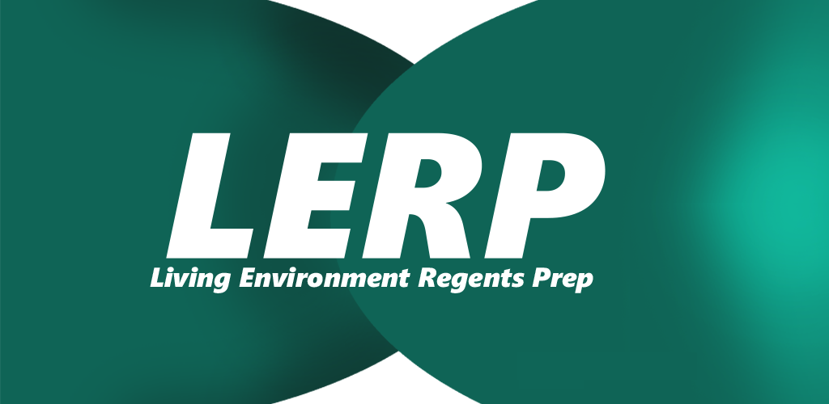

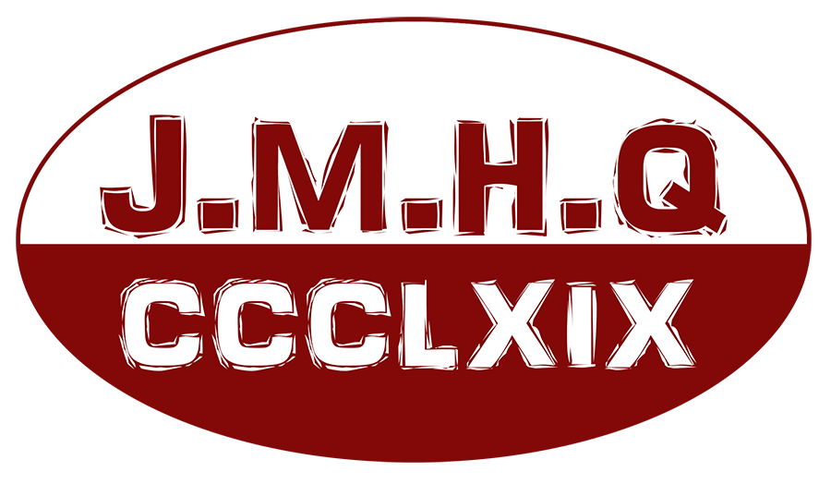

This document has the intention of introducing Living Environment Regents Prep better known as LERP.

INDEX

Introduction…………………………………. Pg 1

How to use LERP…………….……………....Pg 2

About CCCLXIX….…………………...……...Pg 6

[1]

INTRODUCTION

Welcome.

LERP (Living Environment Regents Prep) it's an application with educational purposes. The intention of this app is to help New York State students in their Living Environment Regents. LERP carries many resources for the student to get prepared for the test, such resources are going to be listed in 'How to use LERP' Pg 2. All personal information that the user provides in this app are going to be stored in the individual's own phone and nowhere else. Interactions (Pressing a button, taking quizzes, etc.) the user may have with the application are going to be sent anonymously thru Google Analytics for study in order to improve LERP. CCCLXIX it's a non-profit stamp and it's not going to obtain profit for any of the interactions the users may have with the application.

LERP complies with all Google Analytics privacy policies.

From a student to a student.

J. Marcos Hernandez Q.

[2]

HOW TO USE LERP

LERP has been designed to be user friendly, intuitive from the first run. In this section of the presentation, I'm going to explain the utilities and advantages of using LERP.

Lets being with the first Activity:

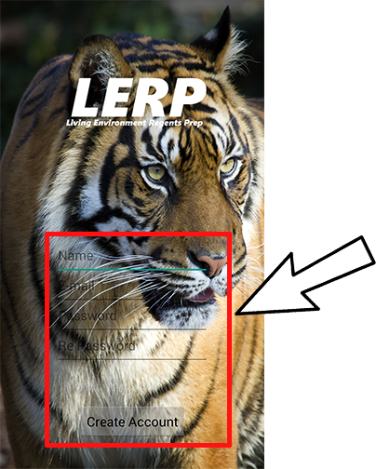This is the first activity that the user is going to encounter right after the presentation. LERP gives the user the ability to have a more personalized experience by asking the user to provide the information inside the red box. In care the user doesn't want to provide the information, it is possible to just tap 'Create Account' and the application will give access as a normal user would.

[3]

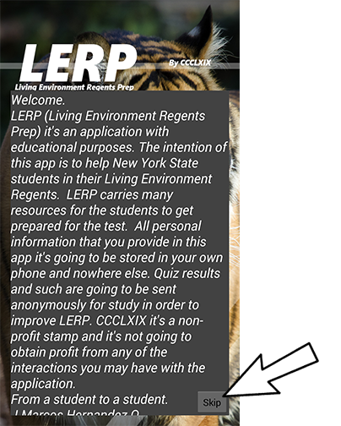The following activity would be the welcoming of the user. This activity only happens once right after the user registers.

The 'Skip' button it's going to take the user to the Main Menu activity which is next.

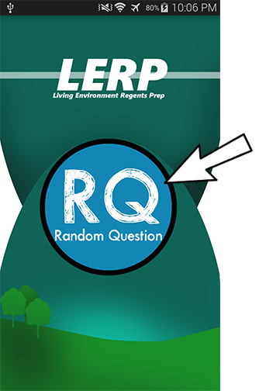The Main Menu activity displays all the functionality of LERP, which are the following:

1) Random Question (RQ) gives the user the ability to practice some regents questions that are being selected randomly by the application.

Next page…..

[4]

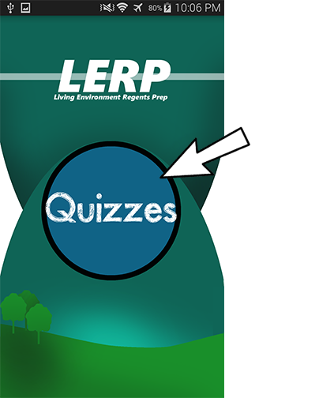2) Quizzes gives the user the ability to test himself by taking one of the three currently provided quizzes by LERP. The app displays the score and saves it. The questions that LERP uses were took from <http://www.nysedregents.org/livingenvironment/>

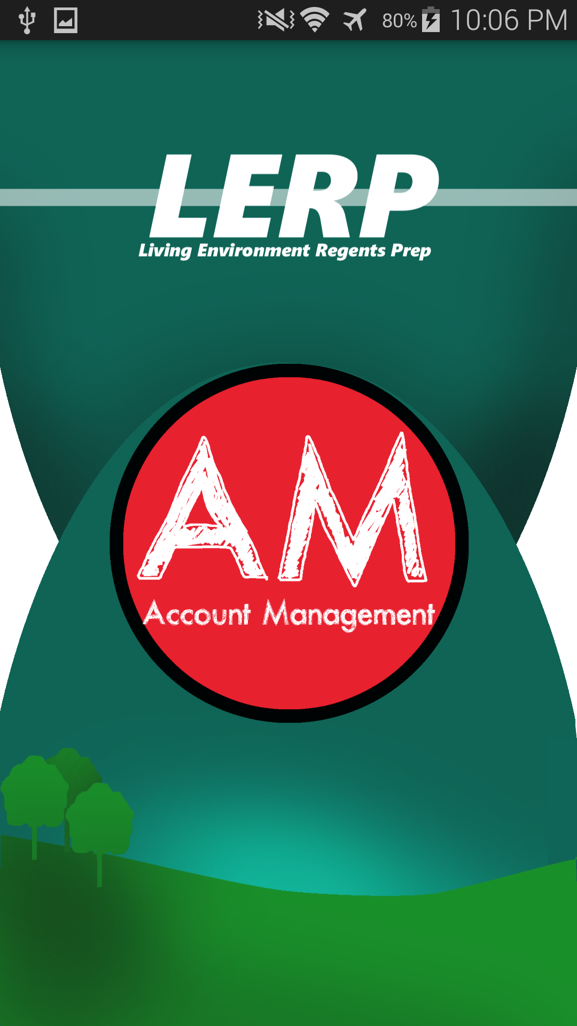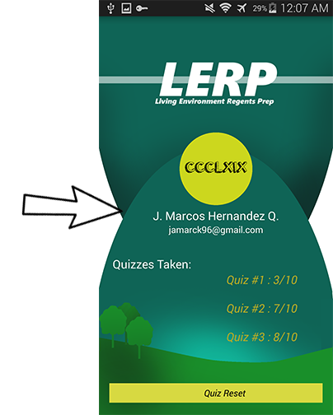The answer key for these quizzes are provided in 'Resources for Teachers'

3) Account Management (AM) this activity gives the user information about the quizzes he/she has taken and the opportunity to Reset them to take them again.

[5]

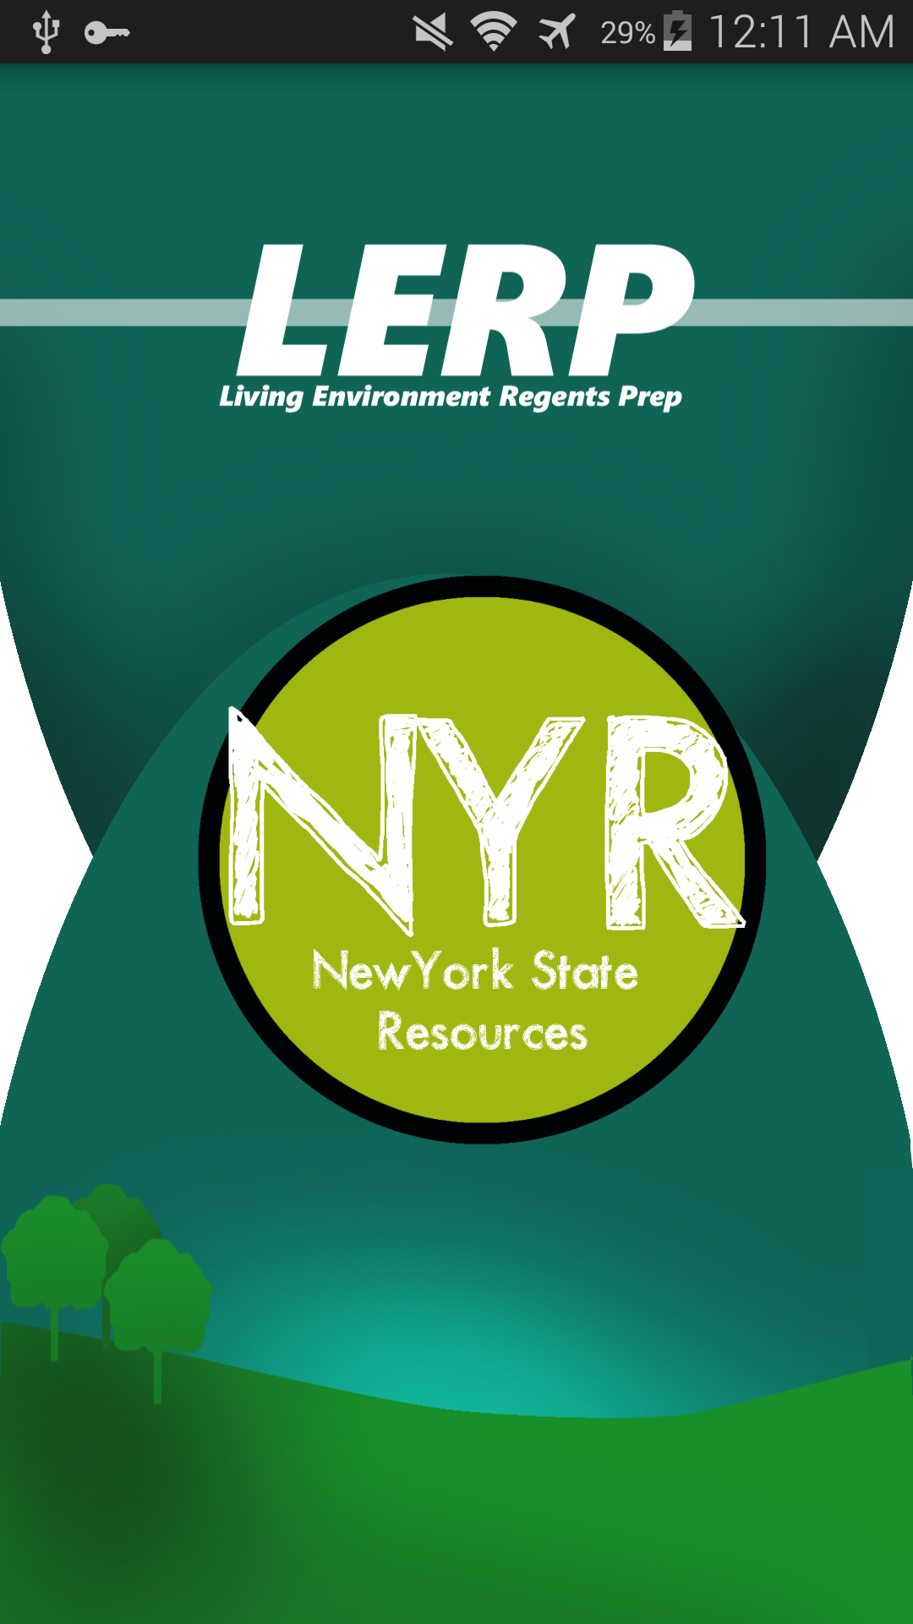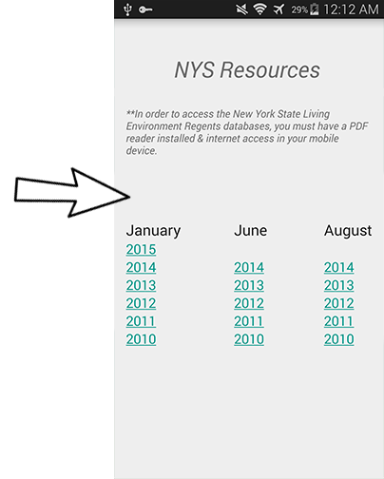

4) New York State Resources (NYR) facilitates the user the links of past Living Environment Regents.

[6]

About CCCLXIX

In conclusion CCCLXIX it's what I like to call a stamp. A name (In this case a roman number) that takes credit for the work done. It's basically a company name, but without an actual company, just me. CCCLXIX (369) It's my stamp and the philosophy behind it is very simple. “Help yourself by helping others”

P.S.

Jam 3; Marcos 6; Hernandez 9

1.
2.
3.
4.
5.
6.