Software Requirements Specification

for

FlatFinder: Housing Selection Assistant
Version 1.0
Prepared by
Caleb Fook, Ryan Lim, Shamyata, Justin
SC2006 Team 2006-SCSC-F4, Nanyang Technological University
8 November 2026

Table of Contents
Table of Contents ii
Revision History iii
1. Introduction 1
1.1 Purpose 1
1.2 Document Conventions 1
1.3 Intended Audience and Reading Suggestions 1
1.4 Product Scope 1
1.5 References 2
2. Overall Description 2
2.1 Product Perspective 2
2.2 Product Functions 3
2.3 User Classes and Characteristics 3
2.4 Operating Environment 4
2.5 Design and Implementation Constraints 4
2.6 User Documentation 4
2.7 Assumptions and Dependencies 4
3. External Interface Requirements 5
3.1 User Interfaces 5
3.2 Hardware Interfaces 10
3.3 Software Interfaces 10
3.4 Communications Interfaces 11
4. System Features 11
4.1 Search and Filter 11
4.2 Fit Score, Ranking and Sorting 13
4.3 Interactive Map 13
4.4 Results, Block Details and Nearby Amenities 14
4.5 Walking Distance 15
4.6 Bookmarks 16
4.7 Compare Flats 17
4.8 Error Handling 17
5. Other Nonfunctional Requirements 18
5.1 Performance Requirements 18
5.2 Safety Requirements 18
5.3 Security Requirements 19
5.4 Software Quality Attributes 19
5.5 Business Rules 20
6. Other Requirements 20
6.1 Database and Data Import Requirements 20
6.2 Legal and Language Requirements 21
6.3 Traceability Matrix 21
Appendix A: Data Dictionary 23
Appendix B: Analysis Models 26

Revision History
Name | Date | Reason For Changes | Version
Caleb, Ryan, Shamyata, Justin | 8/11/26 | Initial version of the SRS. | 1.0

Introduction

Purpose
This document specifies the software requirements for FlatFinder: Housing Selection Assistant, version 1.0. It covers the whole system: the web application, its data import and its use of external services.

Document Conventions
- The keyword ‘shall’ states a functional capability, ‘must’ establishes a performance requirement or constraint, and ‘will’ cites something the operating or development environment provides.
- Priority is set per feature (High, Medium or Low), and detailed requirements inherit it.

Intended Audience and Reading Suggestions
Reader | Suggested reading
Lab supervisor and assessors | Sections 1 and 2 for the overview, Section 4 for functions, then Appendix B and Section 6.3.
Developers | Sections 3 to 6. Appendix A defines the terms used.
Testers | Sections 4 and 5, then Section 6.3, which links requirements to tests.

Section 1 introduces the document, section 2 describes the product, section 3 covers interfaces, and section 4 presents the product’s functional requirements by feature. Section 5 consists of the non-functional requirements and business rules while section 6 covers data and legal requirements and traceability. The appendices hold the data dictionary, and analysis models

Product Scope
Project mission statement. The FlatFinder team will develop an interactive map-based web application that helps prospective HDB resale flat buyers in Singapore identify flats matching their budget, flat type, lease and proximity preferences for transport and everyday amenities. The project will be complete when the application has been tested and demonstrated to match the user-specified criteria against the data.gov.sg and OneMap datasets. The project supports prospective Singapore homebuyers in making faster, better-informed resale flat decisions, replacing the fragmented process of cross-referencing HDB resale records, map applications and transport directories with one centralised platform.

Project Scope. FlatFinder helps buyers explore resale flats sold in the last 12 months. Users can search and rank these flats, view them on a map, see each block's details and nearby amenities, get walking routes, save flats for the session and compare up to three homes. FlatFinder shows past sales, not flats currently on the market, so users cannot make offers or buy flats through it. It does not estimate what a flat is worth. It has no user accounts.

References
Ref | Document or source | Location
R1 | IEEE Std 830-1998, Recommended Practice for Software Requirements Specifications | IEEE Xplore
R2 | FlatFinder README (setup, data import, Fit Score) | README.md
R3 | OneMap API documentation | https://www.onemap.gov.sg/apidocs/
D1 | Resale flat prices, 2017 onwards | https://data.gov.sg/datasets/d_8b84c4ee58e3cfc0ece0d773c8ca6abc/view
D2 | Town and planning area boundaries | https://data.gov.sg/datasets/d_2cc750190544007400b2cfd5d7f53209/view
D3 | LTA MRT station exits (FR 2.3.2) | https://data.gov.sg/datasets/d_b39d3a0871985372d7e1637193335da5/view
D4 | LTA bus stops (FR 2.3.1) | https://data.gov.sg/datasets/d_3f172c6feb3f4f92a2f47d93eed2908a/view
D5 | Child care services (FR 2.3.3) | data.gov.sg dataset d_5d668e3f544335f8028f546827b773b4
D6 | Hawker centres (FR 2.3.4) | data.gov.sg dataset d_4a086da0a5553be1d89383cd90d07ecd
D7 | CHAS clinics, excluding public polyclinics and hospitals (FR 2.3.5) | https://data.gov.sg/datasets/d_548c33ea2d99e29ec63a7cc9edcccedc/view

Overall Description

Product Perspective
FlatFinder is a new, self-contained web application. It replaces a manual process in which a buyer checks resale prices, maps and transport information on separate sites. The system stores its own copy of government open data, and calls OneMap only for place search, walking routes and base map tiles.

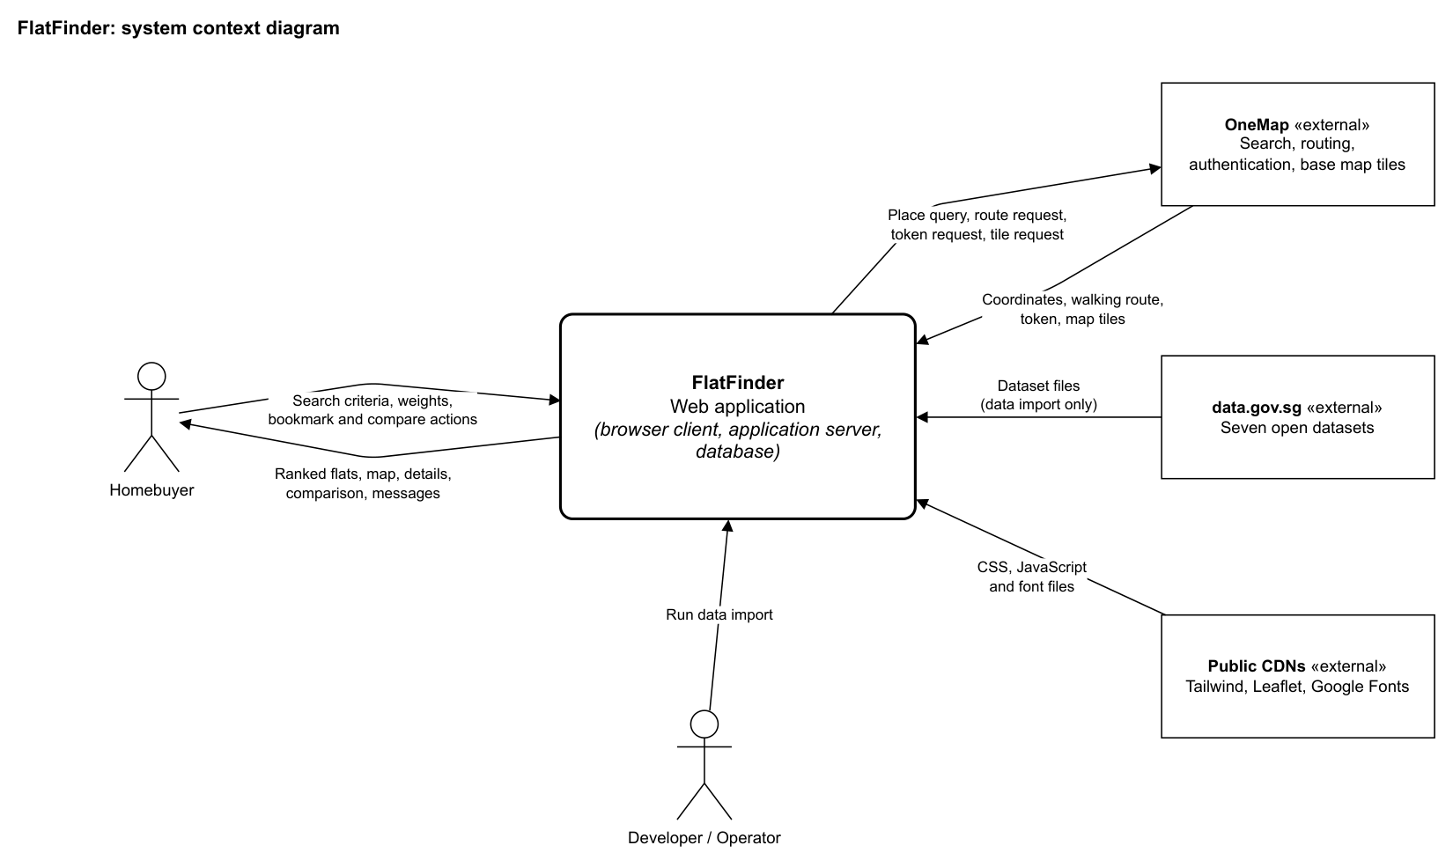
Figure 1: System context diagram

Product Functions
- Search for resale flats by budget, flat type, remaining lease and distance to amenities
- Rank results with a personalised Fit Score, and sort them by Fit Score, price, remaining lease or floor area.
- Display results in a list view and on an interactive map.
- Show block details, past transactions, typical layouts and amenities within a 1 km radius.
- Calculate the distance of a walking route to a selected amenity.
- Save flats for the session.
- Compare two or three homes with adjustable weights.
- Keep working when OneMap API fails.

The use case diagram in Appendix B (Figure 13) shows how these functions relate.

User Classes and Characteristics
User class | Characteristics | Importance
Homebuyer | Prospective HDB resale buyer, often a first-time buyer. Uses a desktop browser, with no technical knowledge assumed. Remains anonymous. Uses every feature in Section 4. | Primary
Developer / Operator | A team member who sets up the system and runs the data import from the command line. Does not use a separate interface in the application. | Secondary

Stakeholders are the parties with an interest in the system:

Stakeholder | Interest
Prospective HDB resale buyers | The users the system serves.
FlatFinder project team | Develops and maintains the system.

Operating Environment
- Client: a current desktop web browser with JavaScript enabled and internet access, at a screen resolution of 1366×768 or larger.
- Server: Python 3.12 or 3.13 on Windows, macOS or Linux, directly or through Docker.
- Database: PostgreSQL 16 in Docker, or SQLite for local development.

The system has been tested on Chrome 157 and Microsoft Edge 156 on Windows 11. Other browsers have not been tested.

Design and Implementation Constraints
- The system must be a web application built with Django, with server-rendered pages.
- The system must not require user accounts or collect personal data (NFR 4).
- The system must not call OneMap to geocode flats while running. Flat coordinates are supplied by a prepared file.
- Calls to the OneMap Routing API must use a token, which must stay on the server.
- The system is a local prototype and is not deployed publicly.

User Documentation
- README.md: setup, data import and test instructions for developers.
- On-screen guidance in the application, such as sidebar hints and the map legend.

Assumptions and Dependencies
- The resale dataset contains past transactions and no coordinates. Coordinates come from the file database/data/flat_coordinates.csv, which was produced offline.
- OneMap remains available without charge for this use. Place search and map tiles need no token, and routing tokens last 3 days.
- The client has internet access, because base map tiles, Tailwind, Leaflet and Google Fonts load from external sources.
- A straight-line distance is an acceptable estimate for ranking. A OneMap walking distance is used only when a user requests one.

External Interface Requirements

User Interfaces
The screens below are from the implemented system, captured at 1366×768.

- Every page has a header with the logo, which returns to the Start page when clicked, and the "Saved (n)" counter.
- The Start, Results, Details and Saved pages have a List View and Map View switch.
- The Start and Results pages show the search bar and search sidebar on the left.
- Error messages appear in a dismissible banner under the header. Validation messages appear on the sidebar.
- Monetary values are shown in SGD, distances in metres and floor areas in square metres.

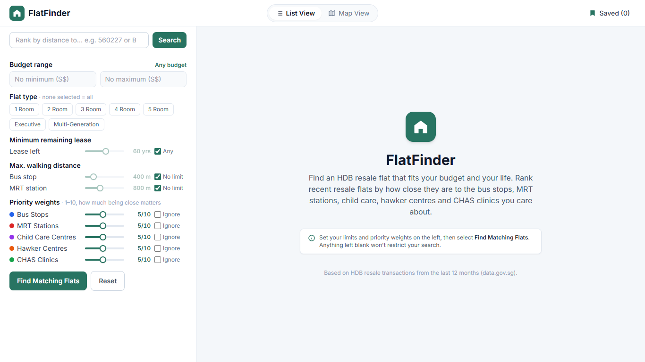
Figure 2: Start page, List View

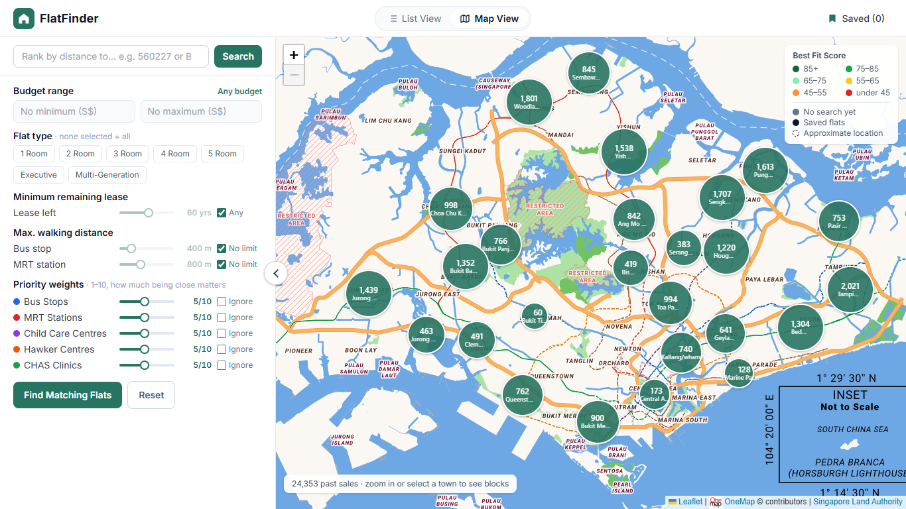
Figure 3: Start page, Map View with flat counts per town

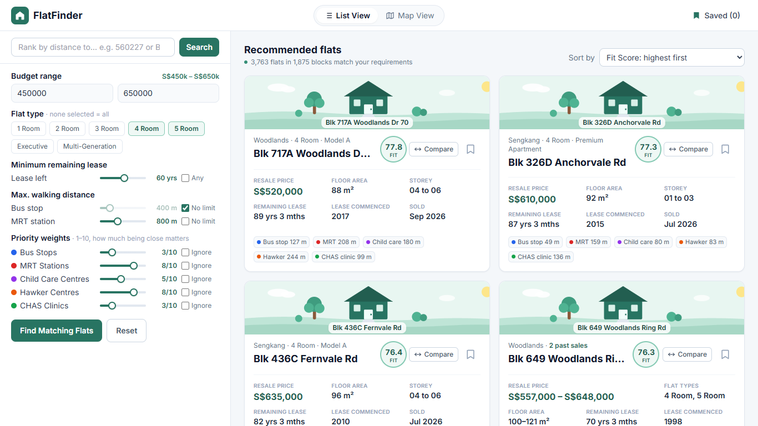
Figure 4: Results page, List View

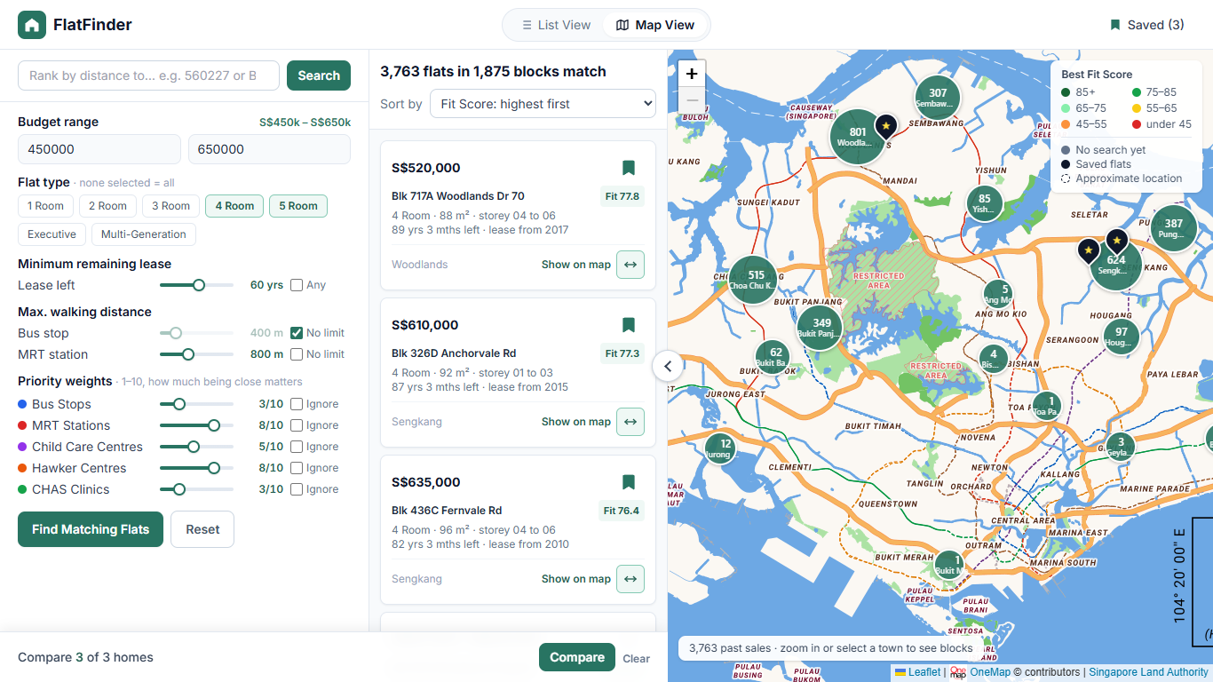
Figure 5: Results page, Map View with the compare tray

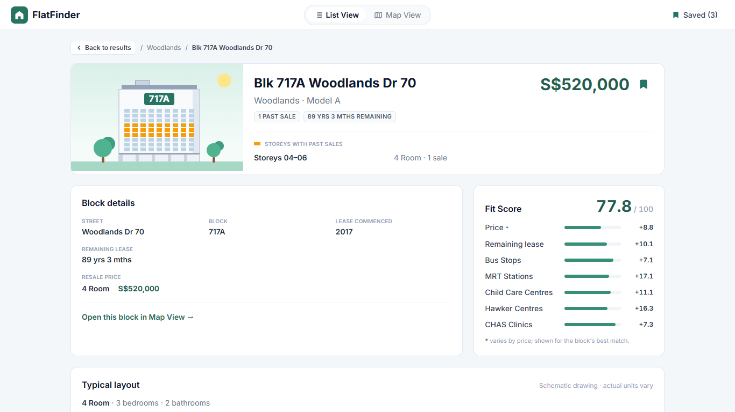
Figure 6: Details page, List View

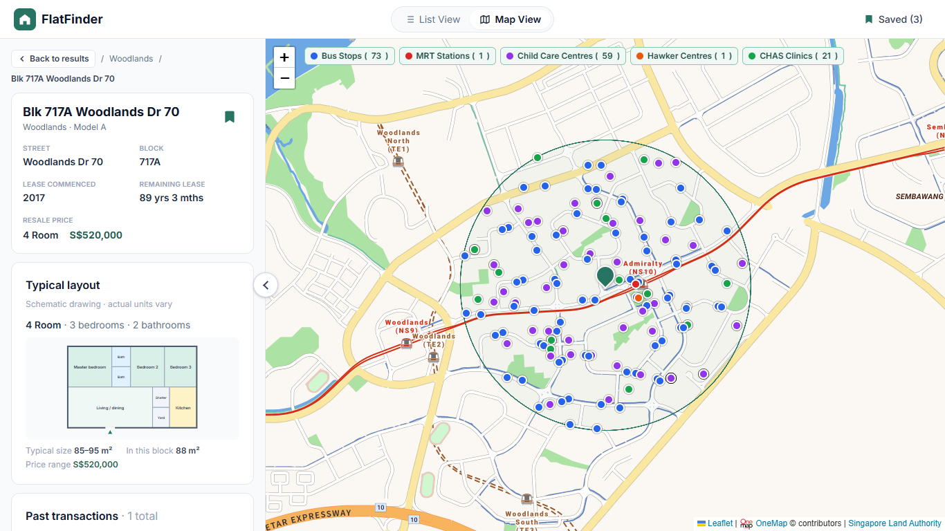
Figure 7: Details page, Map View with amenities within 1 km and category toggles

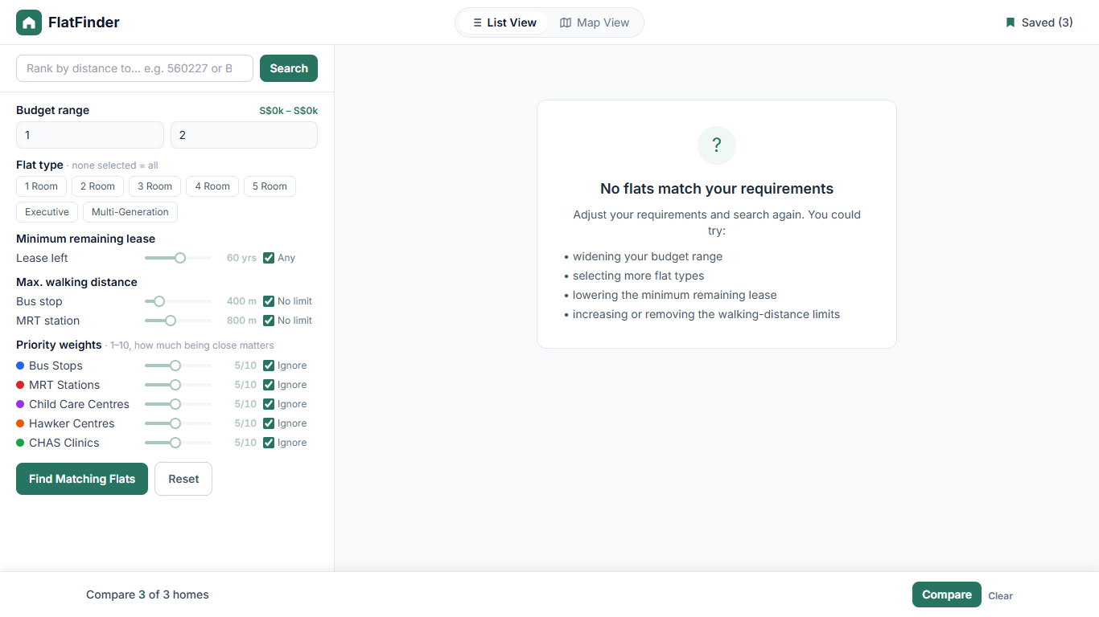
Figure 8: No results prompt

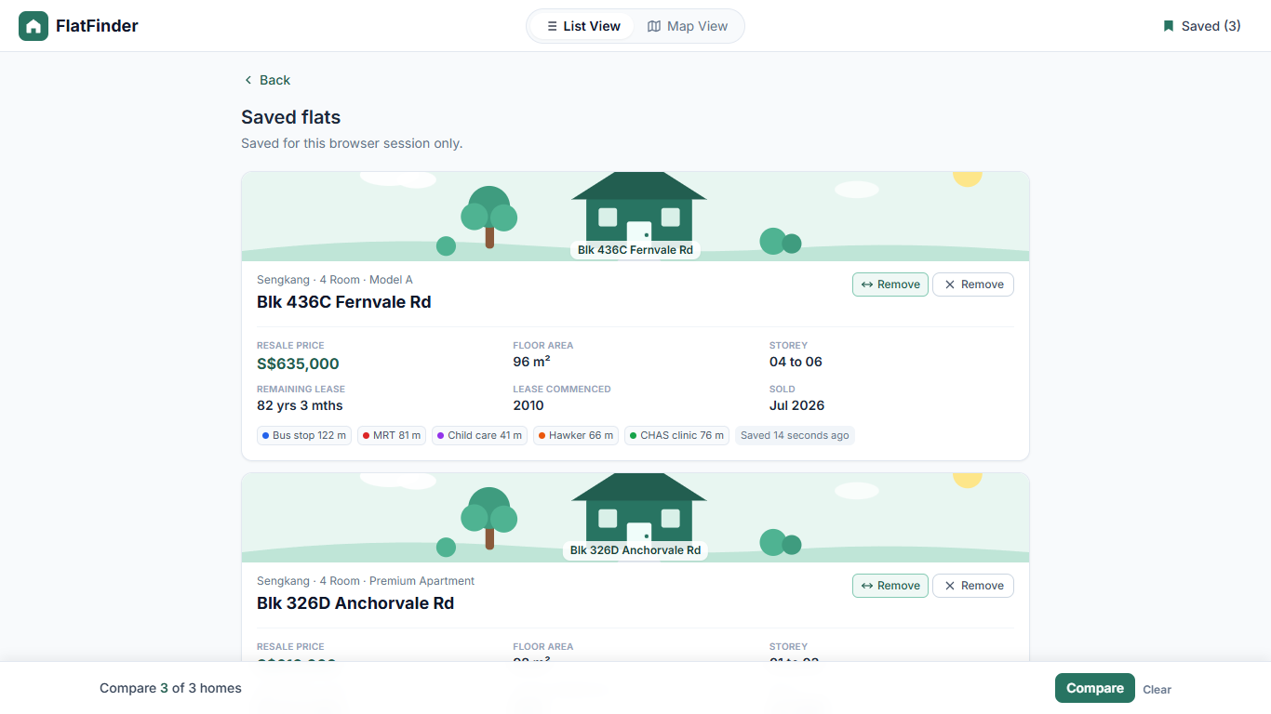
Figure 9: Saved flats page

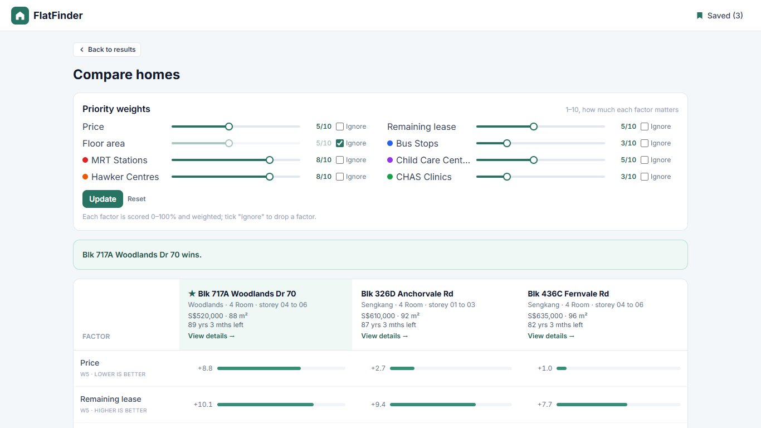
Figure 10: Compare page

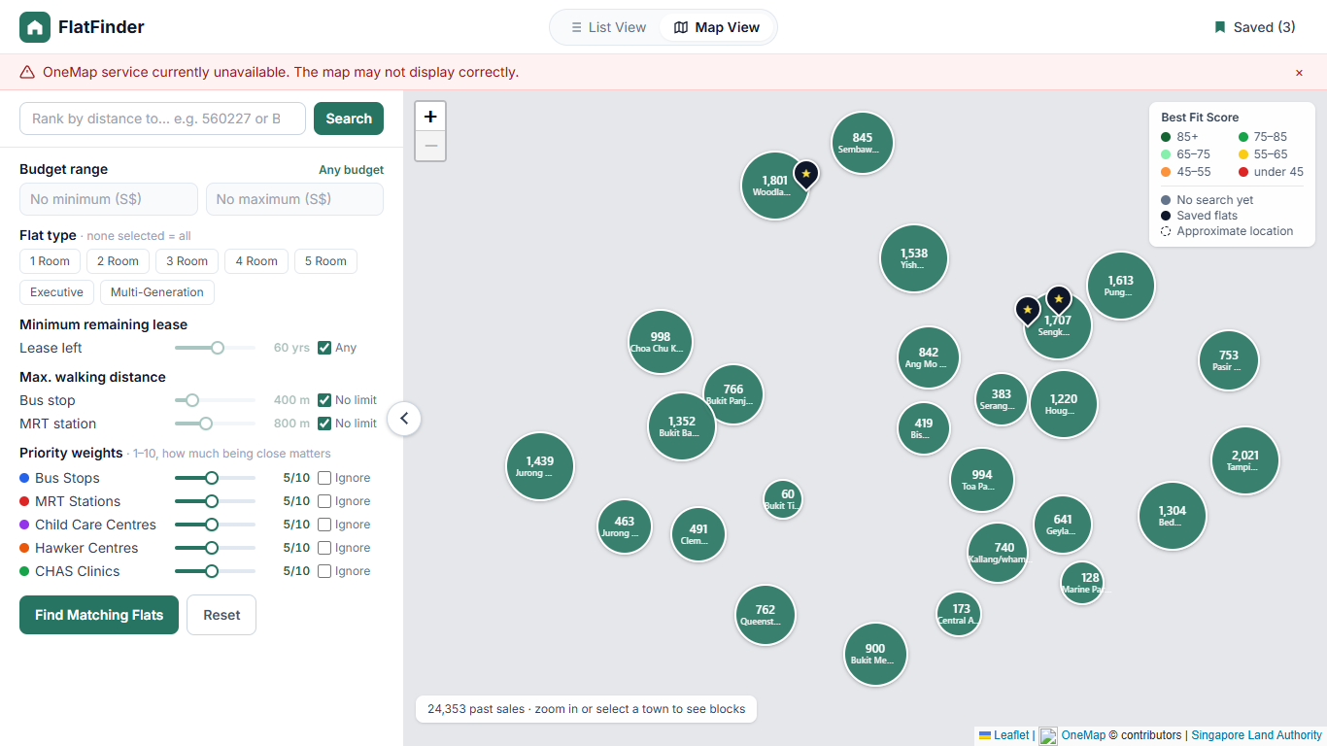
Figure 11: OneMap error banner, with OneMap blocked and tiles unavailable

The navigation between these screens is defined by the dialog map in Appendix B (Figure 14).

Hardware Interfaces
FlatFinder has no direct hardware interfaces. It uses the keyboard, pointing device and display of the client device through the web browser.

Software Interfaces
Component | Version | Purpose and data exchanged
Python | 3.12 / 3.13 | Application runtime
Requests | 2.32.5 | Sends all server calls to OneMap and data.gov.sg
psycopg | 3.2.10 | Connects Django to PostgreSQL
python-dotenv | 1.1.1 | Loads settings and database address from the environment
dj-database-url | 3.0.1 | Converts the DATABASE_URL setting in Django’s database configuration
Django | 5.2.7 | Web framework.
PostgreSQL / SQLite | 16.10 / bundled | Stores flats, towns, transport nodes, amenities, stored distances and sessions.
NumPy | 2.3.3 | Calculates Fit Scores in bulk, using nearest-neighbour distances and coordinate conversion.
SciPy | 1.16.2 | Finds the nearest facility to each flat during data import
pyproj | 3.7.2 | Converts SVY21 coordinates to WGS84 format during data import
Leaflet | 1.9.4 | Displays the interactive map in the browser
Tailwind CSS | 3.4.17 | Page styling, loaded from a public CDN.
OneMap Search API | Current public | In: postal code or place name.  Out: coordinates and label. No token.
OneMap Routing API | Current public | In: origin and destination.  Out: distance, time and route geometry. Token required.
OneMap Authentication API | Current public | In: account email and password. Out: token, valid for 3 days.
OneMap map tiles | Current public | Base map images requested by the browser. Token not required.
data.gov.sg API | v1 public | Downloading of the seven datasets, during data import only.

Communications Interfaces
- The browser and the application server communicate over HTTP, using HTML pages, form submissions and JSON responses.
- All calls to OneMap, data.gov.sg and public Content Delivery Networks (CDNs) must use HTTPS.
- Each server call to OneMap must time out after 5 seconds.
- When a OneMap walking route request fails, the server must return a JSON error message with HTTP status 502. When a search bar request fails, the server must redirect to the results page and display the error message there.
- Search criteria, sort order and page number must be held in the URL, so that Back, refresh and shared links keep the search. The server session additionally keeps the last search, for use by the Saved and Compare pages.

System Features
Functional requirements are organized by features. Each feature lists its use cases, whose full descriptions are in Appendix B.

Search and Filter
4.1.1 Description and Priority
Allows the User to describe the parameters of a resale flat they want and retrieves every flat that matches. With no search yet, every importance weight defaults to 5 and the lease and distance limits are off. Priority: High. Use cases: UC-01, UC-07, UC-08.
4.1.2 Stimulus/Response Sequences
Stimulus | Response
User sets criteria and selects "Find Matching Flats". | System filters the dataset, ranks the matches and displays the results.
User enters a postal code or place name in the search bar. | System resolves the location through OneMap and re-ranks the results by distance to it.
User submits criteria that match no flat. | System prompts the User to adjust their requirements.
User submits invalid values. | System lists the invalid values on the sidebar.

4.1.3 Functional Requirements
FR 1: The system shall allow users to search for resale HDB flats.
FR 1.1: The system shall allow users to query by specifying their requirements.
FR 1.1.1: The system shall allow the user to specify a minimum and maximum budget from S$0 to S$10,000,000.
FR 1.1.1.1: The system shall reject a search in which the minimum budget exceeds the maximum budget.
FR 1.1.2: The system shall allow users to select one or more flat types (1 Room, 2 Room, 3 Room, 4 Room, 5 Room, Executive, Multi-Generation).
FR 1.1.3: The system shall allow users to set a maximum distance from a flat to the nearest transport node, from 100 m to 2,000 m in steps of 50 m, through slider control. The system shall exclude any flat whose stored straight-line distance to the nearest node exceeds the limit.
FR 1.1.3.1: The system shall allow users to set the maximum distance to a bus stop.
FR 1.1.3.2: The system shall allow users to set the maximum distance to an MRT station.
FR 1.1.4: The system shall allow users to assign an importance level from 1 (least important) to 10 (most important), or Ignore, to each of the five proximity categories: Bus Stops, MRT Stations, Child Care Centres, Hawker Centres and CHAS Clinics.
FR 1.1.5: The system shall allow the user to specify the minimum remaining lease in years.
FR 1.1.6: If a criterion is left blank, the system shall treat it as unconstrained.
FR 1.1.7: The system shall allow search by postal code or place name, geocoded through OneMap, as a proximity anchor.
FR 1.1.7.1: When an anchor is set, the system shall allow the user to assign it an importance level from 1 to 10, with a default of 5.
FR 1.1.7.2: If the query matches no location, the system shall display a "No matching location found" message.
FR 1.1.8: The system shall allow the user to reset all search criteria to their default values.

Fit Score, Ranking and Sorting
4.2.1 Description and Priority
Scores how well each matching flat fits the search and orders the results. The Fit Score formula is business rule BR-1 in Section 5.5. Priority: High. Use cases: UC-09, UC-10.
4.2.2 Stimulus/Response Sequences
Stimulus | Response
User submits a search by clicking the ‘Find Matching Flats’ on the left sidebar. | System calculates a Fit Score for each match and displays the results, highest score first.
User selects a sort option by clicking on the ‘Sort by’ dropdown menu. | System reorders the results. Matches and Fit Scores do not change.

4.2.3 Functional Requirements
FR 2.2.2: The system shall calculate a Fit Score from 0 to 100 for each matching flat, according to BR-1.
FR 2.2.2.1: The system shall weigh proximity categories with higher importance levels more heavily in the Fit Score.
FR 2.2.2.2: The system shall display a breakdown of each flat's Fit Score by factor.
FR 2.2.3.2: The system shall display matching flats in descending order of Fit Score by default.
FR 2.2.3.3: The system shall allow the user to reorder results by Fit Score, price, remaining lease or floor area, in ascending or descending order.

Interactive Map
4.3.1 Description and Priority
Shows flats and nearby facilities on a map of Singapore. The User can switch between List View and Map View on the Start, Results, Details and Saved pages. Priority: High. Use cases: UC-03, UC-12.
4.3.2 Stimulus/Response Sequences
Stimulus | Response
User selects Map View. | System displays the map with flat counts per town.
User zooms in to level 14 or above. | System replaces the counts with flat pins.
User selects a flat pin. | System opens the details page for the block at that location.
User clears a category toggle. | System hides that category's pins with no new request.

4.3.3 Functional Requirements
FR 2: The system shall display an interactive map of Singapore.
FR 2.1: The system shall allow users to pan and zoom the interactive map.
FR 2.1.1: Below zoom level 14, the map shall display the number of matching resale flats in each town.
FR 2.1.2: From zoom level 14 upwards, the map shall display individual flat pins.
FR 2.1.3: The system shall allow users to hide the side panels so that the map fills the window.
FR 2.1.4: The system shall reopen a browsing map at the position the user last viewed.
FR 2.2: The interactive map shall display the flats matching the user's requirements.
FR 2.2.1: The system shall display matching flats on the map as location pins.
FR 2.2.1.1: The system shall colour each pin by the best Fit Score at that location, in six bands with lower bounds of 85, 75, 65, 55 and 45, and shall display a legend for the bands.
FR 2.2.1.2: The system shall display pins in a neutral colour when no search is active.
FR 2.2.1.3: When the user selects a flat pin, the system shall open the details page of the block at that location.

Results, Block Details and Nearby Amenities
4.4.1 Description and Priority
Presents results and detail pages. Each data record is one past sale, so results are grouped by block. A block is every sale with the same block number and street name. Priority: High. Use cases: UC-01, UC-02, UC-11.
4.4.2 Stimulus/Response Sequences
Stimulus | Response
User opens a block from the results. | System displays the block's details, past transactions, typical layout and nearby amenities.
User filters the past transactions. | System updates the transaction list without changing the main search.

4.4.3 Functional Requirements
FR 2.2.3: The system shall display the matching flats on a results panel in both List View and Map View.
FR 2.2.3.1: The system shall report the details of each flat in the same format, containing the fields in FR 2.2.3.1.1 to 2.2.3.1.9.
FR 2.2.3.1.1: The displayed data shall contain the street.
FR 2.2.3.1.2: The displayed data shall contain the block number.
FR 2.2.3.1.3: The displayed data shall contain the flat type.
FR 2.2.3.1.4: The displayed data shall contain the floor area.
FR 2.2.3.1.5: The displayed data shall contain the storey range.
FR 2.2.3.1.6: The displayed data shall contain the resale price in SGD.
FR 2.2.3.1.7: The displayed data shall contain the lease commence date.
FR 2.2.3.1.8: The displayed data shall contain the remaining lease.
FR 2.2.3.1.9: The displayed data shall contain the Fit Score when a search is active. When no search is active, the system shall omit the score and display a prompt to start a search.

FR 2.3: The system shall display all amenities and transport nodes within a 1 km radius of a selected flat.
FR 2.3.1: The system shall display the Bus Stops within the radius, using location pins on the map.
FR 2.3.2: The system shall display the MRT stations within the radius, listing each station once by its nearest exit.
FR 2.3.3: The system shall display the Child Care Centres within the radius.
FR 2.3.4: The system shall display the Hawker Centres within the radius.
FR 2.3.5: The system shall display the CHAS clinics within the radius.
FR 2.3.6: The system shall allow users to toggle the visibility of each category layer without a new query.

FR 4: The system shall present resale data at block level.
FR 4.1: The system shall group matching flats by block, with one result card per block, and display 20 blocks per page.
FR 4.1.1: A block shall take the position of its highest-placed flat in the current sort order.
FR 4.2: When opened from Start or Results, the details page shall display the whole block: its shared fields, its flat types, its storey ranges and its price by flat type.
FR 4.2.1: When opened from Saved or Compare, the details page shall display the single selected sale.
FR 4.3: The system shall display the block's past transactions, newest first, with 7 per page.
FR 4.3.1: The system shall allow the user to filter past transactions by flat type and price. The filters shall default to the active search.
FR 4.4: The system shall display a typical layout for each flat type sold in the block, and shall state that the drawing is schematic and that actual units vary.

Walking Distance
4.5.1 Description and Priority
Gives the actual walking route to one selected facility, as a more accurate figure than the stored straight-line distance. Priority: Medium. Use cases: UC-04.
4.5.2 Stimulus/Response Sequences
Stimulus | Response
User selects an amenity or transport node pin. | System requests a route from OneMap, then displays the distance and estimated walking time and draws the route.
OneMap fails. | System displays an error message and keeps the current map.

4.5.3 Functional Requirements
FR 1.2: The system shall calculate the walking distance from a flat to a selected amenity or transport node.
FR 1.2.1: The system shall query the OneMap Routing API to calculate the walking distance.
FR 1.2.1.1: If the OneMap API fails, the system shall display a user-facing error message.
FR 1.2.1.2: Upon API failure, the system shall preserve the last successfully rendered map state.
FR 1.2.2: The system shall display the walking distance, walking time, and shall draw the walking route on the map.
FR 1.2.3: The system shall reject a walking distance request to a point more than 1.5 km in a straight line from the flat.

Bookmarks
4.6.1 Description and Priority
Lets the User keep a list of flats for the current browser session. Priority: Medium. Use cases: UC-05, UC-14.
4.6.2 Stimulus/Response Sequences
Stimulus | Response
User selects the bookmark icon. | System adds or removes the flat and updates the "Saved (n)" counter.
User selects "Saved (n)". | System displays the saved flats, or an empty-state message if there are none.

4.6.3 Functional Requirements
FR 2.2.4: The system shall allow users to manage bookmarked resale flats.
FR 2.2.4.1: The system shall allow users to bookmark a resale flat, and to remove a bookmark from the results page, the details page or the saved list.
FR 2.2.4.2: The system shall allow users to view their bookmarked flats as a list or as pins on the map.
FR 2.2.4.3: The system shall display an empty-state message when no flats are bookmarked.
FR 2.2.4.4: The system shall display the number of bookmarked flats on every page.
FR 2.2.4.5: The system shall retain bookmarks for the browser session only.

Compare Flats
4.7.1 Description and Priority
Lets the User weigh two or three homes side by side. The Compare Score is defined by business rule BR-2 in Section 5.5. Priority: Medium. Use cases: UC-15.
4.7.2 Stimulus/Response Sequences
Stimulus | Response
User selects Compare on a card in Results or Saved. | System adds the home to the tray and updates the counter.
User opens the Compare page. | System displays the homes side by side and marks the winner.
User changes a weight and selects Update. | System recalculates the totals and the winner.

4.7.3 Functional Requirements
FR 3: The system shall allow users to compare two or three flats side by side.
FR 3.1: The system shall allow users to add flats to, and remove them from, a compare tray from the Results and Saved pages.
FR 3.1.1: The tray shall hold at most three flats and shall last for the browser session.
FR 3.1.2: A block added to the tray shall be represented by its best-ranked flat.
FR 3.1.3: The system shall display the number of flats in the tray and shall allow the user to clear it.
FR 3.2: The Compare page shall display each home's attributes and a score for each factor: price, remaining lease, floor area, the five proximity categories and, if set, the search location.
FR 3.2.1: If the tray holds fewer than two flats, the system shall prompt the user to add homes.
FR 3.3: The system shall allow users to set each factor to a weight from 1 to 10, or to Ignore, and to reset the weights.
FR 3.4: The system shall calculate a total for each home according to BR-2, and shall mark the highest total as the winner.
FR 3.4.1: The system shall break a tie in favour of the lower price, then the longer remaining lease.

Error Handling
4.8.1 Description and Priority
Keeps the application usable when OneMap fails. Priority is Low because failures are infrequent, not because the behaviour is optional. Priority: Low. Use cases: UC-06, UC-13.
4.8.2 Stimulus/Response Sequences
Stimulus | Response
A OneMap request fails or times out. | System logs walking route and search bar failures, and displays a dismissible message.
Map tiles fail to load. | On the Start and Results maps, system returns the map to the last saved view. Otherwise it displays a blank map.

4.8.3 Functional Requirements
FR 5: The system shall handle OneMap failures without stopping the application.
FR 5.1: The system shall treat a OneMap request as failed if it returns an error status or if a server request takes longer than 5 seconds.
FR 5.2: The system shall log the endpoint, timestamp and error code of each walking route and search bar failure.
FR 5.3: The system shall display a dismissible error message.
FR 5.4: On the Details and Saved maps, or if no last map state exists, the system shall display a blank map with the error message.

Other Nonfunctional Requirements

Performance Requirements
ID | Requirement | Verification
NFR 1 | The system must return search results within 5 seconds for a query against the full resale dataset. | Automated test ranks 25,000 flats in under 1 second. About 0.24 s measured on 24,353 flats.

Safety Requirements
FlatFinder has no physical safety risk. Its main risk is a financial decision based on misread data, so the following apply.

ID | Requirement | Verification
SR-1 | The system must not present resale data as a current listing, and the details page must show the month of each sale. | Inspection of result and details pages.
SR-2 | The system must label typical layouts as schematic and must label any flat placed at its town centre as an approximate location. | Automated tests; inspection.

Security Requirements
ID | Requirement | Verification
NFR 4 | The system shall not require the user to submit any personally identifiable information (for example NRIC, full name or contact number) to perform a flat search. | Inspection: no account or personal fields exist.
NFR 4.1 | OneMap credentials and tokens must remain on the server and must not be sent to the browser. | Code inspection.
NFR 4.2 | Secrets must be supplied through environment settings and must not be committed to the repository. | Inspection of .gitignore and .env.example
NFR 4.3 | State-changing requests must use HTTP POST with cross-site request forgery protection. | Code inspection.

Software Quality Attributes
ID | Requirement | Verification
NFR 2.1 | Reliability: if OneMap is unreachable, the system shall display an error message to the user. If data.gov.sg is unreachable during data import, the import shall report the failure. | Automated tests with OneMap mocked
NFR 2.2 | Reliability: if no flat matches the user's requirements, the system shall display a message prompting the user to adjust them. | Automated test; Figure 8.
NFR 2.3 | Availability: search, results, details, bookmarks and Compare must remain available when OneMap is unreachable. | Failure rehearsal in README §6; Figure 11.
NFR 3.1 | Usability: 80% of first-time users must be able to complete the preference input flow within 2 minutes without external guidance. | Passed in user end-to-end testing.
NFR 3.2 | Usability: all search criteria controls must be visible in the sidebar without scrolling at a screen resolution of 1366×768 or larger. | Measured: the search button ends 616 px down a 768 px window.
NFR 5 | Standards: coordinates must use WGS84 decimal degrees and prices must use SGD. | Inspection; import tests.
NFR 6 | Maintainability: the automated test suite must pass in full before a release, and must not depend on the live OneMap service. | 280 tests passed on 7 Nov 2026 (pytest, SQLite).
NFR 7 | Portability: the system must run on Windows, macOS and Linux through Docker, and on both PostgreSQL and SQLite. | Suite passed on SQLite and PostgreSQL 16.10, 7 Nov 2026.

Business Rules
BR-1 Fit Score. The Fit Score is a weighted average of the scores below, shown from 0 to 100. d is a straight-line distance in metres.

Score | Formula
Proximity (per category) | max(0, 1 − d / 1000); 0 if nothing is within 1 km or the flat has no location
Price | clamp((maxBudget − price) / (maxBudget − minBudget), 0, 1)
Lease | clamp((remaining − minLease) / (99 − minLease), 0, 1)
Anchor (if set) | max(0, 1 − d_anchor / 3000)
Total | round(100 × Σ(weight × score) / Σ weight, 1)

- Price and lease have a fixed weight of 5. Each proximity category uses the user's 1 to 10 weight. A category set to Ignore is left out.
- A blank budget or minimum lease takes its value from the matching flats.

BR-2 Compare Score. The total Compare Score is calculated using:

round(100 × Σ(weight × score) / Σ weight, 1) over the factors not set to Ignore.

- With active search, price and lease reuse the Fit Score scoring and fixed weights, and floor area defaults to Ignore, so the default total equals the Fit Score.
- With no search, floor area defaults to ‘Ignore’ and every other factor defaults to weight 5. Price scores 0 at S$1,500,000, floor area scores 1 at 150 m², and lease is remaining lease divided by 99 years.

BR-3 Data window. A "flat" is a resale transaction from the 12 months up to the latest month in the dataset. Each transaction is one record.

BR-4 Anonymous use. Anyone can use every function. Bookmarks and the compare tray belong to the browser session and end when the browser closes.

BR-5 Classification. LRT stations count as MRT Stations. A station's distance is measured to its nearest exit.

Other Requirements

Database and Data Import Requirements
ID | Requirement
DR-1 | The system shall import the seven datasets D1 to D7 and shall download any that are missing.
DR-2 | The system shall import resale transactions according to BR-3. The current data holds 24,353 flats, from November 2025 to October 2026.
DR-3 | The system shall store remaining lease in decimal years and shall keep the dataset's original text.
DR-4 | The system shall load flat coordinates from a CSV file, matching on block and street name, and shall reject coordinates outside Singapore.
DR-5 | The system shall calculate and store each flat's straight-line distance to the nearest facility in each category during import, so that no distance is calculated during a search.
DR-6 | The system shall skip hawker centres marked "Under Construction".
DR-7 | A flat with no coordinates shall appear in list results with proximity scores of 0, shall not appear on the map, and shall be excluded while a distance limit is set.

Legal and Language Requirements
ID | Requirement
LR-1 | The map must display attribution to OneMap, the Singapore Land Authority and Leaflet.
LR-2 | Typical layouts must be the team's own schematic drawings and must not reproduce HDB floor plans.
LR-3 | The user interface must be in English.

Traceability Matrix
Each feature links to its use cases and the automated tests that cover it. The test files are in the tests/ folder. Lab 4 black box and white box tests (test_lab4_blackbox.py, test_lab4_whitebox.py) also cover Features 4.1, 4.2 and 4.7.

Feature | Requirements | Use cases | Automated tests
4.1 Search and Filter | FR 1 to 1.1.8 | UC-01, 07, 08 | test_search.py, test_onemap.py
4.2 Fit Score, Ranking, Sorting | FR 2.2.2, 2.2.3.2, 2.2.3.3 | UC-09, 10 | test_search.py, test_details.py, test_bookmarks_sort.py
4.3 Interactive Map | FR 2 to 2.2.1.3, 2.3.6 | UC-03, 12 | test_map.py
4.4 Results, Details, Amenities | FR 2.2.3, 2.3, FR 4 | UC-01, 02, 11 | test_details.py, test_blocks.py
4.5 Walking Distance | FR 1.2 to 1.2.3 | UC-04 | test_onemap.py
4.6 Bookmarks | FR 2.2.4 | UC-05, 14 | test_bookmarks_sort.py
4.7 Compare Flats | FR 3 | UC-15 | test_compare.py
4.8 Error Handling | FR 5, NFR 2.1 | UC-06, 13 | test_onemap.py, test_map.py
Data import | DR-1 to DR-7 | None | test_import.py, test_geocode.py
Performance | NFR 1 | UC-01, 09 | test_search.py

This matrix is at feature level. A per-requirement matrix is a possible next step.

Appendix A: Data Dictionary
This appendix is the data dictionary for the system.

Term | Description | Attributes | Relationships
User (Homebuyer) | A person using the application to find an HDB resale flat. Anonymous, and identified only by a browser session. | Budget limits, flat types, distance limits, importance weights, bookmarks, compare tray, sort order. | Creates Search Queries, saves Bookmarks, fills a Compare Tray.
Resale Flat | One past resale transaction from the government dataset. Not a current listing. | Town, block, street, flat type and model, floor area, storey range, price, sale month, lease commence date, remaining lease, coordinates. | Belongs to a Block. Near Transport Nodes and Amenities. Given a Fit Score.
Block | All Resale Flats with the same block number and street name. | Block number, street name. | Holds one or more Resale Flats. Located in a Town.
Town | An HDB town, used for map counts. | Name, centre coordinates. | Contains Blocks.
Transport Node | A public transit point: an MRT or LRT station exit, or a bus stop. | Type, name, coordinates, stop code or exit code. | Listed for flats within 1 km. Used by distance limits and the Fit Score.
Amenity | A neighbourhood facility: Child Care Centre, Hawker Centre or CHAS Clinic. | Type, name, address, postal code, coordinates. | Listed for flats within 1 km. Used by the Fit Score.
Proximity Category | One of five groups scored for proximity: Bus Stops, MRT Stations, Child Care Centres, Hawker Centres, CHAS Clinics. | Importance weight (1 to 10, or Ignore). | Covers both Transport Nodes and Amenities.
Search Query | The active filters and preferences. | Budget range, flat types, minimum lease, distance limits, importance weights, optional Proximity Anchor. Blank criteria are unconstrained. | Created by the User. Decides which flats appear and their ranking.
Proximity Anchor | A location from the search bar, used to rank flats by distance to it. | Label, coordinates, importance weight (default 5). | Optional part of a Search Query. Geocoded through OneMap.
Fit Score | A rating from 0 to 100 of how well a flat matches the current Search Query (BR-1). | Total, plus scores for price, lease, each category and the anchor. | Calculated for each flat when the query changes.
Compare Score | A rating of a home on the Compare page, with adjustable weights (BR-2). | Total, plus a score per factor. | Calculated for each home in the Compare Tray.
Compare Tray | The session list of up to three flats chosen for comparison. | Flat identifiers. | Belongs to a session. Refers to Resale Flats.
Bookmark | A flat saved for the current session. | Time saved, session identifier, flat identifier. | Links a session to a Resale Flat.
Sort Order | The field and direction for displaying results. | Field (Fit Score, price, remaining lease, floor area), direction. | Changes only the display order, not the matches or scores.
Straight-line Distance | The great-circle distance between two points. Stored during import, and used for filtering and scoring. | Metres. | Compare with Walking Distance.
Walking Distance | The route distance from the flat to the selected facility drawn by OneMap Routing API, calculated on request for one flat and one facility. | Metres, minutes, route geometry. | Displayed for a selected pin. Not used in the Fit Score.

Abbreviation | Meaning
API | Application Programming Interface
BR | Business Rule
CDN | Content Delivery Network
CHAS | Community Health Assist Scheme
CSV | Comma-Separated Values
DR | Data Requirement
FR / NFR | Functional Requirement / Nonfunctional Requirement
HDB | Housing & Development Board
HTML | HyperText Markup Language
HTTP / HTTPS | Hypertext Transfer Protocol / Hypertext Transfer Protocol Secure
JSON | JavaScript Object Notation
LR | Legal or Language Requirement
LRT / MRT | Light Rail Transit / Mass Rapid Transit
LTA | Land Transport Authority
NRIC | National Registration Identity Card
SGD | Singapore Dollar
SR | Safety Requirement
SRS | Software Requirements Specification
SVY21 | Singapore's national map coordinate system
UC | Use Case
UI | User Interface
URL | Uniform Resource Locator
WGS84 | World Geodetic System 1984

Appendix B: Analysis Models
B.1 Class Diagram
This diagram shows all FlatFinder classes. Editable version: docs/ClassDiagram_final.drawio.

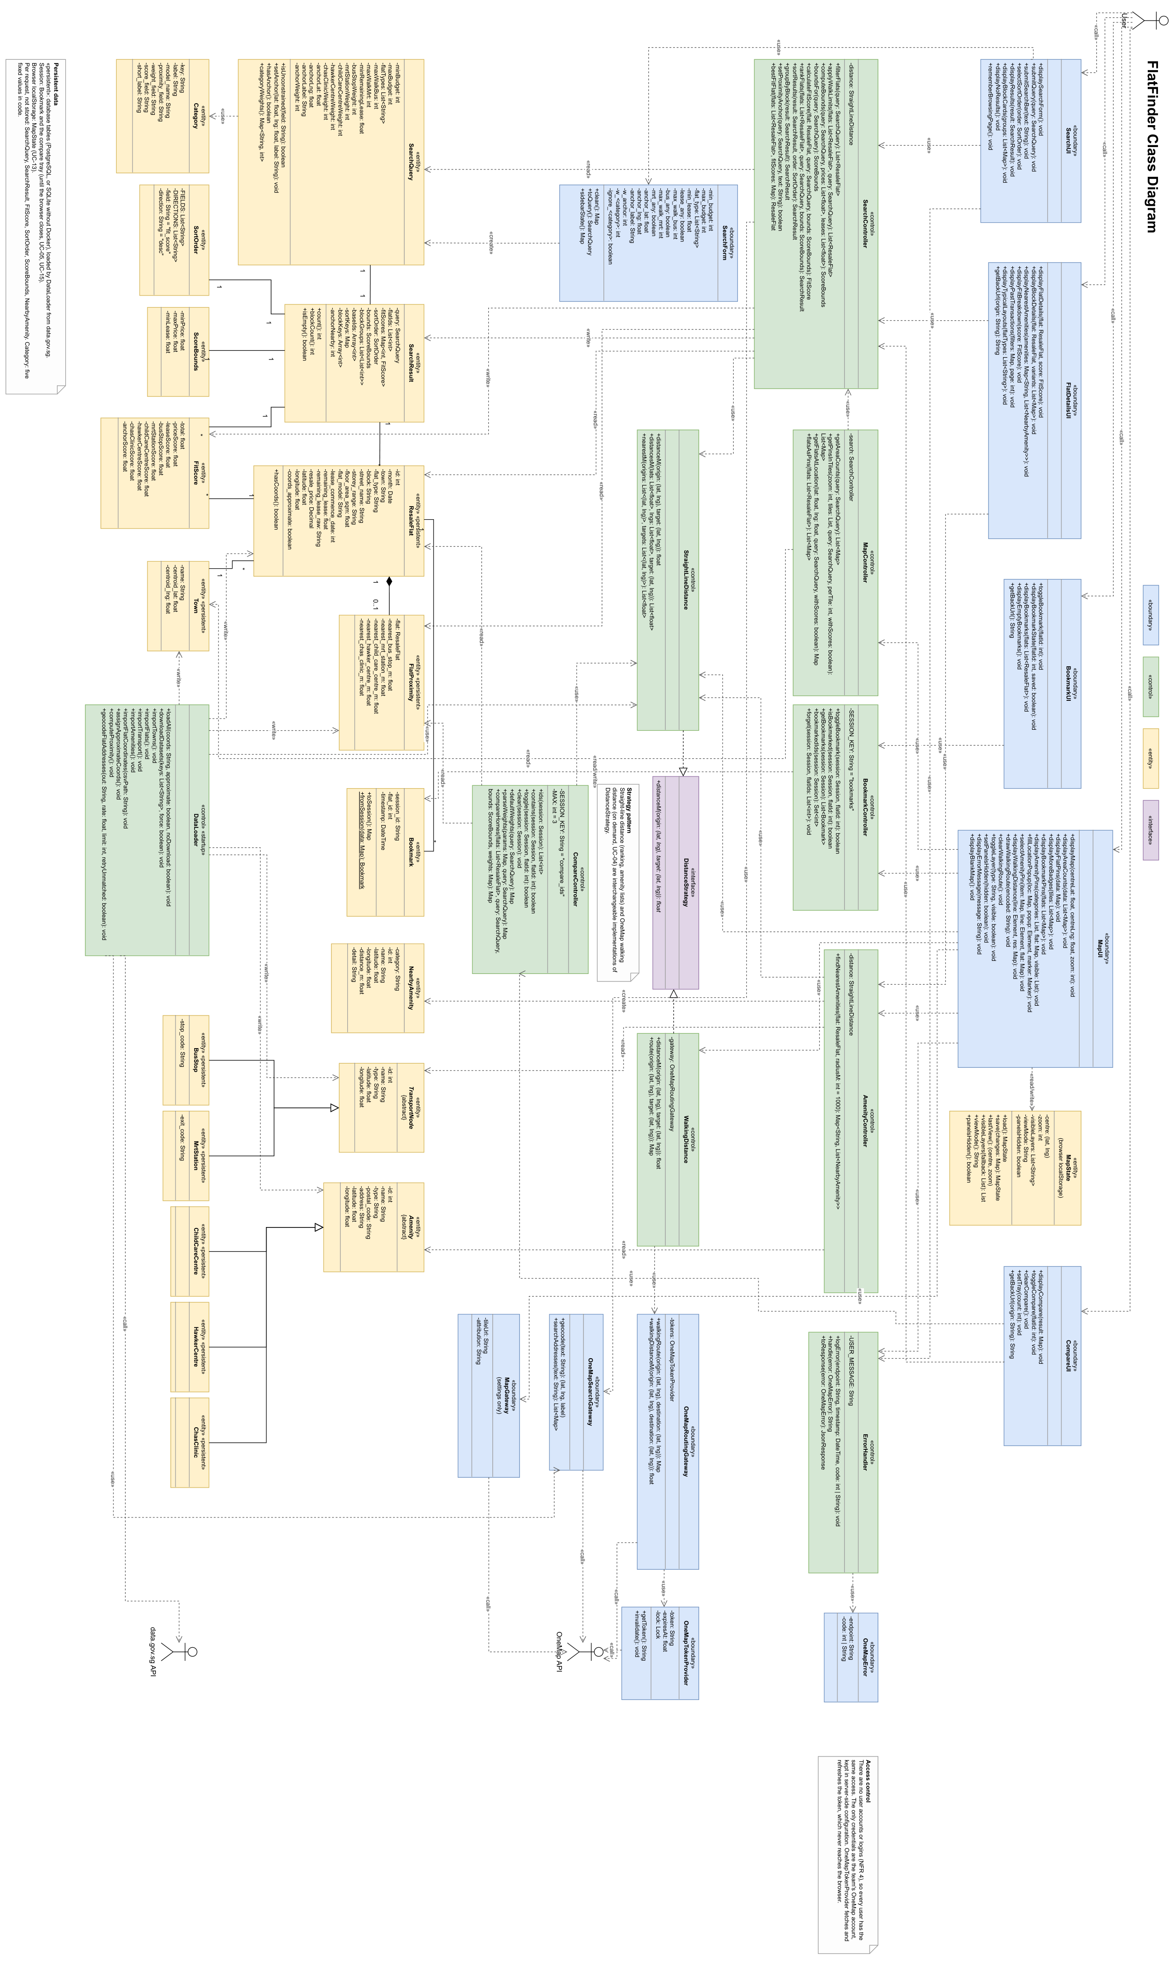
Figure 12: FlatFinder Class diagram, rotated to fit the page. Full size: FlatFinder/docs/ClassDiagram_final.png
B.2 Use Case Diagram
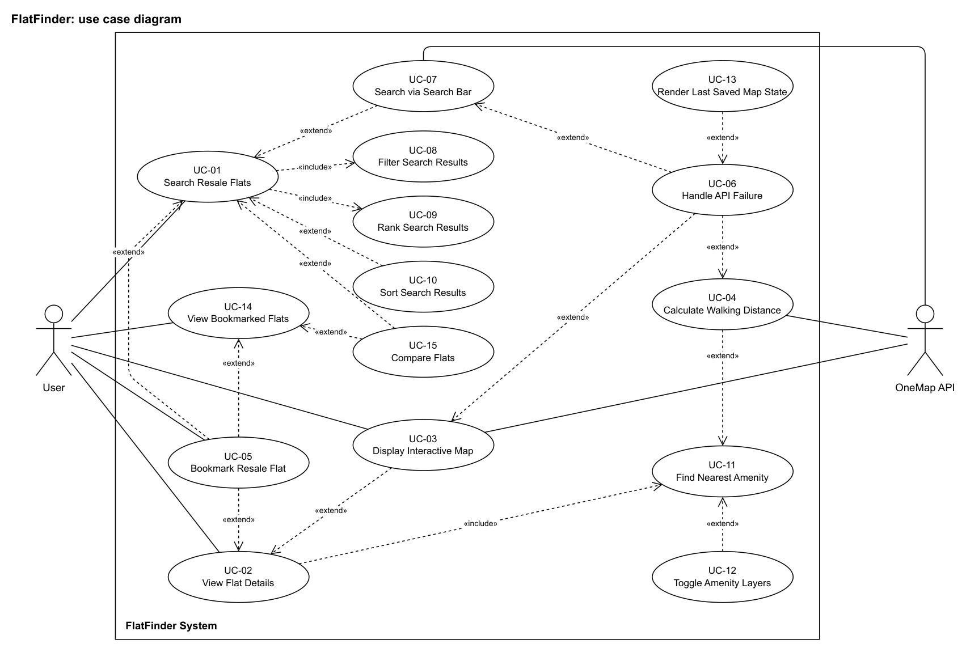
Figure 13: Use case diagram

Note: Use cases with no direct User line are reached through an include or extend relationship.
B.3 Use Case Descriptions

UC-01: Search Resale Flats
Actor | User
Description | Allows the User to specify budget, flat type, distance limits, lease and importance weights to retrieve a ranked list of matching resale flats, without submitting personally identifiable information.
Preconditions | The system is running and the database is populated.
Postconditions | A ranked list of matching flats is displayed, ordered by Fit Score.
Priority / Frequency | High / High
Flow of Events | 1. User adjusts the filter criteria (budget range, flat types, minimum remaining lease, maximum distances) on the sidebar.  2. User assigns importance weights (1 to 10, or Ignore) to Bus Stops, MRT Stations, Child Care Centres, Hawker Centres and CHAS Clinics, then selects "Find Matching Flats".  3. System executes UC-08: Filter Search Results.  4. System executes UC-09: Rank Search Results.  5. System displays the matching flats, grouped by block, in descending order of Fit Score.
Alternative Flows | UC-01.AC.1: User submits a location through UC-07 in addition to the sidebar filters.  UC-01.AC.2: User applies UC-10 to reorder the displayed results.
Exceptions | UC-01.EX.1: If no flat satisfies the query, the system prompts the User to adjust their requirements (NFR 2.2).  UC-01.EX.2: If an input is invalid, the system lists the invalid values on the sidebar and returns no results.
Relationships | Includes UC-08, UC-09. Extended by UC-05, UC-07, UC-10, UC-15.
Notes | Results must be returned within 5 seconds (NFR 1). All filter controls remain visible without scrolling at 1366×768 (NFR 3.2).

UC-02: View Flat Details
Actor | User
Description | Displays the attributes of a selected block or flat, its past transactions, a typical layout and its nearby amenities.
Preconditions | Search results are displayed, or the User has selected a pin on the map, a saved flat or a home on the Compare page.
Postconditions | The details are displayed and, in Map View, the map is centred on the location with nearby amenities plotted.
Priority / Frequency | High / High
Flow of Events | 1. User selects a block or flat from the results, a flat pin on the map, a saved flat, or "View details" on the Compare page.  2. System retrieves the block and flat data.  3. System executes UC-11: Find Nearest Amenity.  4. System displays the details in a standard format, with the past transactions and typical layout.  5. If the User selects Map View, the system executes UC-03: Display Interactive Map, centred on the location.
Alternative Flows | UC-02.AC.1: From Start or Results the system shows the whole block. From Saved or Compare it shows the single sale.  UC-02.AC.2: With no active search, the system shows a "Start a search" prompt in place of the Fit Score (FR 2.2.3.1.9).
Exceptions | -
Relationships | Includes UC-11. Extended by UC-03, UC-05.
Notes | Displayed fields follow FR 2.2.3.1.1 to 2.2.3.1.9.

UC-03: Display Interactive Map
Actor | User, OneMap API
Description | Retrieves base map tiles and renders the interactive map of Singapore with flat data on top.
Preconditions | The system is running and a page with Map View is loaded.
Postconditions | An interactive map is displayed that supports pan and zoom, centred on a flat when one is active.
Priority / Frequency | High / High
Flow of Events | 1. User selects Map View, or UC-02 passes a location.  2. The browser requests the base map tiles from OneMap.  3. OneMap returns the tiles.  4. System renders the map, centred on the flat if one is active.  5. On the Start and Results pages, the system displays the number of matching flats per town below zoom level 14, and flat pins from zoom level 14 upwards.
Alternative Flows | UC-03.AC.1: If the User has bookmarked flats, the system also renders them as pins.
Exceptions | UC-03.EX.1: If the tiles fail to load, the system triggers UC-06.
Relationships | Extends UC-02. Extended by UC-06.
Notes | Map tiles do not require a OneMap token.

UC-04: Calculate Walking Distance
Actor | User (through UC-11), OneMap API
Description | Calculates the walking distance and time from a flat to a selected amenity or transport node, and draws the walking route on the map.
Preconditions | UC-11 has rendered amenity pins for the selected flat.
Postconditions | The walking distance, walking time and route are displayed for the selected pin.
Priority / Frequency | Medium / Medium
Flow of Events | 1. User selects an amenity or transport node pin.  2. System sends the flat and pin coordinates to the OneMap Routing API.  3. OneMap returns the route.  4. System displays the walking distance and time, and draws the route on the map.
Alternative Flows | -
Exceptions | UC-04.EX.1: If the OneMap Routing API fails, the system triggers UC-06.  UC-04.EX.2: If the target is more than 1.5 km in a straight line from the flat, or the flat has no location, the system rejects the request.
Relationships | Extends UC-11. Extended by UC-06.
Notes | The User association is inherited through UC-11 and is not drawn on the diagram.

UC-05: Bookmark Resale Flat
Actor | User
Description | Adds a flat to, or removes it from, the User's saved list.
Preconditions | Flats are displayed.
Postconditions | The bookmark status is toggled and the "Saved (n)" counter is updated.
Priority / Frequency | Low / Medium
Flow of Events | 1. User selects the bookmark icon on a flat in the results, the details page or the saved list.  2. System adds the flat to the saved list, or removes it if already saved.  3. System updates the icon and the counter.
Alternative Flows | UC-05.AC.1: If the flat is already saved, selecting the icon removes it and resets the icon.
Exceptions | -
Relationships | Extends UC-01, UC-02, UC-14.
Notes | Bookmarks last for the browser session because the system has no user accounts.

UC-06: Handle API Failure
Actor | None (system-triggered)
Description | Intercepts failed OneMap requests, logs walking route and search bar failures, and displays a message without stopping the application.
Preconditions | A OneMap request fails during UC-03, UC-04 or UC-07. Server requests fail after 5 seconds.
Postconditions | The message is displayed, walking route and search bar failures are logged, and all other functions remain available.
Priority / Frequency | Low / Low
Flow of Events | 1. A OneMap request times out or returns an error status.  2. For a walking route or search bar failure, the system logs the endpoint, timestamp and error code.  3. System displays a dismissible message, for example "OneMap service currently unavailable".  4. If the failure occurred while displaying the map, the system executes UC-13.
Alternative Flows | -
Exceptions | -
Relationships | Extends UC-03, UC-04, UC-07. Extended by UC-13.
Notes | UC-11 does not trigger this use case, because amenities come from the system's own database.

UC-07: Search via Search Bar
Actor | User, OneMap API
Description | Allows the User to enter a postal code or place name, geocoded through OneMap, as a proximity anchor.
Preconditions | The search bar is displayed.
Postconditions | The resolved location is set as the proximity anchor and the results are re-ranked.
Priority / Frequency | Medium / Medium
Flow of Events | 1. User enters a postal code or place name in the search bar.  2. System sends the query to the OneMap Search API.  3. OneMap returns the matching location and its coordinates.  4. System sets the location as the proximity anchor and re-executes UC-09.
Alternative Flows | UC-07.AC.1: If no matching flat is within 3 km of the location, the system displays a message that the ranking is unchanged.
Exceptions | UC-07.EX.1: If the OneMap API fails, the system triggers UC-06.  UC-07.EX.2: If the query matches no location, the system displays a "No matching location found" message.
Relationships | Extends UC-01. Extended by UC-06.
Notes | The anchor adds a sixth proximity score, with its own weight (default 5).

UC-08: Filter Search Results
Actor | User
Description | Constrains the search by budget range, flat type, minimum remaining lease and maximum distance to transport.
Preconditions | A search has been submitted.
Postconditions | The flats that satisfy every active criterion are selected.
Priority / Frequency | High / High
Flow of Events | 1. User sets the budget range (FR 1.1.1).  2. User selects one or more flat types (FR 1.1.2).  3. User sets the minimum remaining lease (FR 1.1.5).  4. User sets the maximum distances to a bus stop and an MRT station (FR 1.1.3).  5. System treats any criterion left blank as unconstrained (FR 1.1.6).
Alternative Flows | -
Exceptions | -
Relationships | Included by UC-01.
Notes | -

UC-09: Rank Search Results
Actor | User
Description | Calculates a Fit Score for each matching flat and orders the results.
Preconditions | UC-08 has produced at least one matching flat.
Postconditions | Every matching flat has a Fit Score and the results are in descending order.
Priority / Frequency | High / High
Flow of Events | 1. User assigns importance weights on the sidebar (FR 1.1.4).  2. System calculates a Fit Score for each matching flat (FR 2.2.2, BR-1).  3. System orders the flats in descending order of Fit Score (FR 2.2.3.2).
Alternative Flows | -
Exceptions | -
Relationships | Included by UC-01.
Notes | Distances in the Fit Score are stored straight-line distances, not OneMap walking distances. UC-08 and UC-09 together must complete within NFR 1.

UC-10: Sort Search Results
Actor | User
Description | Reorders the displayed results by another field, without changing which flats match or their Fit Scores.
Preconditions | UC-01 has returned at least one result.
Postconditions | The displayed results are reordered.
Priority / Frequency | Low / Medium
Flow of Events | 1. User selects a field and direction from the "Sort by" list (Fit Score, Price, Remaining Lease or Floor Area).  2. System reorders the displayed results.
Alternative Flows | -
Exceptions | -
Relationships | Extends UC-01.
Notes | -

UC-11: Find Nearest Amenity
Actor | User
Description | Finds the amenities and transport nodes within 1 km of a selected flat and displays them.
Preconditions | UC-02 is active for a flat with a known location.
Postconditions | The amenities and transport nodes within 1 km are listed and, in Map View, plotted as pins.
Priority / Frequency | High / High
Flow of Events | 1. System queries its database for amenities and transport nodes within 1 km of the flat.  2. System displays them by category (FR 2.3.1 to 2.3.5).  3. User selects an amenity or transport node pin.  4. System executes UC-04 for the selected pin.
Alternative Flows | -
Exceptions | -
Relationships | Included by UC-02. Extended by UC-04, UC-12.
Notes | The search radius is fixed at 1 km. Each MRT station is listed once, using its nearest exit.

UC-12: Toggle Amenity Layers
Actor | User
Description | Shows or hides amenity categories on the map without a new query.
Preconditions | UC-11 has rendered amenity pins.
Postconditions | Only the selected categories are visible on the map.
Priority / Frequency | Low / Medium
Flow of Events | 1. User selects or clears a category toggle (Bus Stops, MRT Stations, Child Care Centres, Hawker Centres or CHAS Clinics) at the top of the map.  2. System shows or hides the pins for that category.
Alternative Flows | -
Exceptions | -
Relationships | Extends UC-11.
Notes | Toggling makes no new request.

UC-13: Render Last Saved Map State
Actor | None (system-triggered)
Description | Returns the map to its last successfully rendered view after a map failure.
Preconditions | UC-06 has been triggered while UC-03 was active.
Postconditions | The map displays its last successfully rendered position.
Priority / Frequency | Low / Low
Flow of Events | 1. System retrieves the last saved centre and zoom from browser storage.  2. System returns the map to that view.
Alternative Flows | -
Exceptions | UC-13.EX.1: On the Details and Saved maps, or if no saved state exists, the system displays a blank map with the UC-06 message.
Relationships | Extends UC-06.
Notes | Satisfies FR 1.2.1.2.

UC-14: View Bookmarked Flats
Actor | User
Description | Displays the flats the User has saved during the session.
Preconditions | The application is open.
Postconditions | The saved flats are displayed in a list or on the map.
Priority / Frequency | Medium / Medium
Flow of Events | 1. User selects "Saved (n)".  2. System retrieves the saved flats for the session.  3. System displays them in a list, or as pins in Map View.
Alternative Flows | UC-14.AC.1: If no flats are saved, the system displays an empty-state message.
Exceptions | -
Relationships | Extended by UC-05, UC-15.
Notes | -

UC-15: Compare Flats
Actor | User
Description | Allows the User to collect two or three flats in a session tray and compare them side by side with adjustable weights.
Preconditions | The User has search results (UC-01) or saved flats (UC-14).
Postconditions | Each home's attributes and factor scores are displayed, and the highest-scoring home is marked as the winner unless every factor is set to ignore.
Priority / Frequency | Medium / Medium
Flow of Events | 1. User adds a home to the compare tray from Results or Saved. A block contributes its best-ranked flat.  2. System stores the flat in the tray, up to three, and updates the "Compare n of 3" counter.  3. User opens the Compare page.  4. System displays one column per home, with its attributes and factor scores.  5. User changes the factor weights (1 to 10, or Ignore) and selects Update.  6. System recalculates each total and marks the winner.
Alternative Flows | UC-15.AC.1: With no active search, the User compares saved flats directly. Price, remaining lease and floor area use fixed reference scales. Floor area defaults to Ignore and every other factor defaults to weight 5.  UC-15.AC.2: With fewer than two homes in the tray, the system prompts the User to add homes.
Exceptions | -
Relationships | Extends UC-01, UC-14.
Notes | Ties go to the lower price, then the longer remaining lease. The tray lasts for the browser session.

B.4 Dialog Map
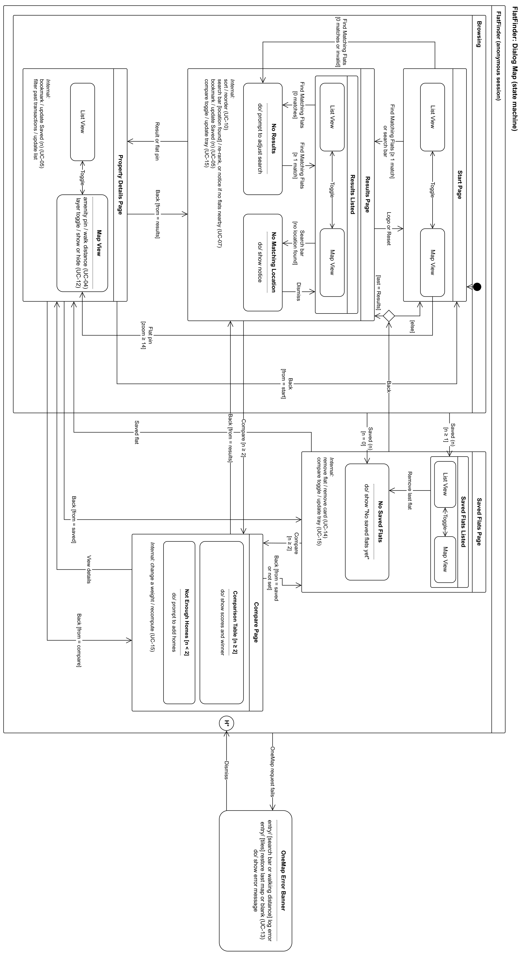
Figure 14: Dialog map (UI state machine), rotated to fit the page. Full size: FlatFinder/docs/Diagrams/DialogMap_final.pdf

