WEKA NEURAL NETWORK CLASSIFIER

1. Training and testing with separate corpus

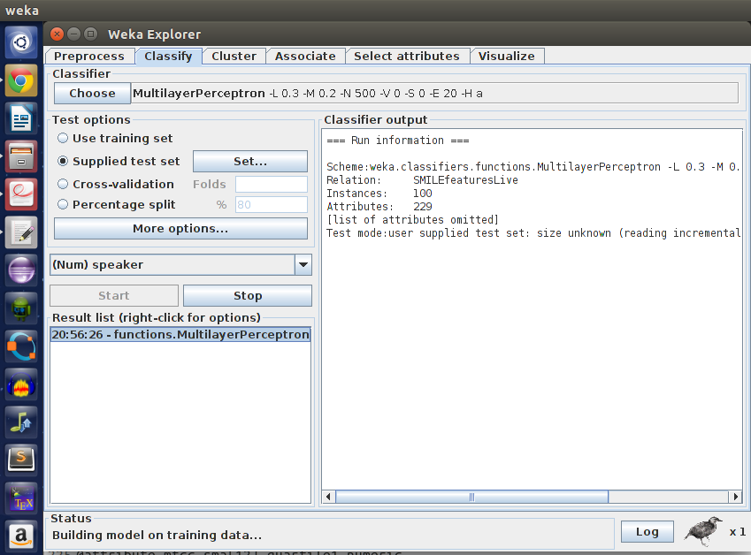

2. Training with 5-fold cross validation

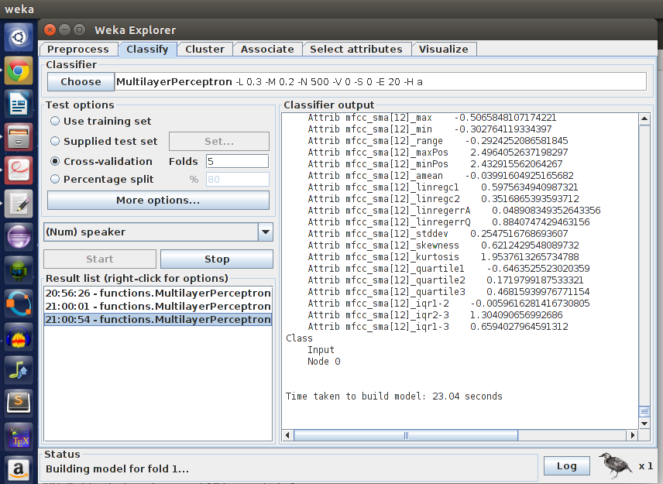

3. Testing with a part of the train corpus

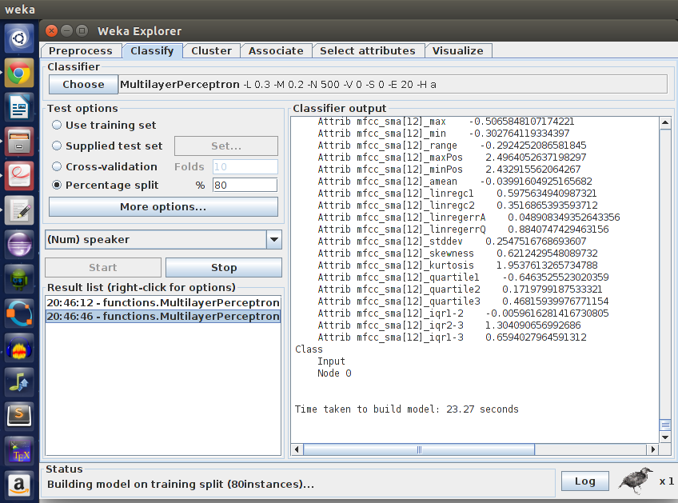

4. k-means clustering of data

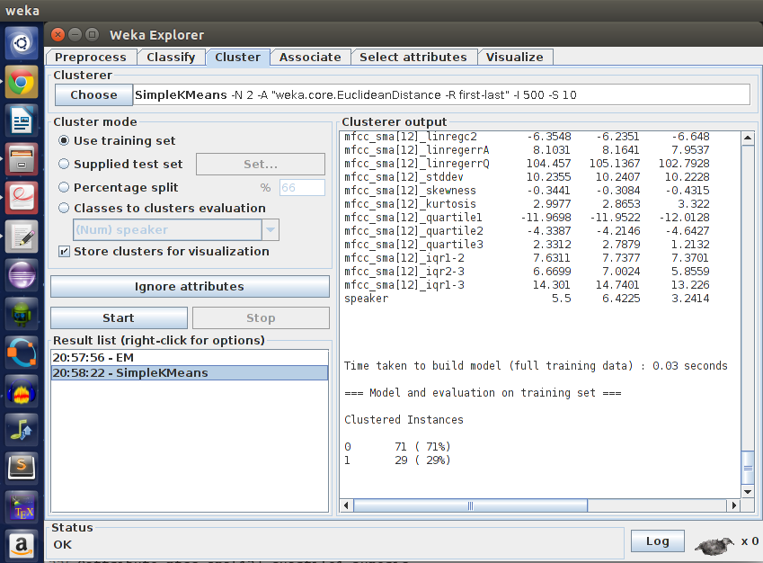

5. Testing without cross fold validation

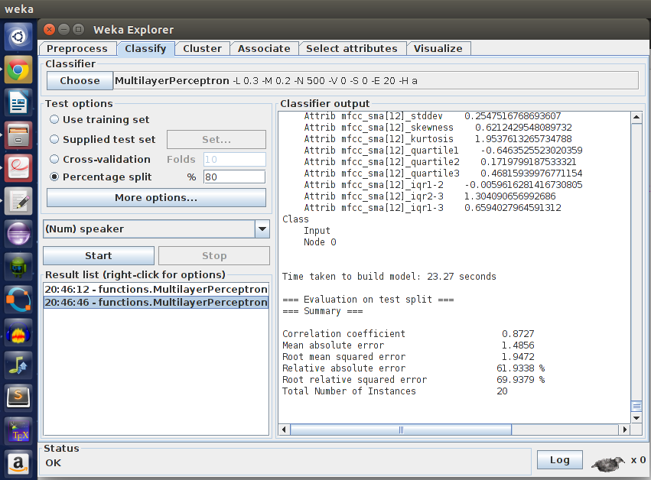

6. Testing with cross fold validation
