**SummerSCIP 2022 Image Analysis with Python and ImageJ Track**

This material is based upon work supported by the NSF under Grant No. **DBI-1548297**.

**Disclaimer: Any opinions, findings and conclusions or recommendations expressed in this material are those of the authors and do not necessarily reflect the views of the National Science Foundation.**

**Program Organizer:**

**Faye Orcales**

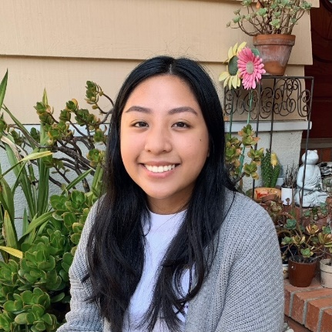

**Content Creators:**

* **Thomas Zimmerman (IBM Research)**
  + BS, Humanities and Engineering MIT
  + MS, Media Arts and Science MIT

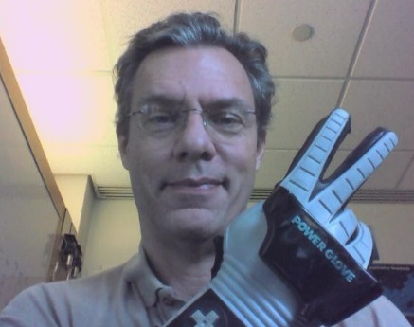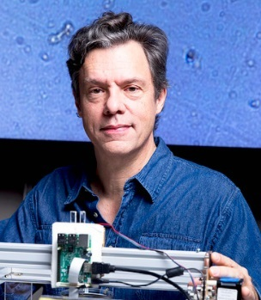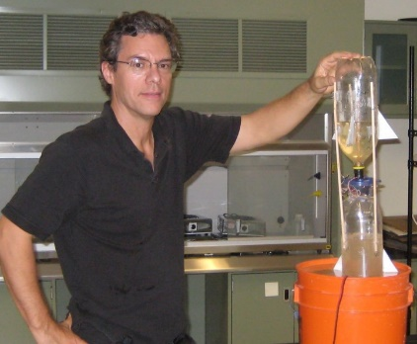

* **Raymond Esquerra (SFSU Professor for Chemistry and Biochemistry)**
  + BS, Physics Stanford University
  + PhD, Physical Chemistry UCSD

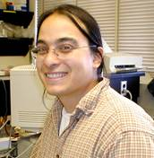    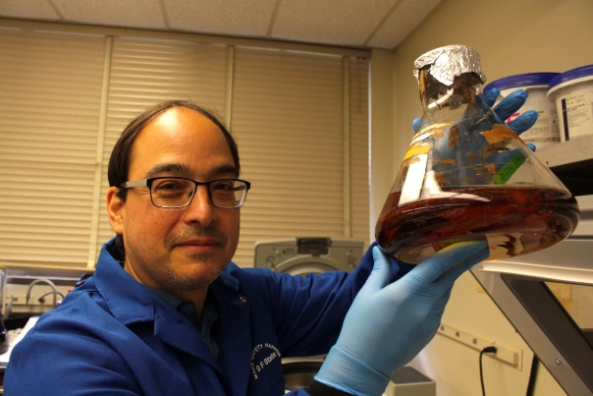

* **Left: Johnny Duong & Right: Dr. Ziah Dean (SFSU)**

**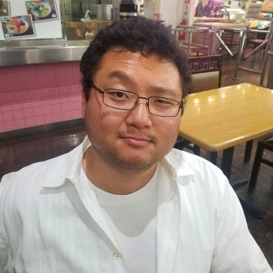    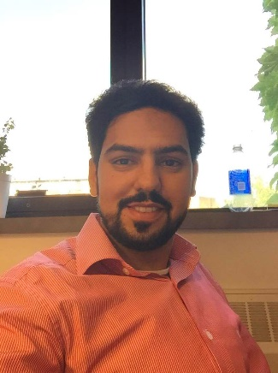**

**Science Coding Immersion Program (SCIP) Spring 2022**

**San Francisco State University**

**Thomas Zimmerman (IBM Research), Ray Esquerra (SFSU), Faye Orcales (SFSU)**

**Course Syllabus**

|  |  |
| --- | --- |
|  |  |
| **Course Title:** | Image Processing in Python and OpenCV |
|  |  |

**Image Analysis Course Topics Schedule**

|  |  |
| --- | --- |
| **Week** | **Topics** |
| Week 1 | Overview and Introduction  INTRODUCTION TO COLAB  <https://www.tutorialspoint.com/google_colab/index.htm>  IMAGES AND NUMPY ARRAYS  Loading image into array and display (color and grayscale).  Cropping and combining images using the image arrays.  Using a threshold (fixed and adaptive) to create a binary image.  **Instructional videos:**  Introduction to Image Processing Pipeline  Part 1 [https://youtu.be/XYcGepJysow](https://urldefense.proofpoint.com/v2/url?u=https-3A__nam10.safelinks.protection.outlook.com_-3Furl-3Dhttps-253A-252F-252Fyoutu.be-252FXYcGepJysow-26data-3D05-257C01-257Cpennings-2540sfsu.edu-257C9d42d04fa5854b766b7e08da3e6f9c58-257Cd8fbe335822c41a987747f16709aac9f-257C0-257C0-257C637890946332305098-257CUnknown-257CTWFpbGZsb3d8eyJWIjoiMC4wLjAwMDAiLCJQIjoiV2luMzIiLCJBTiI6Ik1haWwiLCJXVCI6Mn0-253D-257C3000-257C-257C-257C-26sdata-3D8y-252FqA3gRXTuBbRgHMtBGT0FrlZkRXmnECb7J3Kpg6sE-253D-26reserved-3D0&d=DwMF-g&c=jf_iaSHvJObTbx-siA1ZOg&r=Iih7OZjzN1SrKeTeZm-QGA&m=WsFZCXdyj5R2h91QOnD6RgCM2byD_bAXsz3uXGuSBGaMNXYSgfPm3K8AO5tucYuS&s=V3cGiMwxEAjDgQzfKluV0gCMlQdQfV2qS4nFacEKCiI&e=)  Part 2 [https://youtu.be/f67r5dQ1AjI](https://urldefense.proofpoint.com/v2/url?u=https-3A__nam10.safelinks.protection.outlook.com_-3Furl-3Dhttps-253A-252F-252Fyoutu.be-252Ff67r5dQ1AjI-26data-3D05-257C01-257Cpennings-2540sfsu.edu-257C9d42d04fa5854b766b7e08da3e6f9c58-257Cd8fbe335822c41a987747f16709aac9f-257C0-257C0-257C637890946332305098-257CUnknown-257CTWFpbGZsb3d8eyJWIjoiMC4wLjAwMDAiLCJQIjoiV2luMzIiLCJBTiI6Ik1haWwiLCJXVCI6Mn0-253D-257C3000-257C-257C-257C-26sdata-3DFyGmqcbt0z2-252FcvIchFEbly3TdZeXPYfybC2iC6N5-252FX0-253D-26reserved-3D0&d=DwMF-g&c=jf_iaSHvJObTbx-siA1ZOg&r=Iih7OZjzN1SrKeTeZm-QGA&m=WsFZCXdyj5R2h91QOnD6RgCM2byD_bAXsz3uXGuSBGaMNXYSgfPm3K8AO5tucYuS&s=3ZLD39D8ngrjPWf3j7RWvO3X_XHCC8ZNrHpEj84dABI&e=)  Representing Color Images in Numpy Arrays  Part 1 <https://youtu.be/Svu3Af-eWzc>  Part 2 <https://youtu.be/7IzI9LU1I0Y>  **CoLab Data for all Weeks:** <https://drive.google.com/drive/folders/11bWCIr62mzRmNOrbopiOBMhxGUrPEjs0?usp=sharing>  **CoLab Demo Code:**  Week 1 Exercises: <https://drive.google.com/drive/folders/1fTk9V5W_7nufoXidvN5zBFKRPMQ99GZR?usp=sharing> |
| Week 2 | DETECTING OBJECTS IN AN IMAGE  **Instructional Videos:**  Image Thresholding: Converting images into binary images.<https://youtu.be/fFCVyH8yuq0>  Advanced Image Thresholding: Converting images with large changes in lighting into binary images. <https://youtu.be/E2SPeAZKtNs>  Blurring to Improve Image Thresholding: Estimating illumination by blurring and subtracting it from an image to improve thresholding.<https://youtu.be/4qxwhmTU4XI>  Detecting Objects with Contour: Applying the findCountour() function on binary images to detect objects. Selecting objects by area.  Part 1<https://youtu.be/5GXGiZe3bqY>  Part 2<https://youtu.be/w3Fy10hHD8w>  **CoLab Demo Code:**  Week 2 Exercises: <https://drive.google.com/drive/folders/1TPOfWXR3zffGpr9oqzMgoK33z0q50O69?usp=sharing> |
| Week 3 | TRACKING OBJECTS  **Instructional Videos:**  Tracking multiple objects detected in a video. (Recommended to read the text in the [Week3_Part5_Tracking](https://colab.research.google.com/drive/1VgaHLNfhkvESLXtbUrR9QcGT5gIm0JDg?usp=sharing) notebook first before watching this video).  [https://youtu.be/Ky8J56lbm3c](https://nam10.safelinks.protection.outlook.com/?url=https%3A%2F%2Fyoutu.be%2FKy8J56lbm3c&data=05%7C01%7Cforcales%40mail.sfsu.edu%7Cfeb2c62e31054bec9cc008da4d7d0ee1%7Cd8fbe335822c41a987747f16709aac9f%7C0%7C0%7C637907496765146910%7CUnknown%7CTWFpbGZsb3d8eyJWIjoiMC4wLjAwMDAiLCJQIjoiV2luMzIiLCJBTiI6Ik1haWwiLCJXVCI6Mn0%3D%7C3000%7C%7C%7C&sdata=wx1ZTQ8w8QnfGcF1Eo7JR3ZPrWUaYUy%2Bzd%2BHQFLWZ6s%3D&reserved=0)  **CoLab Demo Code:**  Week 3 Exercises:  <https://drive.google.com/drive/folders/1RnTMiD5b5oipR3Rn19A84icvUS7jkqTt?usp=sharing> |
| Week 4 | REVIEW    **Youtube videos:**  A review of python basics: <https://drive.google.com/file/d/18u4I1anDlCJRZNScj9tiWGILGGq3_s-d/view?usp=sharing>  **CoLab Demo Code:**  Week 4 Exercises:  <https://drive.google.com/drive/folders/1iUBNnLNRThWoI5Dyrz6PBTwisQwFrdF4?usp=sharing> |
| Week 5 | FEATURE EXTRACTION  Extracting morphological (shape) features of objects.  **Youtube videos (refer to documentation):**  <https://docs.google.com/document/d/1oHxWHyIMMaQ73GDoNZmZBDCmbR-7DBXaHGnlCVte_Og/edit?usp=sharing>  **CoLab Demo Code:**  Week 5 Exercises:  <https://drive.google.com/drive/folders/1au3W2NbygZQt2S5lmAX5tLG6_gArPL_0?usp=sharing> |
| Week 6 | UNSUPERVISED CLUSTERING  Using features to group (cluster) similar objects together.  Using clusters to create a training set.  SUPERVISED CLASSIFICATION  Set up training and testing dataset for scikit-learn.  Test multiple classification methods.  Use Confusion Matrix to evaluate classification methods.  **CoLab Demo Code:**  Week 6 Exercises:  <https://drive.google.com/drive/folders/1UV17mtG8AOgba_xFTk64gzWjOvu5xS4-?usp=sharing> |

**ACKNOWLEDGEMENTS:**

**CONTENT CREATOR:  TOM ZIMMERMAN (IBM RESEARCH), RAY ESQUERRA (SFSU), JOHNNY DUONG (SFSU), ZIAH DEAN (SFSU)**

Image J

Creators of the course:

**Arne Seitz, Romain Guiet, Olivier Burri, Nicolas Chiaruttini**

For this track, you will be following an online course on edX. Here are some instructions to help guide you through the sign-up process.

Signing up for the course on edX:

1. Click on this link: <https://www.edx.org/course/image-processing-and-analysis-for-life-scientists>
2. Click “Enroll”

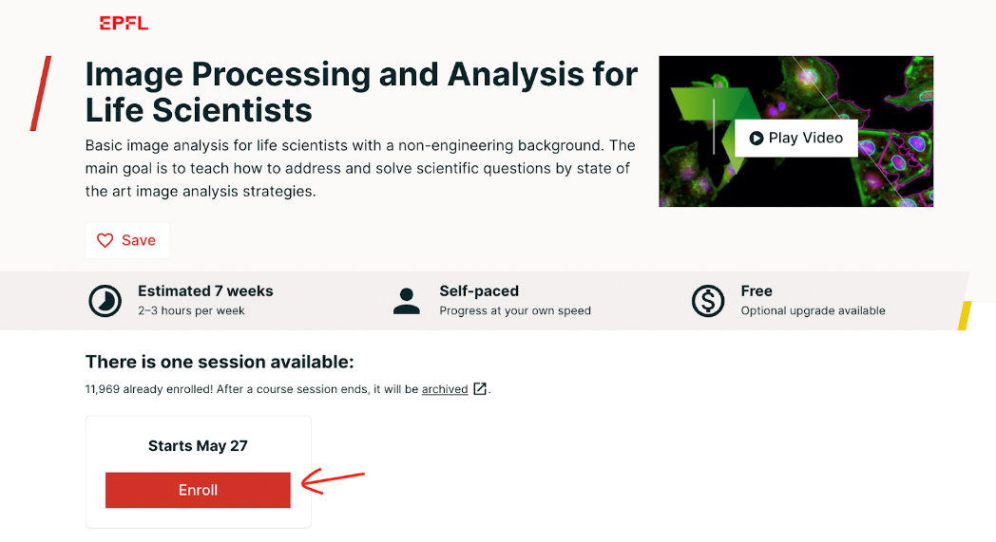

1. Register if you don’t already have an account with edX
2. Select the Free course option

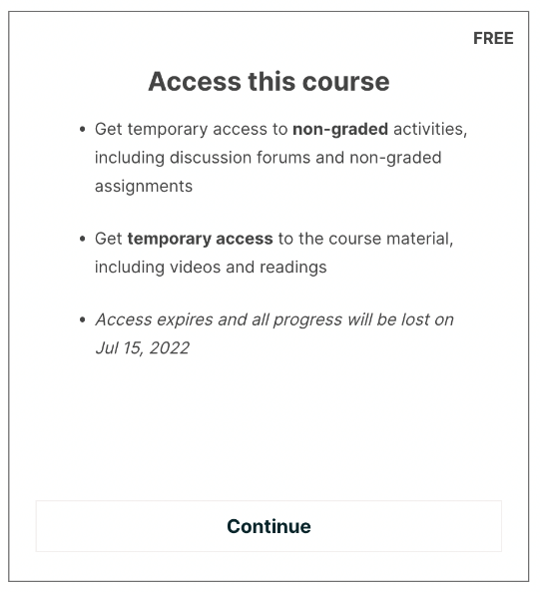

1. If you see this at the top of your page, then congrats! You’re ready to start the course.

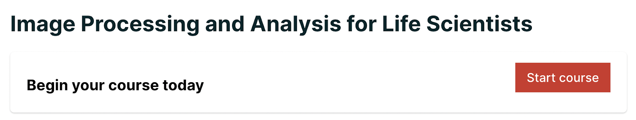

ImageJ Suggested Schedule

|  |  |  |
| --- | --- | --- |
| ***Week*** | ***Dates*** | **ImageJ Schedule** |
| 1 | 5/31 | * EdX: Preamble * EdX: Digital Images |
| 2 | 6/6 | * EdX: Of Colors & Dimensions |
| 3 | 6/13 | * EdX: Resizing, Interpolation, & Mathematical Operations |
| 4 | 6/20 | * EdX: Filtering * EdX: Segmentation, From Intensities to Objects |
| 5 | 6/27 | * EdX: ROIs & Results |
| 6 | 7/5 | * *EdX*: Color in Depth, Projections & Reslicing |