### Step 1

Run the ExtractDuplicateGeoreferences code. The dataset of the collection you are seeking to update should be loaded as the “mycoll” data frame.

### Step 2

Remove duplicate lat/longs in Excel:

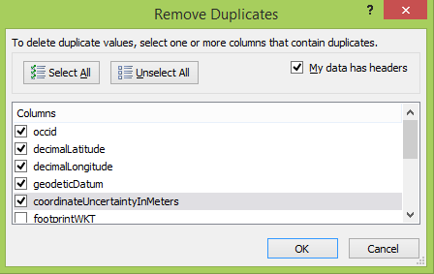

### Step 3

Visualize duplicates that still exist:

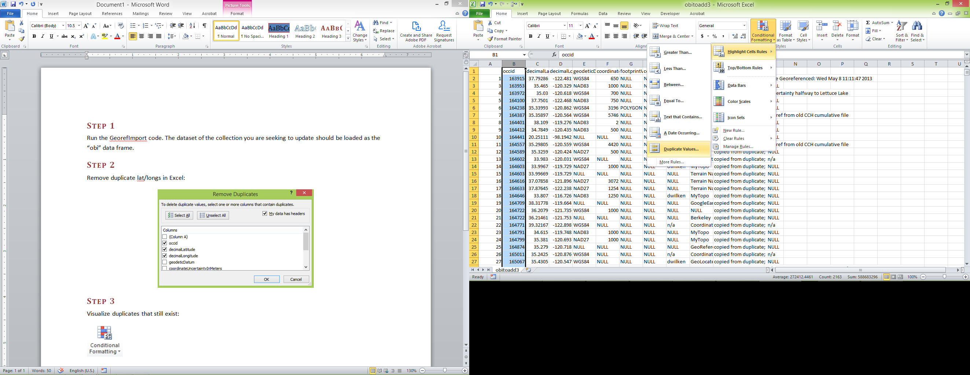

### Step 4

Decide which set of duplicates to keep by following these rules. You should prioritize georeferences:

1. purported coordinates from label
2. with non-NULL georeference remarks, datum, coordinate uncertainty, etc. fields
3. with named georeferencers (not just UCBerkeley, etc.)
4. with smaller error radii (unless they are suspicious)

Examples



Keep 813 because it has datum and error radius (1000)



Keep 821 because it has the smallest error radius



Keep 824 because it has a georeferencer (dwilken)



Keep 1333 because it has a georeferencer (Bill Carlson)



Keep 1390 because the source is the collector/specimen label



Keep 1476 because georeference remarks are more specific

### Step 5

Remove “; NULL” and “; n/a” from the end of georeference remarks field

