#----------------------------------------------------------------------------------------------------------------------------------------------#
Procesando county: 0, is_business: 0, product_type: 1, is_consumption: 0
Generando ACF y PACF para county: 0, is_business: 0, product_type: 1, is_consumption: 0

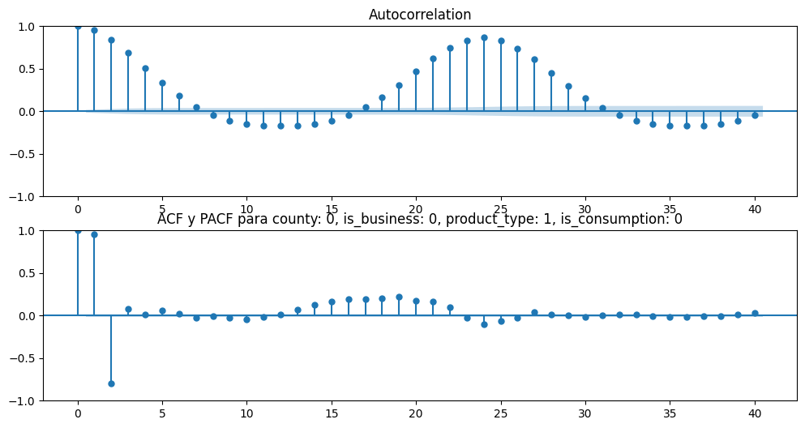
Guardado exitosamente en /imagenes/acf_pacf

Generando Decomposición para county: 0, is_business: 0, product_type: 1, is_consumption: 0

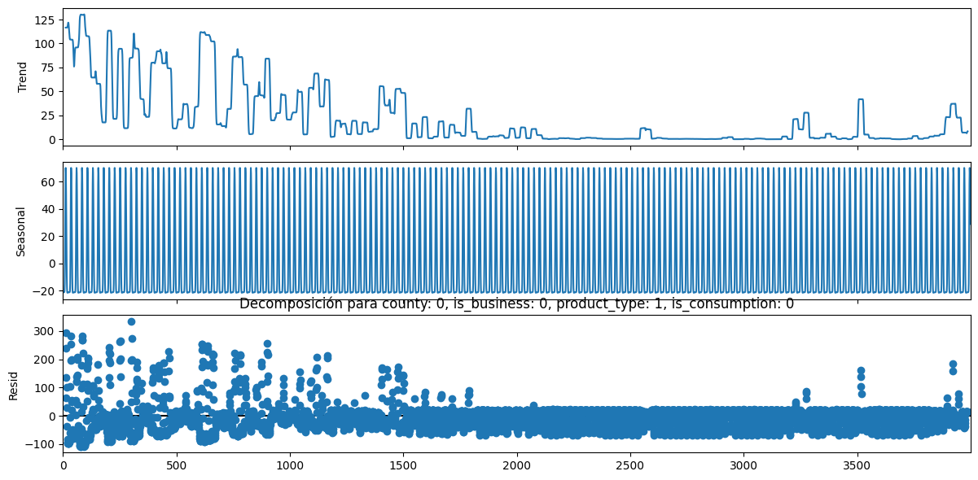
Guardado exitosamente en /imagenes/decomposition

Test de ADF para county: 0, is_business: 0, product_type: 1, is_consumption: 0

ADF Statistic: -4.3183, p-value: 0.0004, conclusión: No hay raíz unitaria (Estacionario)
Entrenando modelo ARIMA para county: 0, is_business: 0, product_type: 1, is_consumption: 0

Generando combinaciones de hiperparámetros para county: 0, is_business: 0, product_type: 1, is_consumption: 0

No se aplica diferenciación ya que la serie es estacionaria

El número de modelos a probar es 32
Buscando mejor modelo para county: 0, is_business: 0, product_type: 1, is_consumption: 0

Probando un ARIMA(1, 0, 1)(1, 0, 0)(24)
Probando un ARIMA(1, 0, 1)(1, 0, 1)(24)
Probando un ARIMA(1, 0, 1)(1, 1, 0)(24)
Probando un ARIMA(1, 0, 1)(1, 1, 1)(24)
Probando un ARIMA(1, 0, 1)(2, 0, 0)(24)
Probando un ARIMA(1, 0, 1)(2, 0, 1)(24)
Probando un ARIMA(1, 0, 1)(2, 1, 0)(24)
Probando un ARIMA(1, 0, 1)(2, 1, 1)(24)
Probando un ARIMA(1, 0, 2)(1, 0, 0)(24)
Probando un ARIMA(1, 0, 2)(1, 0, 1)(24)
Probando un ARIMA(1, 0, 2)(1, 1, 0)(24)
Probando un ARIMA(1, 0, 2)(1, 1, 1)(24)
Probando un ARIMA(1, 0, 2)(2, 0, 0)(24)
Probando un ARIMA(1, 0, 2)(2, 0, 1)(24)
Probando un ARIMA(1, 0, 2)(2, 1, 0)(24)
Probando un ARIMA(1, 0, 2)(2, 1, 1)(24)
Probando un ARIMA(2, 0, 1)(1, 0, 0)(24)
Probando un ARIMA(2, 0, 1)(1, 0, 1)(24)
Probando un ARIMA(2, 0, 1)(1, 1, 0)(24)
Probando un ARIMA(2, 0, 1)(1, 1, 1)(24)
Probando un ARIMA(2, 0, 1)(2, 0, 0)(24)
Probando un ARIMA(2, 0, 1)(2, 0, 1)(24)
Probando un ARIMA(2, 0, 1)(2, 1, 0)(24)
Probando un ARIMA(2, 0, 1)(2, 1, 1)(24)
Probando un ARIMA(2, 0, 2)(1, 0, 0)(24)
Probando un ARIMA(2, 0, 2)(1, 0, 1)(24)
Probando un ARIMA(2, 0, 2)(1, 1, 0)(24)
Probando un ARIMA(2, 0, 2)(1, 1, 1)(24)
Probando un ARIMA(2, 0, 2)(2, 0, 0)(24)
Probando un ARIMA(2, 0, 2)(2, 0, 1)(24)
Probando un ARIMA(2, 0, 2)(2, 1, 0)(24)
Probando un ARIMA(2, 0, 2)(2, 1, 1)(24)
Los modelos probados para county: 0, is_business: 0, product_type: 1, is_consumption: 0 son:
model ljung_box (p-value) jarque_bera (p-value) \
0 NaN NaN NaN
0 ARIMA(1, 0, 1)(1, 0, 0)24 3414.1402(0.0) 145346.6424(0.0)
0 ARIMA(1, 0, 1)(1, 0, 1)24 1001.6833(0.0) 198012.1093(0.0)
0 ARIMA(1, 0, 1)(1, 1, 0)24 956.89(0.0) 166834.6411(0.0)
0 ARIMA(1, 0, 1)(1, 1, 1)24 950.3741(0.0) 207179.4327(0.0)
0 ARIMA(1, 0, 1)(2, 0, 0)24 1389.0363(0.0) 150724.7246(0.0)
0 ARIMA(1, 0, 1)(2, 0, 1)24 969.9589(0.0) 201404.5575(0.0)
0 ARIMA(1, 0, 1)(2, 1, 0)24 777.3113(0.0) 177354.1085(0.0)
0 ARIMA(1, 0, 1)(2, 1, 1)24 940.5119(0.0) 205622.4227(0.0)
0 ARIMA(1, 0, 2)(1, 0, 0)24 2770.241(0.0) 183977.418(0.0)
0 ARIMA(1, 0, 2)(1, 0, 1)24 377.3033(0.0) 230996.7851(0.0)
0 ARIMA(1, 0, 2)(1, 1, 0)24 459.5133(0.0) 184983.687(0.0)
0 ARIMA(1, 0, 2)(1, 1, 1)24 343.5889(0.0) 241234.5533(0.0)
0 ARIMA(1, 0, 2)(2, 0, 0)24 860.6613(0.0) 181153.1141(0.0)
0 ARIMA(1, 0, 2)(2, 0, 1)24 357.0218(0.0) 236313.1096(0.0)
0 ARIMA(1, 0, 2)(2, 1, 0)24 260.1275(0.0) 198784.5415(0.0)
0 ARIMA(1, 0, 2)(2, 1, 1)24 339.2174(0.0) 239525.7639(0.0)
0 ARIMA(2, 0, 1)(1, 0, 0)24 1635.6754(0.0) 243558.1972(0.0)
0 ARIMA(2, 0, 1)(1, 0, 1)24 191.0403(0.0) 252170.2034(0.0)
0 ARIMA(2, 0, 1)(1, 1, 0)24 340.0145(0.0) 199957.2978(0.0)
0 ARIMA(2, 0, 1)(1, 1, 1)24 173.6489(0.0) 262733.746(0.0)
0 ARIMA(2, 0, 1)(2, 0, 0)24 654.2334(0.0) 215205.987(0.0)
0 ARIMA(2, 0, 1)(2, 0, 1)24 182.9353(0.0) 258372.4181(0.0)
0 ARIMA(2, 0, 1)(2, 1, 0)24 454.0855(0.0) 170036.6179(0.0)
0 ARIMA(2, 0, 1)(2, 1, 1)24 650.6351(0.0) 205742.477(0.0)
0 ARIMA(2, 0, 2)(1, 0, 0)24 1625.7018(0.0) 241169.0024(0.0)
0 ARIMA(2, 0, 2)(1, 0, 1)24 184.3209(0.0) 253641.2452(0.0)
0 ARIMA(2, 0, 2)(1, 1, 0)24 337.4737(0.0) 201293.8014(0.0)
0 ARIMA(2, 0, 2)(1, 1, 1)24 169.6101(0.0) 263985.2655(0.0)
0 ARIMA(2, 0, 2)(2, 0, 0)24 620.5482(0.0) 215248.6145(0.0)
0 ARIMA(2, 0, 2)(2, 0, 1)24 177.6965(0.0) 259906.7812(0.0)
0 ARIMA(2, 0, 2)(2, 1, 0)24 nan(nan) nan(nan)
0 ARIMA(2, 0, 2)(2, 1, 1)24 663.7317(0.0) 205112.9761(0.0)

MAE
0 NaN
0 494.577325
0 450.660222
0 454.158381
0 451.897959
0 491.615813
0 451.576963
0 451.006815
0 451.929533
0 495.102679
0 450.951991
0 454.154729
0 451.922277
0 492.600123
0 451.946246
0 450.989157
0 451.939245
0 495.763175
0 451.425199
0 454.151313
0 451.927791
0 493.242028
0 451.762860
0 451.176529
0 451.935711
0 495.732739
0 451.577172
0 454.150122
0 451.927386
0 493.649954
0 452.408560
0 735451.619061
0 451.935455
El mejor modelo para county: 0, is_business: 0, product_type: 1, is_consumption: 0 es:
model ljung_box (p-value) jarque_bera (p-value) \
0 ARIMA(1, 0, 1)(1, 0, 1)24 1001.6833(0.0) 198012.1093(0.0)

MAE
0 450.660222
#----------------------------------------------------------------------------------------------------------------------------------------------#
Procesando county: 0, is_business: 0, product_type: 1, is_consumption: 1
Generando ACF y PACF para county: 0, is_business: 0, product_type: 1, is_consumption: 1

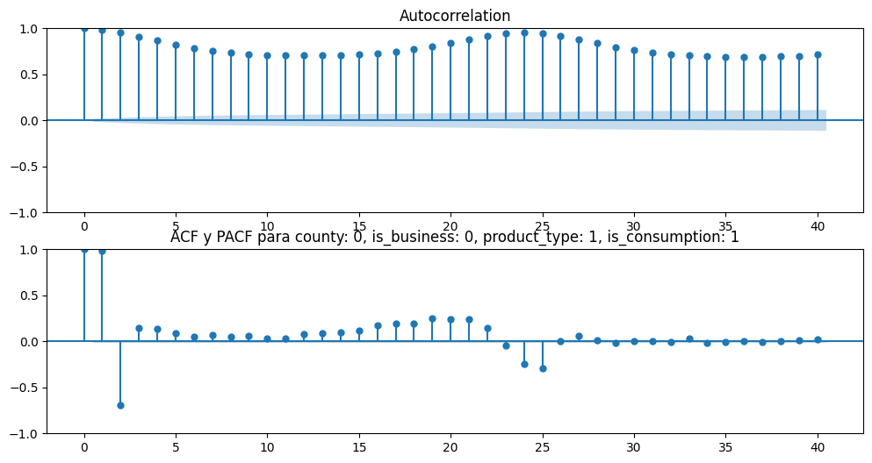
Guardado exitosamente en /imagenes/acf_pacf

Generando Decomposición para county: 0, is_business: 0, product_type: 1, is_consumption: 1

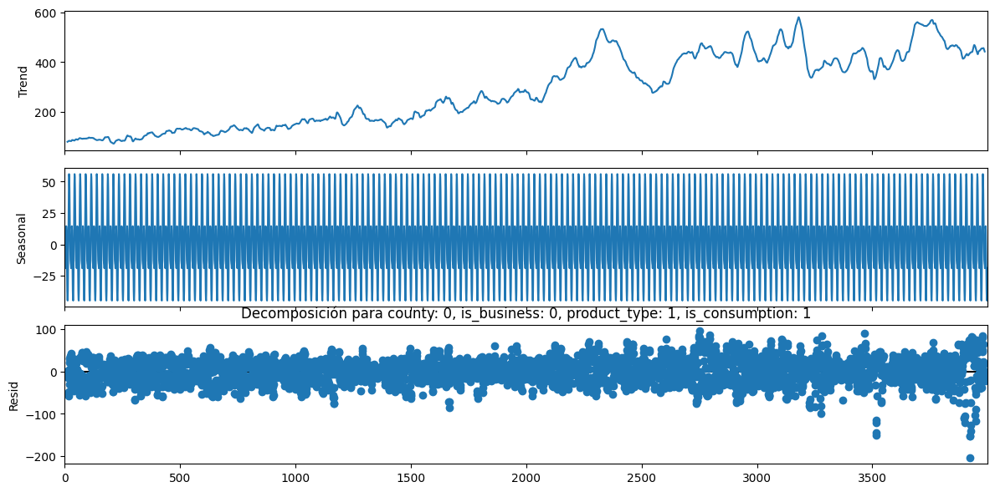
Guardado exitosamente en /imagenes/decomposition

Test de ADF para county: 0, is_business: 0, product_type: 1, is_consumption: 1

ADF Statistic: -2.4731, p-value: 0.1222, conclusión: Hay raíz unitaria (No estacionario)
Entrenando modelo ARIMA para county: 0, is_business: 0, product_type: 1, is_consumption: 1

Generando combinaciones de hiperparámetros para county: 0, is_business: 0, product_type: 1, is_consumption: 1

Se aplica diferenciación ya que la serie no es estacionaria

El número de modelos a probar es 32
Buscando mejor modelo para county: 0, is_business: 0, product_type: 1, is_consumption: 1

Probando un ARIMA(1, 1, 1)(1, 0, 0)(24)
Probando un ARIMA(1, 1, 1)(1, 0, 1)(24)
Probando un ARIMA(1, 1, 1)(1, 1, 0)(24)
Probando un ARIMA(1, 1, 1)(1, 1, 1)(24)
Probando un ARIMA(1, 1, 1)(2, 0, 0)(24)
Probando un ARIMA(1, 1, 1)(2, 0, 1)(24)
Probando un ARIMA(1, 1, 1)(2, 1, 0)(24)
Probando un ARIMA(1, 1, 1)(2, 1, 1)(24)
Probando un ARIMA(1, 1, 2)(1, 0, 0)(24)
Probando un ARIMA(1, 1, 2)(1, 0, 1)(24)
Probando un ARIMA(1, 1, 2)(1, 1, 0)(24)
Probando un ARIMA(1, 1, 2)(1, 1, 1)(24)
Probando un ARIMA(1, 1, 2)(2, 0, 0)(24)
Probando un ARIMA(1, 1, 2)(2, 0, 1)(24)
Probando un ARIMA(1, 1, 2)(2, 1, 0)(24)
Probando un ARIMA(1, 1, 2)(2, 1, 1)(24)
Probando un ARIMA(2, 1, 1)(1, 0, 0)(24)
Probando un ARIMA(2, 1, 1)(1, 0, 1)(24)
Probando un ARIMA(2, 1, 1)(1, 1, 0)(24)
Probando un ARIMA(2, 1, 1)(1, 1, 1)(24)
Probando un ARIMA(2, 1, 1)(2, 0, 0)(24)
Probando un ARIMA(2, 1, 1)(2, 0, 1)(24)
Probando un ARIMA(2, 1, 1)(2, 1, 0)(24)
Probando un ARIMA(2, 1, 1)(2, 1, 1)(24)
Probando un ARIMA(2, 1, 2)(1, 0, 0)(24)
Probando un ARIMA(2, 1, 2)(1, 0, 1)(24)
Probando un ARIMA(2, 1, 2)(1, 1, 0)(24)
Probando un ARIMA(2, 1, 2)(1, 1, 1)(24)
Probando un ARIMA(2, 1, 2)(2, 0, 0)(24)
Probando un ARIMA(2, 1, 2)(2, 0, 1)(24)
Probando un ARIMA(2, 1, 2)(2, 1, 0)(24)
Probando un ARIMA(2, 1, 2)(2, 1, 1)(24)
Los modelos probados para county: 0, is_business: 0, product_type: 1, is_consumption: 1 son:
model ljung_box (p-value) jarque_bera (p-value) \
1 NaN NaN NaN
0 ARIMA(1, 1, 1)(1, 0, 0)24 2370.03(0.0) 5624.8918(0.0)
0 ARIMA(1, 1, 1)(1, 0, 1)24 41471.0687(0.0) 3944.4672(0.0)
0 ARIMA(1, 1, 1)(1, 1, 0)24 580.5761(0.0) 4937.4434(0.0)
0 ARIMA(1, 1, 1)(1, 1, 1)24 456.092(0.0) 5681.2652(0.0)
0 ARIMA(1, 1, 1)(2, 0, 0)24 2442.73(0.0) 5676.817(0.0)
0 ARIMA(1, 1, 1)(2, 0, 1)24 nan(nan) nan(nan)
0 ARIMA(1, 1, 1)(2, 1, 0)24 401.8495(0.0) 5593.4843(0.0)
0 ARIMA(1, 1, 1)(2, 1, 1)24 456.8862(0.0) 5681.1353(0.0)
0 ARIMA(1, 1, 2)(1, 0, 0)24 2256.7997(0.0) 5628.8899(0.0)
0 ARIMA(1, 1, 2)(1, 0, 1)24 40928.431(0.0) 3978.2576(0.0)
0 ARIMA(1, 1, 2)(1, 1, 0)24 586.2093(0.0) 4931.9571(0.0)
0 ARIMA(1, 1, 2)(1, 1, 1)24 435.9272(0.0) 5638.9931(0.0)
0 ARIMA(1, 1, 2)(2, 0, 0)24 nan(nan) nan(nan)
0 ARIMA(1, 1, 2)(2, 0, 1)24 43425.5818(0.0) 3761.6028(0.0)
0 ARIMA(1, 1, 2)(2, 1, 0)24 377.1488(0.0) 5286.1564(0.0)
0 ARIMA(1, 1, 2)(2, 1, 1)24 436.1093(0.0) 5559.6253(0.0)
0 ARIMA(2, 1, 1)(1, 0, 0)24 2212.4392(0.0) 5476.842(0.0)
0 ARIMA(2, 1, 1)(1, 0, 1)24 52564.4637(0.0) 1589.9692(0.0)
0 ARIMA(2, 1, 1)(1, 1, 0)24 580.3154(0.0) 4952.2277(0.0)
0 ARIMA(2, 1, 1)(1, 1, 1)24 1978.9174(0.0) 4161.2718(0.0)
0 ARIMA(2, 1, 1)(2, 0, 0)24 6077.6233(0.0) 3111.5208(0.0)
0 ARIMA(2, 1, 1)(2, 0, 1)24 61241.4063(0.0) 1141.8139(0.0)
0 ARIMA(2, 1, 1)(2, 1, 0)24 5143.2235(0.0) 3856.7825(0.0)
0 ARIMA(2, 1, 1)(2, 1, 1)24 1300.8014(0.0) 4313.0922(0.0)
0 ARIMA(2, 1, 2)(1, 0, 0)24 1953.0256(0.0) 4185.4058(0.0)
0 ARIMA(2, 1, 2)(1, 0, 1)24 42956.632(0.0) 2348.1517(0.0)
0 ARIMA(2, 1, 2)(1, 1, 0)24 6549.1615(0.0) 3665.4246(0.0)
0 ARIMA(2, 1, 2)(1, 1, 1)24 581.8921(0.0) 4557.2666(0.0)
0 ARIMA(2, 1, 2)(2, 0, 0)24 6877.8343(0.0) 3043.5096(0.0)
0 ARIMA(2, 1, 2)(2, 0, 1)24 51577.2764(0.0) 1754.0439(0.0)
0 ARIMA(2, 1, 2)(2, 1, 0)24 8686.4073(0.0) 3889.3037(0.0)
0 ARIMA(2, 1, 2)(2, 1, 1)24 535.308(0.0) 4313.8568(0.0)

MAE
1 NaN
0 284.895023
0 325.750804
0 3648.481214
0 284.714447
0 293.223576
0 321.169518
0 2851.893099
0 284.786071
0 284.665248
0 325.590378
0 3657.552770
0 284.560046
0 293.192020
0 321.131468
0 2873.741298
0 284.051859
0 284.777926
0 330.455704
0 3643.876649
0 656.539507
0 332.442713
0 327.718435
0 2013.773672
0 792.431008
0 325.413239
0 330.472313
0 520.456402
0 482.097348
0 334.807671
0 323.270976
0 1837.986693
0 740.003289
El mejor modelo para county: 0, is_business: 0, product_type: 1, is_consumption: 1 es:
model ljung_box (p-value) jarque_bera (p-value) \
1 ARIMA(1, 1, 2)(2, 1, 1)24 436.1093(0.0) 5559.6253(0.0)

MAE
1 284.051859
#-------------------------------------------------------------------------------------------------------#
Procesando county: 0, is_business: 0, product_type: 2, is_consumption: 0
Generando ACF y PACF para county: 0, is_business: 0, product_type: 2, is_consumption: 0

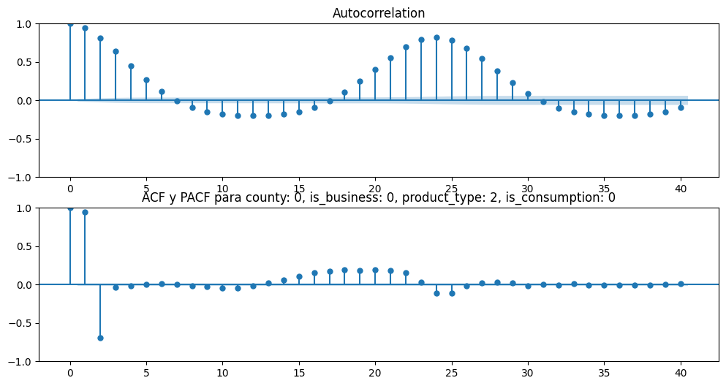
Guardado exitosamente en /imagenes/acf_pacf

Generando Decomposición para county: 0, is_business: 0, product_type: 2, is_consumption: 0

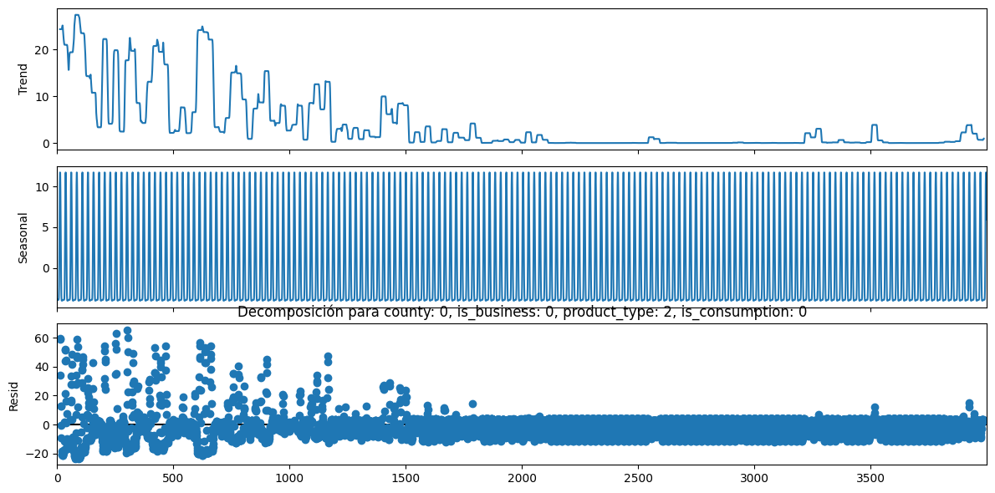
Guardado exitosamente en /imagenes/decomposition

Test de ADF para county: 0, is_business: 0, product_type: 2, is_consumption: 0

ADF Statistic: -6.2698, p-value: 0.0, conclusión: No hay raíz unitaria (Estacionario)
Entrenando modelo ARIMA para county: 0, is_business: 0, product_type: 2, is_consumption: 0

Generando combinaciones de hiperparámetros para county: 0, is_business: 0, product_type: 2, is_consumption: 0

No se aplica diferenciación ya que la serie es estacionaria

El número de modelos a probar es 32
Buscando mejor modelo para county: 0, is_business: 0, product_type: 2, is_consumption: 0

Probando un ARIMA(1, 0, 1)(1, 0, 0)(24)
Probando un ARIMA(1, 0, 1)(1, 0, 1)(24)
Probando un ARIMA(1, 0, 1)(1, 1, 0)(24)
Probando un ARIMA(1, 0, 1)(1, 1, 1)(24)
Probando un ARIMA(1, 0, 1)(2, 0, 0)(24)
Probando un ARIMA(1, 0, 1)(2, 0, 1)(24)
Probando un ARIMA(1, 0, 1)(2, 1, 0)(24)
Probando un ARIMA(1, 0, 1)(2, 1, 1)(24)
Probando un ARIMA(1, 0, 2)(1, 0, 0)(24)
Probando un ARIMA(1, 0, 2)(1, 0, 1)(24)
Probando un ARIMA(1, 0, 2)(1, 1, 0)(24)
Probando un ARIMA(1, 0, 2)(1, 1, 1)(24)
Probando un ARIMA(1, 0, 2)(2, 0, 0)(24)
Probando un ARIMA(1, 0, 2)(2, 0, 1)(24)
Probando un ARIMA(1, 0, 2)(2, 1, 0)(24)
Probando un ARIMA(1, 0, 2)(2, 1, 1)(24)
Probando un ARIMA(2, 0, 1)(1, 0, 0)(24)
Probando un ARIMA(2, 0, 1)(1, 0, 1)(24)
Probando un ARIMA(2, 0, 1)(1, 1, 0)(24)
Probando un ARIMA(2, 0, 1)(1, 1, 1)(24)
Probando un ARIMA(2, 0, 1)(2, 0, 0)(24)
Probando un ARIMA(2, 0, 1)(2, 0, 1)(24)
Probando un ARIMA(2, 0, 1)(2, 1, 0)(24)
Probando un ARIMA(2, 0, 1)(2, 1, 1)(24)
Probando un ARIMA(2, 0, 2)(1, 0, 0)(24)
Probando un ARIMA(2, 0, 2)(1, 0, 1)(24)
Probando un ARIMA(2, 0, 2)(1, 1, 0)(24)
Probando un ARIMA(2, 0, 2)(1, 1, 1)(24)
Probando un ARIMA(2, 0, 2)(2, 0, 0)(24)
Probando un ARIMA(2, 0, 2)(2, 0, 1)(24)
Probando un ARIMA(2, 0, 2)(2, 1, 0)(24)
Probando un ARIMA(2, 0, 2)(2, 1, 1)(24)
Los modelos probados para county: 0, is_business: 0, product_type: 2, is_consumption: 0 son:
model ljung_box (p-value) jarque_bera (p-value) \
2 NaN NaN NaN
0 ARIMA(1, 0, 1)(1, 0, 0)24 2665.1857(0.0) 78916.3196(0.0)
0 ARIMA(1, 0, 1)(1, 0, 1)24 799.1414(0.0) 98367.8697(0.0)
0 ARIMA(1, 0, 1)(1, 1, 0)24 1704.1687(0.0) 98486.1616(0.0)
0 ARIMA(1, 0, 1)(1, 1, 1)24 2008.5691(0.0) 84405.8938(0.0)
0 ARIMA(1, 0, 1)(2, 0, 0)24 1213.0688(0.0) 96039.4027(0.0)
0 ARIMA(1, 0, 1)(2, 0, 1)24 750.693(0.0) 100585.3652(0.0)
0 ARIMA(1, 0, 1)(2, 1, 0)24 1765.0427(0.0) 94139.8995(0.0)
0 ARIMA(1, 0, 1)(2, 1, 1)24 2123.5832(0.0) 83035.8163(0.0)
0 ARIMA(1, 0, 2)(1, 0, 0)24 2290.6102(0.0) 91256.4845(0.0)
0 ARIMA(1, 0, 2)(1, 0, 1)24 424.7133(0.0) 111364.0068(0.0)
0 ARIMA(1, 0, 2)(1, 1, 0)24 1071.6579(0.0) 106675.9198(0.0)
0 ARIMA(1, 0, 2)(1, 1, 1)24 1185.172(0.0) 97541.3101(0.0)
0 ARIMA(1, 0, 2)(2, 0, 0)24 922.3936(0.0) 108466.4842(0.0)
0 ARIMA(1, 0, 2)(2, 0, 1)24 399.8324(0.0) 114179.4983(0.0)
0 ARIMA(1, 0, 2)(2, 1, 0)24 978.1544(0.0) 100601.9674(0.0)
0 ARIMA(1, 0, 2)(2, 1, 1)24 1259.5343(0.0) 95112.3075(0.0)
0 ARIMA(2, 0, 1)(1, 0, 0)24 1378.9882(0.0) 95052.8372(0.0)
0 ARIMA(2, 0, 1)(1, 0, 1)24 245.6013(0.0) 115324.2221(0.0)
0 ARIMA(2, 0, 1)(1, 1, 0)24 672.7118(0.0) 111970.0512(0.0)
0 ARIMA(2, 0, 1)(1, 1, 1)24 586.7871(0.0) 107843.2105(0.0)
0 ARIMA(2, 0, 1)(2, 0, 0)24 663.3516(0.0) 112044.6587(0.0)
0 ARIMA(2, 0, 1)(2, 0, 1)24 229.7426(0.0) 118286.4349(0.0)
0 ARIMA(2, 0, 1)(2, 1, 0)24 483.6131(0.0) 105892.7354(0.0)
0 ARIMA(2, 0, 1)(2, 1, 1)24 645.1234(0.0) 103737.3375(0.0)
0 ARIMA(2, 0, 2)(1, 0, 0)24 1360.7106(0.0) 92211.1109(0.0)
0 ARIMA(2, 0, 2)(1, 0, 1)24 238.2486(0.0) 113736.4978(0.0)
0 ARIMA(2, 0, 2)(1, 1, 0)24 722.0798(0.0) 110472.1714(0.0)
0 ARIMA(2, 0, 2)(1, 1, 1)24 665.1504(0.0) 105048.8902(0.0)
0 ARIMA(2, 0, 2)(2, 0, 0)24 628.0533(0.0) 108913.5327(0.0)
0 ARIMA(2, 0, 2)(2, 0, 1)24 222.6986(0.0) 116629.9186(0.0)
0 ARIMA(2, 0, 2)(2, 1, 0)24 538.1458(0.0) 104855.1301(0.0)
0 ARIMA(2, 0, 2)(2, 1, 1)24 723.0655(0.0) 101455.4645(0.0)

MAE
2 NaN
0 9.425977
0 6.309168
0 5.569350
0 5.497309
0 9.305082
0 6.180095
0 5.490364
0 5.492096
0 9.445702
0 6.353249
0 5.569345
0 5.497424
0 9.340795
0 6.232858
0 5.490072
0 5.491760
0 9.473194
0 6.436668
0 5.569345
0 5.497709
0 9.382877
0 6.022073
0 5.490056
0 5.491873
0 9.474488
0 6.450002
0 5.569345
0 5.497716
0 9.386624
0 6.035801
0 5.490060
0 5.491931
El mejor modelo para county: 0, is_business: 0, product_type: 2, is_consumption: 0 es:
model ljung_box (p-value) jarque_bera (p-value) \
2 ARIMA(2, 0, 1)(2, 1, 0)24 483.6131(0.0) 105892.7354(0.0)

MAE
2 5.490056
#----------------------------------------------------------------------------------------------------------------------------------------------#
Procesando county: 0, is_business: 0, product_type: 2, is_consumption: 1
Generando ACF y PACF para county: 0, is_business: 0, product_type: 2, is_consumption: 1

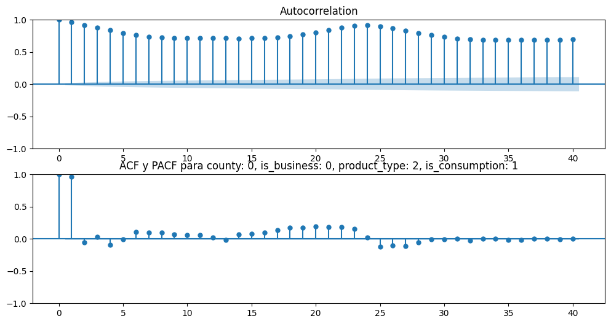
Guardado exitosamente en /imagenes/acf_pacf

Generando Decomposición para county: 0, is_business: 0, product_type: 2, is_consumption: 1

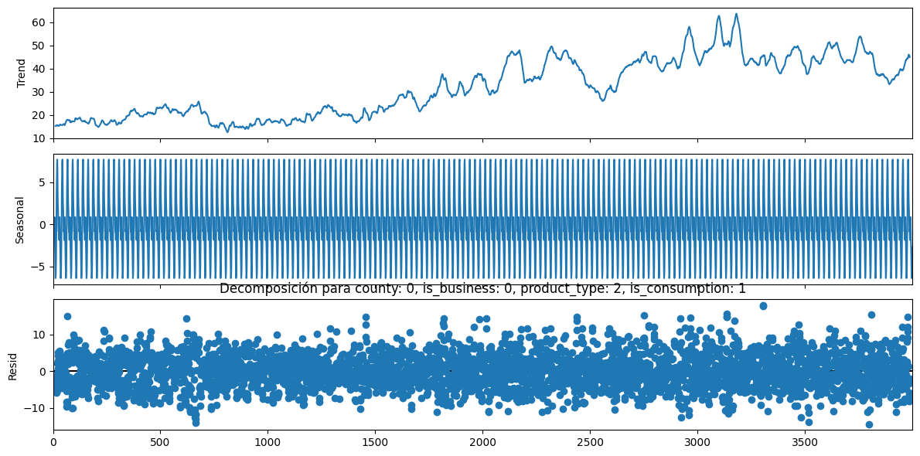
Guardado exitosamente en /imagenes/decomposition

Test de ADF para county: 0, is_business: 0, product_type: 2, is_consumption: 1

ADF Statistic: -3.0414, p-value: 0.0312, conclusión: No hay raíz unitaria (Estacionario)
Entrenando modelo ARIMA para county: 0, is_business: 0, product_type: 2, is_consumption: 1

Generando combinaciones de hiperparámetros para county: 0, is_business: 0, product_type: 2, is_consumption: 1

No se aplica diferenciación ya que la serie es estacionaria

El número de modelos a probar es 32
Buscando mejor modelo para county: 0, is_business: 0, product_type: 2, is_consumption: 1

Probando un ARIMA(1, 0, 1)(1, 0, 0)(24)
Probando un ARIMA(1, 0, 1)(1, 0, 1)(24)
Probando un ARIMA(1, 0, 1)(1, 1, 0)(24)
Probando un ARIMA(1, 0, 1)(1, 1, 1)(24)
Probando un ARIMA(1, 0, 1)(2, 0, 0)(24)
Probando un ARIMA(1, 0, 1)(2, 0, 1)(24)
Probando un ARIMA(1, 0, 1)(2, 1, 0)(24)
Probando un ARIMA(1, 0, 1)(2, 1, 1)(24)
Probando un ARIMA(1, 0, 2)(1, 0, 0)(24)
Probando un ARIMA(1, 0, 2)(1, 0, 1)(24)
Probando un ARIMA(1, 0, 2)(1, 1, 0)(24)
Probando un ARIMA(1, 0, 2)(1, 1, 1)(24)
Probando un ARIMA(1, 0, 2)(2, 0, 0)(24)
Probando un ARIMA(1, 0, 2)(2, 0, 1)(24)
Probando un ARIMA(1, 0, 2)(2, 1, 0)(24)
Probando un ARIMA(1, 0, 2)(2, 1, 1)(24)
Probando un ARIMA(2, 0, 1)(1, 0, 0)(24)
Probando un ARIMA(2, 0, 1)(1, 0, 1)(24)
Probando un ARIMA(2, 0, 1)(1, 1, 0)(24)
Probando un ARIMA(2, 0, 1)(1, 1, 1)(24)
Probando un ARIMA(2, 0, 1)(2, 0, 0)(24)
Probando un ARIMA(2, 0, 1)(2, 0, 1)(24)
Probando un ARIMA(2, 0, 1)(2, 1, 0)(24)
Probando un ARIMA(2, 0, 1)(2, 1, 1)(24)
Probando un ARIMA(2, 0, 2)(1, 0, 0)(24)
Probando un ARIMA(2, 0, 2)(1, 0, 1)(24)
Probando un ARIMA(2, 0, 2)(1, 1, 0)(24)
Probando un ARIMA(2, 0, 2)(1, 1, 1)(24)
Probando un ARIMA(2, 0, 2)(2, 0, 0)(24)
Probando un ARIMA(2, 0, 2)(2, 0, 1)(24)
Probando un ARIMA(2, 0, 2)(2, 1, 0)(24)
Probando un ARIMA(2, 0, 2)(2, 1, 1)(24)
Los modelos probados para county: 0, is_business: 0, product_type: 2, is_consumption: 1 son:
model ljung_box (p-value) jarque_bera (p-value) \
3 NaN NaN NaN
0 ARIMA(1, 0, 1)(1, 0, 0)24 2284.202(0.0) 1383.5276(0.0)
0 ARIMA(1, 0, 1)(1, 0, 1)24 941.9355(0.0) 1328.6505(0.0)
0 ARIMA(1, 0, 1)(1, 1, 0)24 3280.0667(0.0) 1347.936(0.0)
0 ARIMA(1, 0, 1)(1, 1, 1)24 14842.8933(0.0) 1555.9332(0.0)
0 ARIMA(1, 0, 1)(2, 0, 0)24 1374.2002(0.0) 1515.9956(0.0)
0 ARIMA(1, 0, 1)(2, 0, 1)24 961.3045(0.0) 1333.2121(0.0)
0 ARIMA(1, 0, 1)(2, 1, 0)24 5810.8966(0.0) 1542.6968(0.0)
0 ARIMA(1, 0, 1)(2, 1, 1)24 14322.9219(0.0) 1574.9226(0.0)
0 ARIMA(1, 0, 2)(1, 0, 0)24 2134.7742(0.0) 1441.3041(0.0)
0 ARIMA(1, 0, 2)(1, 0, 1)24 546.209(0.0) 1333.0132(0.0)
0 ARIMA(1, 0, 2)(1, 1, 0)24 6947.3093(0.0) 1584.1076(0.0)
0 ARIMA(1, 0, 2)(1, 1, 1)24 30918.0218(0.0) 1712.1165(0.0)
0 ARIMA(1, 0, 2)(2, 0, 0)24 949.5272(0.0) 1615.0837(0.0)
0 ARIMA(1, 0, 2)(2, 0, 1)24 541.372(0.0) 1330.7629(0.0)
0 ARIMA(1, 0, 2)(2, 1, 0)24 12557.7964(0.0) 1764.0965(0.0)
0 ARIMA(1, 0, 2)(2, 1, 1)24 30309.3137(0.0) 1742.7052(0.0)
0 ARIMA(2, 0, 1)(1, 0, 0)24 2140.6118(0.0) 1172.2972(0.0)
0 ARIMA(2, 0, 1)(1, 0, 1)24 795.9617(0.0) 1318.8411(0.0)
0 ARIMA(2, 0, 1)(1, 1, 0)24 11300.6731(0.0) 1602.2784(0.0)
0 ARIMA(2, 0, 1)(1, 1, 1)24 158884.8835(0.0) 1731.4988(0.0)
0 ARIMA(2, 0, 1)(2, 0, 0)24 3736.9689(0.0) 586.7485(0.0)
0 ARIMA(2, 0, 1)(2, 0, 1)24 4806.1168(0.0) 608.6214(0.0)
0 ARIMA(2, 0, 1)(2, 1, 0)24 24425.5177(0.0) 1761.6246(0.0)
0 ARIMA(2, 0, 1)(2, 1, 1)24 159593.6132(0.0) 1816.8627(0.0)
0 ARIMA(2, 0, 2)(1, 0, 0)24 2059.1051(0.0) 1456.7313(0.0)
0 ARIMA(2, 0, 2)(1, 0, 1)24 498.8297(0.0) 1355.0912(0.0)
0 ARIMA(2, 0, 2)(1, 1, 0)24 4883.9533(0.0) 1546.759(0.0)
0 ARIMA(2, 0, 2)(1, 1, 1)24 23110.5237(0.0) 1696.2668(0.0)
0 ARIMA(2, 0, 2)(2, 0, 0)24 21307.6373(0.0) 2228.4845(0.0)
0 ARIMA(2, 0, 2)(2, 0, 1)24 220851.0628(0.0) 559.34(0.0)
0 ARIMA(2, 0, 2)(2, 1, 0)24 8883.2418(0.0) 1744.4064(0.0)
0 ARIMA(2, 0, 2)(2, 1, 1)24 22650.6926(0.0) 1725.6339(0.0)

MAE
3 NaN
0 12.205700
0 14.749927
0 20.235251
0 18.450346
0 12.155697
0 14.958489
0 19.963002
0 18.377092
0 12.203026
0 14.904713
0 20.320422
0 18.462732
0 12.147400
0 16.475966
0 20.033369
0 18.396255
0 12.209042
0 15.022225
0 20.455728
0 18.521144
0 12.807209
0 13.272077
0 20.163565
0 18.434634
0 12.203610
0 14.914539
0 20.245887
0 18.455712
0 12.229742
0 14.568754
0 19.975177
0 18.383333
El mejor modelo para county: 0, is_business: 0, product_type: 2, is_consumption: 1 es:
model ljung_box (p-value) jarque_bera (p-value) \
3 ARIMA(1, 0, 2)(2, 0, 0)24 949.5272(0.0) 1615.0837(0.0)

MAE
3 12.1474
#----------------------------------------------------------------------------------------------------------------------------------------------#
Procesando county: 0, is_business: 0, product_type: 3, is_consumption: 0
Generando ACF y PACF para county: 0, is_business: 0, product_type: 3, is_consumption: 0

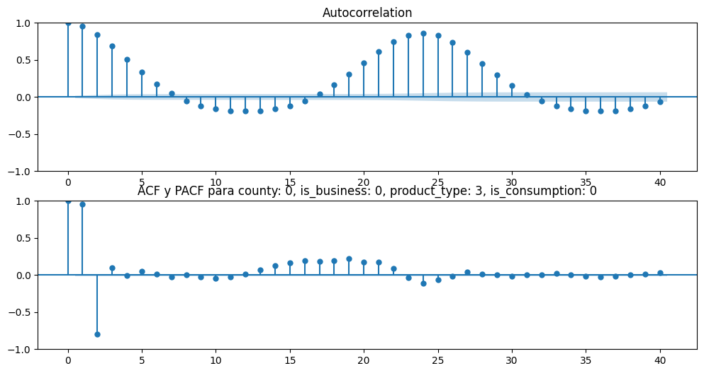
Guardado exitosamente en /imagenes/acf_pacf

Generando Decomposición para county: 0, is_business: 0, product_type: 3, is_consumption: 0

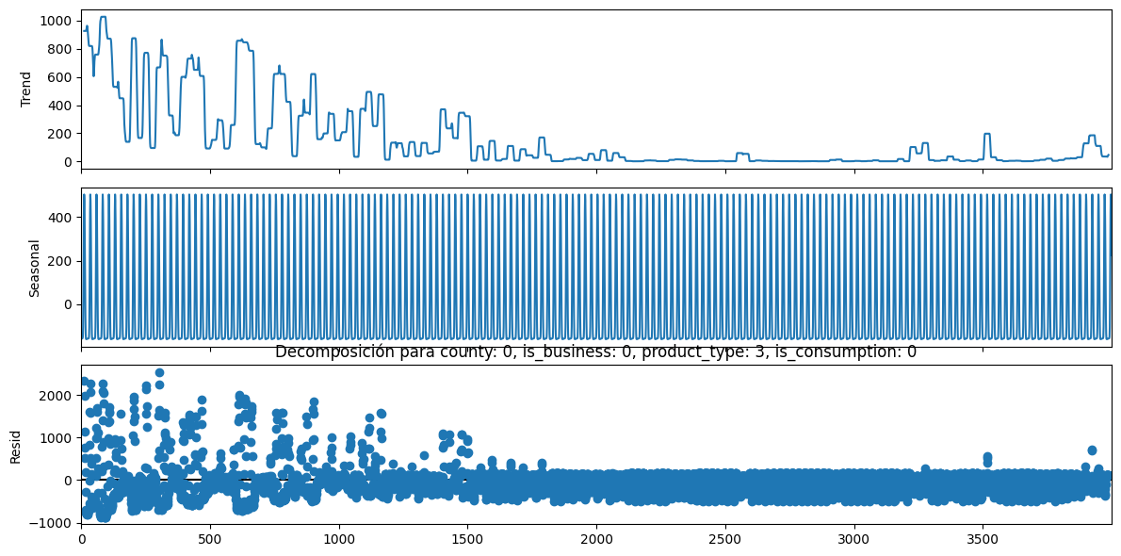
Guardado exitosamente en /imagenes/decomposition

Test de ADF para county: 0, is_business: 0, product_type: 3, is_consumption: 0

ADF Statistic: -4.4789, p-value: 0.0002, conclusión: No hay raíz unitaria (Estacionario)
Entrenando modelo ARIMA para county: 0, is_business: 0, product_type: 3, is_consumption: 0

Generando combinaciones de hiperparámetros para county: 0, is_business: 0, product_type: 3, is_consumption: 0

No se aplica diferenciación ya que la serie es estacionaria

El número de modelos a probar es 32
Buscando mejor modelo para county: 0, is_business: 0, product_type: 3, is_consumption: 0

Probando un ARIMA(1, 0, 1)(1, 0, 0)(24)
Probando un ARIMA(1, 0, 1)(1, 0, 1)(24)
Probando un ARIMA(1, 0, 1)(1, 1, 0)(24)
Probando un ARIMA(1, 0, 1)(1, 1, 1)(24)
Probando un ARIMA(1, 0, 1)(2, 0, 0)(24)
Probando un ARIMA(1, 0, 1)(2, 0, 1)(24)
Probando un ARIMA(1, 0, 1)(2, 1, 0)(24)
Probando un ARIMA(1, 0, 1)(2, 1, 1)(24)
Probando un ARIMA(1, 0, 2)(1, 0, 0)(24)
Probando un ARIMA(1, 0, 2)(1, 0, 1)(24)
Probando un ARIMA(1, 0, 2)(1, 1, 0)(24)
Probando un ARIMA(1, 0, 2)(1, 1, 1)(24)
Probando un ARIMA(1, 0, 2)(2, 0, 0)(24)
Probando un ARIMA(1, 0, 2)(2, 0, 1)(24)
Probando un ARIMA(1, 0, 2)(2, 1, 0)(24)
Probando un ARIMA(1, 0, 2)(2, 1, 1)(24)
Probando un ARIMA(2, 0, 1)(1, 0, 0)(24)
Probando un ARIMA(2, 0, 1)(1, 0, 1)(24)
Probando un ARIMA(2, 0, 1)(1, 1, 0)(24)
Probando un ARIMA(2, 0, 1)(1, 1, 1)(24)
Probando un ARIMA(2, 0, 1)(2, 0, 0)(24)
Probando un ARIMA(2, 0, 1)(2, 0, 1)(24)
Probando un ARIMA(2, 0, 1)(2, 1, 0)(24)
Probando un ARIMA(2, 0, 1)(2, 1, 1)(24)
Probando un ARIMA(2, 0, 2)(1, 0, 0)(24)
Probando un ARIMA(2, 0, 2)(1, 0, 1)(24)
Probando un ARIMA(2, 0, 2)(1, 1, 0)(24)
Probando un ARIMA(2, 0, 2)(1, 1, 1)(24)
Probando un ARIMA(2, 0, 2)(2, 0, 0)(24)
Probando un ARIMA(2, 0, 2)(2, 0, 1)(24)
Probando un ARIMA(2, 0, 2)(2, 1, 0)(24)
Probando un ARIMA(2, 0, 2)(2, 1, 1)(24)
Los modelos probados para county: 0, is_business: 0, product_type: 3, is_consumption: 0 son:
model ljung_box (p-value) jarque_bera (p-value) \
4 NaN NaN NaN
0 ARIMA(1, 0, 1)(1, 0, 0)24 3365.4536(0.0) 94607.209(0.0)
0 ARIMA(1, 0, 1)(1, 0, 1)24 993.4126(0.0) 124208.6804(0.0)
0 ARIMA(1, 0, 1)(1, 1, 0)24 2220.2663(0.0) 87943.7827(0.0)
0 ARIMA(1, 0, 1)(1, 1, 1)24 2500.5033(0.0) 83717.0772(0.0)
0 ARIMA(1, 0, 1)(2, 0, 0)24 1435.5043(0.0) 98533.6497(0.0)
0 ARIMA(1, 0, 1)(2, 0, 1)24 986.0227(0.0) 127201.6452(0.0)
0 ARIMA(1, 0, 1)(2, 1, 0)24 2202.4597(0.0) 80429.9927(0.0)
0 ARIMA(1, 0, 1)(2, 1, 1)24 2587.7535(0.0) 82198.9971(0.0)
0 ARIMA(1, 0, 2)(1, 0, 0)24 2813.7033(0.0) 121833.2132(0.0)
0 ARIMA(1, 0, 2)(1, 0, 1)24 385.0284(0.0) 151431.8768(0.0)
0 ARIMA(1, 0, 2)(1, 1, 0)24 1201.6009(0.0) 101761.9999(0.0)
0 ARIMA(1, 0, 2)(1, 1, 1)24 1276.3354(0.0) 108938.9133(0.0)
0 ARIMA(1, 0, 2)(2, 0, 0)24 927.9824(0.0) 121572.5806(0.0)
0 ARIMA(1, 0, 2)(2, 0, 1)24 376.0484(0.0) 153900.2249(0.0)
0 ARIMA(1, 0, 2)(2, 1, 0)24 1045.9113(0.0) 92793.2015(0.0)
0 ARIMA(1, 0, 2)(2, 1, 1)24 1341.6919(0.0) 107031.0335(0.0)
0 ARIMA(2, 0, 1)(1, 0, 0)24 1613.7696(0.0) 162318.2022(0.0)
0 ARIMA(2, 0, 1)(1, 0, 1)24 185.4144(0.0) 166809.9254(0.0)
0 ARIMA(2, 0, 1)(1, 1, 0)24 697.9248(0.0) 118464.0633(0.0)
0 ARIMA(2, 0, 1)(1, 1, 1)24 573.584(0.0) 137404.1461(0.0)
0 ARIMA(2, 0, 1)(2, 0, 0)24 697.3271(0.0) 147216.4189(0.0)
0 ARIMA(2, 0, 1)(2, 0, 1)24 183.5253(0.0) 169439.9979(0.0)
0 ARIMA(2, 0, 1)(2, 1, 0)24 442.7575(0.0) 105652.5206(0.0)
0 ARIMA(2, 0, 1)(2, 1, 1)24 611.1817(0.0) 135227.5471(0.0)
0 ARIMA(2, 0, 2)(1, 0, 0)24 1578.5718(0.0) 158702.3326(0.0)
0 ARIMA(2, 0, 2)(1, 0, 1)24 174.6581(0.0) 166747.3354(0.0)
0 ARIMA(2, 0, 2)(1, 1, 0)24 696.6808(0.0) 118461.2919(0.0)
0 ARIMA(2, 0, 2)(1, 1, 1)24 589.3034(0.0) 135600.6547(0.0)
0 ARIMA(2, 0, 2)(2, 0, 0)24 645.2541(0.0) 145953.0481(0.0)
0 ARIMA(2, 0, 2)(2, 0, 1)24 173.2044(0.0) 169493.0803(0.0)
0 ARIMA(2, 0, 2)(2, 1, 0)24 444.2926(0.0) 105293.6661(0.0)
0 ARIMA(2, 0, 2)(2, 1, 1)24 628.0067(0.0) 133432.941(0.0)

MAE
4 NaN
0 1589.071741
0 1430.170778
0 1442.563446
0 1432.895161
0 1579.067800
0 1432.743088
0 1428.136578
0 1433.104453
0 1590.861583
0 1431.719231
0 1442.560150
0 1433.077459
0 1582.456785
0 1431.132836
0 1428.034451
0 1433.259936
0 1593.124346
0 1429.453671
0 1442.557015
0 1433.178017
0 1586.037296
0 1432.571021
0 1428.026558
0 1433.331136
0 1593.191475
0 1433.826155
0 1442.556819
0 1433.176860
0 1586.394678
0 1433.611135
0 1428.032182
0 1433.324950
El mejor modelo para county: 0, is_business: 0, product_type: 3, is_consumption: 0 es:
model ljung_box (p-value) jarque_bera (p-value) \
4 ARIMA(2, 0, 1)(2, 1, 0)24 442.7575(0.0) 105652.5206(0.0)

MAE
4 1428.026558
#----------------------------------------------------------------------------------------------------------------------------------------------#
Procesando county: 0, is_business: 0, product_type: 3, is_consumption: 1
Generando ACF y PACF para county: 0, is_business: 0, product_type: 3, is_consumption: 1

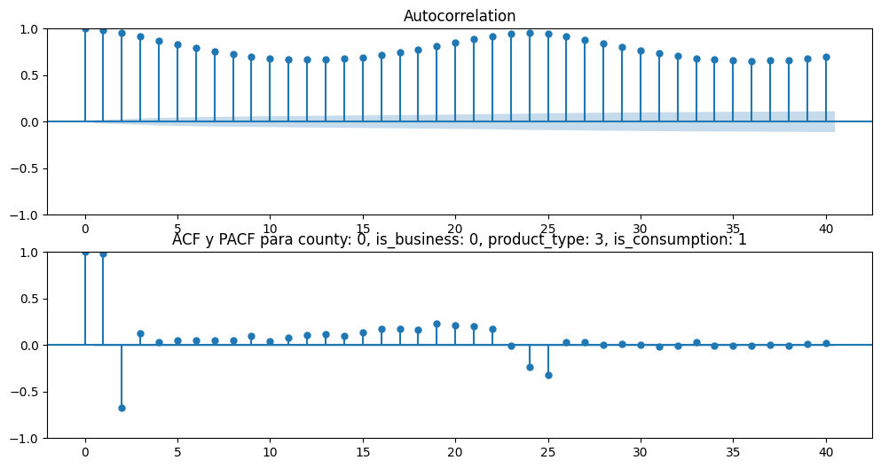
Guardado exitosamente en /imagenes/acf_pacf

Generando Decomposición para county: 0, is_business: 0, product_type: 3, is_consumption: 1

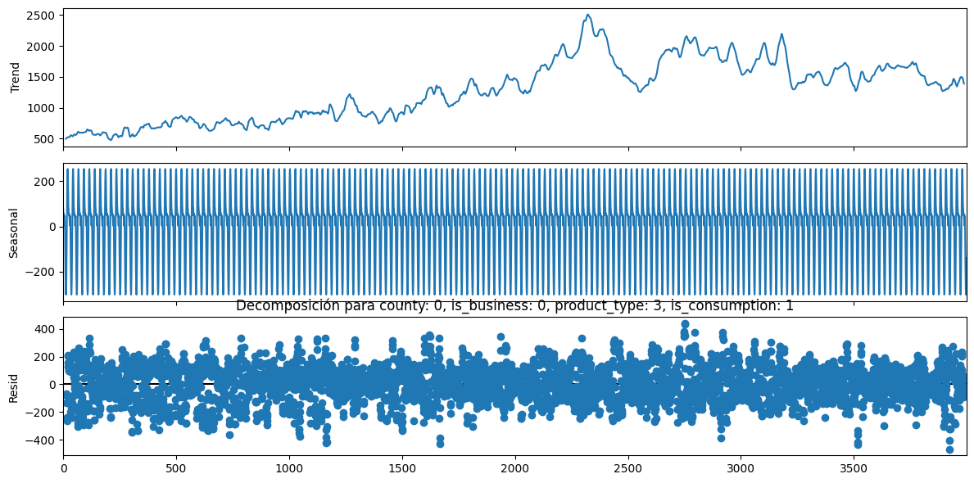
Guardado exitosamente en /imagenes/decomposition

Test de ADF para county: 0, is_business: 0, product_type: 3, is_consumption: 1

ADF Statistic: -2.593, p-value: 0.0944, conclusión: Hay raíz unitaria (No estacionario)
Entrenando modelo ARIMA para county: 0, is_business: 0, product_type: 3, is_consumption: 1

Generando combinaciones de hiperparámetros para county: 0, is_business: 0, product_type: 3, is_consumption: 1

Se aplica diferenciación ya que la serie no es estacionaria

El número de modelos a probar es 32
Buscando mejor modelo para county: 0, is_business: 0, product_type: 3, is_consumption: 1

Probando un ARIMA(1, 1, 1)(1, 0, 0)(24)
Probando un ARIMA(1, 1, 1)(1, 0, 1)(24)
Probando un ARIMA(1, 1, 1)(1, 1, 0)(24)
Probando un ARIMA(1, 1, 1)(1, 1, 1)(24)
Probando un ARIMA(1, 1, 1)(2, 0, 0)(24)
Probando un ARIMA(1, 1, 1)(2, 0, 1)(24)
Probando un ARIMA(1, 1, 1)(2, 1, 0)(24)
Probando un ARIMA(1, 1, 1)(2, 1, 1)(24)
Probando un ARIMA(1, 1, 2)(1, 0, 0)(24)
Probando un ARIMA(1, 1, 2)(1, 0, 1)(24)
Probando un ARIMA(1, 1, 2)(1, 1, 0)(24)
Probando un ARIMA(1, 1, 2)(1, 1, 1)(24)
Probando un ARIMA(1, 1, 2)(2, 0, 0)(24)
Probando un ARIMA(1, 1, 2)(2, 0, 1)(24)
Probando un ARIMA(1, 1, 2)(2, 1, 0)(24)
Probando un ARIMA(1, 1, 2)(2, 1, 1)(24)
Probando un ARIMA(2, 1, 1)(1, 0, 0)(24)
Probando un ARIMA(2, 1, 1)(1, 0, 1)(24)
Probando un ARIMA(2, 1, 1)(1, 1, 0)(24)
Probando un ARIMA(2, 1, 1)(1, 1, 1)(24)
Probando un ARIMA(2, 1, 1)(2, 0, 0)(24)
Probando un ARIMA(2, 1, 1)(2, 0, 1)(24)
Probando un ARIMA(2, 1, 1)(2, 1, 0)(24)
Probando un ARIMA(2, 1, 1)(2, 1, 1)(24)
Probando un ARIMA(2, 1, 2)(1, 0, 0)(24)
Probando un ARIMA(2, 1, 2)(1, 0, 1)(24)
Probando un ARIMA(2, 1, 2)(1, 1, 0)(24)
Probando un ARIMA(2, 1, 2)(1, 1, 1)(24)
Probando un ARIMA(2, 1, 2)(2, 0, 0)(24)
Probando un ARIMA(2, 1, 2)(2, 0, 1)(24)
Probando un ARIMA(2, 1, 2)(2, 1, 0)(24)
Probando un ARIMA(2, 1, 2)(2, 1, 1)(24)
Los modelos probados para county: 0, is_business: 0, product_type: 3, is_consumption: 1 son:
model ljung_box (p-value) jarque_bera (p-value) \
5 NaN NaN NaN
0 ARIMA(1, 1, 1)(1, 0, 0)24 1941.8072(0.0) 3997.0698(0.0)
0 ARIMA(1, 1, 1)(1, 0, 1)24 nan(nan) nan(nan)
0 ARIMA(1, 1, 1)(1, 1, 0)24 597.3629(0.0) 4247.91(0.0)
0 ARIMA(1, 1, 1)(1, 1, 1)24 nan(nan) nan(nan)
0 ARIMA(1, 1, 1)(2, 0, 0)24 nan(nan) nan(nan)
0 ARIMA(1, 1, 1)(2, 0, 1)24 nan(nan) nan(nan)
0 ARIMA(1, 1, 1)(2, 1, 0)24 nan(nan) nan(nan)
0 ARIMA(1, 1, 1)(2, 1, 1)24 403.0162(0.0) 4936.7384(0.0)
0 ARIMA(1, 1, 2)(1, 0, 0)24 1939.4539(0.0) 4038.2479(0.0)
0 ARIMA(1, 1, 2)(1, 0, 1)24 36819.2252(0.0) 1771.7108(0.0)
0 ARIMA(1, 1, 2)(1, 1, 0)24 613.0717(0.0) 4191.1581(0.0)
0 ARIMA(1, 1, 2)(1, 1, 1)24 5056.8809(0.0) 2964.1957(0.0)
0 ARIMA(1, 1, 2)(2, 0, 0)24 nan(nan) nan(nan)
0 ARIMA(1, 1, 2)(2, 0, 1)24 37424.3275(0.0) 1637.8001(0.0)
0 ARIMA(1, 1, 2)(2, 1, 0)24 nan(nan) nan(nan)
0 ARIMA(1, 1, 2)(2, 1, 1)24 2295.1889(0.0) 3202.6215(0.0)
0 ARIMA(2, 1, 1)(1, 0, 0)24 2688.9513(0.0) 2706.7684(0.0)
0 ARIMA(2, 1, 1)(1, 0, 1)24 61689.7654(0.0) 244.7009(0.0)
0 ARIMA(2, 1, 1)(1, 1, 0)24 5694.0019(0.0) 2577.4757(0.0)
0 ARIMA(2, 1, 1)(1, 1, 1)24 1139.5823(0.0) 3675.6408(0.0)
0 ARIMA(2, 1, 1)(2, 0, 0)24 7500.2114(0.0) 1661.2364(0.0)
0 ARIMA(2, 1, 1)(2, 0, 1)24 64990.1073(0.0) 198.6829(0.0)
0 ARIMA(2, 1, 1)(2, 1, 0)24 10861.3853(0.0) 2249.2924(0.0)
0 ARIMA(2, 1, 1)(2, 1, 1)24 1049.8739(0.0) 3706.5836(0.0)
0 ARIMA(2, 1, 2)(1, 0, 0)24 3358.3619(0.0) 2272.5452(0.0)
0 ARIMA(2, 1, 2)(1, 0, 1)24 63726.6566(0.0) 200.6004(0.0)
0 ARIMA(2, 1, 2)(1, 1, 0)24 660.7789(0.0) 4679.9026(0.0)
0 ARIMA(2, 1, 2)(1, 1, 1)24 1401.89(0.0) 3533.9351(0.0)
0 ARIMA(2, 1, 2)(2, 0, 0)24 6662.8136(0.0) 1915.0232(0.0)
0 ARIMA(2, 1, 2)(2, 0, 1)24 58952.5894(0.0) 260.4007(0.0)
0 ARIMA(2, 1, 2)(2, 1, 0)24 341.5757(0.0) 3723.0707(0.0)
0 ARIMA(2, 1, 2)(2, 1, 1)24 1290.2748(0.0) 3563.8624(0.0)

MAE
5 NaN
0 8.317017e+02
0 1.080588e+03
0 1.678973e+04
0 6.541460e+02
0 8.301186e+02
0 1.064143e+03
0 1.366581e+04
0 6.881852e+02
0 8.316861e+02
0 1.080557e+03
0 1.671251e+04
0 3.550216e+03
0 8.301235e+02
0 1.062578e+03
0 1.738136e+09
0 3.584642e+03
0 1.197181e+03
0 1.166903e+03
0 2.353022e+03
0 2.898491e+03
0 1.149047e+03
0 1.146907e+03
0 2.411575e+03
0 2.872218e+03
0 1.122082e+03
0 1.168049e+03
0 1.702776e+04
0 2.997758e+03
0 1.139003e+03
0 1.170097e+03
0 1.364690e+04
0 2.975686e+03
El mejor modelo para county: 0, is_business: 0, product_type: 3, is_consumption: 1 es:
model ljung_box (p-value) jarque_bera (p-value) \
5 ARIMA(1, 1, 1)(1, 1, 1)24 nan(nan) nan(nan)

MAE
5 654.146048
Procesando county: 0, is_business: 1, product_type: 0, is_consumption: 0
#----------------------------------------------------------------------------------------------------------------------------------------------#
Generando ACF y PACF para county: 0, is_business: 1, product_type: 0, is_consumption: 0

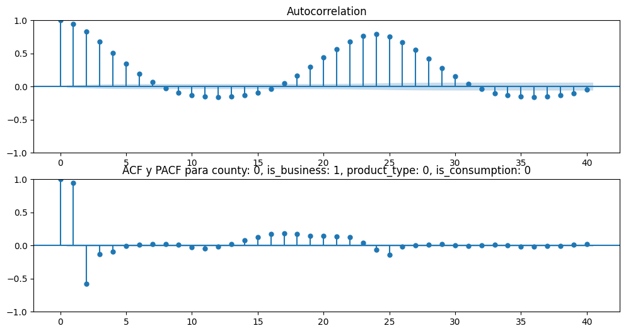
Guardado exitosamente en /imagenes/acf_pacf

Generando Decomposición para county: 0, is_business: 1, product_type: 0, is_consumption: 0

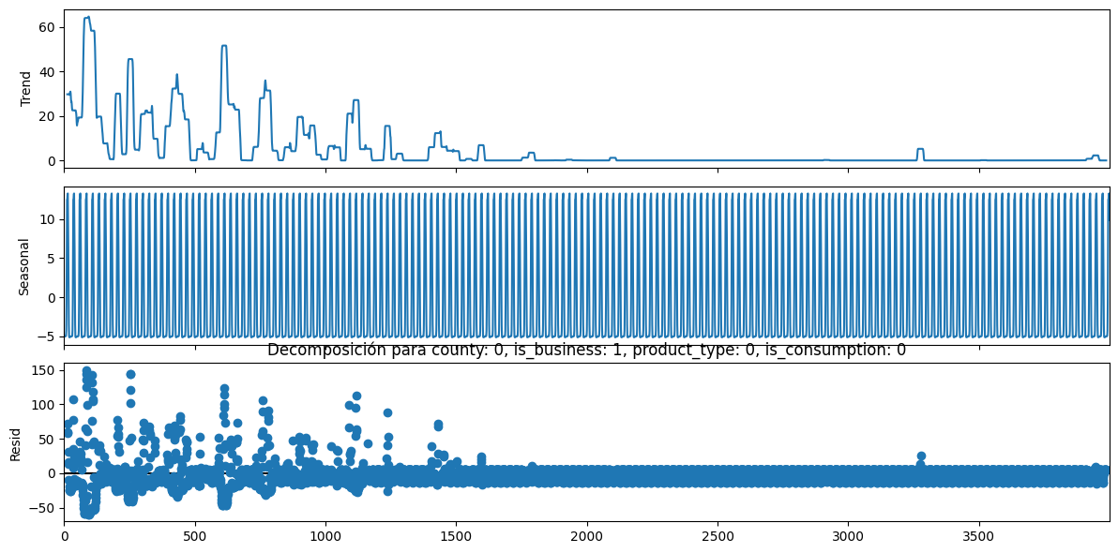
Guardado exitosamente en /imagenes/decomposition

Test de ADF para county: 0, is_business: 1, product_type: 0, is_consumption: 0

ADF Statistic: -6.8639, p-value: 0.0, conclusión: No hay raíz unitaria (Estacionario)
Entrenando modelo ARIMA para county: 0, is_business: 1, product_type: 0, is_consumption: 0

Generando combinaciones de hiperparámetros para county: 0, is_business: 1, product_type: 0, is_consumption: 0

No se aplica diferenciación ya que la serie es estacionaria

El número de modelos a probar es 32
Buscando mejor modelo para county: 0, is_business: 1, product_type: 0, is_consumption: 0

Probando un ARIMA(1, 0, 1)(1, 0, 0)(24)
Probando un ARIMA(1, 0, 1)(1, 0, 1)(24)
Probando un ARIMA(1, 0, 1)(1, 1, 0)(24)
Probando un ARIMA(1, 0, 1)(1, 1, 1)(24)
Probando un ARIMA(1, 0, 1)(2, 0, 0)(24)
Probando un ARIMA(1, 0, 1)(2, 0, 1)(24)
Probando un ARIMA(1, 0, 1)(2, 1, 0)(24)
Probando un ARIMA(1, 0, 1)(2, 1, 1)(24)
Probando un ARIMA(1, 0, 2)(1, 0, 0)(24)
Probando un ARIMA(1, 0, 2)(1, 0, 1)(24)
Probando un ARIMA(1, 0, 2)(1, 1, 0)(24)
Probando un ARIMA(1, 0, 2)(1, 1, 1)(24)
Probando un ARIMA(1, 0, 2)(2, 0, 0)(24)
Probando un ARIMA(1, 0, 2)(2, 0, 1)(24)
Probando un ARIMA(1, 0, 2)(2, 1, 0)(24)
Probando un ARIMA(1, 0, 2)(2, 1, 1)(24)
Probando un ARIMA(2, 0, 1)(1, 0, 0)(24)
Probando un ARIMA(2, 0, 1)(1, 0, 1)(24)
Probando un ARIMA(2, 0, 1)(1, 1, 0)(24)
Probando un ARIMA(2, 0, 1)(1, 1, 1)(24)
Probando un ARIMA(2, 0, 1)(2, 0, 0)(24)
Probando un ARIMA(2, 0, 1)(2, 0, 1)(24)
Probando un ARIMA(2, 0, 1)(2, 1, 0)(24)
Probando un ARIMA(2, 0, 1)(2, 1, 1)(24)
Probando un ARIMA(2, 0, 2)(1, 0, 0)(24)
Probando un ARIMA(2, 0, 2)(1, 0, 1)(24)
Probando un ARIMA(2, 0, 2)(1, 1, 0)(24)
Probando un ARIMA(2, 0, 2)(1, 1, 1)(24)
Probando un ARIMA(2, 0, 2)(2, 0, 0)(24)
Probando un ARIMA(2, 0, 2)(2, 0, 1)(24)
Probando un ARIMA(2, 0, 2)(2, 1, 0)(24)
Probando un ARIMA(2, 0, 2)(2, 1, 1)(24)
Los modelos probados para county: 0, is_business: 1, product_type: 0, is_consumption: 0 son:
model ljung_box (p-value) jarque_bera (p-value) \
6 NaN NaN NaN
0 ARIMA(1, 0, 1)(1, 0, 0)24 2413.5963(0.0) 80712.4433(0.0)
0 ARIMA(1, 0, 1)(1, 0, 1)24 538.7318(0.0) 89145.0164(0.0)
0 ARIMA(1, 0, 1)(1, 1, 0)24 1617.2554(0.0) 81856.5683(0.0)
0 ARIMA(1, 0, 1)(1, 1, 1)24 433.1738(0.0) 88103.0733(0.0)
0 ARIMA(1, 0, 1)(2, 0, 0)24 1270.6072(0.0) 88353.8823(0.0)
0 ARIMA(1, 0, 1)(2, 0, 1)24 452.321(0.0) 88401.6307(0.0)
0 ARIMA(1, 0, 1)(2, 1, 0)24 425.5253(0.0) 80283.3181(0.0)
0 ARIMA(1, 0, 1)(2, 1, 1)24 432.7497(0.0) 87617.3356(0.0)
0 ARIMA(1, 0, 2)(1, 0, 0)24 2136.2812(0.0) 86993.565(0.0)
0 ARIMA(1, 0, 2)(1, 0, 1)24 414.4179(0.0) 93096.5674(0.0)
0 ARIMA(1, 0, 2)(1, 1, 0)24 1299.559(0.0) 83819.8598(0.0)
0 ARIMA(1, 0, 2)(1, 1, 1)24 341.2738(0.0) 91815.0545(0.0)
0 ARIMA(1, 0, 2)(2, 0, 0)24 1126.7079(0.0) 94782.1899(0.0)
0 ARIMA(1, 0, 2)(2, 0, 1)24 358.2244(0.0) 92269.9576(0.0)
0 ARIMA(1, 0, 2)(2, 1, 0)24 345.7099(0.0) 83684.611(0.0)
0 ARIMA(1, 0, 2)(2, 1, 1)24 341.8843(0.0) 91259.8907(0.0)
0 ARIMA(2, 0, 1)(1, 0, 0)24 1183.0831(0.0) 95743.951(0.0)
0 ARIMA(2, 0, 1)(1, 0, 1)24 256.5553(0.0) 98313.6333(0.0)
0 ARIMA(2, 0, 1)(1, 1, 0)24 929.0237(0.0) 86855.3225(0.0)
0 ARIMA(2, 0, 1)(1, 1, 1)24 220.629(0.0) 97053.1926(0.0)
0 ARIMA(2, 0, 1)(2, 0, 0)24 717.2555(0.0) 101483.2222(0.0)
0 ARIMA(2, 0, 1)(2, 0, 1)24 231.7971(0.0) 97725.3733(0.0)
0 ARIMA(2, 0, 1)(2, 1, 0)24 nan(nan) nan(nan)
0 ARIMA(2, 0, 1)(2, 1, 1)24 1110.5961(0.0) 80389.1198(0.0)
0 ARIMA(2, 0, 2)(1, 0, 0)24 1160.878(0.0) 94262.0948(0.0)
0 ARIMA(2, 0, 2)(1, 0, 1)24 225.4669(0.0) 97948.4228(0.0)
0 ARIMA(2, 0, 2)(1, 1, 0)24 1596.0322(0.0) 84237.1372(0.0)
0 ARIMA(2, 0, 2)(1, 1, 1)24 183.3155(0.0) 96607.8058(0.0)
0 ARIMA(2, 0, 2)(2, 0, 0)24 673.612(0.0) 100230.8683(0.0)
0 ARIMA(2, 0, 2)(2, 0, 1)24 194.2016(0.0) 97222.5962(0.0)
0 ARIMA(2, 0, 2)(2, 1, 0)24 nan(nan) nan(nan)
0 ARIMA(2, 0, 2)(2, 1, 1)24 184.539(0.0) 96131.9973(0.0)

MAE
6 NaN
0 5.884053e+01
0 4.900003e+01
0 4.790716e+01
0 4.774356e+01
0 5.861874e+01
0 4.898222e+01
0 4.763301e+01
0 4.774495e+01
0 5.886785e+01
0 4.908704e+01
0 4.790716e+01
0 4.774295e+01
0 5.866036e+01
0 4.904601e+01
0 4.763205e+01
0 4.774457e+01
0 5.893079e+01
0 4.930318e+01
0 4.790716e+01
0 4.774232e+01
0 5.875575e+01
0 4.925285e+01
0 1.494537e+06
0 4.774566e+01
0 5.892635e+01
0 4.930259e+01
0 4.790713e+01
0 4.774212e+01
0 5.876160e+01
0 4.927222e+01
0 2.325578e+08
0 4.774401e+01
El mejor modelo para county: 0, is_business: 1, product_type: 0, is_consumption: 0 es:
model ljung_box (p-value) jarque_bera (p-value) \
6 ARIMA(1, 0, 2)(2, 1, 0)24 345.7099(0.0) 83684.611(0.0)

MAE
6 47.632048
Procesando county: 0, is_business: 1, product_type: 0, is_consumption: 1
#----------------------------------------------------------------------------------------------------------------------------------------------#
Generando ACF y PACF para county: 0, is_business: 1, product_type: 0, is_consumption: 1

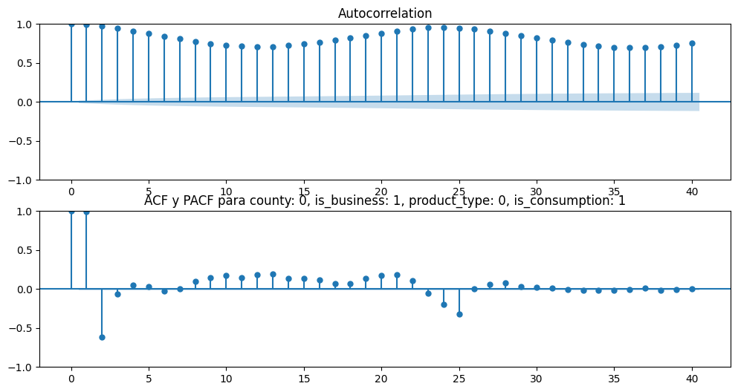
Guardado exitosamente en /imagenes/acf_pacf

Generando Decomposición para county: 0, is_business: 1, product_type: 0, is_consumption: 1

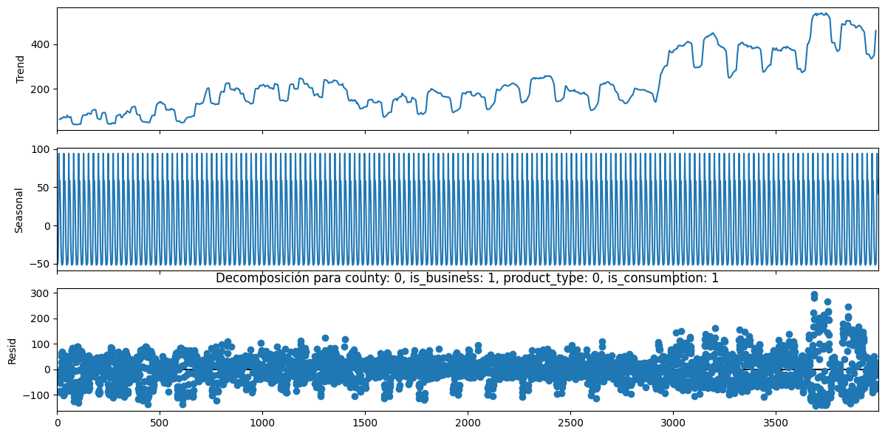
Guardado exitosamente en /imagenes/decomposition

Test de ADF para county: 0, is_business: 1, product_type: 0, is_consumption: 1

ADF Statistic: -3.0124, p-value: 0.0338, conclusión: No hay raíz unitaria (Estacionario)
Entrenando modelo ARIMA para county: 0, is_business: 1, product_type: 0, is_consumption: 1

Generando combinaciones de hiperparámetros para county: 0, is_business: 1, product_type: 0, is_consumption: 1

No se aplica diferenciación ya que la serie es estacionaria

El número de modelos a probar es 32
Buscando mejor modelo para county: 0, is_business: 1, product_type: 0, is_consumption: 1

Probando un ARIMA(1, 0, 1)(1, 0, 0)(24)
Probando un ARIMA(1, 0, 1)(1, 0, 1)(24)
Probando un ARIMA(1, 0, 1)(1, 1, 0)(24)
Probando un ARIMA(1, 0, 1)(1, 1, 1)(24)
Probando un ARIMA(1, 0, 1)(2, 0, 0)(24)
Probando un ARIMA(1, 0, 1)(2, 0, 1)(24)
Probando un ARIMA(1, 0, 1)(2, 1, 0)(24)
Probando un ARIMA(1, 0, 1)(2, 1, 1)(24)
Probando un ARIMA(1, 0, 2)(1, 0, 0)(24)
Probando un ARIMA(1, 0, 2)(1, 0, 1)(24)
Probando un ARIMA(1, 0, 2)(1, 1, 0)(24)
Probando un ARIMA(1, 0, 2)(1, 1, 1)(24)
Probando un ARIMA(1, 0, 2)(2, 0, 0)(24)
Probando un ARIMA(1, 0, 2)(2, 0, 1)(24)
Probando un ARIMA(1, 0, 2)(2, 1, 0)(24)
Probando un ARIMA(1, 0, 2)(2, 1, 1)(24)
Probando un ARIMA(2, 0, 1)(1, 0, 0)(24)
Probando un ARIMA(2, 0, 1)(1, 0, 1)(24)
Probando un ARIMA(2, 0, 1)(1, 1, 0)(24)
Probando un ARIMA(2, 0, 1)(1, 1, 1)(24)
Probando un ARIMA(2, 0, 1)(2, 0, 0)(24)
Probando un ARIMA(2, 0, 1)(2, 0, 1)(24)
Probando un ARIMA(2, 0, 1)(2, 1, 0)(24)
Probando un ARIMA(2, 0, 1)(2, 1, 1)(24)
Probando un ARIMA(2, 0, 2)(1, 0, 0)(24)
Probando un ARIMA(2, 0, 2)(1, 0, 1)(24)
Probando un ARIMA(2, 0, 2)(1, 1, 0)(24)
Probando un ARIMA(2, 0, 2)(1, 1, 1)(24)
Probando un ARIMA(2, 0, 2)(2, 0, 0)(24)
Probando un ARIMA(2, 0, 2)(2, 0, 1)(24)
Probando un ARIMA(2, 0, 2)(2, 1, 0)(24)
Probando un ARIMA(2, 0, 2)(2, 1, 1)(24)
Los modelos probados para county: 0, is_business: 1, product_type: 0, is_consumption: 1 son:
model ljung_box (p-value) jarque_bera (p-value) \
7 NaN NaN NaN
0 ARIMA(1, 0, 1)(1, 0, 0)24 3098.2163(0.0) 29665.9044(0.0)
0 ARIMA(1, 0, 1)(1, 0, 1)24 2011.9377(0.0) 18491.8031(0.0)
0 ARIMA(1, 0, 1)(1, 1, 0)24 1419.8972(0.0) 24174.3453(0.0)
0 ARIMA(1, 0, 1)(1, 1, 1)24 1610.9574(0.0) 19016.1341(0.0)
0 ARIMA(1, 0, 1)(2, 0, 0)24 2136.9327(0.0) 27259.7857(0.0)
0 ARIMA(1, 0, 1)(2, 0, 1)24 1635.2705(0.0) 18836.1708(0.0)
0 ARIMA(1, 0, 1)(2, 1, 0)24 1650.1682(0.0) 19894.6998(0.0)
0 ARIMA(1, 0, 1)(2, 1, 1)24 1577.2159(0.0) 19097.9334(0.0)
0 ARIMA(1, 0, 2)(1, 0, 0)24 2679.2251(0.0) 25604.9863(0.0)
0 ARIMA(1, 0, 2)(1, 0, 1)24 1322.0465(0.0) 17878.4219(0.0)
0 ARIMA(1, 0, 2)(1, 1, 0)24 1050.2596(0.0) 22168.9333(0.0)
0 ARIMA(1, 0, 2)(1, 1, 1)24 1107.4377(0.0) 18428.1942(0.0)
0 ARIMA(1, 0, 2)(2, 0, 0)24 1614.9457(0.0) 24179.2147(0.0)
0 ARIMA(1, 0, 2)(2, 0, 1)24 1122.6846(0.0) 18247.4984(0.0)
0 ARIMA(1, 0, 2)(2, 1, 0)24 1174.0307(0.0) 18238.2899(0.0)
0 ARIMA(1, 0, 2)(2, 1, 1)24 1106.7475(0.0) 18529.3743(0.0)
0 ARIMA(2, 0, 1)(1, 0, 0)24 1894.5918(0.0) 24070.9397(0.0)
0 ARIMA(2, 0, 1)(1, 0, 1)24 663.2247(0.0) 18231.6355(0.0)
0 ARIMA(2, 0, 1)(1, 1, 0)24 568.5447(0.0) 21485.7572(0.0)
0 ARIMA(2, 0, 1)(1, 1, 1)24 565.3138(0.0) 18759.8099(0.0)
0 ARIMA(2, 0, 1)(2, 0, 0)24 2811.2594(0.0) 10171.0374(0.0)
0 ARIMA(2, 0, 1)(2, 0, 1)24 1016.2017(0.0) 21459.7653(0.0)
0 ARIMA(2, 0, 1)(2, 1, 0)24 609.3714(0.0) 18198.2874(0.0)
0 ARIMA(2, 0, 1)(2, 1, 1)24 590.6948(0.0) 18965.6071(0.0)
0 ARIMA(2, 0, 2)(1, 0, 0)24 1857.0161(0.0) 23943.4766(0.0)
0 ARIMA(2, 0, 2)(1, 0, 1)24 662.9865(0.0) 18181.3362(0.0)
0 ARIMA(2, 0, 2)(1, 1, 0)24 568.3504(0.0) 21488.2706(0.0)
0 ARIMA(2, 0, 2)(1, 1, 1)24 560.7073(0.0) 18697.9037(0.0)
0 ARIMA(2, 0, 2)(2, 0, 0)24 1607.9174(0.0) 11092.3867(0.0)
0 ARIMA(2, 0, 2)(2, 0, 1)24 799.7429(0.0) 18903.354(0.0)
0 ARIMA(2, 0, 2)(2, 1, 0)24 608.7019(0.0) 18195.667(0.0)
0 ARIMA(2, 0, 2)(2, 1, 1)24 583.0408(0.0) 18884.4339(0.0)

MAE
7 NaN
0 474.115655
0 527.994115
0 833.800296
0 667.078807
0 445.018808
0 545.074901
0 780.700981
0 673.410668
0 477.233782
0 544.385854
0 824.664740
0 665.778688
0 453.639093
0 547.421299
0 770.674253
0 672.270259
0 483.611992
0 578.617551
0 795.999219
0 664.016707
0 396.094955
0 1106.738527
0 745.158344
0 670.139082
0 483.619783
0 579.008913
0 796.023221
0 663.979804
0 405.505612
0 1268.603968
0 745.221578
0 670.146256
El mejor modelo para county: 0, is_business: 1, product_type: 0, is_consumption: 1 es:
model ljung_box (p-value) jarque_bera (p-value) \
7 ARIMA(2, 0, 1)(2, 0, 0)24 2811.2594(0.0) 10171.0374(0.0)

MAE
7 396.094955
Procesando county: 0, is_business: 1, product_type: 1, is_consumption: 0
#----------------------------------------------------------------------------------------------------------------------------------------------#
Generando ACF y PACF para county: 0, is_business: 1, product_type: 1, is_consumption: 0

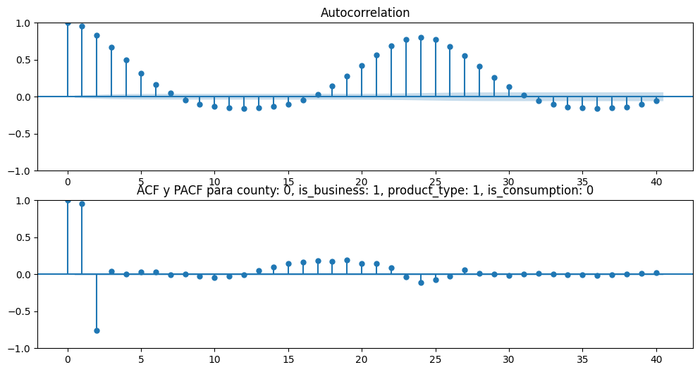
Guardado exitosamente en /imagenes/acf_pacf

Generando Decomposición para county: 0, is_business: 1, product_type: 1, is_consumption: 0

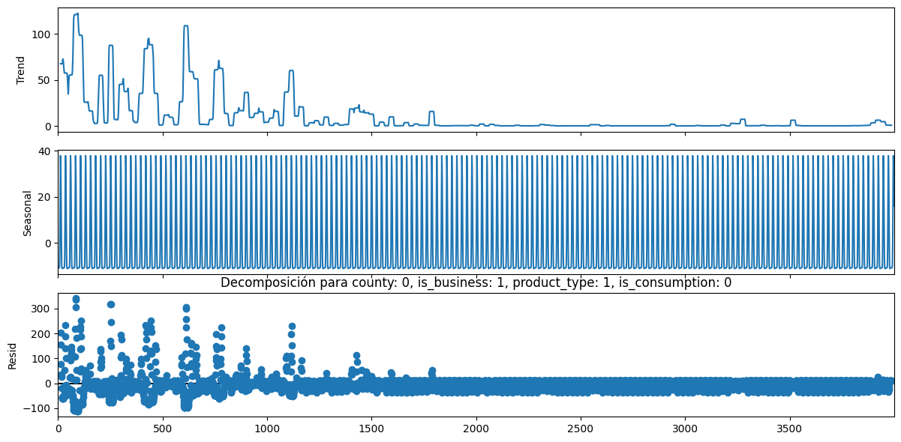
Guardado exitosamente en /imagenes/decomposition

Test de ADF para county: 0, is_business: 1, product_type: 1, is_consumption: 0

ADF Statistic: -6.4028, p-value: 0.0, conclusión: No hay raíz unitaria (Estacionario)
Entrenando modelo ARIMA para county: 0, is_business: 1, product_type: 1, is_consumption: 0

Generando combinaciones de hiperparámetros para county: 0, is_business: 1, product_type: 1, is_consumption: 0

No se aplica diferenciación ya que la serie es estacionaria

El número de modelos a probar es 32
Buscando mejor modelo para county: 0, is_business: 1, product_type: 1, is_consumption: 0

Probando un ARIMA(1, 0, 1)(1, 0, 0)(24)
Probando un ARIMA(1, 0, 1)(1, 0, 1)(24)
Probando un ARIMA(1, 0, 1)(1, 1, 0)(24)
Probando un ARIMA(1, 0, 1)(1, 1, 1)(24)
Probando un ARIMA(1, 0, 1)(2, 0, 0)(24)
Probando un ARIMA(1, 0, 1)(2, 0, 1)(24)
Probando un ARIMA(1, 0, 1)(2, 1, 0)(24)
Probando un ARIMA(1, 0, 1)(2, 1, 1)(24)
Probando un ARIMA(1, 0, 2)(1, 0, 0)(24)
Probando un ARIMA(1, 0, 2)(1, 0, 1)(24)
Probando un ARIMA(1, 0, 2)(1, 1, 0)(24)
Probando un ARIMA(1, 0, 2)(1, 1, 1)(24)
Probando un ARIMA(1, 0, 2)(2, 0, 0)(24)
Probando un ARIMA(1, 0, 2)(2, 0, 1)(24)
Probando un ARIMA(1, 0, 2)(2, 1, 0)(24)
Probando un ARIMA(1, 0, 2)(2, 1, 1)(24)
Probando un ARIMA(2, 0, 1)(1, 0, 0)(24)
Probando un ARIMA(2, 0, 1)(1, 0, 1)(24)
Probando un ARIMA(2, 0, 1)(1, 1, 0)(24)
Probando un ARIMA(2, 0, 1)(1, 1, 1)(24)
Probando un ARIMA(2, 0, 1)(2, 0, 0)(24)
Probando un ARIMA(2, 0, 1)(2, 0, 1)(24)
Probando un ARIMA(2, 0, 1)(2, 1, 0)(24)
Probando un ARIMA(2, 0, 1)(2, 1, 1)(24)
Probando un ARIMA(2, 0, 2)(1, 0, 0)(24)
Probando un ARIMA(2, 0, 2)(1, 0, 1)(24)
Probando un ARIMA(2, 0, 2)(1, 1, 0)(24)
Probando un ARIMA(2, 0, 2)(1, 1, 1)(24)
Probando un ARIMA(2, 0, 2)(2, 0, 0)(24)
Probando un ARIMA(2, 0, 2)(2, 0, 1)(24)
Probando un ARIMA(2, 0, 2)(2, 1, 0)(24)
Probando un ARIMA(2, 0, 2)(2, 1, 1)(24)
Los modelos probados para county: 0, is_business: 1, product_type: 1, is_consumption: 0 son:
model ljung_box (p-value) jarque_bera (p-value) \
8 NaN NaN NaN
0 ARIMA(1, 0, 1)(1, 0, 0)24 3615.1238(0.0) 171127.0671(0.0)
0 ARIMA(1, 0, 1)(1, 0, 1)24 1414.3748(0.0) 191199.7003(0.0)
0 ARIMA(1, 0, 1)(1, 1, 0)24 1214.4695(0.0) 152502.6812(0.0)
0 ARIMA(1, 0, 1)(1, 1, 1)24 1325.9287(0.0) 194430.3773(0.0)
0 ARIMA(1, 0, 1)(2, 0, 0)24 2063.2171(0.0) 169475.1923(0.0)
0 ARIMA(1, 0, 1)(2, 0, 1)24 1351.2185(0.0) 196175.3463(0.0)
0 ARIMA(1, 0, 1)(2, 1, 0)24 1154.8448(0.0) 165266.5197(0.0)
0 ARIMA(1, 0, 1)(2, 1, 1)24 1337.4122(0.0) 196228.6963(0.0)
0 ARIMA(1, 0, 2)(1, 0, 0)24 2615.5053(0.0) 234393.8472(0.0)
0 ARIMA(1, 0, 2)(1, 0, 1)24 566.6256(0.0) 260982.2269(0.0)
0 ARIMA(1, 0, 2)(1, 1, 0)24 586.9694(0.0) 182200.6277(0.0)
0 ARIMA(1, 0, 2)(1, 1, 1)24 521.6667(0.0) 263913.4717(0.0)
0 ARIMA(1, 0, 2)(2, 0, 0)24 1306.3216(0.0) 226831.542(0.0)
0 ARIMA(1, 0, 2)(2, 0, 1)24 539.356(0.0) 266932.1128(0.0)
0 ARIMA(1, 0, 2)(2, 1, 0)24 473.3692(0.0) 200411.7843(0.0)
0 ARIMA(1, 0, 2)(2, 1, 1)24 527.805(0.0) 267229.097(0.0)
0 ARIMA(2, 0, 1)(1, 0, 0)24 1299.3269(0.0) 344296.2583(0.0)
0 ARIMA(2, 0, 1)(1, 0, 1)24 215.2041(0.0) 325343.4552(0.0)
0 ARIMA(2, 0, 1)(1, 1, 0)24 361.1824(0.0) 219476.8847(0.0)
0 ARIMA(2, 0, 1)(1, 1, 1)24 201.7758(0.0) 327082.5957(0.0)
0 ARIMA(2, 0, 1)(2, 0, 0)24 728.6767(0.0) 316026.2433(0.0)
0 ARIMA(2, 0, 1)(2, 0, 1)24 211.0996(0.0) 332373.7856(0.0)
0 ARIMA(2, 0, 1)(2, 1, 0)24 nan(nan) nan(nan)
0 ARIMA(2, 0, 1)(2, 1, 1)24 734.746(0.0) 250865.0533(0.0)
0 ARIMA(2, 0, 2)(1, 0, 0)24 1305.76(0.0) 341567.1327(0.0)
0 ARIMA(2, 0, 2)(1, 0, 1)24 213.3805(0.0) 323628.6643(0.0)
0 ARIMA(2, 0, 2)(1, 1, 0)24 359.5932(0.0) 220421.9477(0.0)
0 ARIMA(2, 0, 2)(1, 1, 1)24 200.6127(0.0) 325492.7686(0.0)
0 ARIMA(2, 0, 2)(2, 0, 0)24 718.457(0.0) 312804.0476(0.0)
0 ARIMA(2, 0, 2)(2, 0, 1)24 209.83(0.0) 330687.9536(0.0)
0 ARIMA(2, 0, 2)(2, 1, 0)24 nan(nan) nan(nan)
0 ARIMA(2, 0, 2)(2, 1, 1)24 770.7217(0.0) 245916.0982(0.0)

MAE
8 NaN
0 1.752614e+02
0 1.524955e+02
0 1.519644e+02
0 1.513504e+02
0 1.744010e+02
0 1.526282e+02
0 1.510106e+02
0 1.513539e+02
0 1.753709e+02
0 1.529238e+02
0 1.519644e+02
0 1.513346e+02
0 1.747500e+02
0 1.529175e+02
0 1.510034e+02
0 1.513462e+02
0 1.756416e+02
0 1.533144e+02
0 1.519643e+02
0 1.513264e+02
0 1.751904e+02
0 1.535245e+02
0 1.058412e+07
0 1.513433e+02
0 1.756441e+02
0 1.533277e+02
0 1.519642e+02
0 1.513273e+02
0 1.751179e+02
0 1.533315e+02
0 1.234416e+07
0 1.513431e+02
El mejor modelo para county: 0, is_business: 1, product_type: 1, is_consumption: 0 es:
model ljung_box (p-value) jarque_bera (p-value) \
8 ARIMA(1, 0, 2)(2, 1, 0)24 473.3692(0.0) 200411.7843(0.0)

MAE
8 151.003367
Procesando county: 0, is_business: 1, product_type: 1, is_consumption: 1
#----------------------------------------------------------------------------------------------------------------------------------------------#
Generando ACF y PACF para county: 0, is_business: 1, product_type: 1, is_consumption: 1

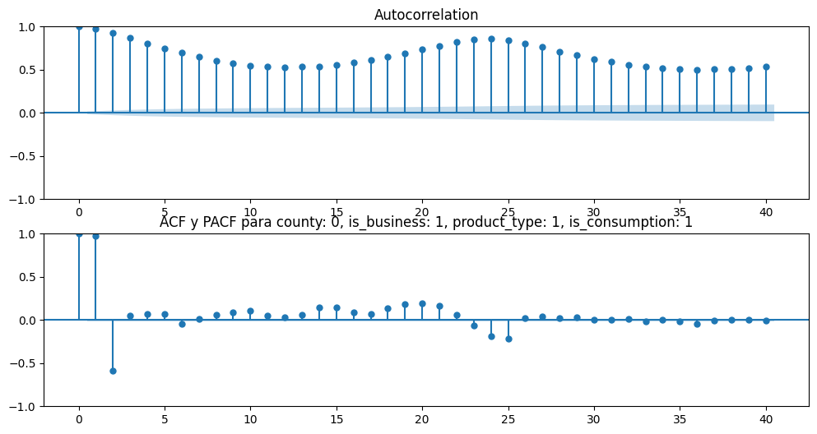
Guardado exitosamente en /imagenes/acf_pacf

Generando Decomposición para county: 0, is_business: 1, product_type: 1, is_consumption: 1

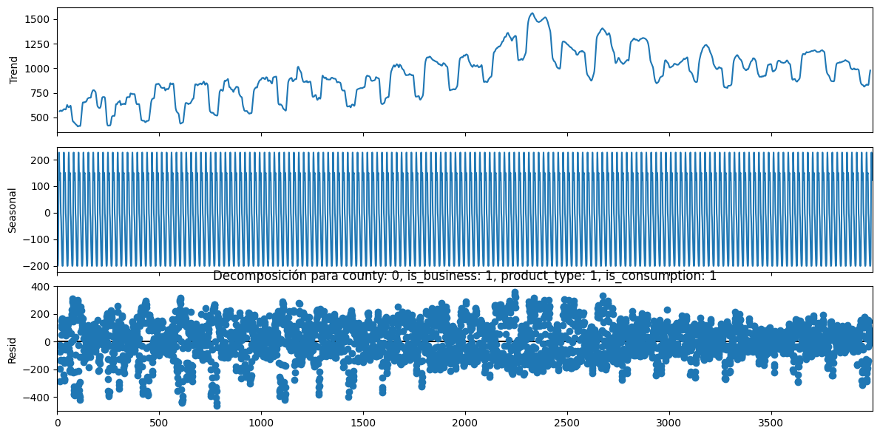
Guardado exitosamente en /imagenes/decomposition

Test de ADF para county: 0, is_business: 1, product_type: 1, is_consumption: 1

ADF Statistic: -5.3525, p-value: 0.0, conclusión: No hay raíz unitaria (Estacionario)
Entrenando modelo ARIMA para county: 0, is_business: 1, product_type: 1, is_consumption: 1

Generando combinaciones de hiperparámetros para county: 0, is_business: 1, product_type: 1, is_consumption: 1

No se aplica diferenciación ya que la serie es estacionaria

El número de modelos a probar es 32
Buscando mejor modelo para county: 0, is_business: 1, product_type: 1, is_consumption: 1

Probando un ARIMA(1, 0, 1)(1, 0, 0)(24)
Probando un ARIMA(1, 0, 1)(1, 0, 1)(24)
Probando un ARIMA(1, 0, 1)(1, 1, 0)(24)
Probando un ARIMA(1, 0, 1)(1, 1, 1)(24)
Probando un ARIMA(1, 0, 1)(2, 0, 0)(24)
Probando un ARIMA(1, 0, 1)(2, 0, 1)(24)
Probando un ARIMA(1, 0, 1)(2, 1, 0)(24)
Probando un ARIMA(1, 0, 1)(2, 1, 1)(24)
Probando un ARIMA(1, 0, 2)(1, 0, 0)(24)
Probando un ARIMA(1, 0, 2)(1, 0, 1)(24)
Probando un ARIMA(1, 0, 2)(1, 1, 0)(24)
Probando un ARIMA(1, 0, 2)(1, 1, 1)(24)
Probando un ARIMA(1, 0, 2)(2, 0, 0)(24)
Probando un ARIMA(1, 0, 2)(2, 0, 1)(24)
Probando un ARIMA(1, 0, 2)(2, 1, 0)(24)
Probando un ARIMA(1, 0, 2)(2, 1, 1)(24)
Probando un ARIMA(2, 0, 1)(1, 0, 0)(24)
Probando un ARIMA(2, 0, 1)(1, 0, 1)(24)
Probando un ARIMA(2, 0, 1)(1, 1, 0)(24)
Probando un ARIMA(2, 0, 1)(1, 1, 1)(24)
Probando un ARIMA(2, 0, 1)(2, 0, 0)(24)
Probando un ARIMA(2, 0, 1)(2, 0, 1)(24)
Probando un ARIMA(2, 0, 1)(2, 1, 0)(24)
Probando un ARIMA(2, 0, 1)(2, 1, 1)(24)
Probando un ARIMA(2, 0, 2)(1, 0, 0)(24)
Probando un ARIMA(2, 0, 2)(1, 0, 1)(24)
Probando un ARIMA(2, 0, 2)(1, 1, 0)(24)
Probando un ARIMA(2, 0, 2)(1, 1, 1)(24)
Probando un ARIMA(2, 0, 2)(2, 0, 0)(24)
Probando un ARIMA(2, 0, 2)(2, 0, 1)(24)
Probando un ARIMA(2, 0, 2)(2, 1, 0)(24)
Probando un ARIMA(2, 0, 2)(2, 1, 1)(24)
Los modelos probados para county: 0, is_business: 1, product_type: 1, is_consumption: 1 son:
model ljung_box (p-value) jarque_bera (p-value) \
9 NaN NaN NaN
0 ARIMA(1, 0, 1)(1, 0, 0)24 2089.7036(0.0) 3105.5873(0.0)
0 ARIMA(1, 0, 1)(1, 0, 1)24 1611.35(0.0) 3330.2465(0.0)
0 ARIMA(1, 0, 1)(1, 1, 0)24 6645.9307(0.0) 4942.5284(0.0)
0 ARIMA(1, 0, 1)(1, 1, 1)24 11571.2524(0.0) 2572.3495(0.0)
0 ARIMA(1, 0, 1)(2, 0, 0)24 1656.771(0.0) 3246.056(0.0)
0 ARIMA(1, 0, 1)(2, 0, 1)24 1260.9974(0.0) 3479.9165(0.0)
0 ARIMA(1, 0, 1)(2, 1, 0)24 9608.6758(0.0) 3758.0769(0.0)
0 ARIMA(1, 0, 1)(2, 1, 1)24 11452.809(0.0) 2572.812(0.0)
0 ARIMA(1, 0, 2)(1, 0, 0)24 1536.1065(0.0) 3153.5522(0.0)
0 ARIMA(1, 0, 2)(1, 0, 1)24 961.6525(0.0) 3486.7001(0.0)
0 ARIMA(1, 0, 2)(1, 1, 0)24 4771.8329(0.0) 4486.5989(0.0)
0 ARIMA(1, 0, 2)(1, 1, 1)24 8667.0004(0.0) 2627.2825(0.0)
0 ARIMA(1, 0, 2)(2, 0, 0)24 1109.6534(0.0) 3326.7955(0.0)
0 ARIMA(1, 0, 2)(2, 0, 1)24 758.5684(0.0) 3621.3583(0.0)
0 ARIMA(1, 0, 2)(2, 1, 0)24 7047.8543(0.0) 3499.1758(0.0)
0 ARIMA(1, 0, 2)(2, 1, 1)24 8630.5559(0.0) 2612.8217(0.0)
0 ARIMA(2, 0, 1)(1, 0, 0)24 1241.3353(0.0) 3389.0948(0.0)
0 ARIMA(2, 0, 1)(1, 0, 1)24 599.2564(0.0) 3706.9586(0.0)
0 ARIMA(2, 0, 1)(1, 1, 0)24 3884.2981(0.0) 3990.9667(0.0)
0 ARIMA(2, 0, 1)(1, 1, 1)24 7898.8866(0.0) 2588.0597(0.0)
0 ARIMA(2, 0, 1)(2, 0, 0)24 1894.0041(0.0) 3150.5806(0.0)
0 ARIMA(2, 0, 1)(2, 0, 1)24 1002.6256(0.0) 3265.4607(0.0)
0 ARIMA(2, 0, 1)(2, 1, 0)24 5930.9953(0.0) 3193.269(0.0)
0 ARIMA(2, 0, 1)(2, 1, 1)24 7999.5398(0.0) 2578.6094(0.0)
0 ARIMA(2, 0, 2)(1, 0, 0)24 1239.2889(0.0) 3371.5128(0.0)
0 ARIMA(2, 0, 2)(1, 0, 1)24 597.7948(0.0) 3711.1475(0.0)
0 ARIMA(2, 0, 2)(1, 1, 0)24 4707.5882(0.0) 4022.6492(0.0)
0 ARIMA(2, 0, 2)(1, 1, 1)24 7968.9635(0.0) 2584.0168(0.0)
0 ARIMA(2, 0, 2)(2, 0, 0)24 901.1804(0.0) 3403.5302(0.0)
0 ARIMA(2, 0, 2)(2, 0, 1)24 745.6367(0.0) 3566.9669(0.0)
0 ARIMA(2, 0, 2)(2, 1, 0)24 6714.7322(0.0) 3184.9474(0.0)
0 ARIMA(2, 0, 2)(2, 1, 1)24 8063.4254(0.0) 2574.9678(0.0)

MAE
9 NaN
0 282.350912
0 286.709663
0 465.483896
0 392.791545
0 278.237676
0 341.914557
0 415.509593
0 391.067236
0 283.797586
0 286.104519
0 466.606964
0 392.969967
0 279.669196
0 342.368972
0 416.419502
0 391.237562
0 284.916139
0 281.911765
0 465.878994
0 392.664925
0 269.832776
0 285.429426
0 415.352311
0 390.955755
0 284.297449
0 283.384716
0 464.700157
0 392.650247
0 278.776910
0 283.649120
0 414.581019
0 390.946931
El mejor modelo para county: 0, is_business: 1, product_type: 1, is_consumption: 1 es:
model ljung_box (p-value) jarque_bera (p-value) \
9 ARIMA(2, 0, 1)(2, 0, 0)24 1894.0041(0.0) 3150.5806(0.0)

MAE
9 269.832776
Procesando county: 0, is_business: 1, product_type: 3, is_consumption: 0
#----------------------------------------------------------------------------------------------------------------------------------------------#
Generando ACF y PACF para county: 0, is_business: 1, product_type: 3, is_consumption: 0

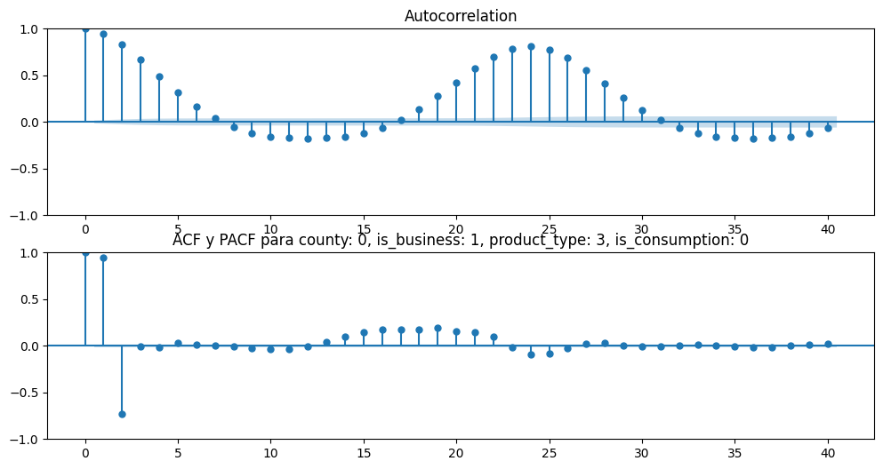
Guardado exitosamente en /imagenes/acf_pacf

Generando Decomposición para county: 0, is_business: 1, product_type: 3, is_consumption: 0

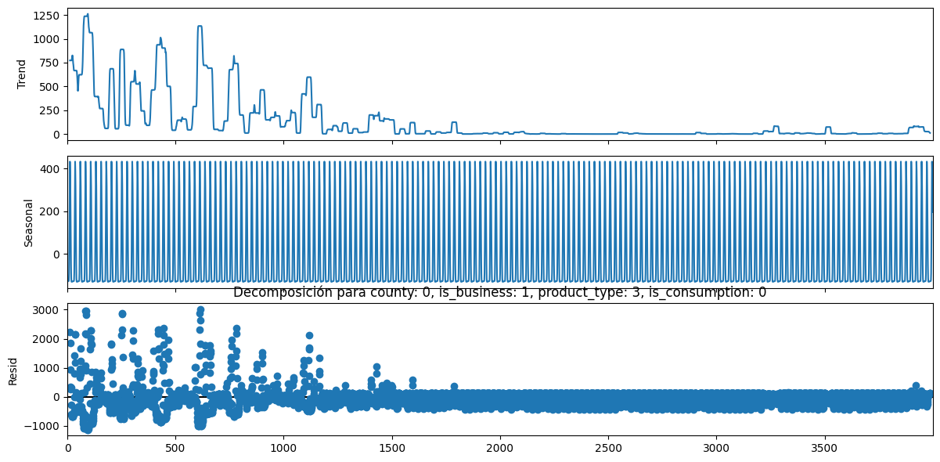
Guardado exitosamente en /imagenes/decomposition

Test de ADF para county: 0, is_business: 1, product_type: 3, is_consumption: 0

ADF Statistic: -6.2694, p-value: 0.0, conclusión: No hay raíz unitaria (Estacionario)
Entrenando modelo ARIMA para county: 0, is_business: 1, product_type: 3, is_consumption: 0

Generando combinaciones de hiperparámetros para county: 0, is_business: 1, product_type: 3, is_consumption: 0

No se aplica diferenciación ya que la serie es estacionaria

El número de modelos a probar es 32
Buscando mejor modelo para county: 0, is_business: 1, product_type: 3, is_consumption: 0

Probando un ARIMA(1, 0, 1)(1, 0, 0)(24)
Probando un ARIMA(1, 0, 1)(1, 0, 1)(24)
Probando un ARIMA(1, 0, 1)(1, 1, 0)(24)
Probando un ARIMA(1, 0, 1)(1, 1, 1)(24)
Probando un ARIMA(1, 0, 1)(2, 0, 0)(24)
Probando un ARIMA(1, 0, 1)(2, 0, 1)(24)
Probando un ARIMA(1, 0, 1)(2, 1, 0)(24)
Probando un ARIMA(1, 0, 1)(2, 1, 1)(24)
Probando un ARIMA(1, 0, 2)(1, 0, 0)(24)
Probando un ARIMA(1, 0, 2)(1, 0, 1)(24)
Probando un ARIMA(1, 0, 2)(1, 1, 0)(24)
Probando un ARIMA(1, 0, 2)(1, 1, 1)(24)
Probando un ARIMA(1, 0, 2)(2, 0, 0)(24)
Probando un ARIMA(1, 0, 2)(2, 0, 1)(24)
Probando un ARIMA(1, 0, 2)(2, 1, 0)(24)
Probando un ARIMA(1, 0, 2)(2, 1, 1)(24)
Probando un ARIMA(2, 0, 1)(1, 0, 0)(24)
Probando un ARIMA(2, 0, 1)(1, 0, 1)(24)
Probando un ARIMA(2, 0, 1)(1, 1, 0)(24)
Probando un ARIMA(2, 0, 1)(1, 1, 1)(24)
Probando un ARIMA(2, 0, 1)(2, 0, 0)(24)
Probando un ARIMA(2, 0, 1)(2, 0, 1)(24)
Probando un ARIMA(2, 0, 1)(2, 1, 0)(24)
Probando un ARIMA(2, 0, 1)(2, 1, 1)(24)
Probando un ARIMA(2, 0, 2)(1, 0, 0)(24)
Probando un ARIMA(2, 0, 2)(1, 0, 1)(24)
Probando un ARIMA(2, 0, 2)(1, 1, 0)(24)
Probando un ARIMA(2, 0, 2)(1, 1, 1)(24)
Probando un ARIMA(2, 0, 2)(2, 0, 0)(24)
Probando un ARIMA(2, 0, 2)(2, 0, 1)(24)
Probando un ARIMA(2, 0, 2)(2, 1, 0)(24)
Probando un ARIMA(2, 0, 2)(2, 1, 1)(24)
Los modelos probados para county: 0, is_business: 1, product_type: 3, is_consumption: 0 son:
model ljung_box (p-value) jarque_bera (p-value) \
10 NaN NaN NaN
0 ARIMA(1, 0, 1)(1, 0, 0)24 3013.0872(0.0) 165546.6811(0.0)
0 ARIMA(1, 0, 1)(1, 0, 1)24 870.9924(0.0) 190118.9182(0.0)
0 ARIMA(1, 0, 1)(1, 1, 0)24 2058.1753(0.0) 118788.0175(0.0)
0 ARIMA(1, 0, 1)(1, 1, 1)24 782.9705(0.0) 194104.6434(0.0)
0 ARIMA(1, 0, 1)(2, 0, 0)24 1528.5762(0.0) 164090.7758(0.0)
0 ARIMA(1, 0, 1)(2, 0, 1)24 1942.9849(0.0) 157947.5743(0.0)
0 ARIMA(1, 0, 1)(2, 1, 0)24 2443.0892(0.0) 100321.8085(0.0)
0 ARIMA(1, 0, 1)(2, 1, 1)24 786.0179(0.0) 194762.2111(0.0)
0 ARIMA(1, 0, 2)(1, 0, 0)24 2518.3245(0.0) 204895.6071(0.0)
0 ARIMA(1, 0, 2)(1, 0, 1)24 419.5355(0.0) 230523.5434(0.0)
0 ARIMA(1, 0, 2)(1, 1, 0)24 1273.4412(0.0) 139497.2311(0.0)
0 ARIMA(1, 0, 2)(1, 1, 1)24 378.7102(0.0) 233244.698(0.0)
0 ARIMA(1, 0, 2)(2, 0, 0)24 1162.0465(0.0) 203587.5366(0.0)
0 ARIMA(1, 0, 2)(2, 0, 1)24 392.8574(0.0) 235937.7265(0.0)
0 ARIMA(1, 0, 2)(2, 1, 0)24 1429.5627(0.0) 119622.7233(0.0)
0 ARIMA(1, 0, 2)(2, 1, 1)24 381.2204(0.0) 233887.7875(0.0)
0 ARIMA(2, 0, 1)(1, 0, 0)24 1321.9033(0.0) 276610.6986(0.0)
0 ARIMA(2, 0, 1)(1, 0, 1)24 194.8487(0.0) 266630.0433(0.0)
0 ARIMA(2, 0, 1)(1, 1, 0)24 752.8405(0.0) 169012.1415(0.0)
0 ARIMA(2, 0, 1)(1, 1, 1)24 178.3474(0.0) 268945.5498(0.0)
0 ARIMA(2, 0, 1)(2, 0, 0)24 762.4754(0.0) 259059.7843(0.0)
0 ARIMA(2, 0, 1)(2, 0, 1)24 186.6867(0.0) 272858.8211(0.0)
0 ARIMA(2, 0, 1)(2, 1, 0)24 nan(nan) nan(nan)
0 ARIMA(2, 0, 1)(2, 1, 1)24 751.6498(0.0) 204883.787(0.0)
0 ARIMA(2, 0, 2)(1, 0, 0)24 1274.2715(0.0) 271630.6407(0.0)
0 ARIMA(2, 0, 2)(1, 0, 1)24 172.3907(0.0) 267018.4611(0.0)
0 ARIMA(2, 0, 2)(1, 1, 0)24 841.6707(0.0) 165006.6777(0.0)
0 ARIMA(2, 0, 2)(1, 1, 1)24 155.4691(0.0) 269714.5168(0.0)
0 ARIMA(2, 0, 2)(2, 0, 0)24 684.4076(0.0) 254567.9895(0.0)
0 ARIMA(2, 0, 2)(2, 0, 1)24 162.9641(0.0) 273768.097(0.0)
0 ARIMA(2, 0, 2)(2, 1, 0)24 nan(nan) nan(nan)
0 ARIMA(2, 0, 2)(2, 1, 1)24 876.2987(0.0) 196589.3261(0.0)

MAE
10 NaN
0 1.266551e+03
0 1.098608e+03
0 1.093762e+03
0 1.088130e+03
0 1.260794e+03
0 1.233136e+03
0 1.088531e+03
0 1.088138e+03
0 1.267653e+03
0 1.100393e+03
0 1.094035e+03
0 1.088114e+03
0 1.262760e+03
0 1.099633e+03
0 1.088720e+03
0 1.088141e+03
0 1.269221e+03
0 1.103425e+03
0 1.094218e+03
0 1.088072e+03
0 1.265386e+03
0 1.101945e+03
0 1.922452e+08
0 1.088068e+03
0 1.269283e+03
0 1.098119e+03
0 1.094203e+03
0 1.088086e+03
0 1.265520e+03
0 1.103343e+03
0 1.563182e+07
0 1.088066e+03
El mejor modelo para county: 0, is_business: 1, product_type: 3, is_consumption: 0 es:
model ljung_box (p-value) jarque_bera (p-value) \
10 ARIMA(2, 0, 2)(2, 1, 1)24 876.2987(0.0) 196589.3261(0.0)

MAE
10 1088.065832
#----------------------------------------------------------------------------------------------------------------------------------------------#
Procesando county: 0, is_business: 1, product_type: 3, is_consumption: 1
Generando ACF y PACF para county: 0, is_business: 1, product_type: 3, is_consumption: 1

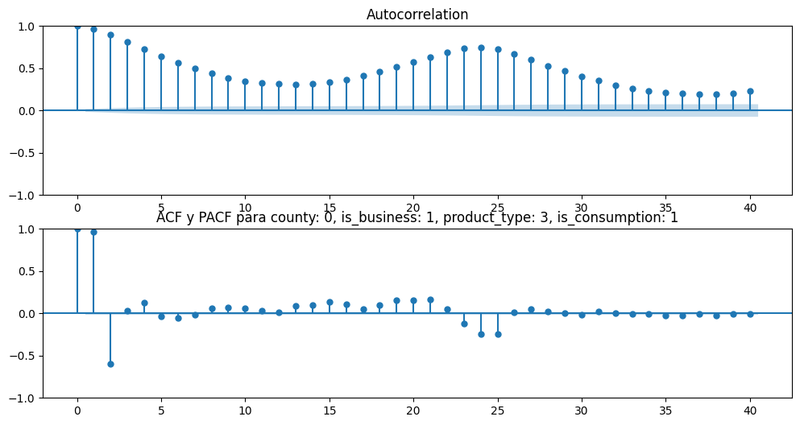
Guardado exitosamente en /imagenes/acf_pacf

Generando Decomposición para county: 0, is_business: 1, product_type: 3, is_consumption: 1

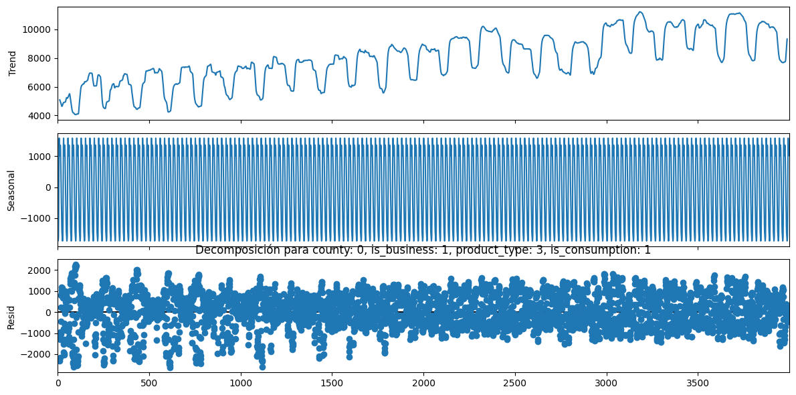
Guardado exitosamente en /imagenes/decomposition

Test de ADF para county: 0, is_business: 1, product_type: 3, is_consumption: 1

ADF Statistic: -9.9668, p-value: 0.0, conclusión: No hay raíz unitaria (Estacionario)
Entrenando modelo ARIMA para county: 0, is_business: 1, product_type: 3, is_consumption: 1

Generando combinaciones de hiperparámetros para county: 0, is_business: 1, product_type: 3, is_consumption: 1

No se aplica diferenciación ya que la serie es estacionaria

El número de modelos a probar es 32
Buscando mejor modelo para county: 0, is_business: 1, product_type: 3, is_consumption: 1

Probando un ARIMA(1, 0, 1)(1, 0, 0)(24)
Probando un ARIMA(1, 0, 1)(1, 0, 1)(24)
Probando un ARIMA(1, 0, 1)(1, 1, 0)(24)
Probando un ARIMA(1, 0, 1)(1, 1, 1)(24)
Probando un ARIMA(1, 0, 1)(2, 0, 0)(24)
Probando un ARIMA(1, 0, 1)(2, 0, 1)(24)
Probando un ARIMA(1, 0, 1)(2, 1, 0)(24)
Probando un ARIMA(1, 0, 1)(2, 1, 1)(24)
Probando un ARIMA(1, 0, 2)(1, 0, 0)(24)
Probando un ARIMA(1, 0, 2)(1, 0, 1)(24)
Probando un ARIMA(1, 0, 2)(1, 1, 0)(24)
Probando un ARIMA(1, 0, 2)(1, 1, 1)(24)
Probando un ARIMA(1, 0, 2)(2, 0, 0)(24)
Probando un ARIMA(1, 0, 2)(2, 0, 1)(24)
Probando un ARIMA(1, 0, 2)(2, 1, 0)(24)
Probando un ARIMA(1, 0, 2)(2, 1, 1)(24)
Probando un ARIMA(2, 0, 1)(1, 0, 0)(24)
Probando un ARIMA(2, 0, 1)(1, 0, 1)(24)
Probando un ARIMA(2, 0, 1)(1, 1, 0)(24)
Probando un ARIMA(2, 0, 1)(1, 1, 1)(24)
Probando un ARIMA(2, 0, 1)(2, 0, 0)(24)
Probando un ARIMA(2, 0, 1)(2, 0, 1)(24)
Probando un ARIMA(2, 0, 1)(2, 1, 0)(24)
Probando un ARIMA(2, 0, 1)(2, 1, 1)(24)
Probando un ARIMA(2, 0, 2)(1, 0, 0)(24)
Probando un ARIMA(2, 0, 2)(1, 0, 1)(24)
Probando un ARIMA(2, 0, 2)(1, 1, 0)(24)
Probando un ARIMA(2, 0, 2)(1, 1, 1)(24)
Probando un ARIMA(2, 0, 2)(2, 0, 0)(24)
Probando un ARIMA(2, 0, 2)(2, 0, 1)(24)
Probando un ARIMA(2, 0, 2)(2, 1, 0)(24)
Probando un ARIMA(2, 0, 2)(2, 1, 1)(24)
Los modelos probados para county: 0, is_business: 1, product_type: 3, is_consumption: 1 son:
model ljung_box (p-value) jarque_bera (p-value) \
11 NaN NaN NaN
0 ARIMA(1, 0, 1)(1, 0, 0)24 2292.3653(0.0) 8345.7729(0.0)
0 ARIMA(1, 0, 1)(1, 0, 1)24 1570.3301(0.0) 7261.0306(0.0)
0 ARIMA(1, 0, 1)(1, 1, 0)24 12809.6998(0.0) 6113.6655(0.0)
0 ARIMA(1, 0, 1)(1, 1, 1)24 16983.9294(0.0) 2598.7394(0.0)
0 ARIMA(1, 0, 1)(2, 0, 0)24 1779.7274(0.0) 8778.1647(0.0)
0 ARIMA(1, 0, 1)(2, 0, 1)24 1279.2428(0.0) 8312.8865(0.0)
0 ARIMA(1, 0, 1)(2, 1, 0)24 18399.067(0.0) 3380.5027(0.0)
0 ARIMA(1, 0, 1)(2, 1, 1)24 16427.8859(0.0) 2695.1883(0.0)
0 ARIMA(1, 0, 2)(1, 0, 0)24 1393.9557(0.0) 10019.5339(0.0)
0 ARIMA(1, 0, 2)(1, 0, 1)24 654.4007(0.0) 9263.5785(0.0)
0 ARIMA(1, 0, 2)(1, 1, 0)24 8482.5463(0.0) 6782.476(0.0)
0 ARIMA(1, 0, 2)(1, 1, 1)24 11591.2476(0.0) 3649.9246(0.0)
0 ARIMA(1, 0, 2)(2, 0, 0)24 895.6029(0.0) 10187.8644(0.0)
0 ARIMA(1, 0, 2)(2, 0, 1)24 501.0266(0.0) 10510.9802(0.0)
0 ARIMA(1, 0, 2)(2, 1, 0)24 12697.3011(0.0) 3963.762(0.0)
0 ARIMA(1, 0, 2)(2, 1, 1)24 11306.7079(0.0) 3750.8629(0.0)
0 ARIMA(2, 0, 1)(1, 0, 0)24 1267.6288(0.0) 9944.411(0.0)
0 ARIMA(2, 0, 1)(1, 0, 1)24 518.6843(0.0) 9199.7114(0.0)
0 ARIMA(2, 0, 1)(1, 1, 0)24 8932.5136(0.0) 6284.4893(0.0)
0 ARIMA(2, 0, 1)(1, 1, 1)24 12445.4588(0.0) 3601.2124(0.0)
0 ARIMA(2, 0, 1)(2, 0, 0)24 1114.5114(0.0) 9530.891(0.0)
0 ARIMA(2, 0, 1)(2, 0, 1)24 624.8243(0.0) 8719.301(0.0)
0 ARIMA(2, 0, 1)(2, 1, 0)24 13505.2879(0.0) 3700.4404(0.0)
0 ARIMA(2, 0, 1)(2, 1, 1)24 12371.0525(0.0) 3664.8057(0.0)
0 ARIMA(2, 0, 2)(1, 0, 0)24 1177.5125(0.0) 10211.8759(0.0)
0 ARIMA(2, 0, 2)(1, 0, 1)24 490.174(0.0) 9454.3688(0.0)
0 ARIMA(2, 0, 2)(1, 1, 0)24 7800.565(0.0) 6672.9147(0.0)
0 ARIMA(2, 0, 2)(1, 1, 1)24 10745.0508(0.0) 3948.6666(0.0)
0 ARIMA(2, 0, 2)(2, 0, 0)24 nan(nan) nan(nan)
0 ARIMA(2, 0, 2)(2, 0, 1)24 1970.203(0.0) 7900.9391(0.0)
0 ARIMA(2, 0, 2)(2, 1, 0)24 11816.1635(0.0) 3992.1793(0.0)
0 ARIMA(2, 0, 2)(2, 1, 1)24 10552.3183(0.0) 4043.2658(0.0)

MAE
11 NaN
0 1838.079254
0 1913.467494
0 2808.158820
0 2191.055003
0 1822.003849
0 1934.984249
0 2407.270890
0 2192.293412
0 1843.185204
0 1893.372043
0 2822.557078
0 2190.948960
0 1826.465067
0 1918.440724
0 2423.095138
0 2191.598360
0 1843.823325
0 1891.358390
0 2801.193669
0 2190.457569
0 1824.801539
0 1739.466232
0 2412.825471
0 2191.231310
0 1844.542325
0 1891.922017
0 2814.407626
0 2190.533930
0 172914.983387
0 4895.095814
0 2420.255333
0 2191.222500
El mejor modelo para county: 0, is_business: 1, product_type: 3, is_consumption: 1 es:
model ljung_box (p-value) jarque_bera (p-value) \
11 ARIMA(2, 0, 1)(2, 0, 1)24 624.8243(0.0) 8719.301(0.0)

MAE
11 1739.466232

