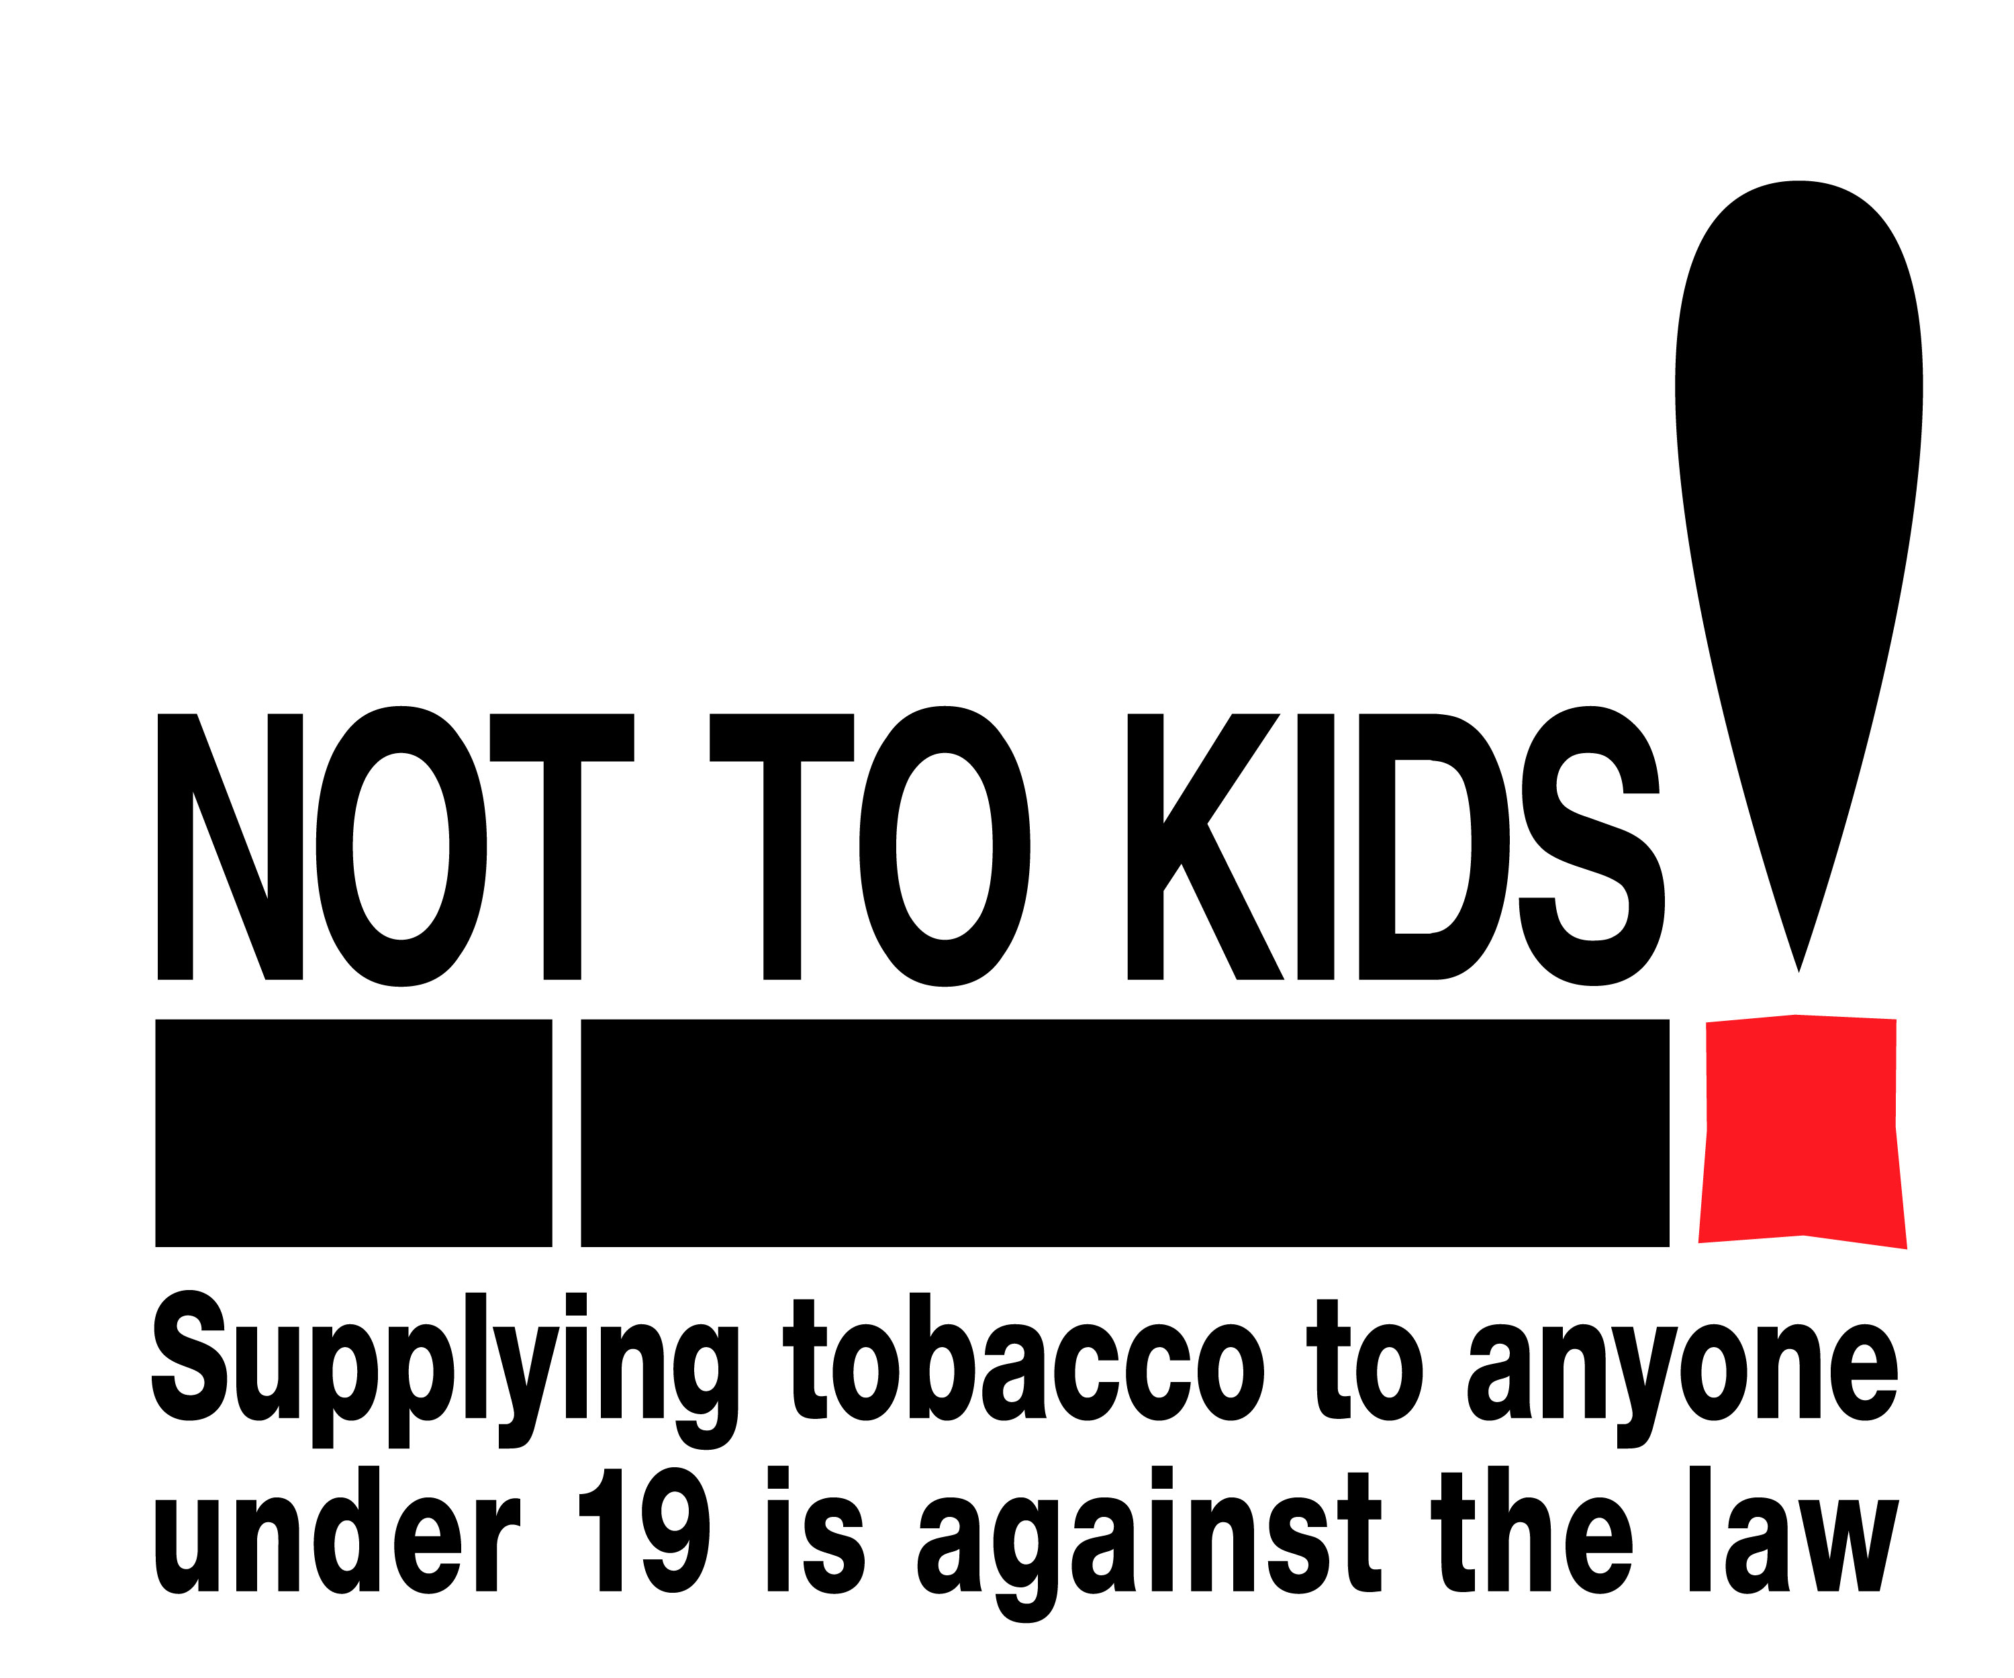
Contraband and Counterfeit Tobacco

Any tobacco product that has not had the appropriate Federal and Provincial taxes paid is illegal to sell or possess in Canada. This includes:
- Tobacco products that are legally manufactured in other countries but smuggled into Canada illegally
- Tobacco products that are illegally manufactured in other countries and smuggled into Canada
- Tobacco products that are illegally manufactured in Canada
- Tobacco products that are imitations or forgeries of real brands. They are most commonly referred to as counterfeit
- Tobacco products that are tax-exempt and designated for First Nations / Meti / Inuit (FNMI) communities but are sold to non- aboriginal people instead

How to identify legal tobacco

Legal tobacco products will have:

- A yellow band around the cellophane wrapper. This indicates the provincial taxes have been paid.
If the band around the cellophane wrapper is peach coloured the tobacco product can
only be sold in FNMI communities.

- An excise duty paid stamp which indicates that the Federal excise tax has been paid.

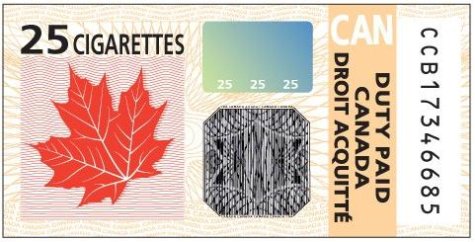

- A Health Canada warning label on the package. Cigarettes and little cigars will have a warning that covers75% of the package. Examples of some of the warnings are:



How to identify Illegal tobacco

Illegal tobacco will not have:
- A yellow Provincial duty paid tear strip on the cellophane
- A Federal excise duty paid stamp
- Health Canada warning labels on packaging in accordance with Health Canada regulations for labelling tobacco products
- Normal packaging and may come in clear plastic bags similar to sandwich bags
- A proper tax paid tear strip and/or duty stamp, but be packaged in a manner similar to authorized and authentic name brands (box and cellophane)

Why is illegal tobacco an Issue?

- It is accessible and affordable to youth, making it easier for them to start smoking
- It is sold at a lower cost keeping current smokers hooked and making it harder to quit
- Criminal Organizations sell and often import illegal tobacco as a way to make money, profits are used to fund other illegal activities within the organization

What can I do as a retailer?

- Only stock tobacco products purchased from registered wholesalers
- Sell tobacco products that have the yellow Provincial duty paid tear strip and the Canada duty paid stamp
- Be prepared to account for all tobacco products in-store with receipts, order forms, shipping manifests, etc.
- Report anyone selling illegal tobacco products

Who enforces the laws regarding illegal tobacco and what are the penalties?
You can report illegal tobacco activity to Crime Stoppers at 1-800-222-TIPS (8477).
The RCMP enforces the Customs and Excise Act.
The Ministry of Finance enforces the Tobacco Tax Act.
Your local Public Health Unit enforces the Smoke-Free Ontario Act.
Fines and assessed penalties can range from $500 to $10,000. Addition and significant tax penalties and jail time are also possible. For further information please visit:
RCMP: http://www.rcmp-grc.gc.ca/index-eng.htm
Ministry of Finance: http://www.fin.gov.on.ca
Or call your local health unit

