ERIC LOUIS D. RAMOS
S2025100392
OCT 10, 2026

setup-01-api-running
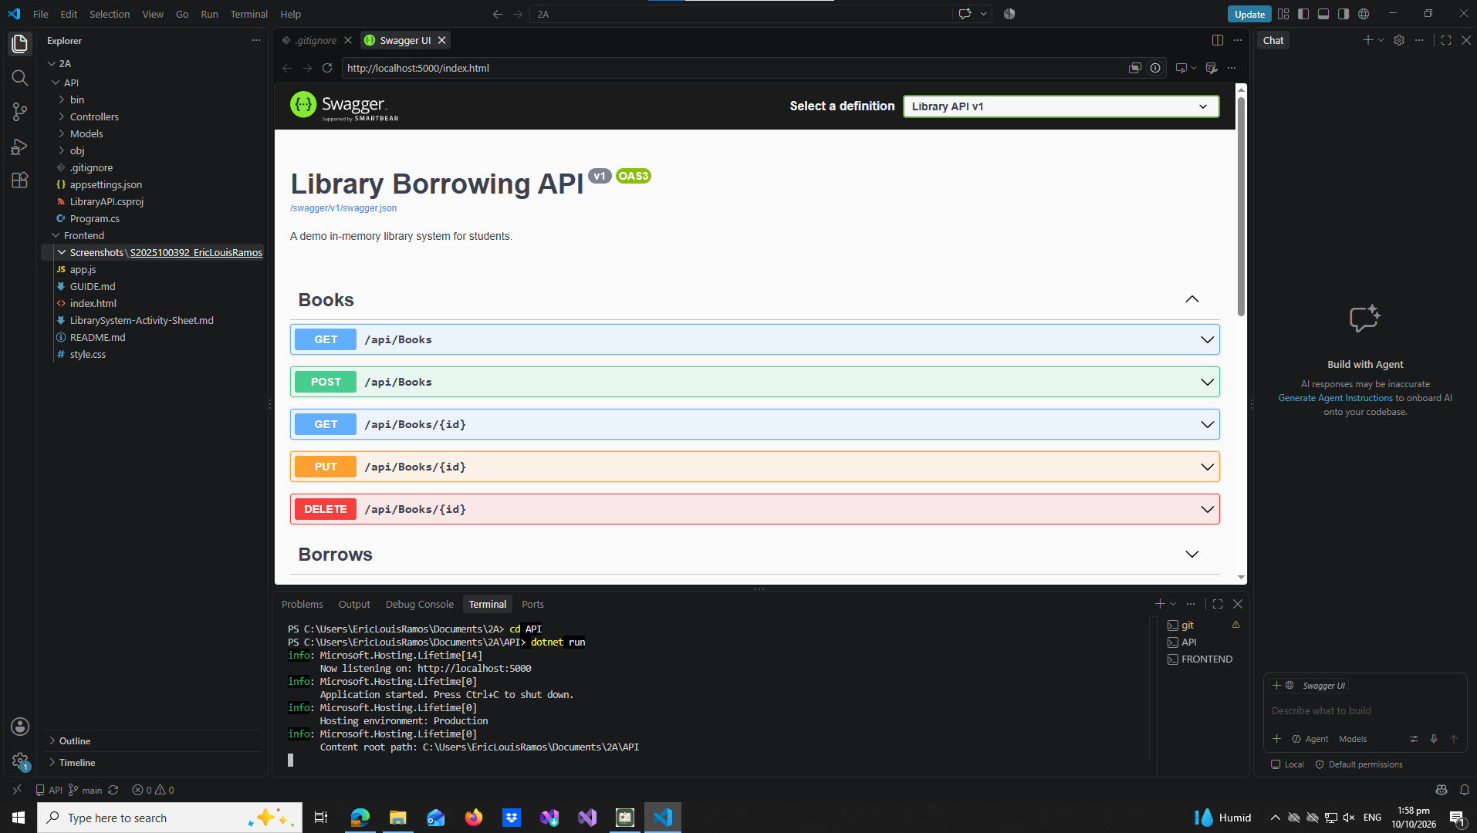

setup-02-api-books-json
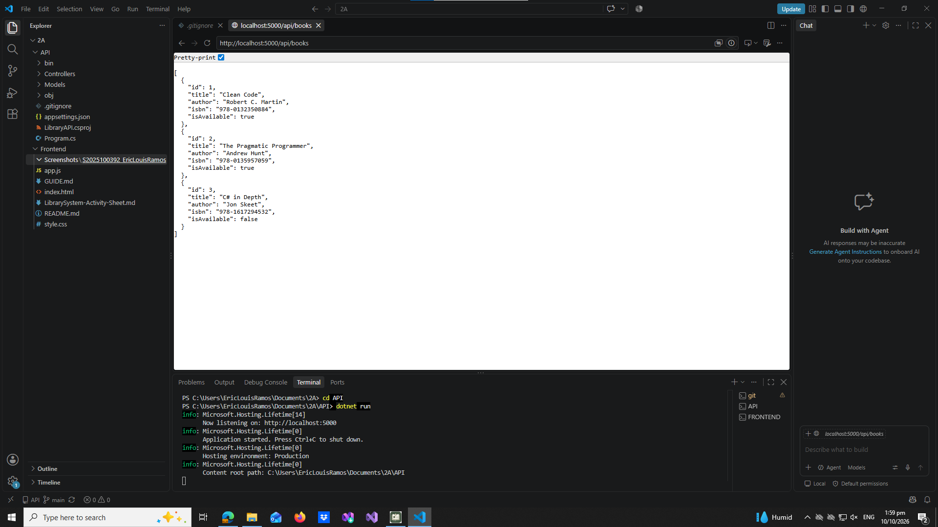
part-01-settings-apifetch
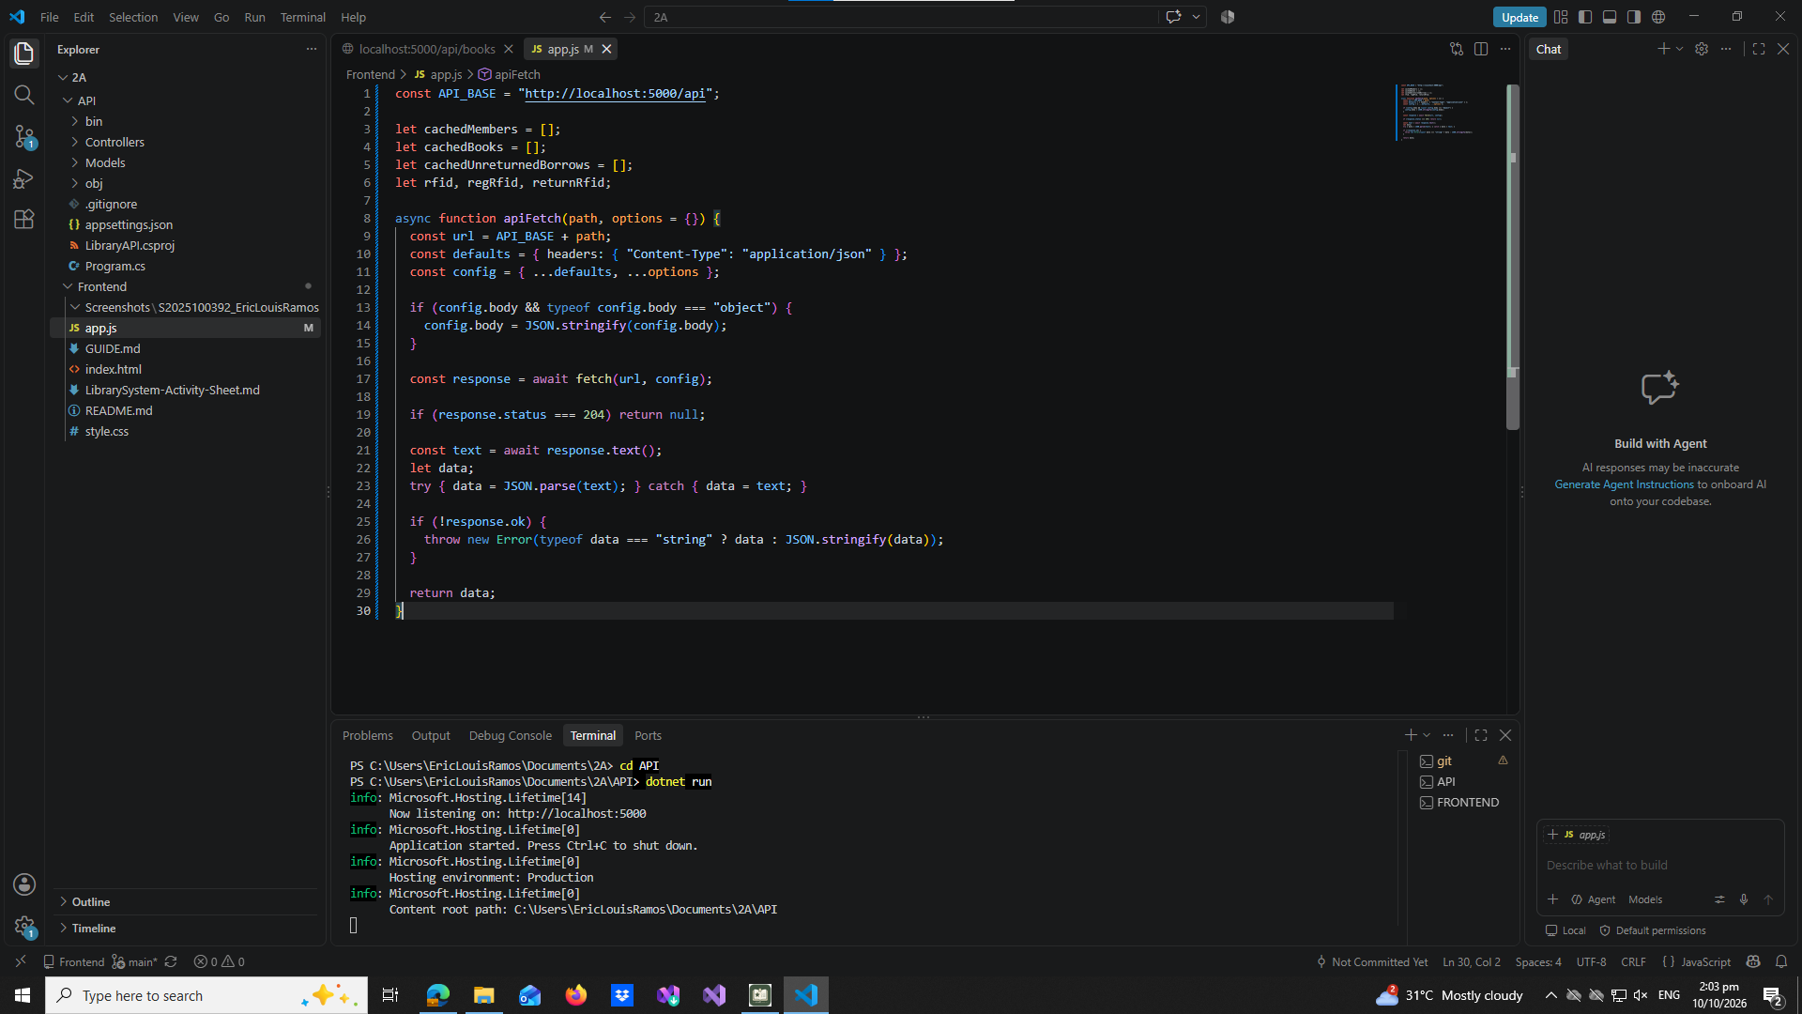

part-02-showtoast
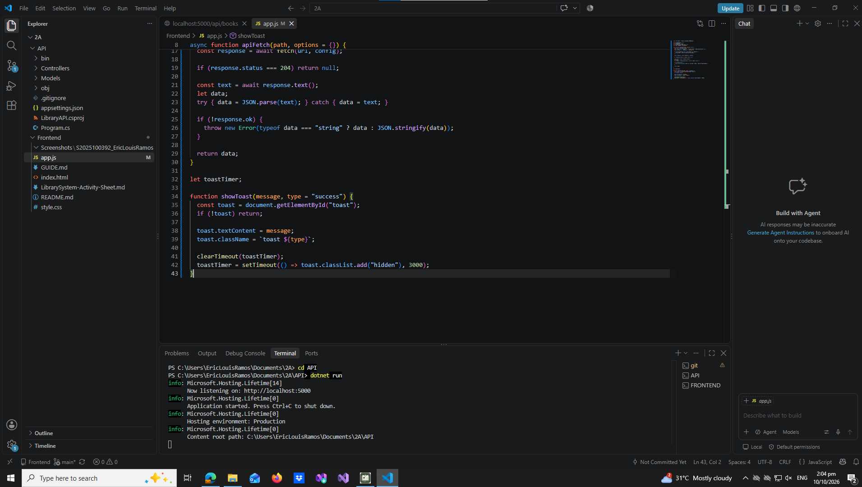

early-01-toast
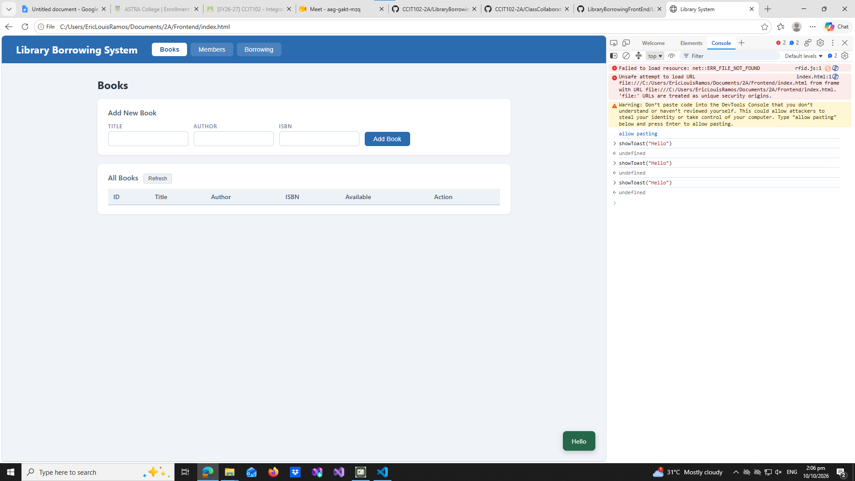

part-03-caches
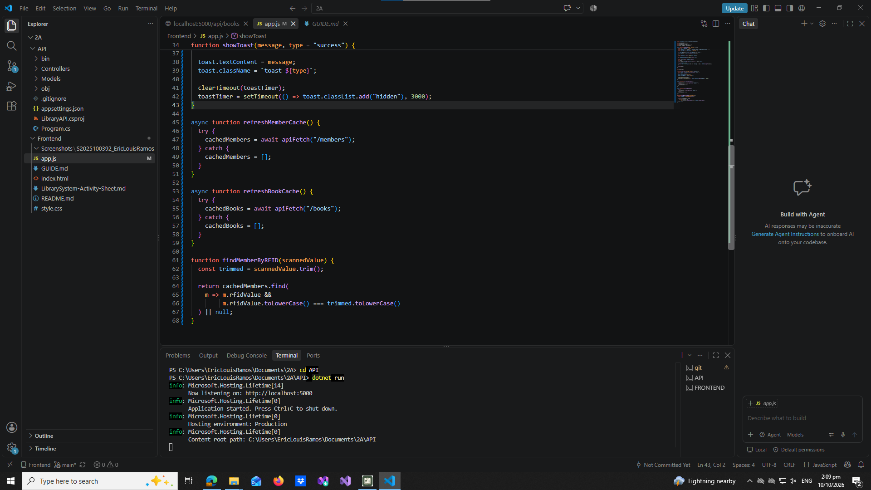

early-02-cache-console
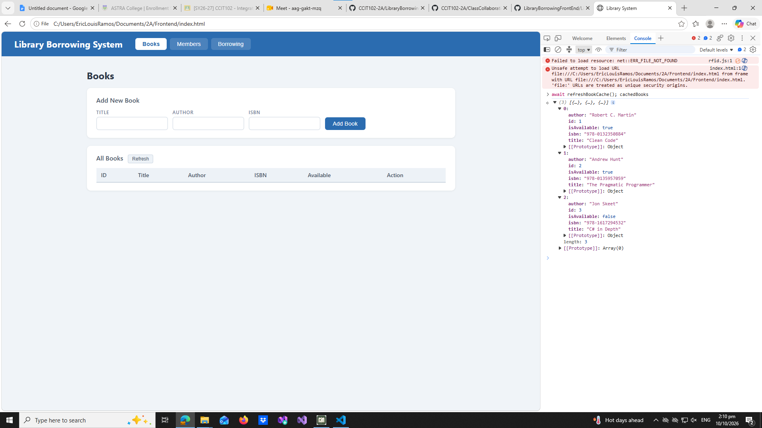

part-04-tabs-refresh
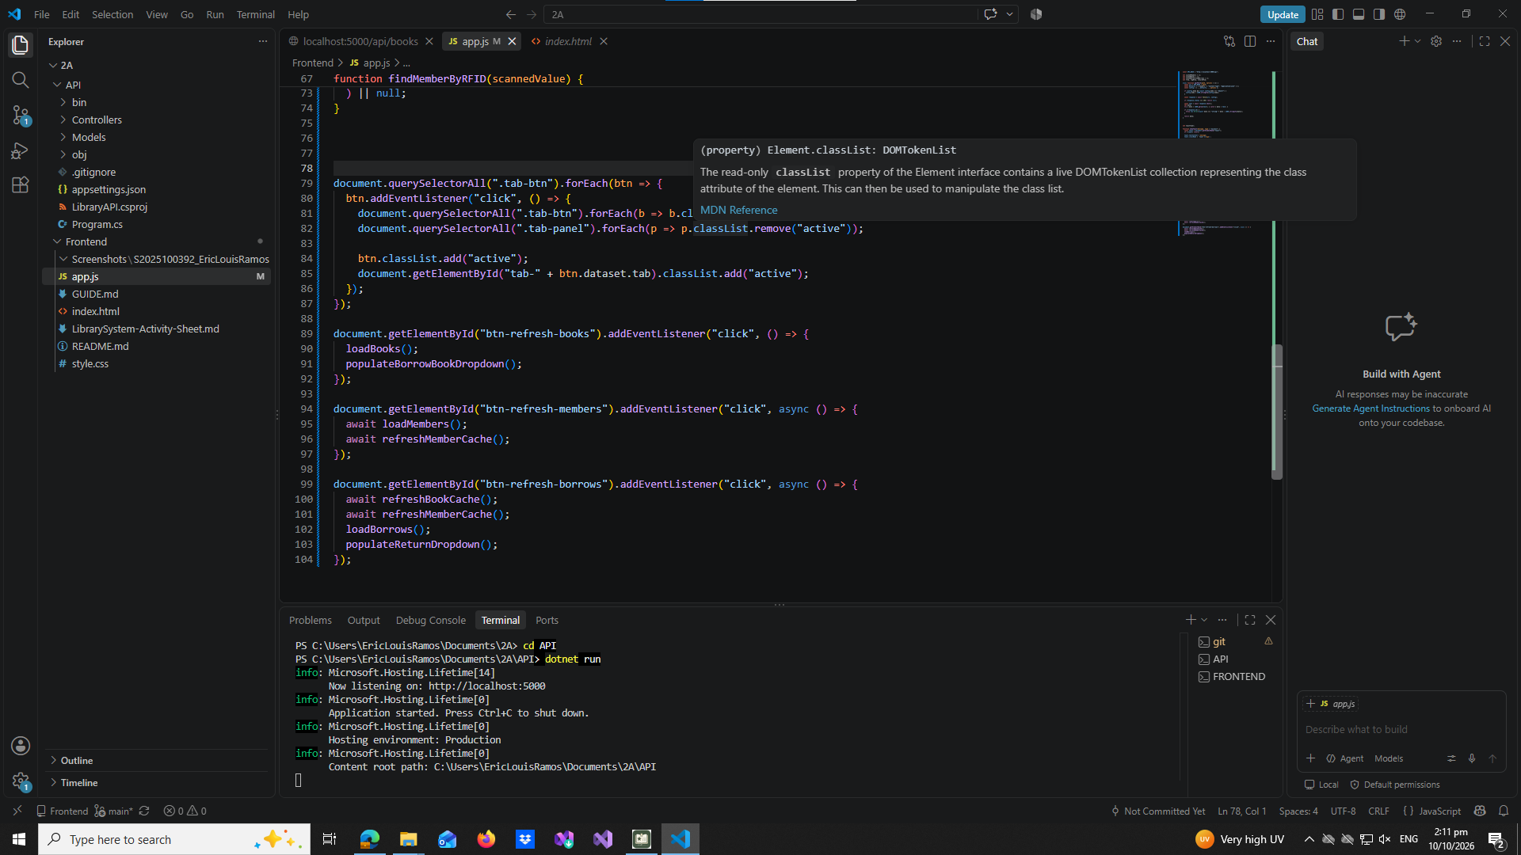

early-03-tabs
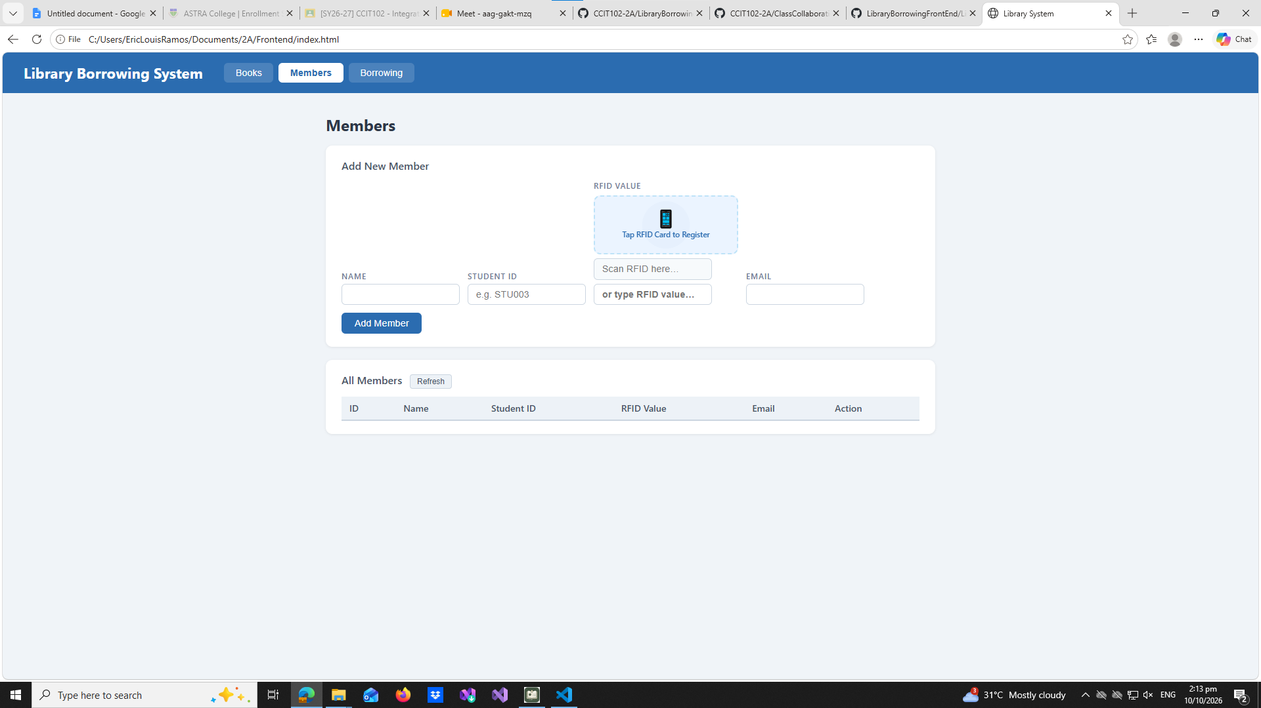

part-05-loadbooks
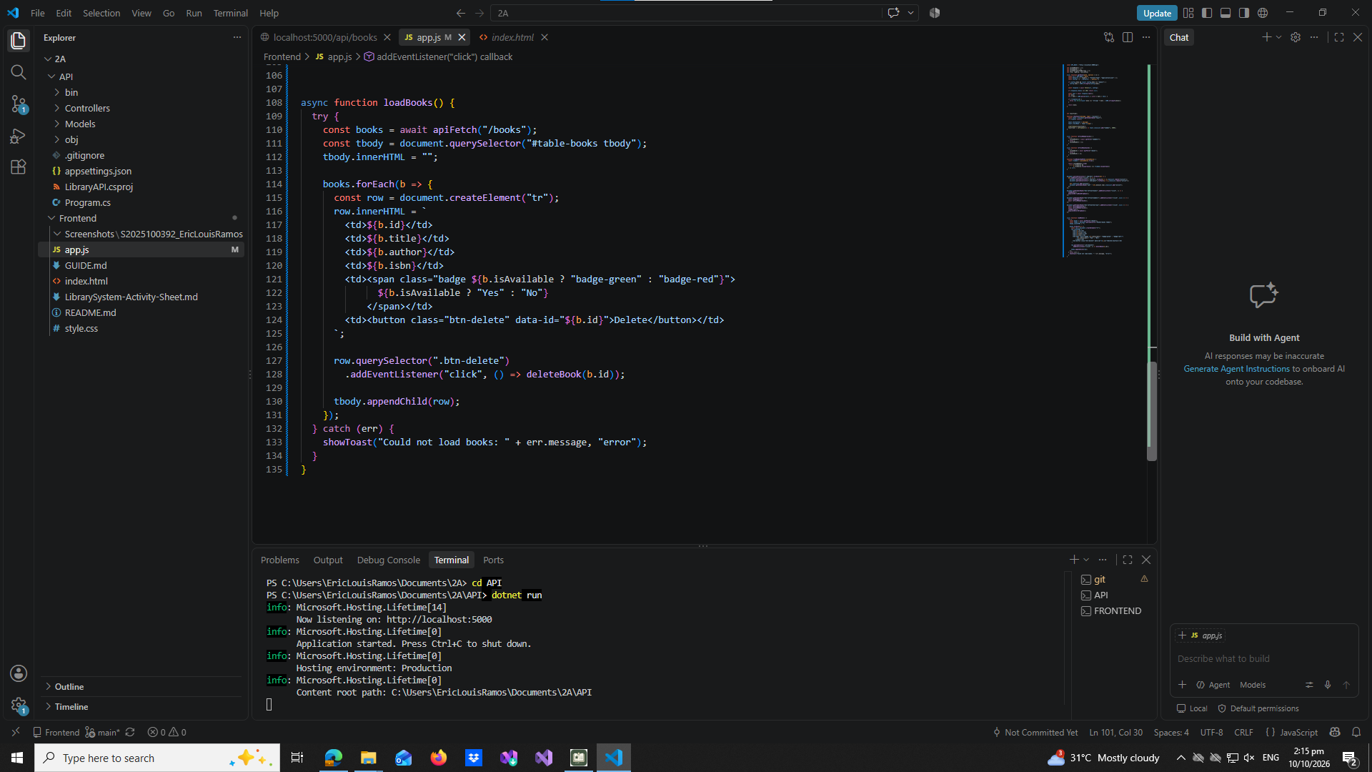

part-06-deletebook
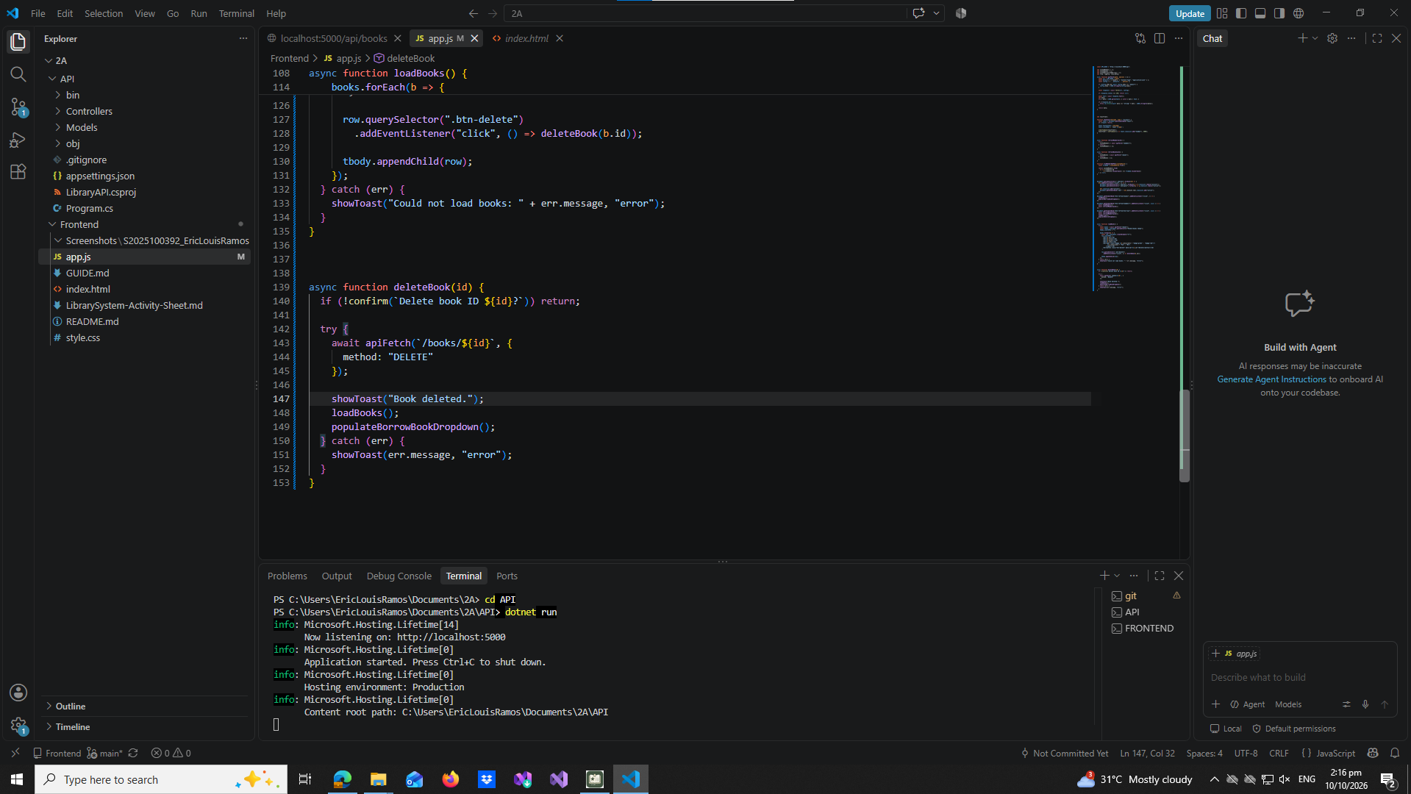

part-07-addbook
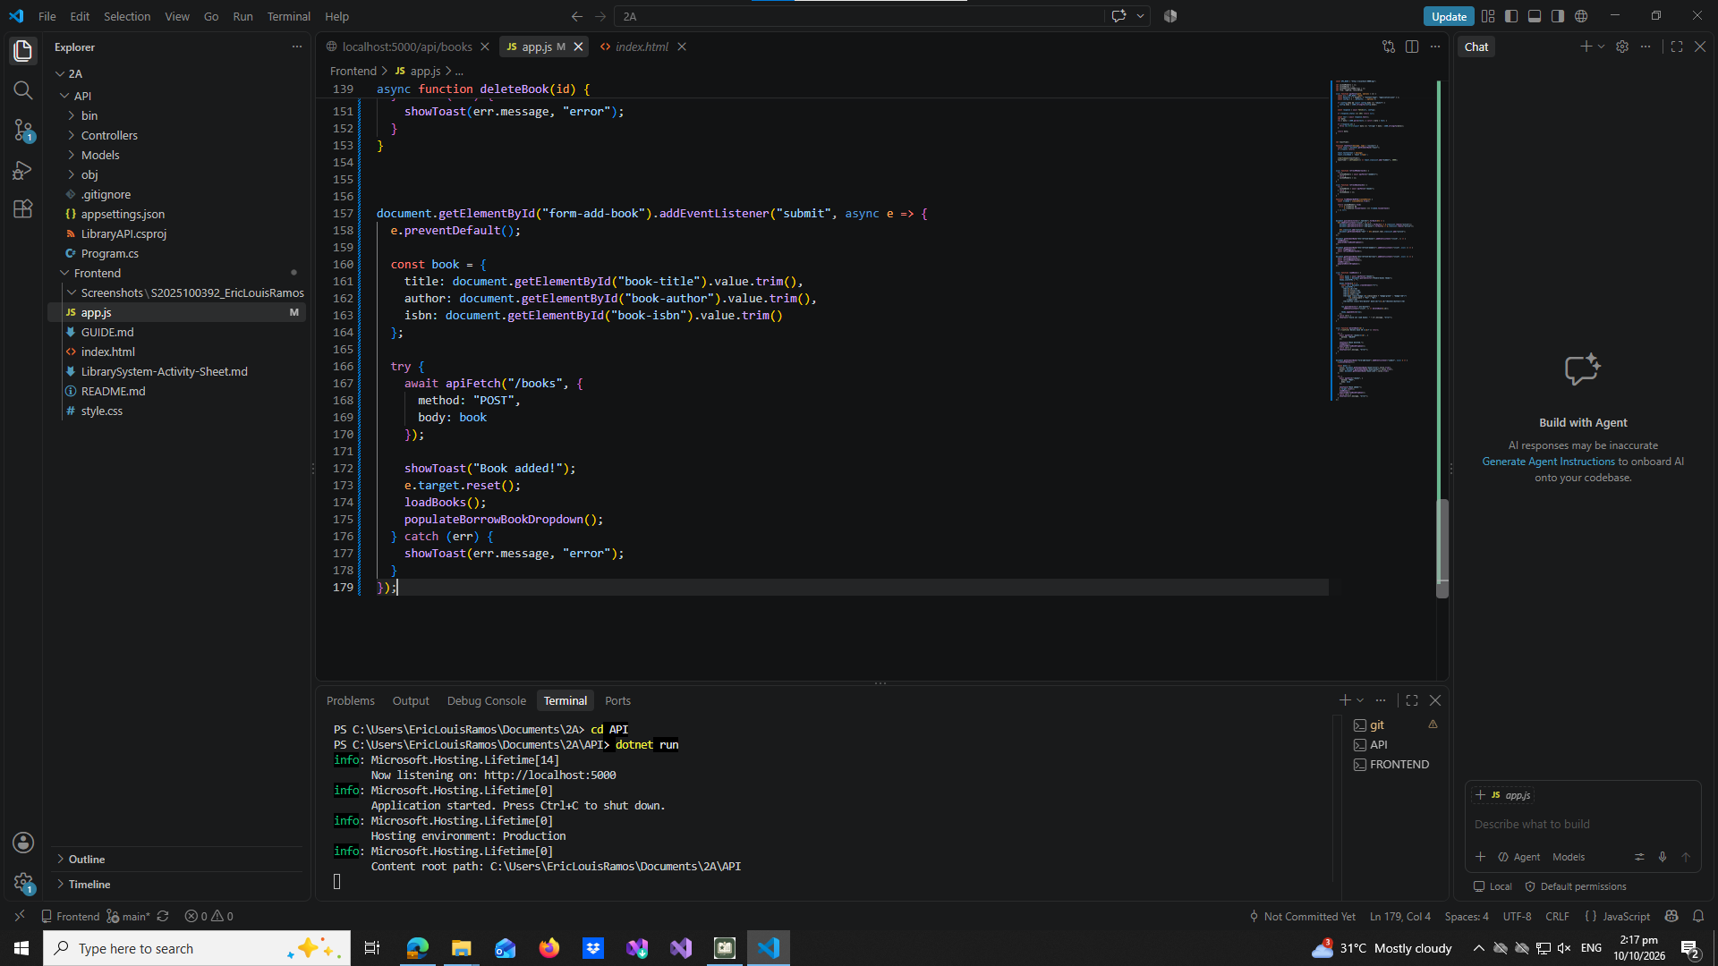

part-08-loadmembers
part-08a
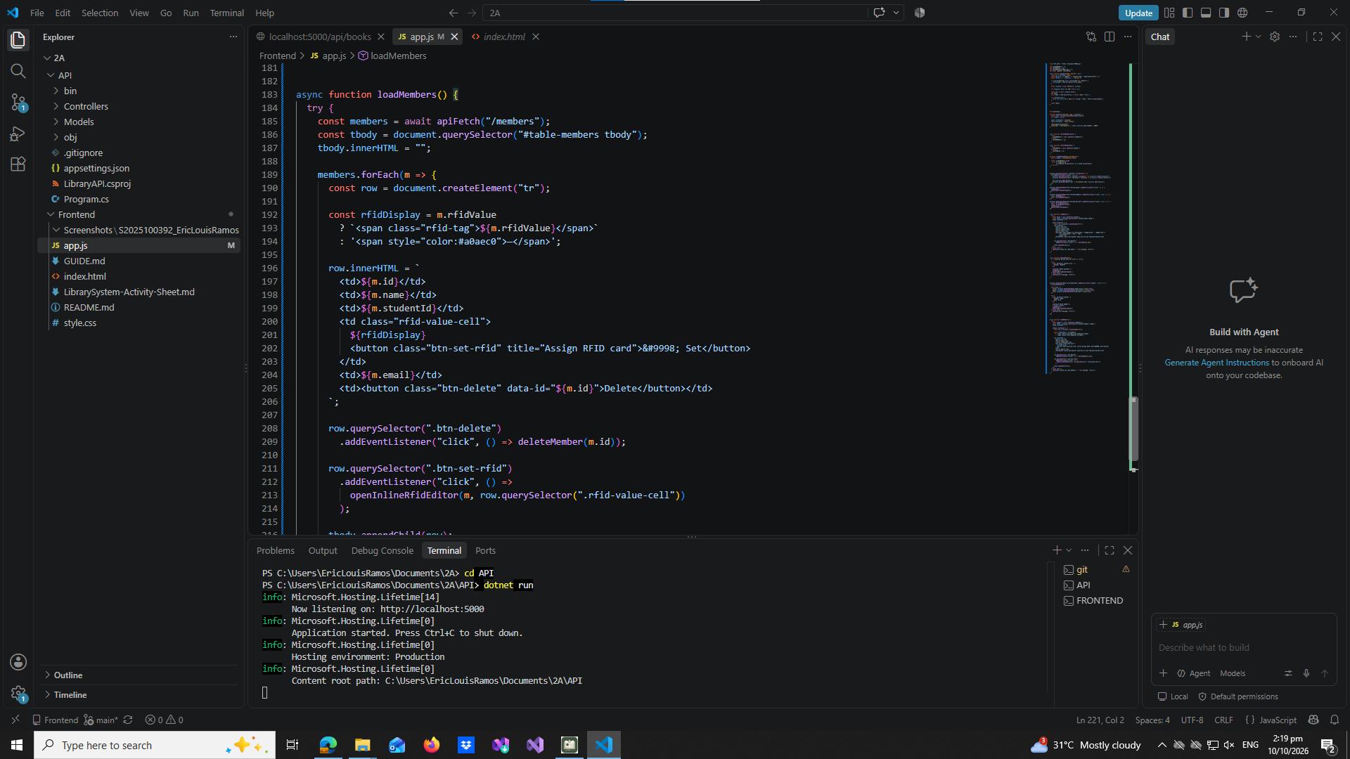

part-08b
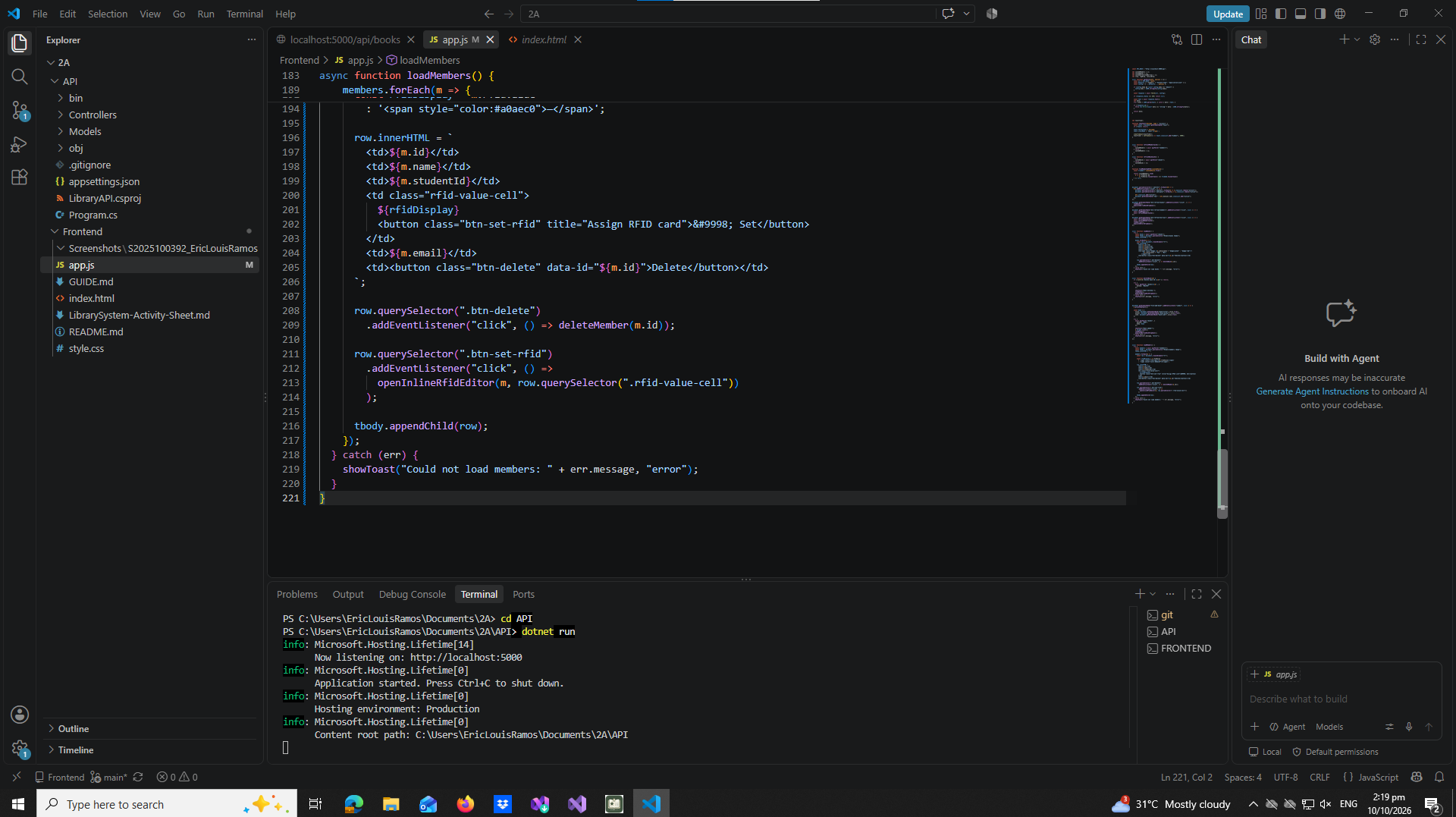

part-09-deletemember
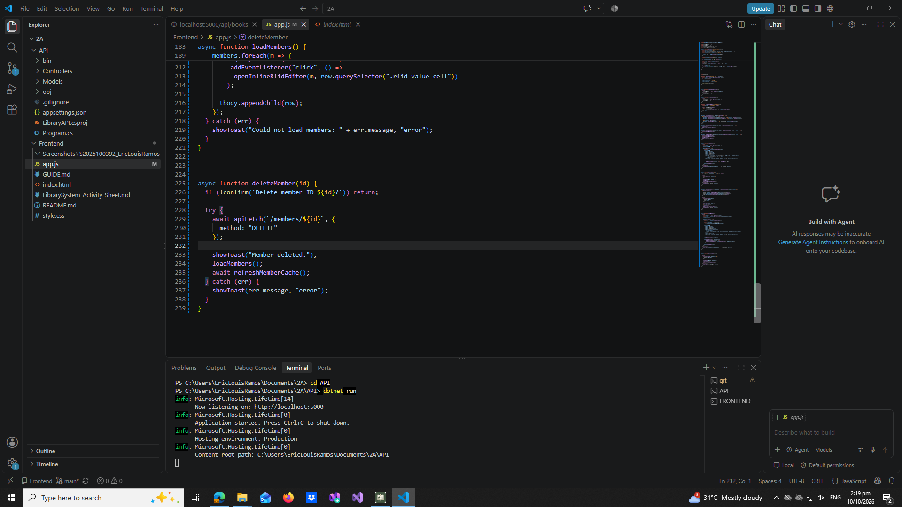

part-10-addmember
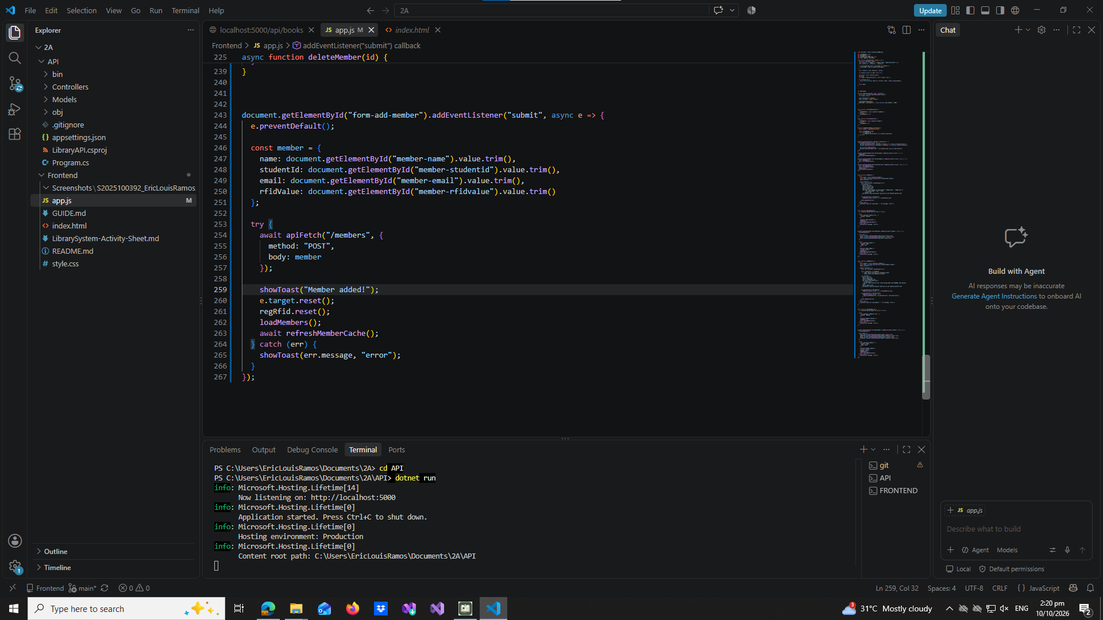

part-11-inline-rfid-editor
part-11a
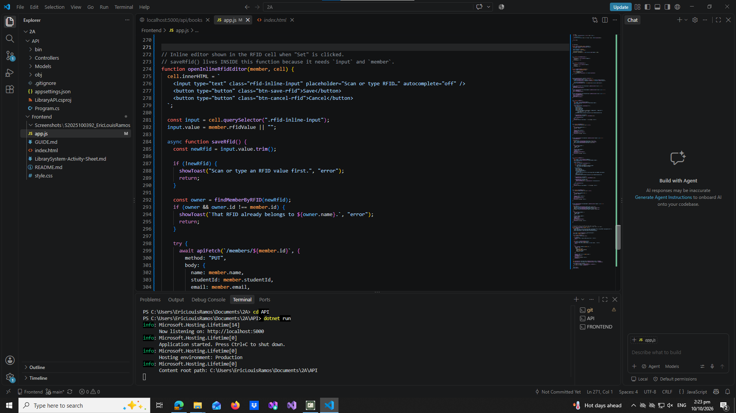
part-11b
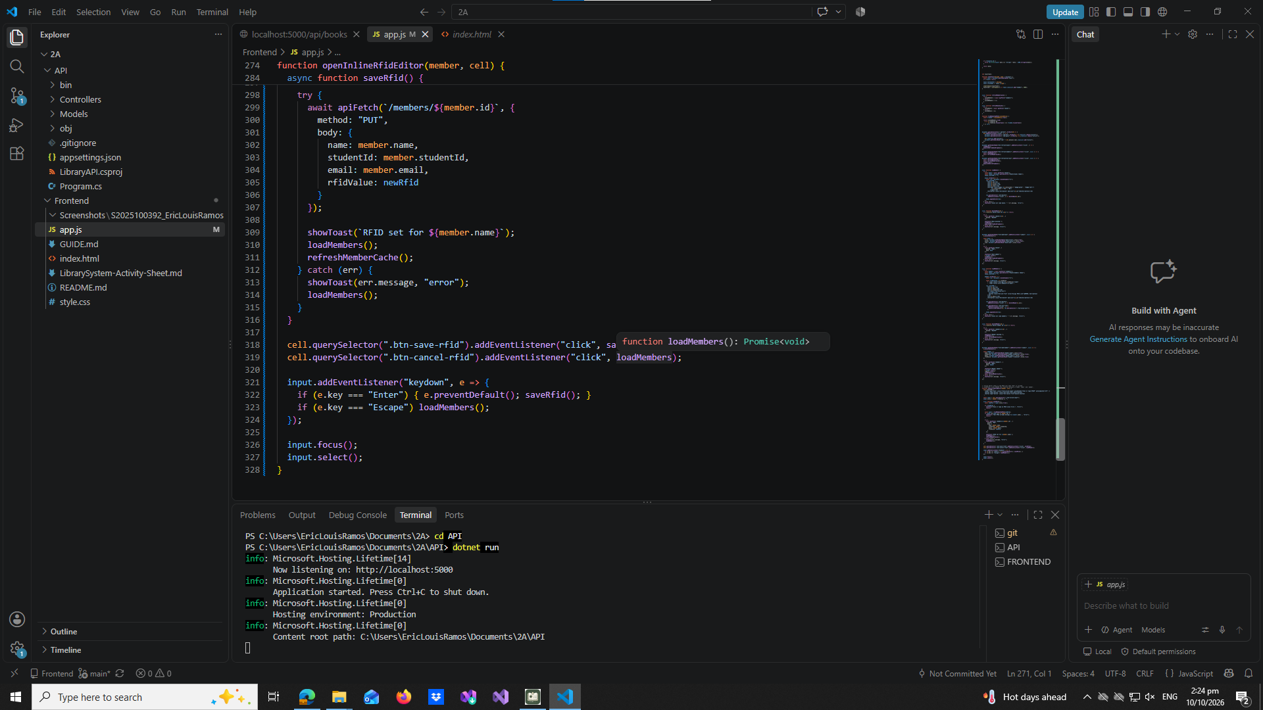

part-12a-rfid-widget-builder
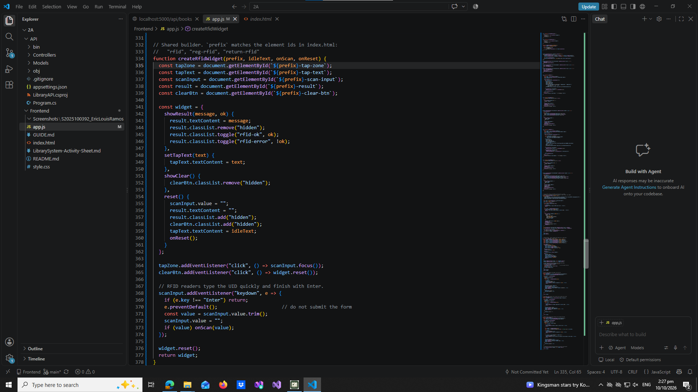

part-12b-rfid-init-functions
initRFID()
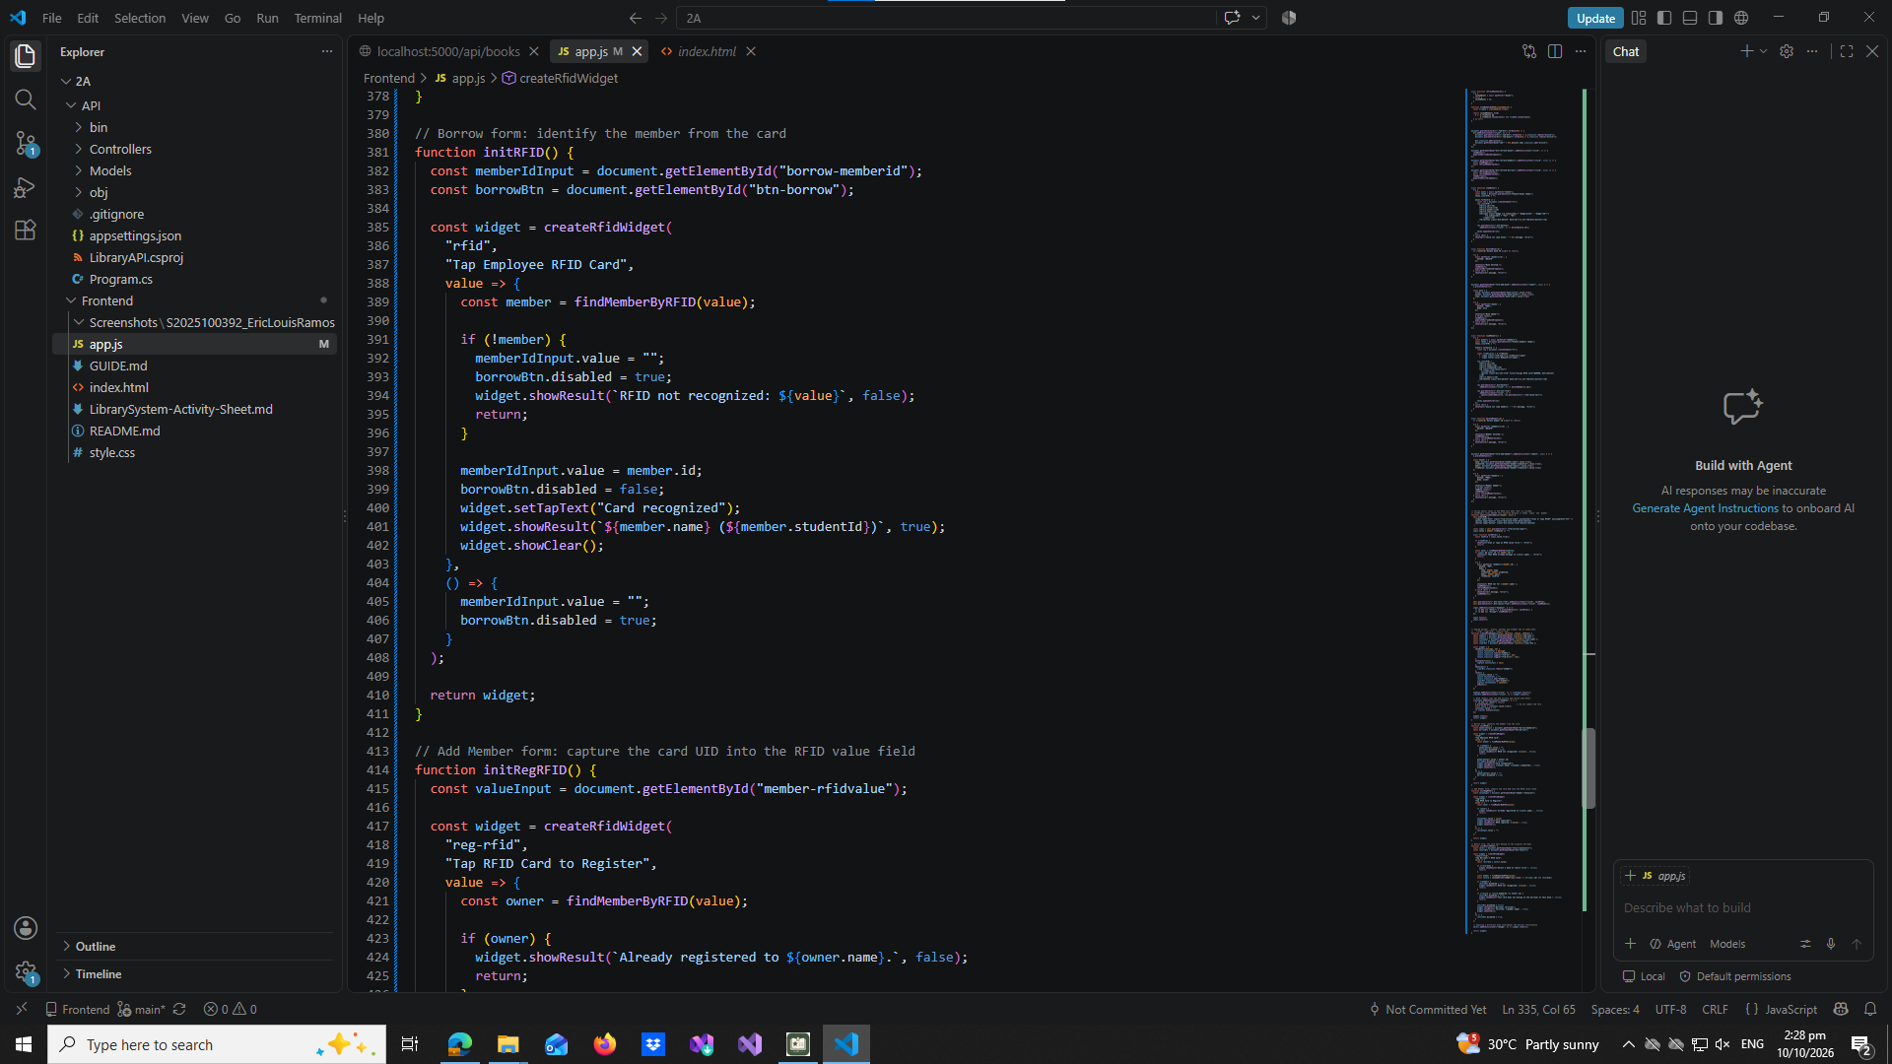

initRegRFID()
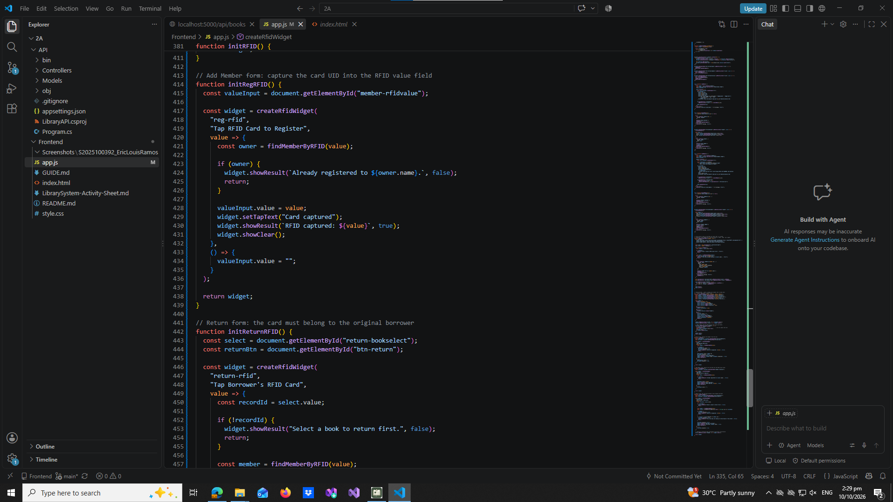

initReturnRFID()
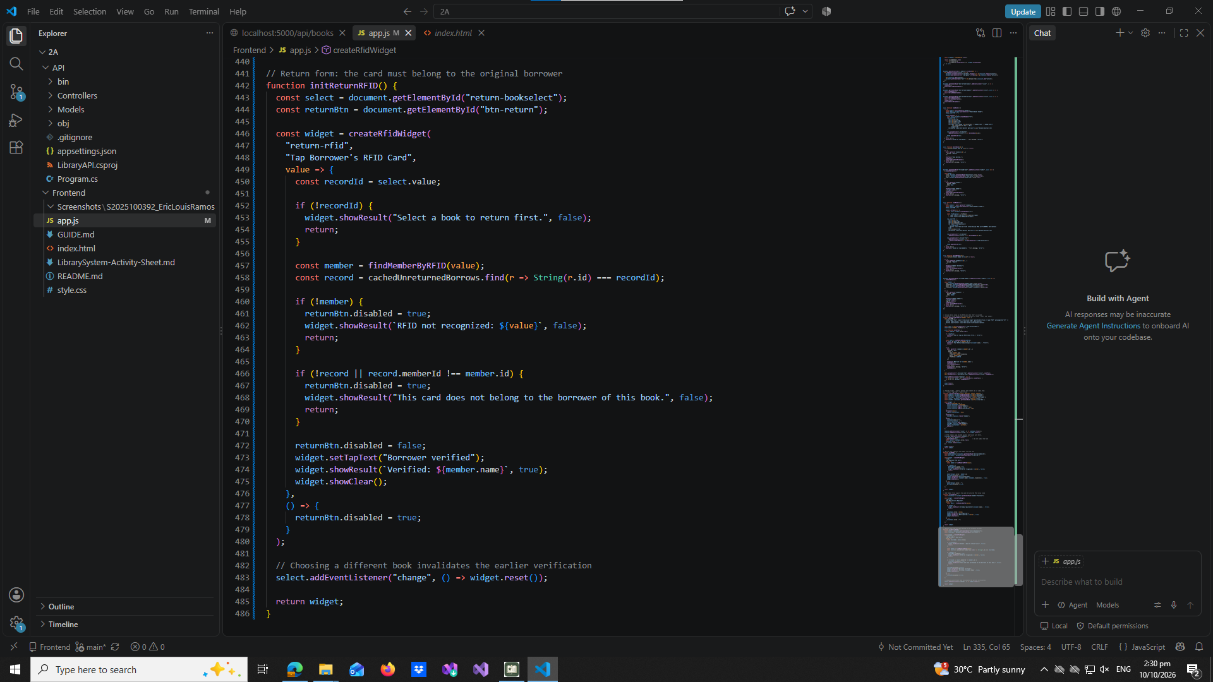

part-13-borrow-dropdown
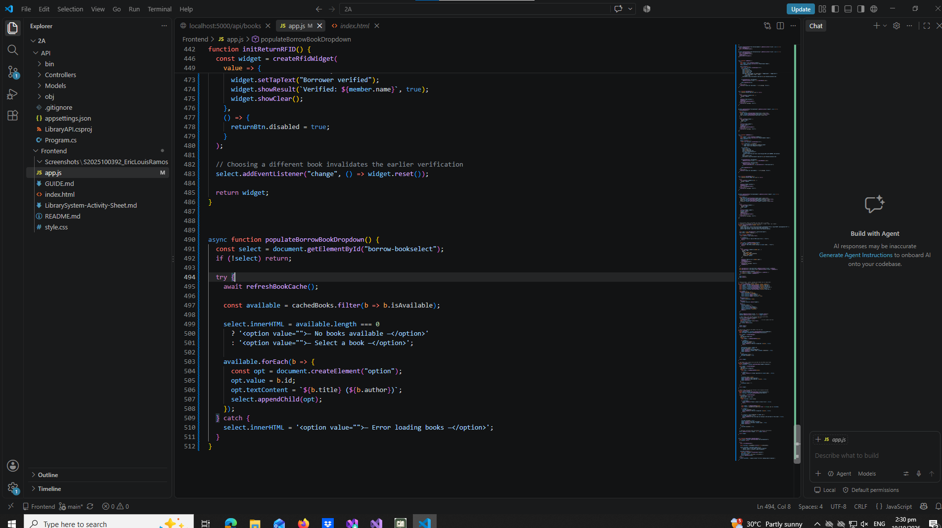

part-14-return-dropdown
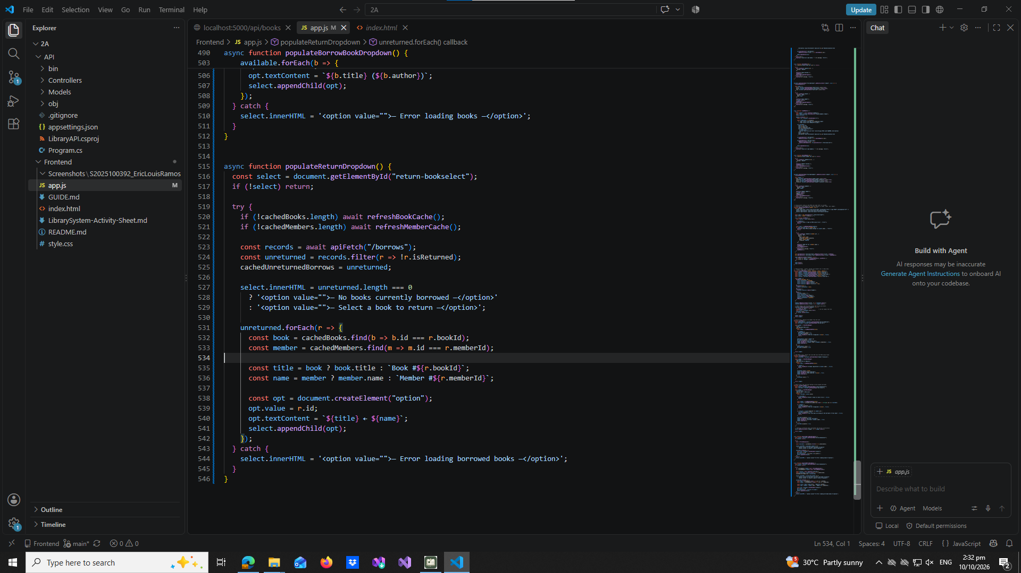

part-15-borrow
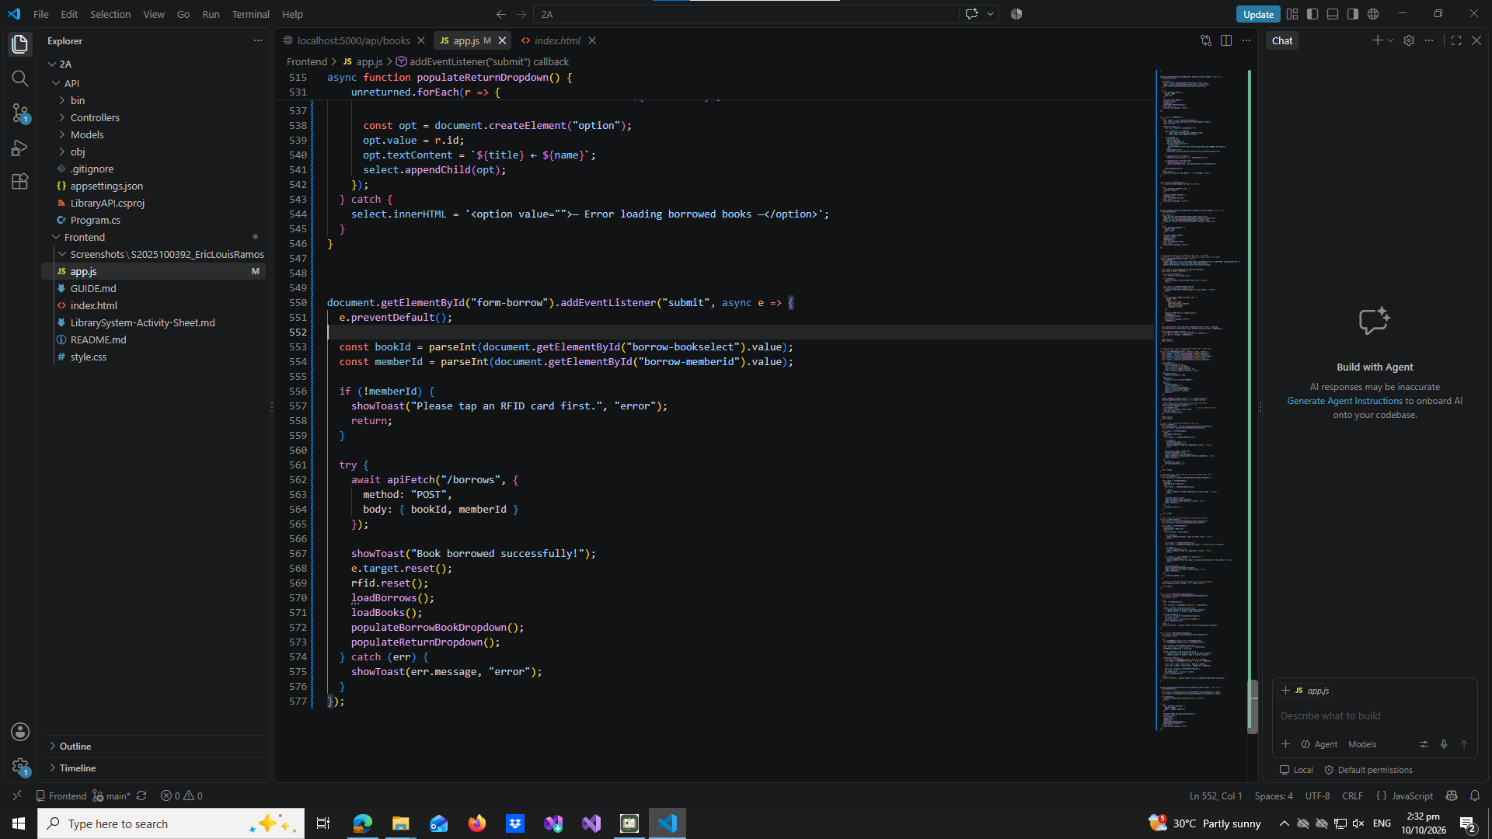

part-16-return
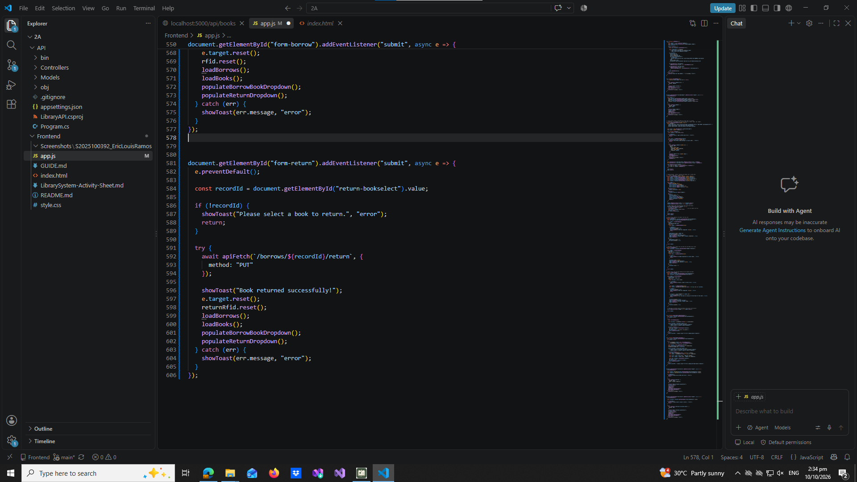

part-17-loadborrows
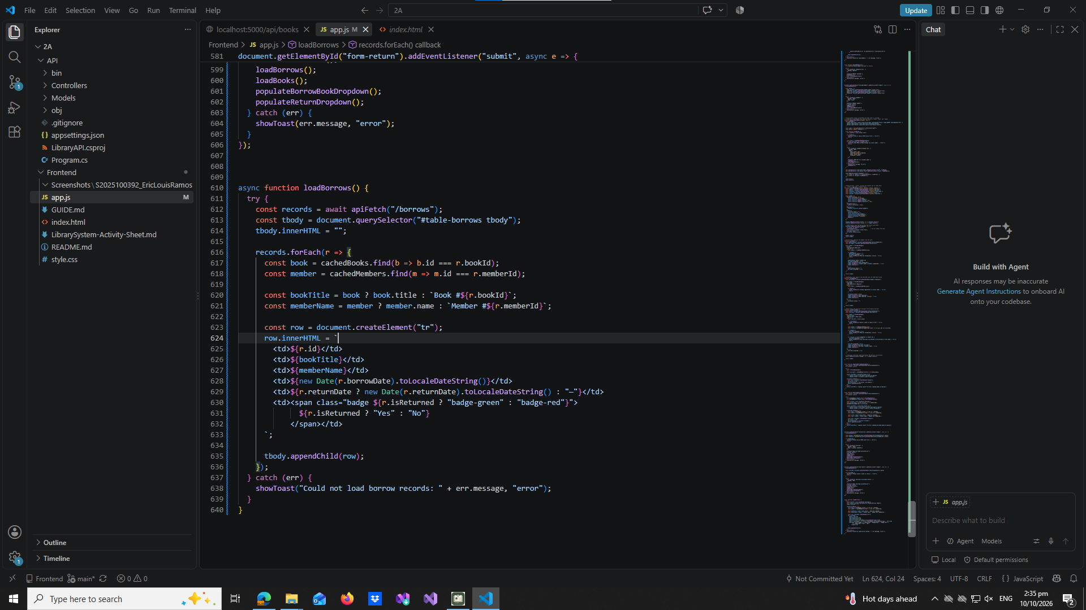

part-18-page-load
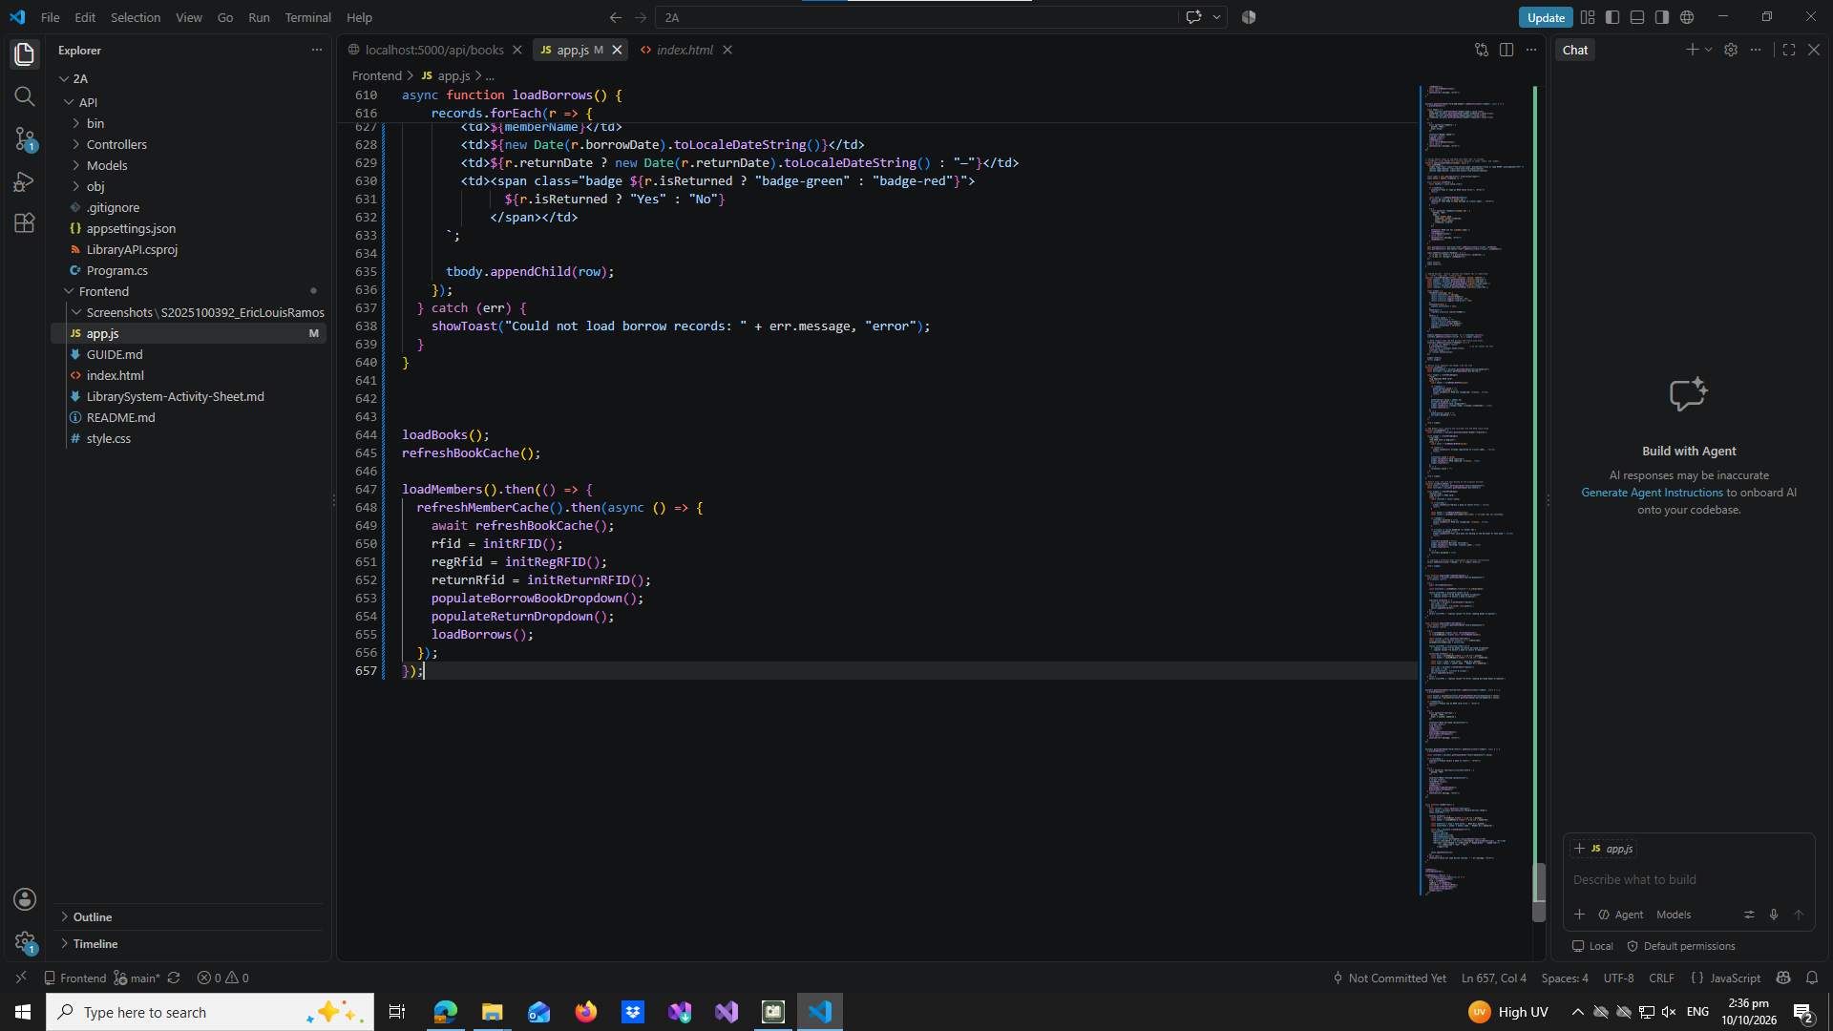

test-01-page-loaded
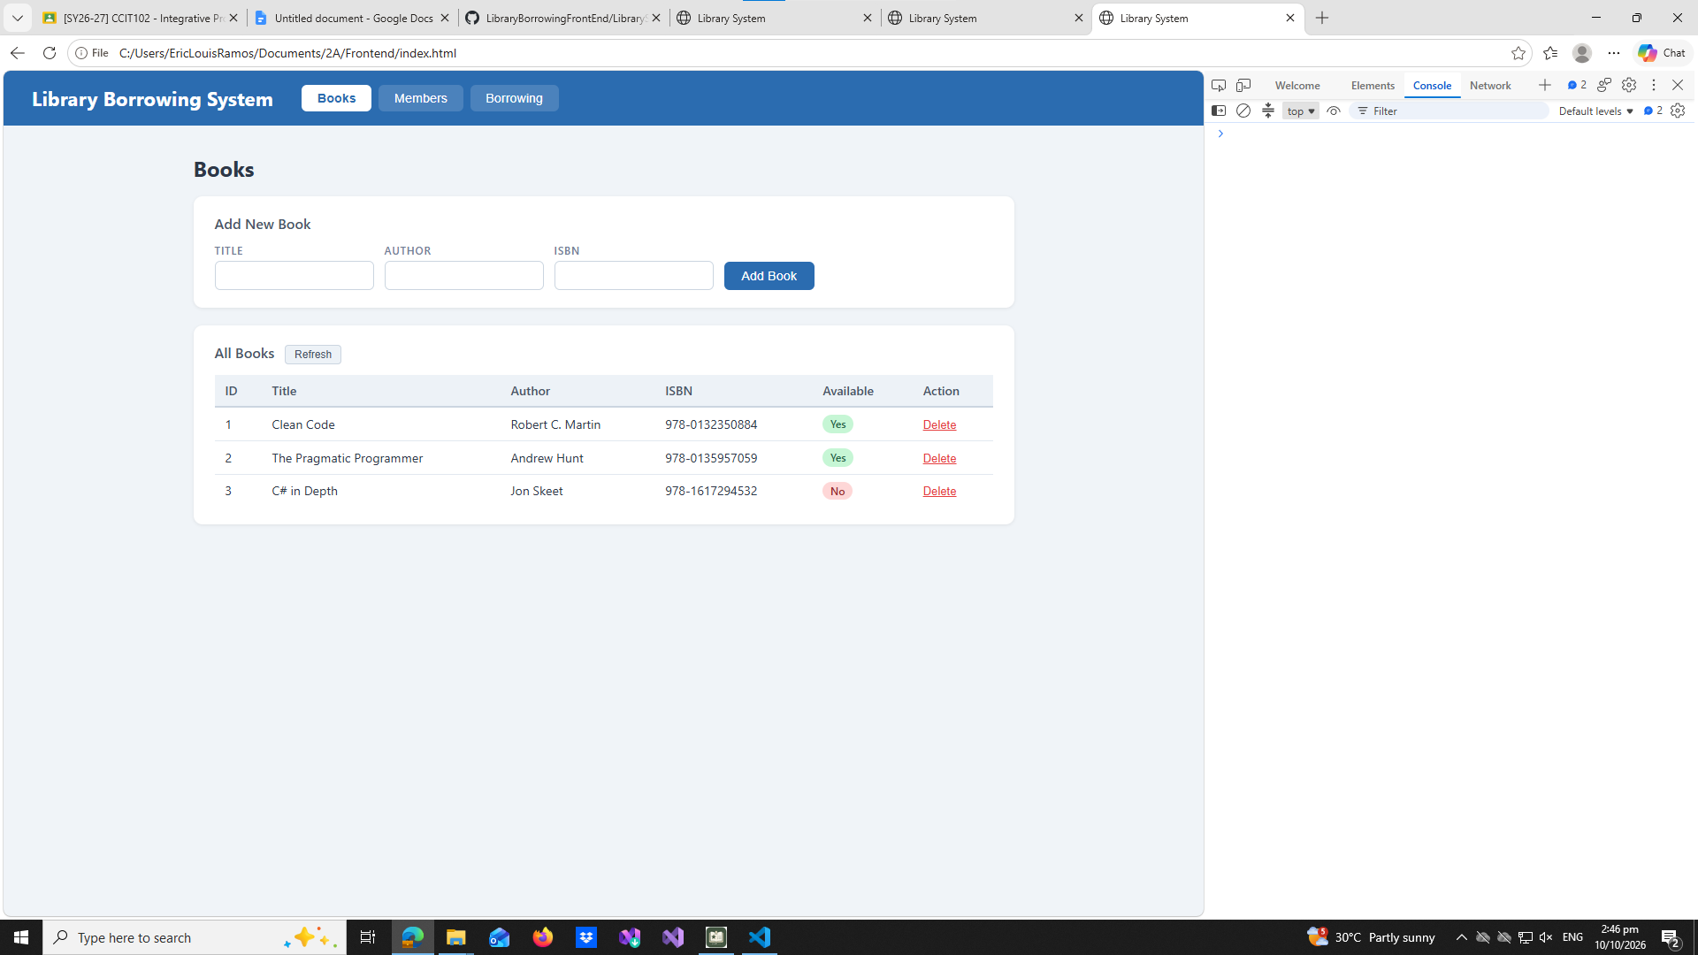

test-02-add-book
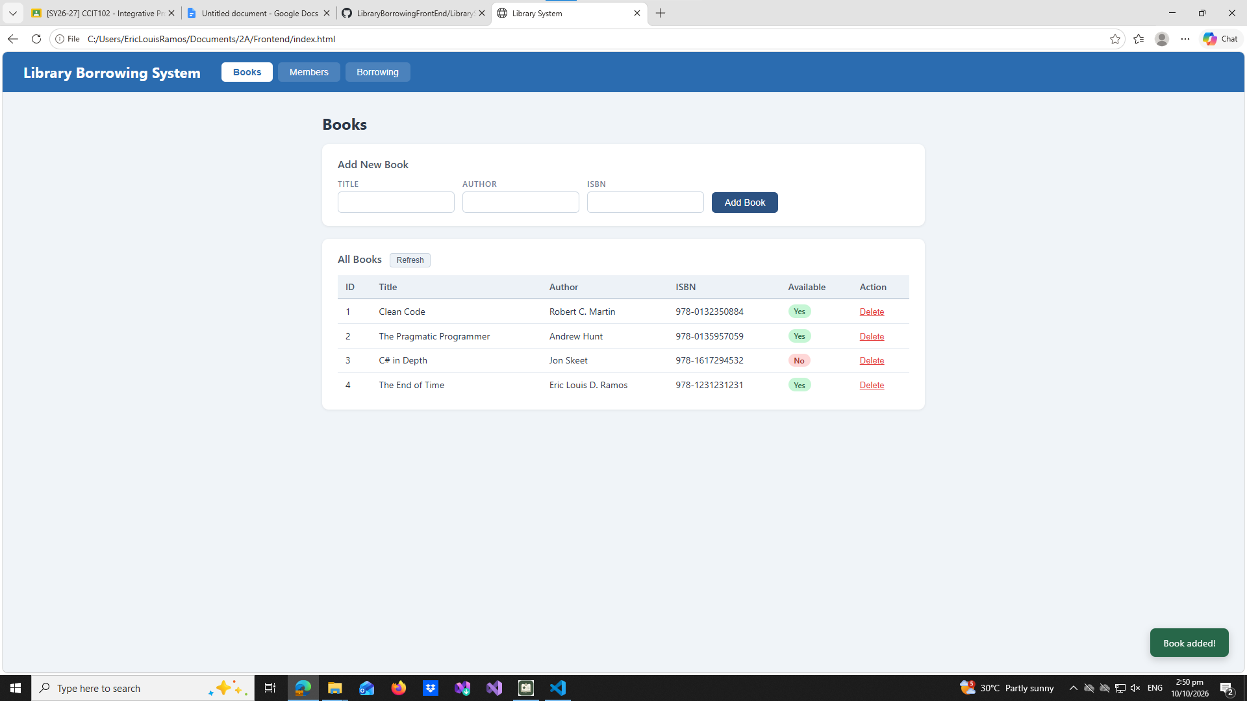

test-03-delete-book
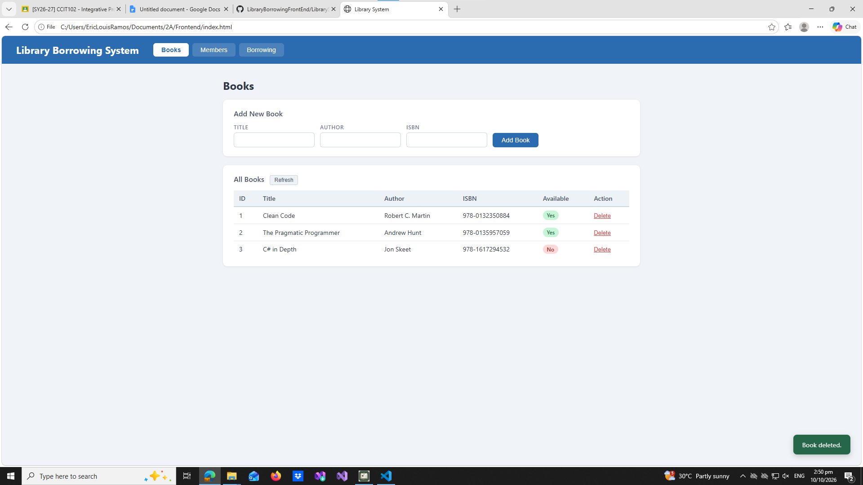

test-04-members-loaded
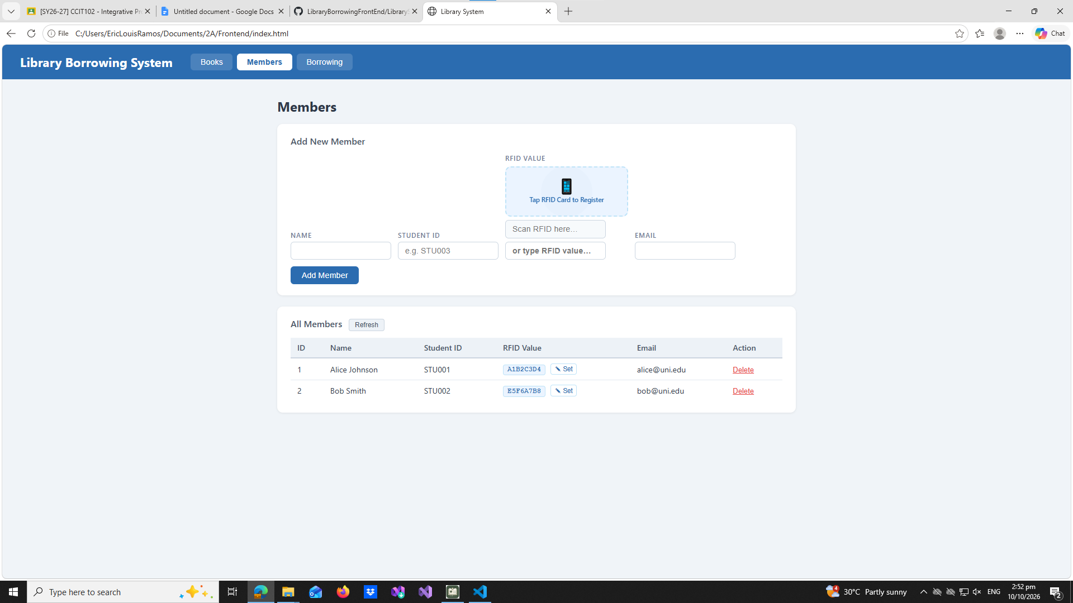

test-05-register-rfid
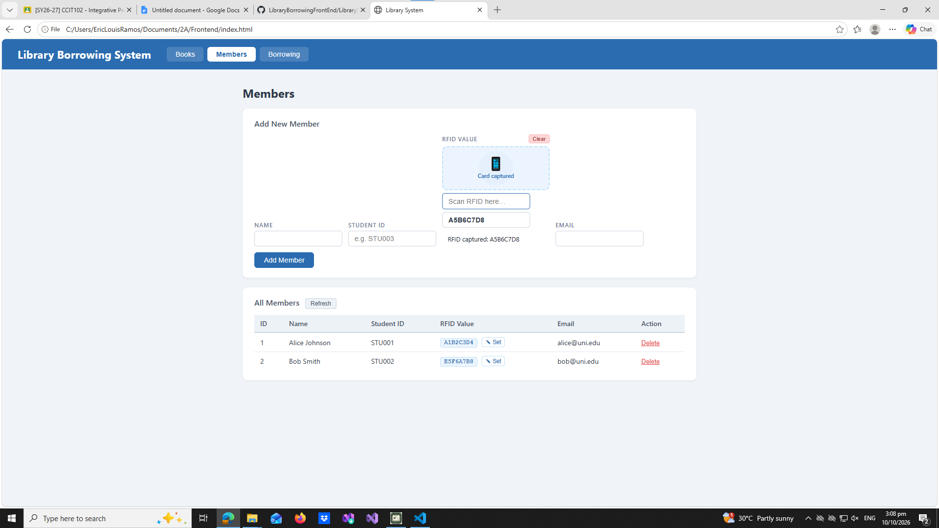

test-06-add-member
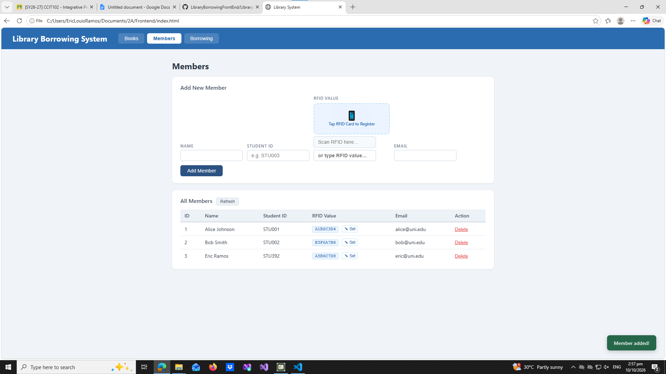

test-07-set-rfid-saved
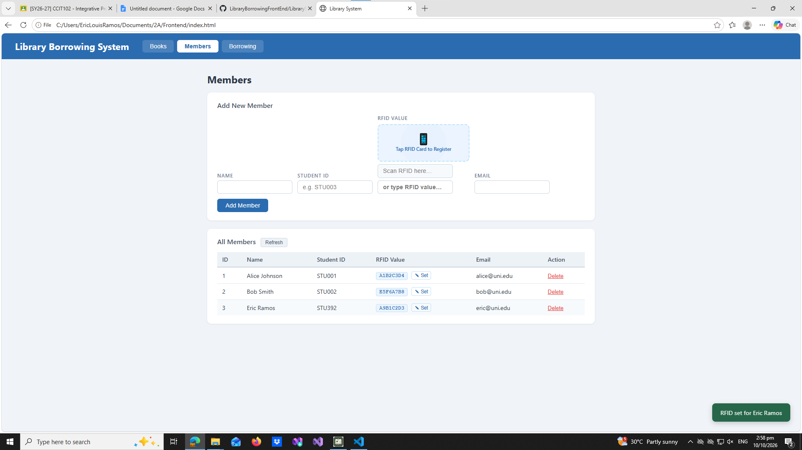

test-08-delete-member
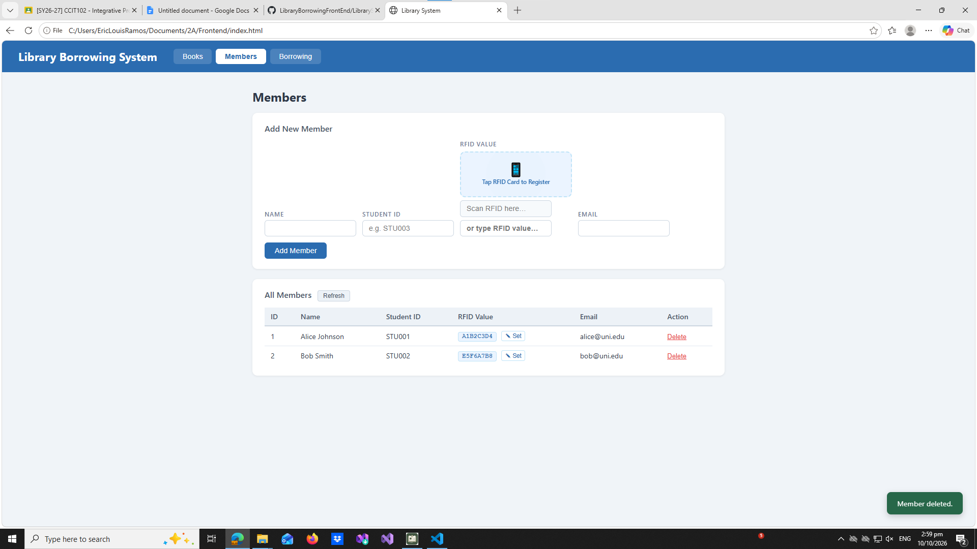

test-09-borrow-rfid-recognized
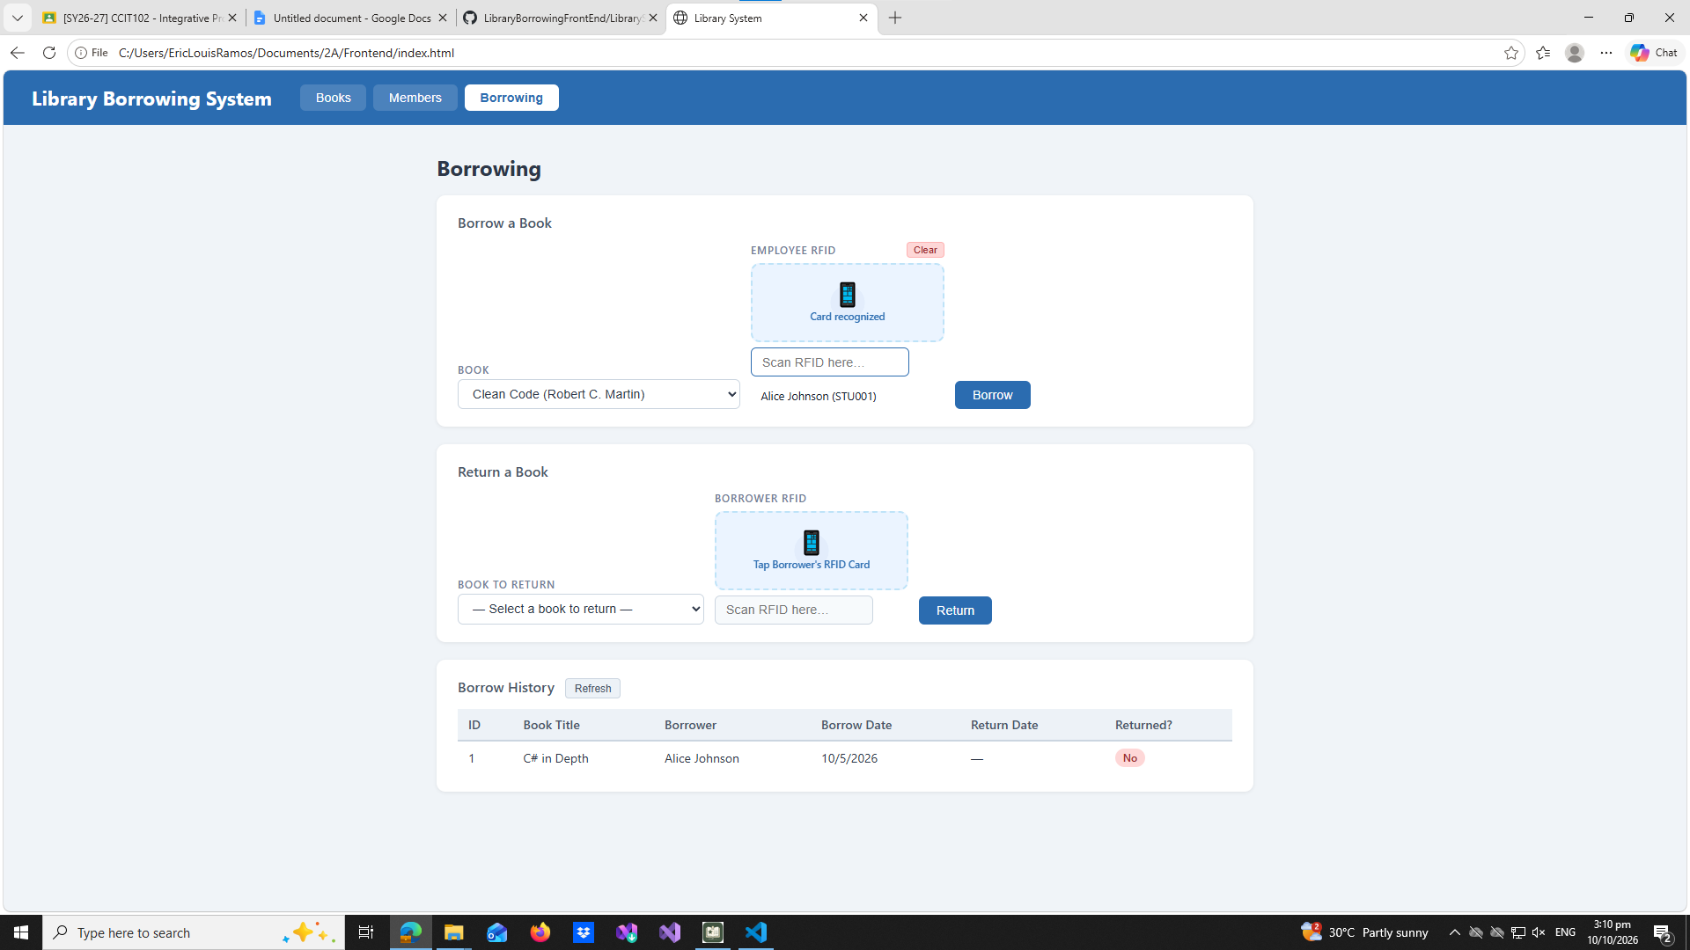

test-10-borrow-success
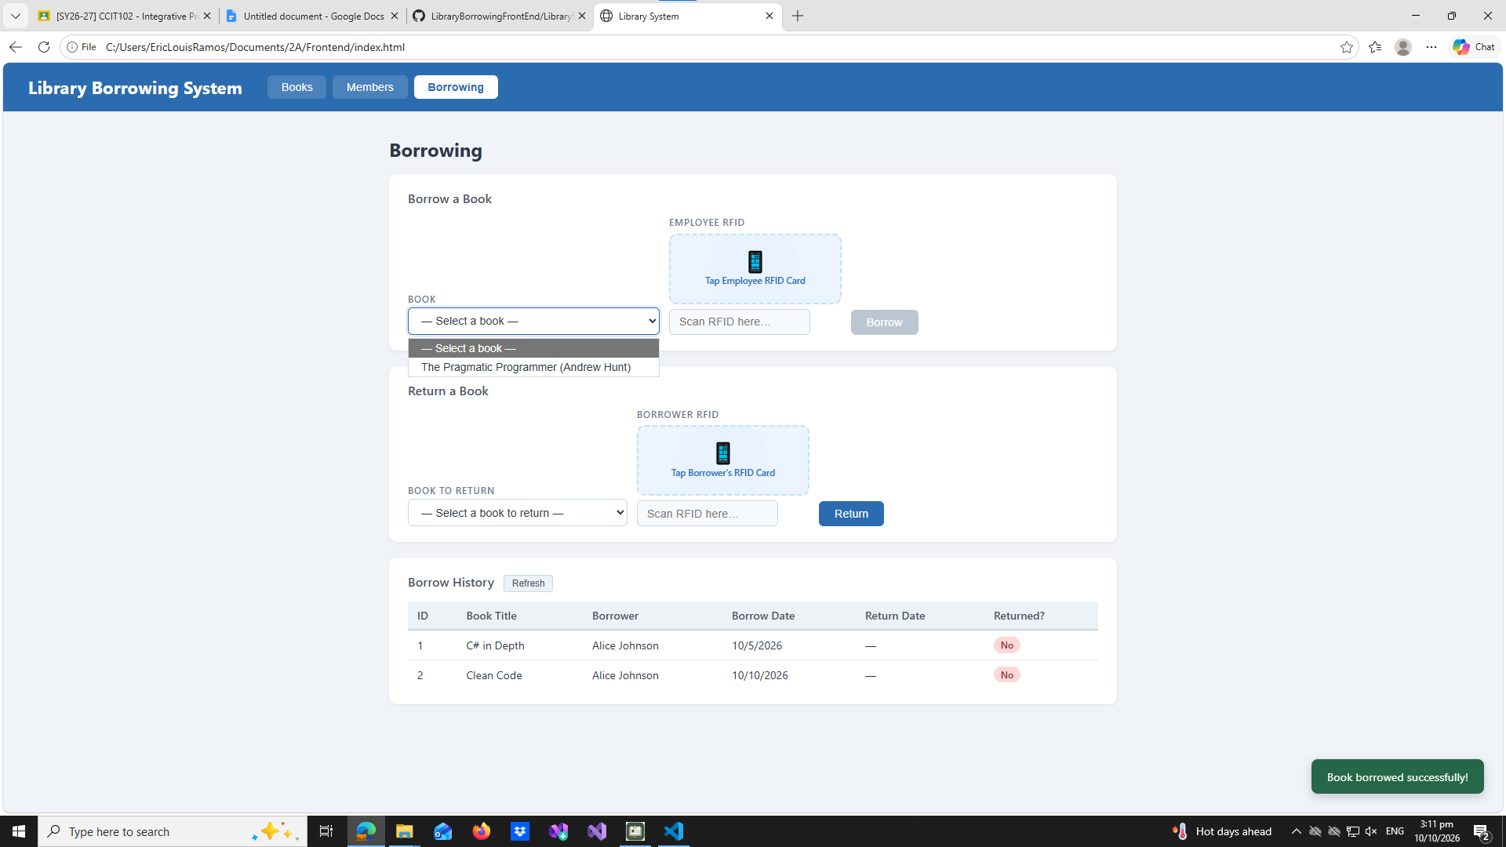

test-11-return-wrong-card
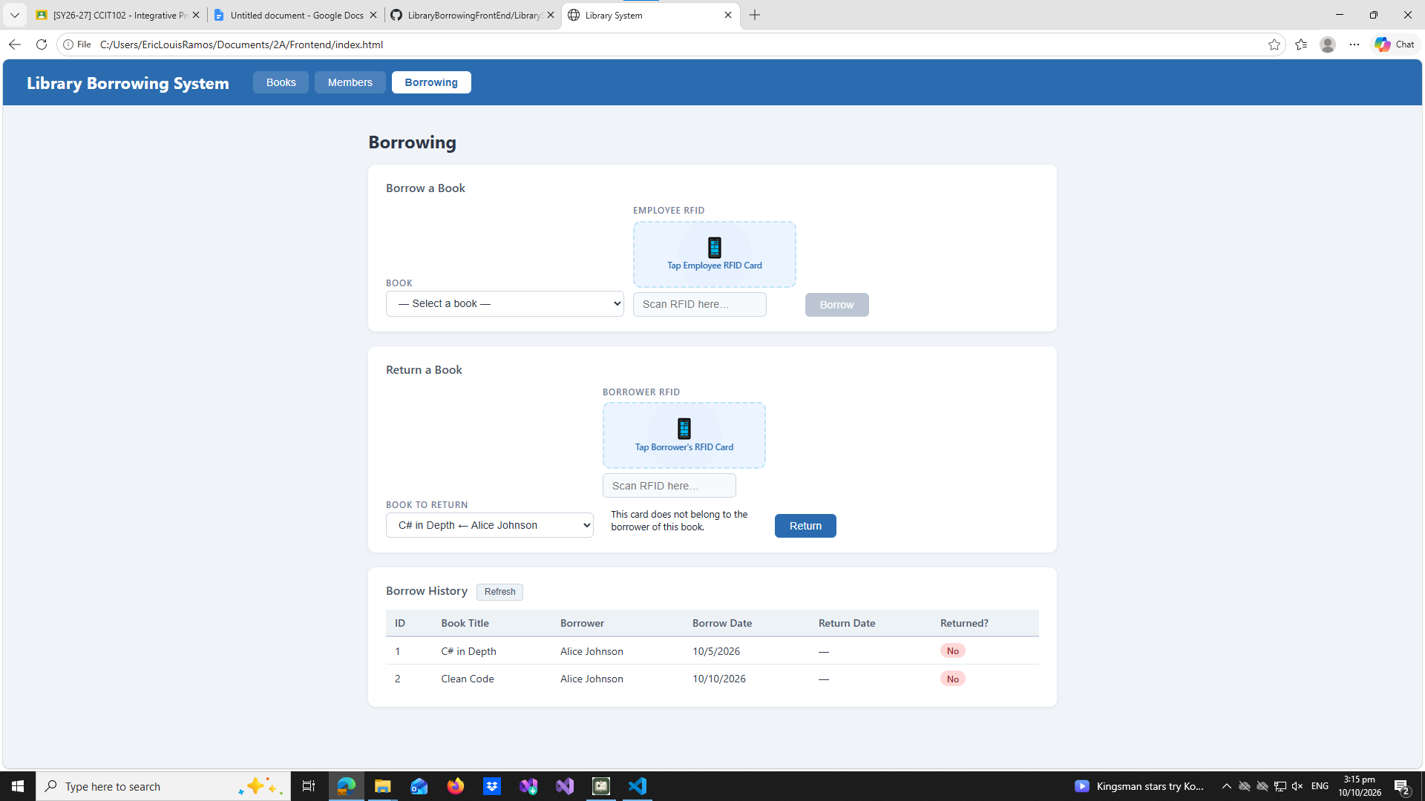

test-12-return-verified
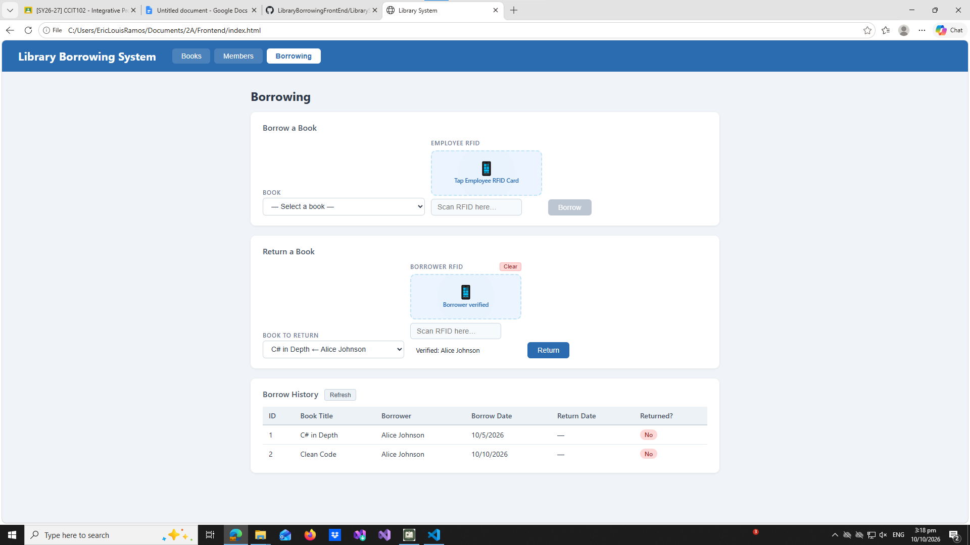

test-13-return-success
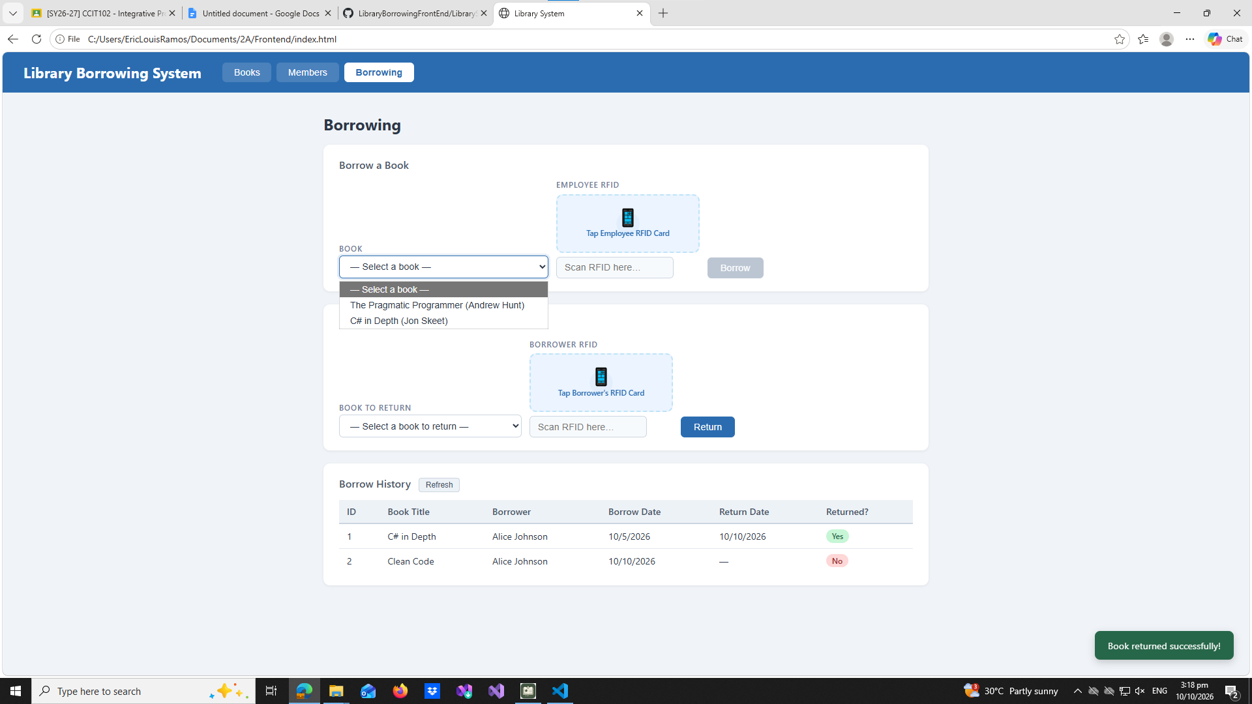

test-14-final-console
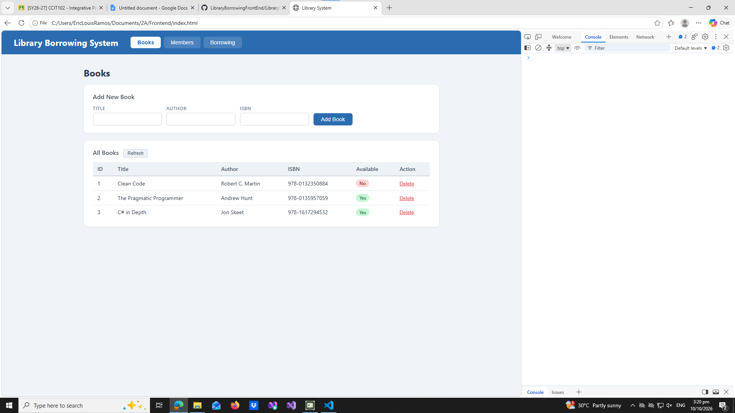

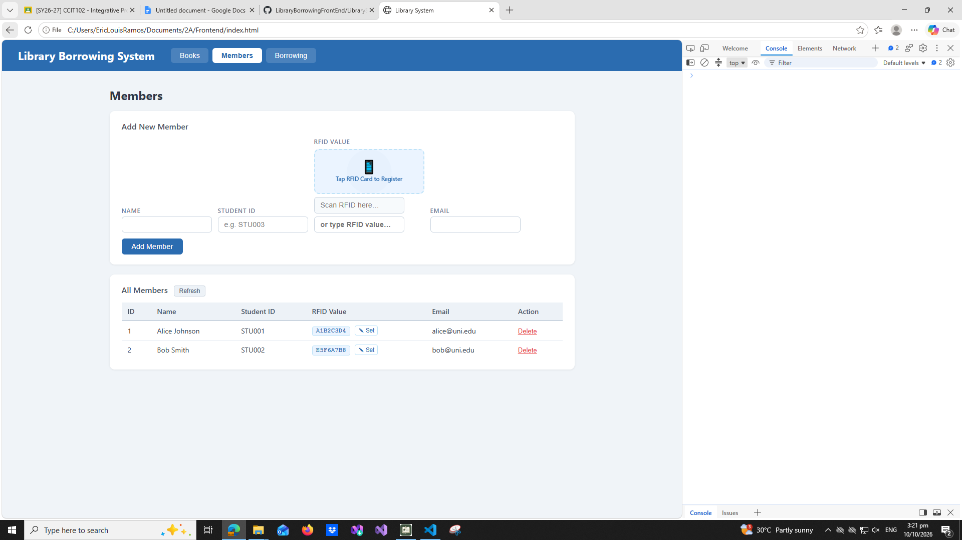

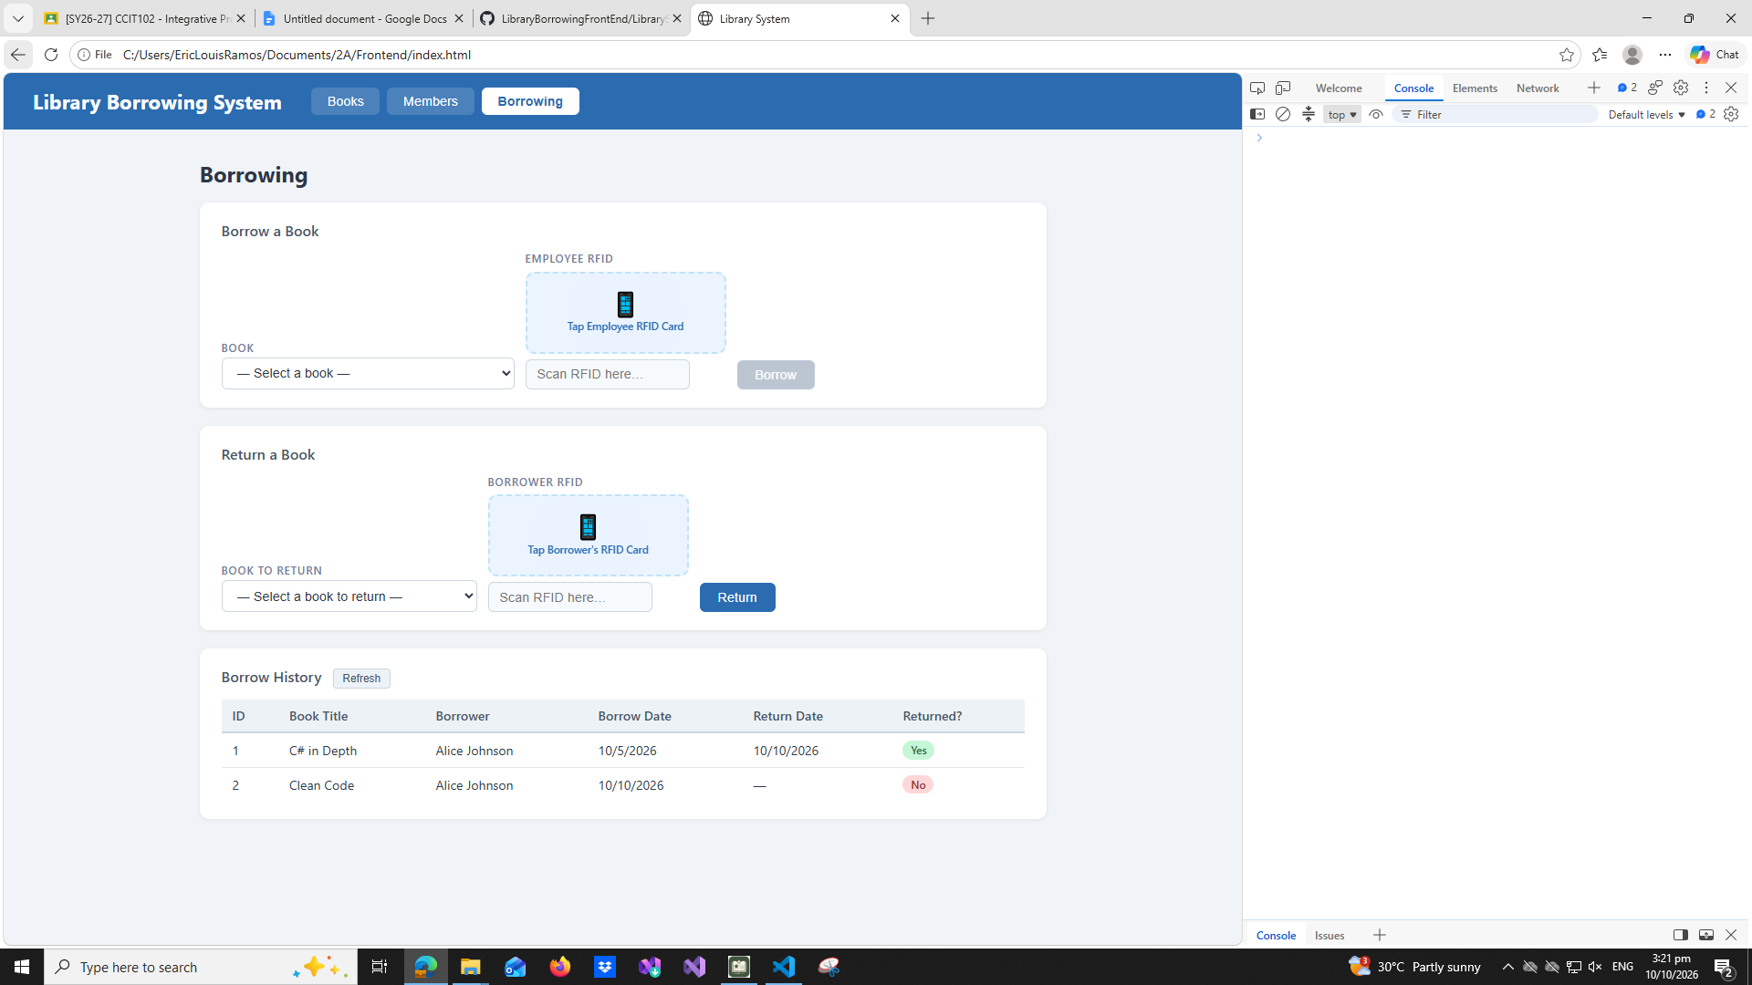

Reflection:

- What does apiFetch() do?
apiFetch() makes it so that doing a long fetch() will be unnecessary because it prevents repeated code.

- Why do we use try/catch around API calls?
To prevent the application from completely stopping or crashing when the executed code failed.

- What is the difference between POST and PUT?
POST creates a new block of data in the database, whereas PUT updates an existing block of data.

- Why does RFID matching use rfidValue instead of studentId?
Because the RFID scanner matches a specific rfidValue in the cachedMembers and that rfidValue is different from studentId.

- Why do we refresh tables after adding, deleting, borrowing, or returning?
To display the latest changes to the frontend, allowing users to know that their action was successful.

- Why does the Return dropdown use borrow record ID instead of book ID?
Because, if we look at this in a database perspective, borrow record ID is the identifier that is directly equal to the record including the book ID.

- What happens if the same event listener is added to a form twice?
The action or request will be performed twice.

- Why must the page-load code be at the bottom of the file?
So that the other functions will be known to the page-load code. The nature of coding is that it reads starting from the top to bottom.

- Why does an RFID reader need e.preventDefault() on the Enter key?
To prevent the default action of reloading the page.

