Dave Miko B. Claveria
BSIT – 2A

Screenshot 1
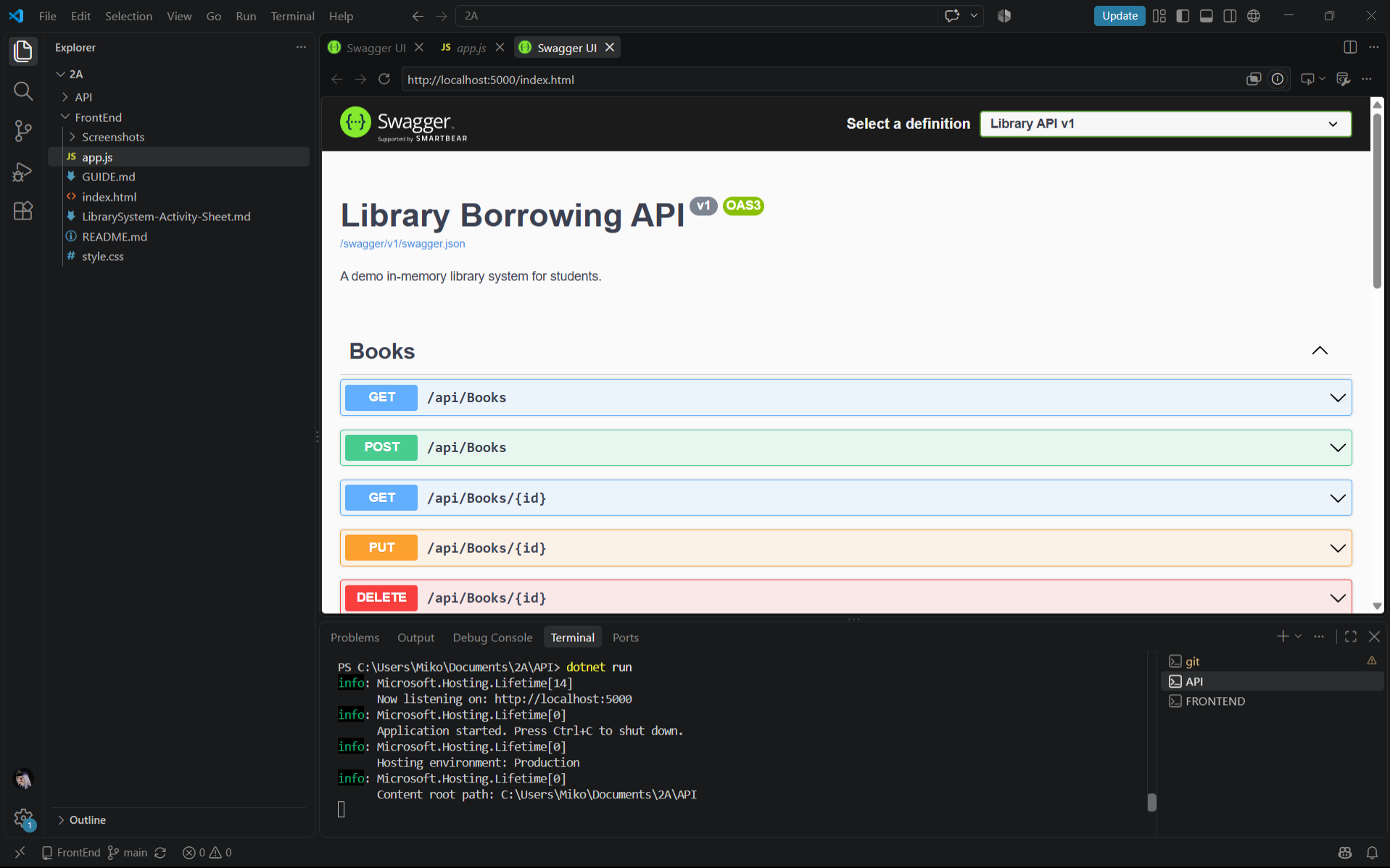

Screenshot 2
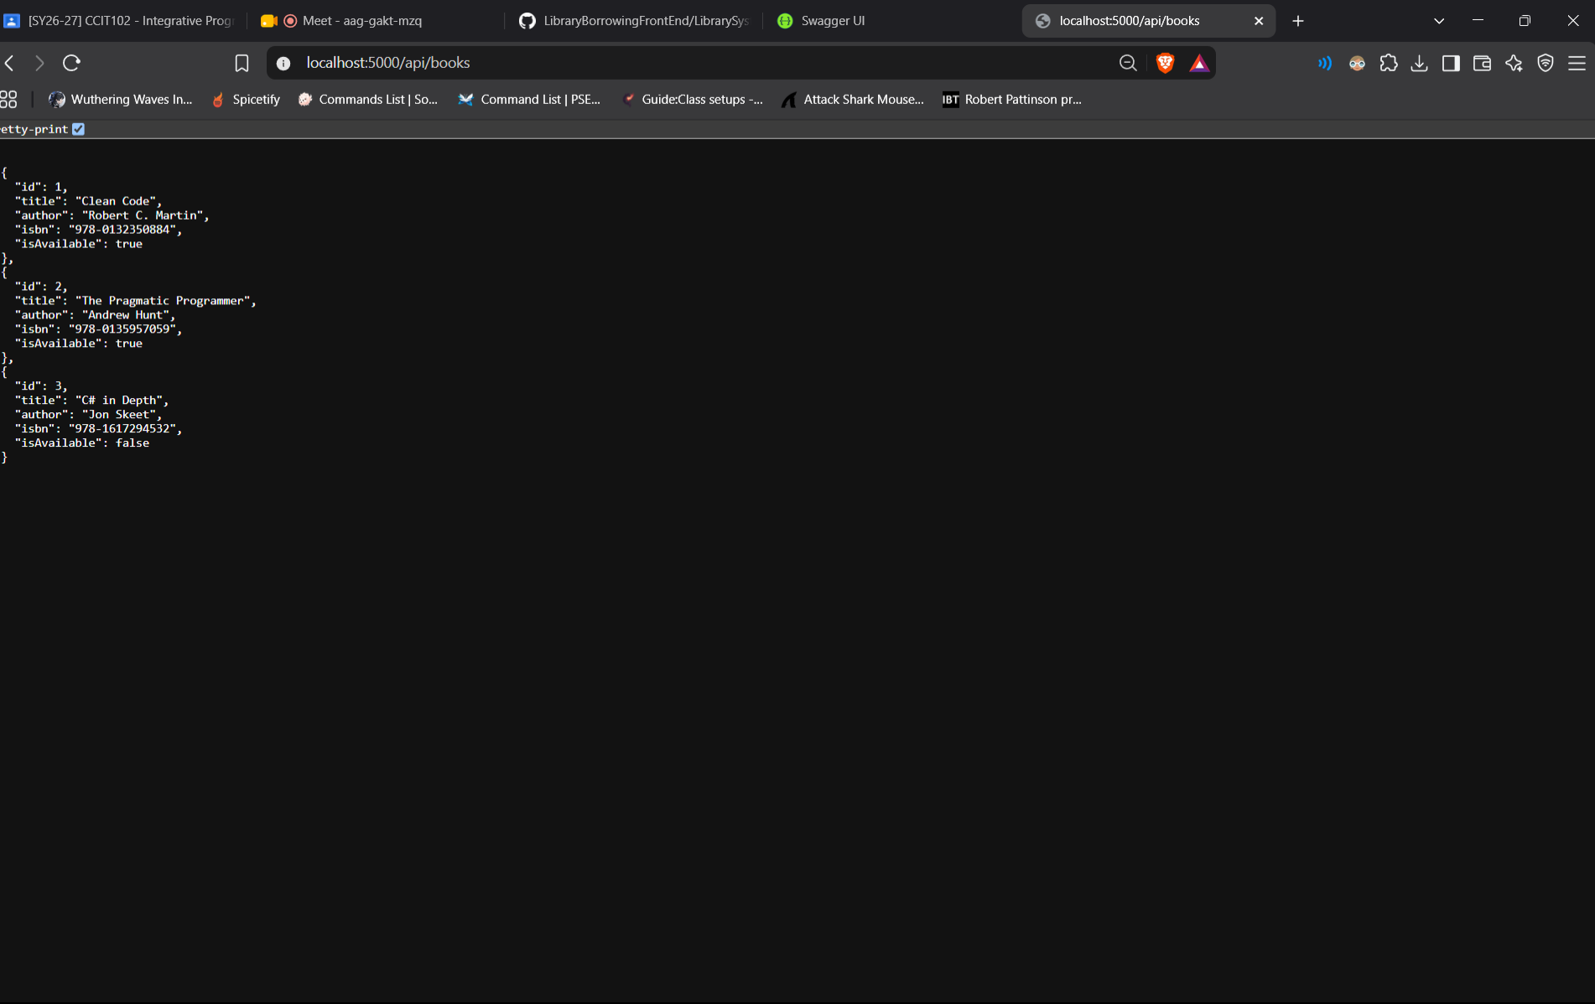

Part-01-settings-apifetch
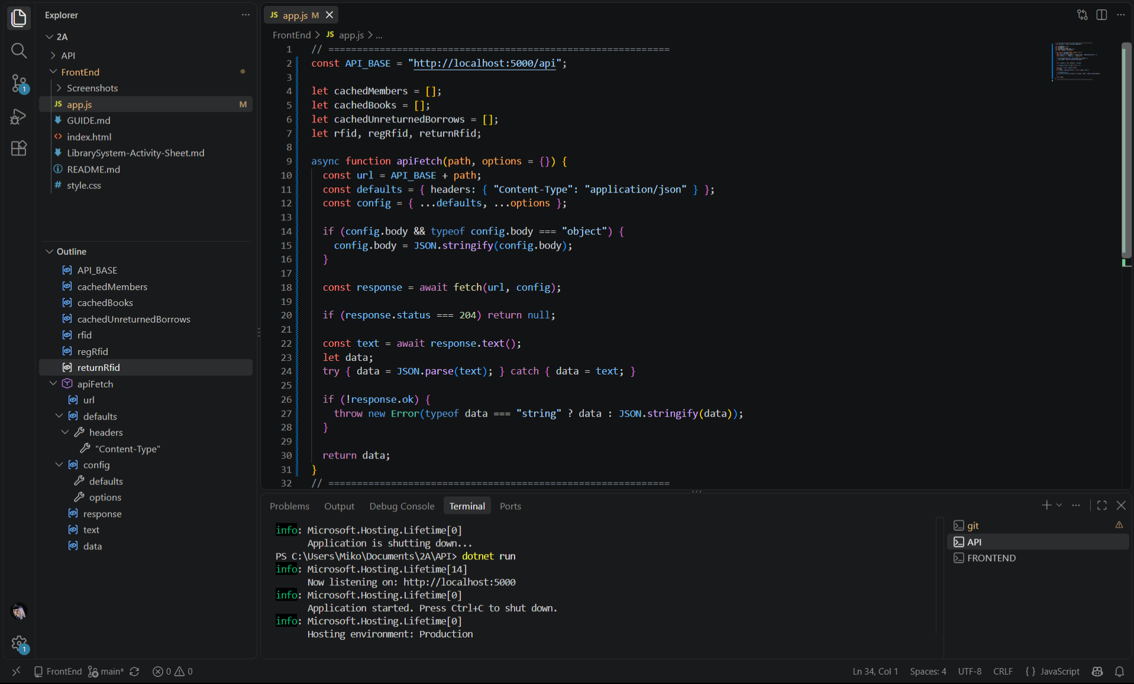

part-02-showtoast
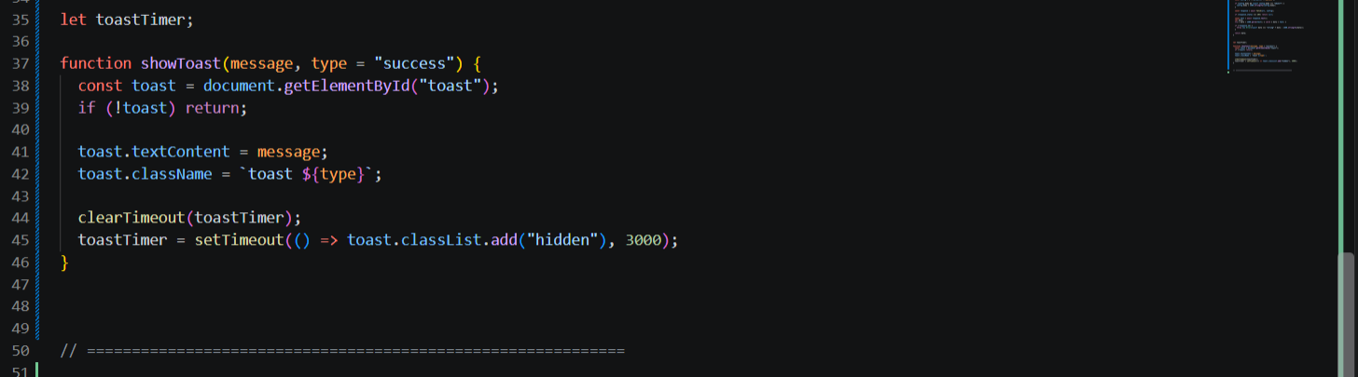

early-01-toast
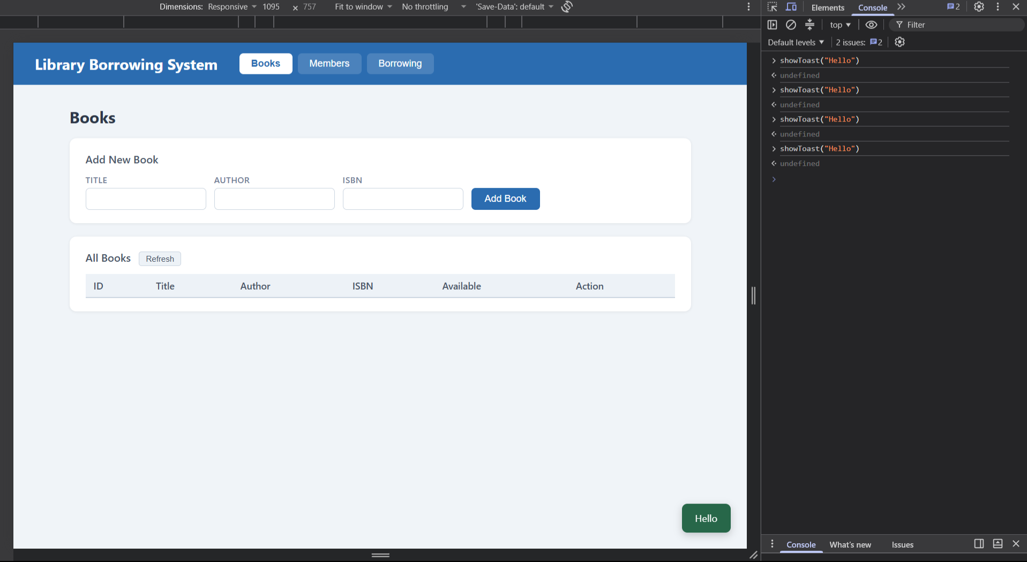
part-03-caches
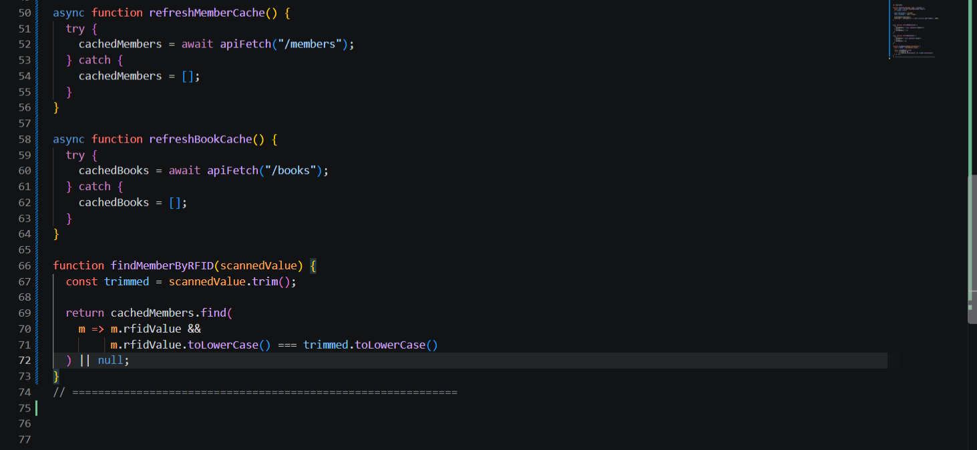

early-02-cache-console
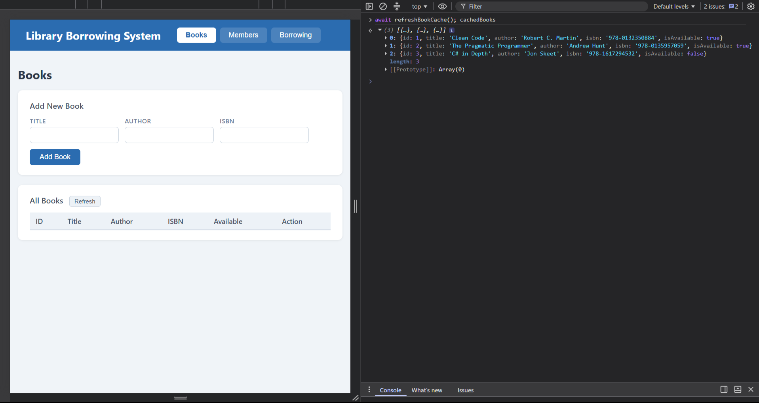

Part-04-tabs-refresh
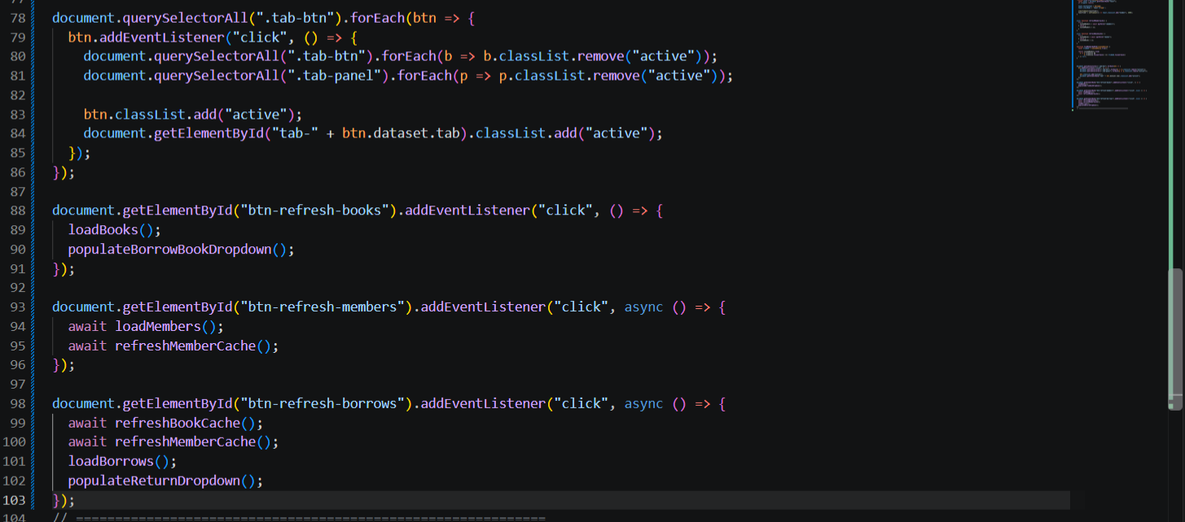

early-03-tabs
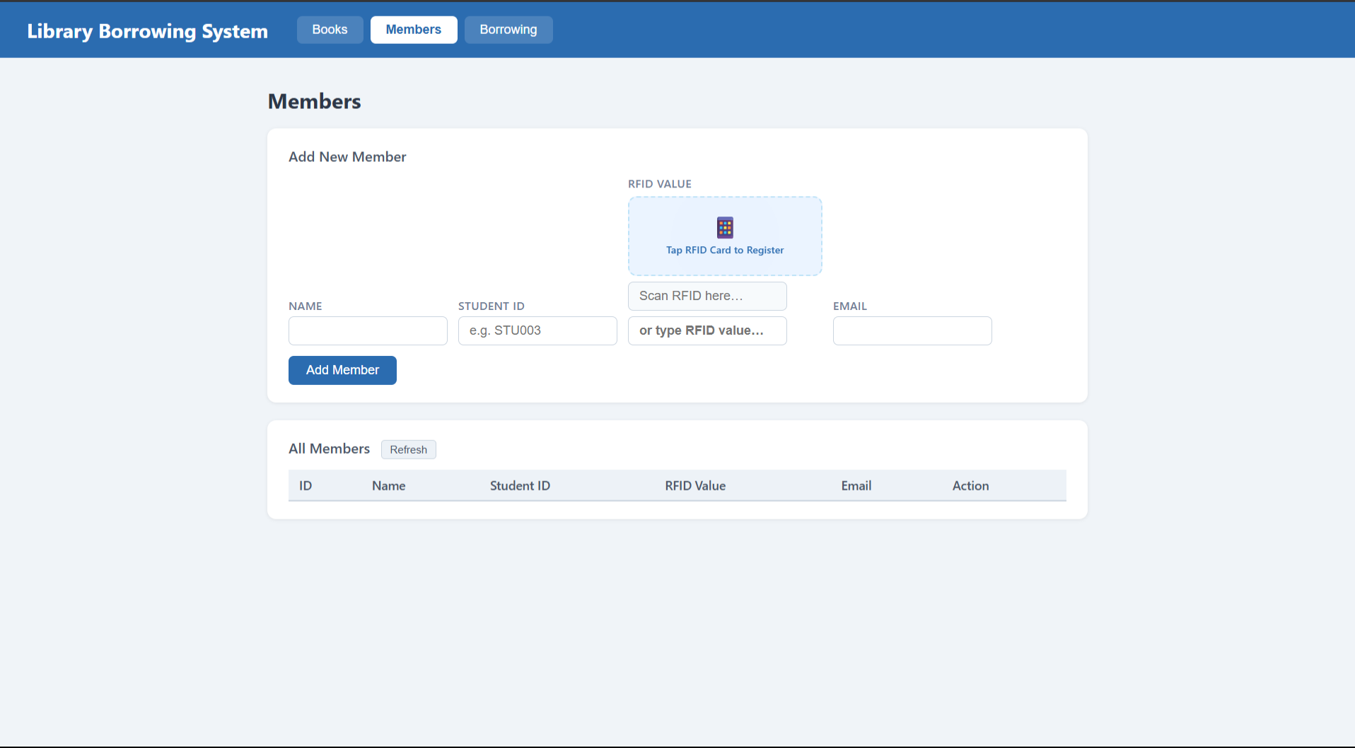
part-05-loadbooks
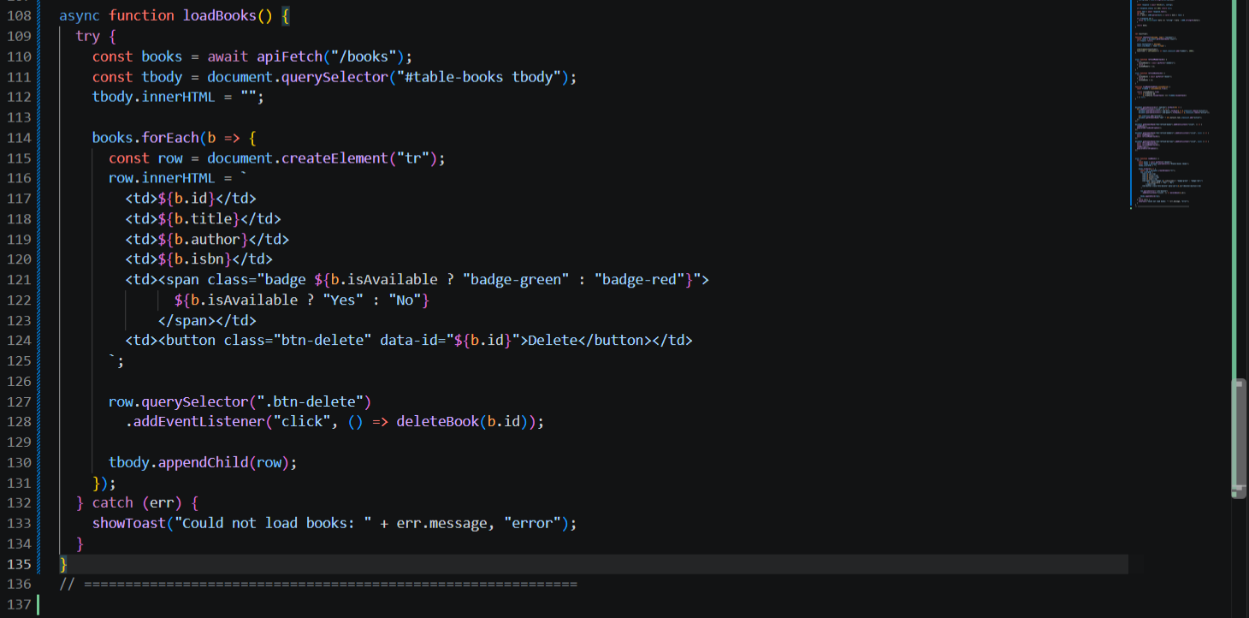

part-06-deletebook
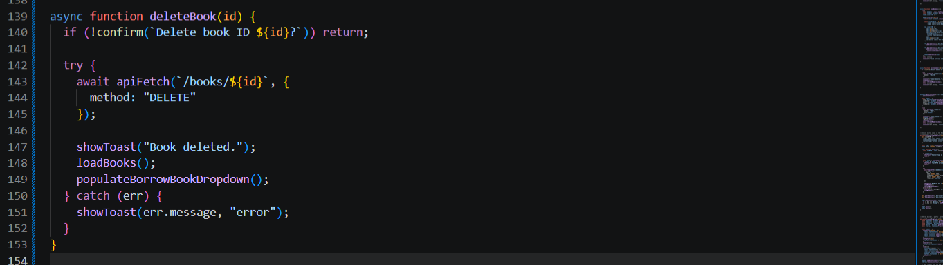
part-07-addbook
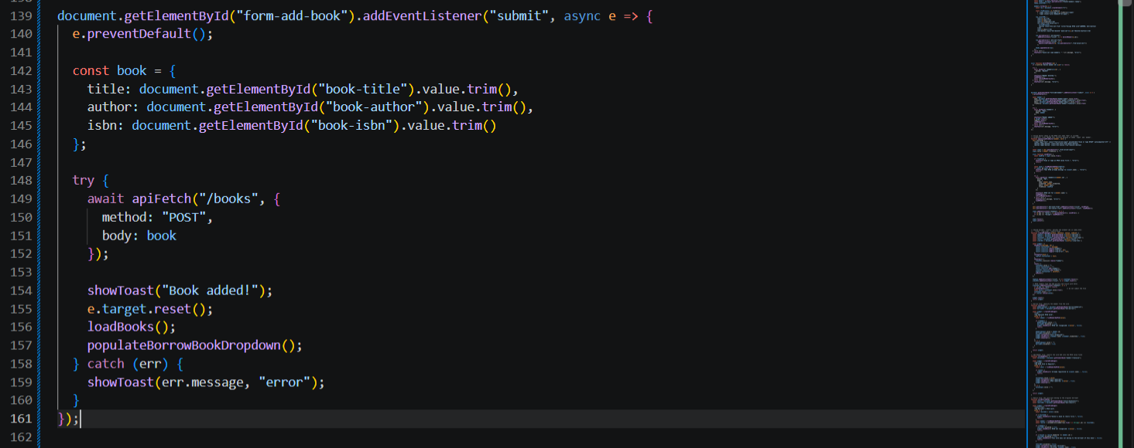

part-08-loadmembers
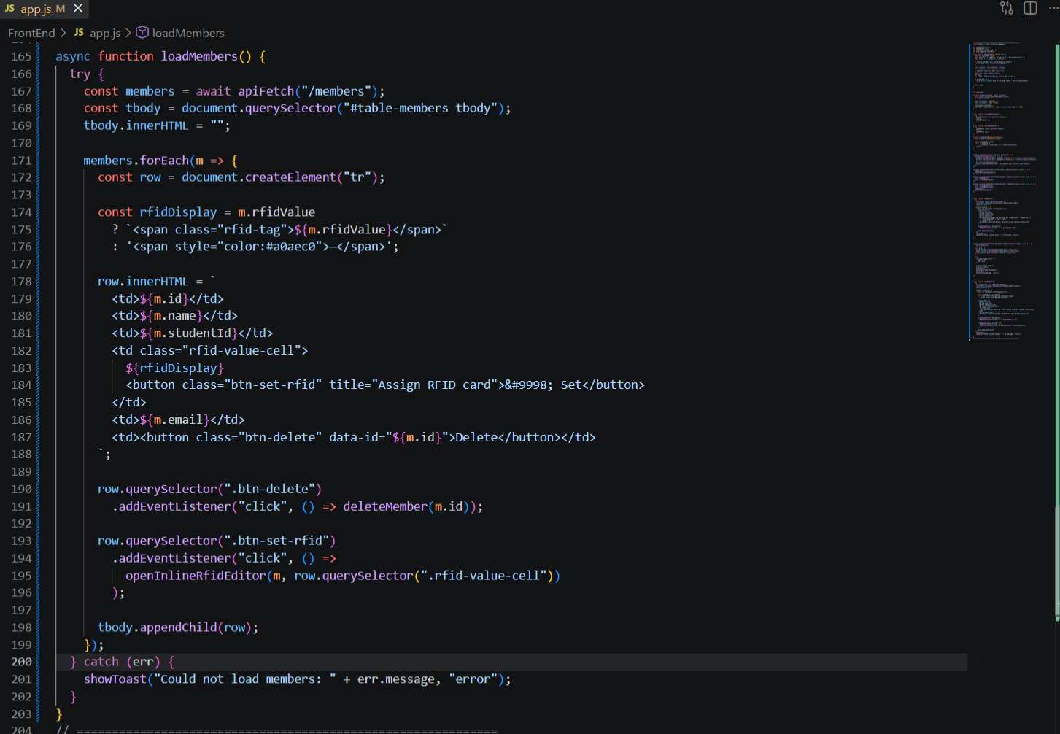
part-09-deletemember
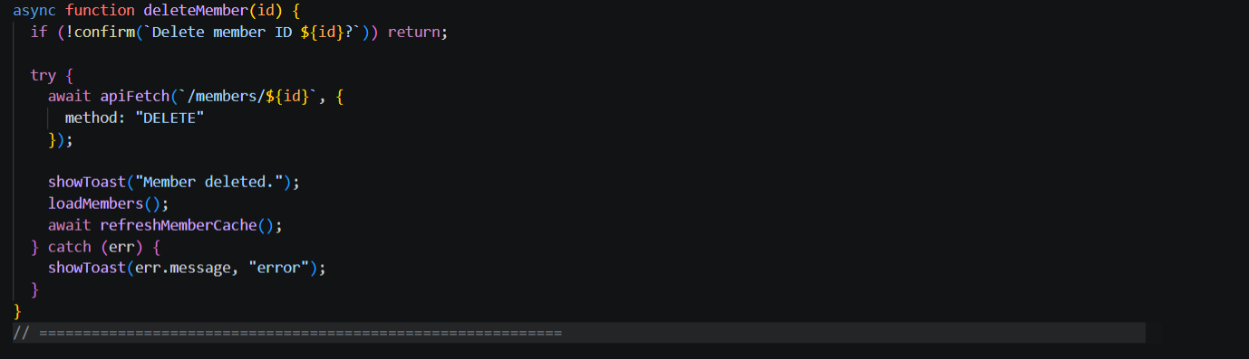

part-10-addmember
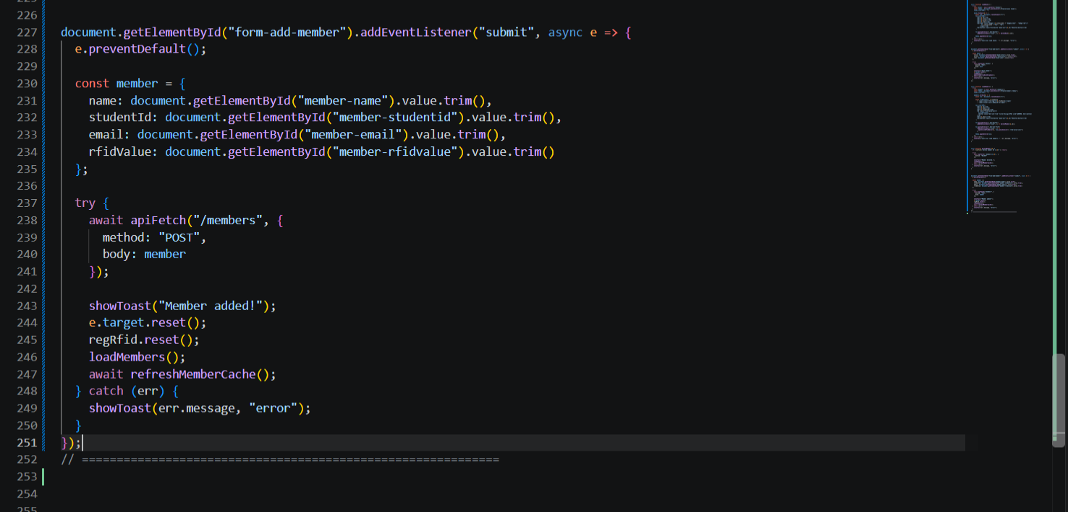

part-11a-inline-rfid-editor
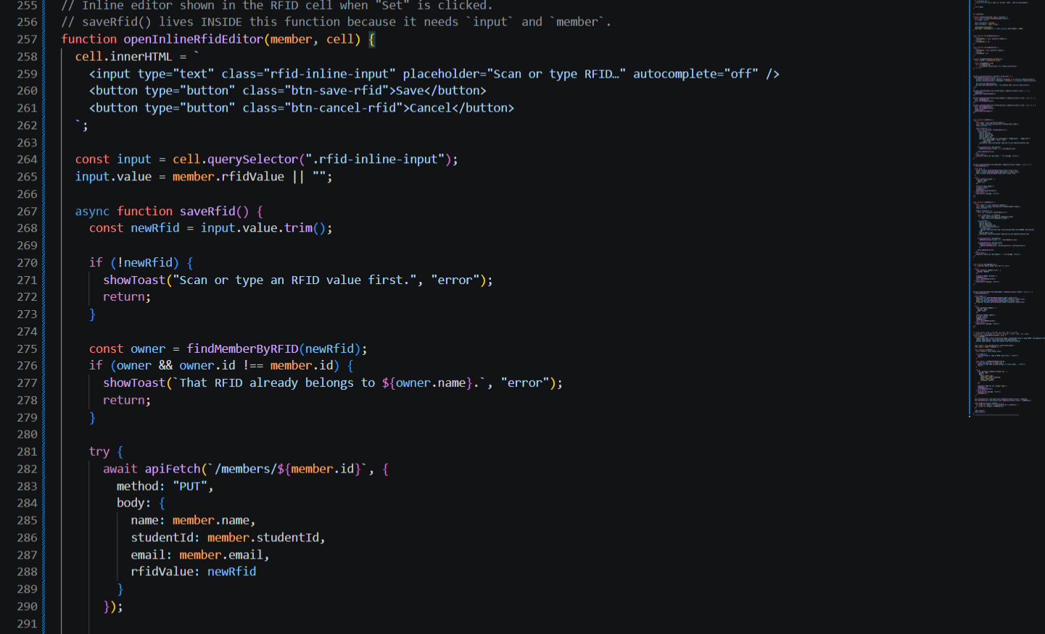

part-11b-inline-rfid-editor
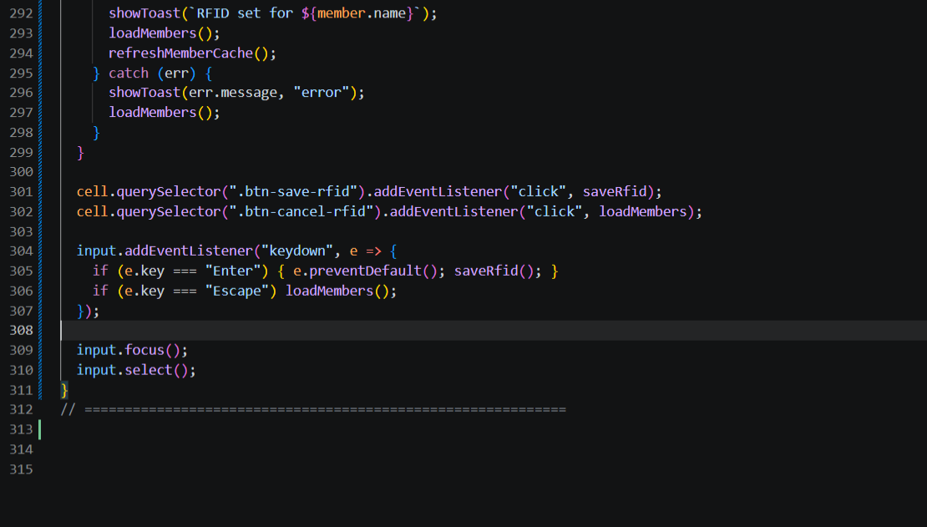
part-12a-rfid-widget-builder
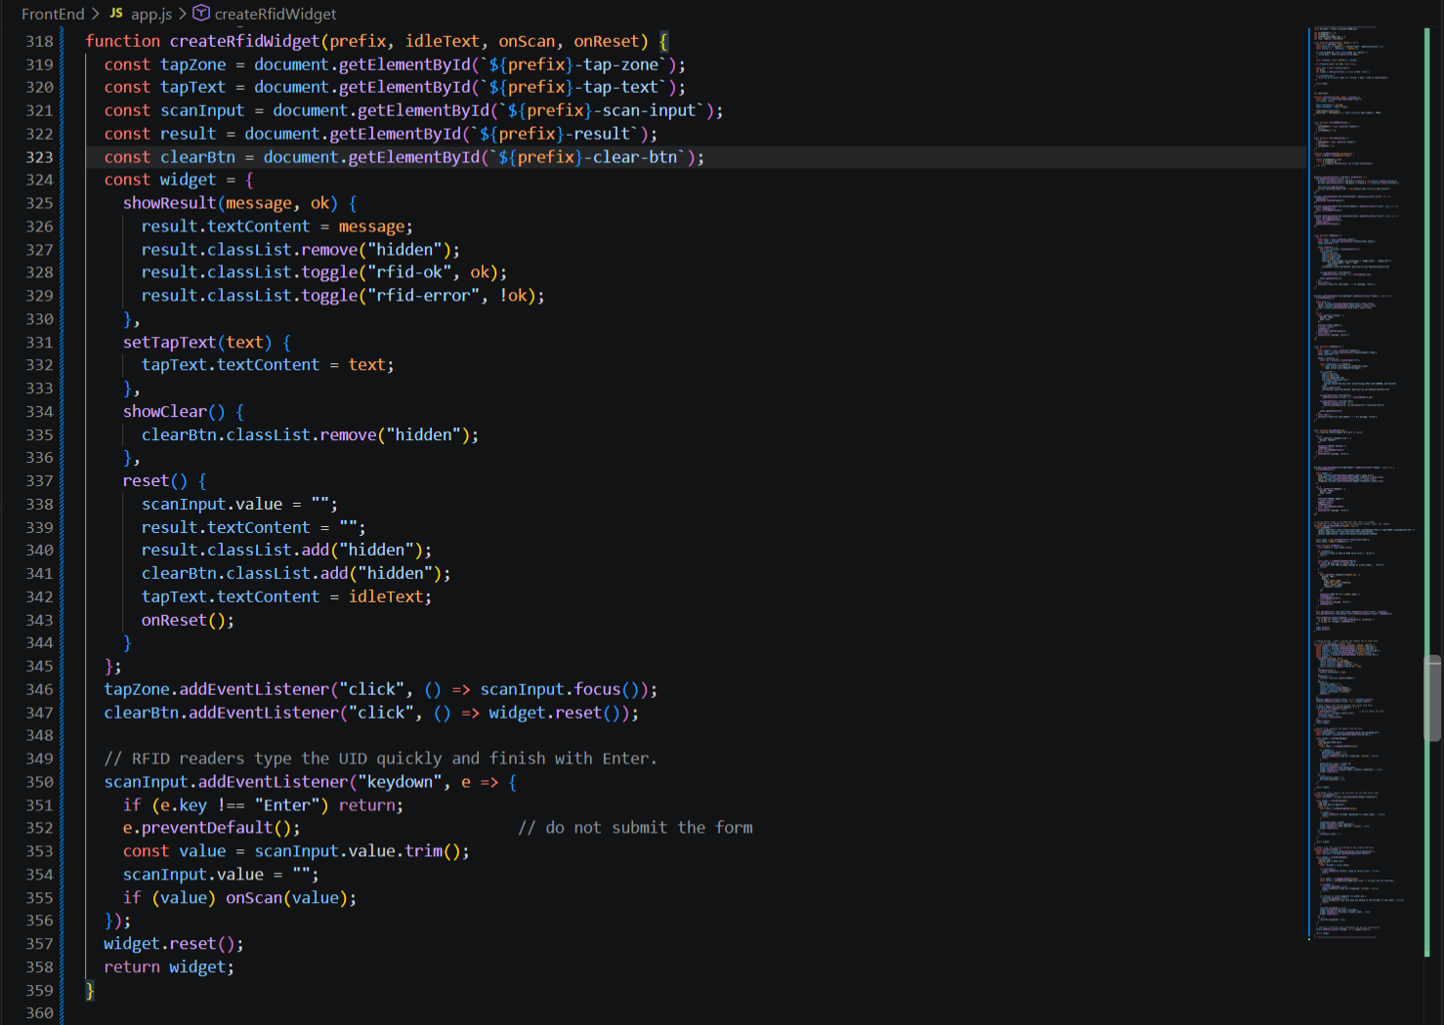

part-12b-rfid-widget-builder
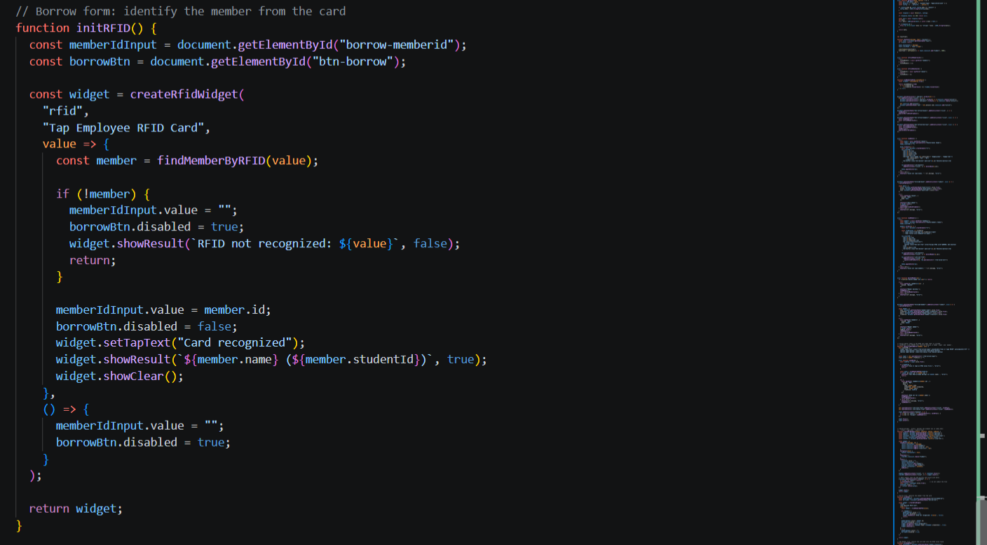

part-12b-rfid-widget-builder
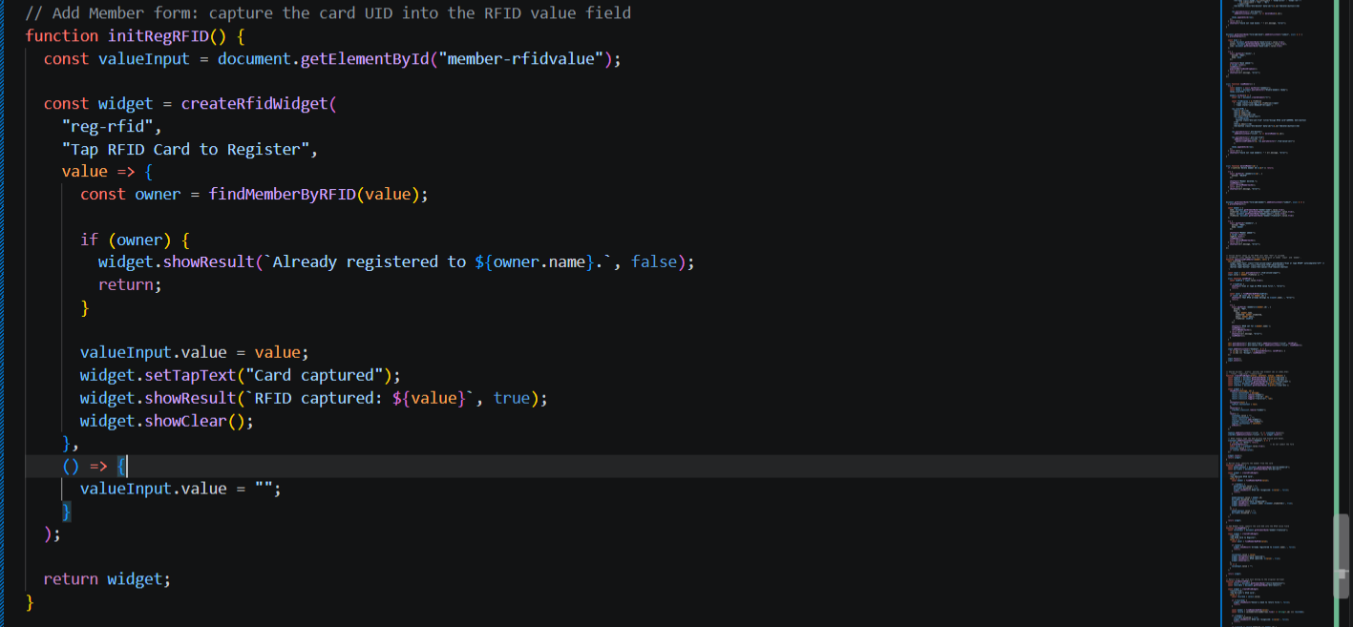
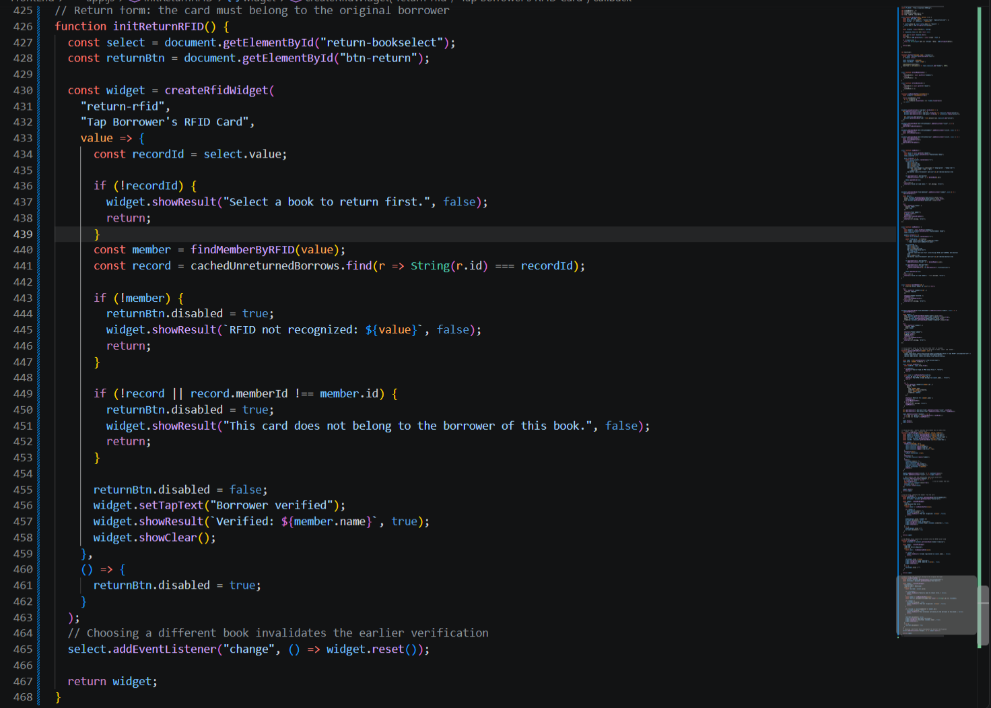

part-13-borrow-dropdown
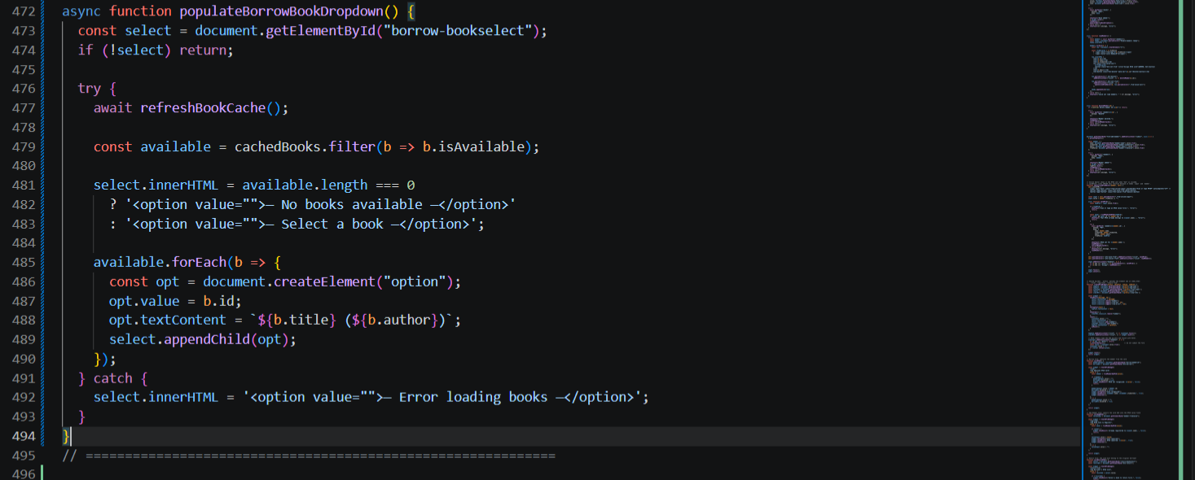

part-14-return-dropdown
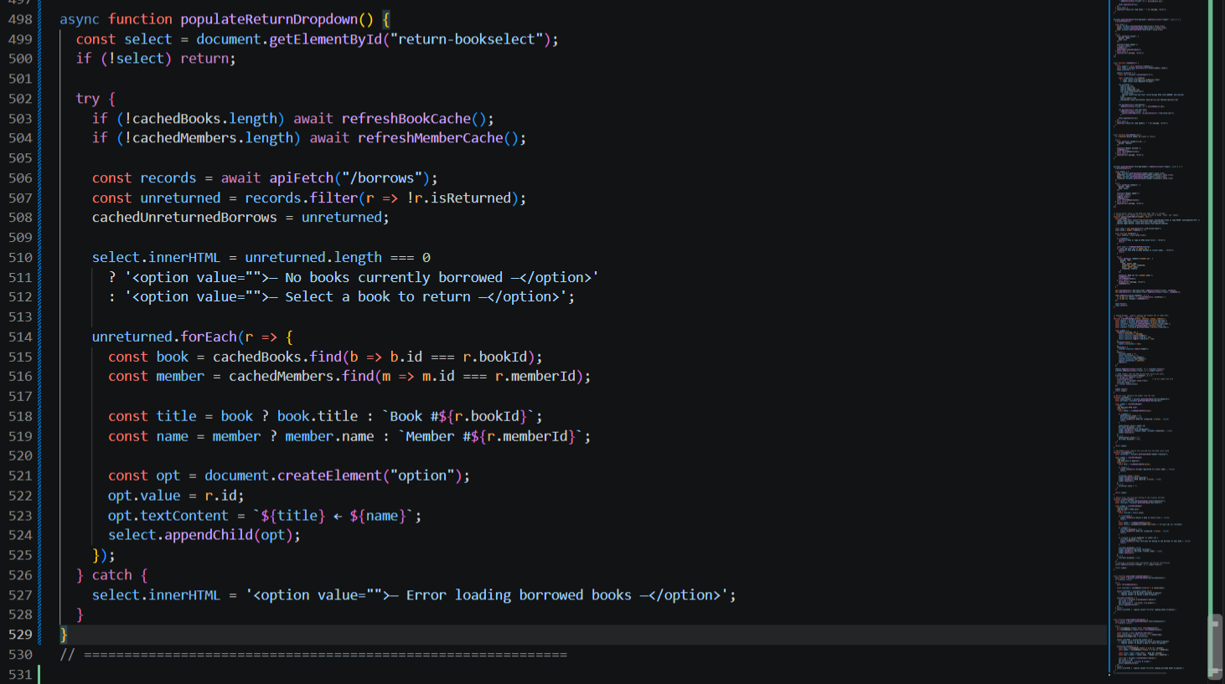
part-15-borrow
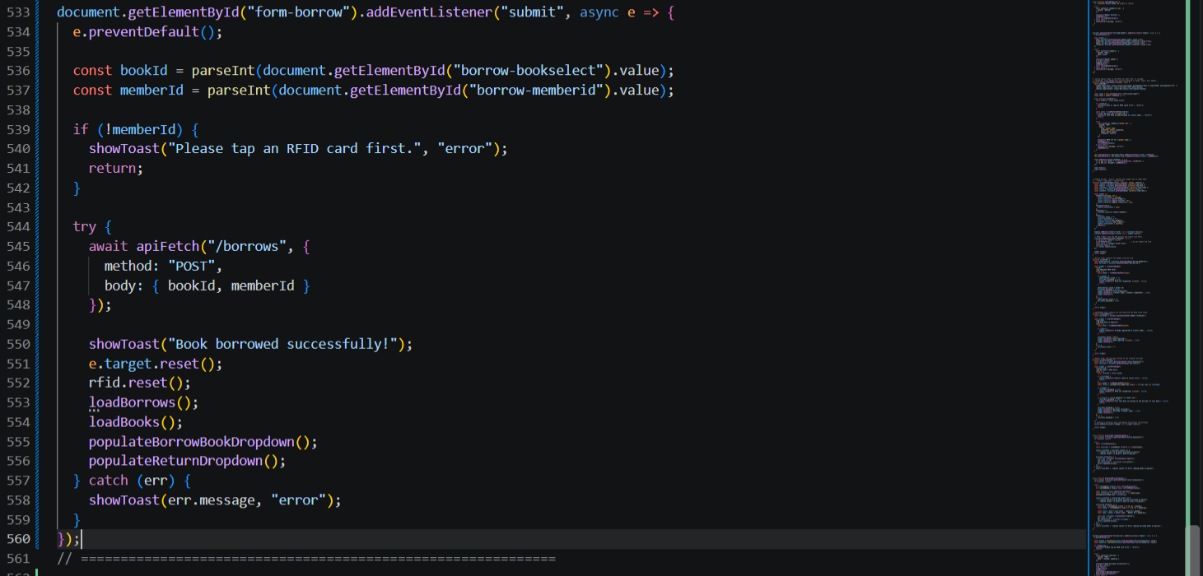

part-16-return
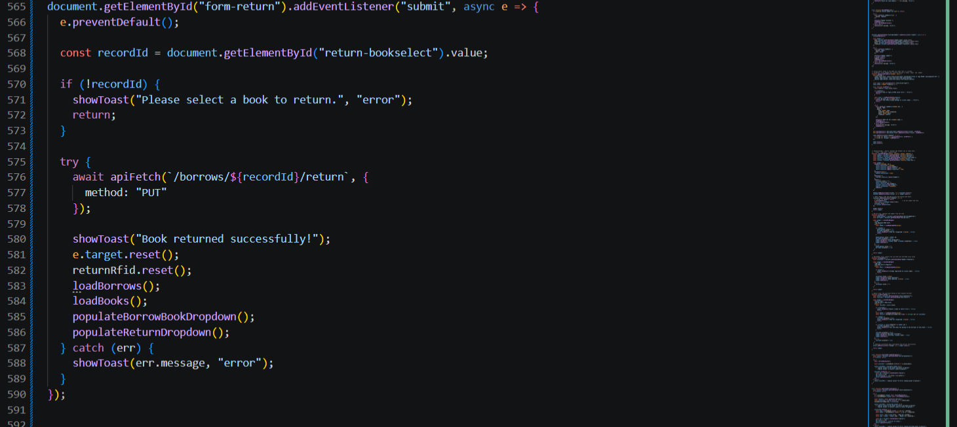

part-17-loadborrows
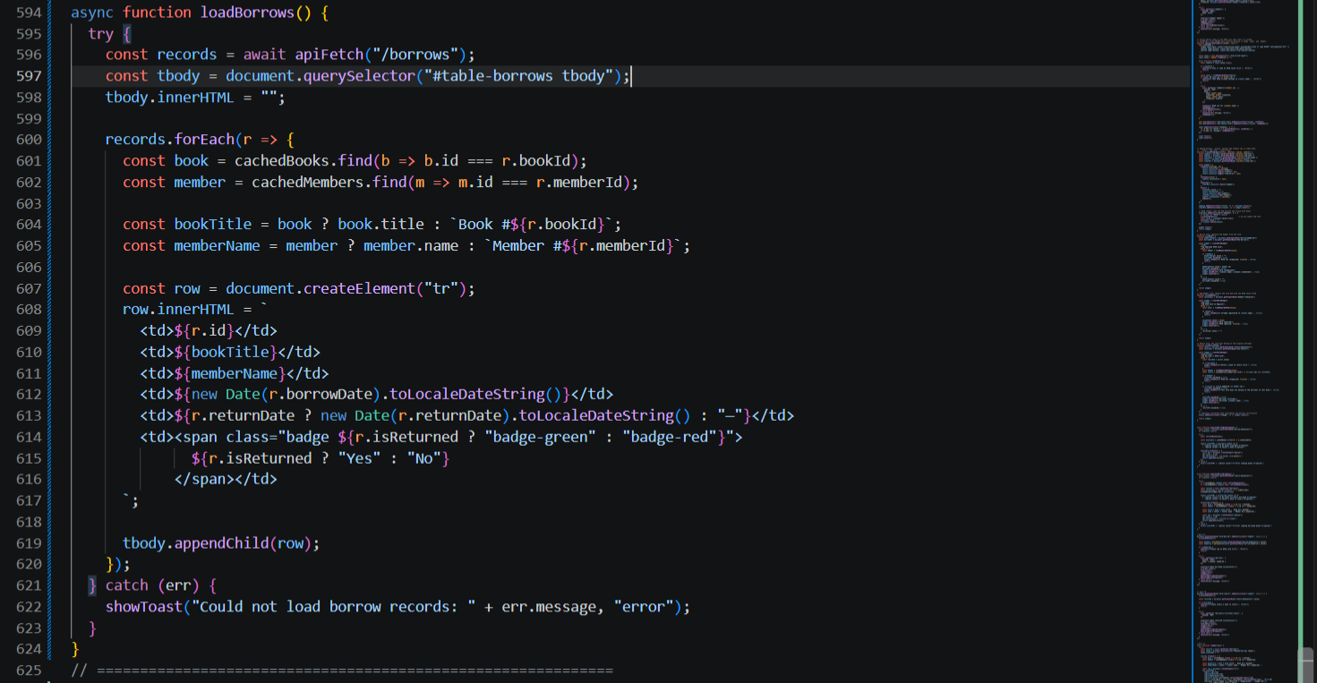

part-18-page-load
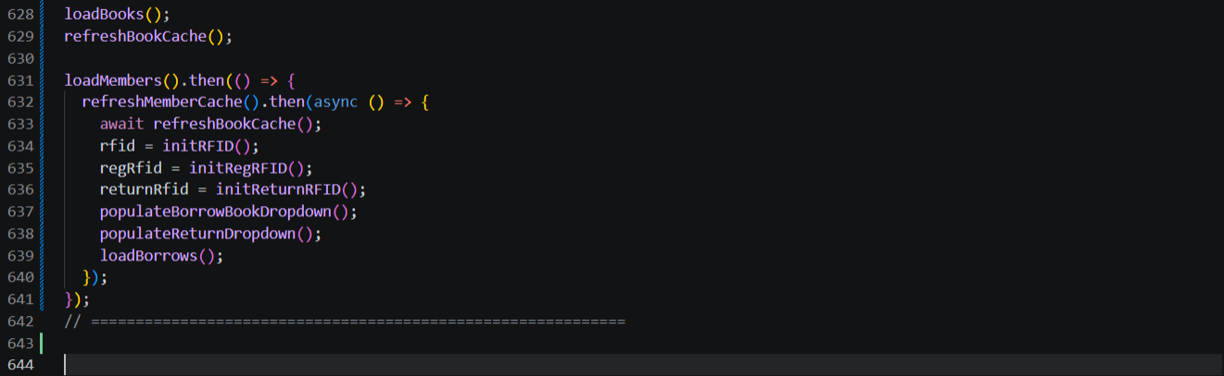

test-01-page-loaded
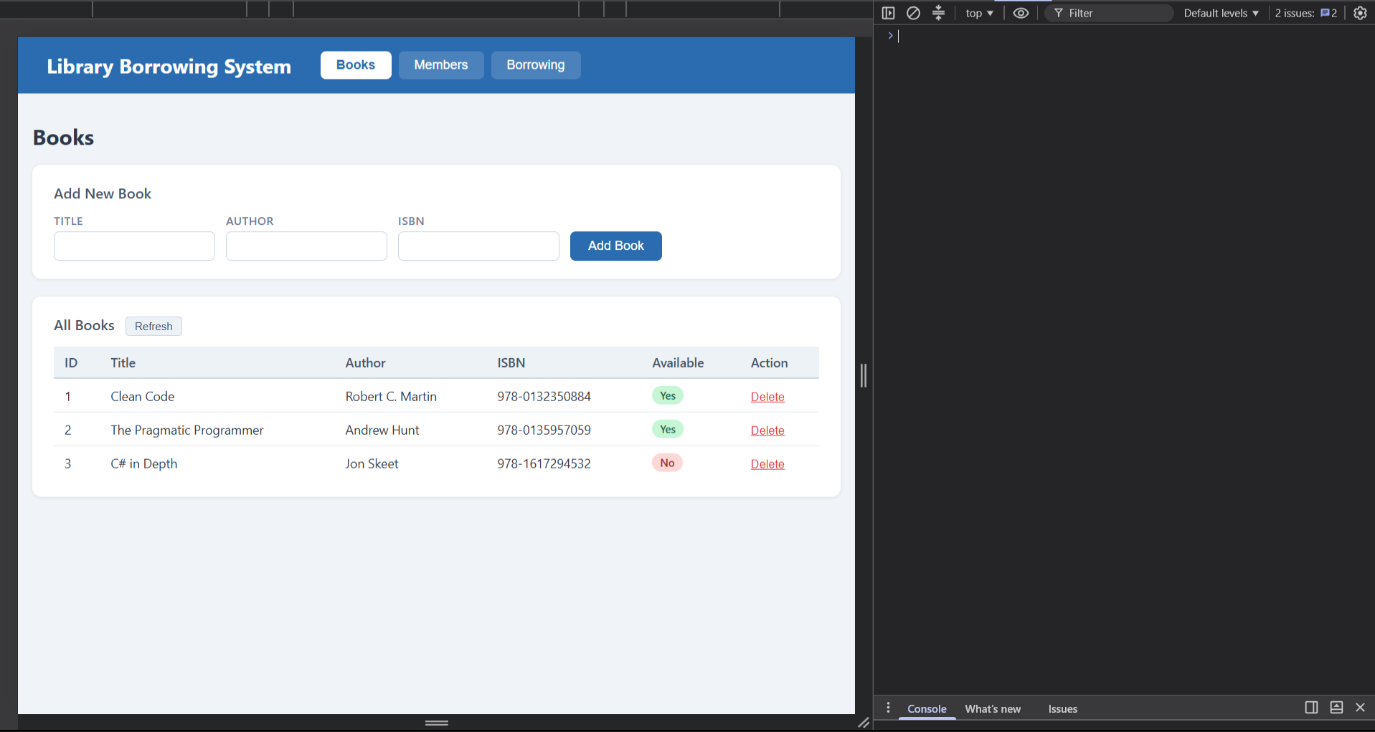

test-03-tabs

test-04-members-loaded
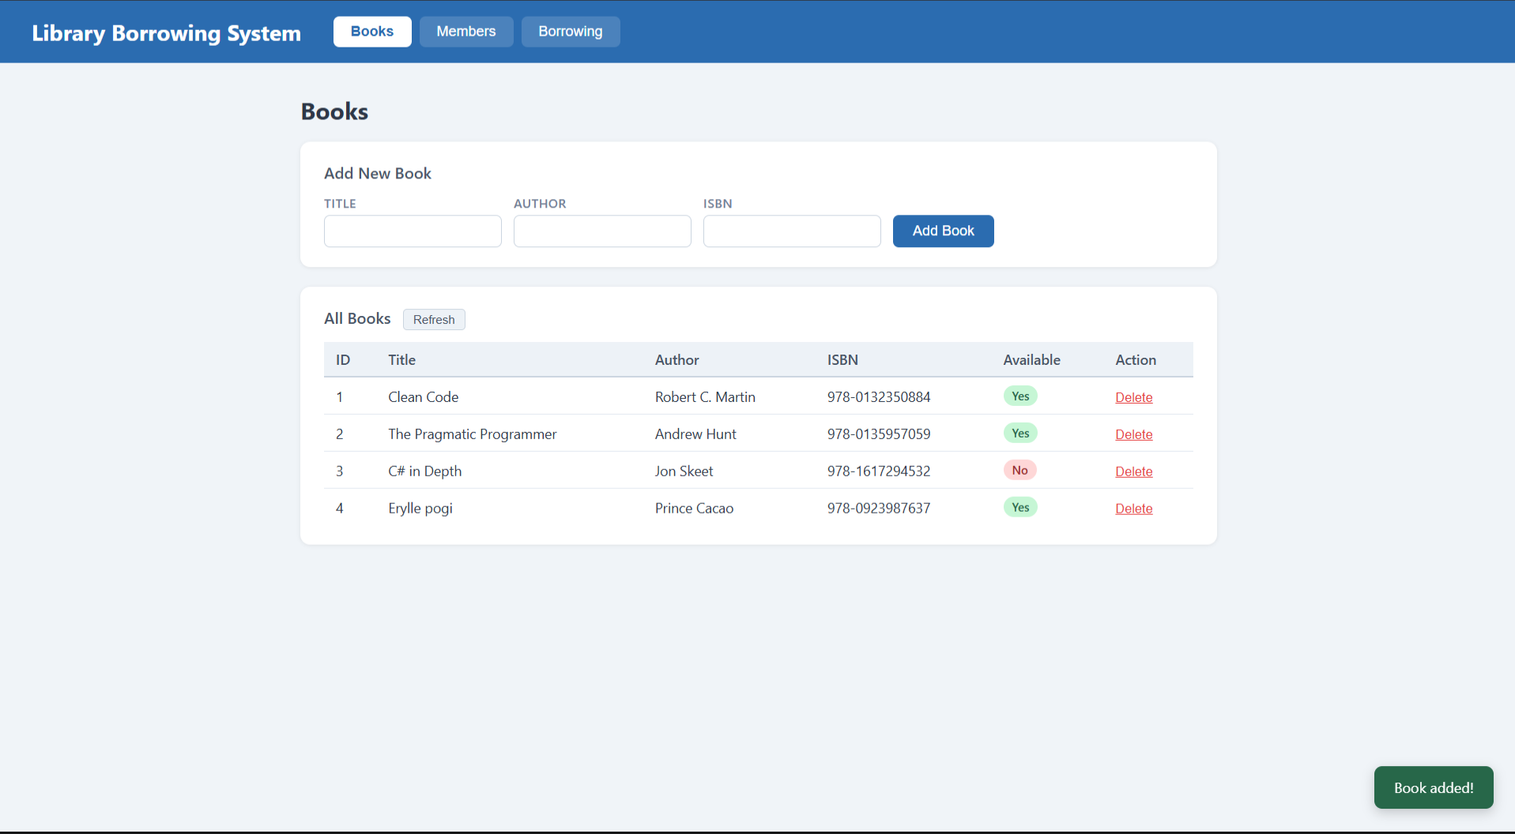
test-03-delete-book
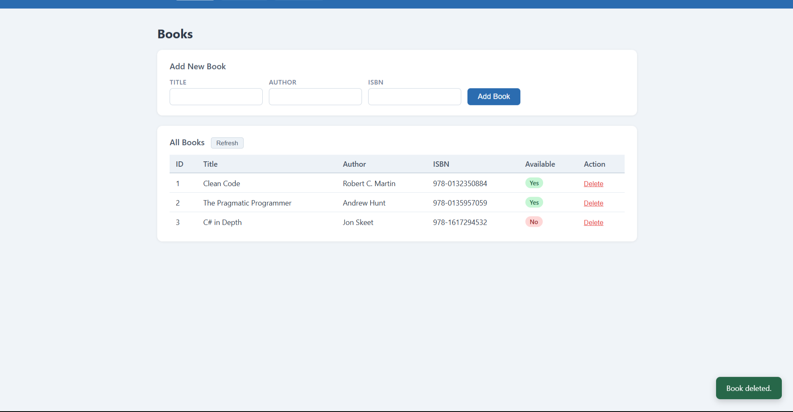

test-04-members-loaded
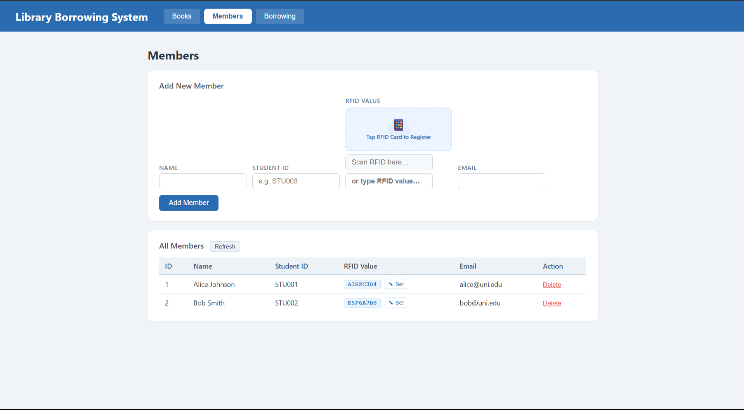
test-05-register-rfid
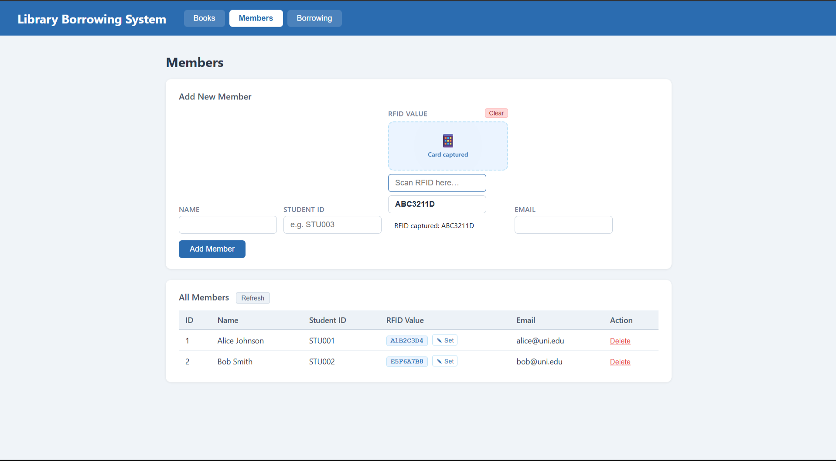

test-06-add-member
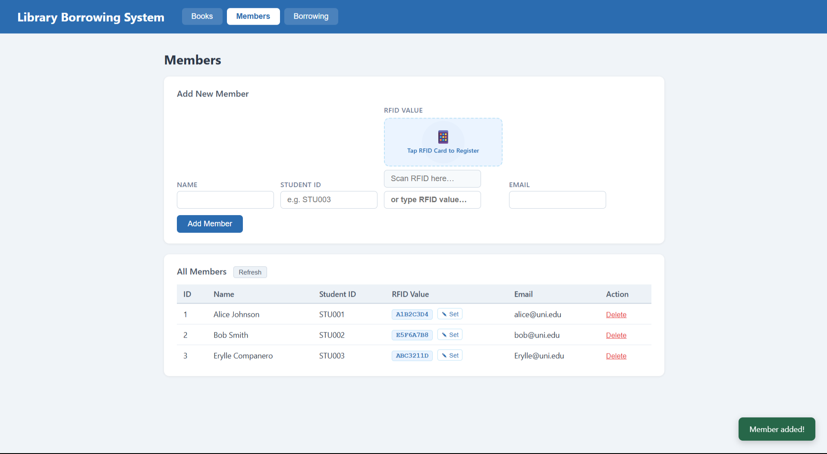
test-07-set-rfid-saved
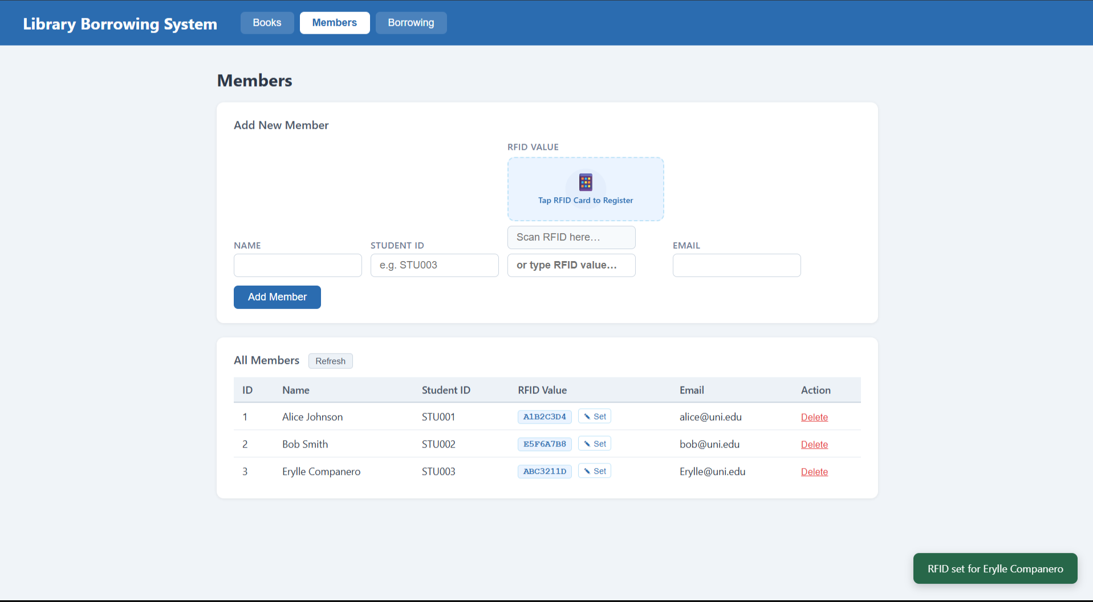

test-08-delete-member
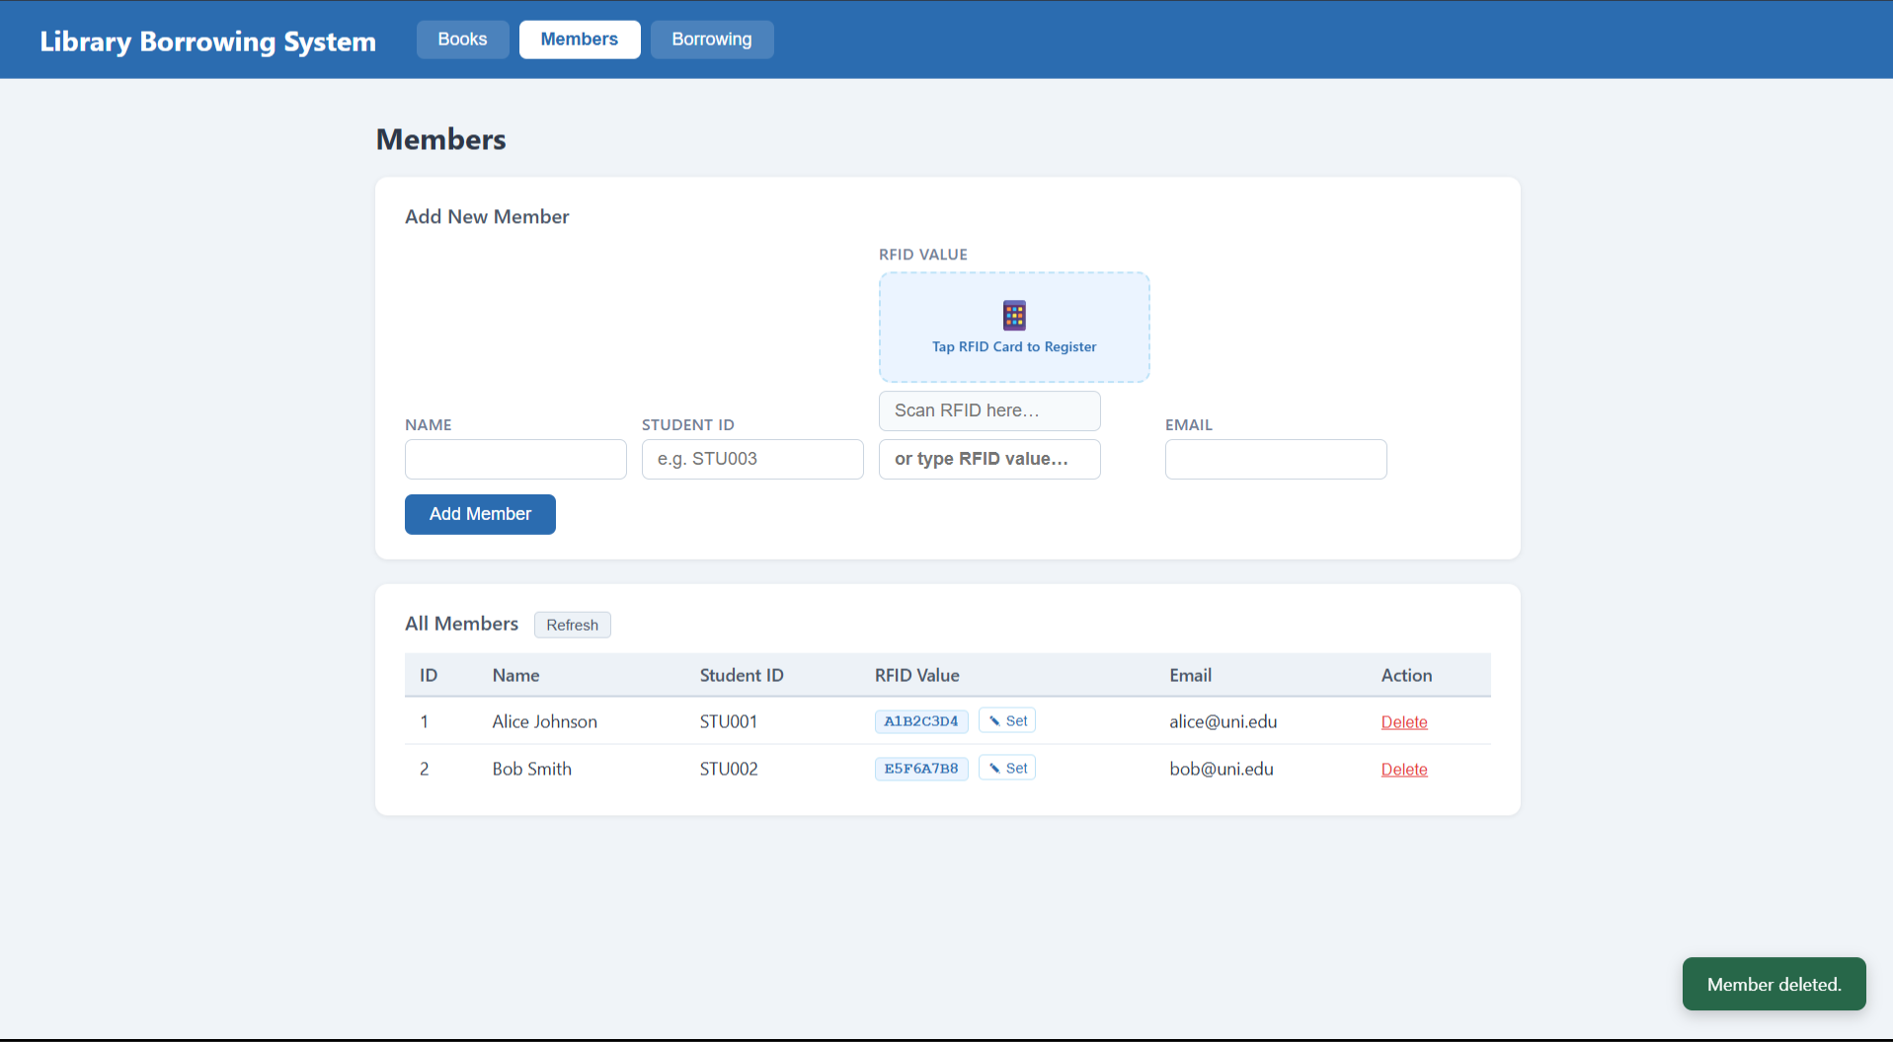
test-09-borrow-rfid-recognized
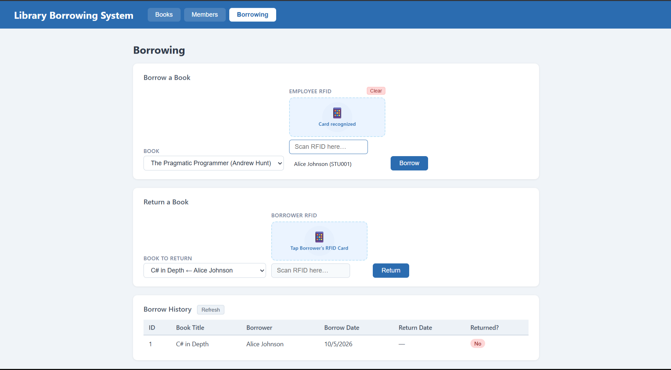

test-10-borrow-success
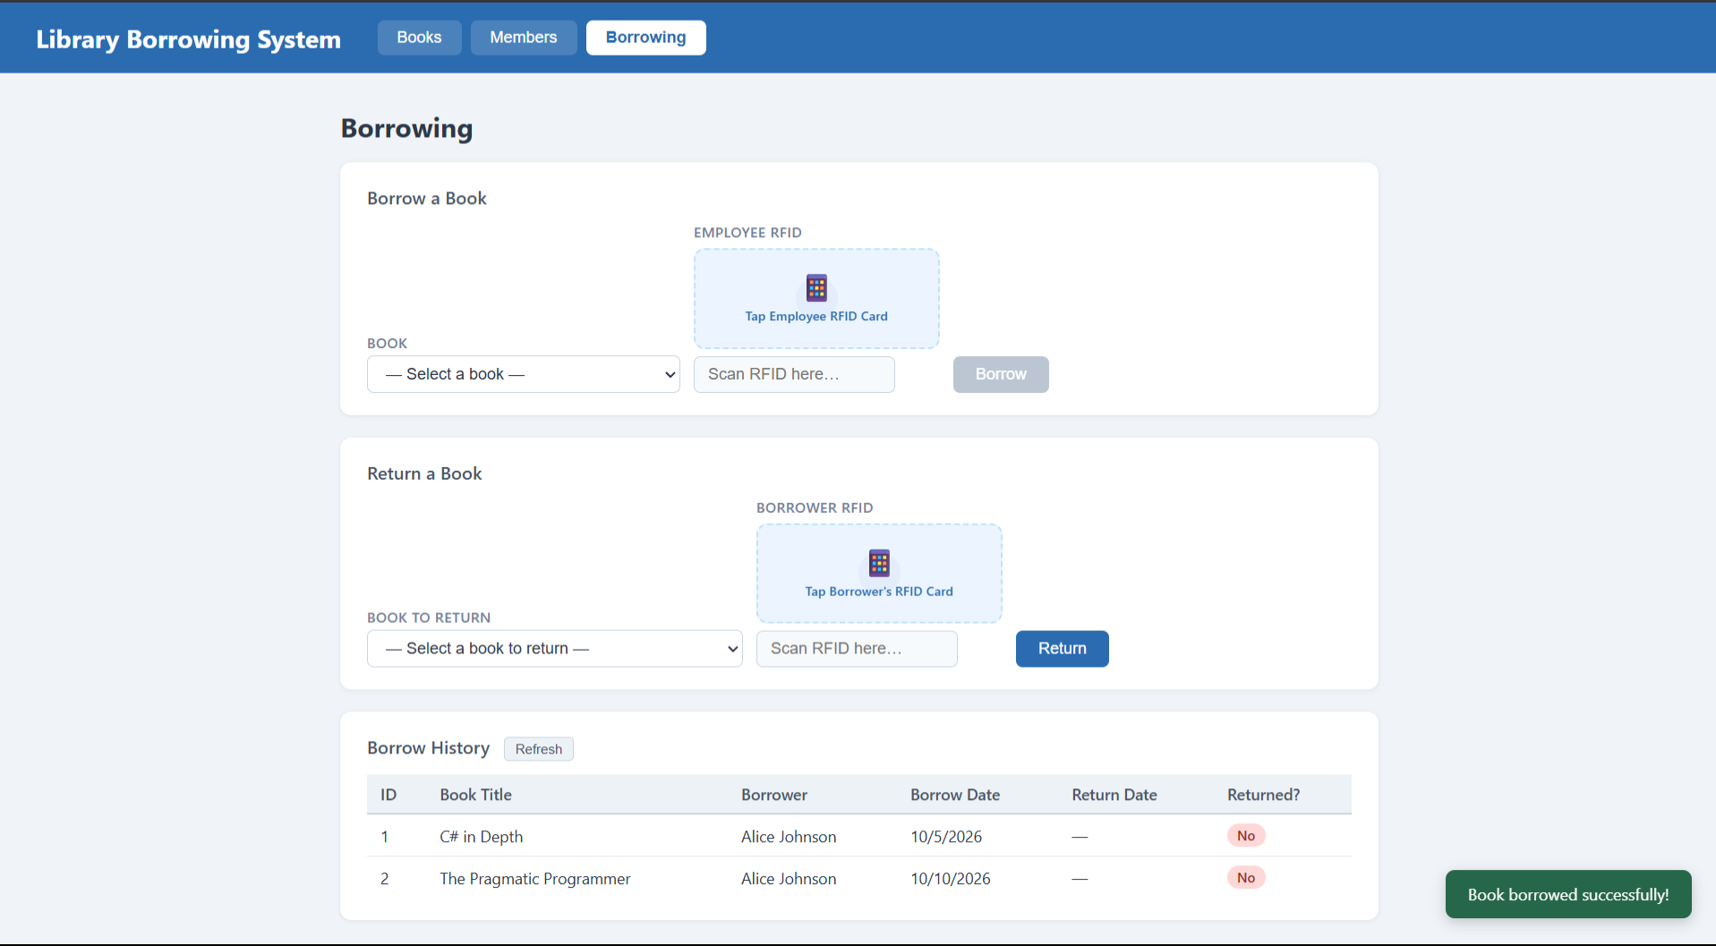

test-11-return-wrong-card
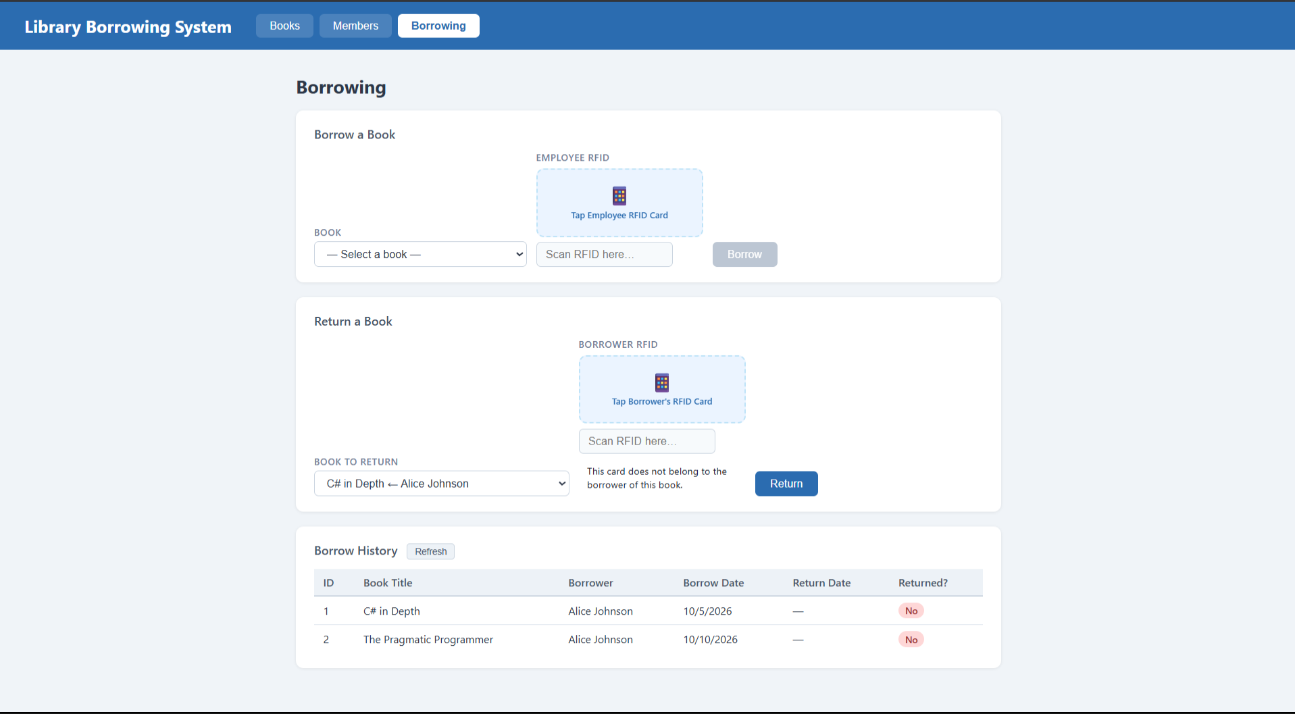

test-12-return-verified
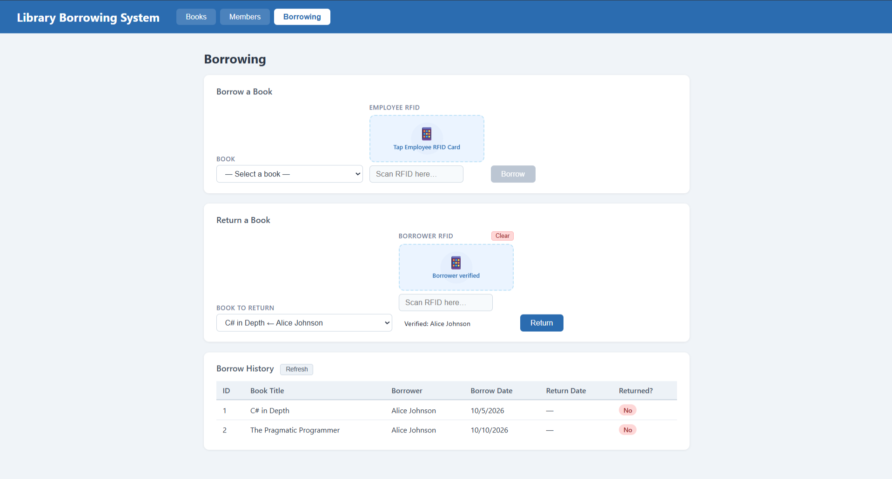
test-13-return-success
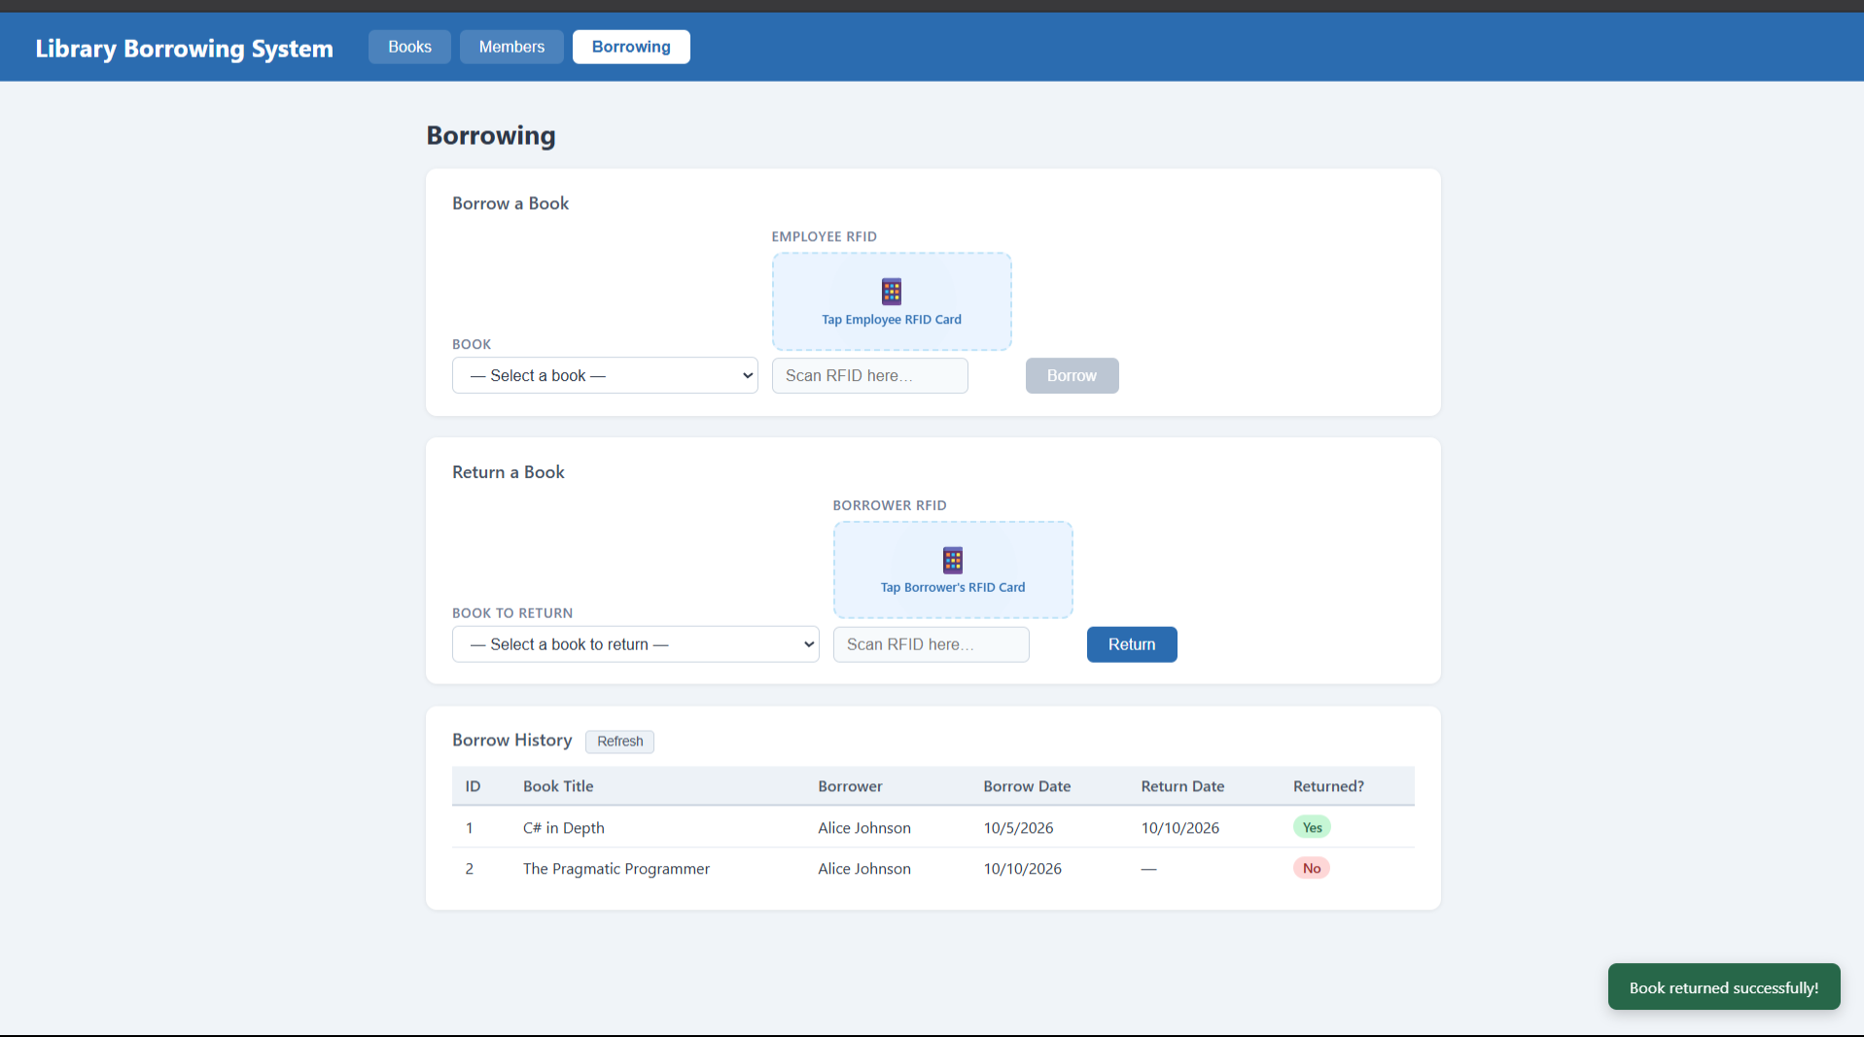

test-14-final-console
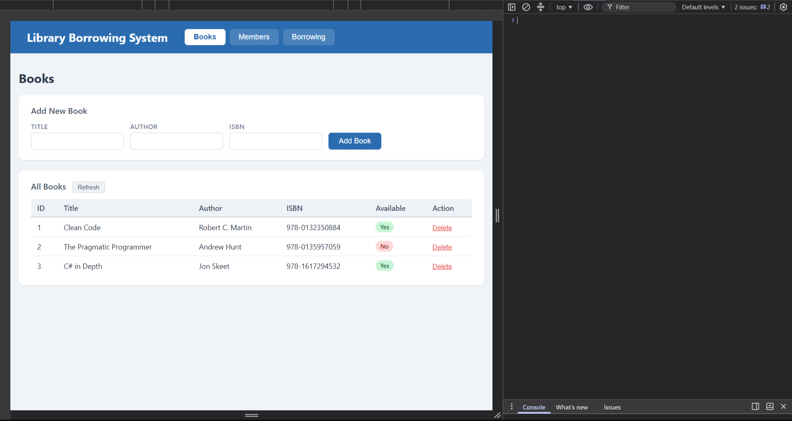
Student Reflection Questions:
- What does apiFetch() do?
- Why do we use try/catch around API calls?
- What is the difference between POST and PUT?
- Why does RFID matching use rfidValue instead of studentId?
- Why do we refresh tables after adding, deleting, borrowing, or returning?
- Why does the Return dropdown use borrow record ID instead of book ID?
- What happens if the same event listener is added to a form twice?
- Why must the page-load code be at the bottom of the file?
- Why does an RFID reader need e.preventDefault() on the Enter key?

- apiFetch() prevents repeated code, it sends a request to the API then handle the response
- Try/catch use to handle errors so it would not crash
- POST creates new data and PUT updates existing data
- The rfidValue defines the RFID itself while the studentID defines the student itself
- So it would display the latest data after the changes
- Because it defines the borrowing transaction
- It may cause duplicate actions
- It is on the bottom so it would run all of the element needed
- So it could stop the page from refreshing when you press enter while scanning the RFID.

