setup-01-api-running
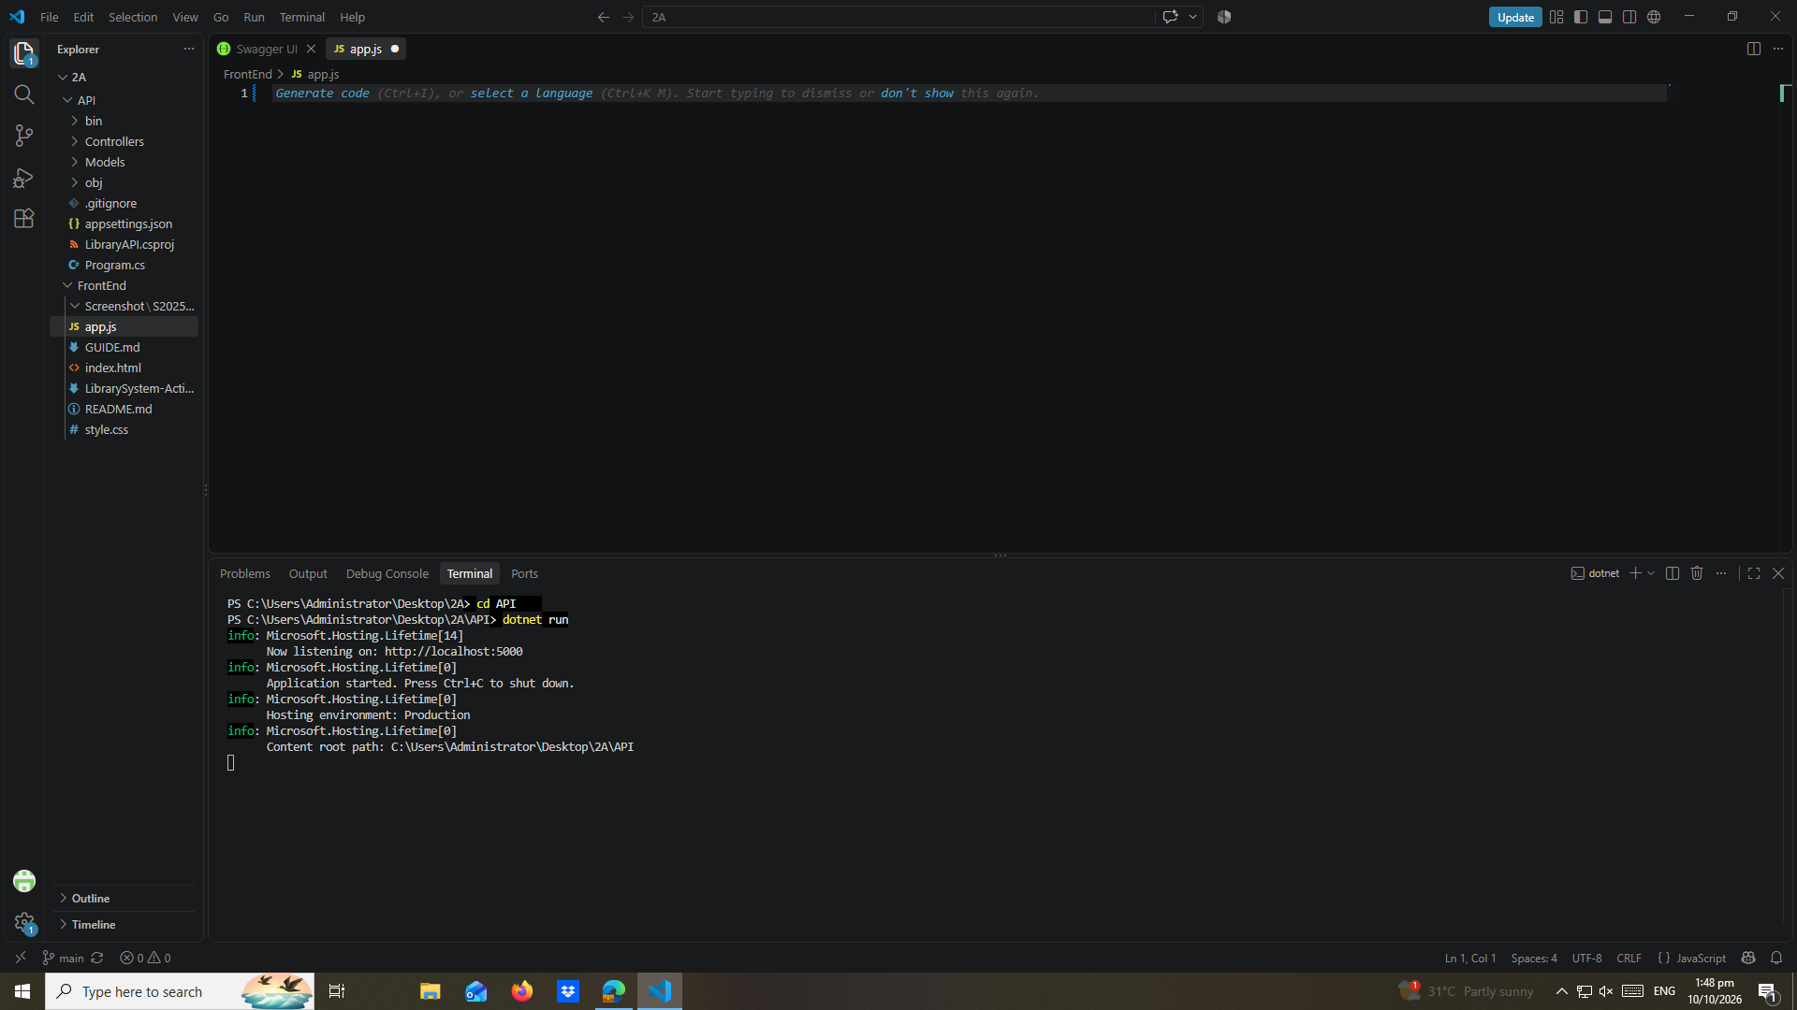

setup-02-api-books-json
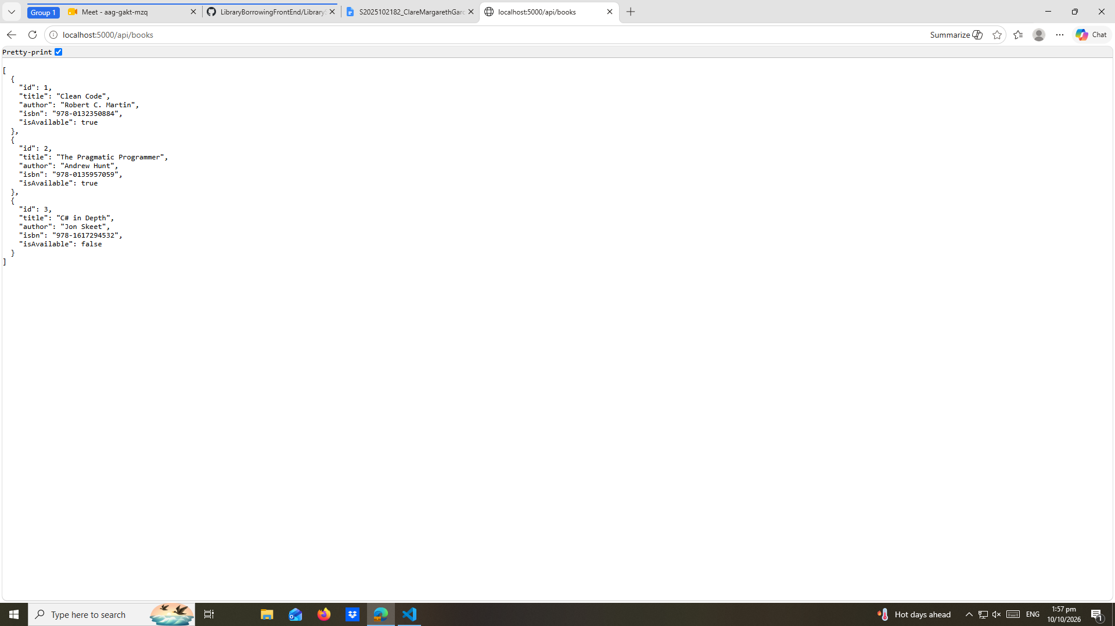

part-01-settings-apifetch
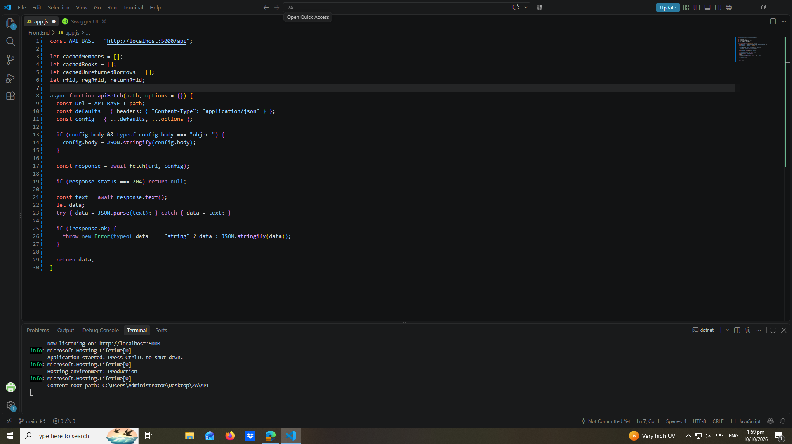

part-02-showtoast
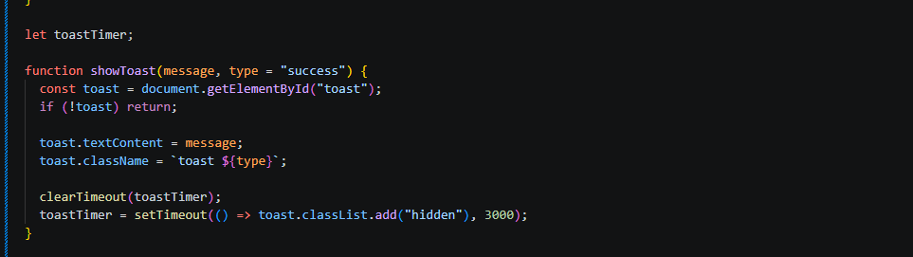

early-01-toast
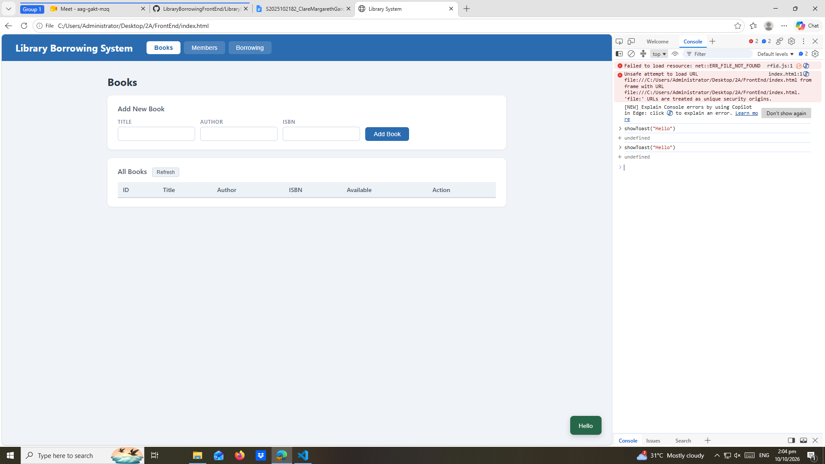

part-03-caches
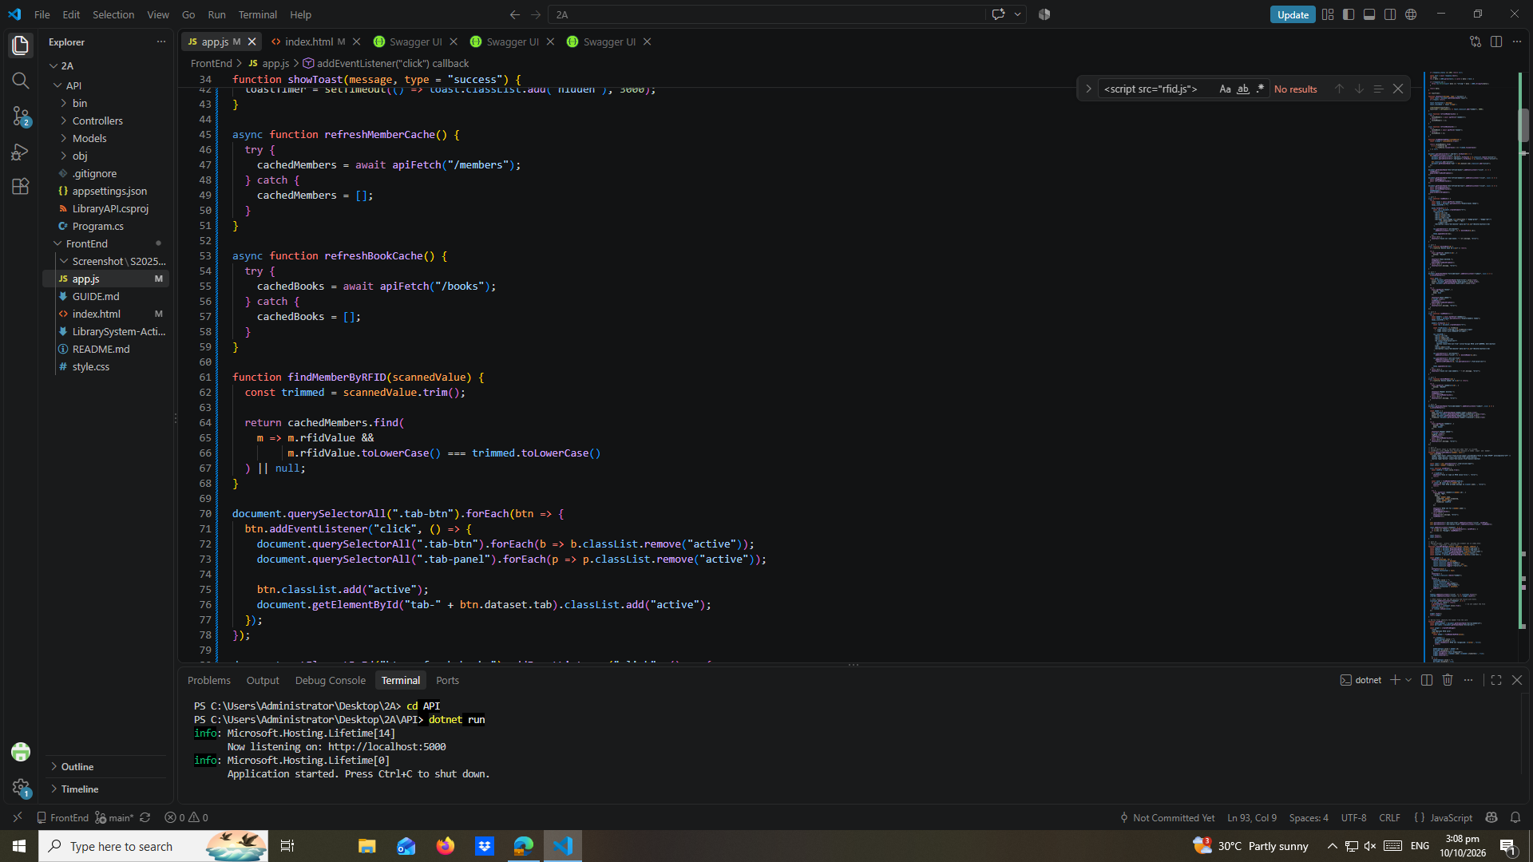

early-02-cache-console
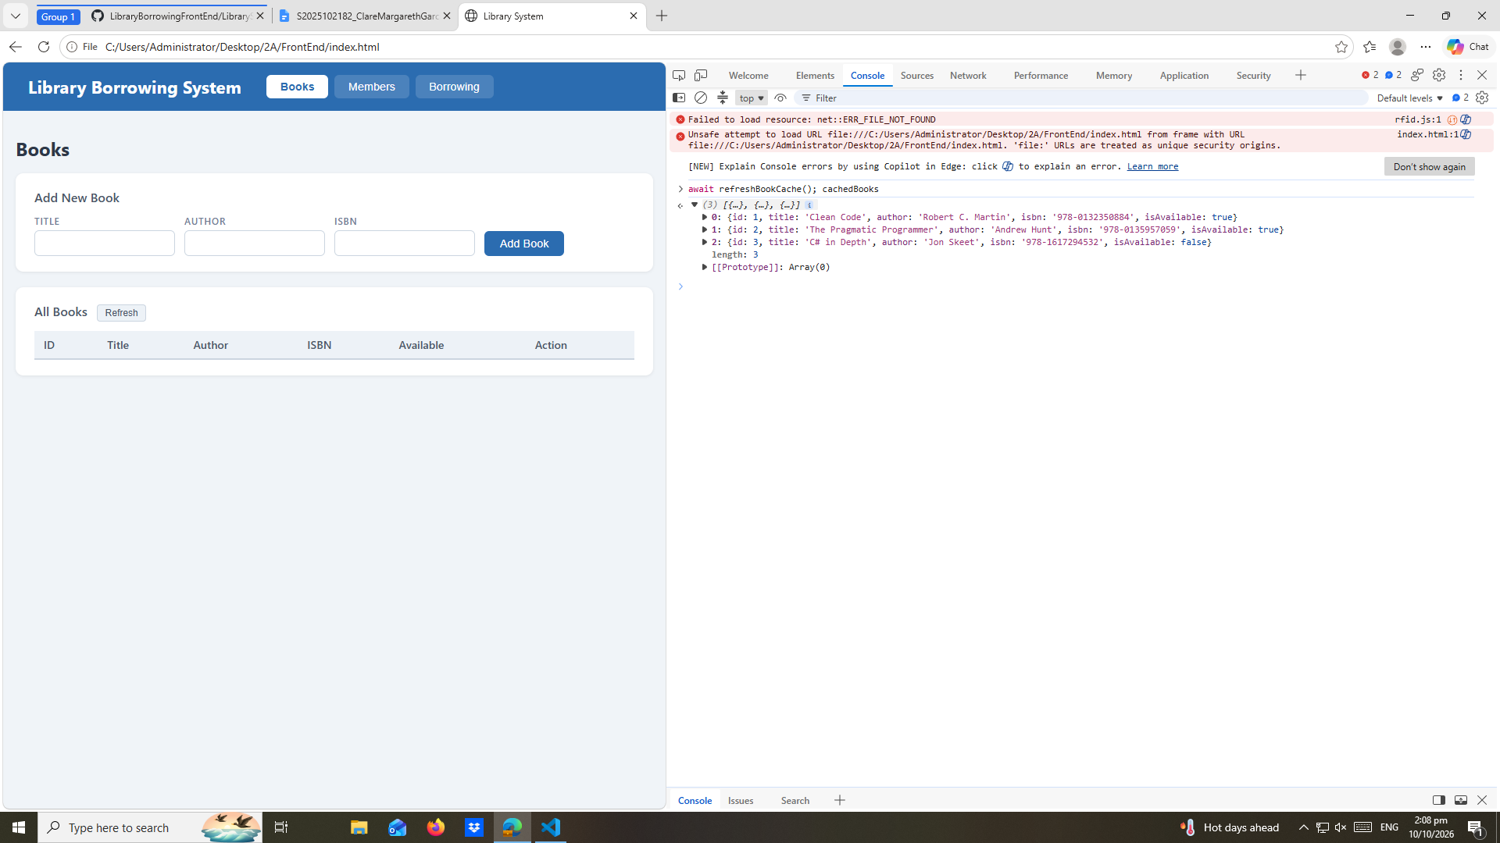

part-04-tabs-refresh
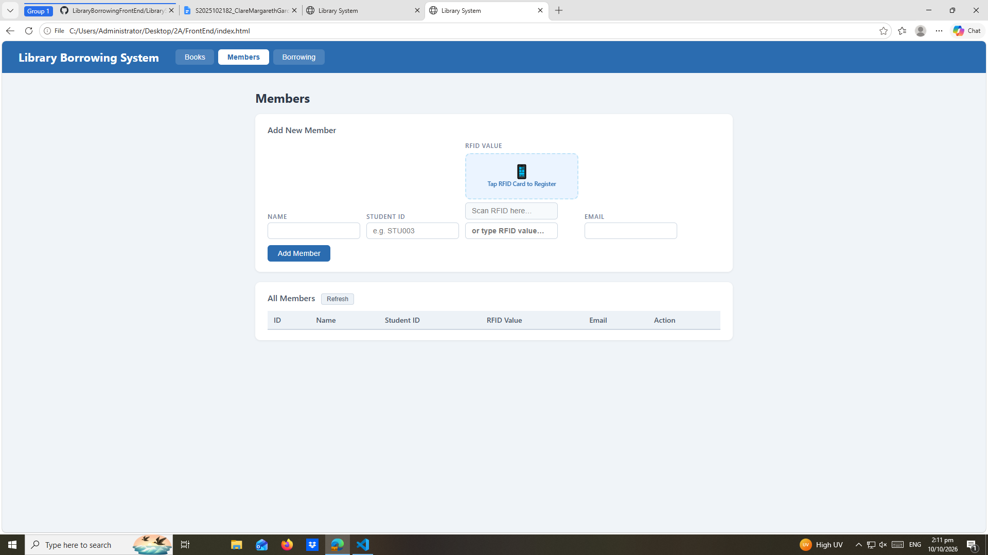

early-03-tabs
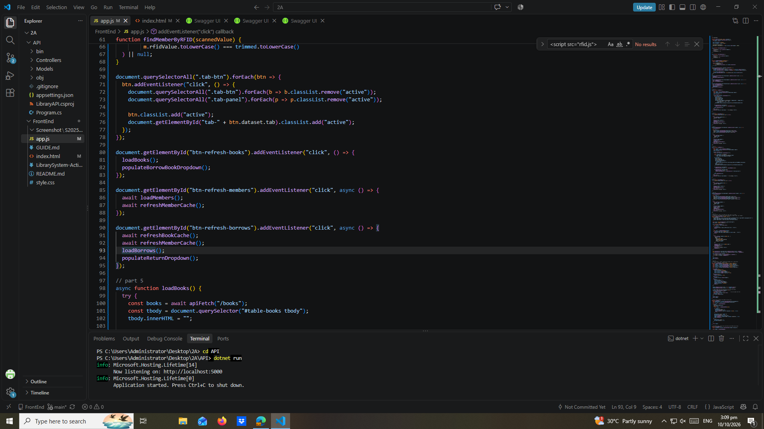

part-05-loadbooks
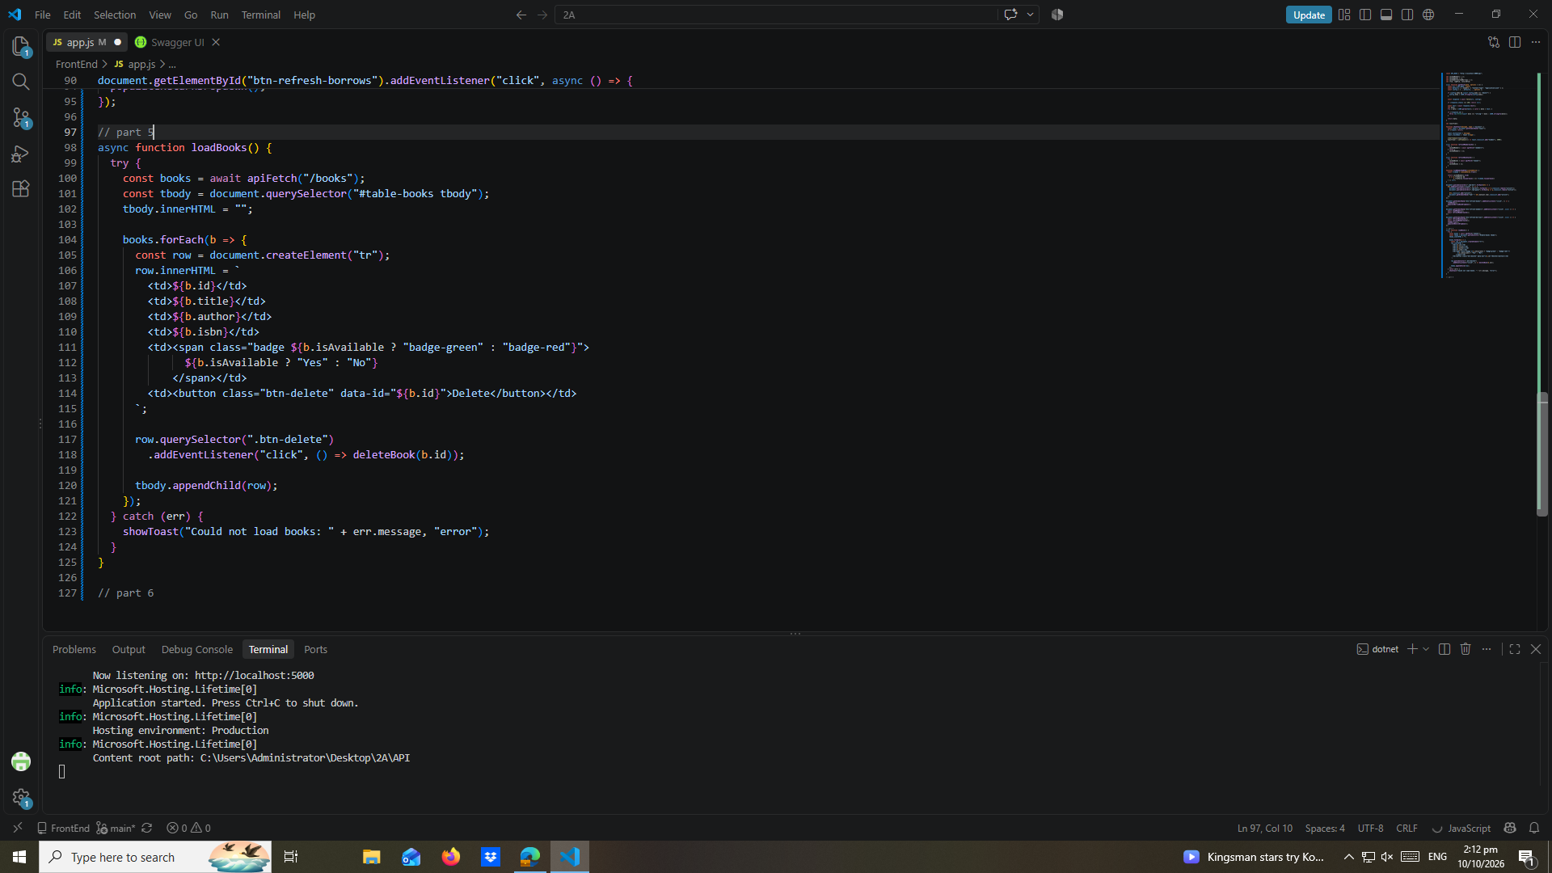

part-06-deletebook
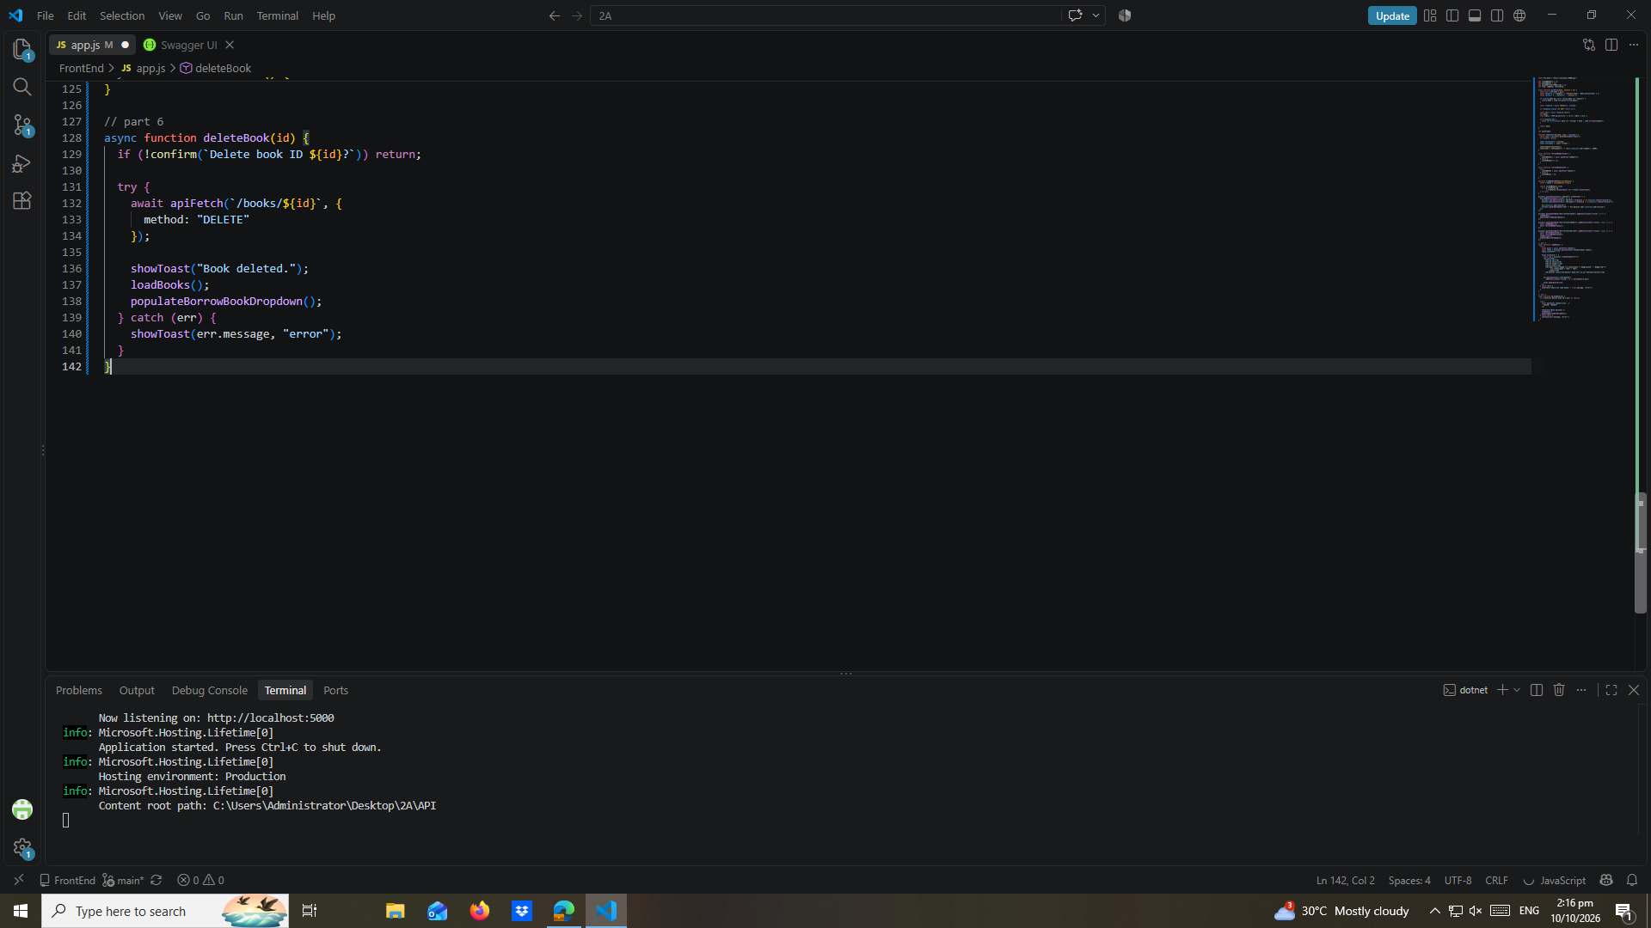

part-07-addbook
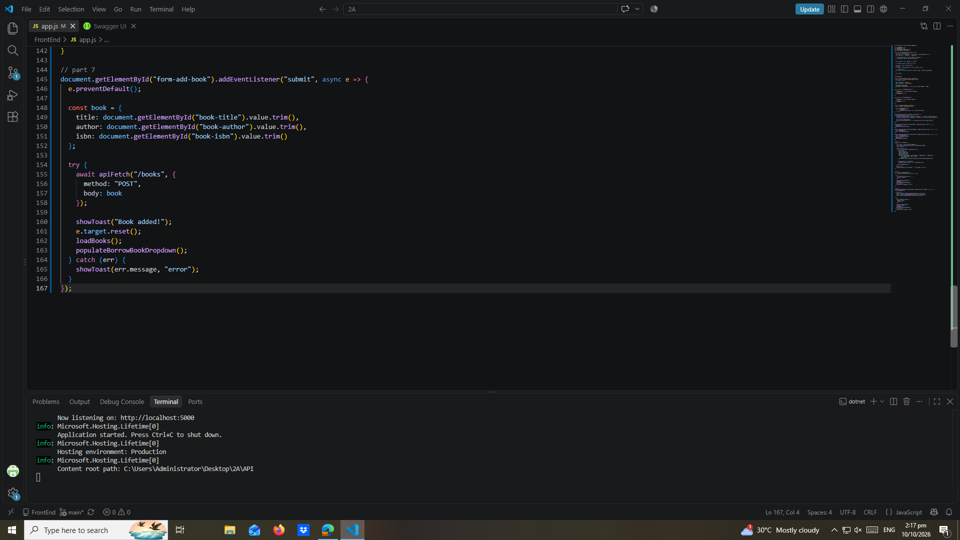

part-08-loadmembers
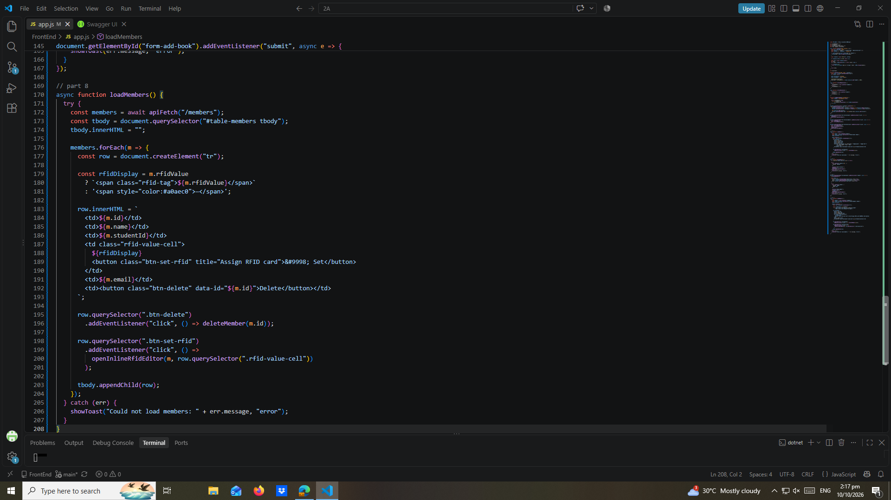

part-09-deletemember
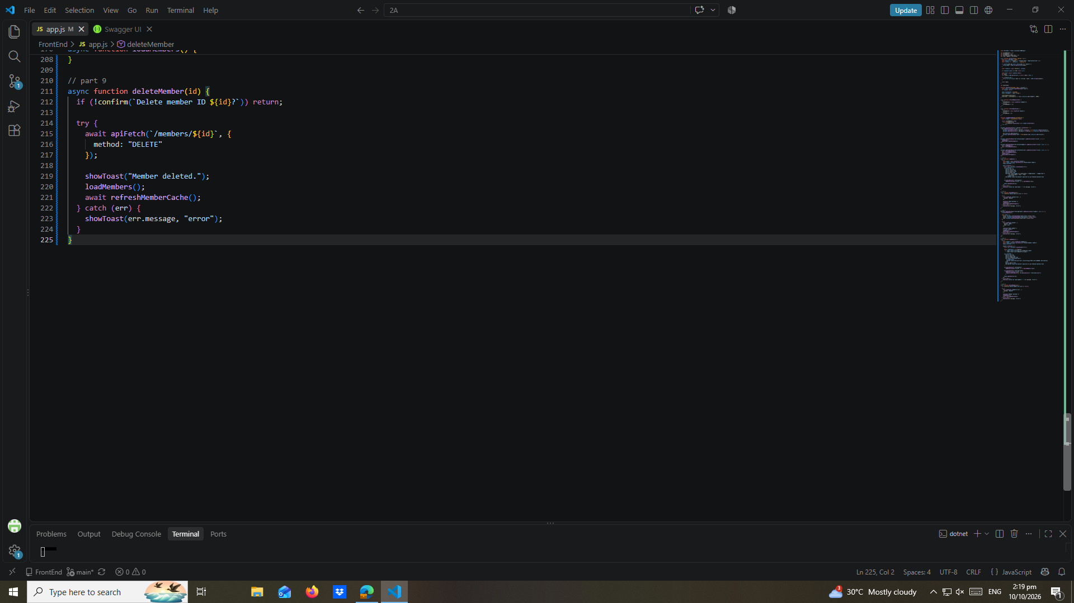

part-10-addmember
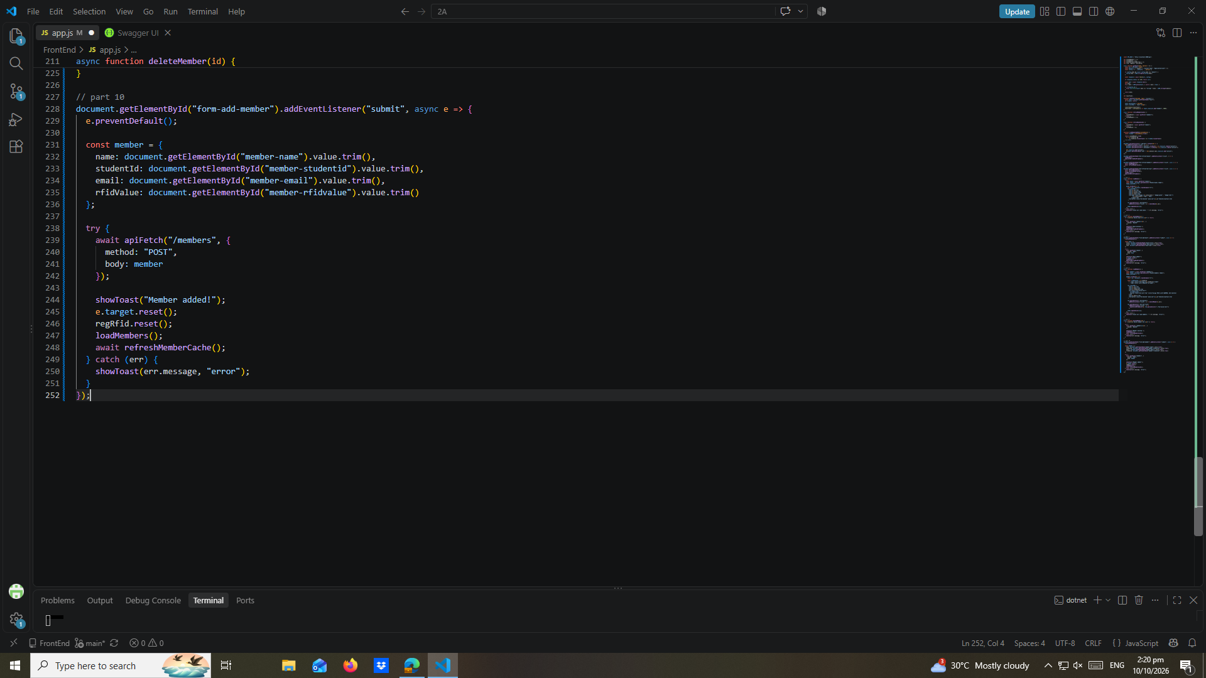

part-11-inline-rfid-editor
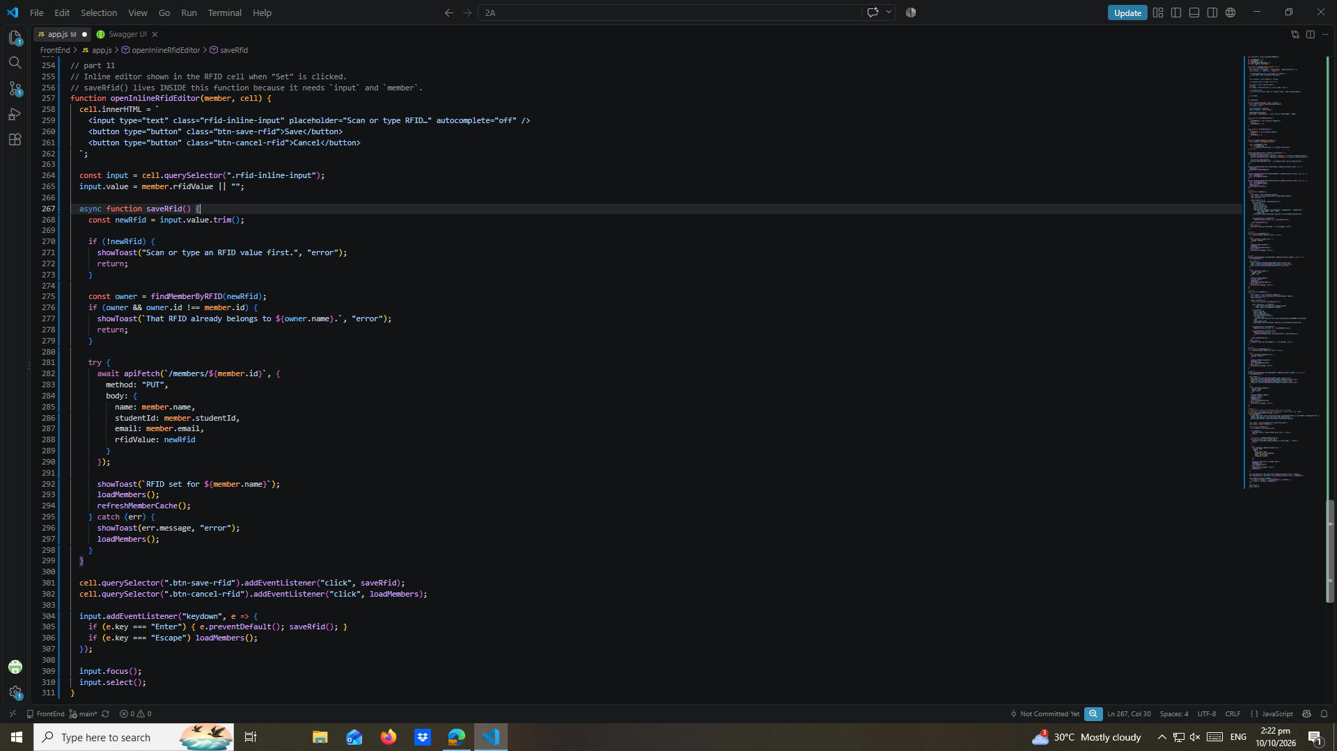

part-12a-rfid-widget-builder
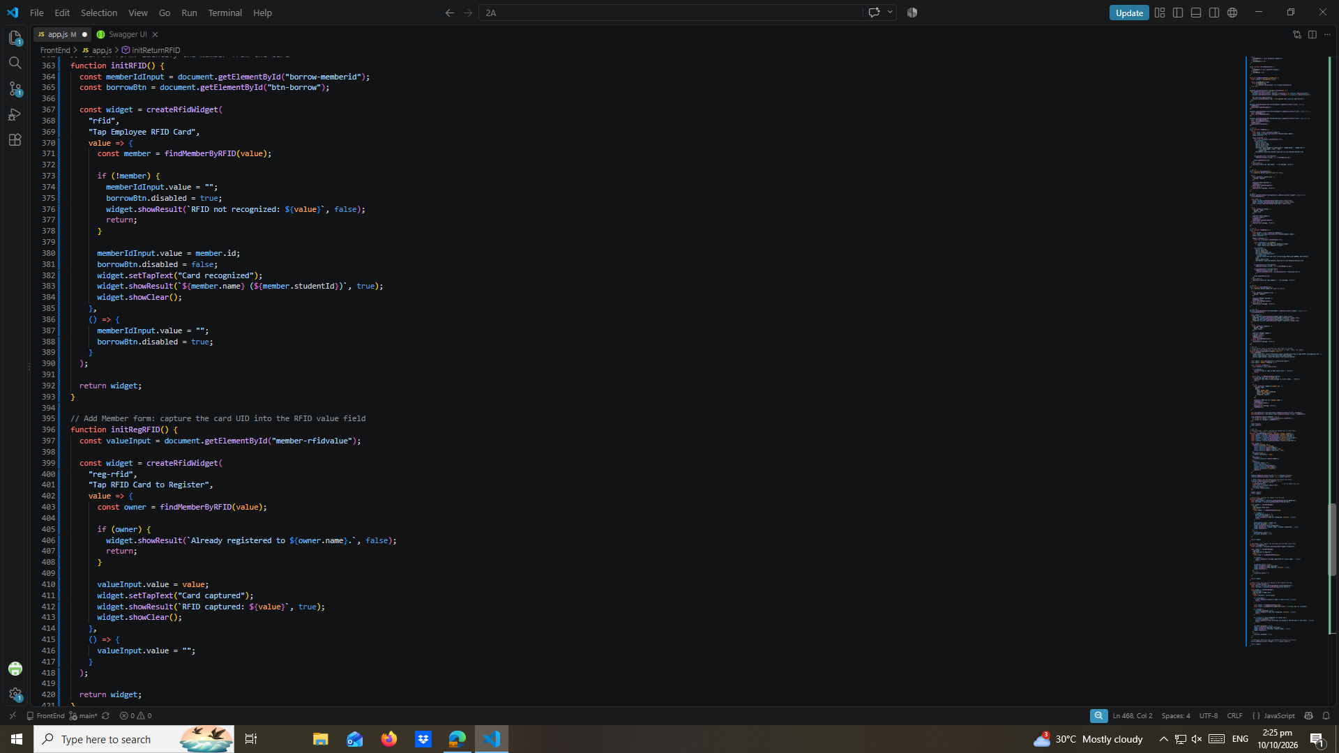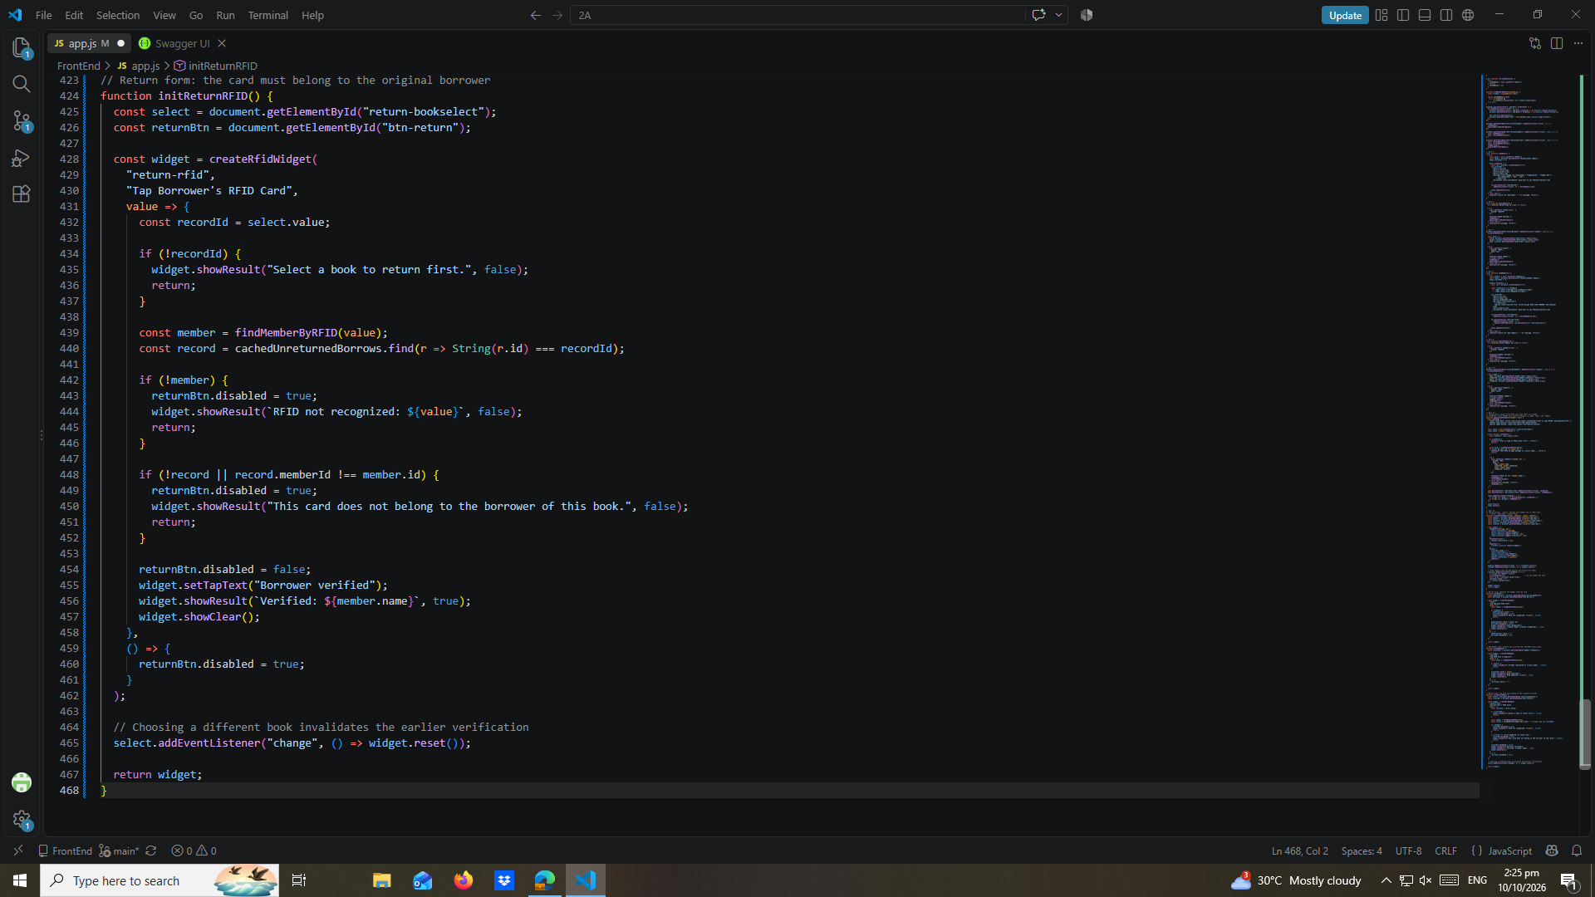

part-13-borrow-dropdown
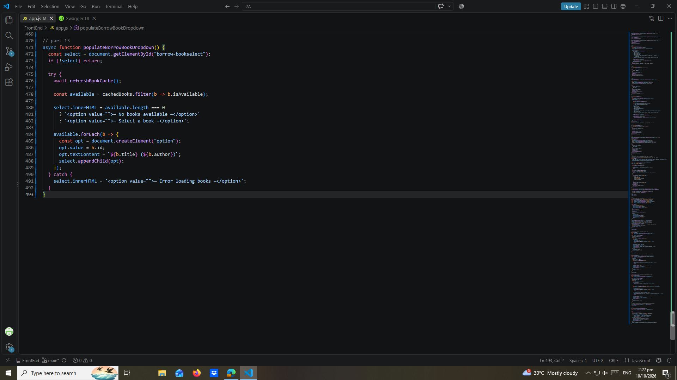

part-14-return-dropdown
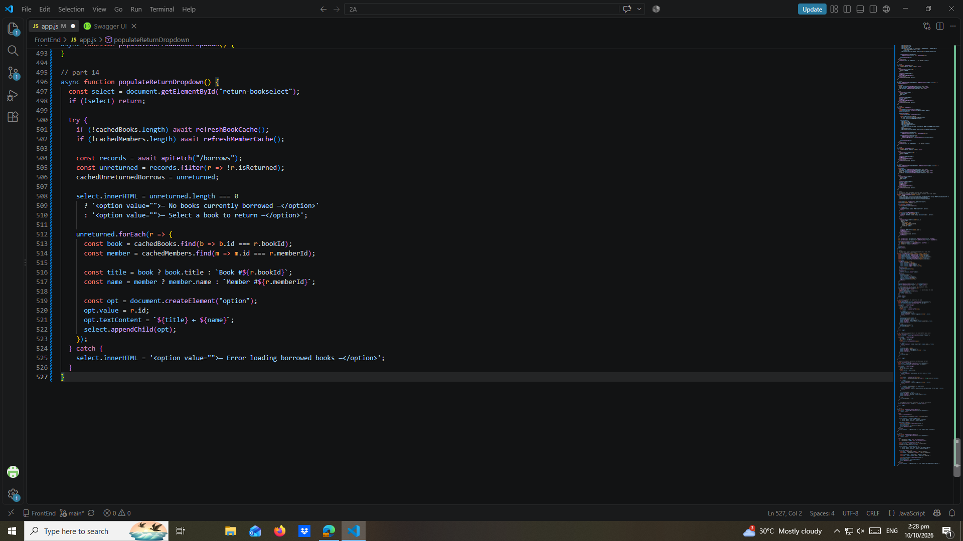

part-15-borrow
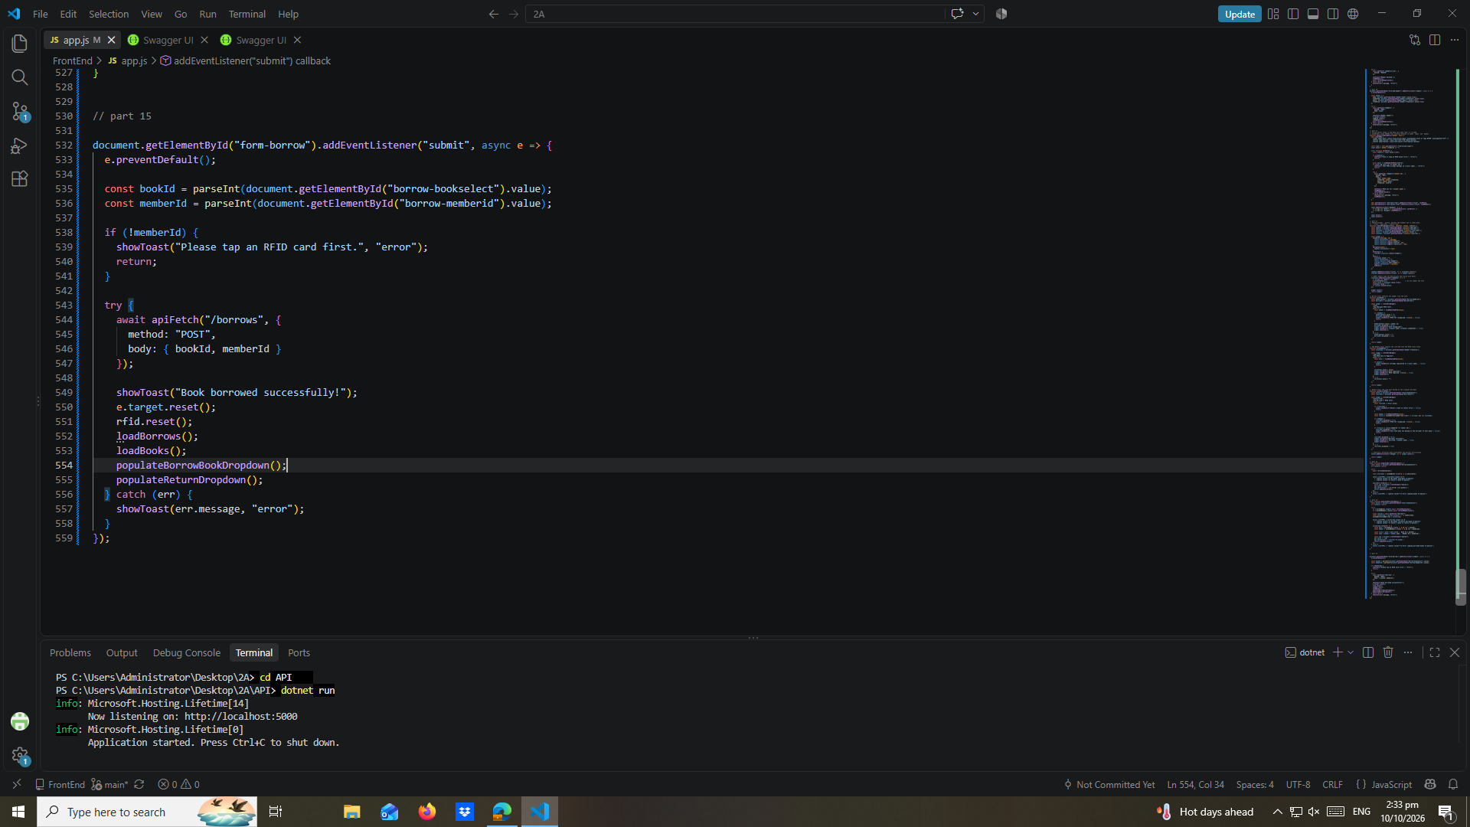

part-16-return

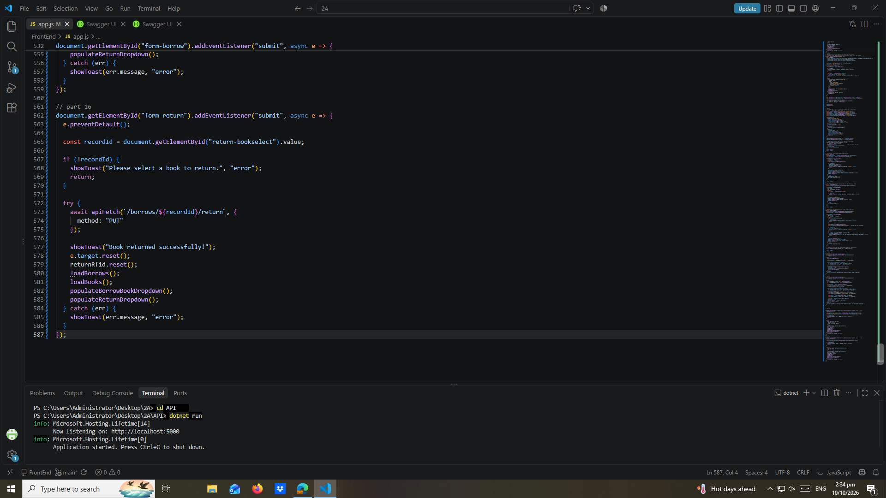

part-17-loadborrows
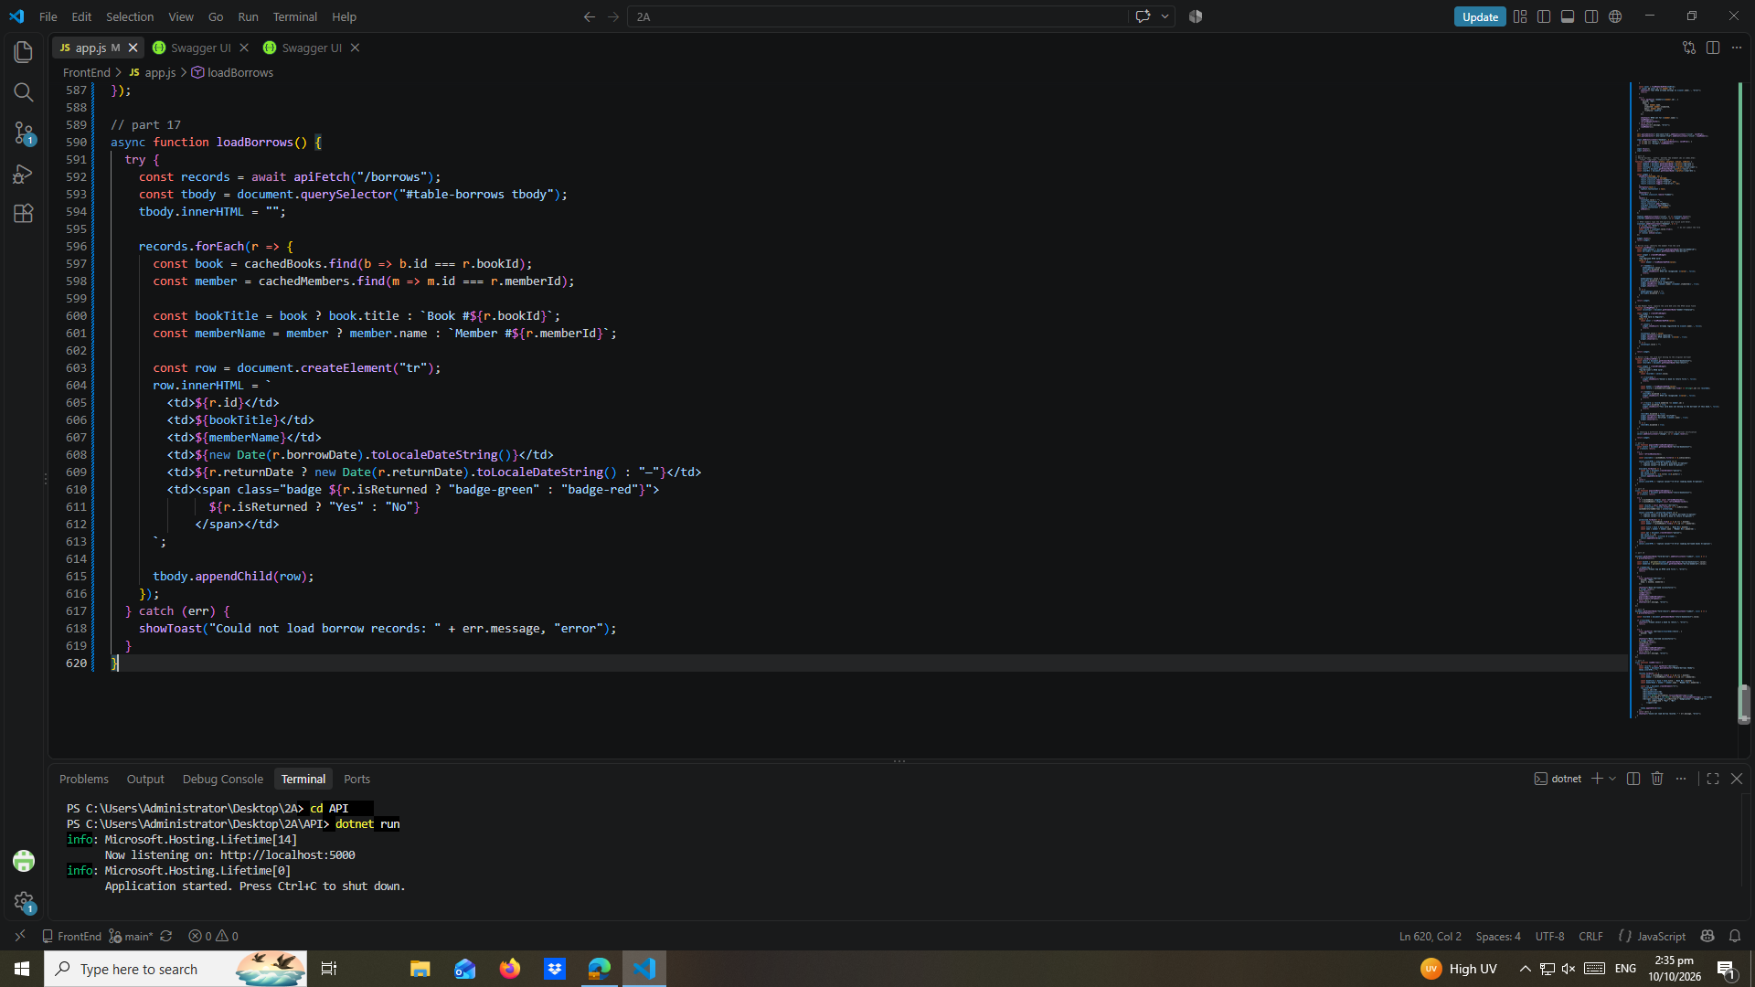

part-18-page-load
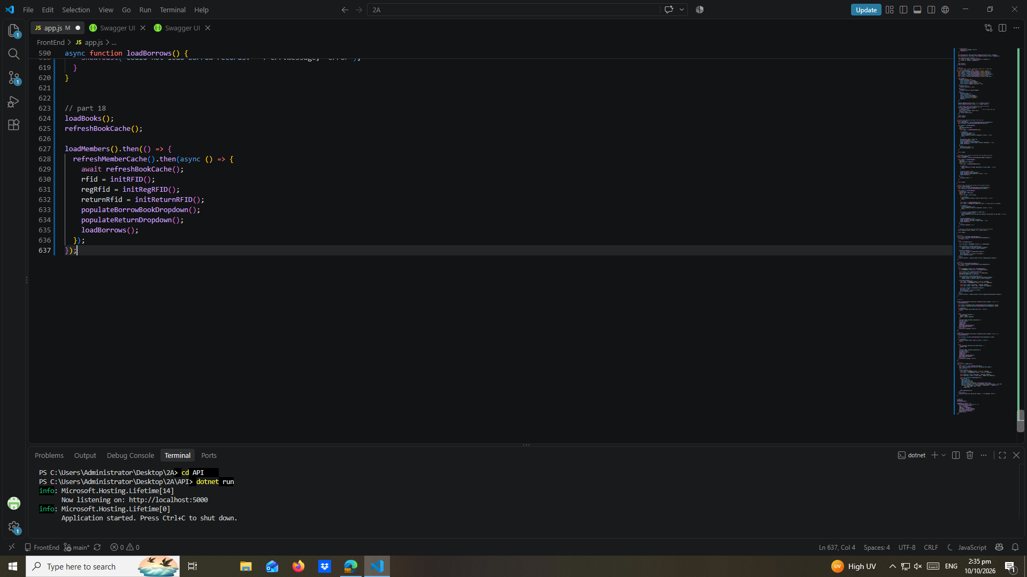

test-01-page-loaded
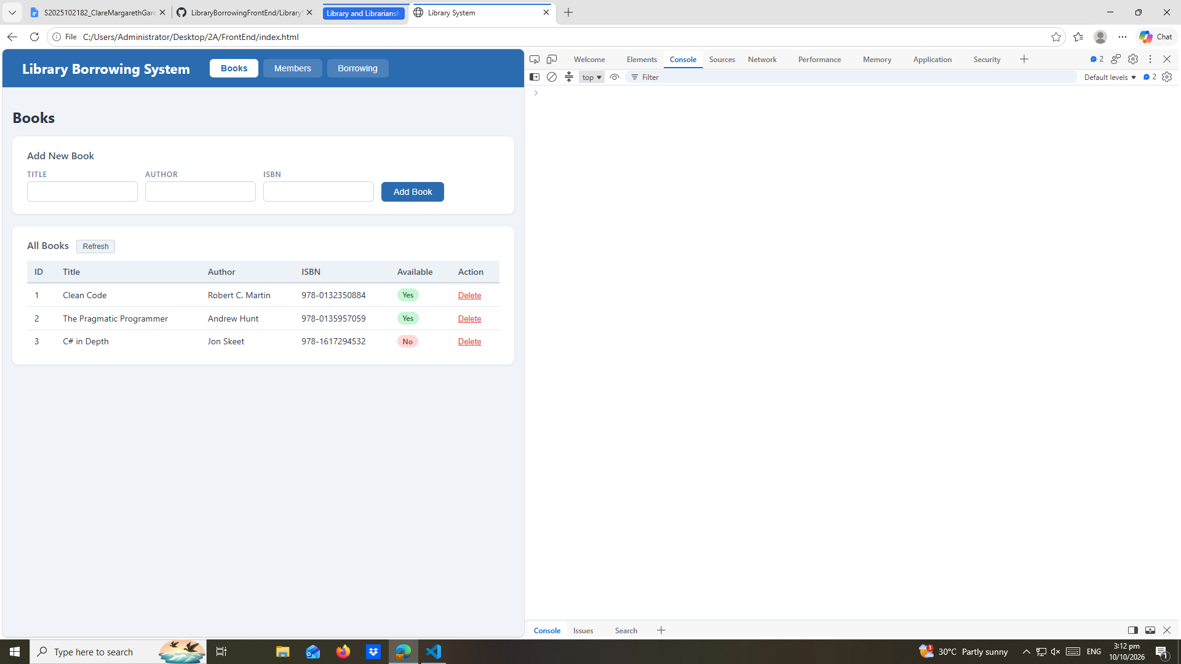

test-02-add-book, test-03-delete-book
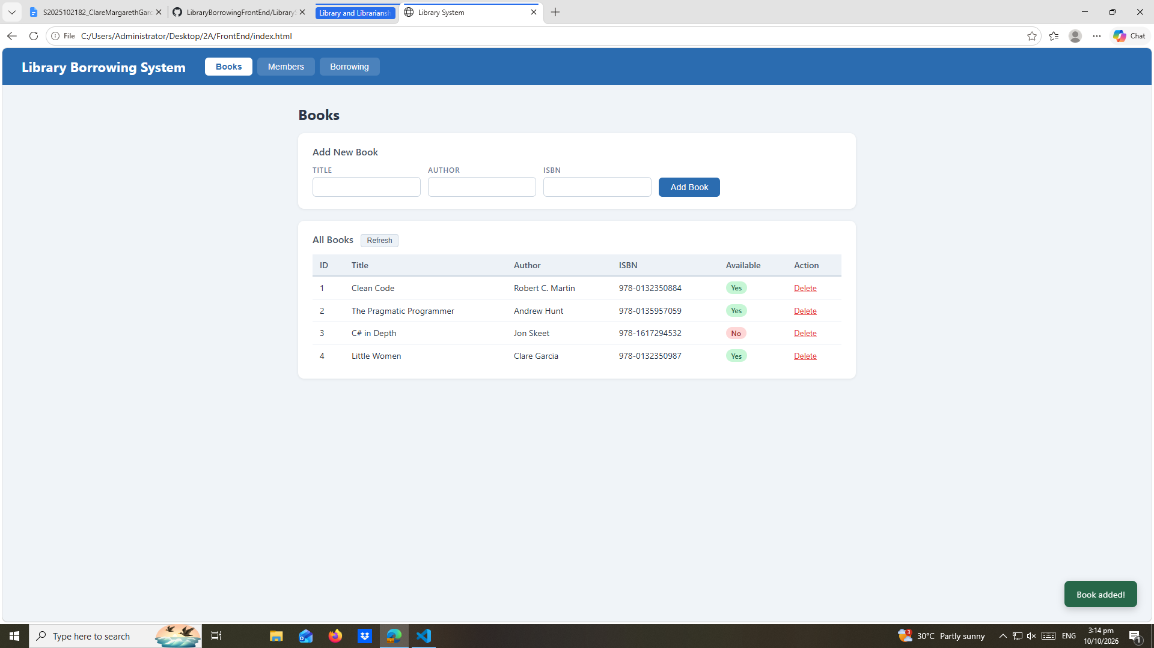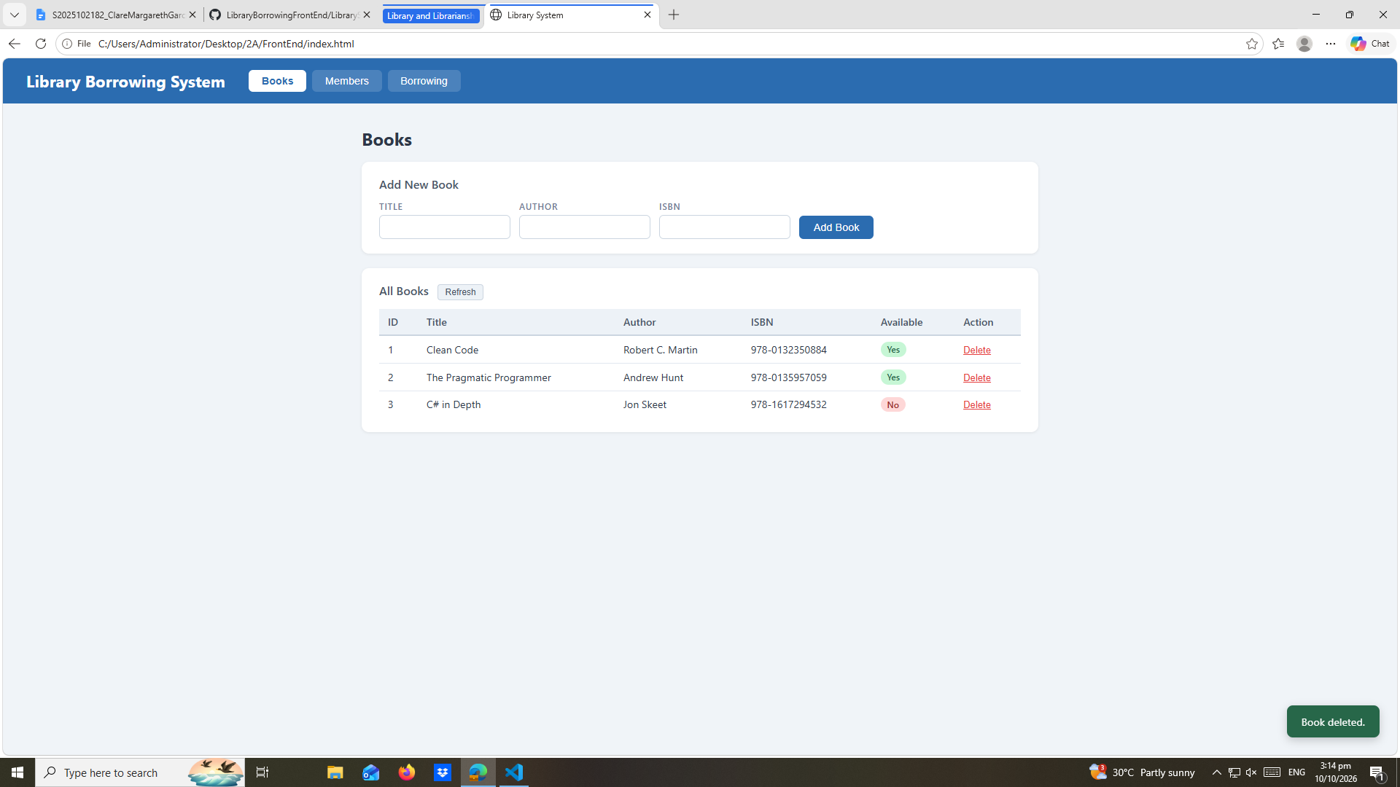

test-04-members-loaded
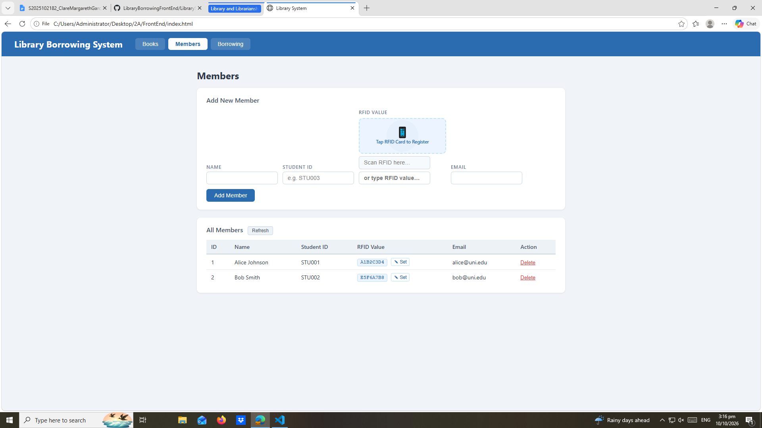

test-05-register-rfid
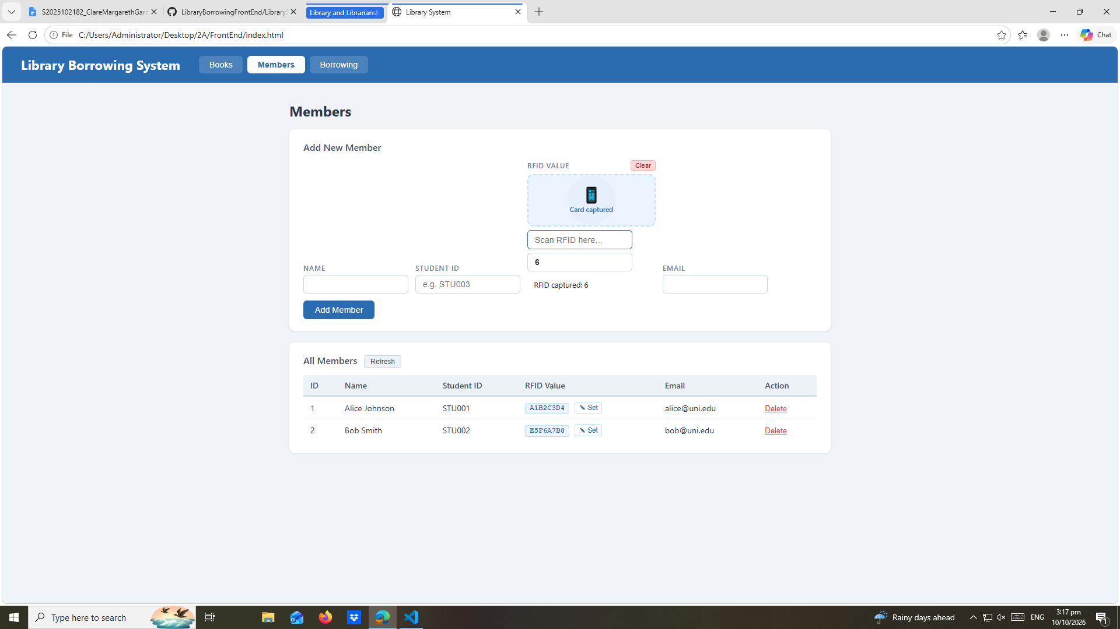

test-06-add-member
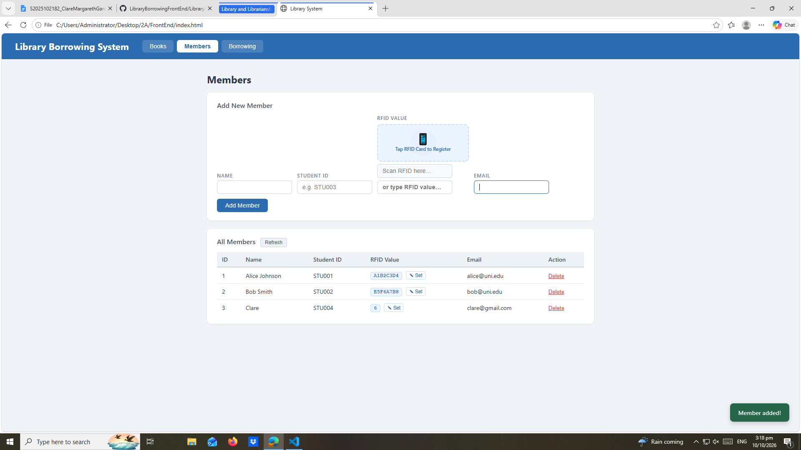

test-07-set-rfid-saved
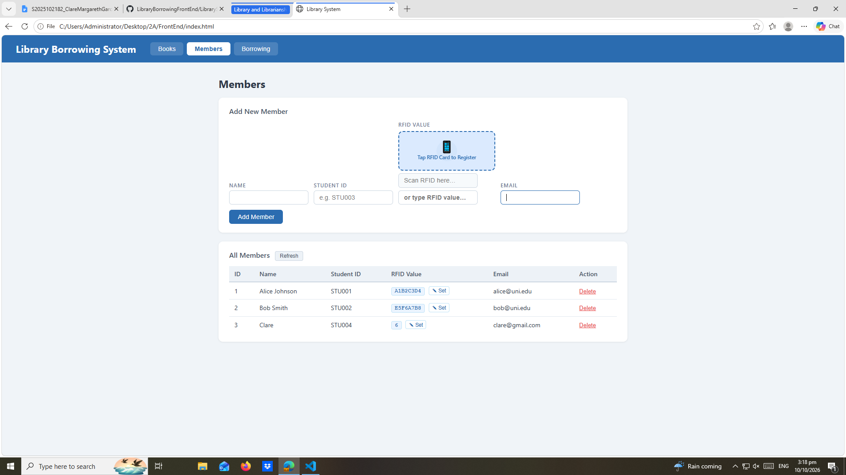

test-08-delete-member
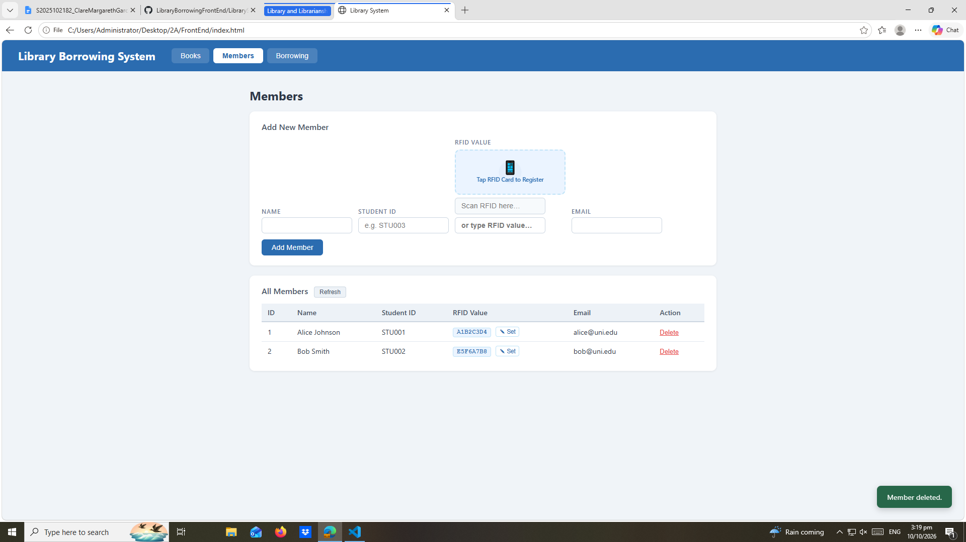

test-09-borrow-rfid-recognized,
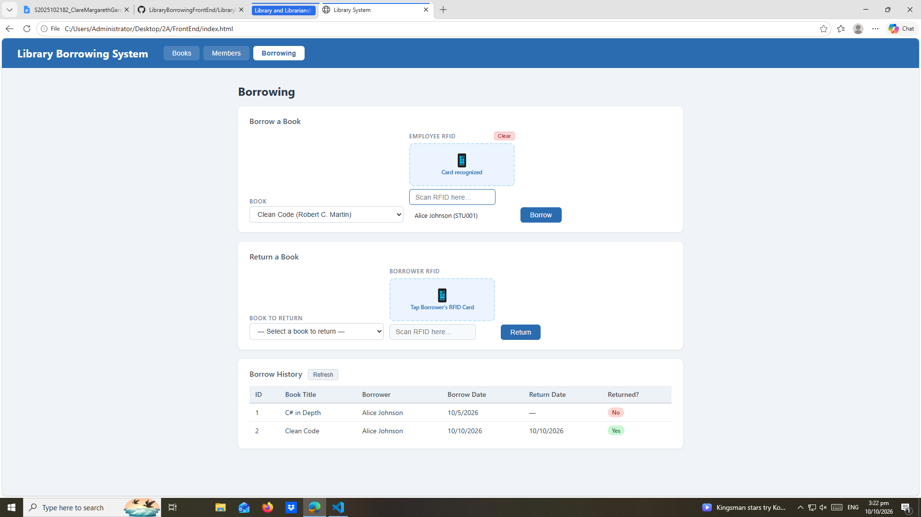

test-10-borrow-success
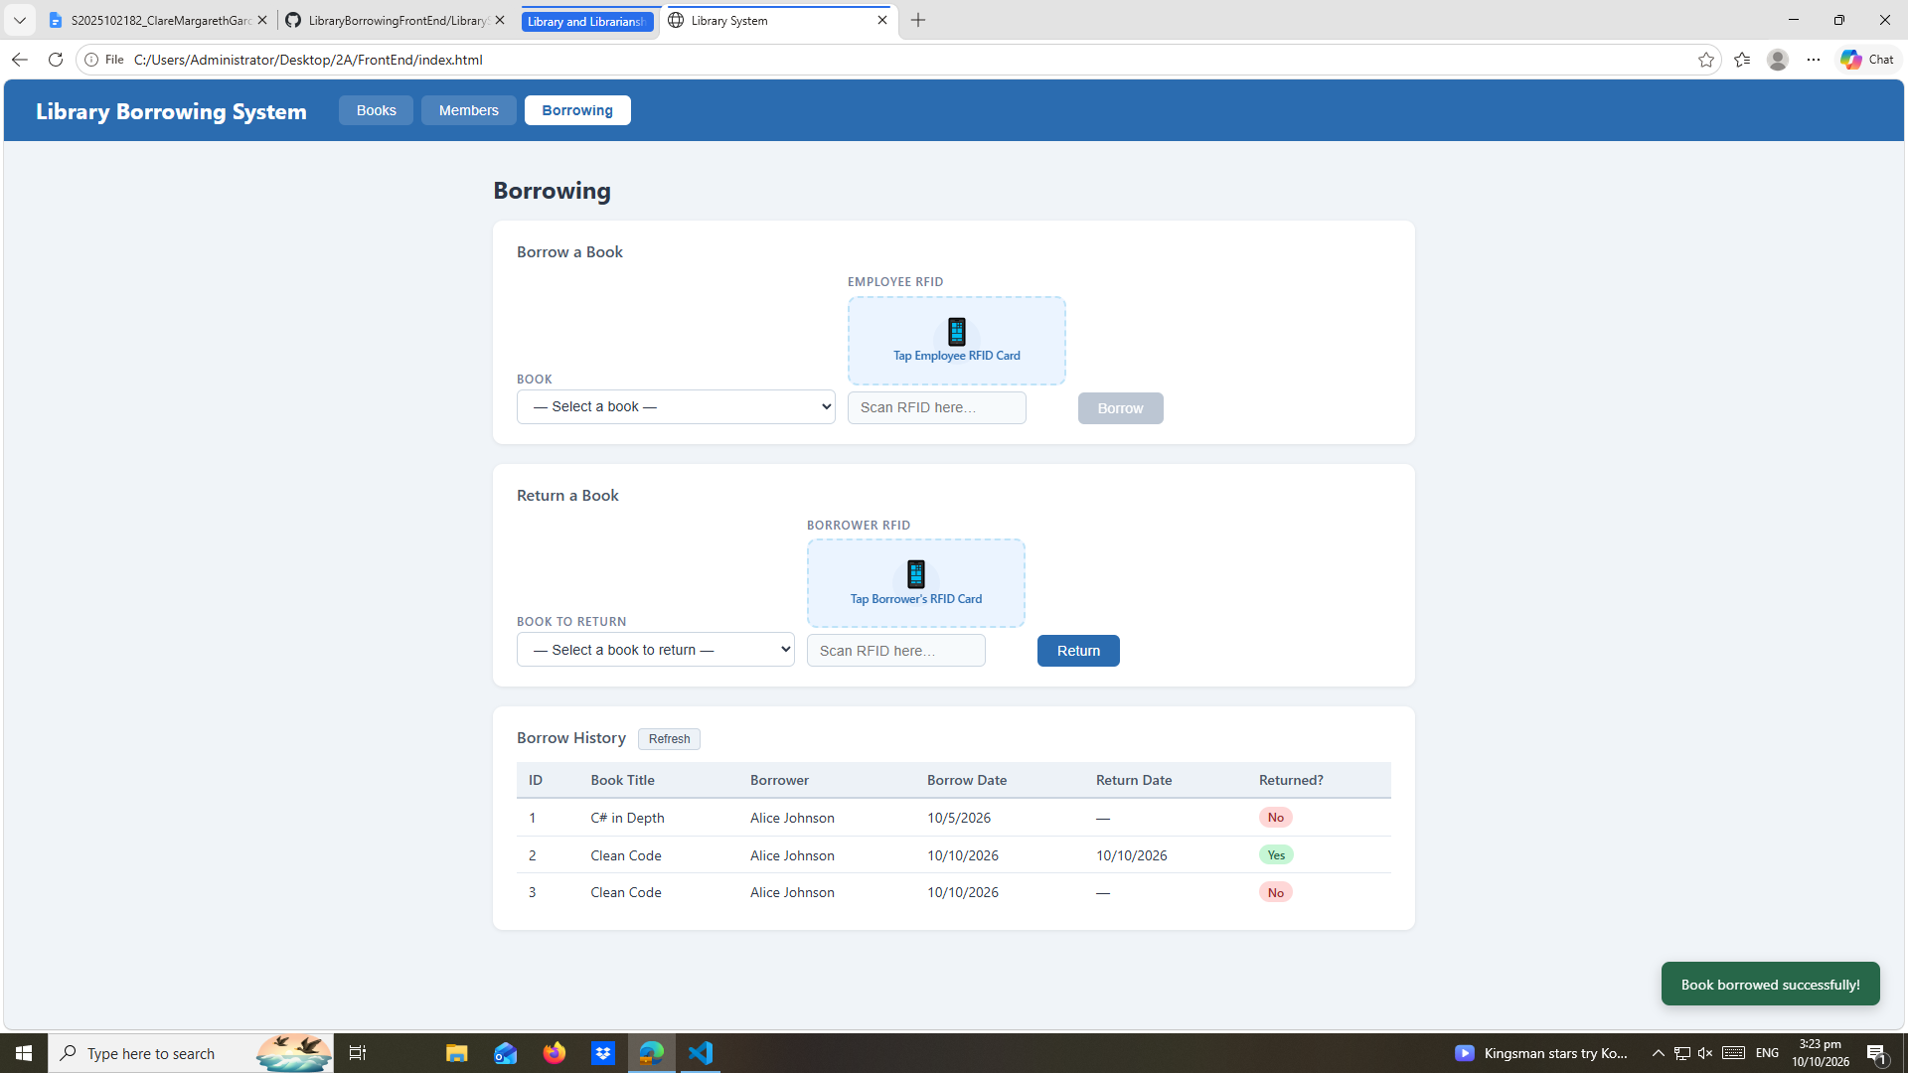

test-11-return-wrong-card
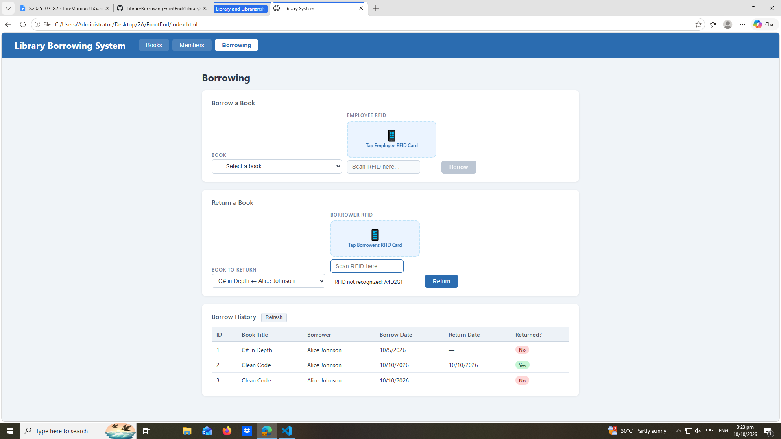
test-12-return-verified
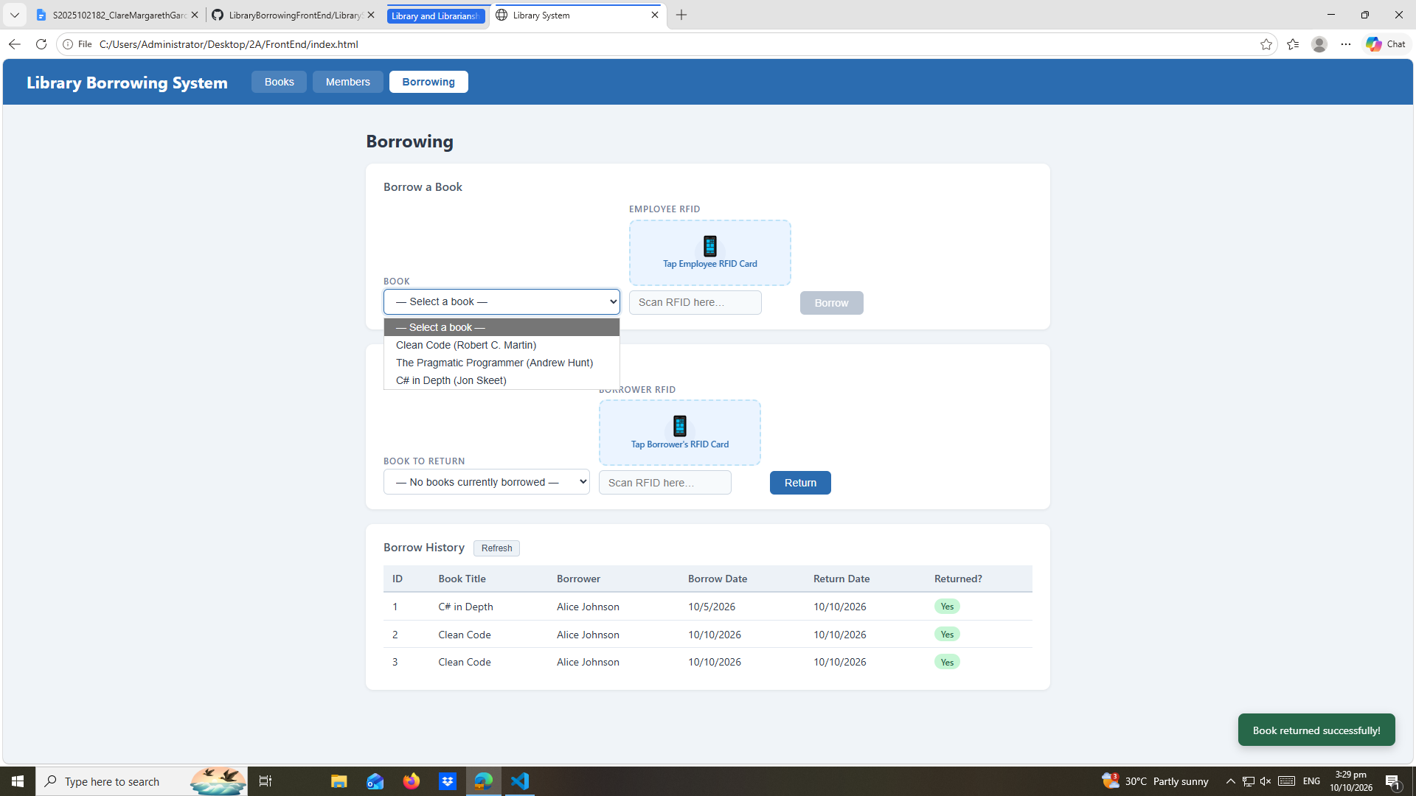
test-13-return-success
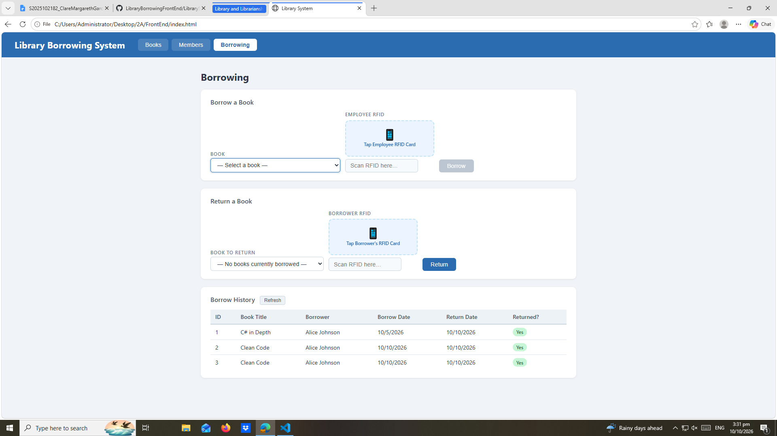

test-14-final-console
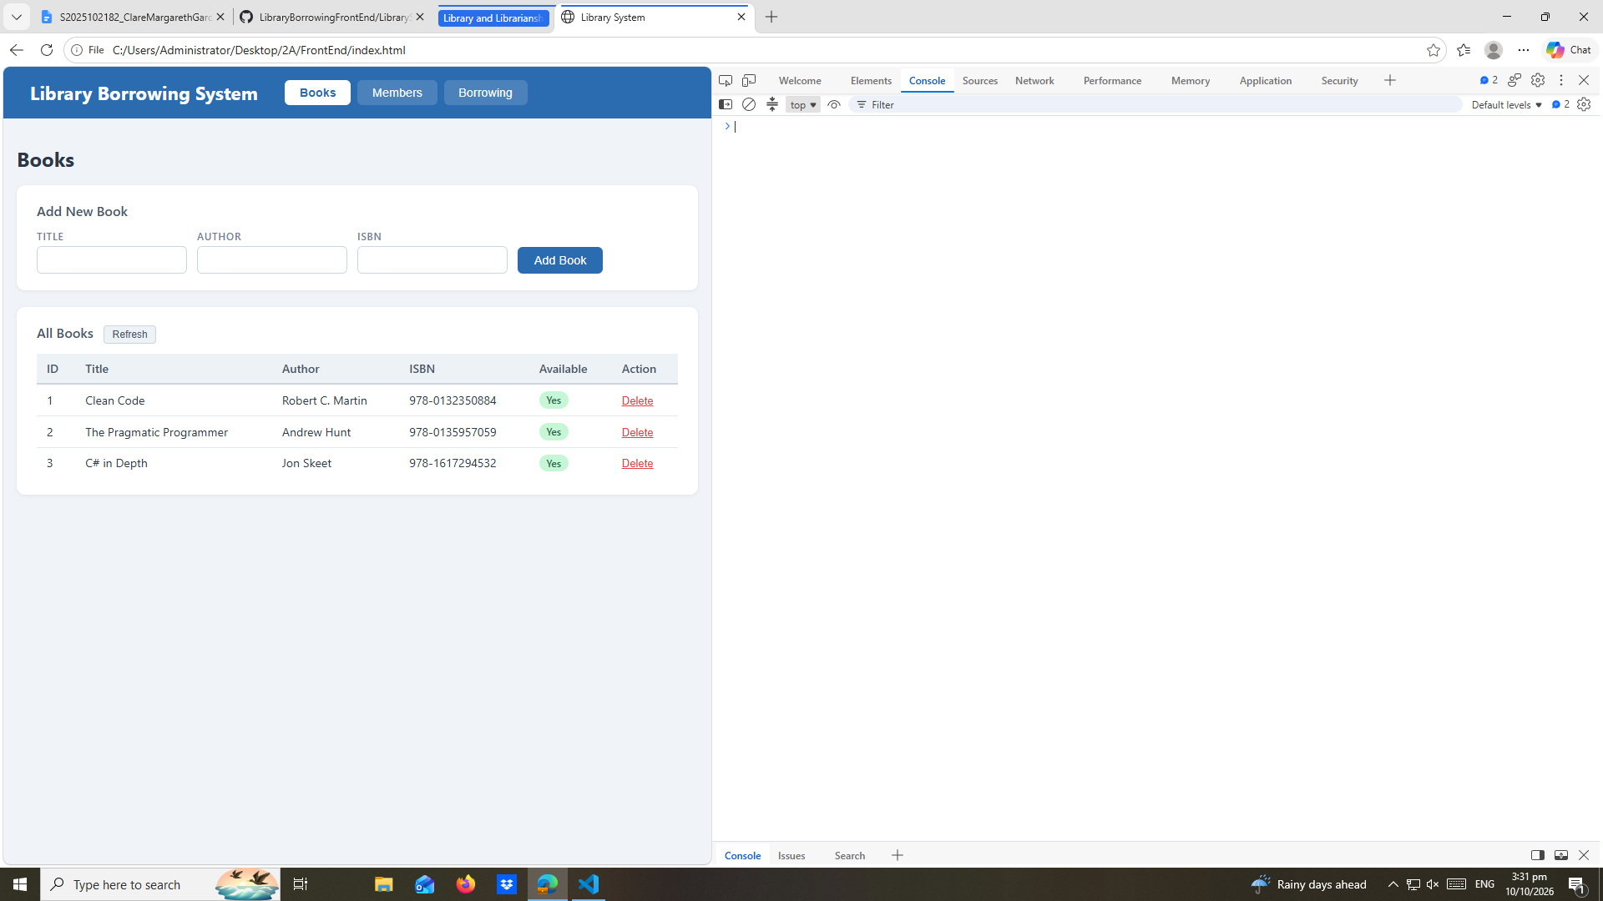

REFLECTION:
- What does apiFetch() do?
- apiFetch() prevents repeated code
- Why do we use try/catch around API calls?
- We use try/catch around API calls because it prevents the application to crash and handles network failures
- What is the difference between POST and PUT?
- POST is to add a new data while PUT is to update data
- Why does RFID matching use rfidValue instead of studentId?
- Because it will work in the application because it will not match the studentId
- Why do we refresh tables after adding, deleting, borrowing, or returning?
- We refresh tables after adding, deleting, borrowing, or returning to update the codes that we encode in the system
- Why does the Return dropdown use a borrowed record ID instead of a book ID?
- Because when we click the return dropdown, it will reflect the borrow record instead of book ID. Because if we use the book ID it will not show in the website
- What happens if the same event listener is added to a form twice?
- The same event listener is added to a form twice it will send two requests for one click
- Why must the page-load code be at the bottom of the file?
- It must be at the bottom of the file in order to all codes before the page-load code will run on how the compiler works reading it from top to bottom
- Why does an RFID reader need e.preventDefault() on the Enter key?
- It needs a e.prventDefault() in order to stop page from refreshing

