Angela Chloe P. Precilla
S2025100001
10-10-16

setup-01-api-running
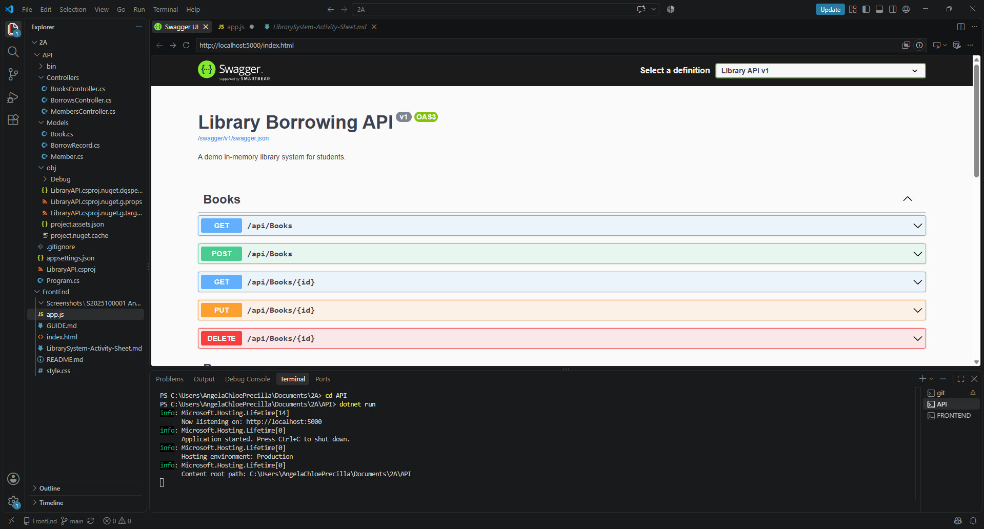

setup-02-api-books-json
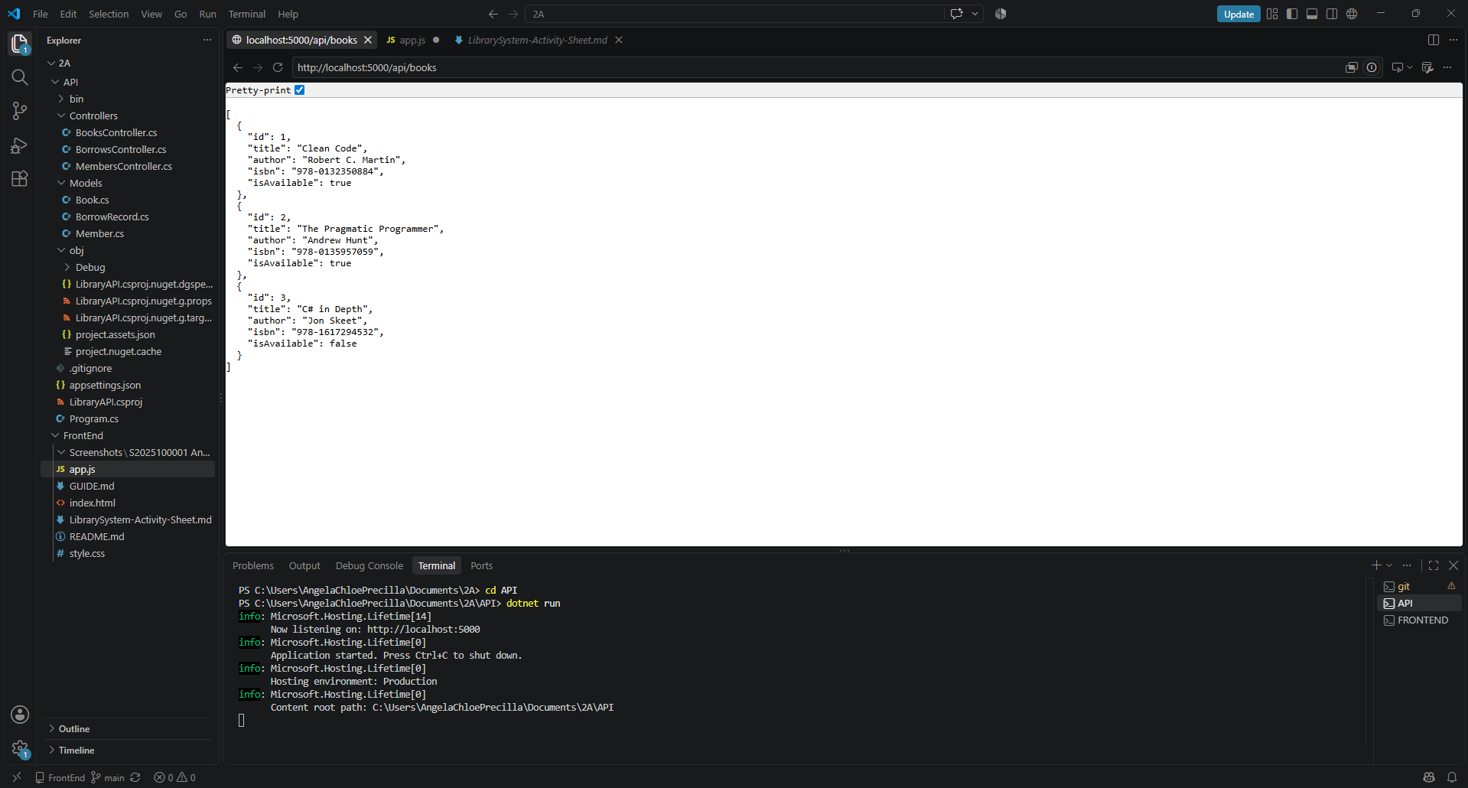

part-01-settings-apifetch
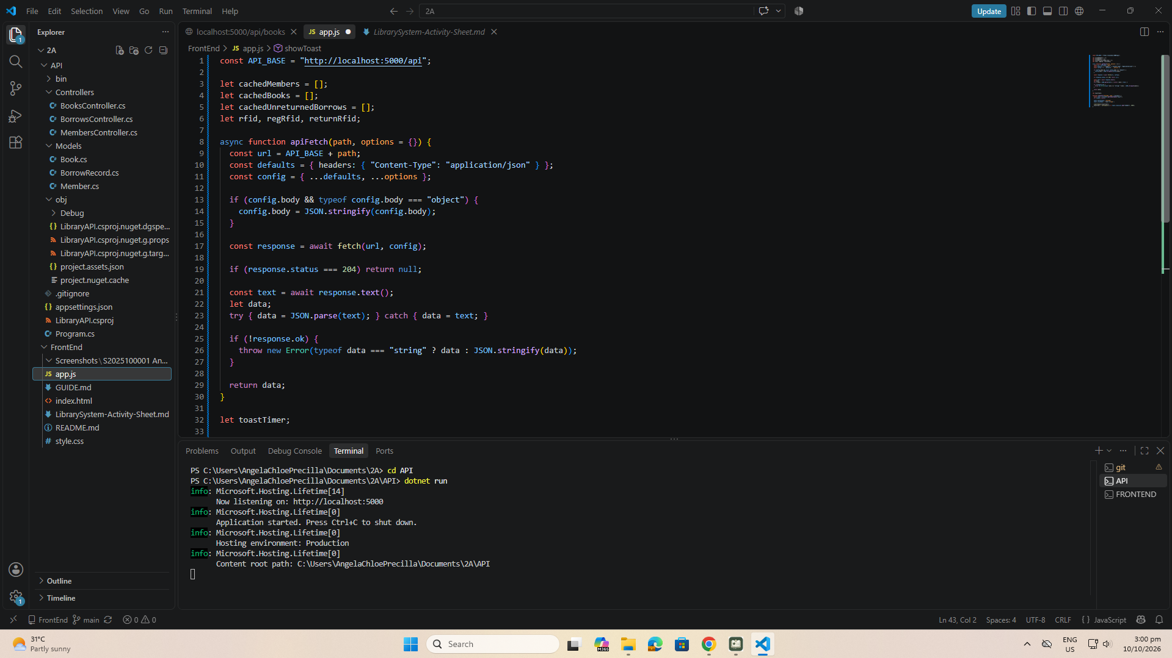
part-02-showtoast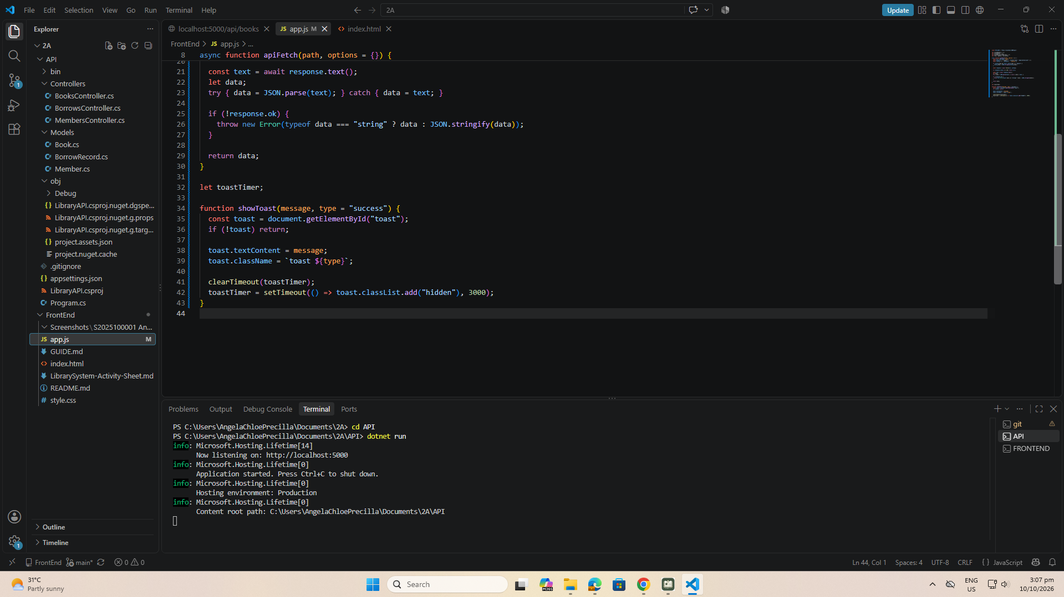

early-01-toast
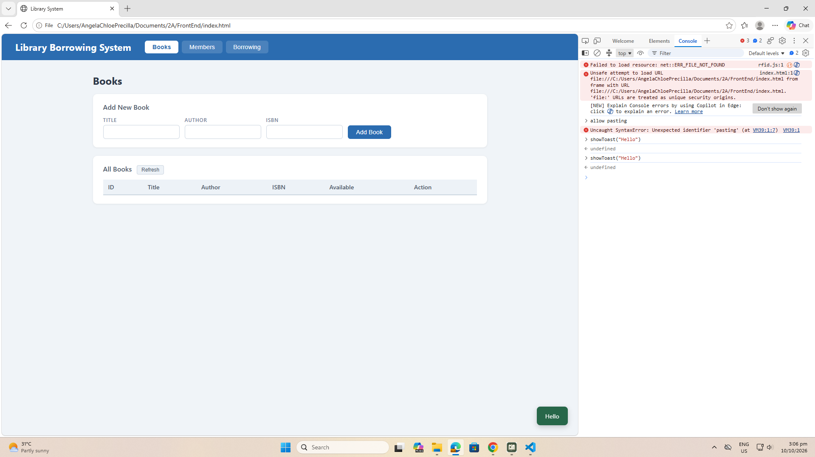
part-03-caches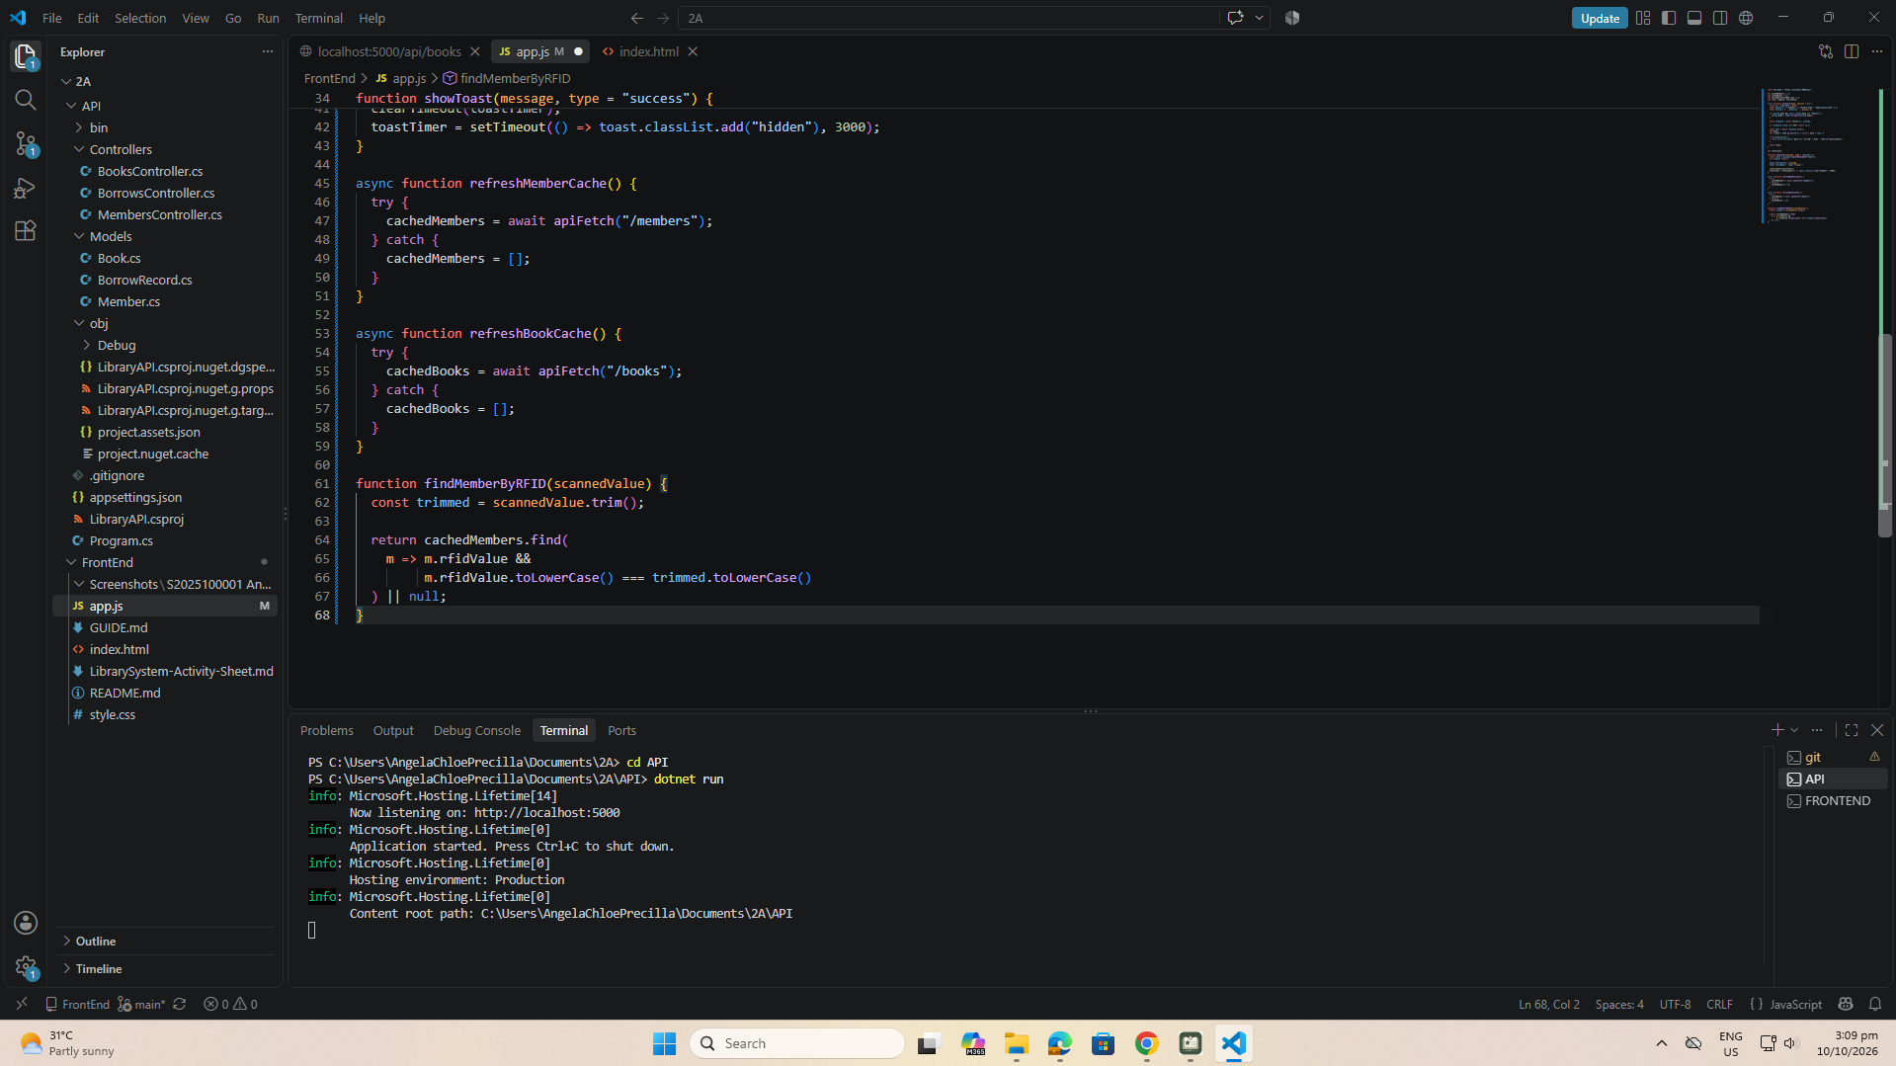

early-02-cache-console
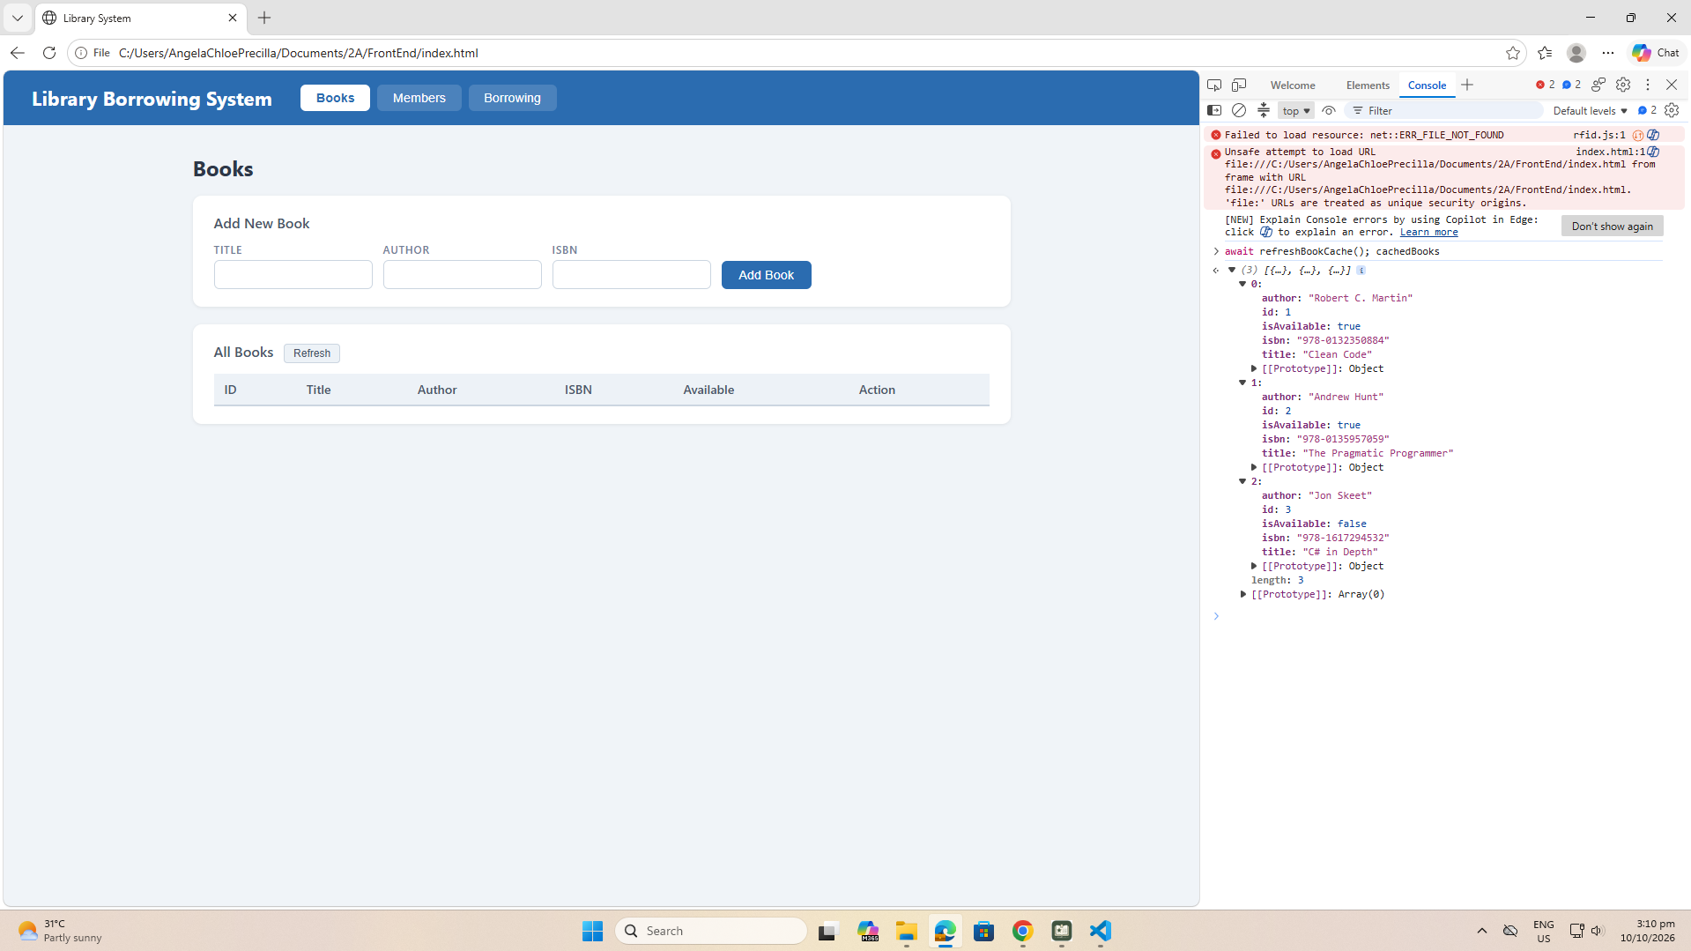

Part-04-tabs-refresh
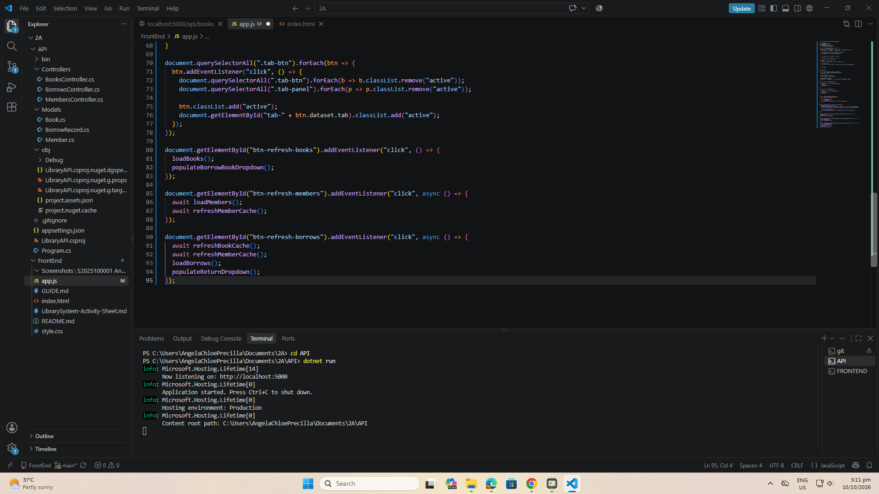
early-03-tabs
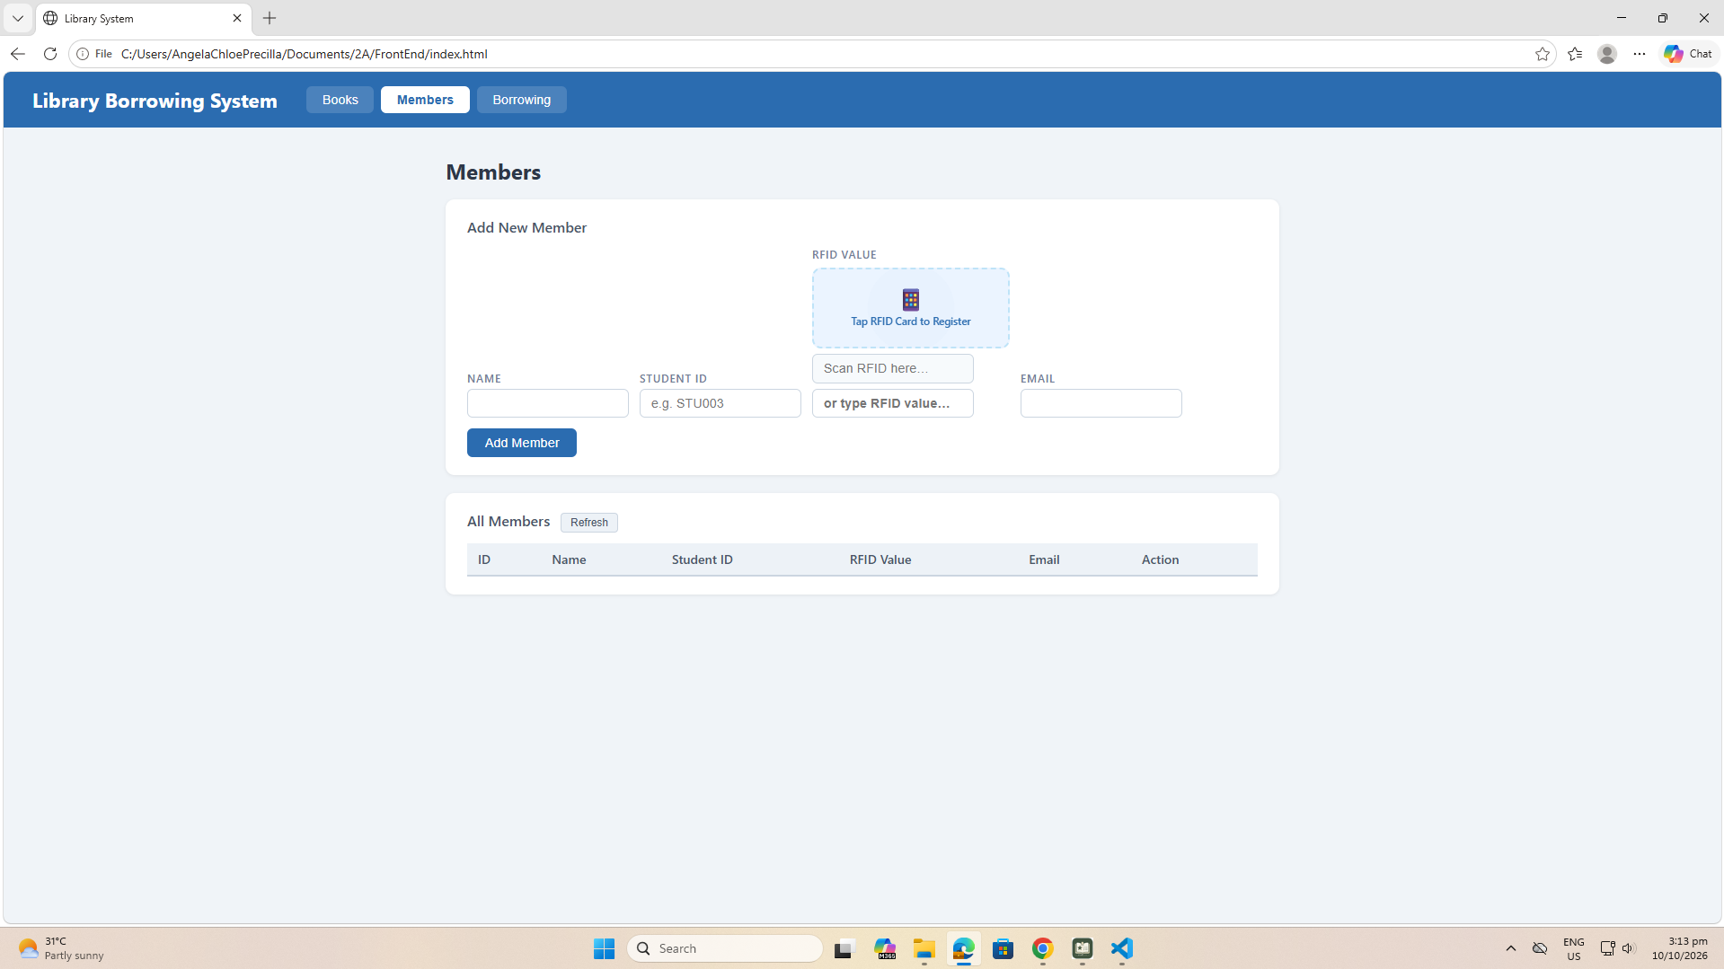
part-05-loadbooks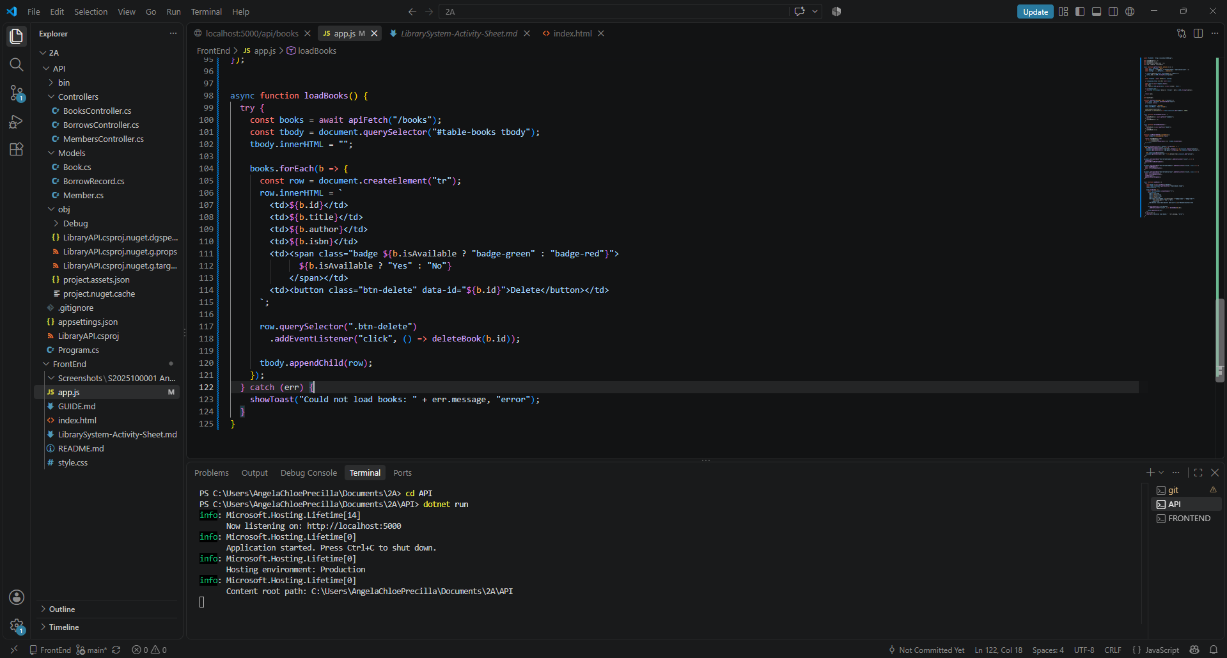

part-06-deletebook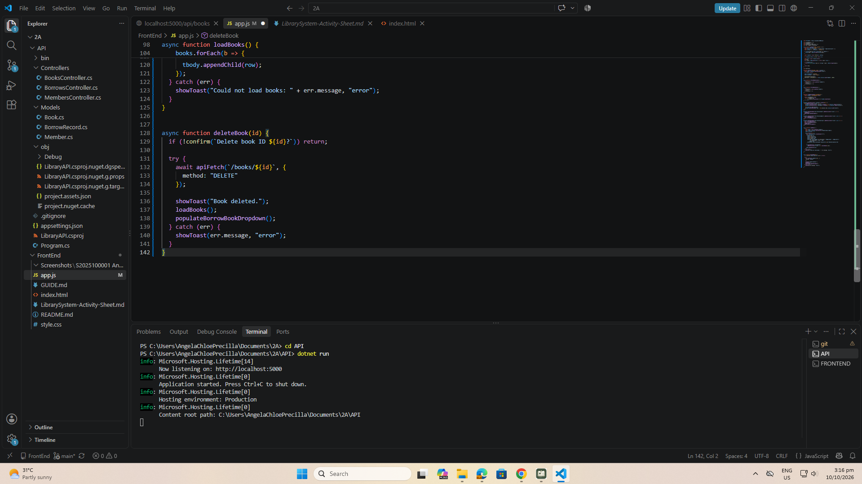
part-07-addbook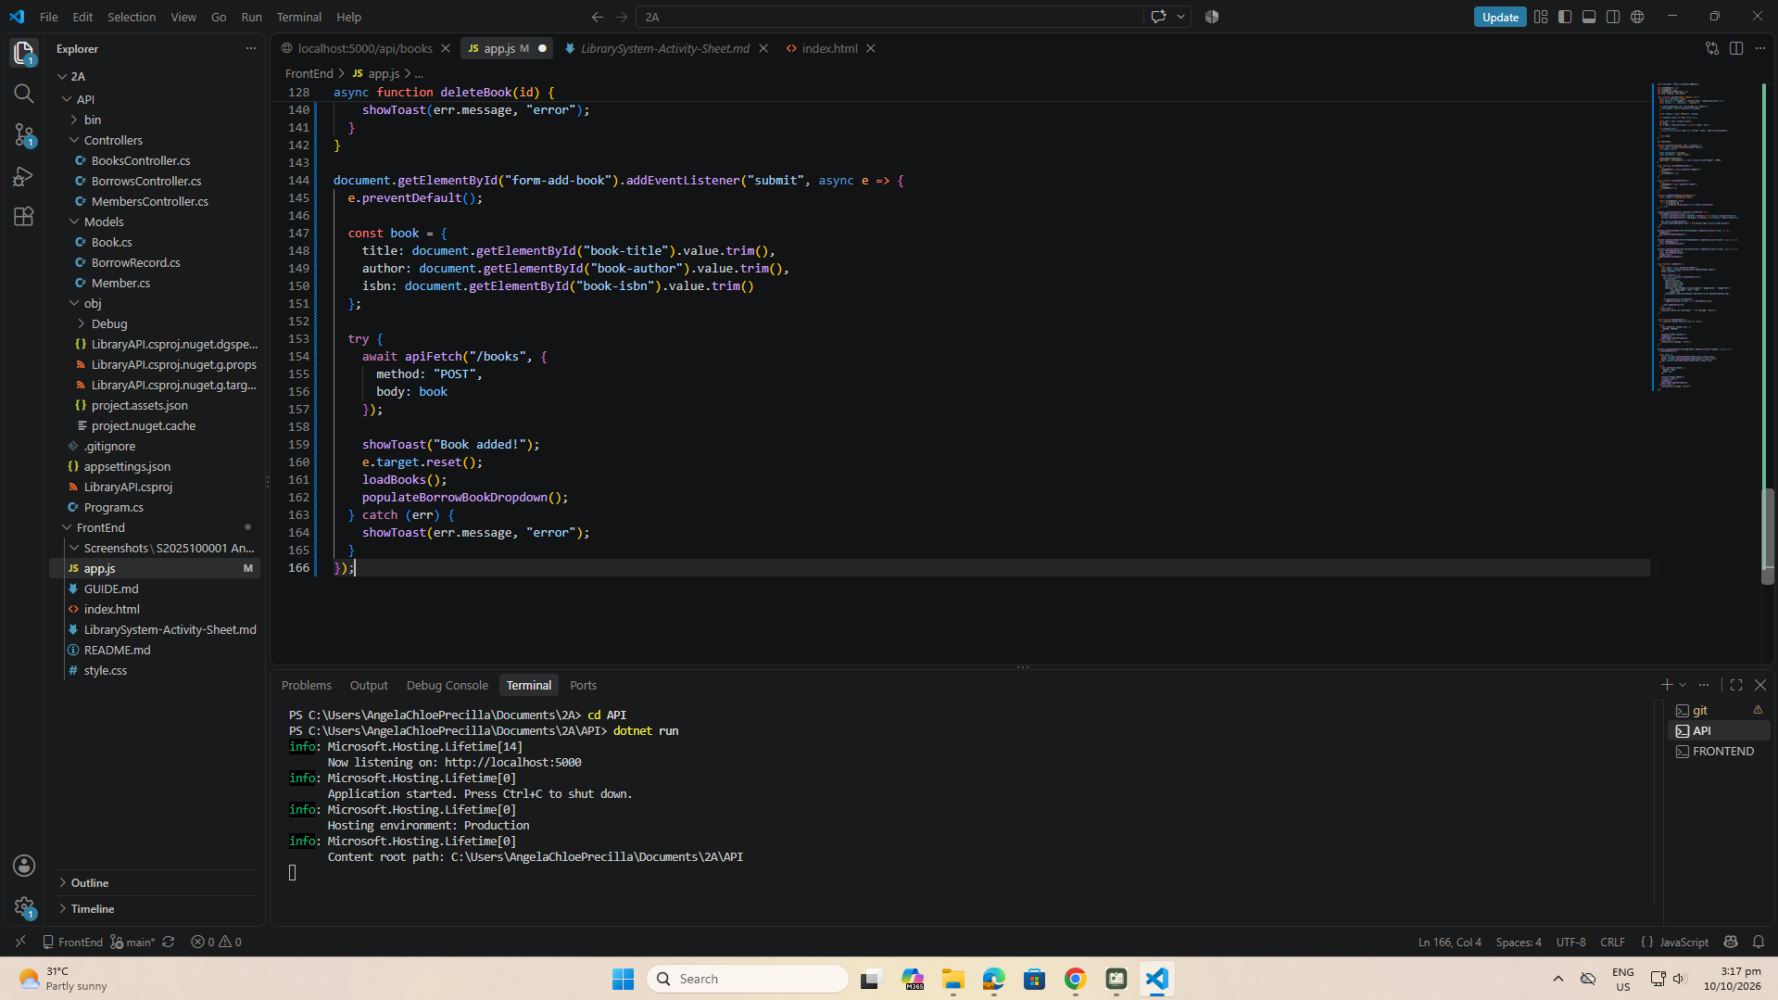

Part-08-loadmembers
part-08a
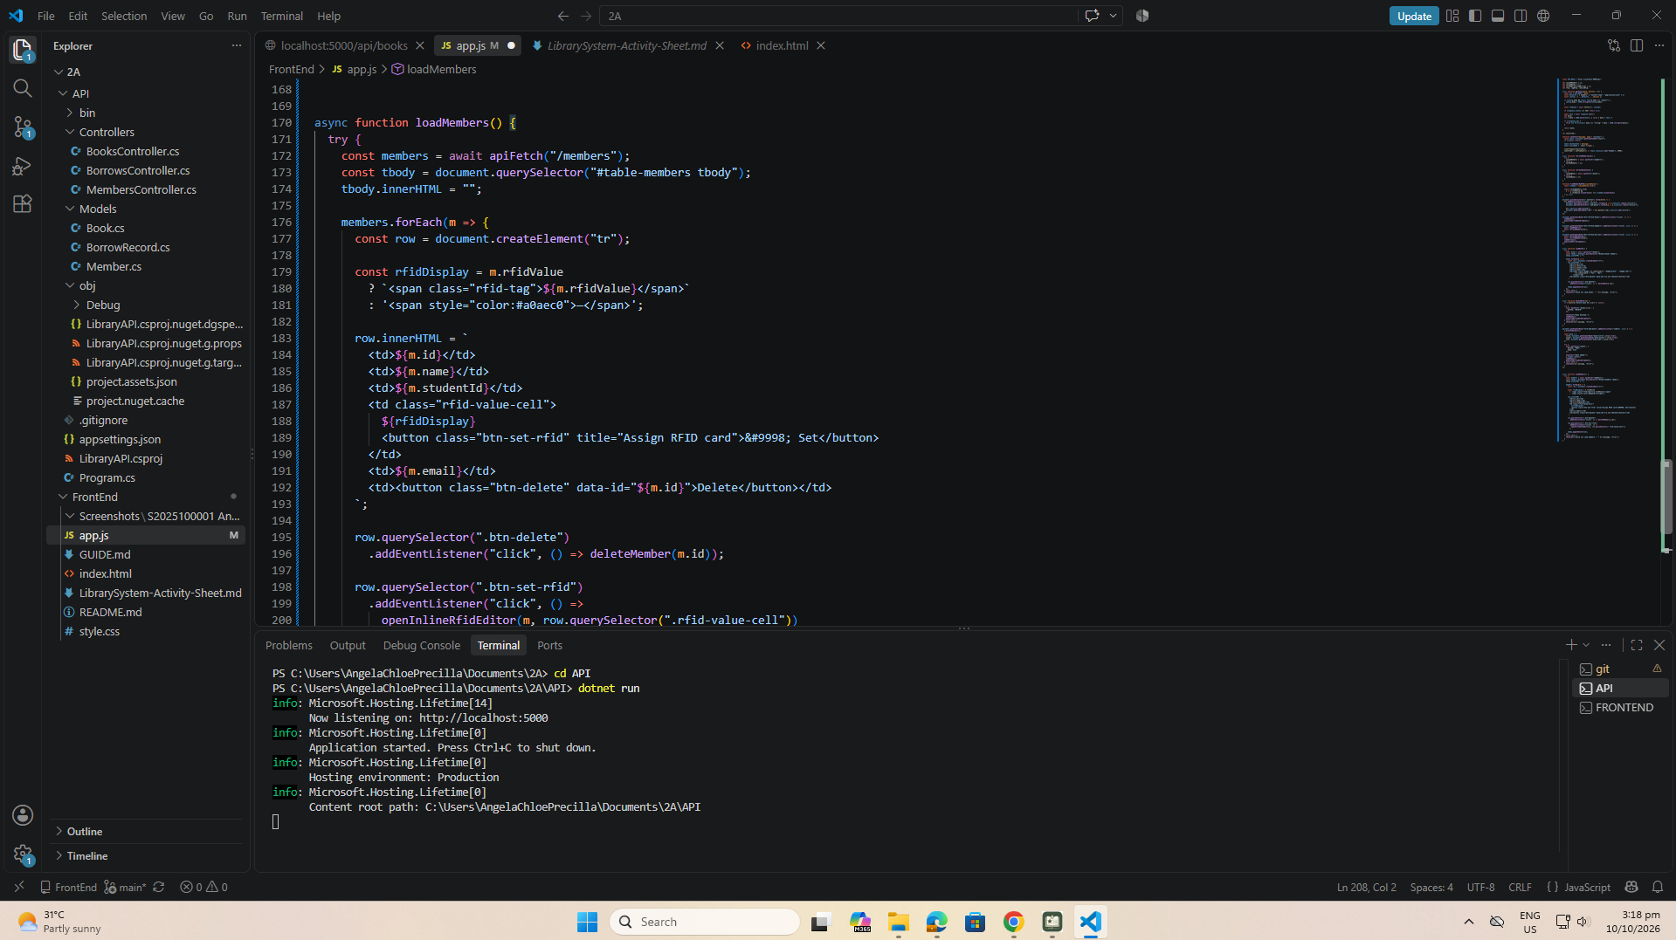
part-08b
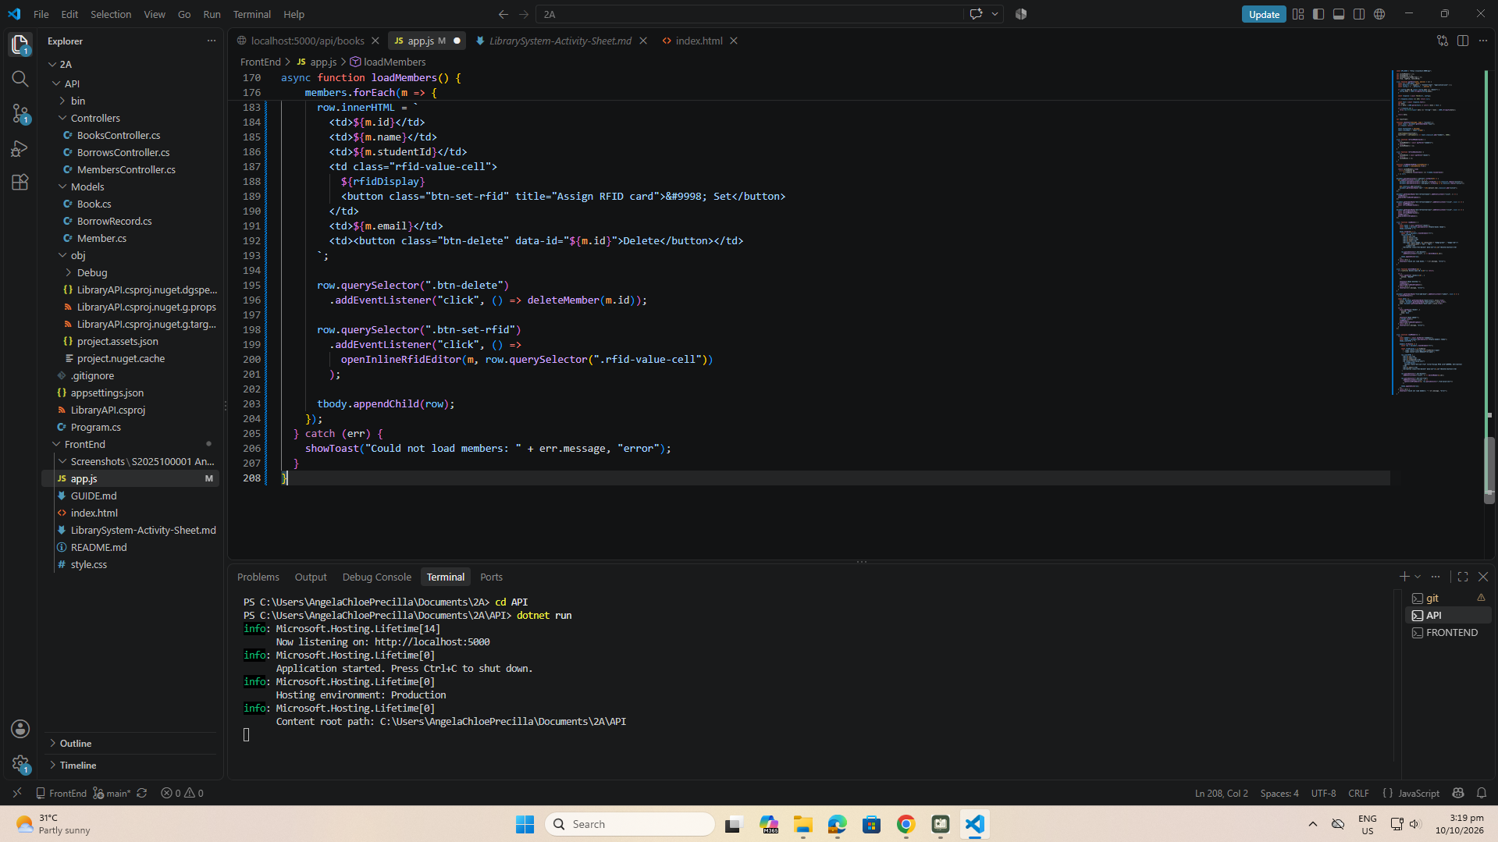
part-09-deletemember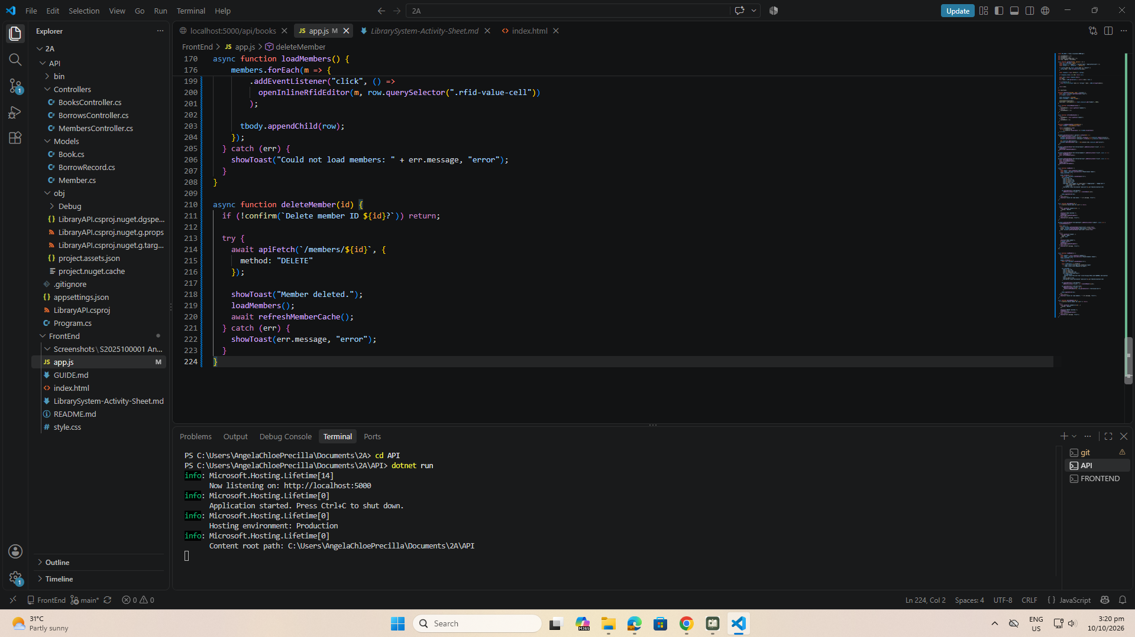
part-10-addmember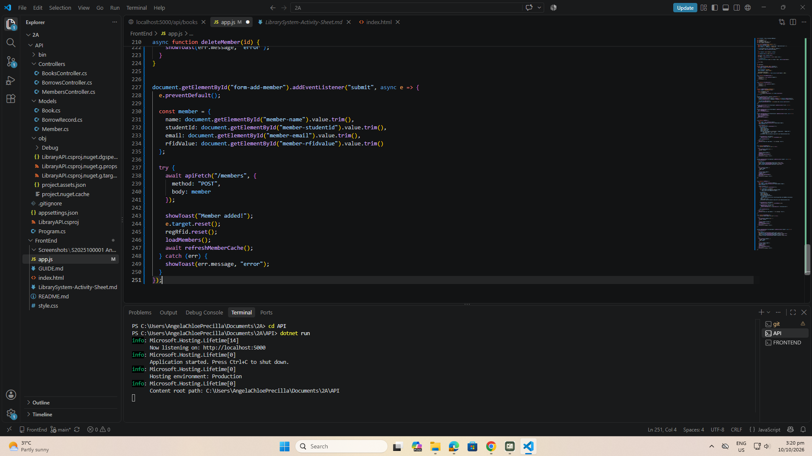

Part-11-inline-rfid-editor
Part-11a
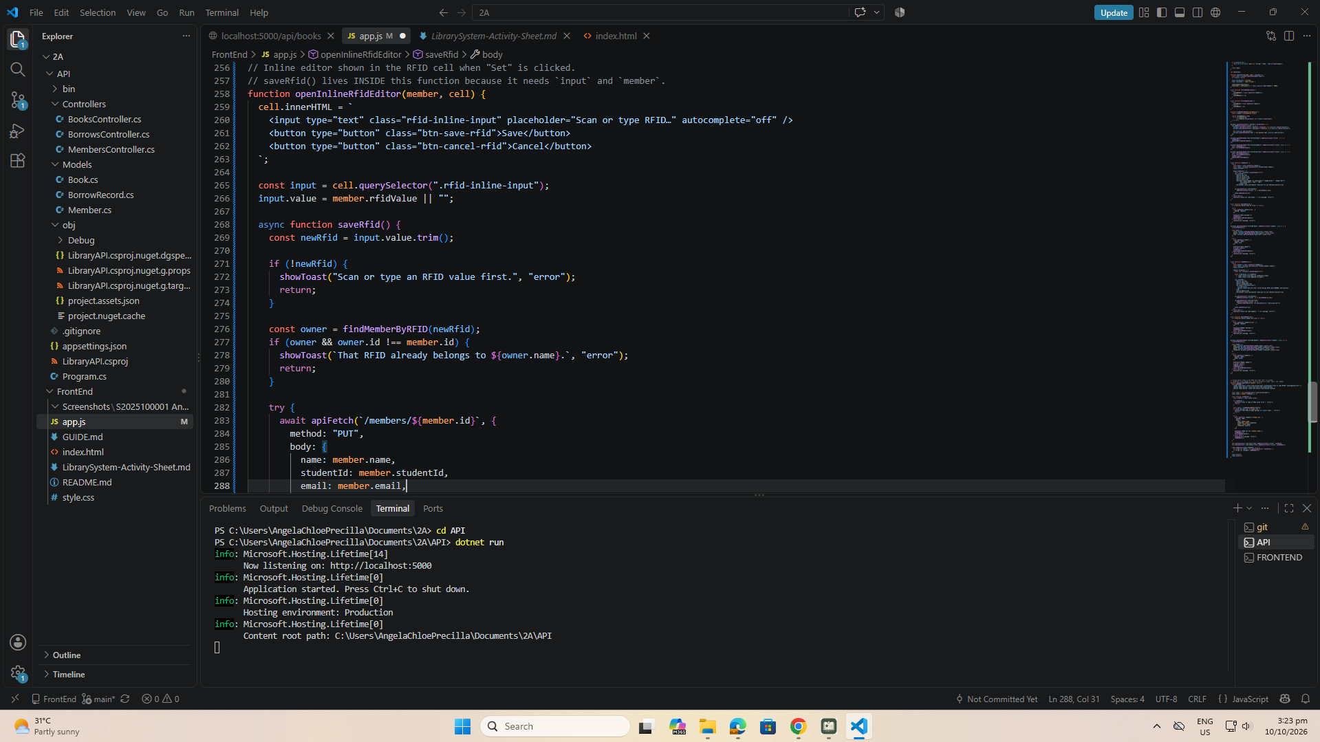
part-11b
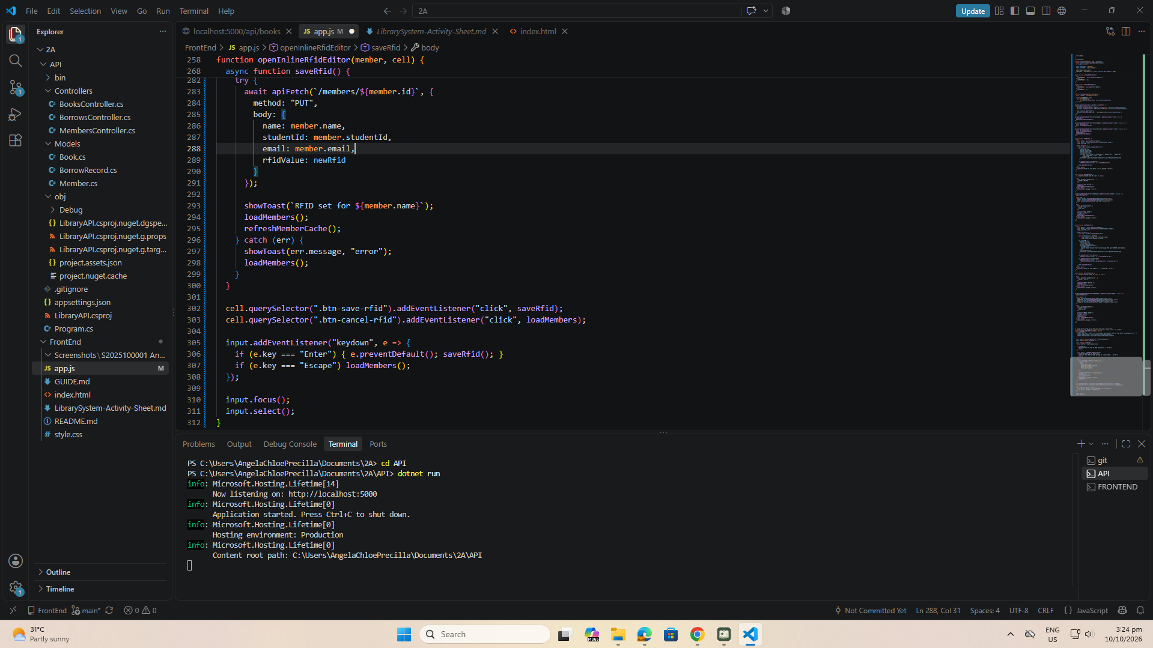
Part-12a-rfid-widget-builder
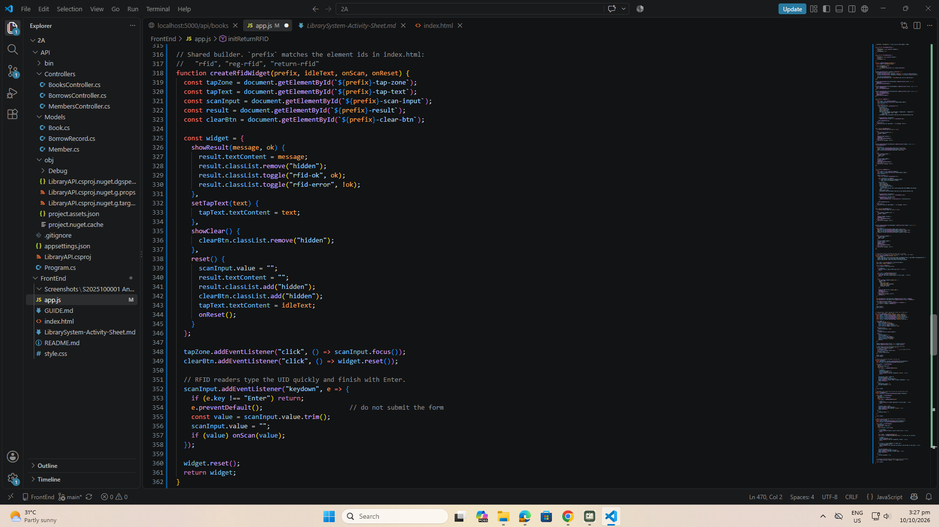
part-12b-rfid-init-functions
initRFID()
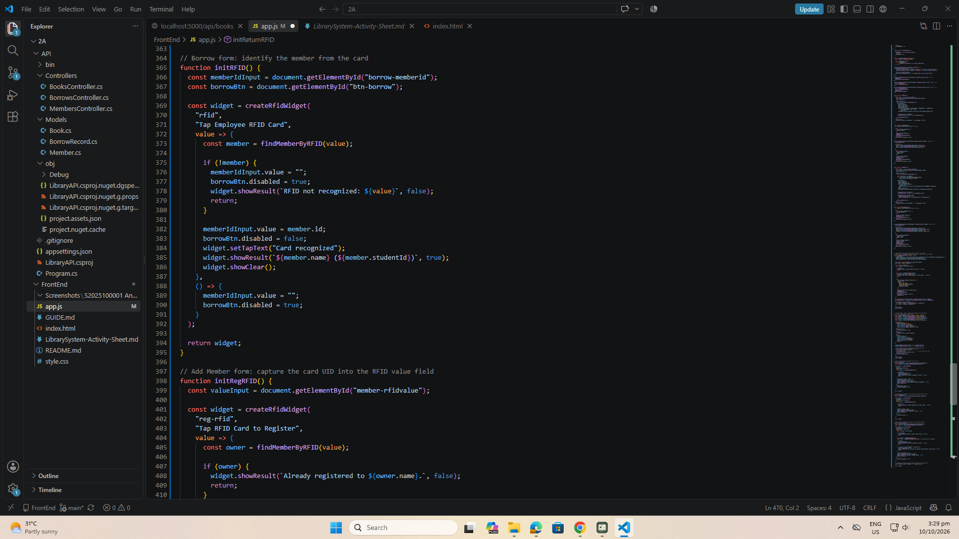
initRegRFID()
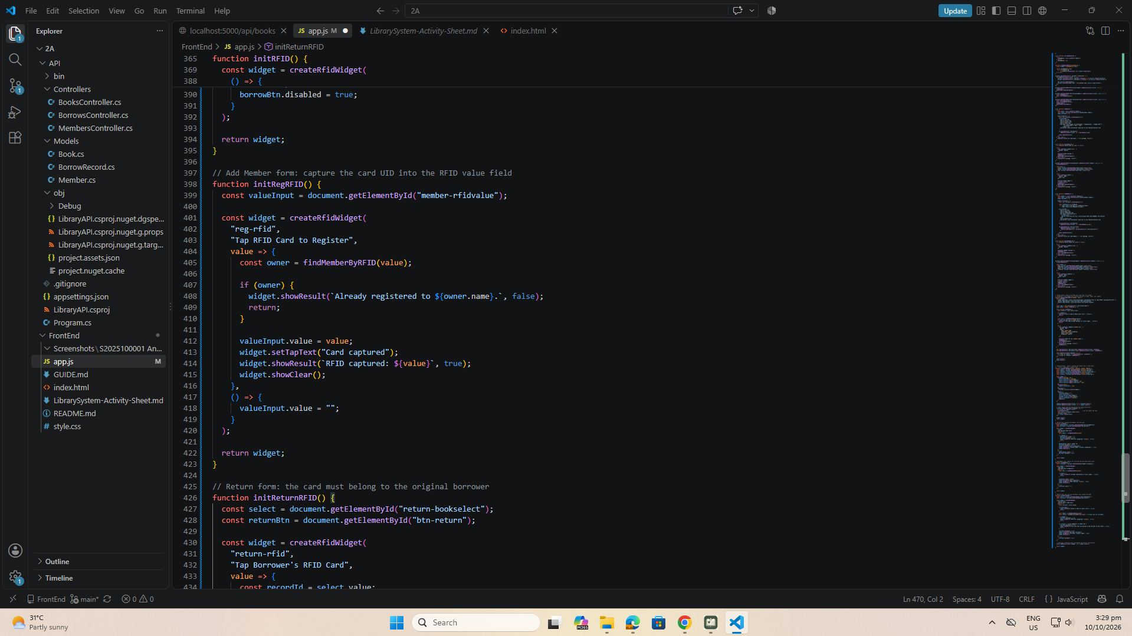
initReturnRFID()
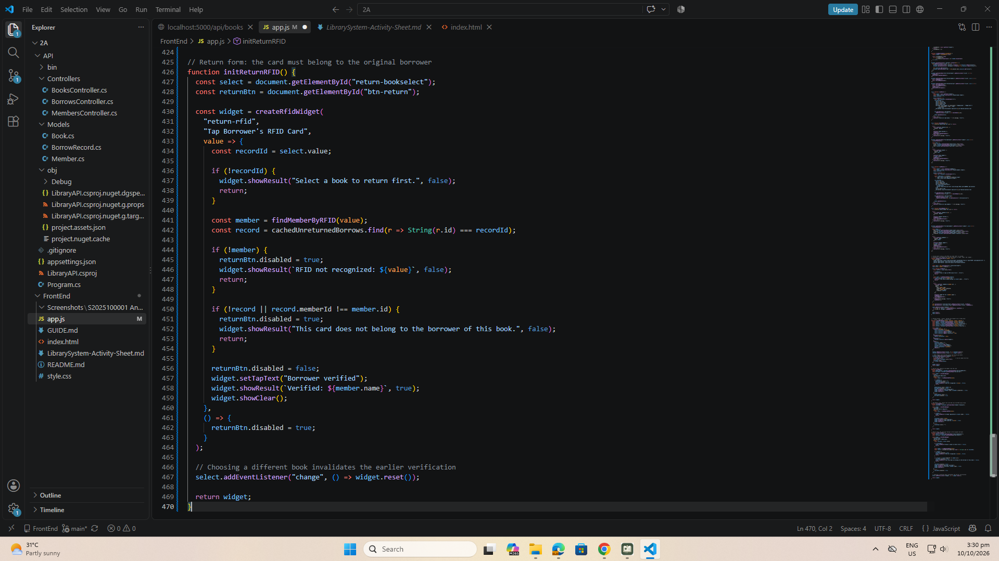

part-13-borrow-dropdown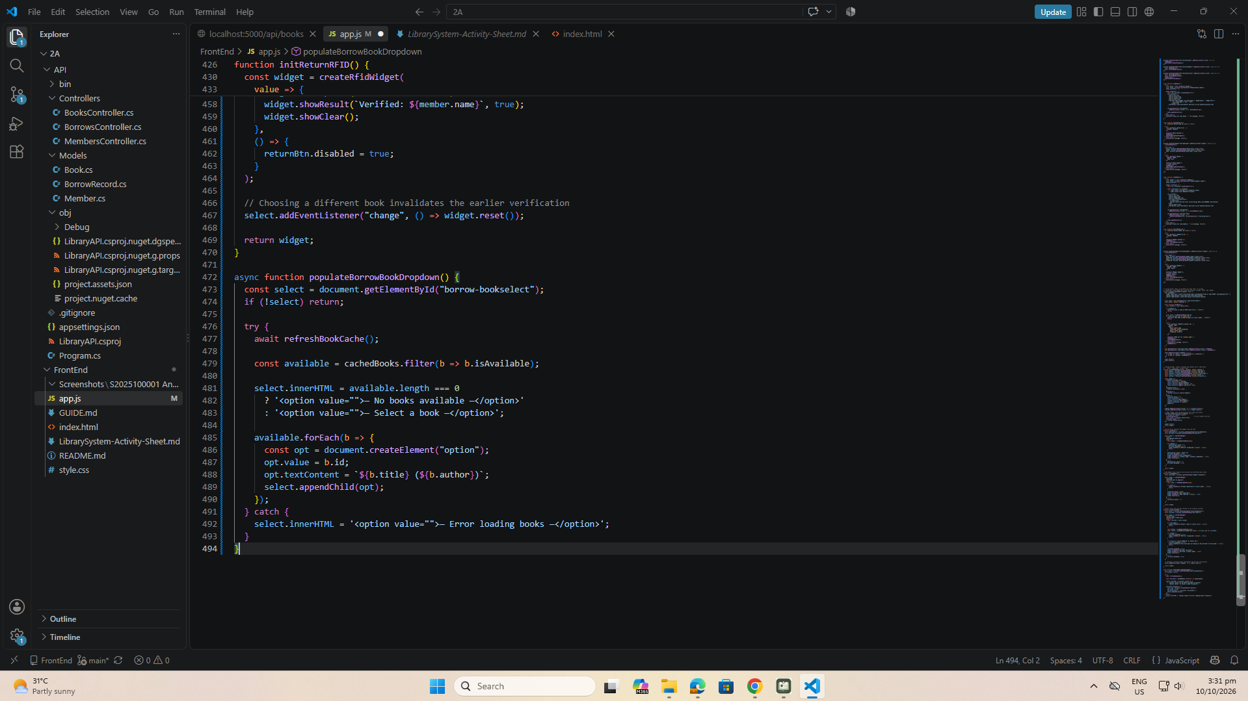

part-14-return-dropdown
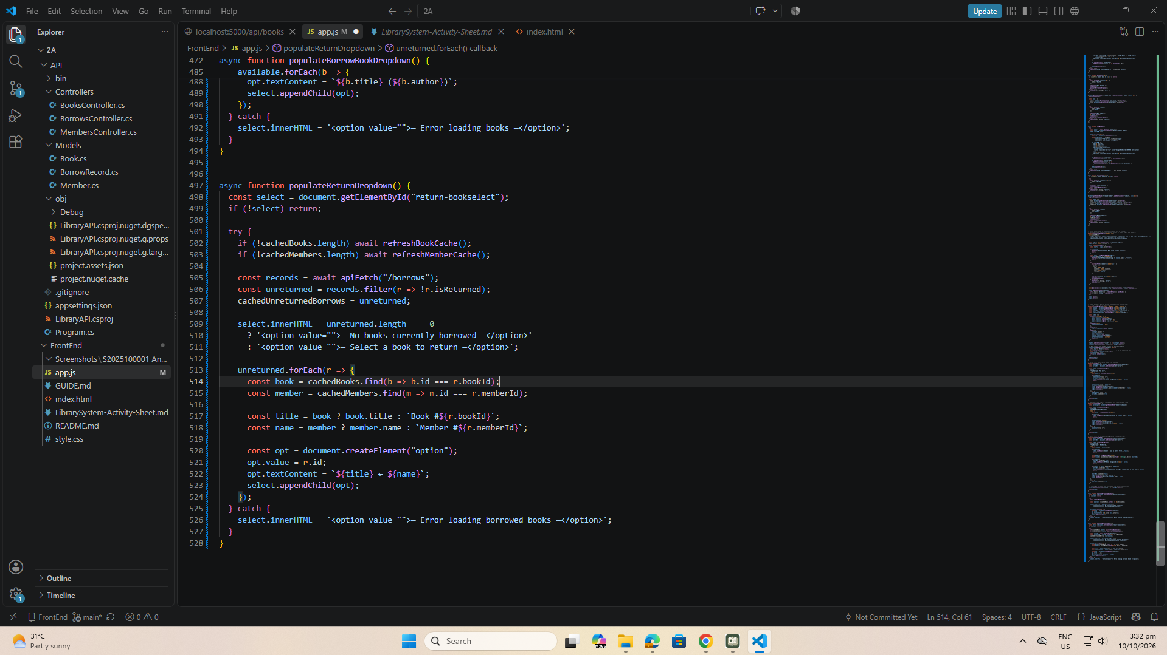
Part-15-borrow
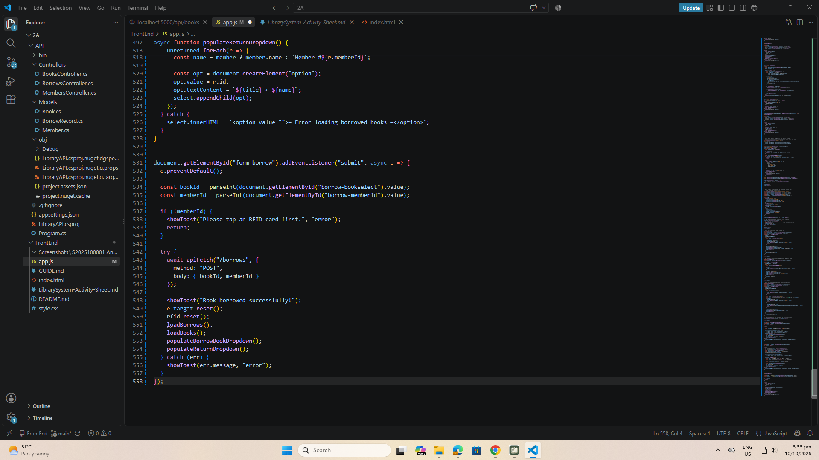
part-16-return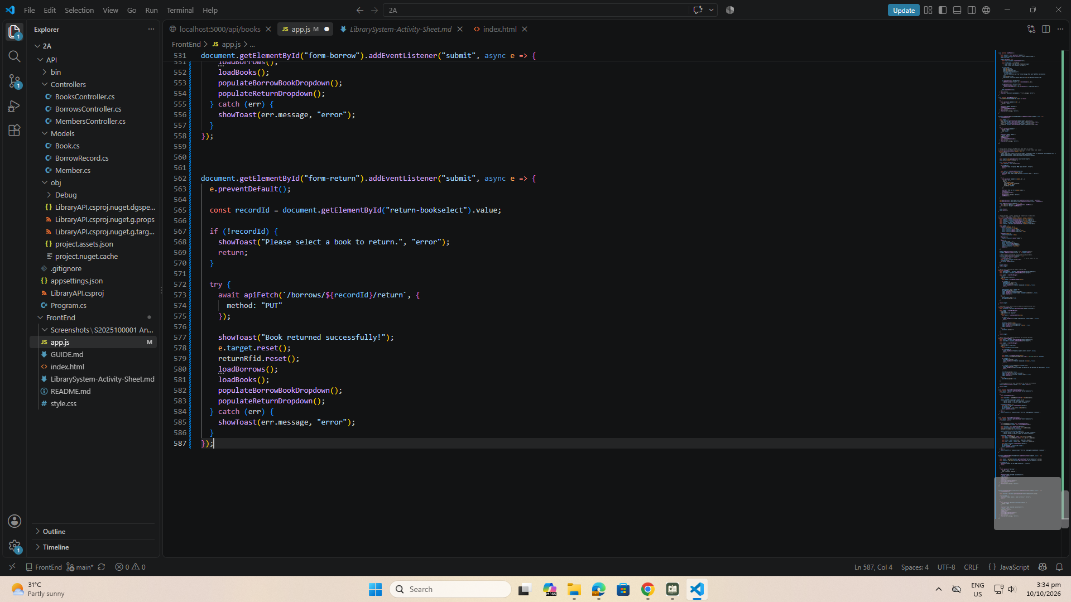

part-17-loadborrows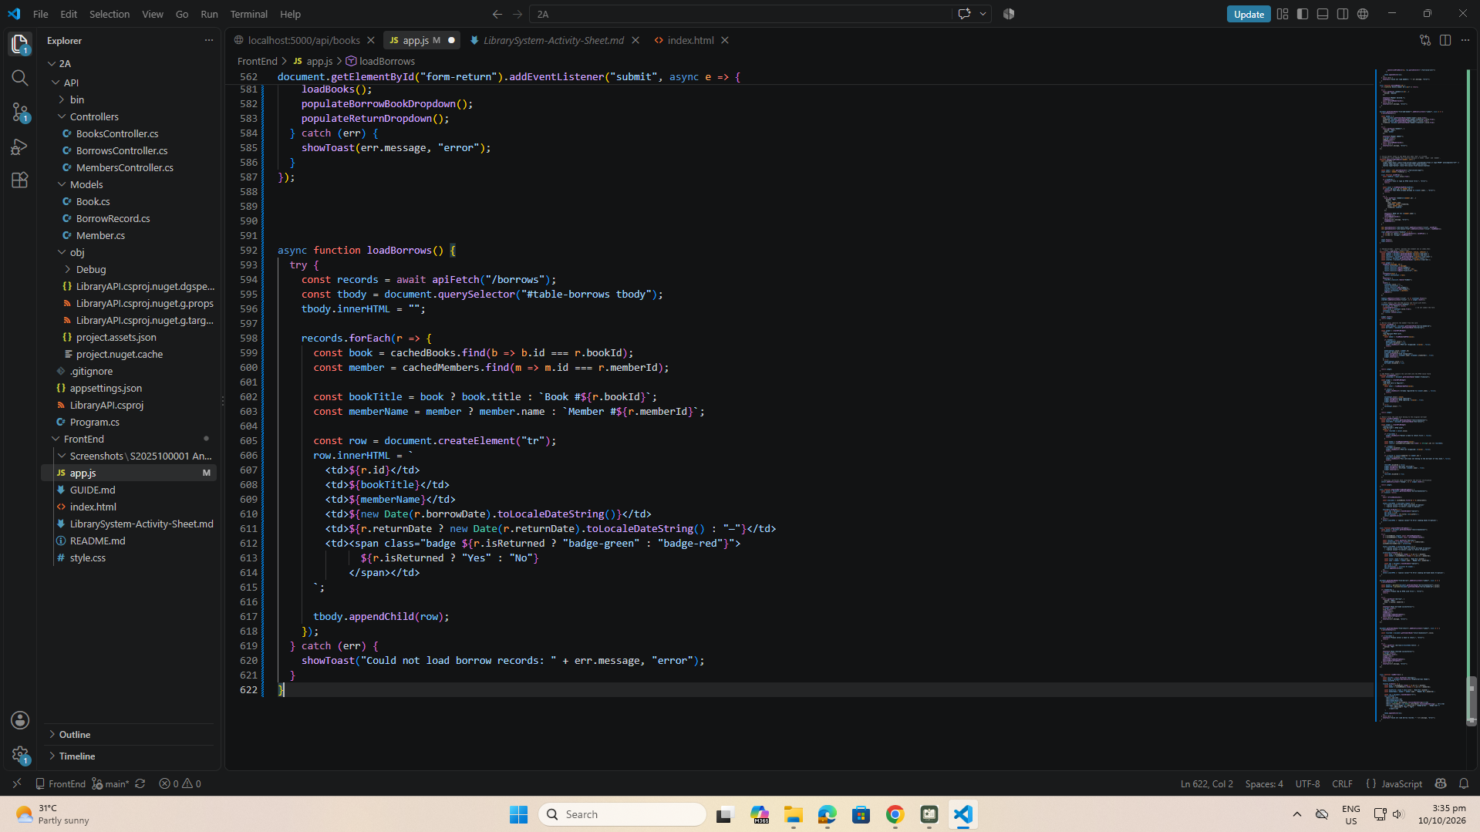
part-18-page-load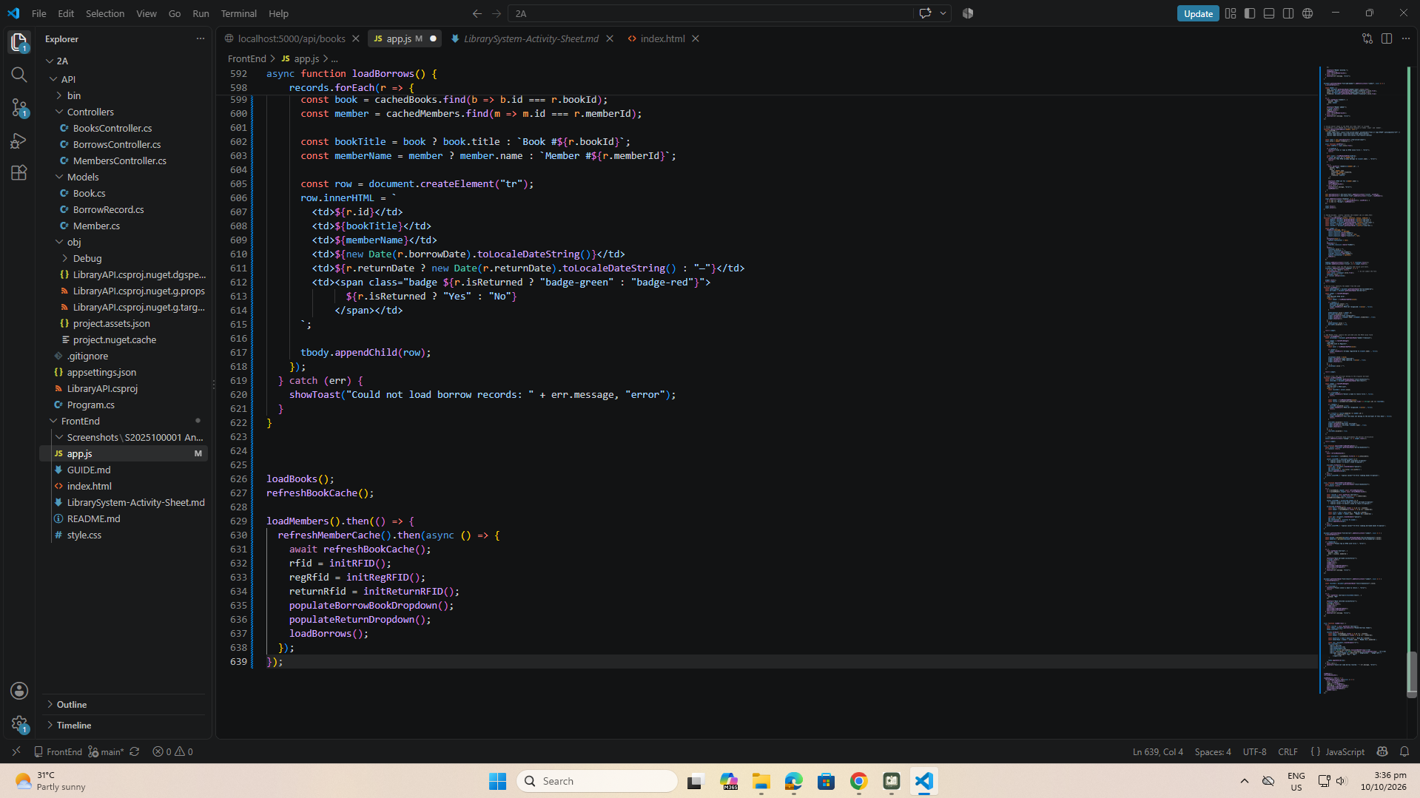

test-01-page-loaded
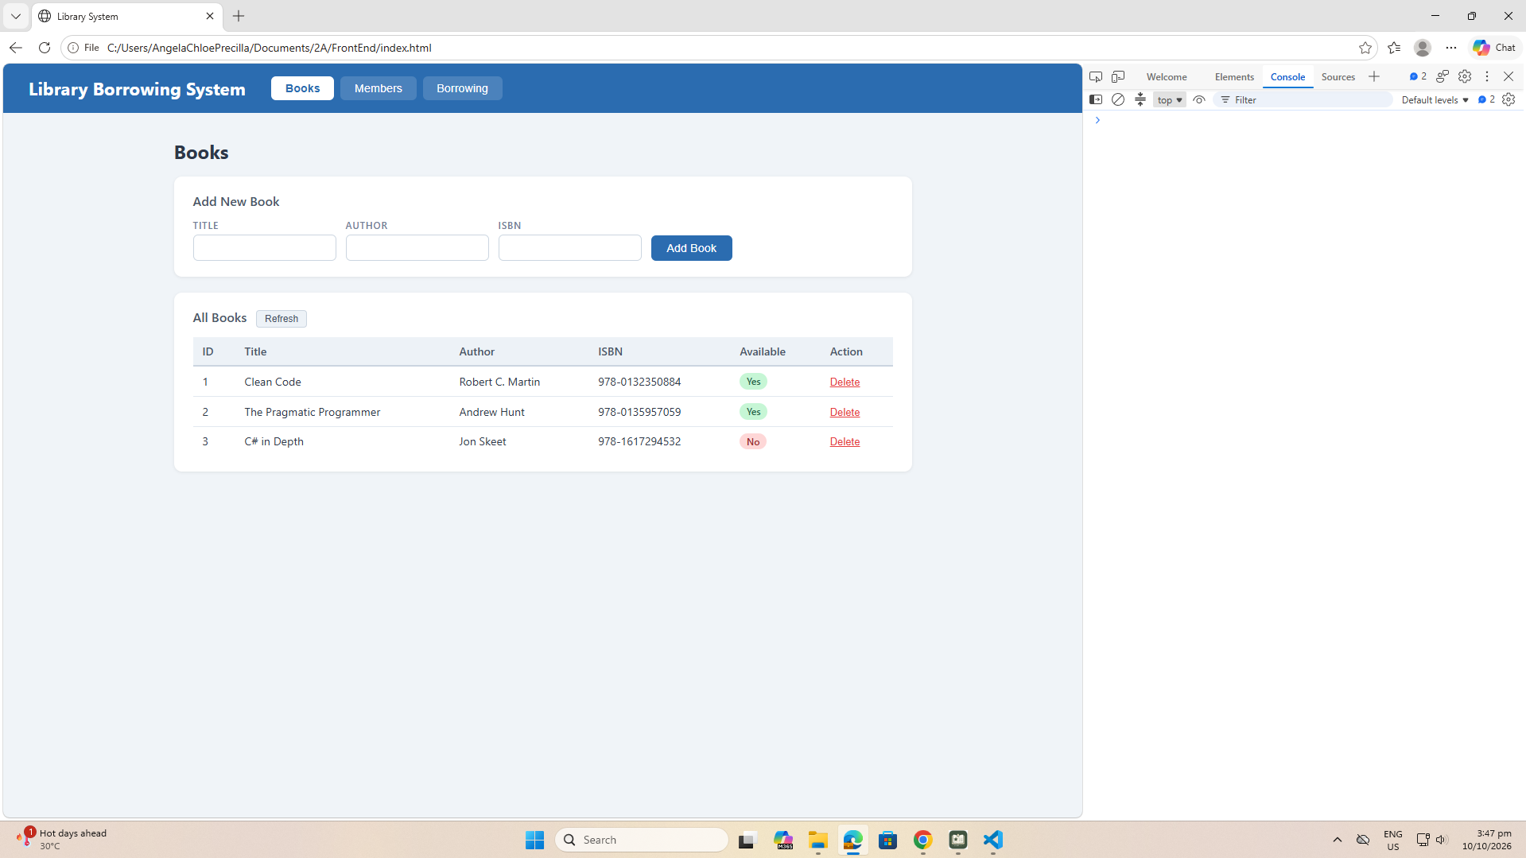

test-02-add-book
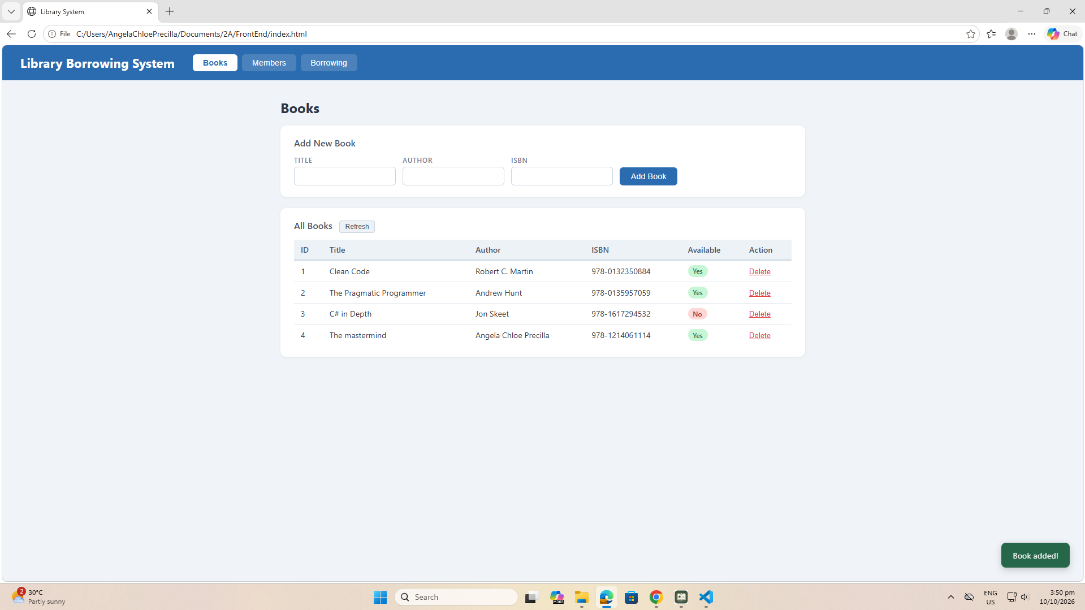
test-03-delete-book
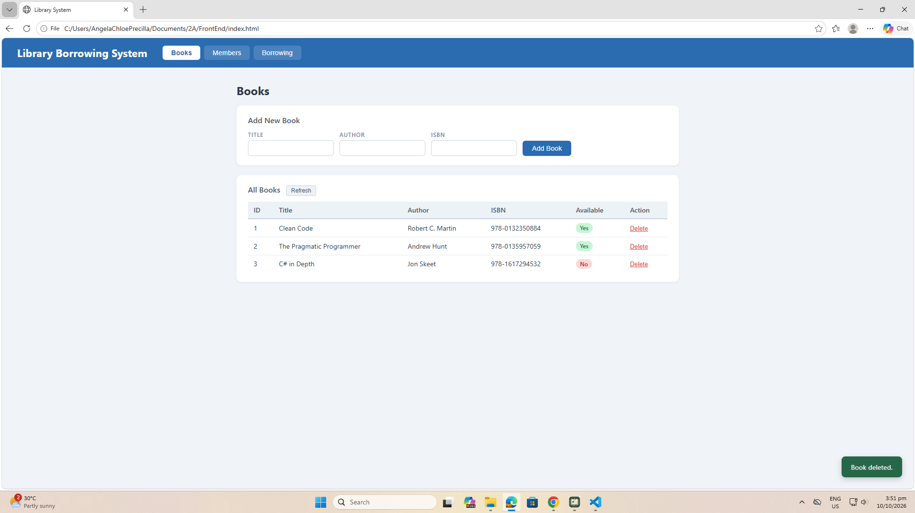

test-04-members-loaded
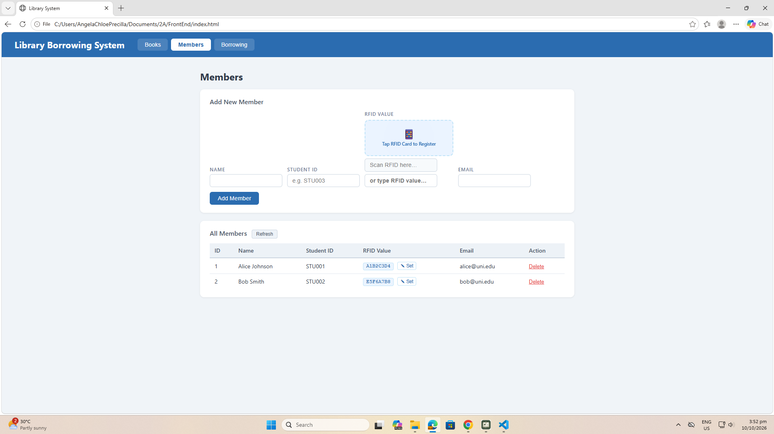
test-05-register-rfid
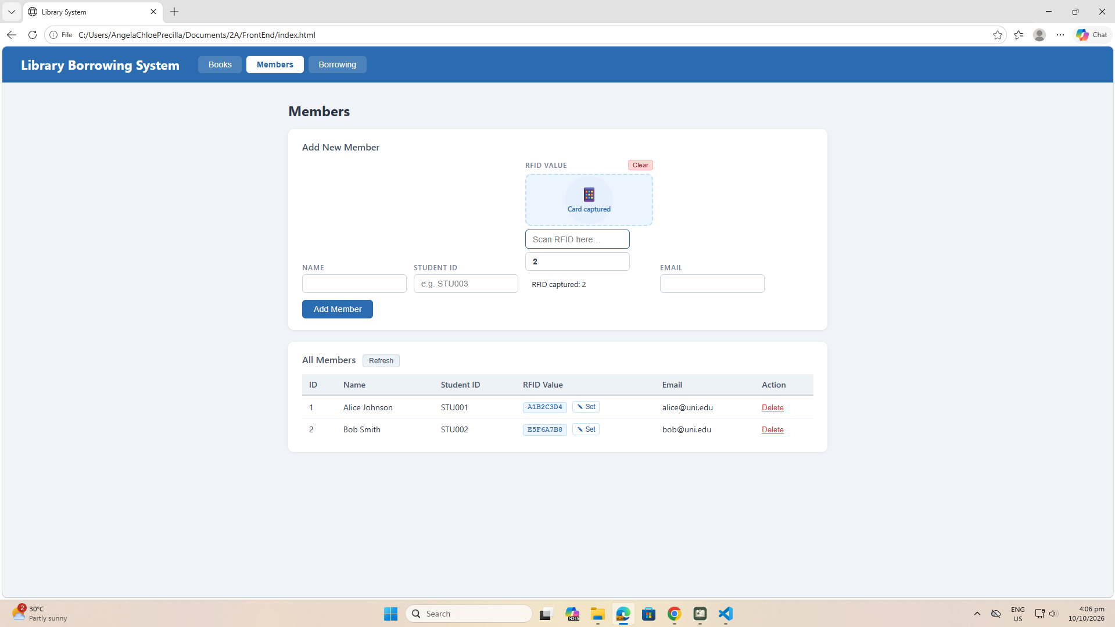
test-06-add-member
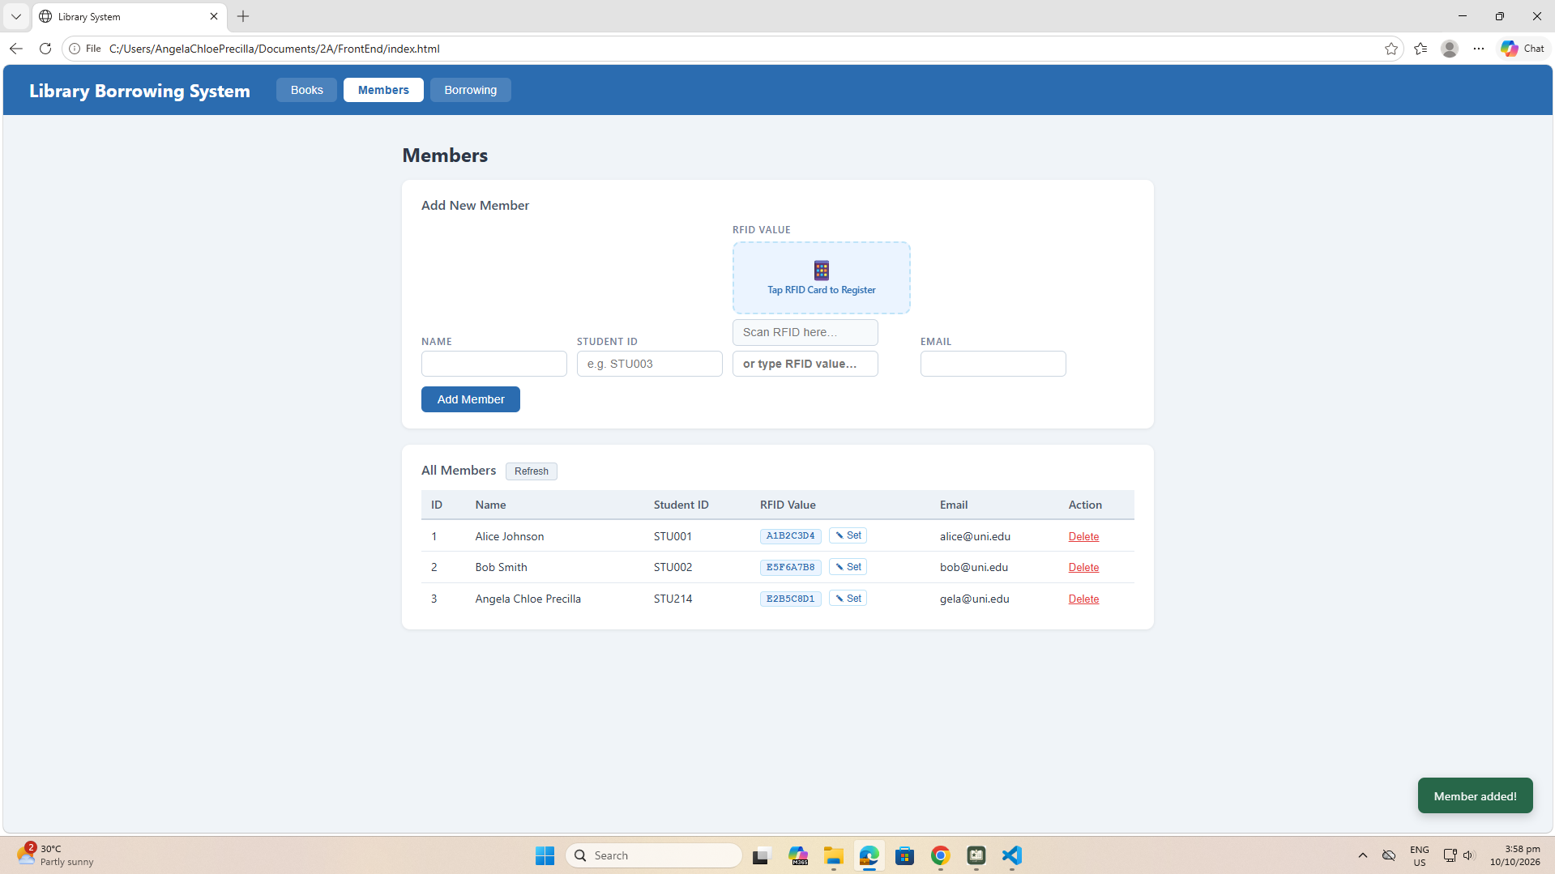

test-07-set-rfid-saved
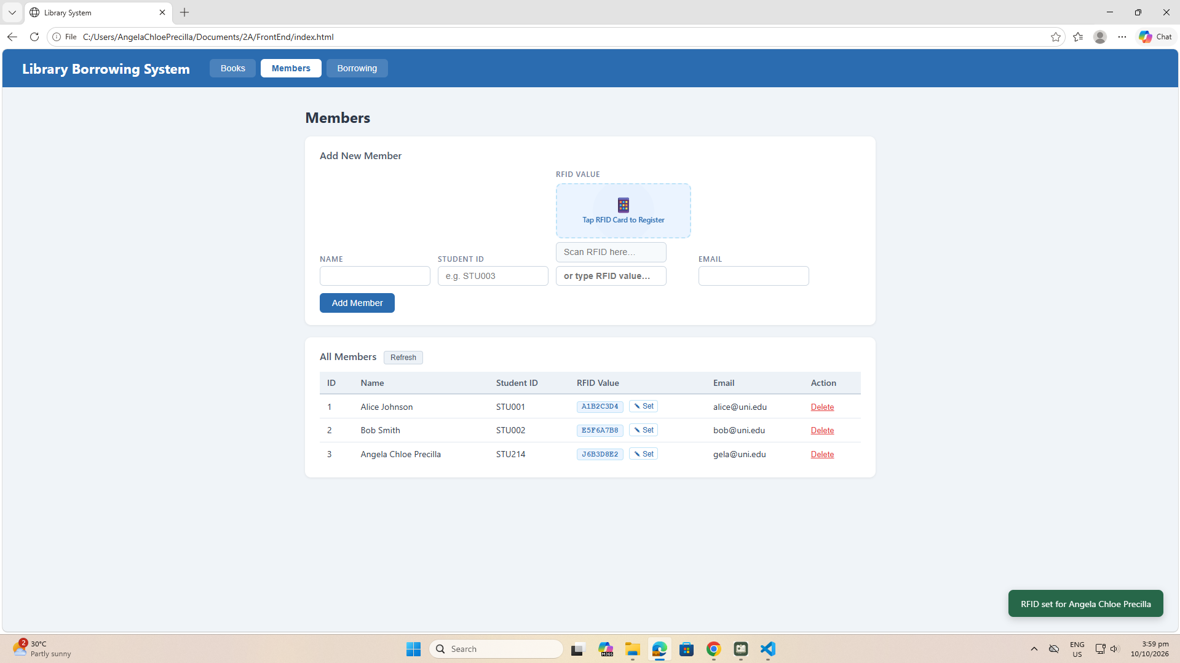
test-08-delete-member
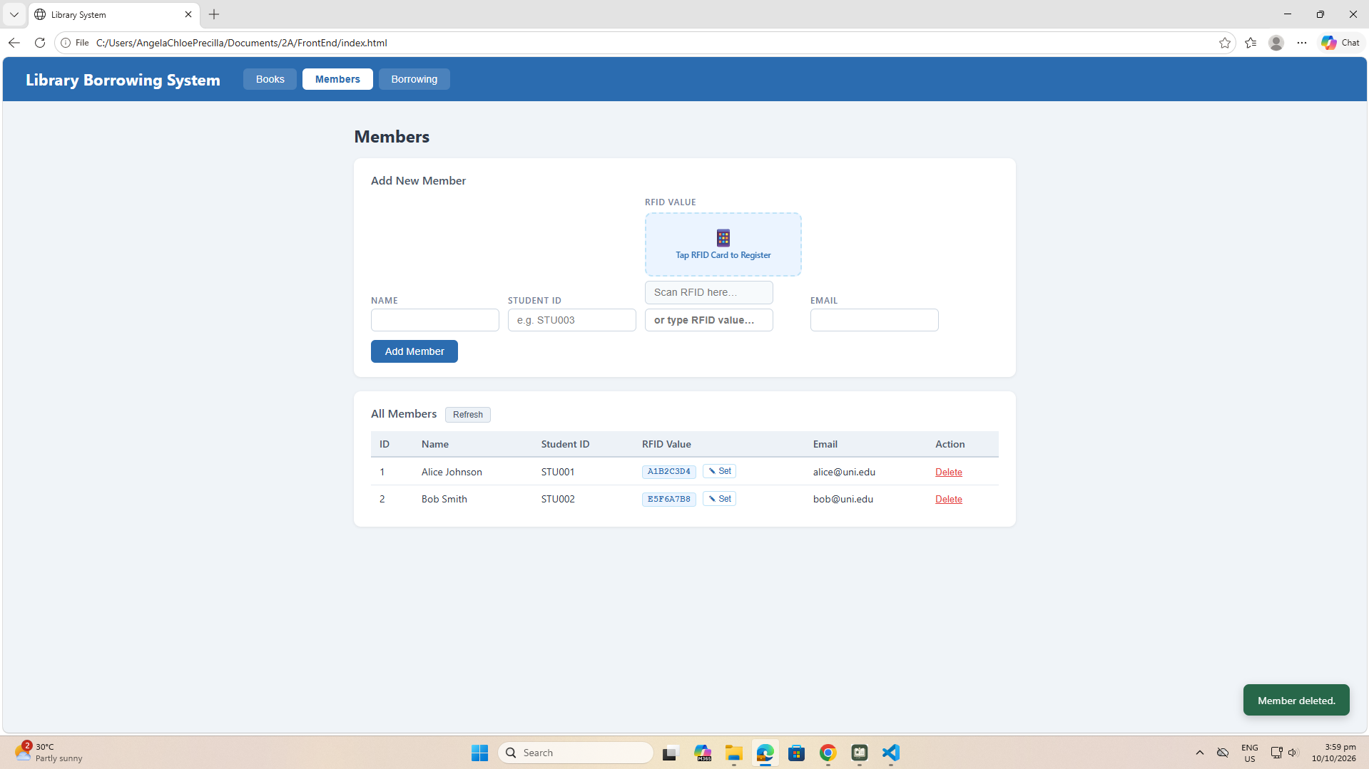

test-09-borrow-rfid-recognized
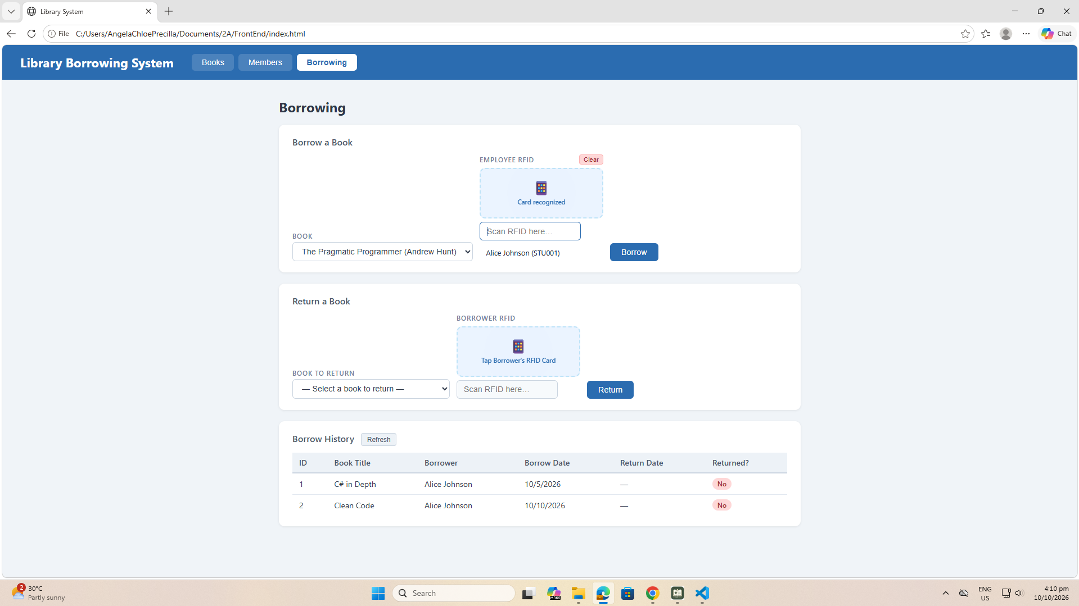
test-10-borrow-success
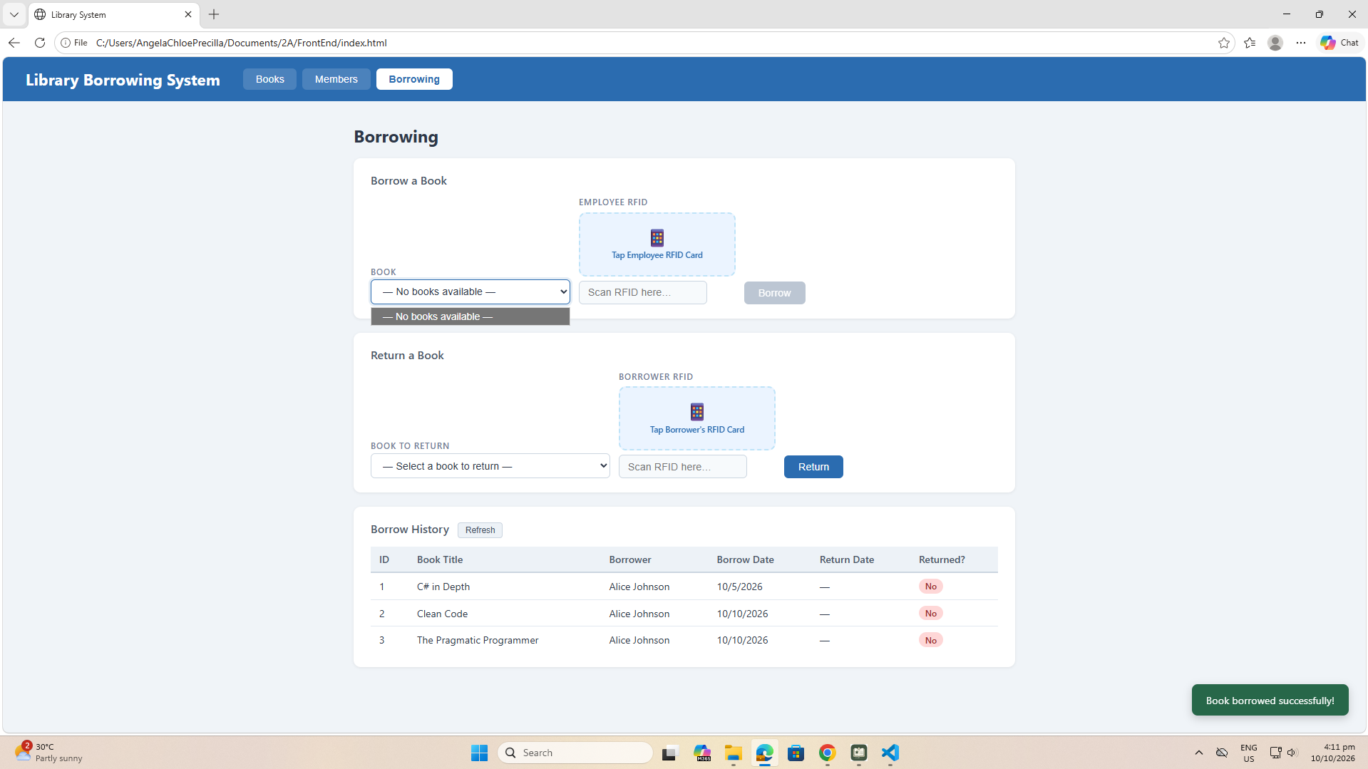

test-11-return-wrong-card
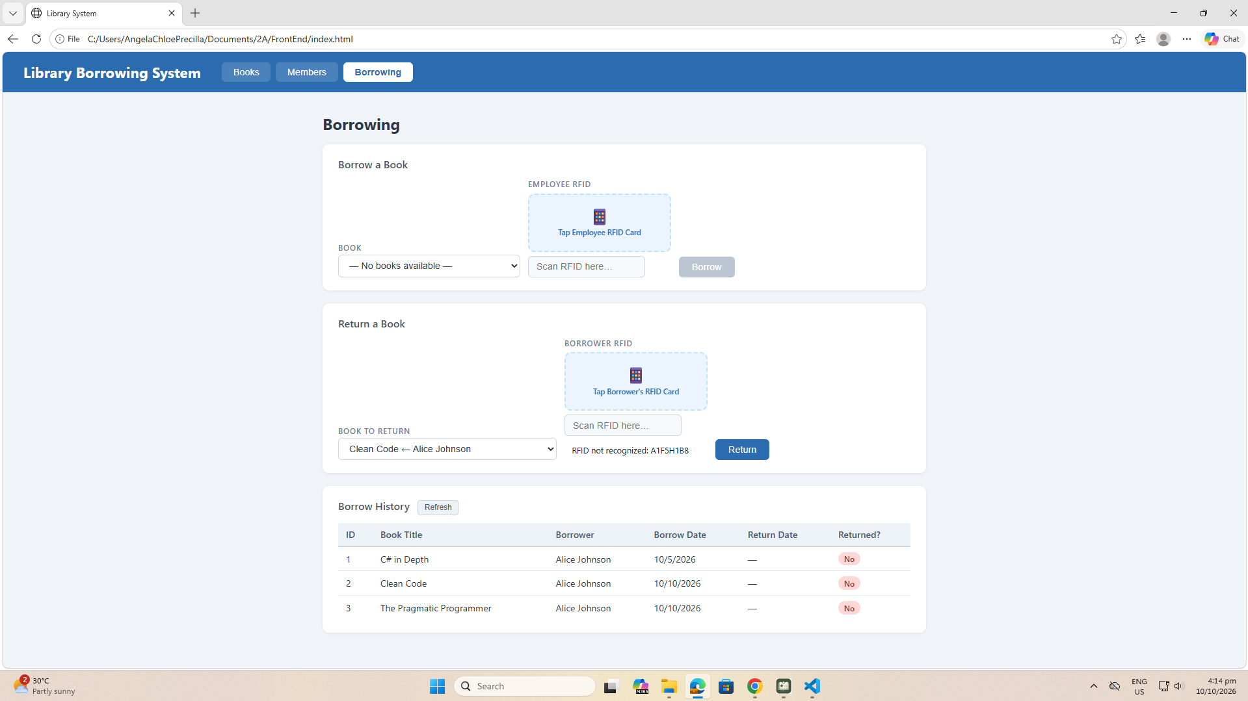

test-12-return-verified
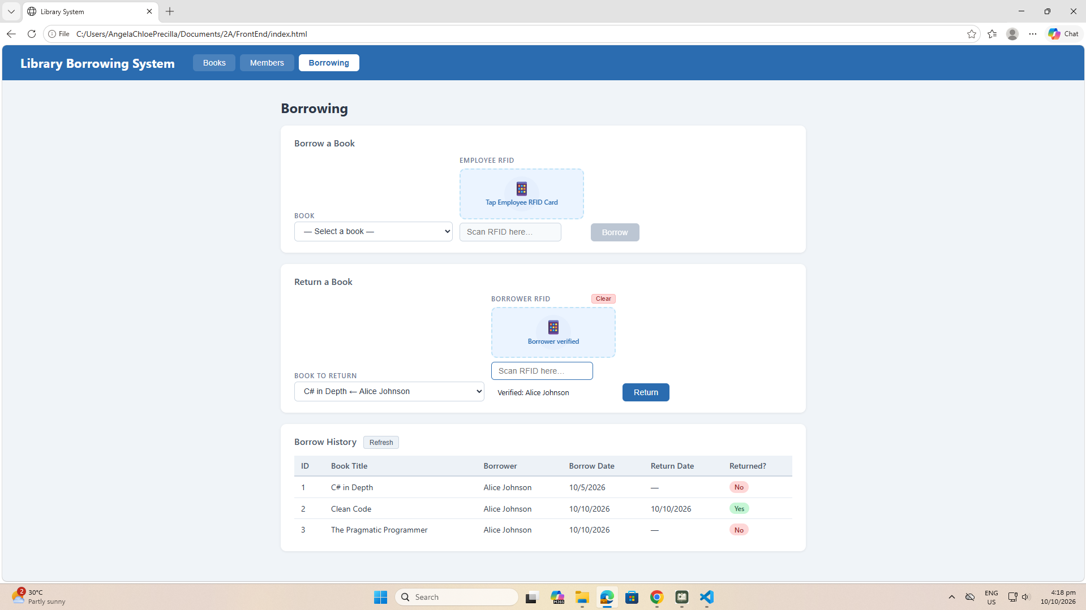
test-13-return-success
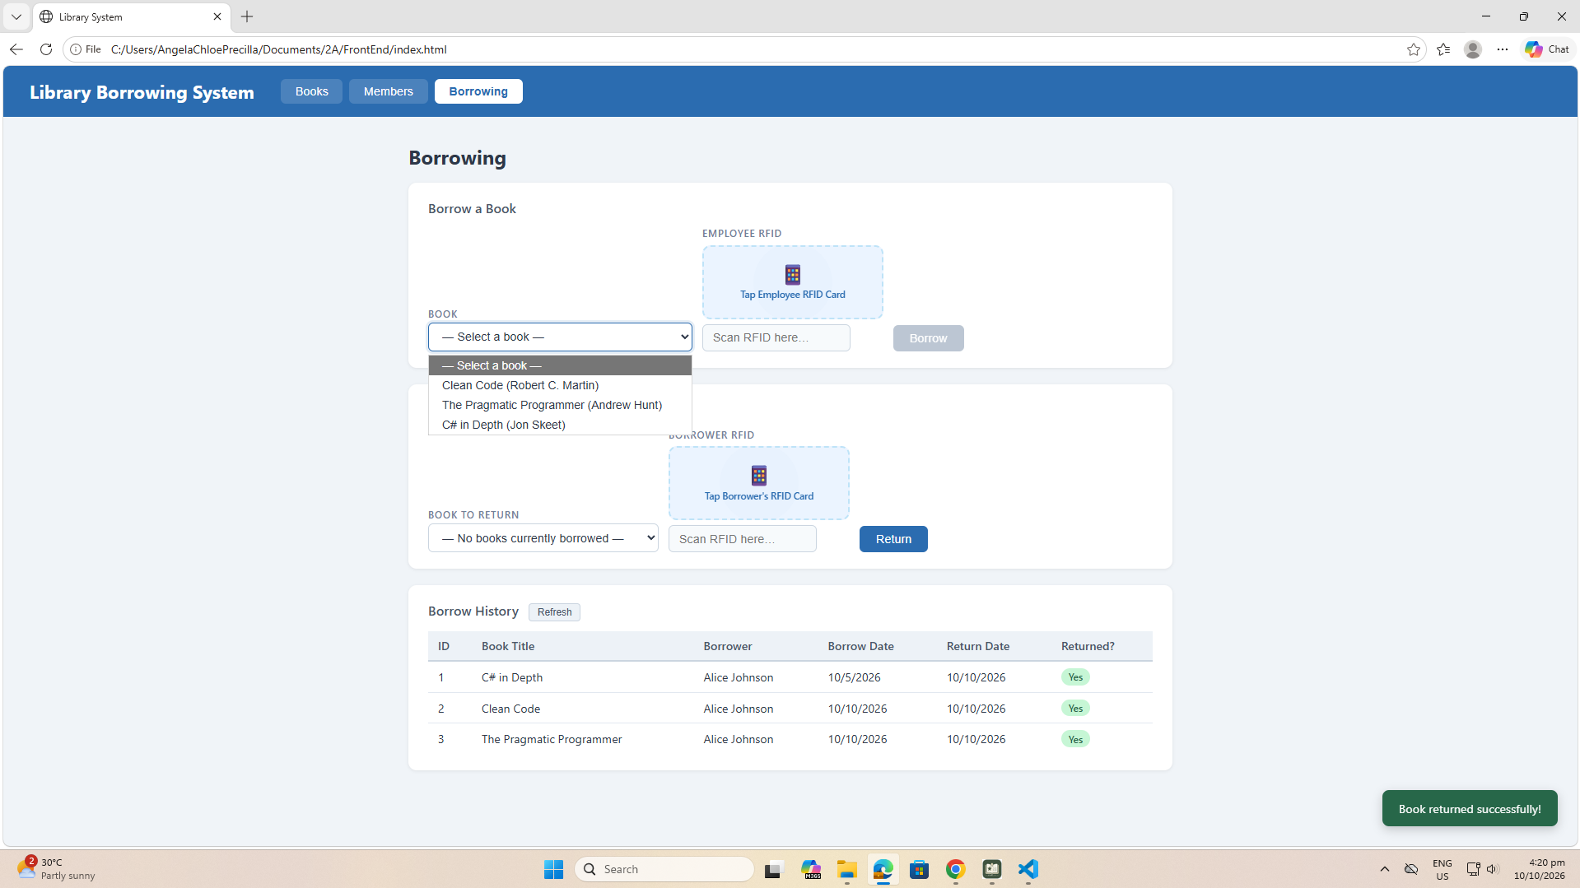

test-14-final-console 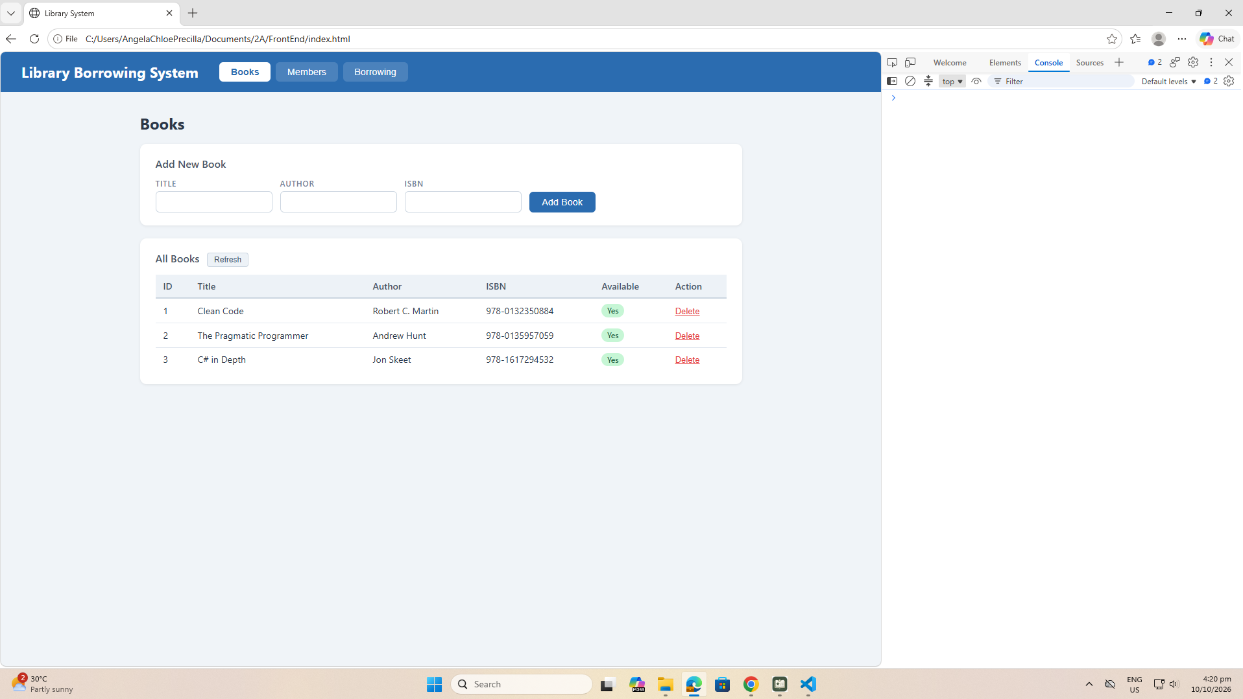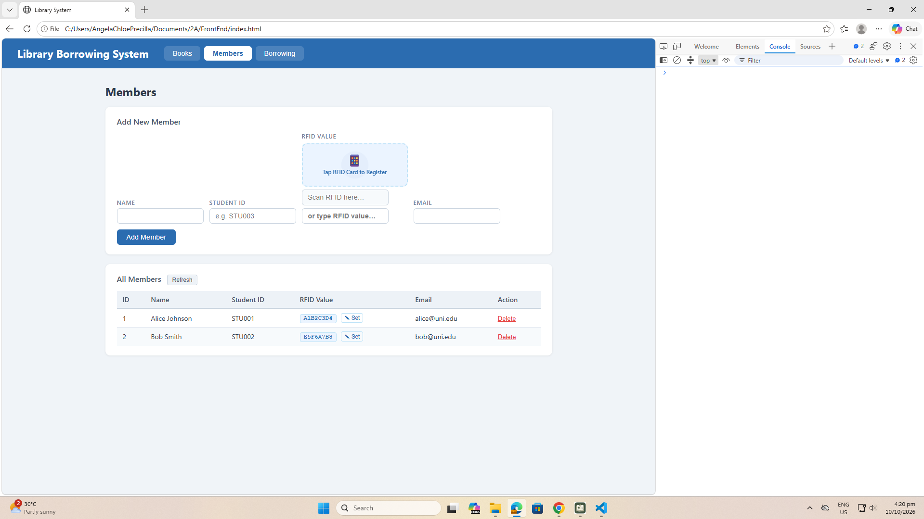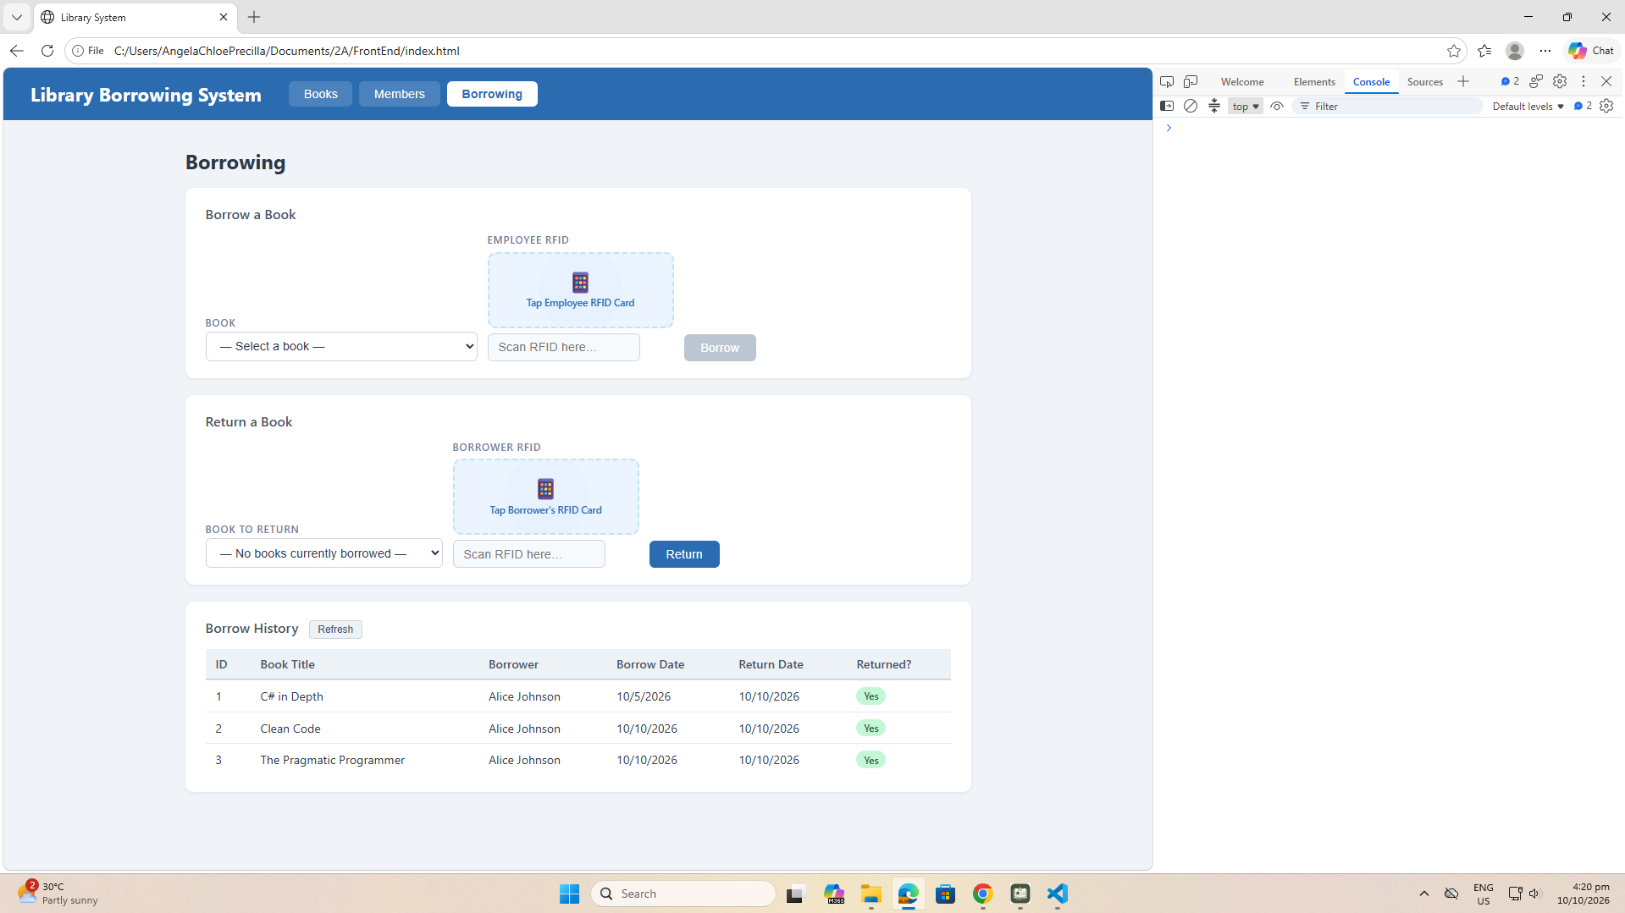

- What does apiFetch() do?
It prevents repeated code

- Why do we use try/catch around API calls?\
Try/catch handles the runtime errors and prevent a program from crashing when something unexpected happens.

- What is the difference between POST and PUT?
Post is used to create a new resource where the server decides the finalURL, while PUT is used to create or completely replace a specific known URL.

- Why does RFID matching use rfidValue instead of studentId?
RFID matching uses a unique RFID tag value instead of direct student ID for security, hardware compatibility and system flexibility.

- Why do we refresh tables after adding, deleting, borrowing, or returning?
We refresh tables after adding, deleting, borrowing and returning to sync the exact thing you change or updated on your code.

- Why does the Return dropdown use borrow record ID instead of book ID?
Since the record is from the borrow record ID you will see if the book is already borrowed, and if it bookID will be used it will cause confusion to them since the record is BOOKID not the borrowed records

- What happens if the same event listener is added to a form twice?
The duplicate record will be discarded

- Why must the page-load code be at the bottom of the file?
It will be best practice to prevent errors and speed up loading

- Why does an RFID reader need e.preventDefault() on the Enter key?
The scanner acts as a keyboard, it is to stop the browser from automatically reloading the page, ensuring scanned data is not accidentally wiped out before it can be processed.

