Carlos Jade R. Mabini / s2025101149 / Oct 10, 2026

setup-01-api-running
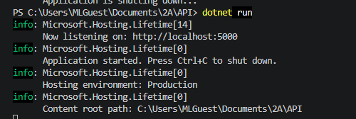

setup-02-api-books-json
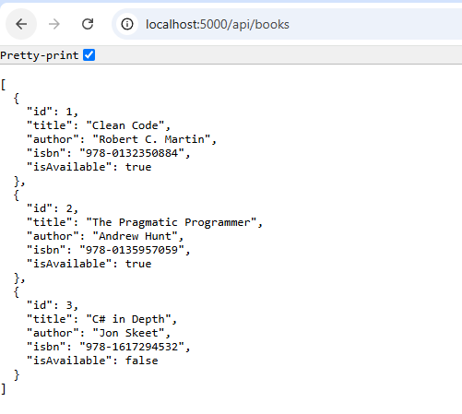

part-01-settings-apifetch
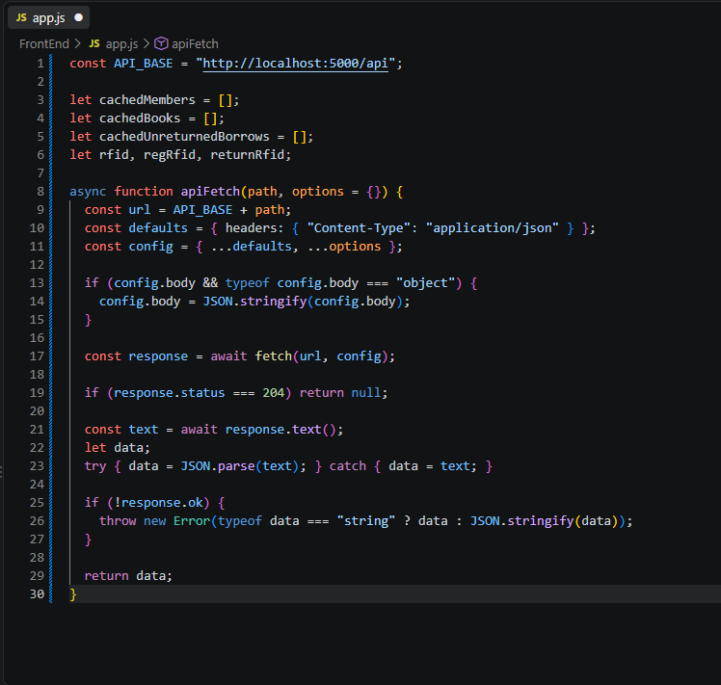

part-02-showtoast
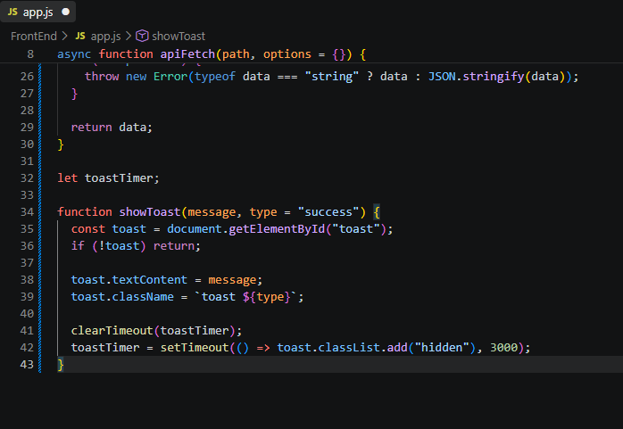

early-01-toast
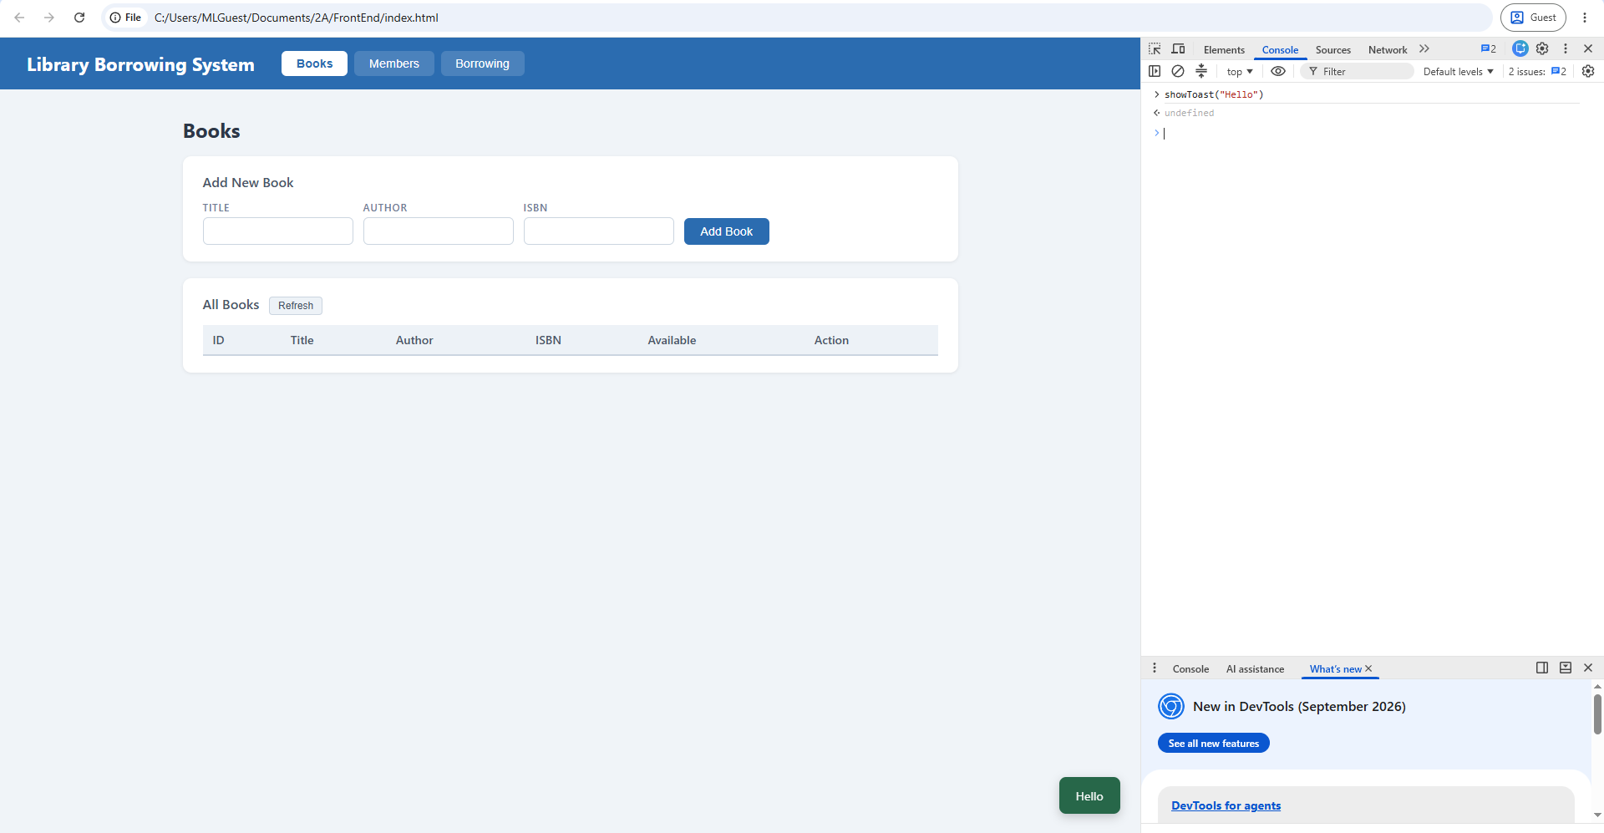

part-03-caches
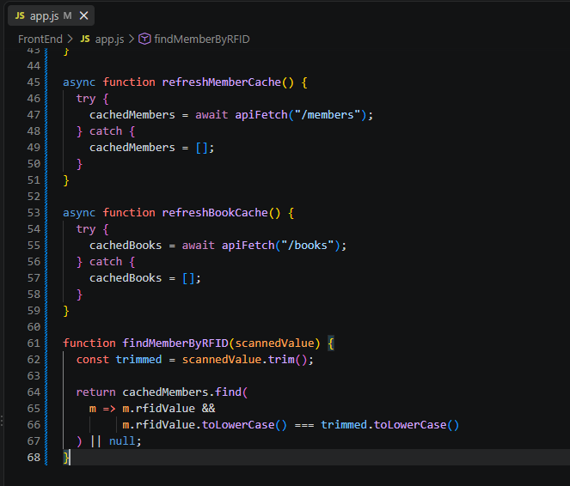

early-02-cache-console
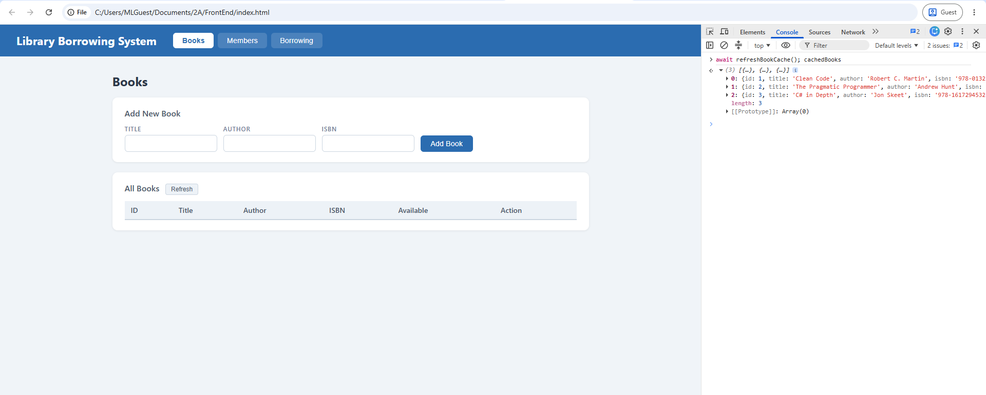
part-04-tabs-refresh
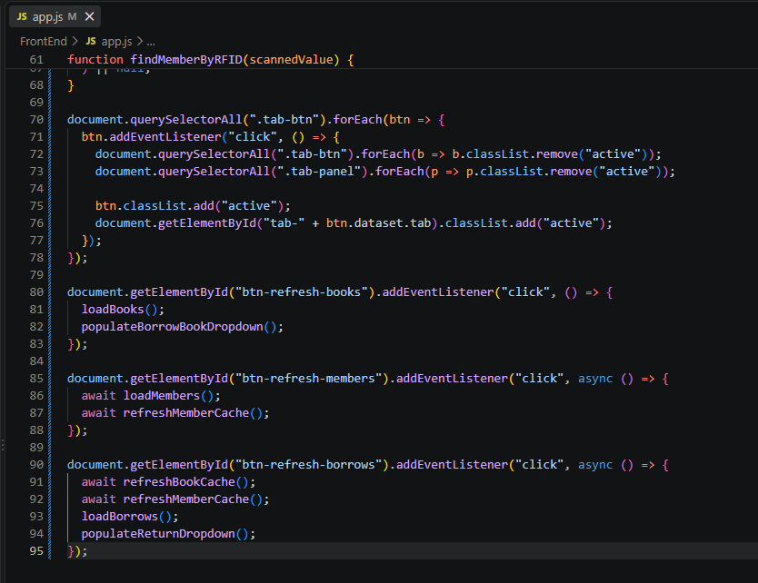

early-03-tabs
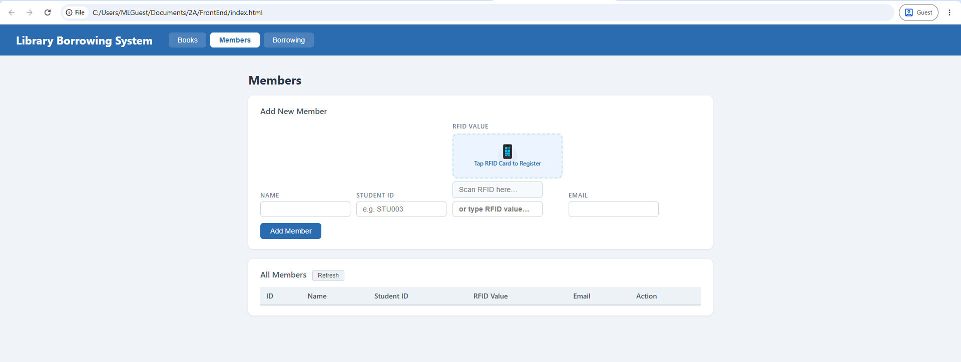

part-05-loadbooks
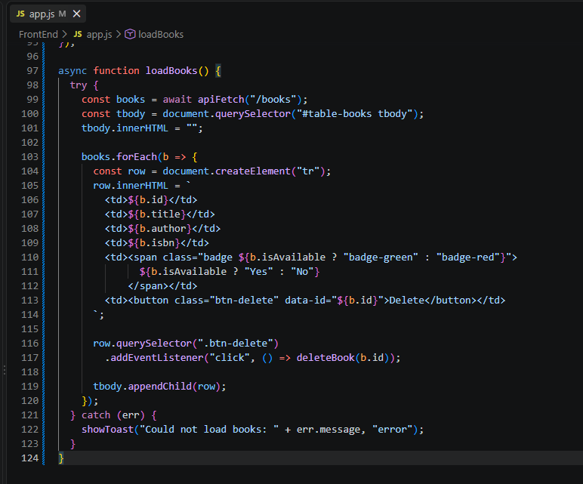

part-06-deletebook
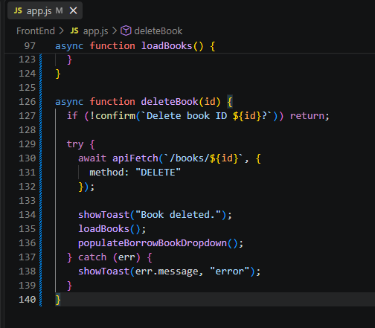

part-07-addbook
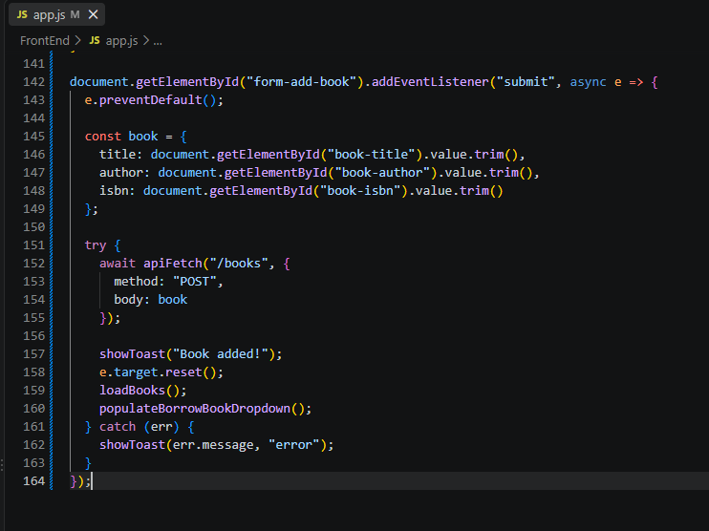

part-08a-loadmembers
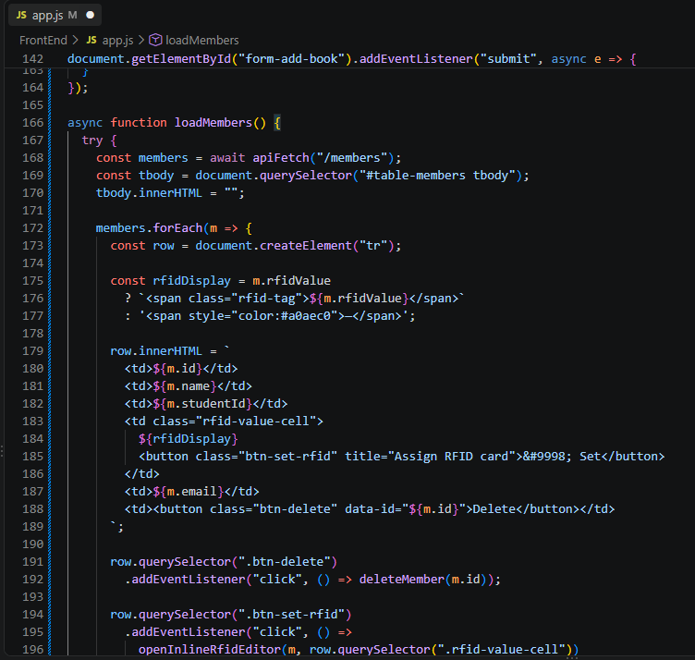

part-08b-loadmembers
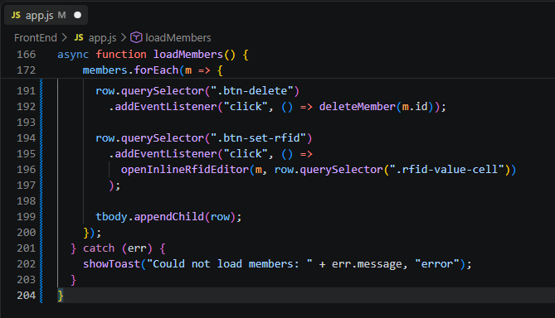

part-09-deletemember
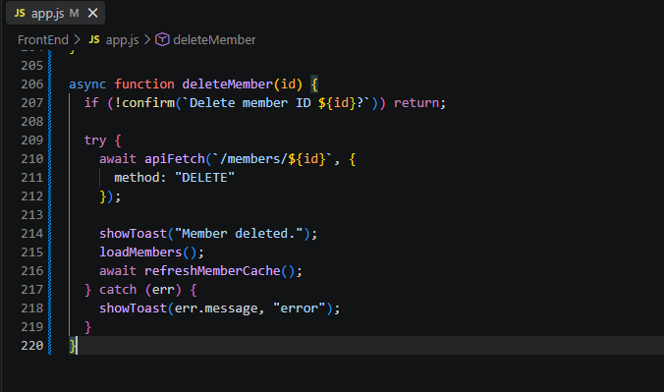

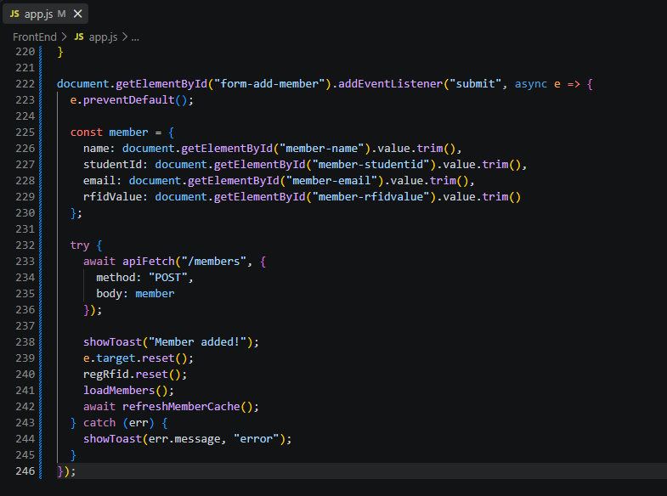
part-10-addmember
part-11-inline-rfid-editor
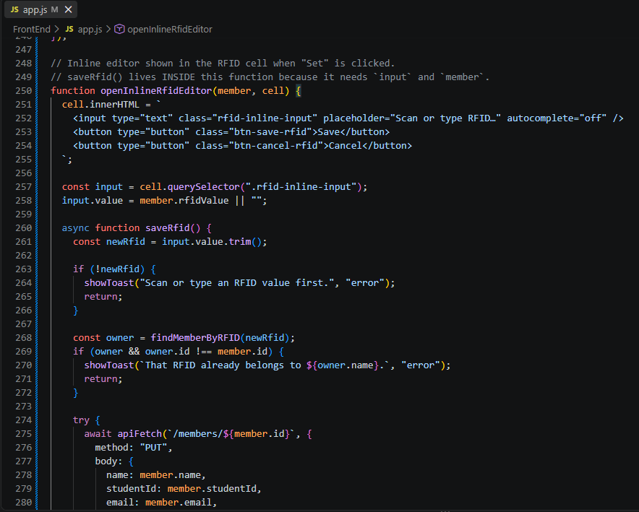

part-11-inline-rfid-editor
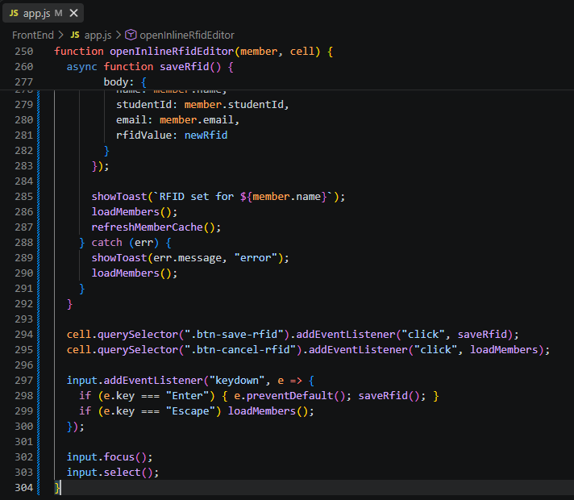

part-12a-rfid-widget-builder
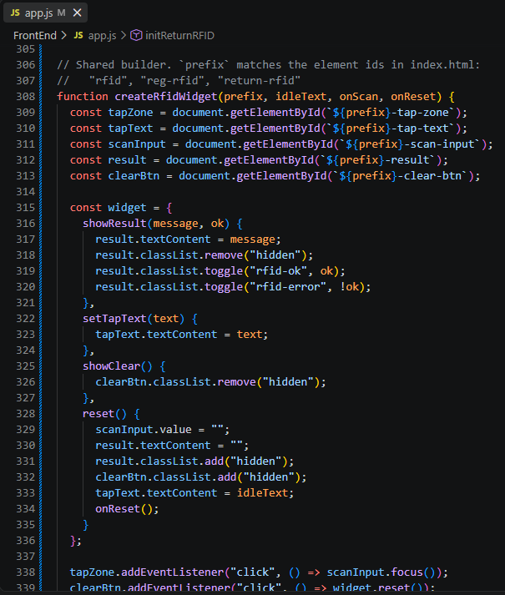

part-12a-rfid-widget-builder
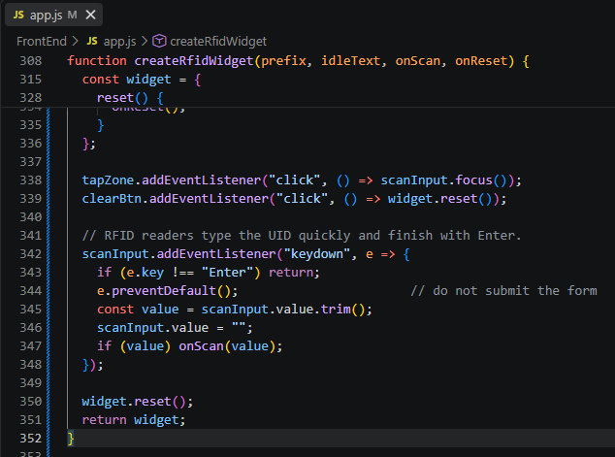

part-12b-rfid-init-functions
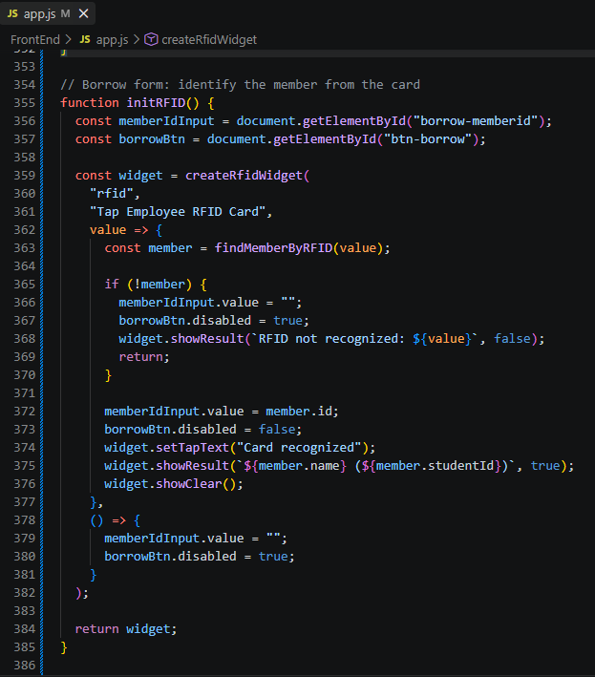

part-12b-rfid-init-functions
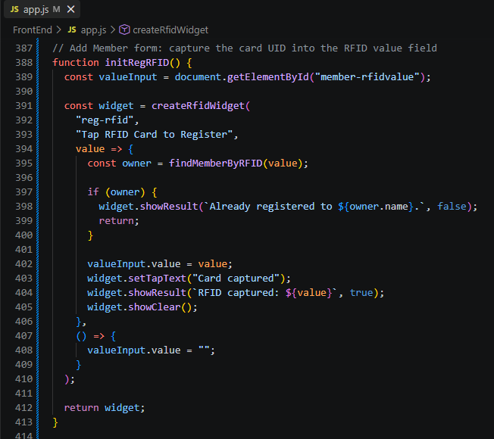

part-12b-rfid-init-functions
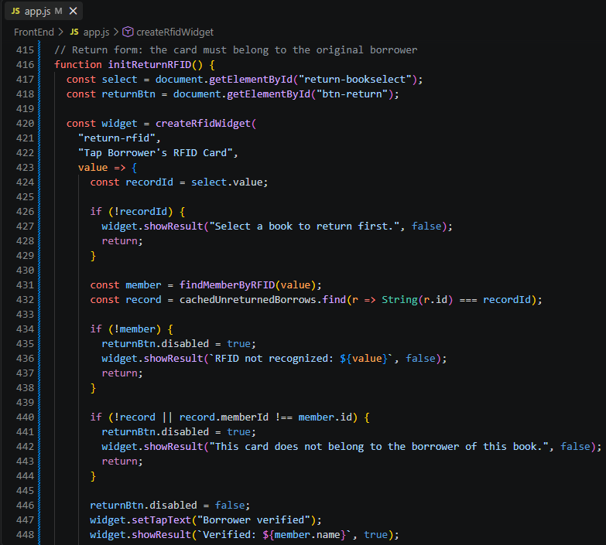

part-12b-rfid-init-functions
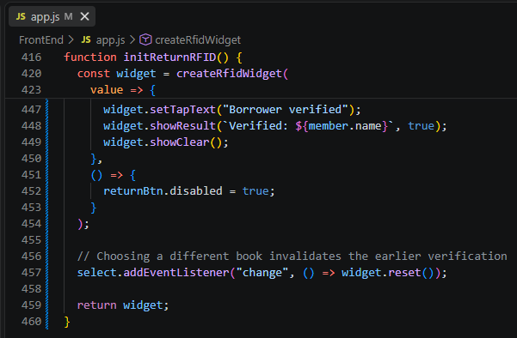

part-13-borrow-dropdown
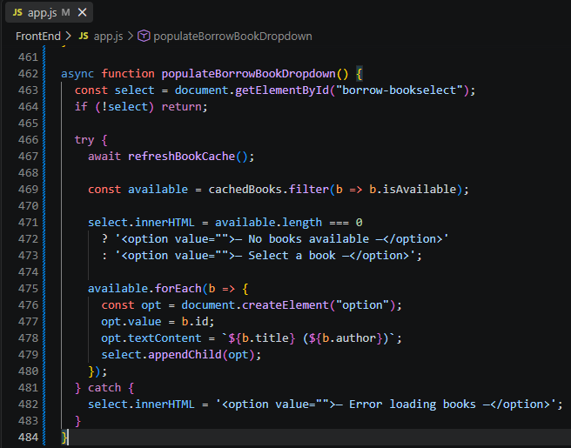

part-14-return-dropdown
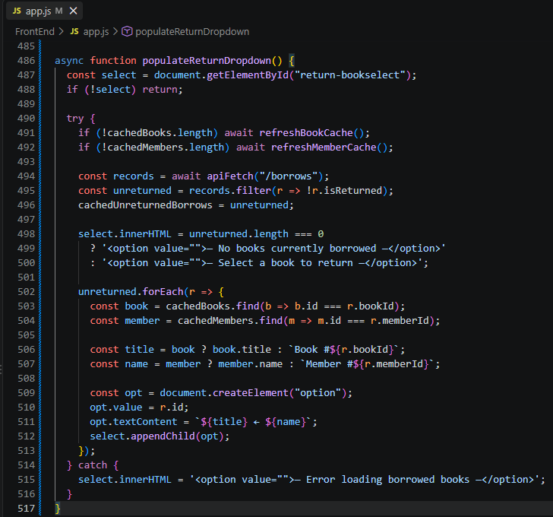

part-15-borrow
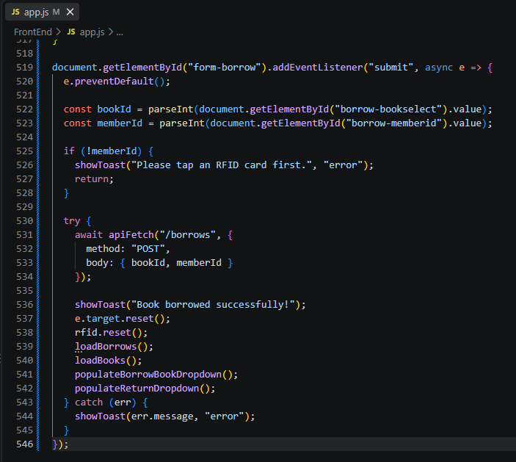

part-16-return
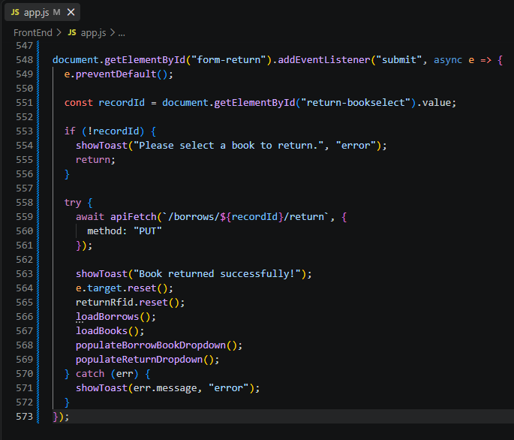

part-17-loadborrows
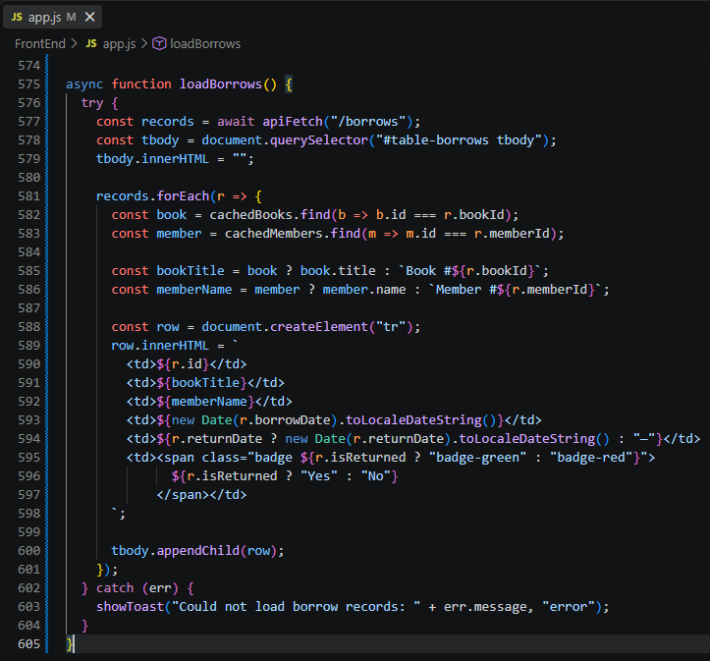

part-18-page-load
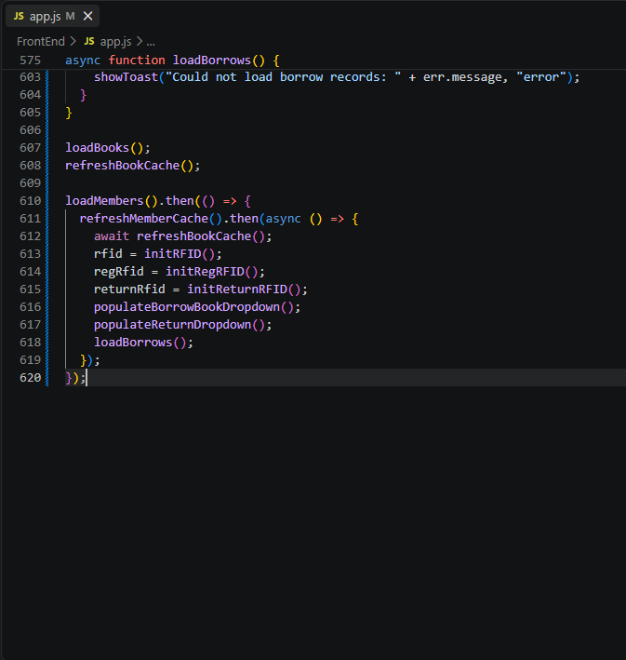

test-01-page-loaded
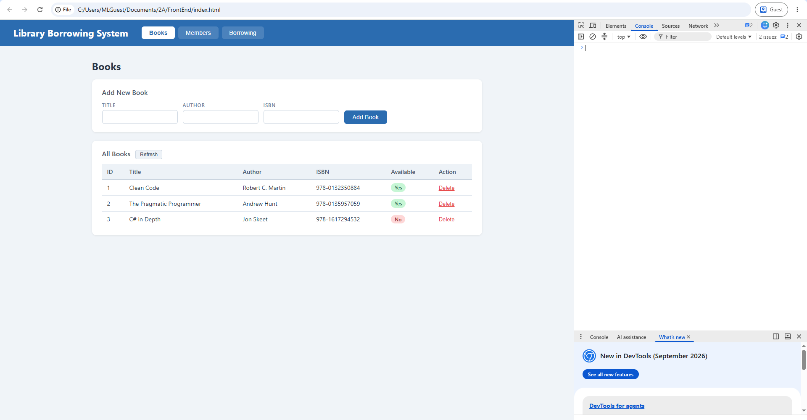

test-02-add-book
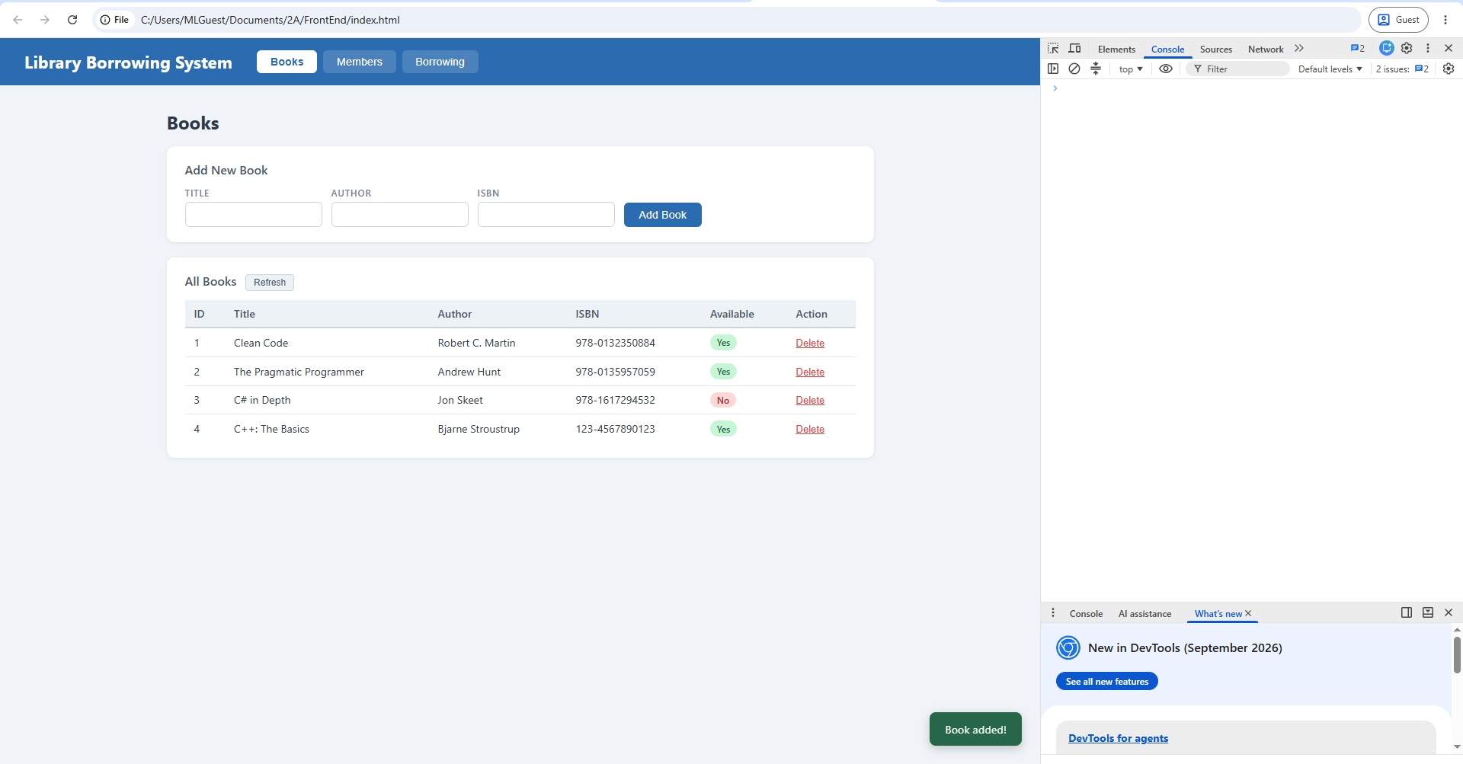

test-03-delete-book
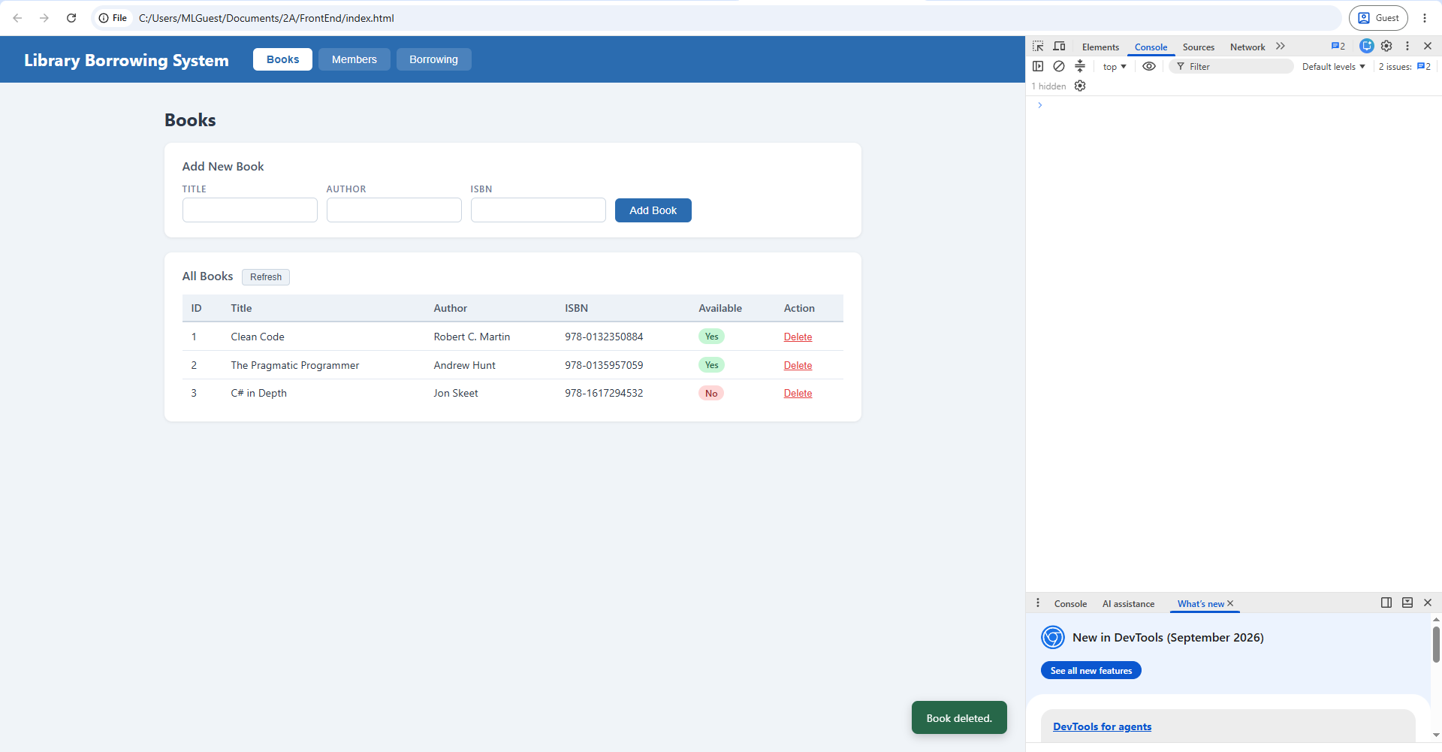

test-04-members-loaded
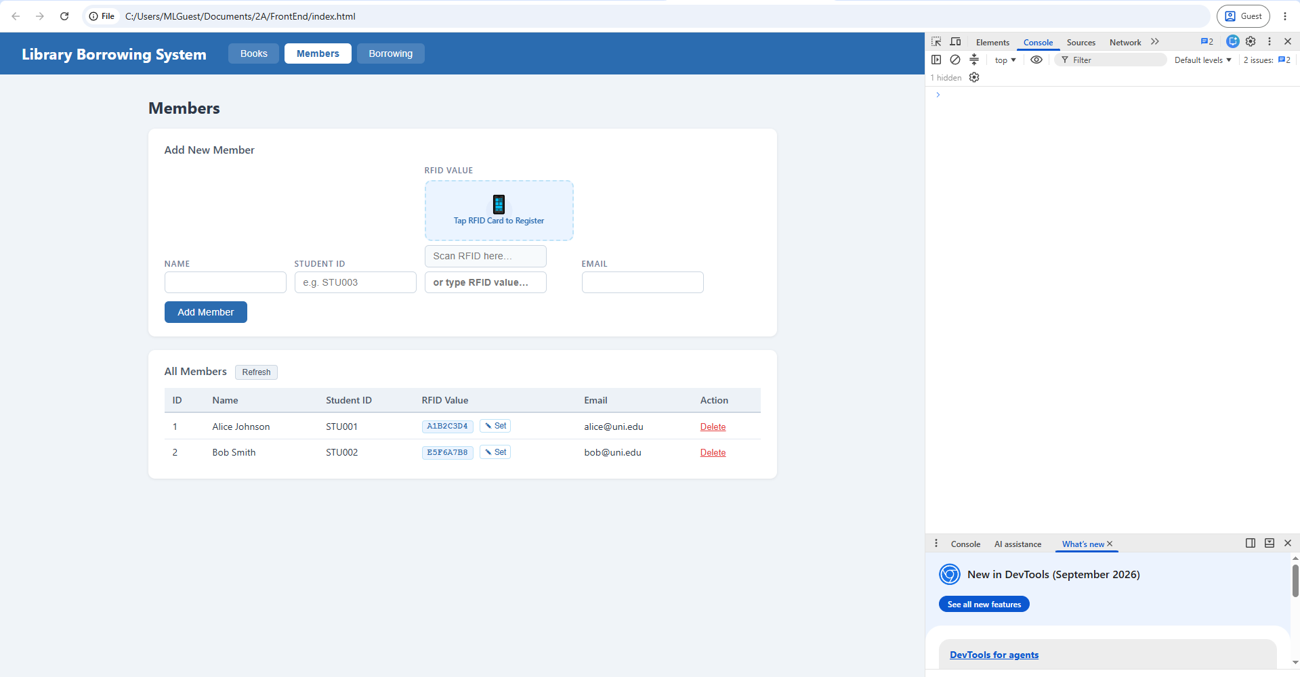

test-05-register-rfid
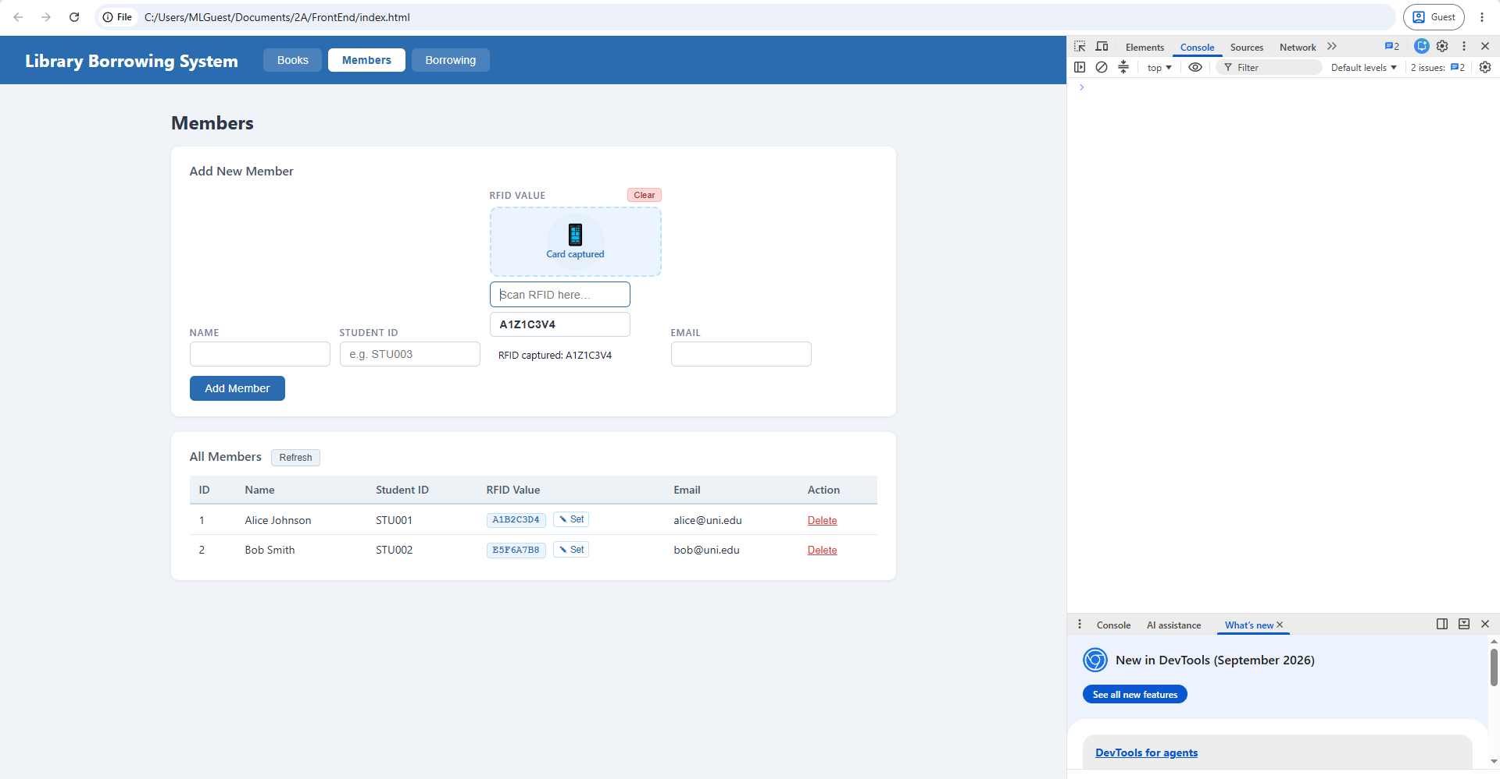

test-06-add-member
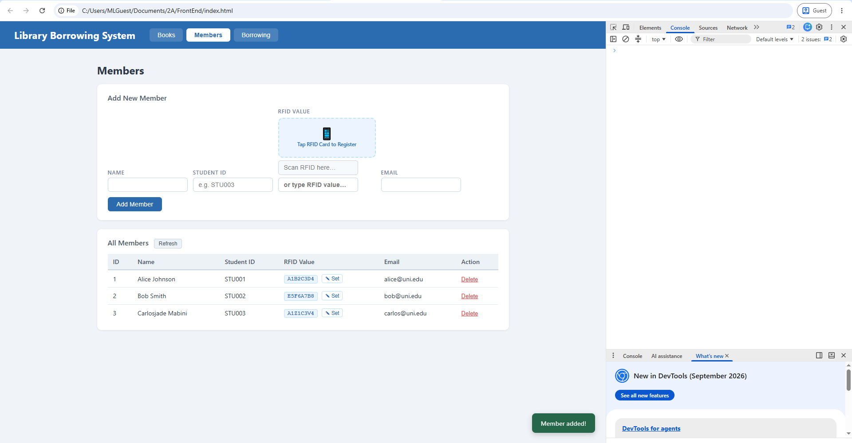

test-07-set-rfid-saved
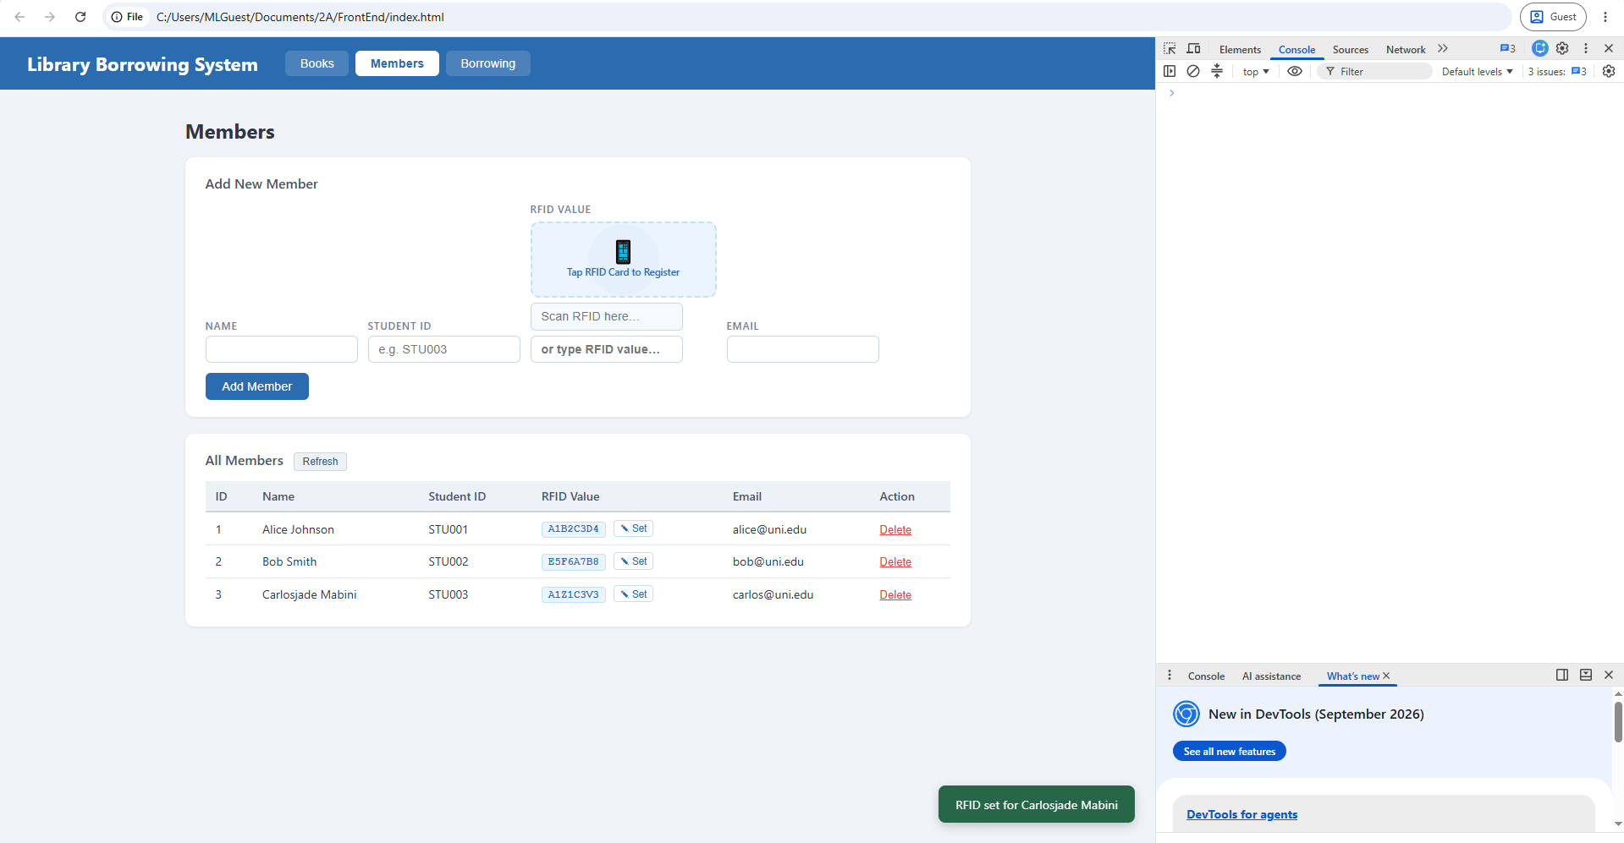

test-08-delete-member
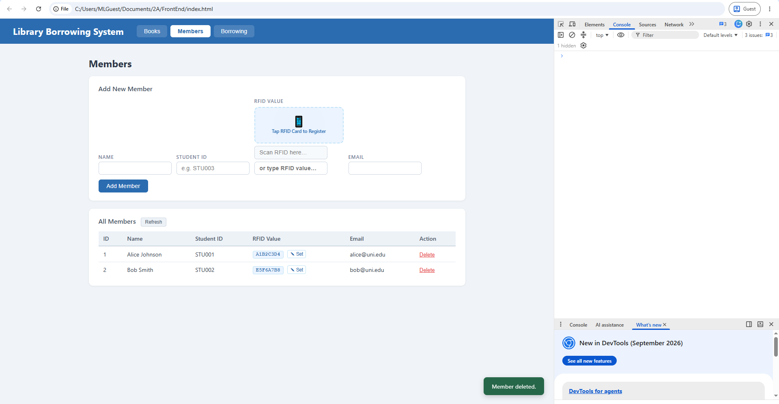

test-09-borrow-rfid-recognized
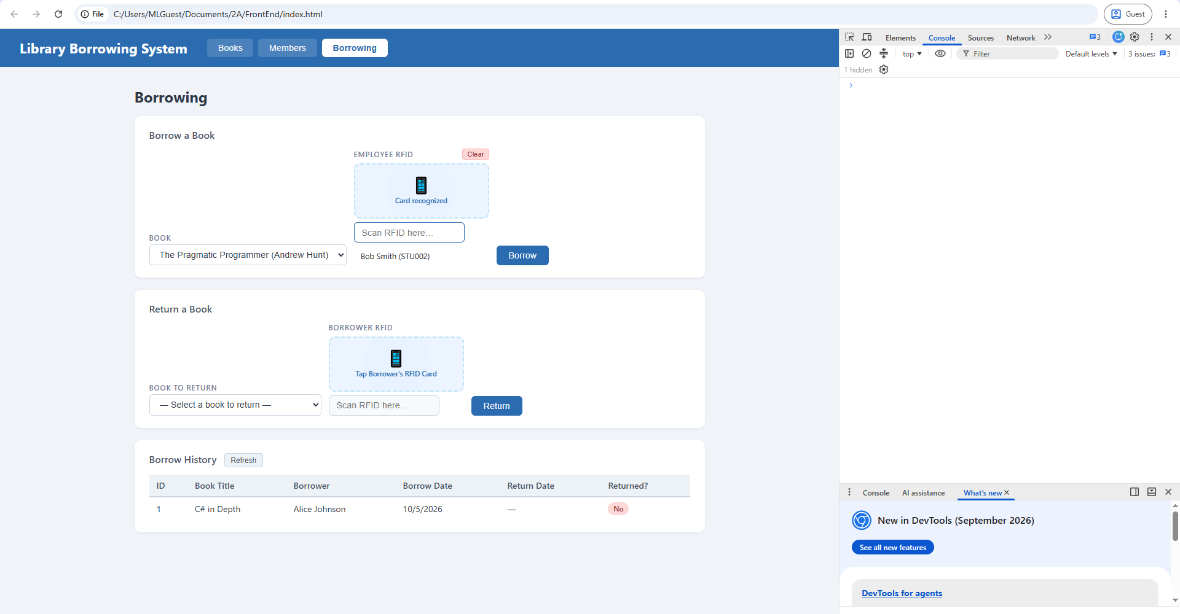

test-10-borrow-success
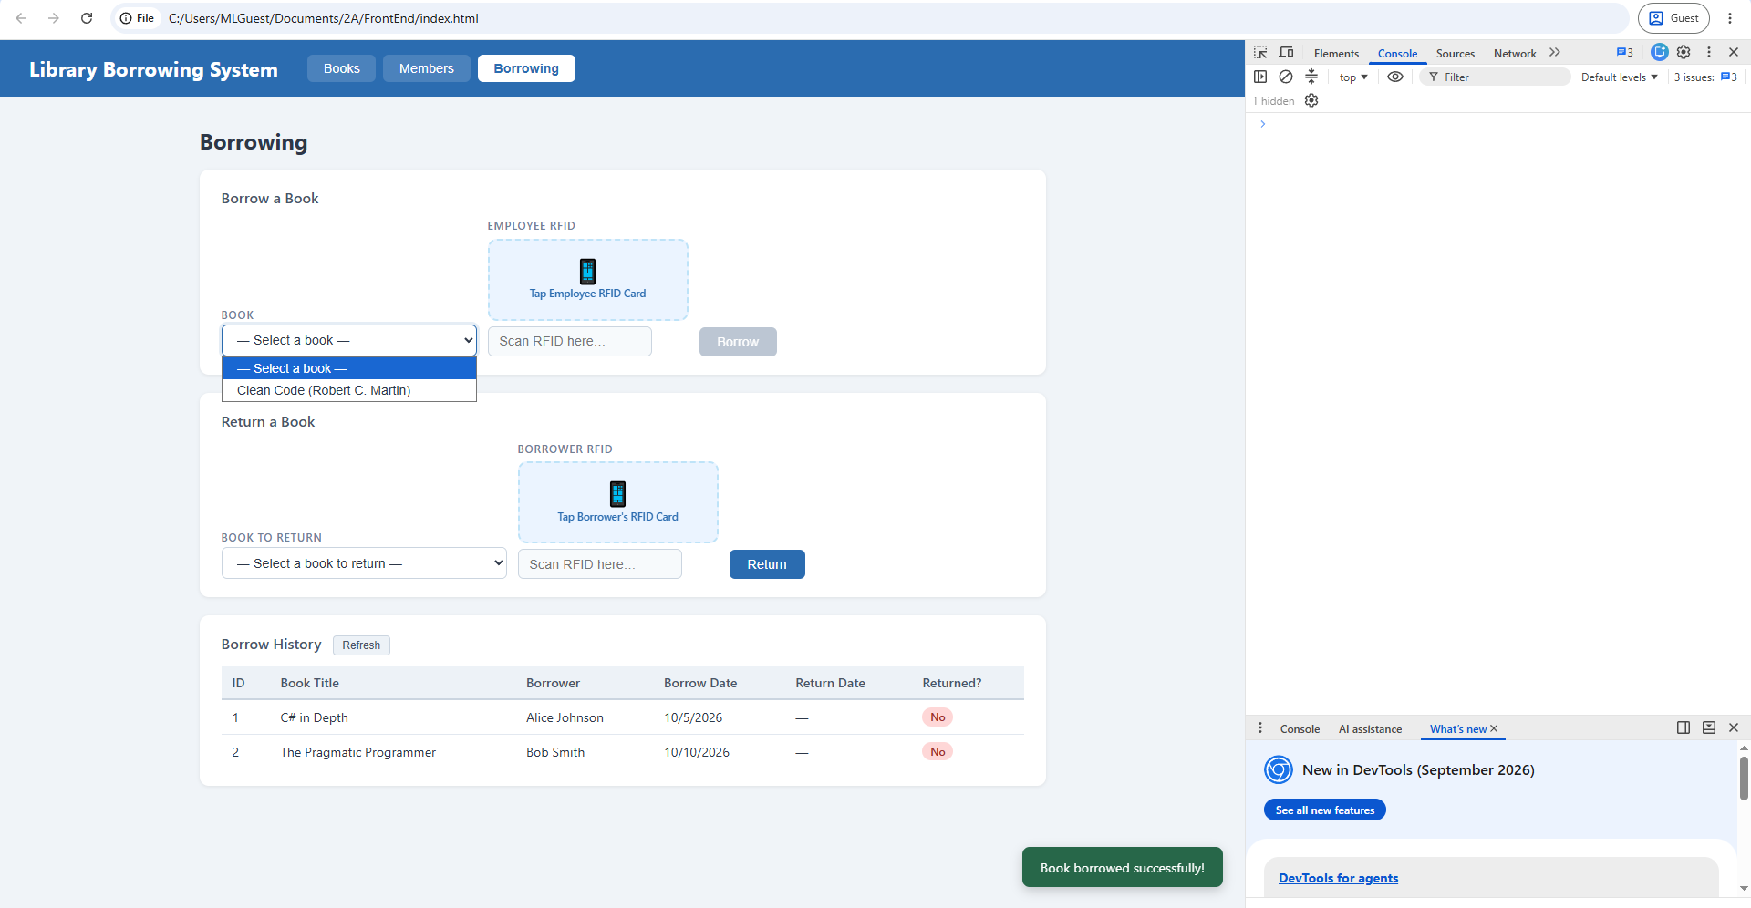

test-11-return-wrong-card
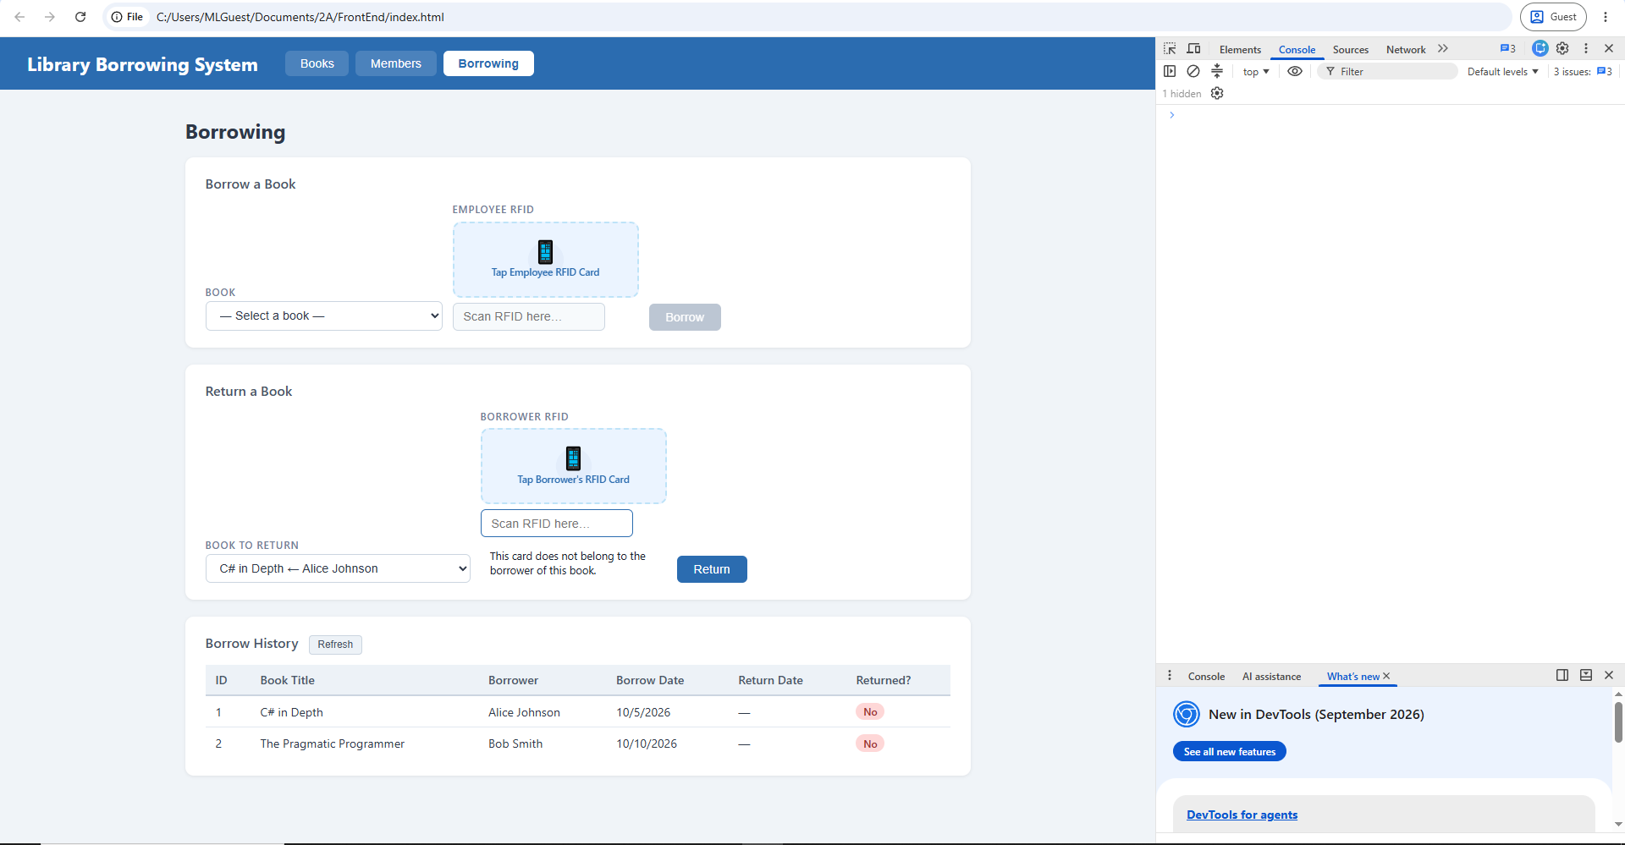

test-12-return-verified
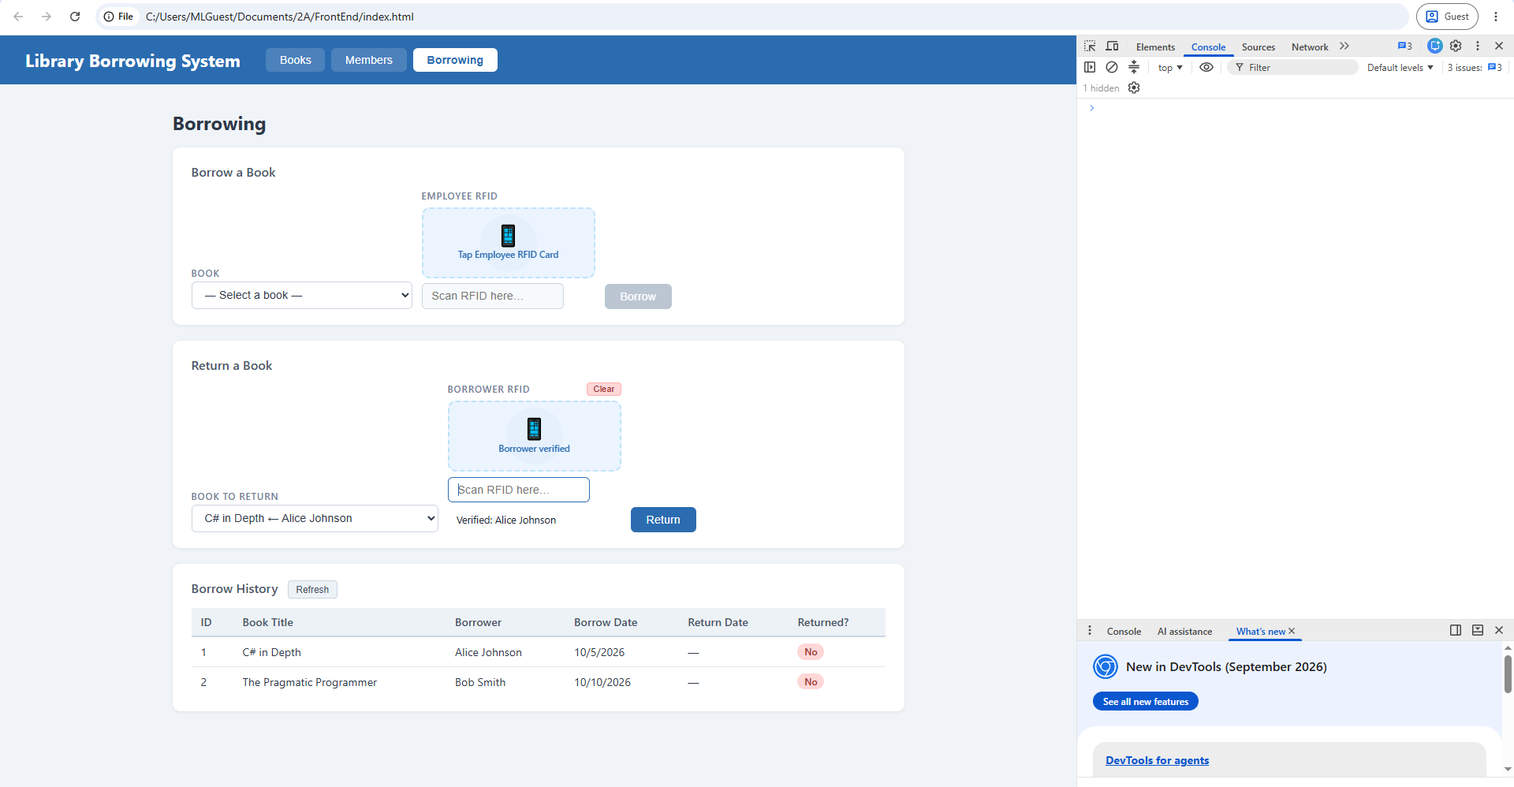

test-13-return-success
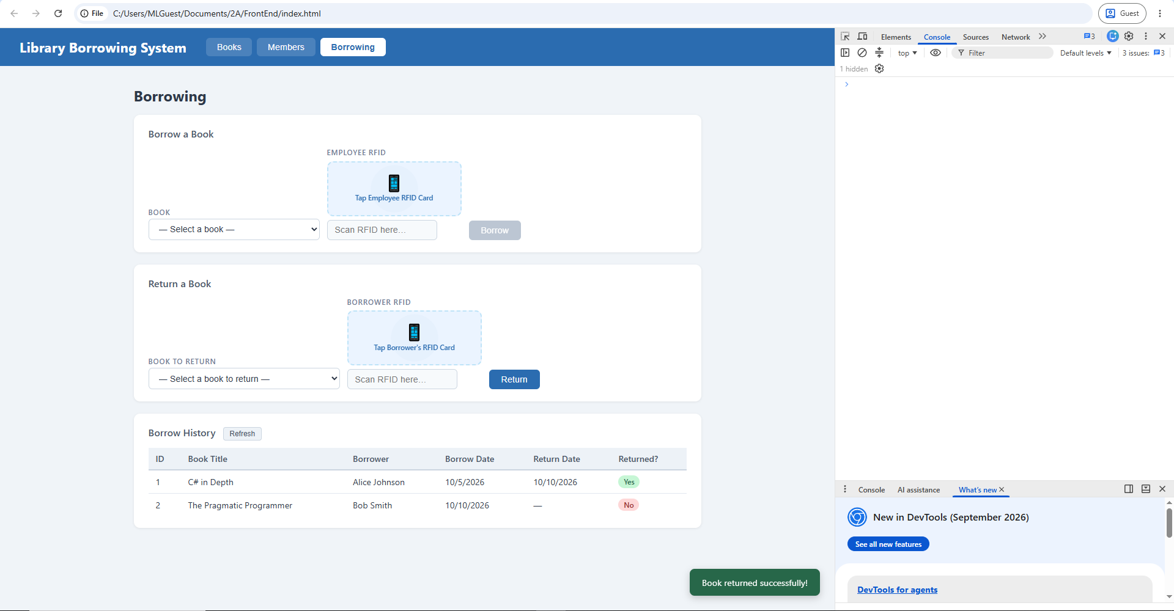

test-14-final-console
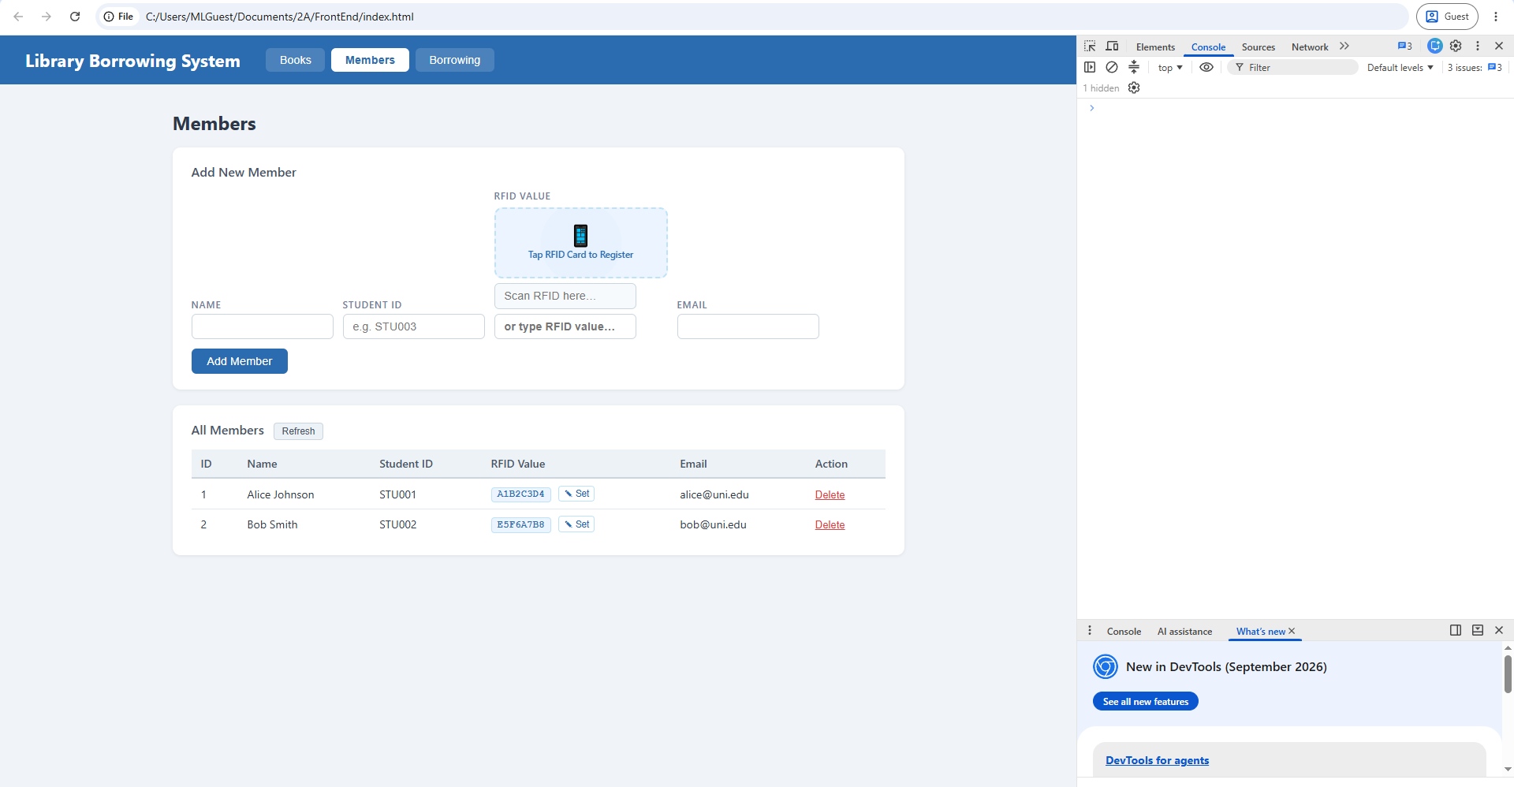

- What does apiFetch() do?

What apiFetch() does is it creates a reusable async API helper. It can be executed/called many times.

- Why do we use try/catch around API calls?

We do this so that whenever something wrong/unexpected has happened, it will either output a message telling that an error has occurred or will try another way to call.

- What is the difference between POST and PUT?

The difference between POST and PUT is that in POST is used to create data while PUT is used to update data.

- Why does RFID matching use rfidValue instead of studentId?

RFID matching use rfidValue instead of studentId because rfidValue belongs to RFID matching form rather than studentId since it is a completely different value as well as the variable name. In a real-world system, RFID is a unique identifier and its format is different from a student ID whereas RFID represents BD31152B while studentID represents s20262463264. Also rfidValue holds the studentName, studentID, and studentEmail.

- Why do we refresh tables after adding, deleting, borrowing, or returning?

We refresh tables to show it to users visually what is added, deleted, borrowed, and returned. Instead of reloading the API page, it updates it in real-time, providing convenience and ease of access when testing/debugging. And the button when clicked, will look nothing because it did not refreshed/updated.

- Why does the Return dropdown use borrow record ID instead of book ID?

Return dropdown uses borrow record ID because it belongs there and is used to track the borrow ID as it is UNIQUE and is able to also track the book ID, the borrower, studentID. And is also used to verify the borrower if it matches.

- What happens if the same event listener is added to a form twice?

If the same event listener (say for example is add book form), is duplicated to a form twice, it will add the same book twice instead of single add book, which can result confusion, cluttered table, etc. And it will show an error if the 2nd request happened.

- Why must the page-load code be at the bottom of the file?

Because the order matters. Say for example, loadBorrows(), if it ran first, the history table will show Book#1 or Member#2, instead of real names.

Its placed at the bottom to make sure that the code above (from part 1 to part 17) is checked thoroughly and is working properly. If we place the page-load code at the very top, it will check the given code which will produce an error because it did and cannot check the codes yet since it will run that first before checking everything.

- Why does an RFID reader need e.preventDefault() on the Enter key?
An RFID reader needs the code e.preventDefault() to be executed when pressed Enter key so that the form cannot be submitted accidentally.

