Lana Clare D. Poblete S2025100781 10/10/2026

setup-01-api-running
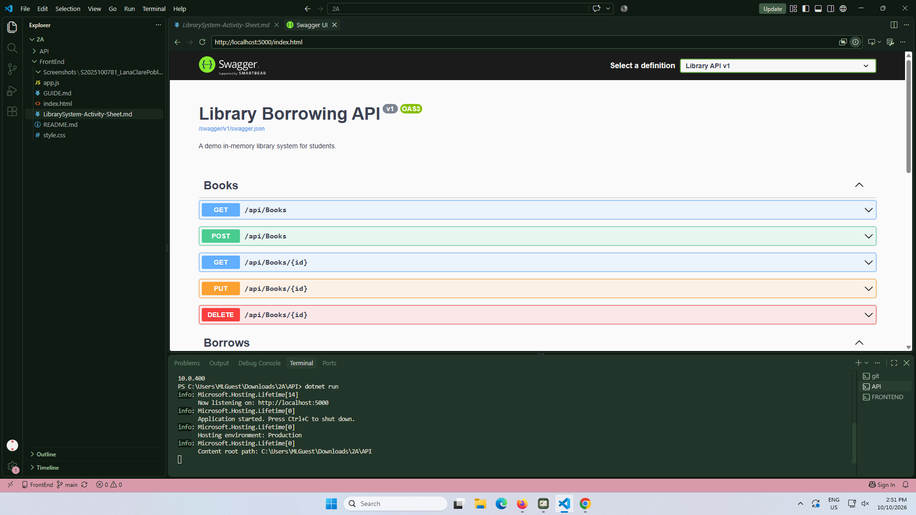

setup-02-api-books-json
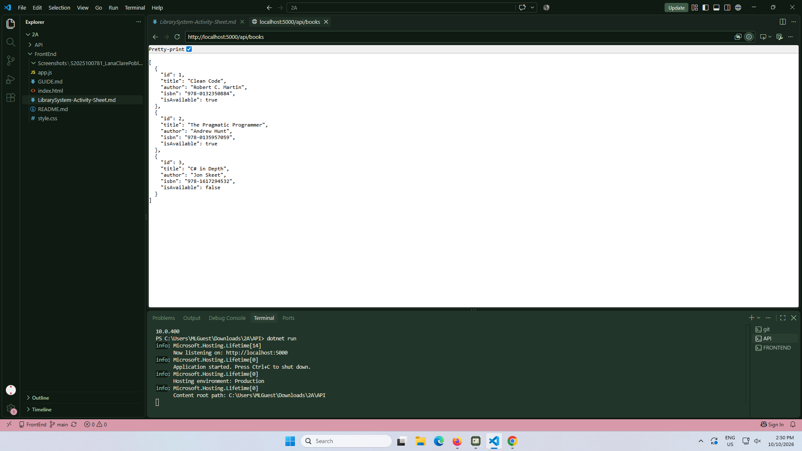

part-01-settings-apifetch
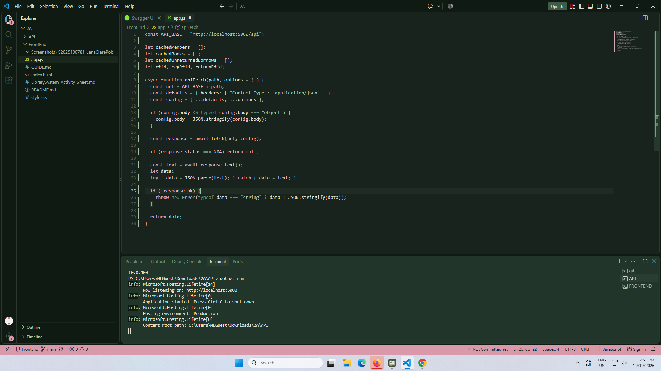

part-02-showtoast
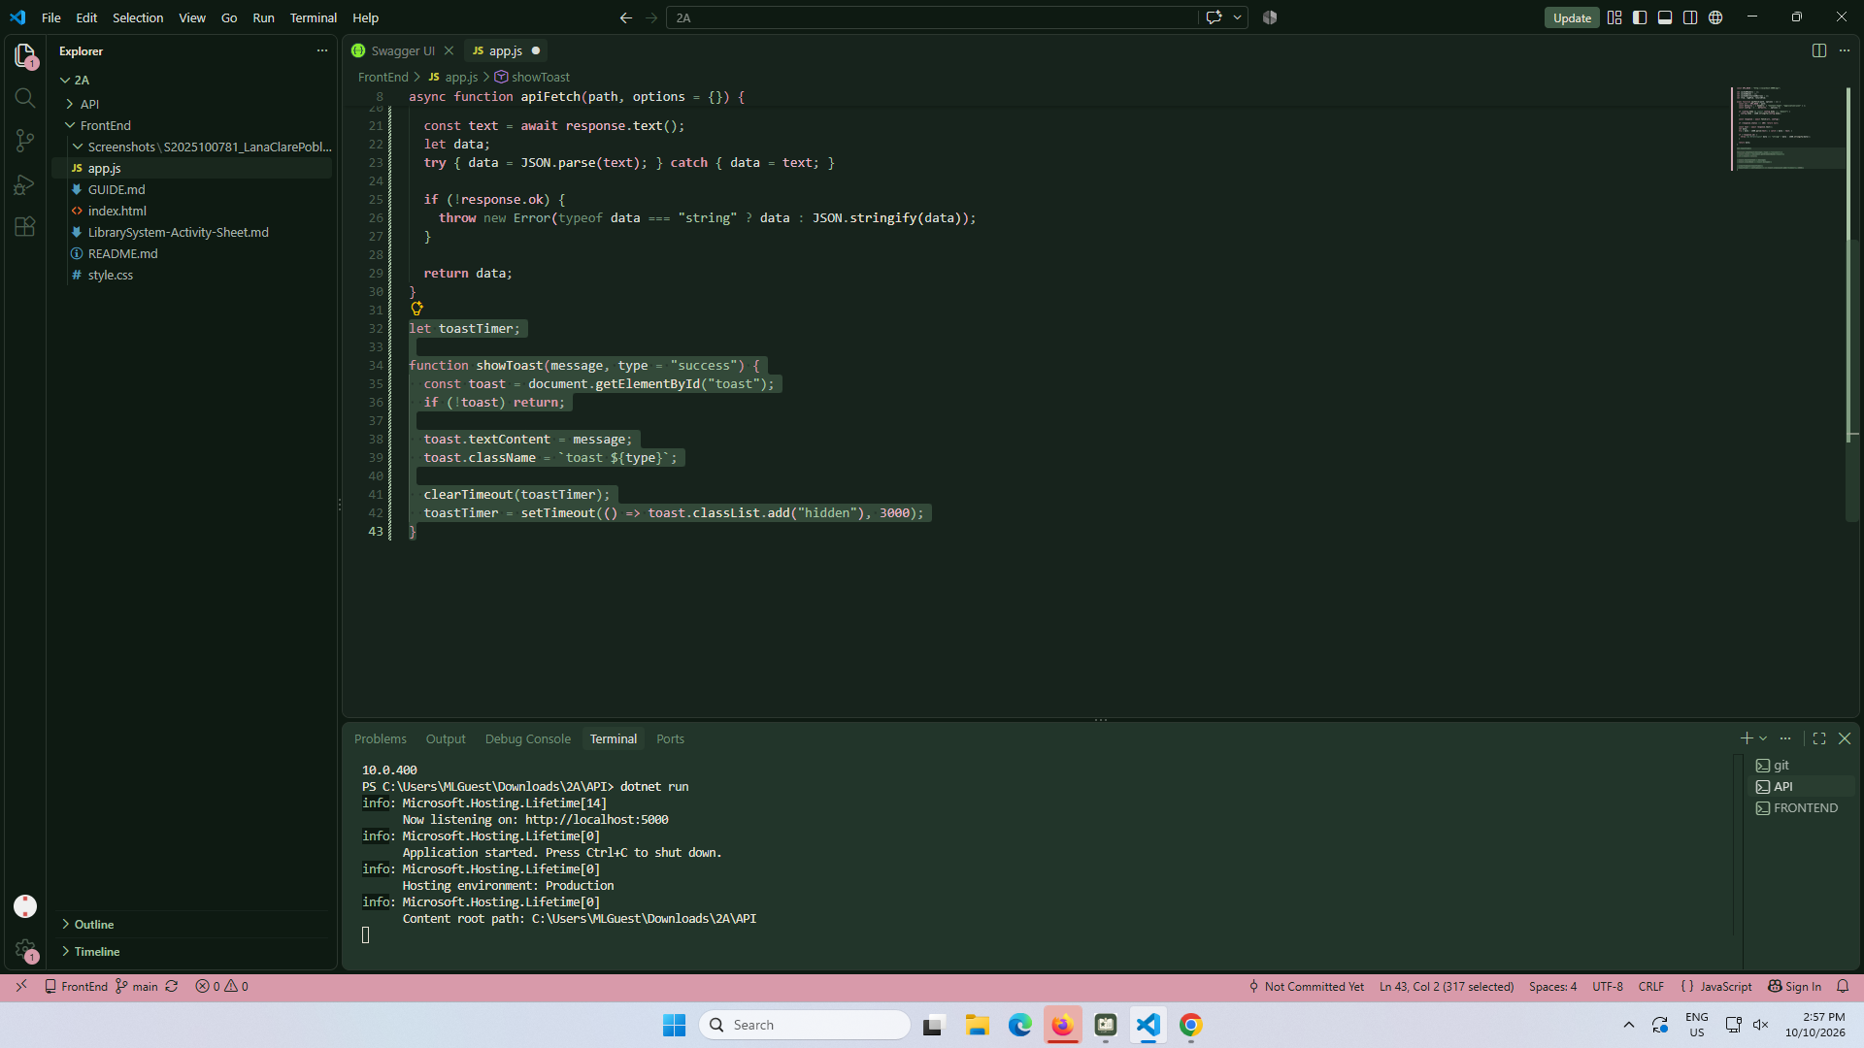

early-01-toast
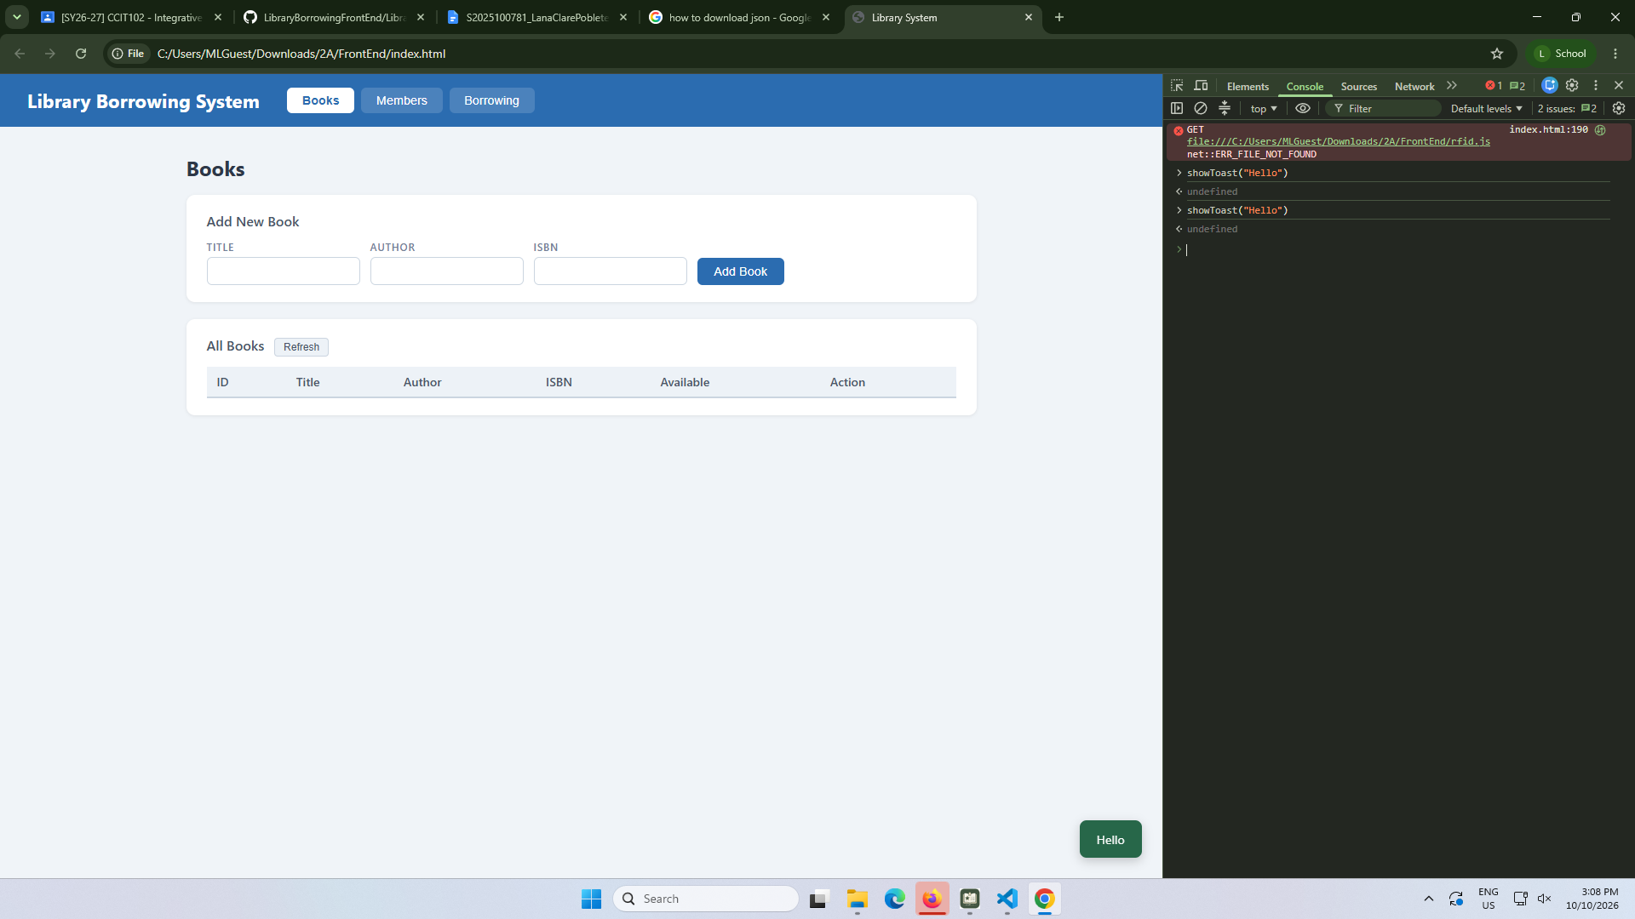

part-03-caches
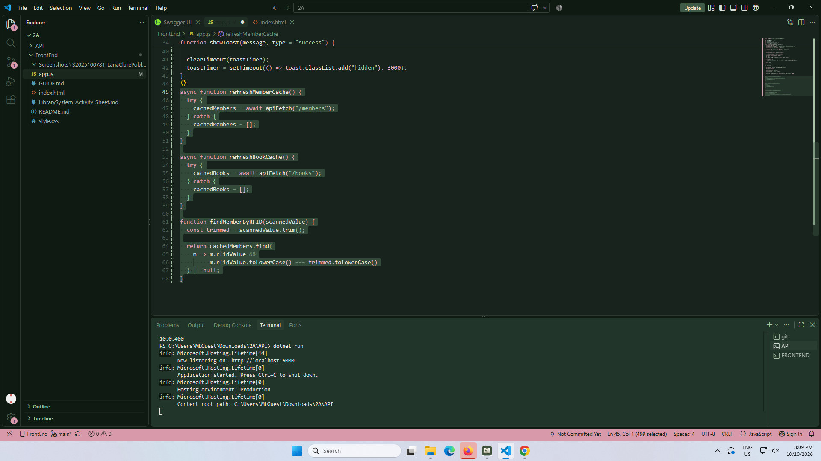

early-02-cache-console
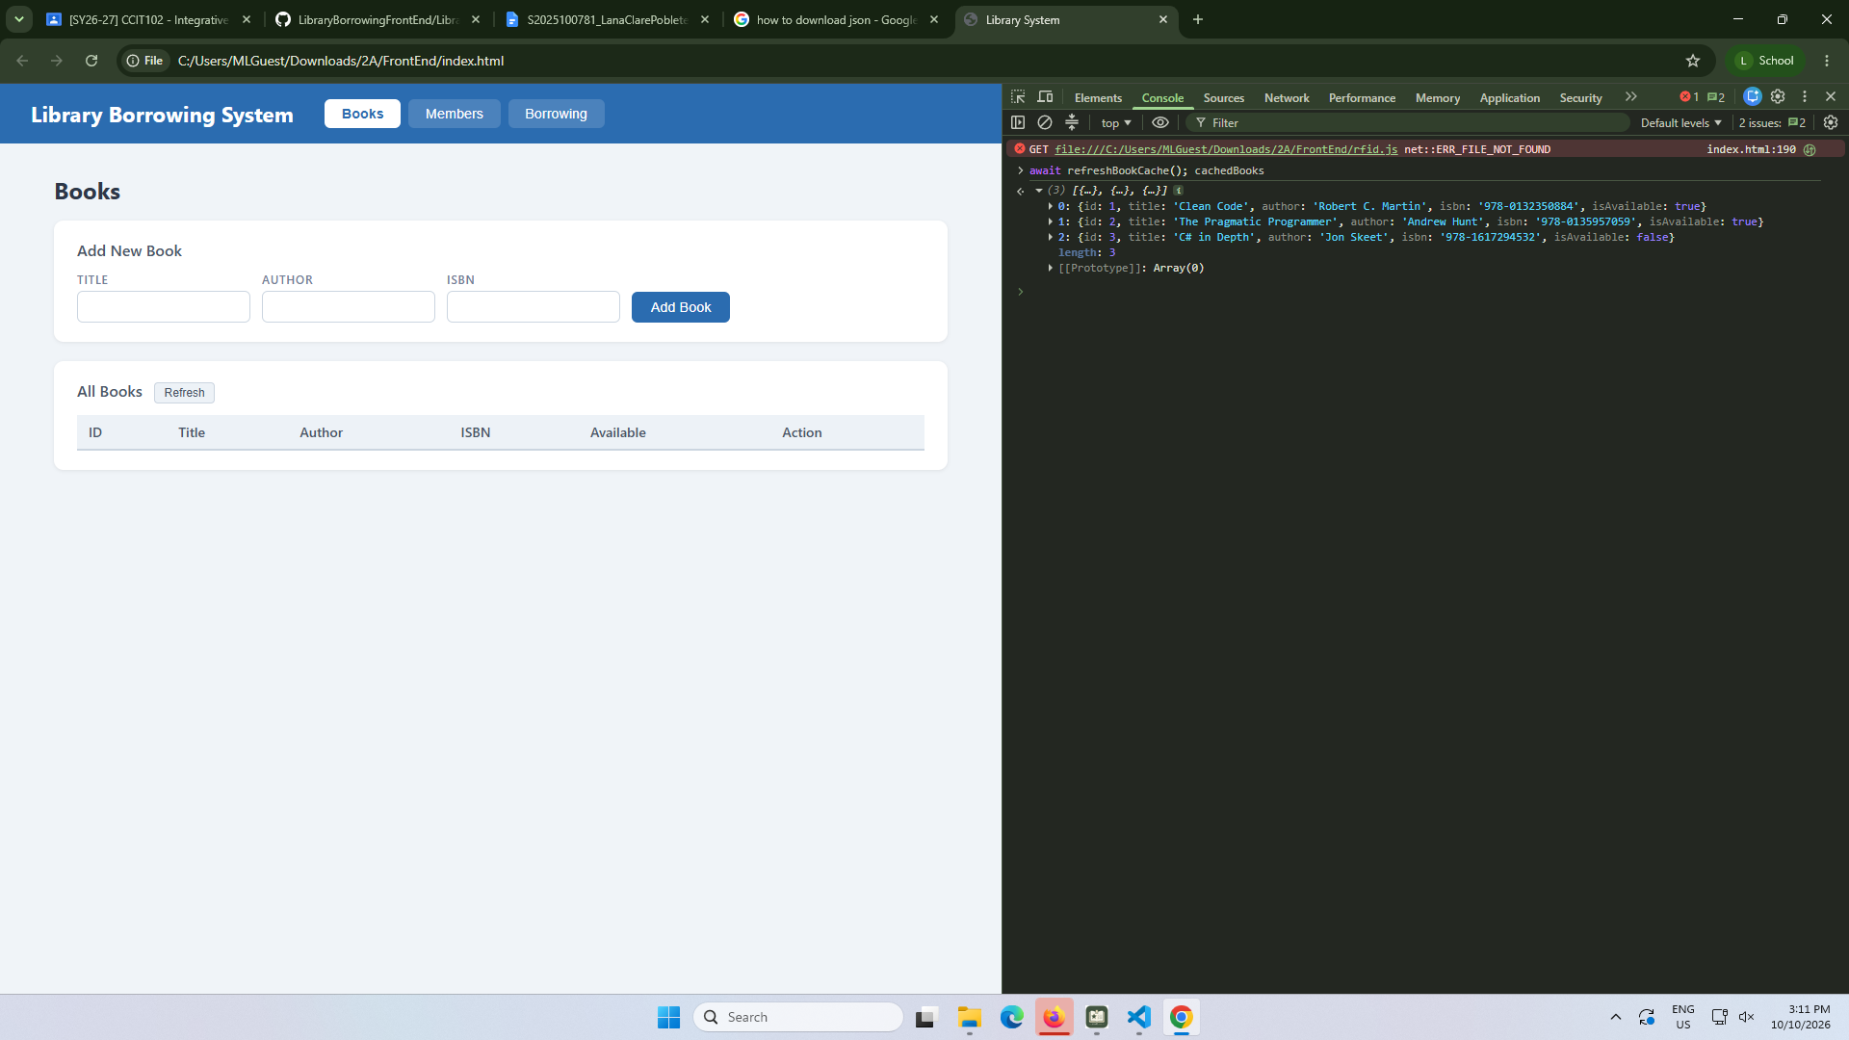

part-04-tabs-refresh
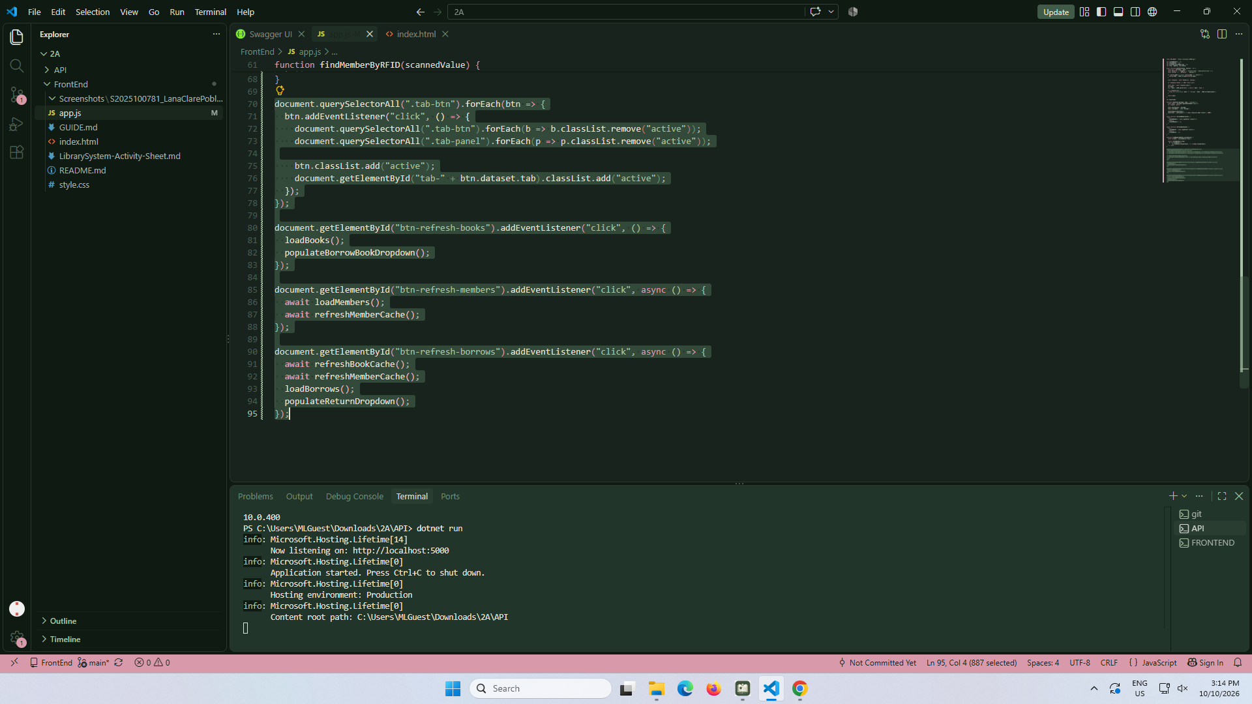

early-03-tabs
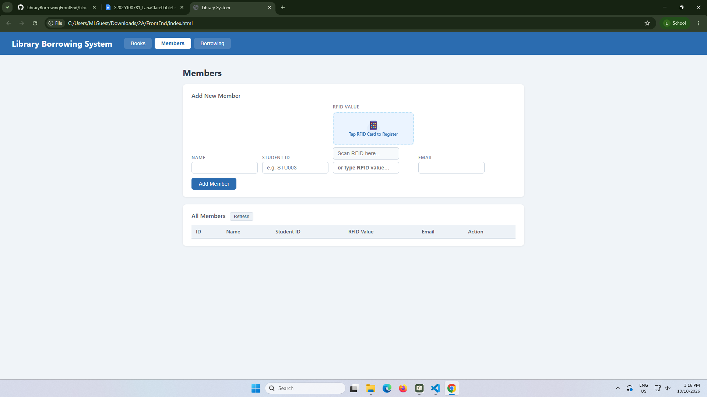

part-05-loadbooks
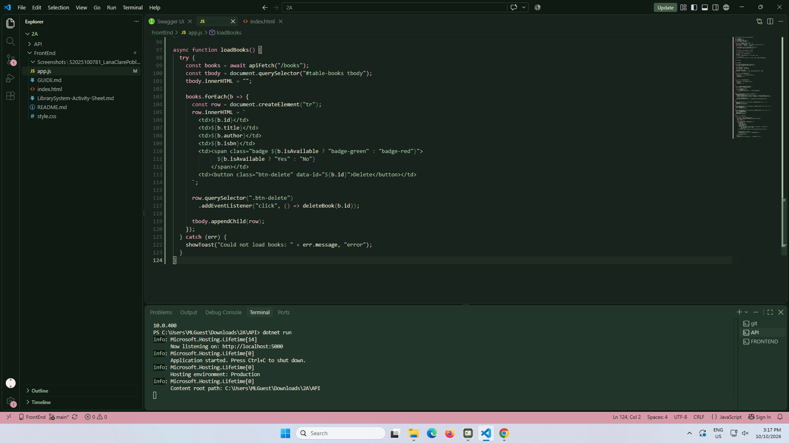

part-06-deletebook
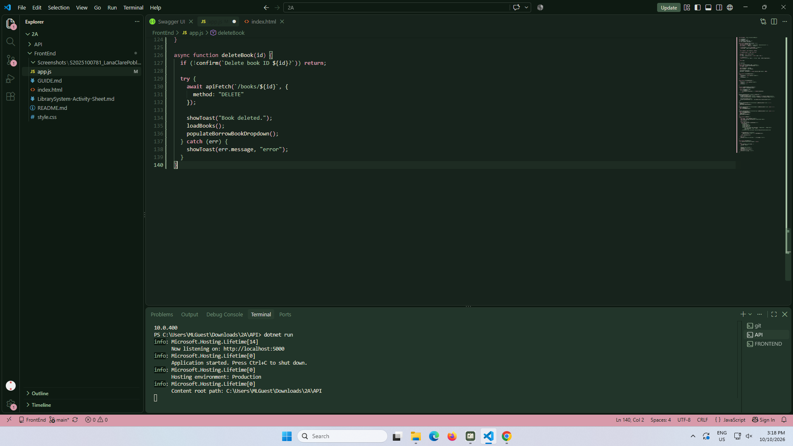

part-07-addbook
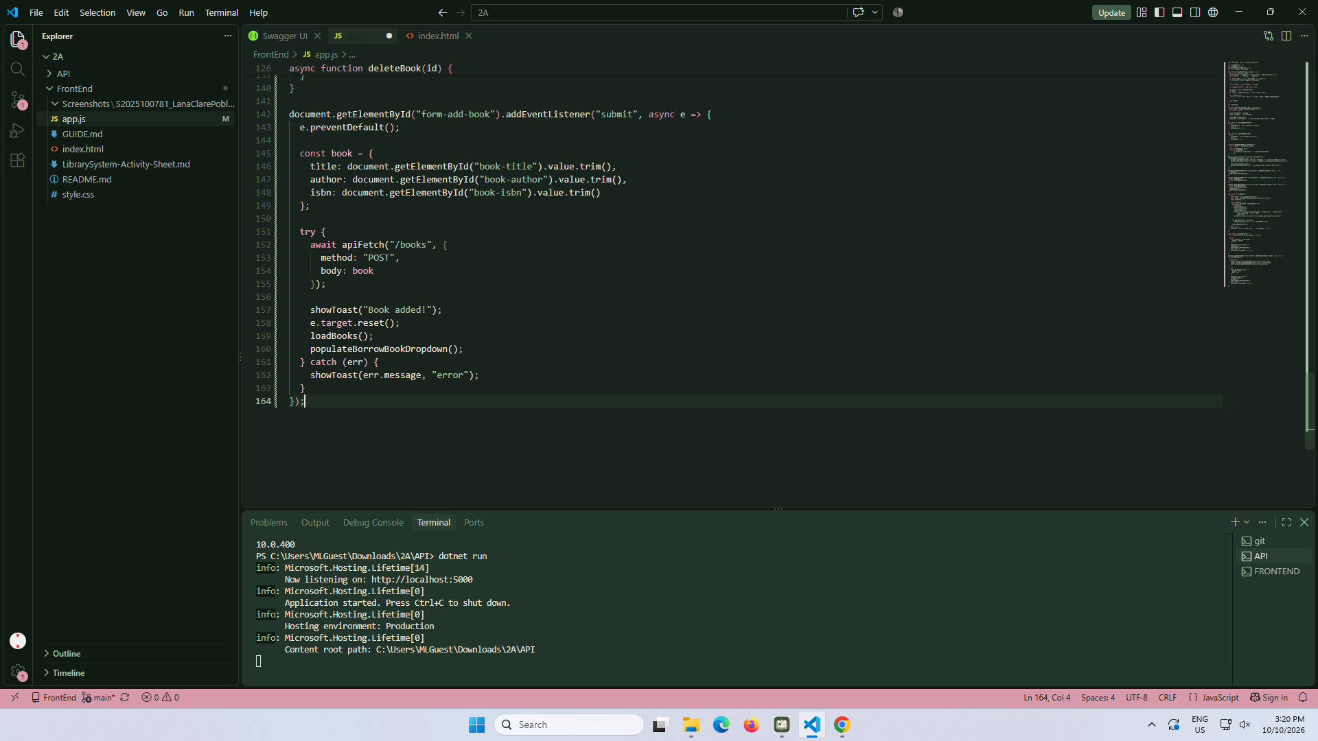

part-08-loadmembers
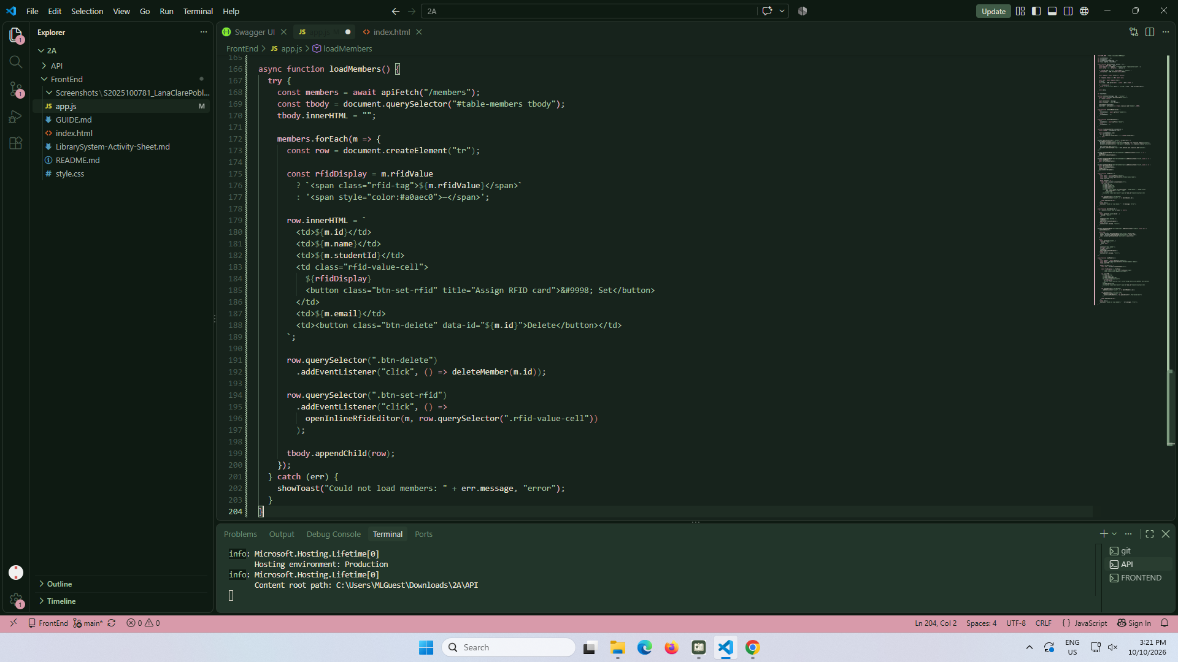

part-09-deletemember
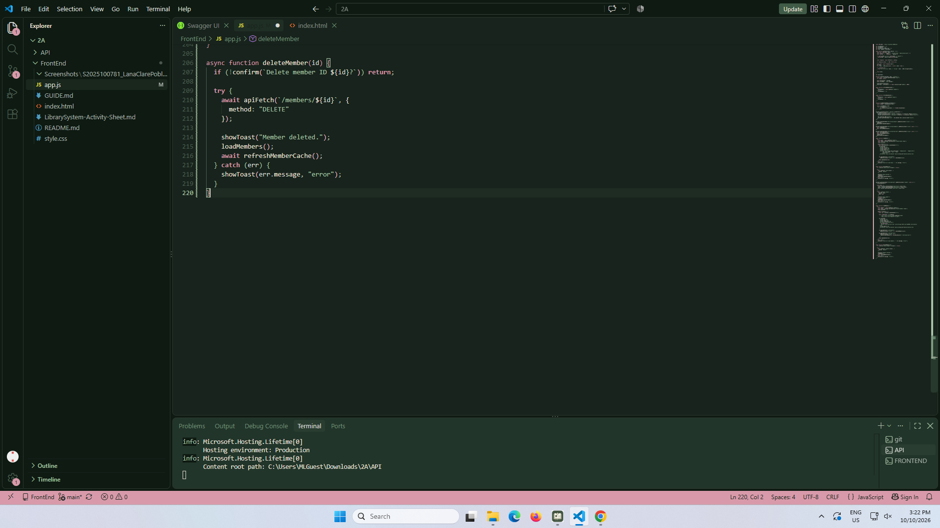

part-10-addmember
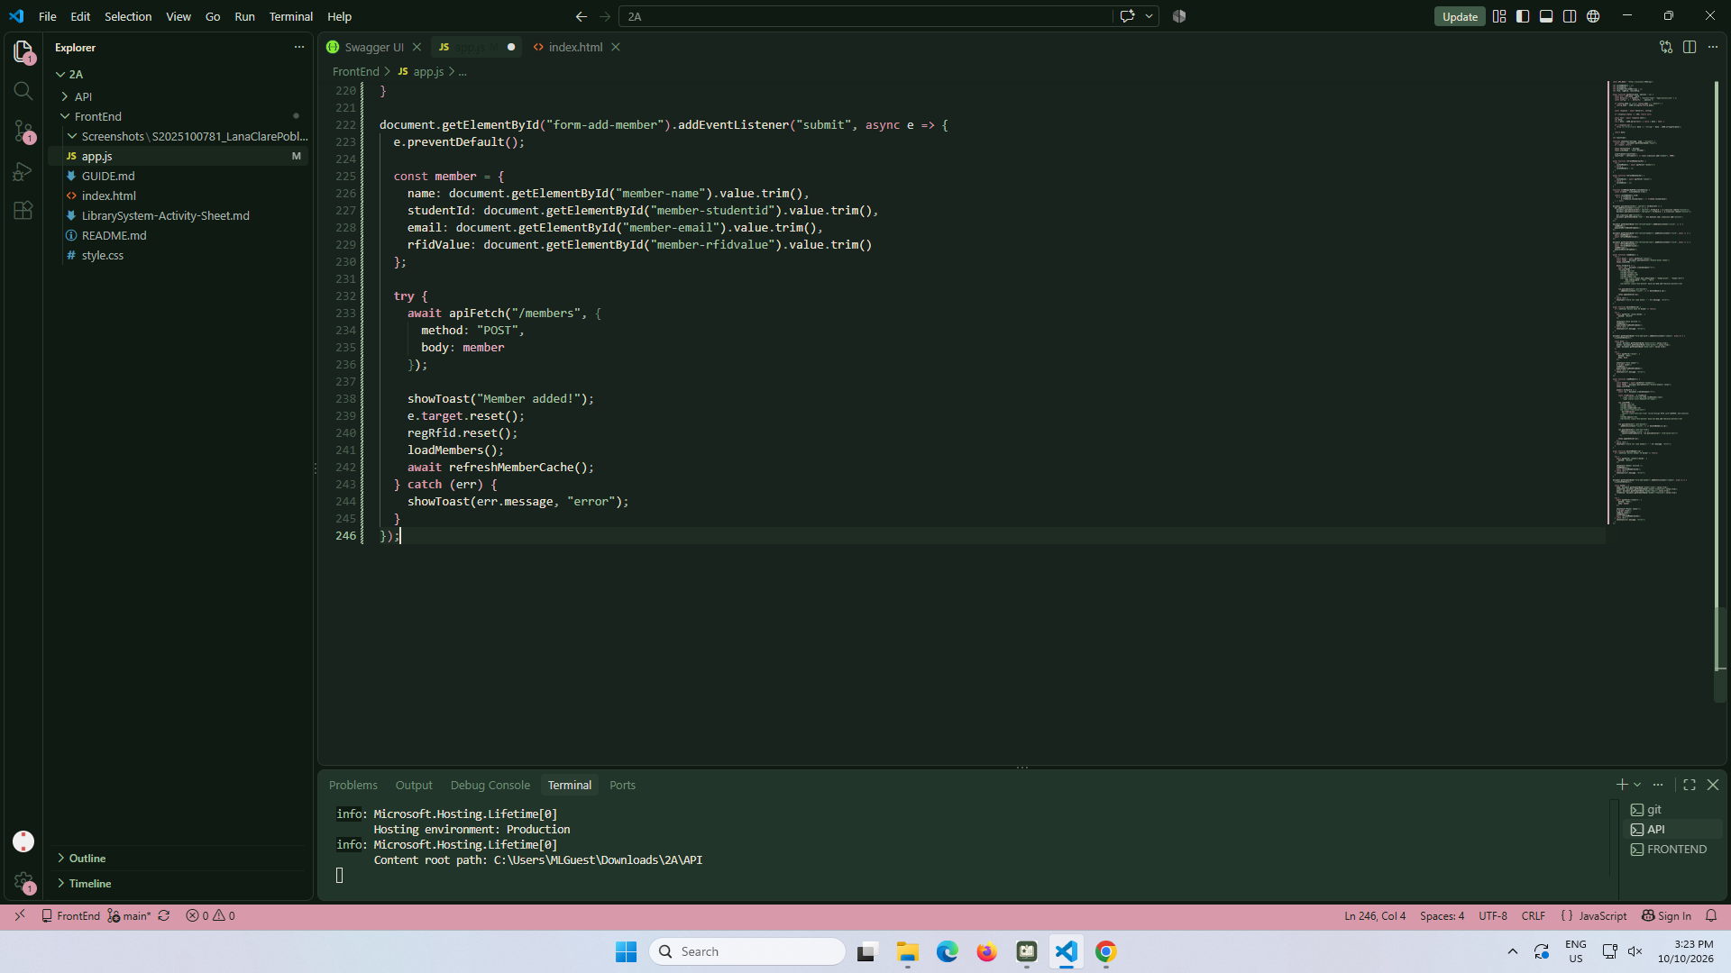

part-11-inline- rfid-editor-inline-rfid-editor
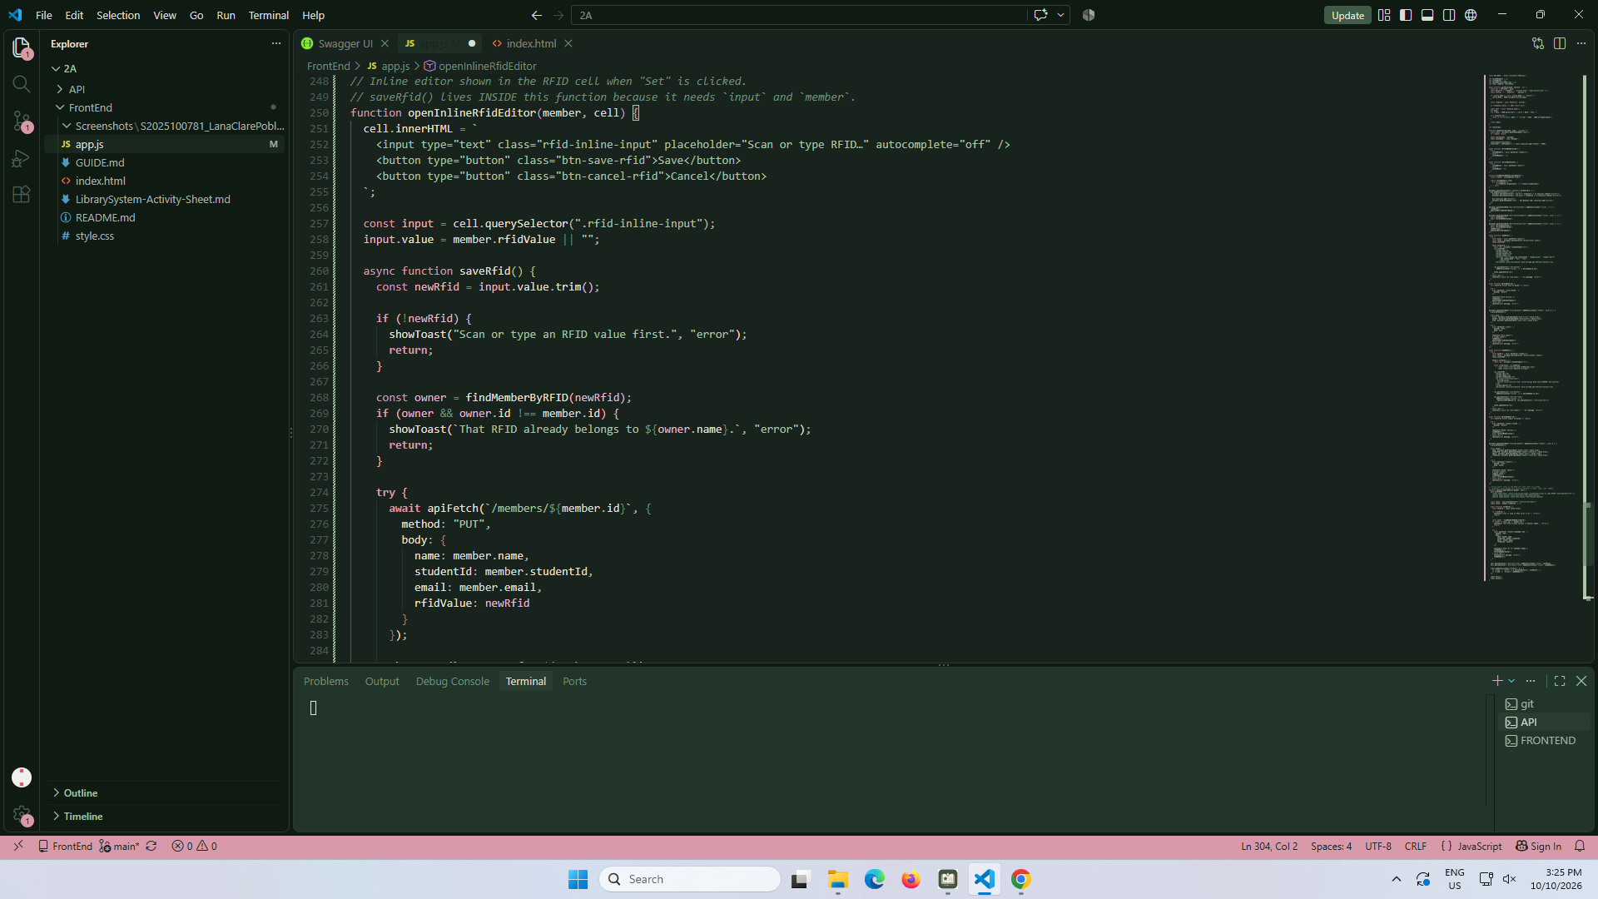
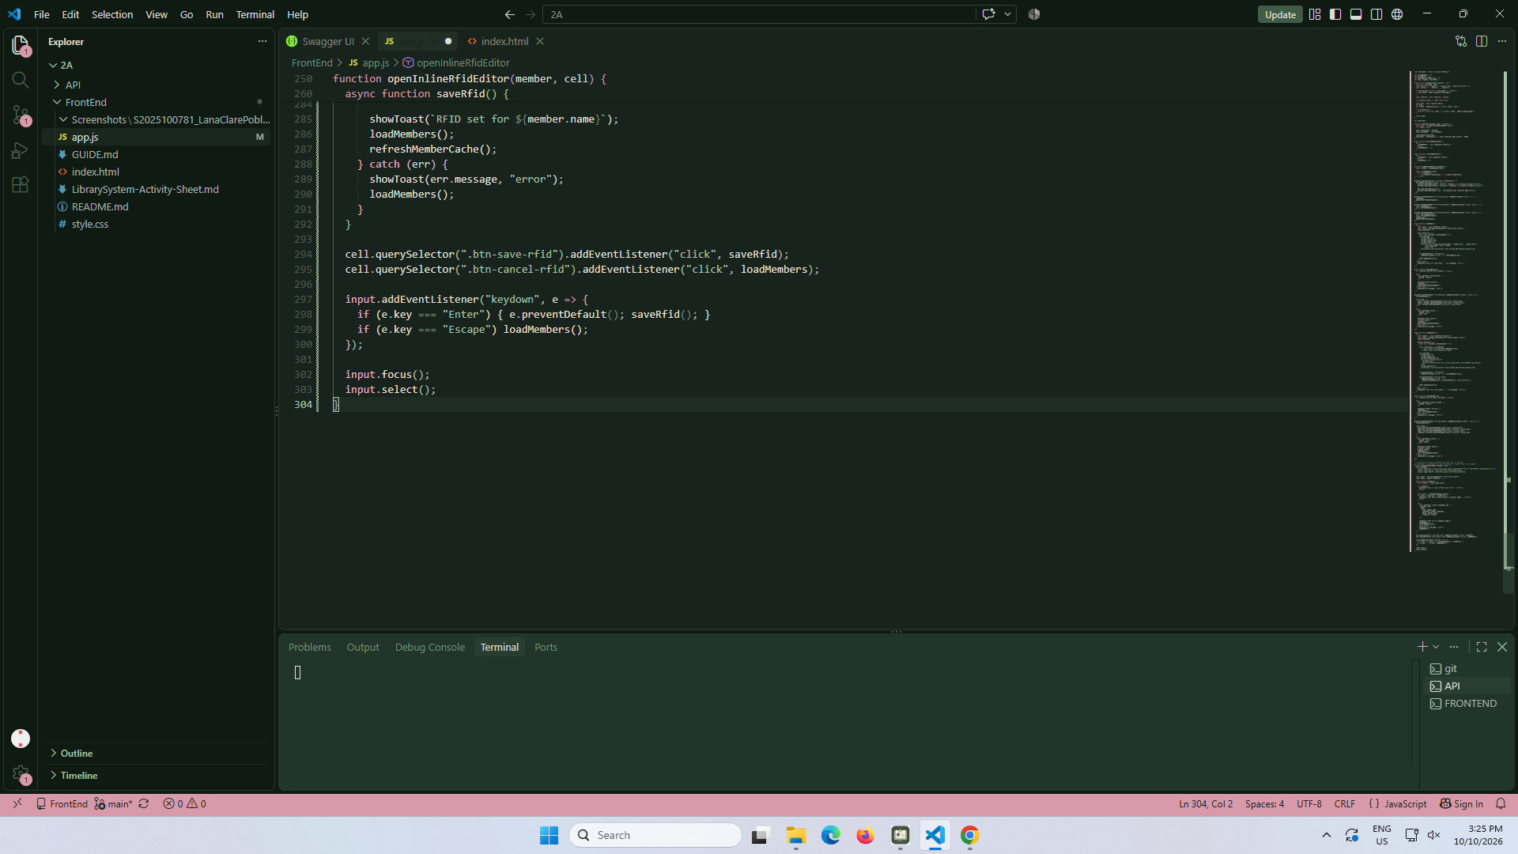

part-12a-rfid-widget-builder
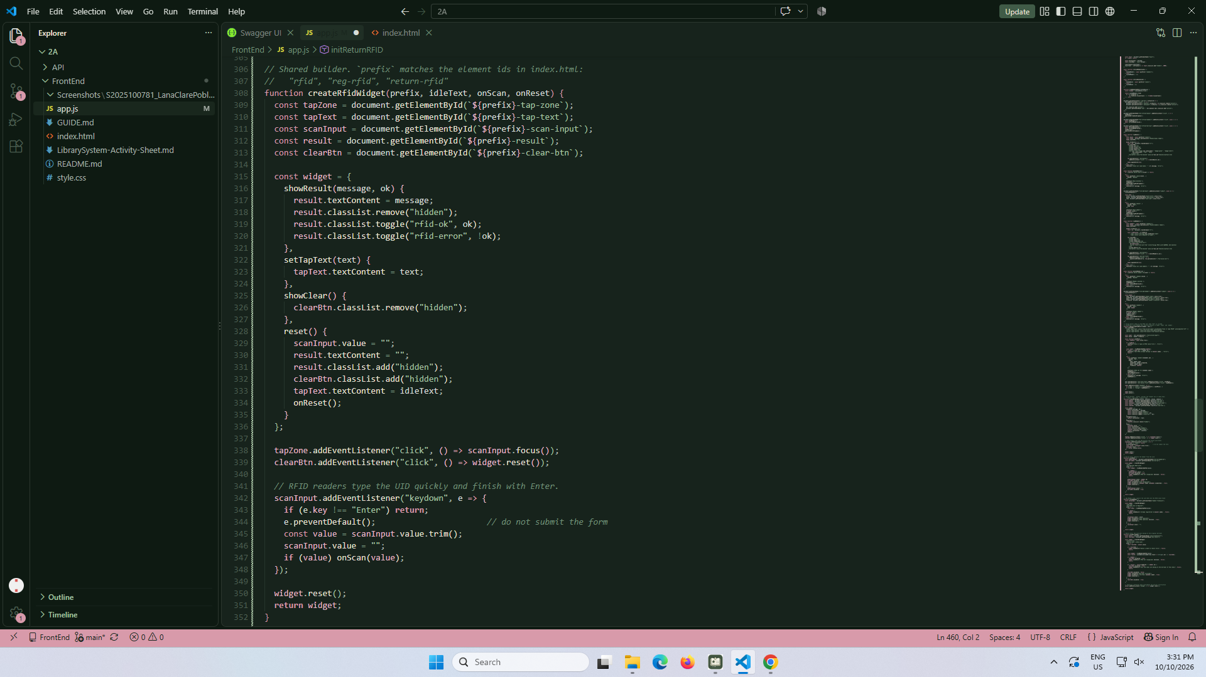

part-12b-rfid-init-functions
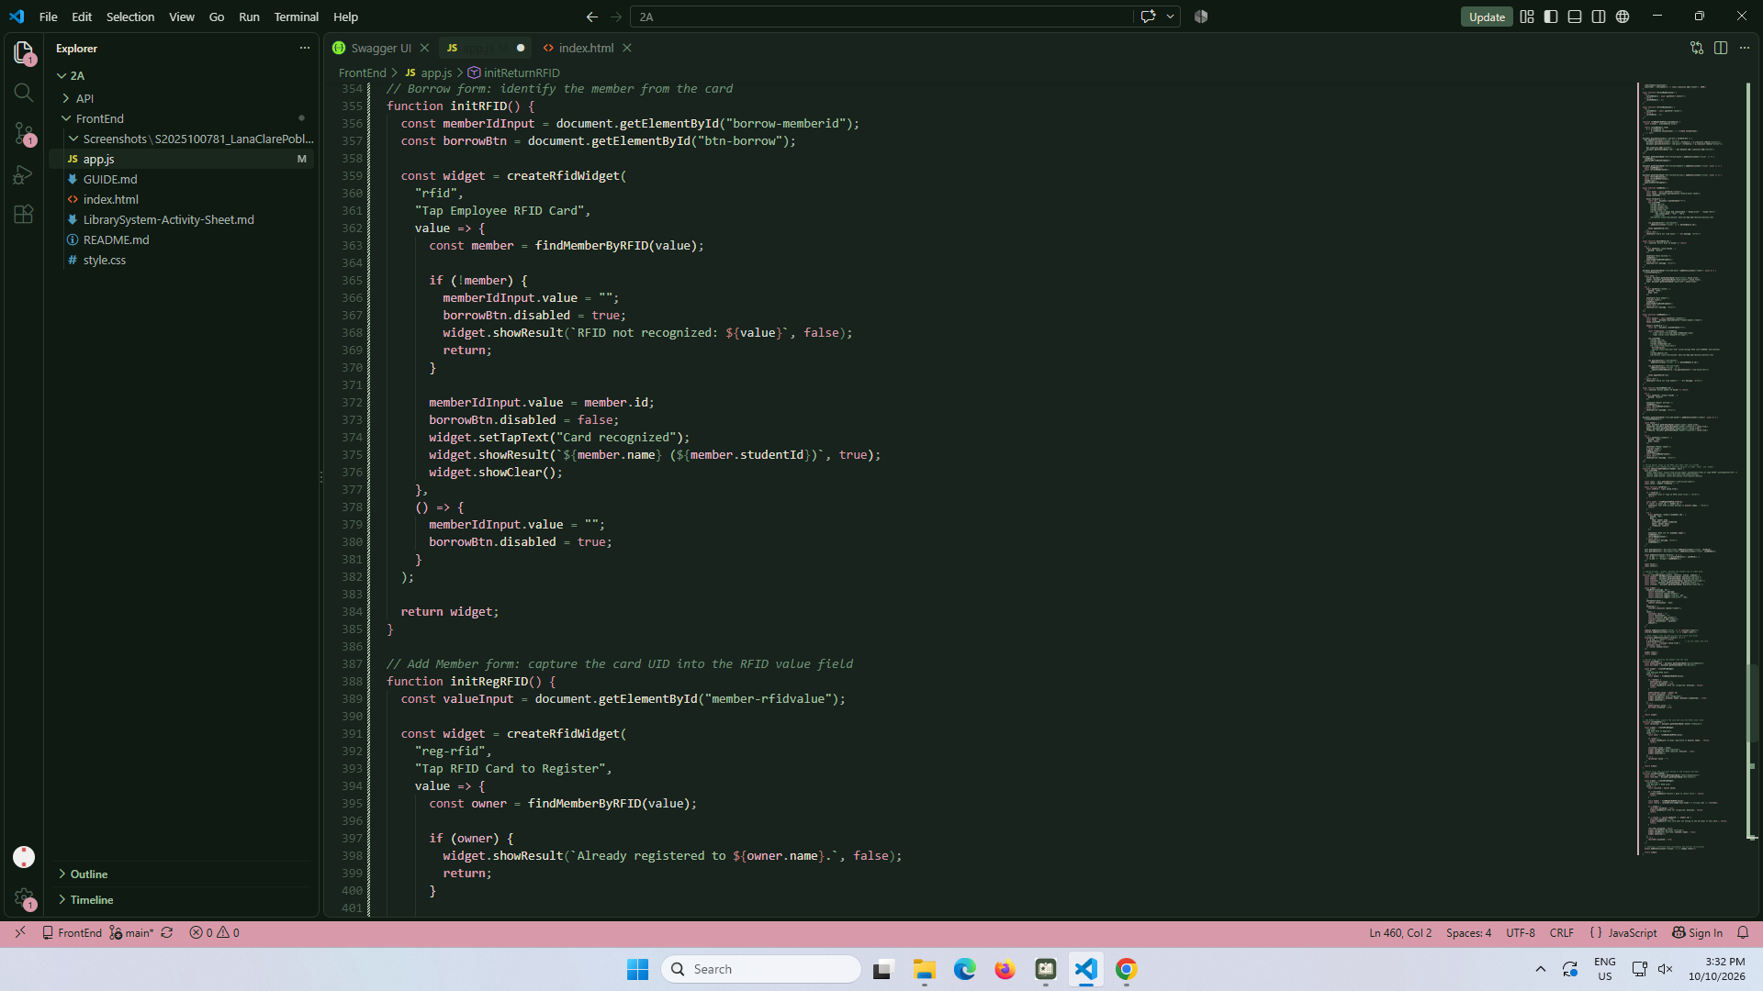
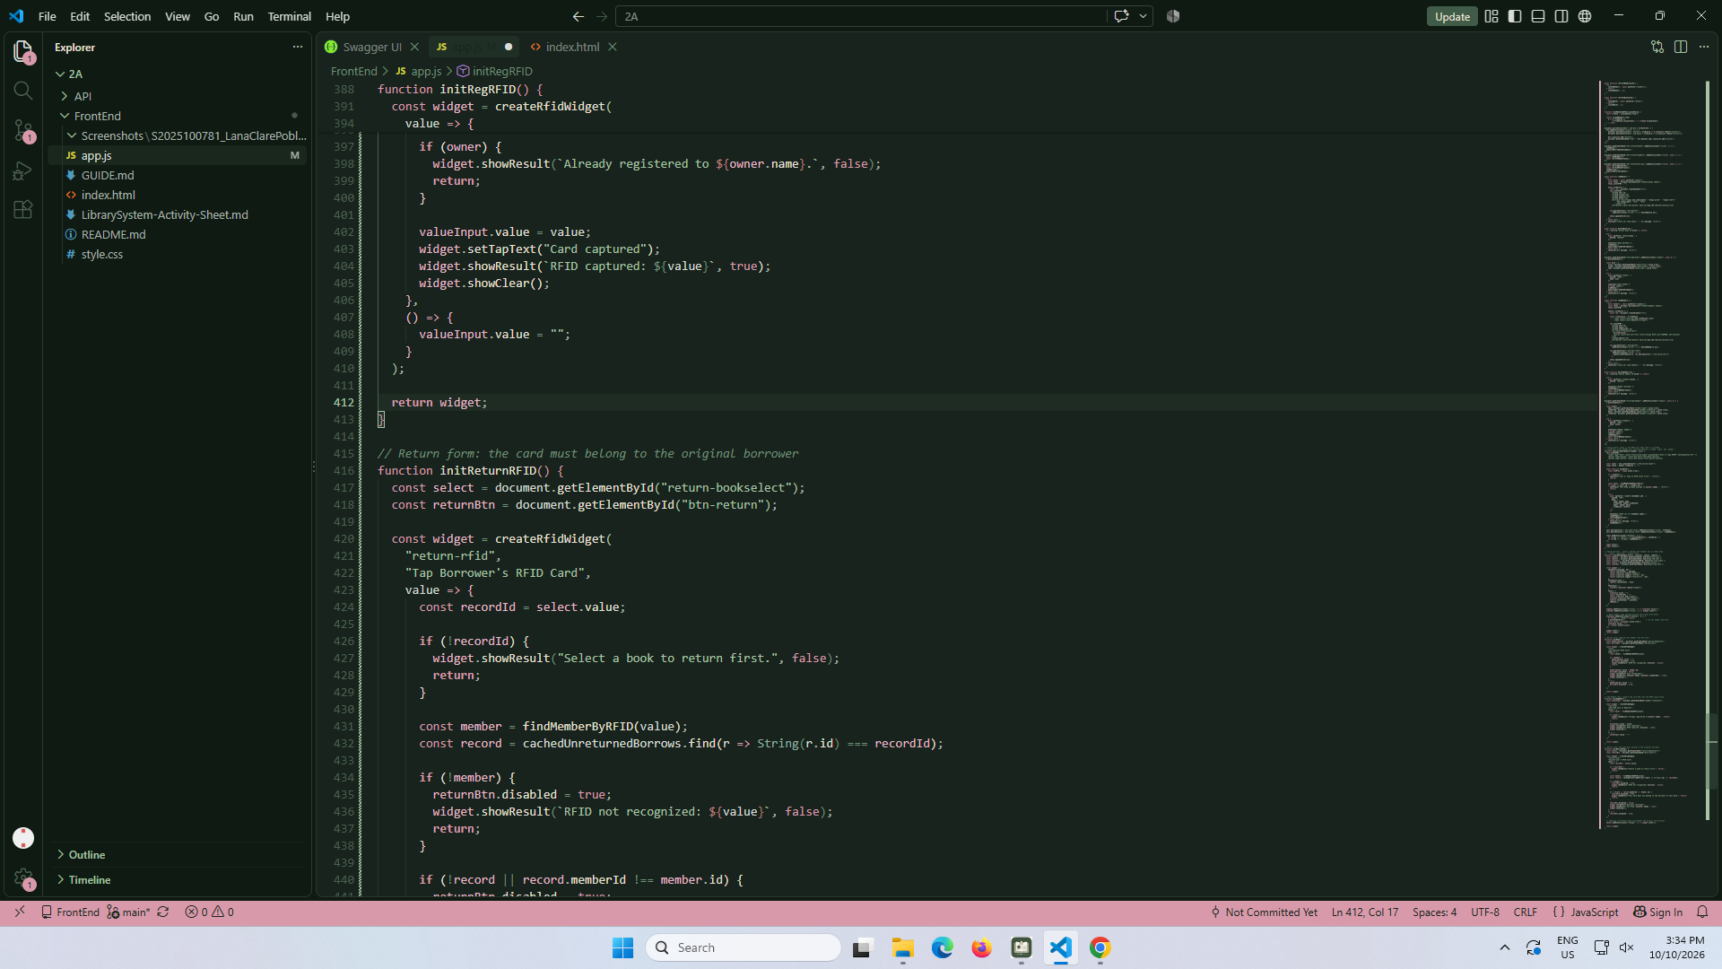
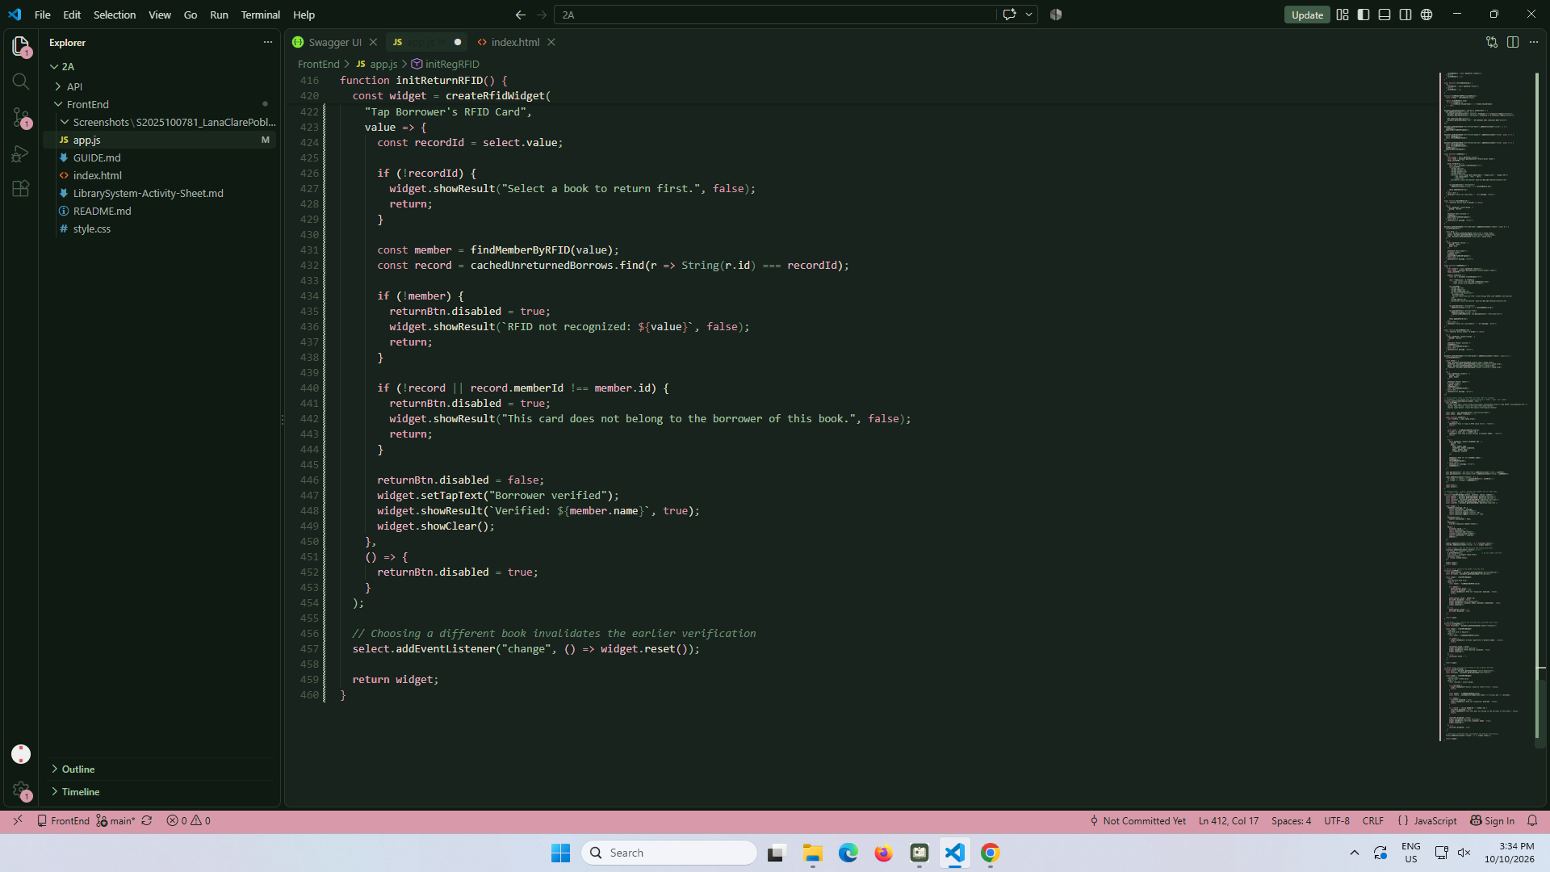

part-13-borrow-dropdown
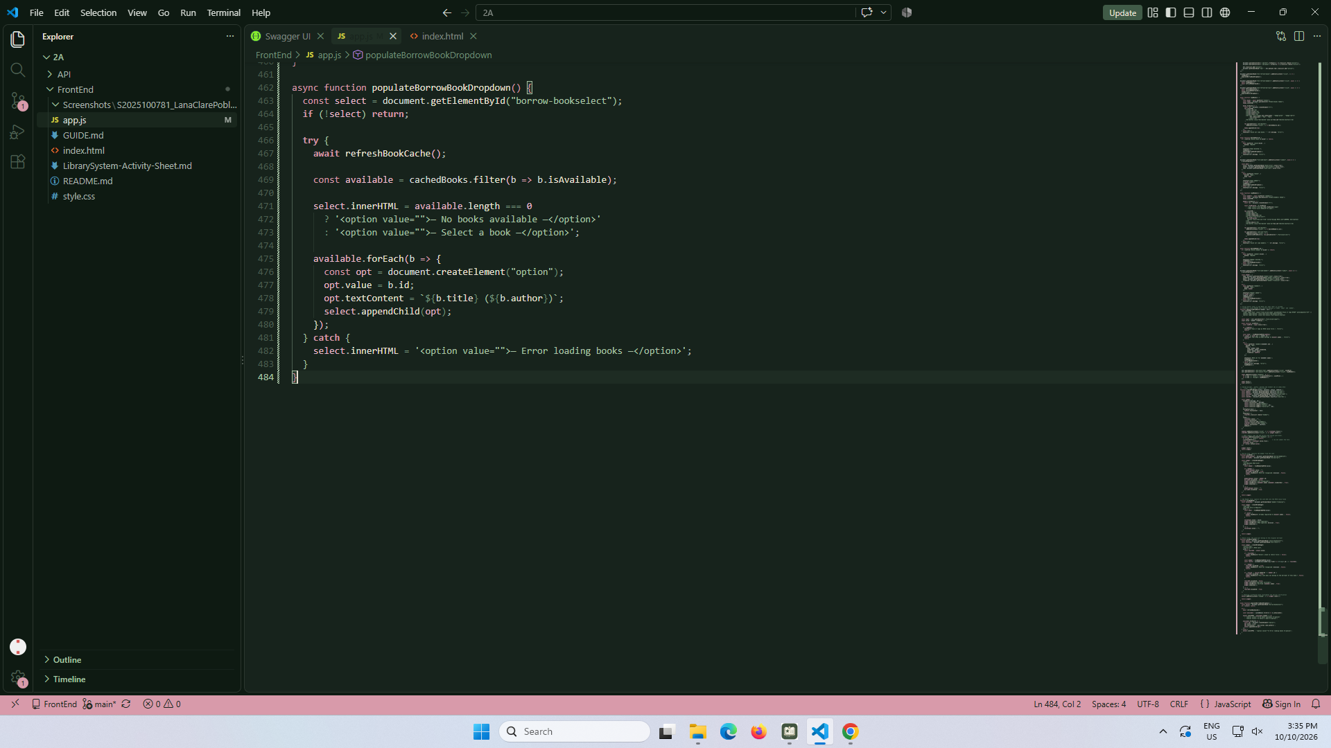

part-14-return-dropdown
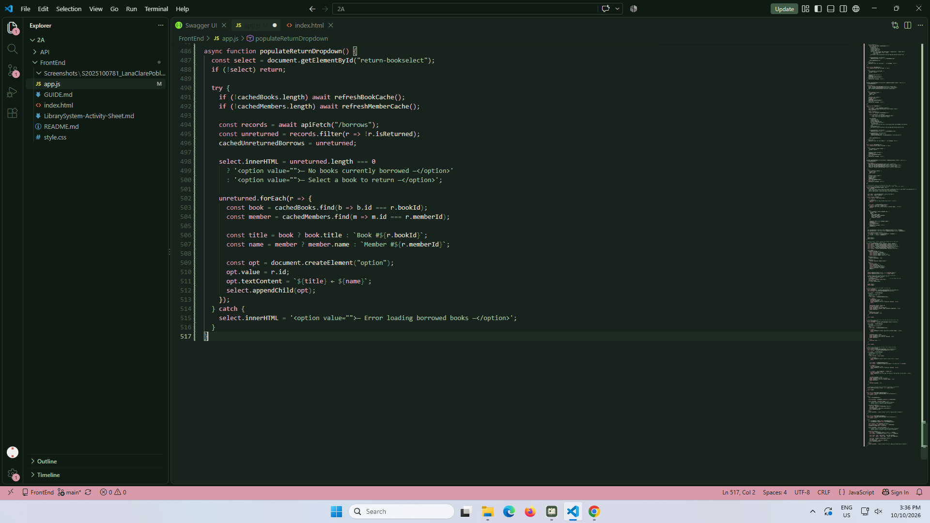

part-15-borrow
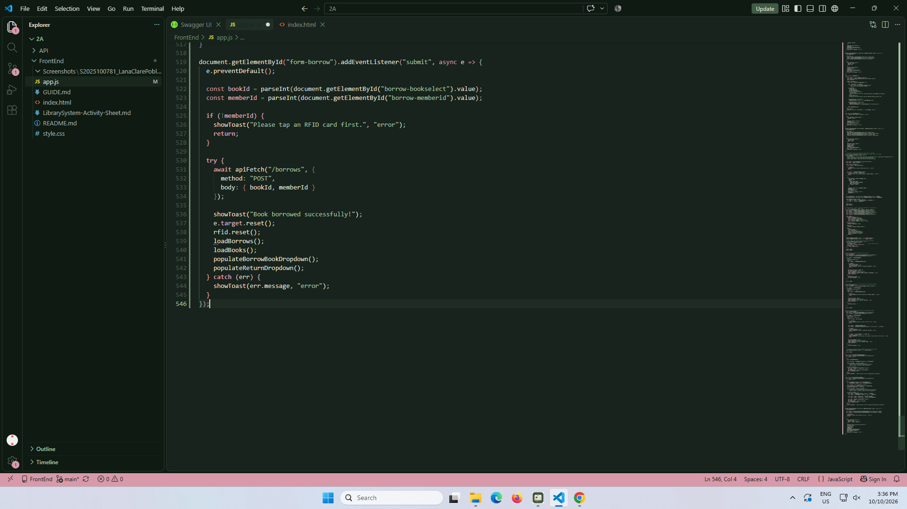

part-16-return
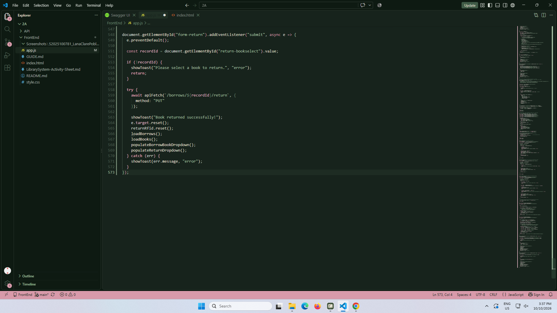

part-17-loadborrows
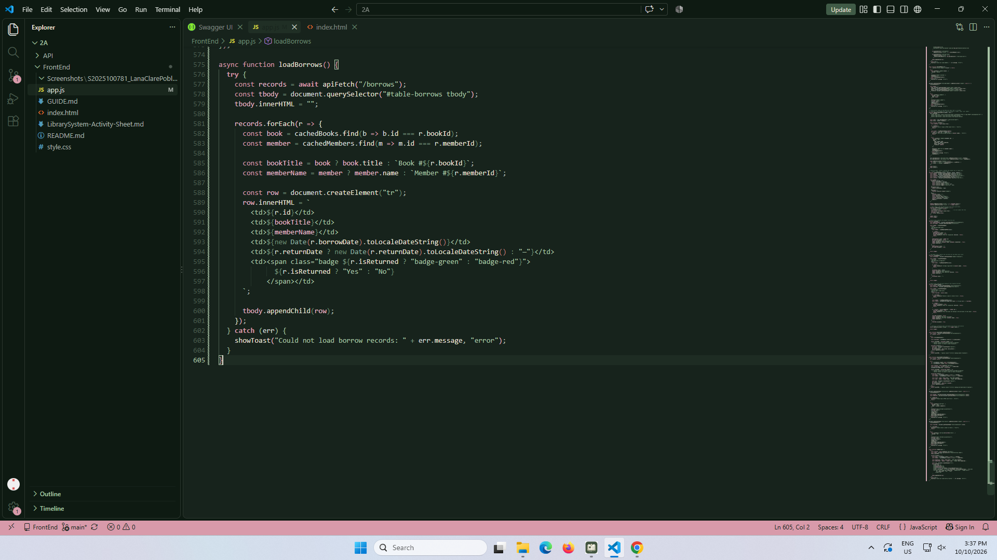

page-18-page-load
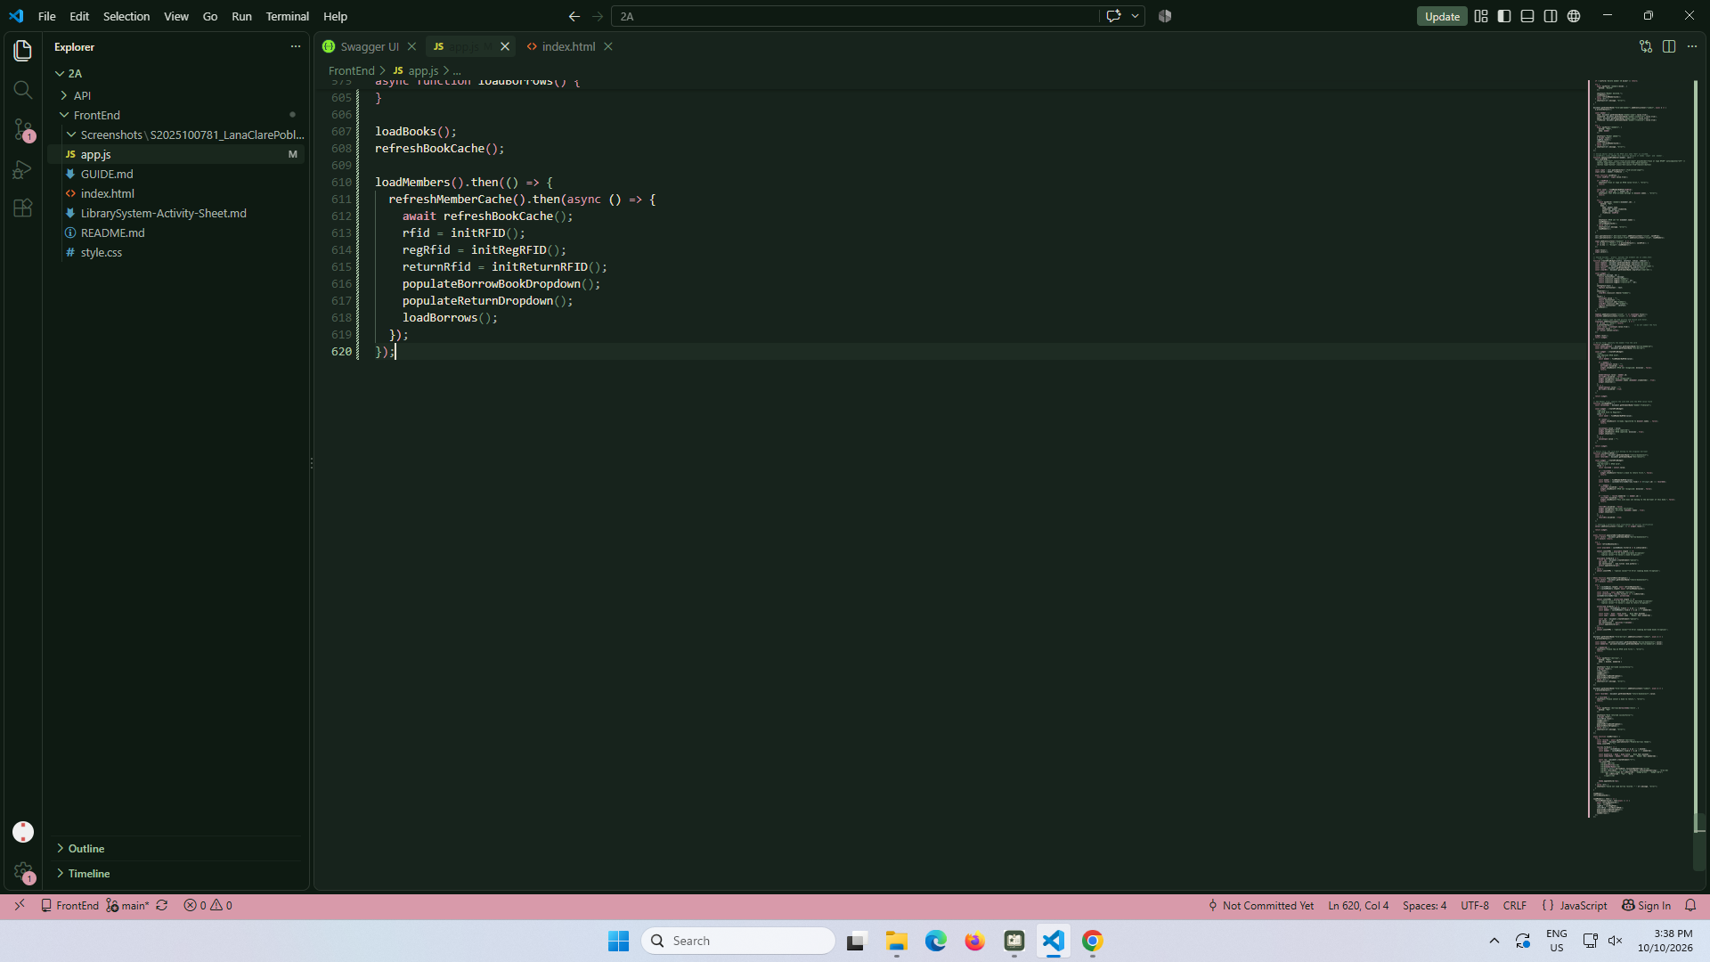

test-01-page-loaded
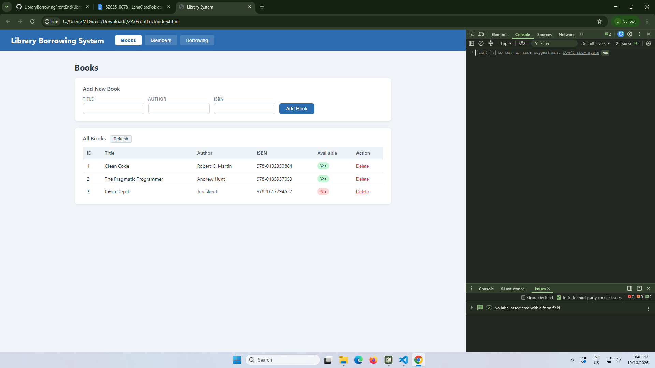

test-02-add-book
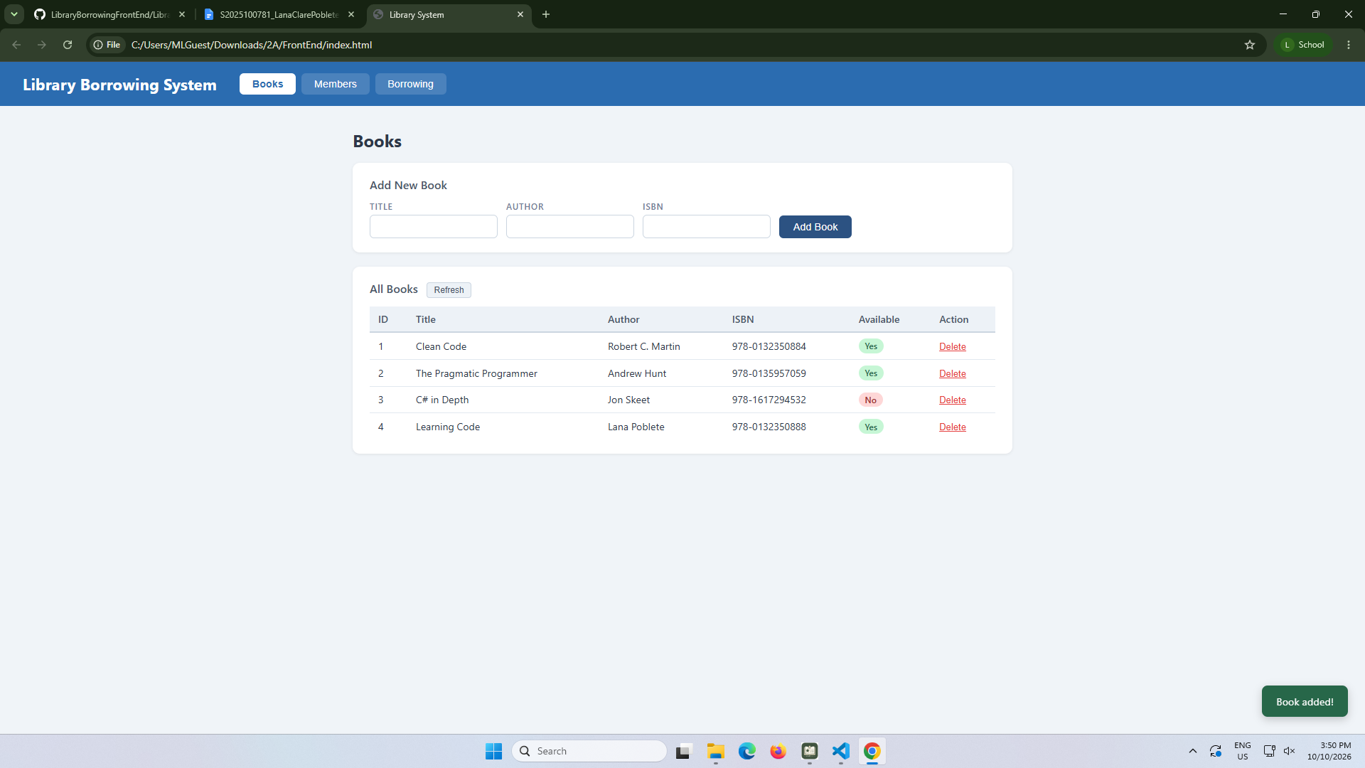

test-03-delete-book
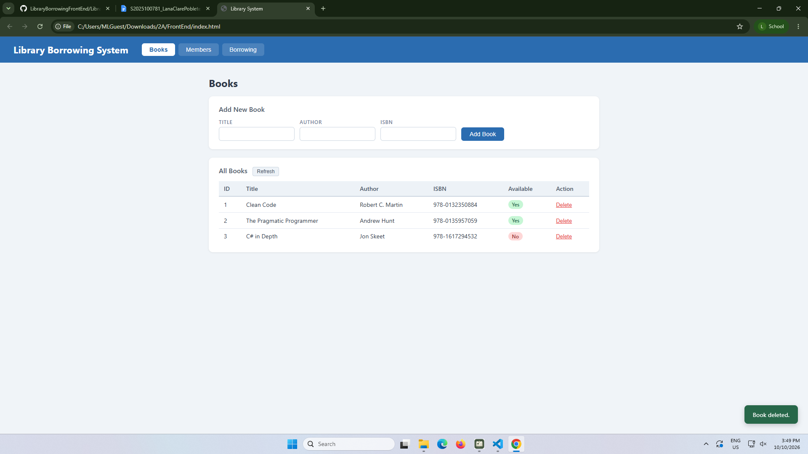

test-04-members-loaded
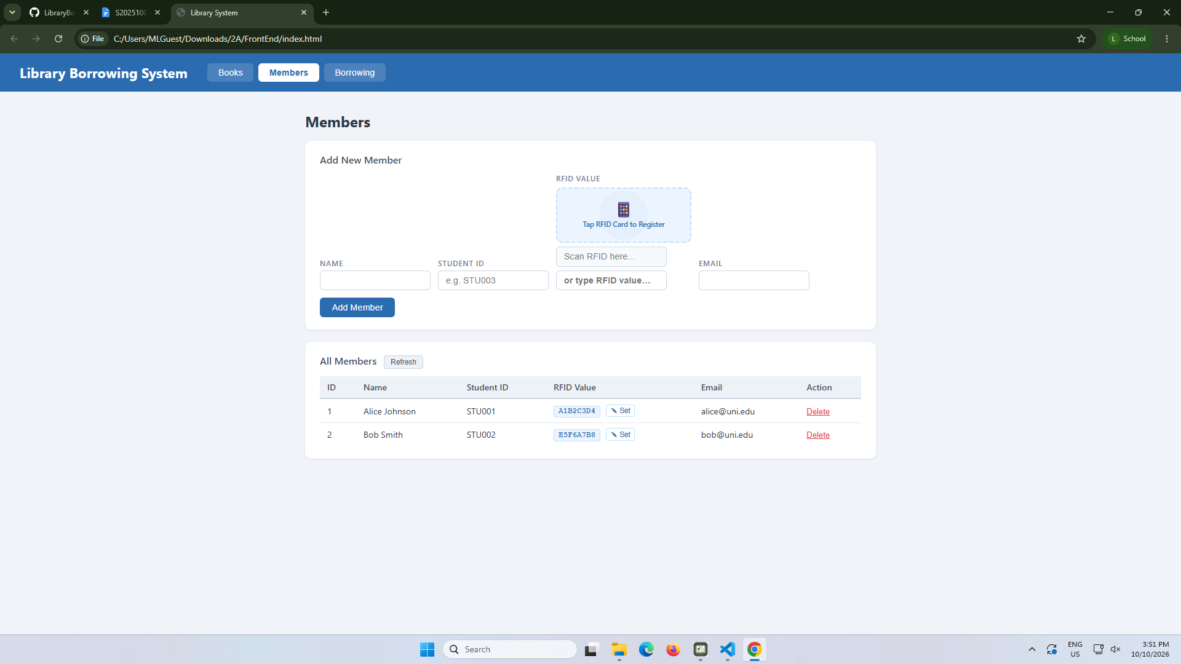

test-05-register-rfid
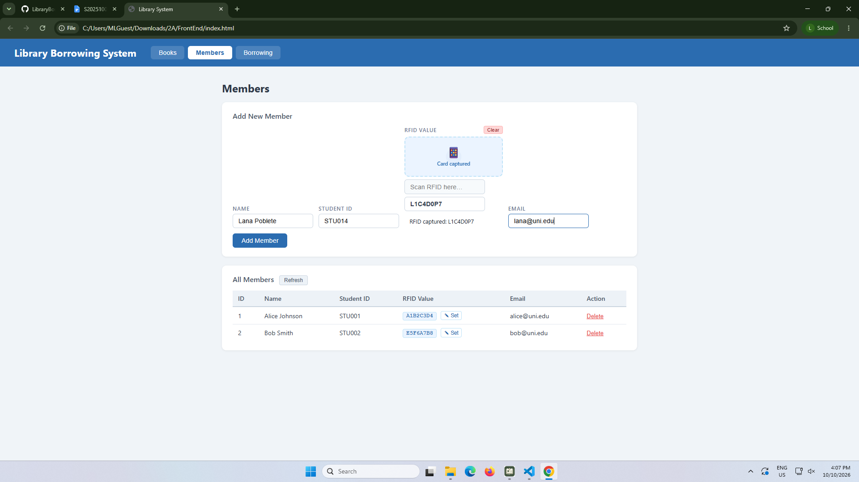

test-06-add-member
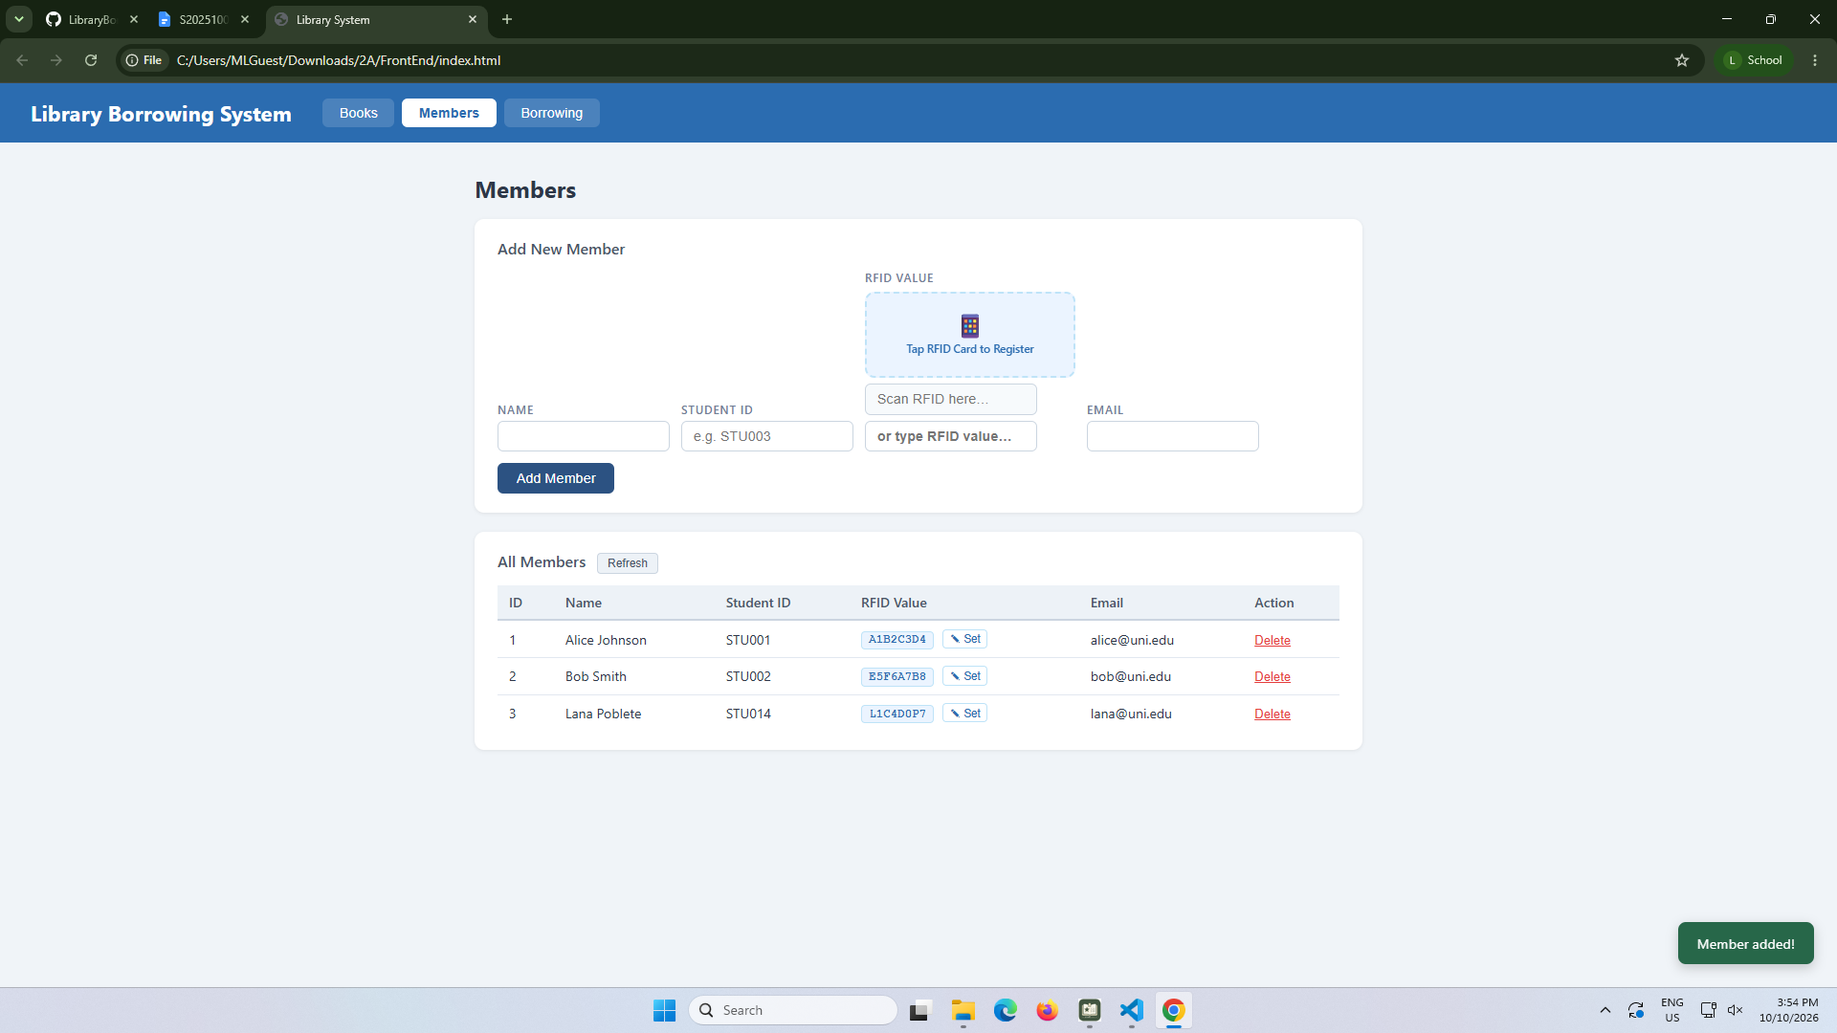
test-07-set-rfid-saved
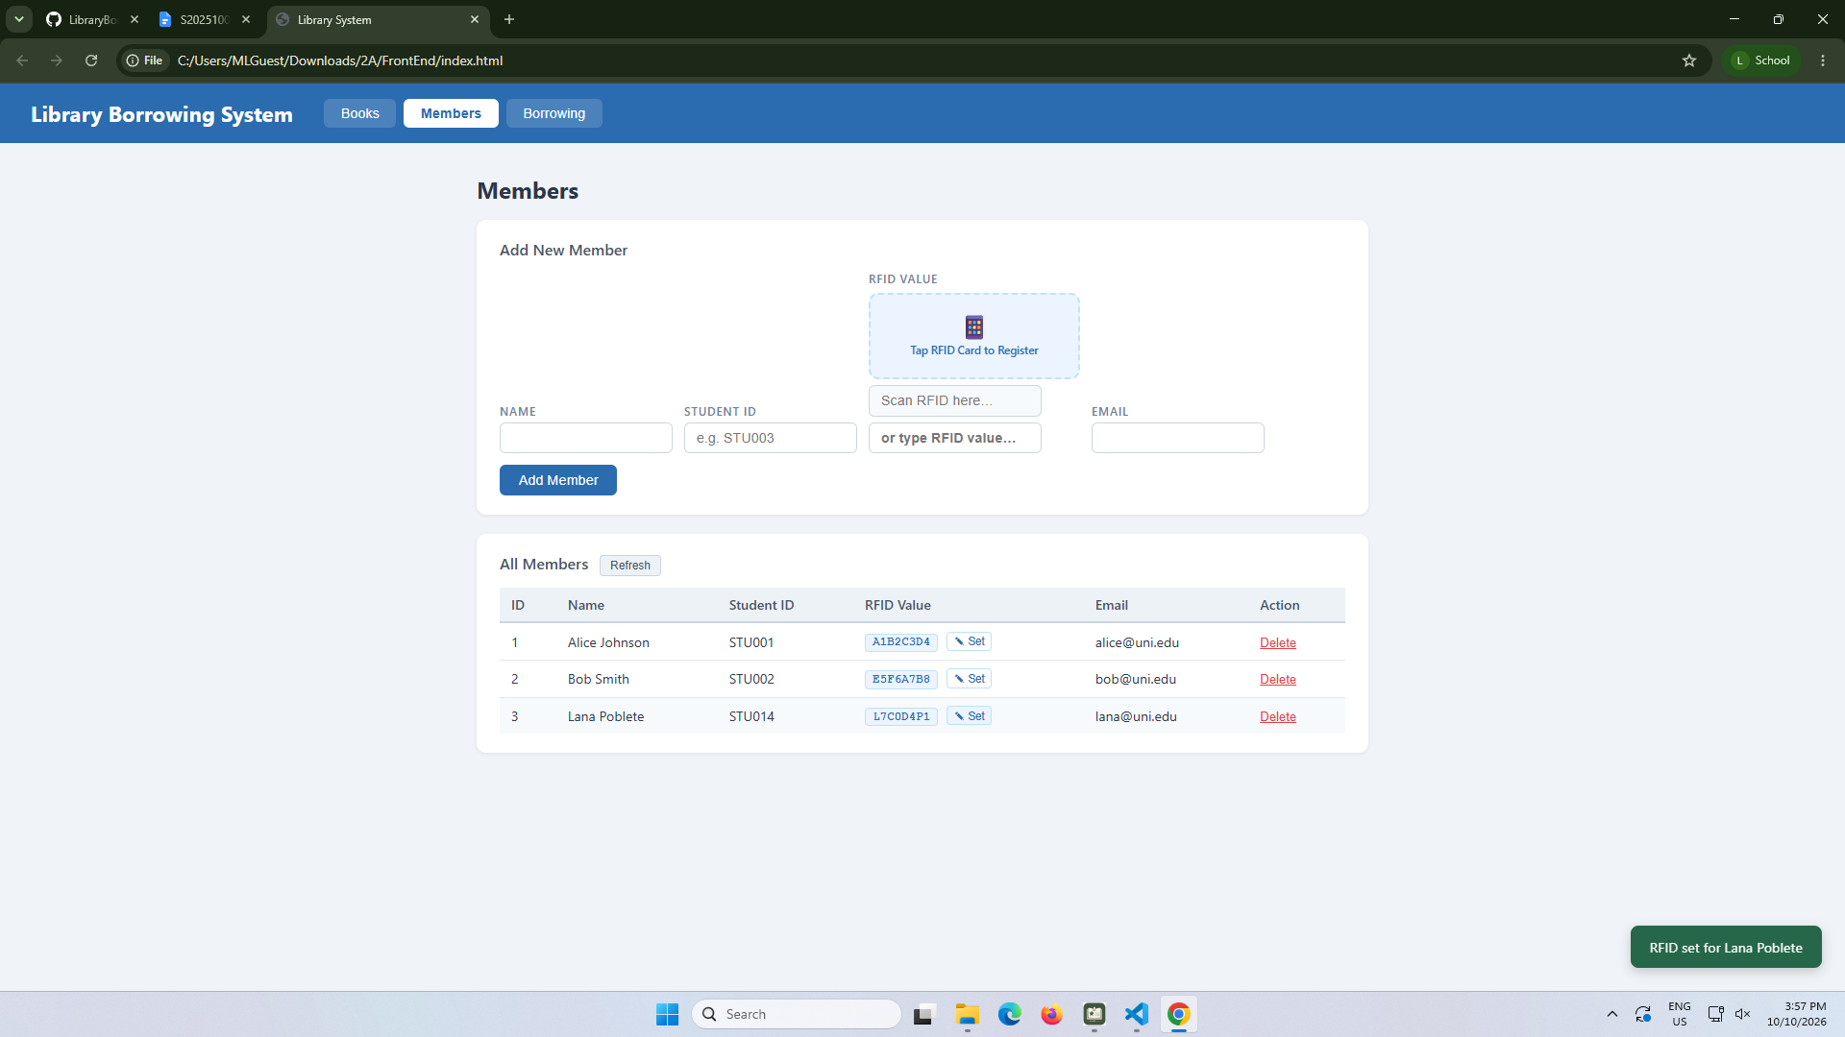

test-08-delete-member
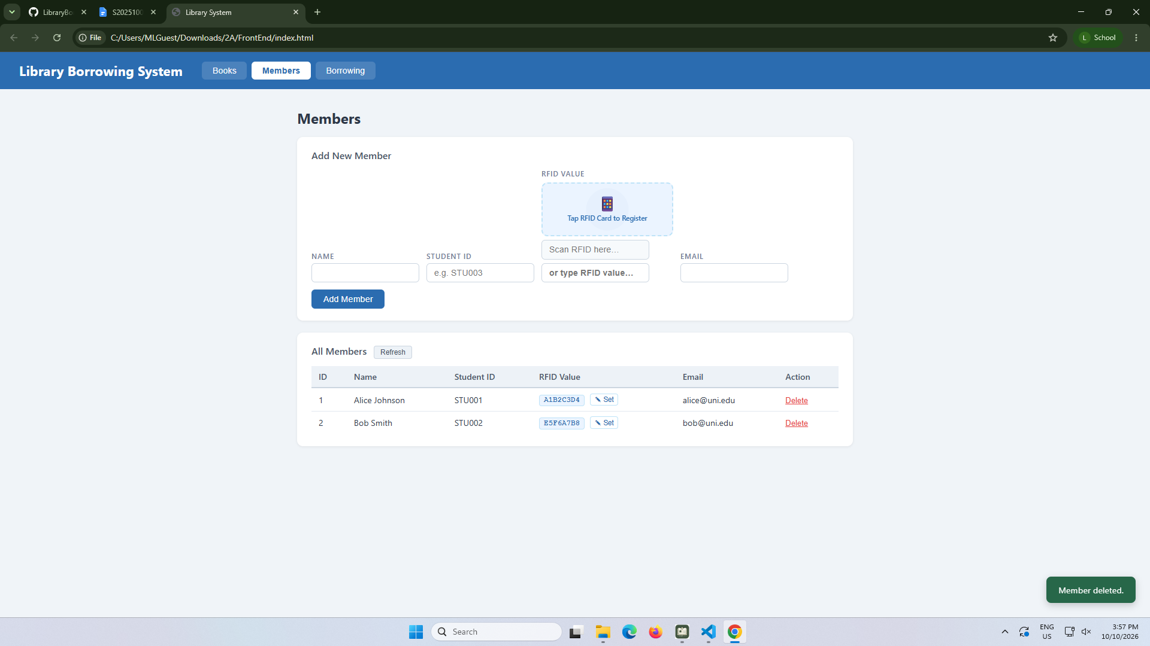

test-09-borrow-rfid-recognized
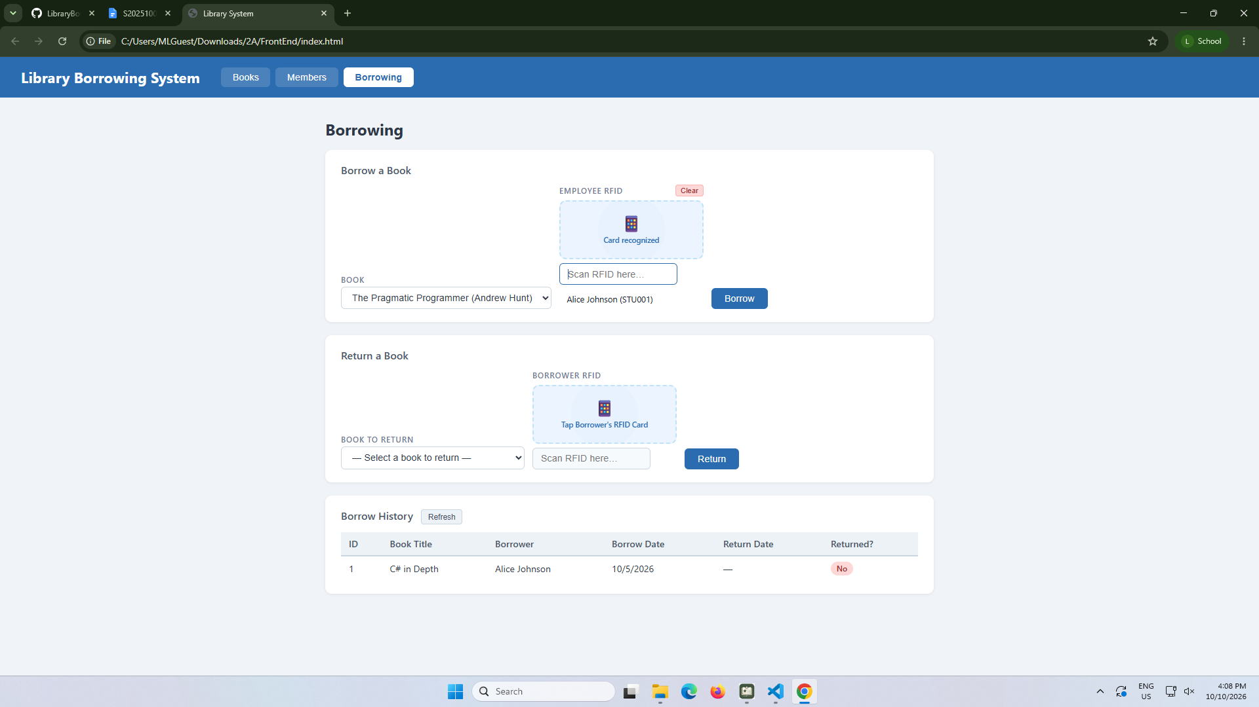

test-10-borrow-success
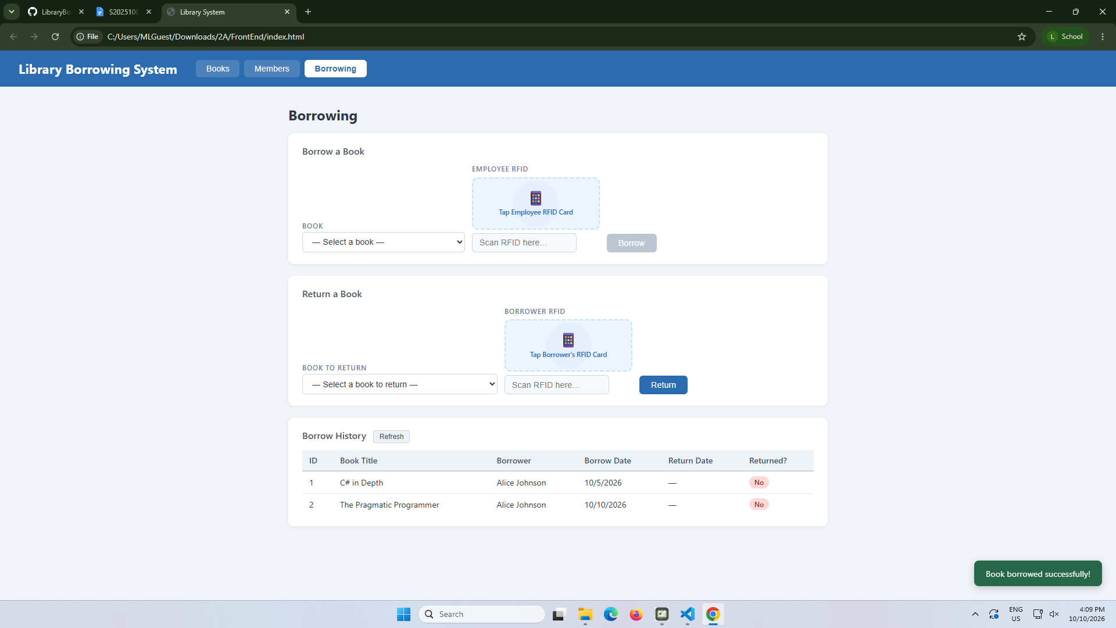

test-11-return-wrong-card
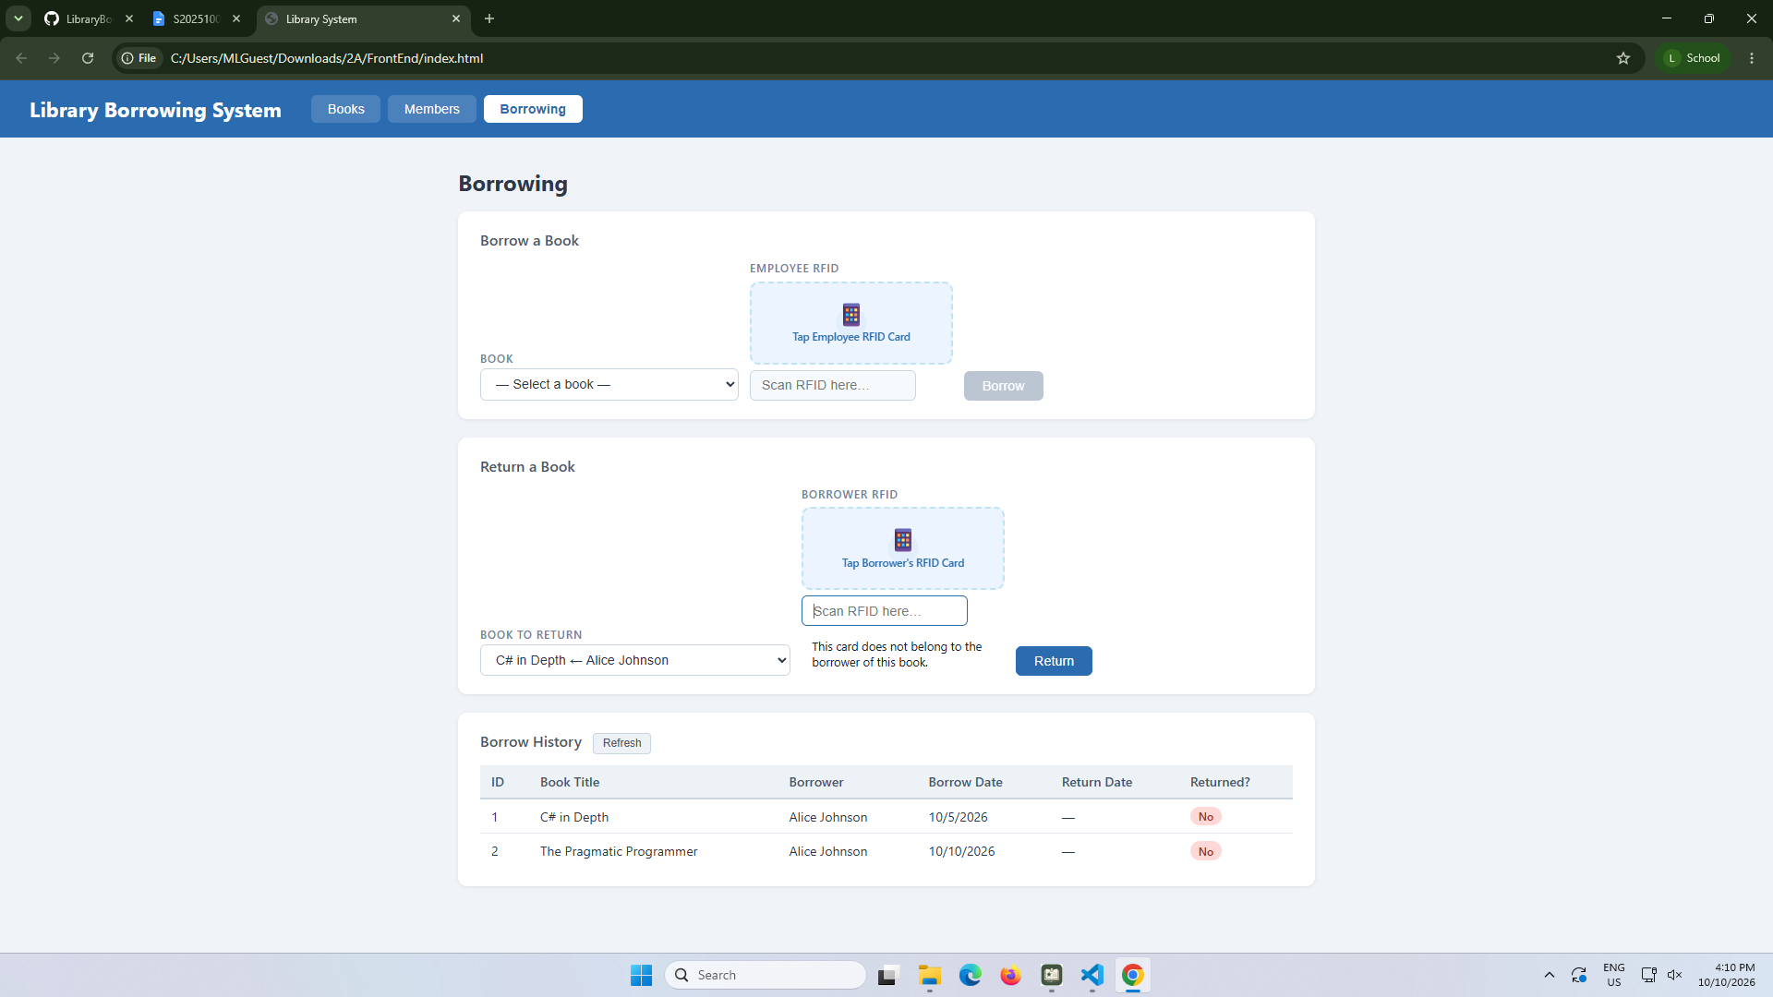

test-12-return-verified
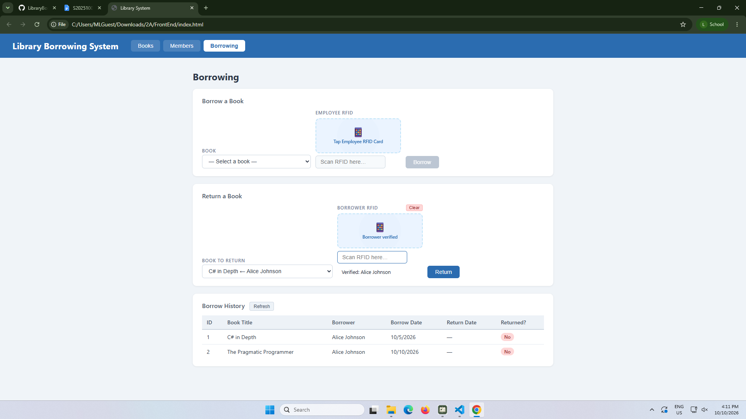

test-13-return-success
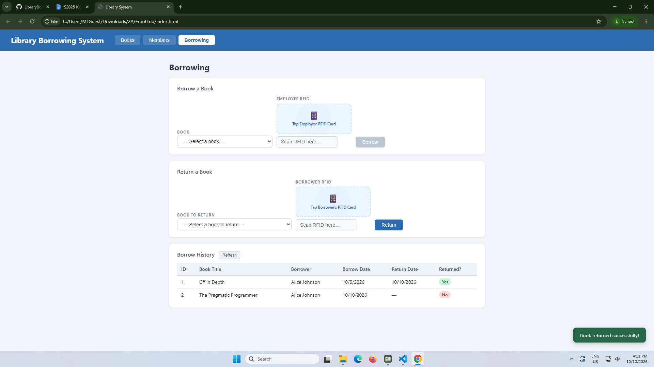

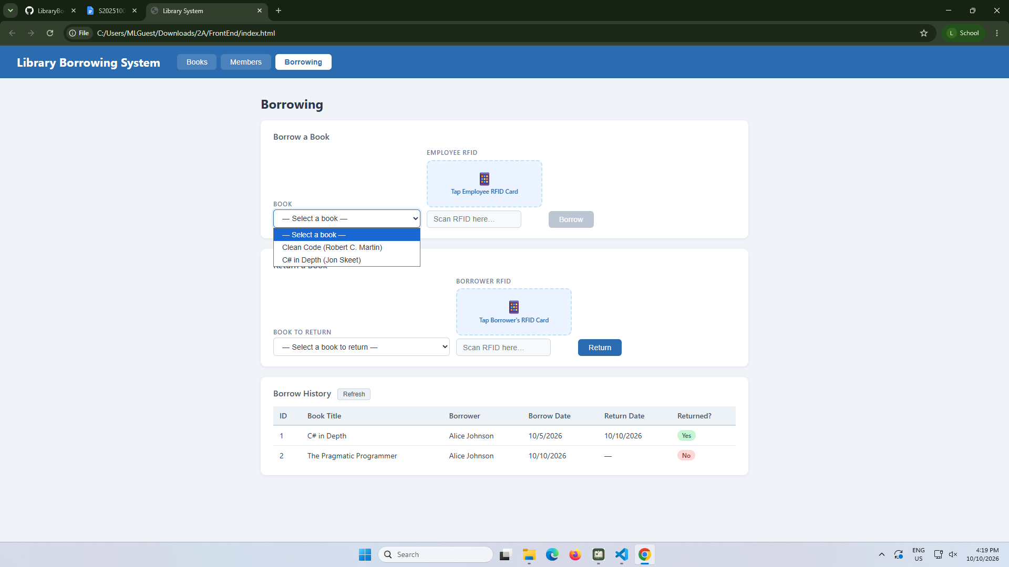

test-14-final-console
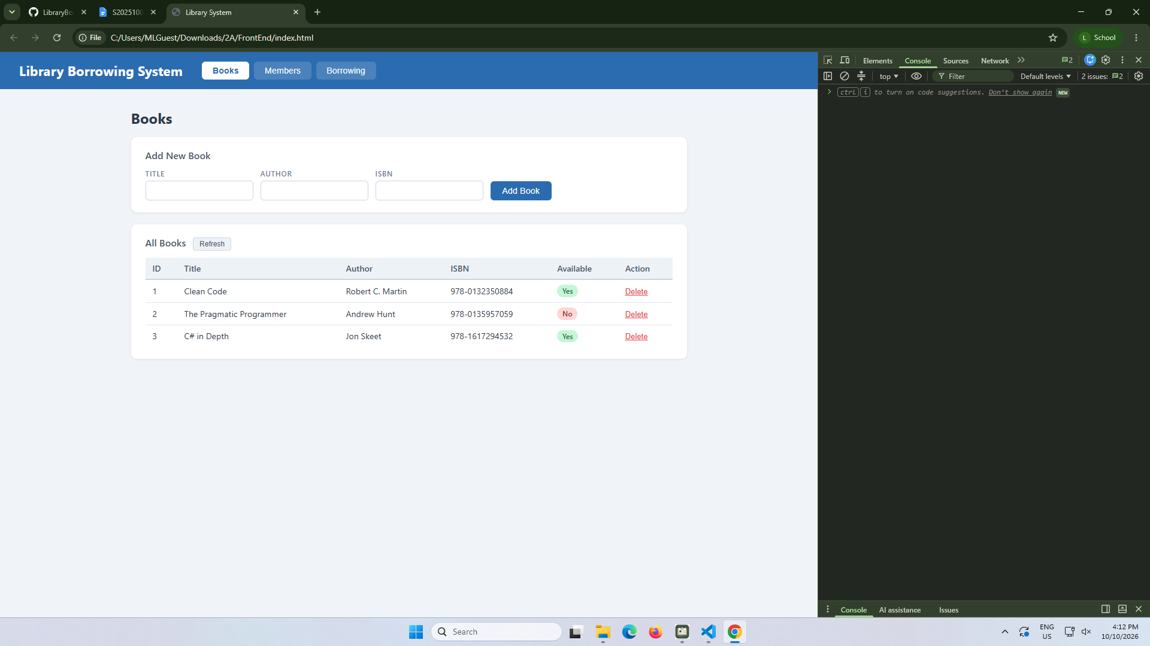
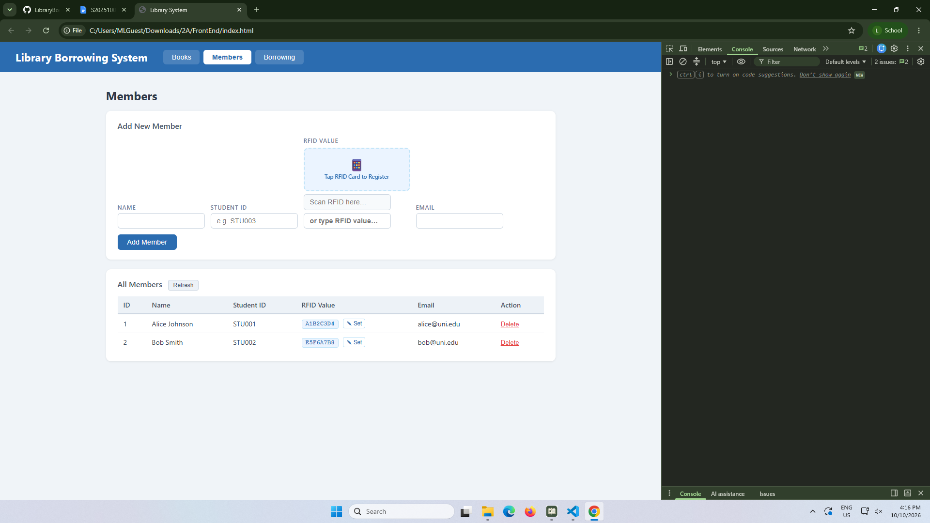
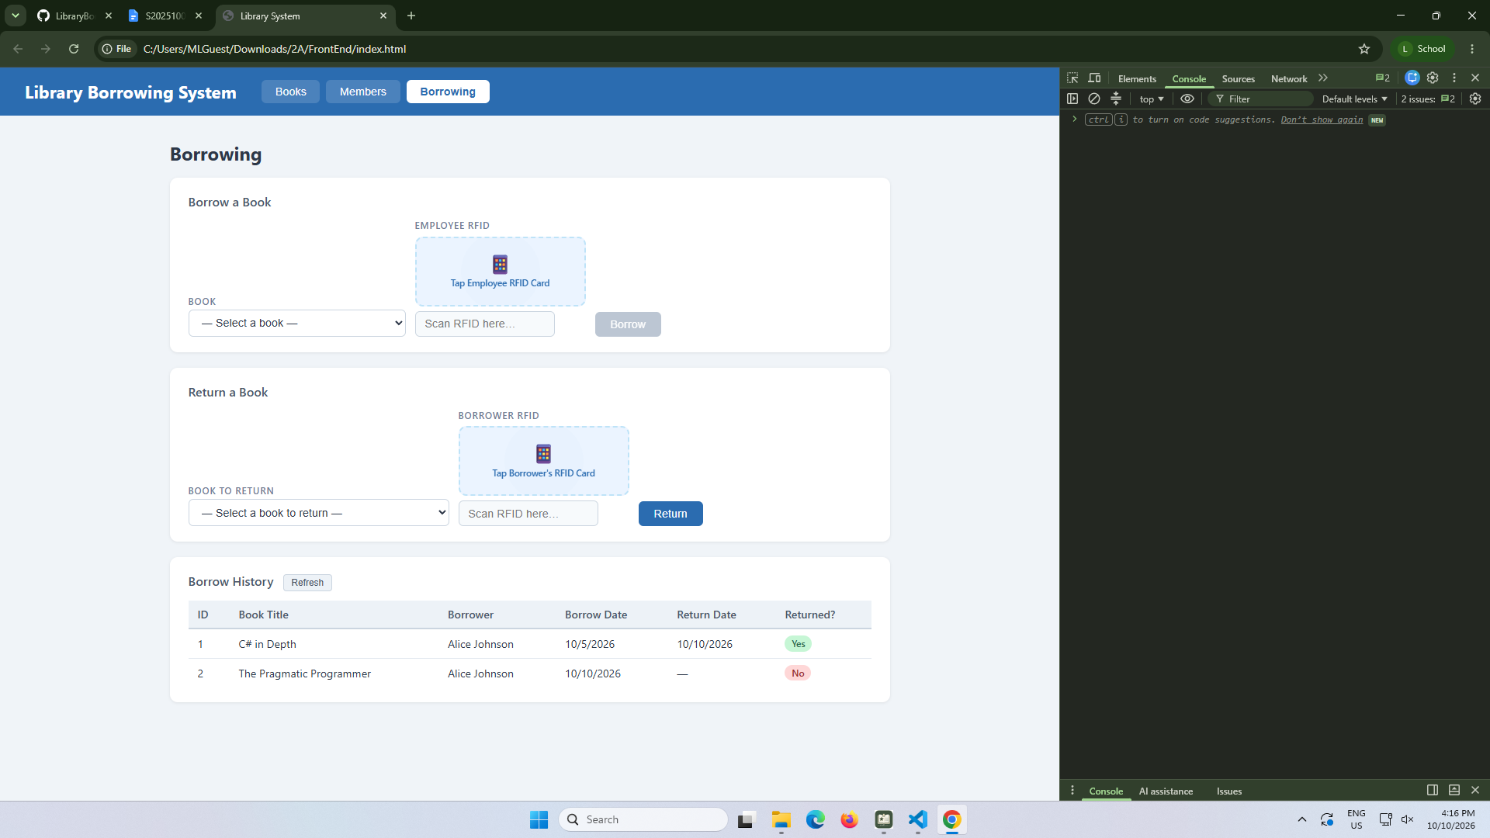

Student Reflection Questions

- What does apiFetch() do?
- It prevents repeated code.

- Why do we use try/catch around API calls?
- It handles the error in the code.

- What is the difference between POST and PUT?
- POST adds or creates new data, while PUT updates the data that already exists.

- Why does RFID matching use rfidValue instead of studentId?
- RFID matching with rfidvalue because identifies the registered member, while studentid identifies the student in the system.

- Why do we refresh tables after adding, deleting, borrowing, or returning?
- Because it displays the most recent or latest changes or updates.

- Why does the Return dropdown use borrow record ID instead of book ID?
- Because it identifies the books listed in borrow, then in the whole book list.

- What happens if the same event listener is added to a form twice?
- It may make the event run multiple times, making duplicate actions or requests.

- Why must the page-load code be at the bottom of the file?
- So that the HTML elements are loaded before JavaScript accesses them.

- Why does an RFID reader need e.preventDefault() on the Enter key?
- So it doesn’t reload the page when scanning the RFID card.

