setup-01-api-running
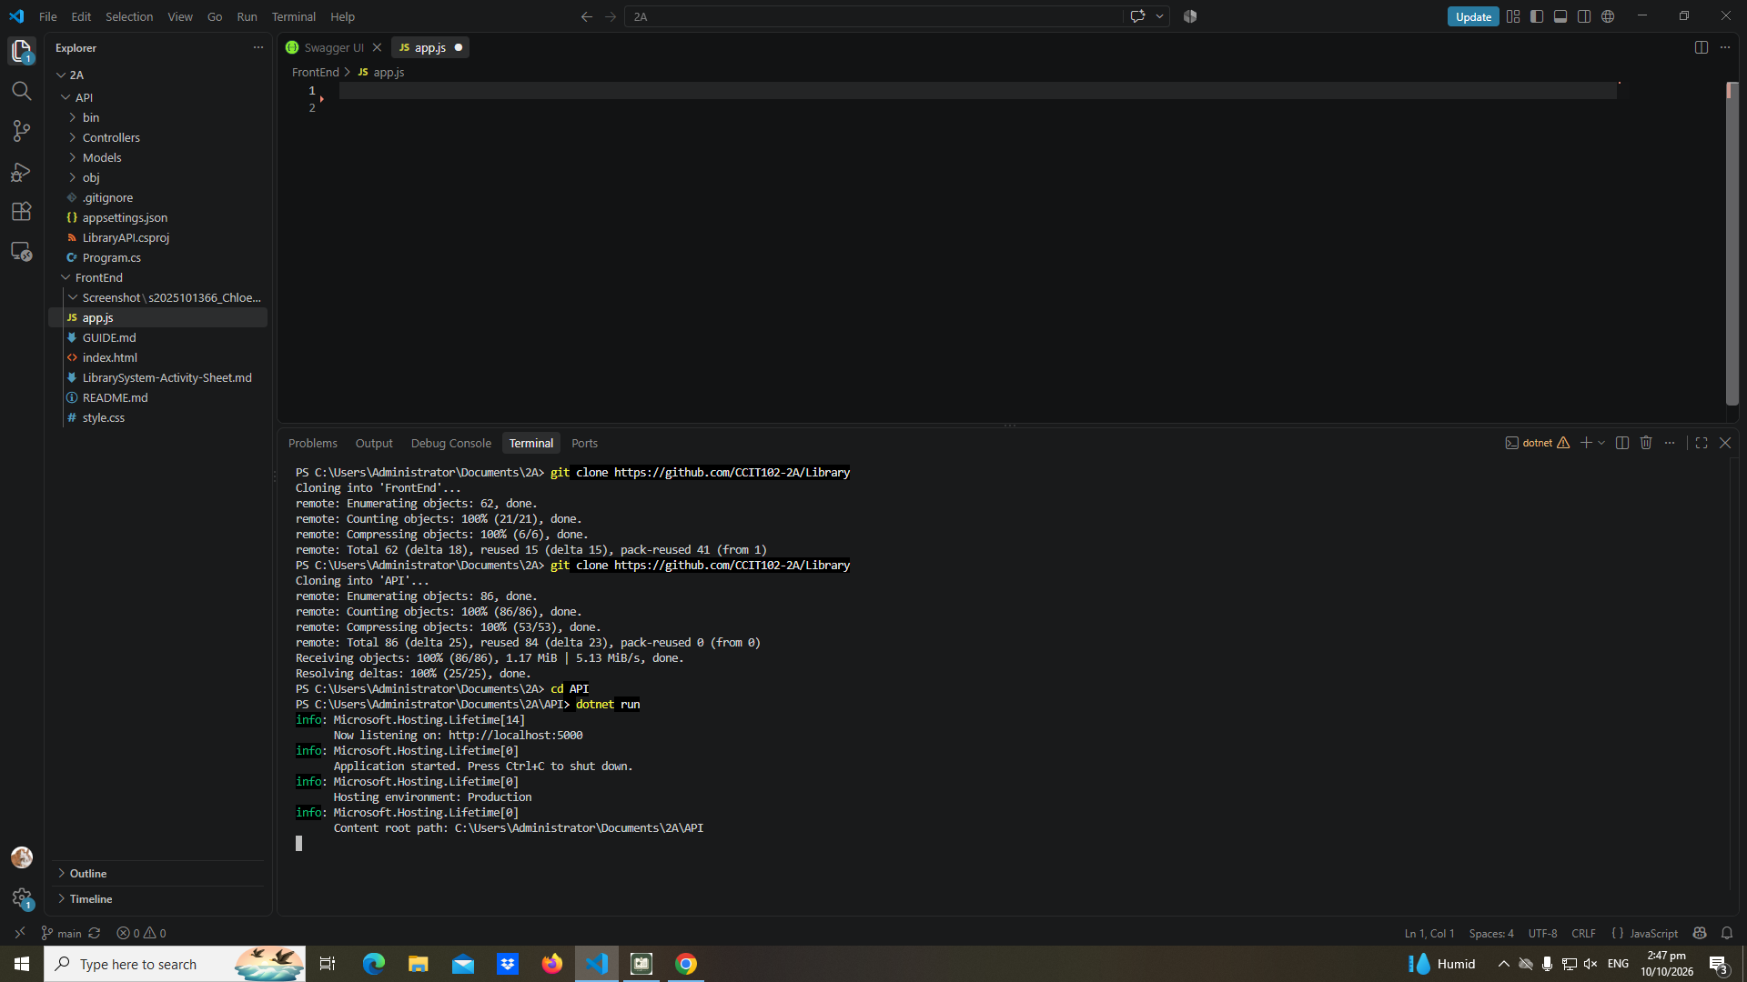

setup-02-api-books-json
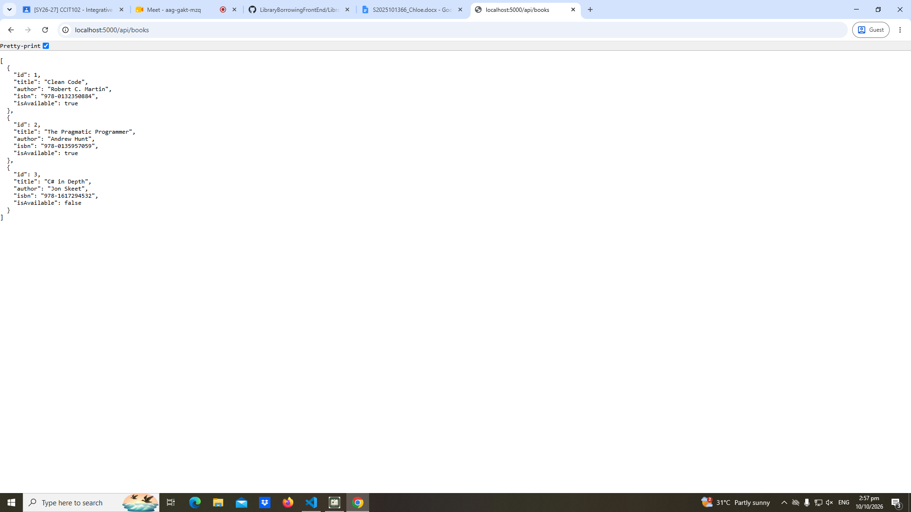

Part-01-settings-apifetch
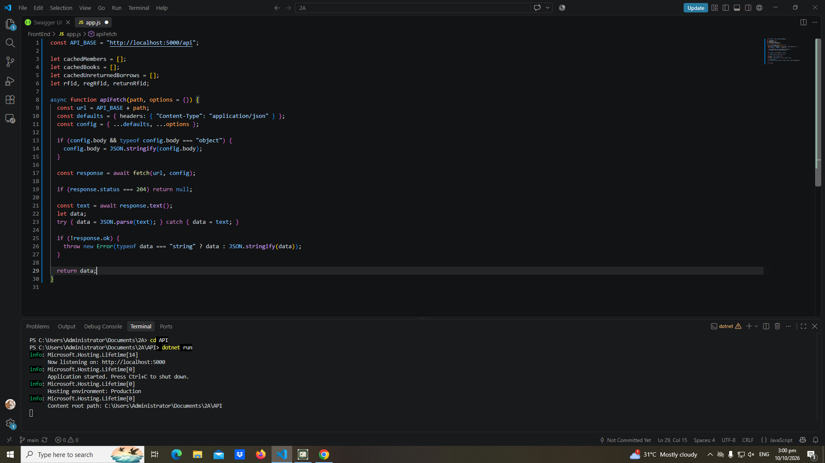

Part-02-showtoast
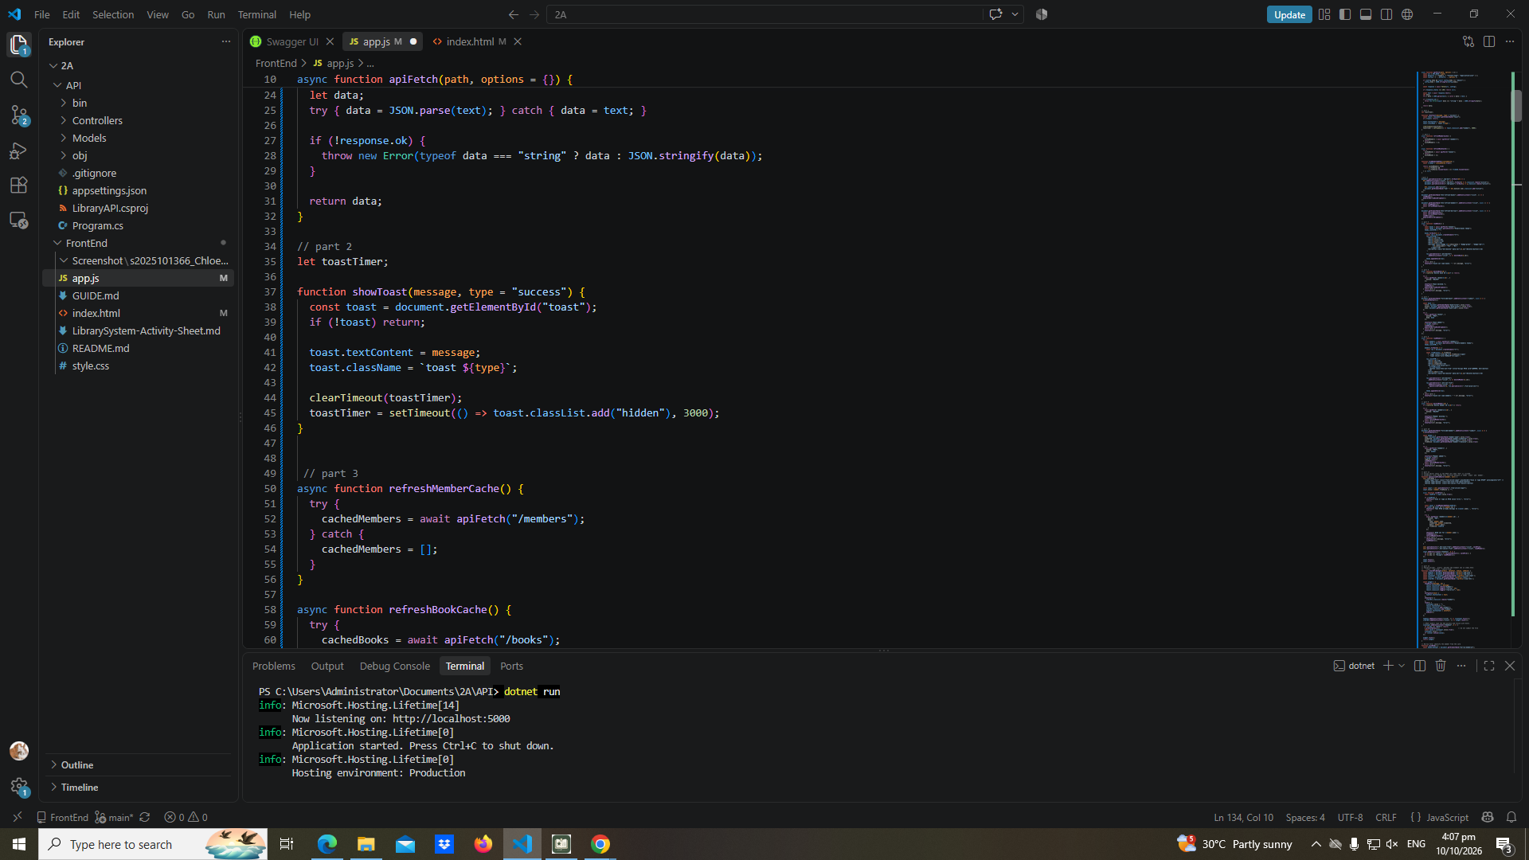

Early-01-toast
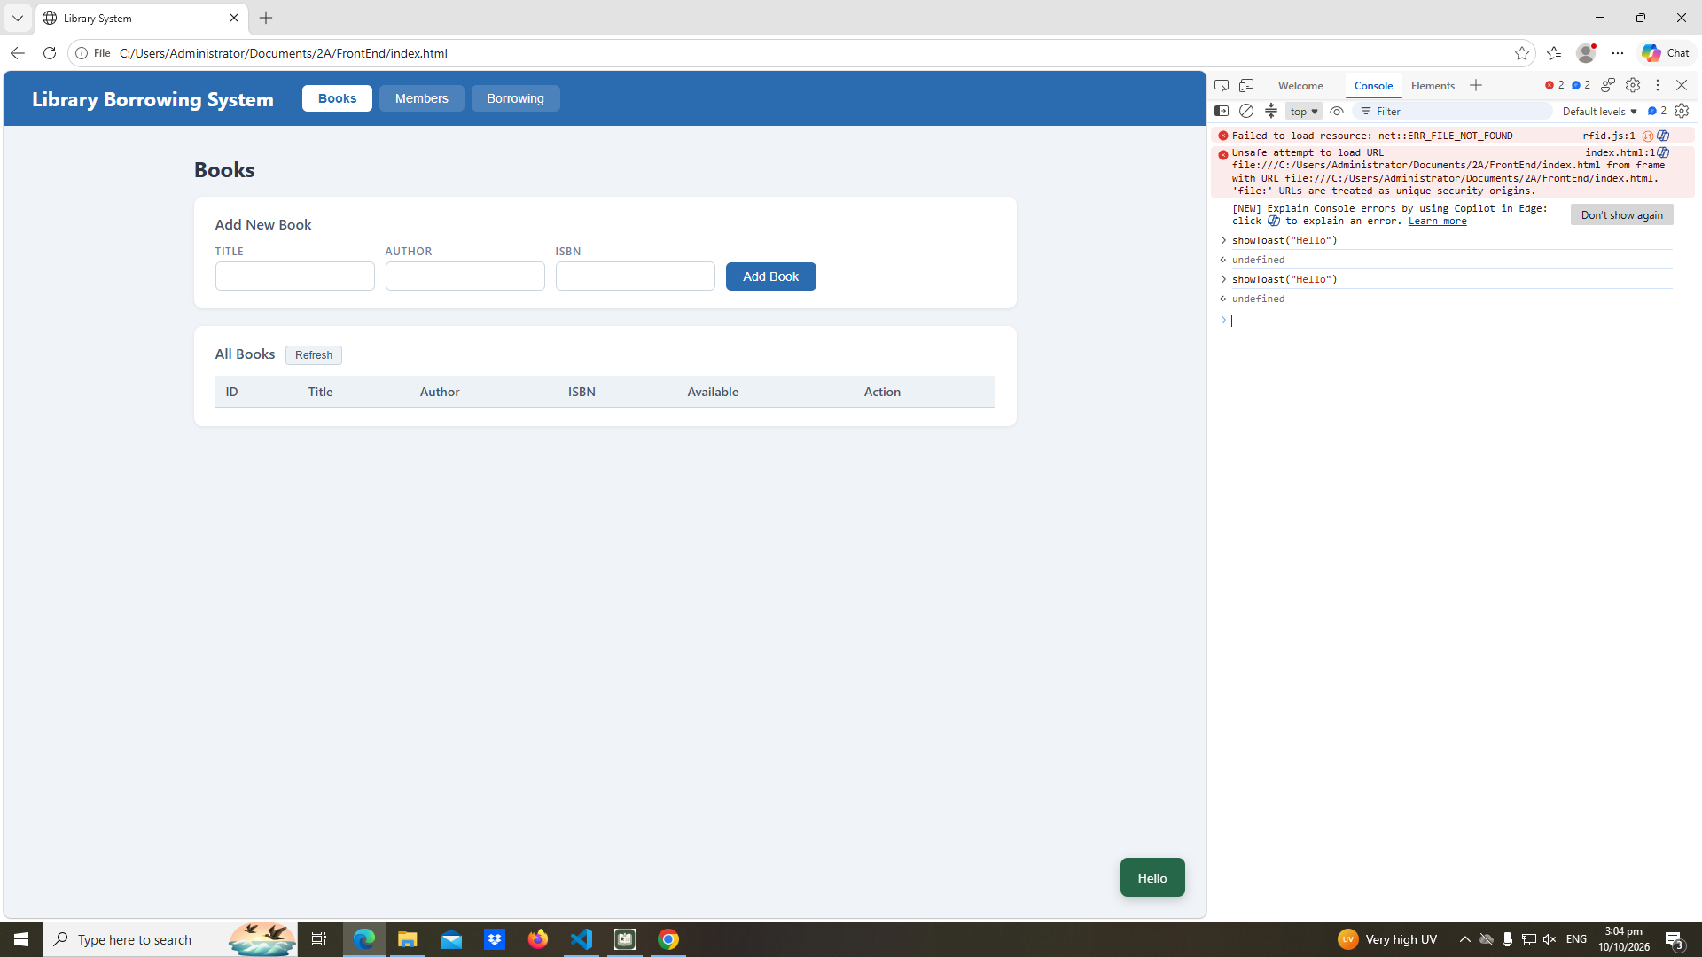

Part-03-caches
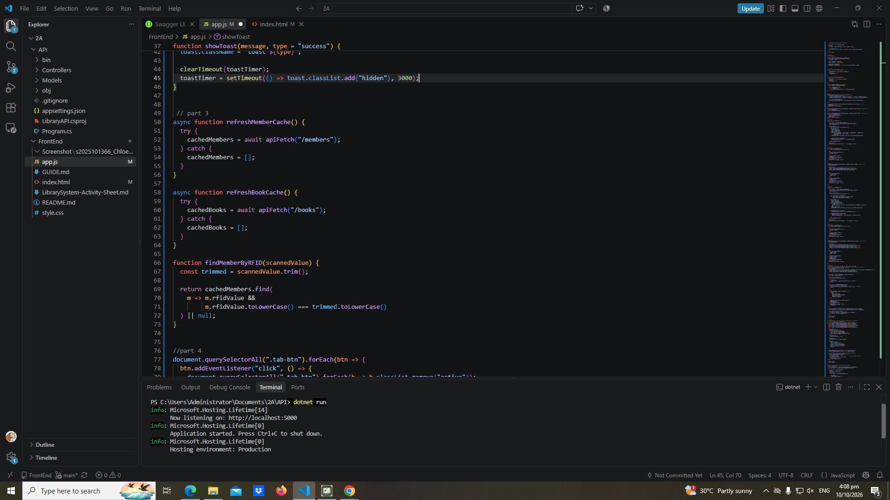

Early-02-cache-console
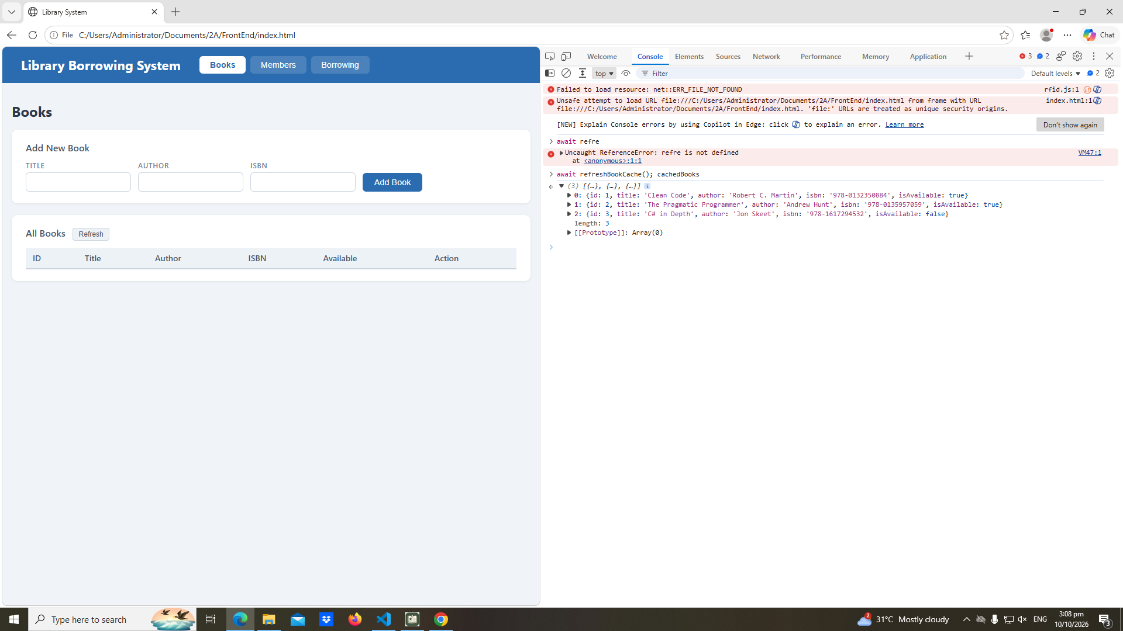

Part-04-tabs-refresh
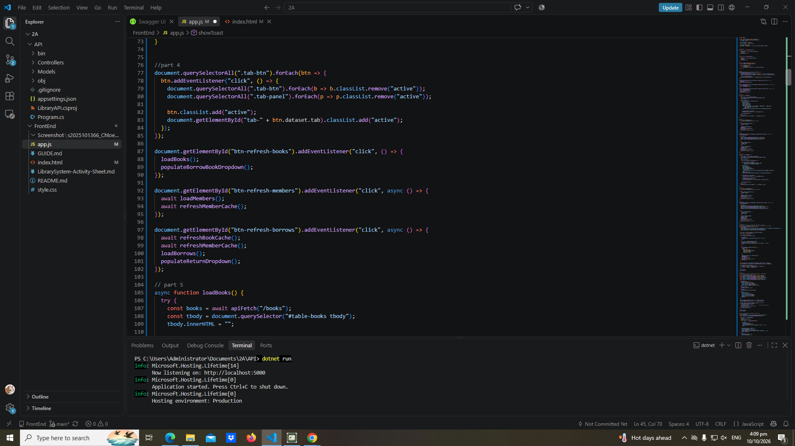

Early-03-tabs
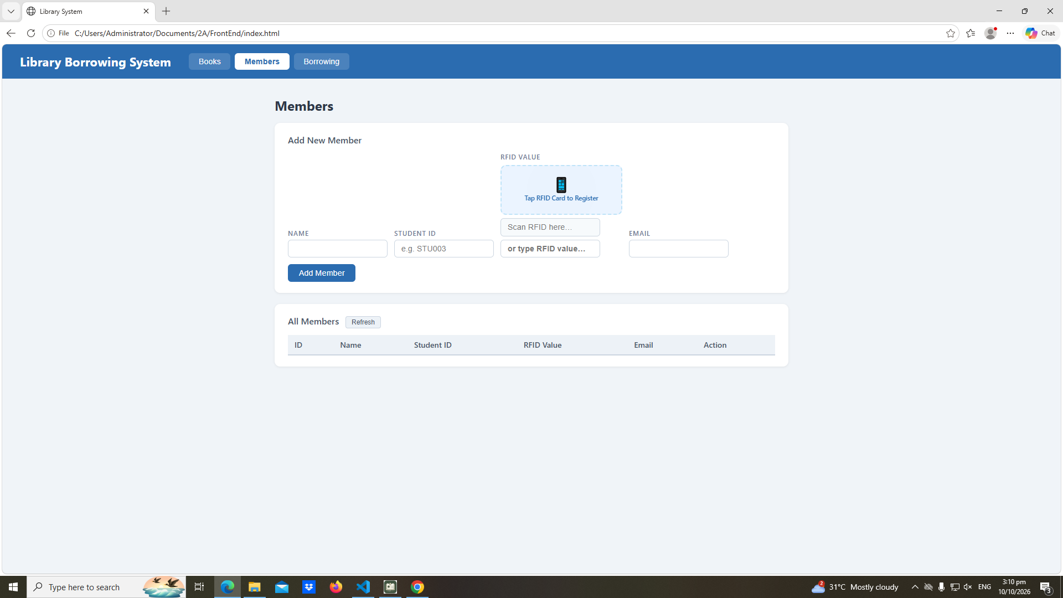

Part-05-loadbooks
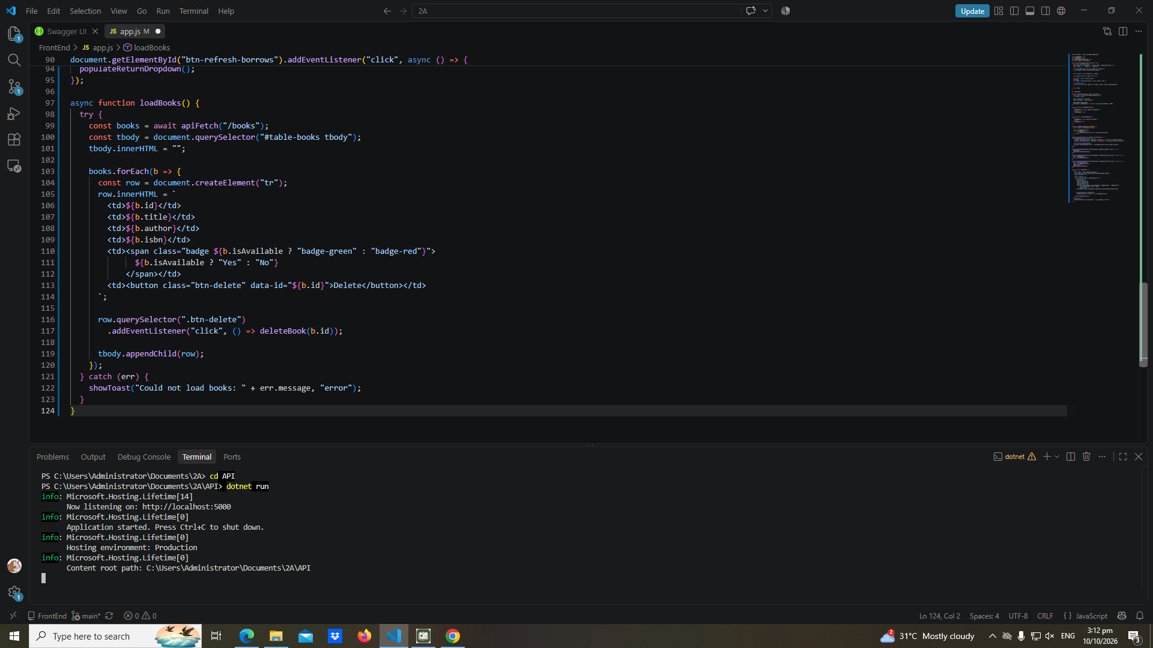

Part-06-deletebook
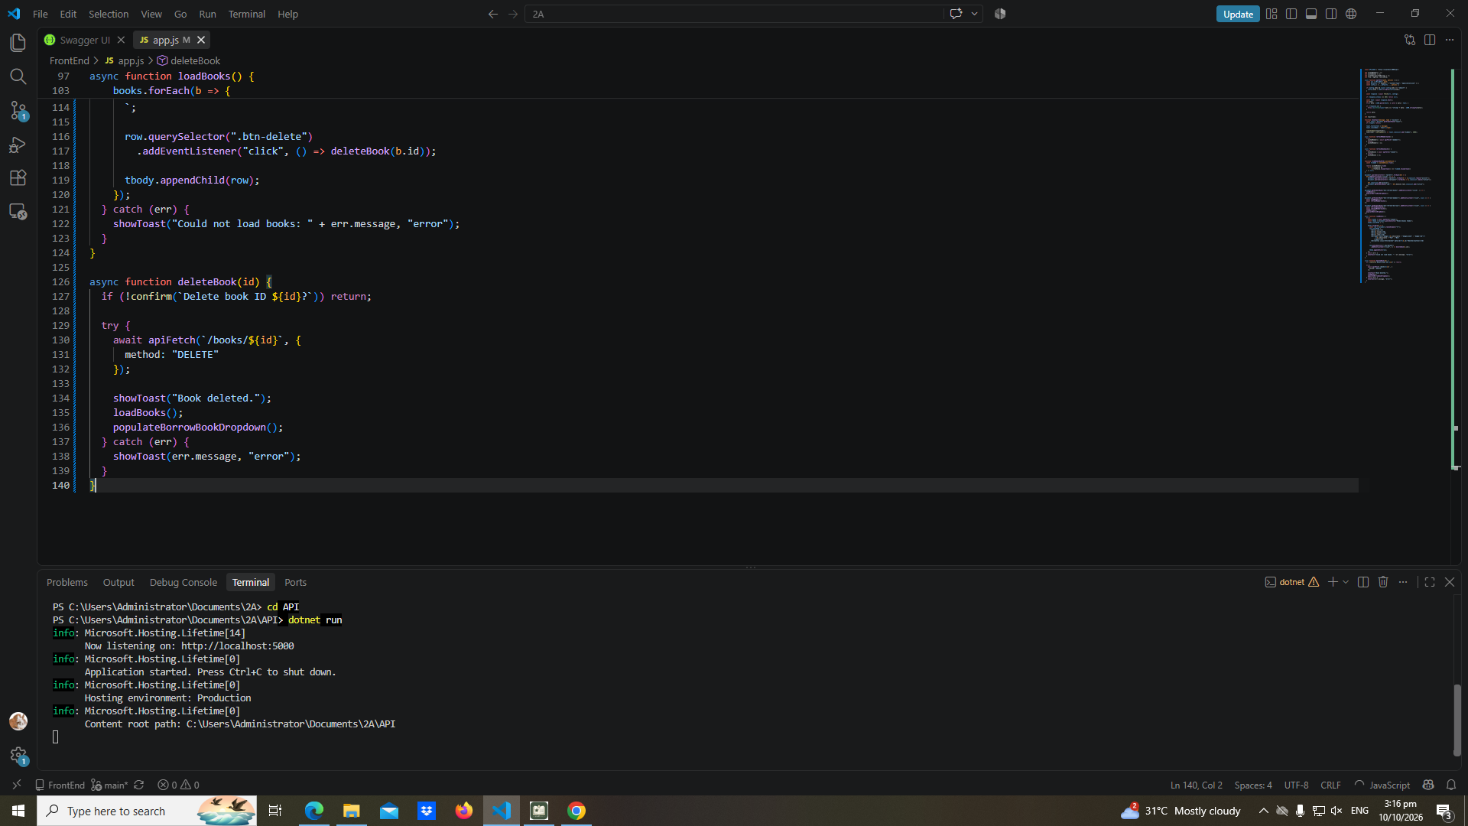

Part-07-addbook
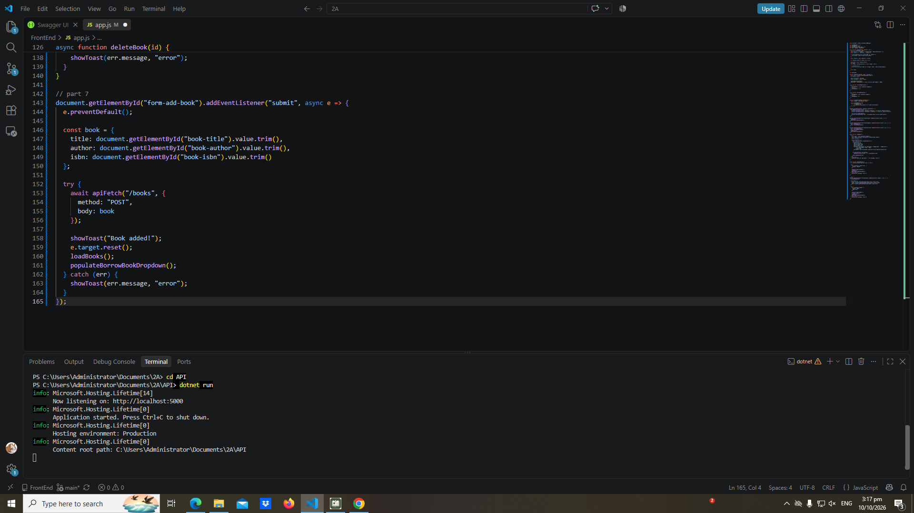

Part-08-loadmembers
Part-08a
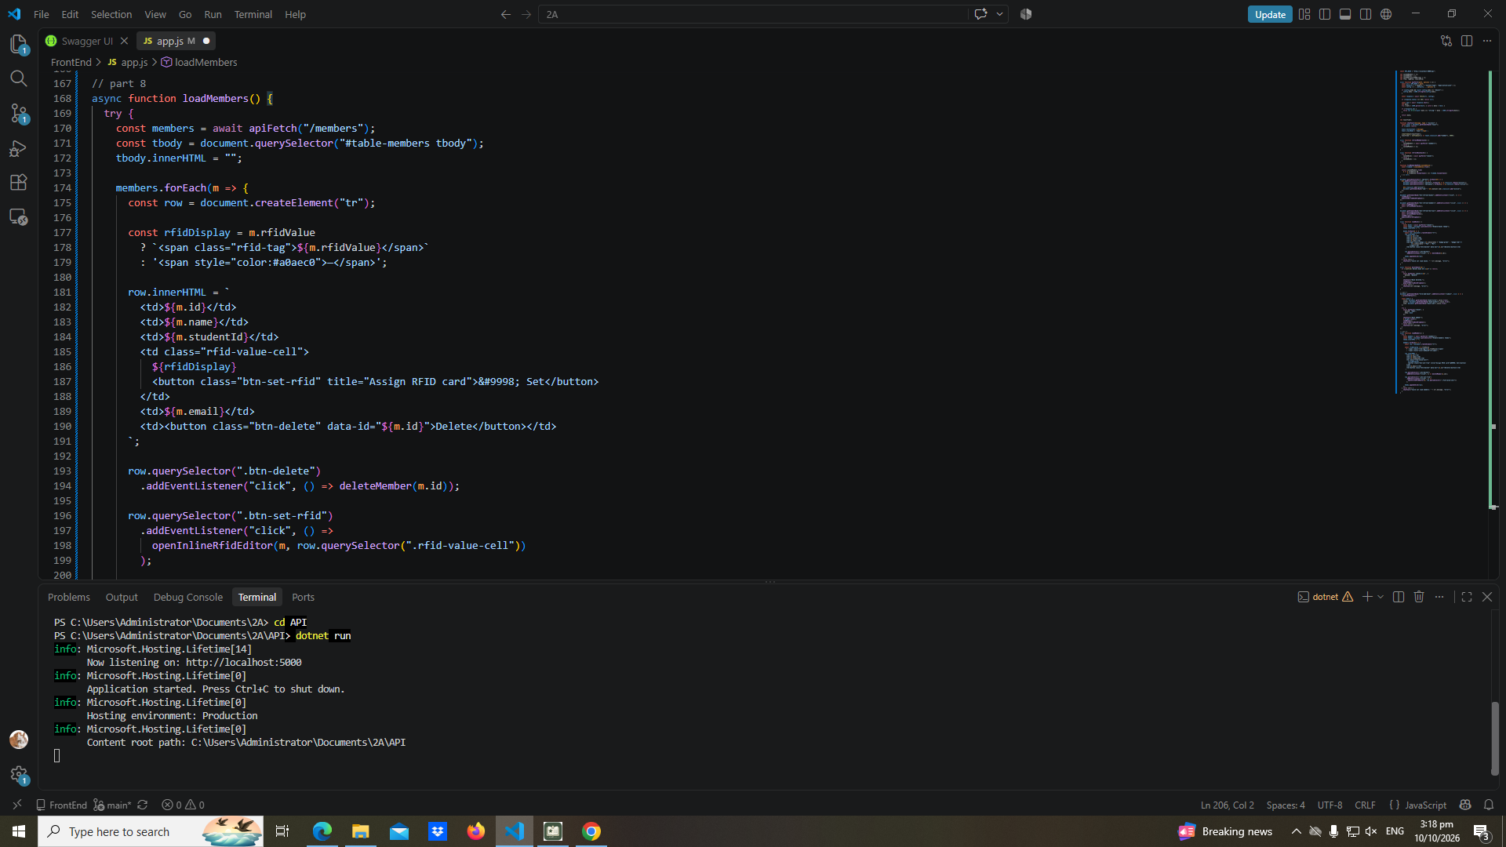

Part-08b
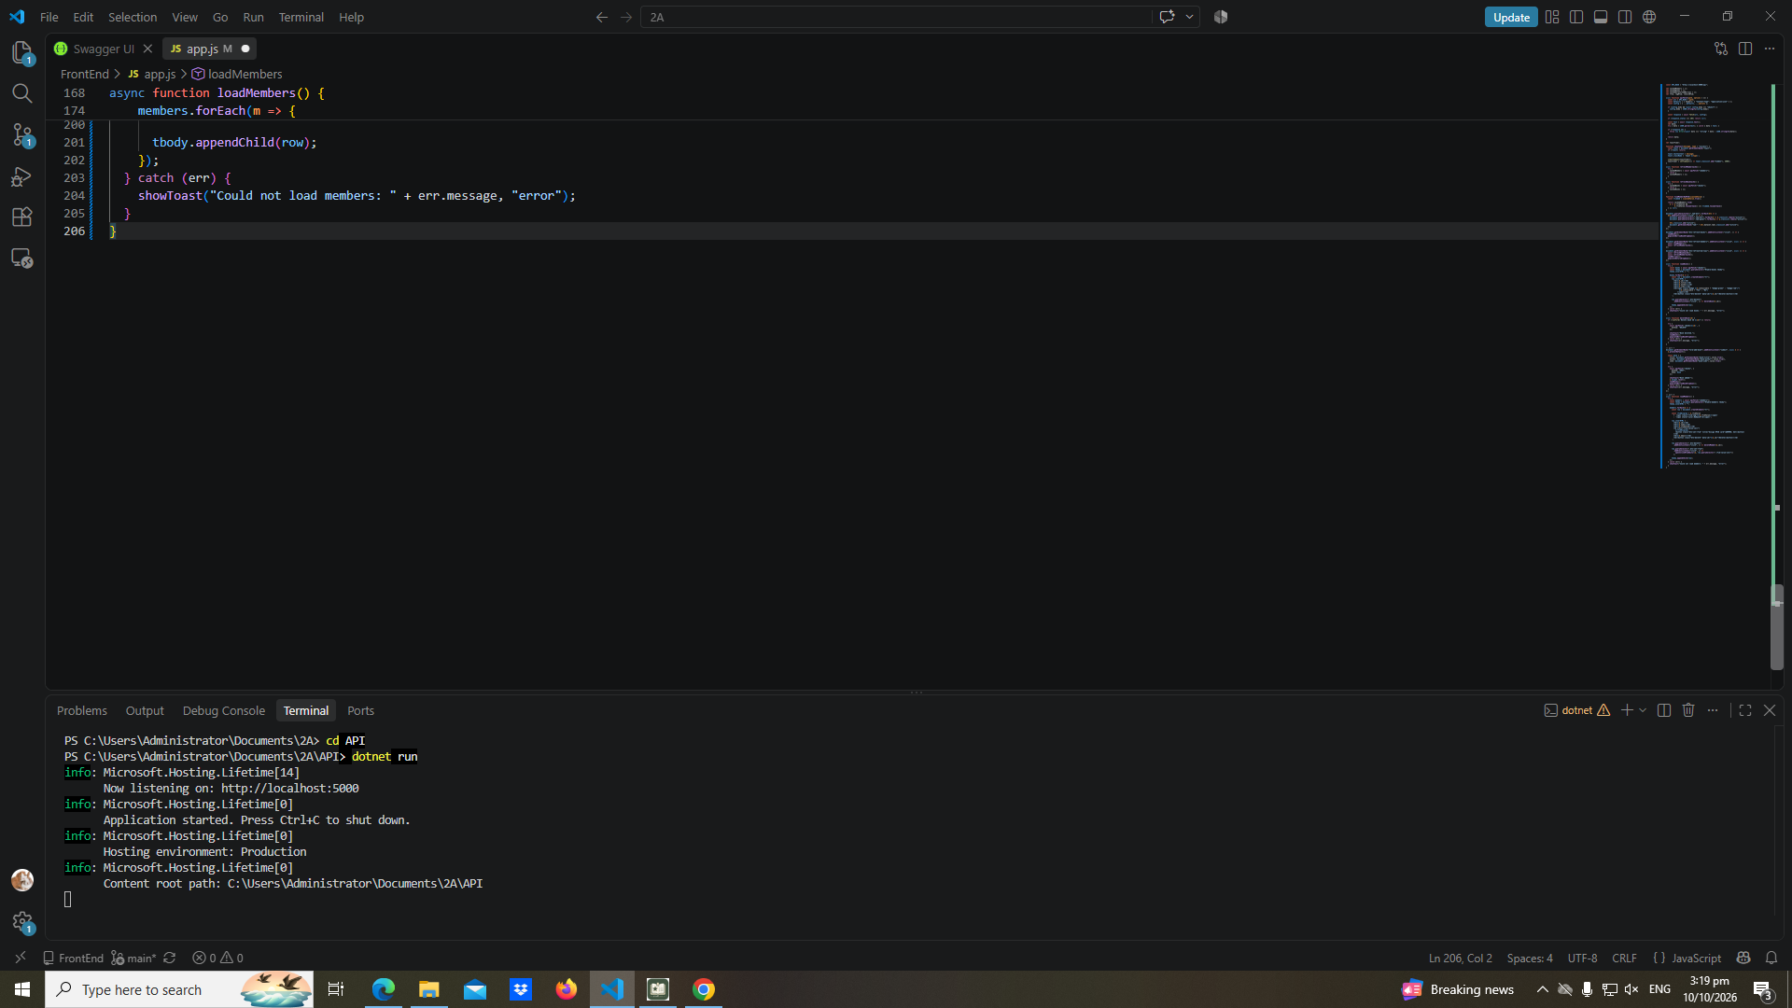

Part-09-deletemember
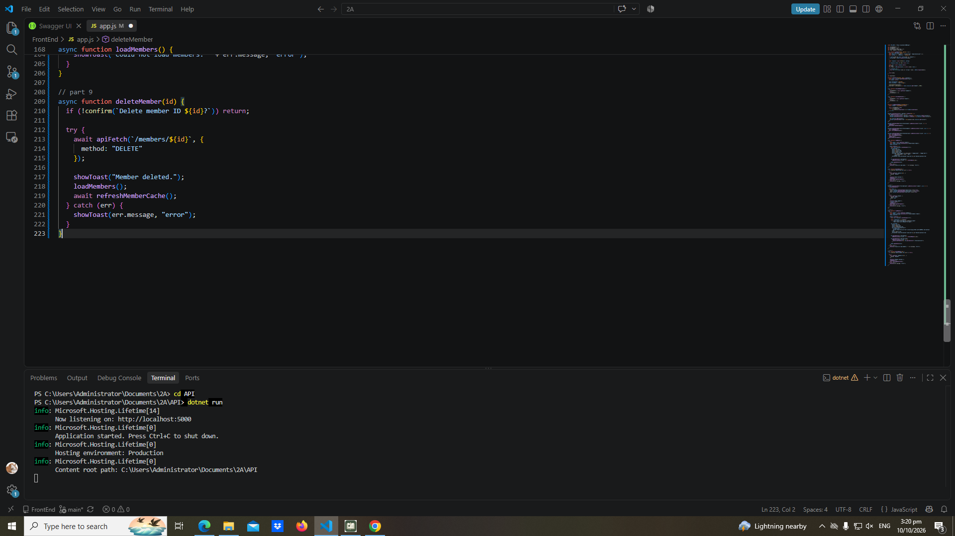

Part-10-addmember
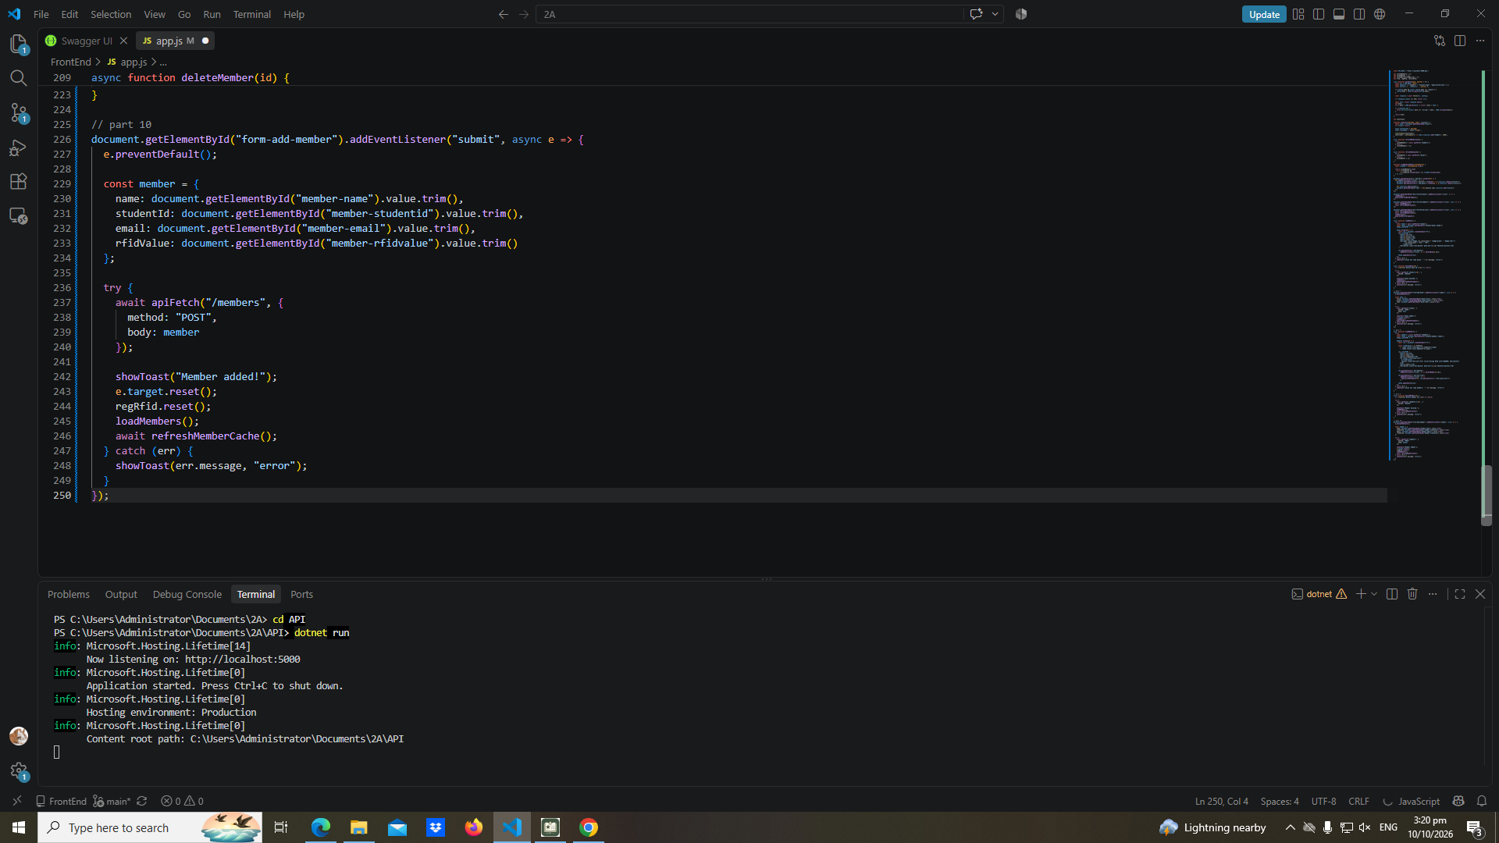

Part-11-inline-rfid-editor
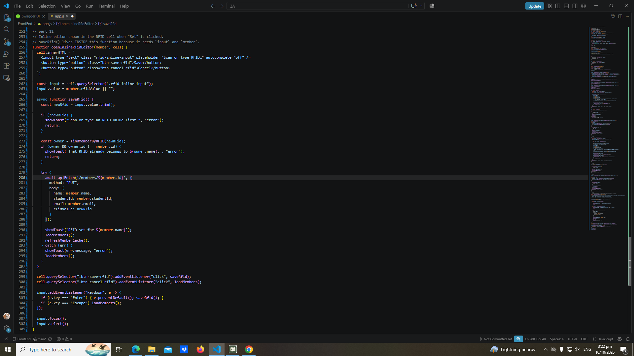

Part-12a-rfid-widget-builder
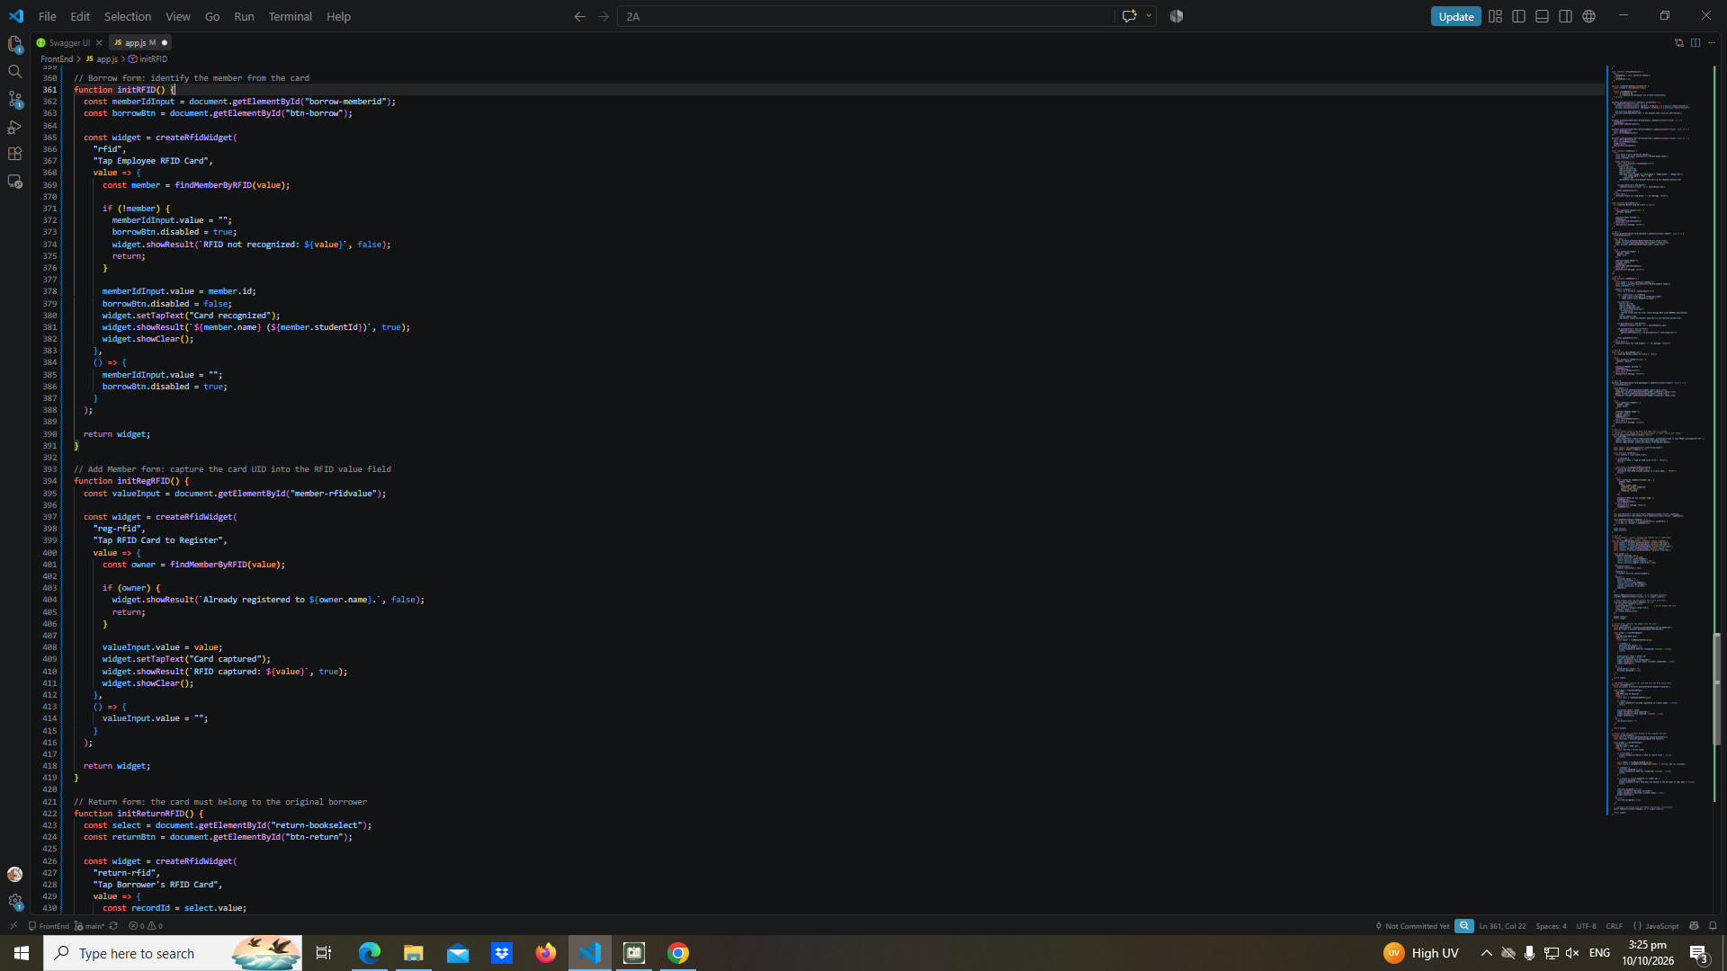
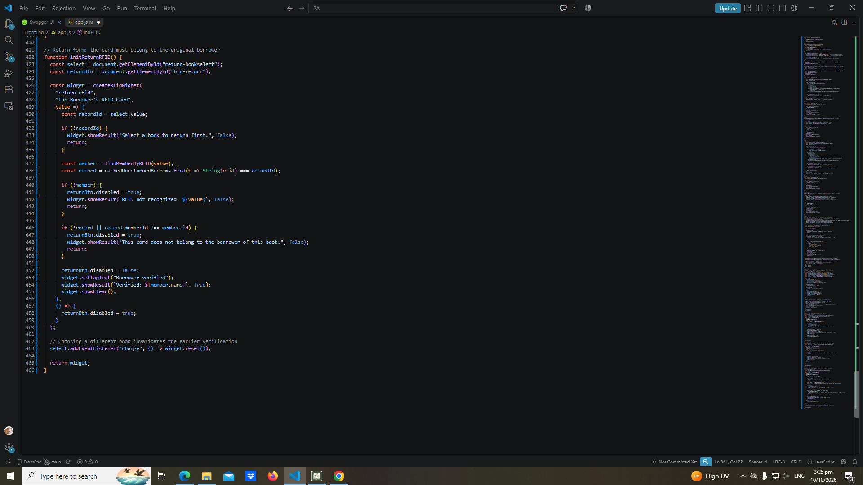

Part-13-borrow-dropdown
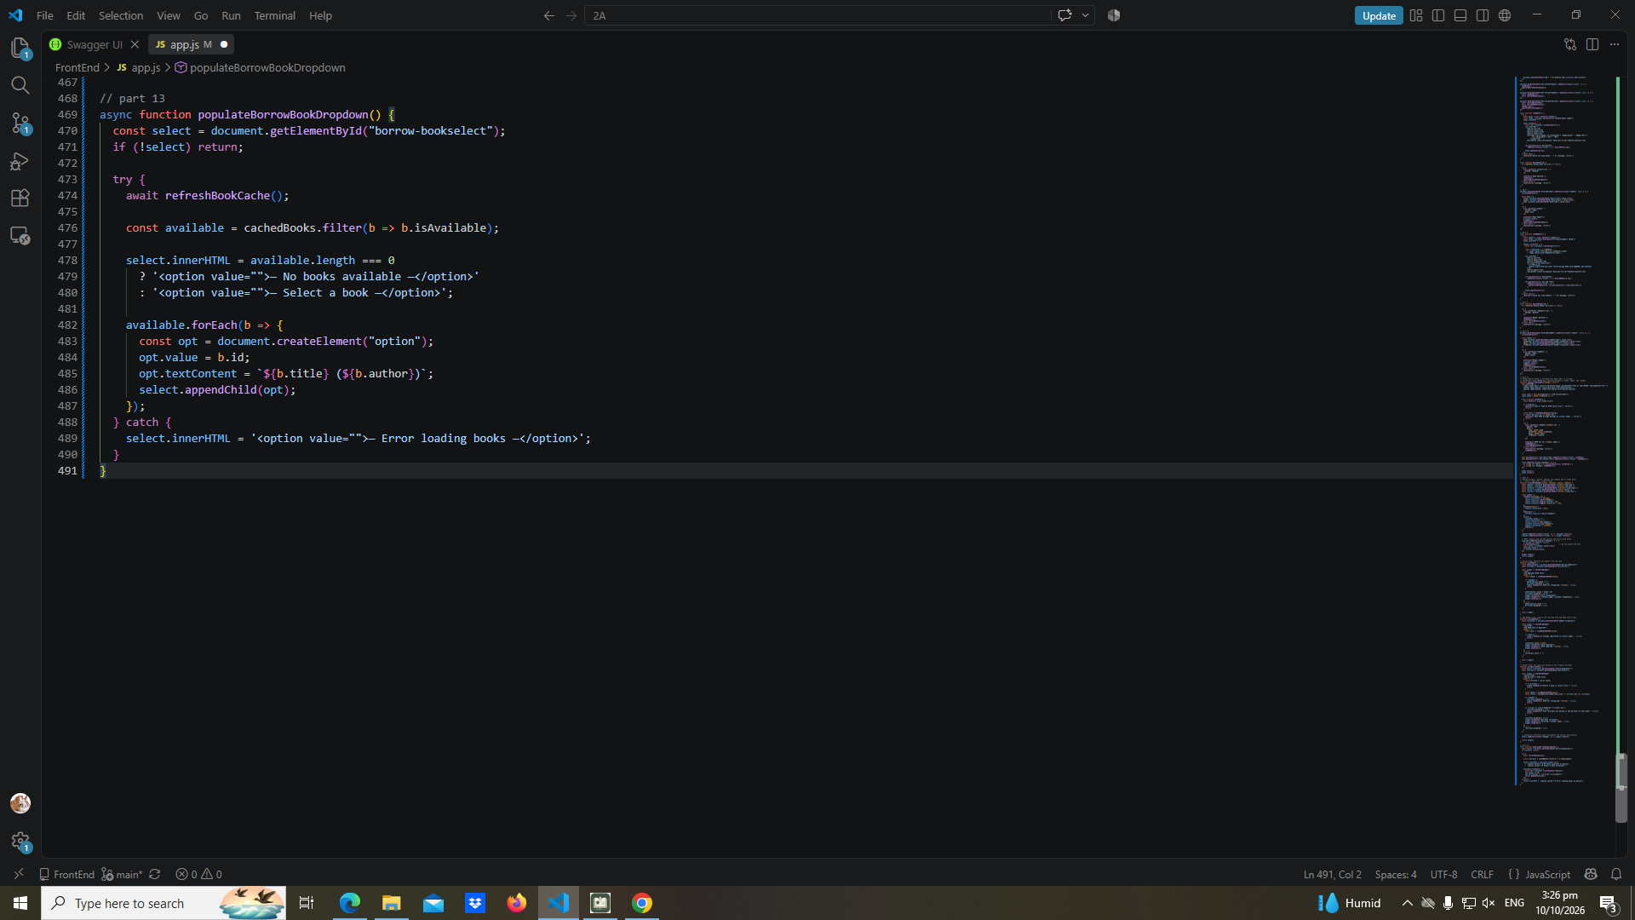

Part-14-return-dropdown
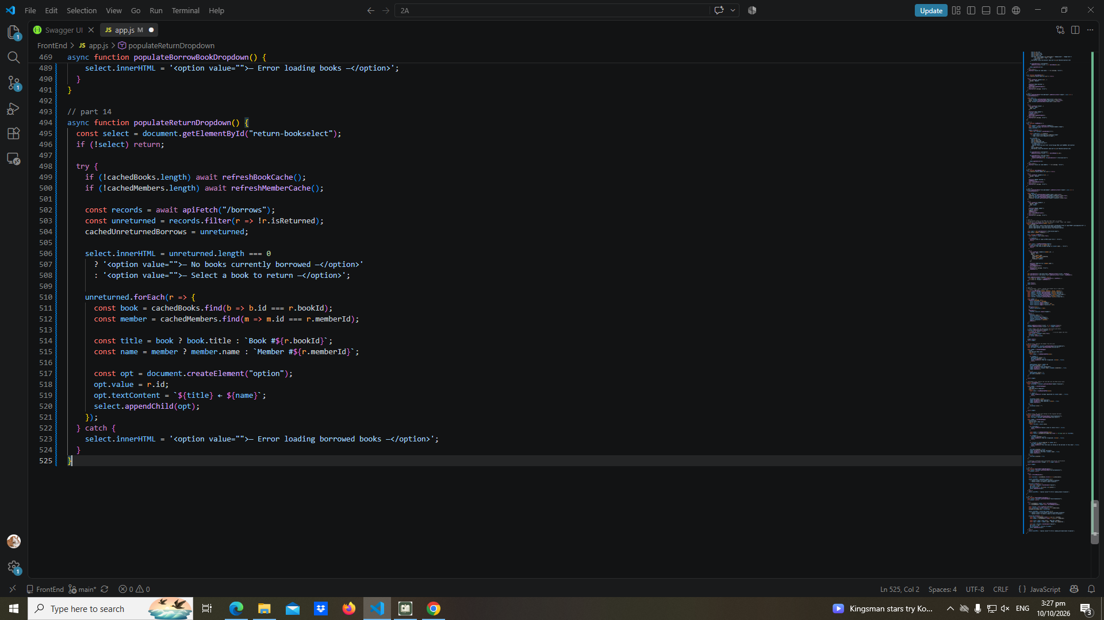

Part-15-borrow
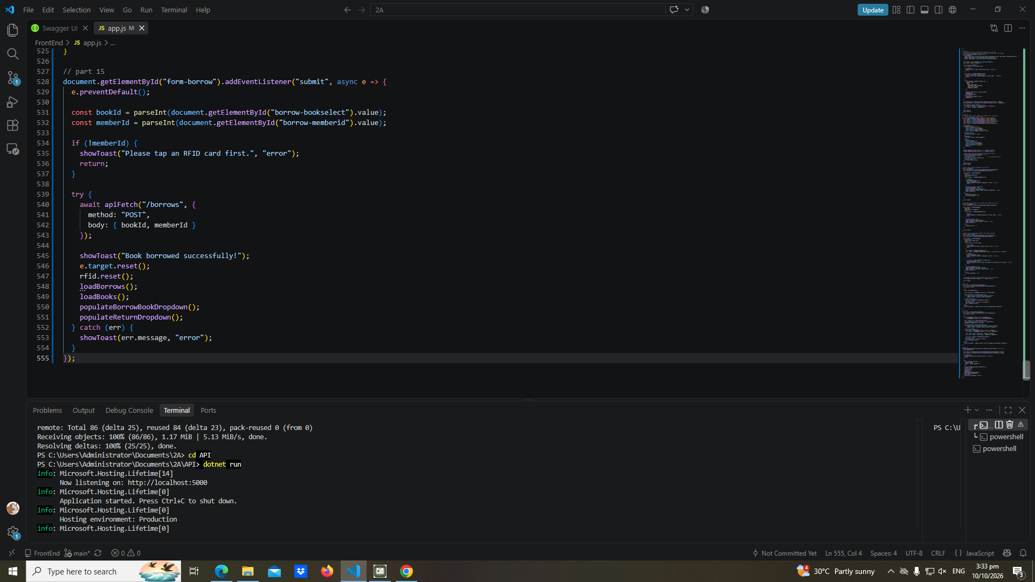

Part-16-return
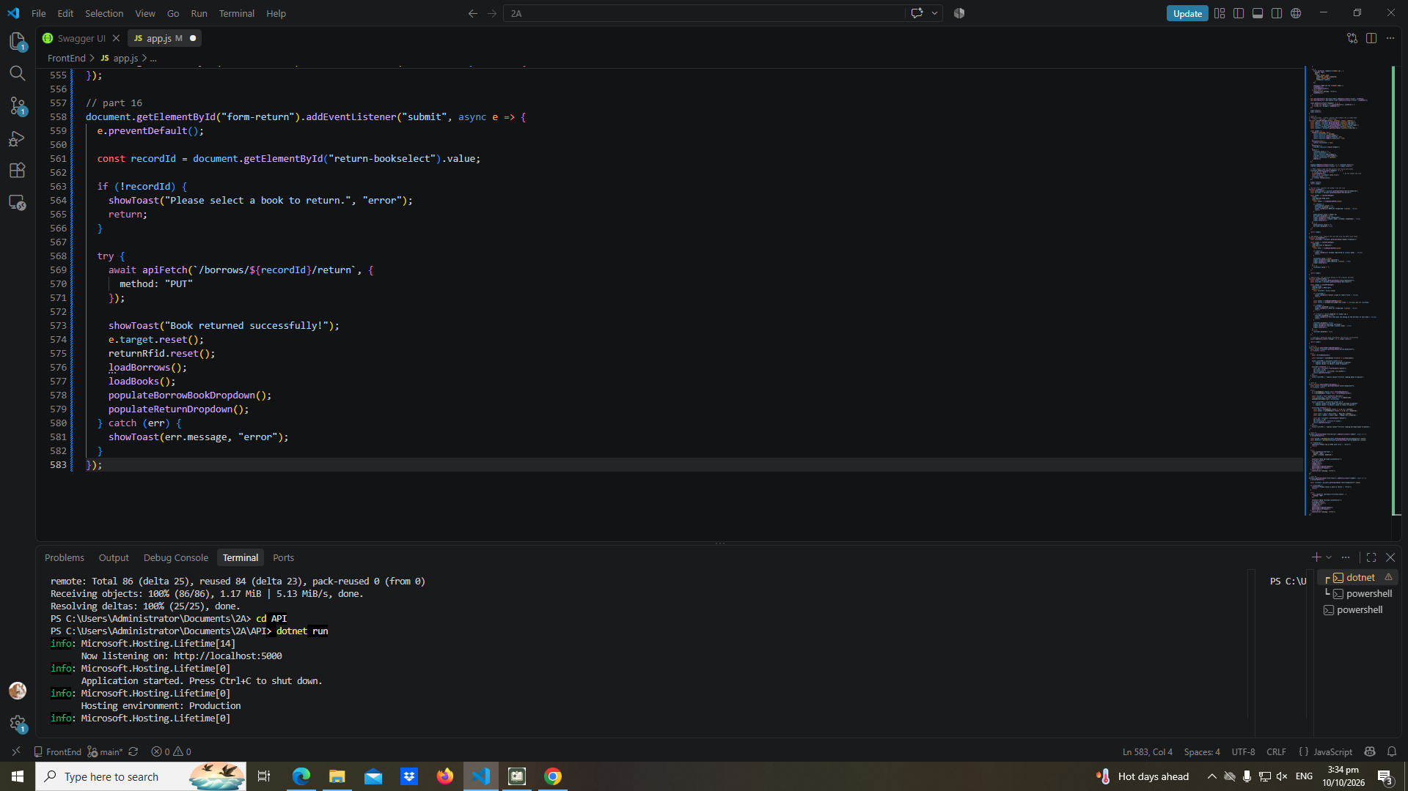

Part-17-loadborrows
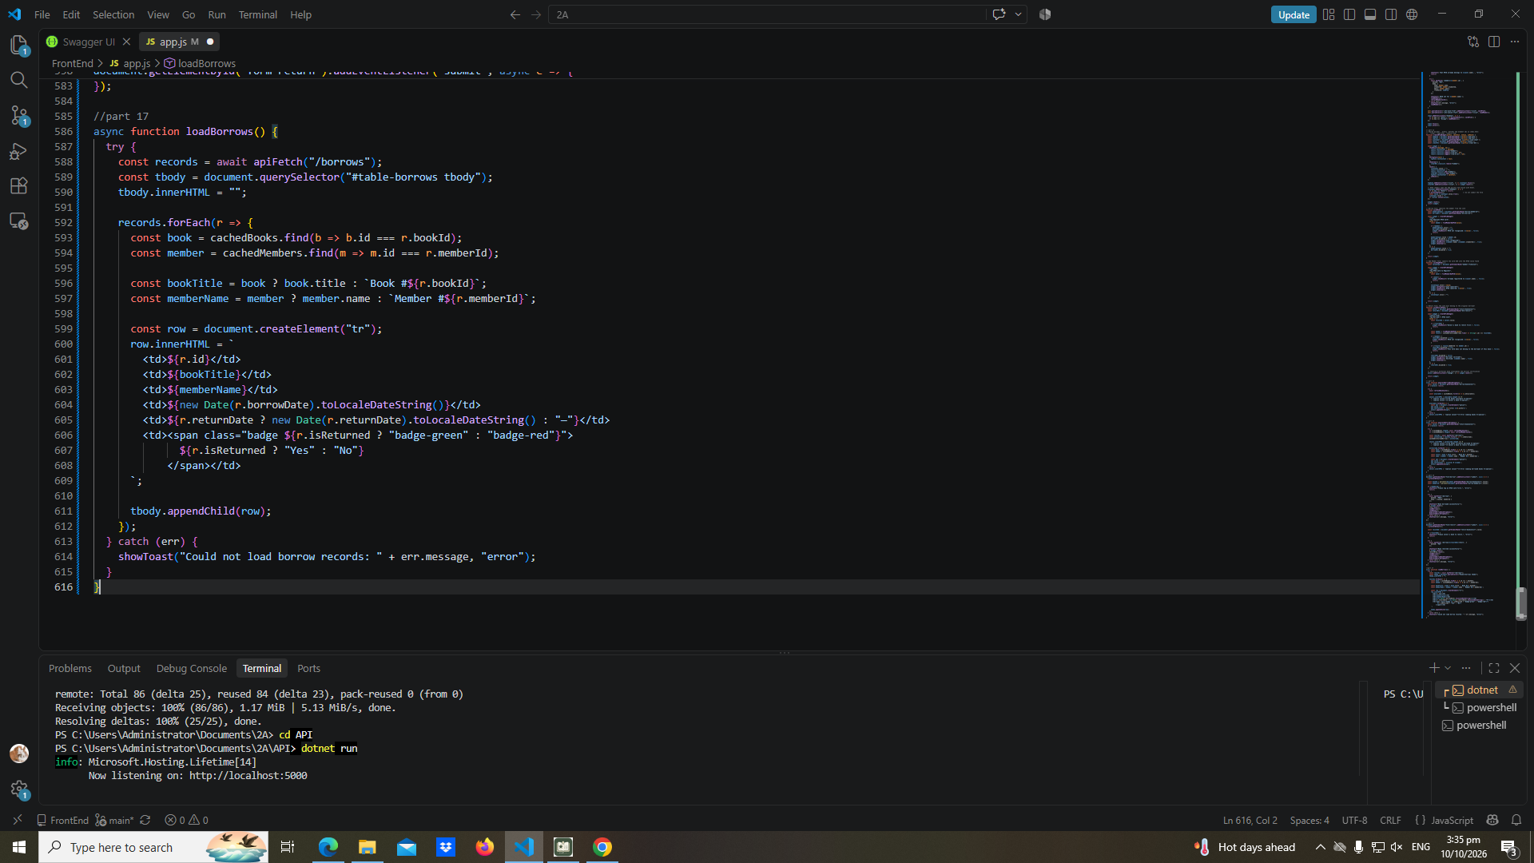

Part-18-page-load
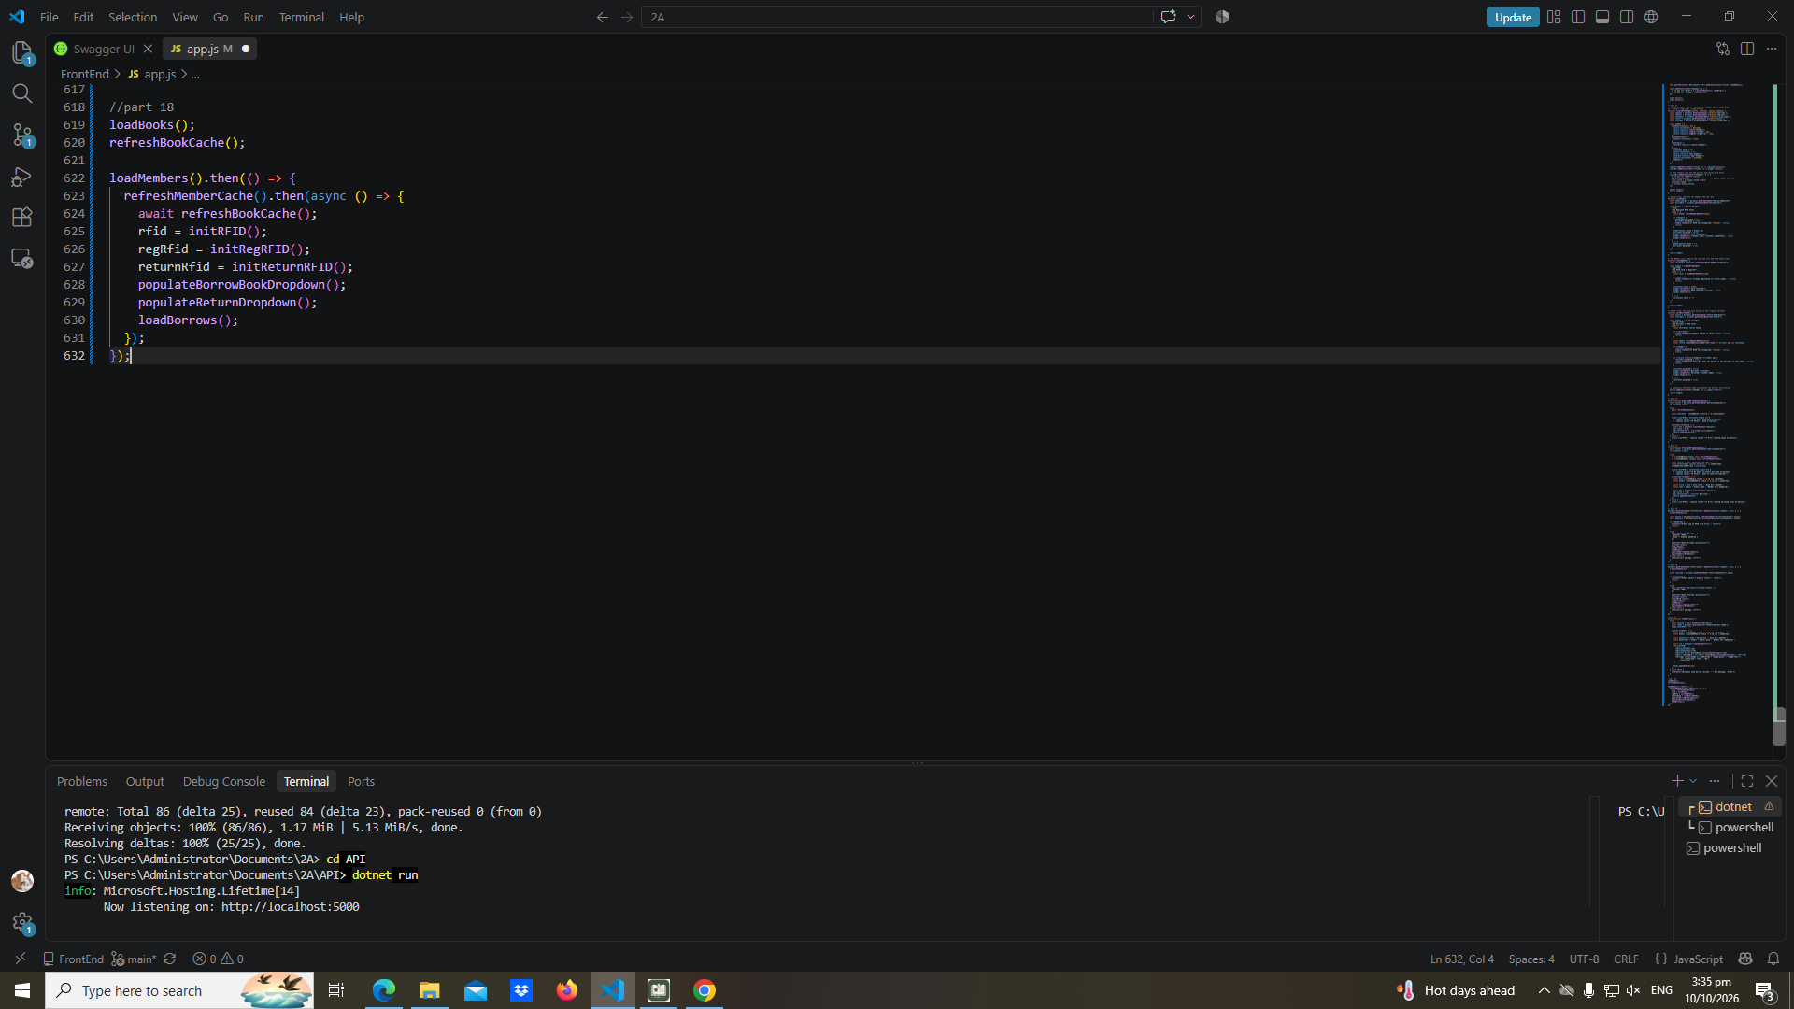

Test-01-page-loaded
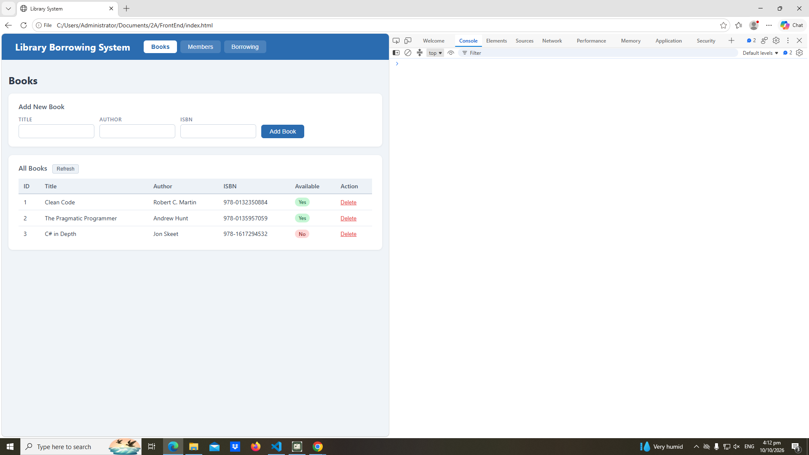

test-02-add-book

Test-02-add-book
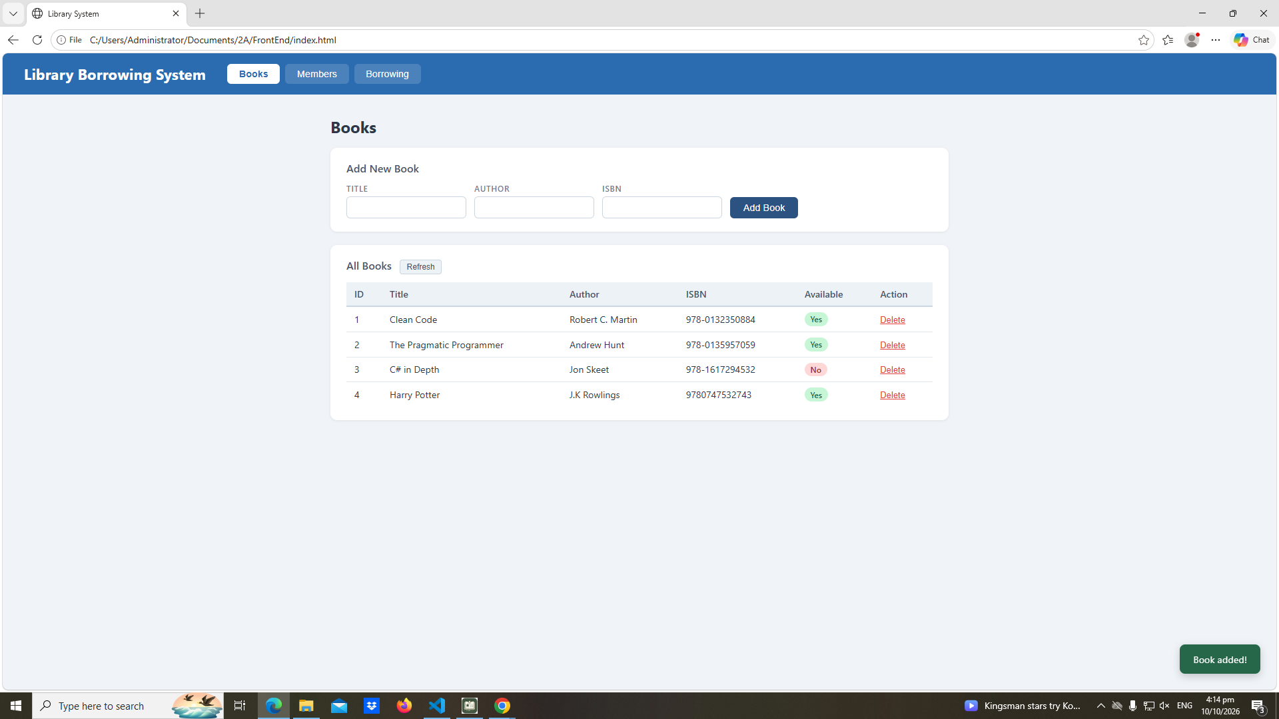

Test-03-delete-book
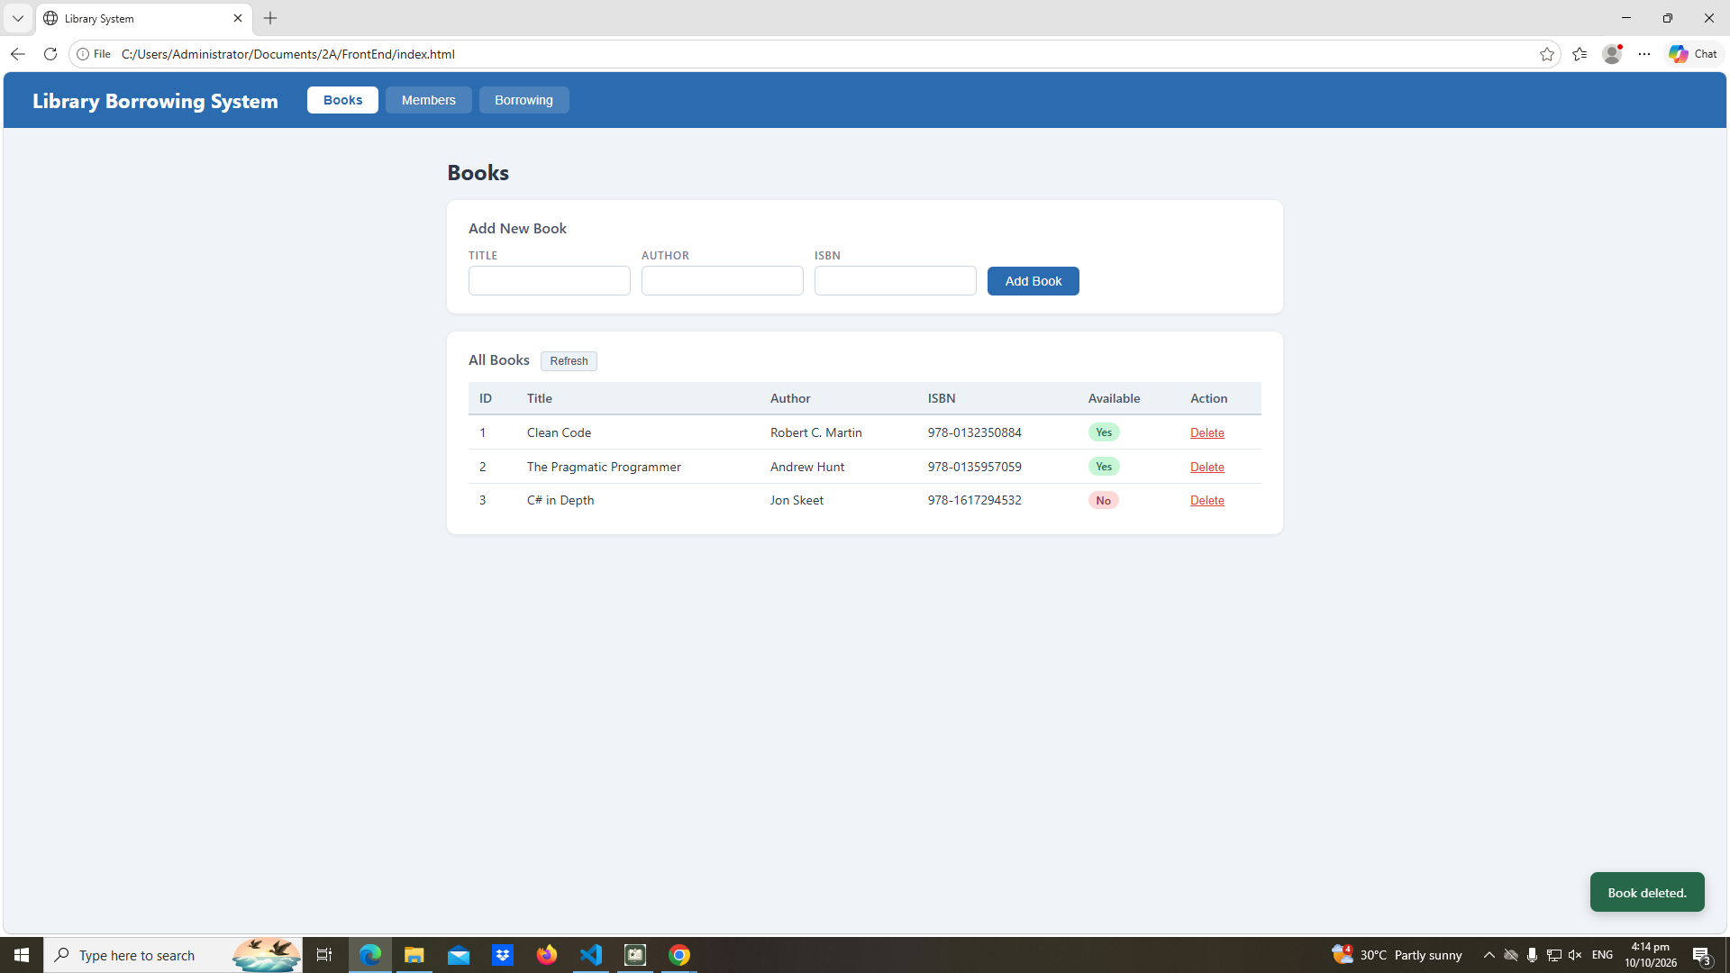

Test-04-members-loaded
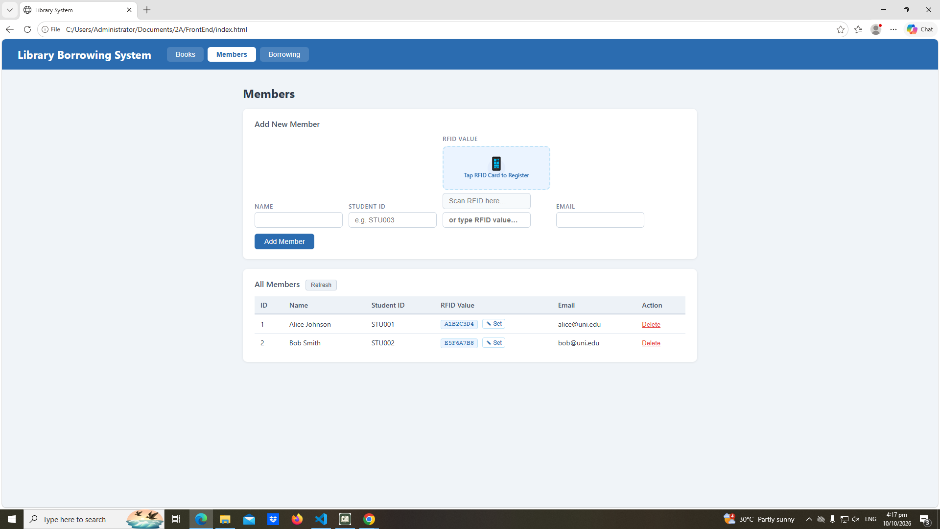

Test-05-register-rfid
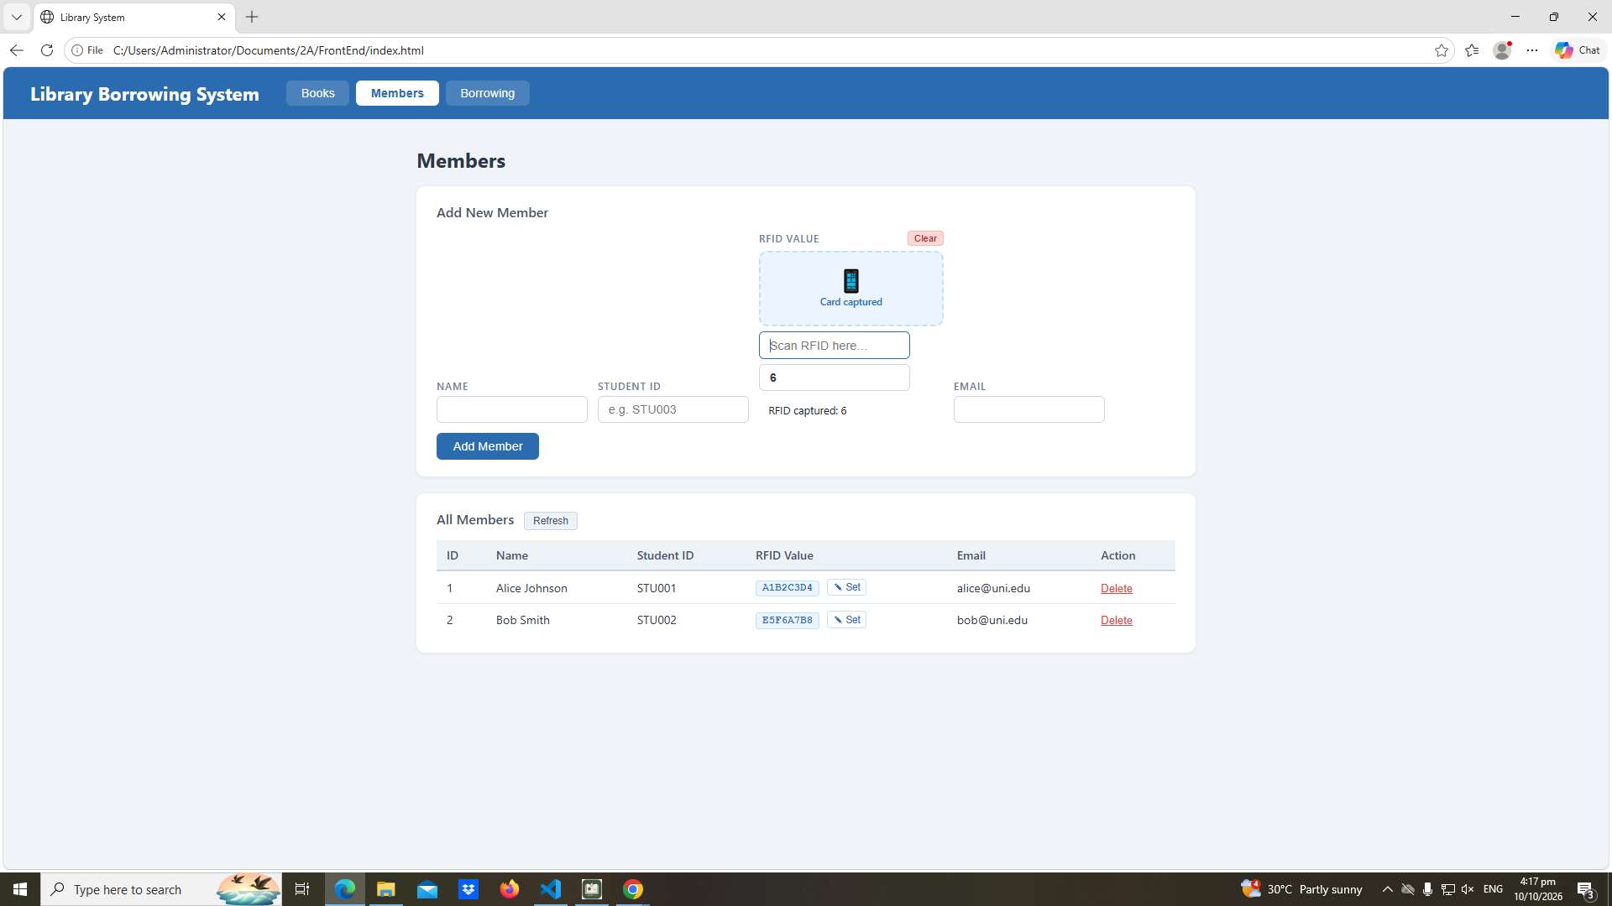

Test-06-add-member
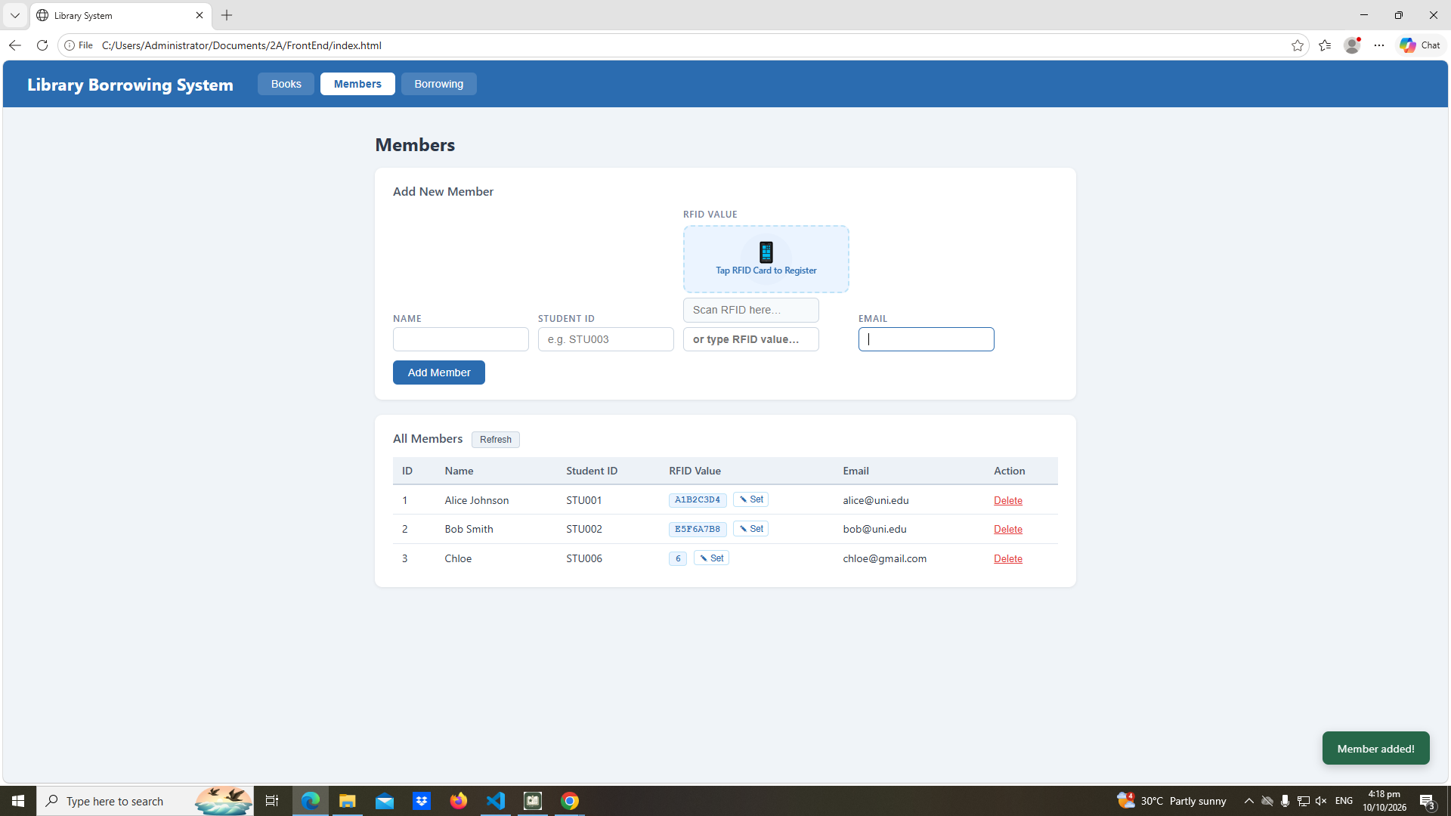

Test-07-set-rfid-saved
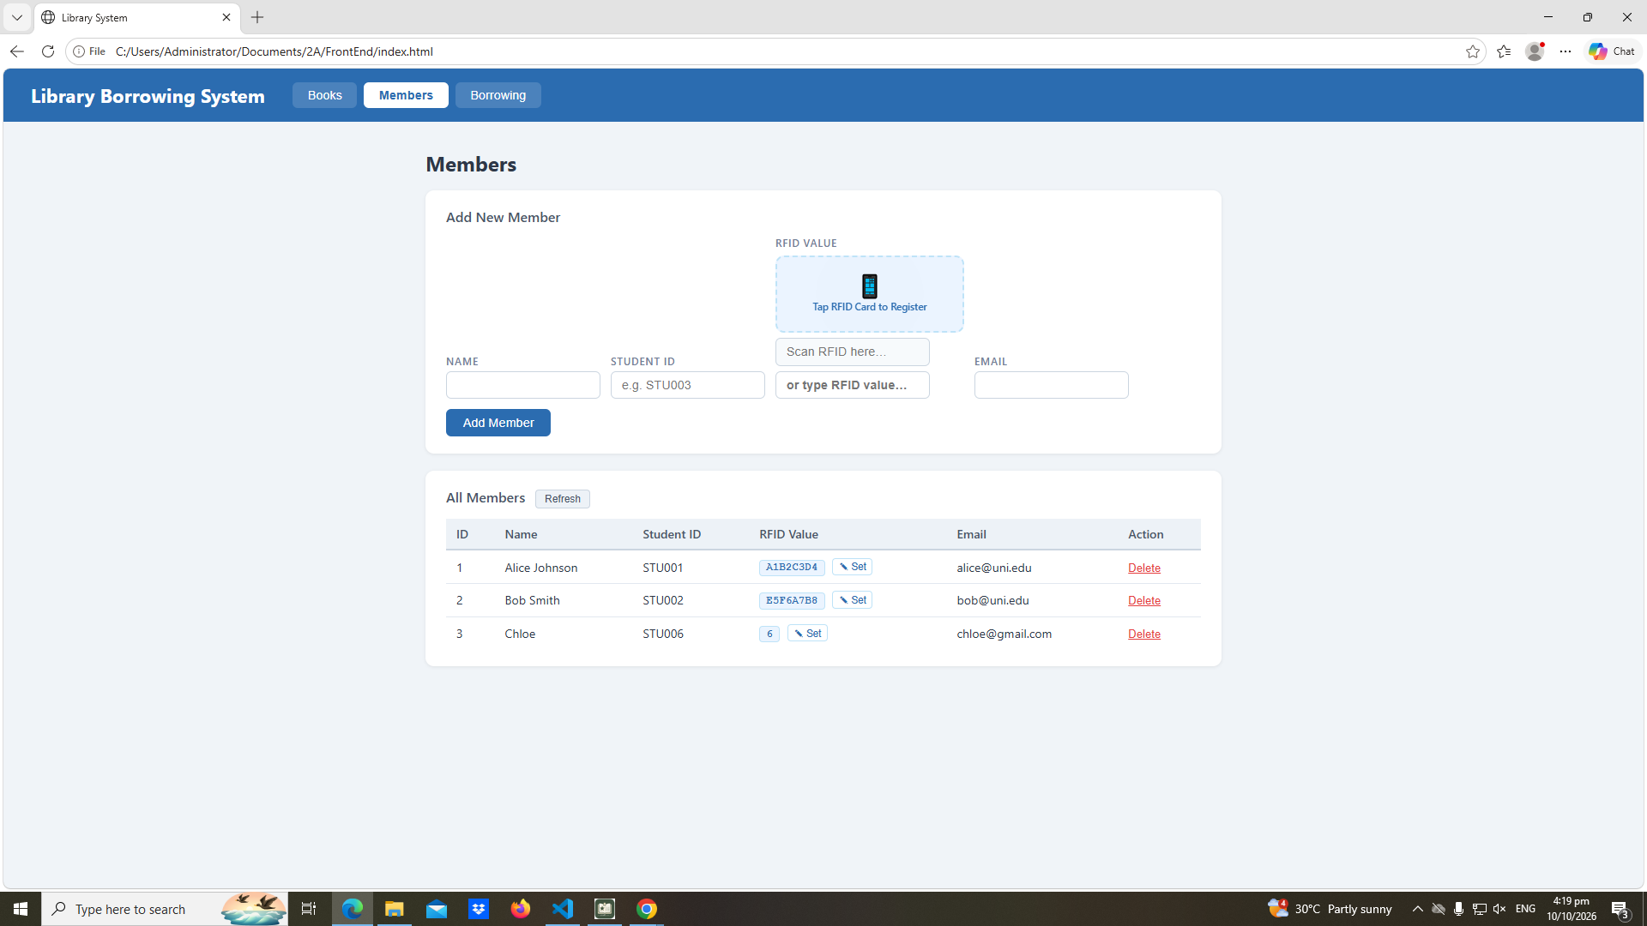

Test-08-delete-member
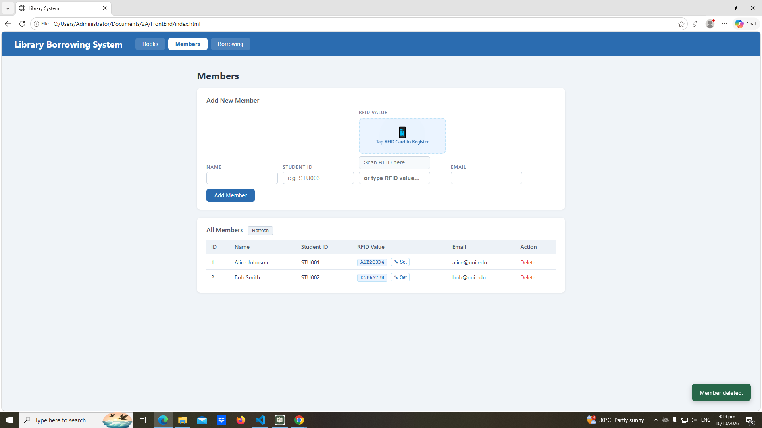

Test-09-borrow-rfid-recognized
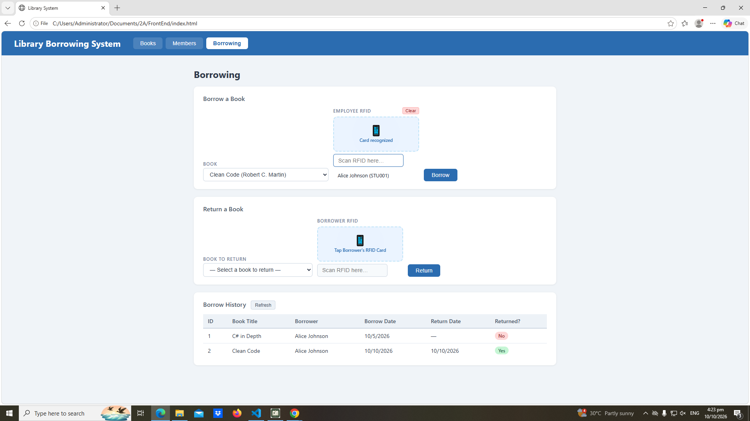

Test-10-borrow-success
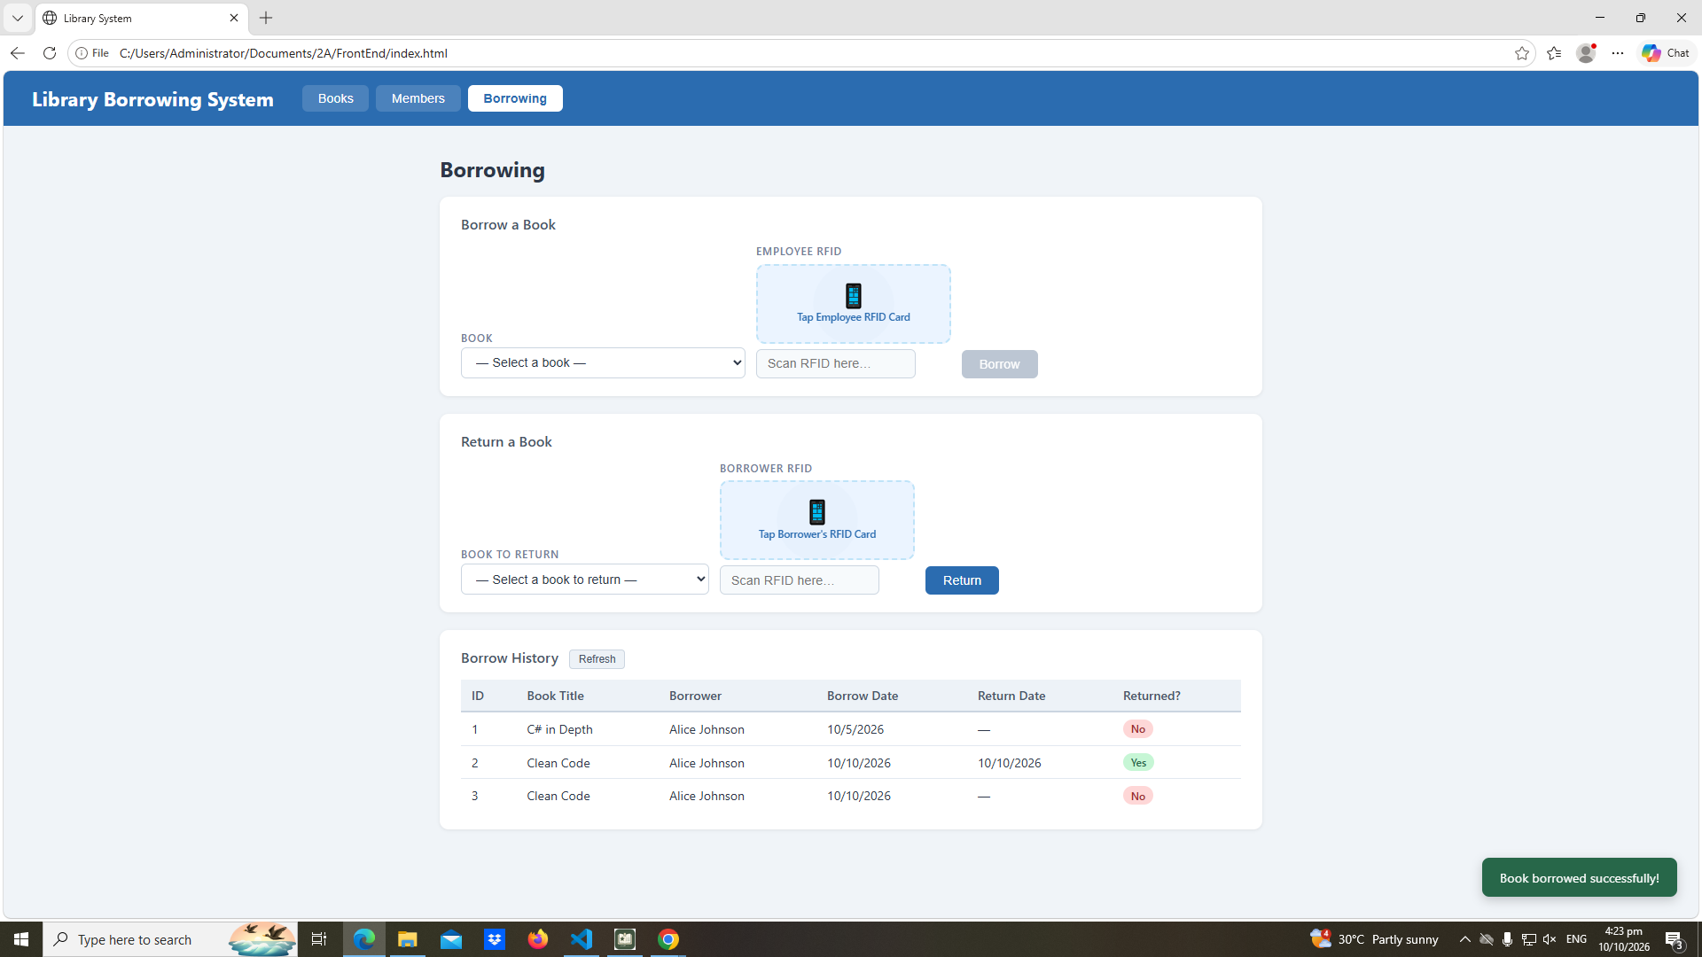

Test-11-return-wrong-card
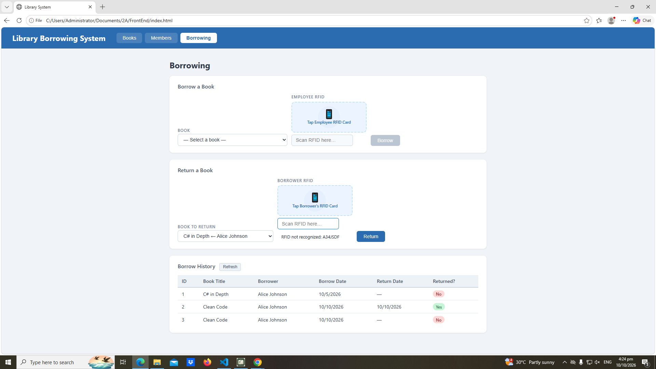

Test-12-return-verified
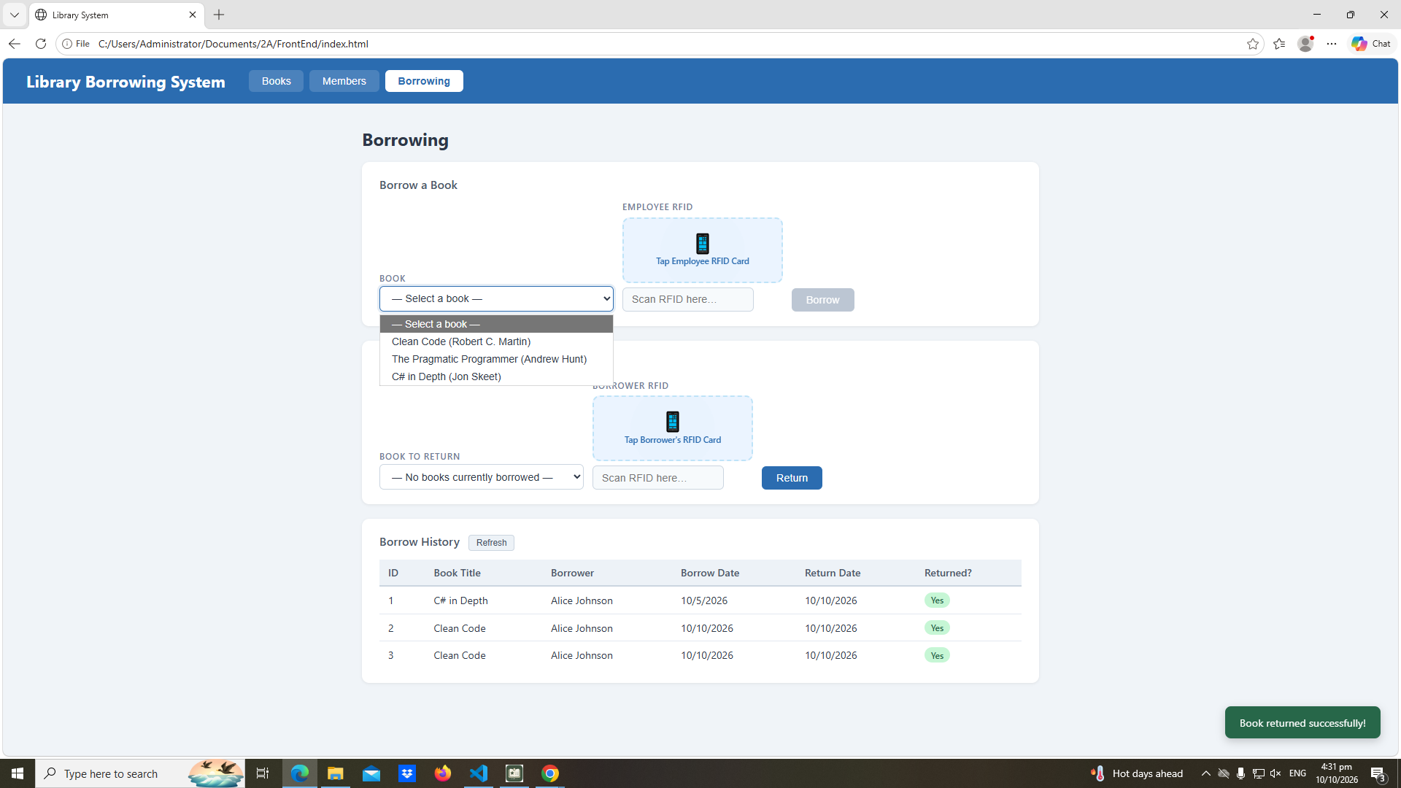

Test-13-return-success
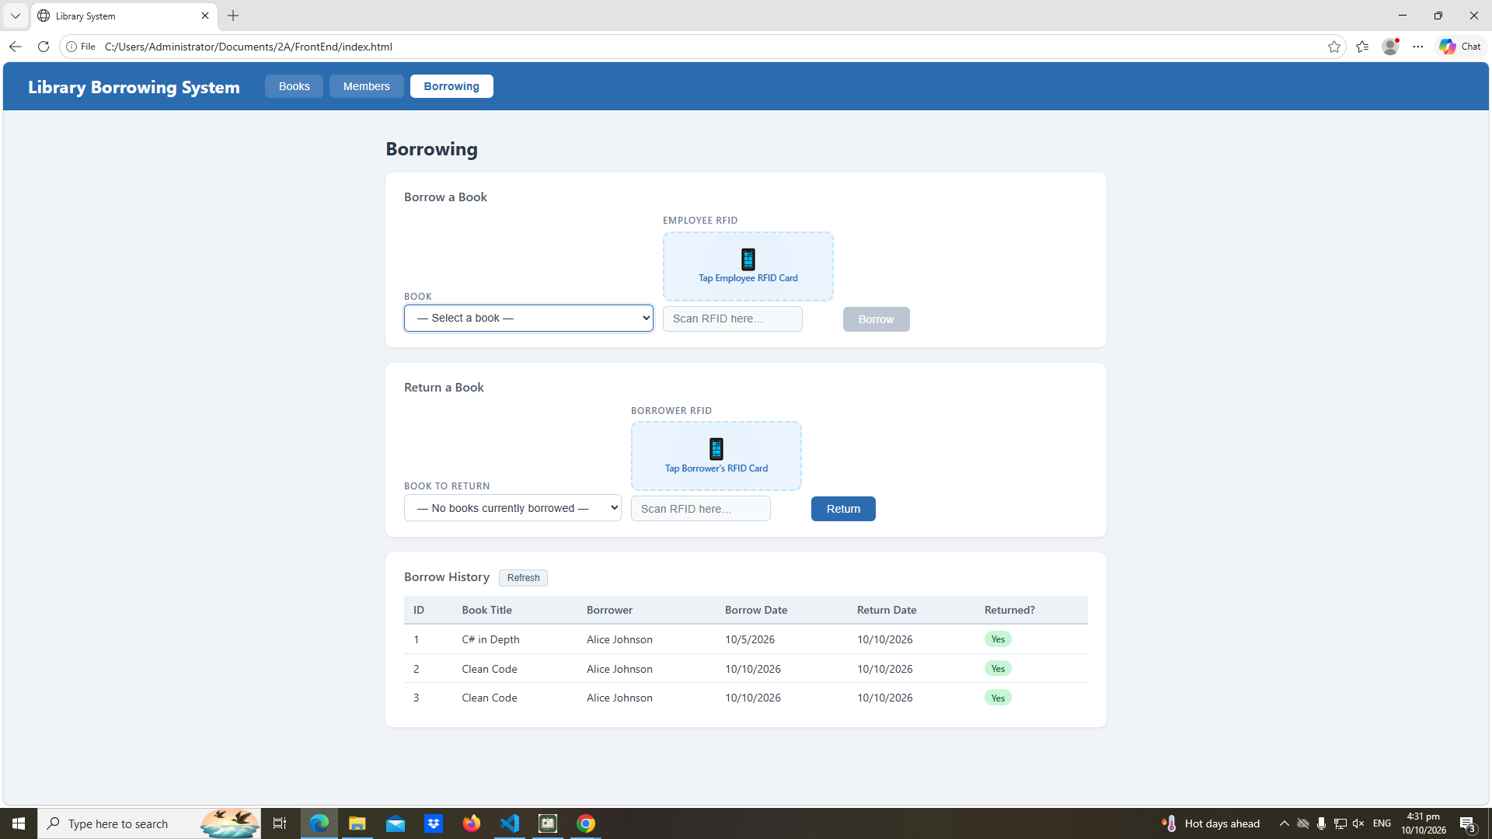

Test-14-final-console
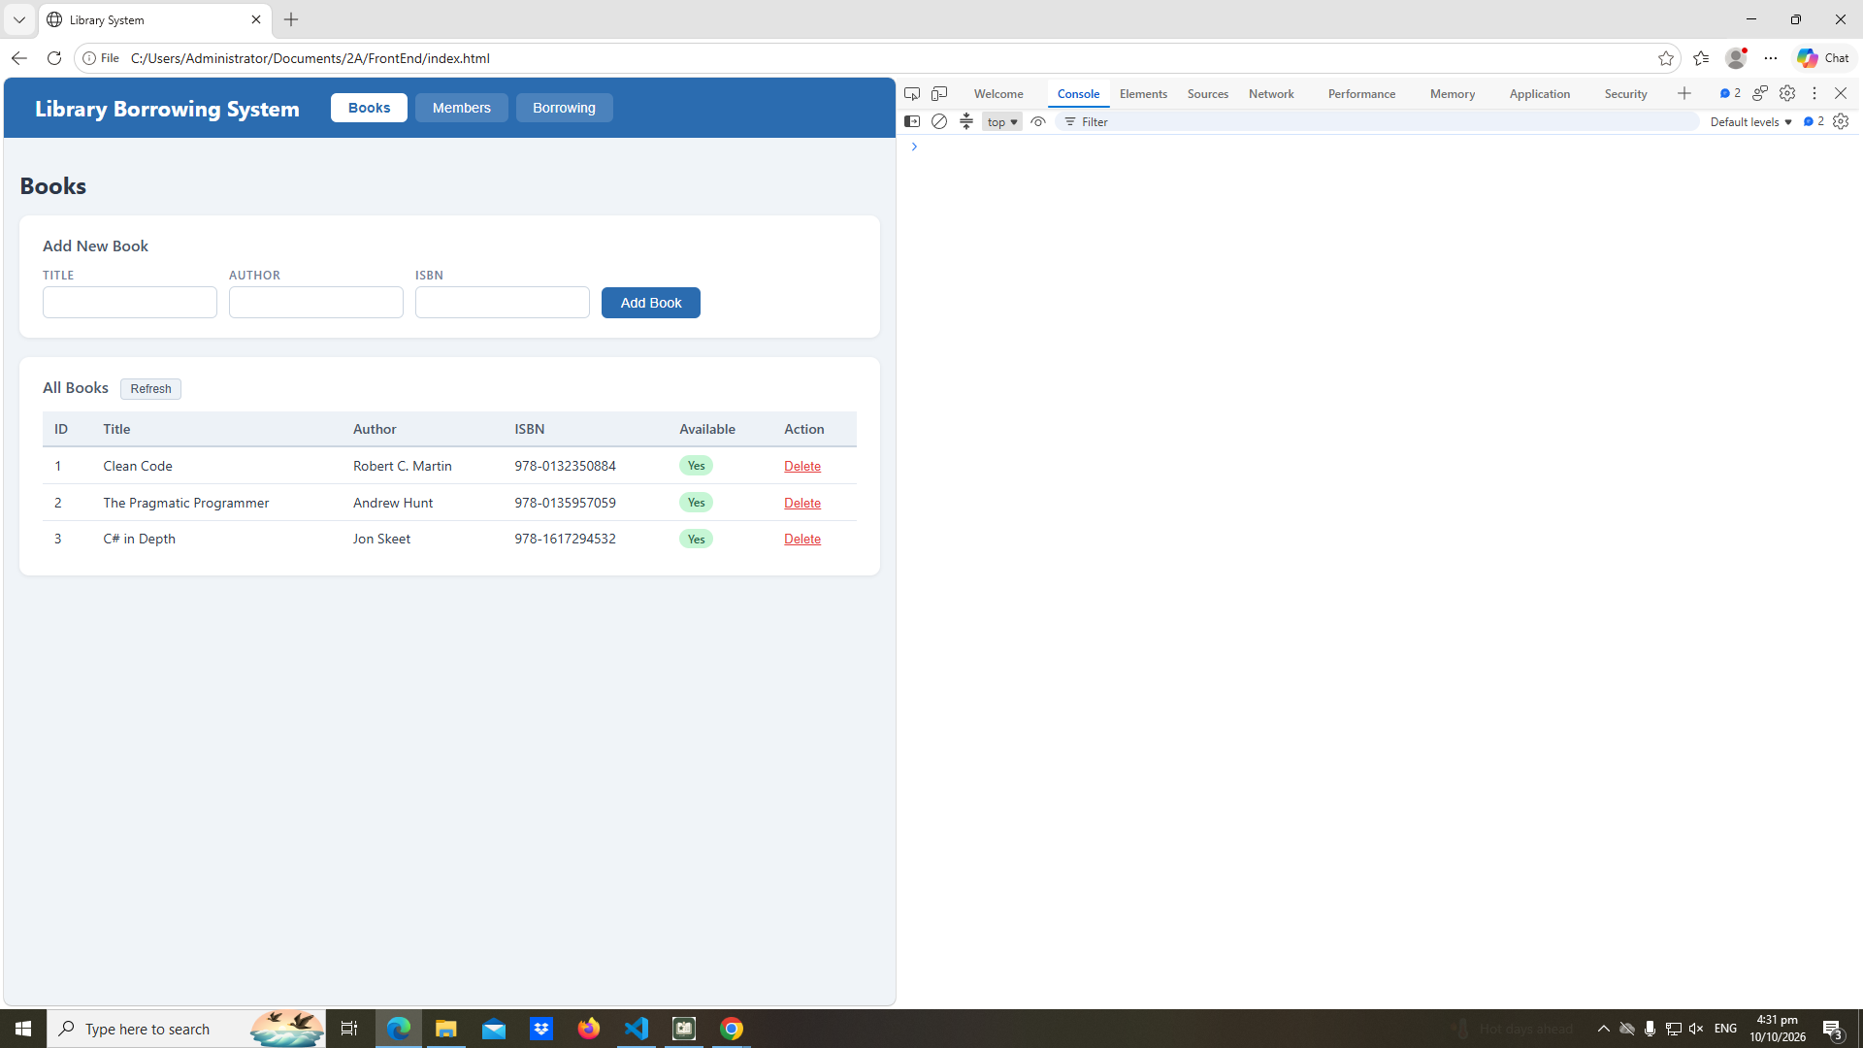

REFLECTION

- What does apiFetch() do?
- apiFetch() prevents repeated code.
- Why do we use try/catch around API calls?
- By using try/catch blocks around API calls primarily to prevent application crashes and handle unpredictable network failures.
- What is the difference between POST and PUT?
- POST is to add data and PUT is to update data.
- Why does RFID matching use rfidValue instead of studentId?
- So that it will work in the application because it cannot match the studentId.
- Why do we refresh tables after adding, deleting, borrowing, or returning?
- For it to be able to update the codes that we encode.
- Why does the Return dropdown use borrow record ID instead of book ID?
- So that when we Return, it will reflect to the borrow record ID instead. Because relying on the book ID will not lead to the actual answer.
- What happens if the same event listener is added to a form twice?
- Because a repeated event listener sends two requests for one click.
- Why must the page-load code be at the bottom of the file?
- TO make sure that all codes before the page-load code will run due to how the compiler works reading it from top to bottom. To add, the order matters in doing this because we have to ensure that every function will work rather than being being suddenly reloaded.
- Why does an RFID reader need e.preventDefault() on the Enter key?
- Because it stops the page reload.

