Ariel Carl R. Lapasaran
BSIT 2A
10/10/2026

Setup-01-api-running
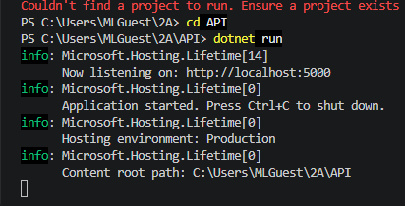
Setup-01-api-setup-01-runningru
Setup-02-api-books-json 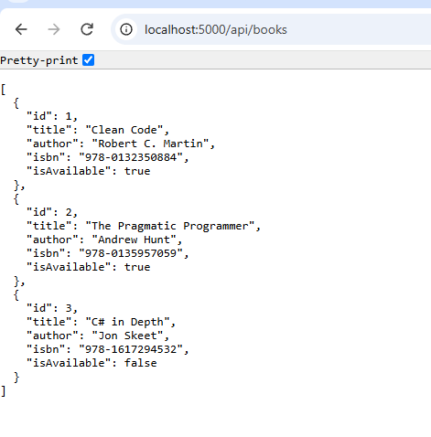
Part-01-settings-apifetch
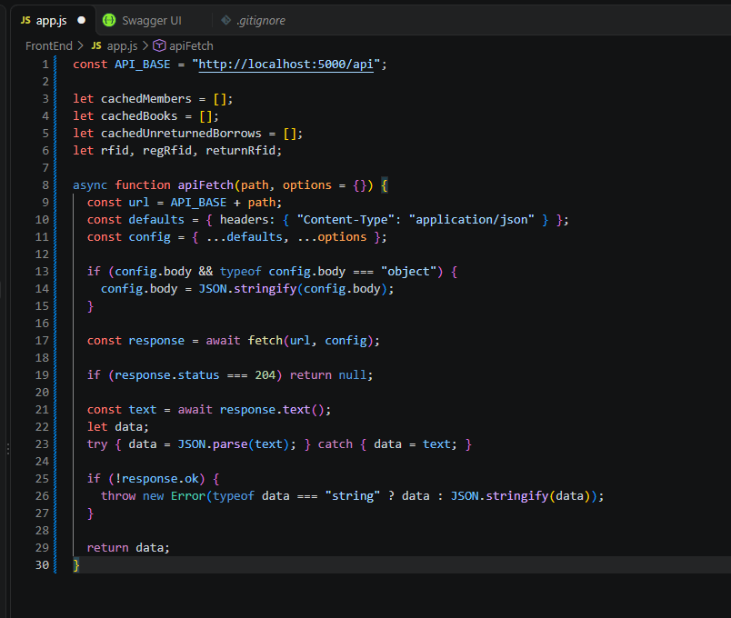

.

early-01-toast
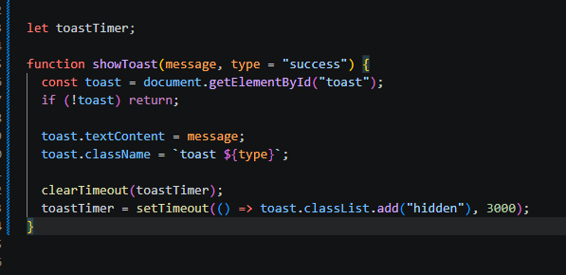

Part-02-showtoast
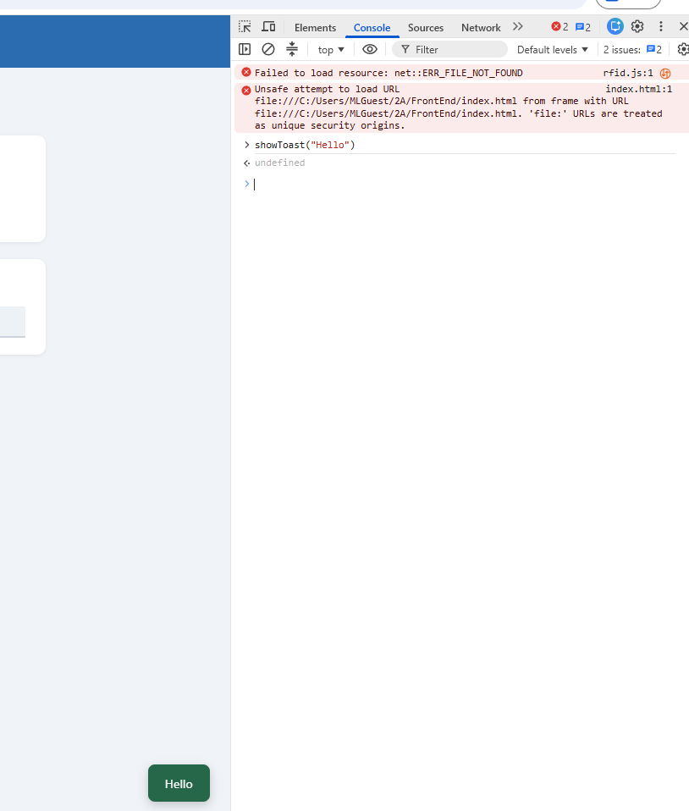

Part-02-cache-console

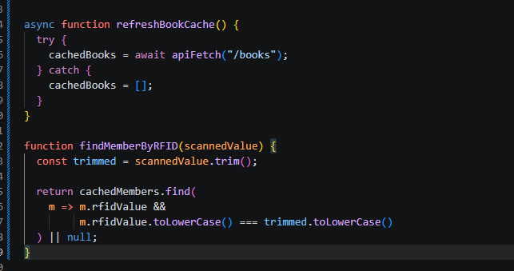

Part-03-caches
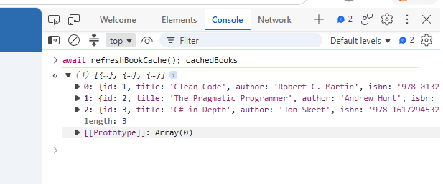

part -03-tabs
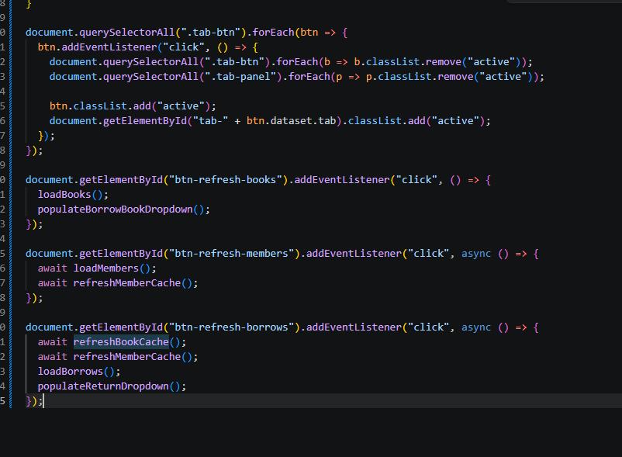

part -04-tabs-referesh
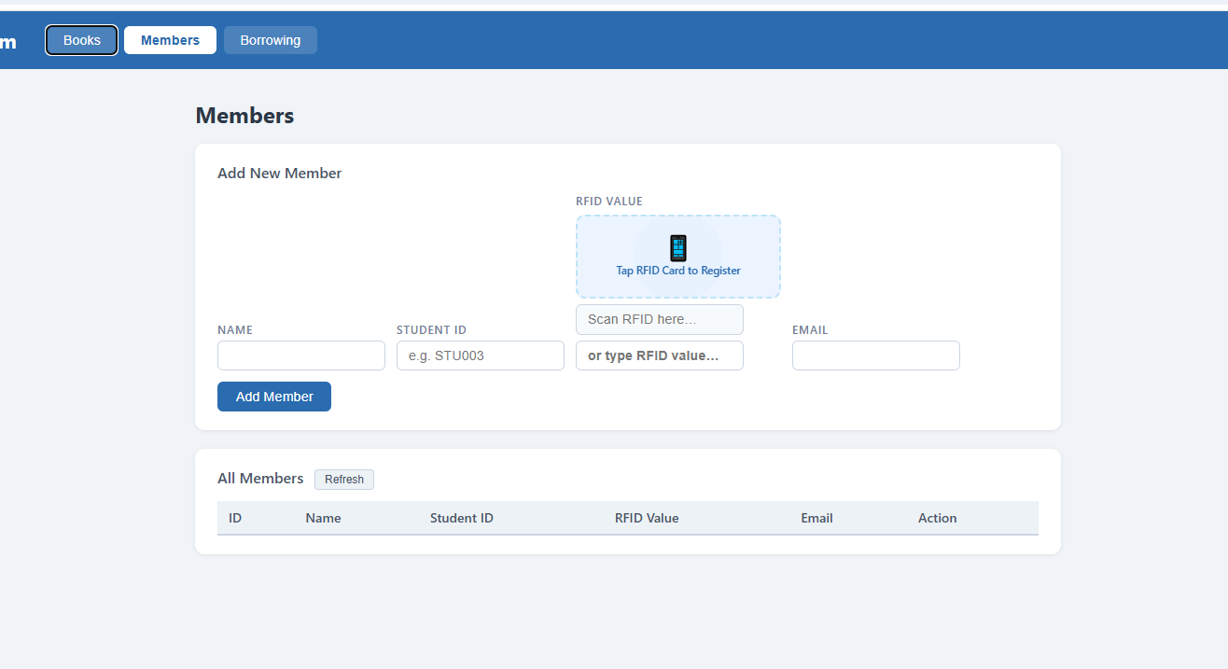

Part-5-loadbooks
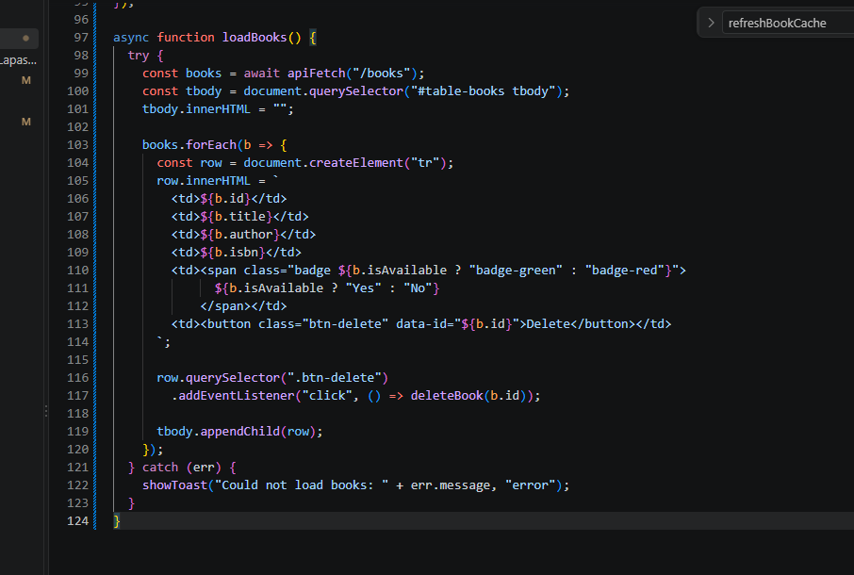

Part-6-DeleteBooks
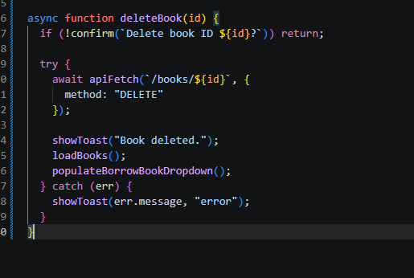

part-7-AddBlock
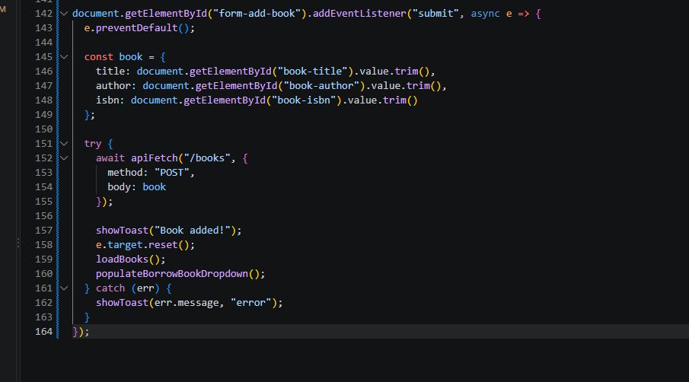

Part-08a-loadmember
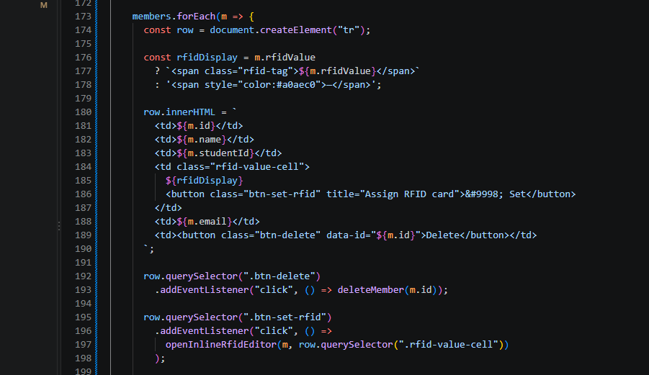
part-08b
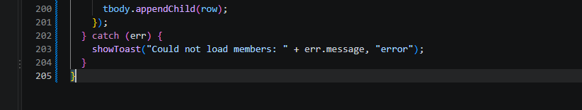

Part-9-deletemember
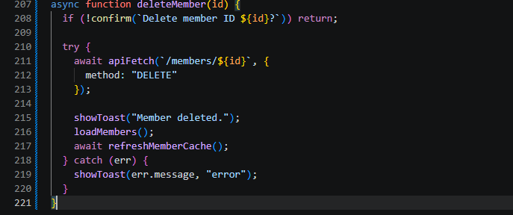

Part-10-Addmember
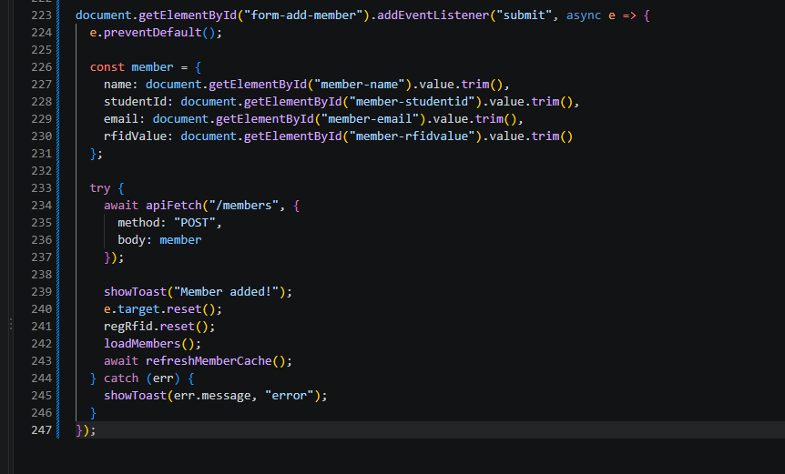

Part-11a-inline-rfid-editor
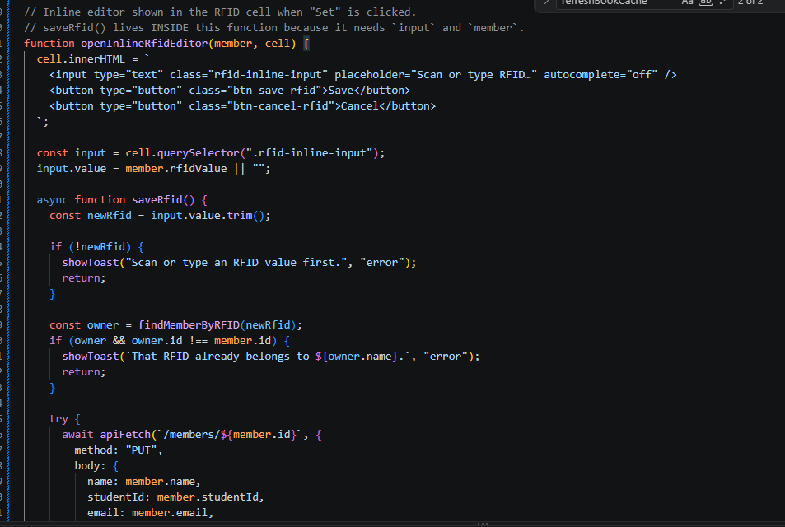
Part-11b-inline-rfid-editor
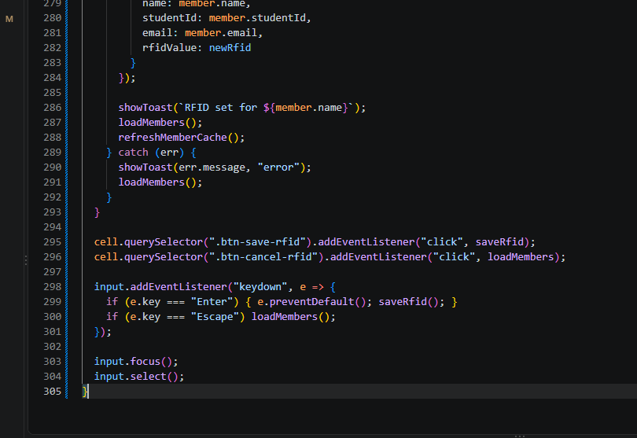

Part-12a-rfid-widget-builder
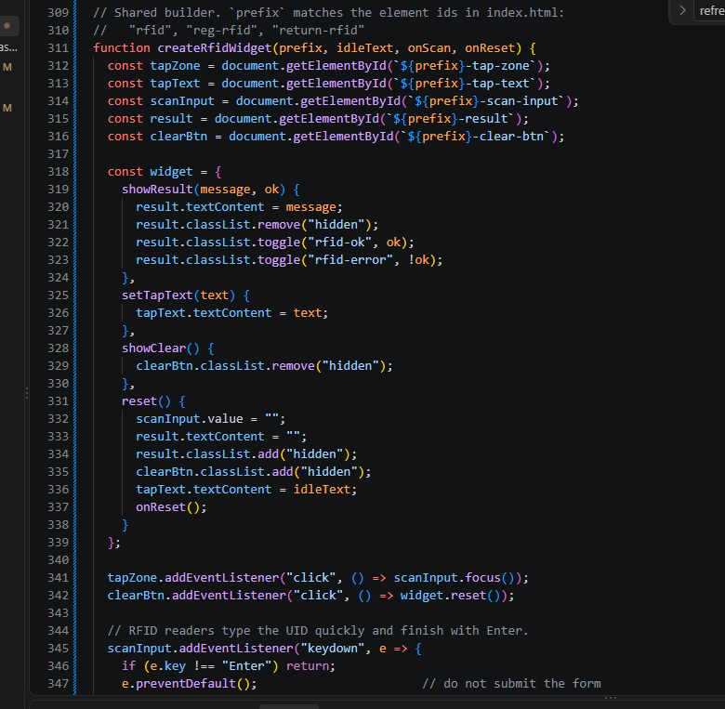
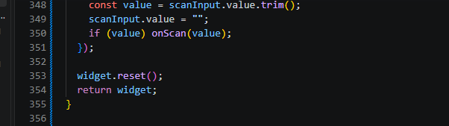

Part-12b-rfid-init-function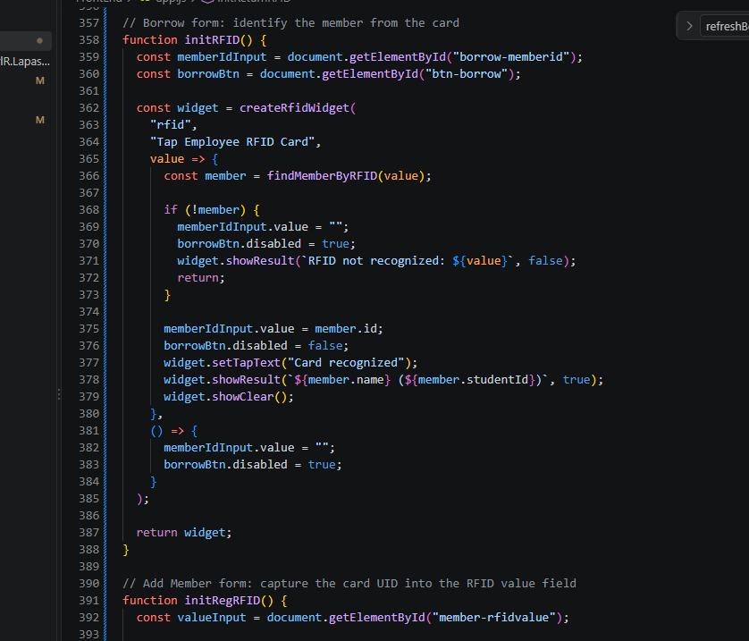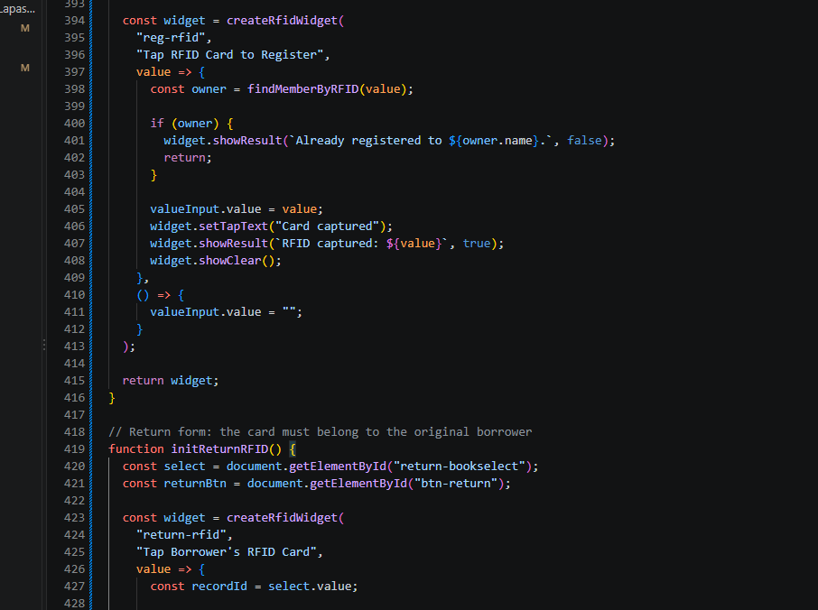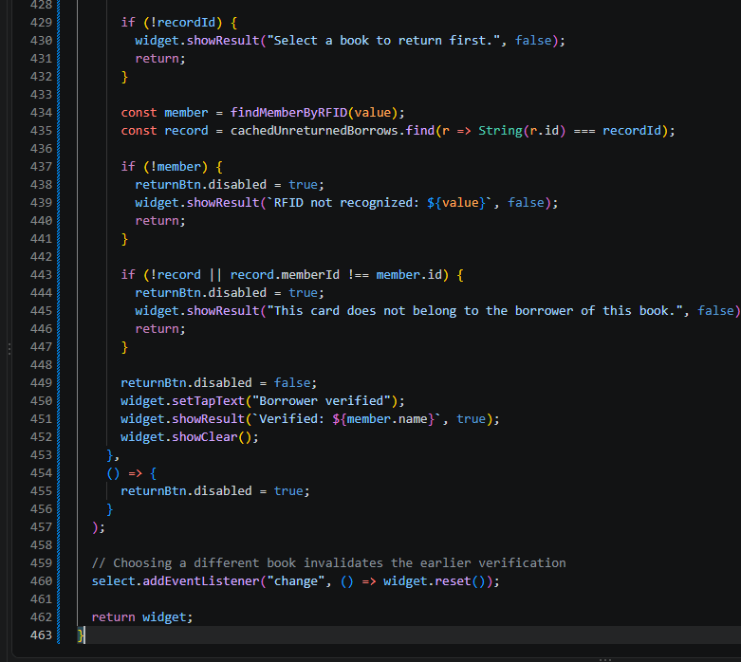
Part-13-borrow-dropdown
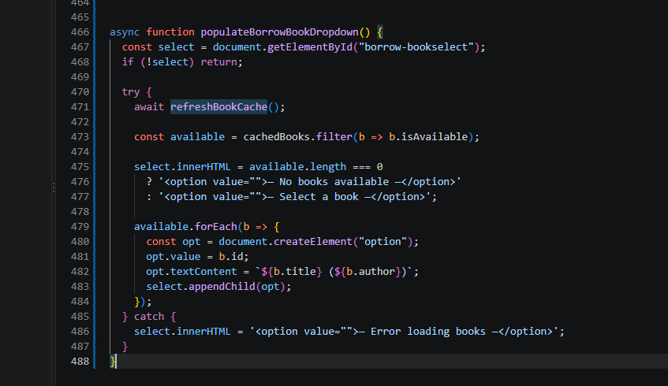

part-14-return-dropdown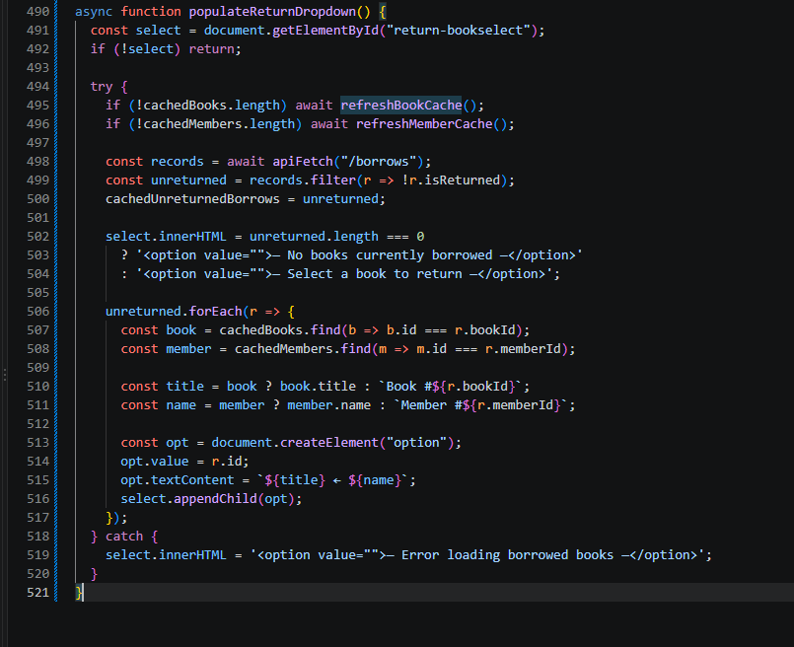

part-15-borrow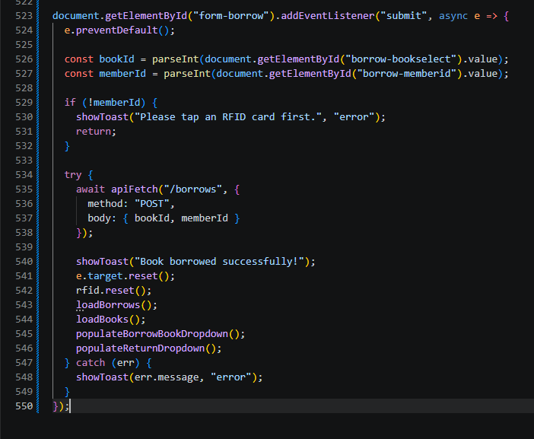

part-16-return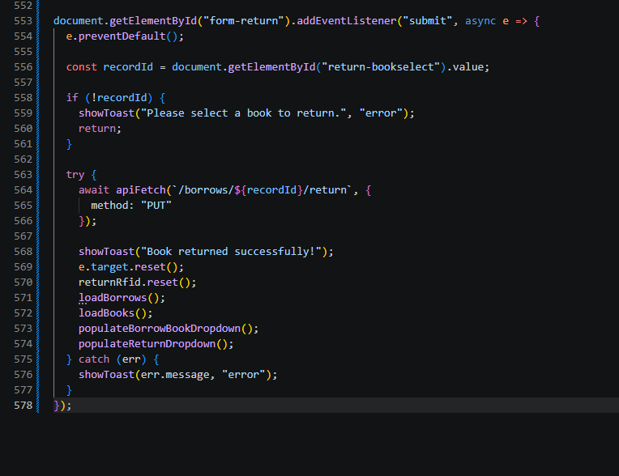

part-17-loadborrow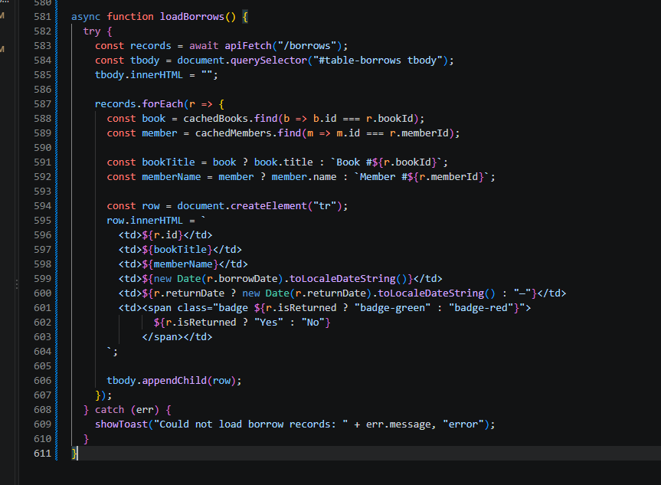

part-18-page-load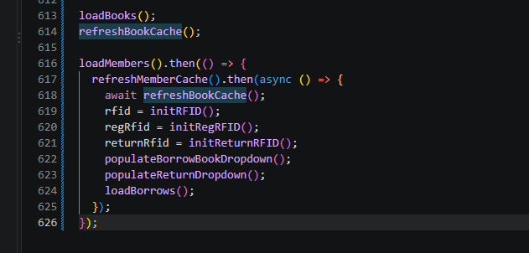

Test-02-page-loaded
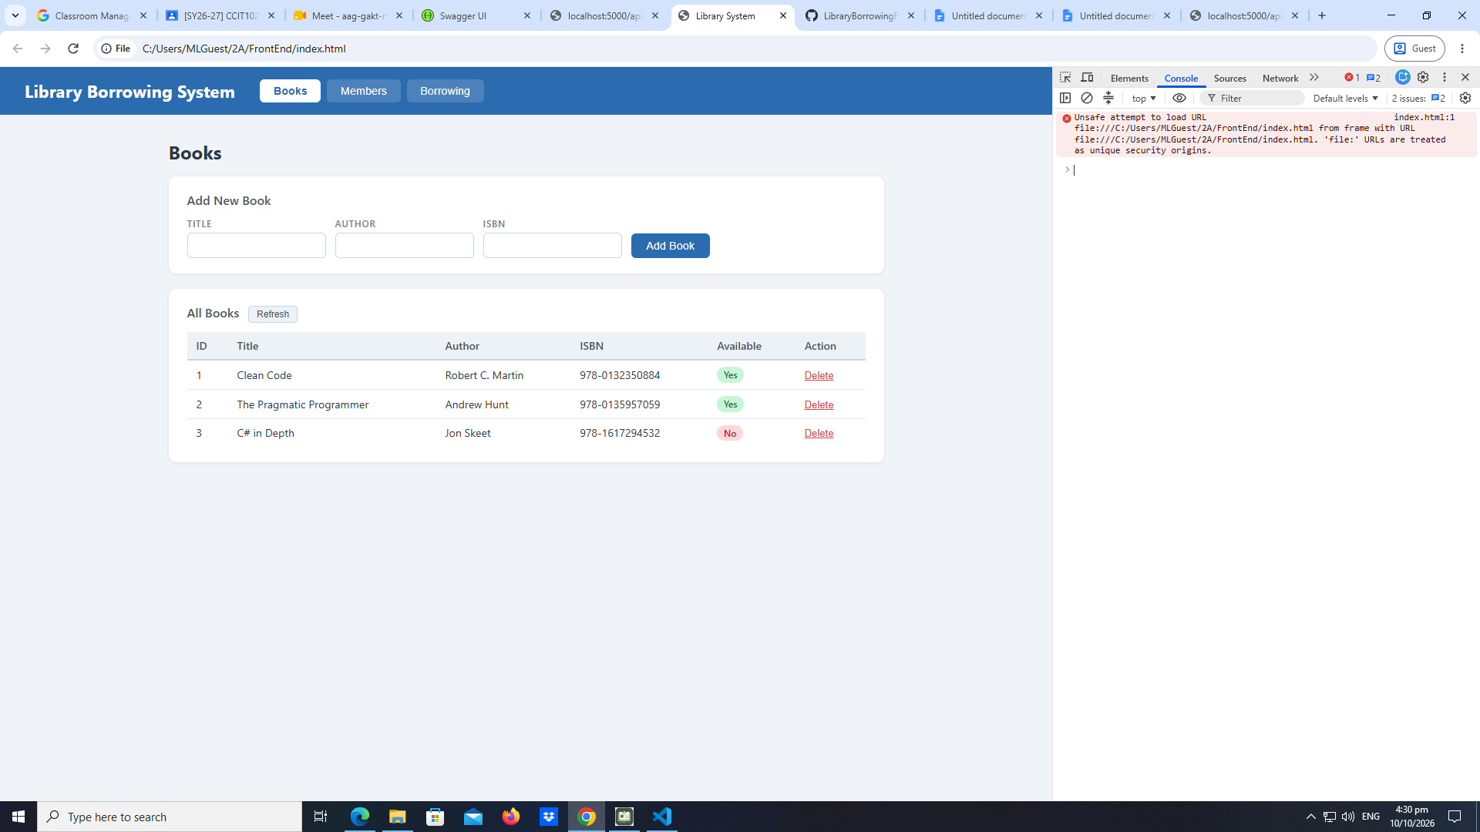

Test-3-test the tabs
early-03-tabs
MEMBER:
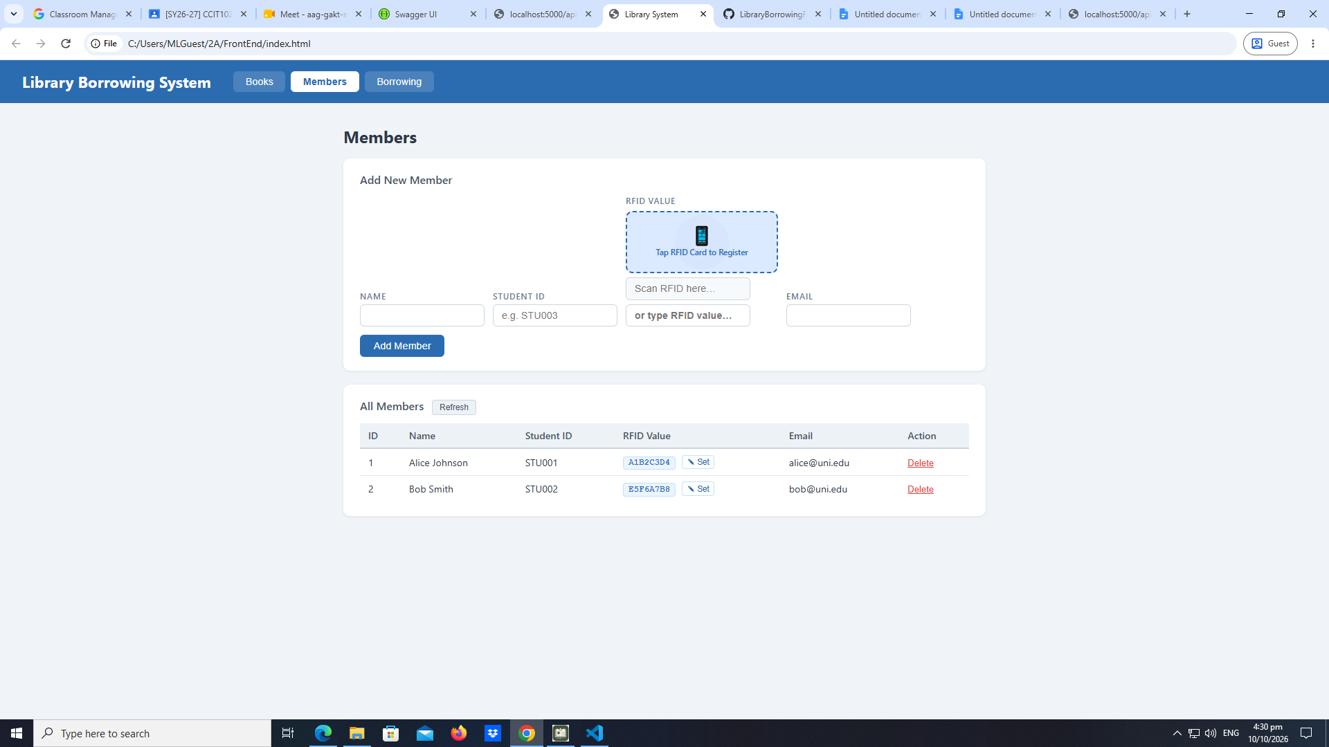
BORROWING: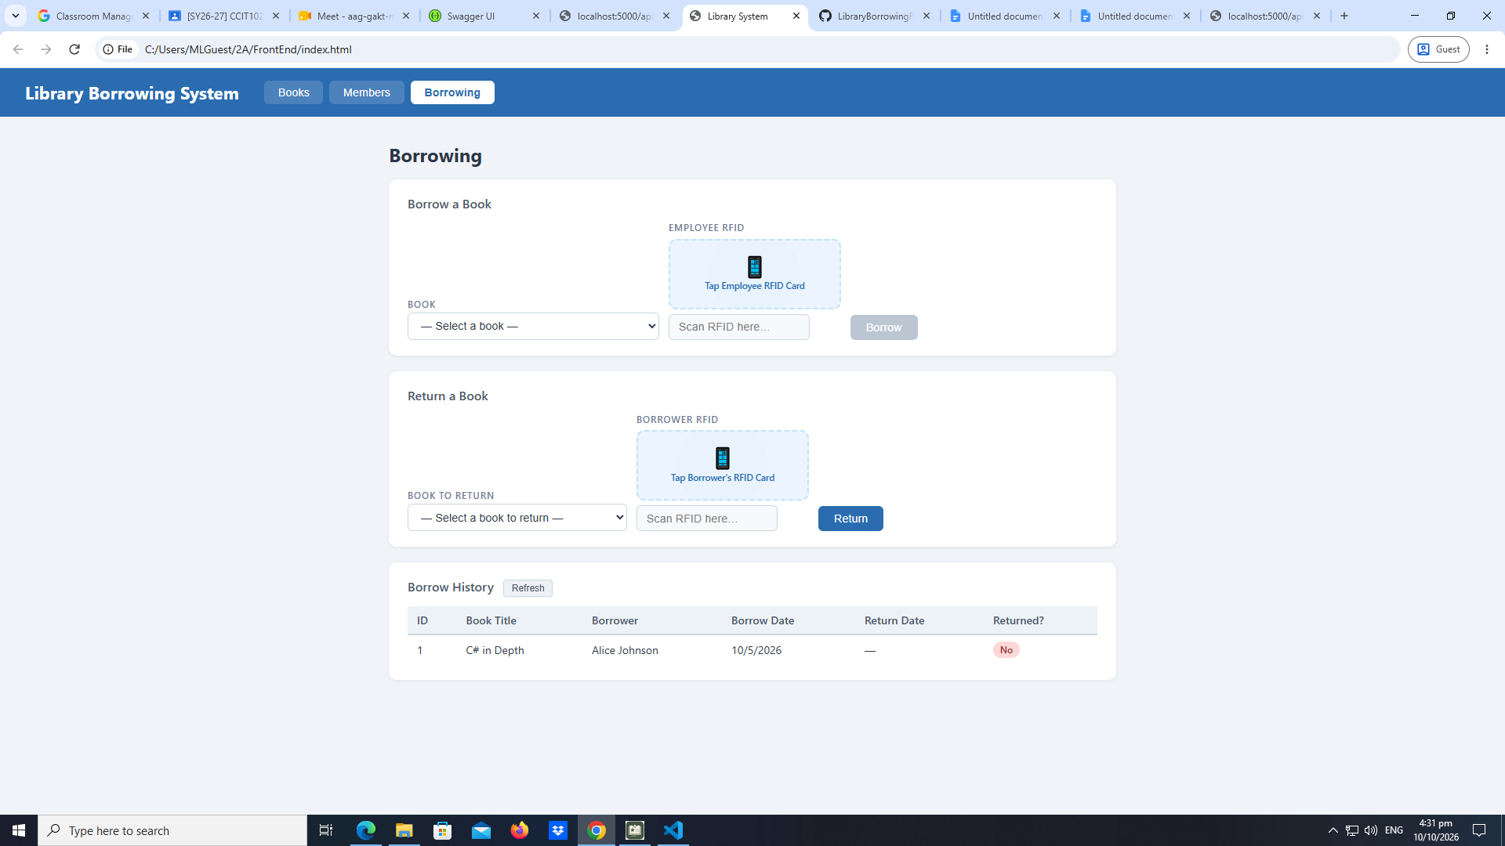
BOOKS: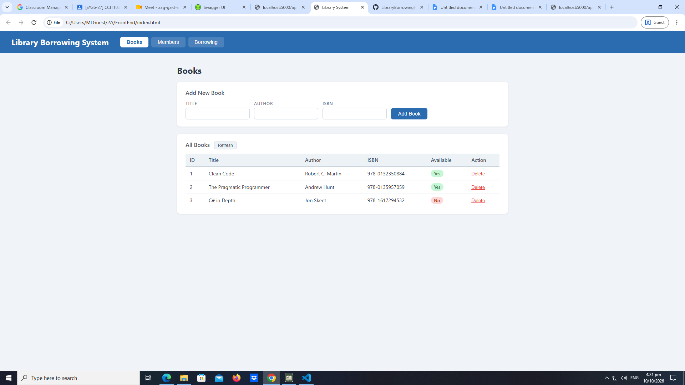

Test-4-test-book
BOOK LOAD: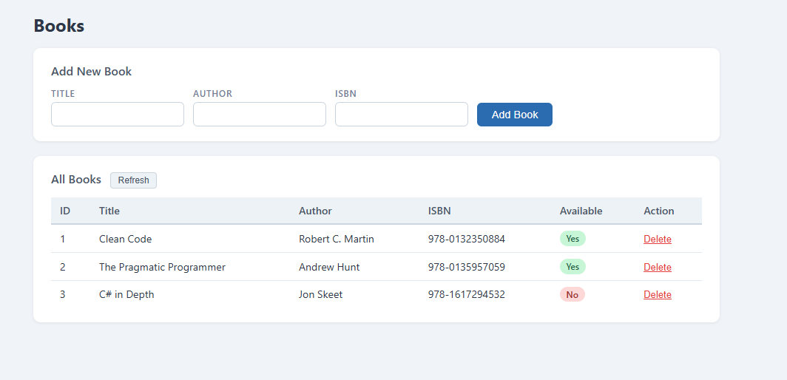
test-02-add-book
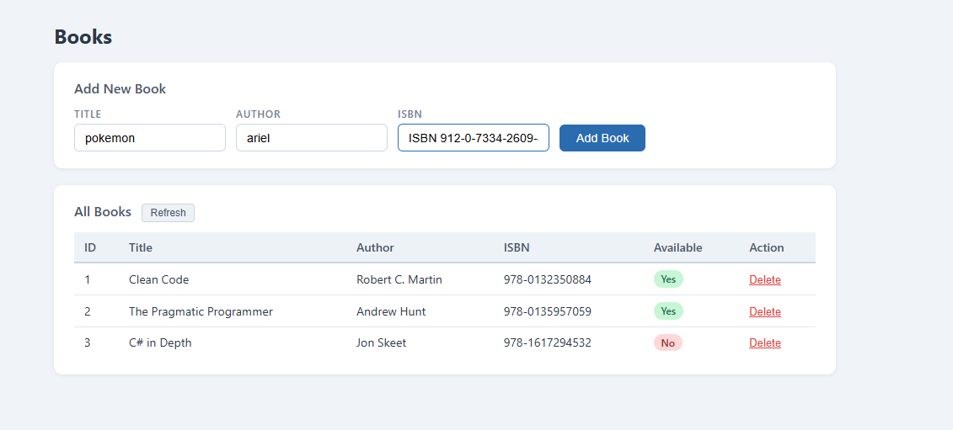
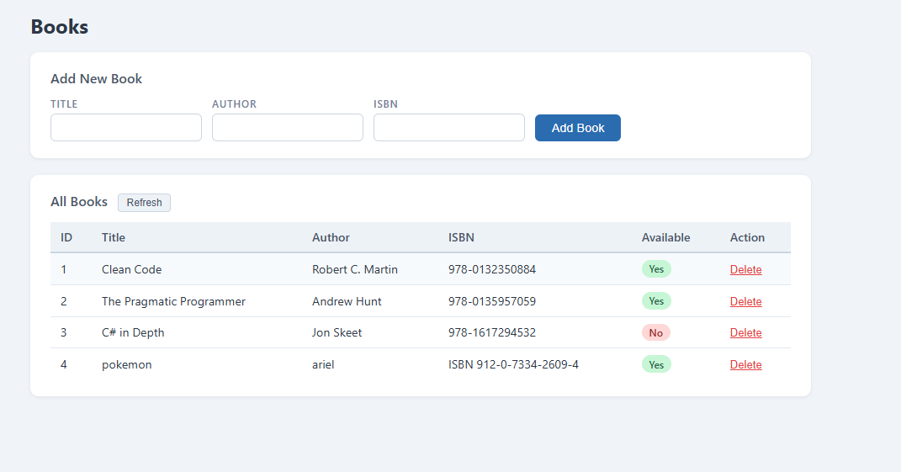
test-03-delete-book
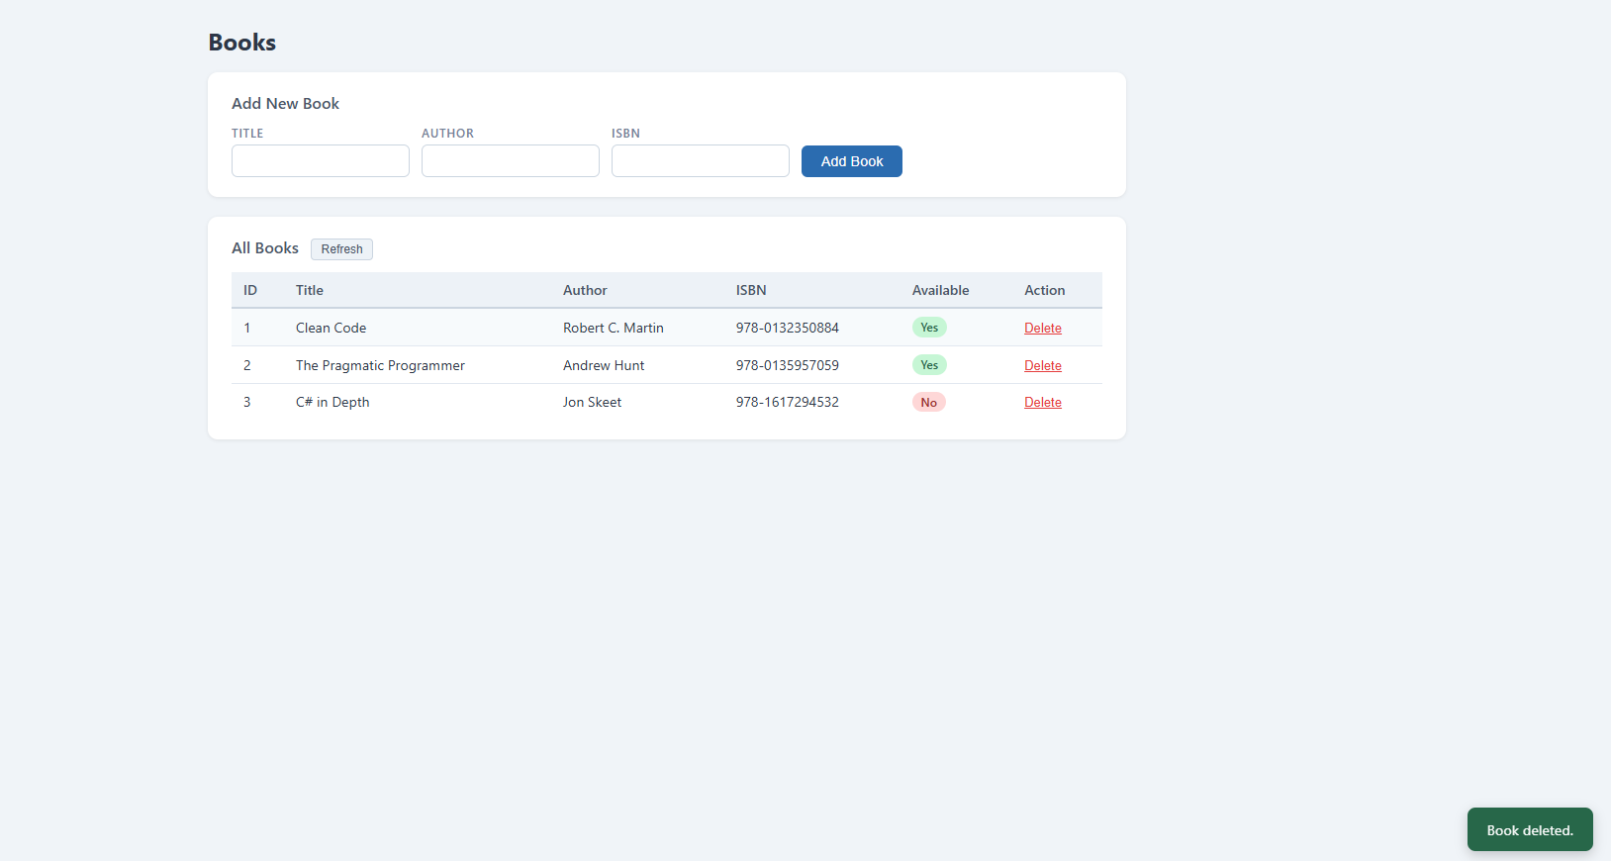

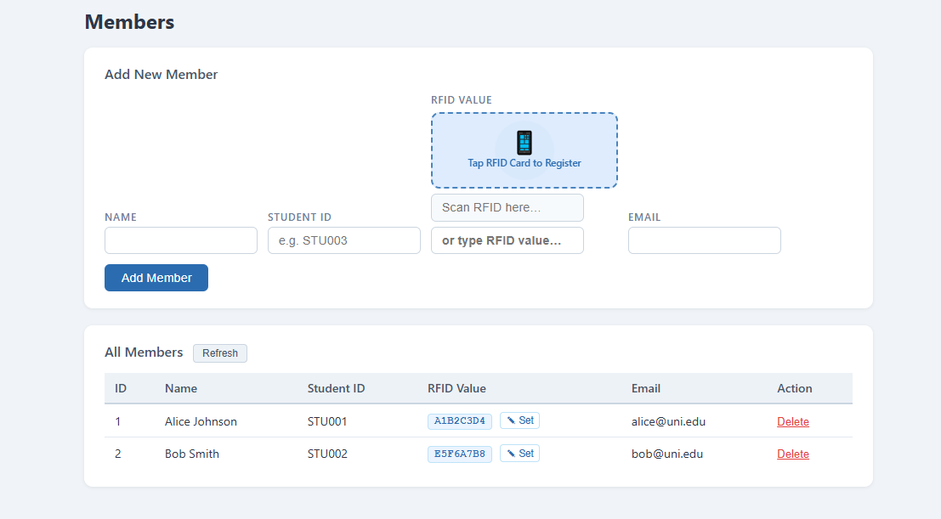
test-05-register-rfid
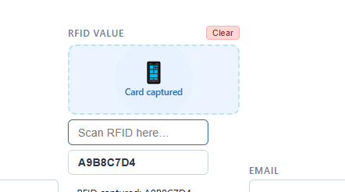

test-06-add-member - test-07-set-rfid-saved
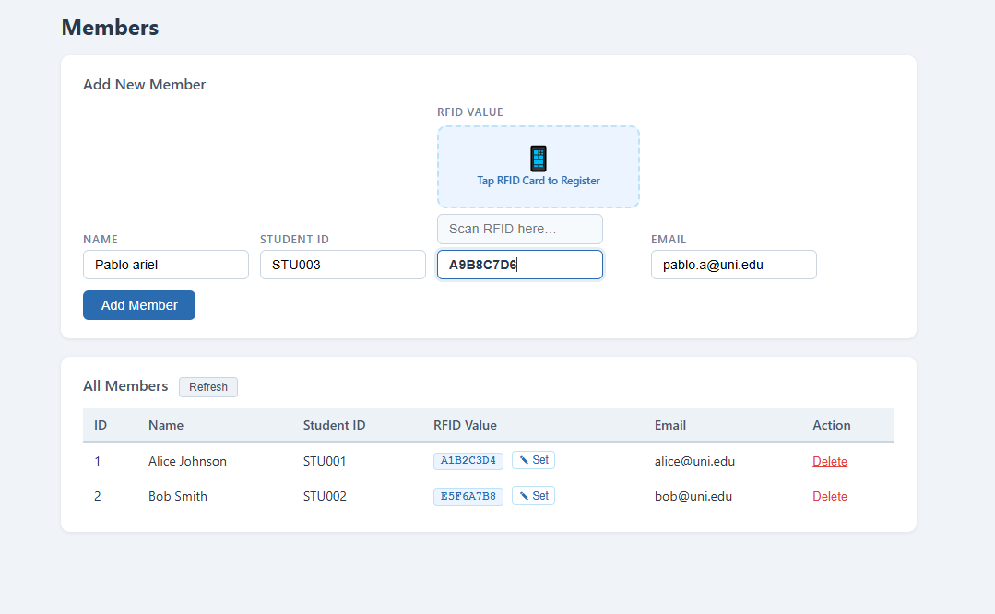
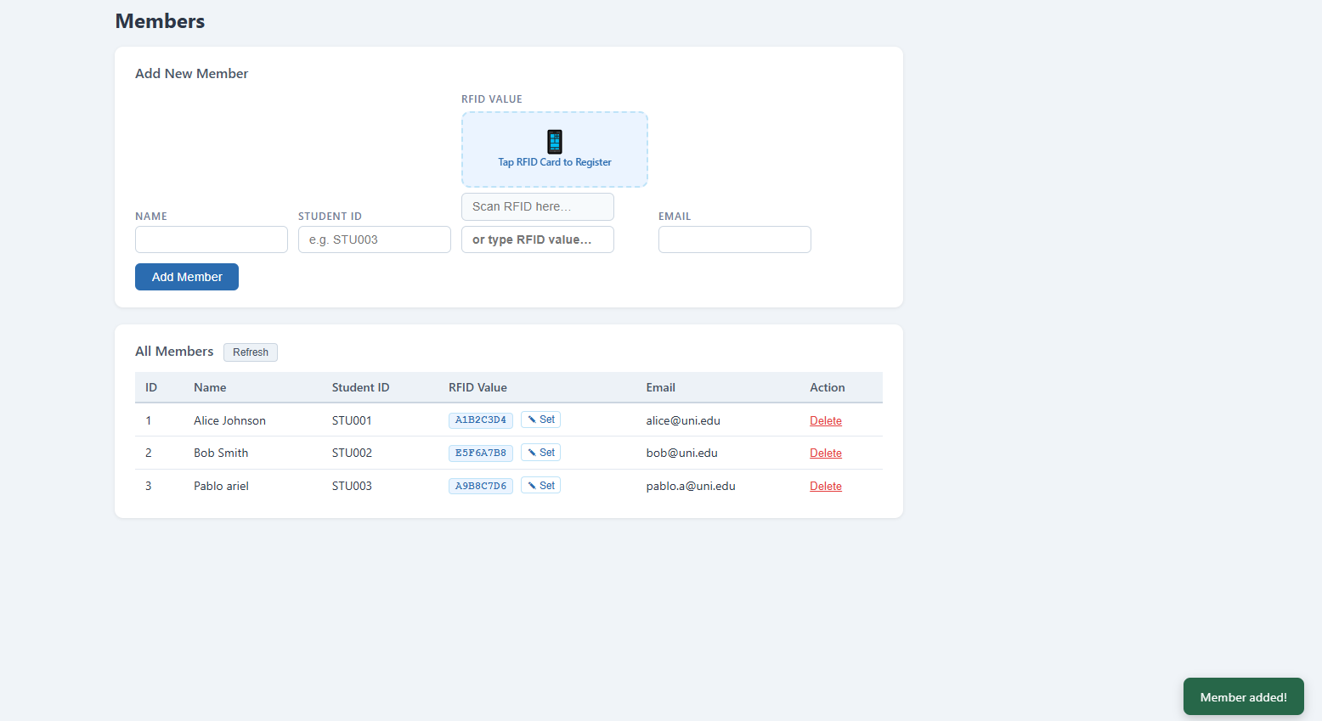test-08-delete-member
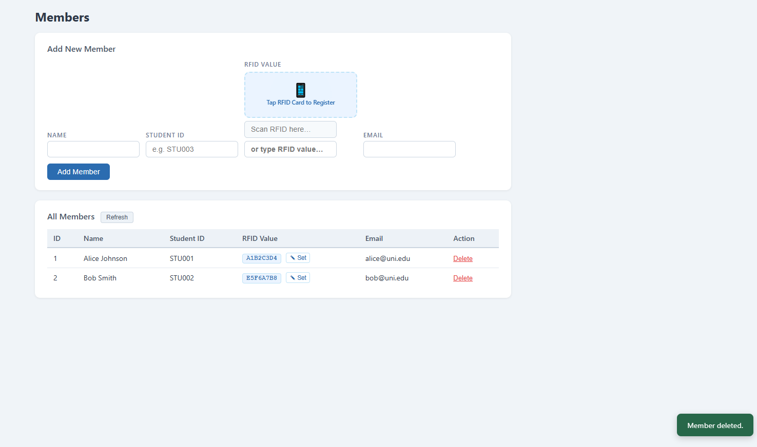

test-09-borrow-rfid-recognized
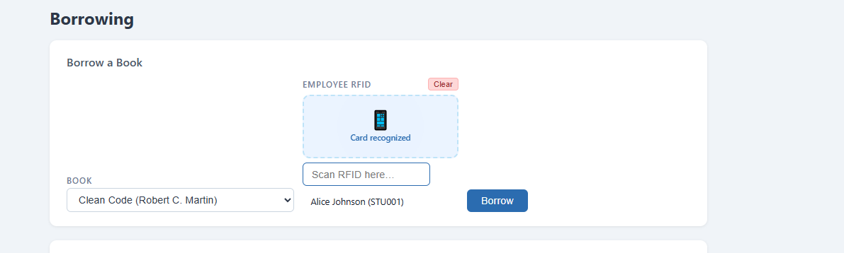
test-10-borrow-success
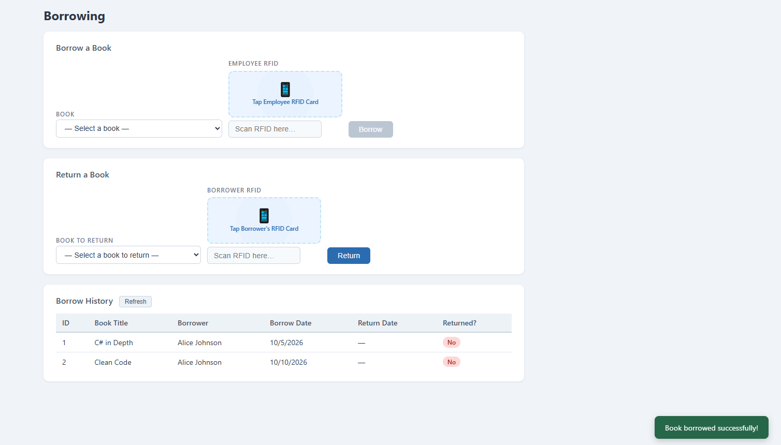

test-11-return-wrong-card
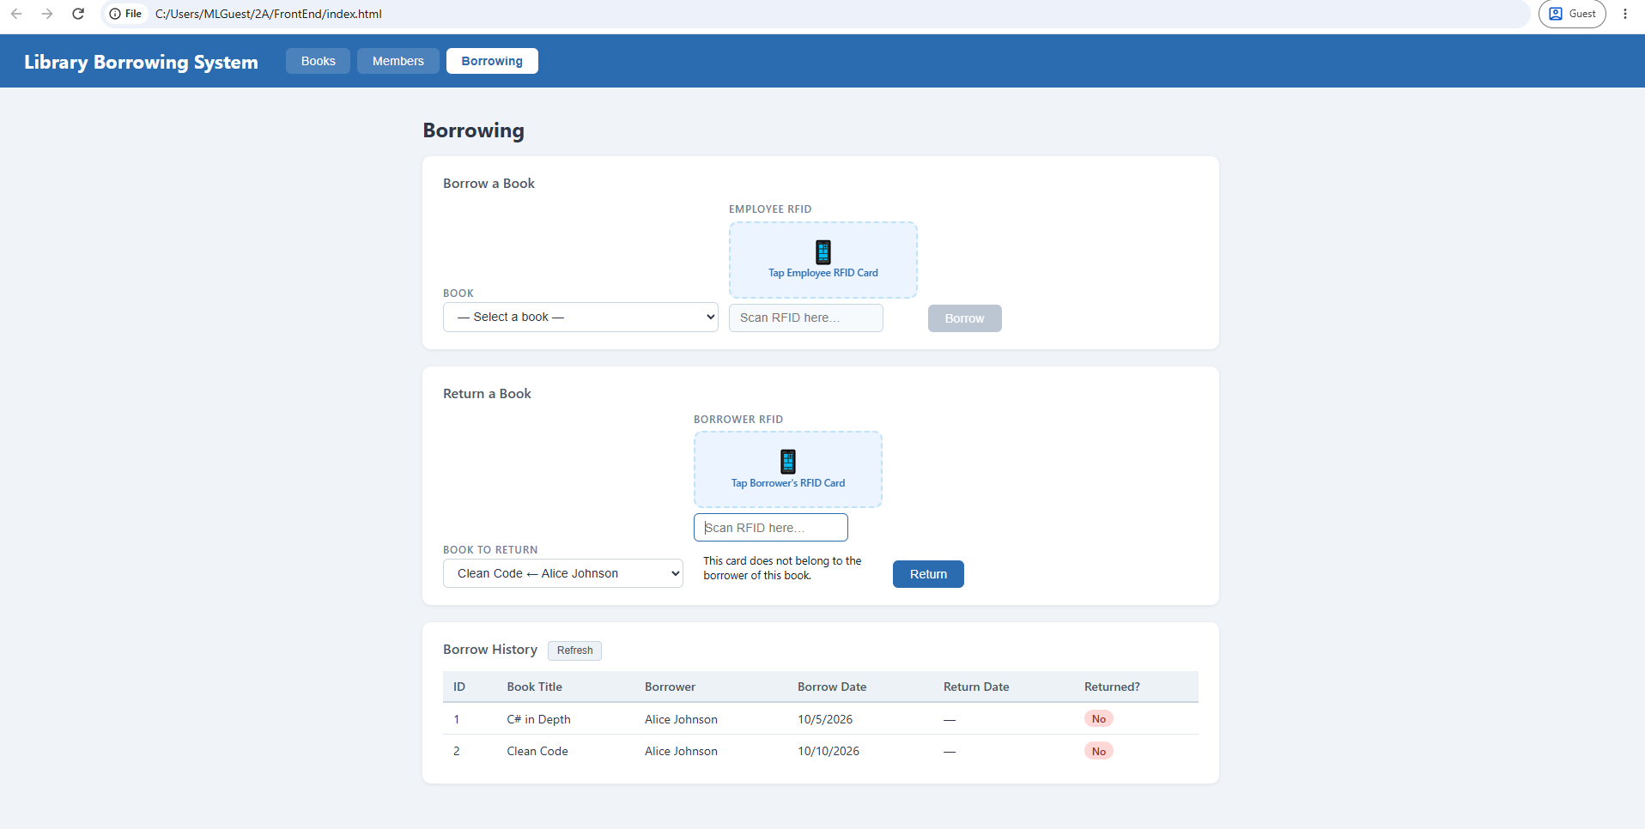
test-12-return-verified
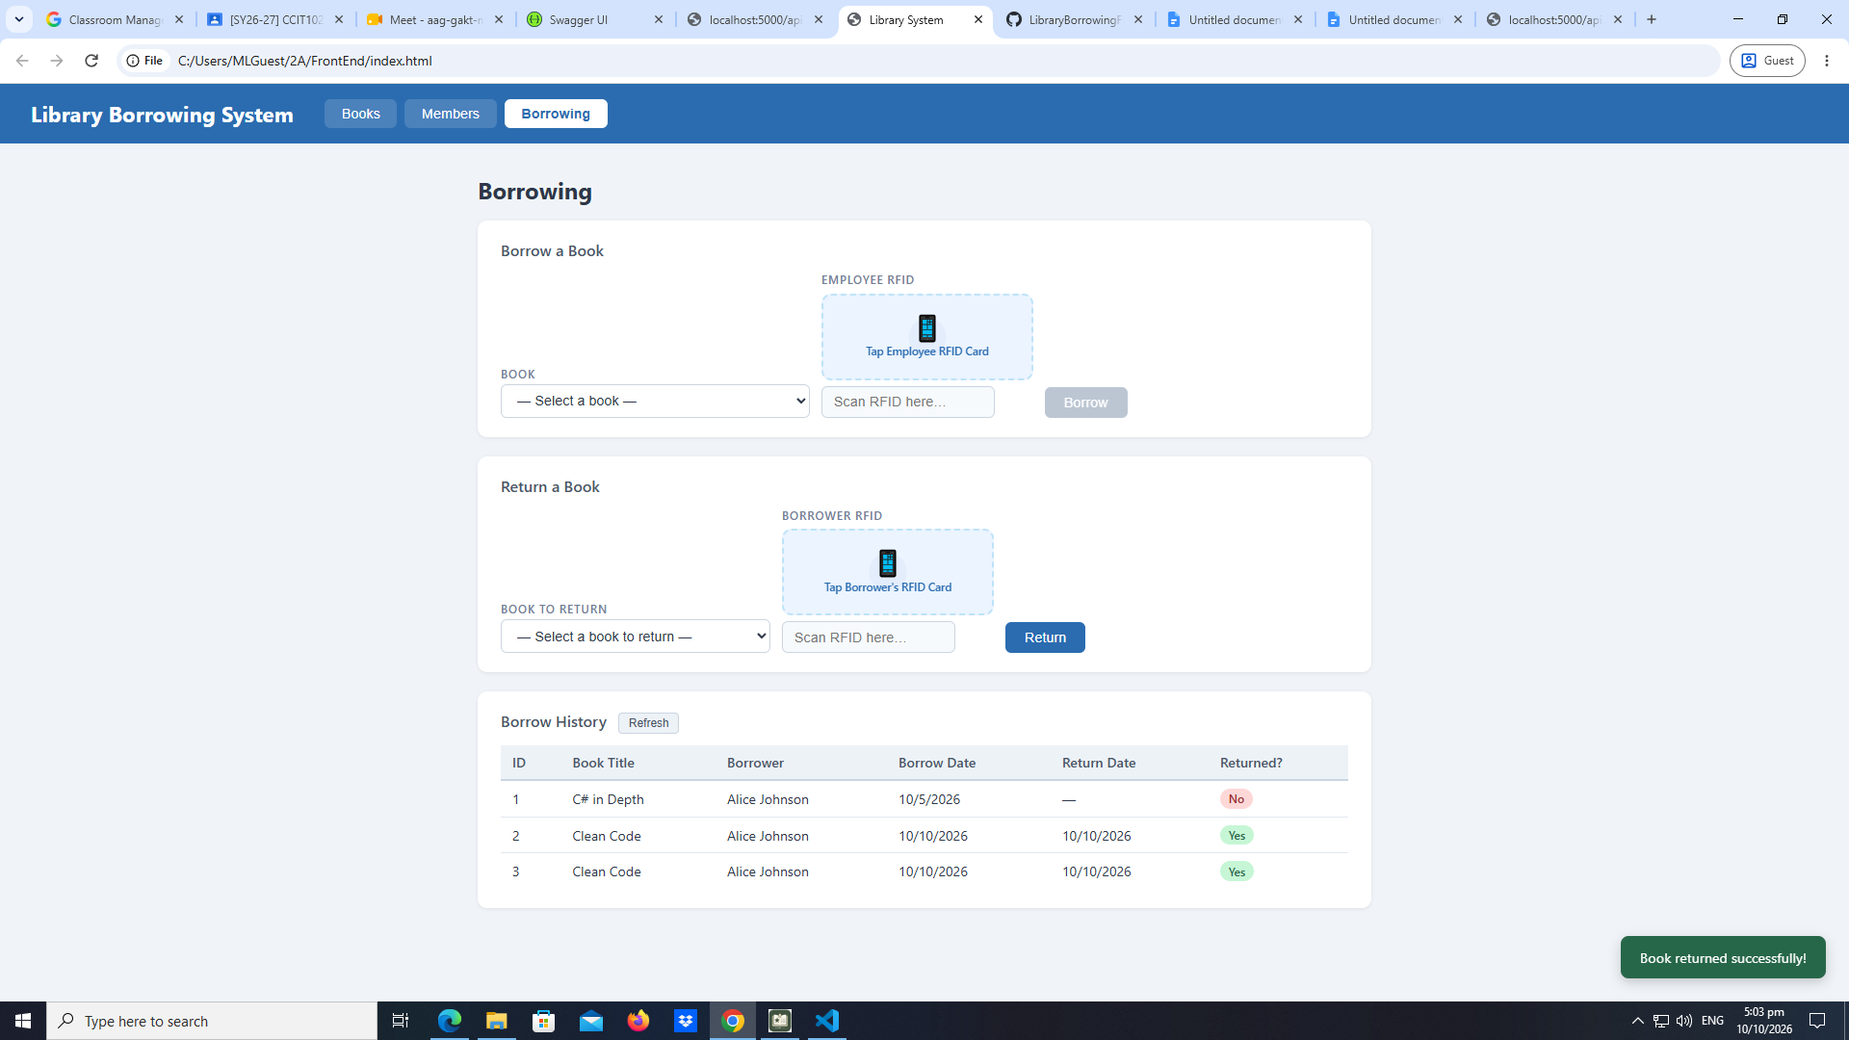
test-13-return-success
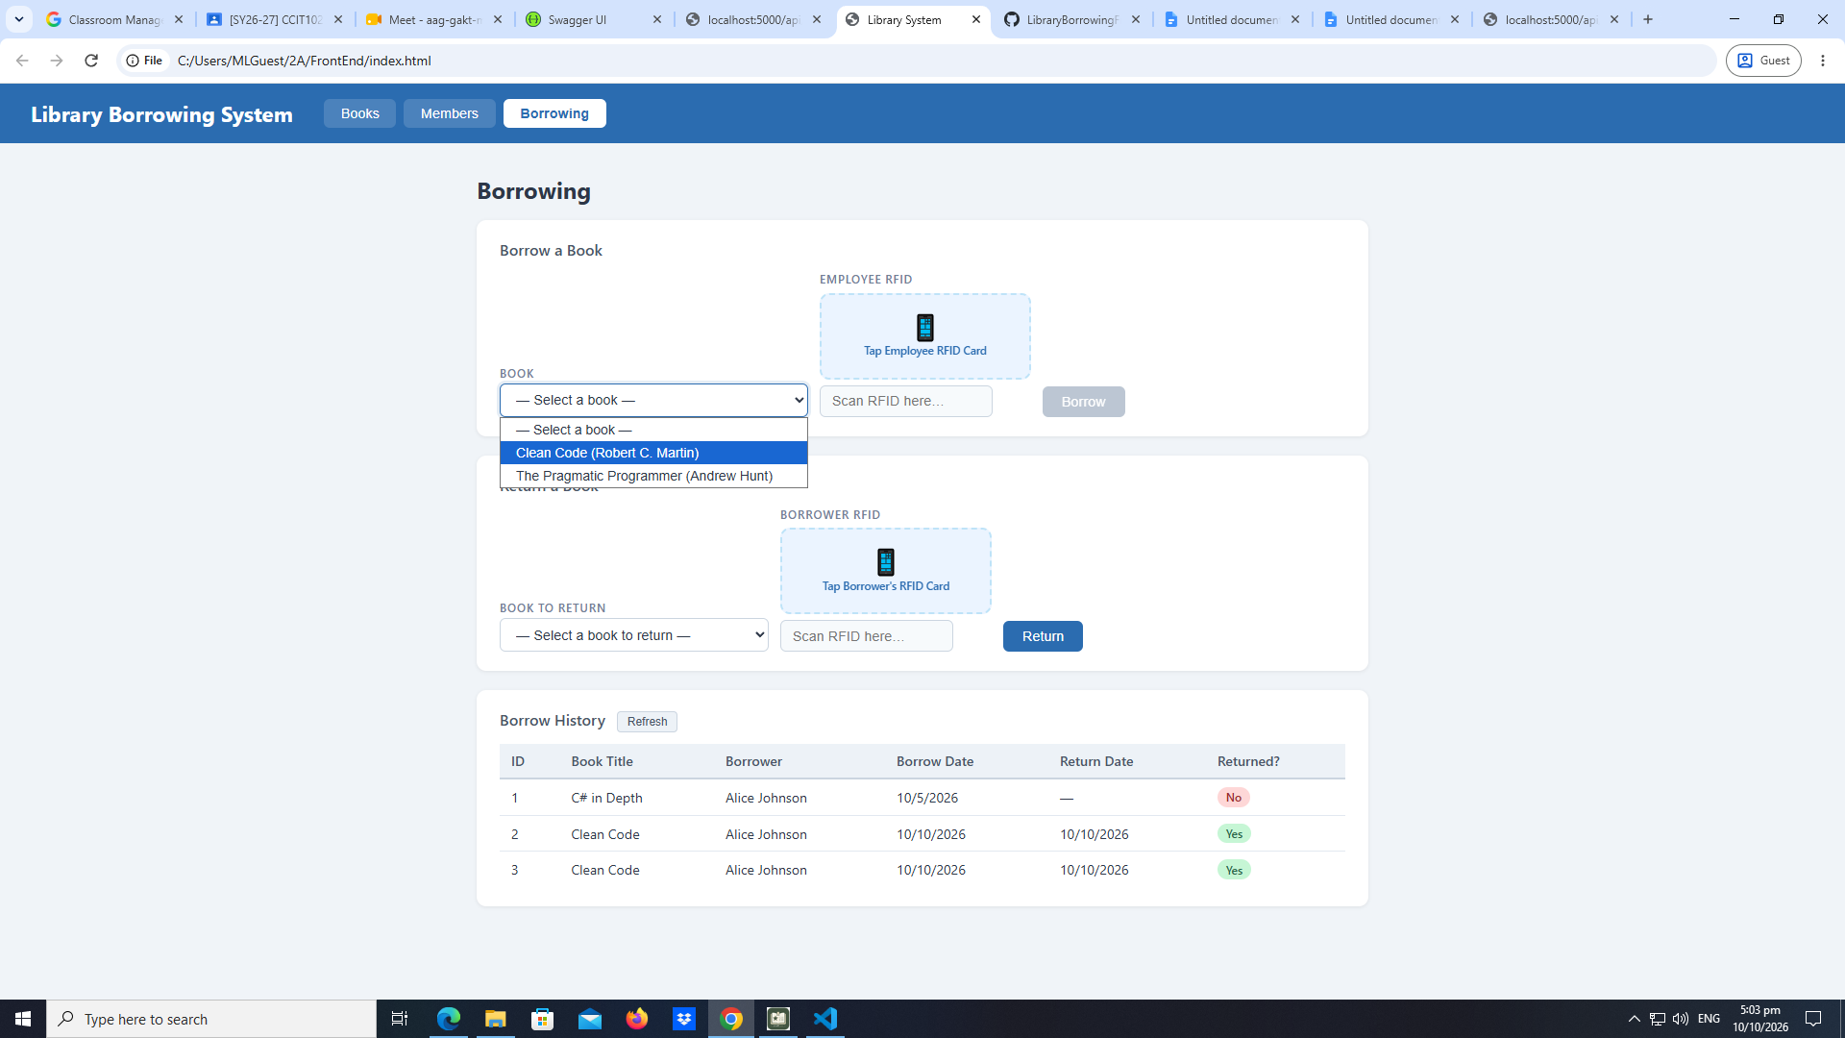
test-14-final-console
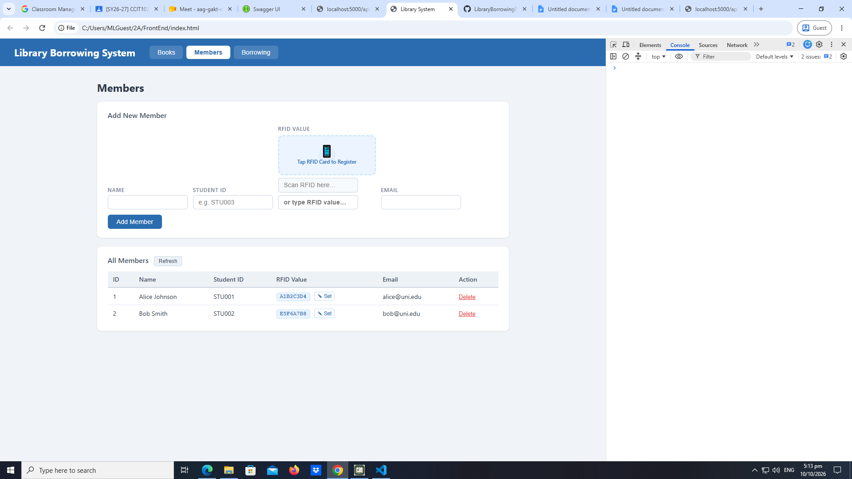

- What does apiFetch() do?
apiFetch() is used to simplify making HTTP request backend server. It standardized how headers base URLs and response error handling are manage across application
- Why do we use try/catch around API calls?
We use try/catch to handle asynchronous error and network without crashing the entire application.
- What is the difference between POST and PUT?
PUT is update and POST is add
- Why does RFID matching use rfidValue instead of studentId?
Because the scanner automatically reads the physical card unique rfidValue to look fast to student.
- Why do we refresh table after adding,deleting, borrowing or returning?
To sync the user interface with the new database records.
- Why does the return dropdown use borrow record ID instead of book Id?
To target and close out that specific checkout transaction since book can be borrowed multiple times.
- What happen if the same event listener is added to a form twice?
Identical code will both execute.
- Why must the page load code be at the bottom of the file?
To ensure that all HTML element are fully loaded before
- Why does an RFID reader need e.preventDefault() on the Enter Key?
To stop the form from performing a default page reload when the scanner press enter.

