setup-01-api-running
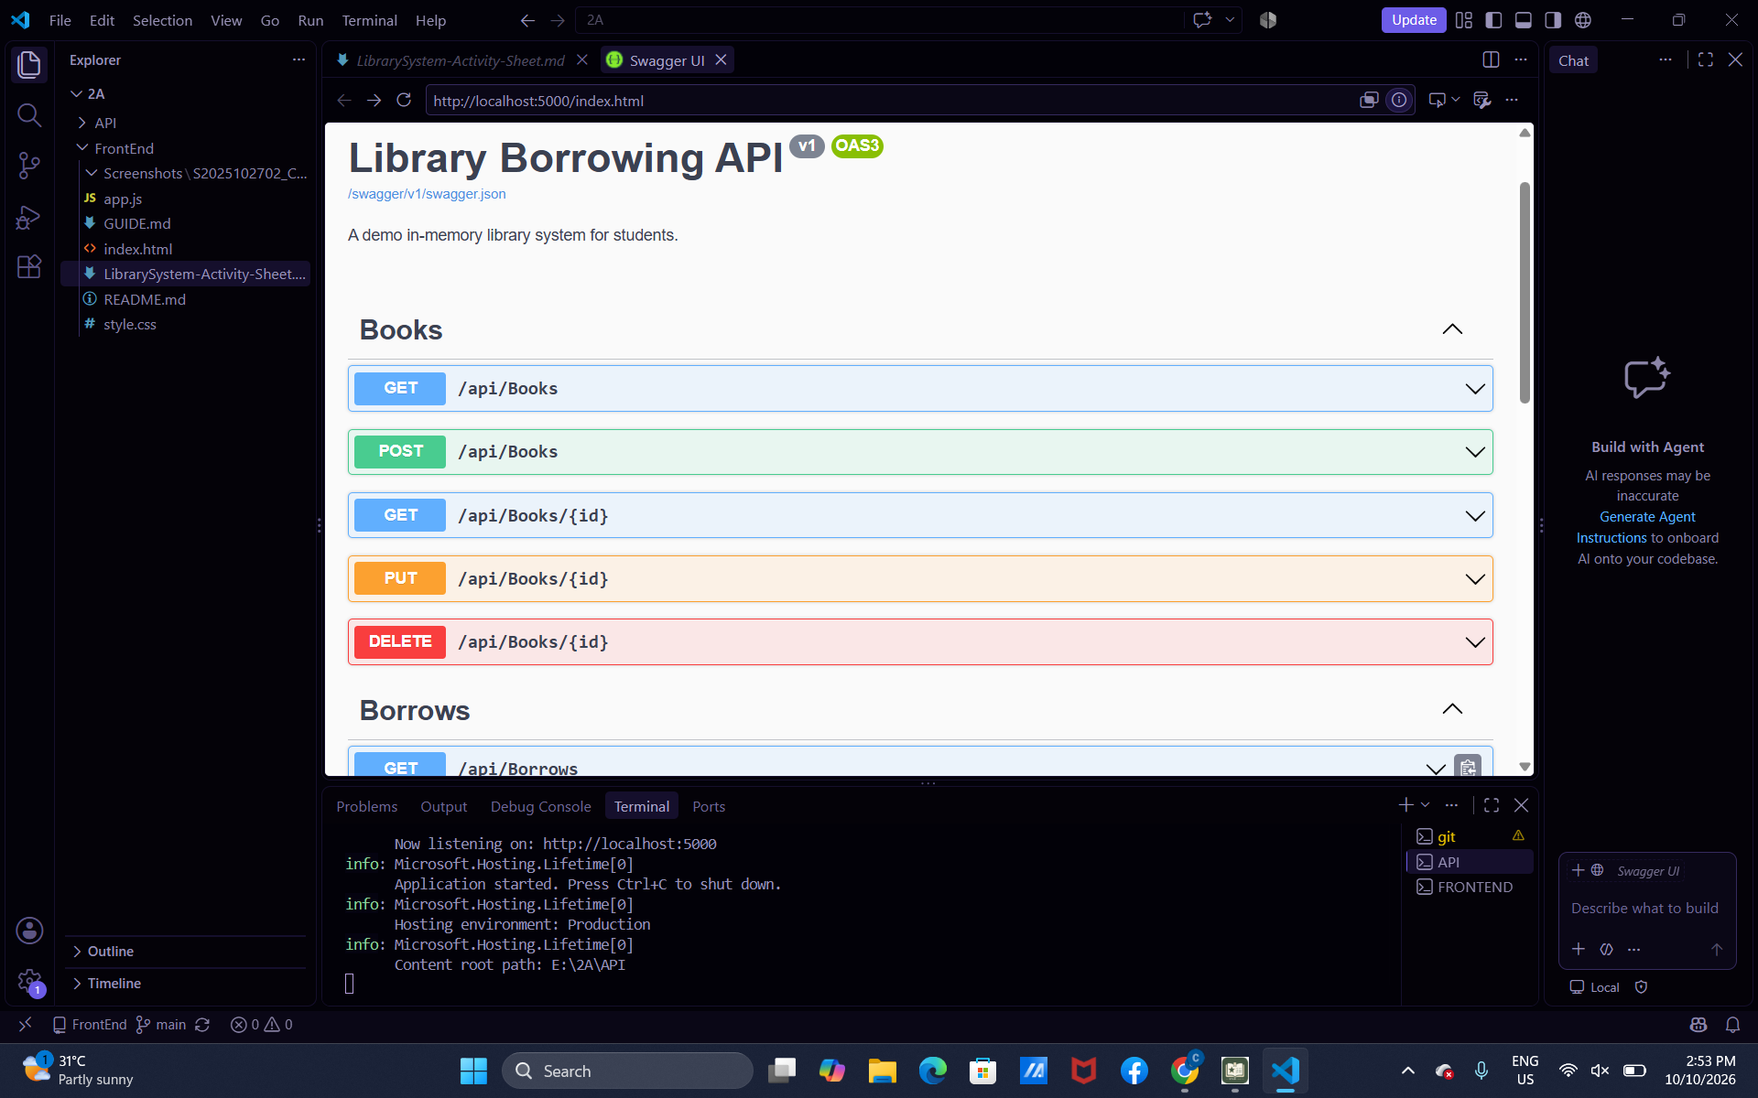

setup-02-api-books-json
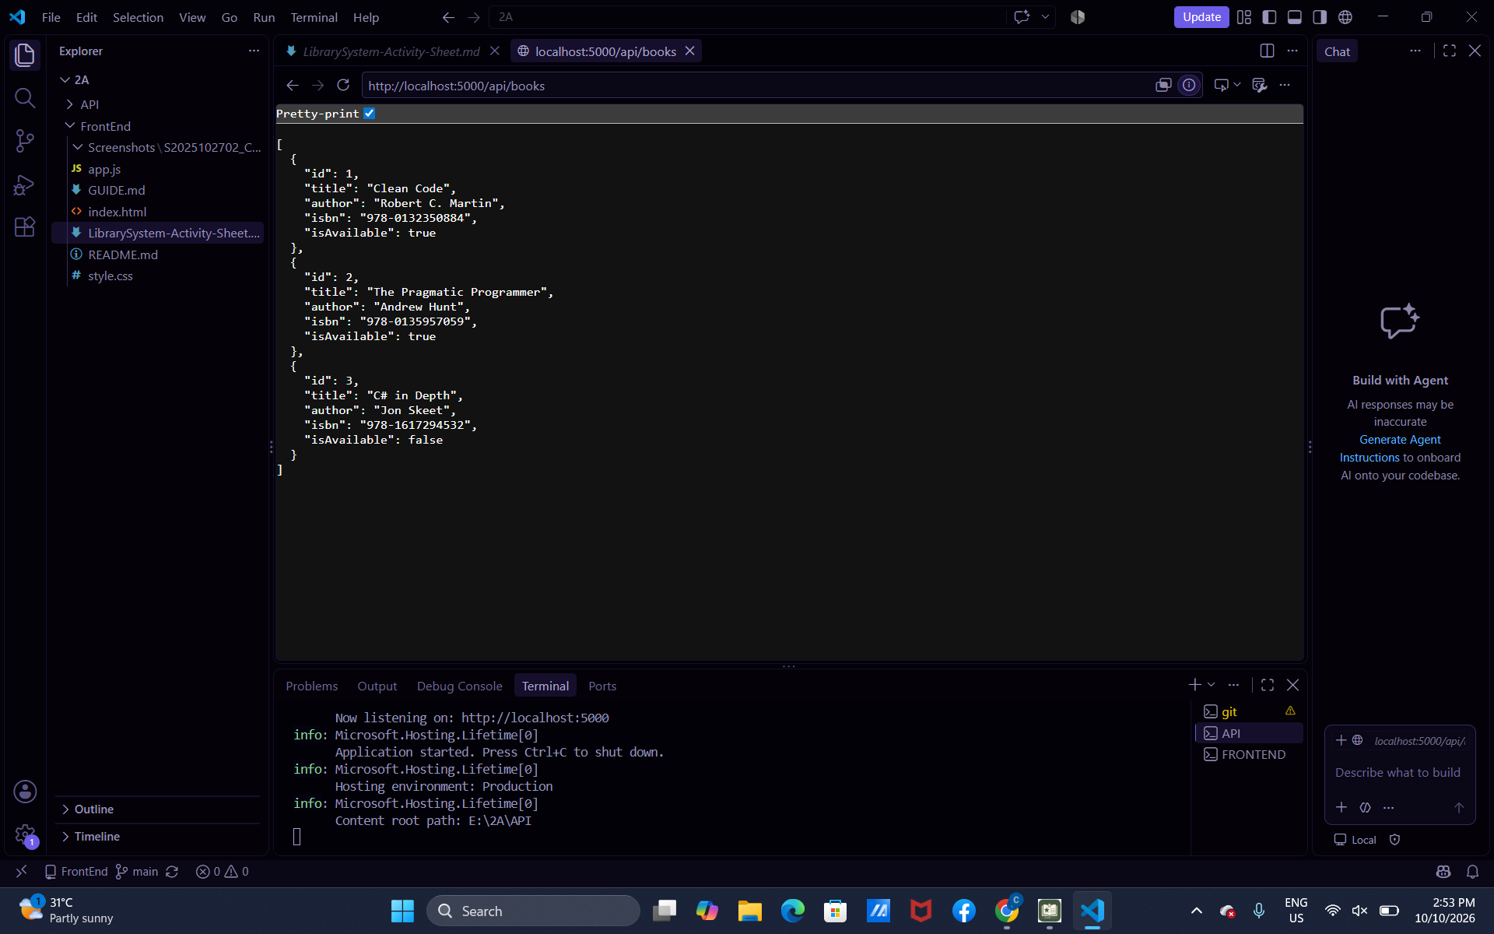
Part-01-settings-apifetch
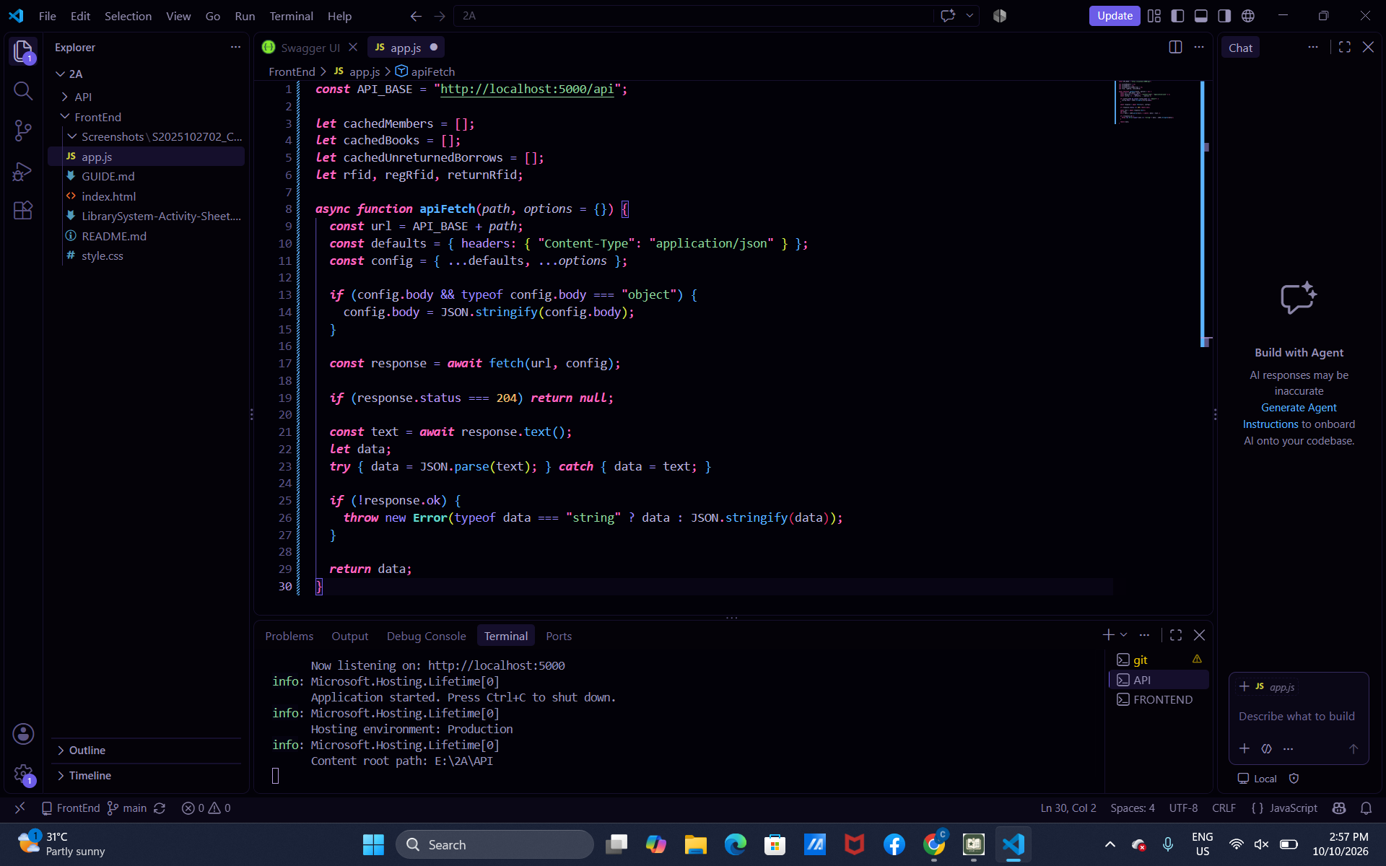

Part-02-showtoast
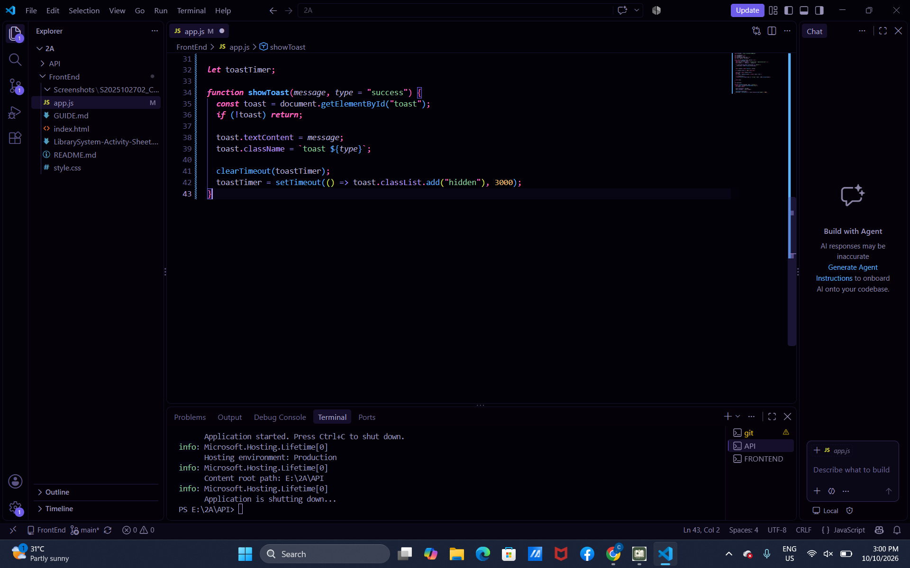
Early-toast-01
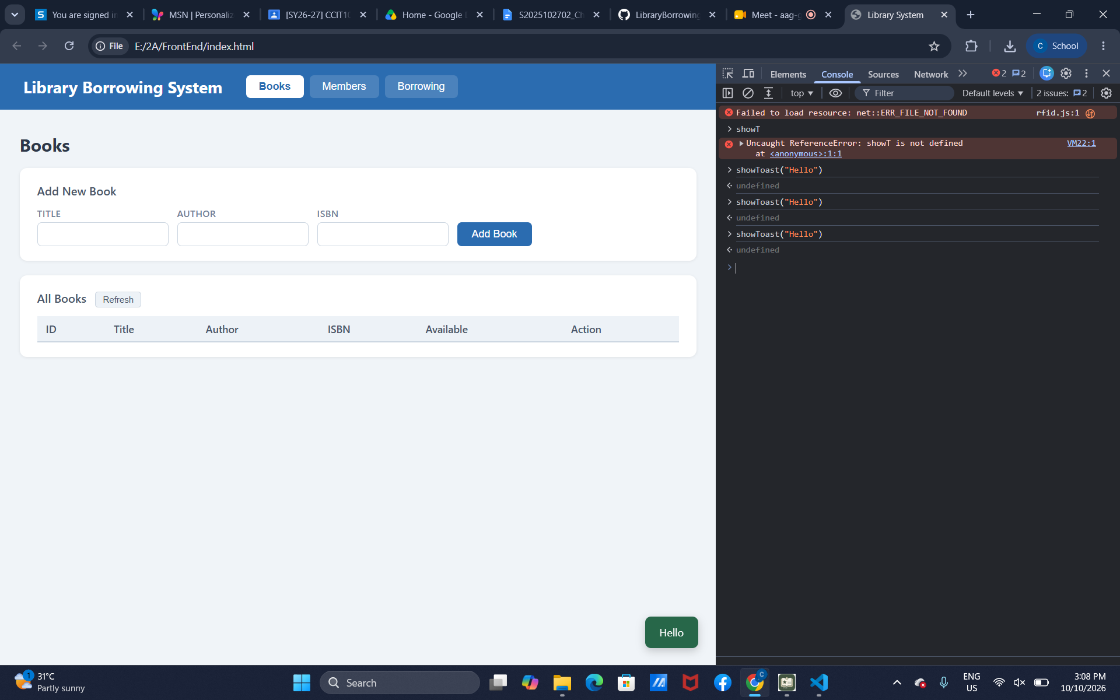
Part-03-caches
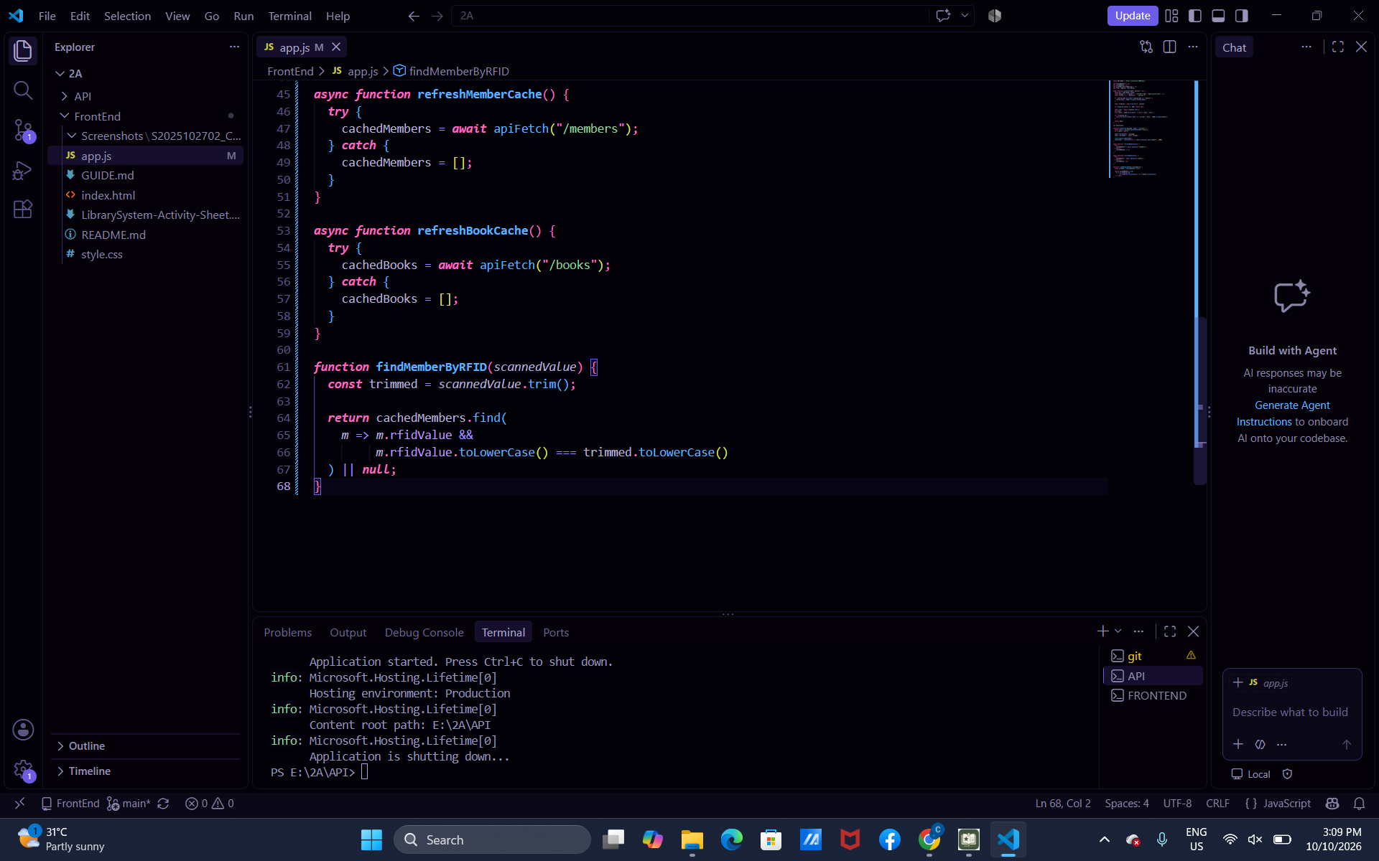

Early-02-cache-console
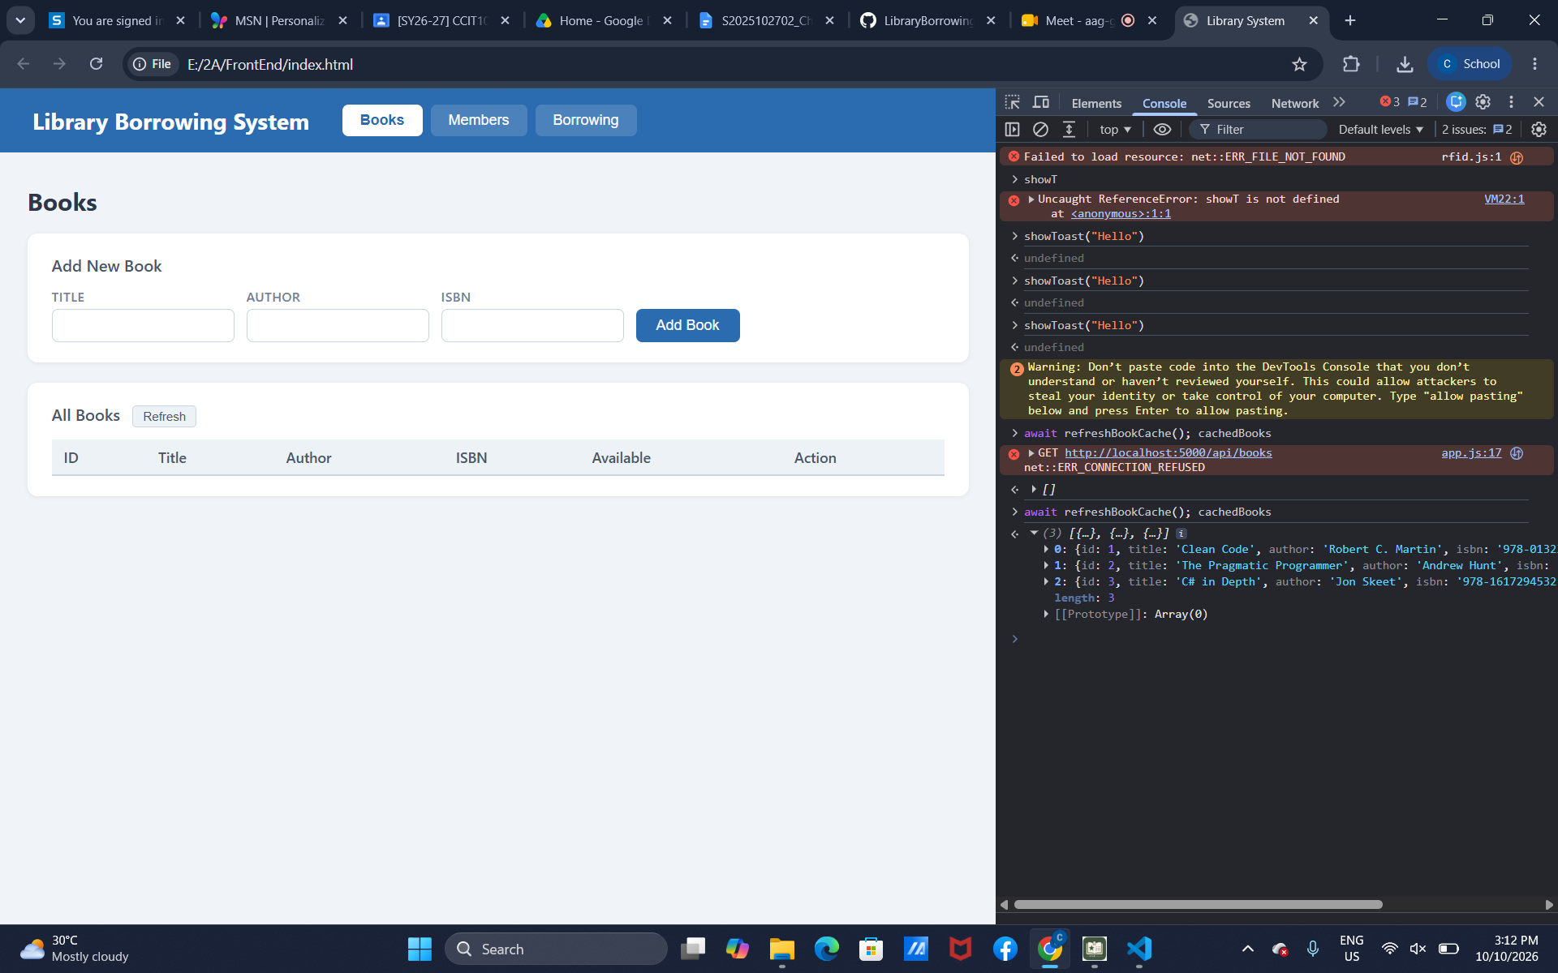

Part-04-tabs-refresh
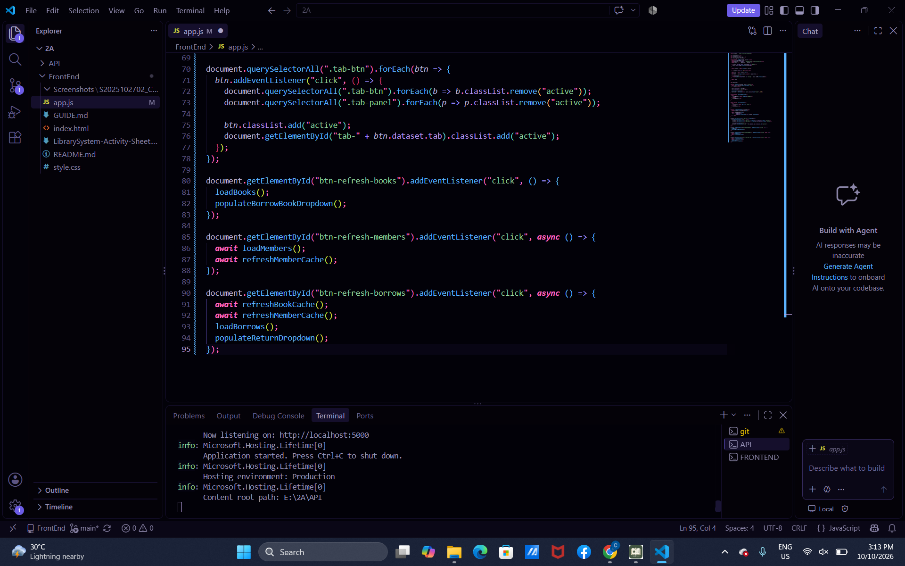
early-03-tabs
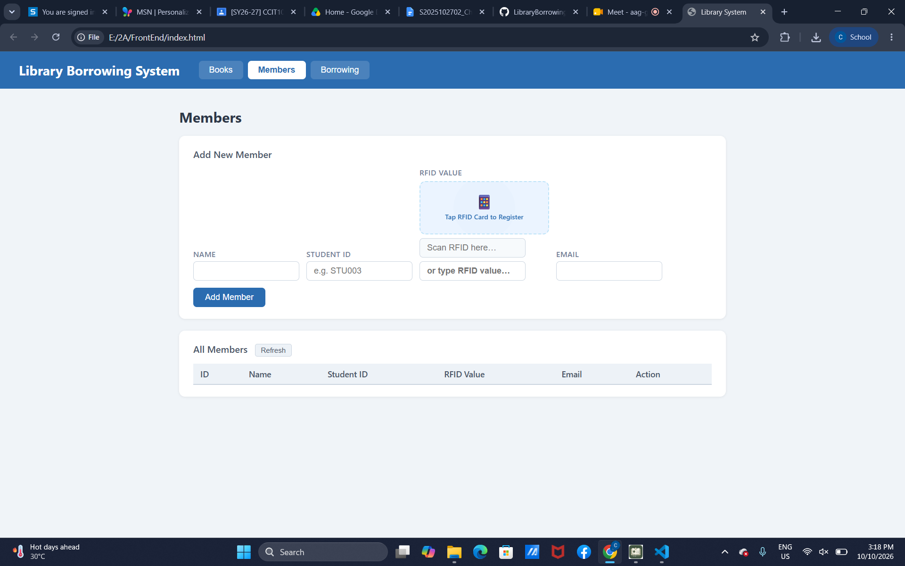

Part-05-loadbooks
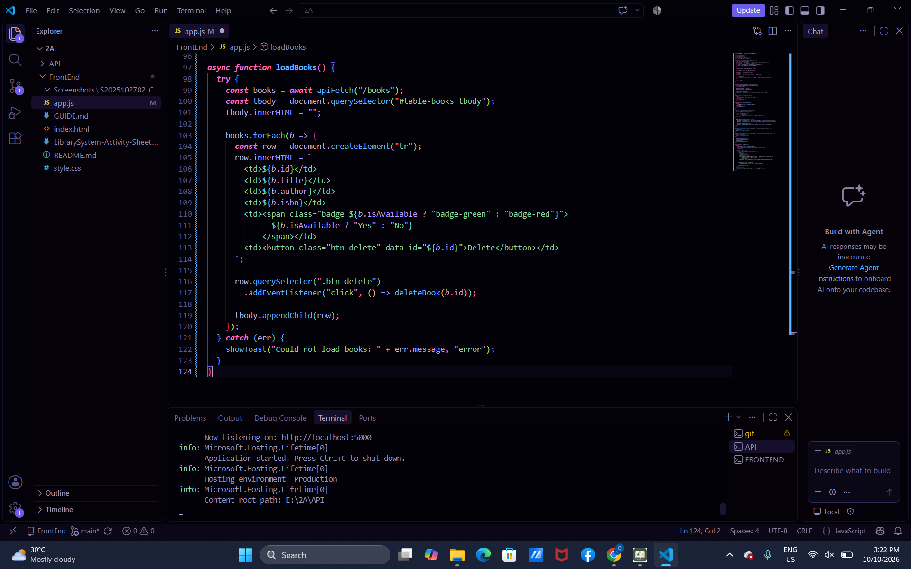
Part-06-deletebook
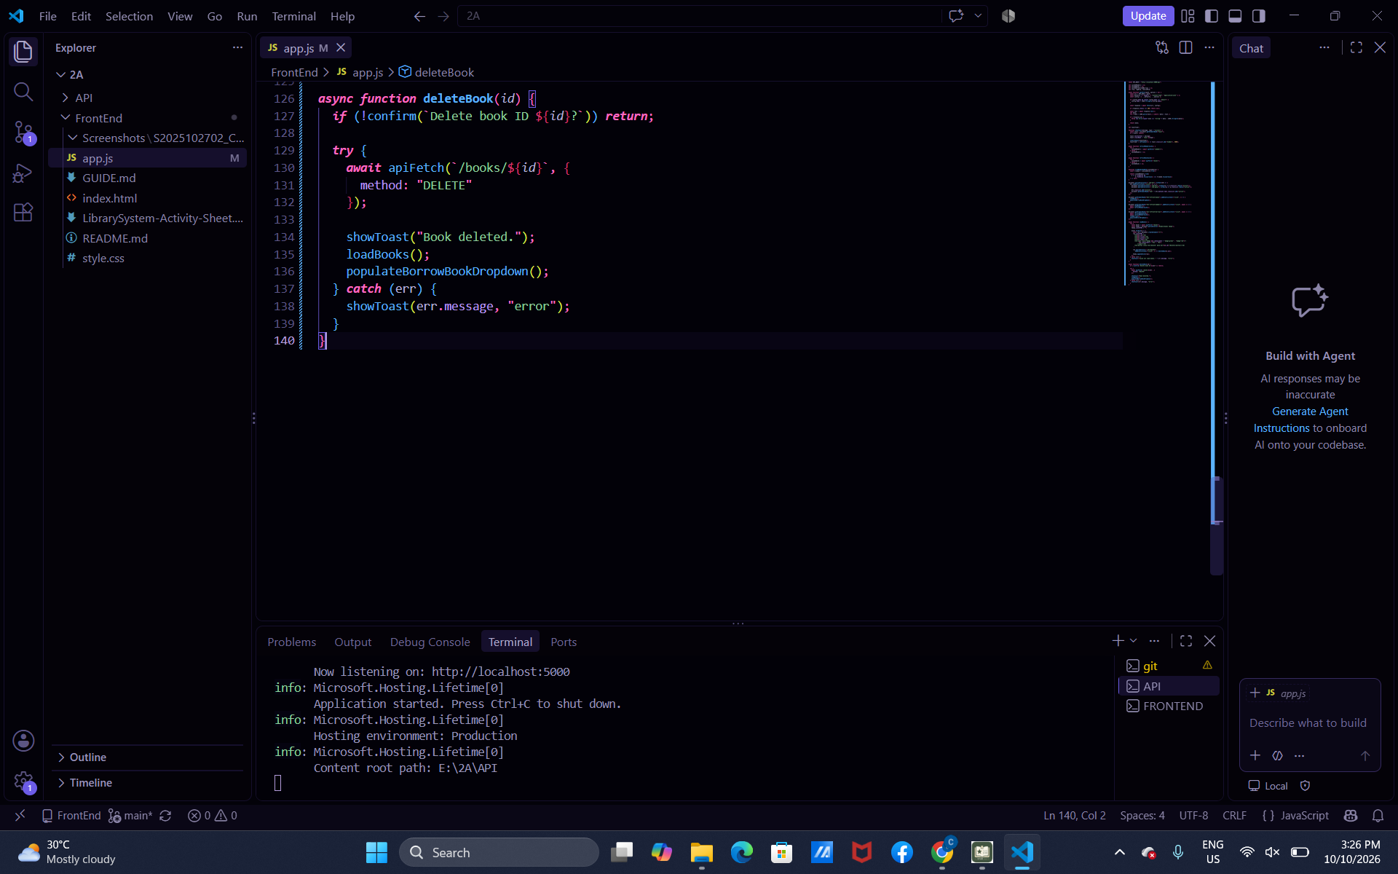

Part-07-addbook
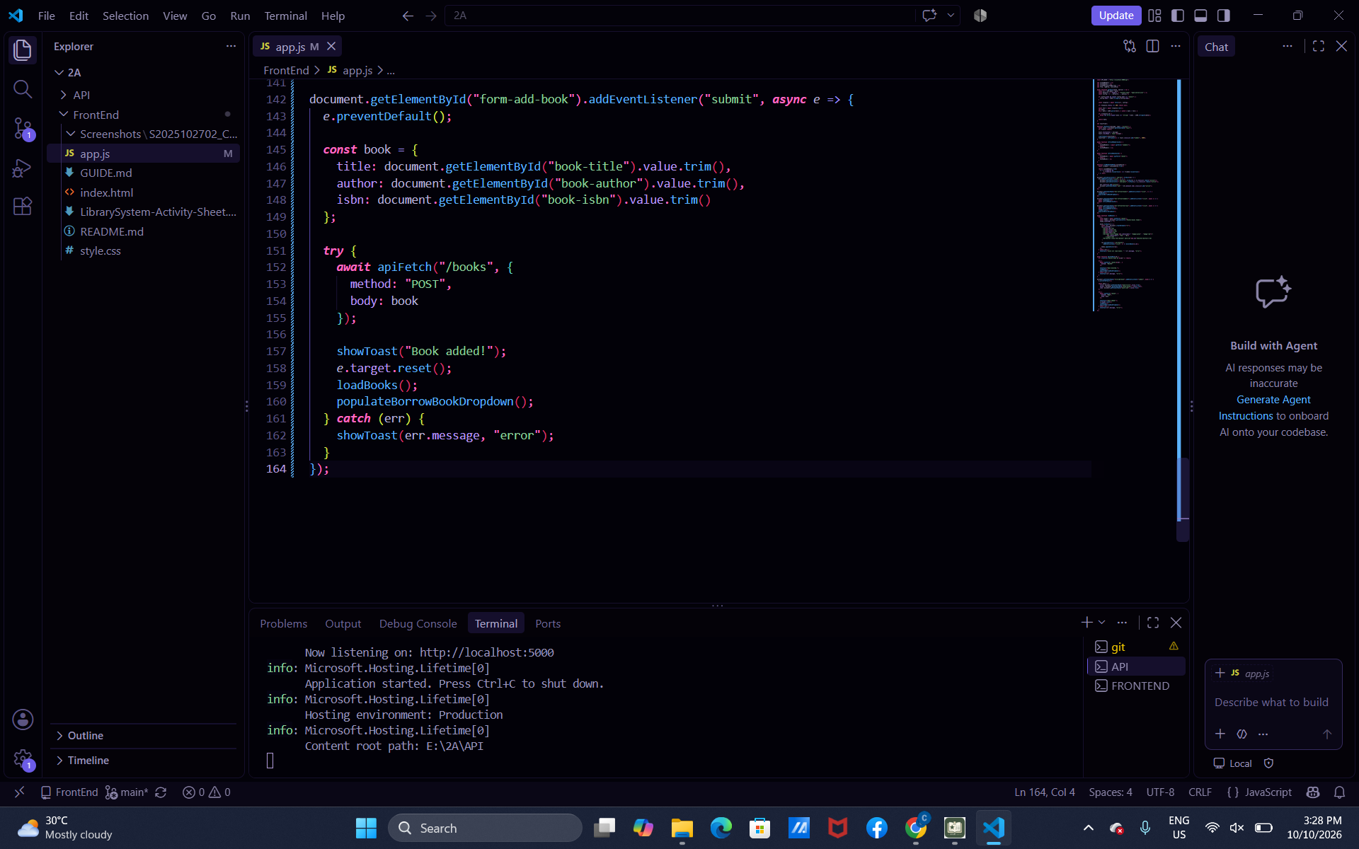
Part-08-loadmembers
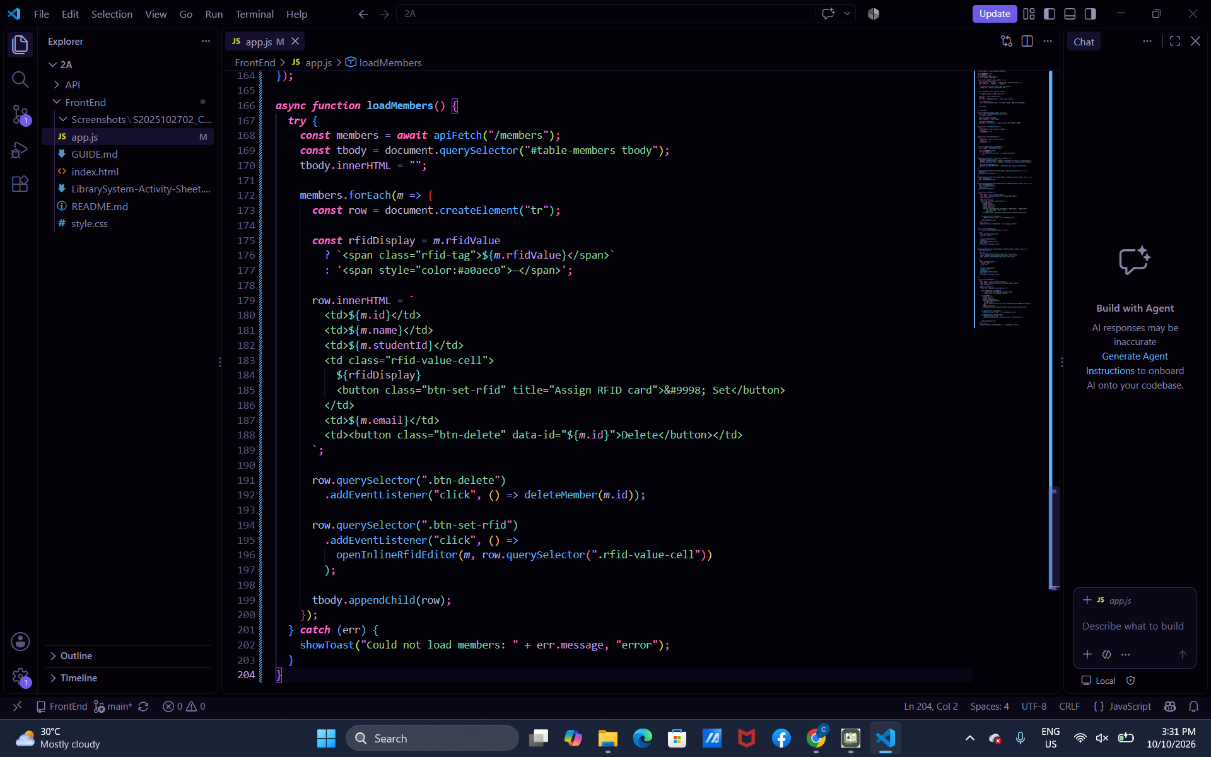

Part-09-deletemember
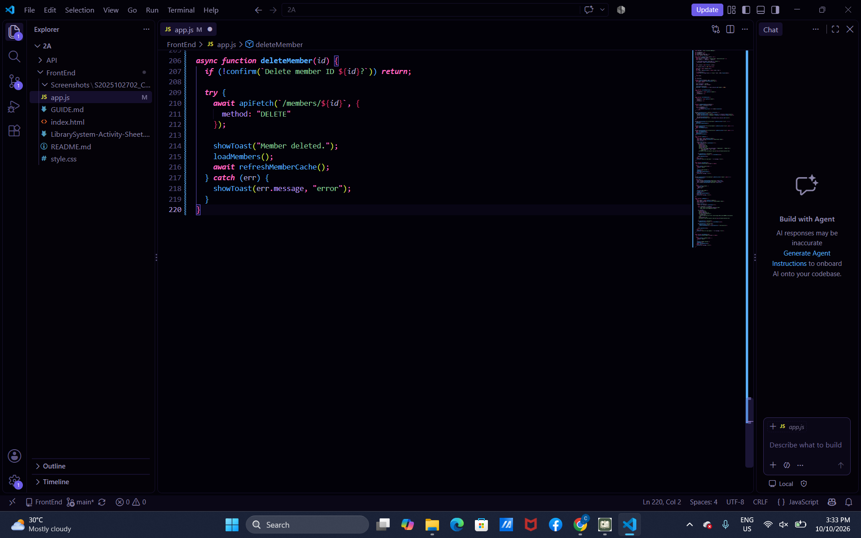
Part-10-addmember
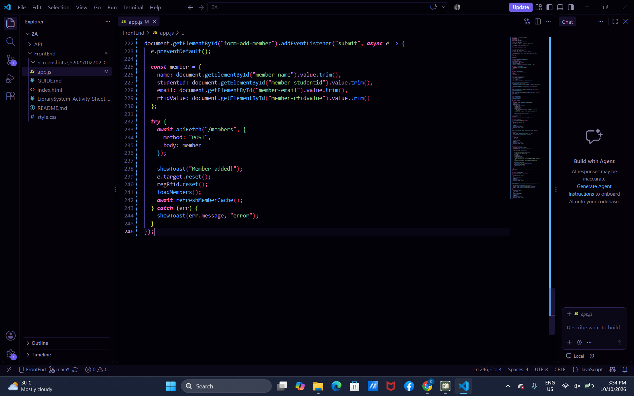

Part-11a-inline-rfid-editor
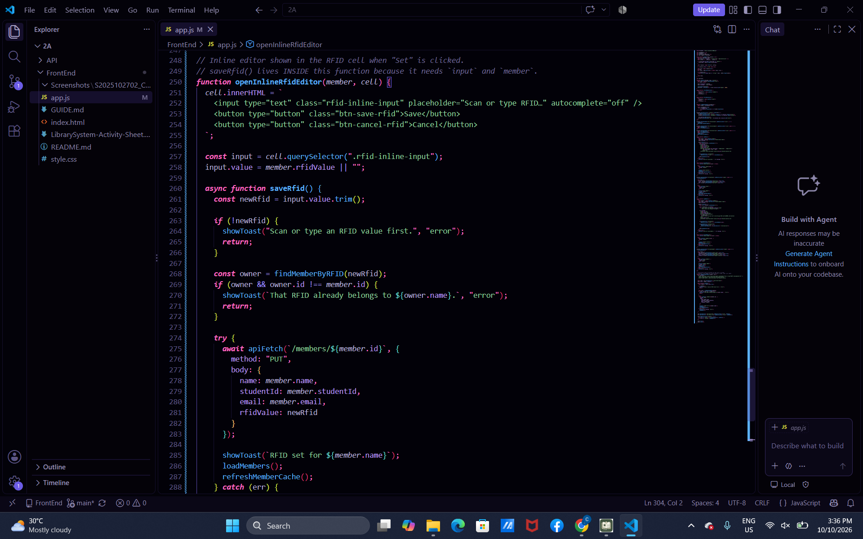
Part-11b-inline-rfid-editor
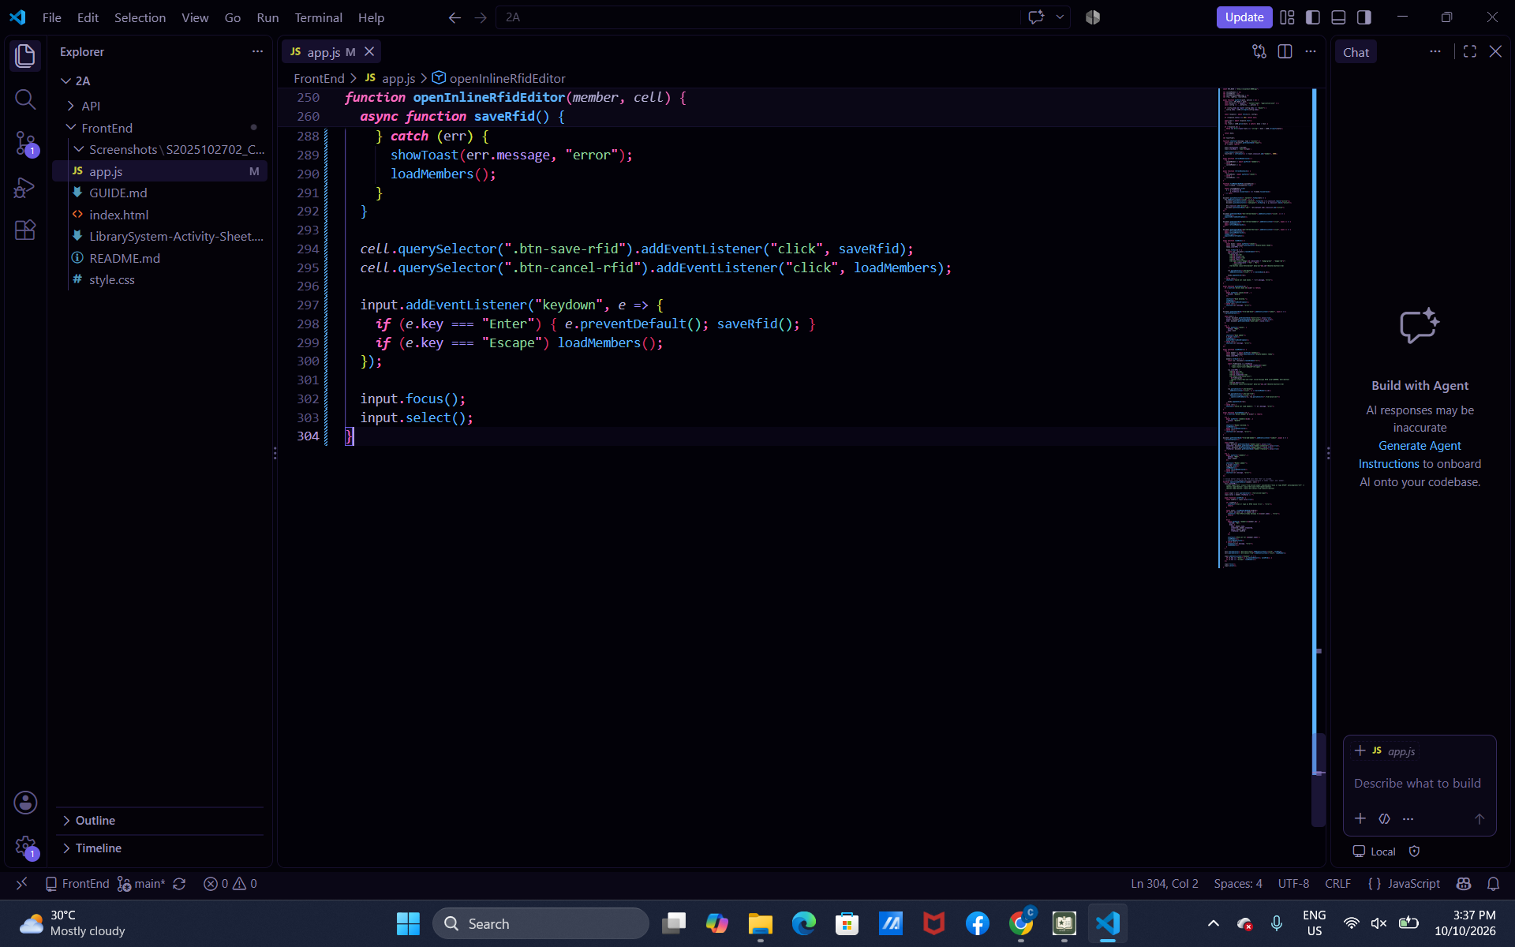

Part-12a-rfid-widget-builder
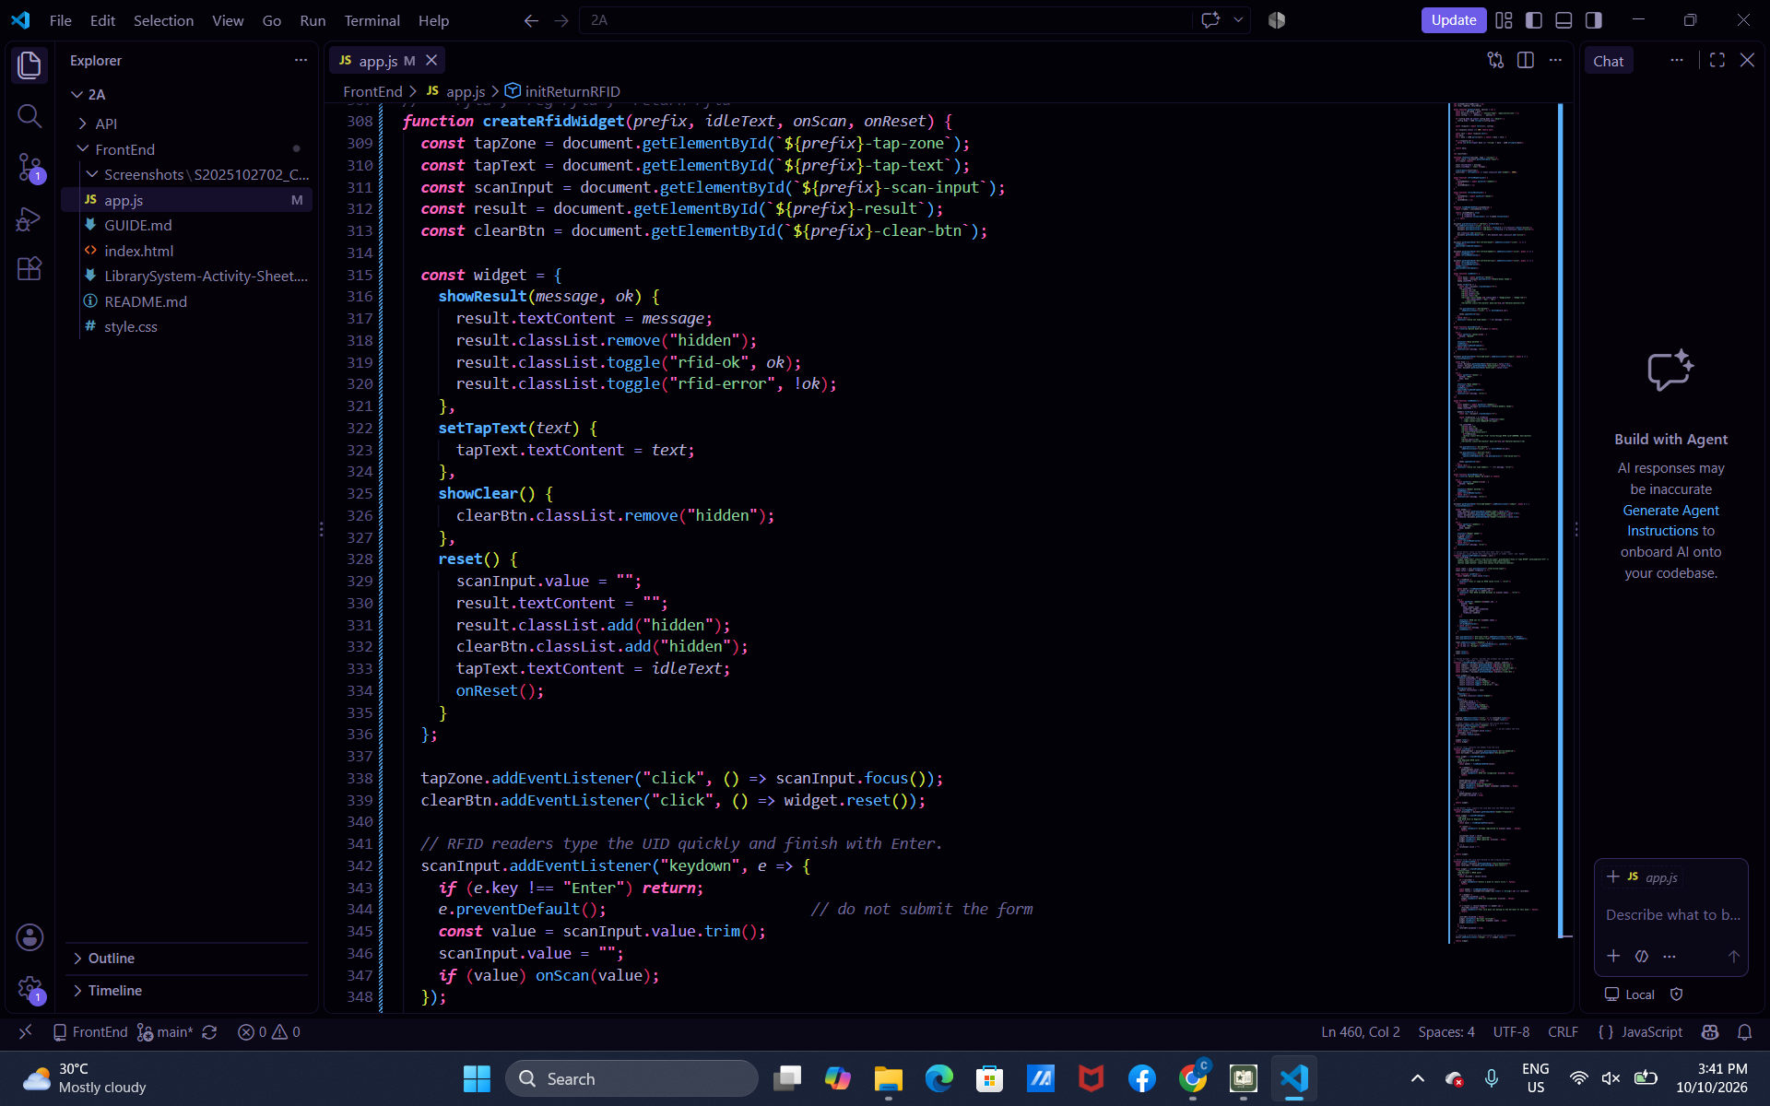
Part-12b-rfid-init-functions
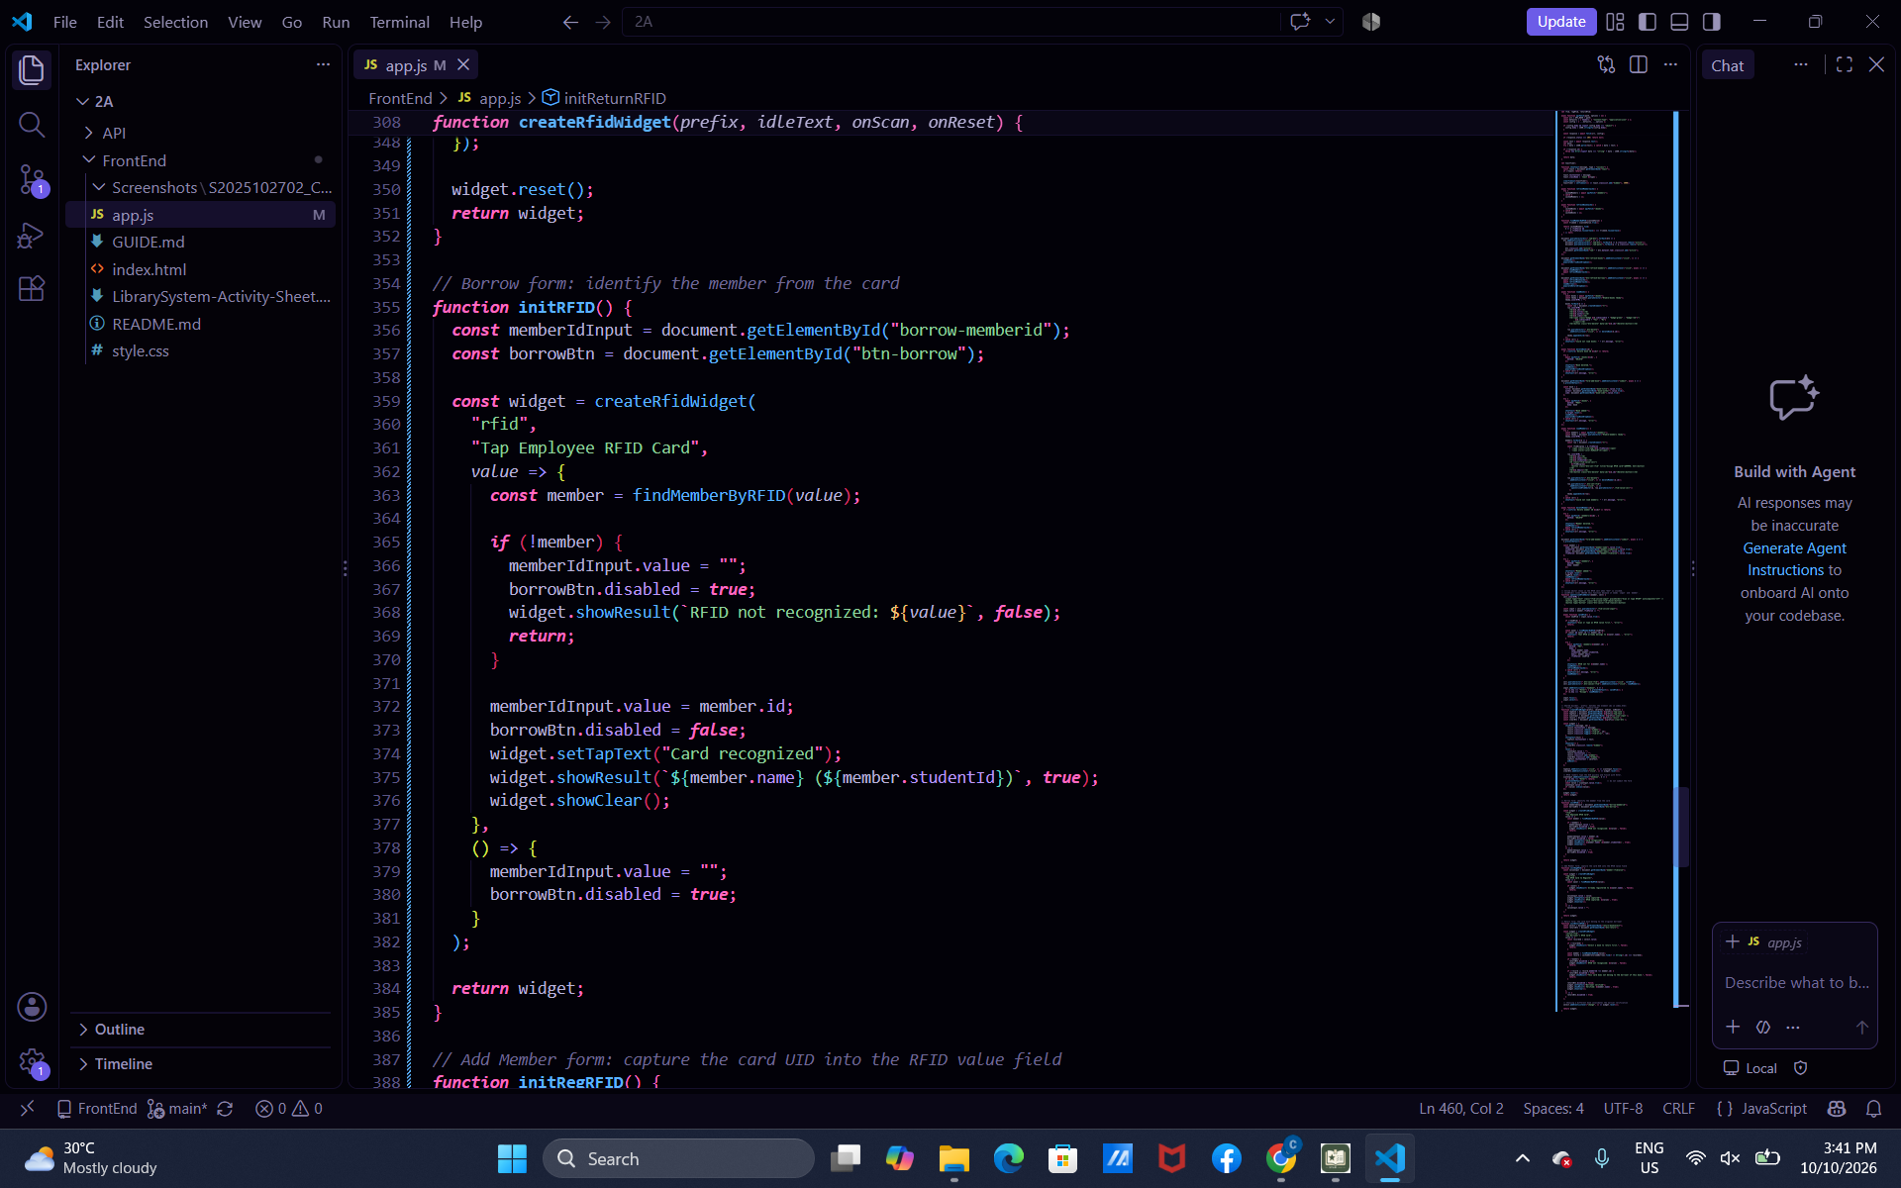
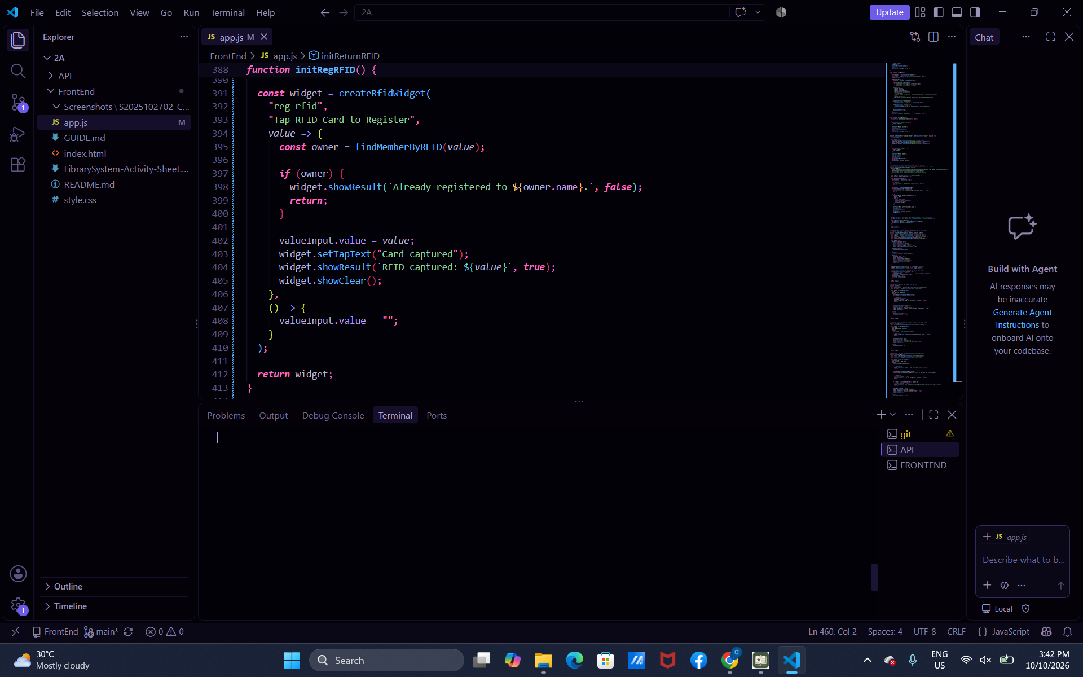
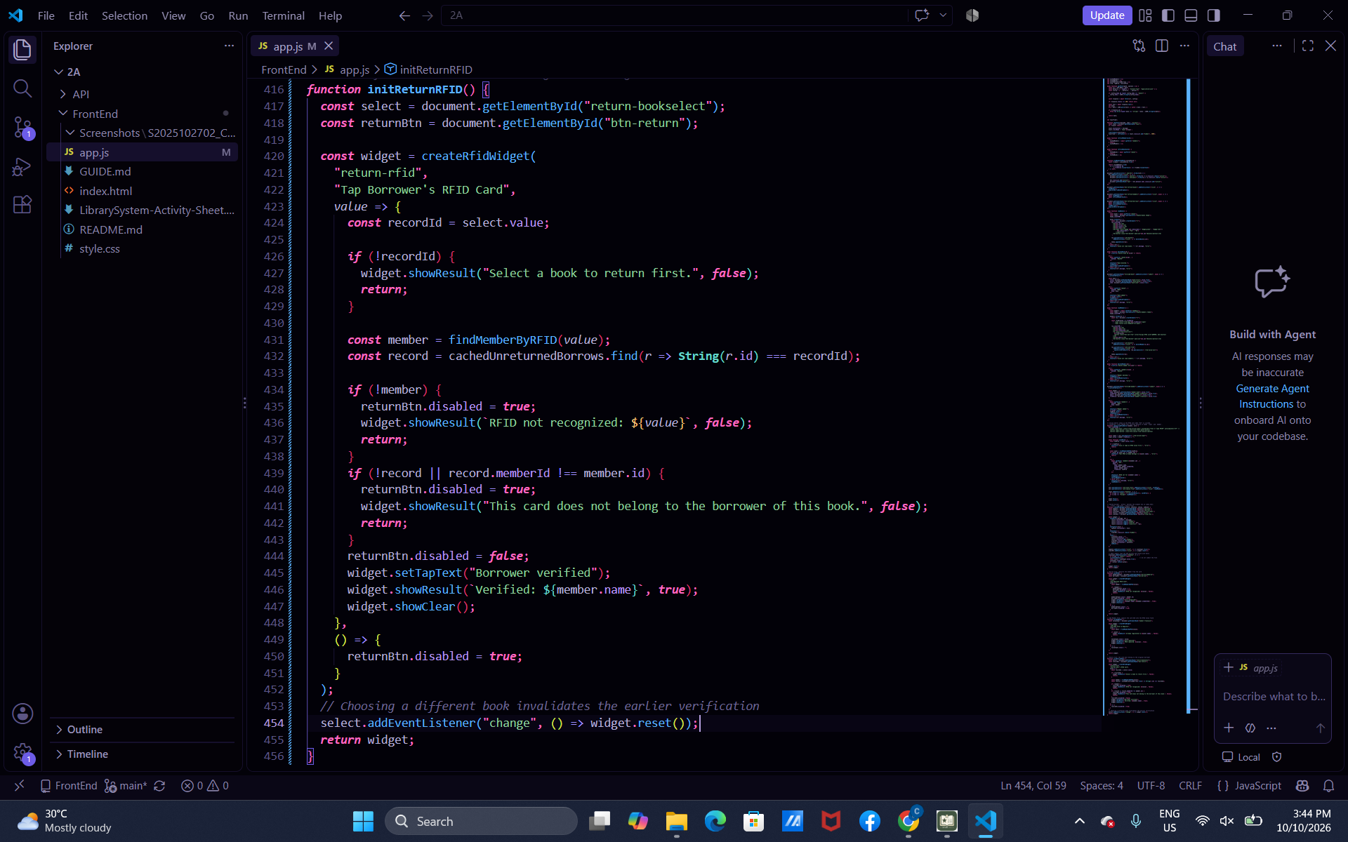

Part-13-borrow-dropdown
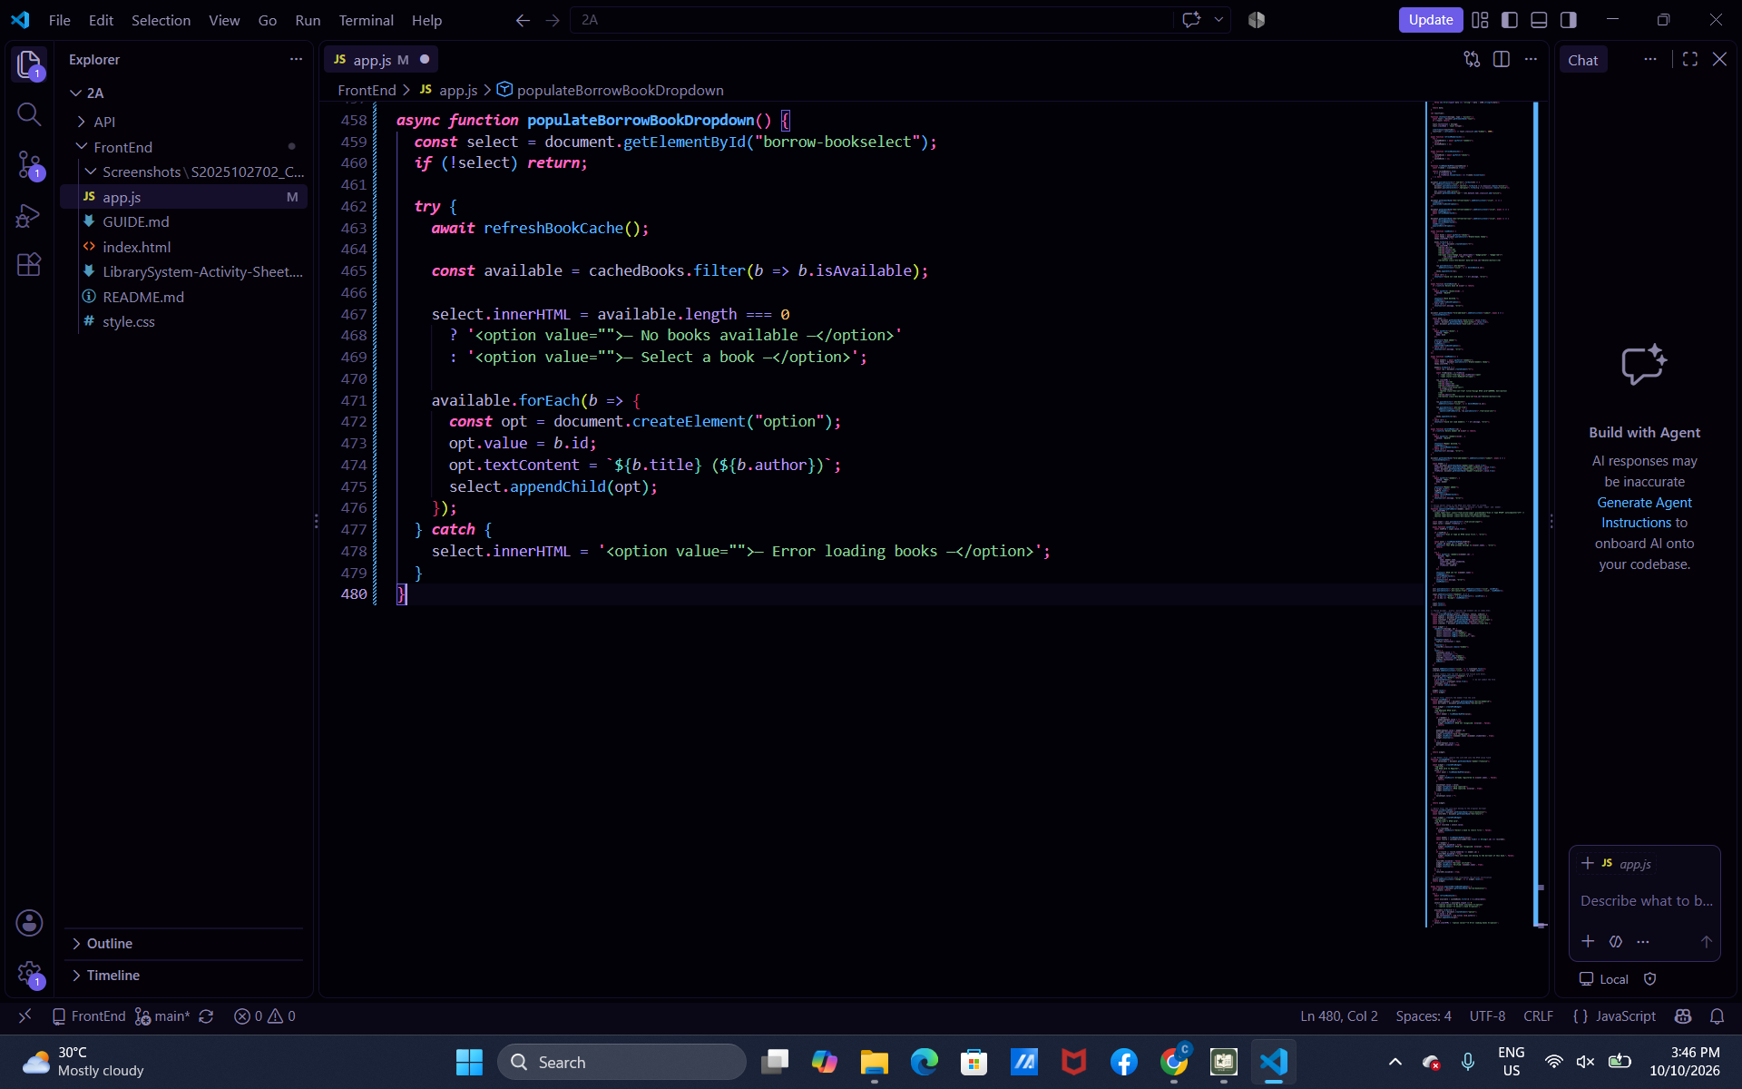

Part-14-return-dropdown
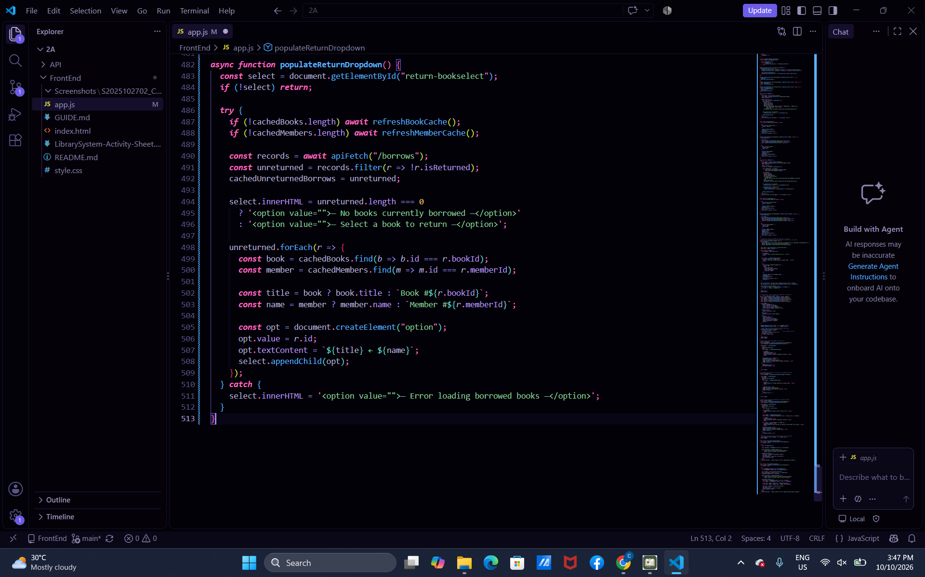

Part-15-borrow
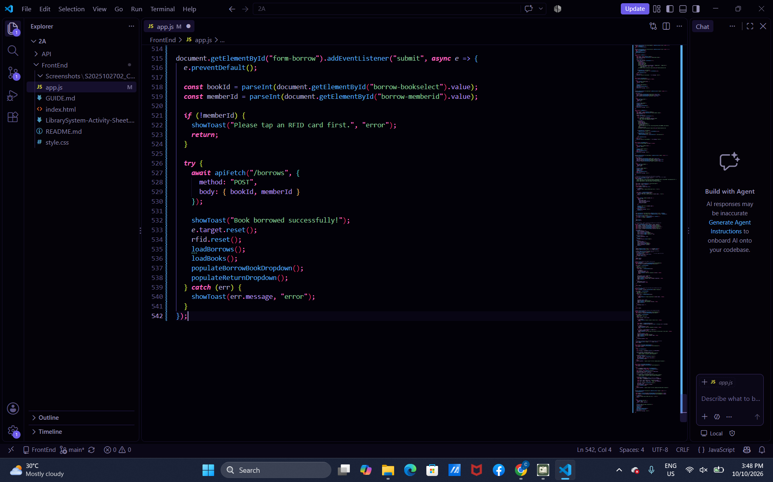
Part-16-return
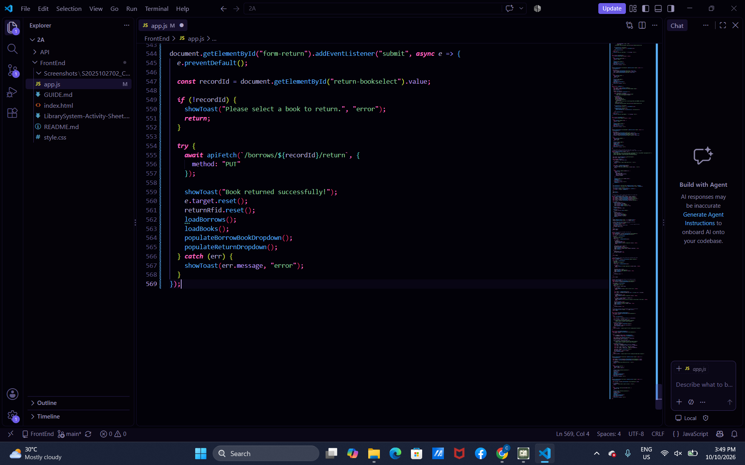

Part-17-loadborrows
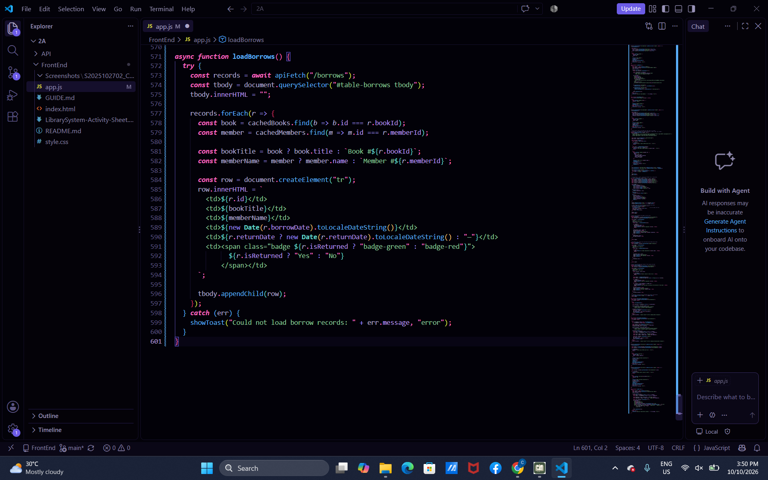
Part-18-page-load
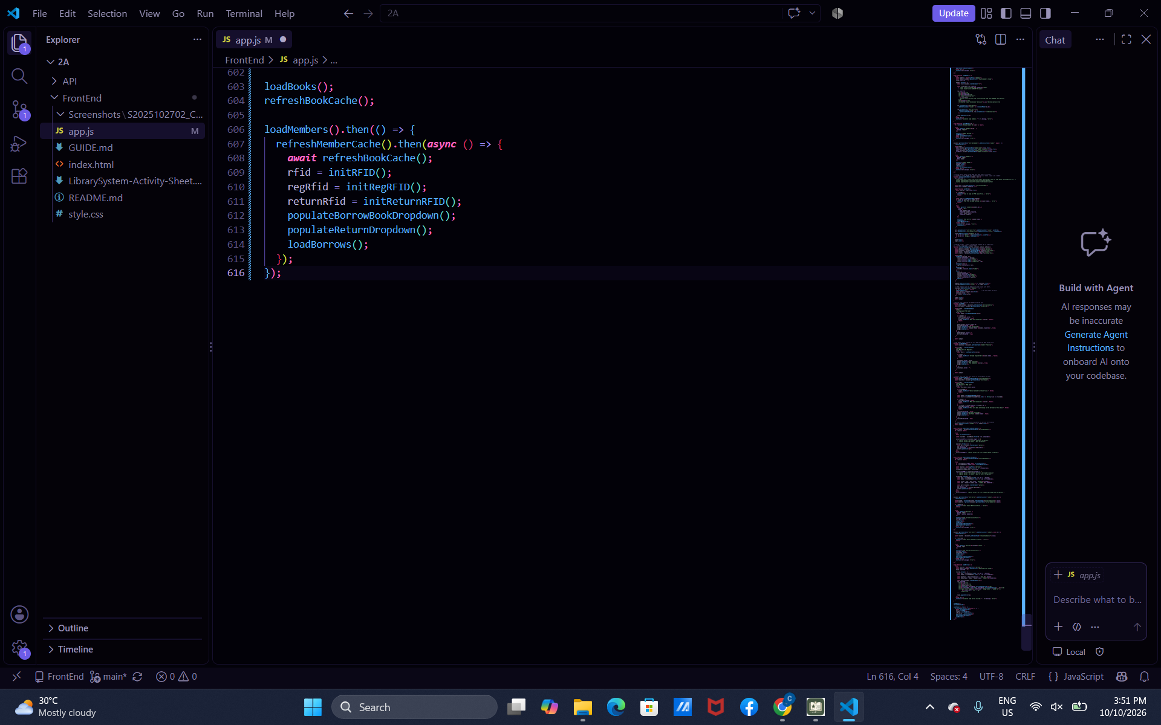

Test-01-page-loaded
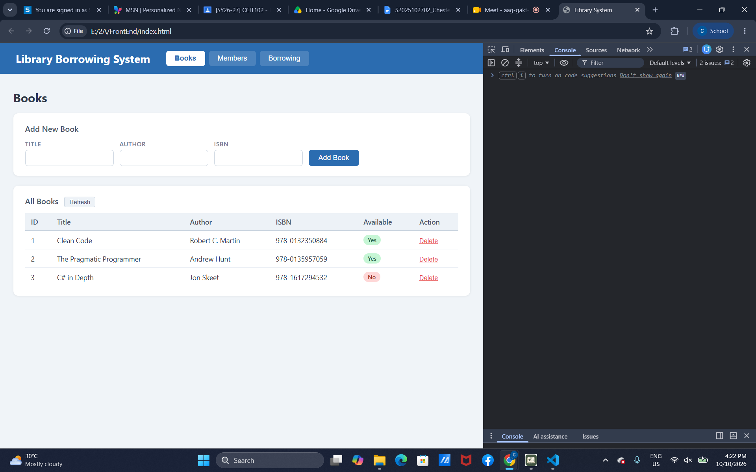
Test-02-add-book
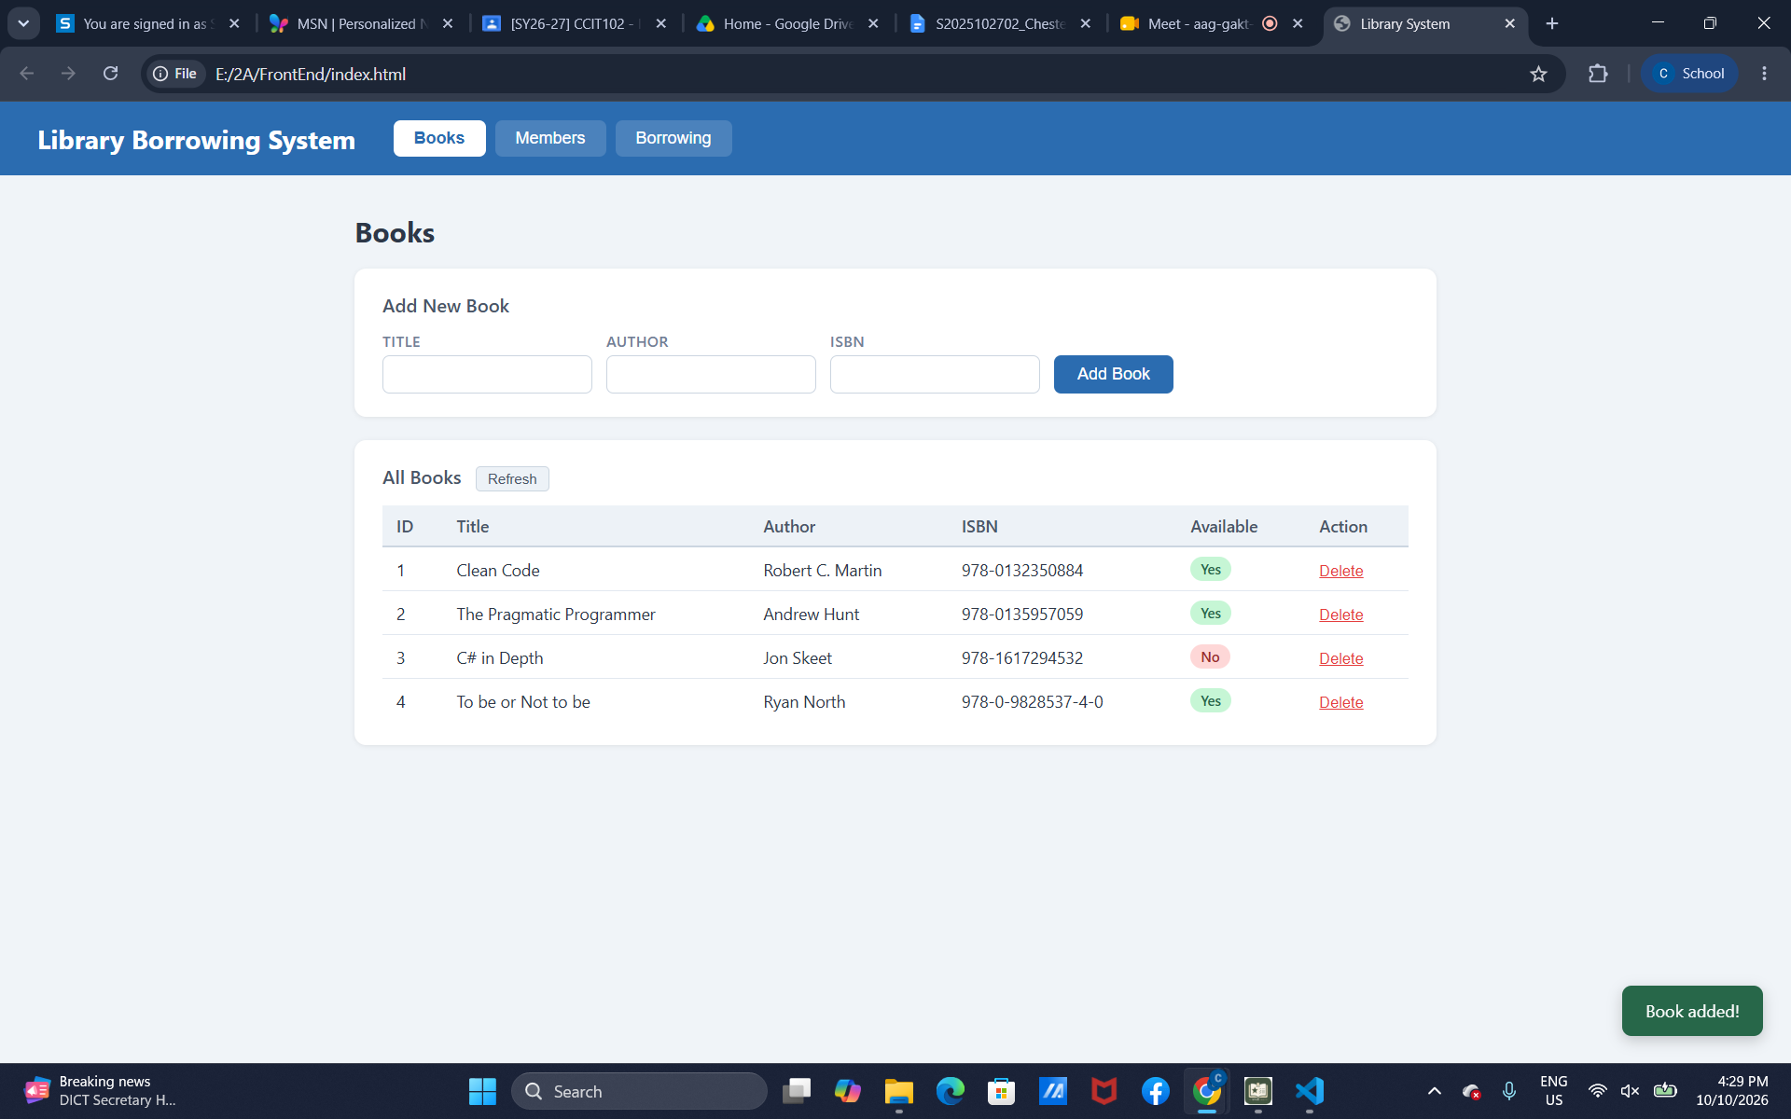
Test-03-delete-book
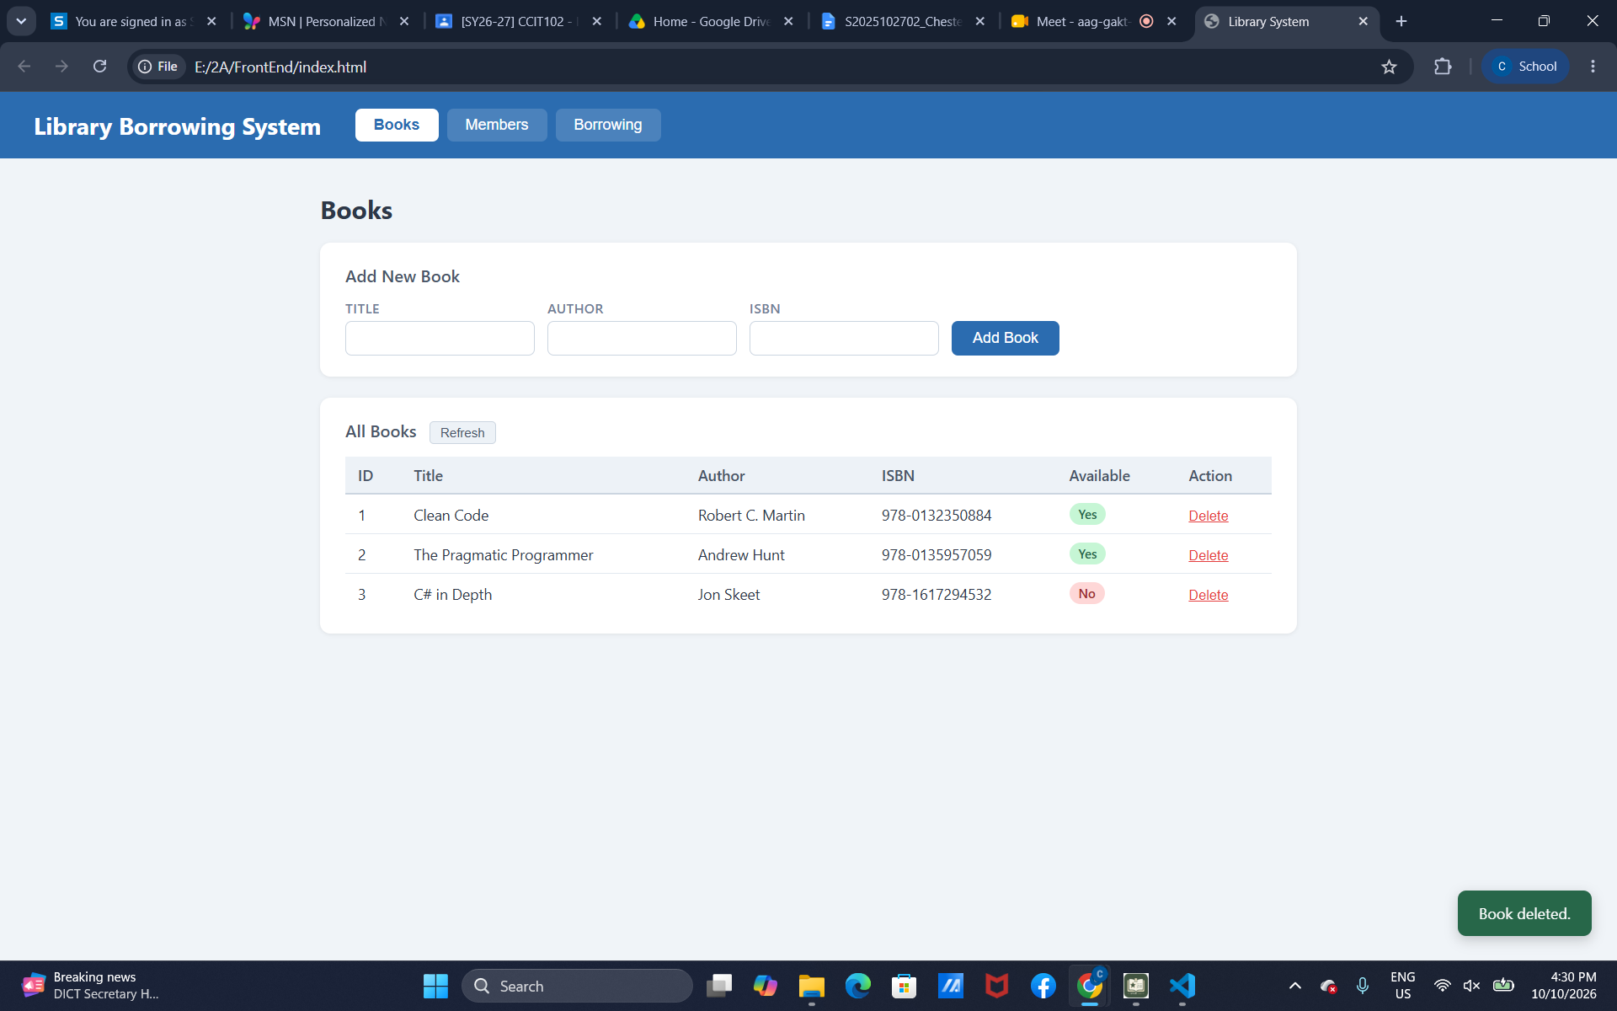

Test-04-members-loaded
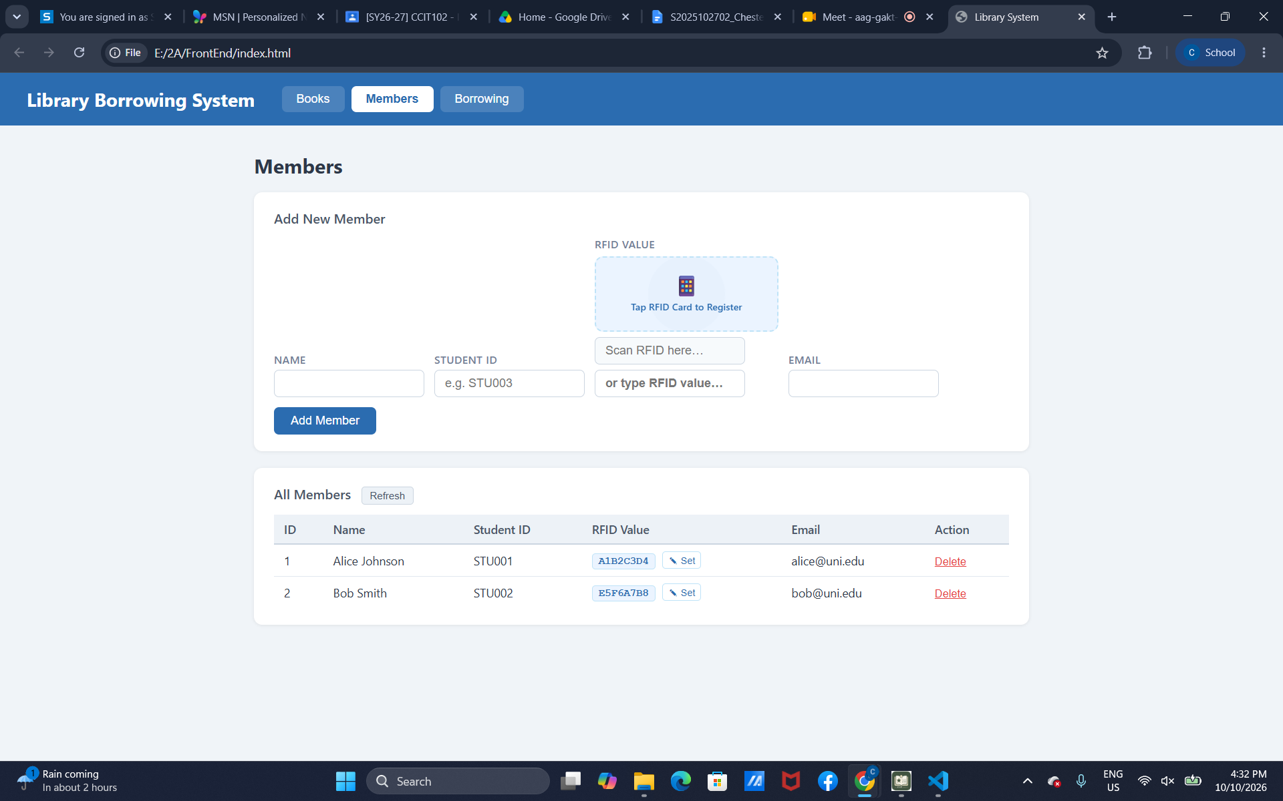
Test-05-register-rfid
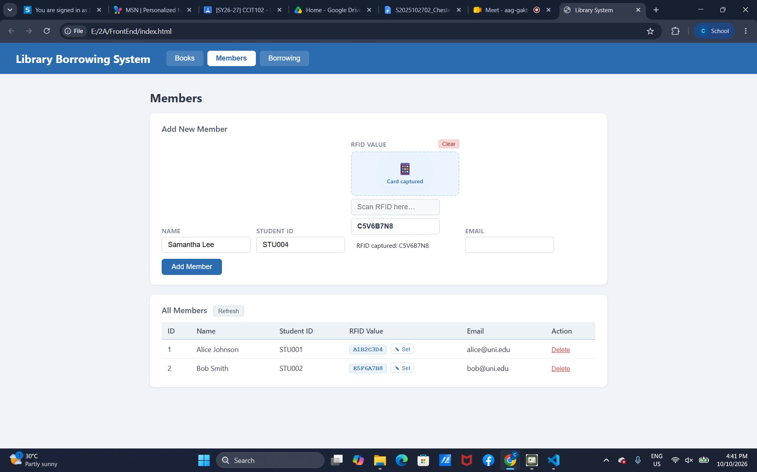

Test-06-add-member
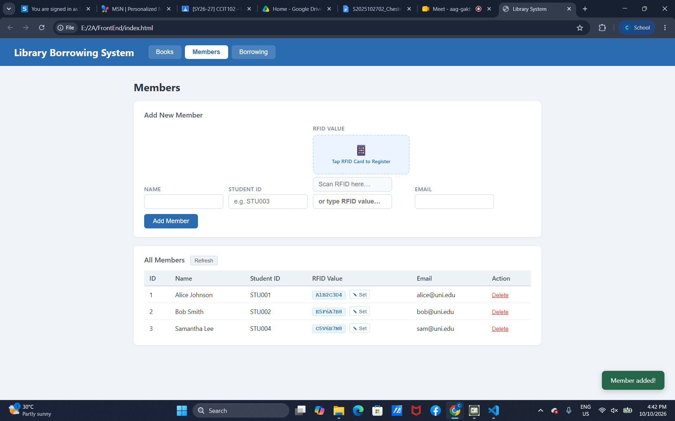
Test-07-set-rfid-saved
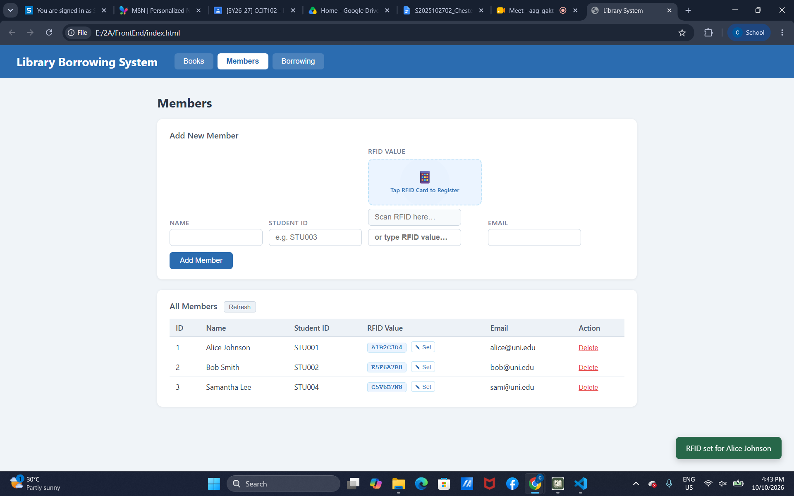

Test-08-delete-member
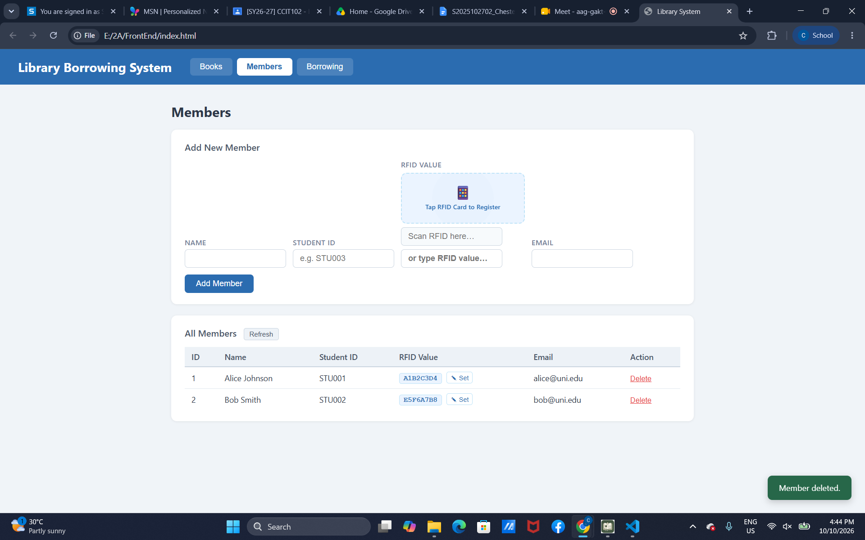
Test-09-borrow-rfid-recognized
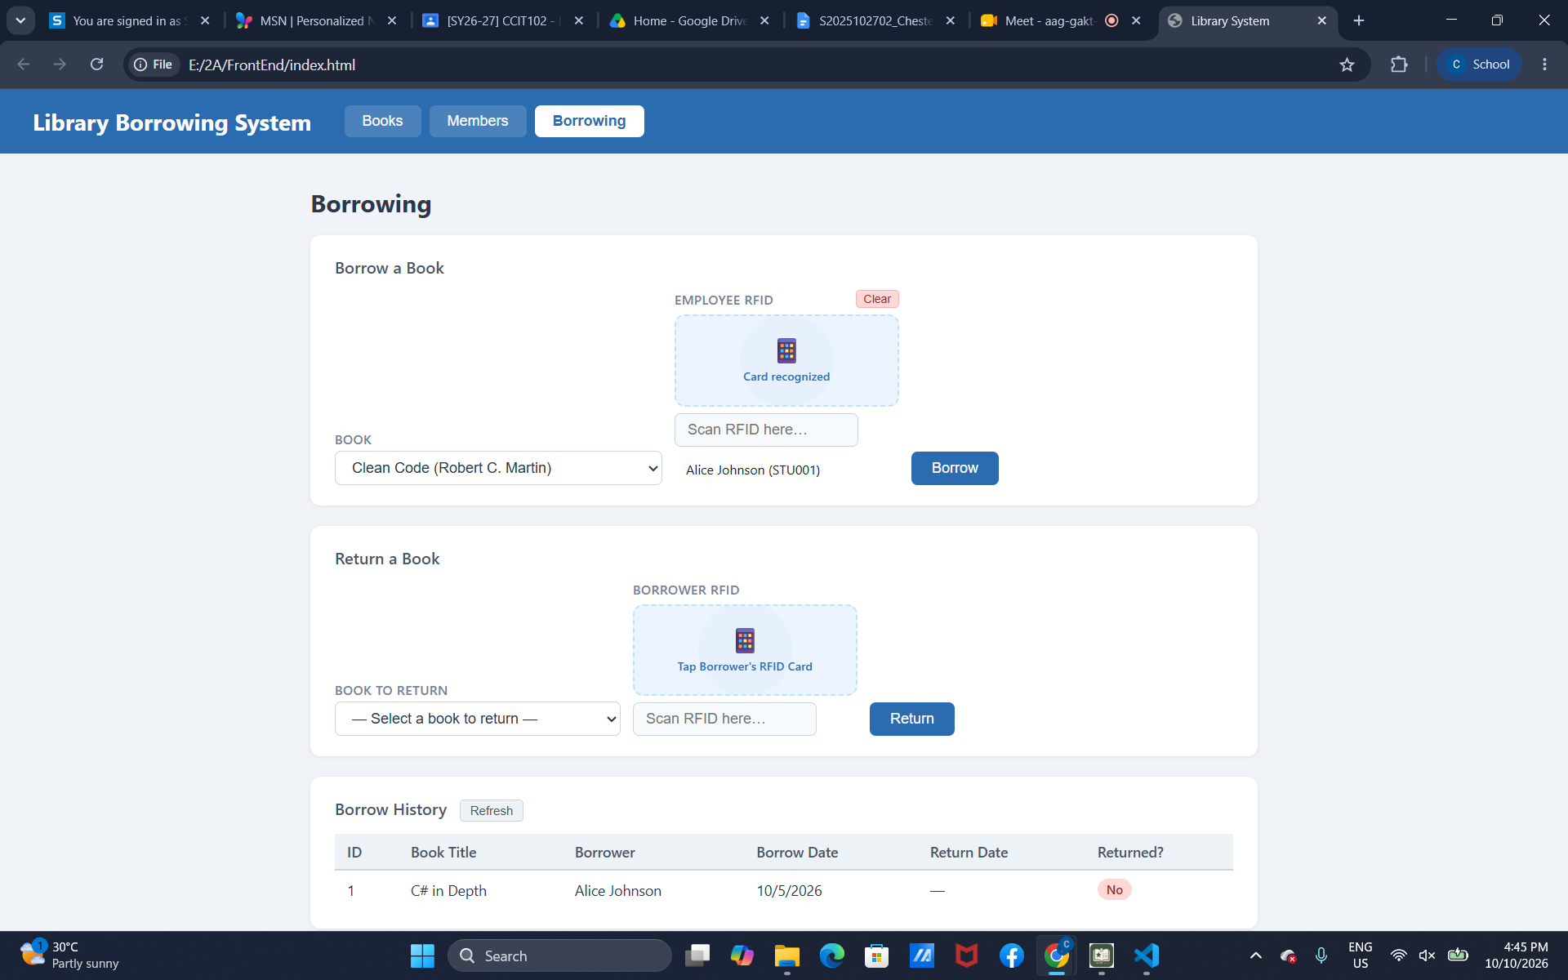

Test–10-borrow-success
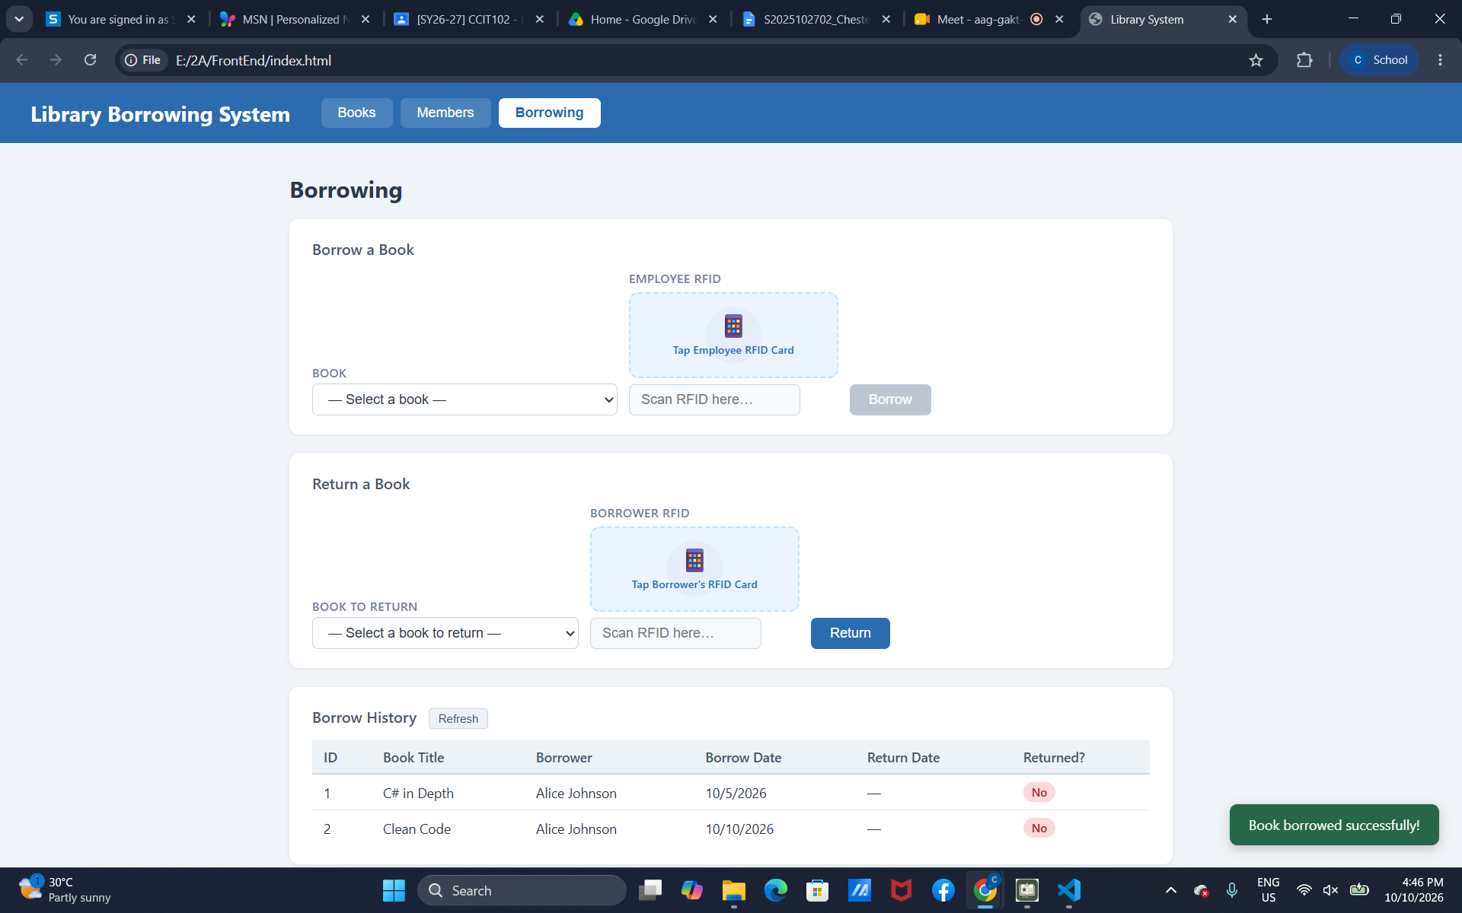
Test-11-return-wrong-card
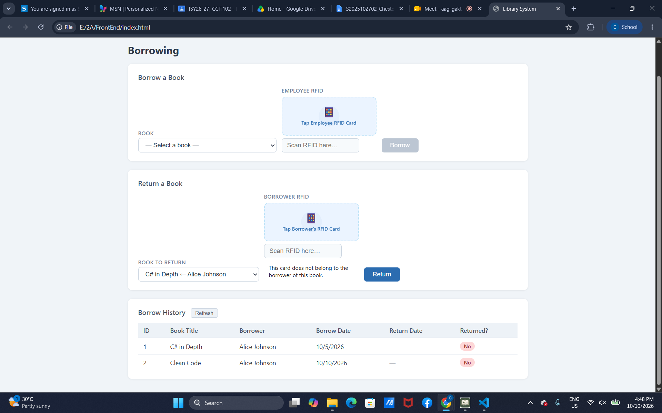

Test-12-return-verified
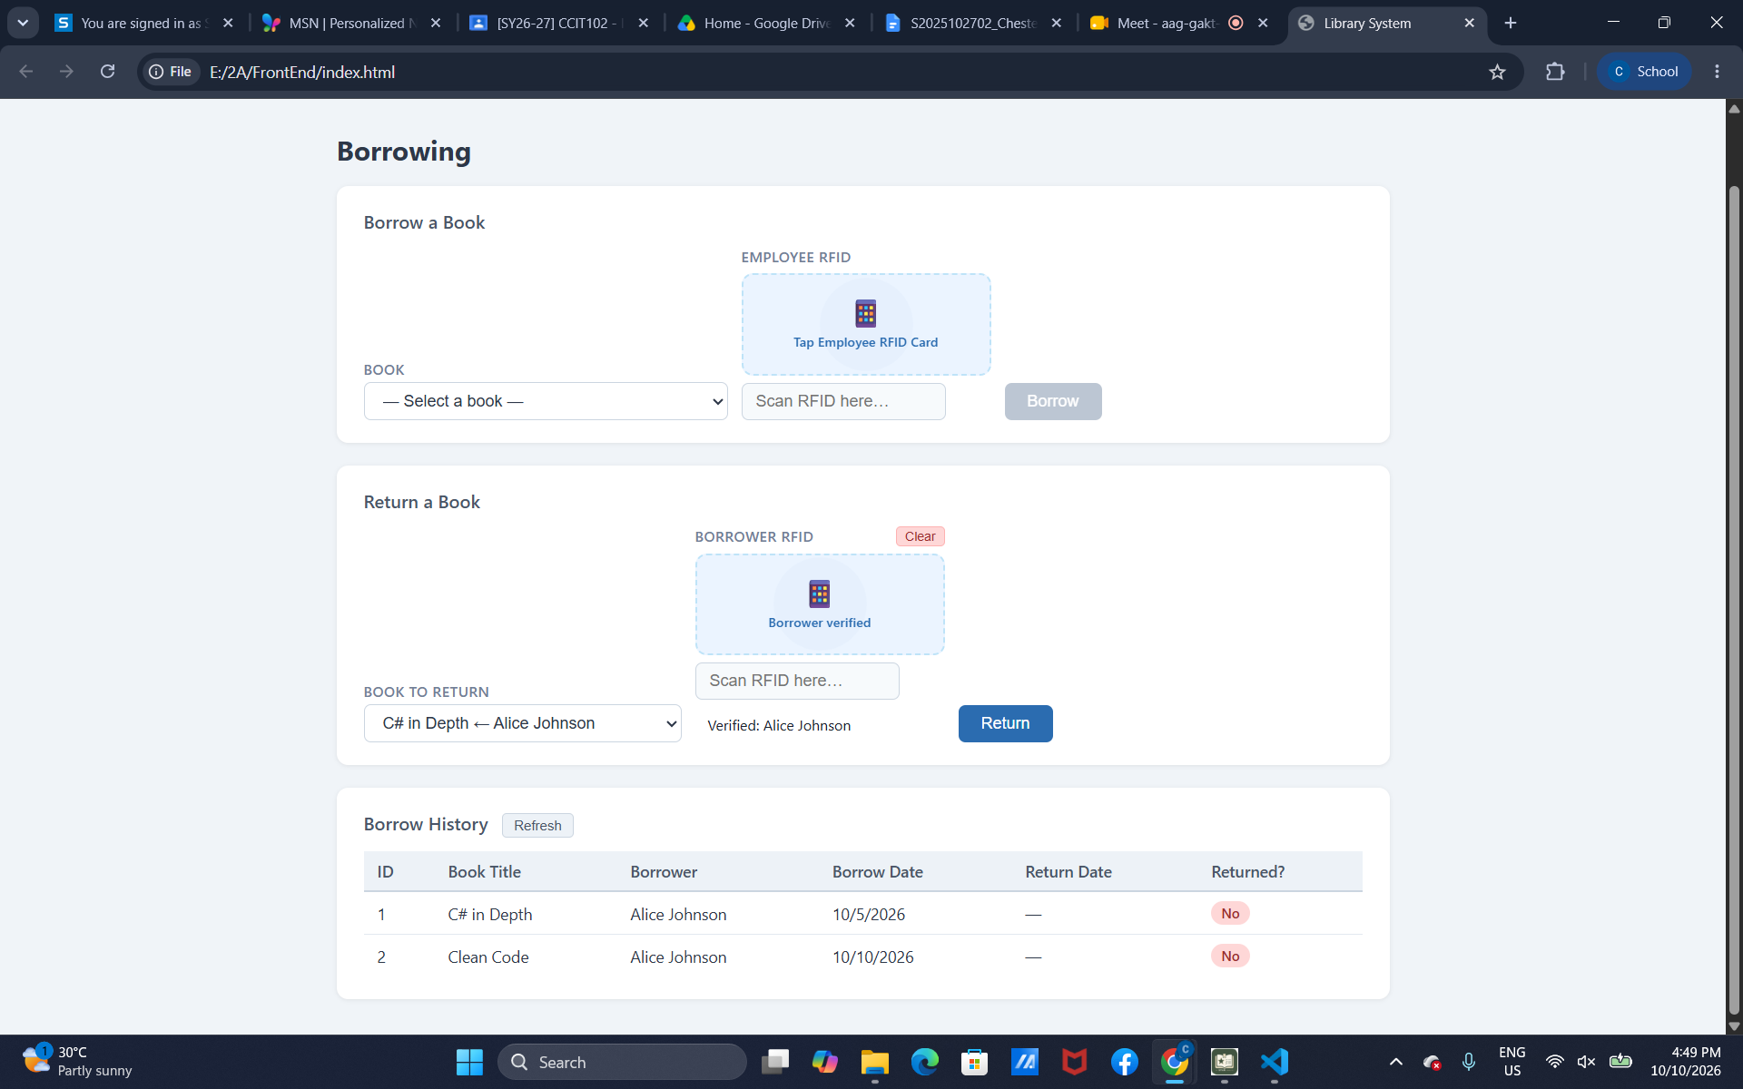
Test-13-return-success
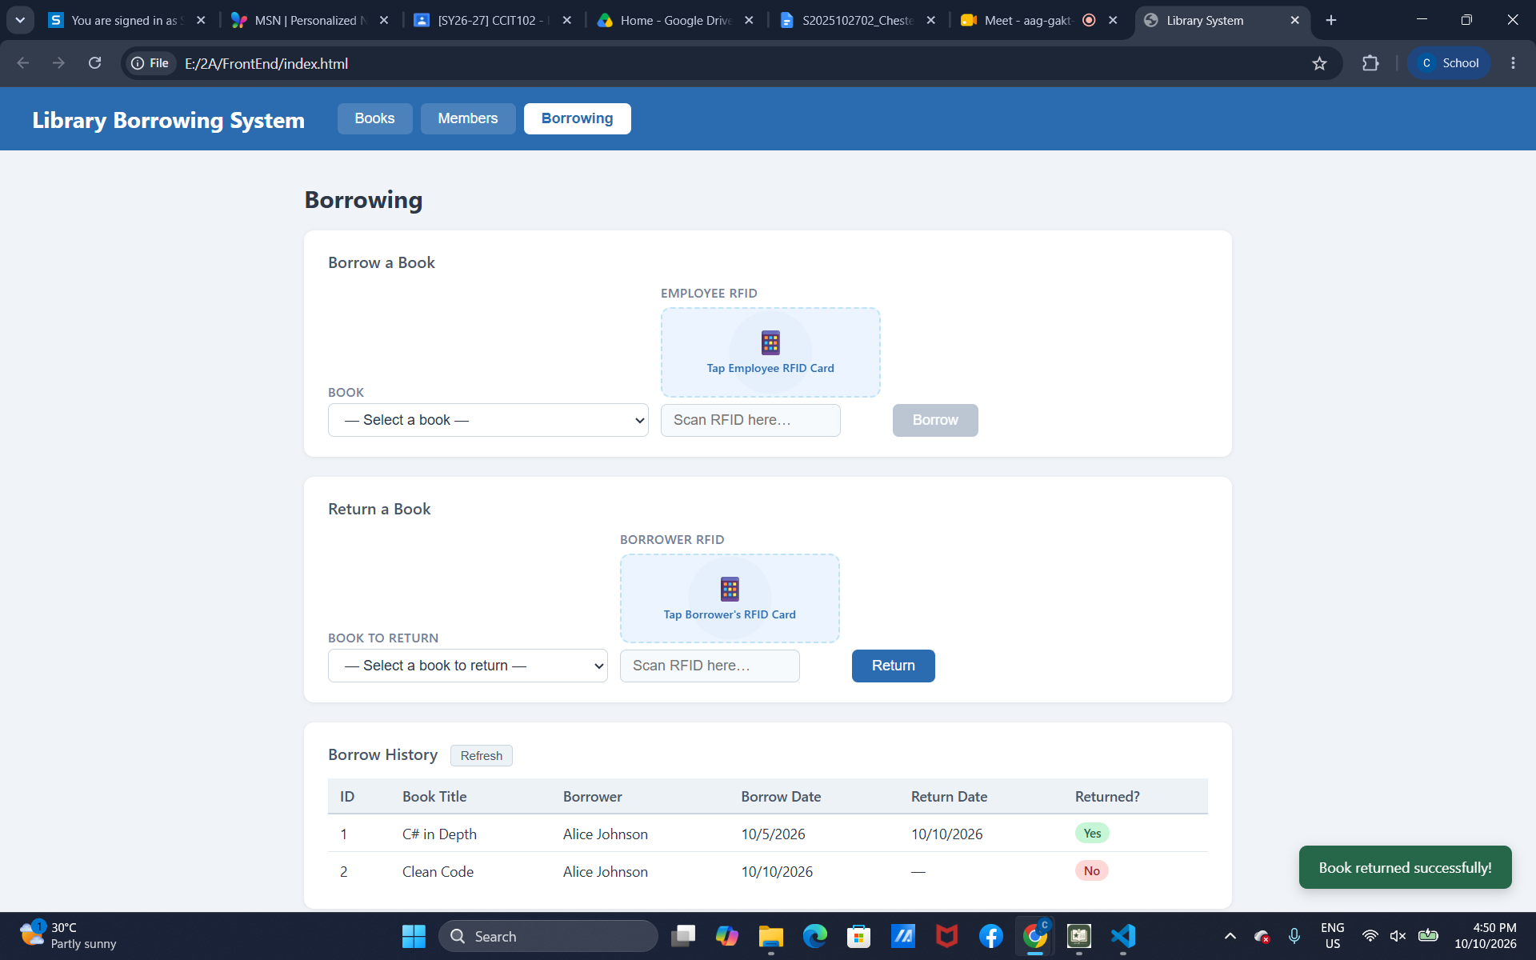

test-14-final-console
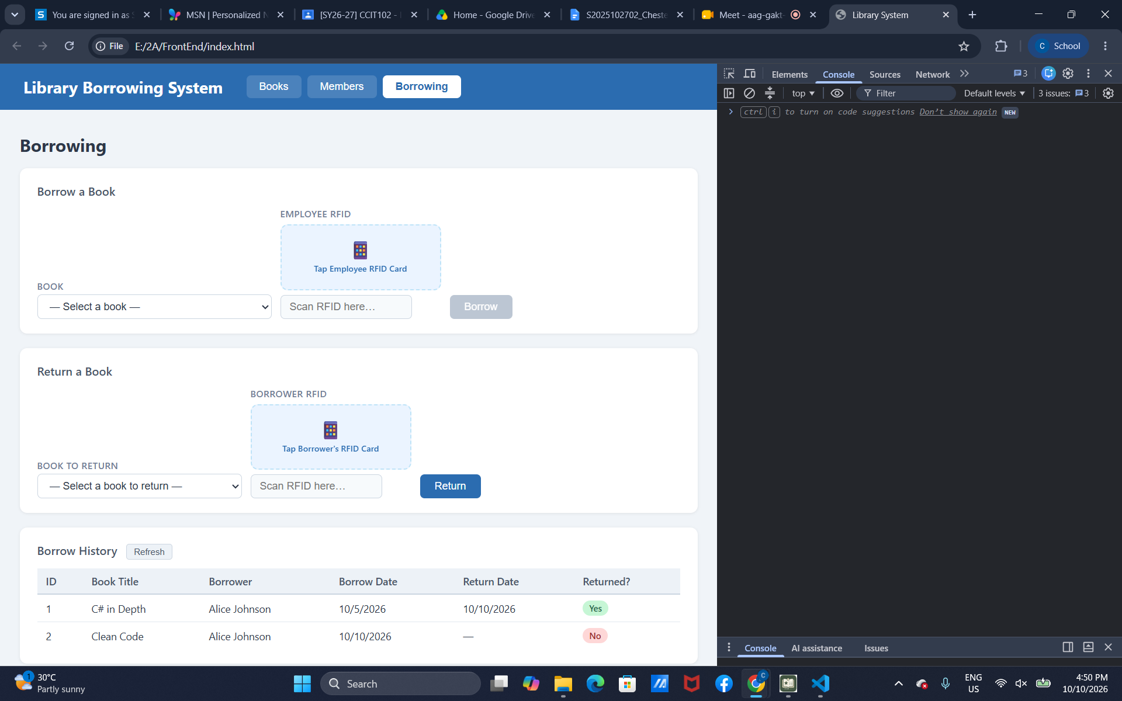
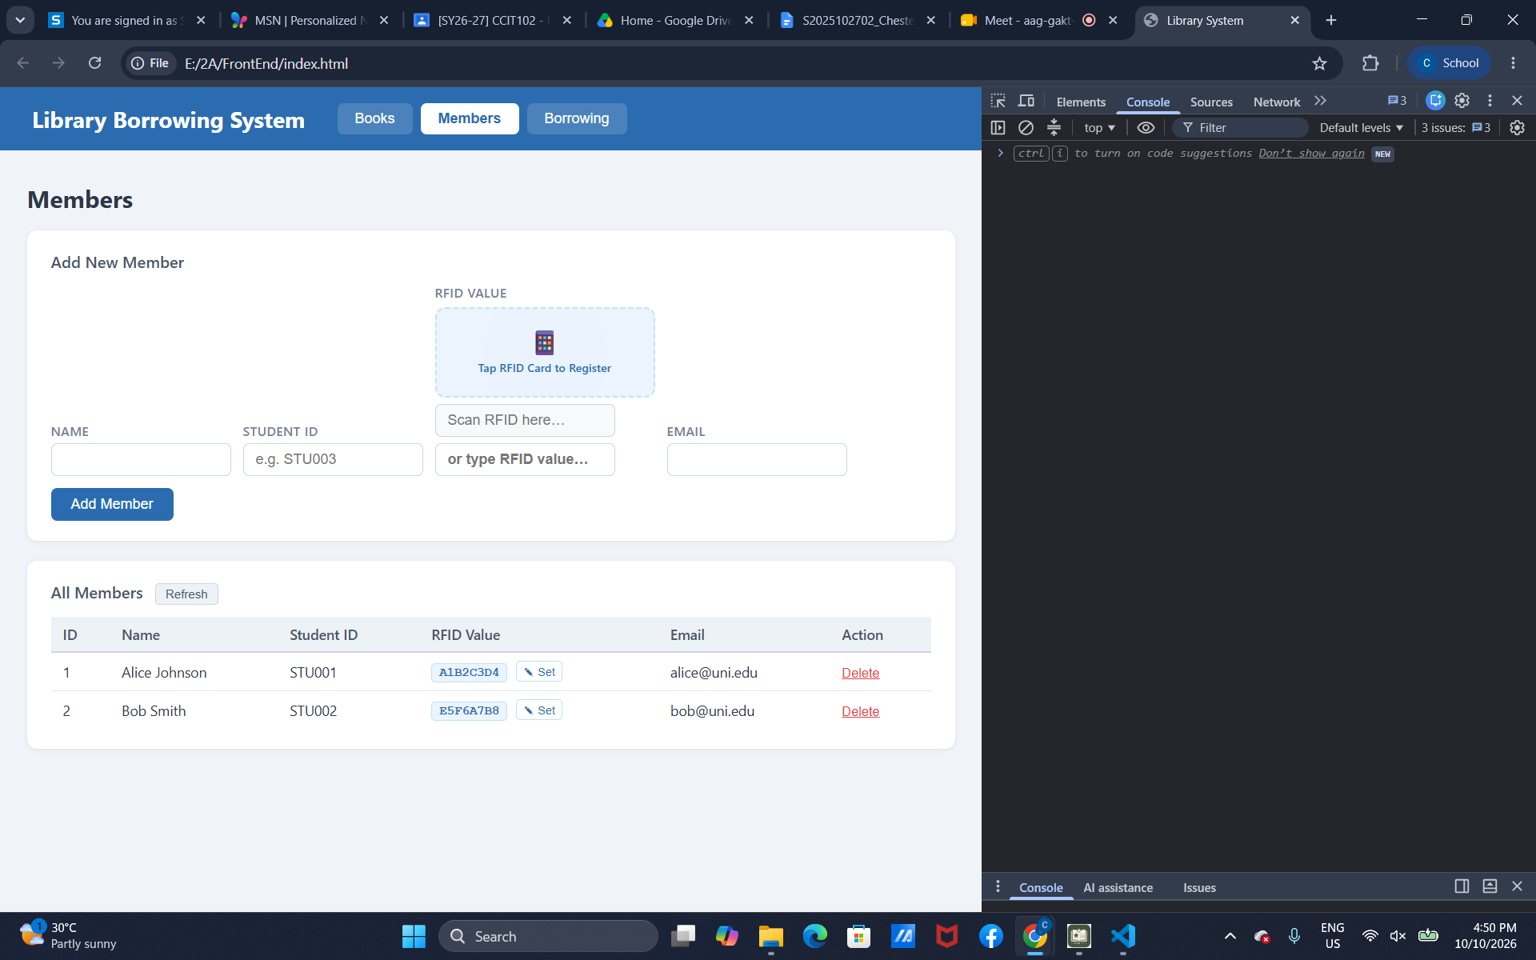

Reflection Questions

- What does apiFetch() do?
- Prevents repeated code.
- Why do we use try/catch around API calls?
- It is used to handle errors.
- What is the difference between POST and PUT?
- POST is to add data while PUT updates the data.
- Why does RFID matching use rfidValue instead of studentId?
- It uses cachedMembers to find the member with the matching rfidValue
- Why do we refresh tables after adding, deleting, borrowing, or returning?
- To display recent or latest tables.
- Why does the Return dropdown use borrow record ID instead of book ID?
- Return dropdown identifies the borrow record ID.
- What happens if the same event listener is added to form twice?
- It will send two requests for one click.
- Why must the page-load code be at the bottom of the file?
- For the let variables to come before any code that uses them.
- Why does an RFID reader need e.preventDefault() on the Enter key?
- So that the RFID reader form will not be submitted by accident.

