Part-01-settings-apifetch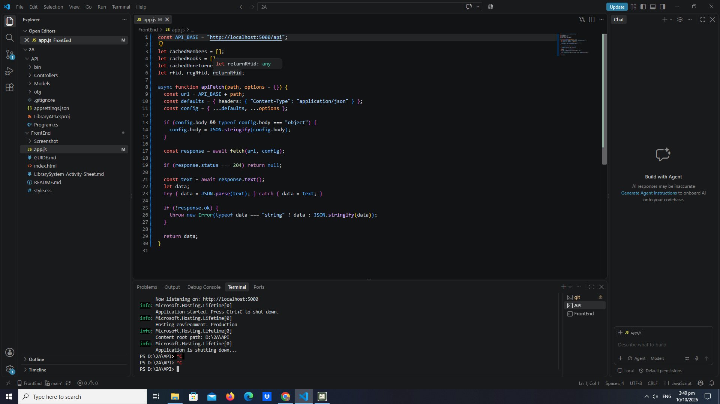

Part-02-showtoast
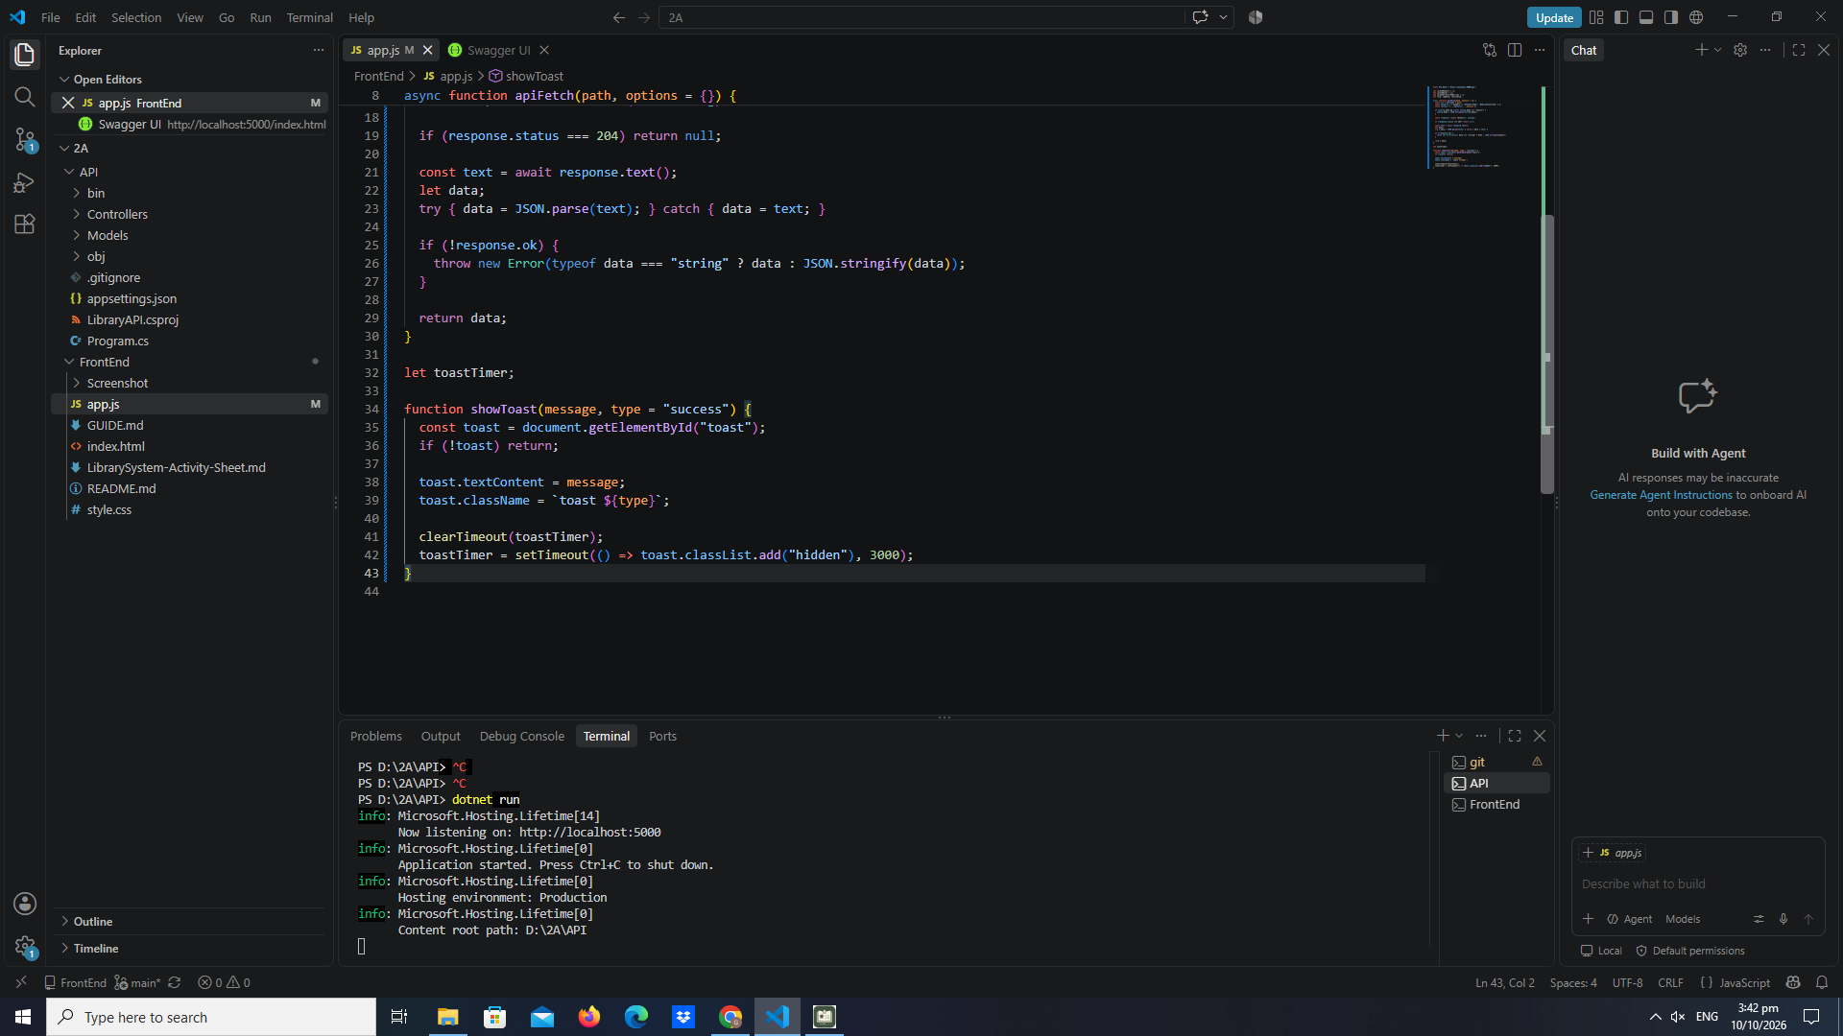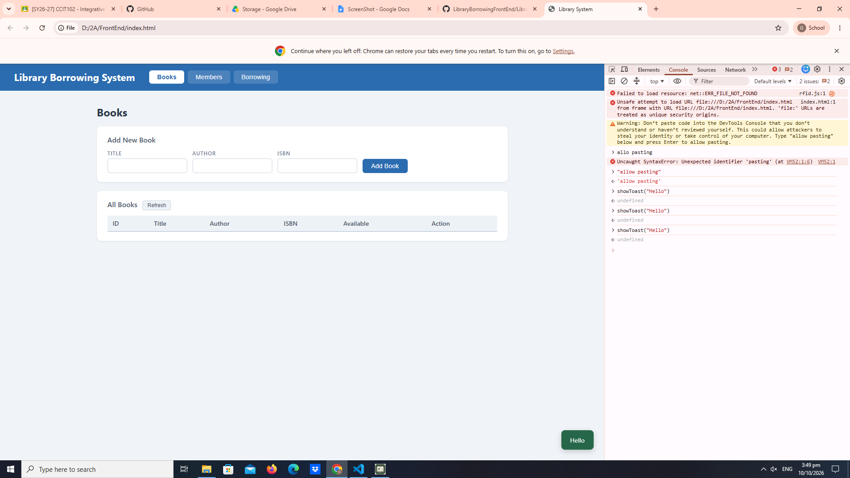

Part-03-caches
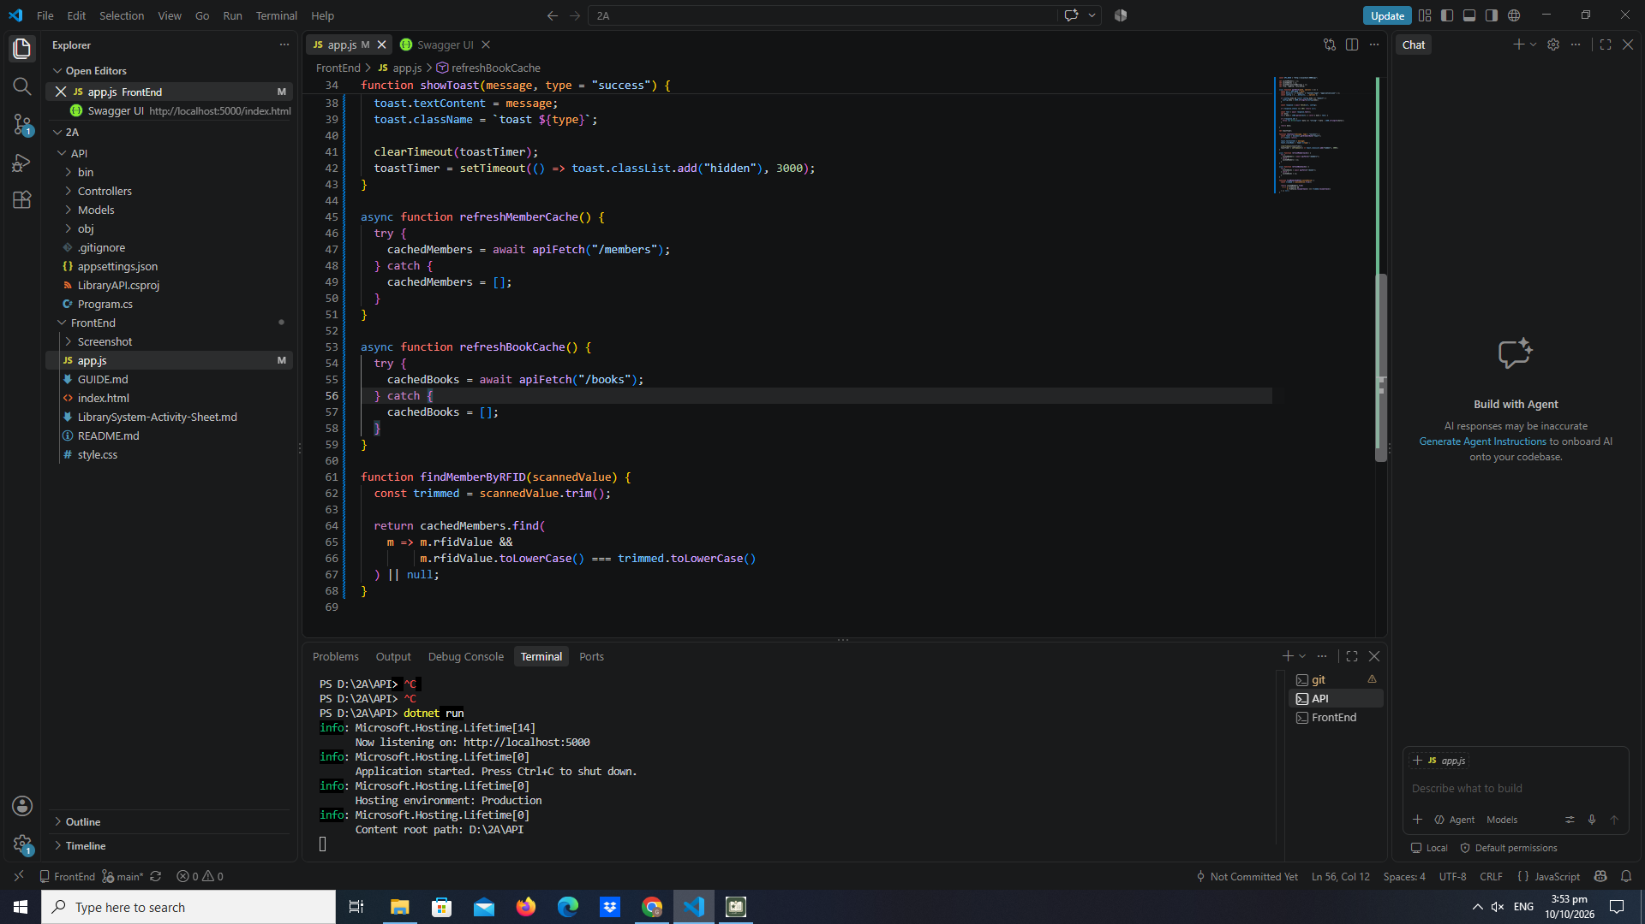

early-02-cache-console

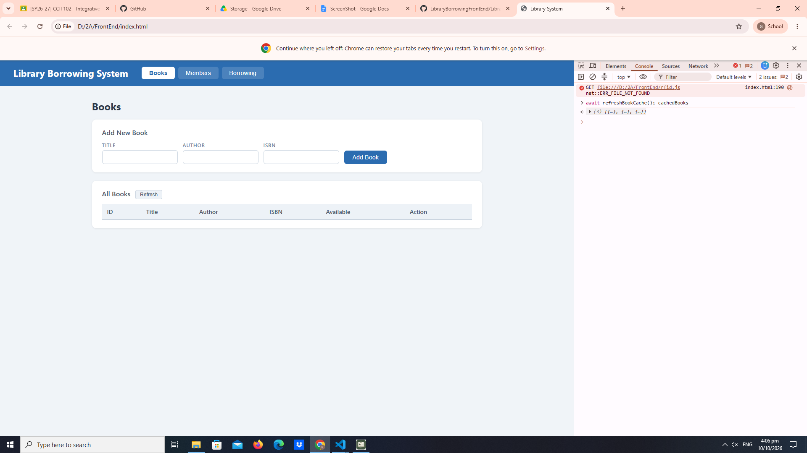

part-04-tabs-refresh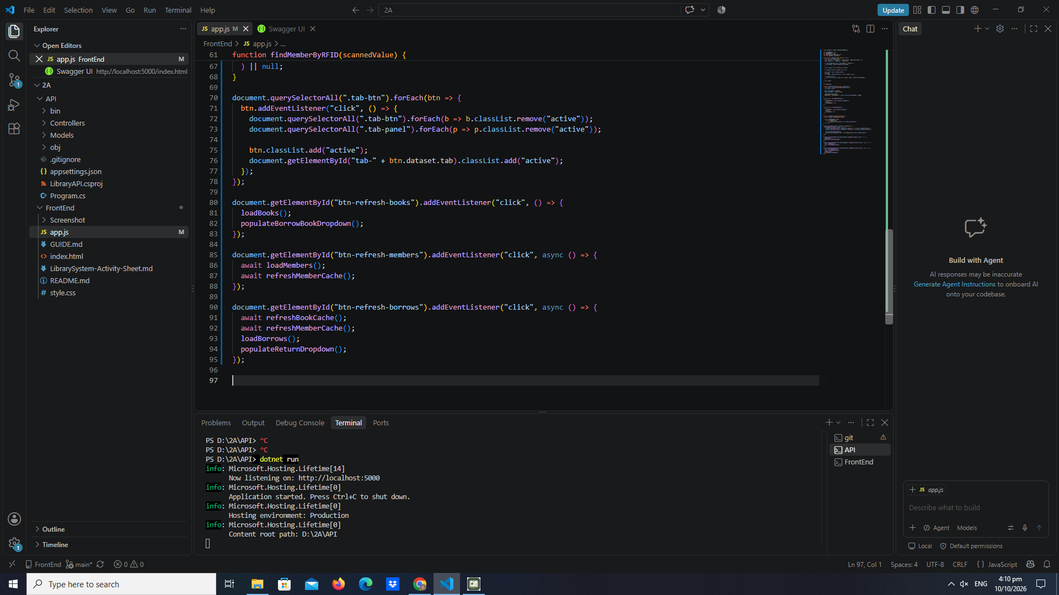
early-03-tabs 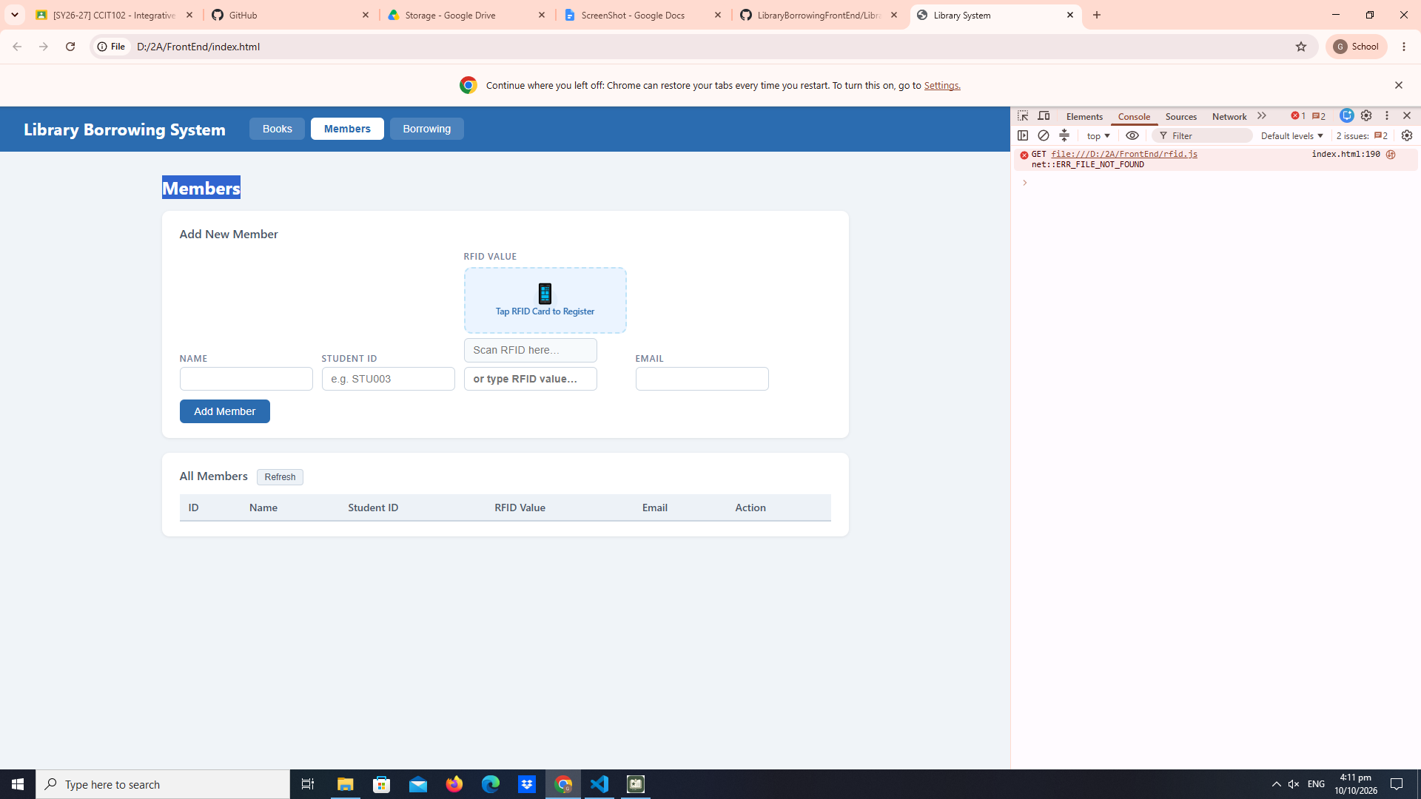

part-05-loadbooks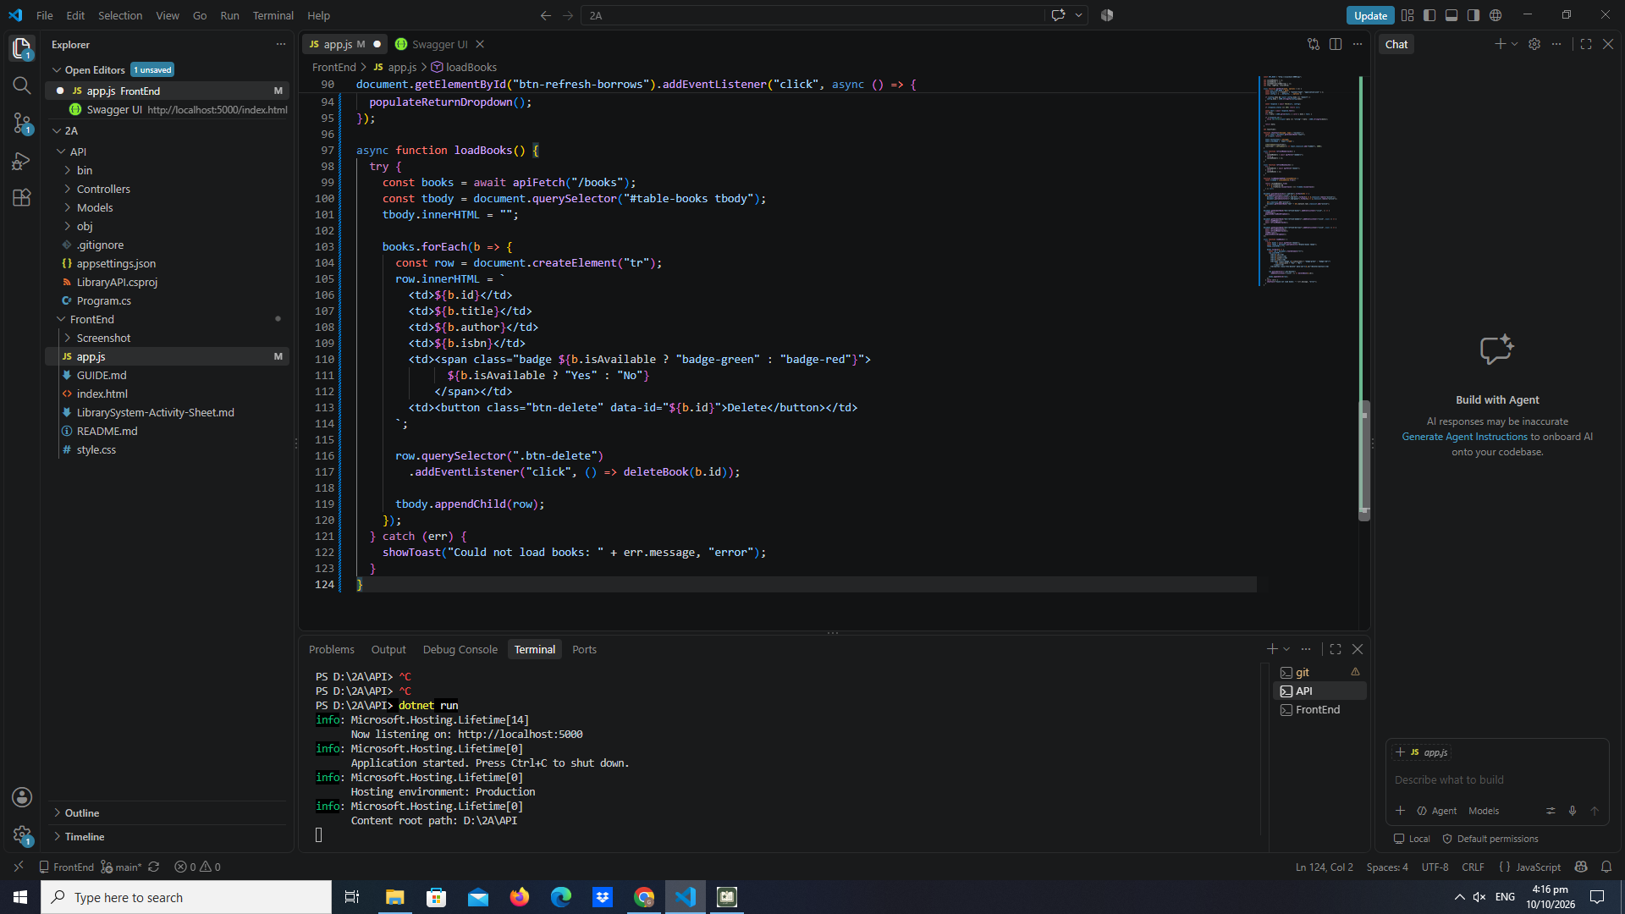

Part 6 — Delete Book

part-06-deletebook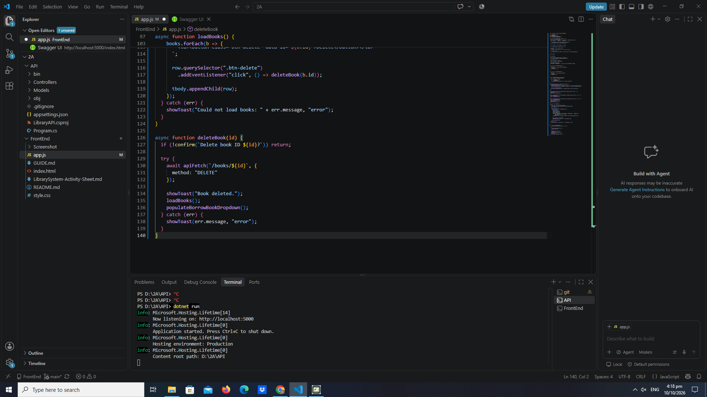

Part 7 — Add Book

part-07-addbook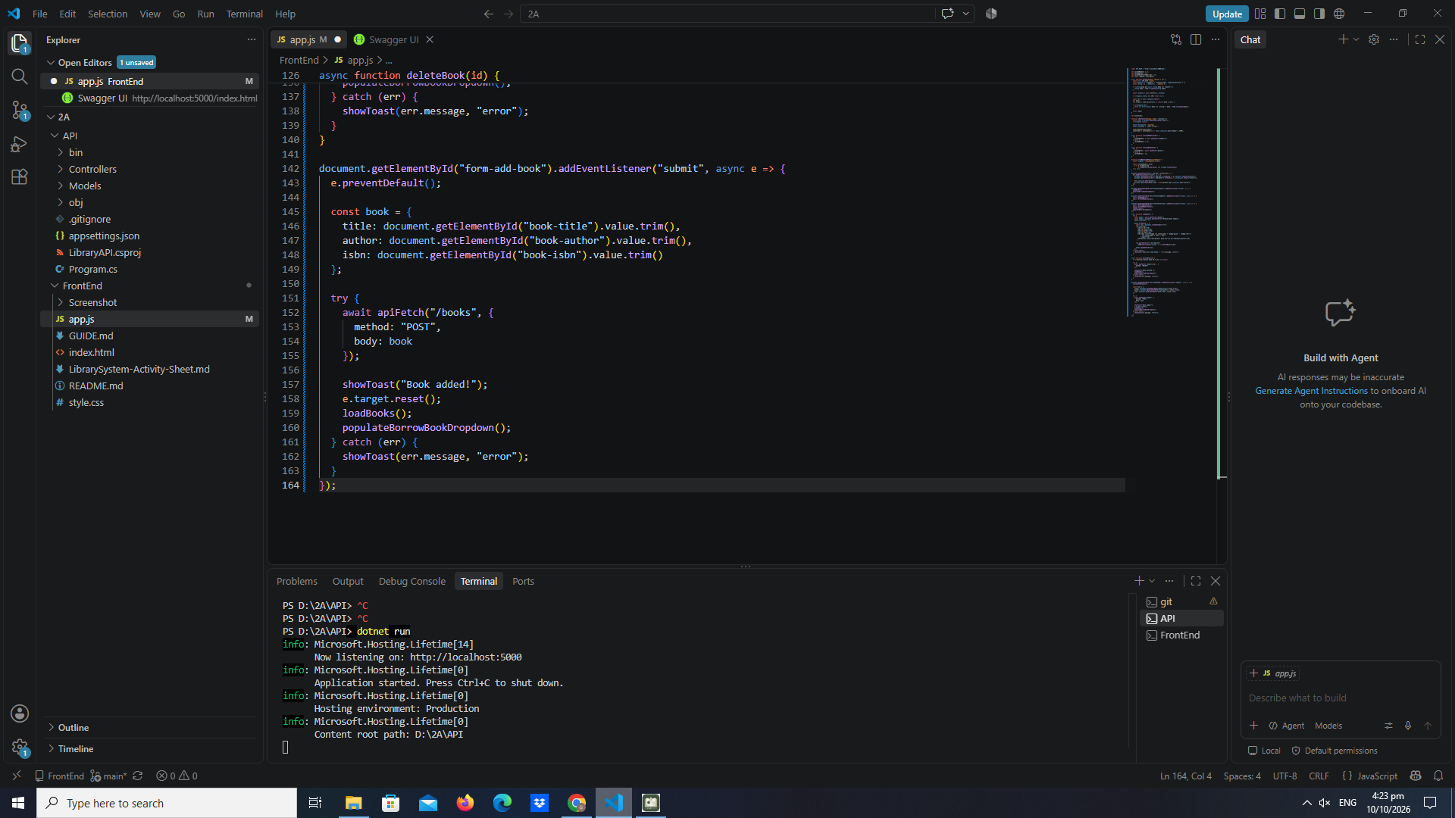

Part 8 — Load Members into Table

part-08-loadmembers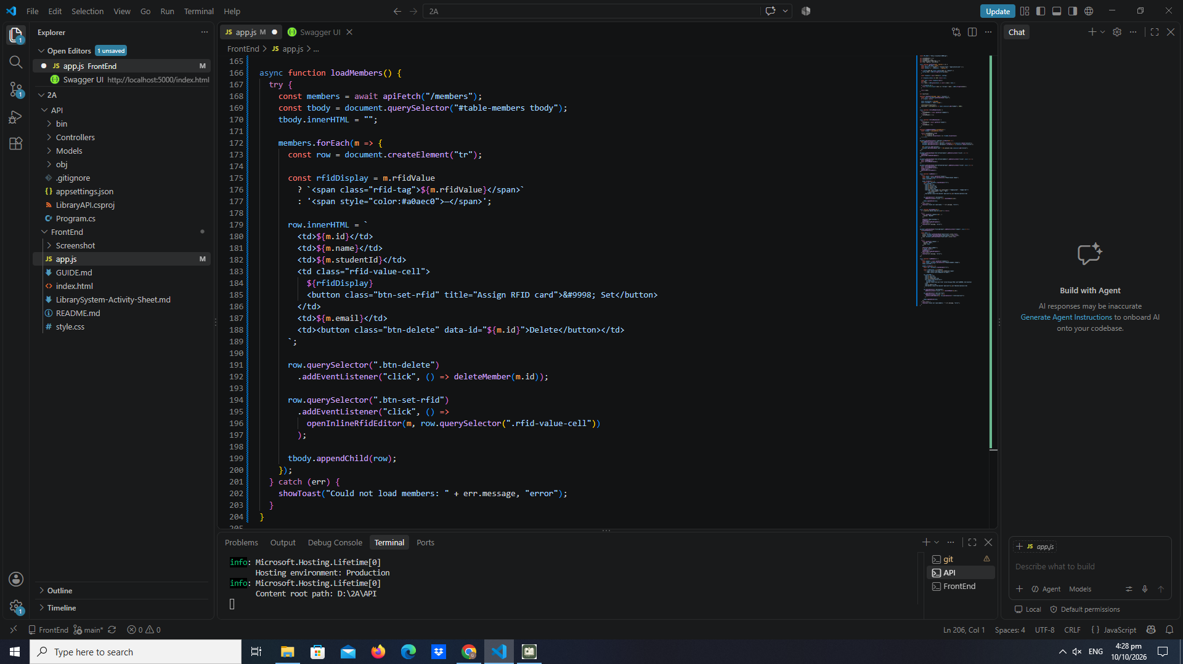

Part 9 — Delete Member

part-09-deletemember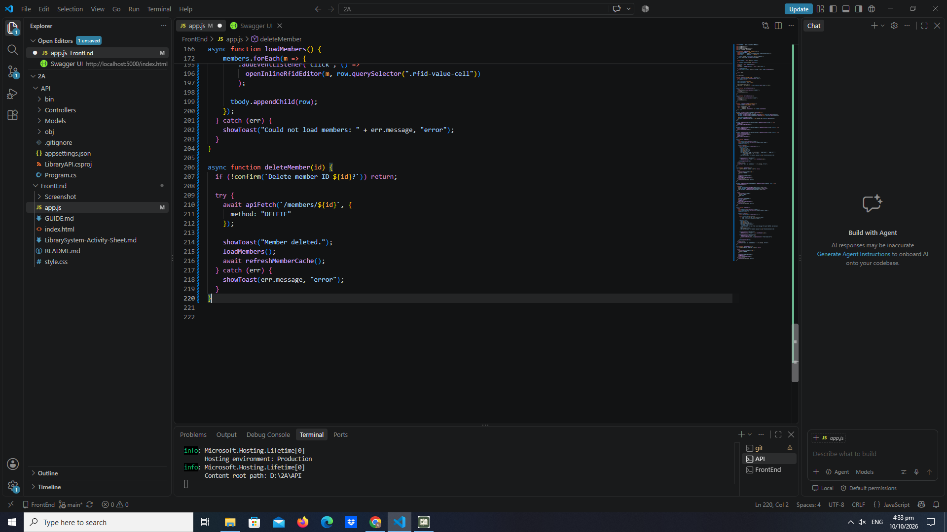

Part 10 — Add Member with RFID Value

part-10-addmember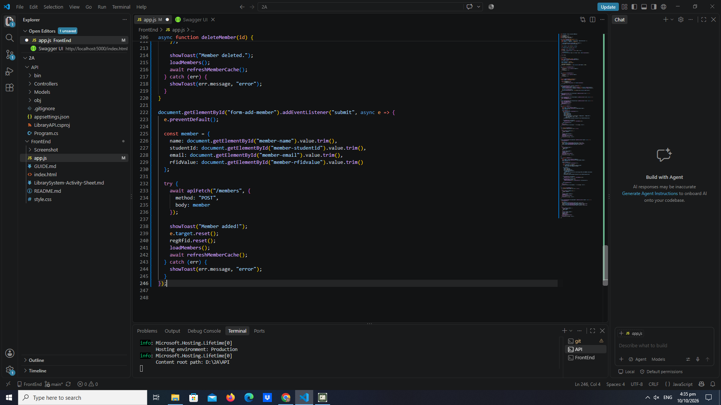

Part 11 — Inline RFID Editor and Update Member RFID

part-11-inline-rfid-editor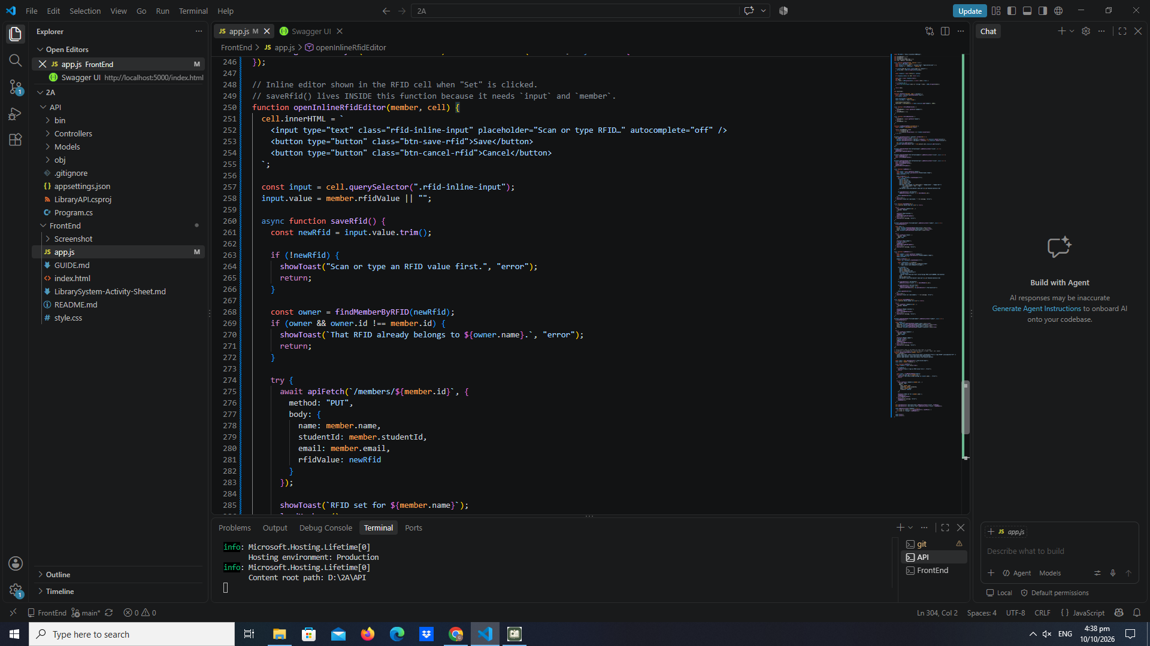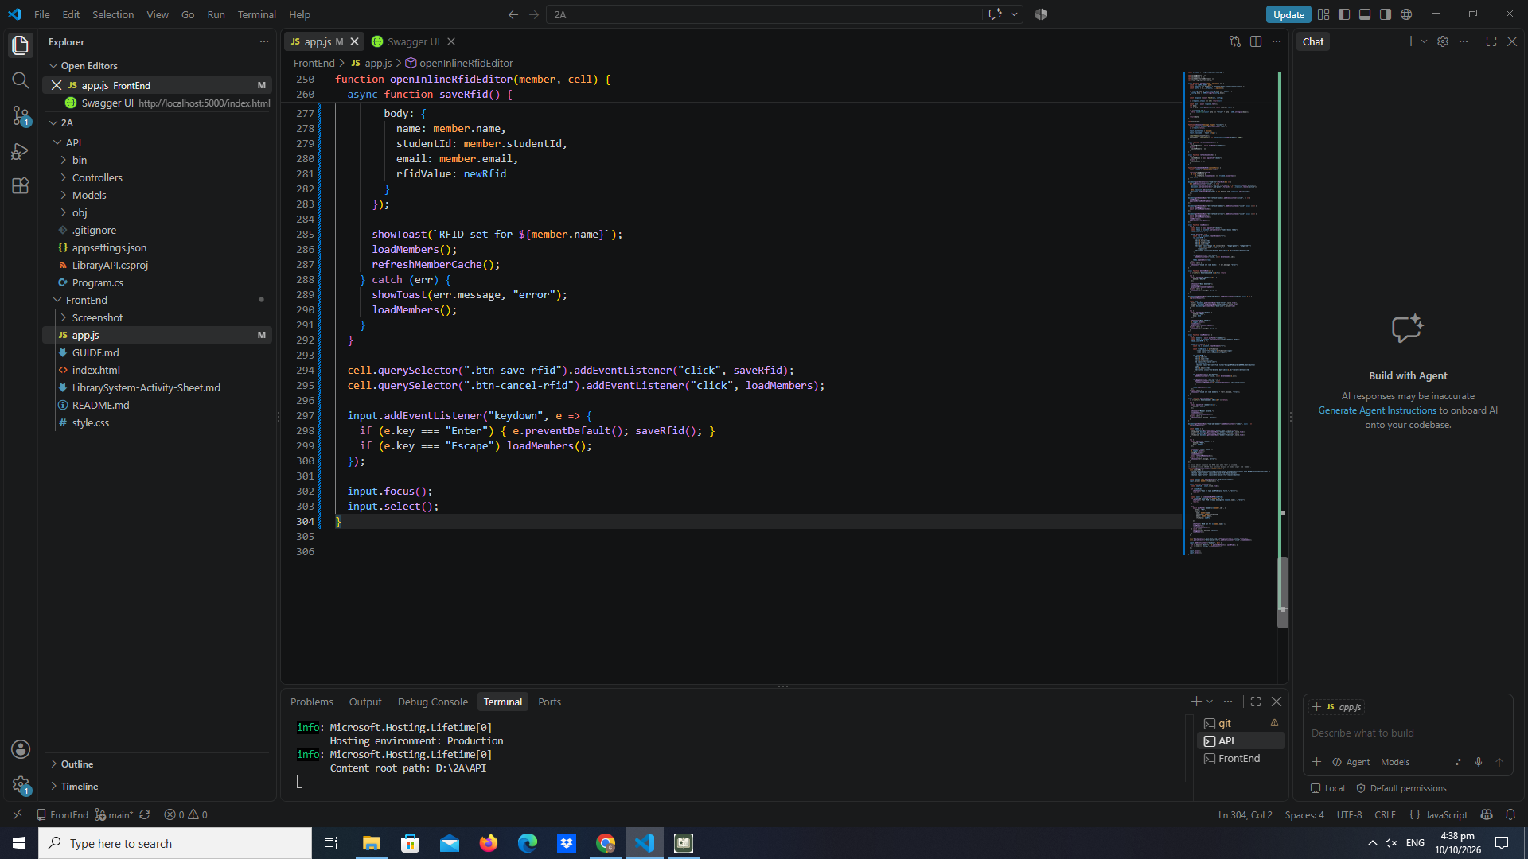

Part 12 — RFID Widgets (Borrow, Register, Return)

part-12a-rfid-widget-builder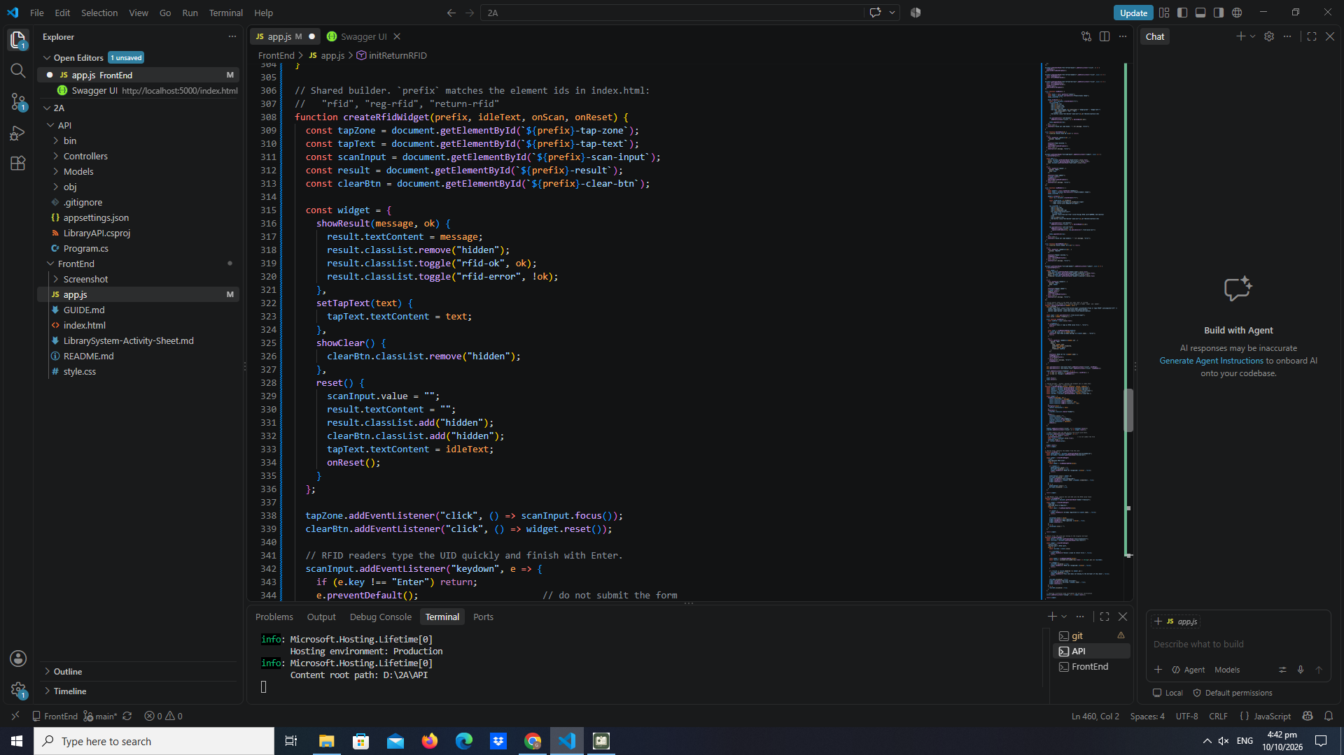
part-12b-rfid-init-functions 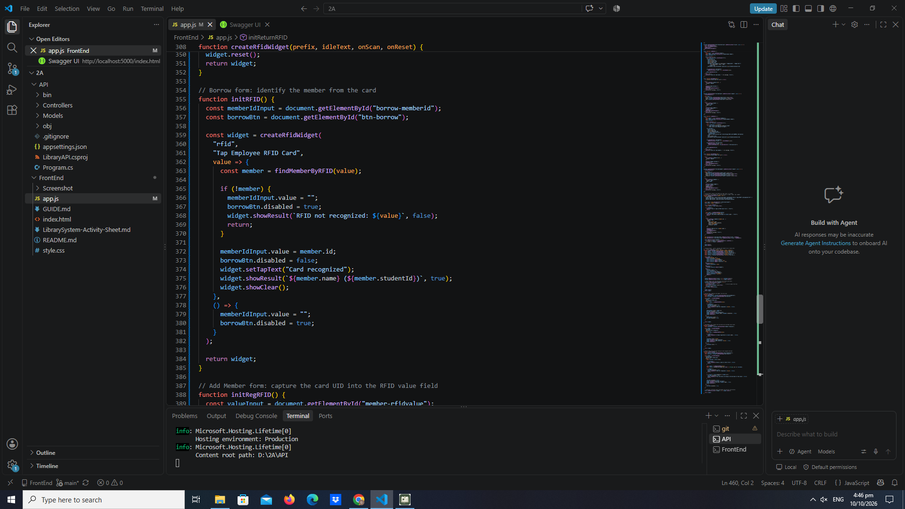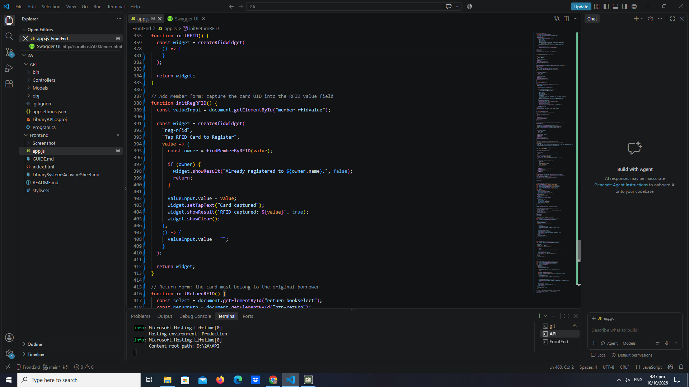
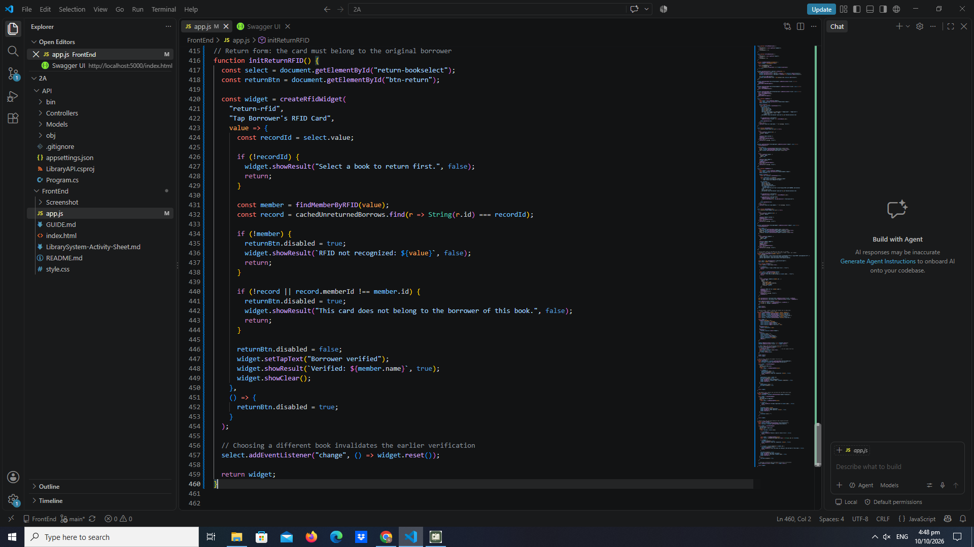

Part 13 — Populate Borrow Book Dropdown

part-13-borrow-dropdown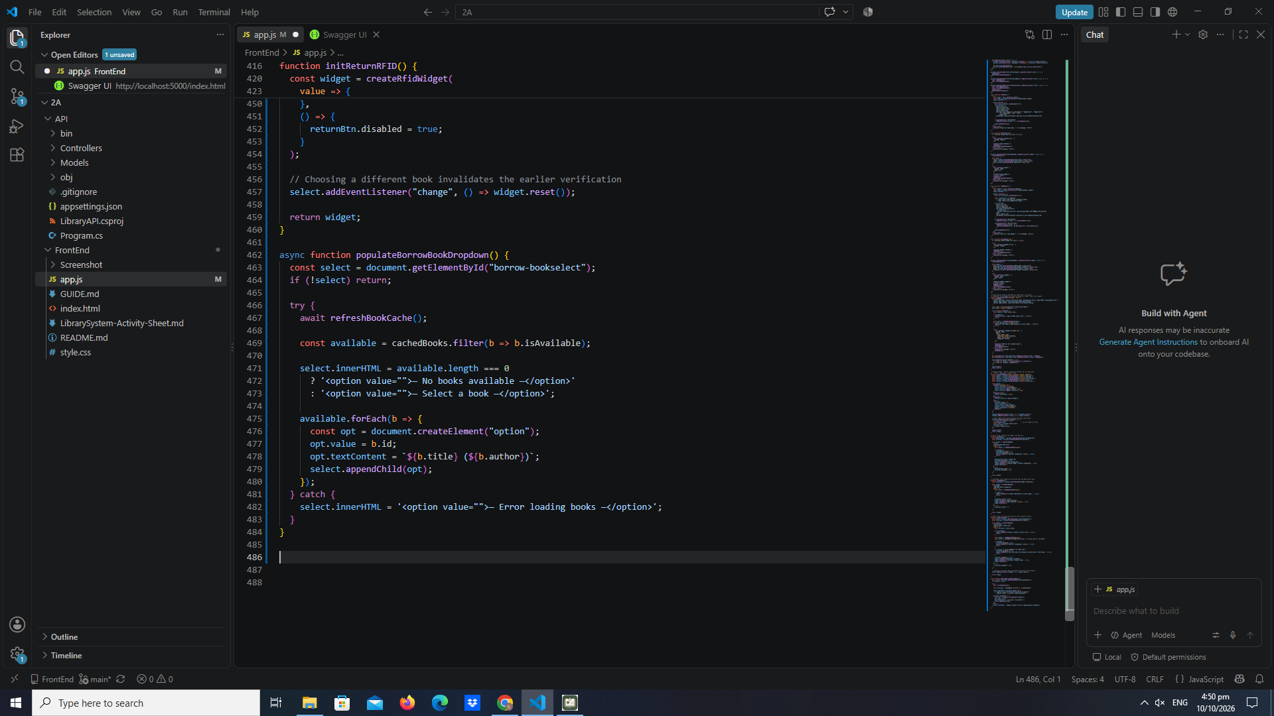

Part 14 — Populate Return Book Dropdown

part-14-return-dropdown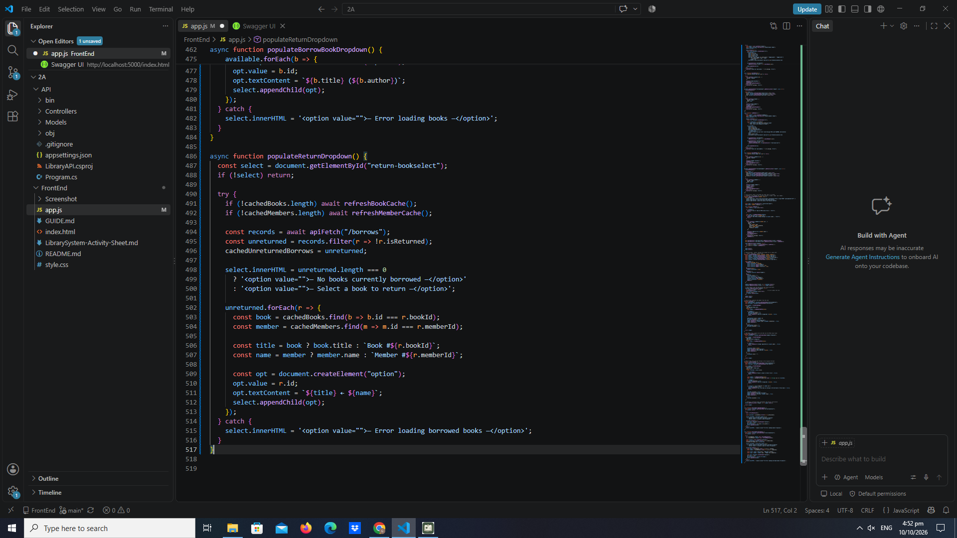

Part 15 — Borrow a Book

part-15-borrow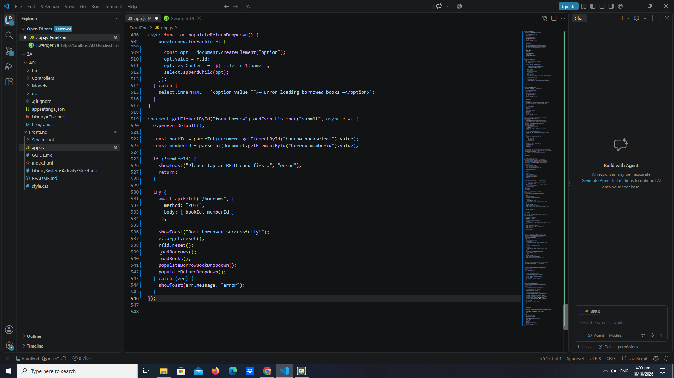

Part 16 — Return a Book

part-16-return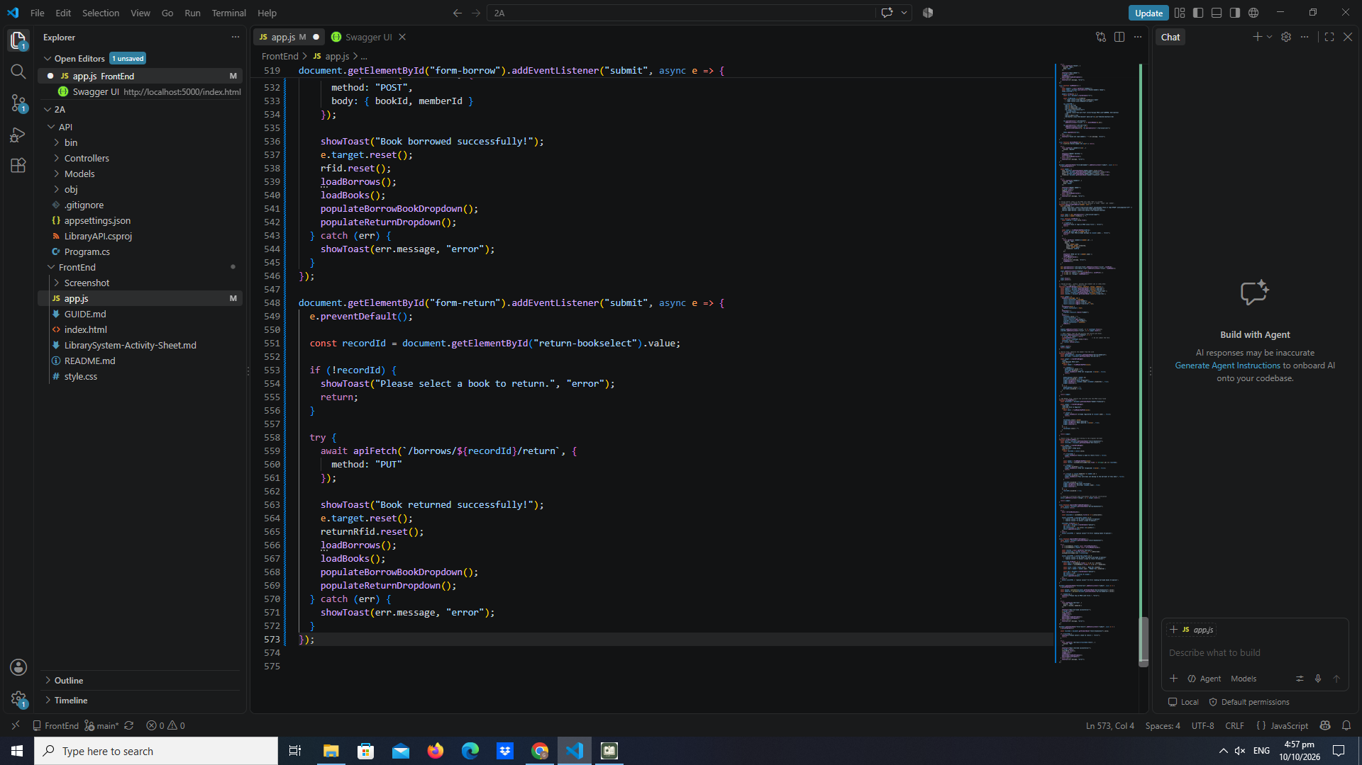

Part 17 — Load Borrow History Table

part-17-loadborrows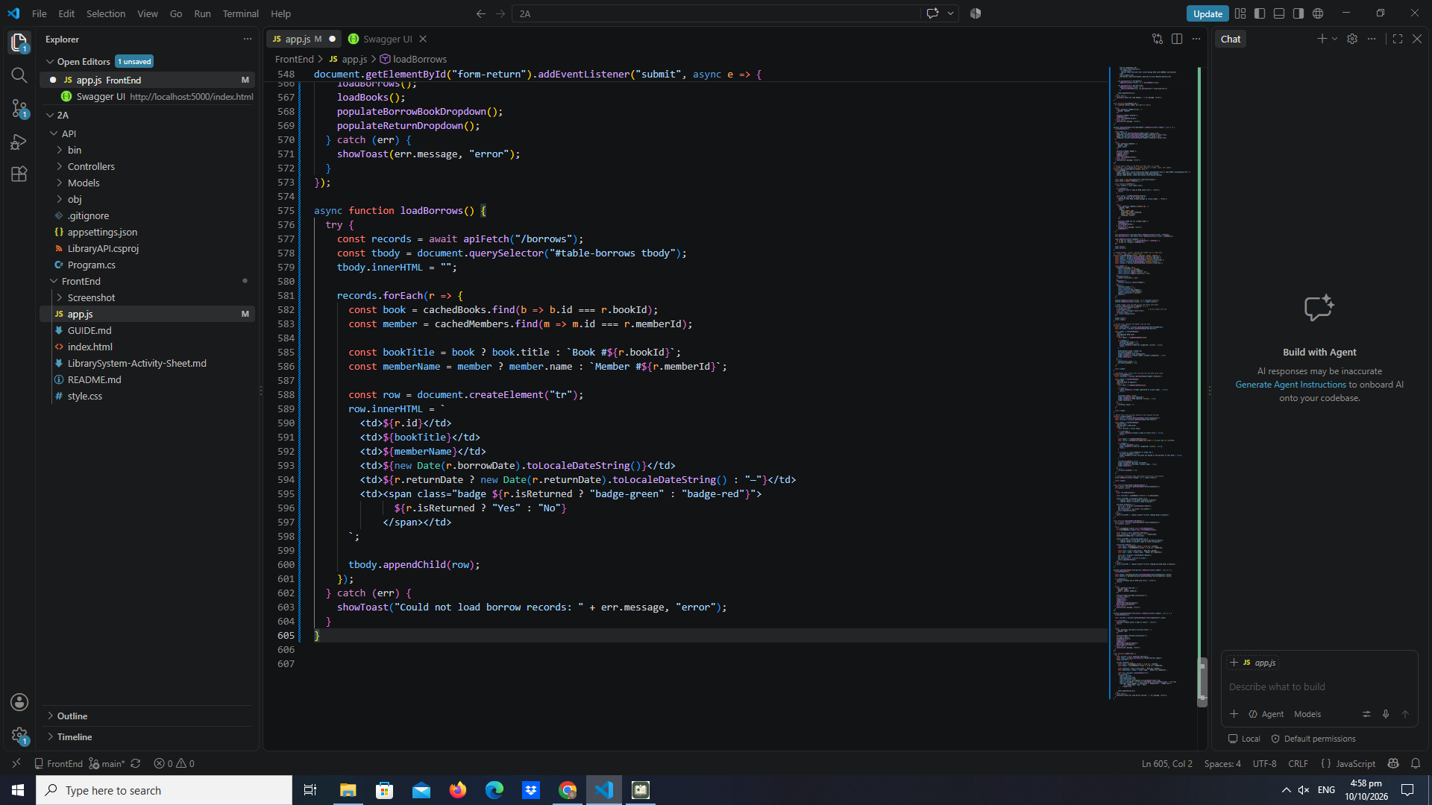

Part 18 — Initial Page Load

Part-18-page-load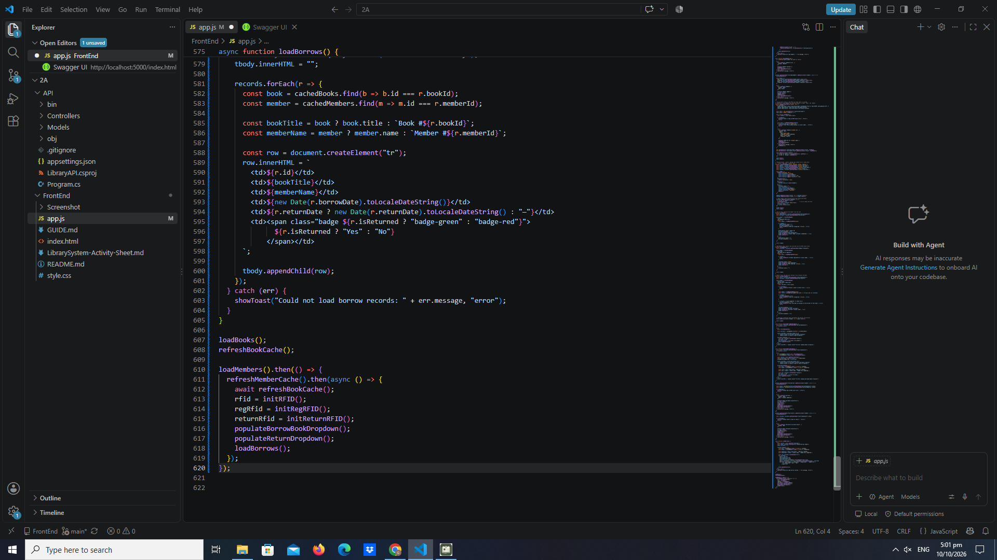

TEST SCREENSHOTS

test-01-page-loaded 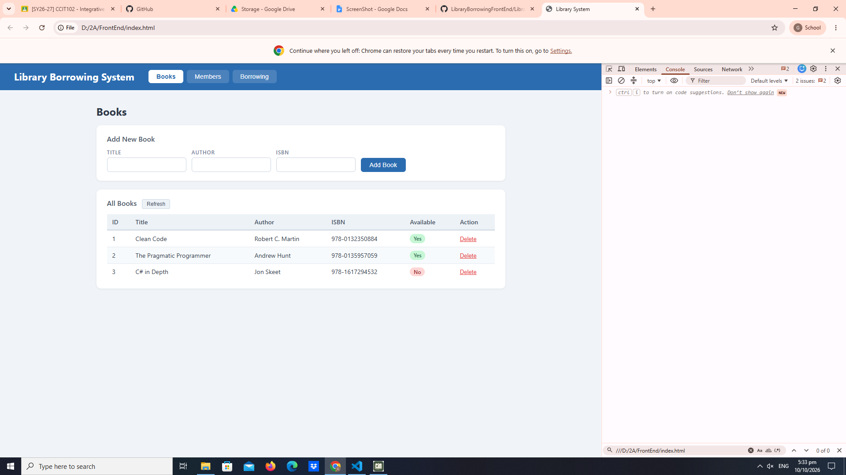

test-02-add-book 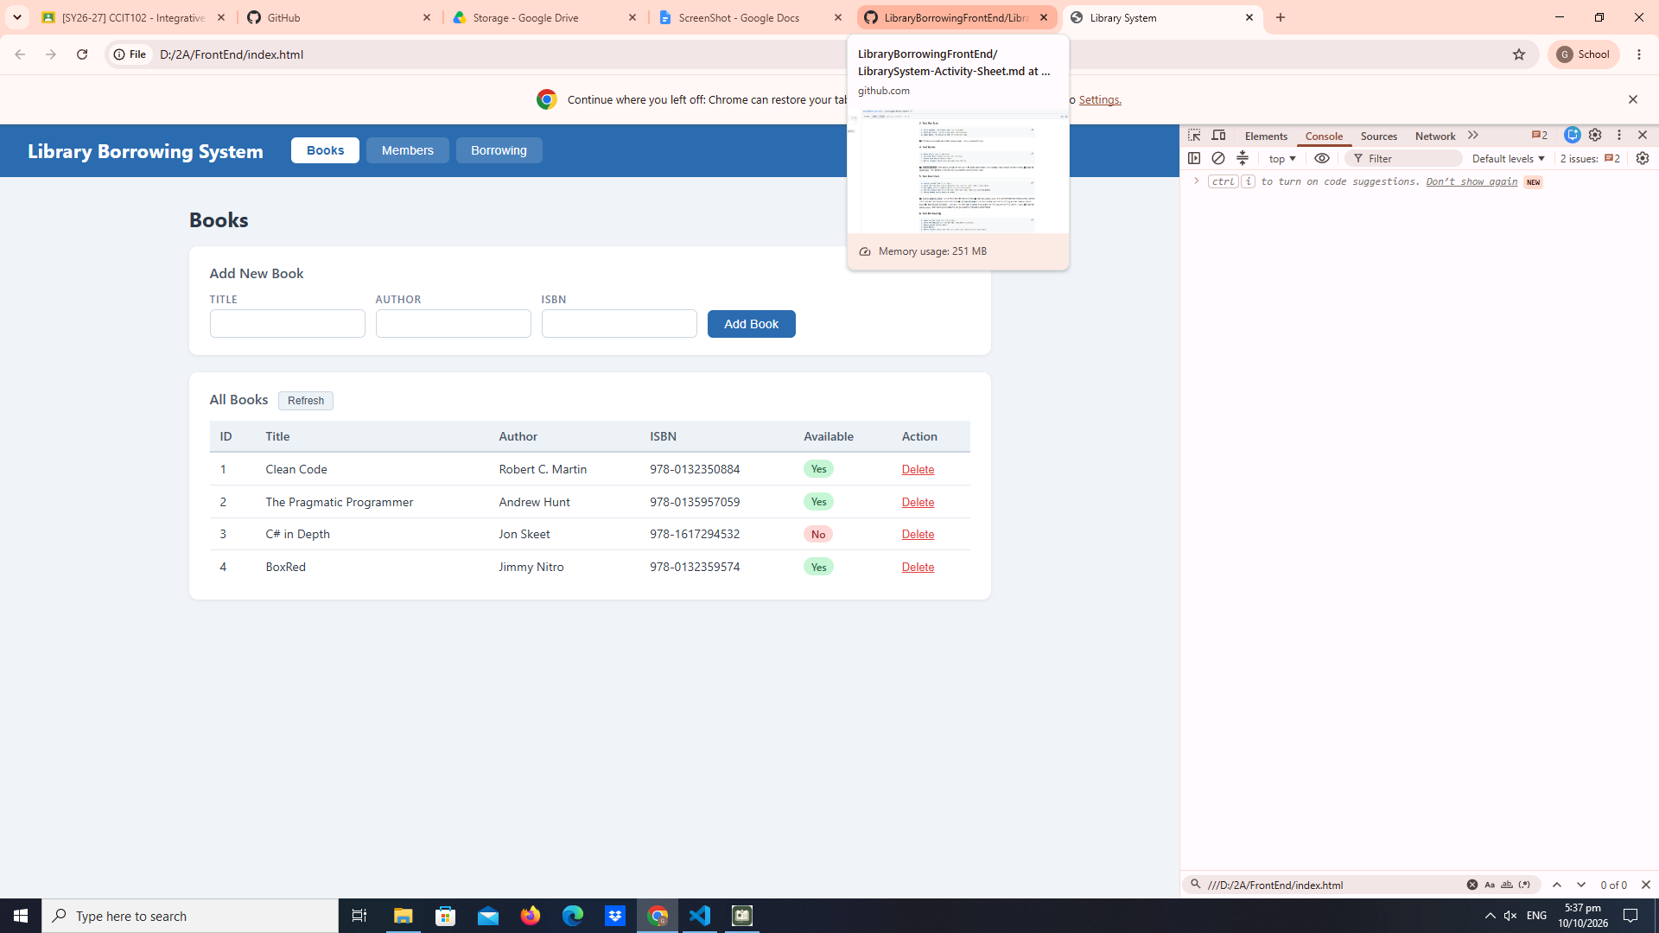

test-03-delete-book 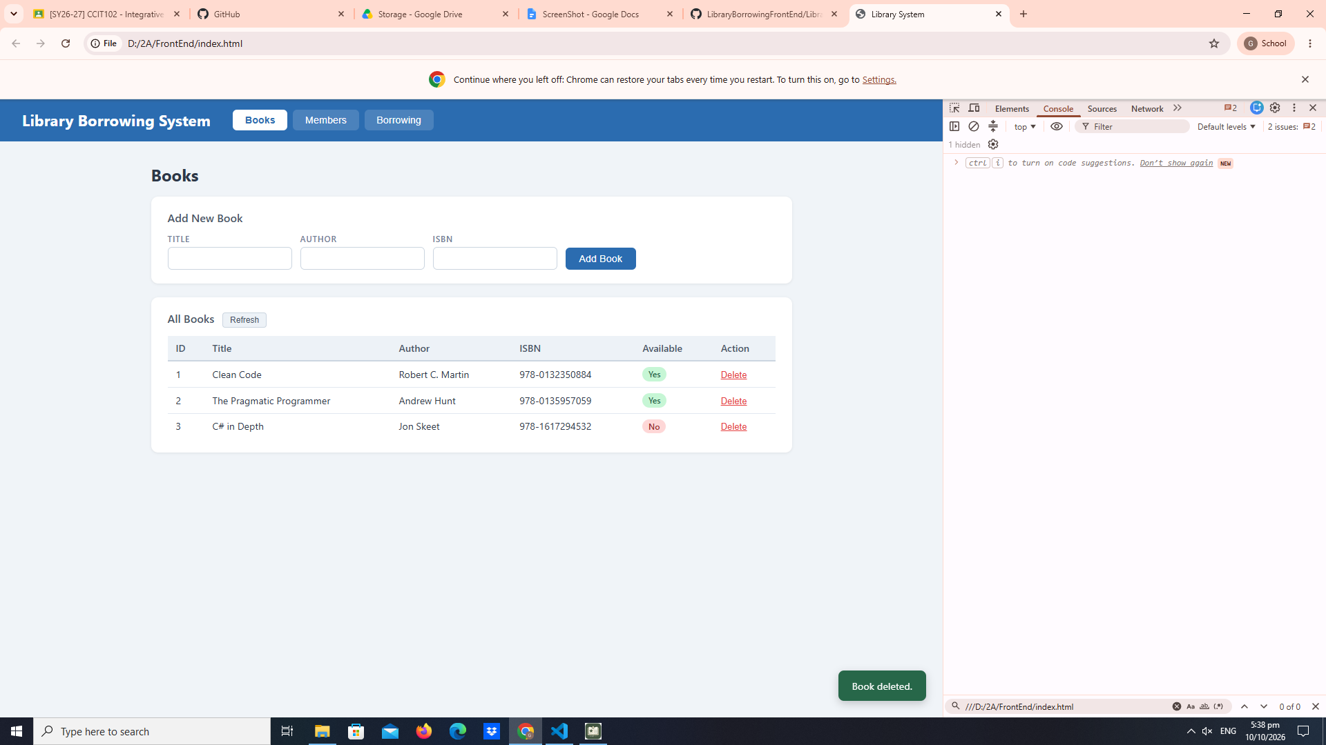
test-04-members-loaded 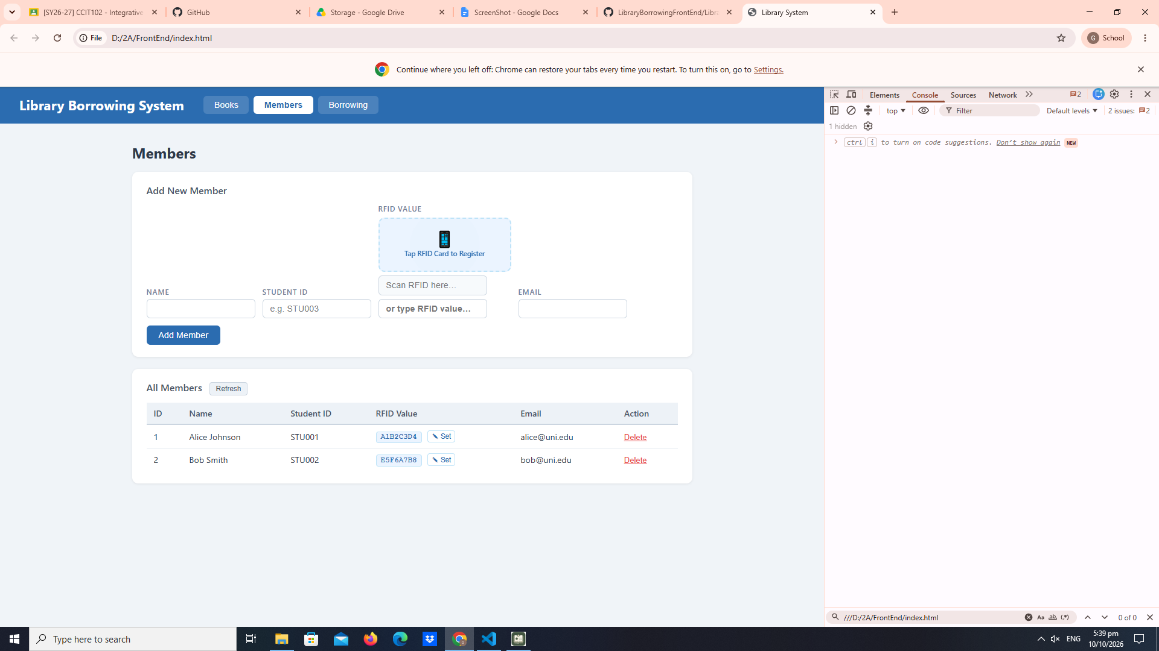
test-05-register-rfid 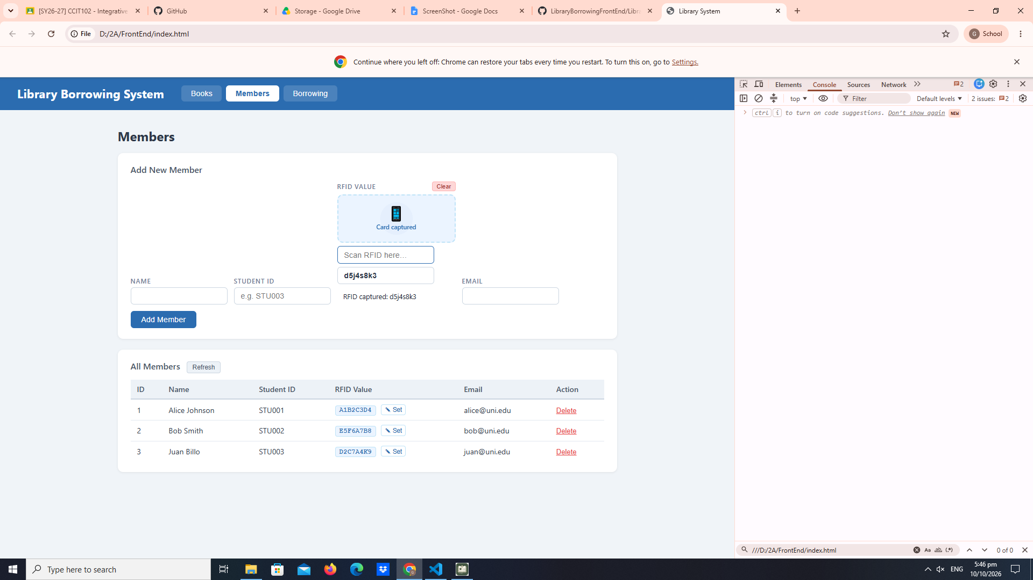
test-06-add-member 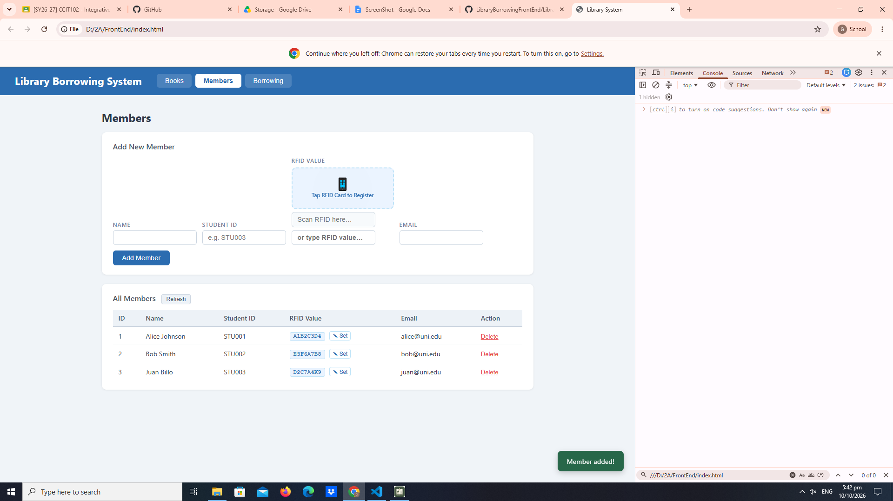
test-07-set-rfid-saved 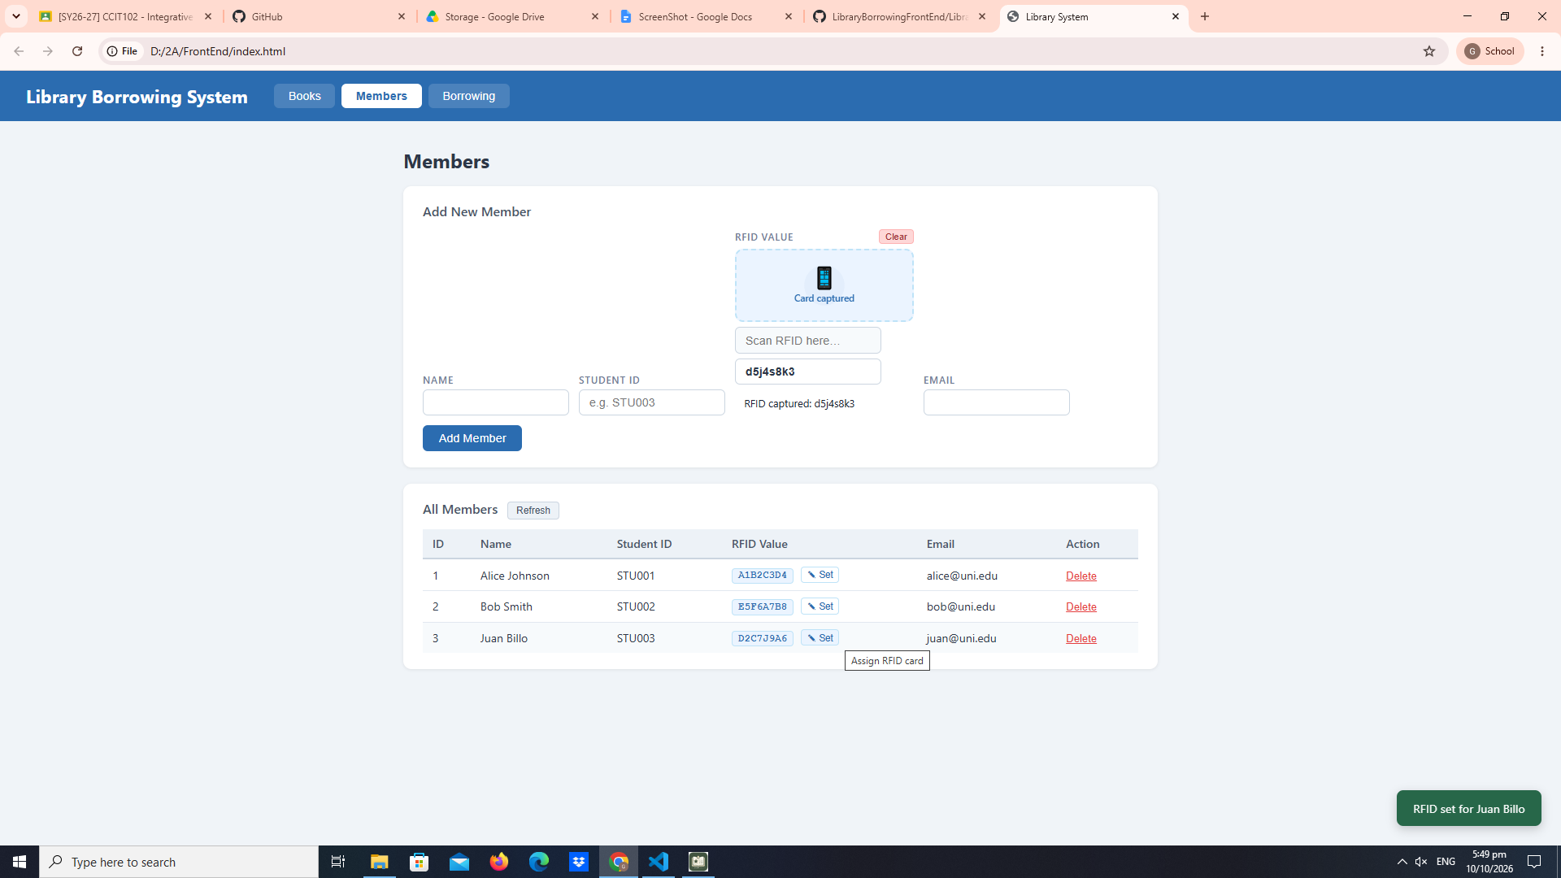
test-08-delete-member 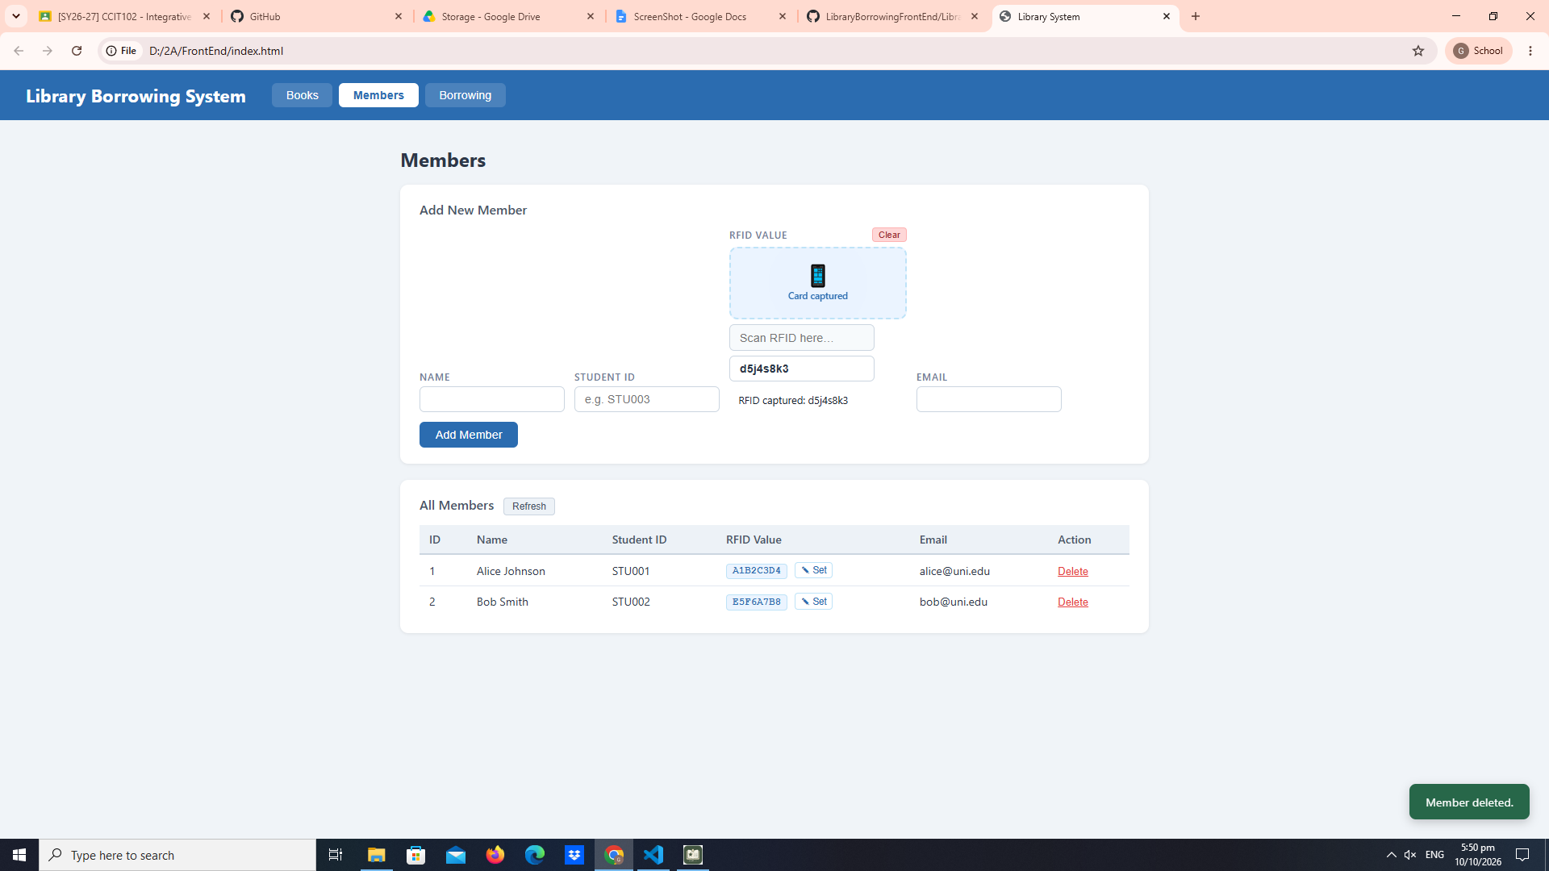
test-09-borrow-rfid-recognized 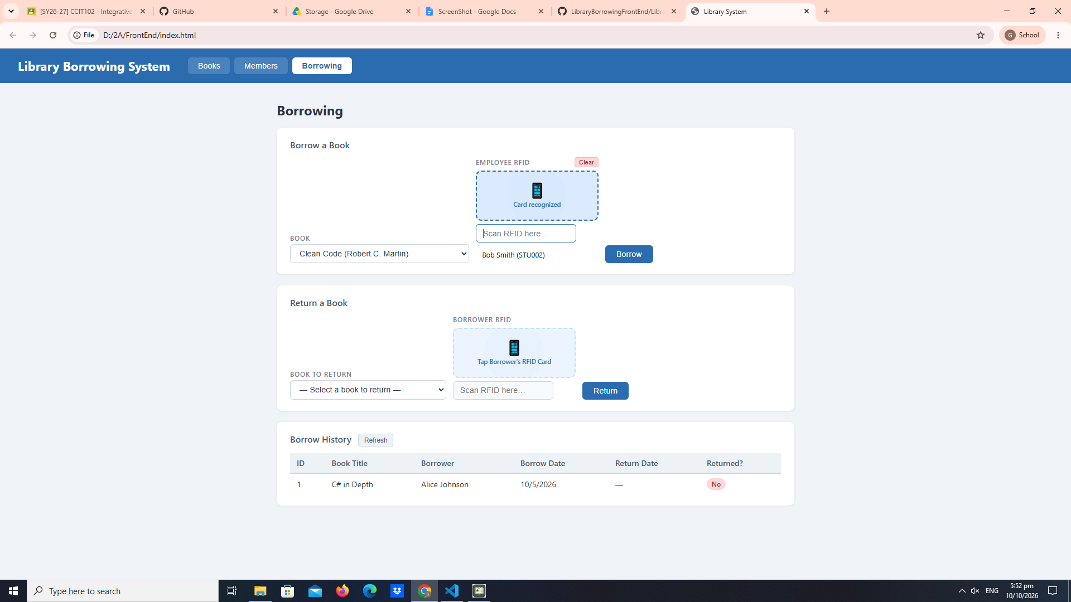
test-10-borrow-success 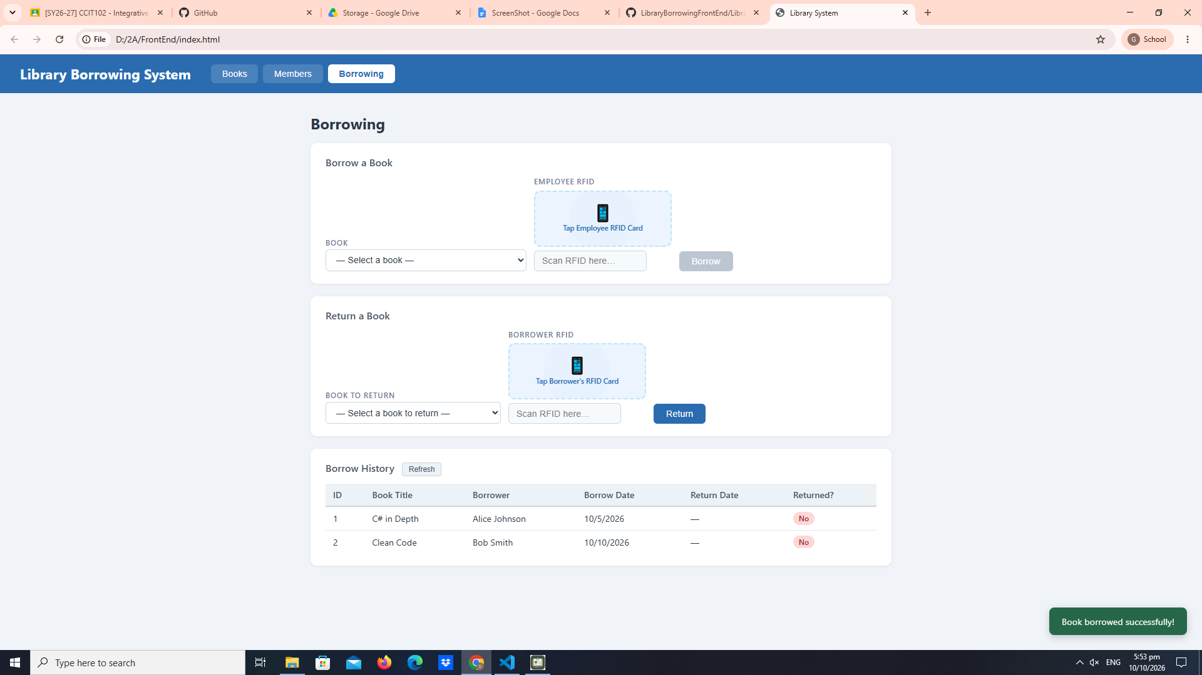
test-11-return-wrong-card 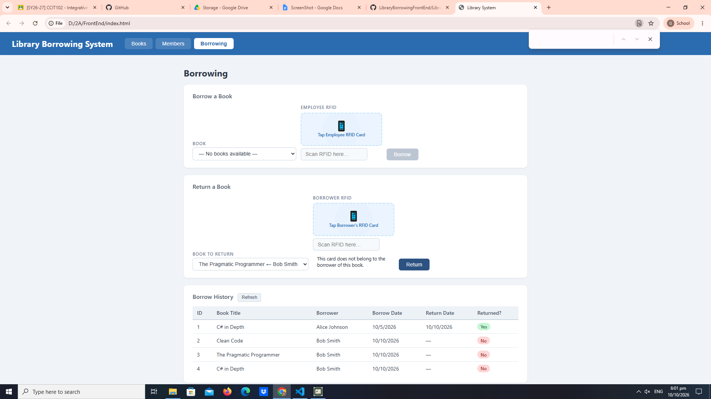
test-12-return-verified 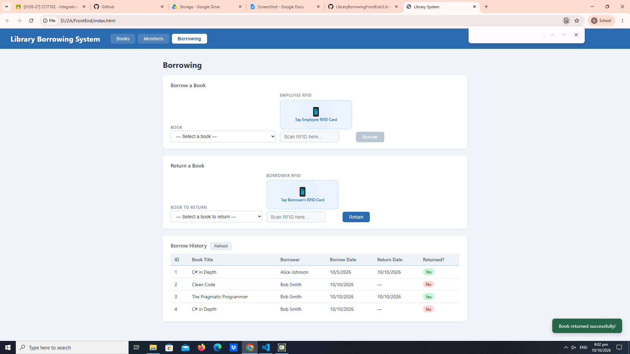
test-13-return-success 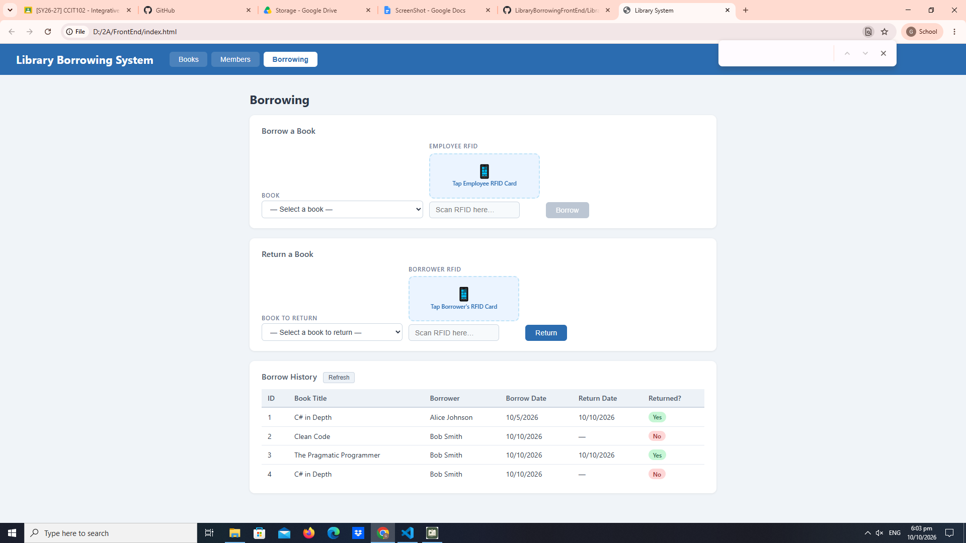
test-14-final-console 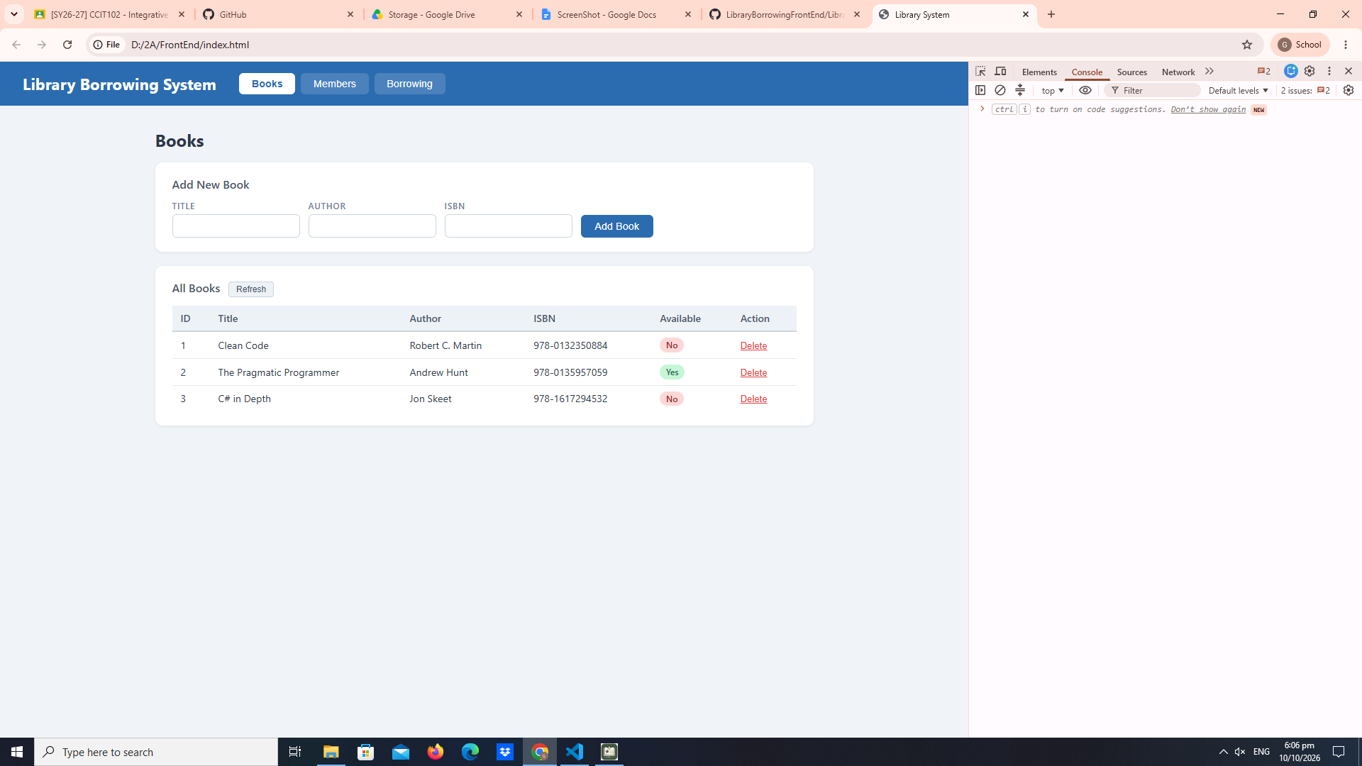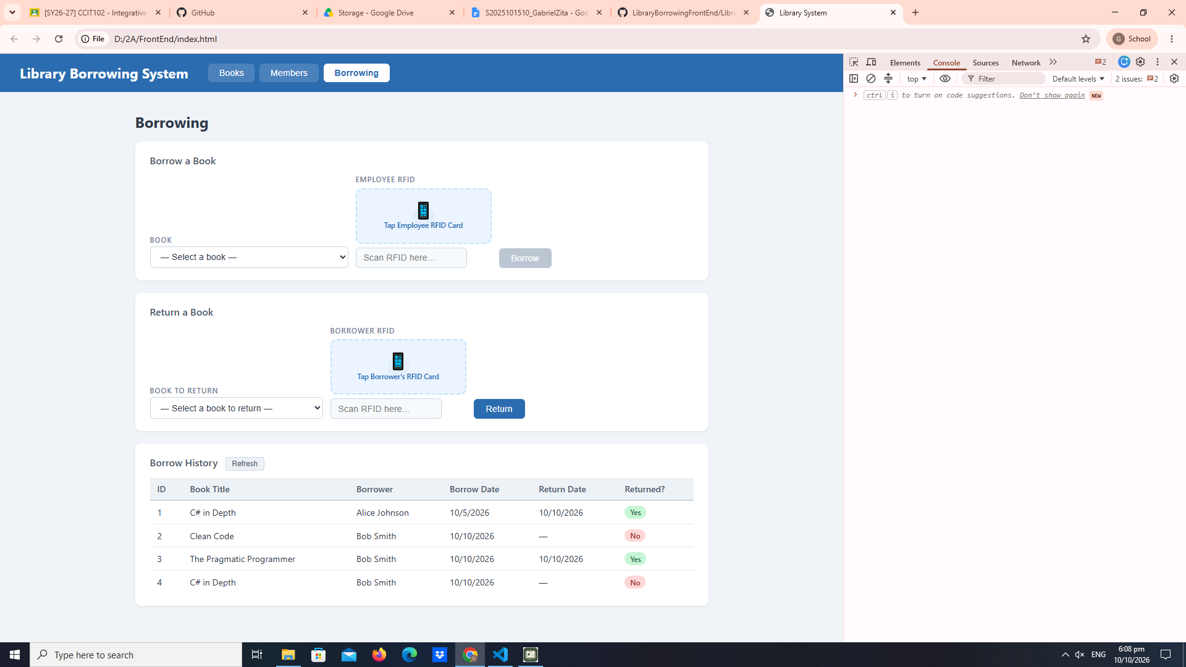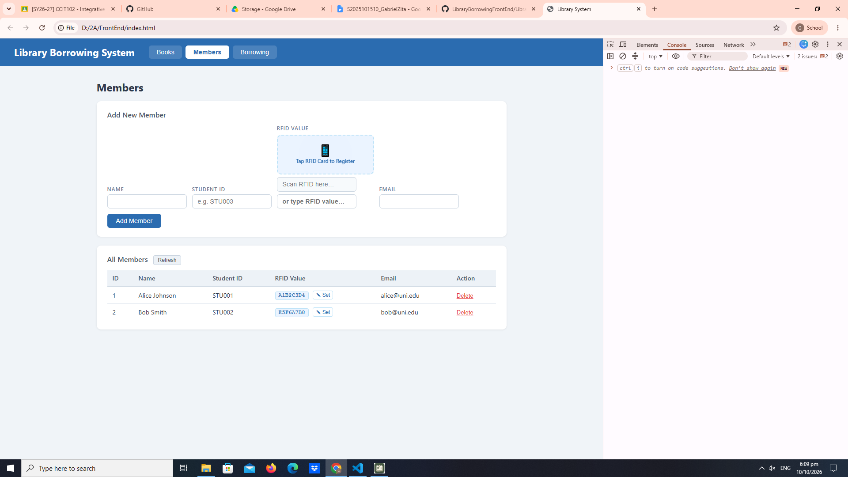

- What does apiFetch() do?
- Why do we use try/catch around API calls?
- What is the difference between POST and PUT?
- Why does RFID matching use rfidValue instead of studentId?
- Why do we refresh tables after adding, deleting, borrowing, or returning?
- Why does the Return dropdown use borrow record ID instead of book ID?
- What happens if the same event listener is added to a form twice?
- Why must the page-load code be at the bottom of the file?
- Why does an RFID reader need e.preventDefault() on the Enter key?

Answers:
- Prevents repeated Code
- Prevents application crashes
- POST creates new data, PUT updates the existing data
- The scanner reads the card tag and not the database id
- To display the up data date in the ui
- To know specific transactions
- Will execute twice
- Makes sure that the html element loads before java script interacts with them
- To stop the scanners to automatically enter keys from entering too early

