Matanguihan, Mickaela C.
BSIT-2B
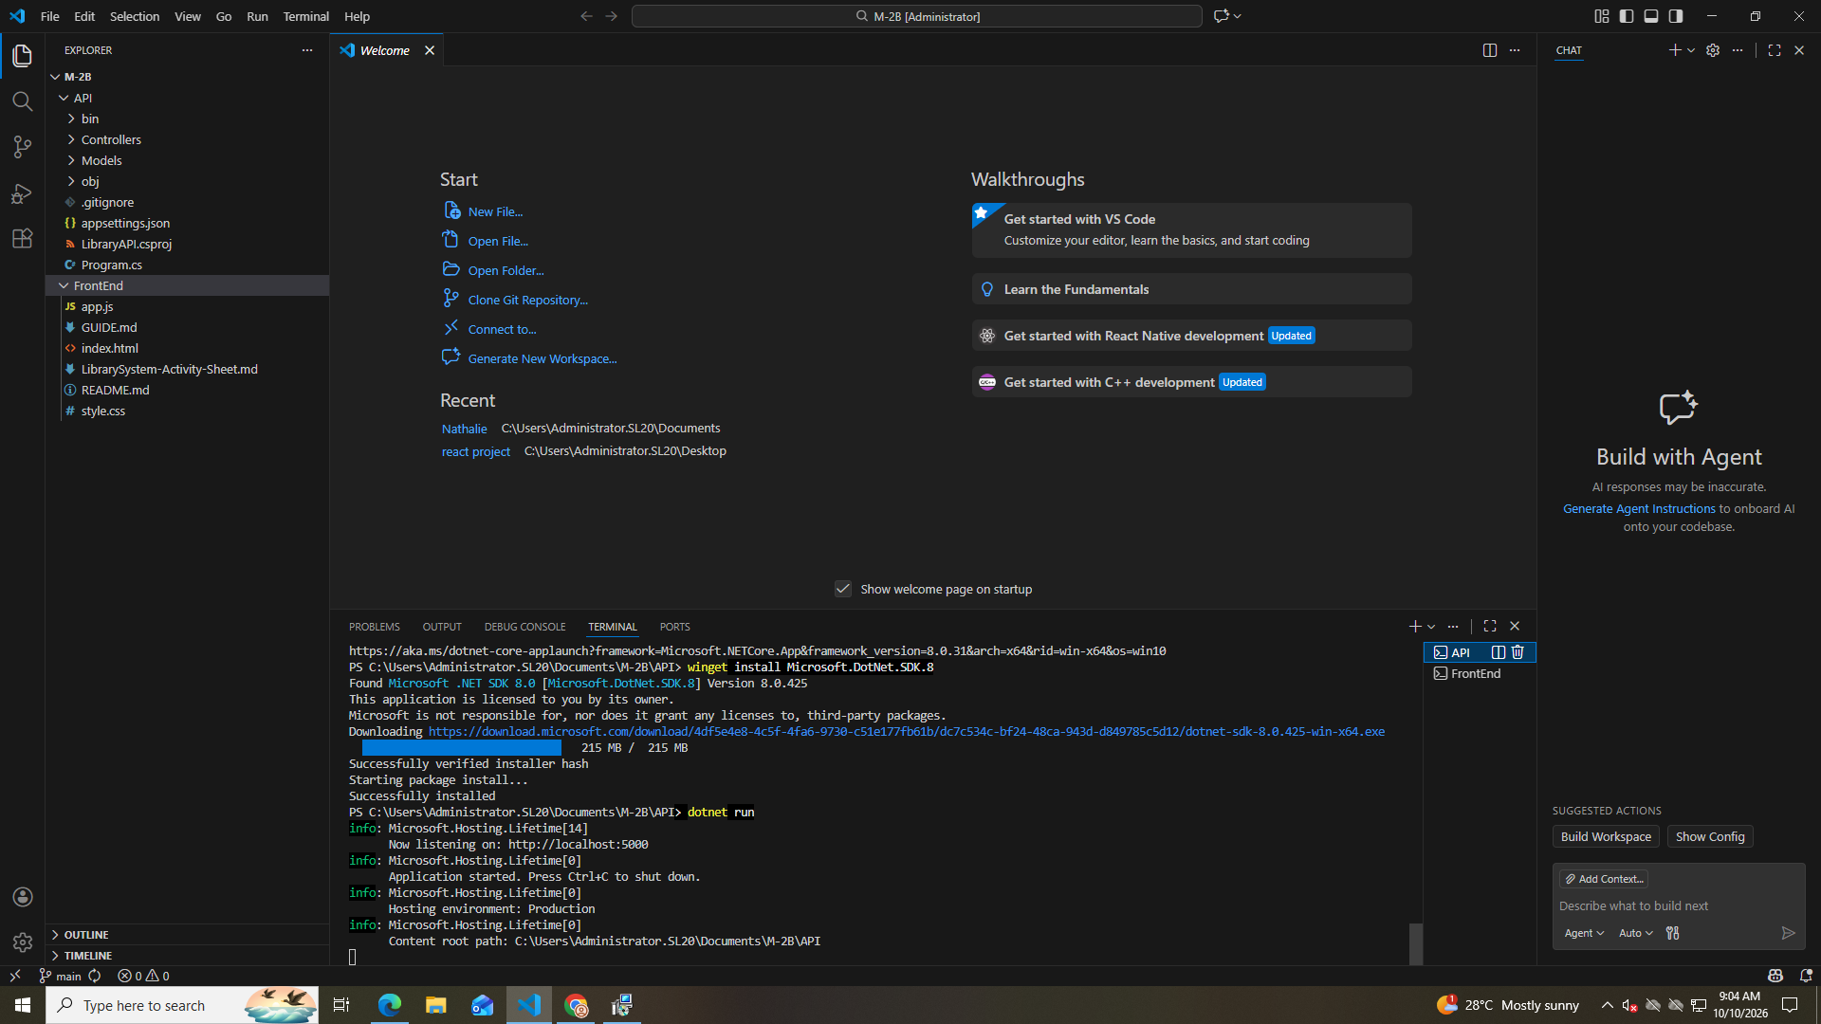
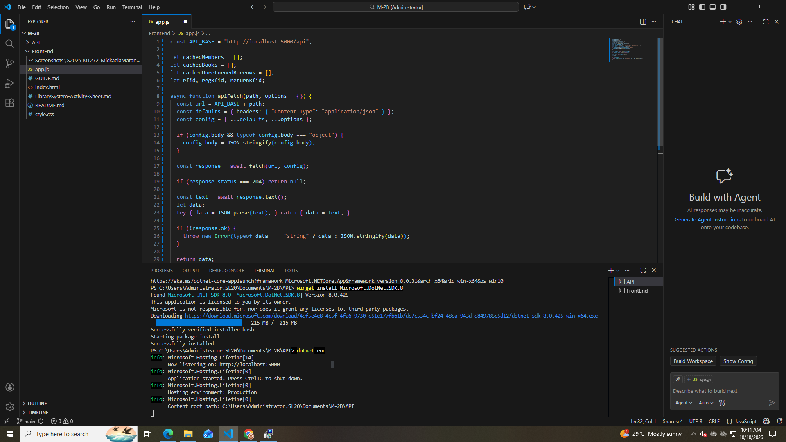
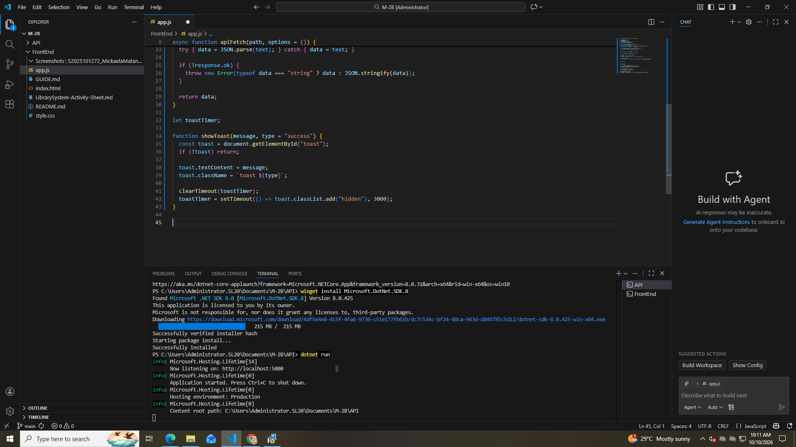
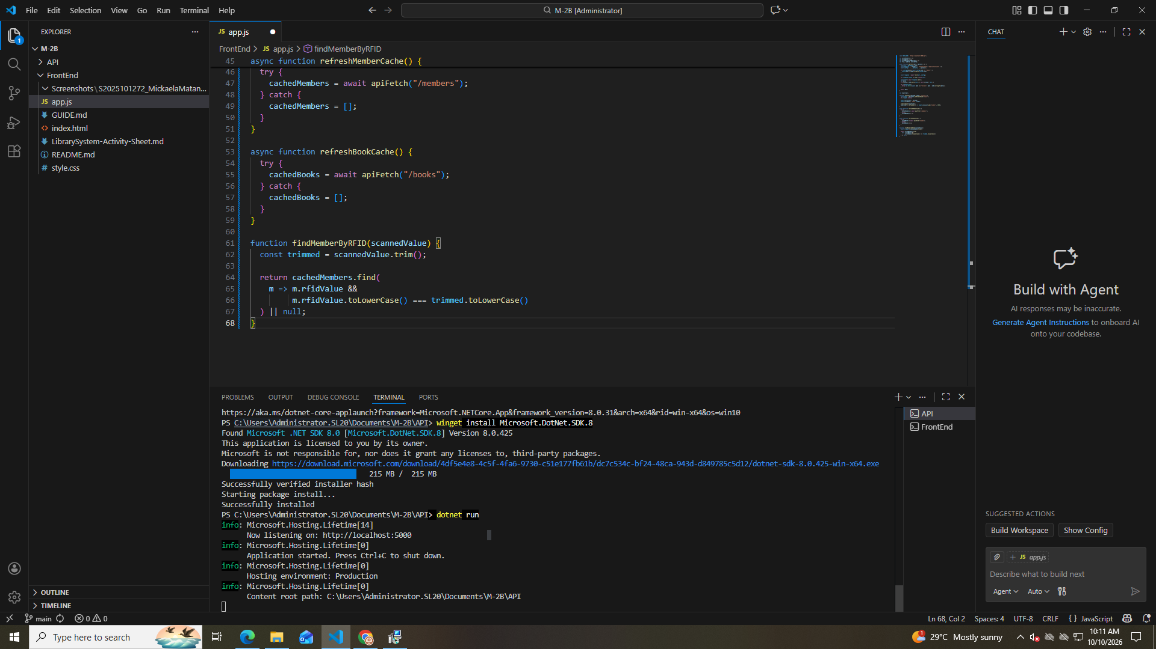

Part 4
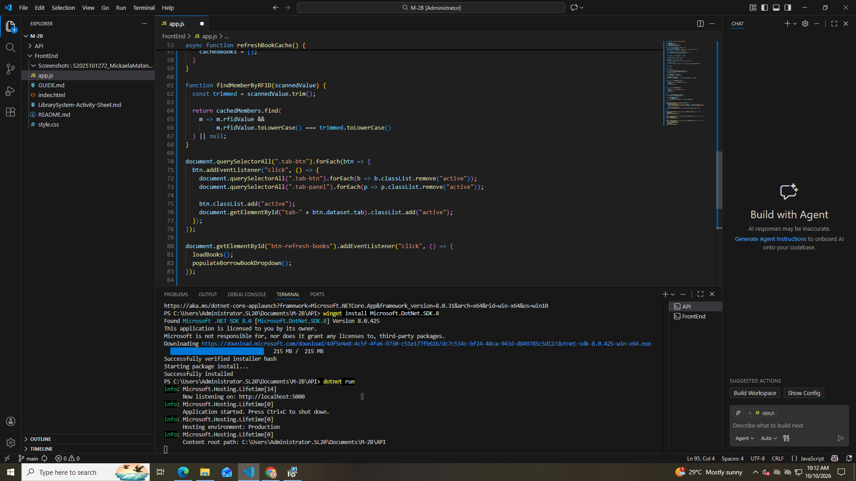

Part 5
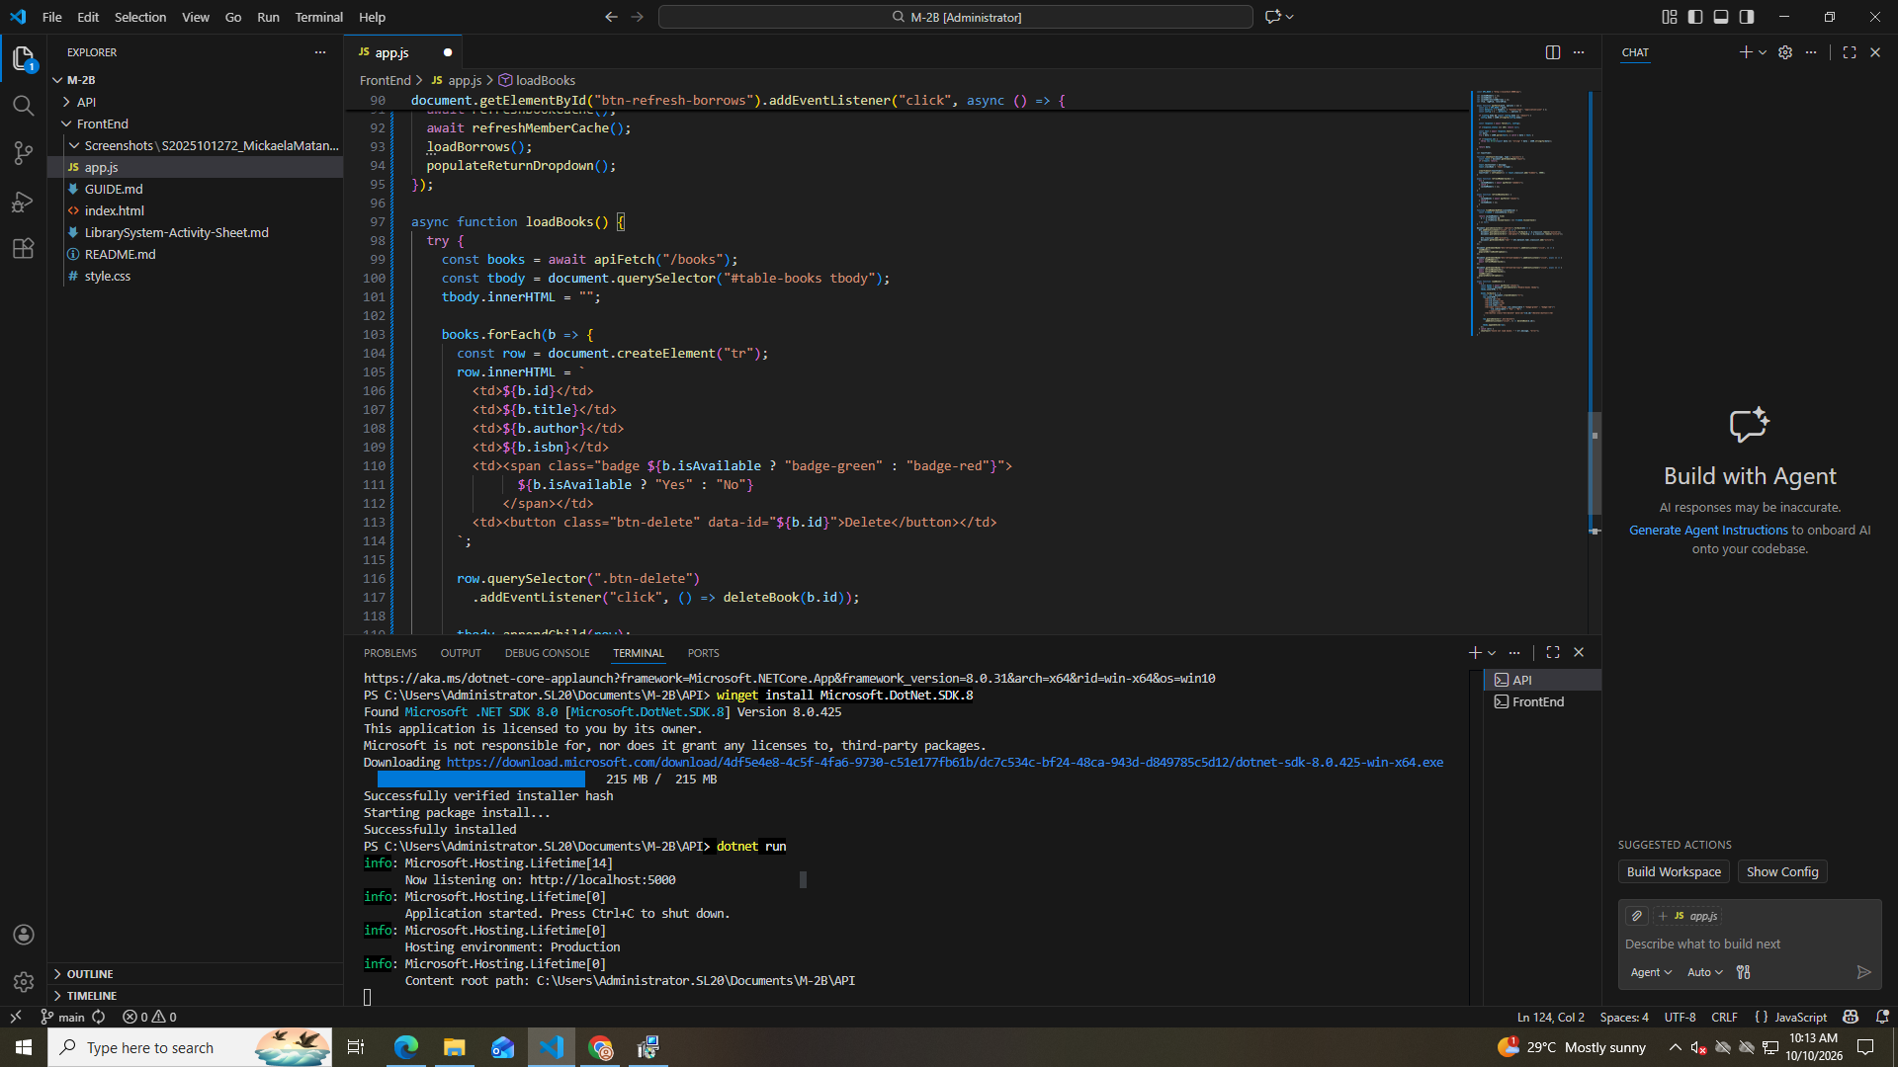

Part 6
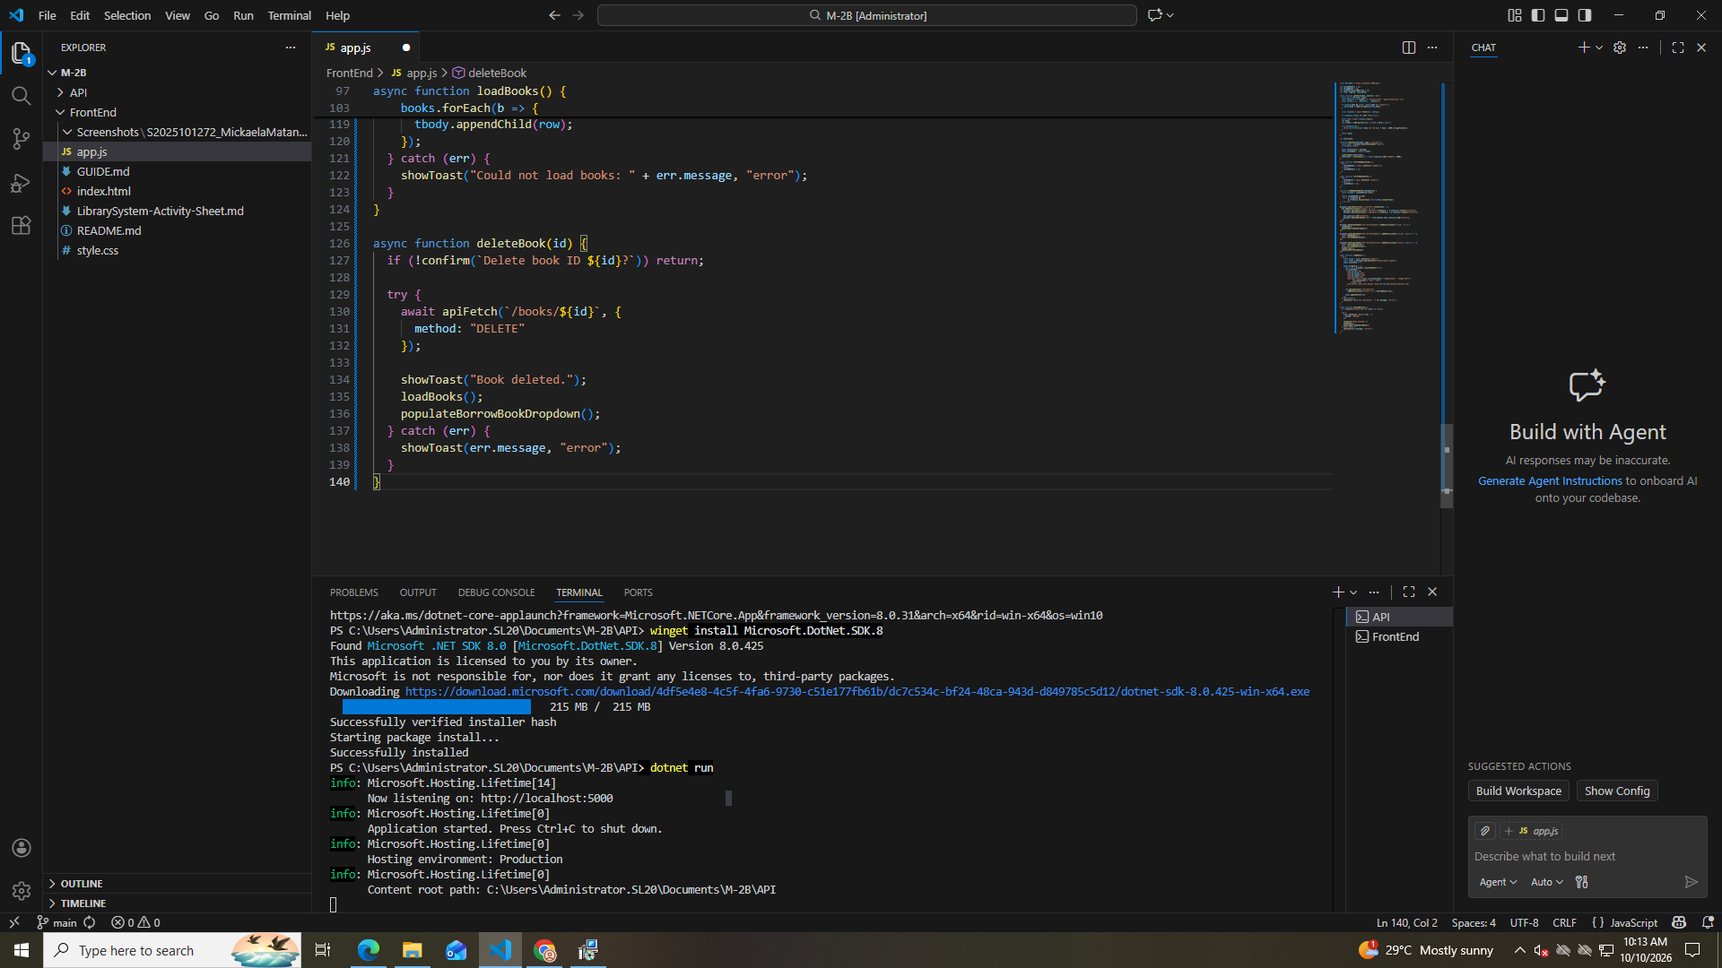

Part 7
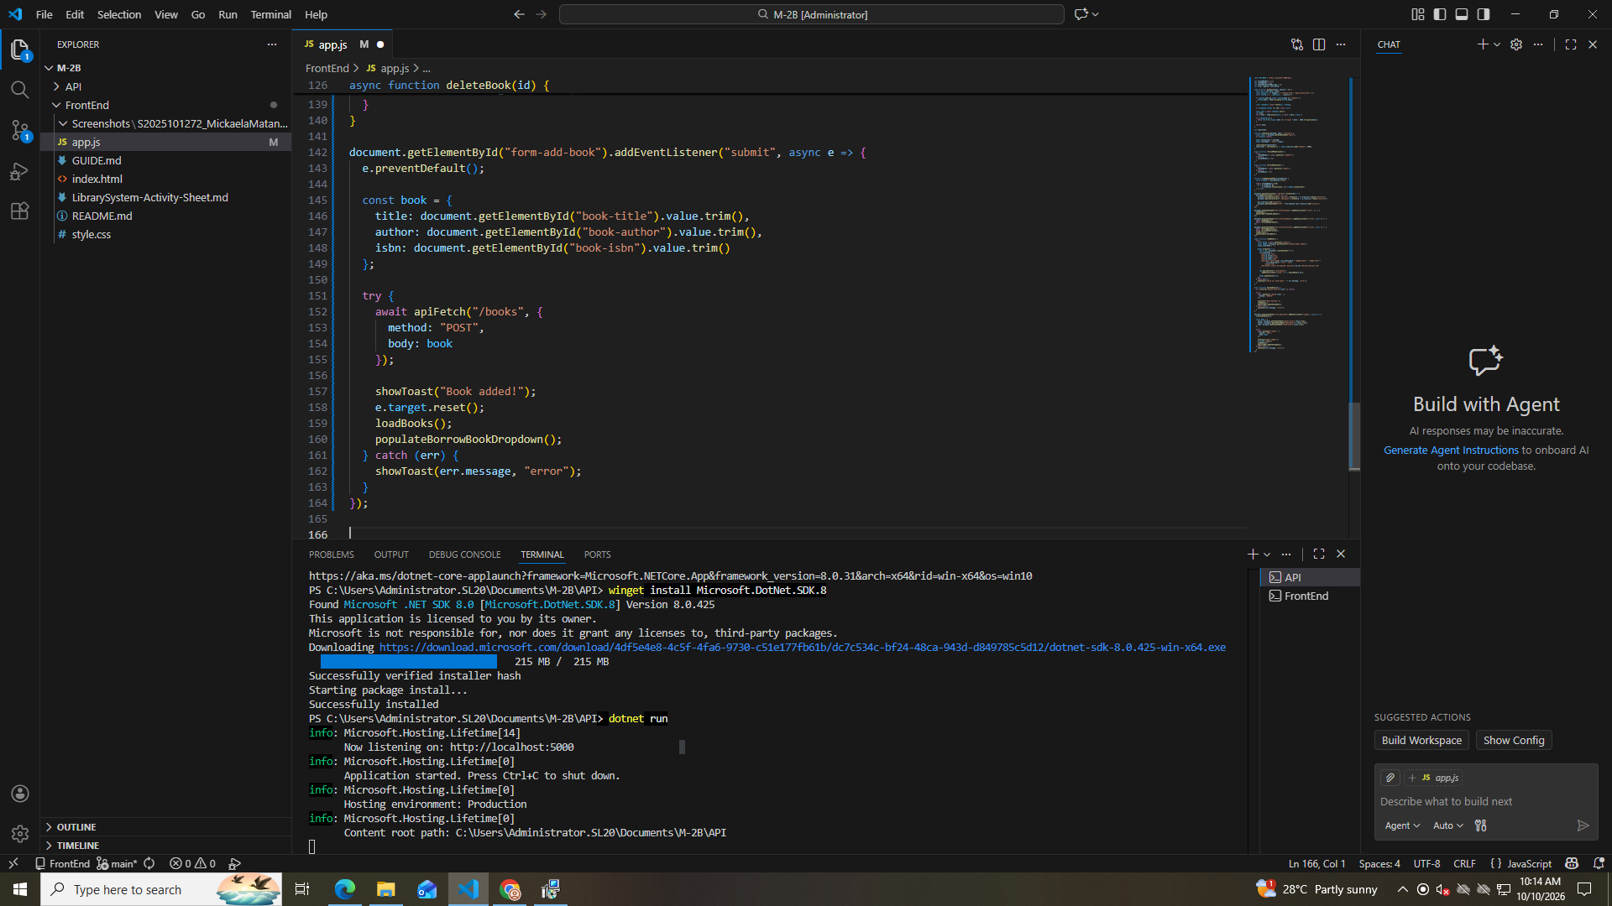

Part 8
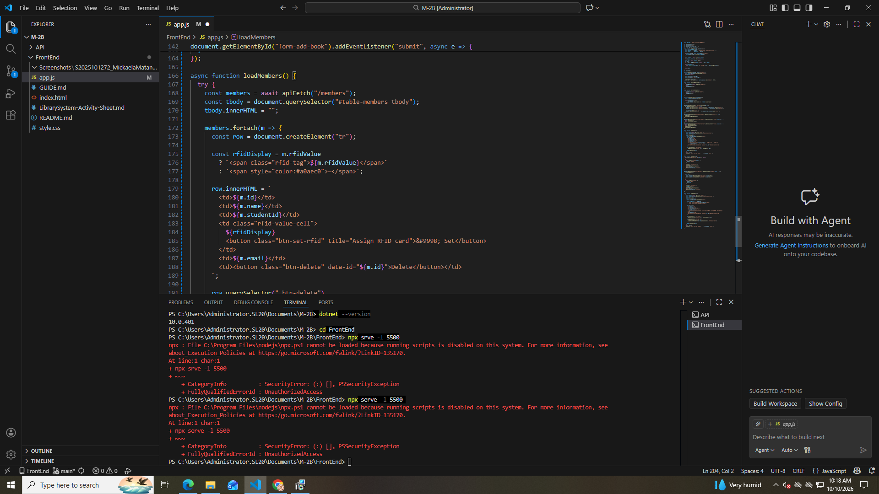

Part 9
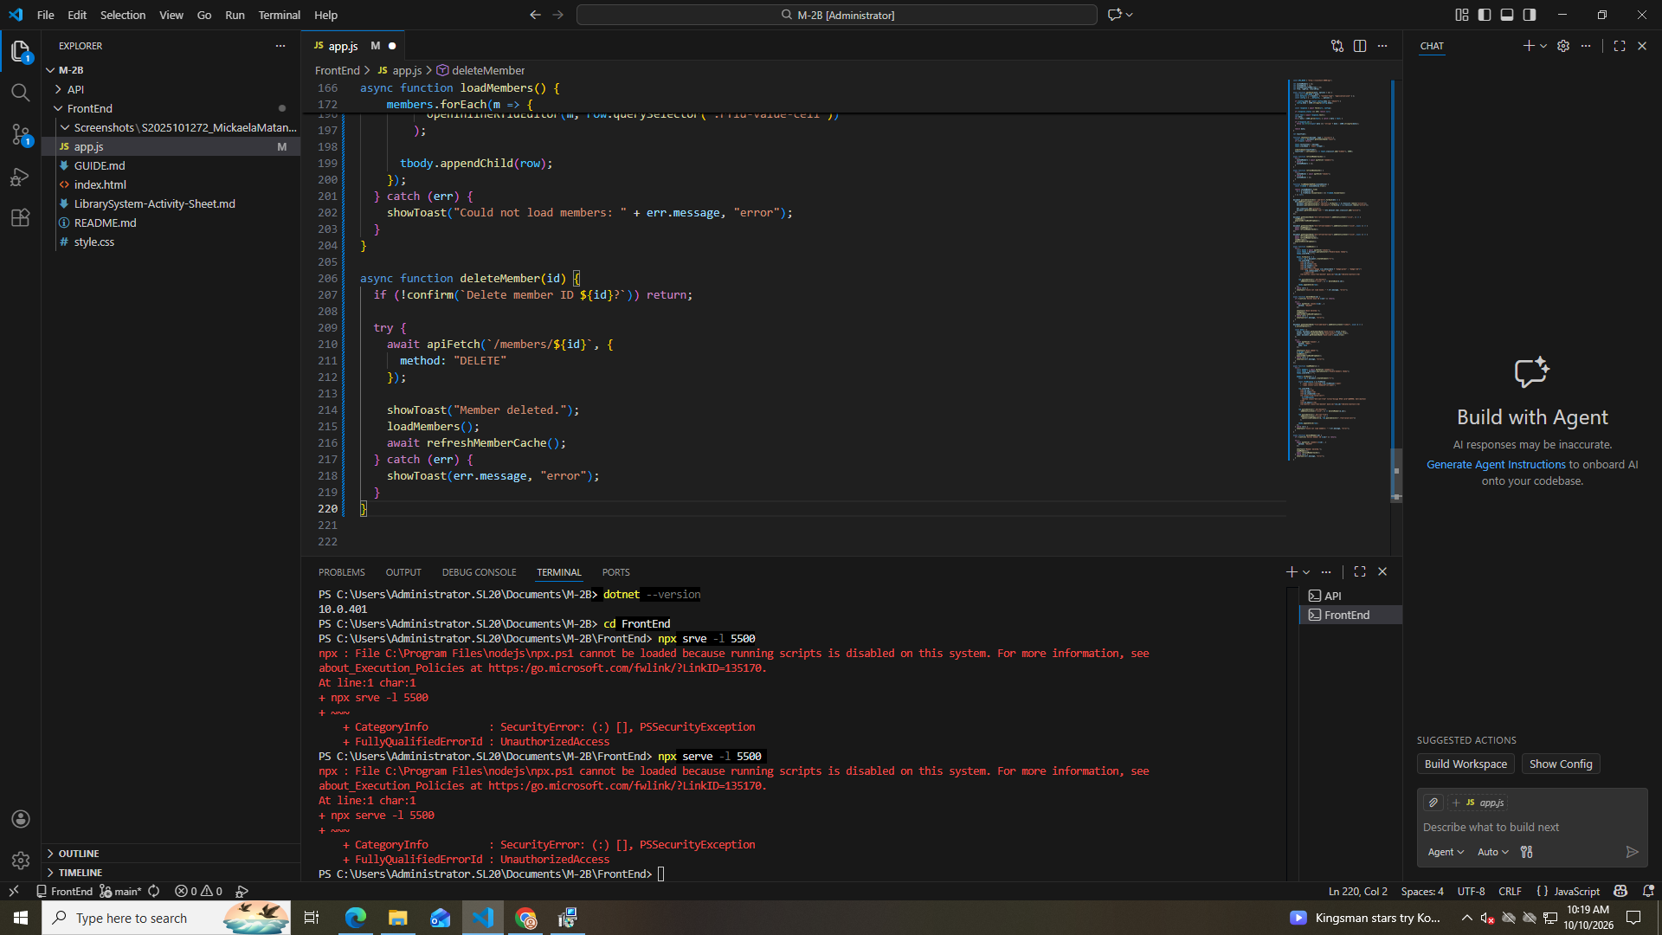

Part 10
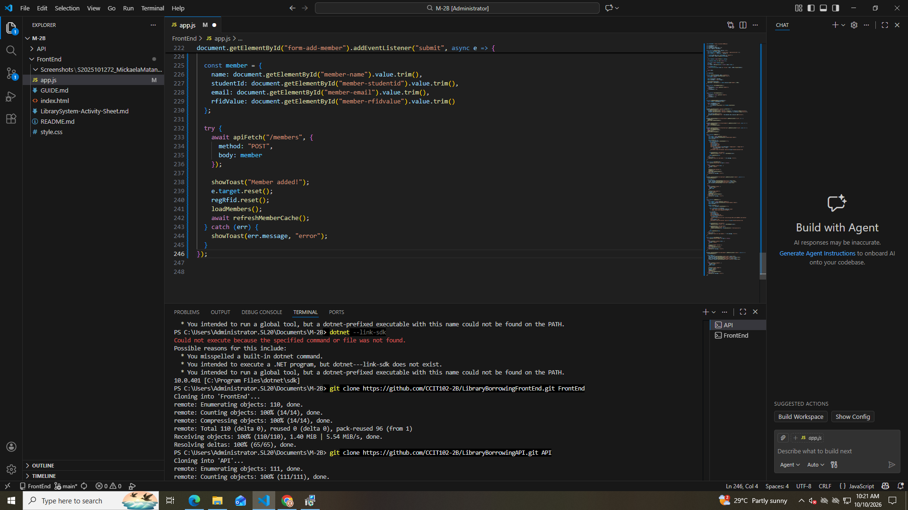

Part 11
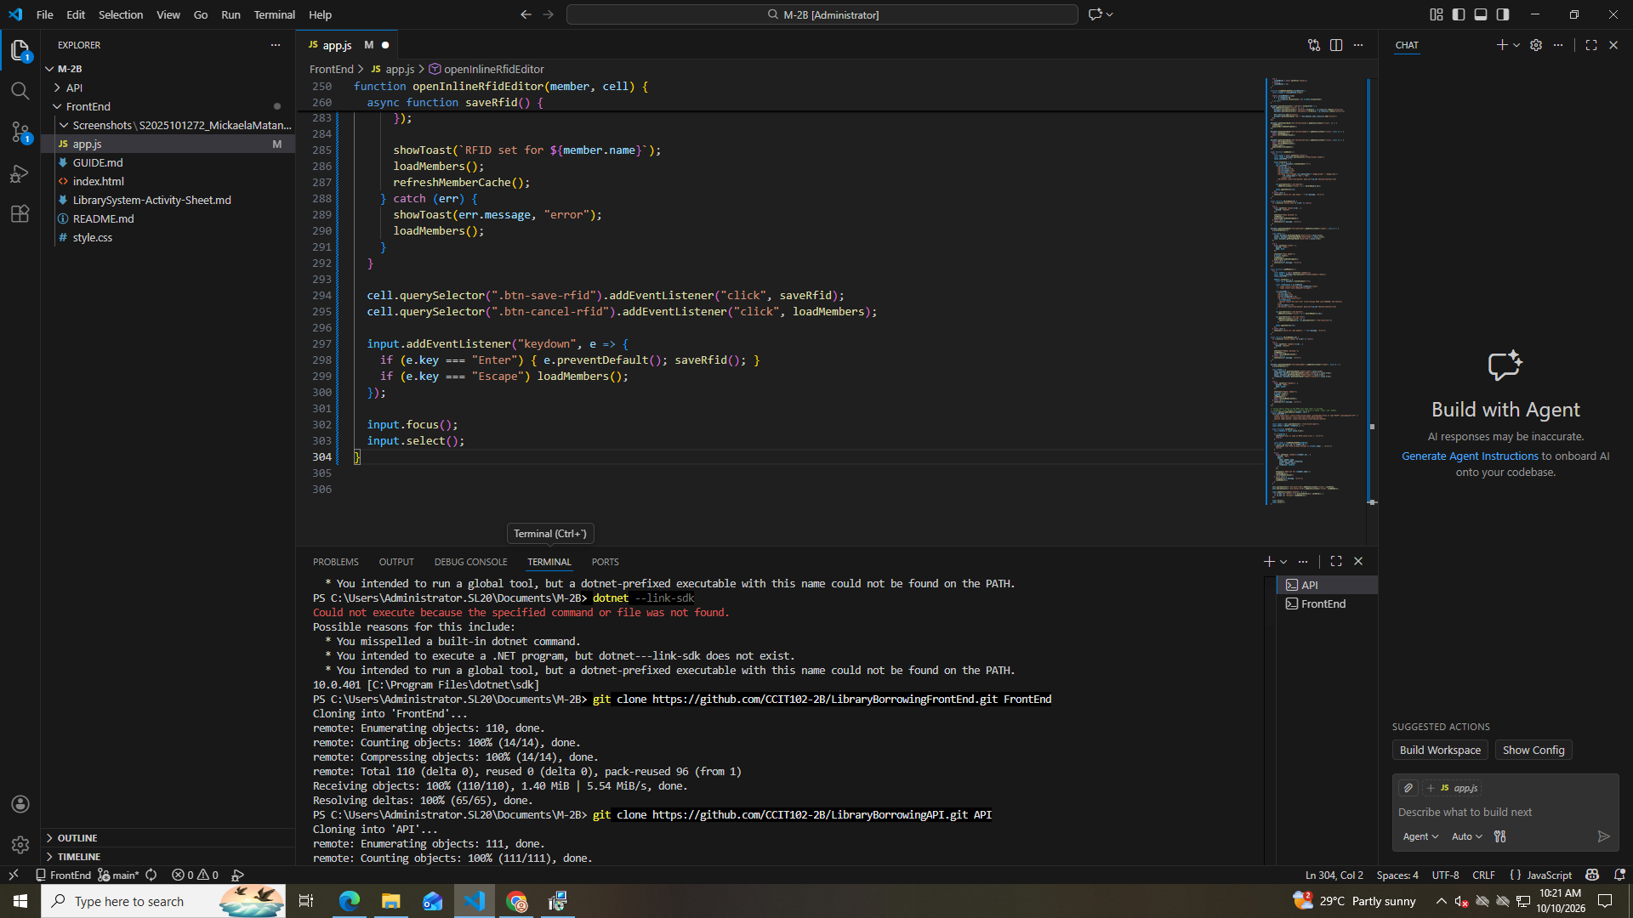

Part 12
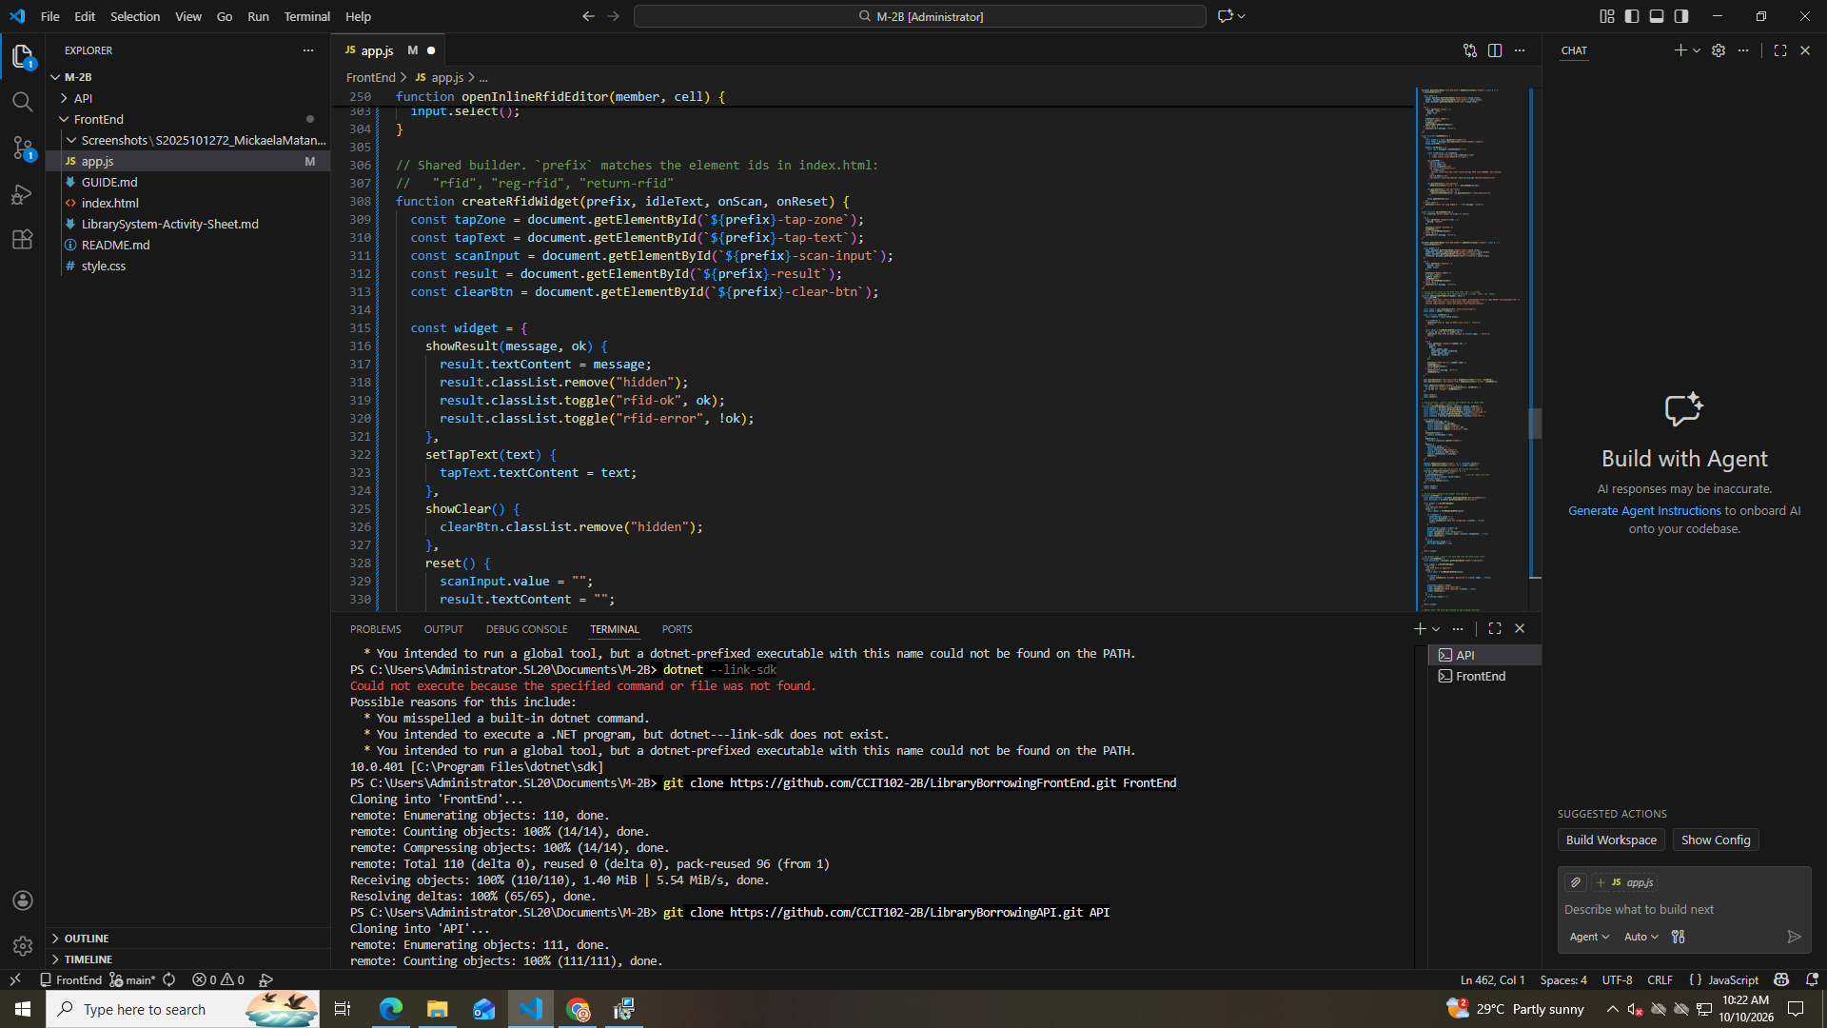

Part 13
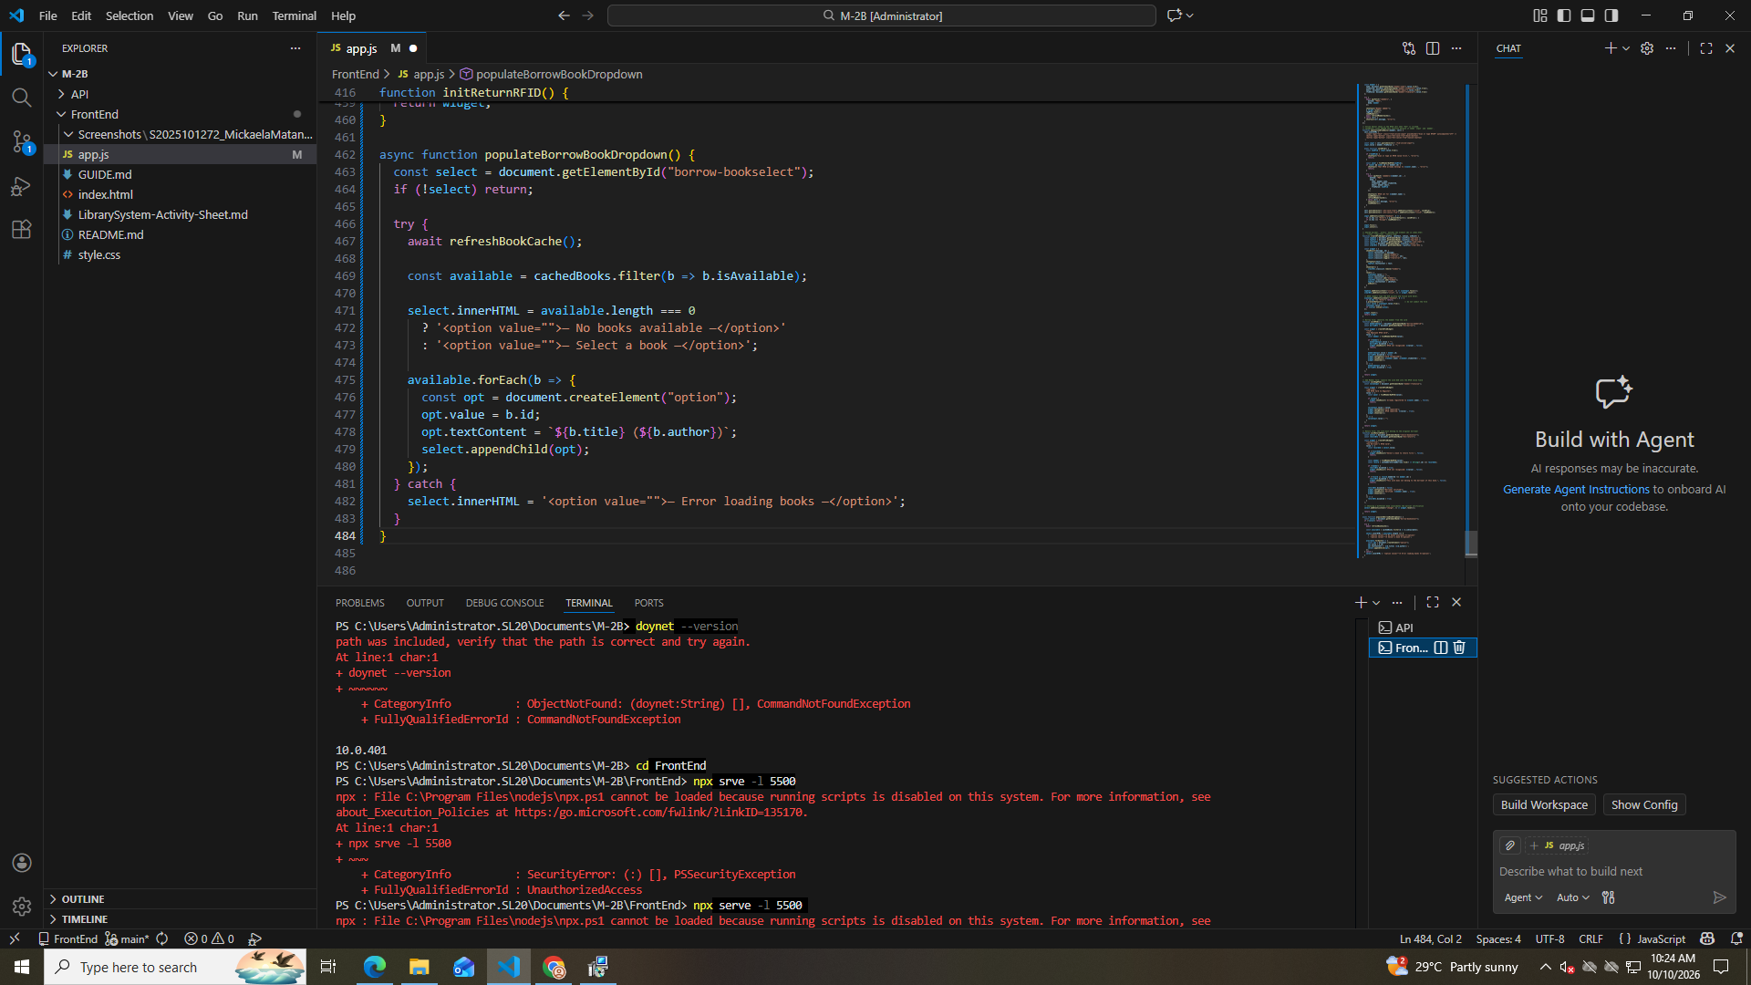

Part 14
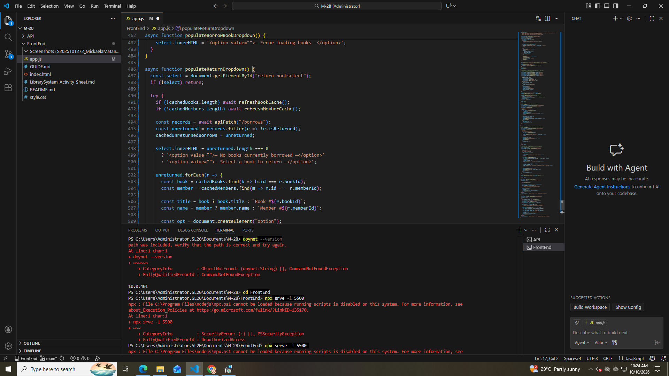

Part 15
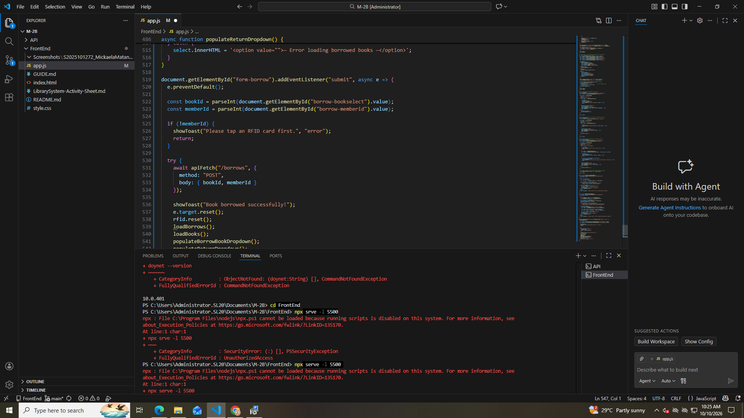

Part 16
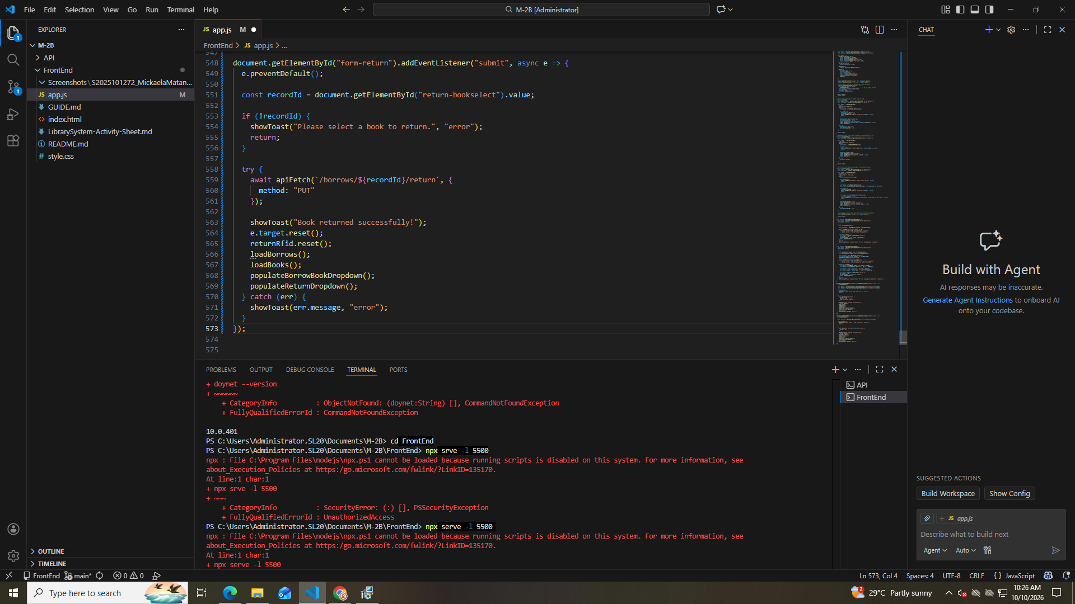

Part 17
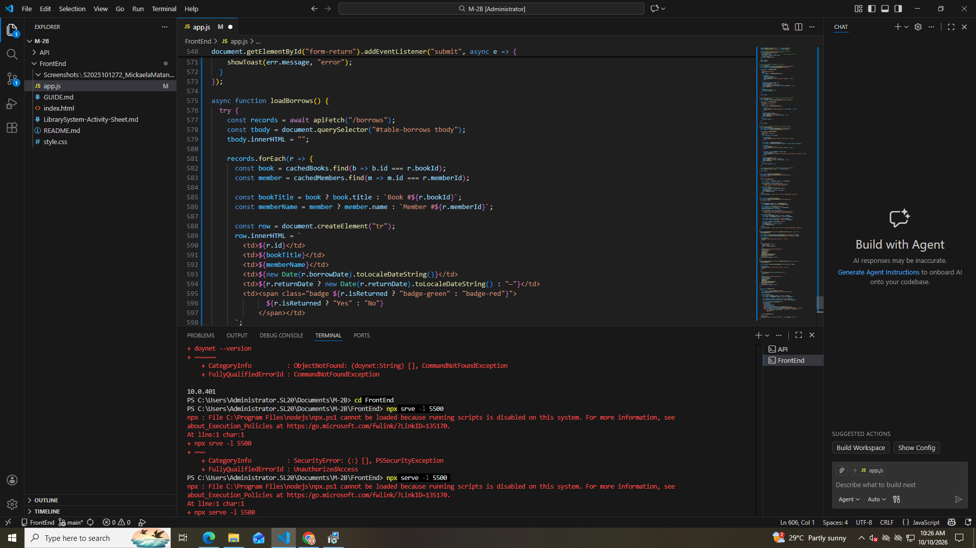

Part 18
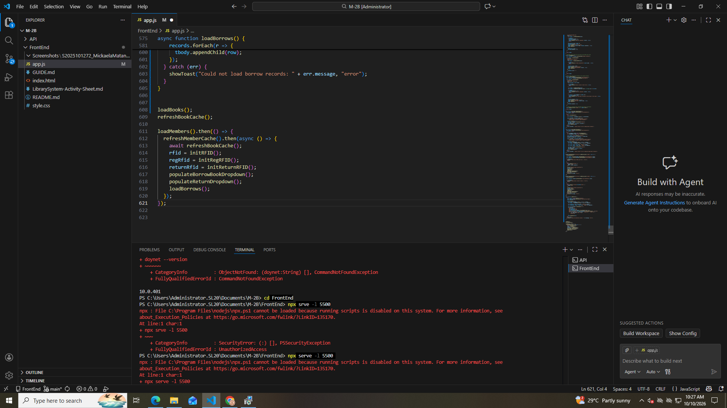

TEST THE TABS
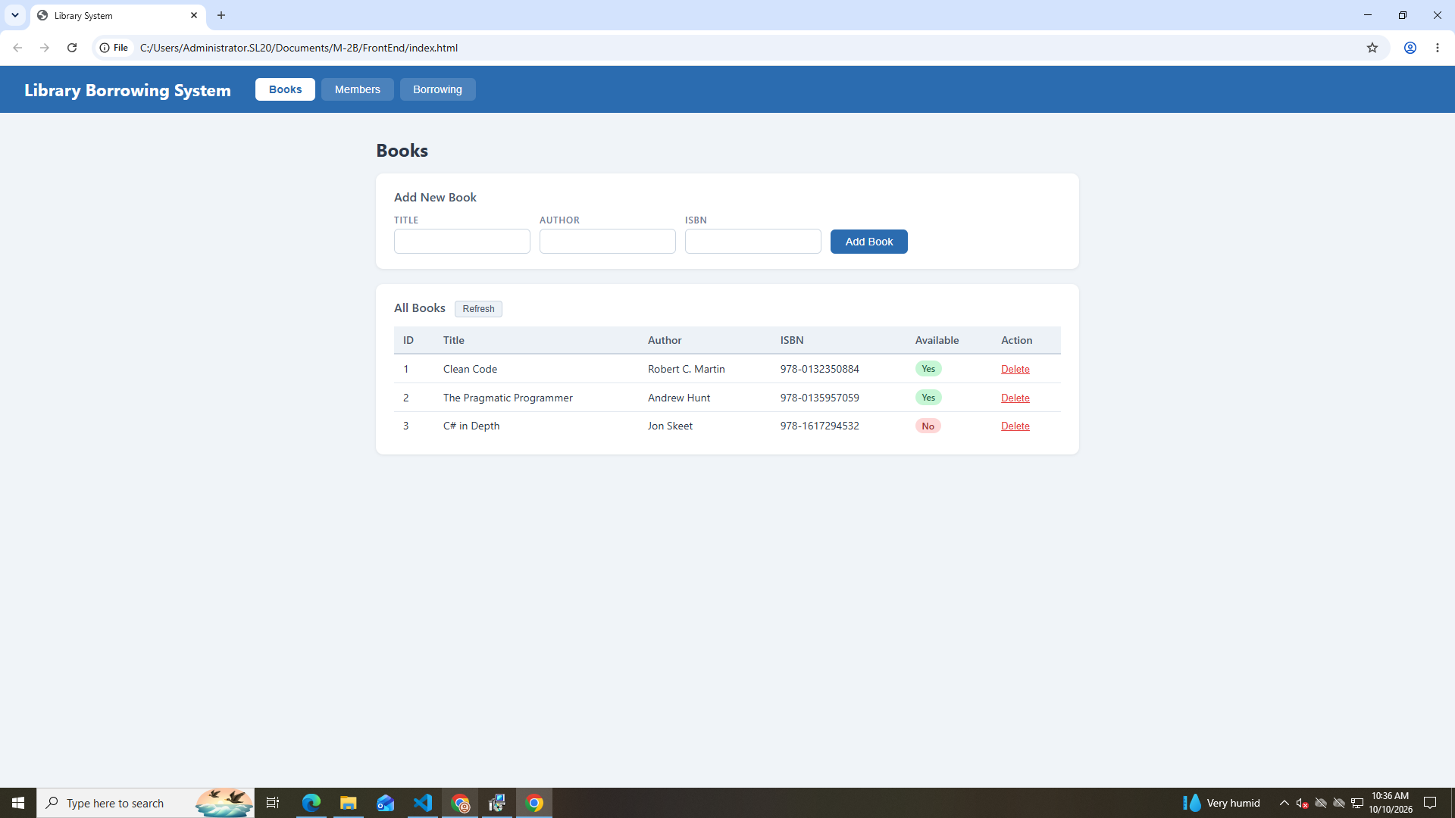
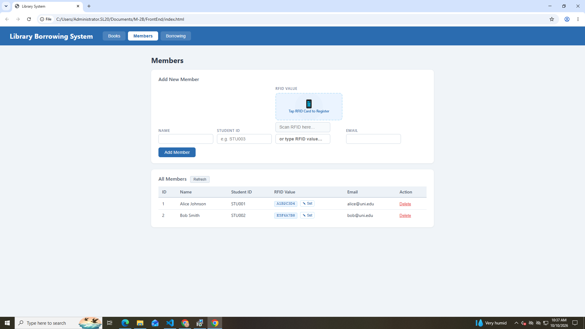
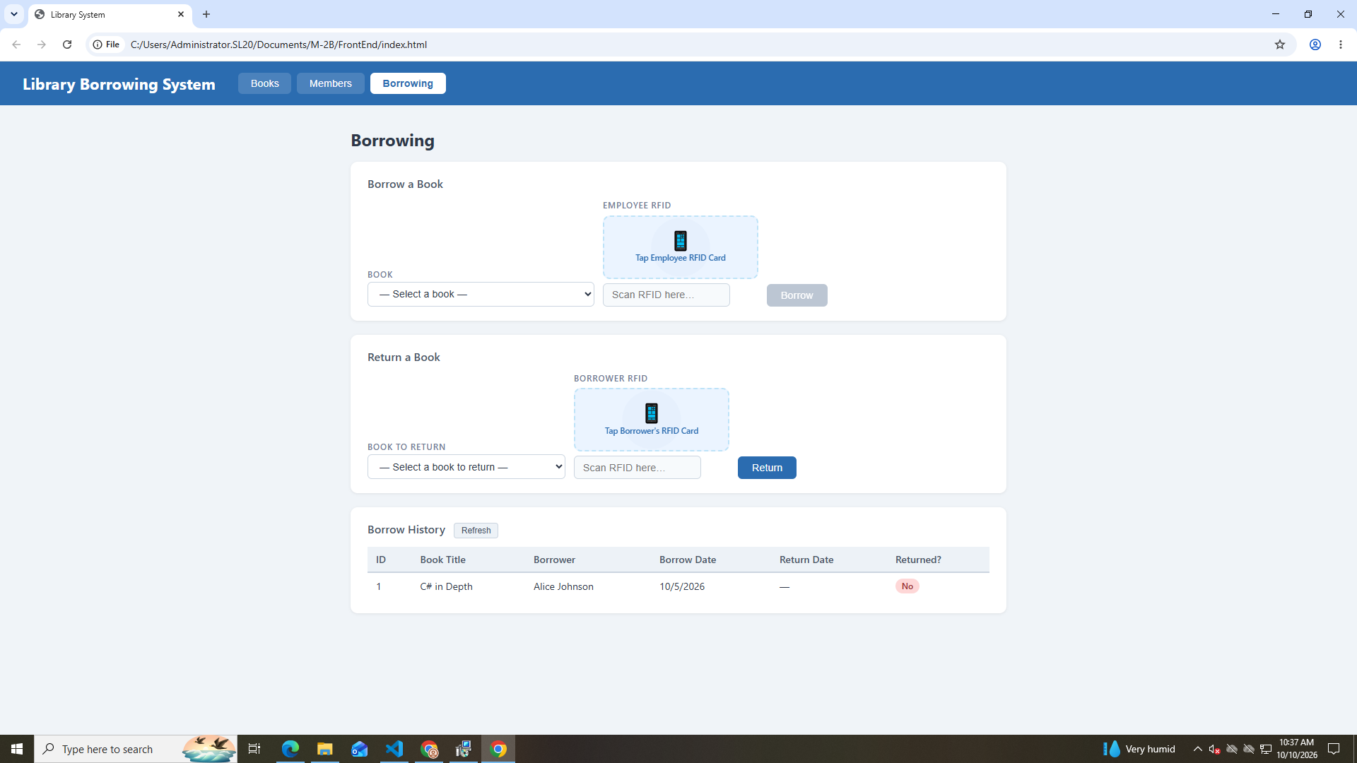

TEST BOOKS
Adding a Book
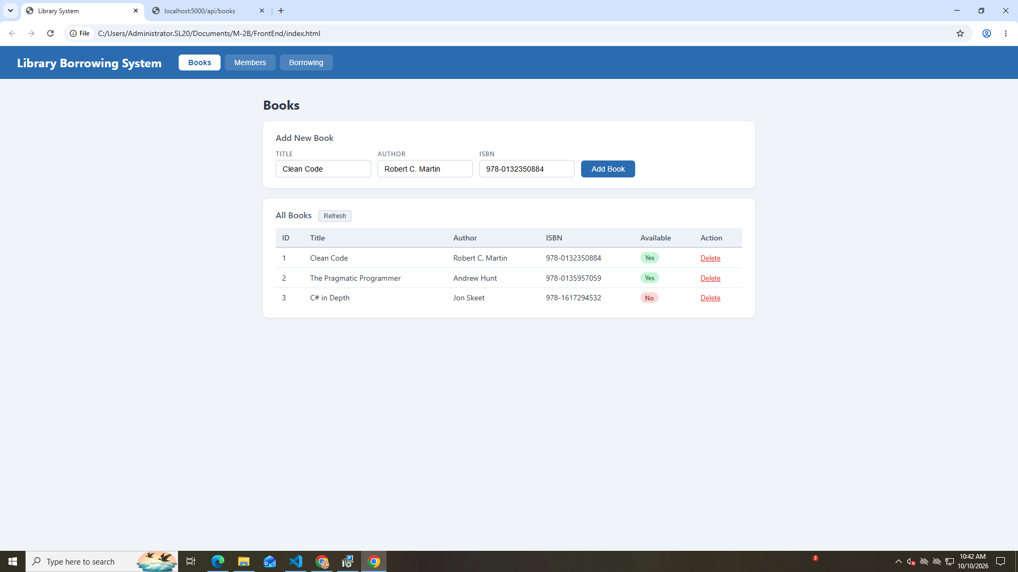

Deleting Books
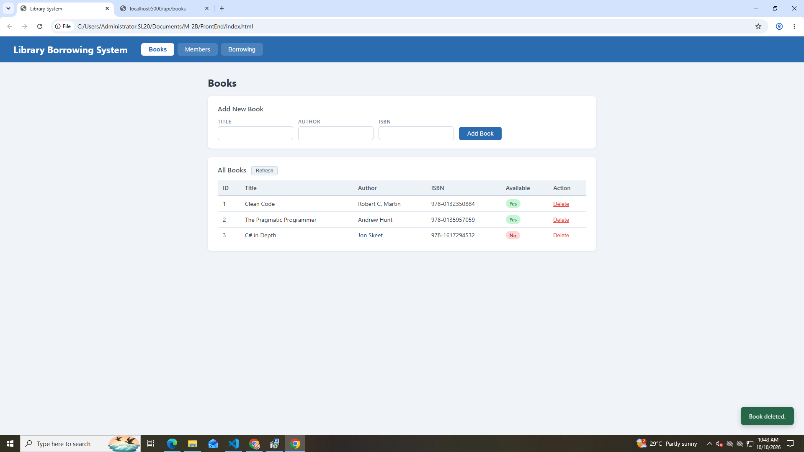

TEST MEMBERS
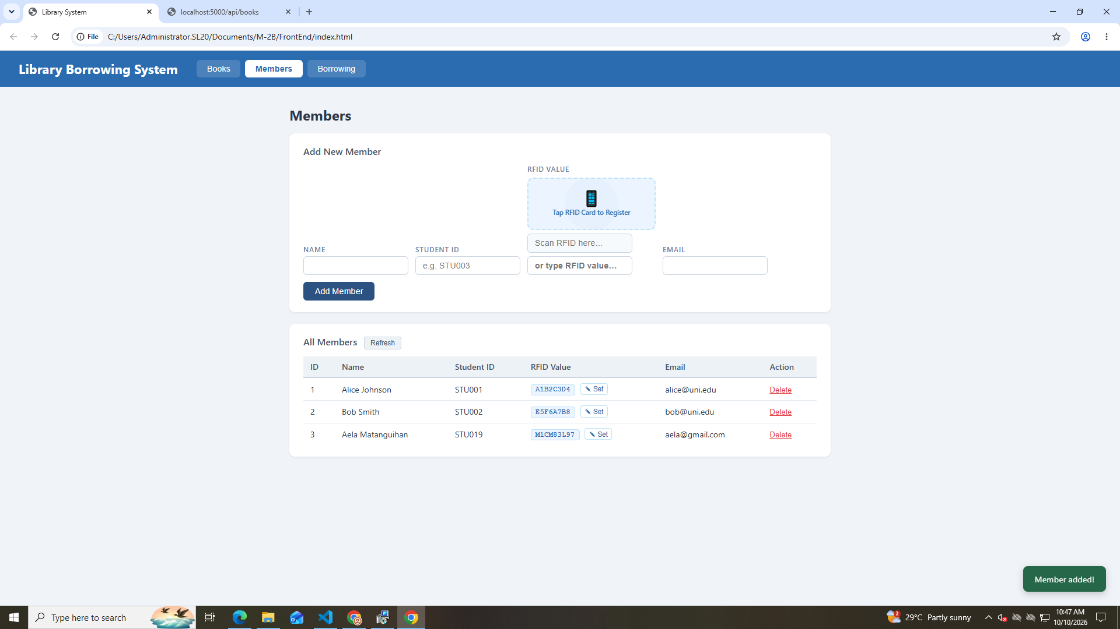
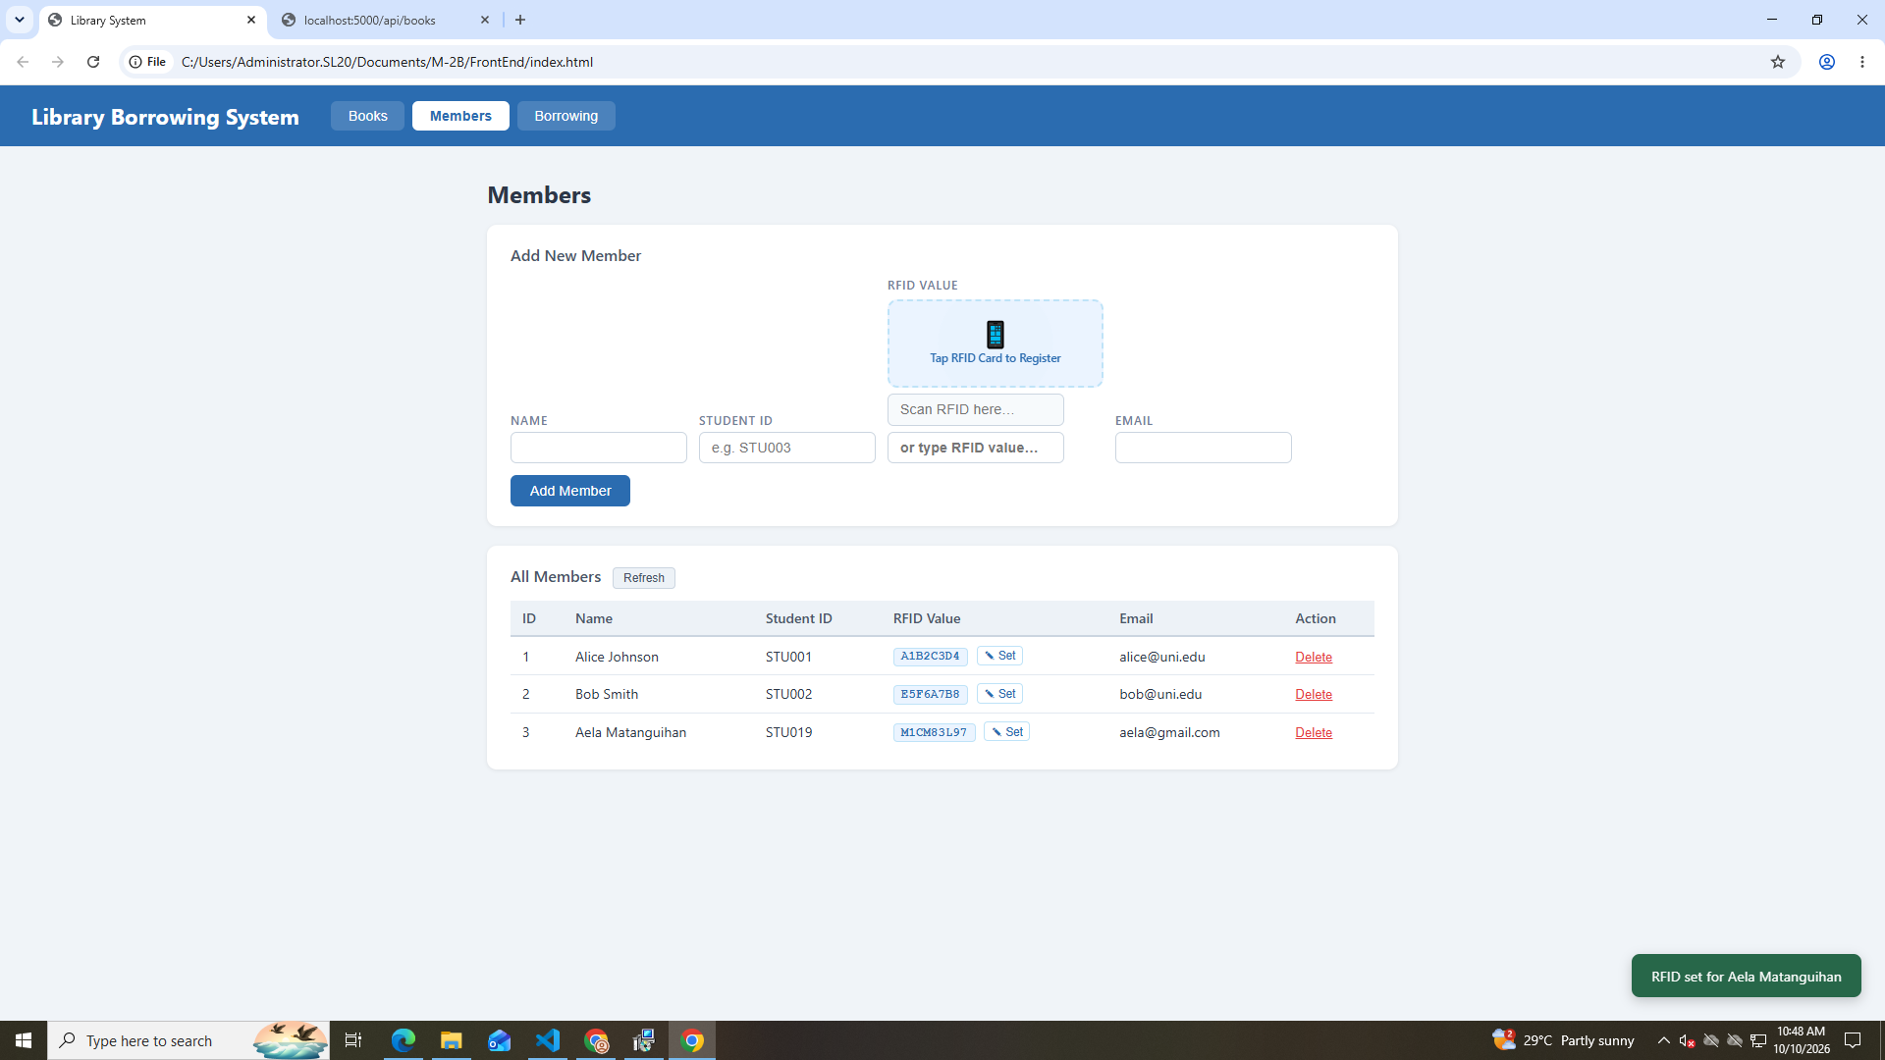
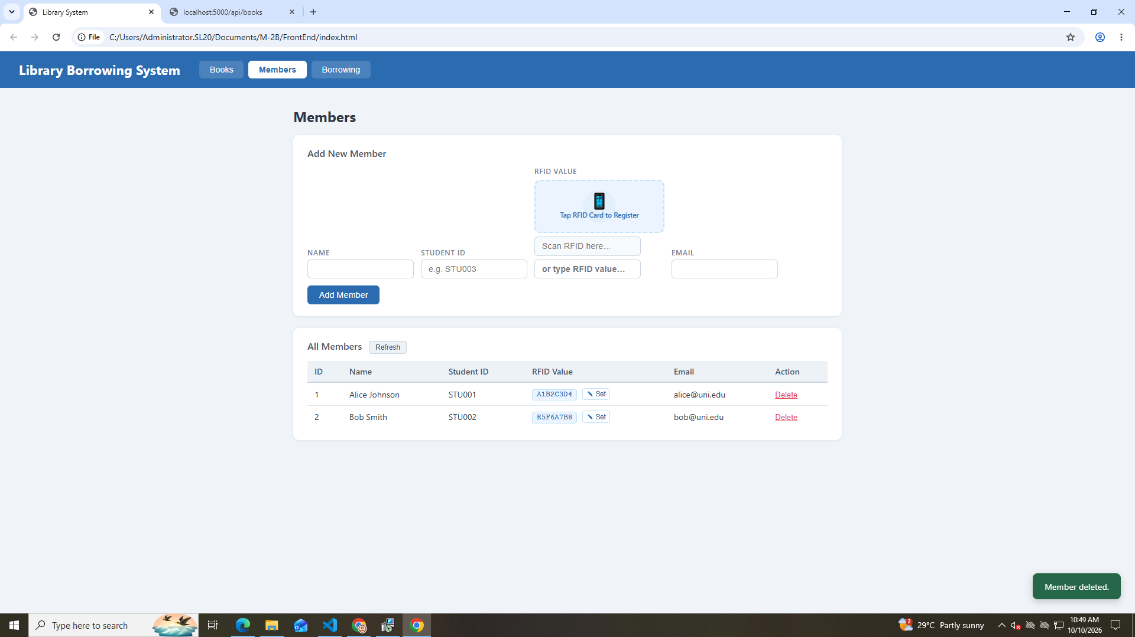

TEST BORROWING
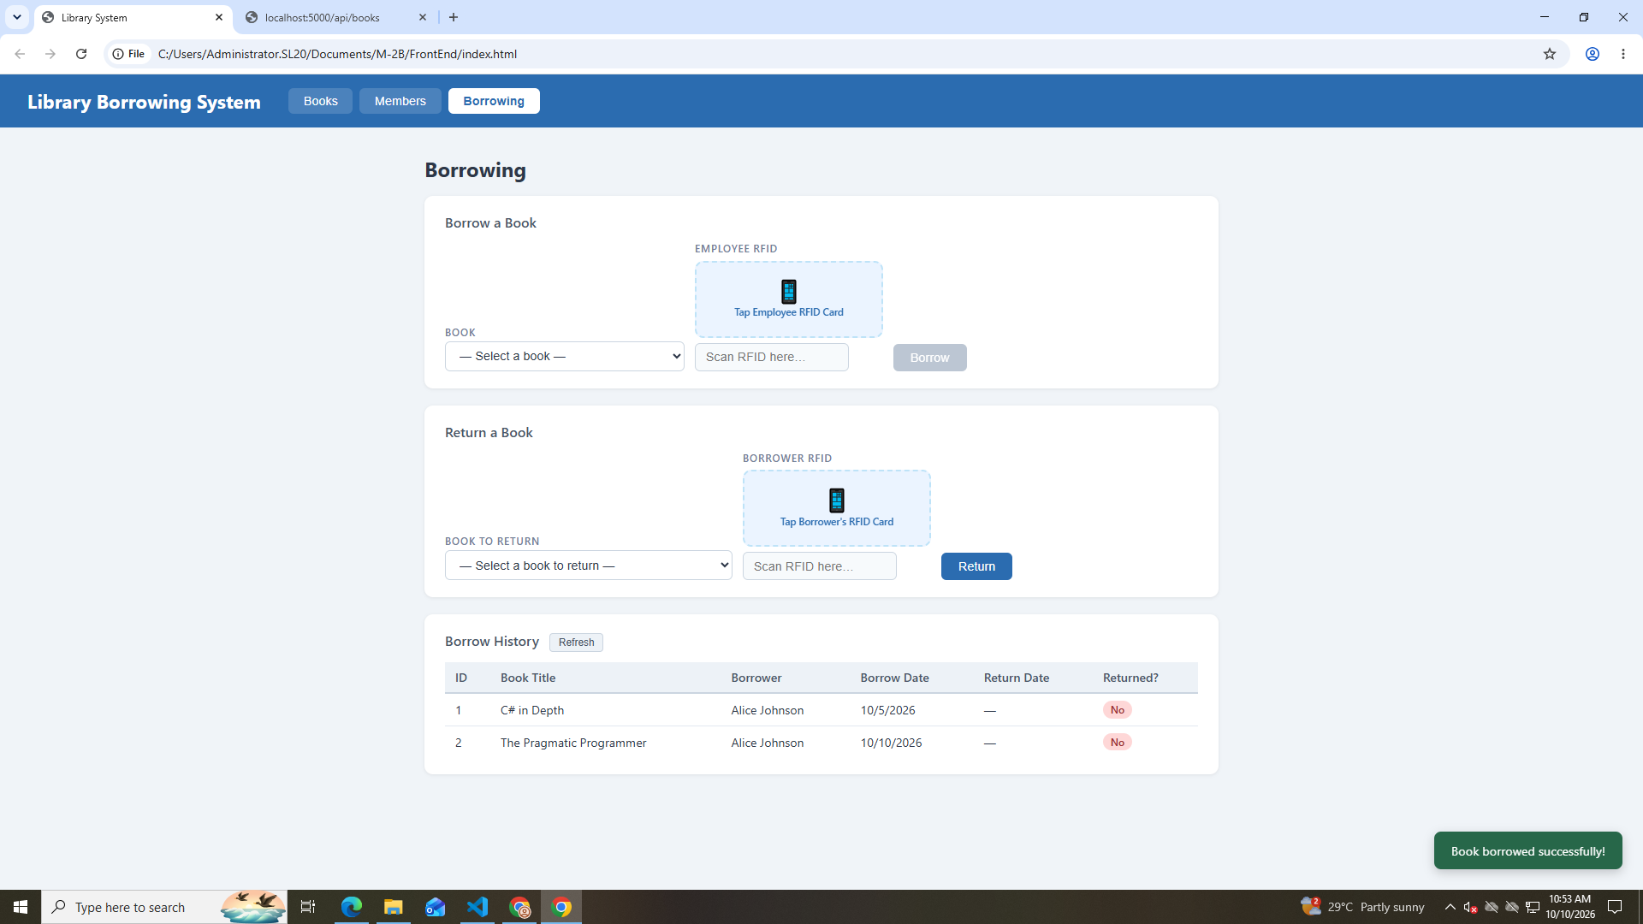

TEST RETURNING
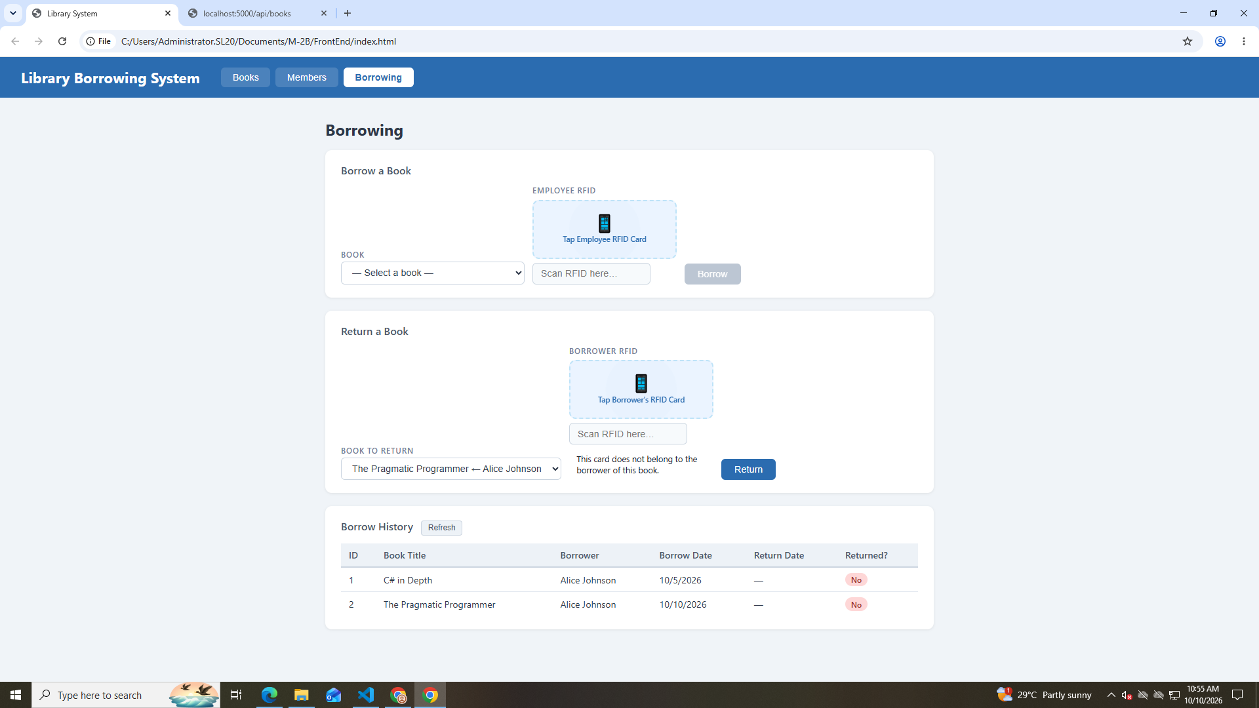
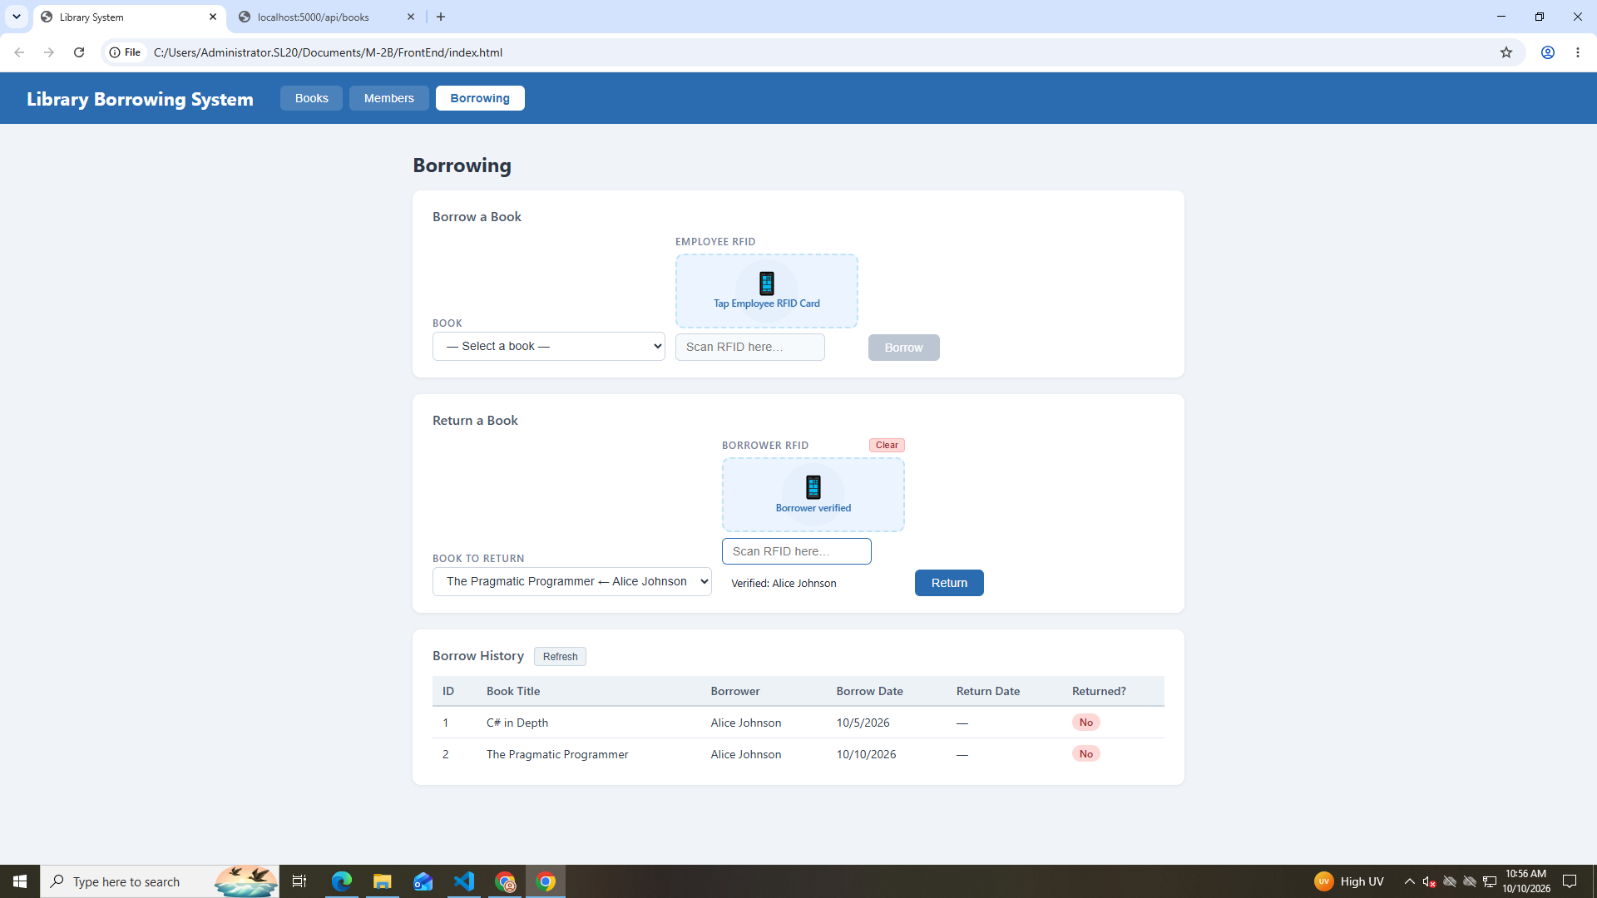
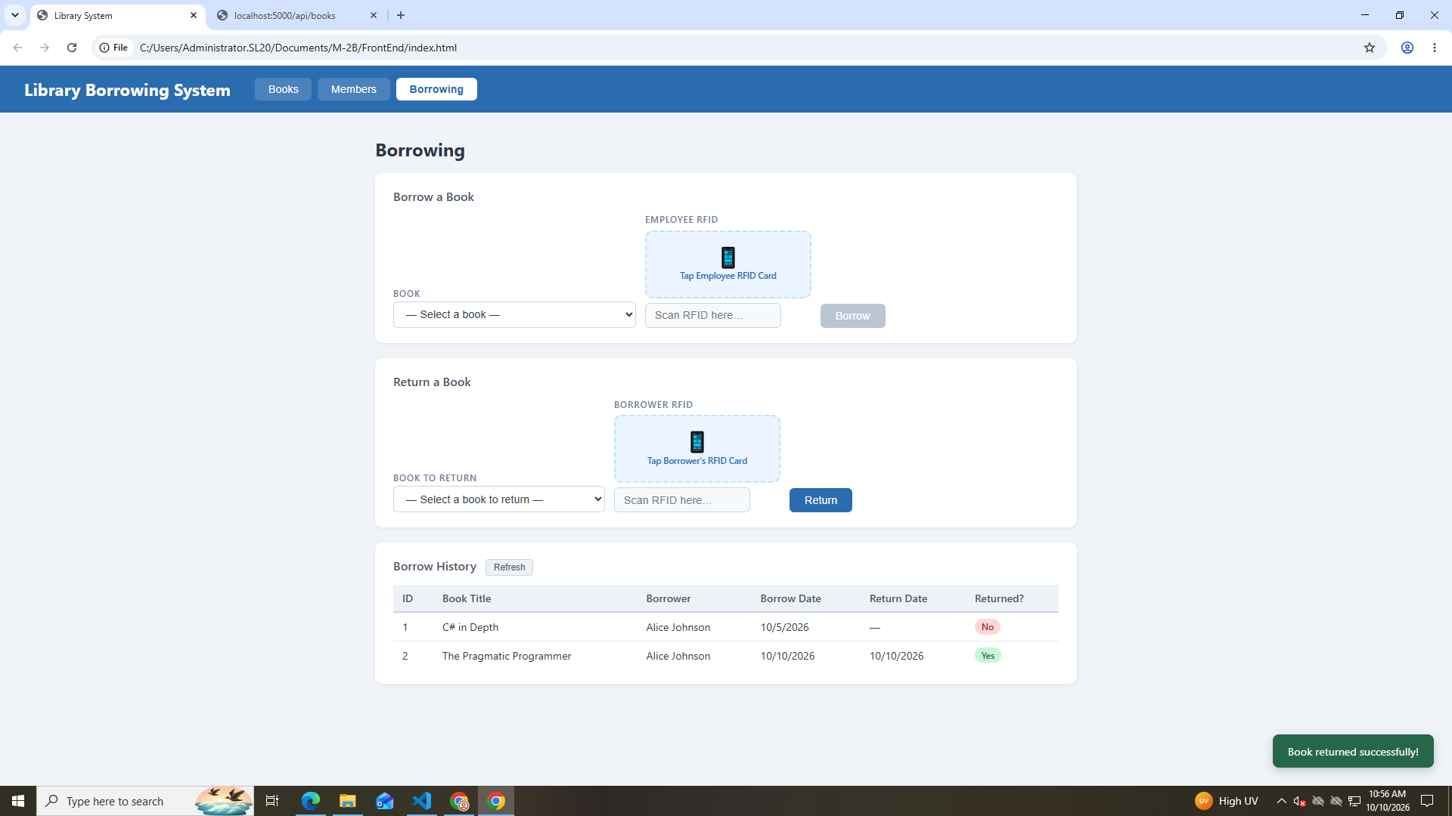

FINAL CONSOLE CHECK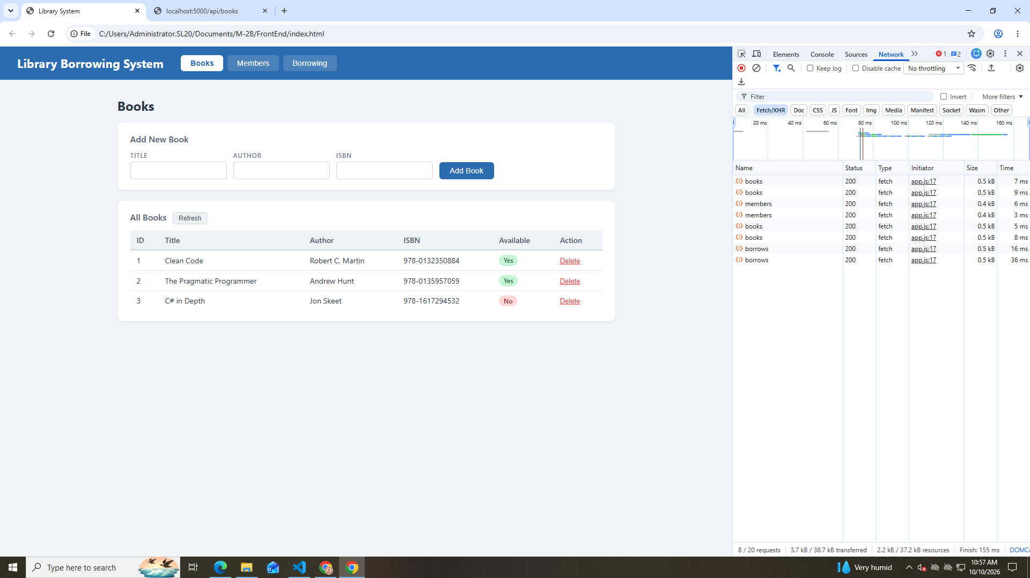

REFLECTION:

- What does `apiFetch()` do?
It sends a request to the API and gets the data or response.

- Why do we use `try/catch` around API calls?
To catch errors and prevent the program from crashing unexpectedly.

- What is the difference between `POST` and `PUT`?
`POST` adds new data, while `PUT` updates existing data.

- Why does RFID matching use `rfidValue` instead of `studentId`?
Because `rfidValue` is the code read from the RFID card, while `studentId` identifies the student.

- Why do we refresh tables after adding, deleting, borrowing, or returning?
To show the latest data in the table.

- Why does the Return dropdown use borrow record ID instead of book ID?
Because the borrow record ID identifies the specific borrowing transaction that needs to be returned.

- What happens if the same event listener is added to a form twice?
The same action may happen twice, such as submitting the form two times, especially if different listener functions are added.

- Why must the page-load code be at the bottom of the file?
So the HTML elements are loaded before the JavaScript tries to use them.

- Why does an RFID reader need `e.preventDefault()` on the Enter key?
It stops Enter from submitting the form or refreshing the page after scanning an RFID card.

