[ ] Part 1 API_BASE, shared variables, apiFetch()

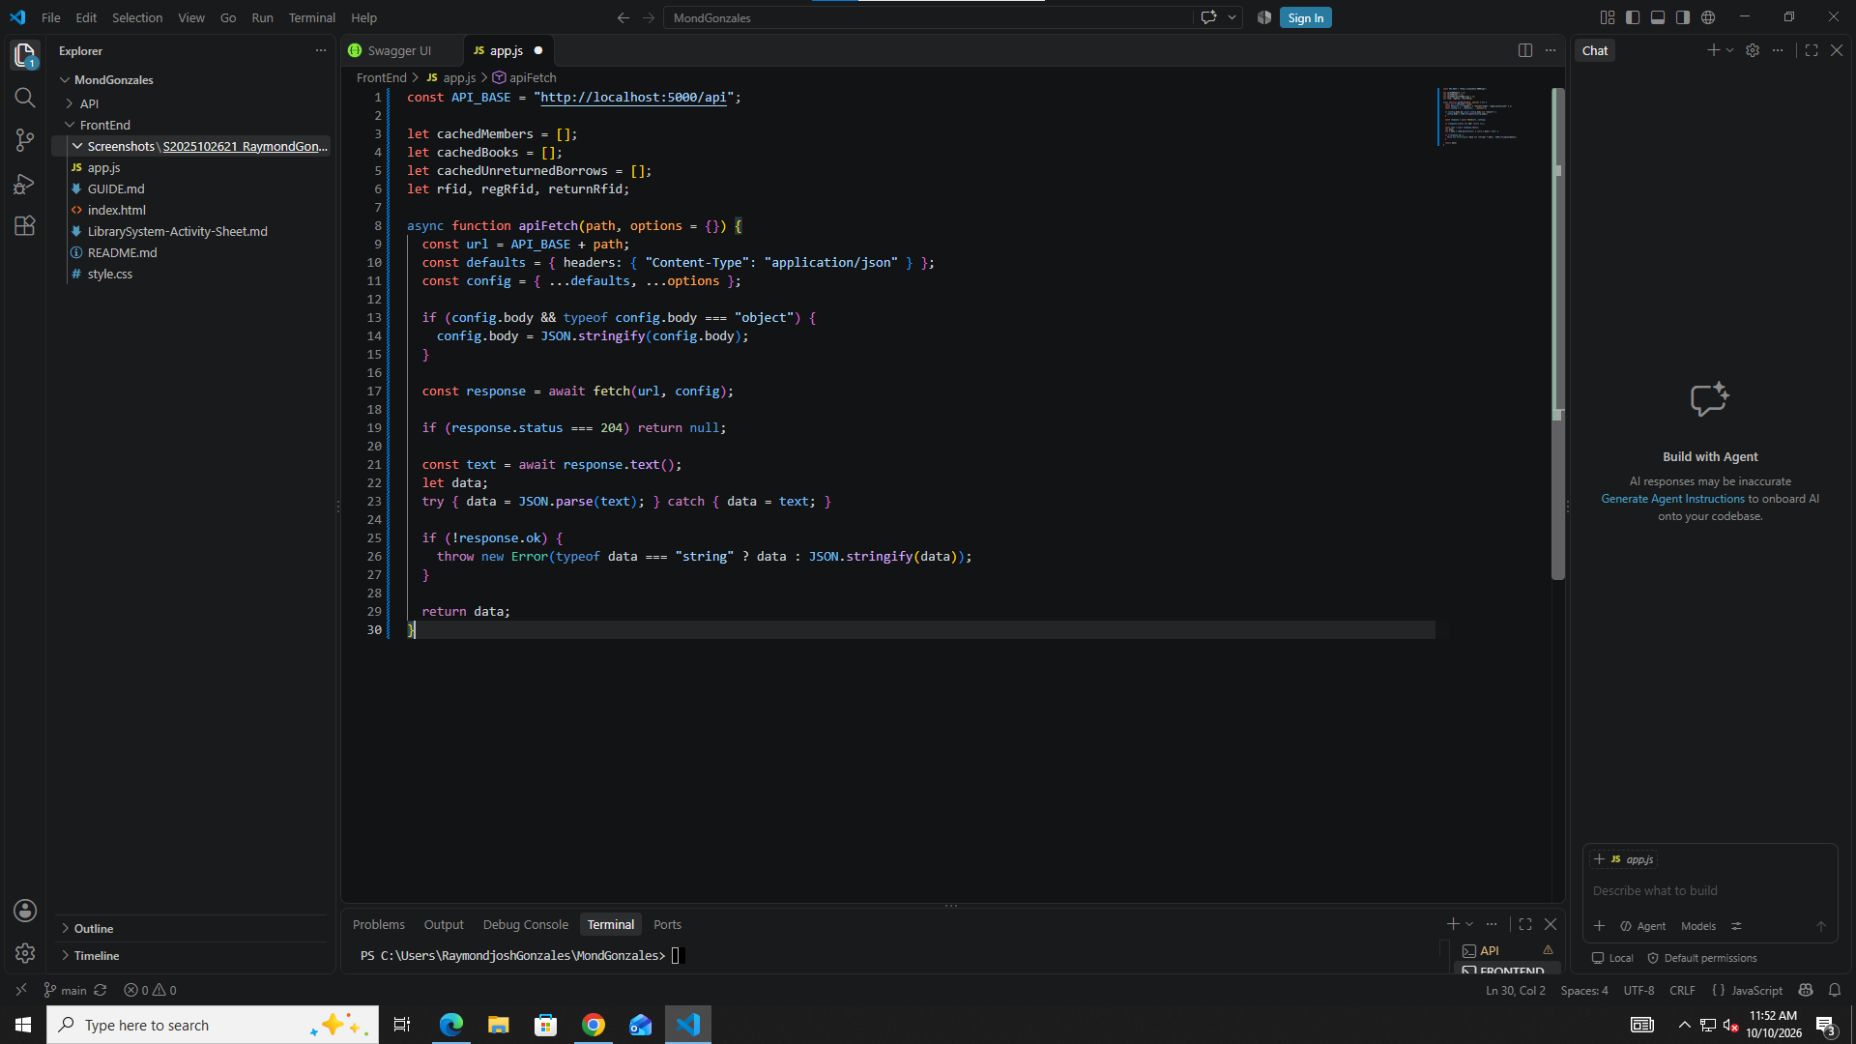

[ ] Part 2 showToast()

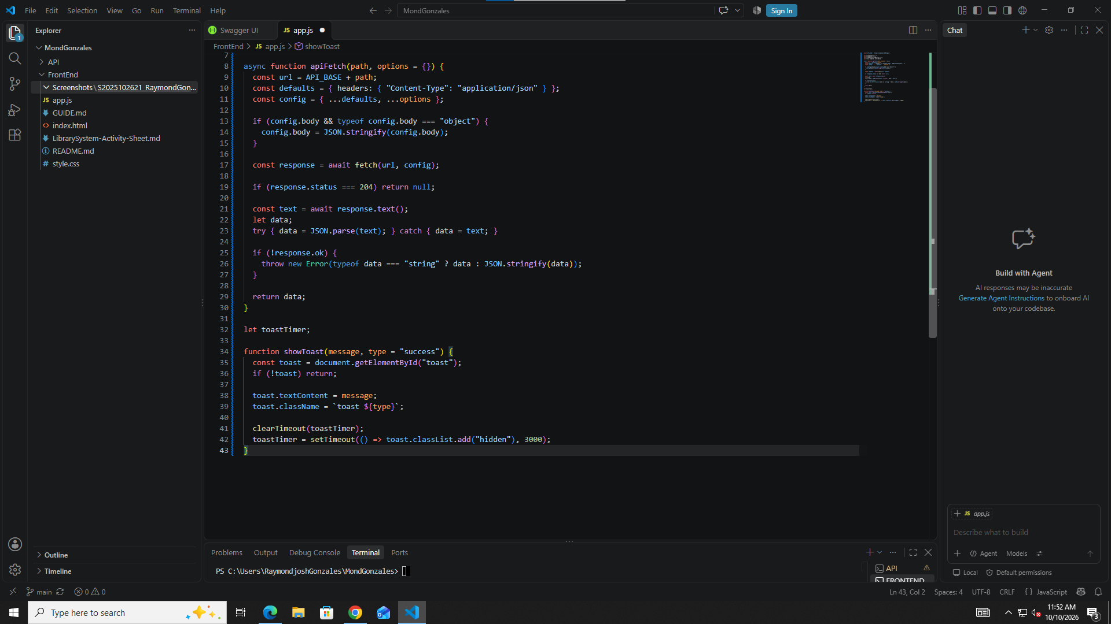

[ ] Part 3 refreshMemberCache(), refreshBookCache(), findMemberByRFID()

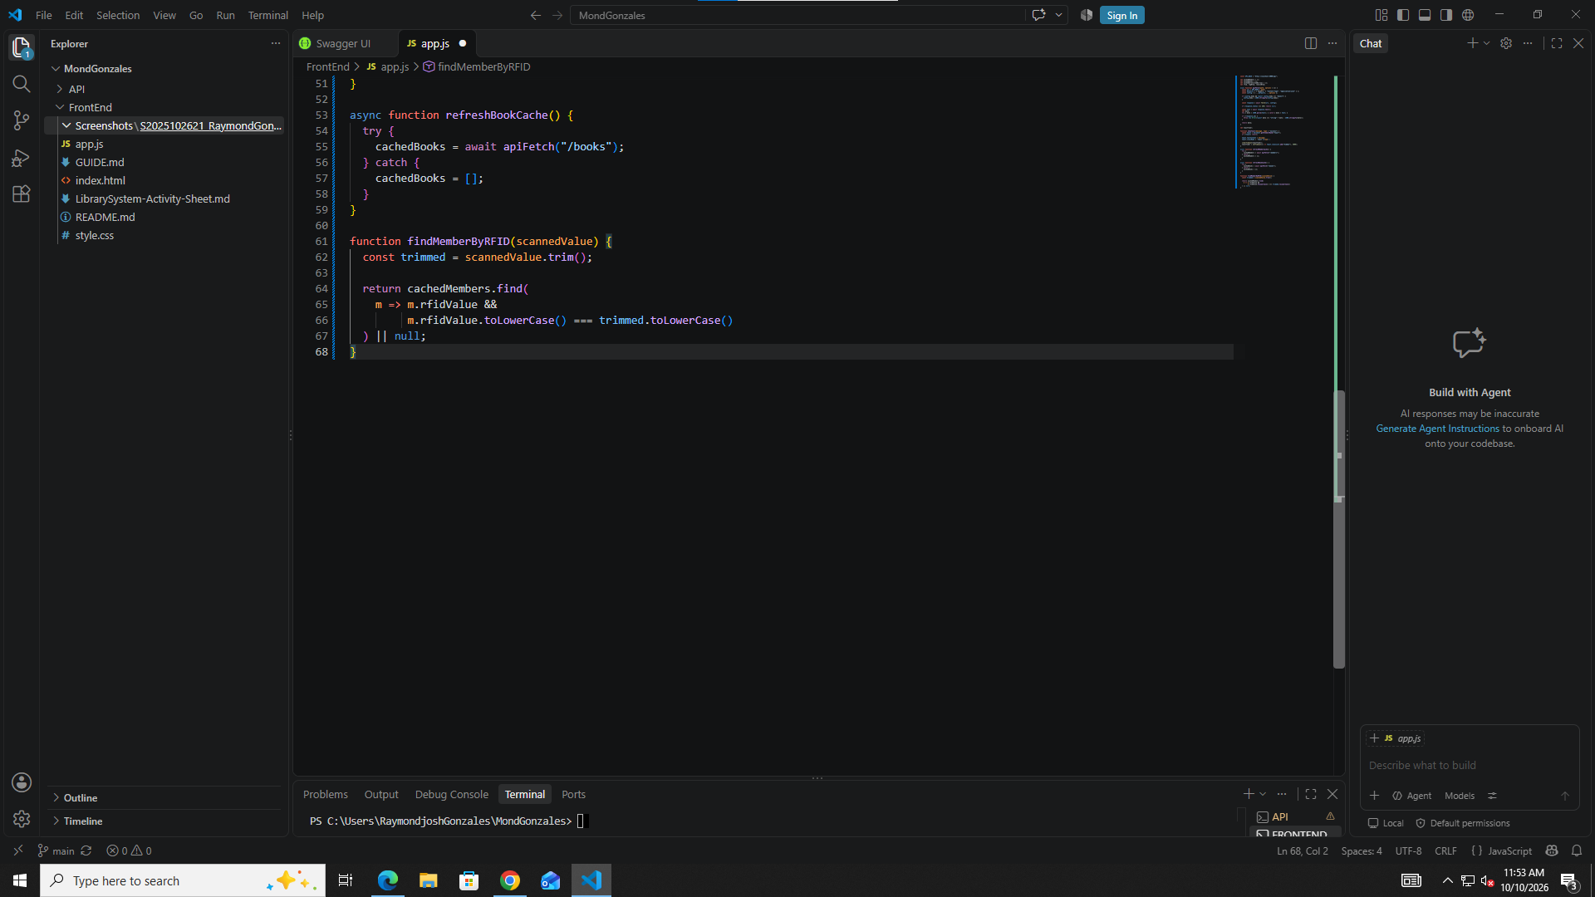
[ ] Part 4 Tab buttons and Refresh buttons

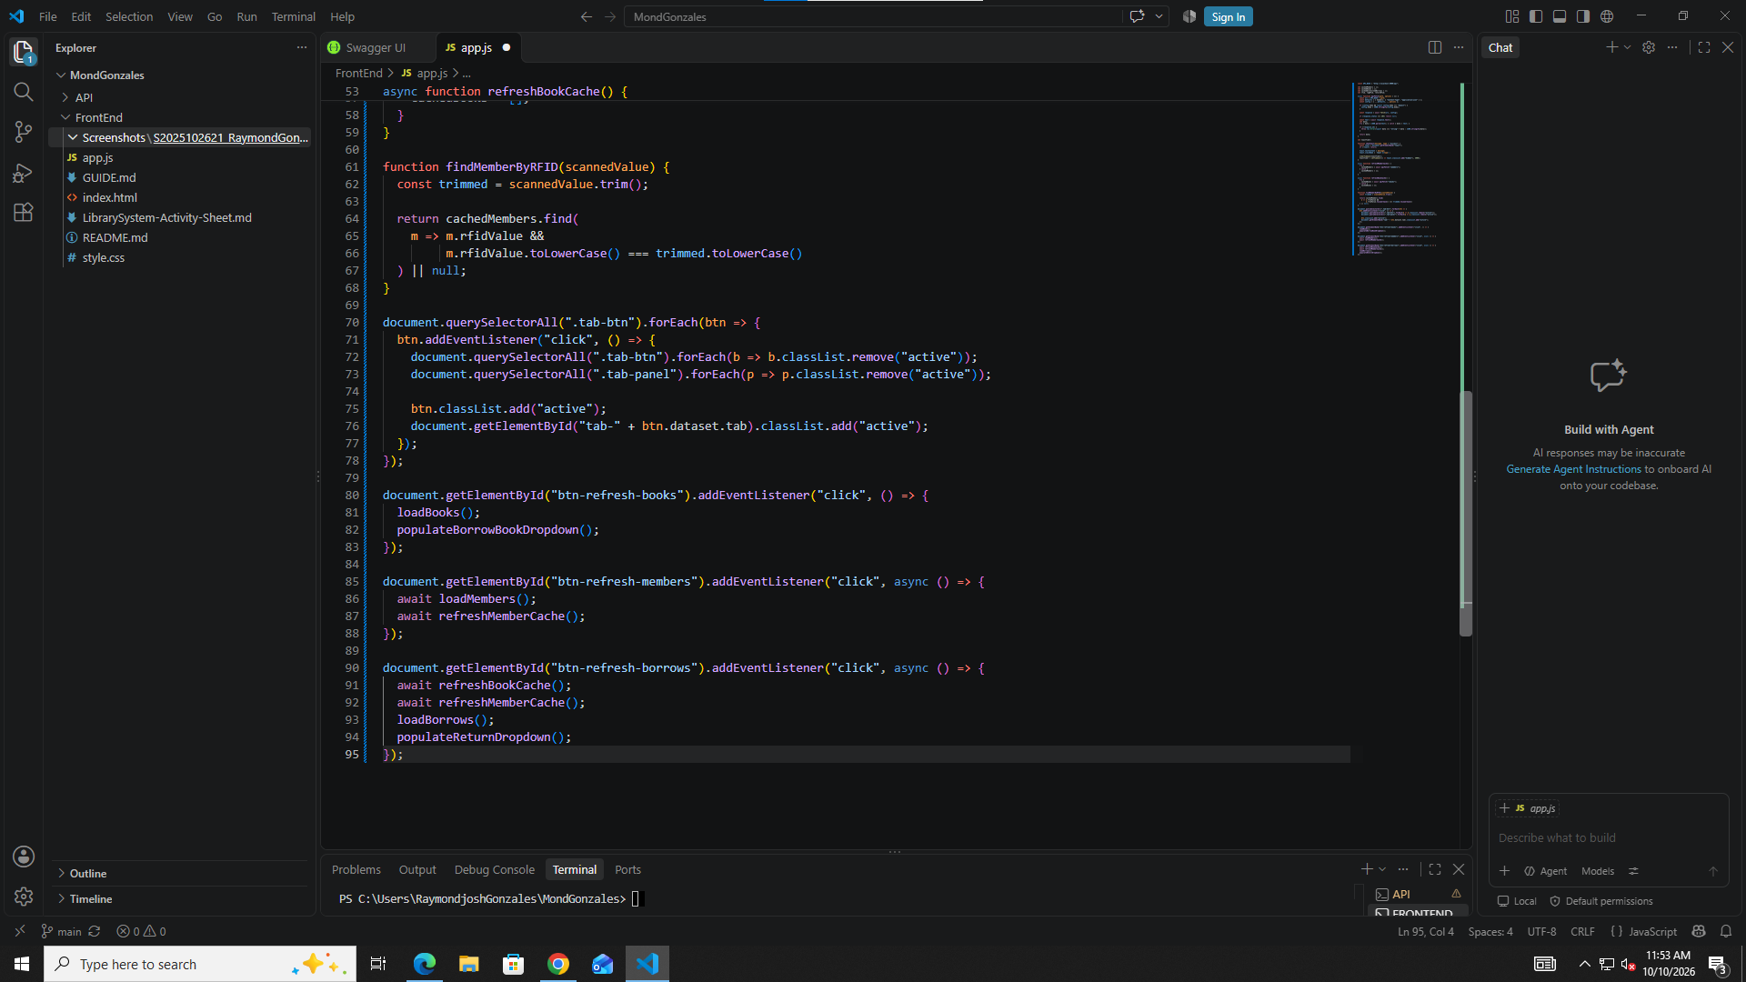
[ ] Part 5 loadBooks()

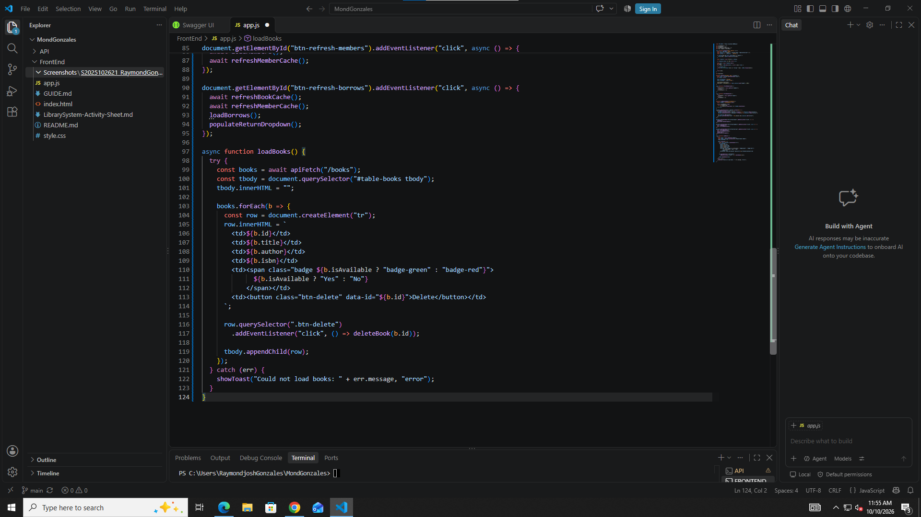
[ ] Part 6 deleteBook(id)

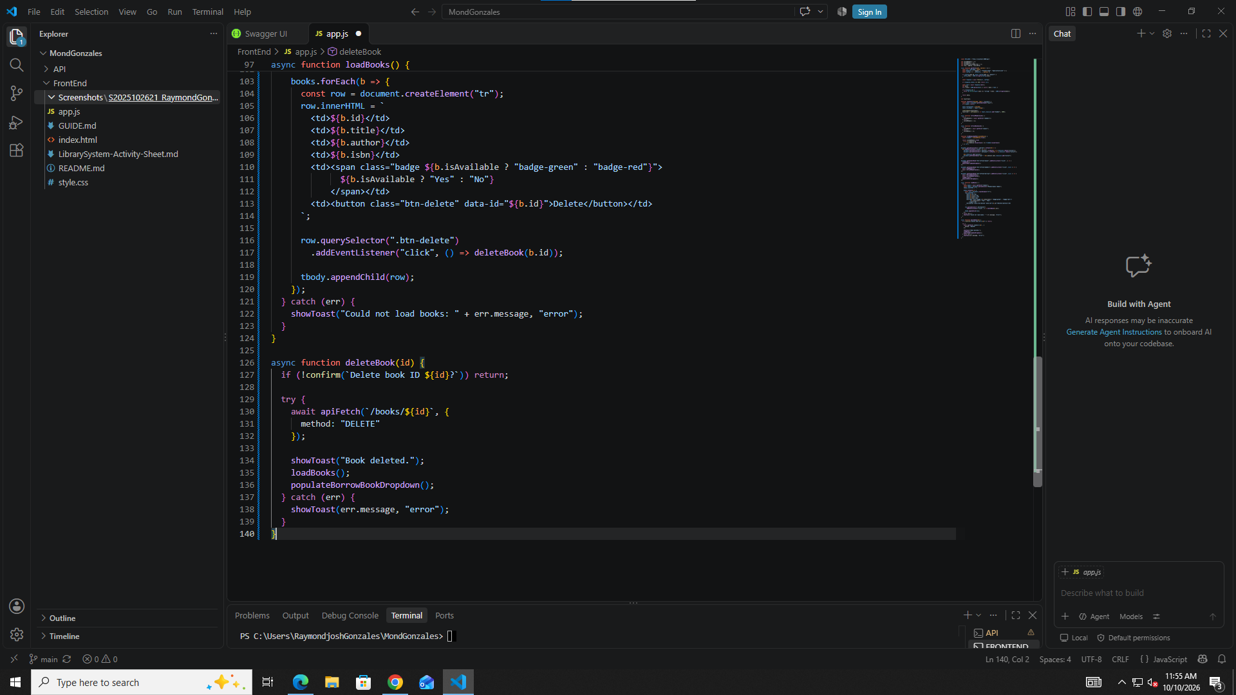
[ ] Part 7 Add Book form submit (once only)

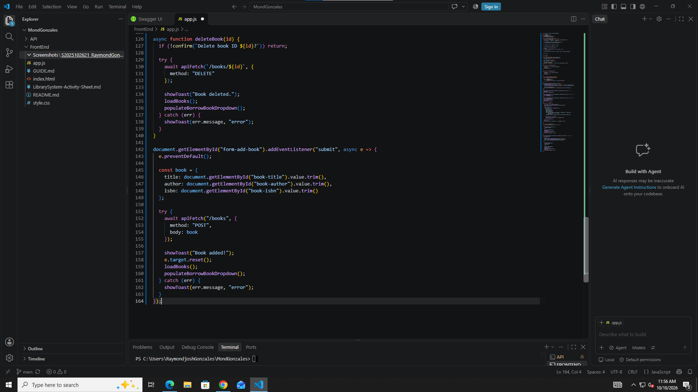
[ ] Part 8 loadMembers()

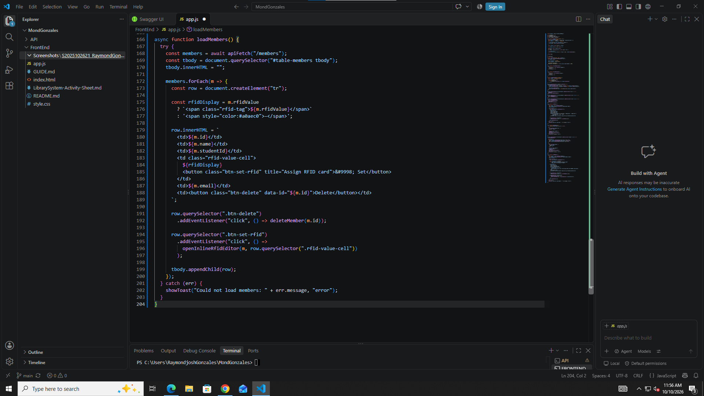
[ ] Part 9 deleteMember(id)

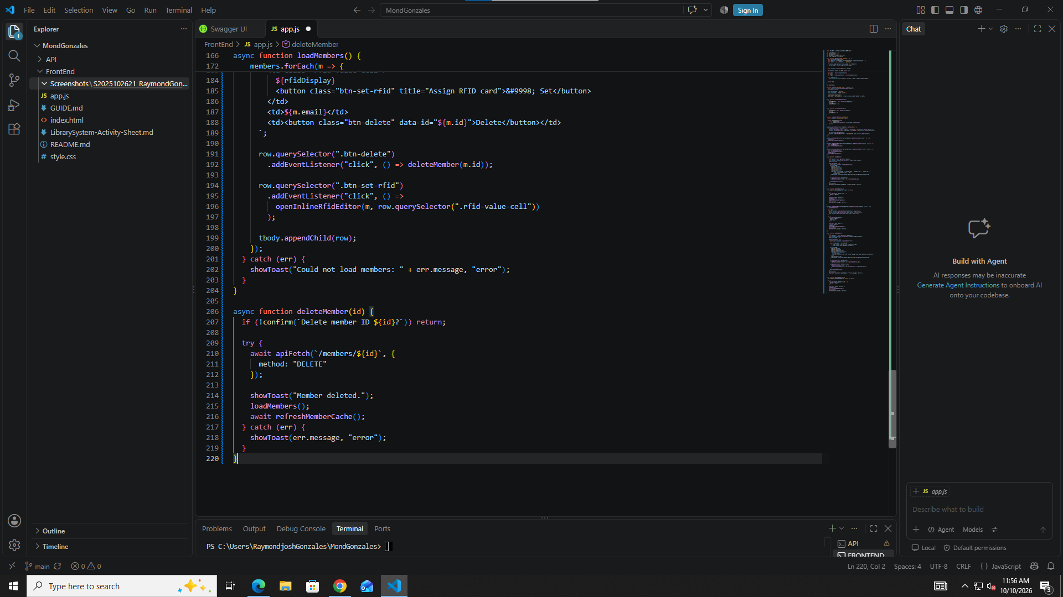
[ ] Part 10 Add Member form submit

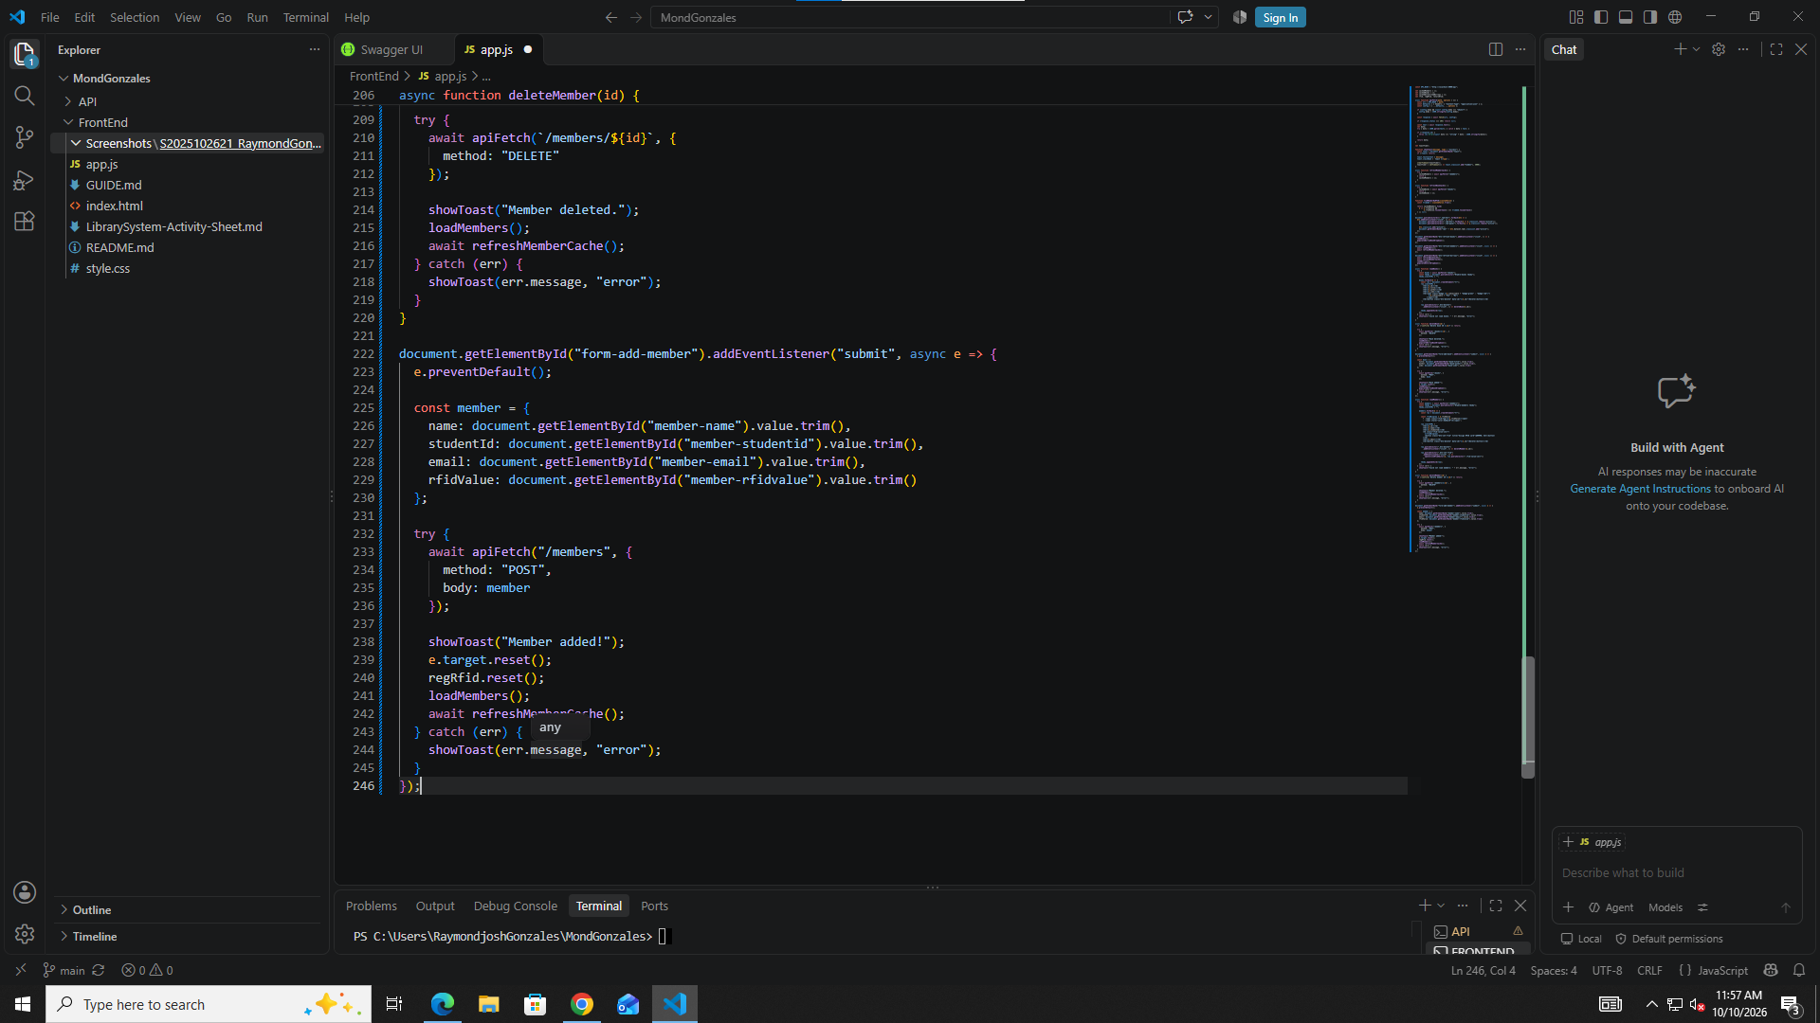
[ ] Part 11 openInlineRfidEditor() with saveRfid() inside

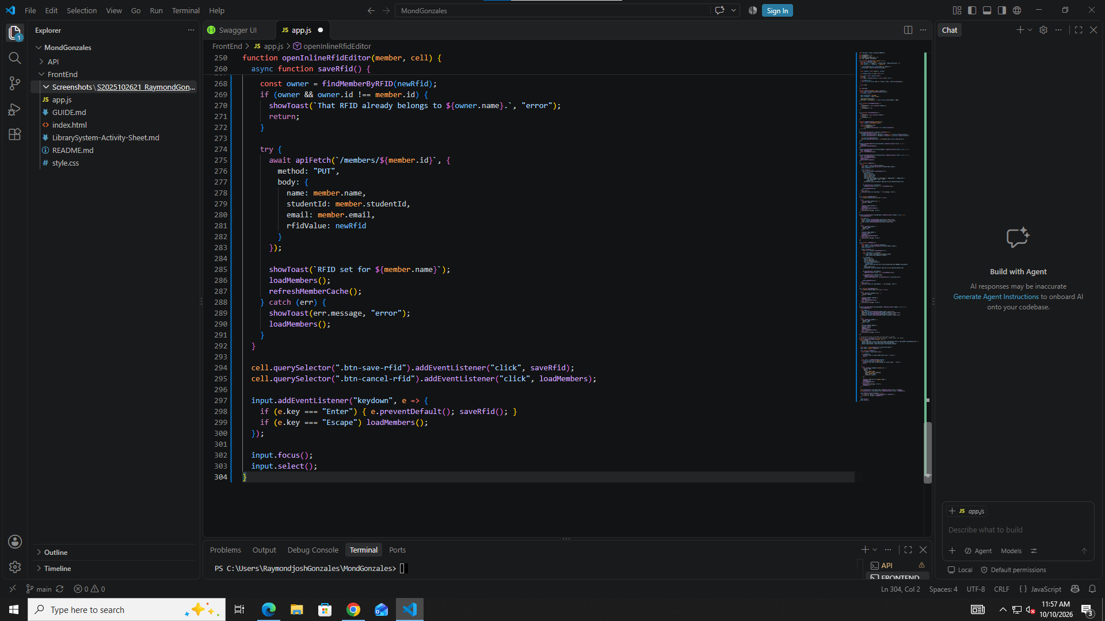
[ ] Part 12 createRfidWidget(), initRFID(), initRegRFID(), initReturnRFID()

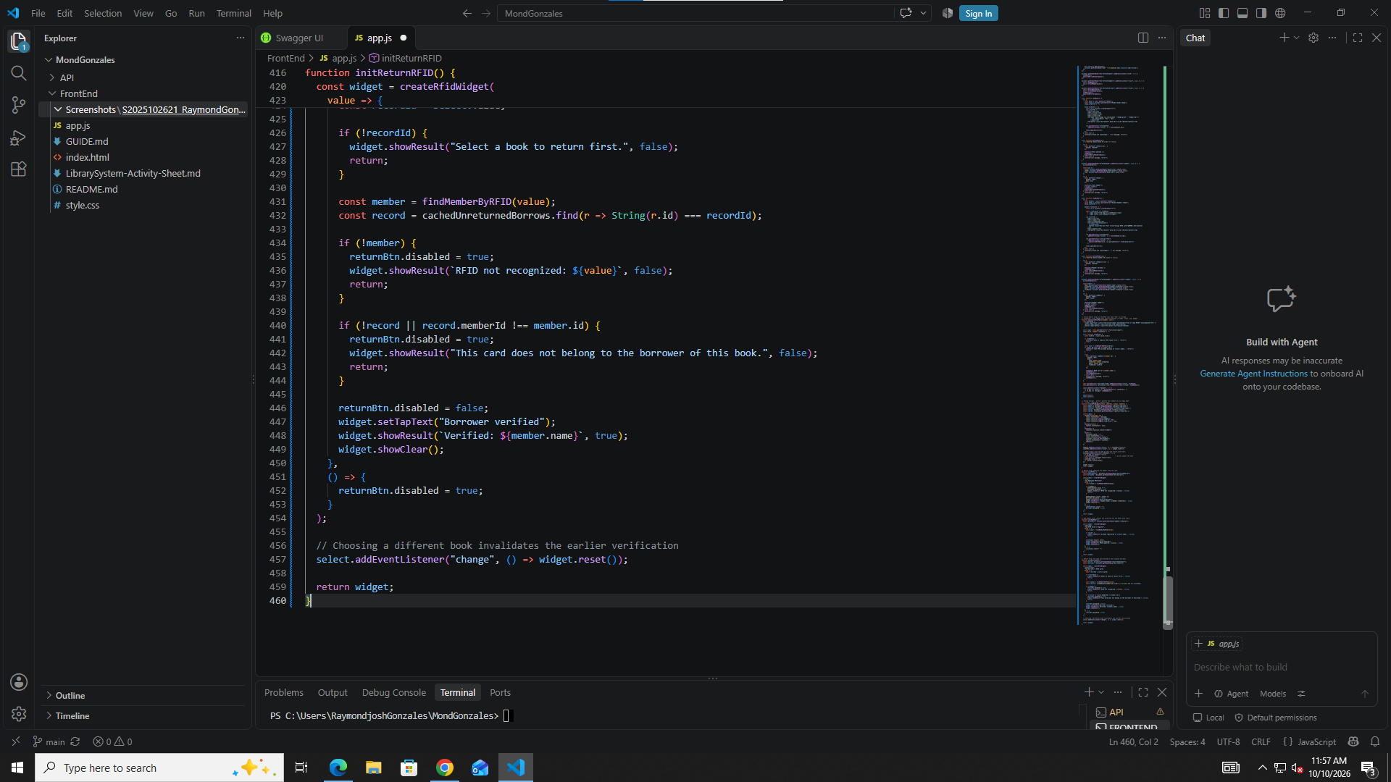
[ ] Part 13 populateBorrowBookDropdown()

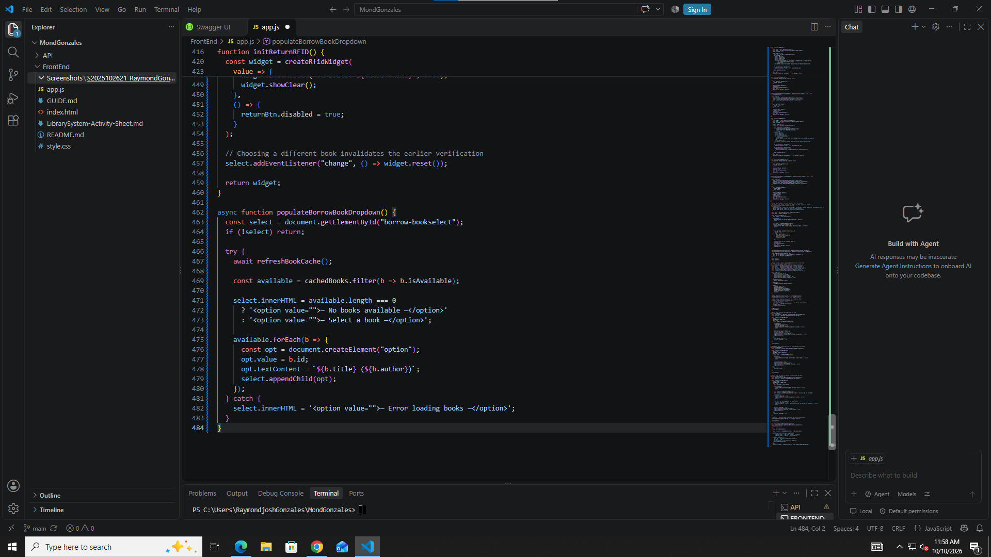
[ ] Part 14 populateReturnDropdown()

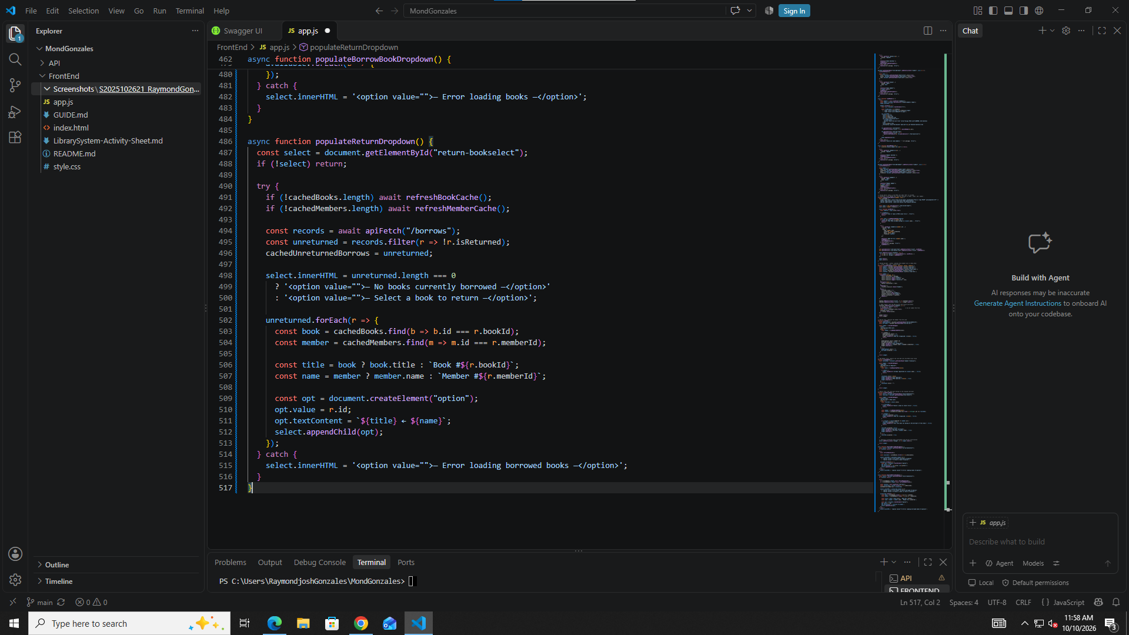
[ ] Part 15 Borrow form submit (once only)

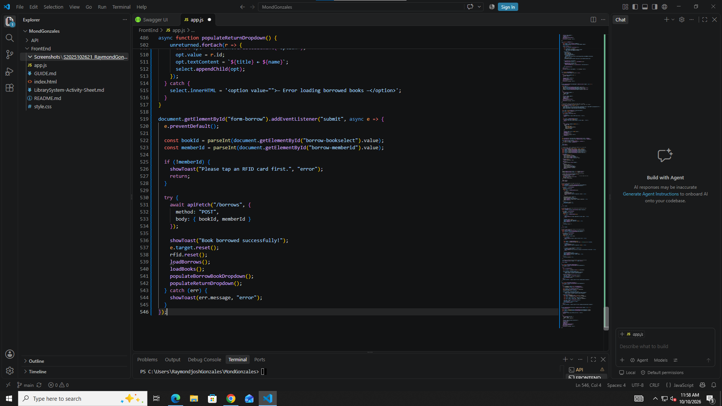
[ ] Part 16 Return form submit (do not skip)

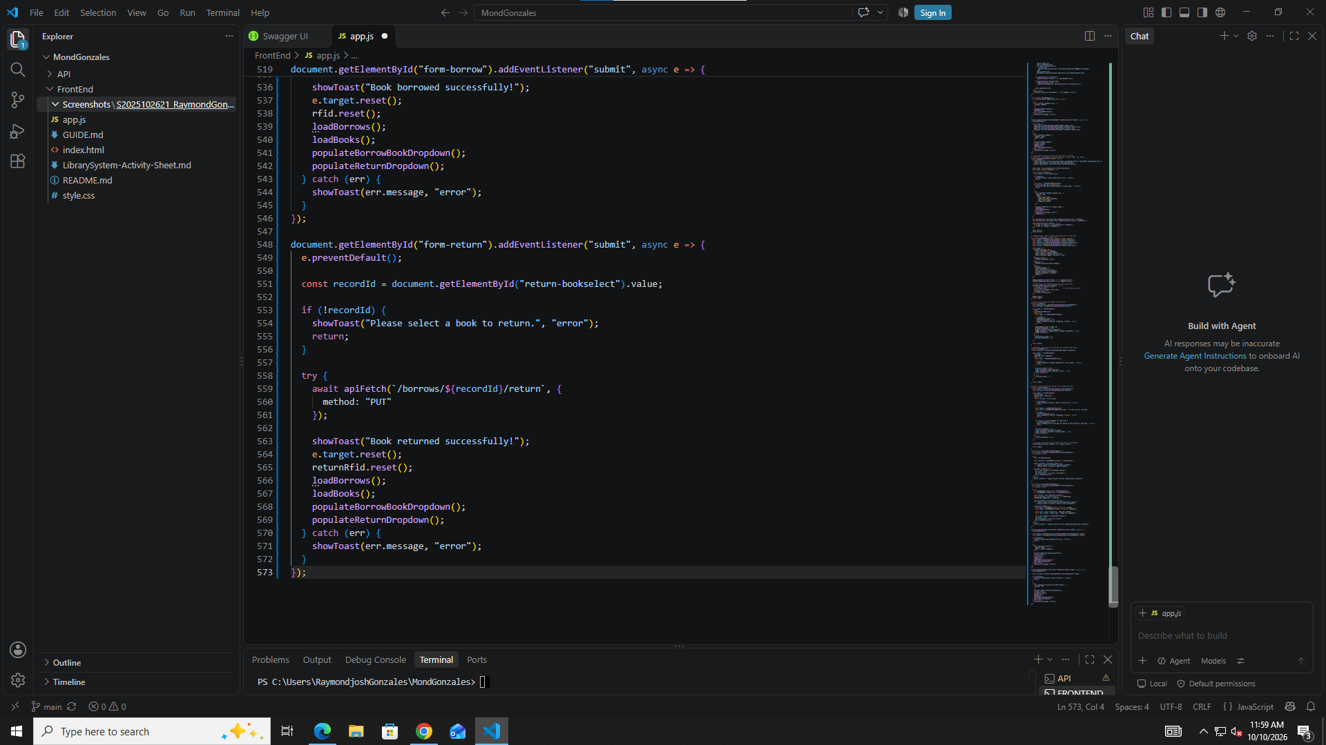
[ ] Part 17 loadBorrows()

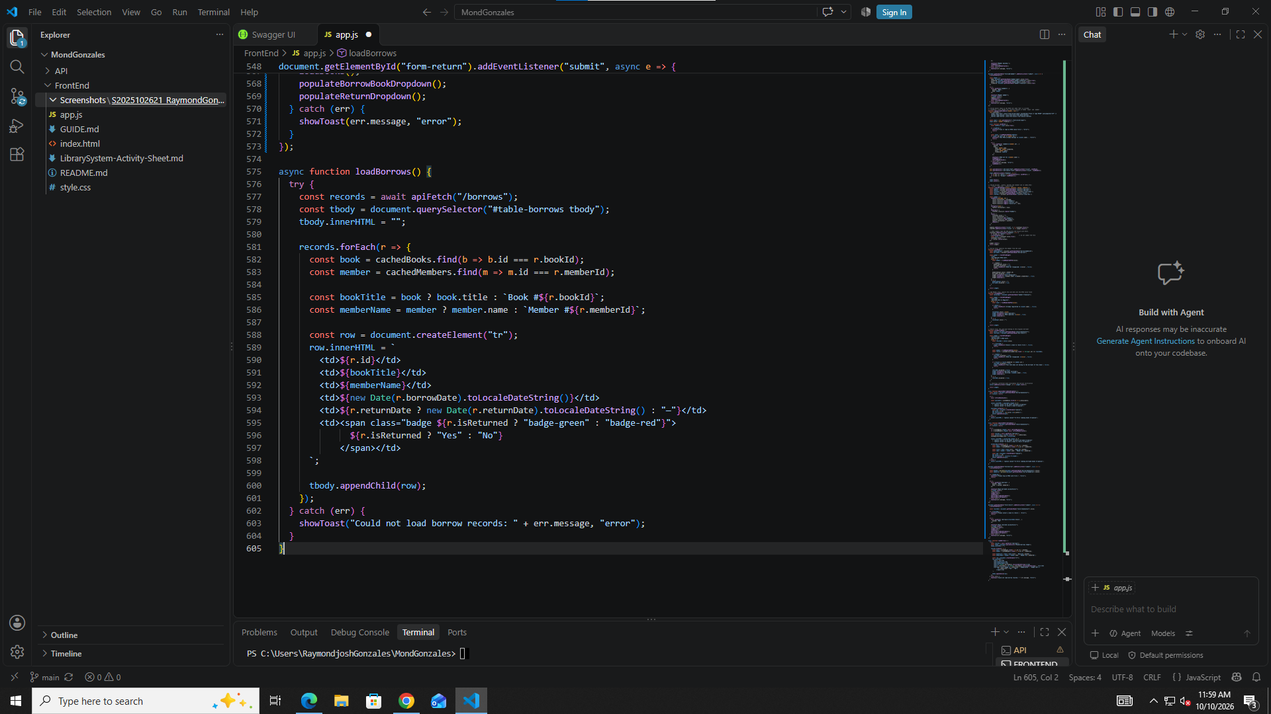
[ ] Part 18 Initial page load (last)

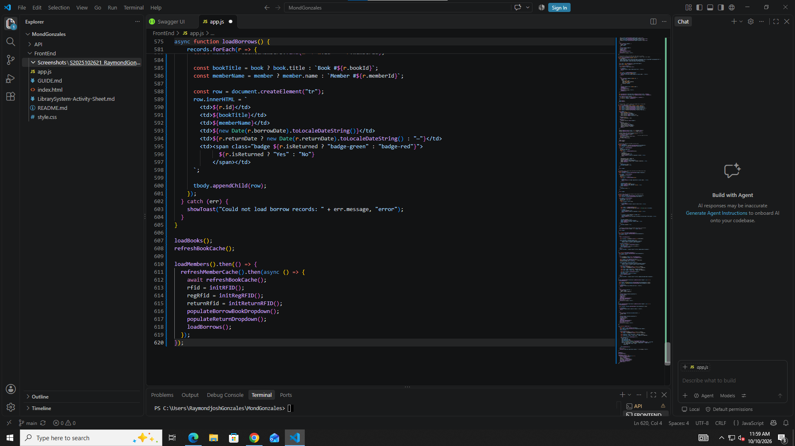
[ ] Removed the rfid.js script tag from index.html

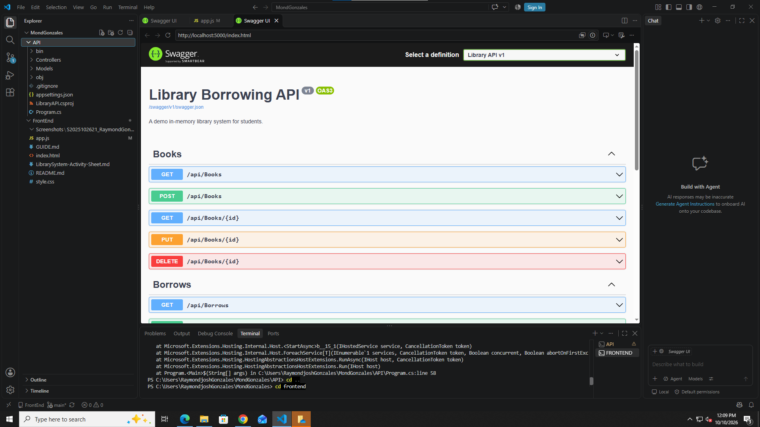

Open the FrontEnd

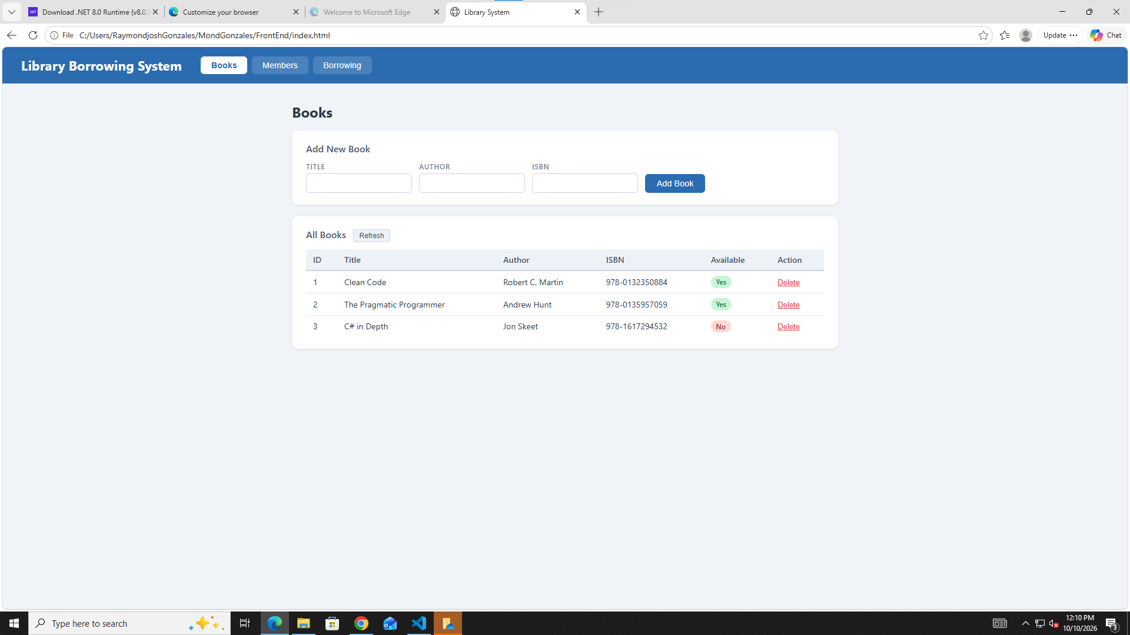

Test the Tabs
DONE

Test Books
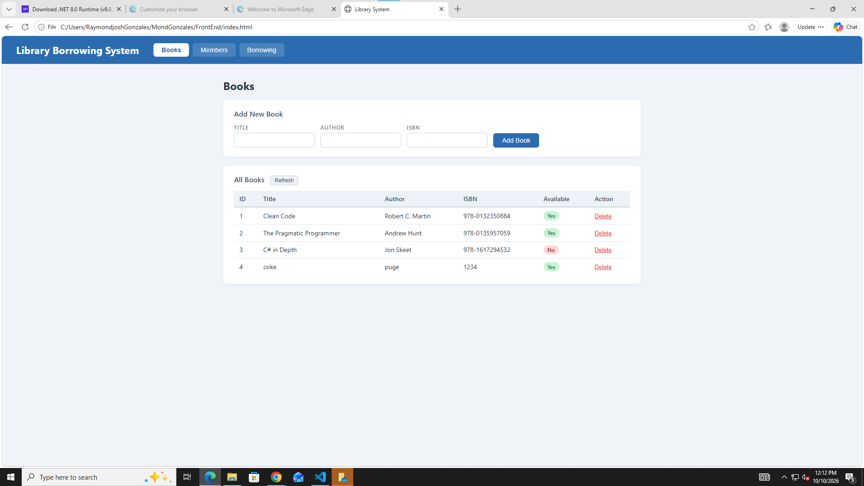
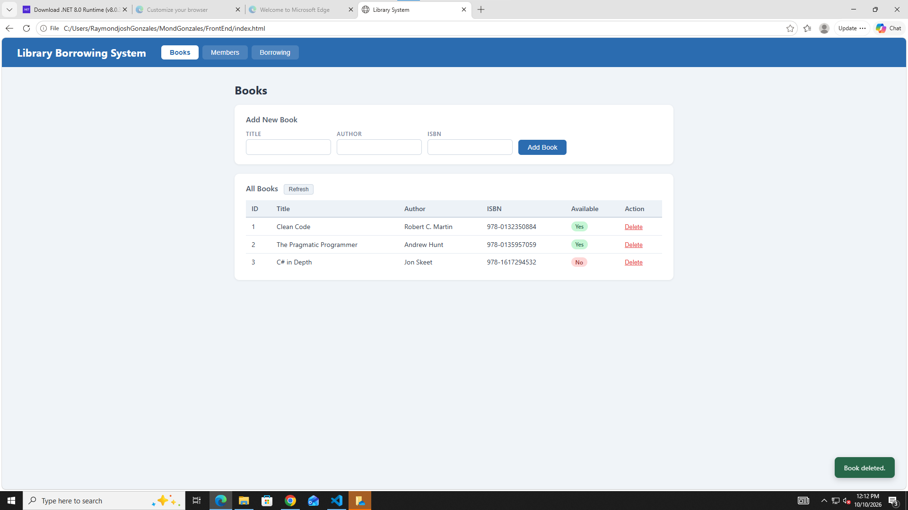

Test Members
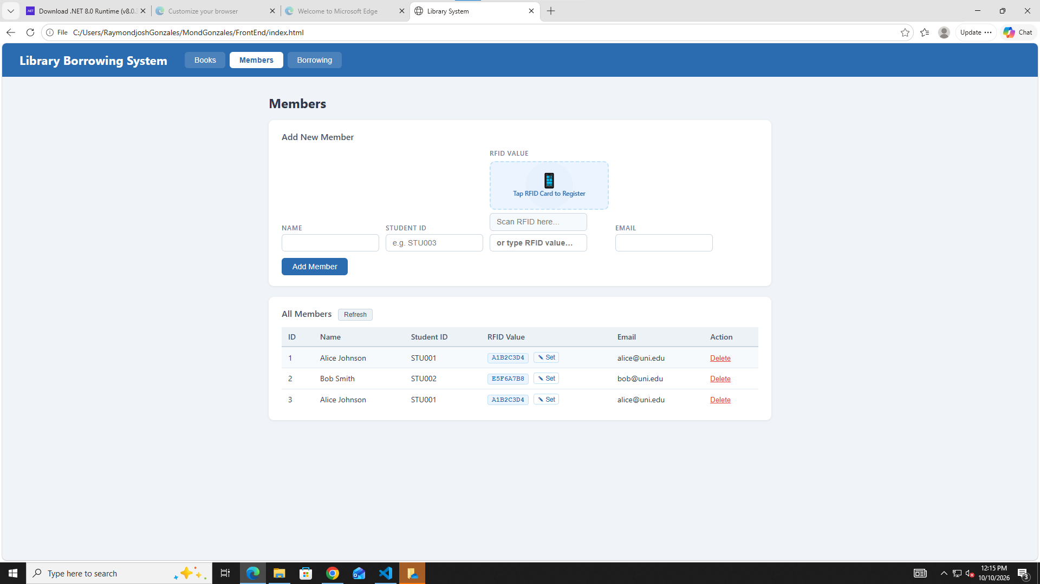

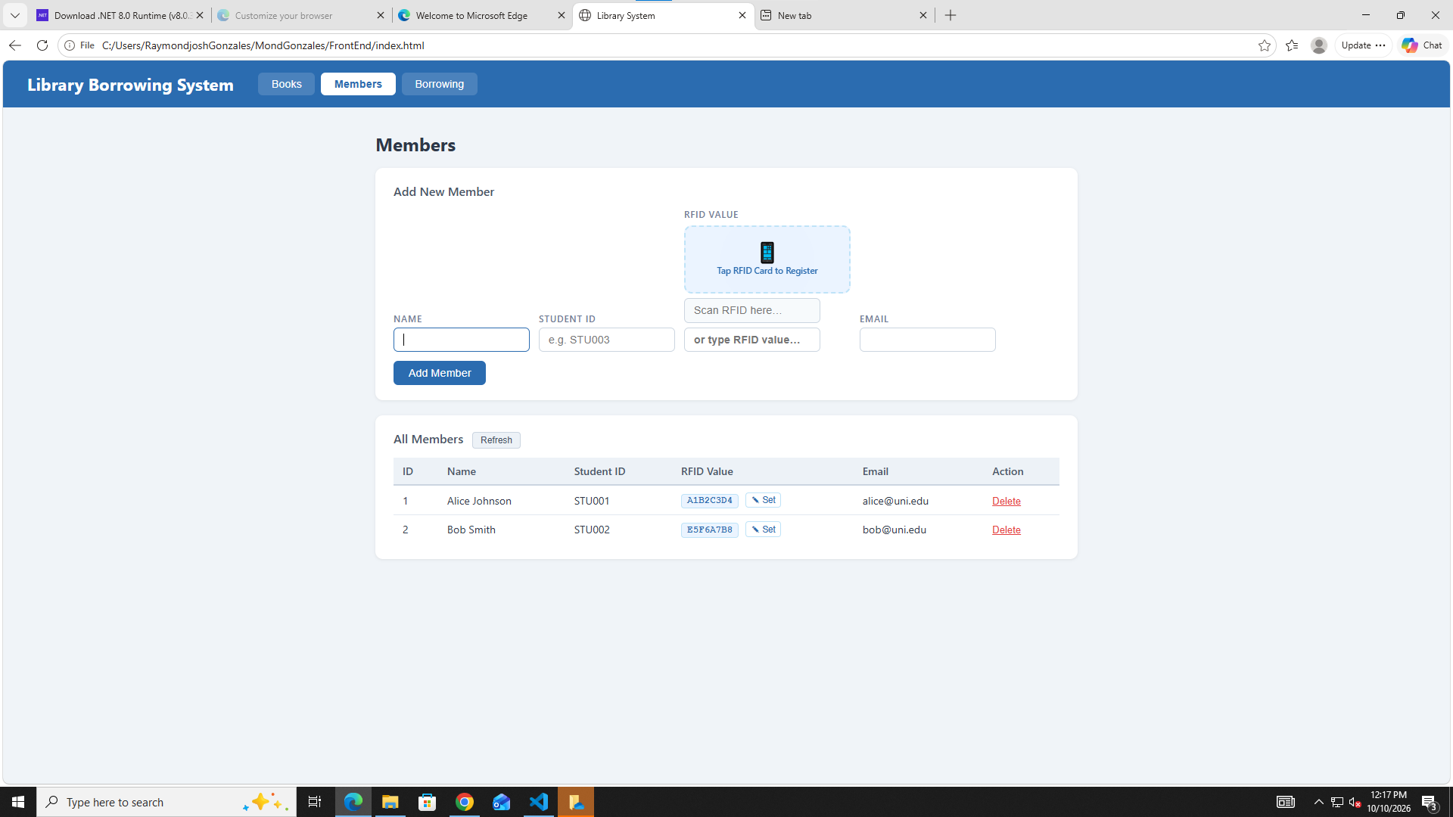

TEST BORROWING
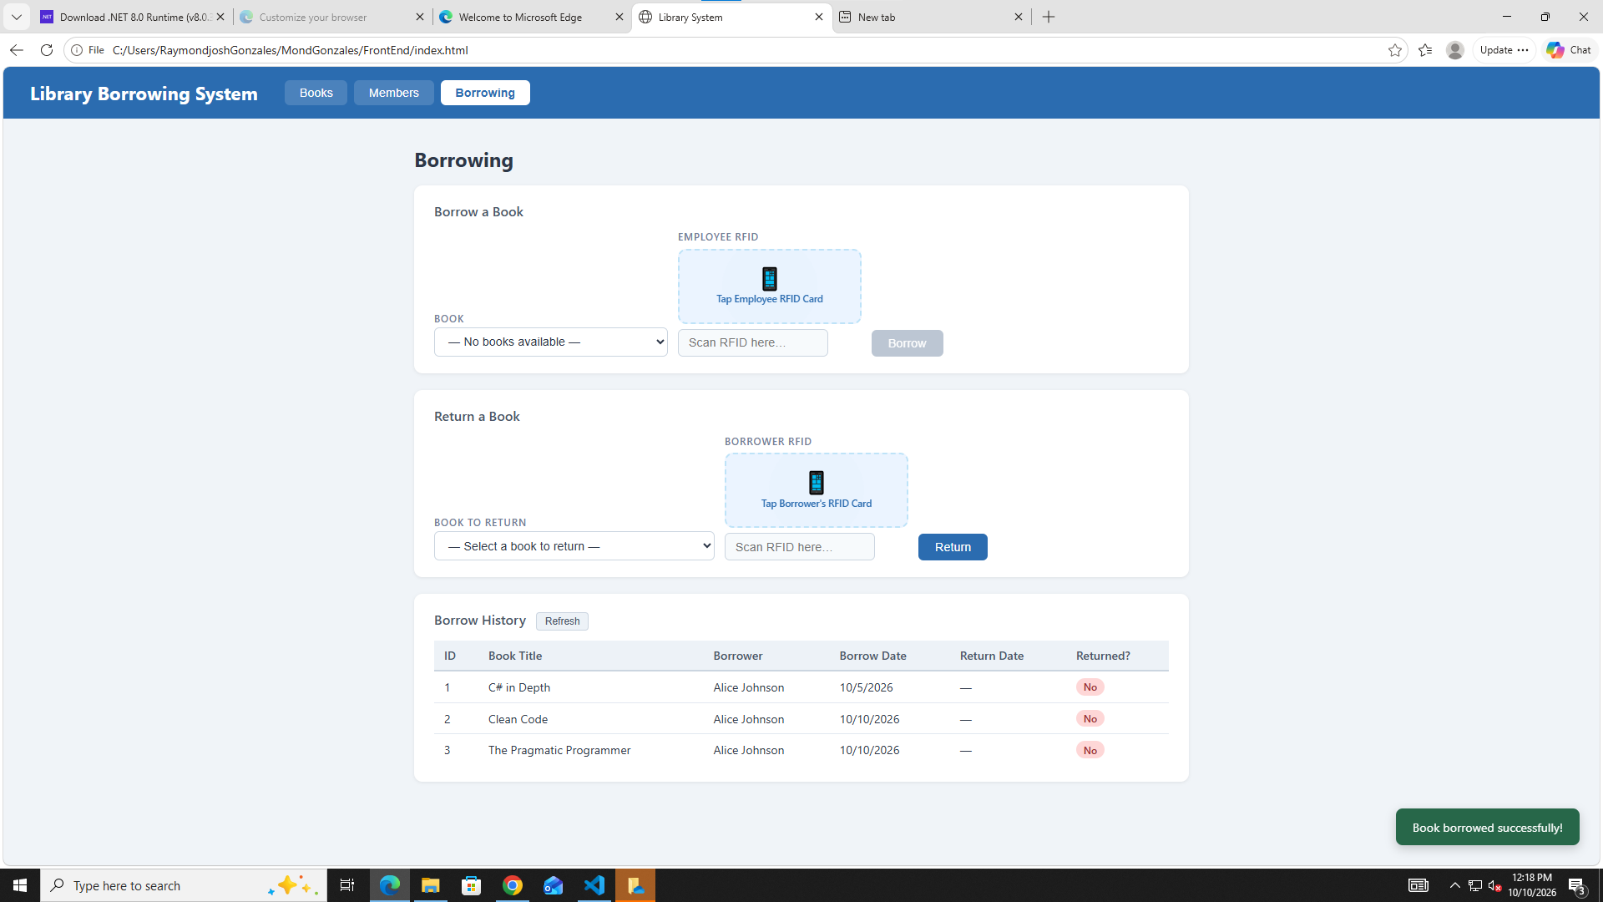

TEST RETURNING
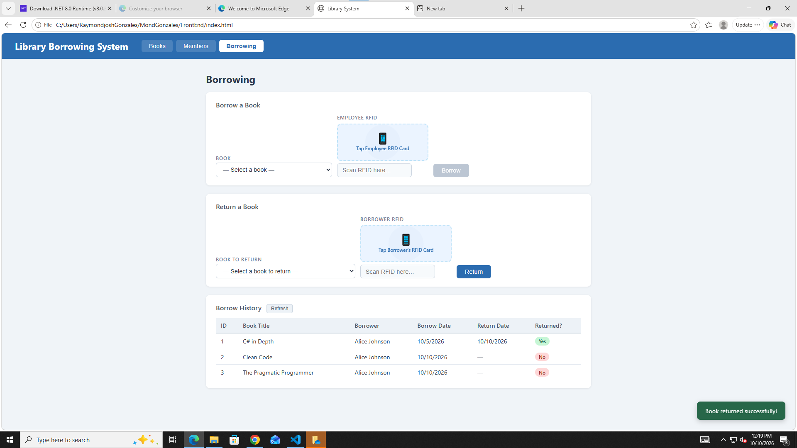

FINAL CONSOLE CHECK
