1. setup-01-api-running: the terminal showing Now listening on: http://localhost:XXXX after dotnet run.

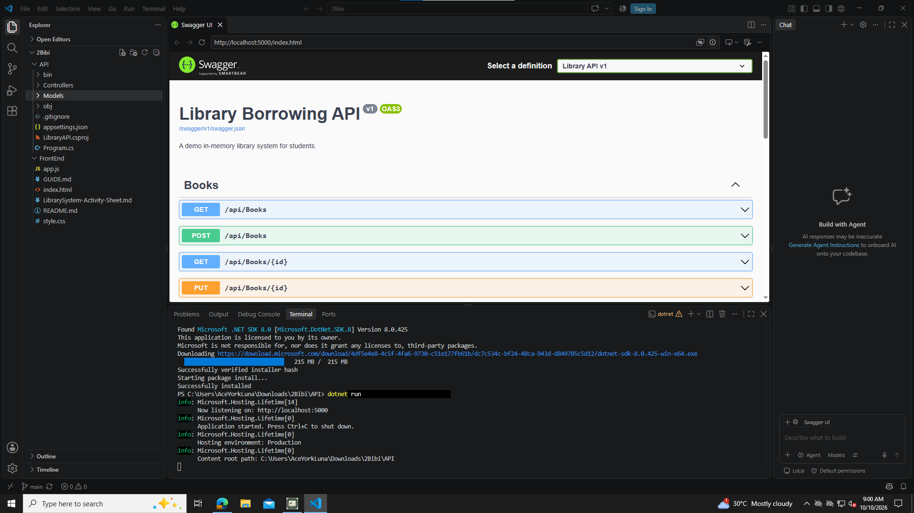

2. setup-02-api-books-json: the browser at http://localhost:XXXX/api/books showing JSON.

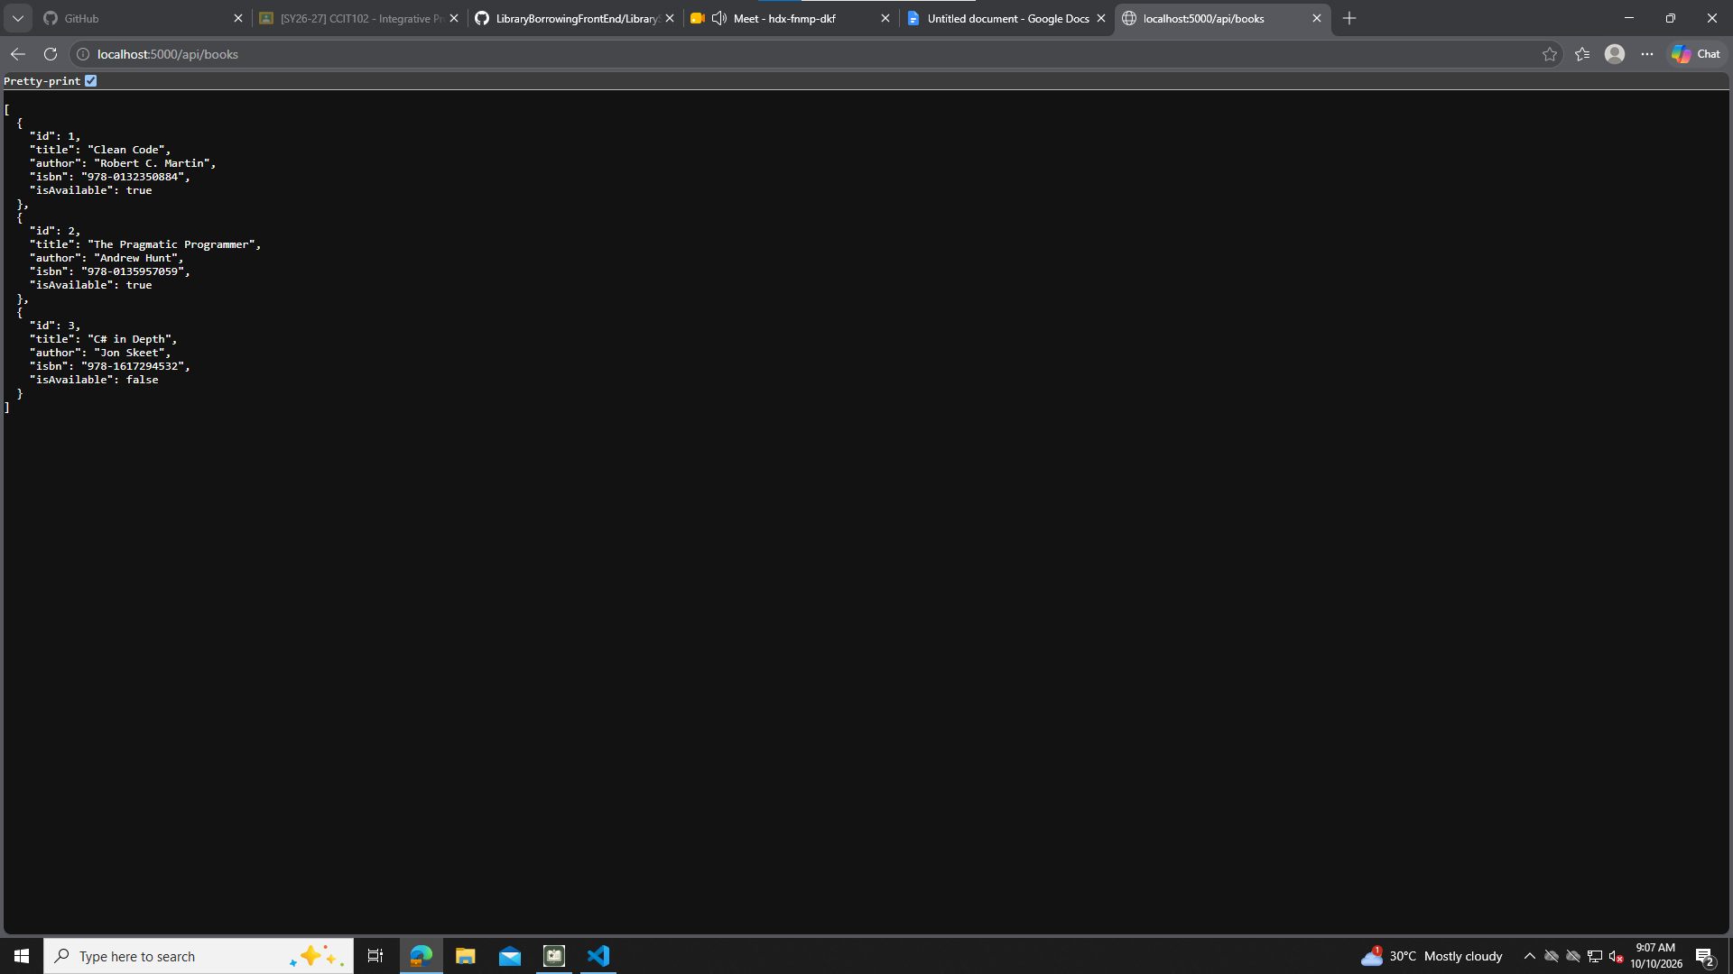

Part 1 API_BASE, shared variables, apiFetch()

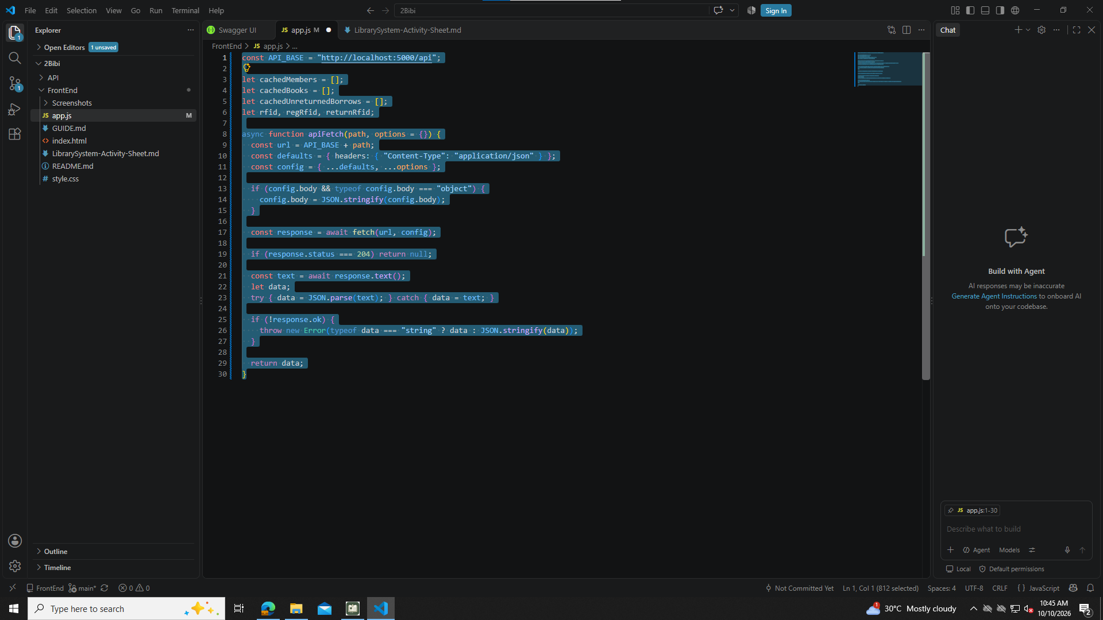

Part 2 showToast()

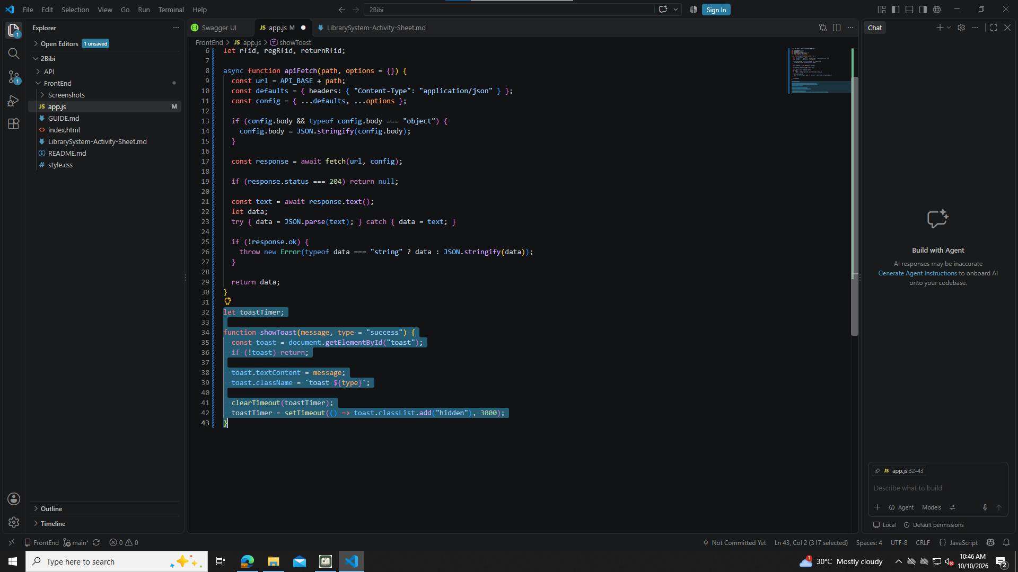

Part 3 refreshMemberCache(), refreshBookCache(), findMemberByRFID()

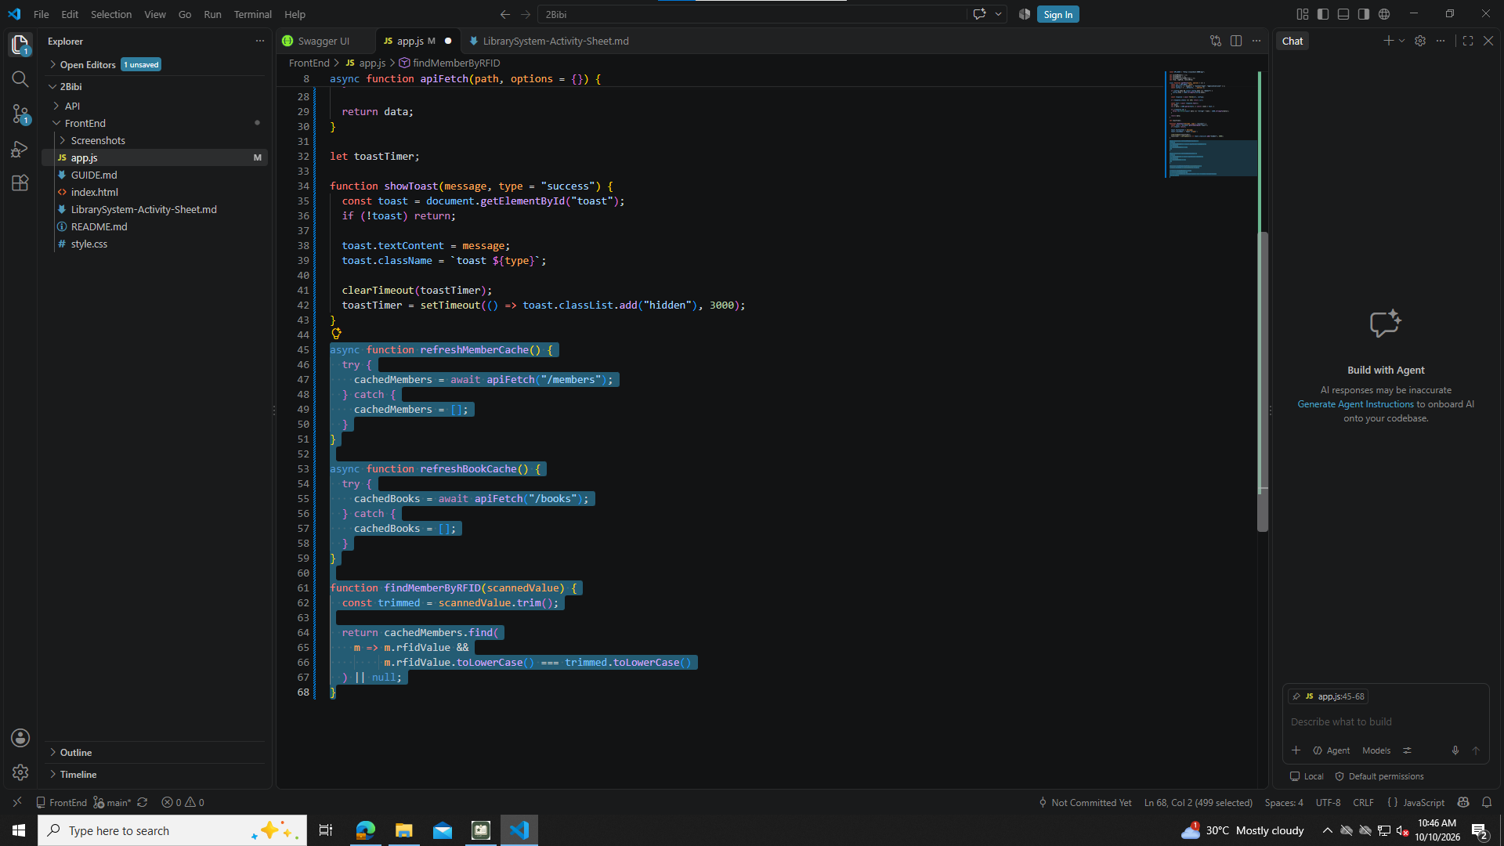

Part 4 Tab buttons and Refresh buttons

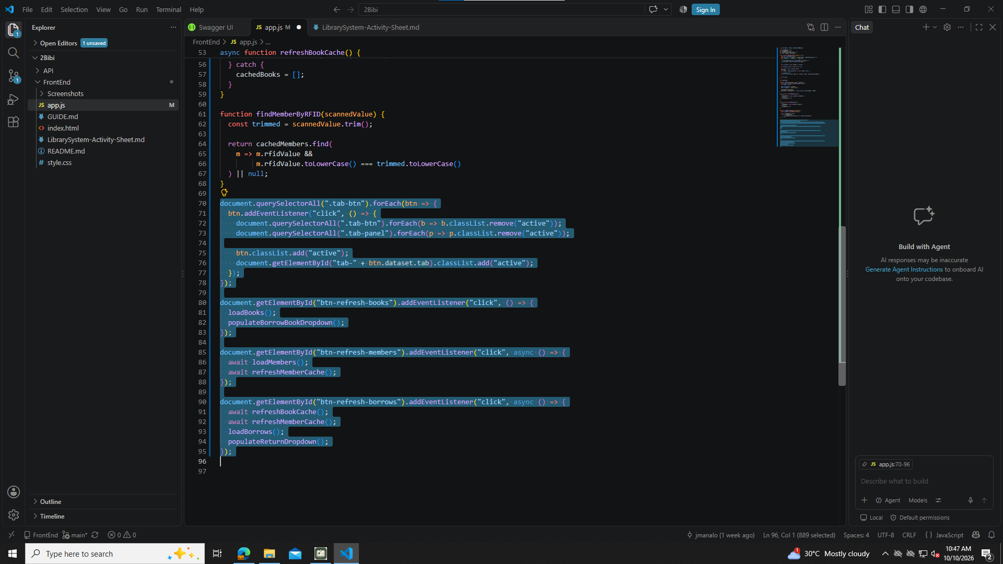

Part 5 loadBooks()

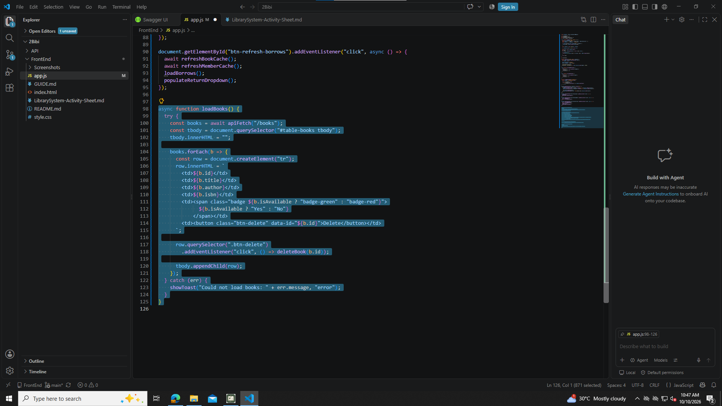

Part 6 deleteBook(id)

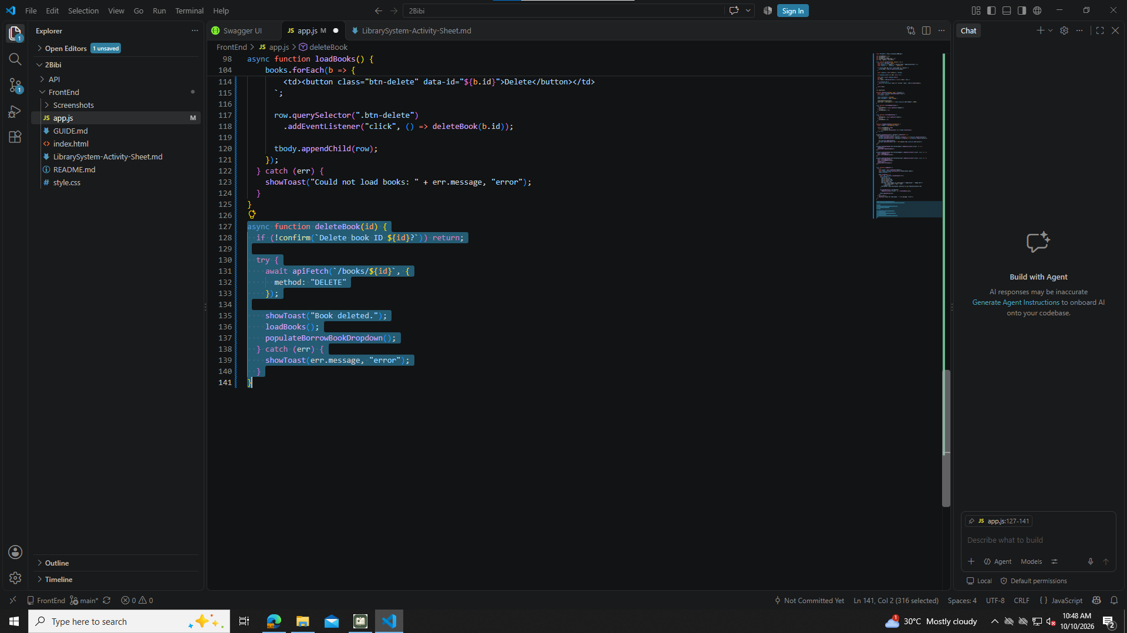

Part 7 Add Book form submit (once only)

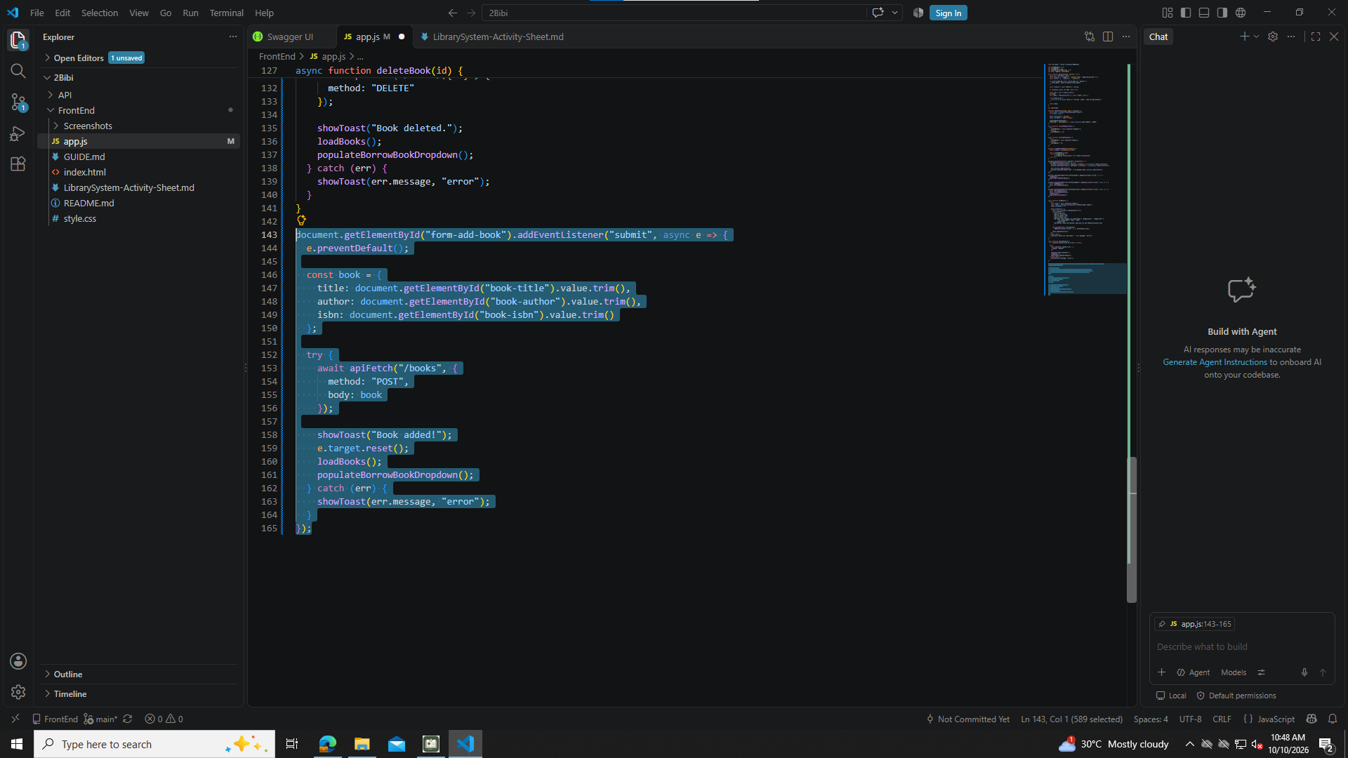

Part 8 loadMembers()

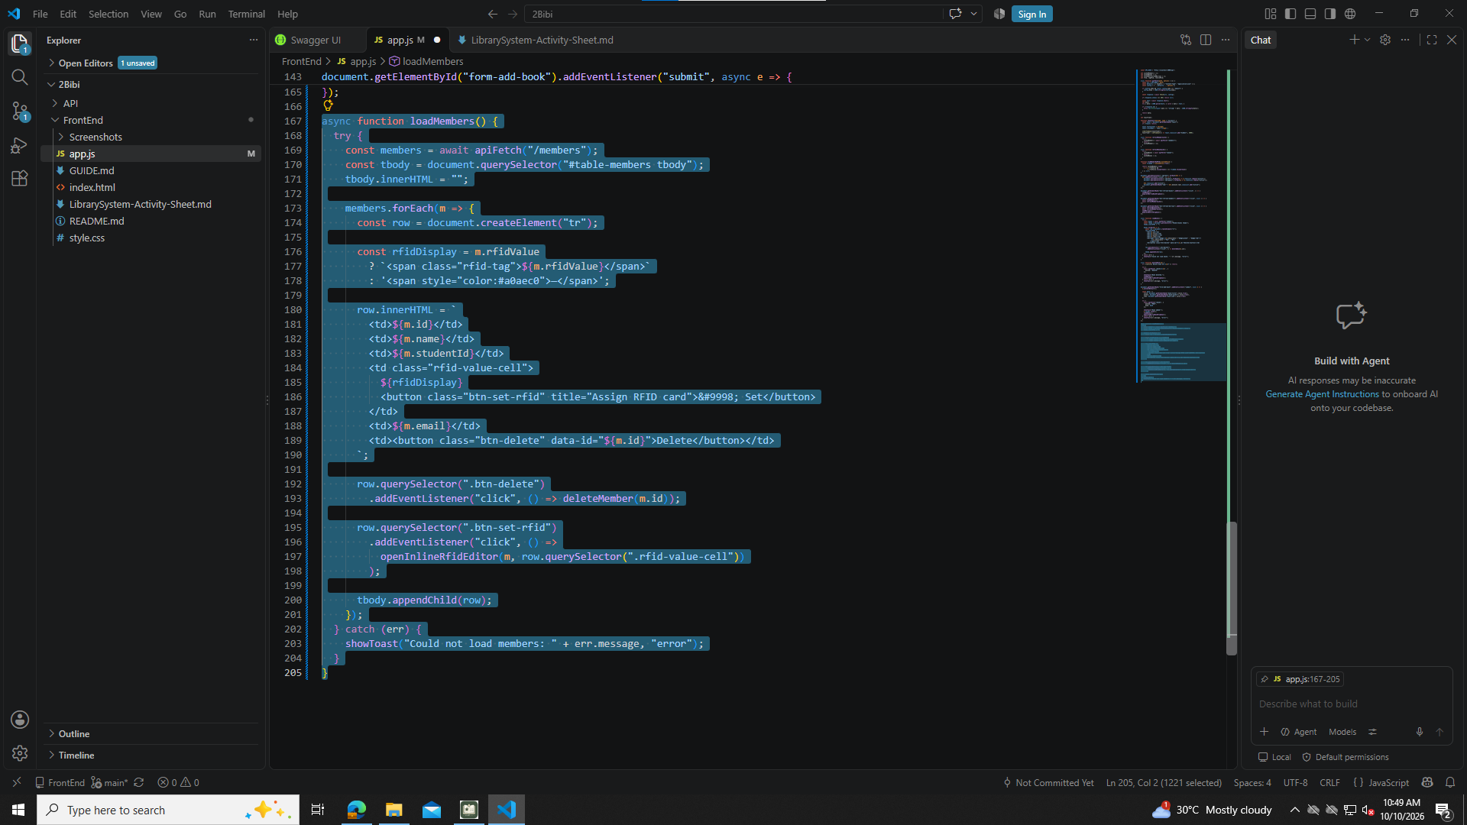

Part 9 deleteMember(id)

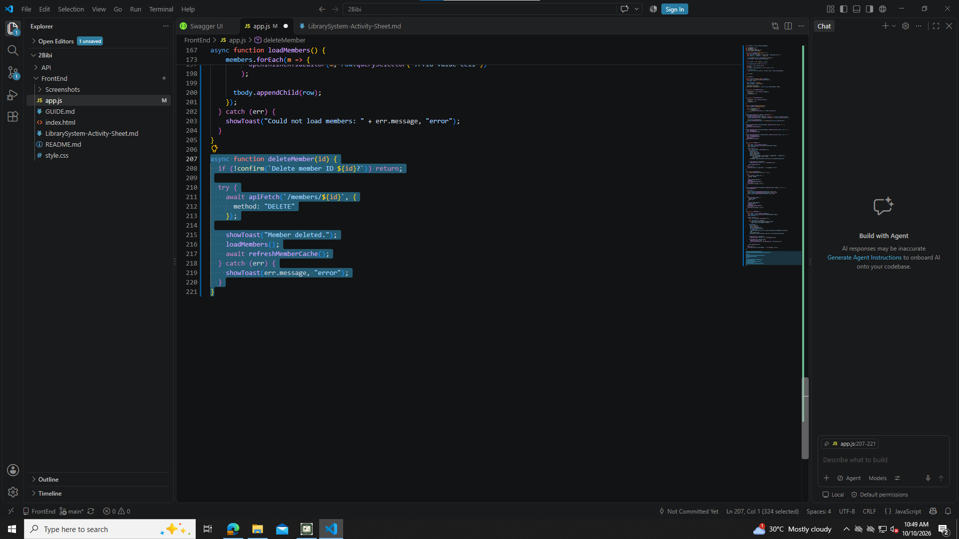

Part 10 Add Member form submit

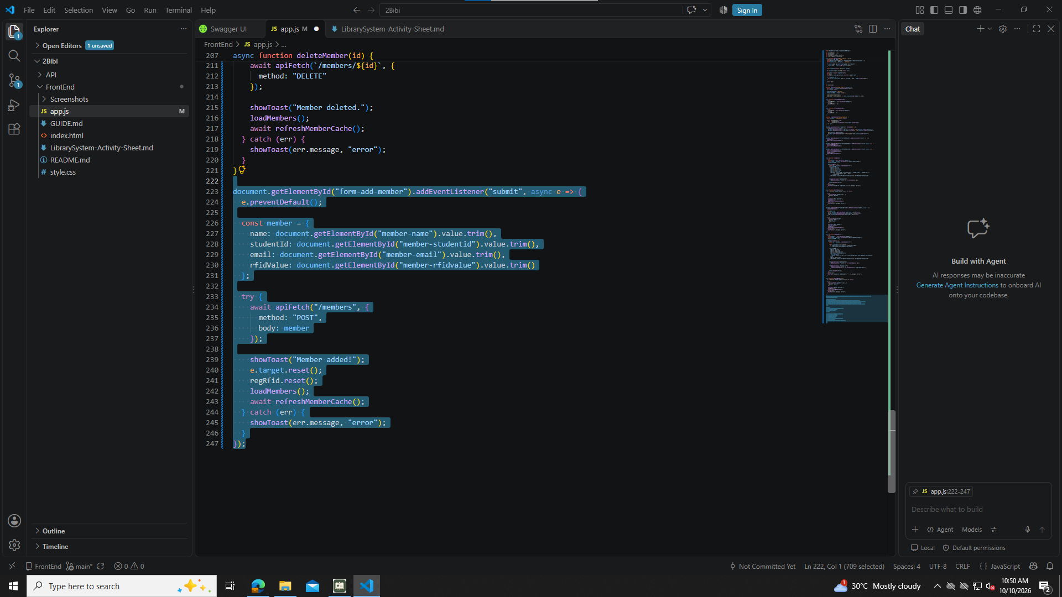

Part 11 openInlineRfidEditor() with saveRfid() inside

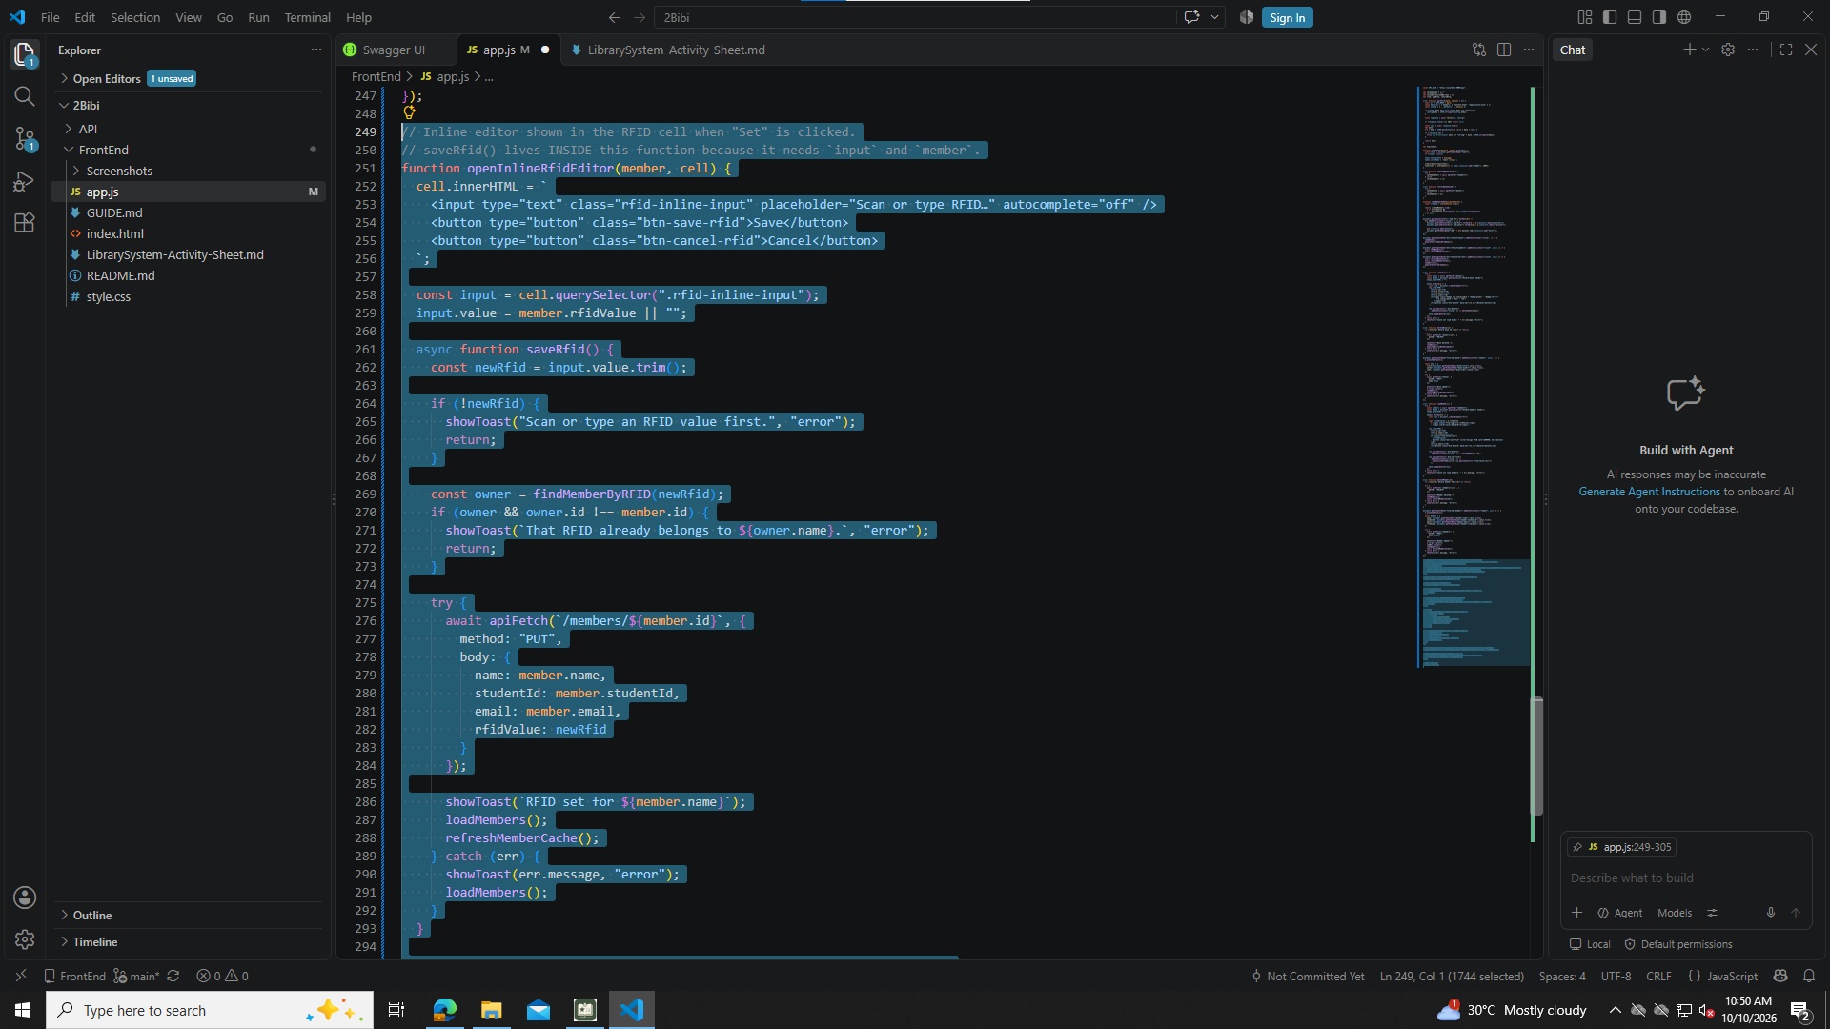
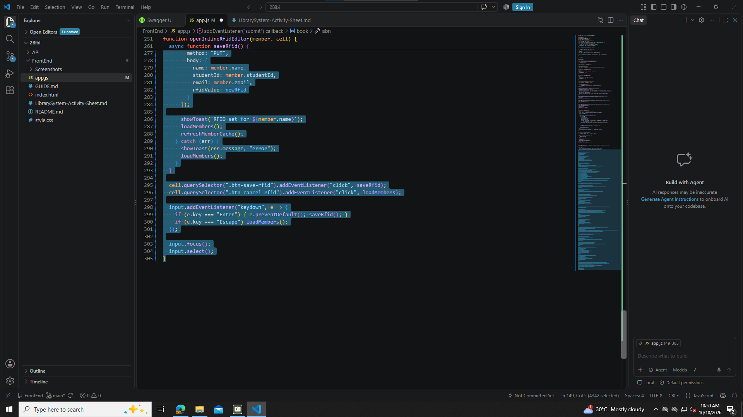

Part 12 createRfidWidget(), initRFID(), initRegRFID(), initReturnRFID()

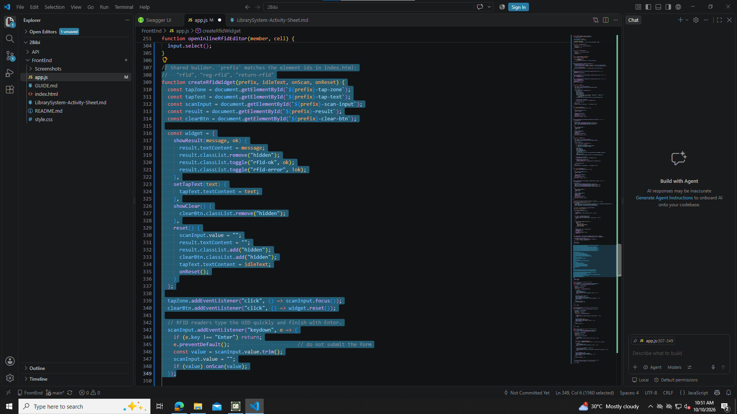
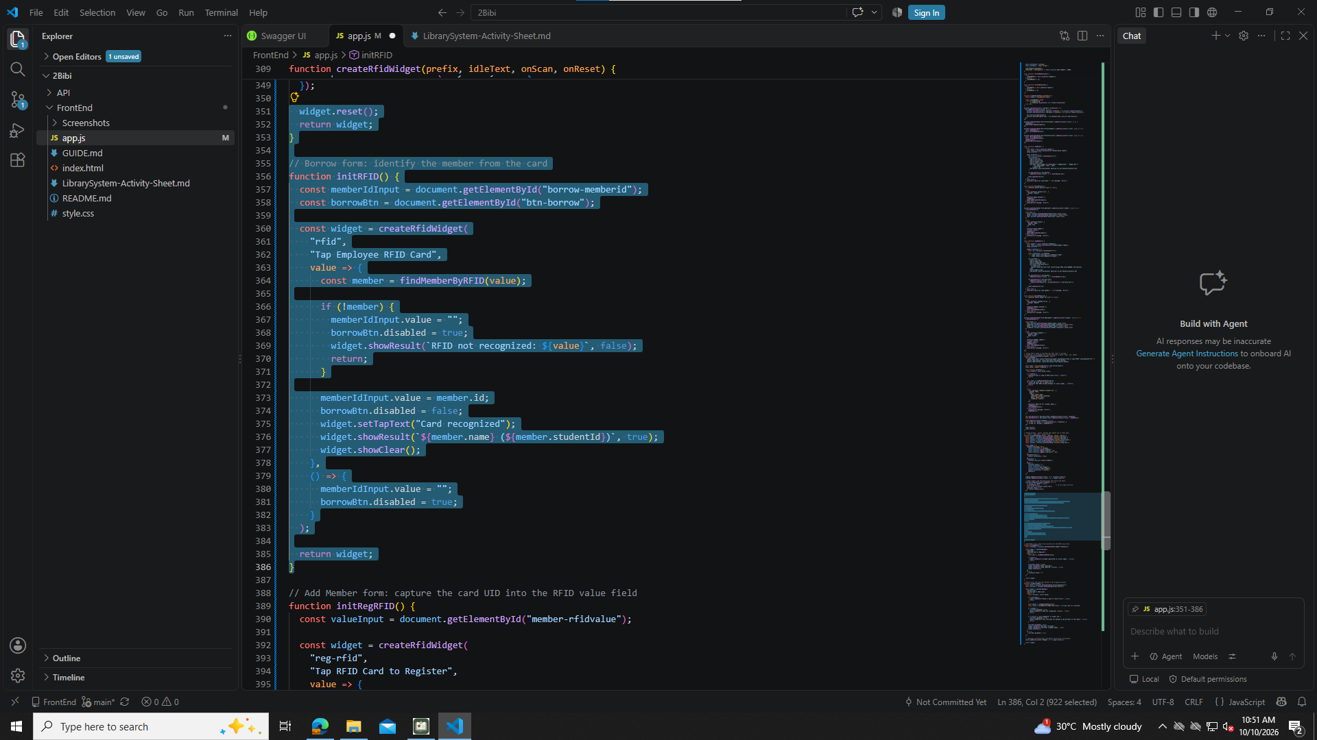
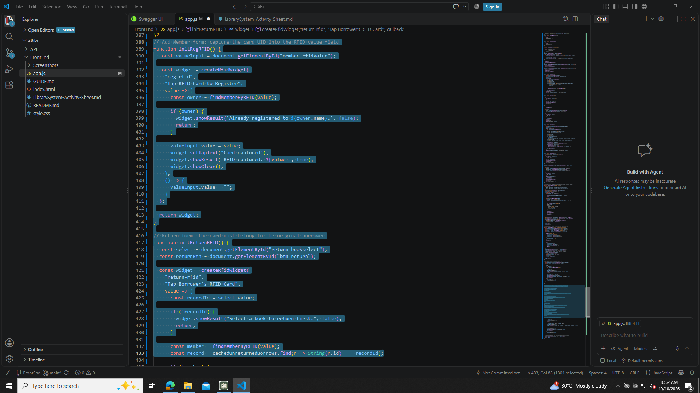
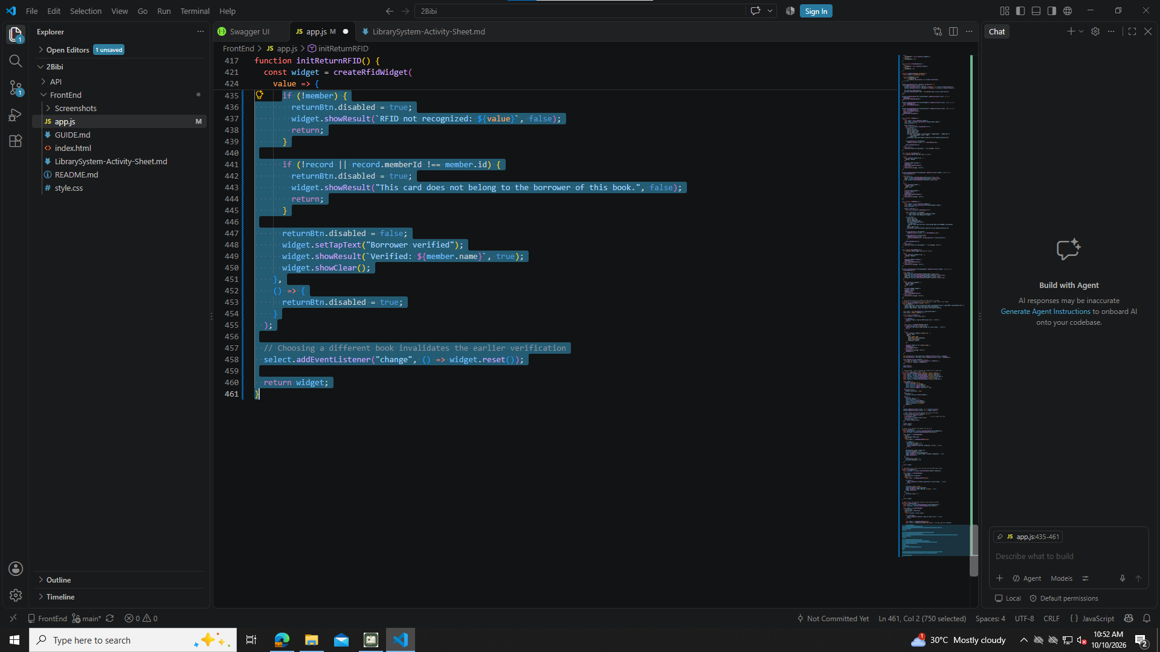

Part 13 populateBorrowBookDropdown()

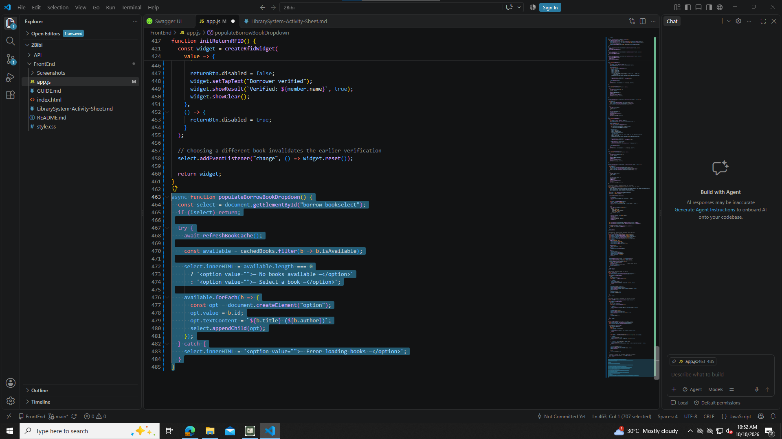

Part 14 populateReturnDropdown()

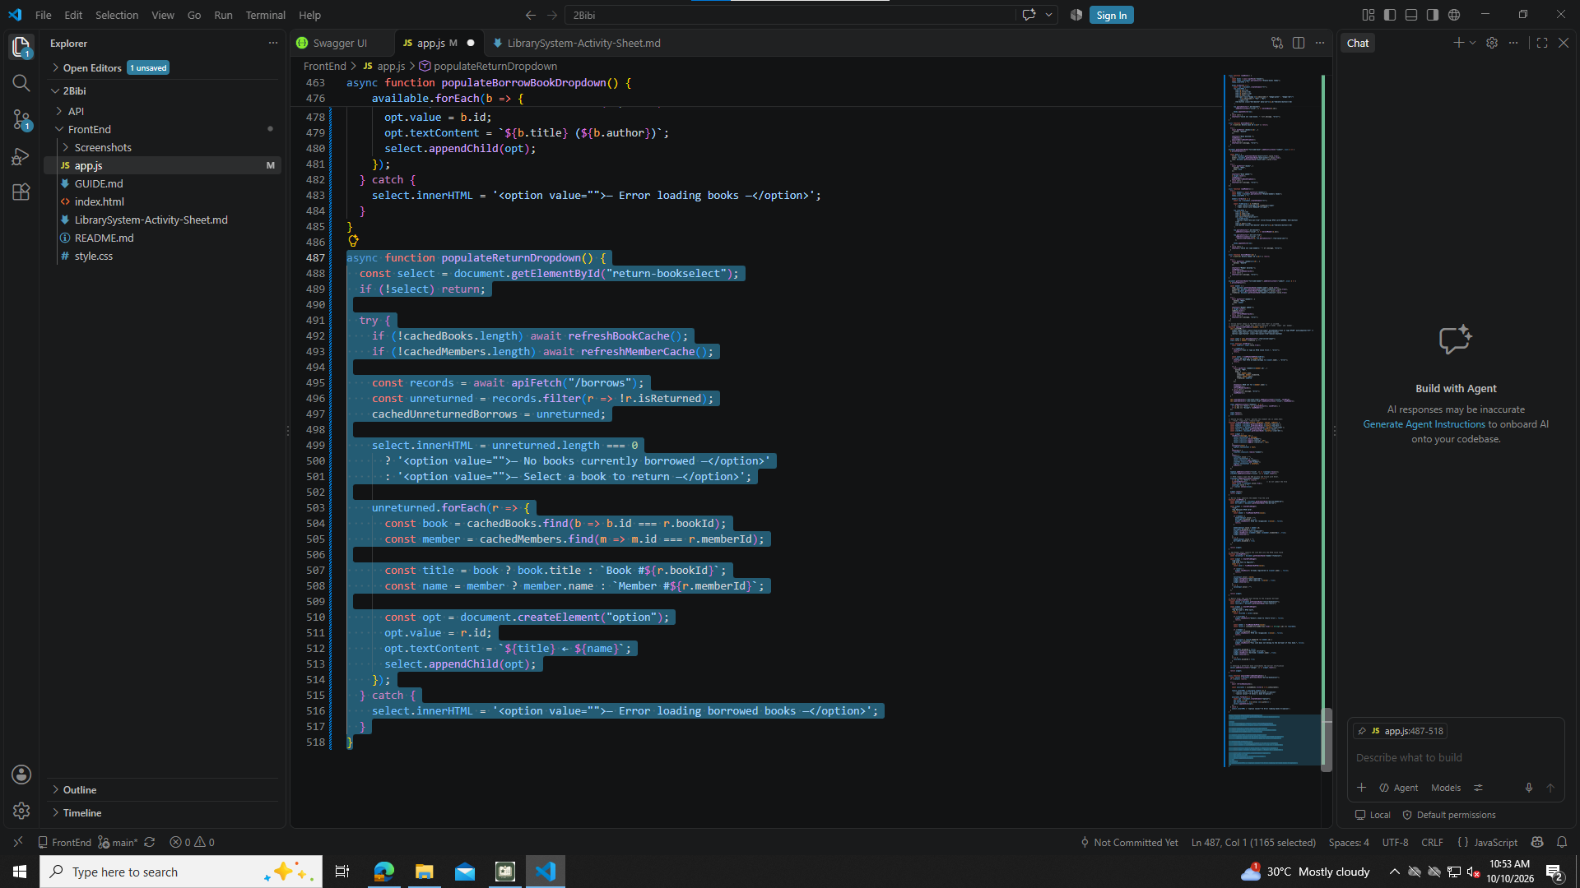

Part 15 Borrow form submit (once only)

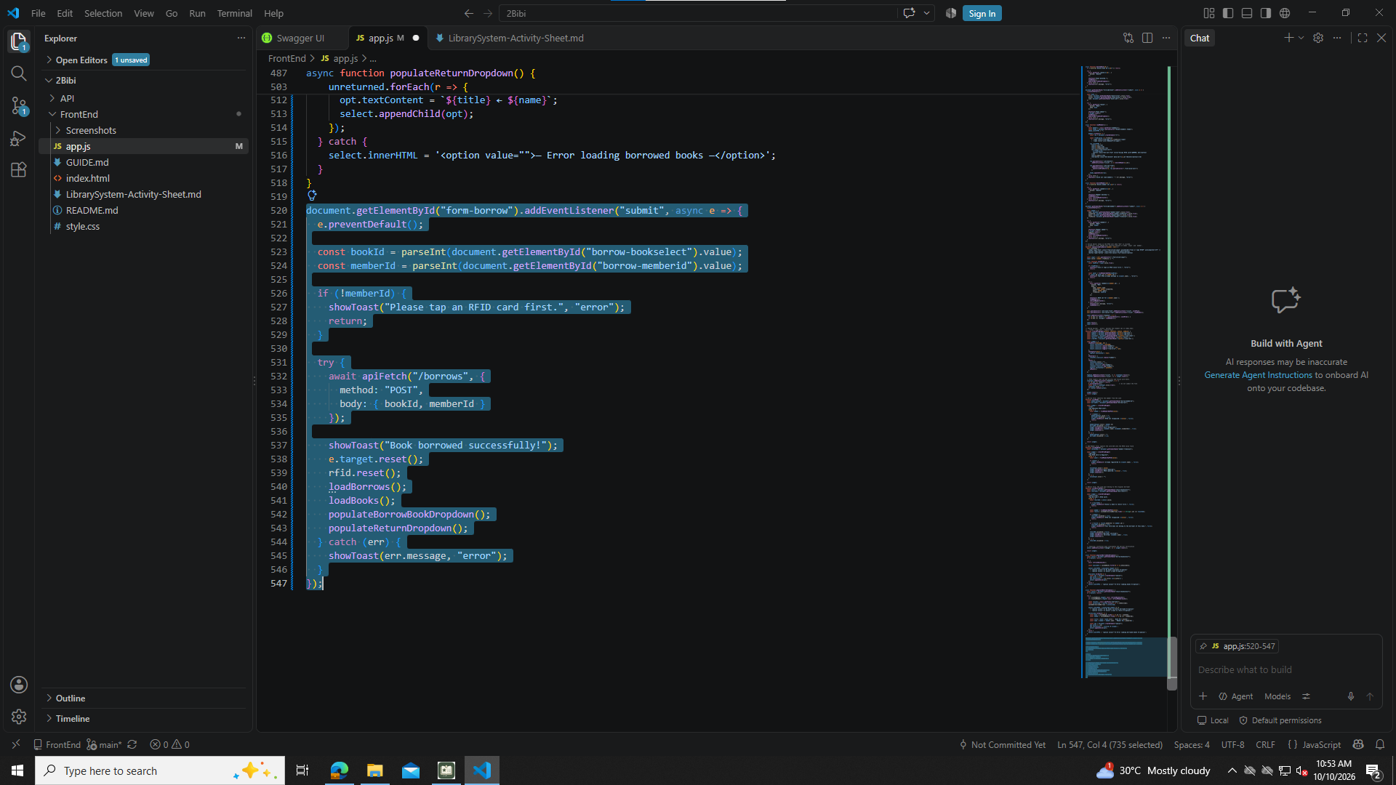

Part 16 Return form submit (do not skip)

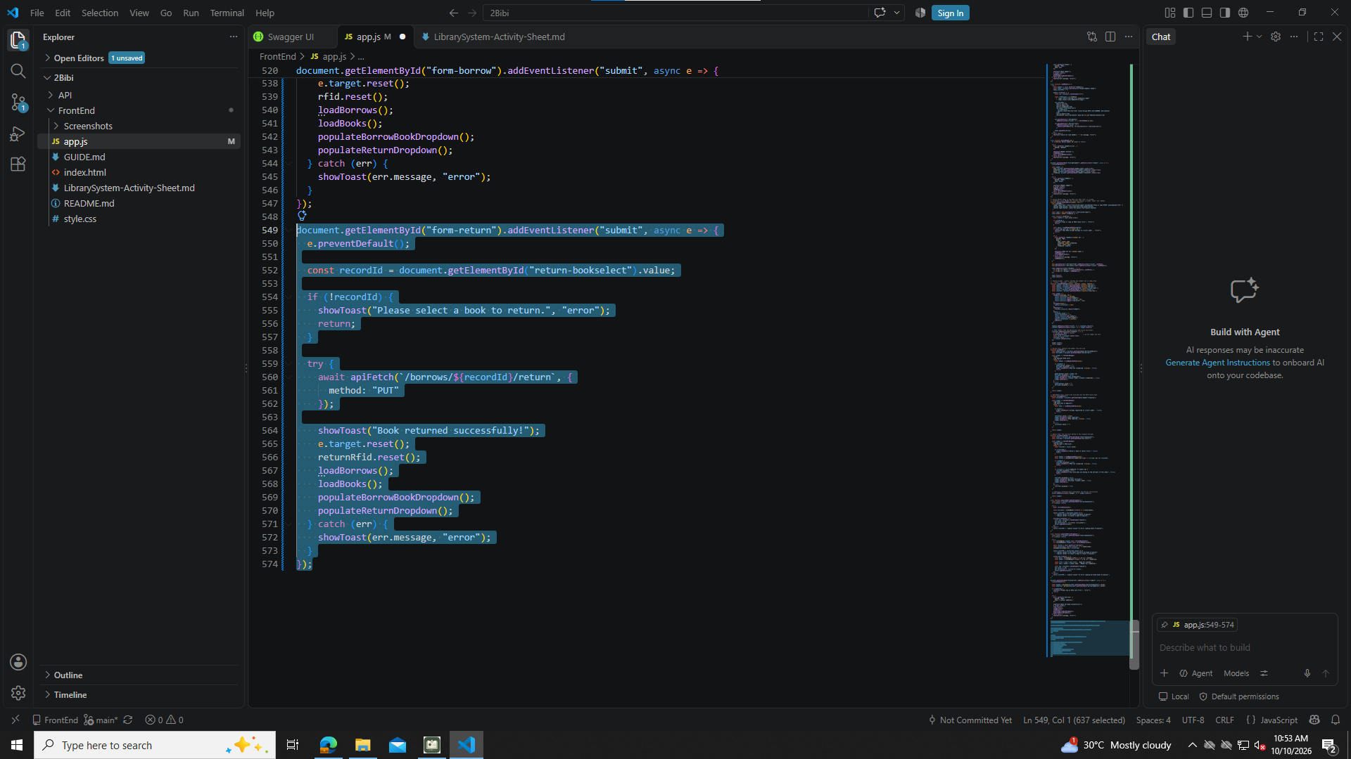

Part 17 loadBorrows()

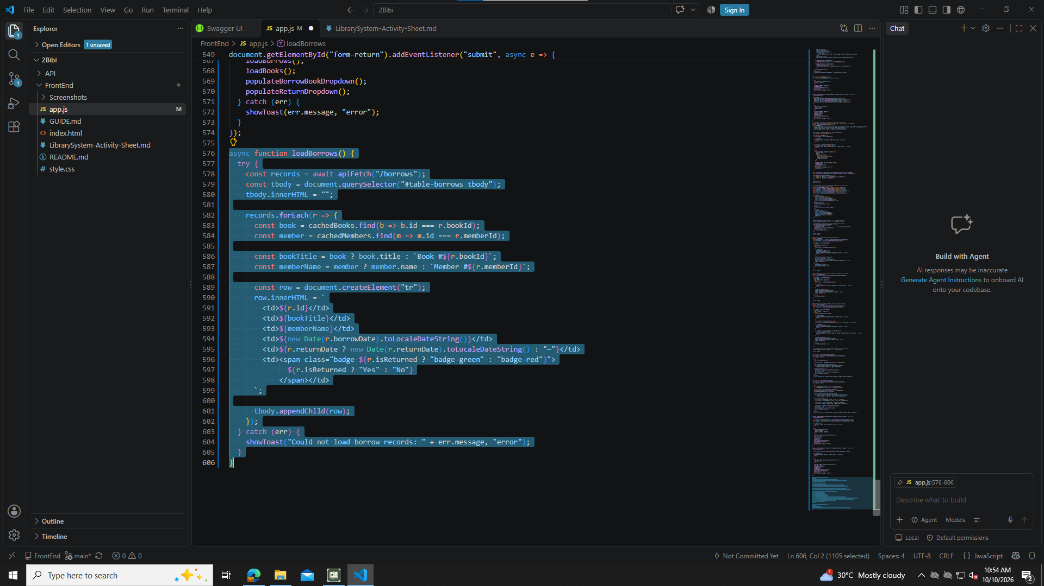

Part 18 Initial page load (last)

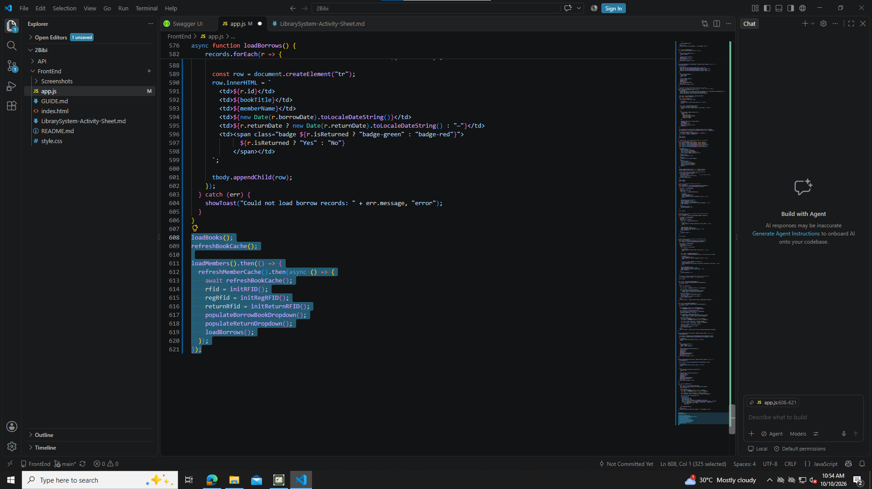

Testing Steps

1. Start the API
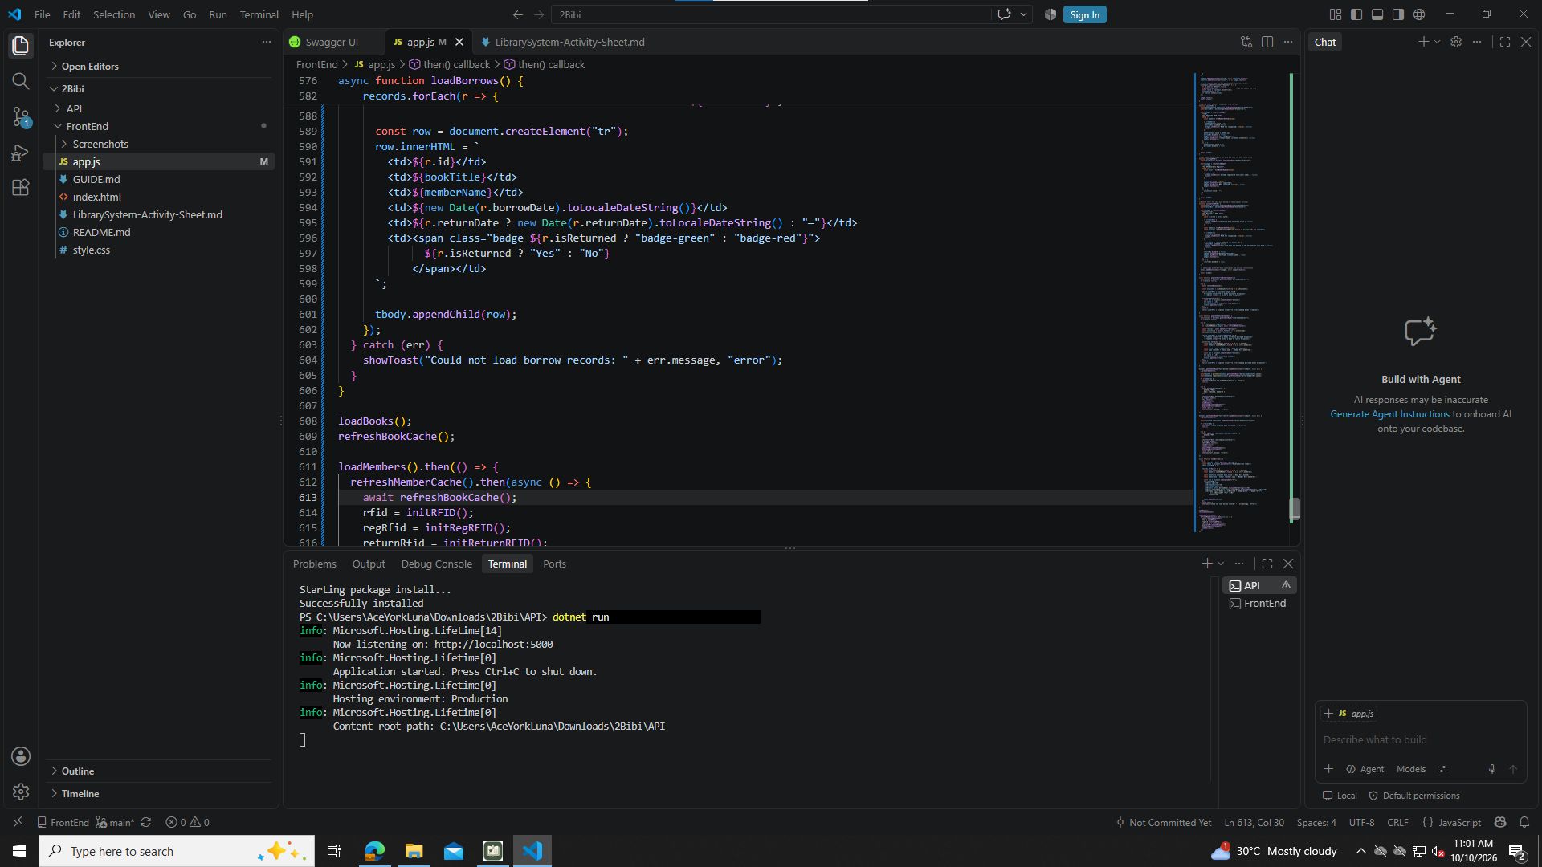

2. Open the FrontEnd
test-01-page-loaded
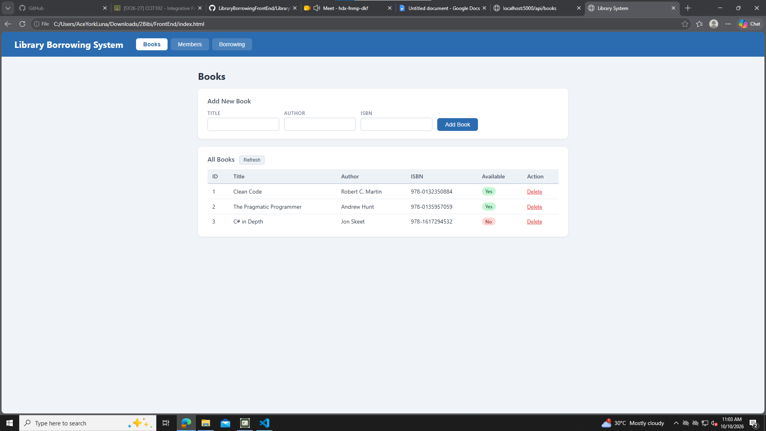
3. Test the Tabs
DONE!

4. Test Books
test-02-add-book
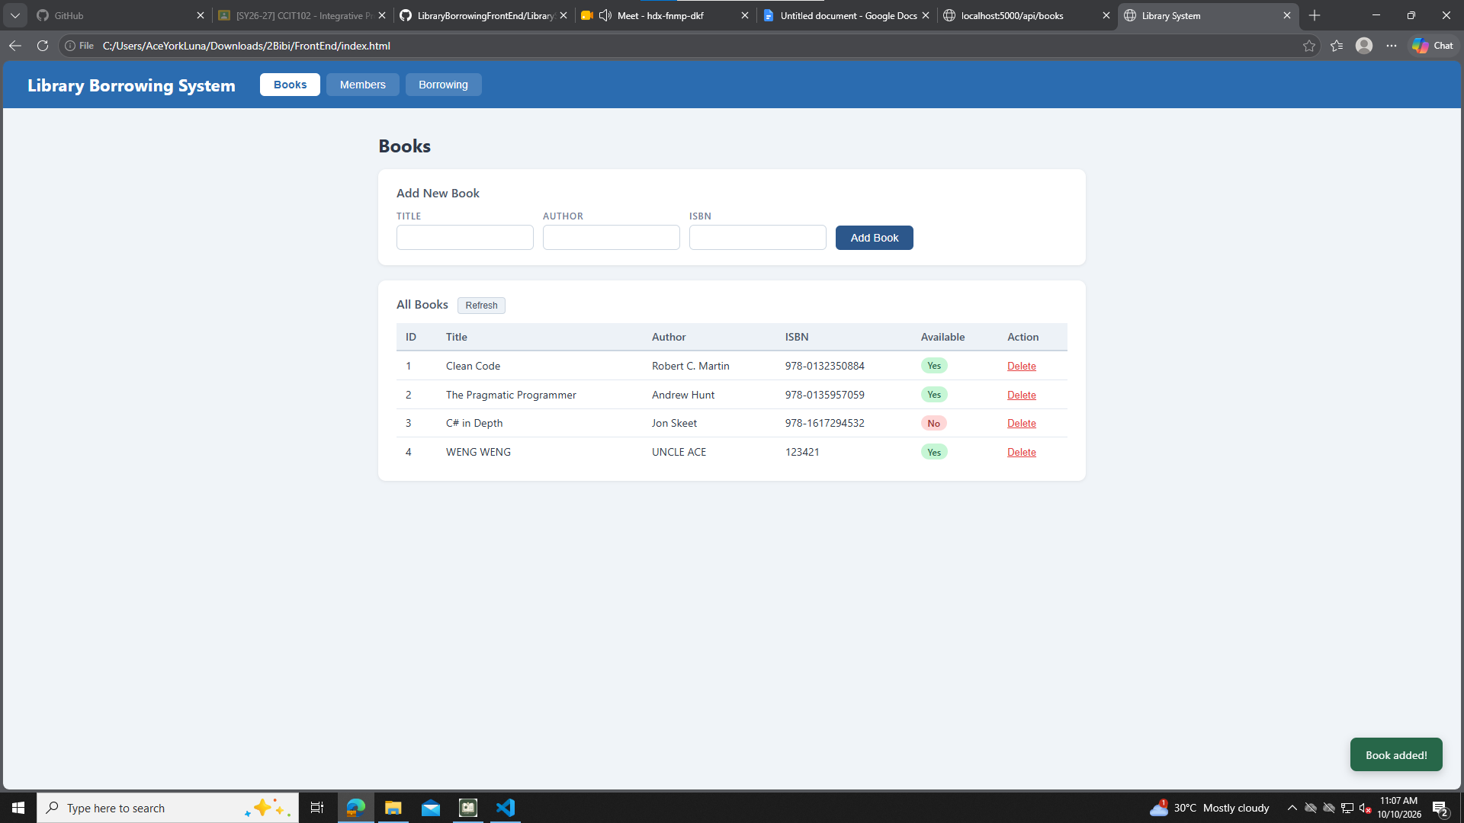
test-03-delete-book
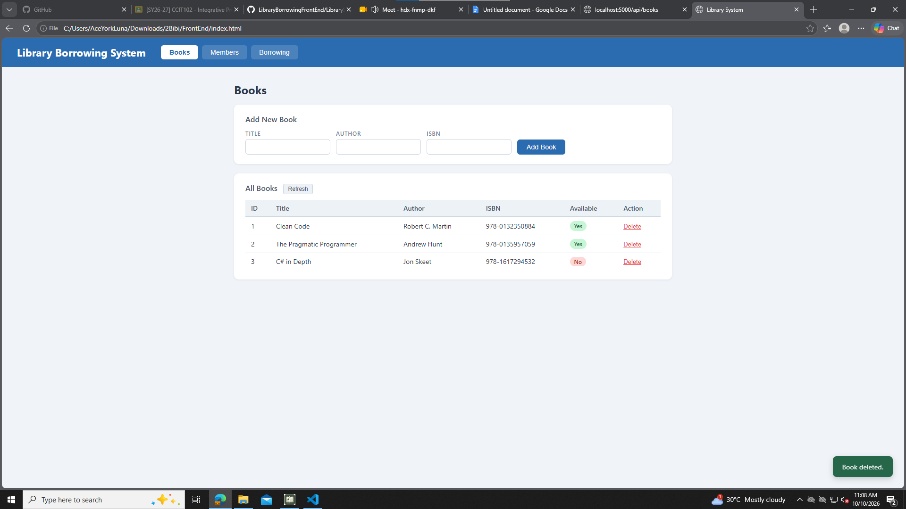

5. Test Members
test-04-members-loaded
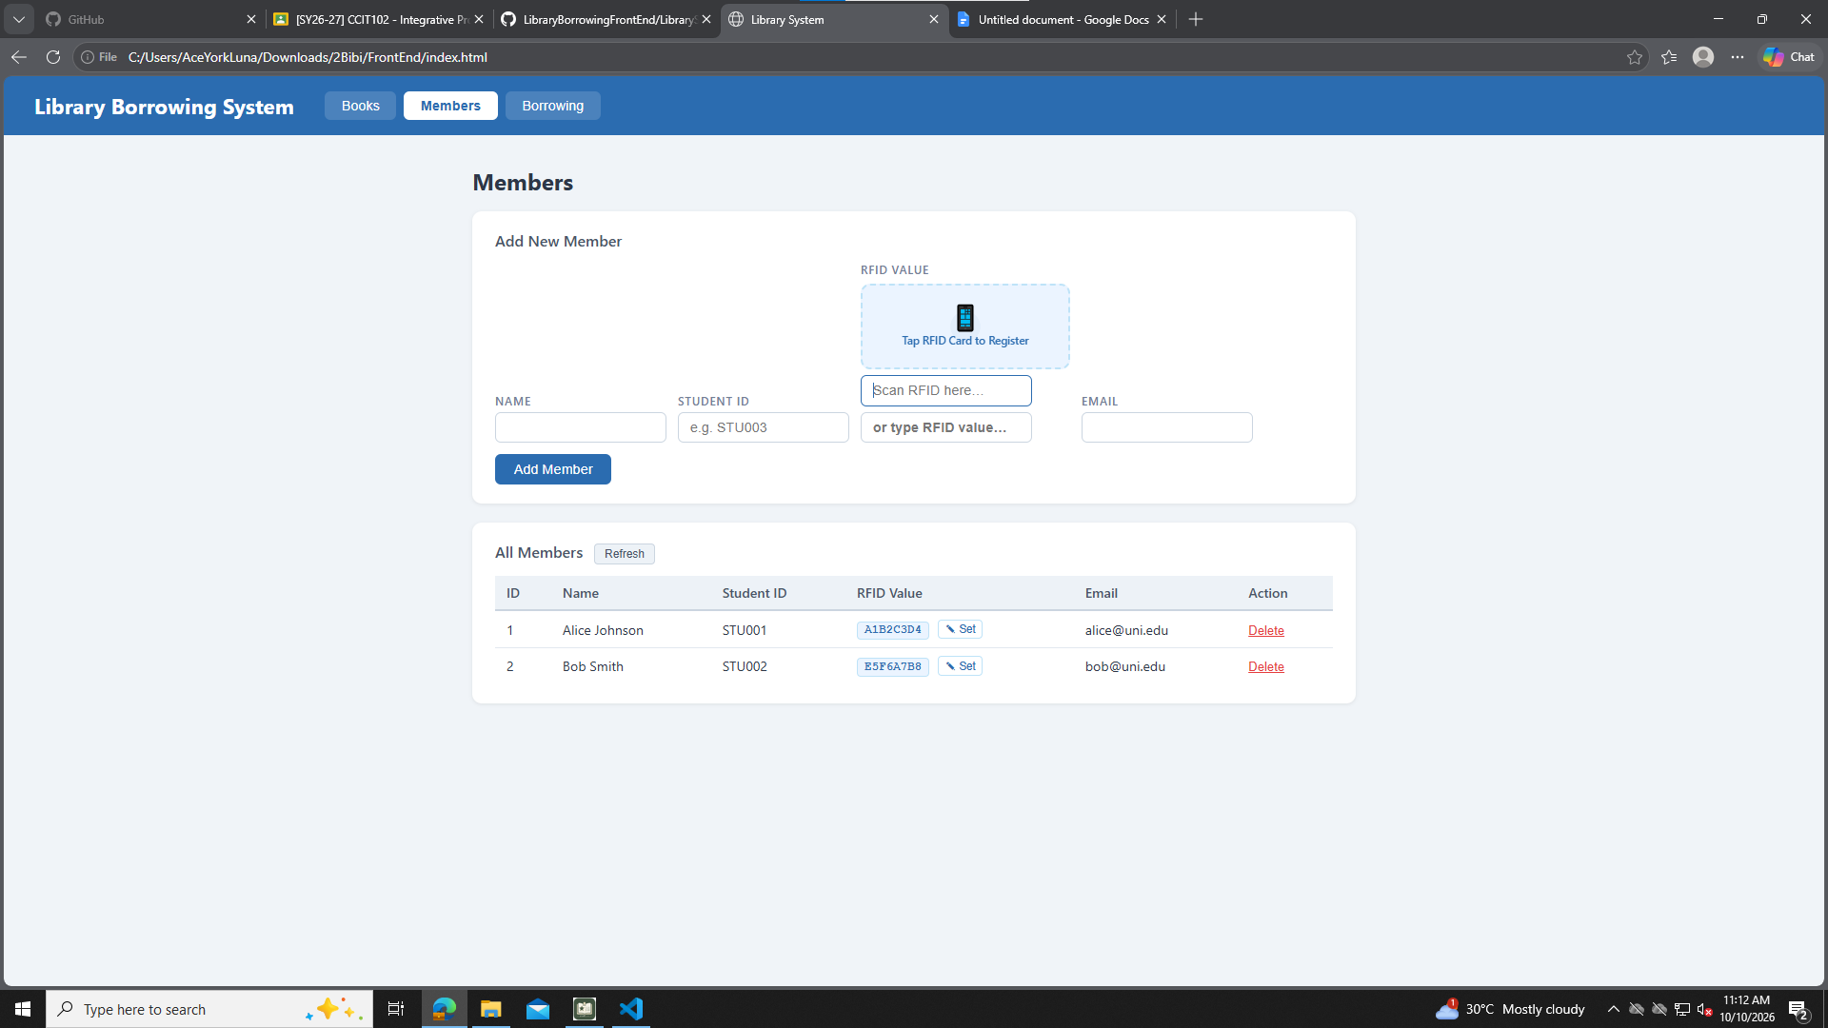
test-05-register-rfid
test-06-add-member
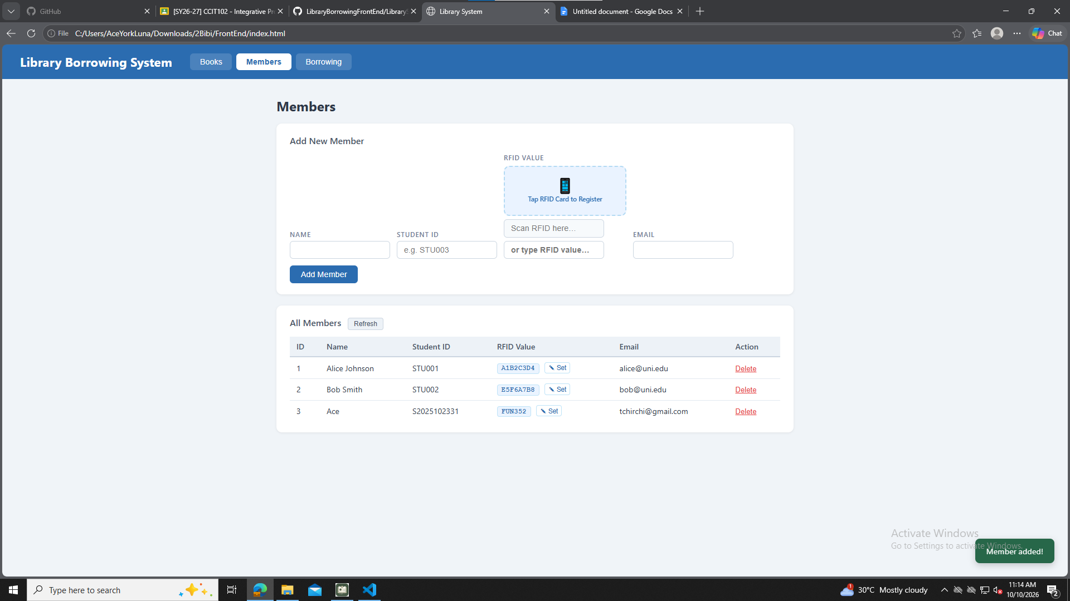

test-07-set-rfid-save
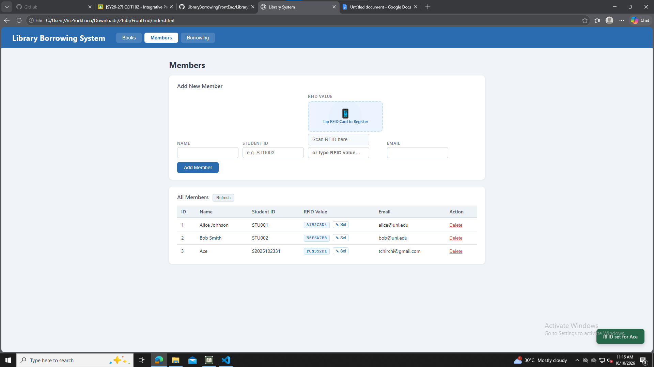
test-08-delete-member
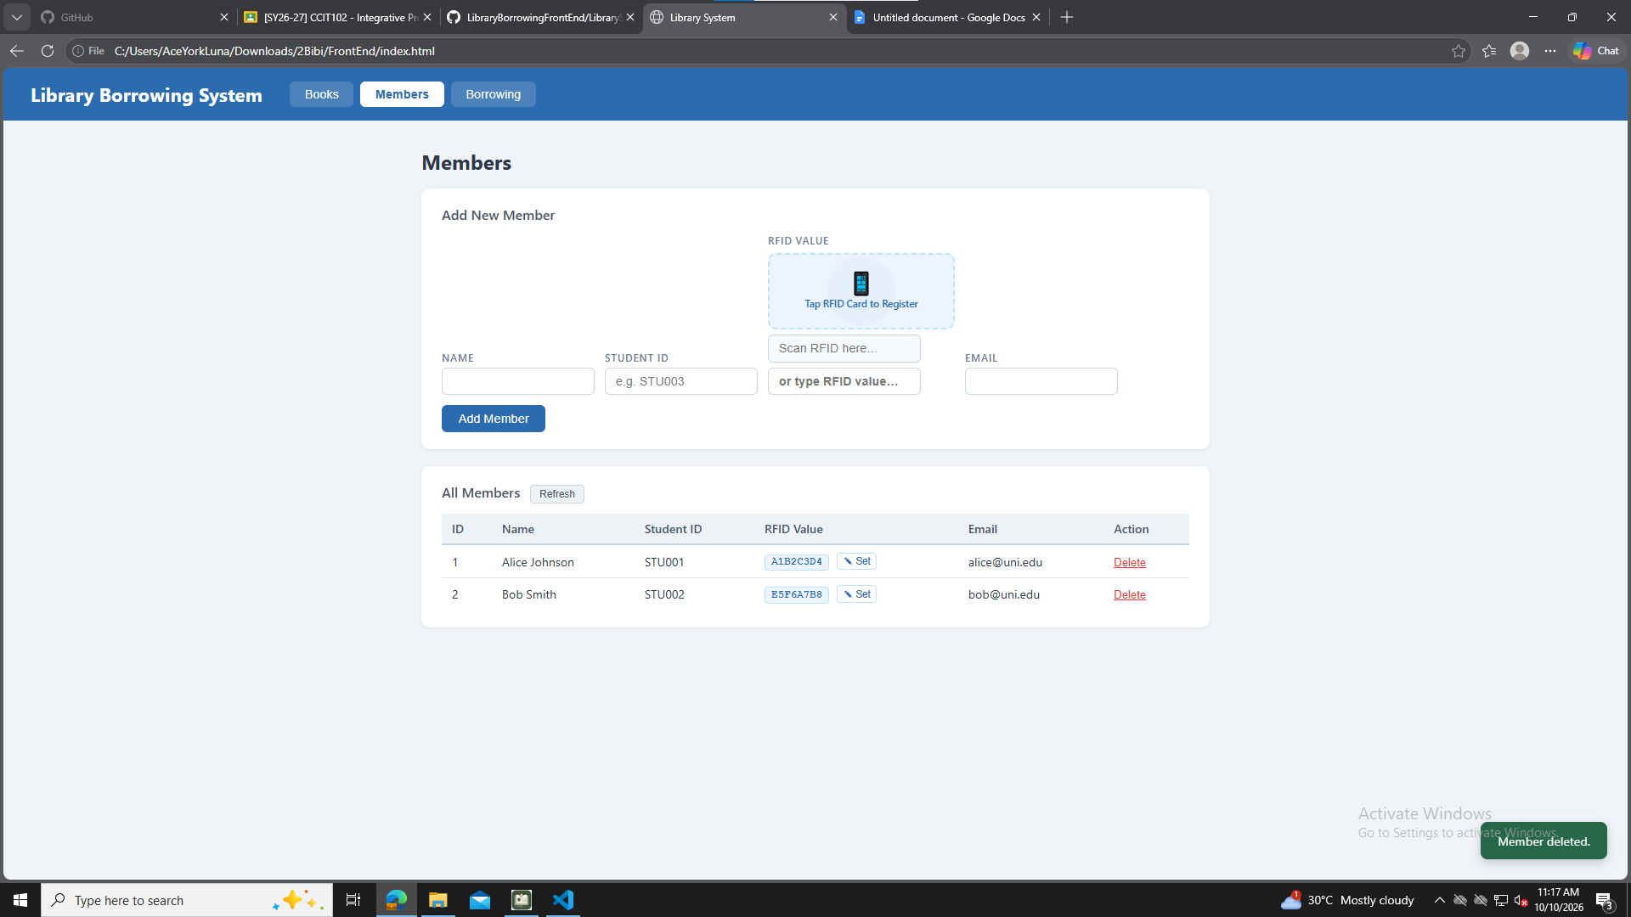

6. Test Borrowing
test-09-borrow-rfid-recognized
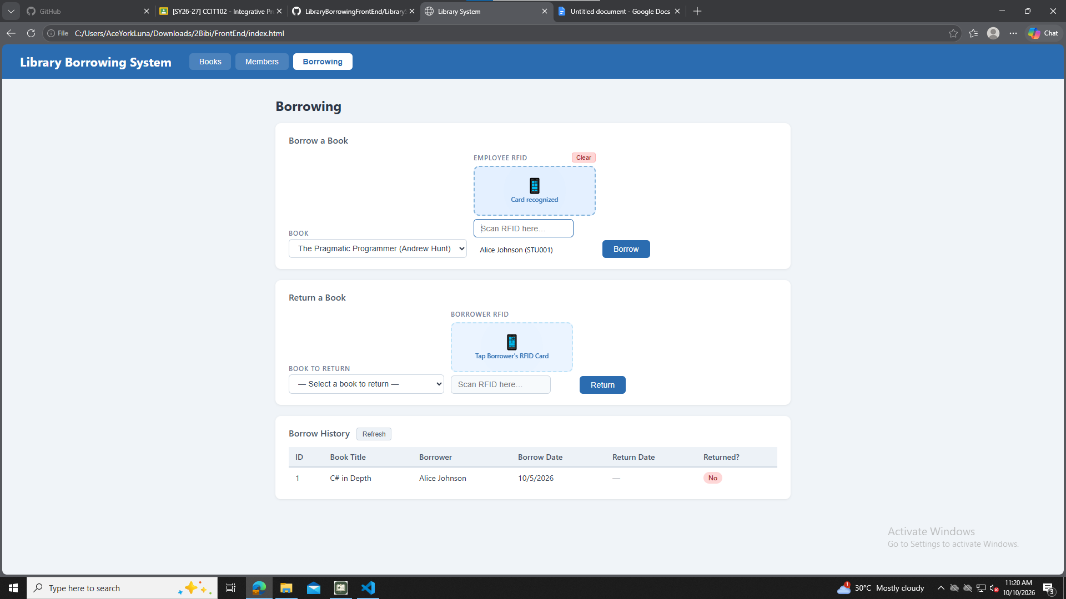

test-10-borrow-success
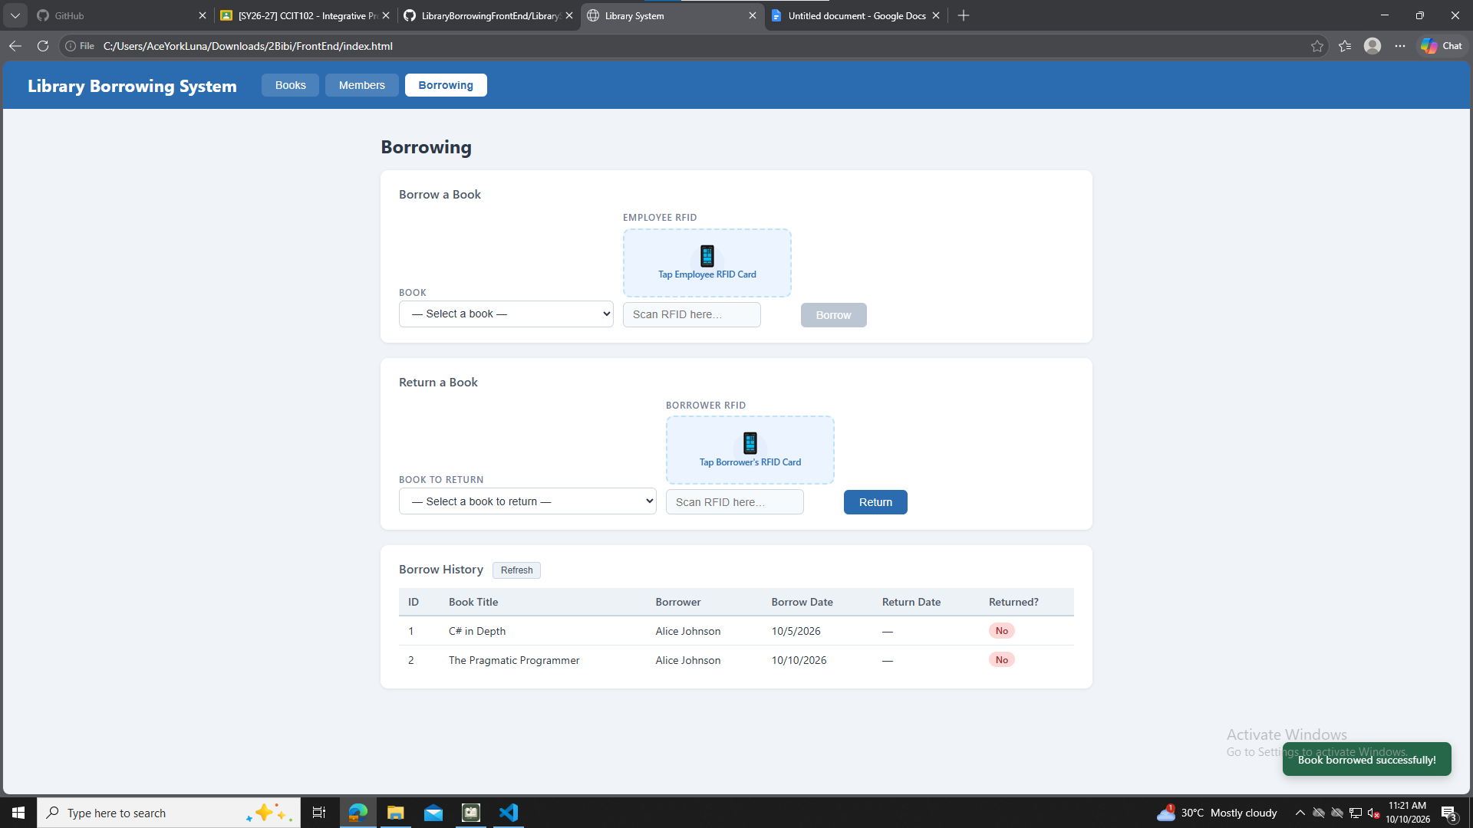

7. Test Returning
test-11-return-wrong-card
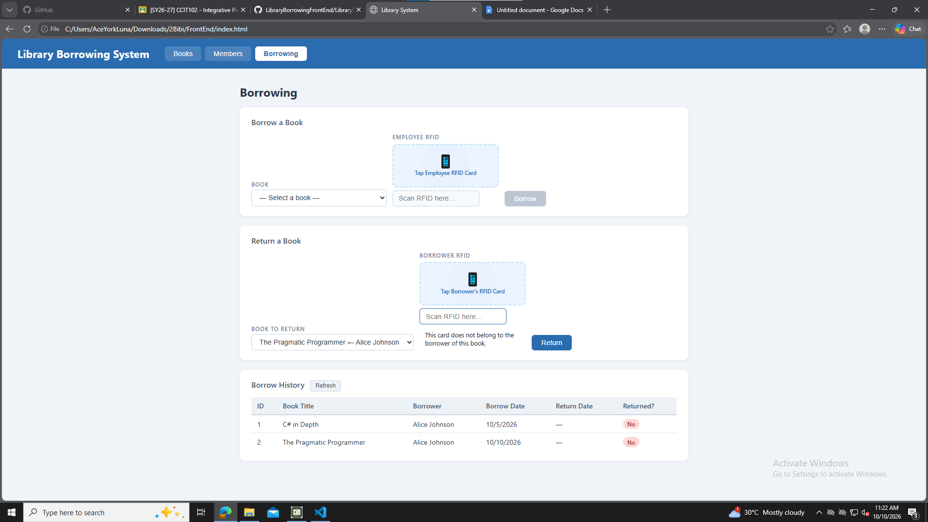
test-12-return-verified
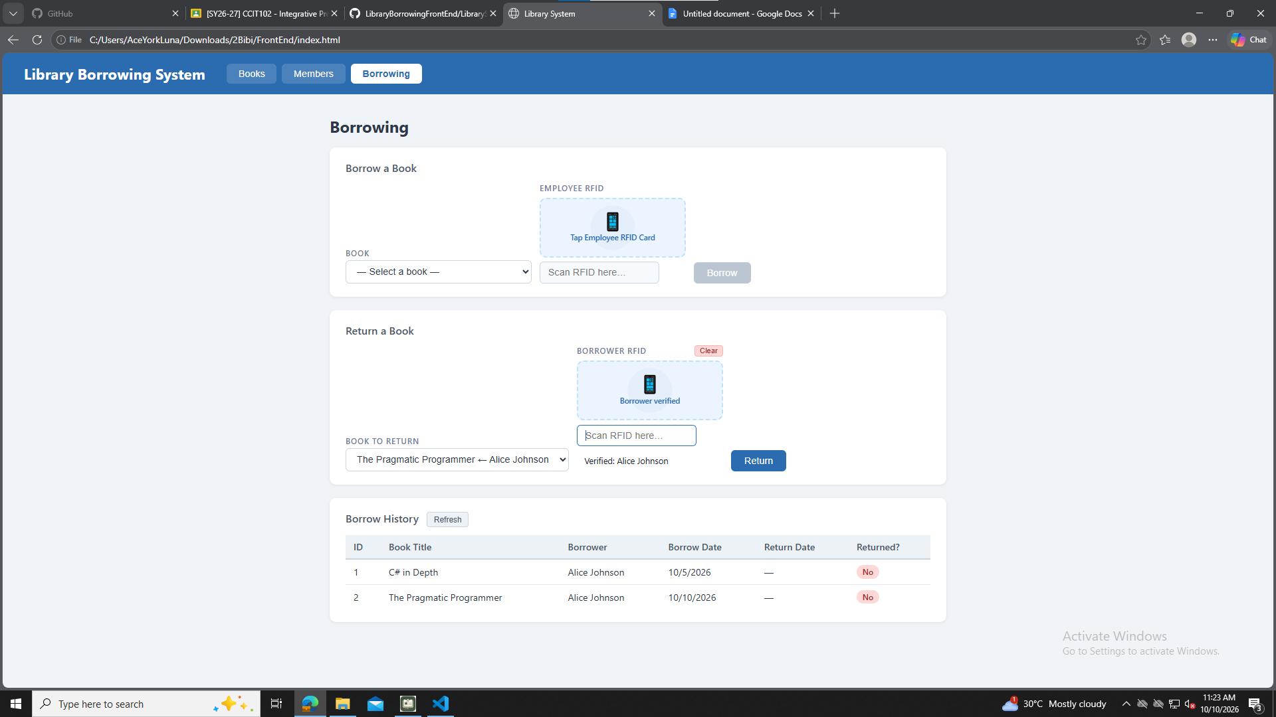

test-13-return-success
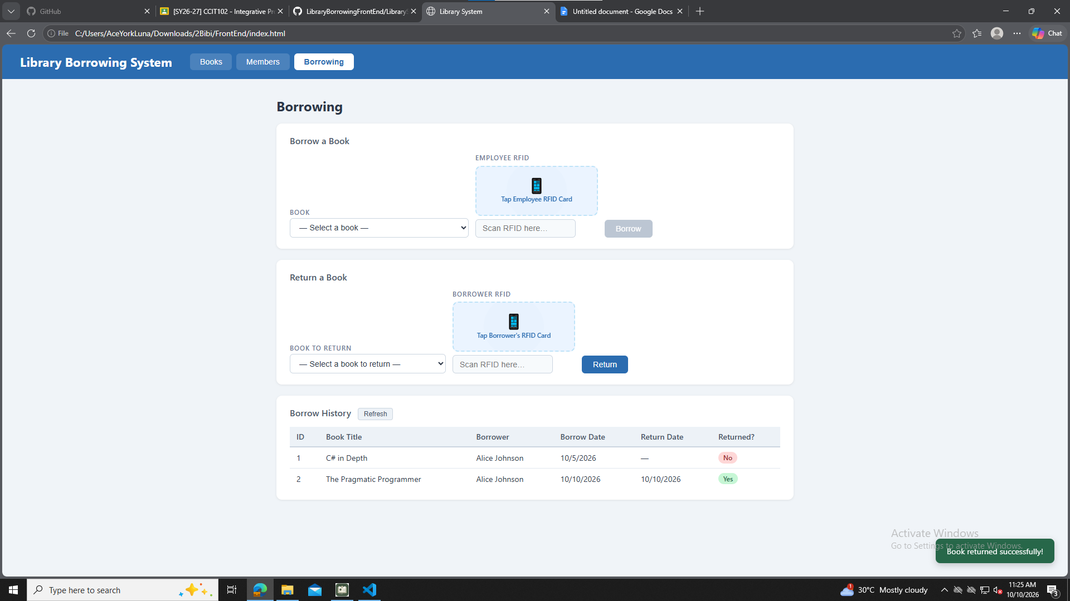

8. Final Console Check
test-14-final-console
