1.test-01-page-loaded
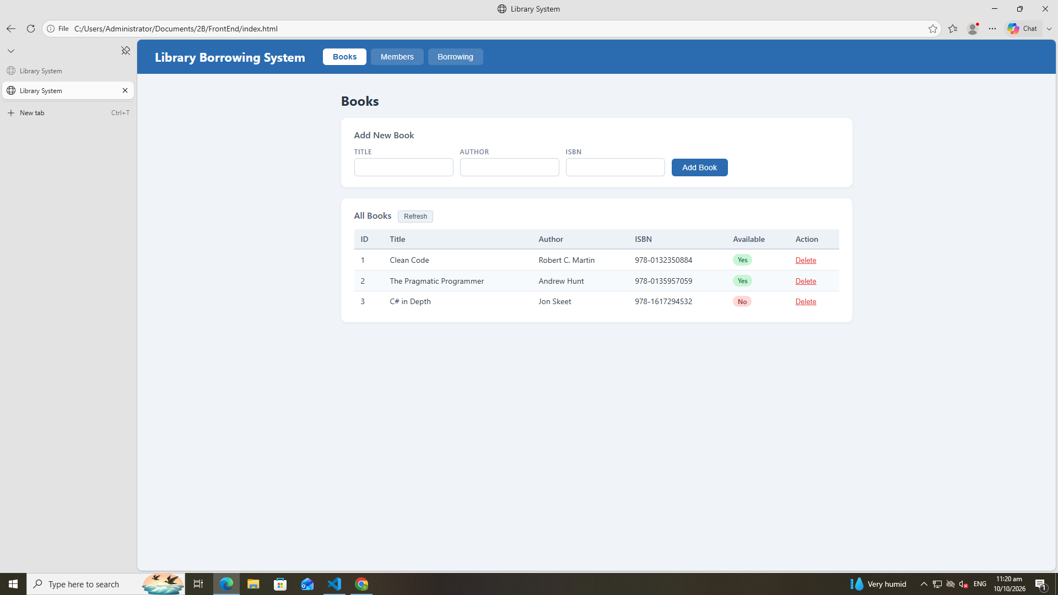

2. Test the tabs
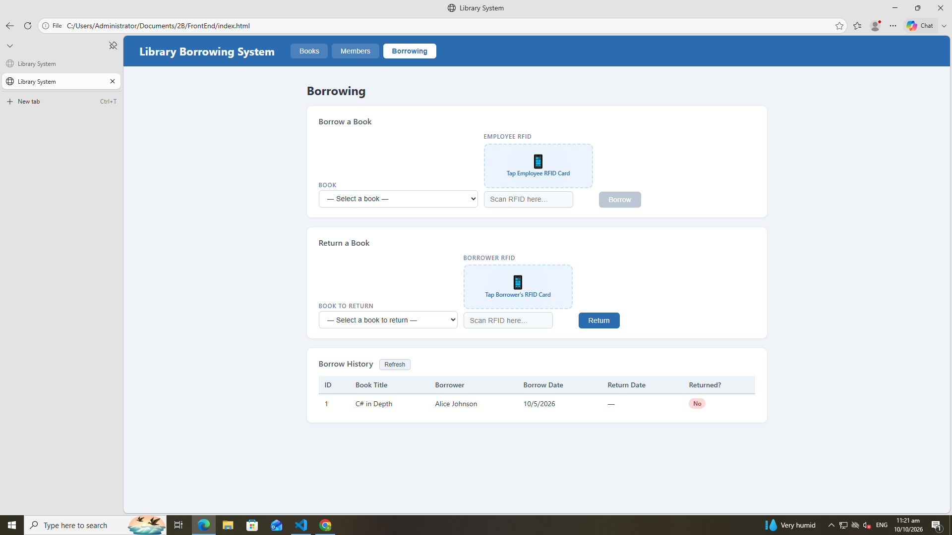
3. Test-02-add-books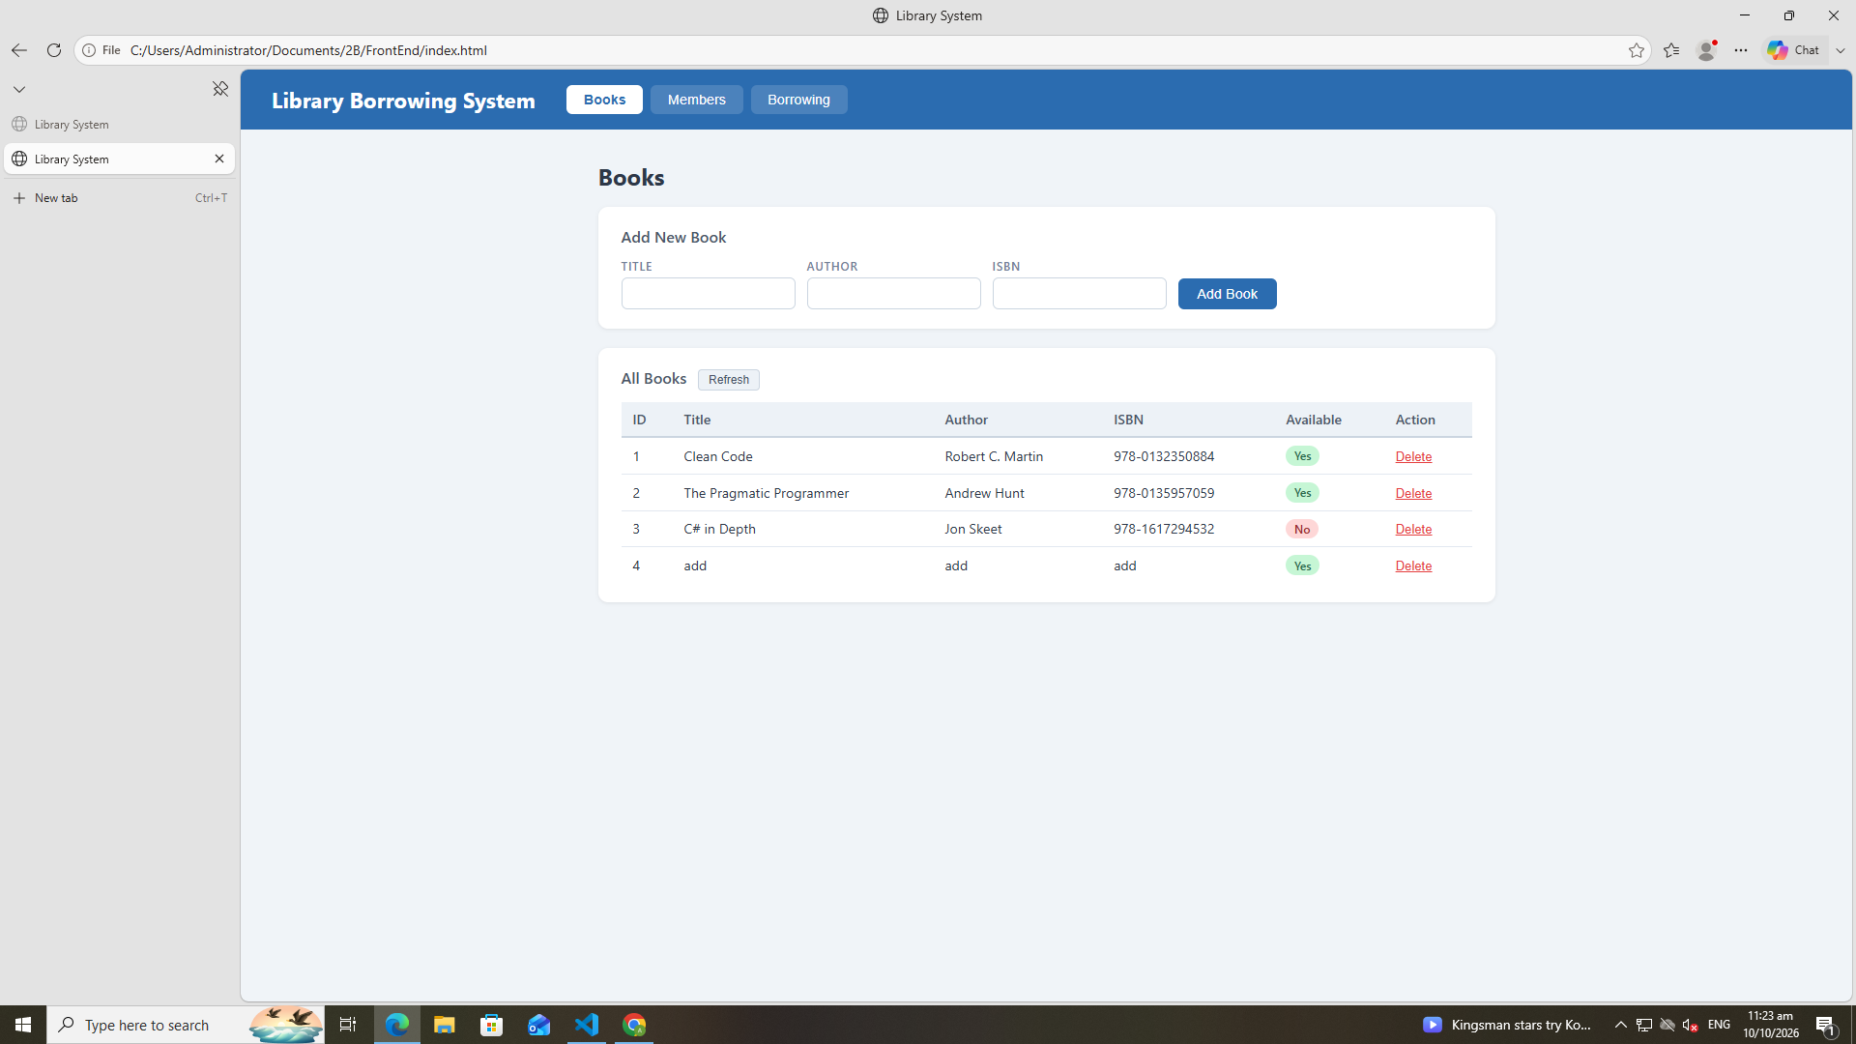
4. Test-03-Remove-books
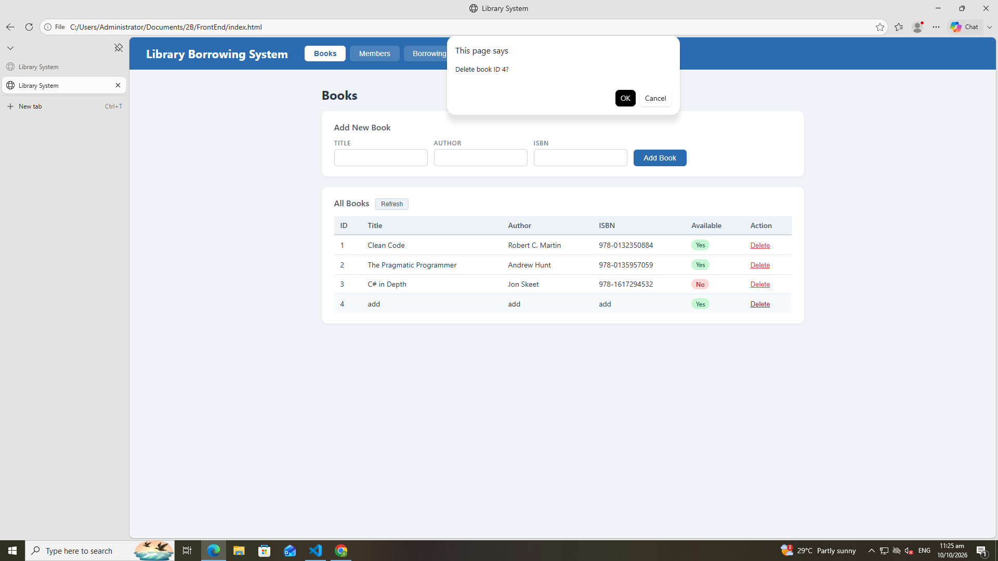
5. Test-05-register-rfid
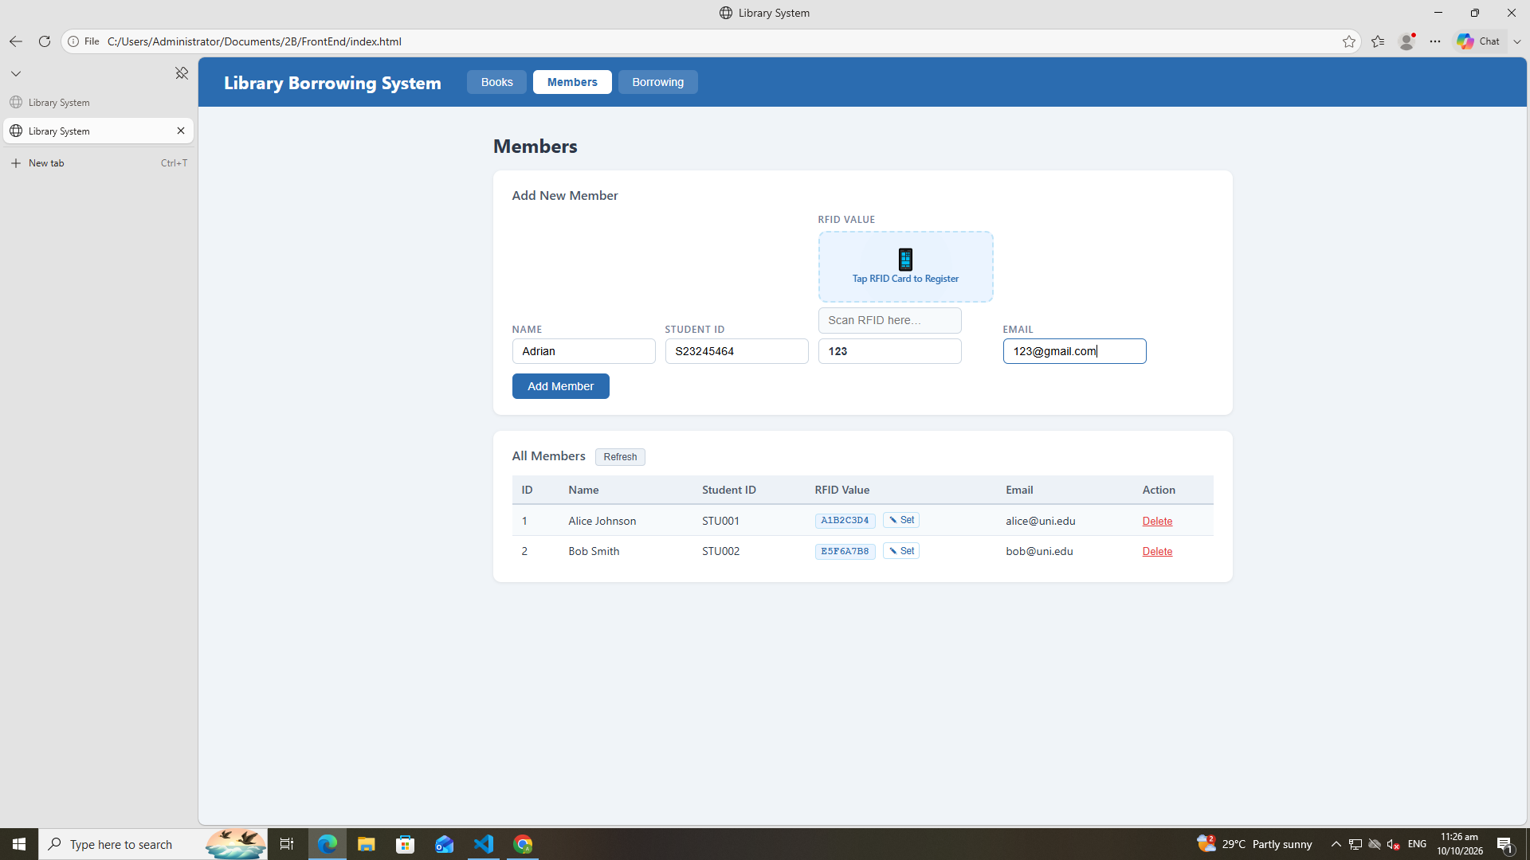
6.Test-06-Add-member
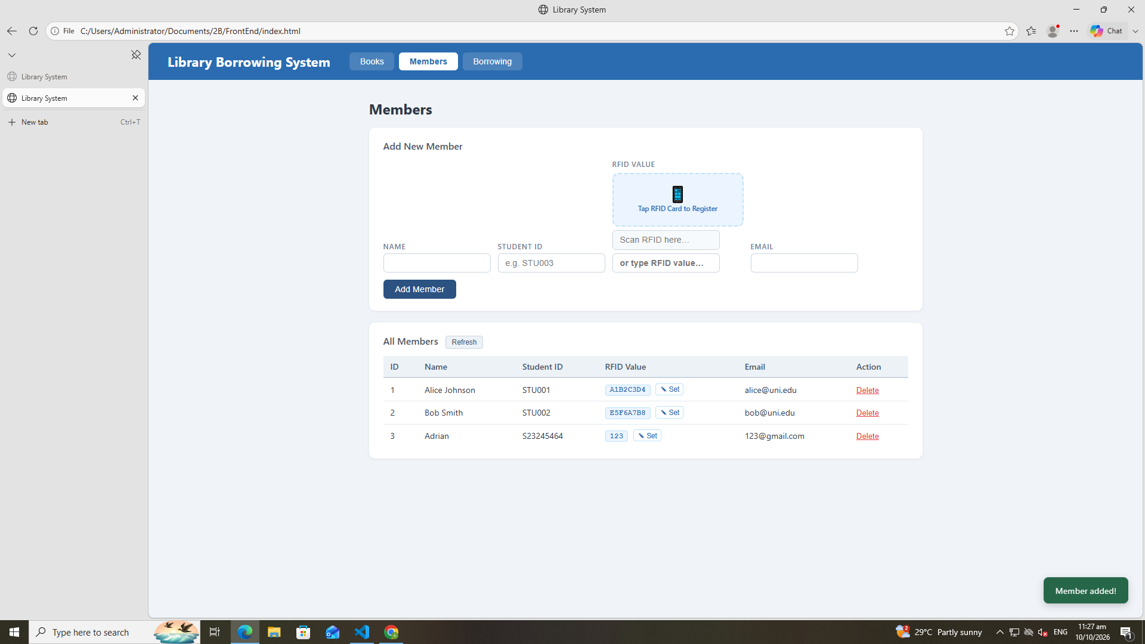
7.Test-07-Set-Rfid-Save
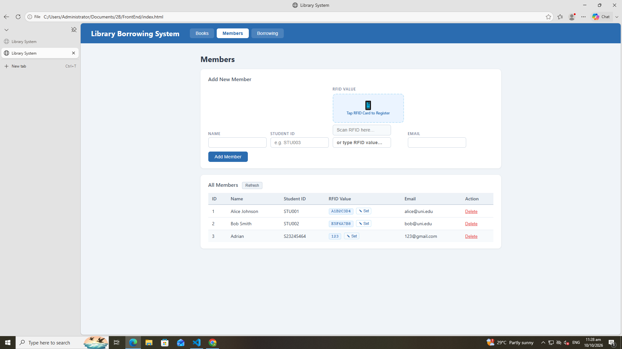
8.Test-08-Delete-Member
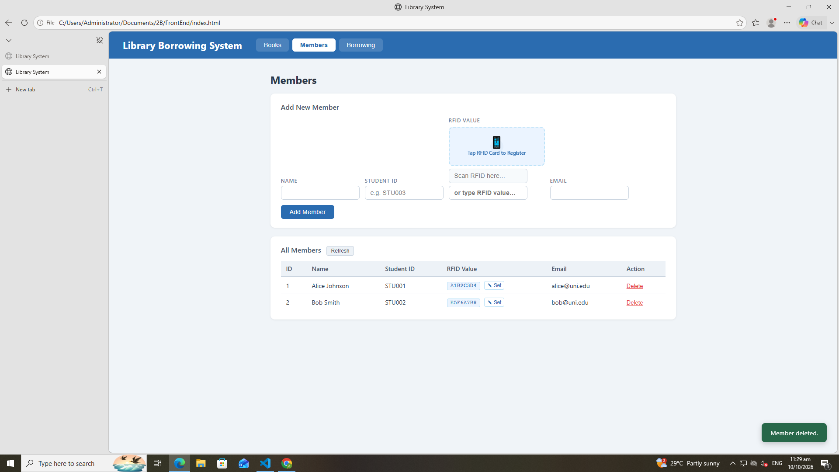

9.Test-09-Borrrow-rfid-Recognize
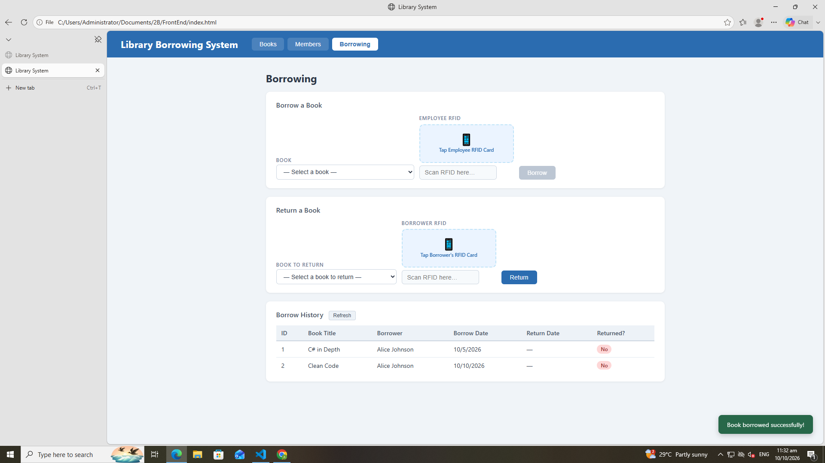

10. Test-10-Borrowed-Acces
11.Test-11-Return-Wrong-Card
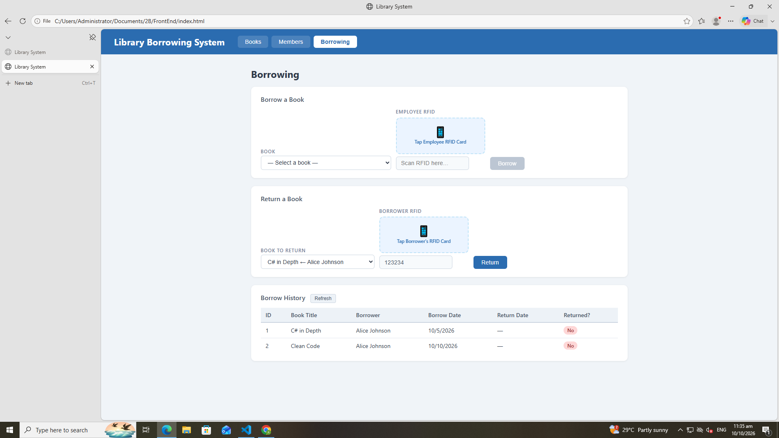
12. Test-

