Part 1 API_BASE, shared variables, apiFetch()
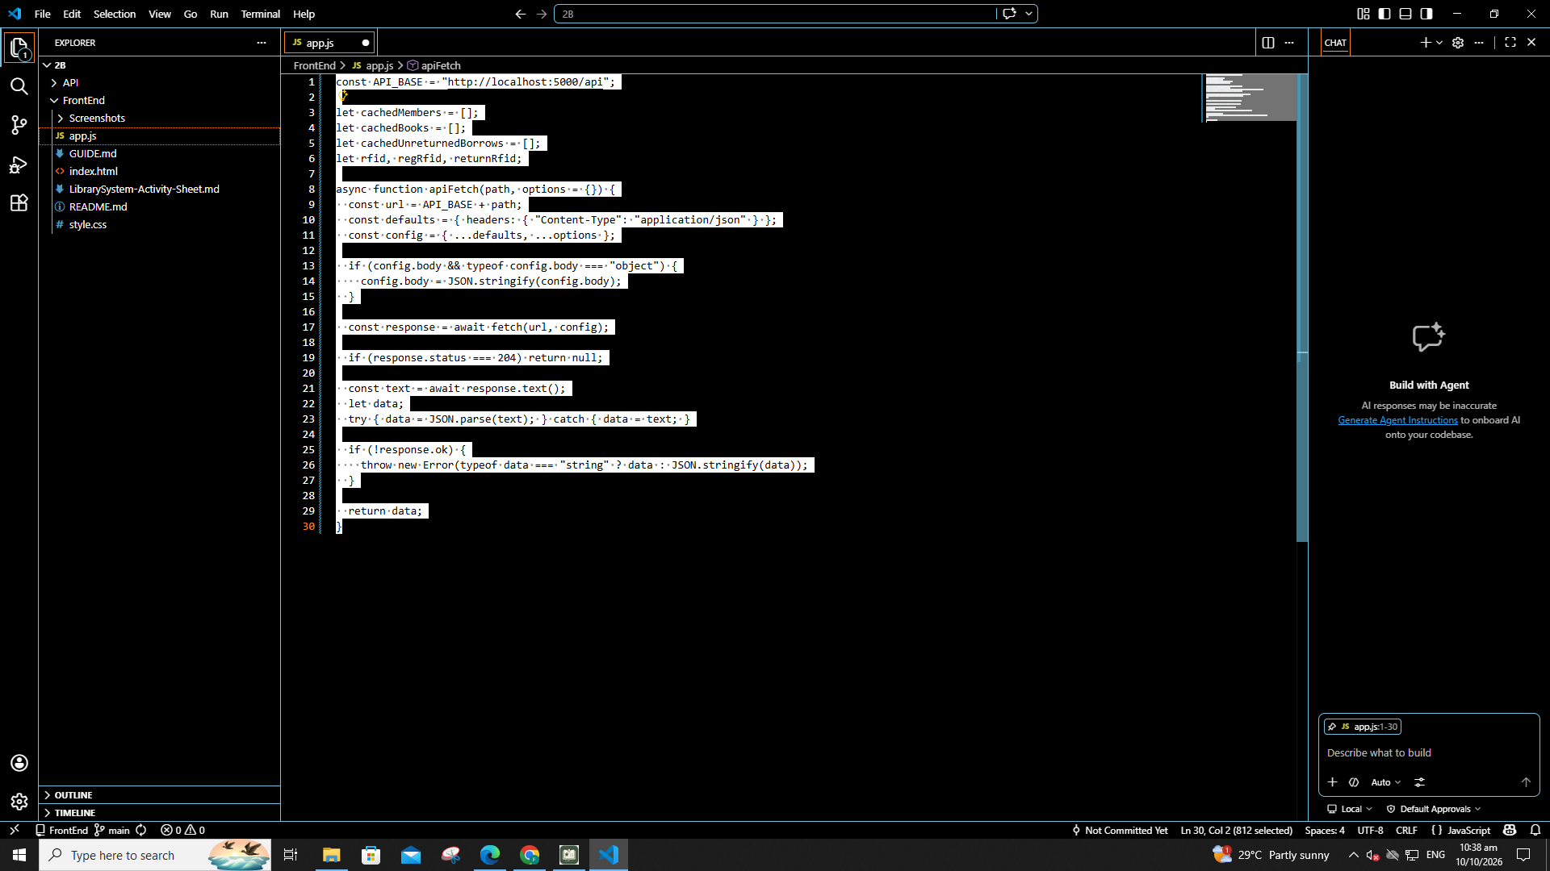
Part 2 showToast()
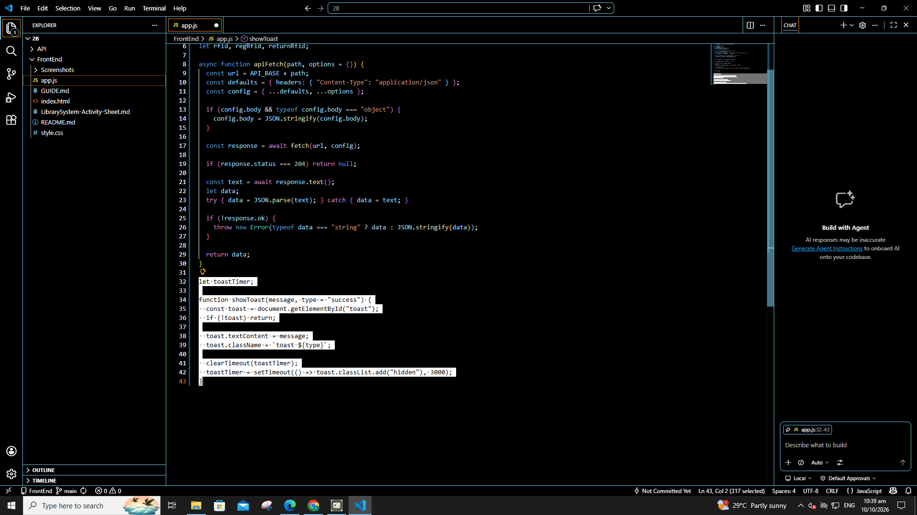

Part 3 refreshMemberCache(), refreshBookCache(), findMemberByRFID()
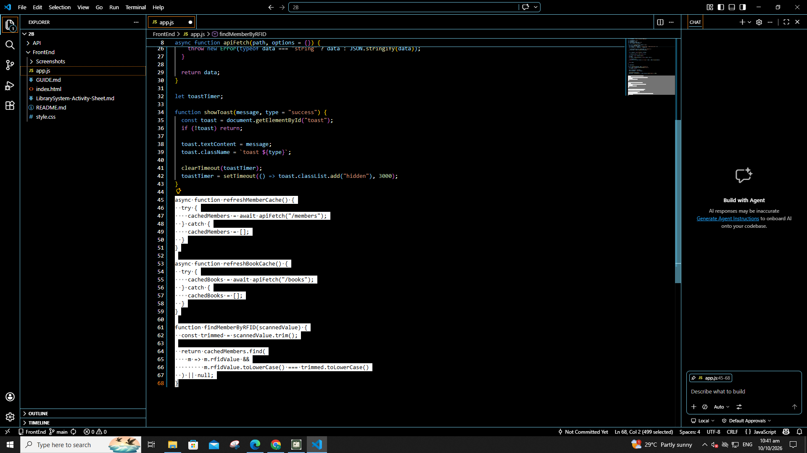
Part 4 Tab buttons and Refresh buttons
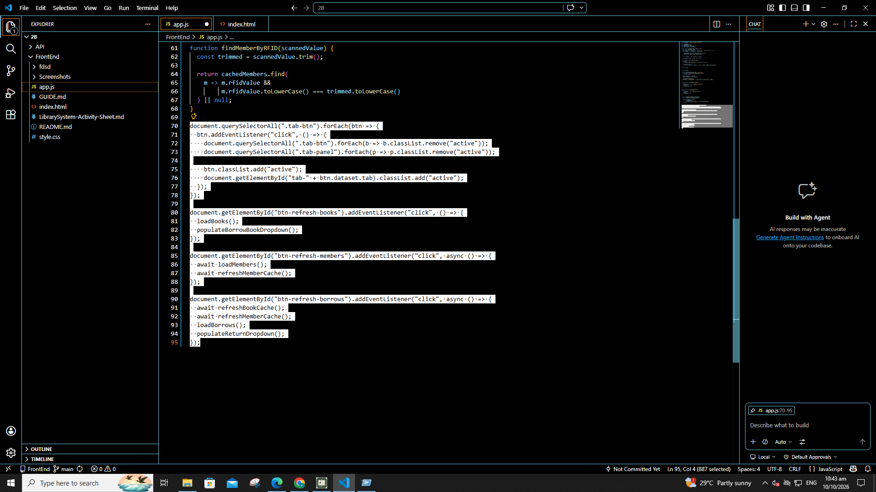

Part 5 loadBooks()
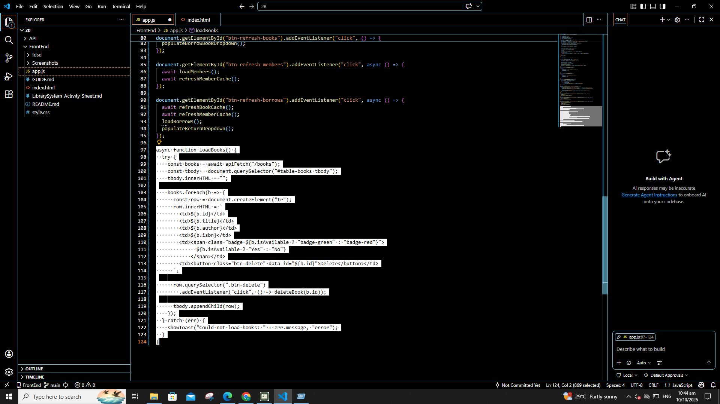
Part 6 deleteBook(id)
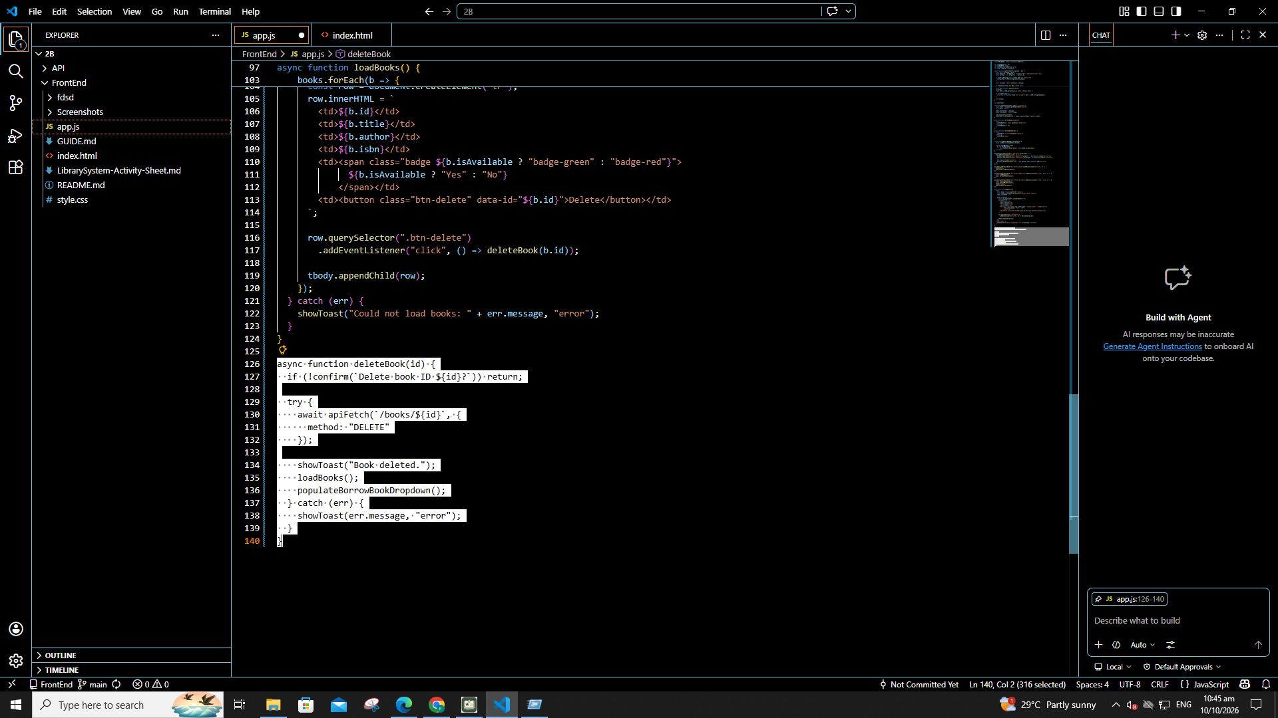

Part 7 Add Book form submit (once only)
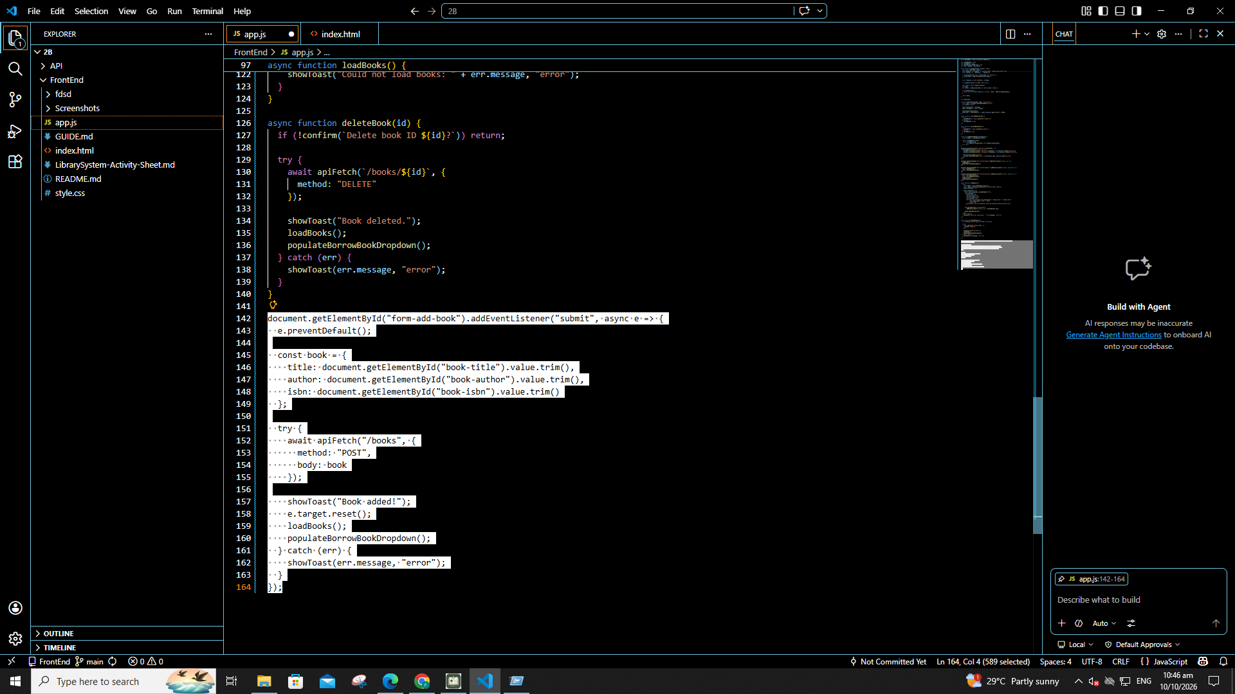
Part 8 loadMembers()
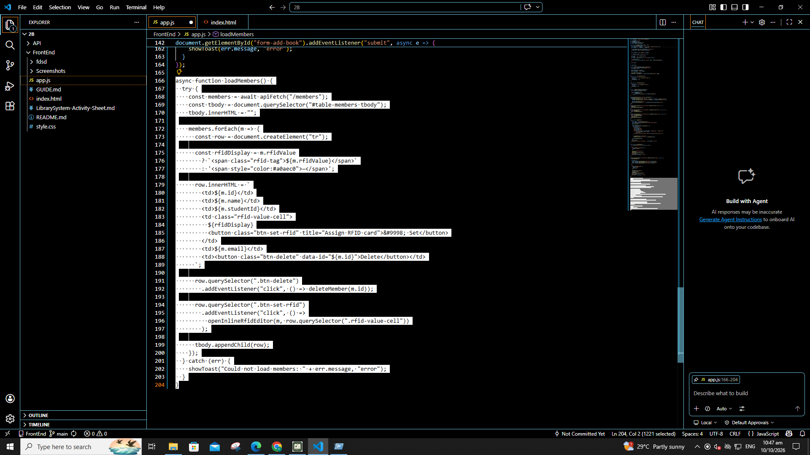

Part 9 deleteMember(id)
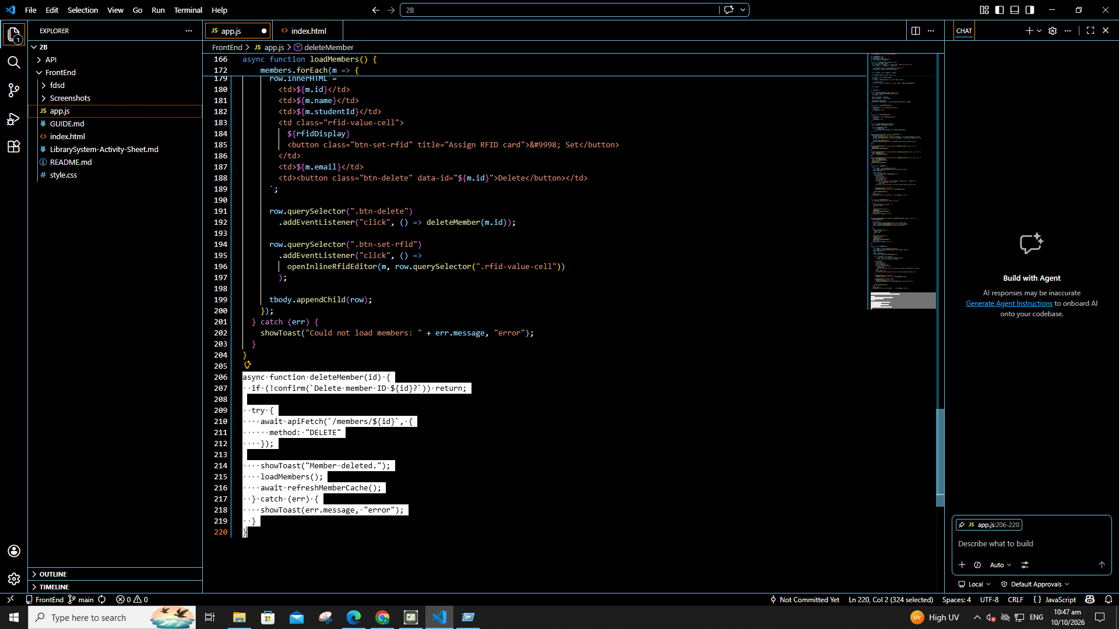
Part 10 Add Member form submit
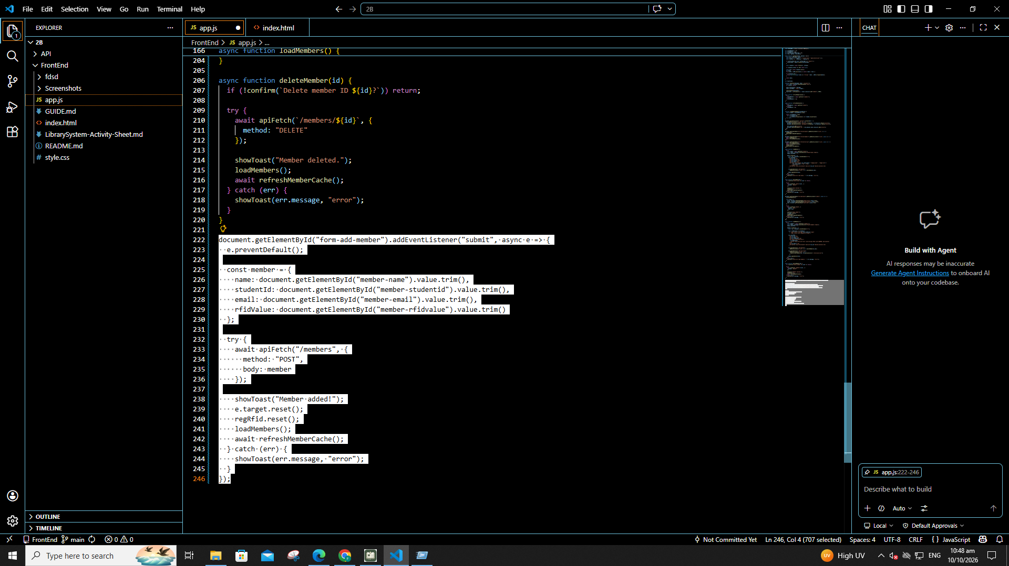

Part 11 openInlineRfidEditor() with saveRfid() inside
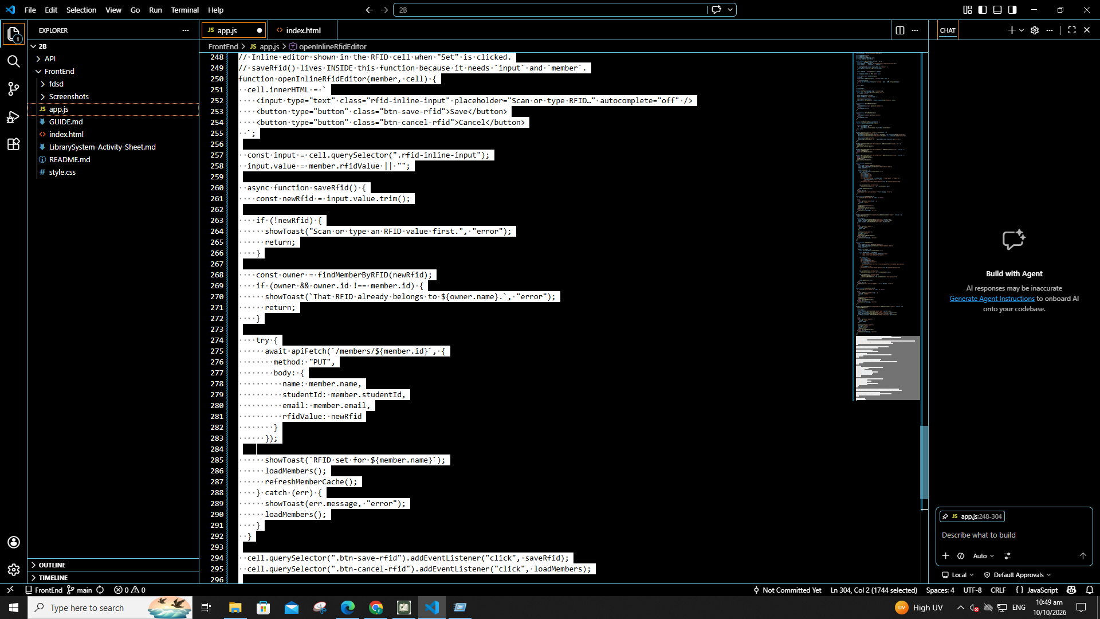
Part 12 createRfidWidget(), initRFID(), initRegRFID(), initReturnRFID()
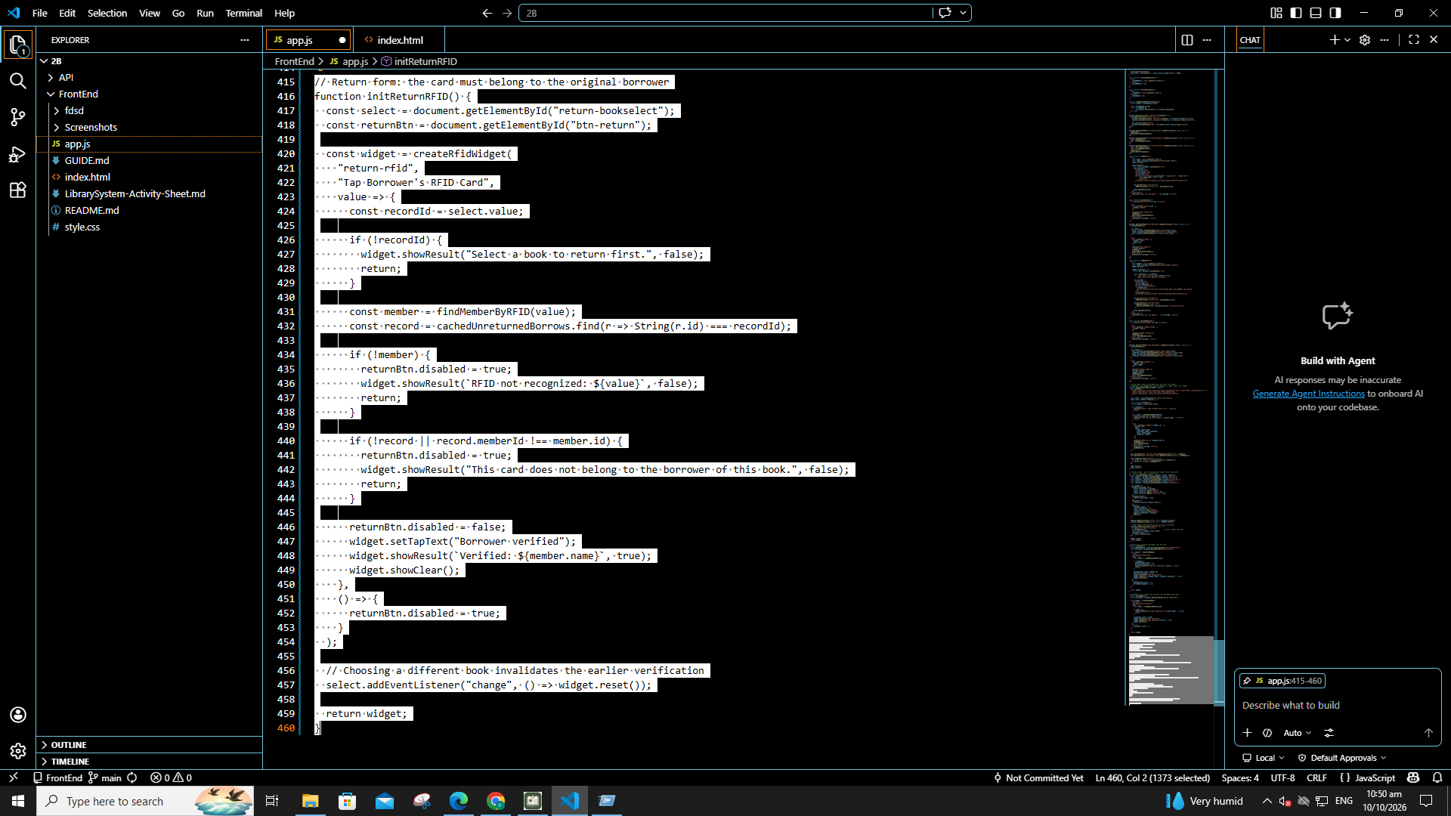

Part 13 populateBorrowBookDropdown()
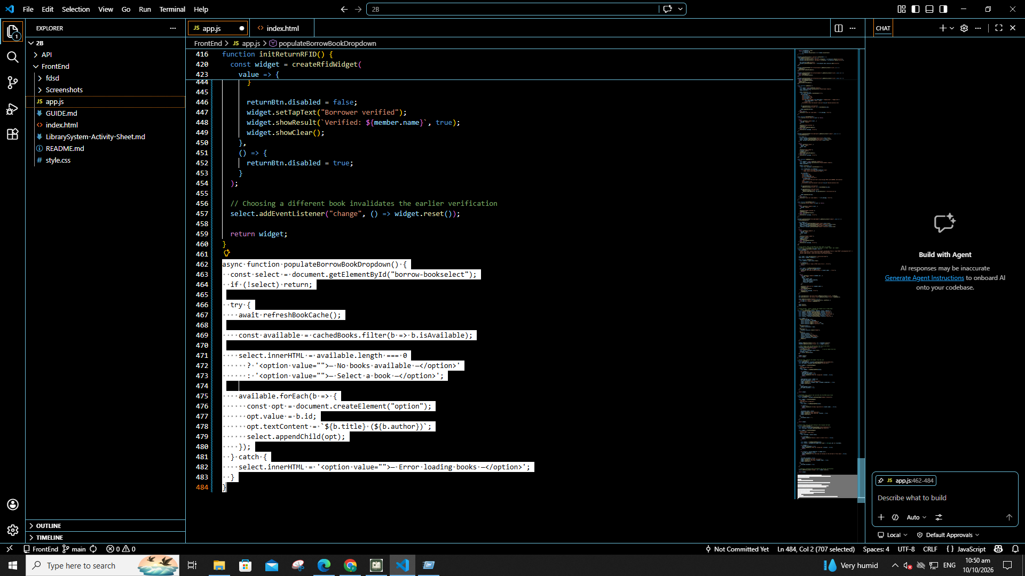
Part 14 populateReturnDropdown()
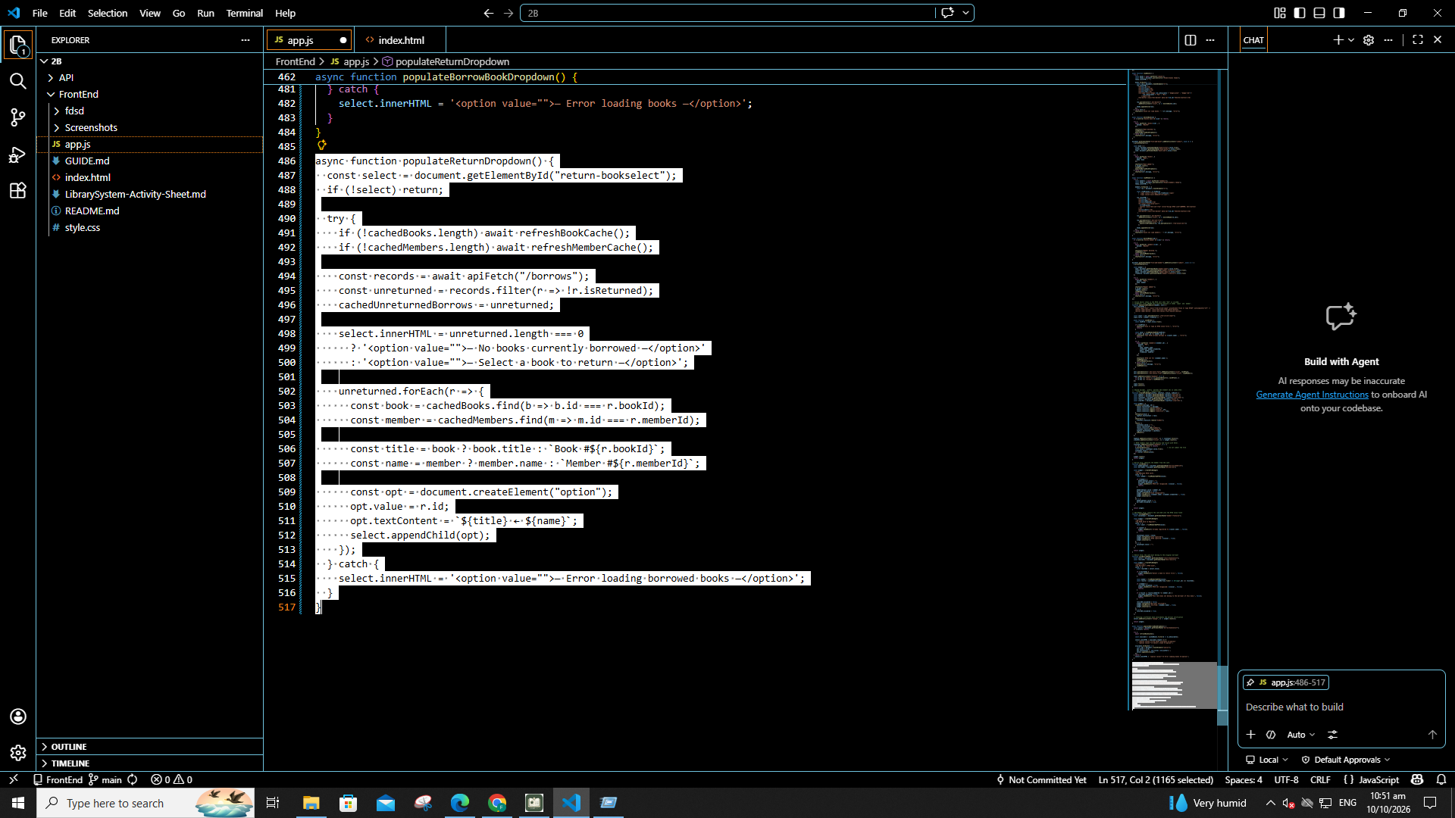

Part 15 Borrow form submit (once only)
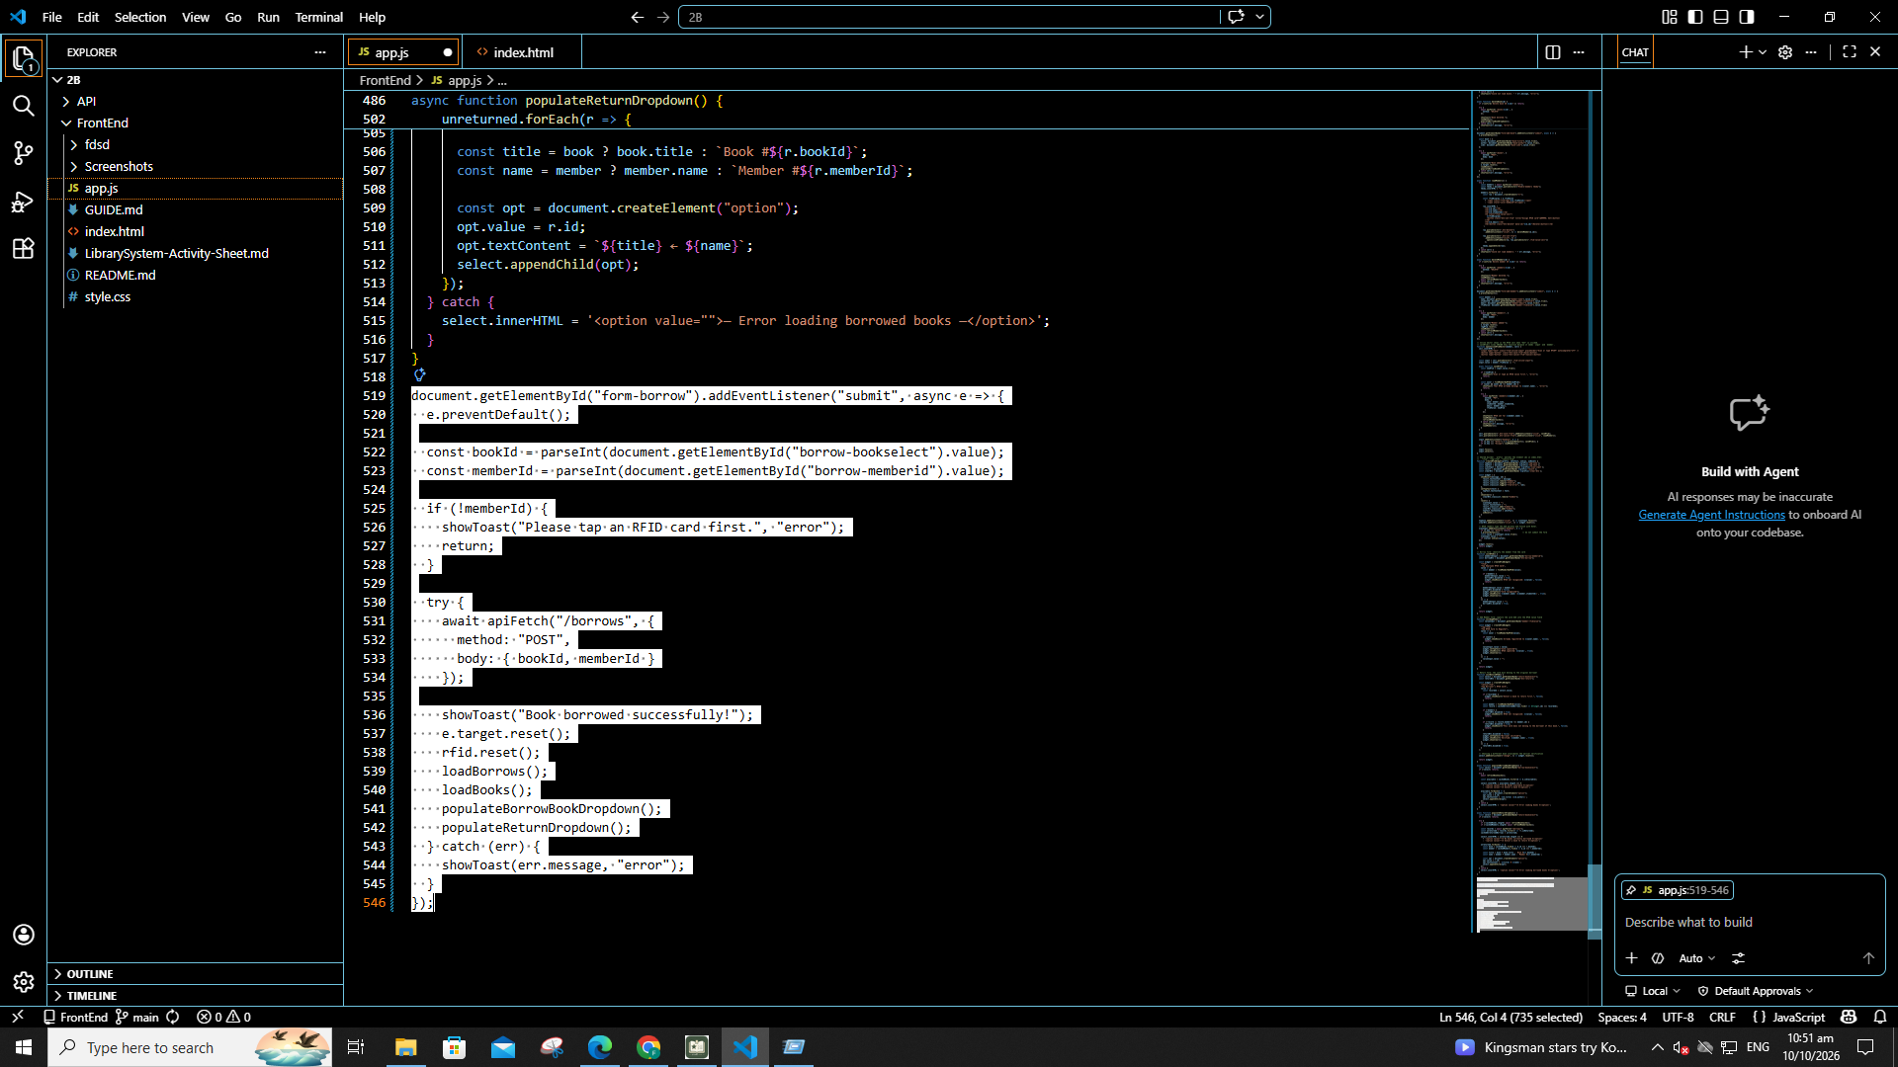
Part 16 Return form submit (do not skip)
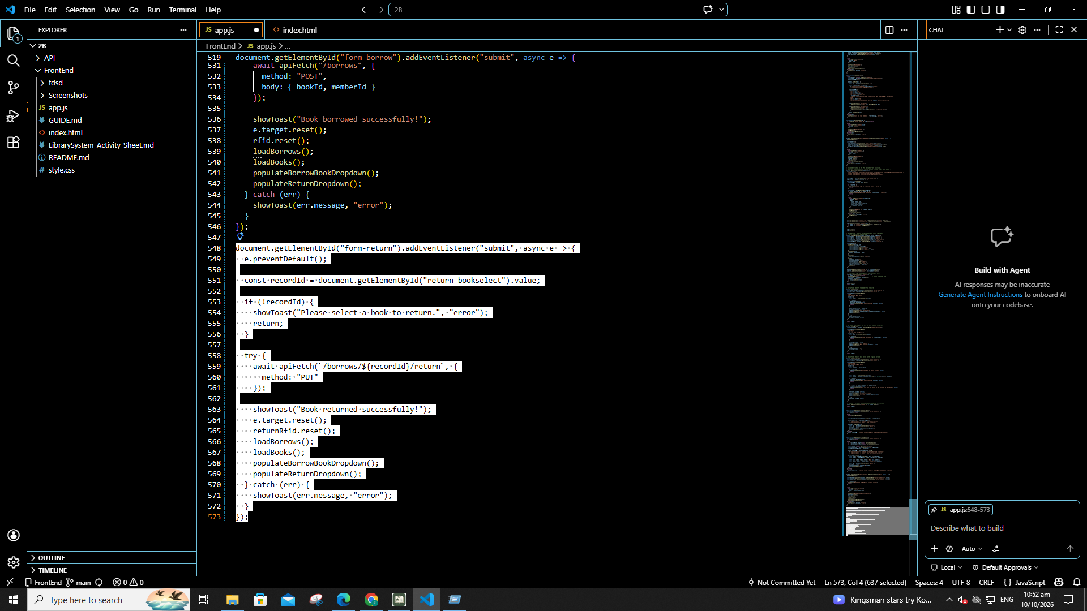

Part 17 loadBorrows()
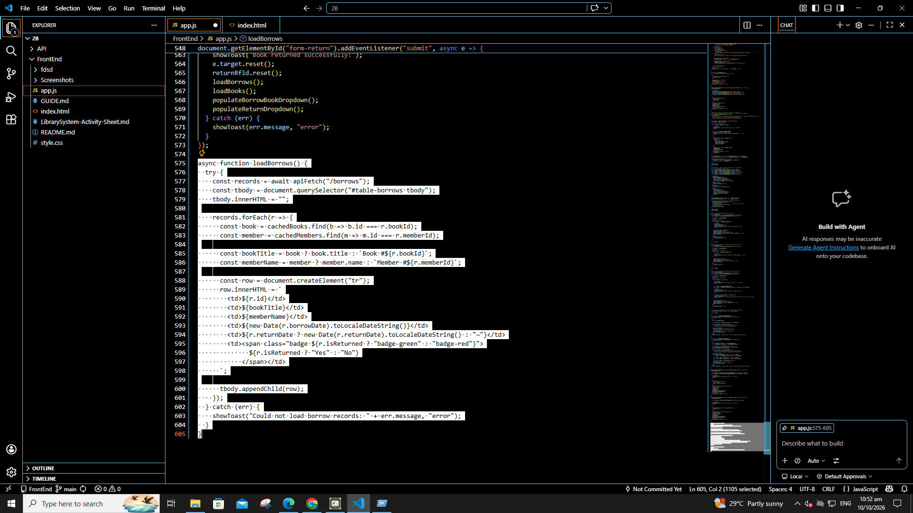
Part 18 Initial page load (last)
Removed the rfid.js script tag from index.html
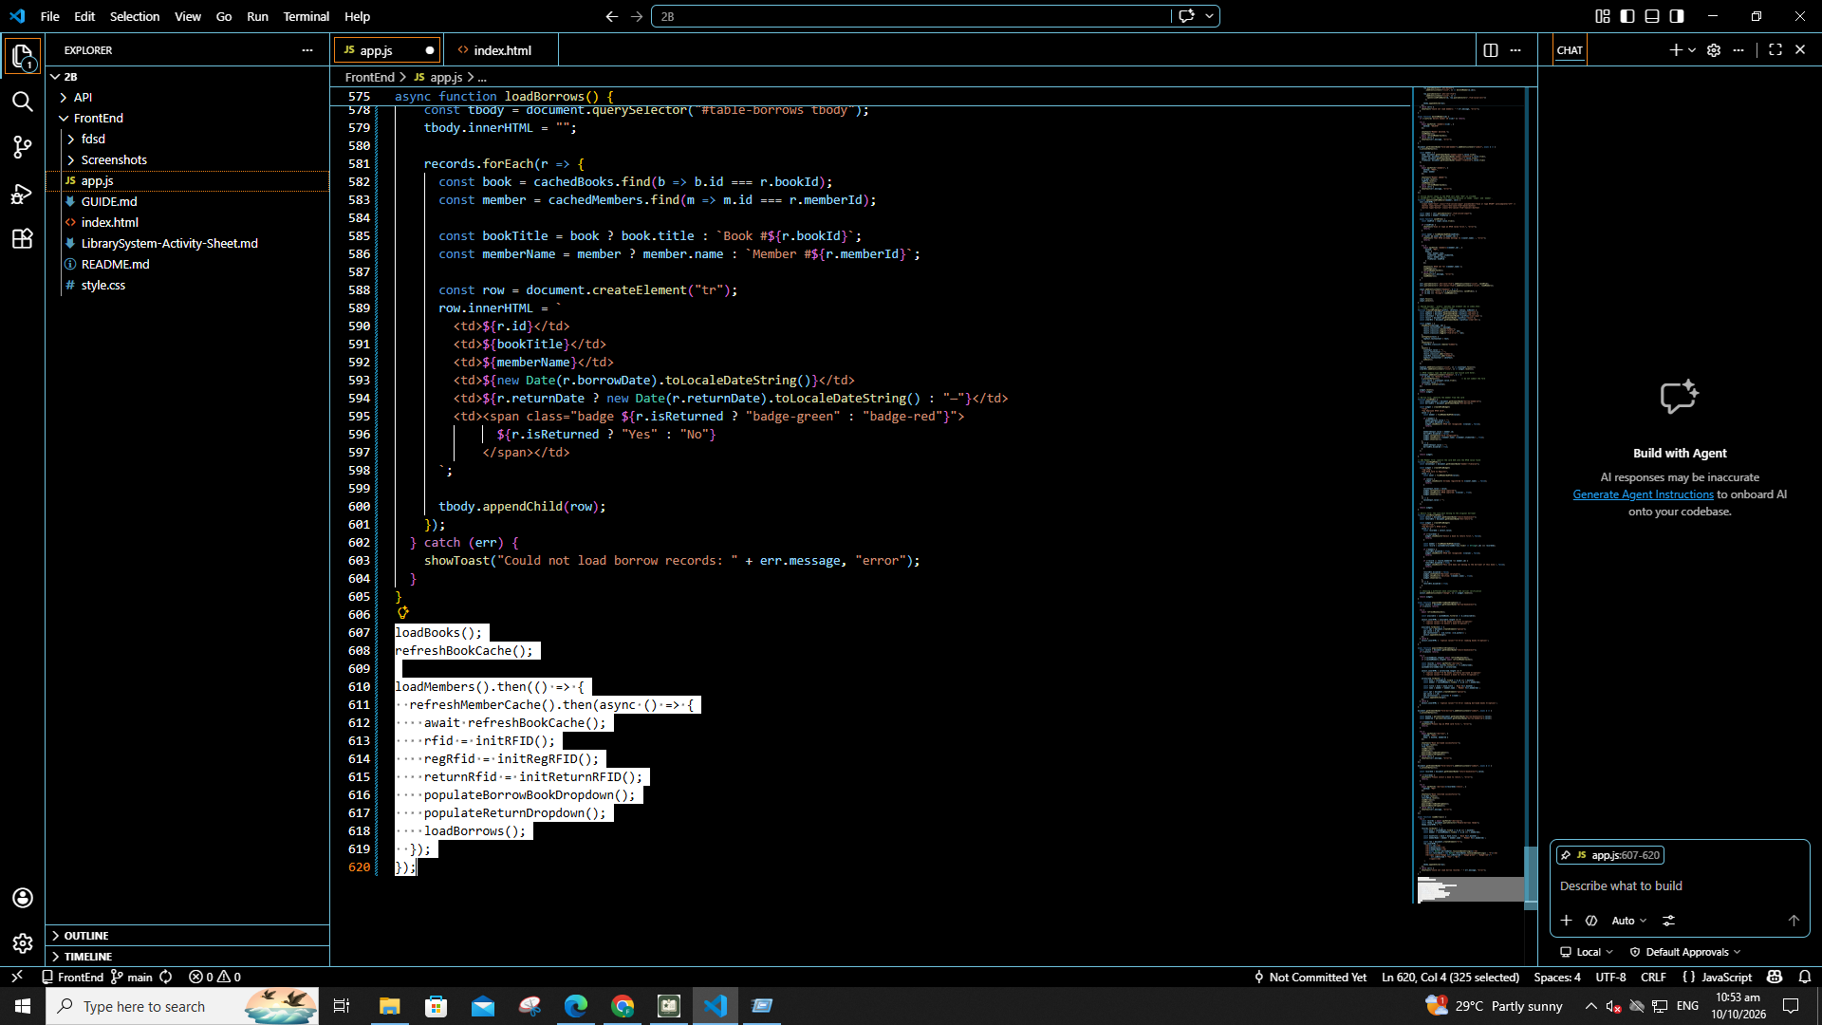

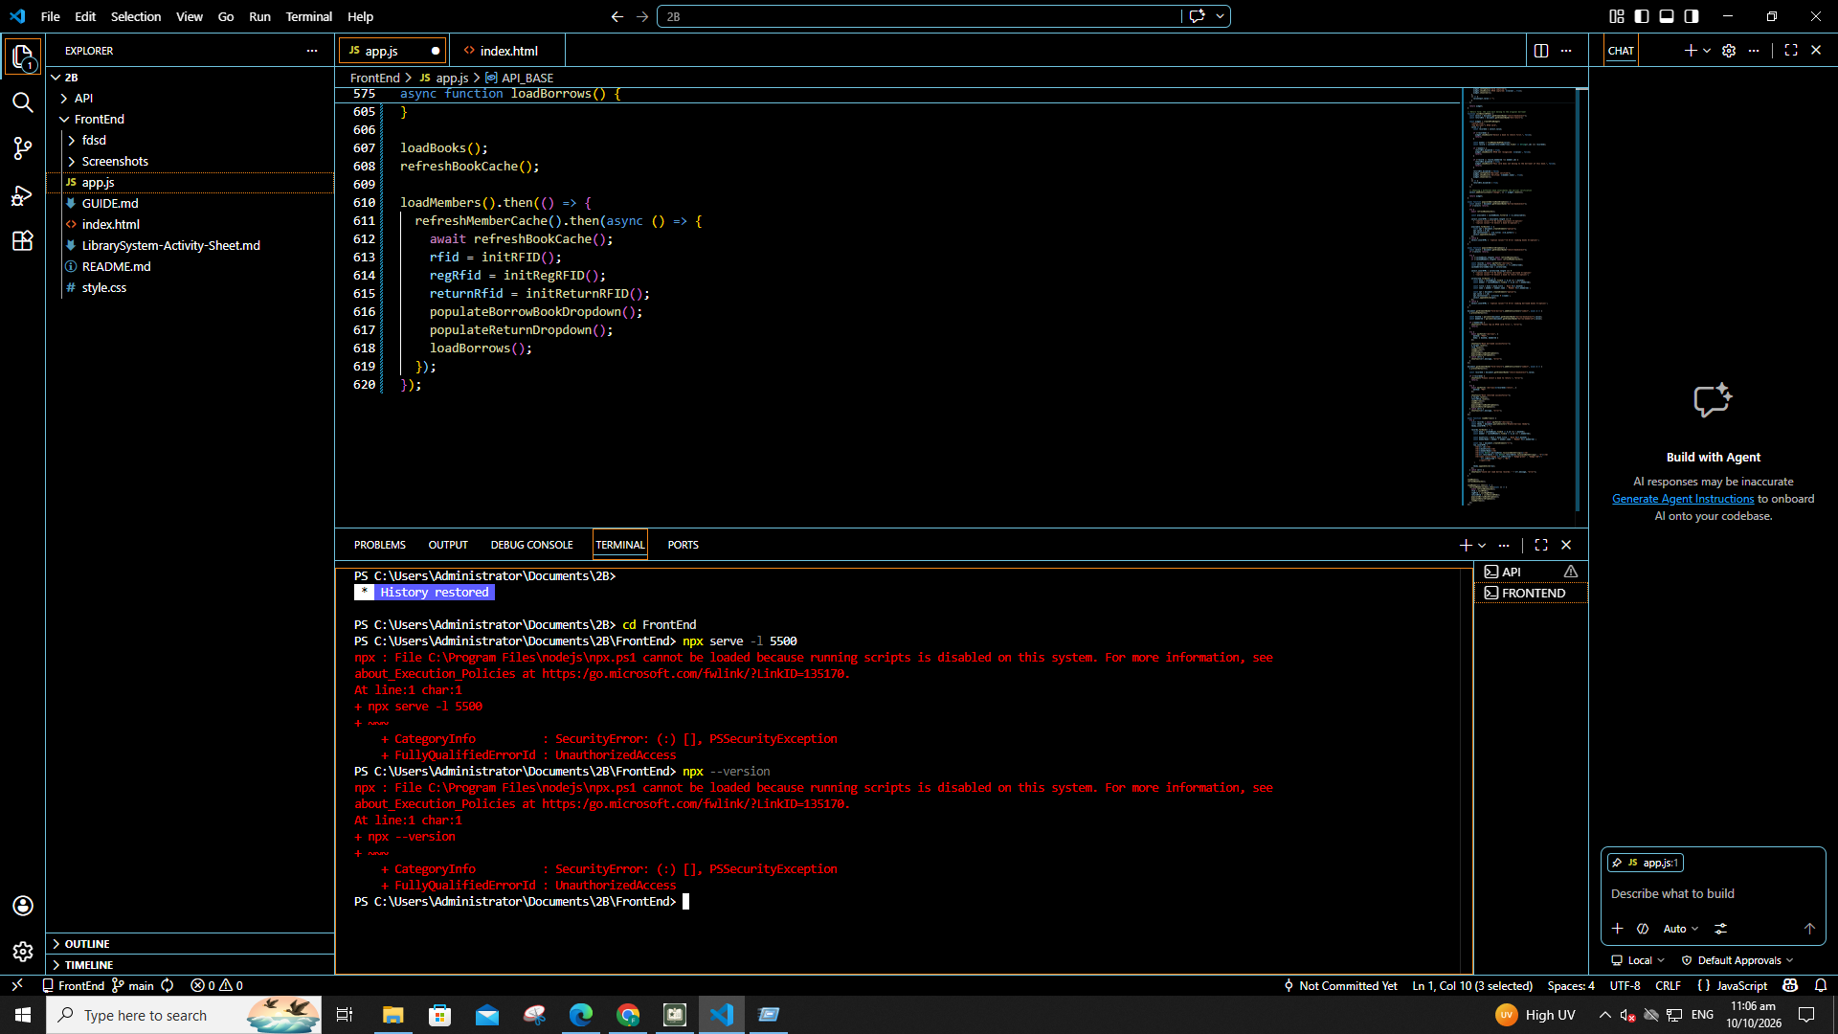
1. Start the API

2. Open the FrontEnd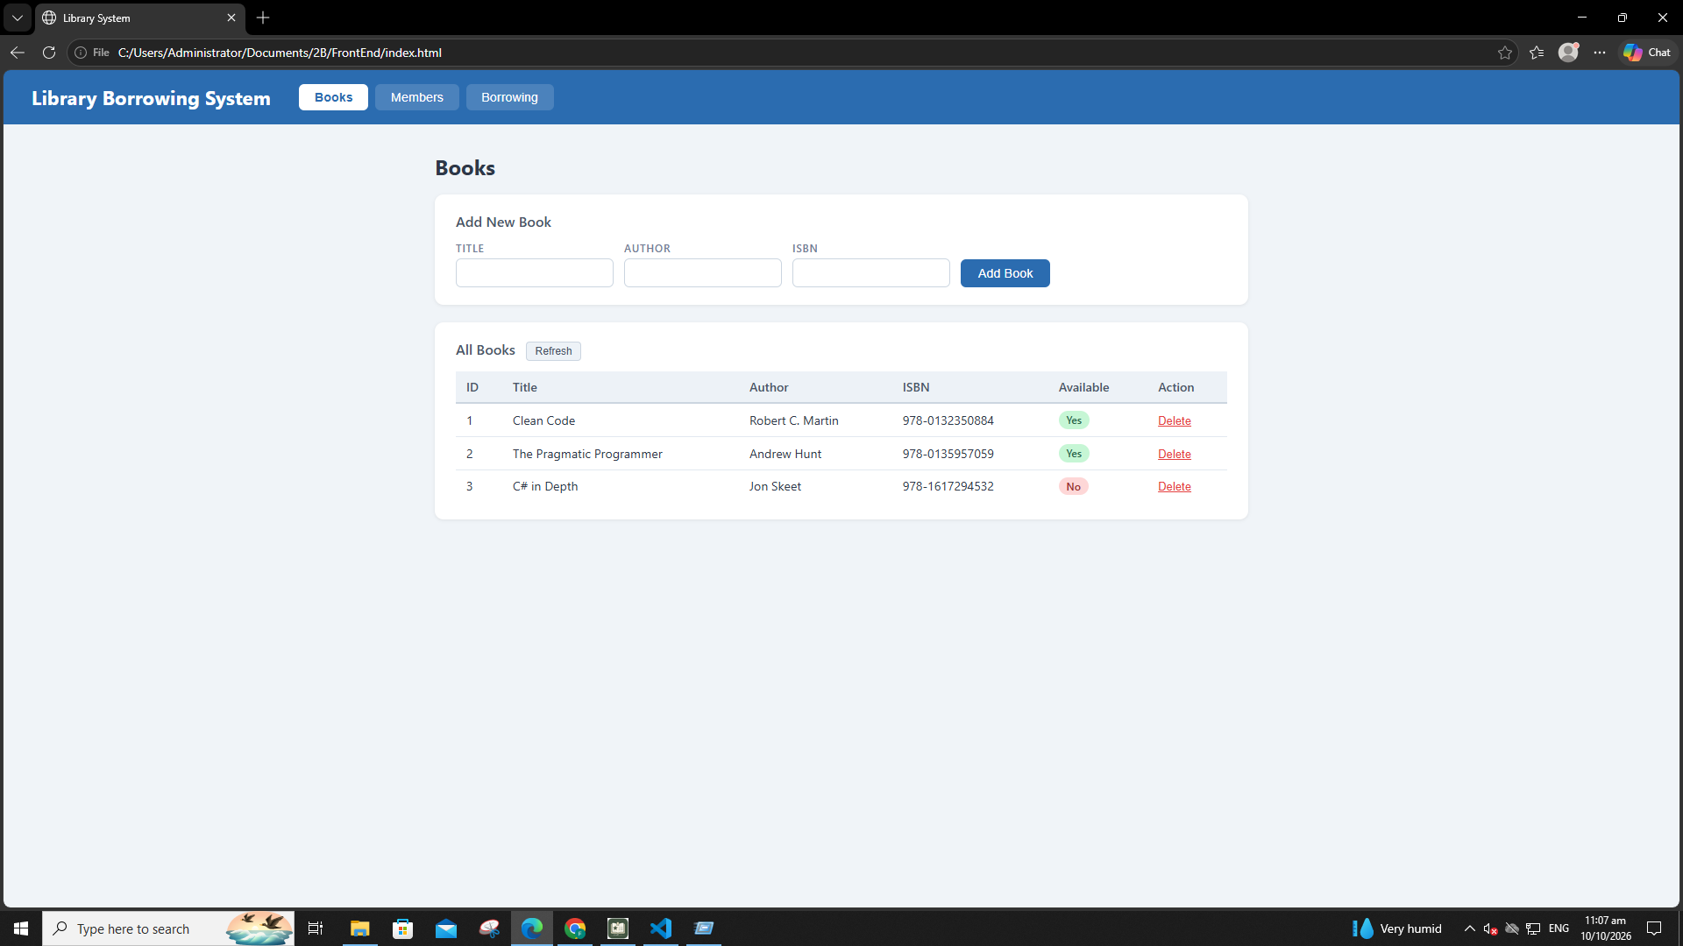

3. Test the Tabs
DONE!

4. Test Books
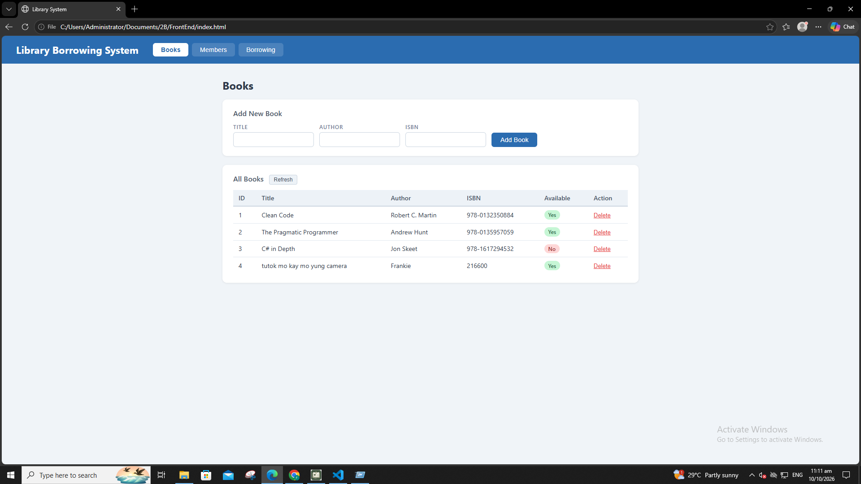
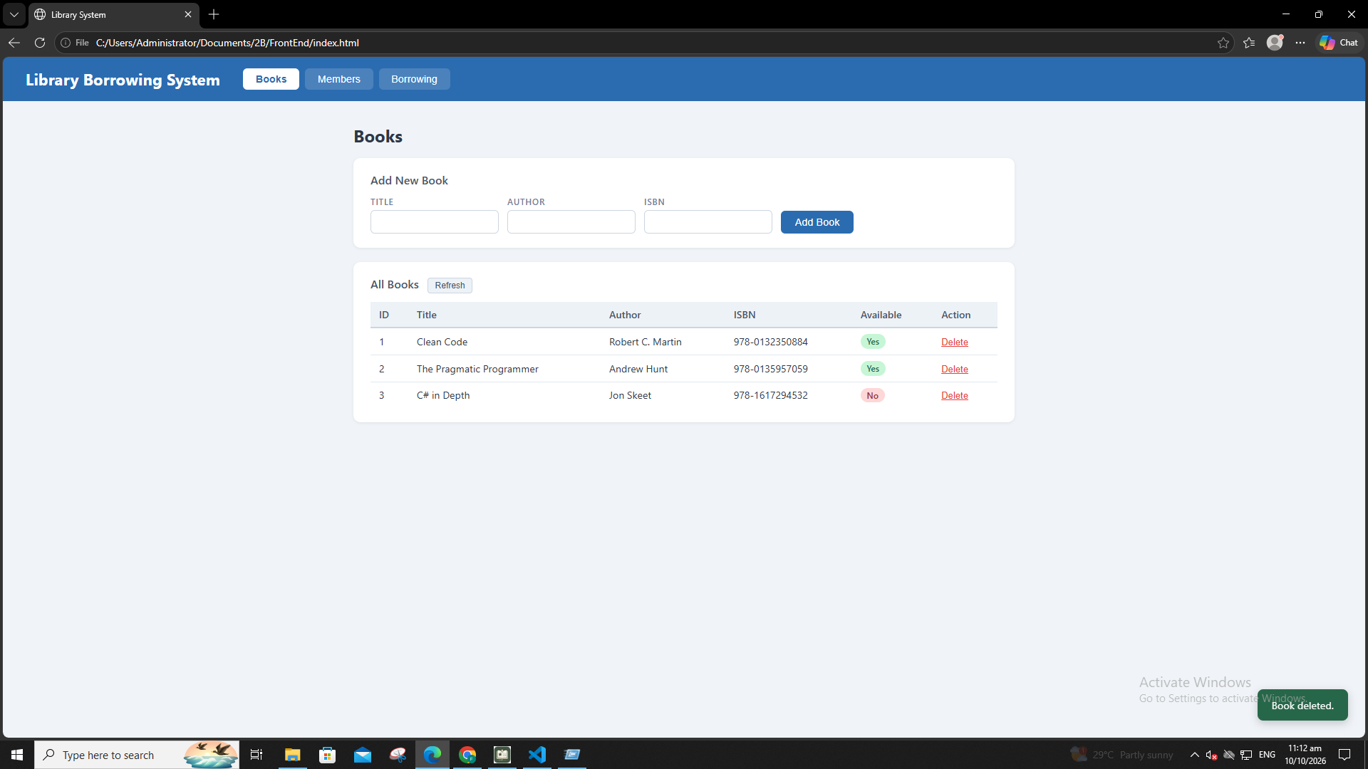
5. Test Members
test-04-members-loaded
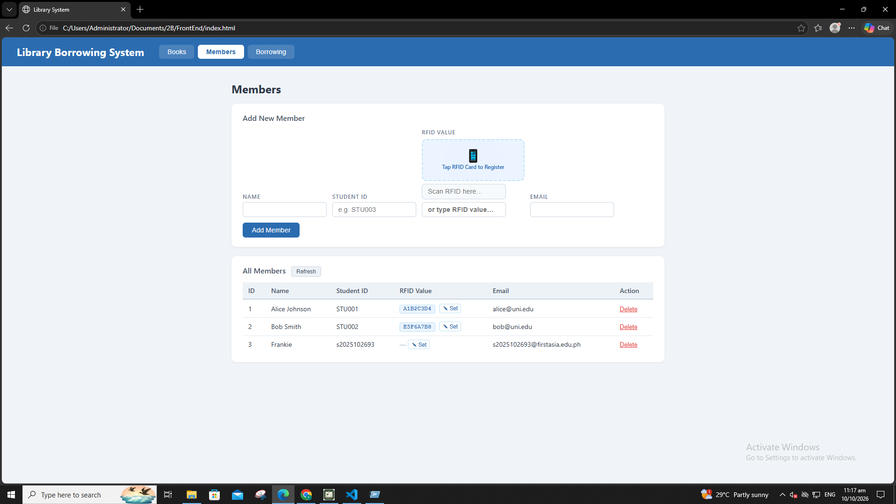
test-05-register-rfid
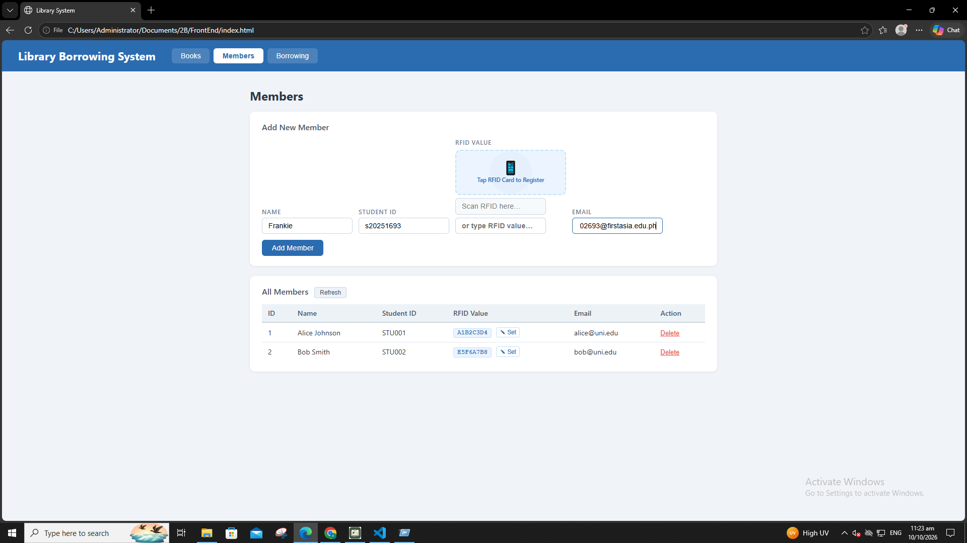

test-06-add-member
test-07-set-rfid-saved

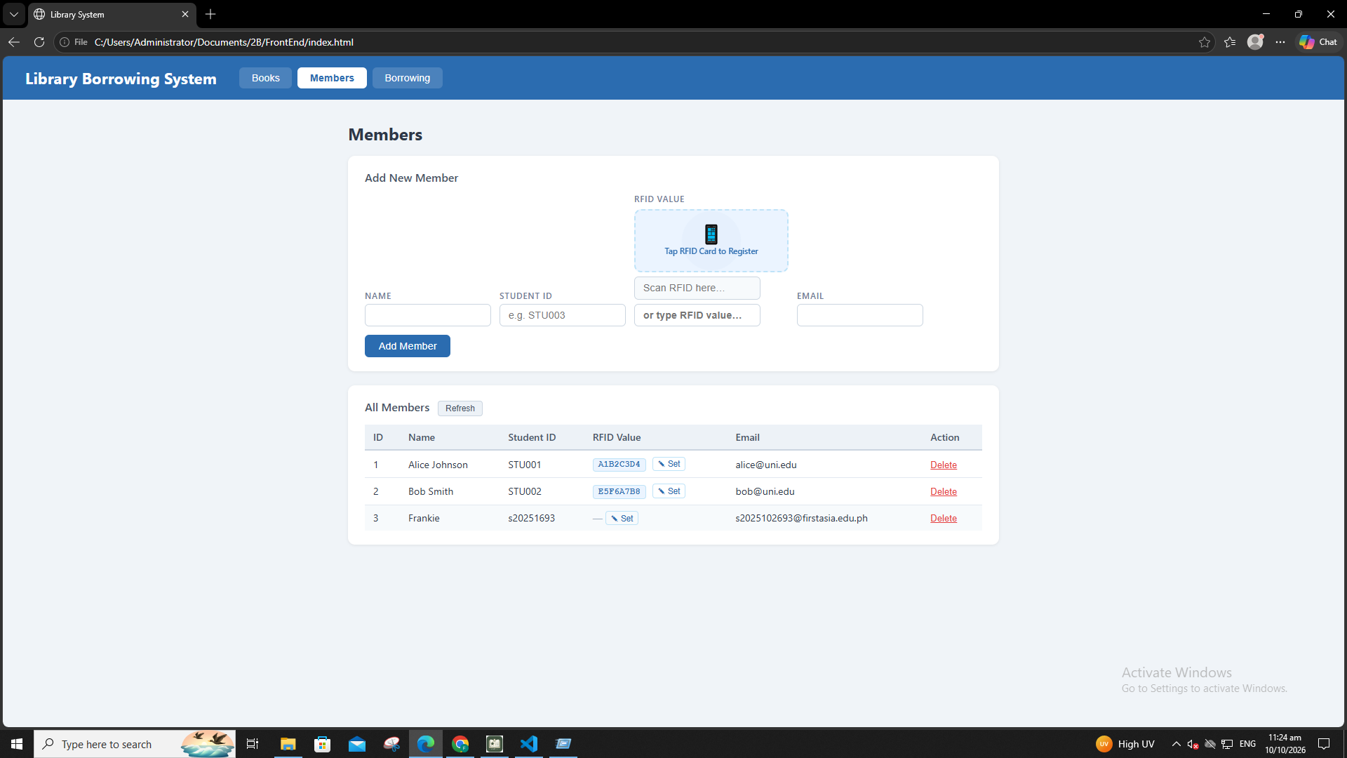
test-08-delete-member
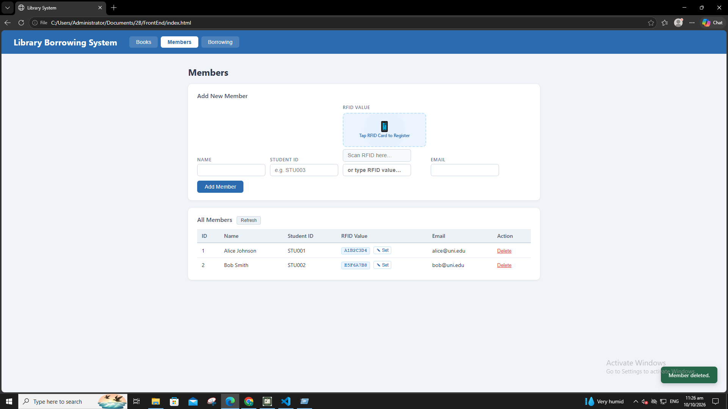

6. Test Borowwing
test-09-borrow-rfid-recognized
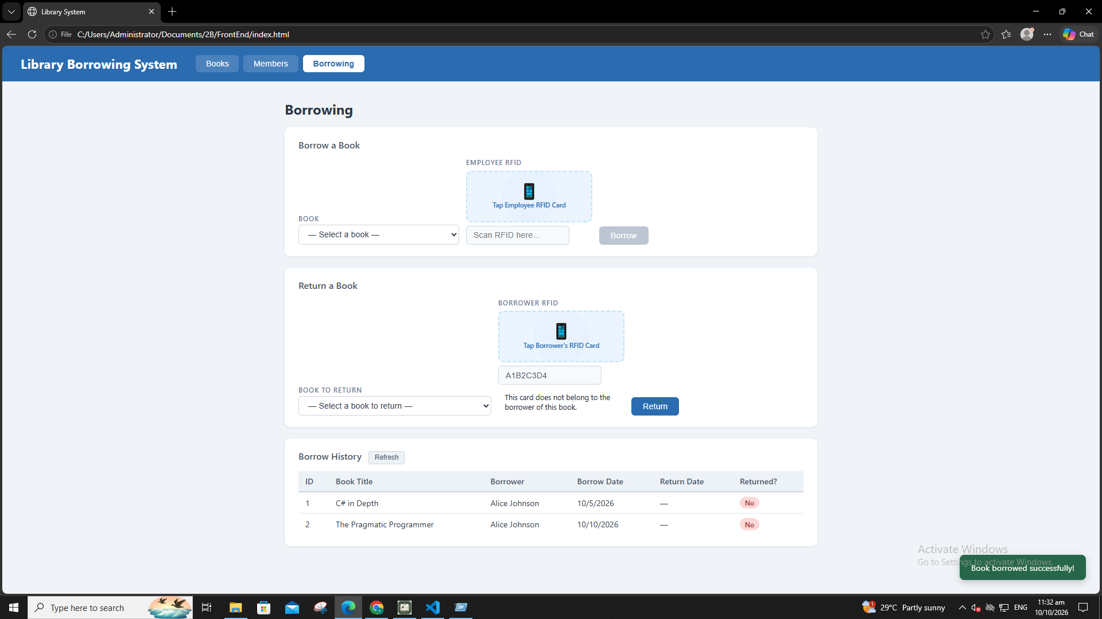
test-10-borrow-success

7. Test Returnig
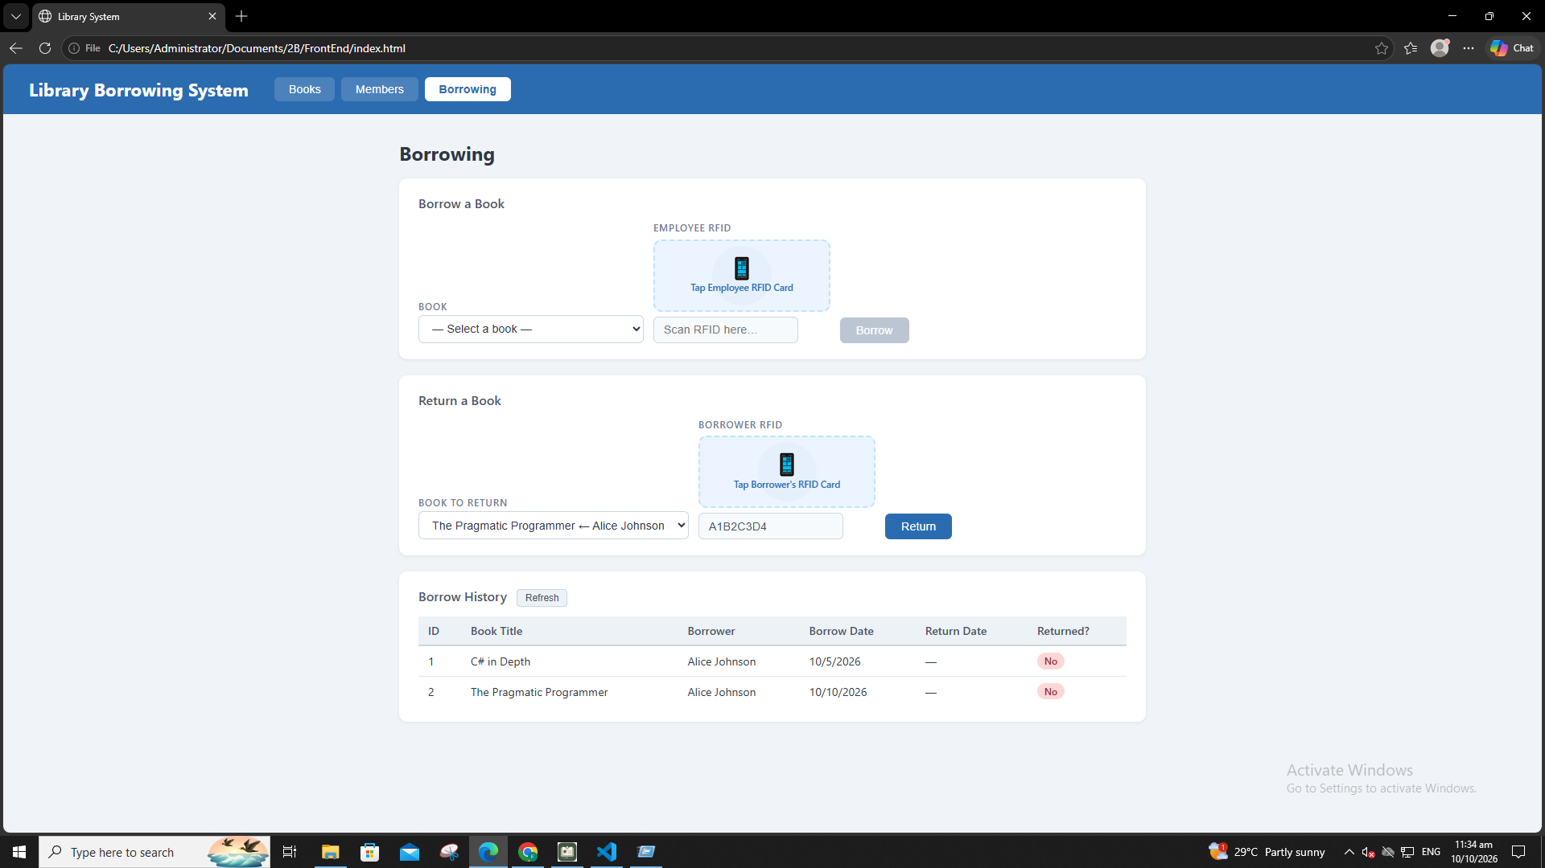
test-11-return-wrong-card
test-12-return-verified
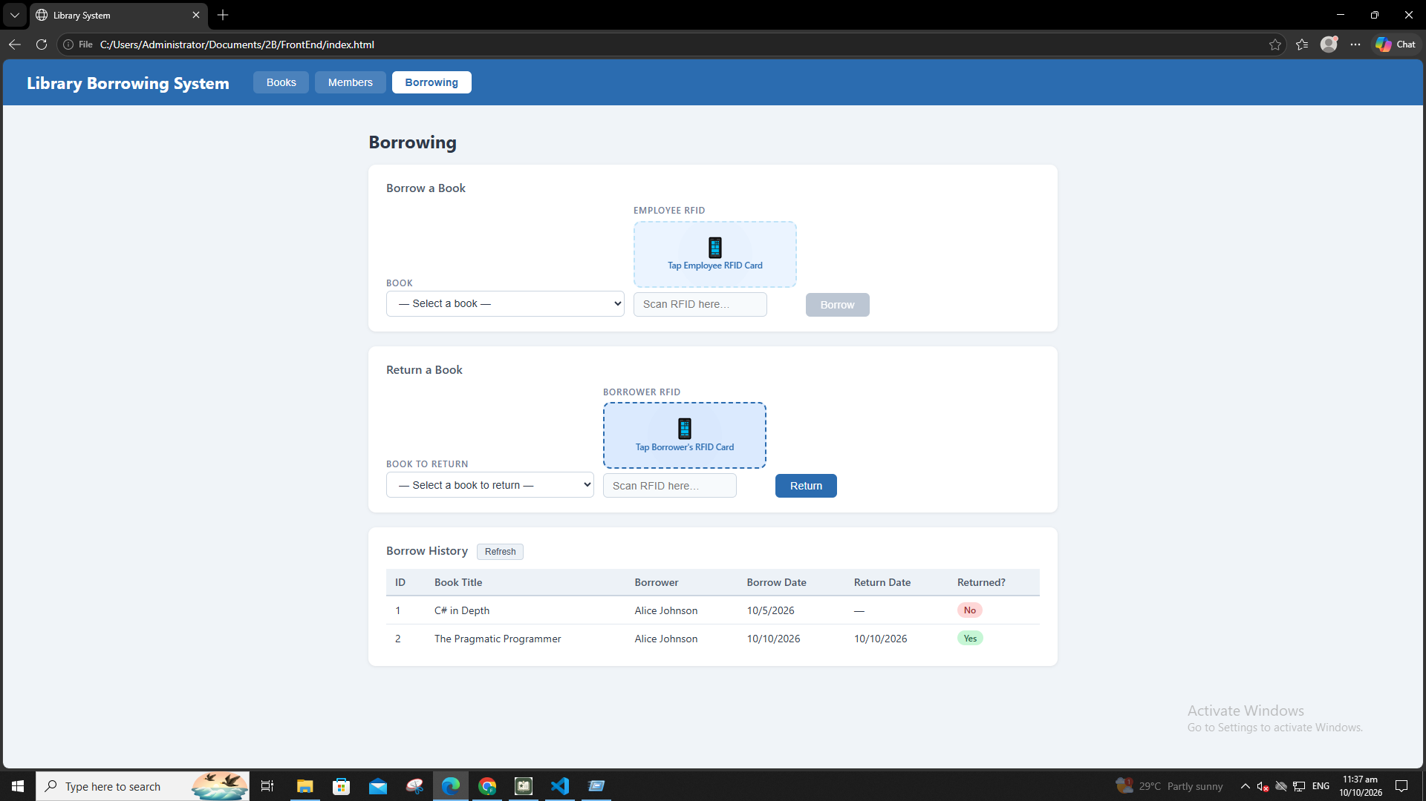

8. Final Console Check
test-14-final-console
