setup-01-api-running
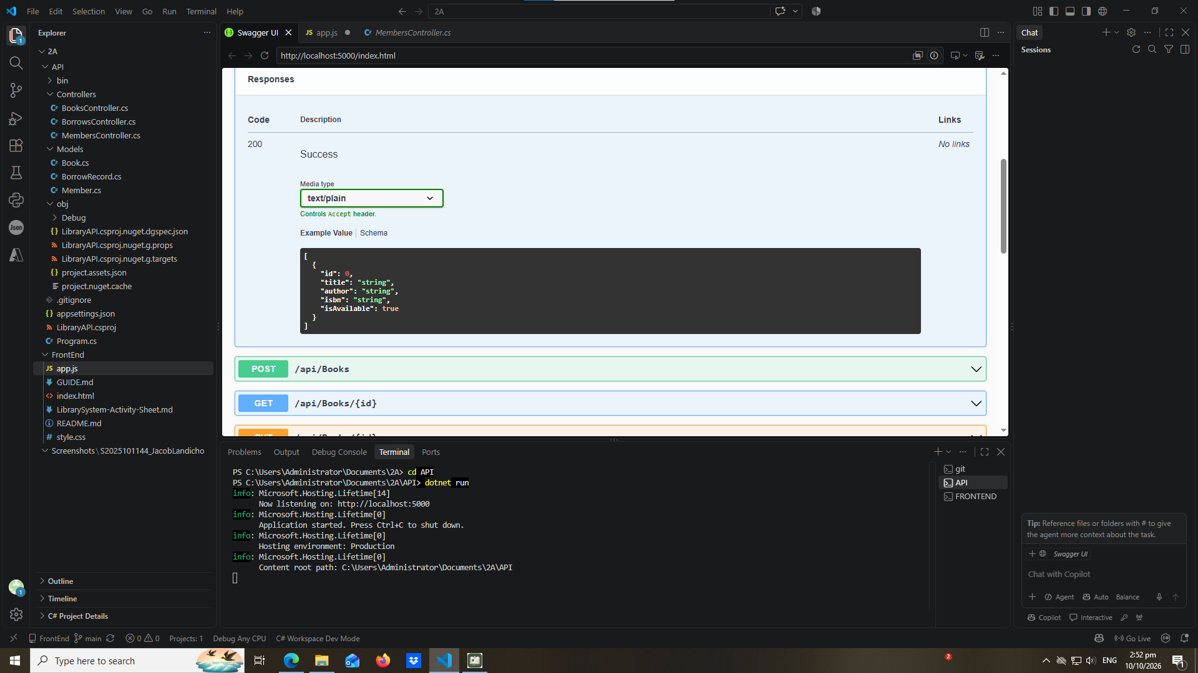
early-01-toast
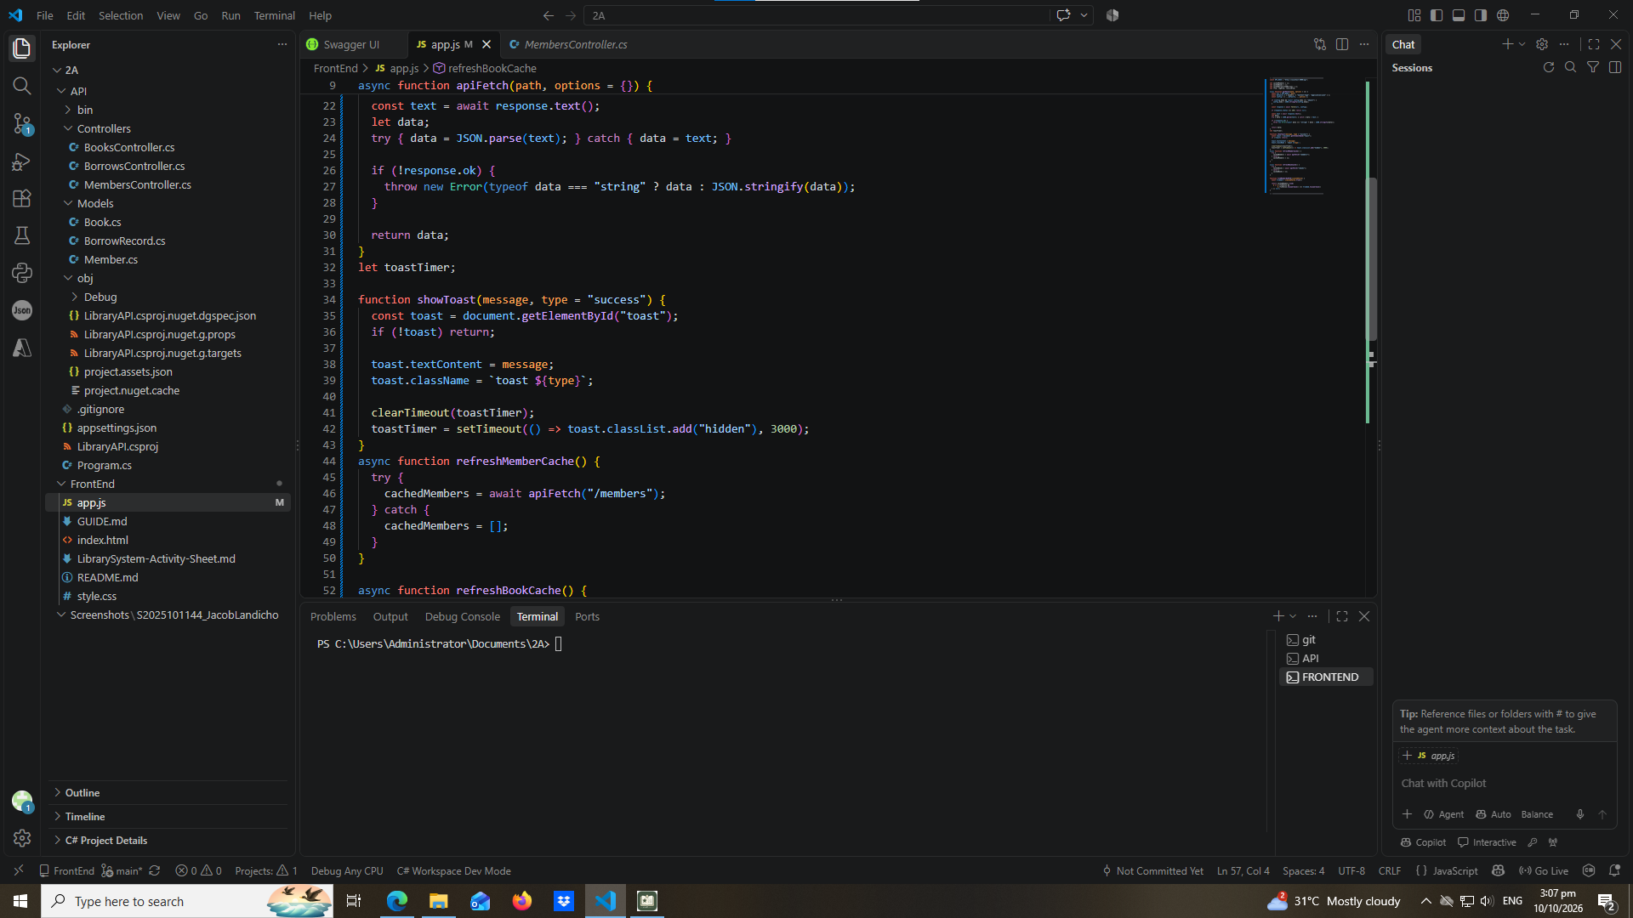

part-02-showtoast
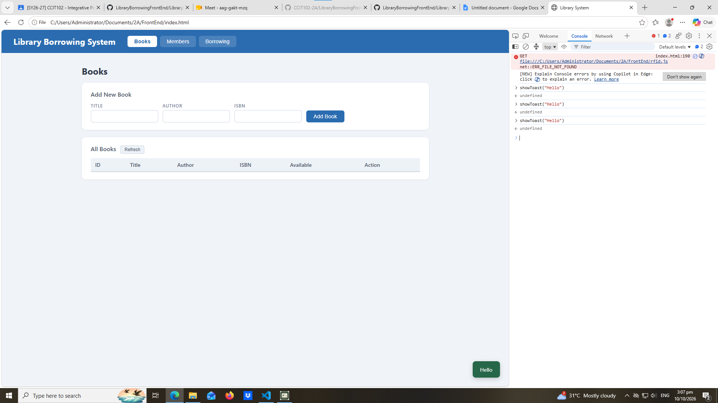

early-02-cache-console
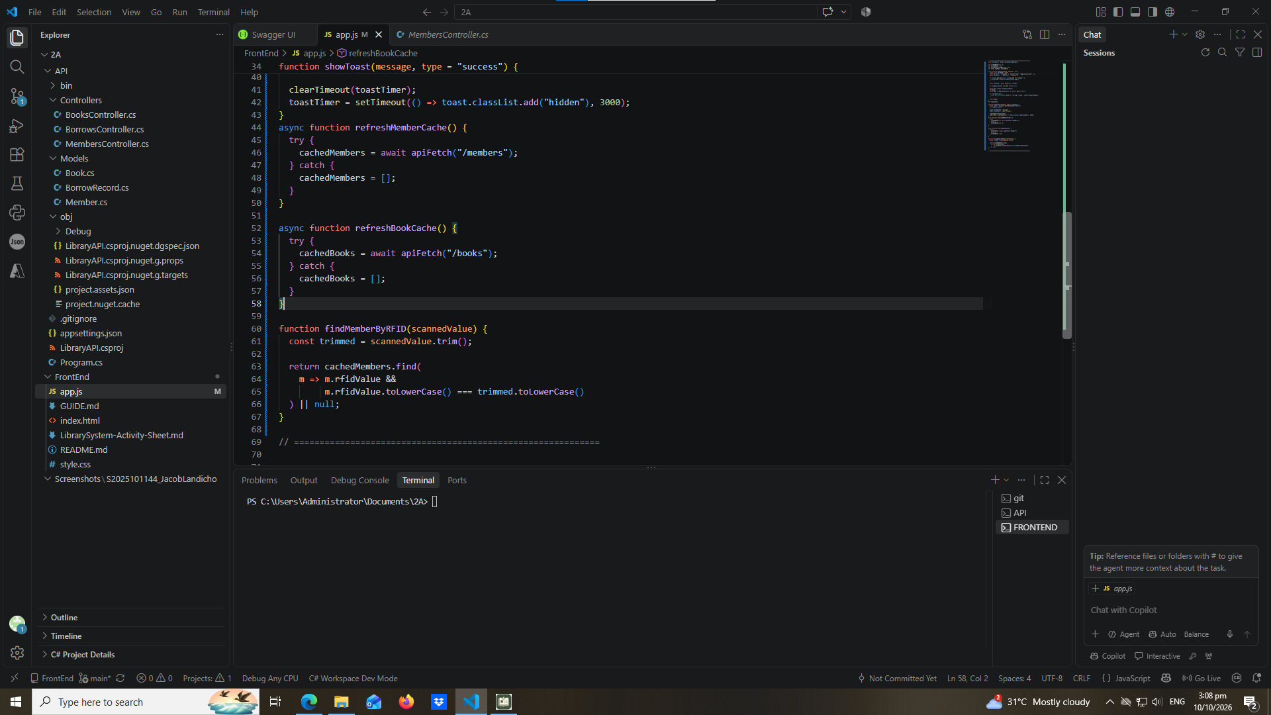

part-03-caches
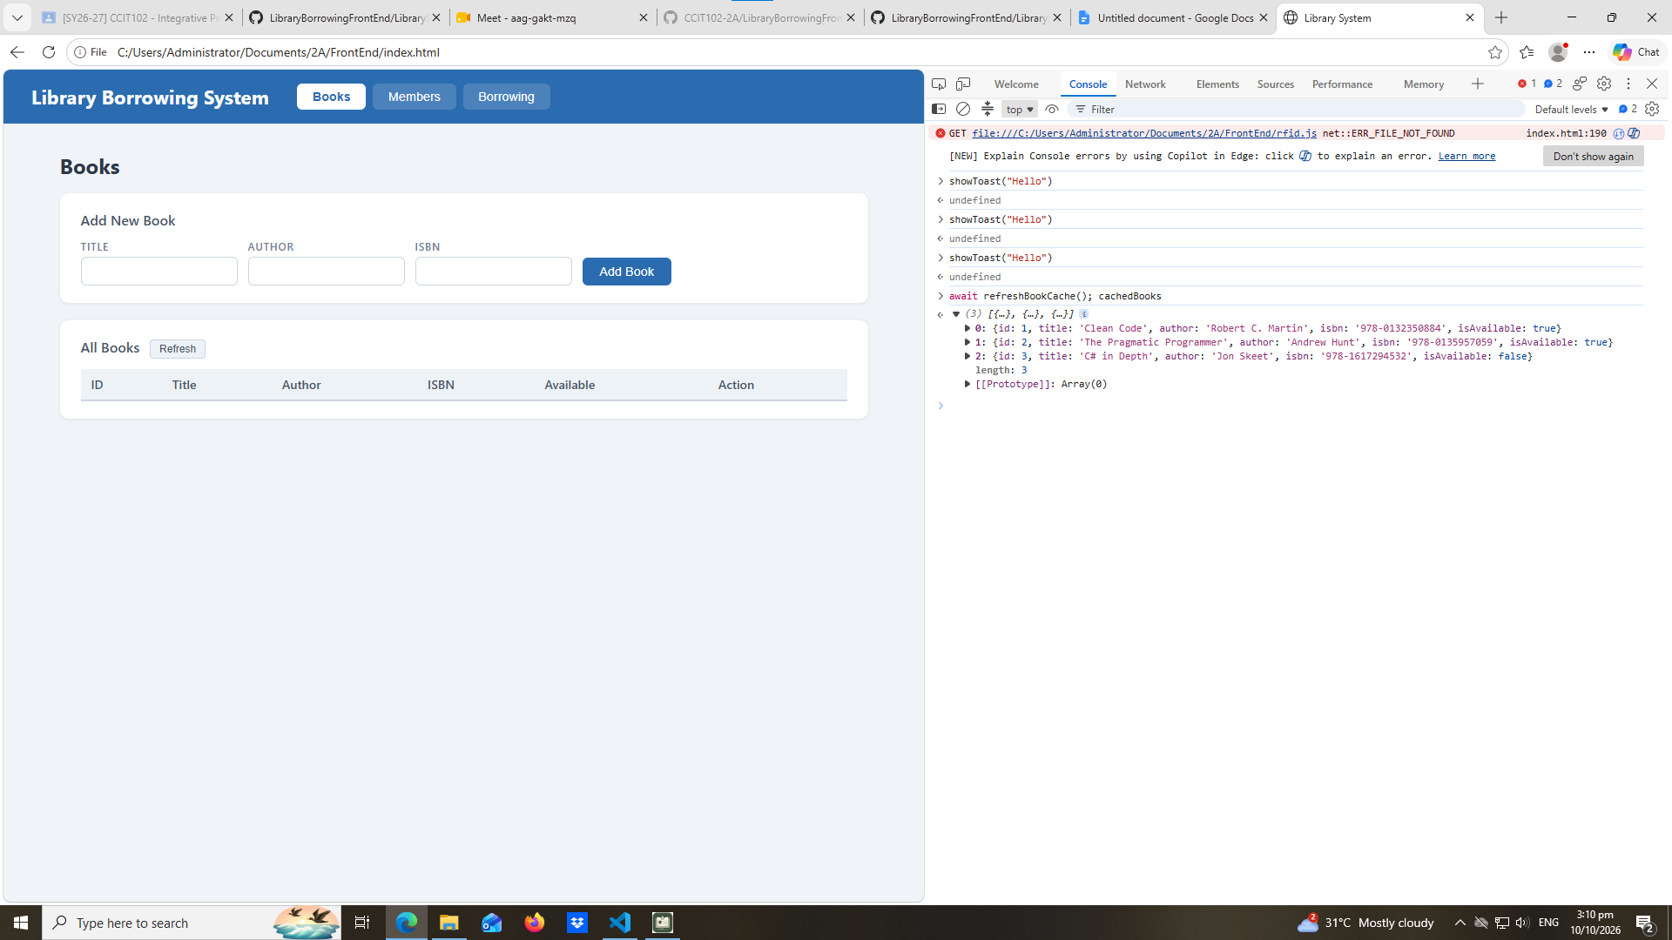

early-03-tabs
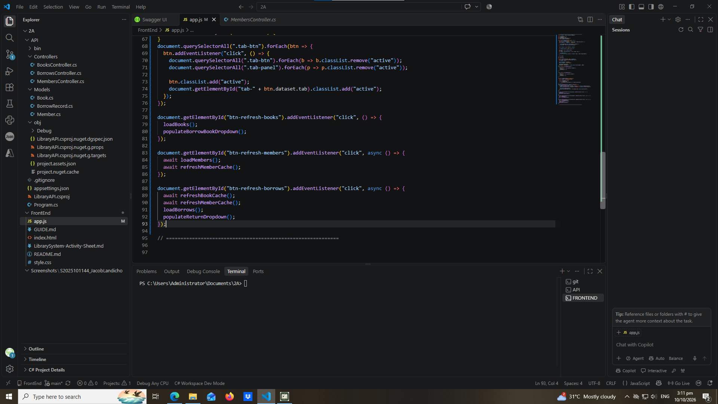

part-04-tabs-refresh
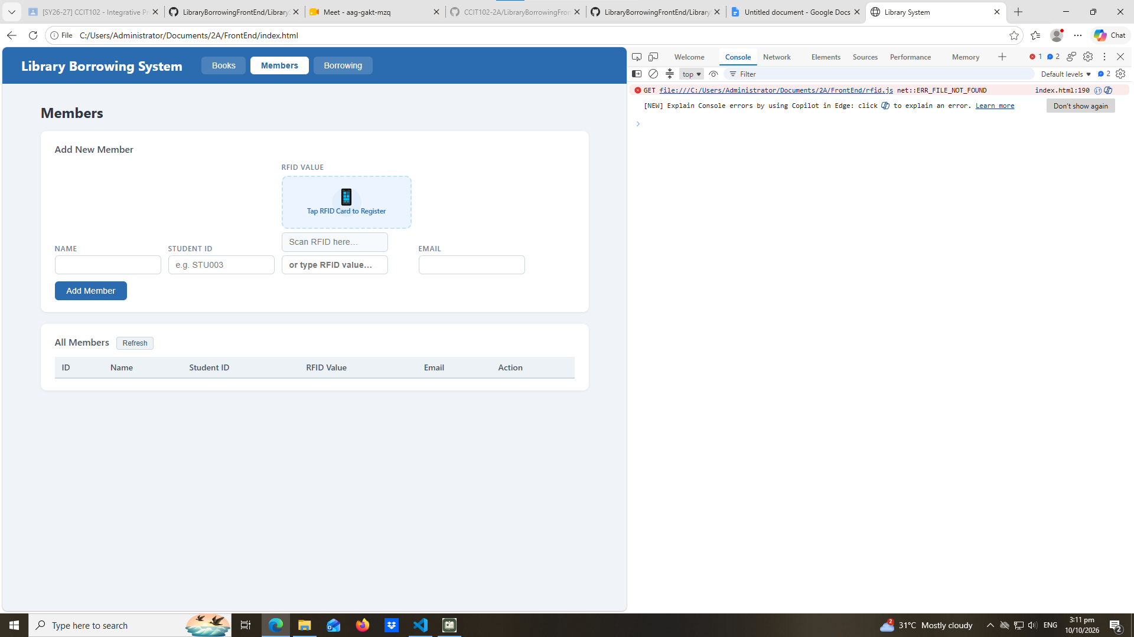

part-05-loadbooks
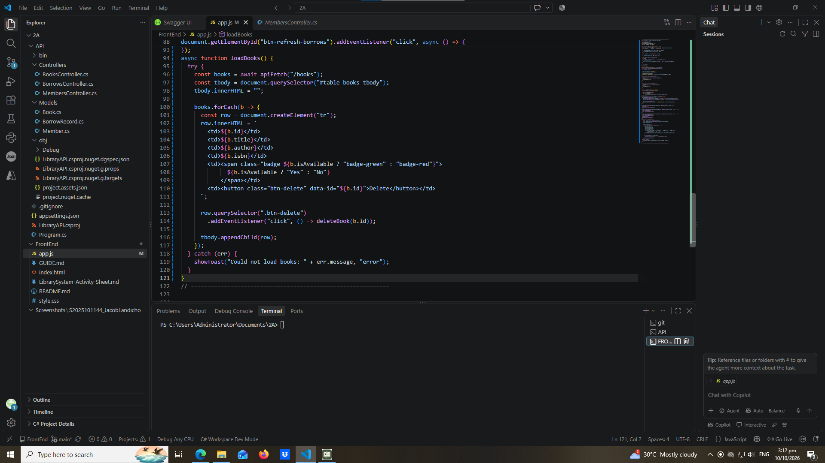

part-06-deletebook
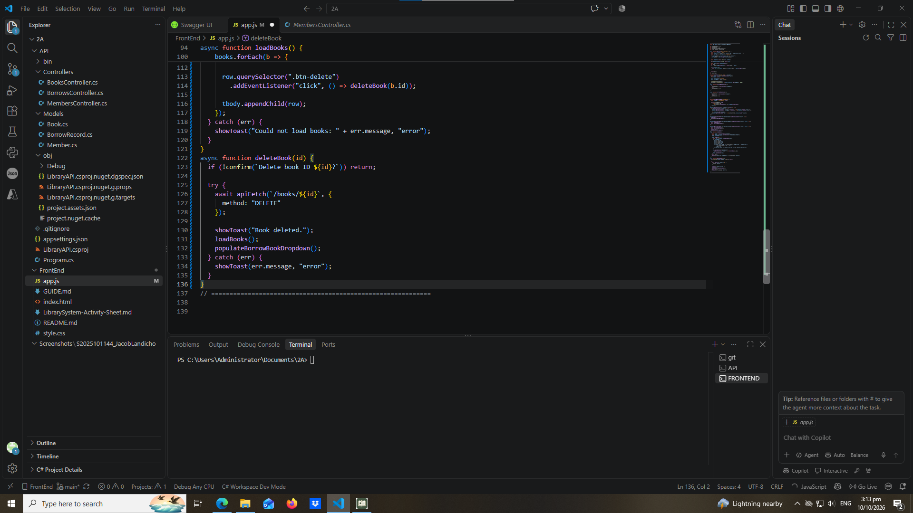

part-07-addbook
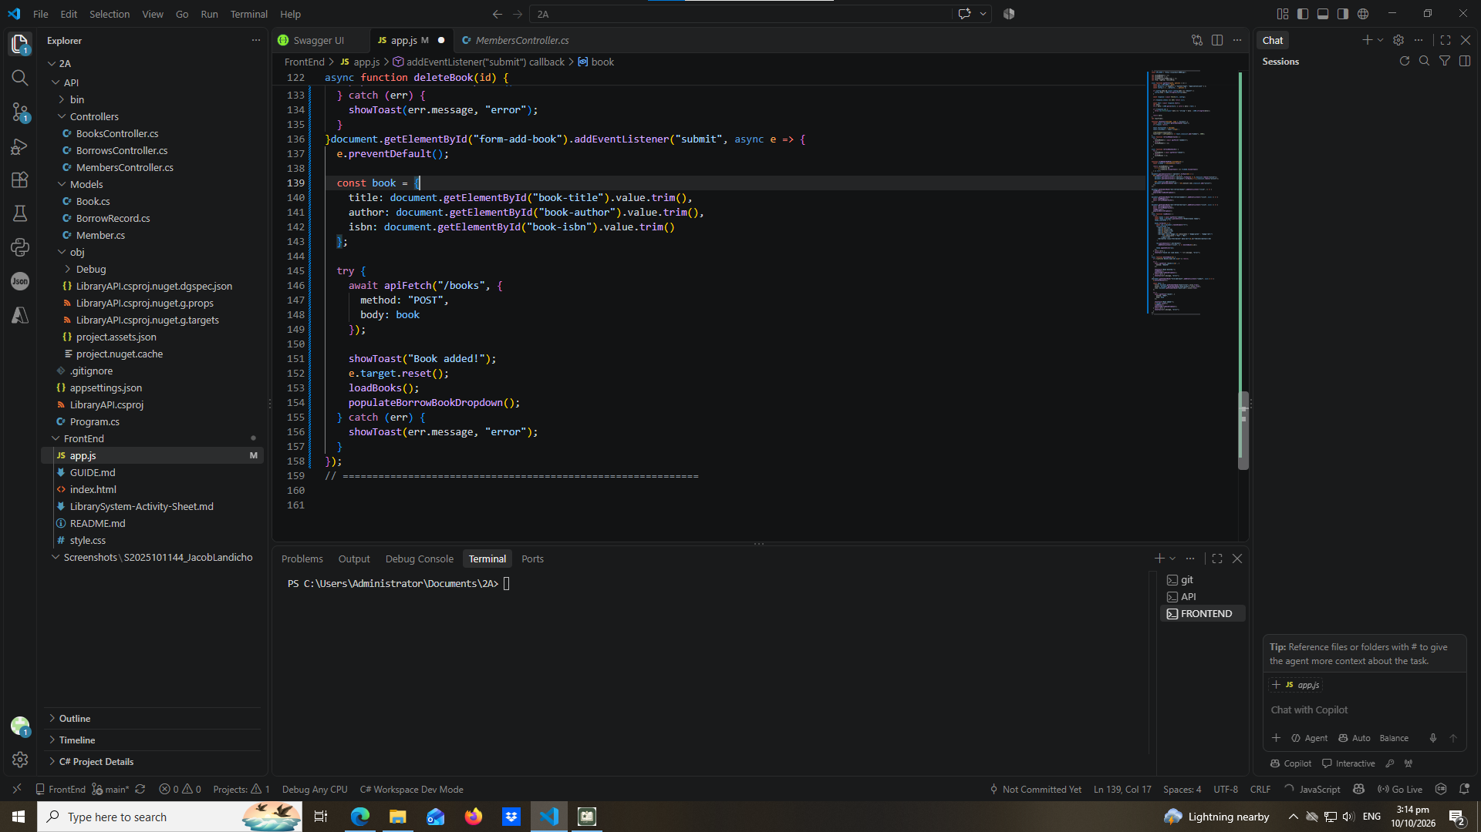

part-08a-loadmembers
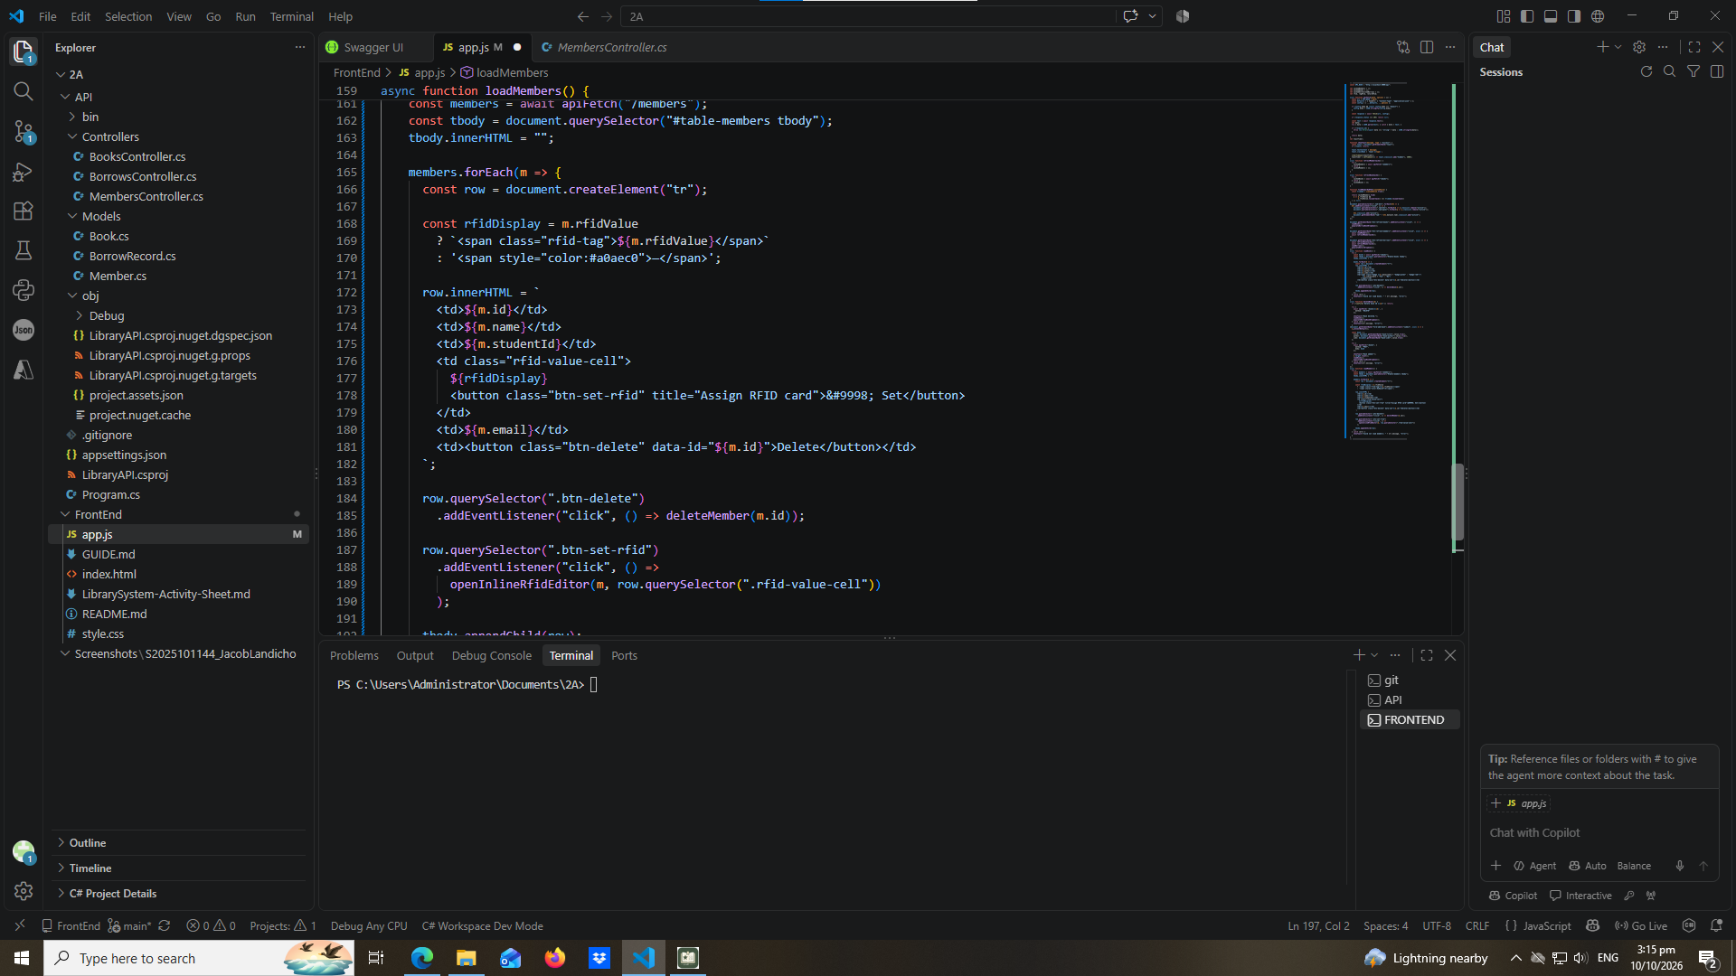

part-09-deletemember
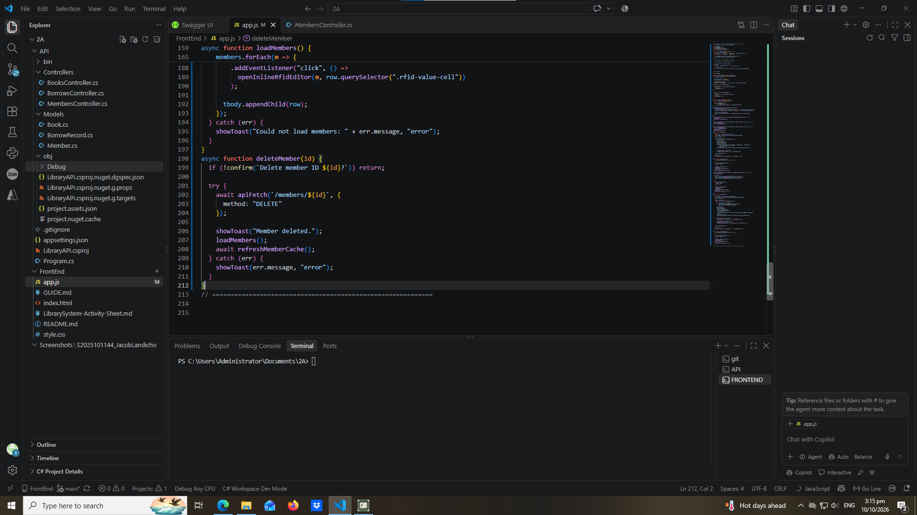

part-10-addmember
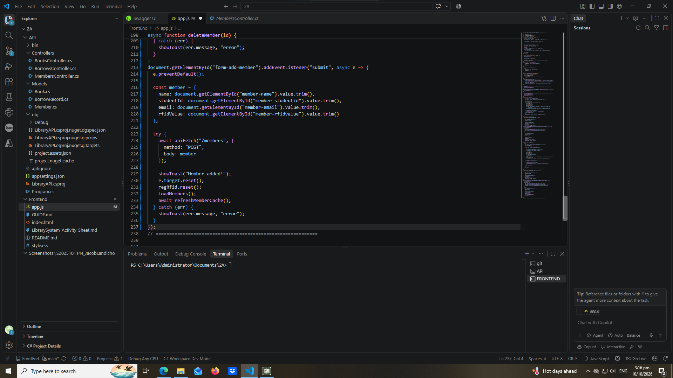

part-11-inline-rfid-editor
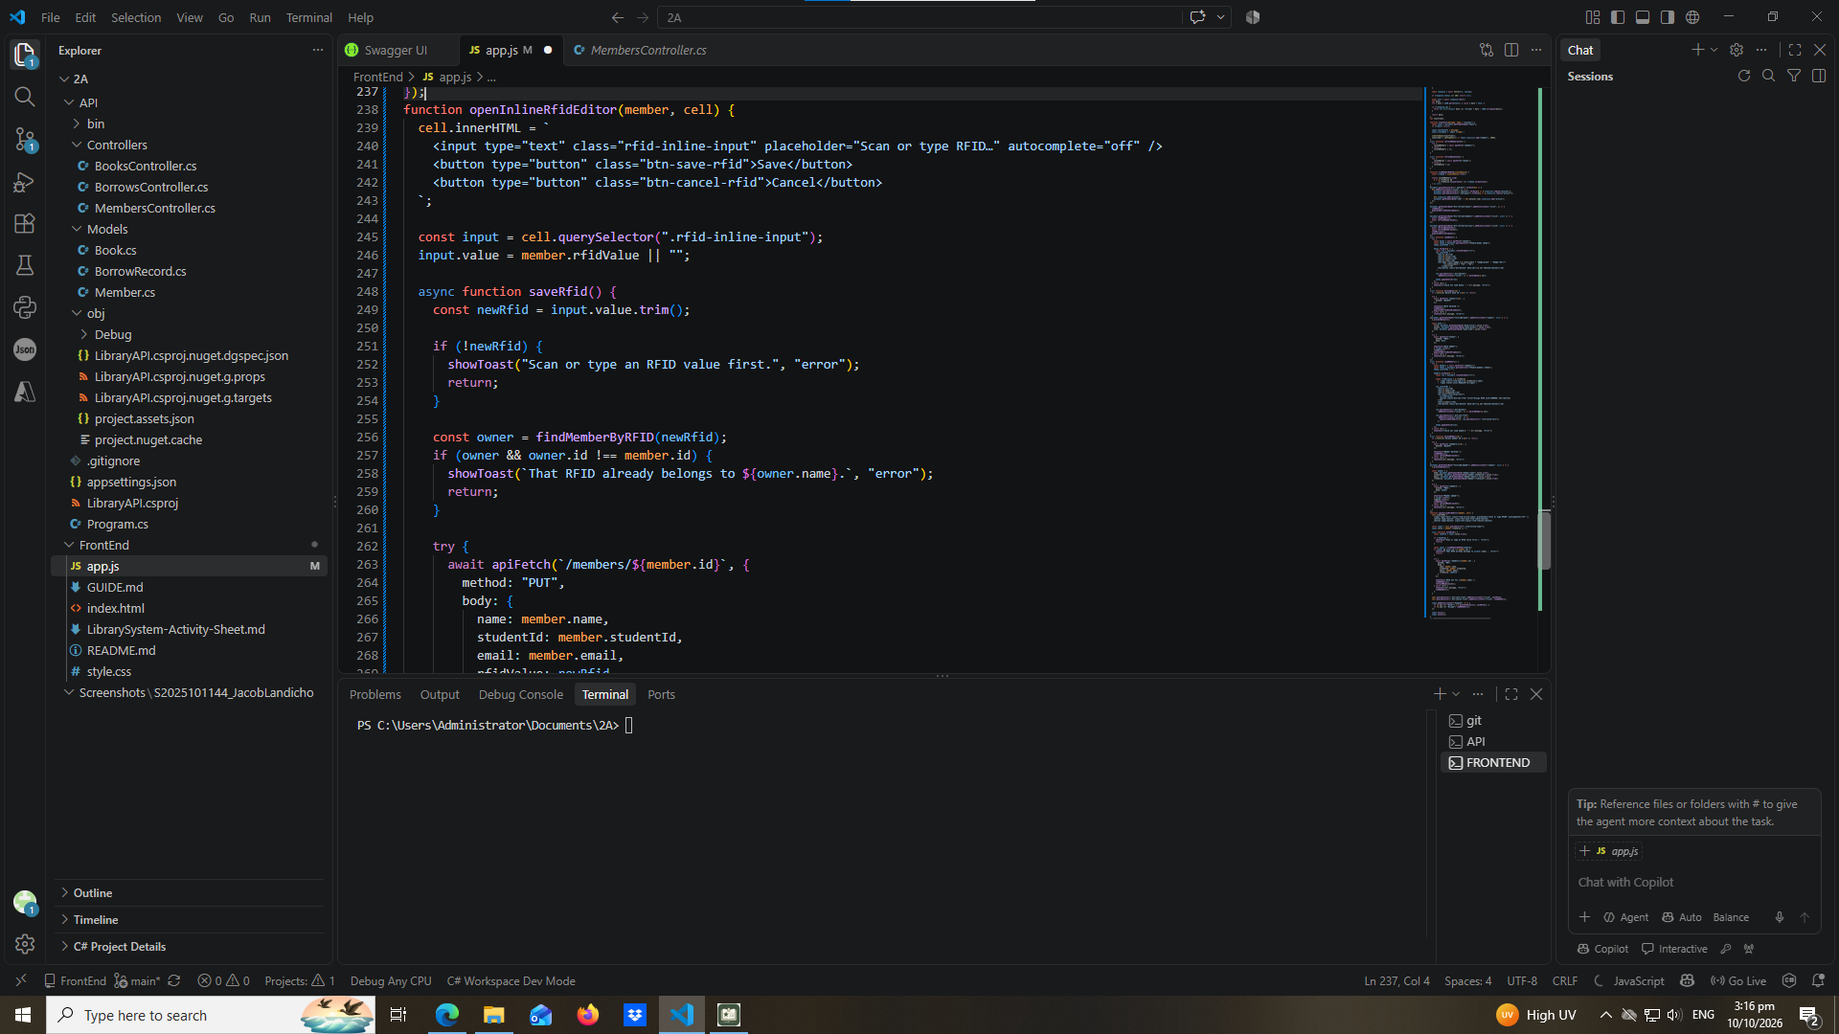
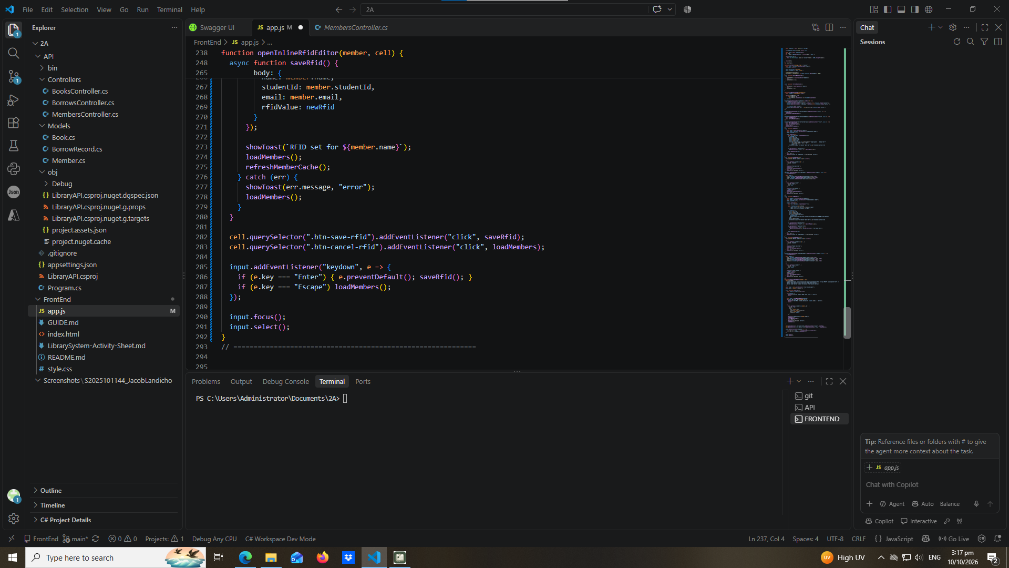
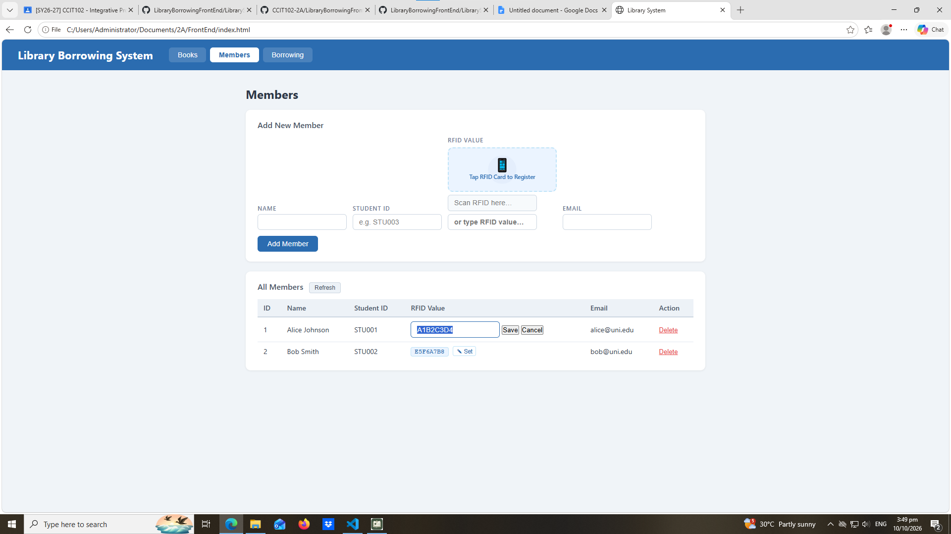

part-12a-rfid-widget-builder
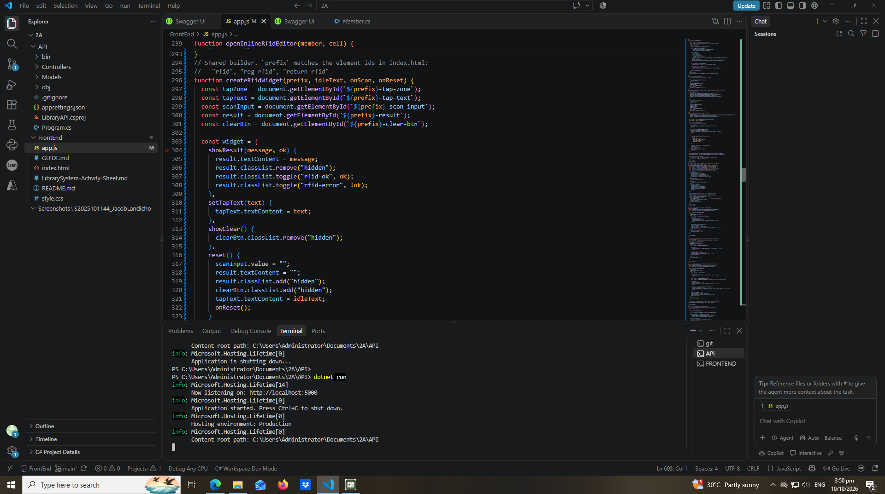
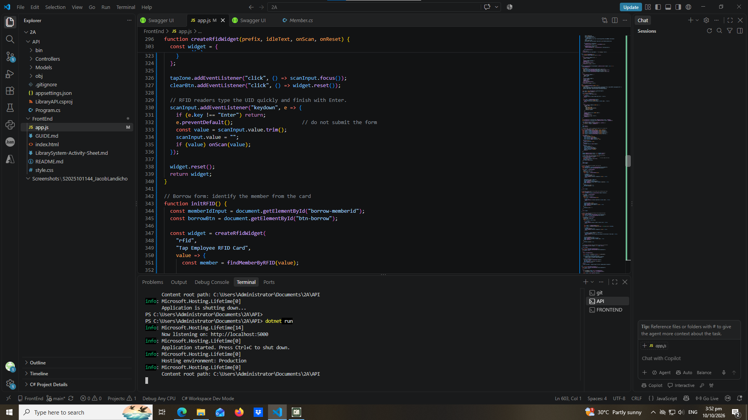
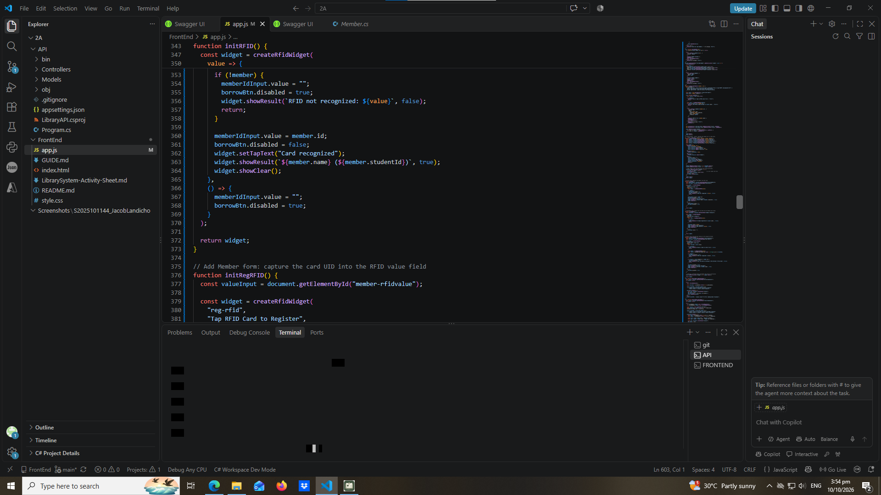
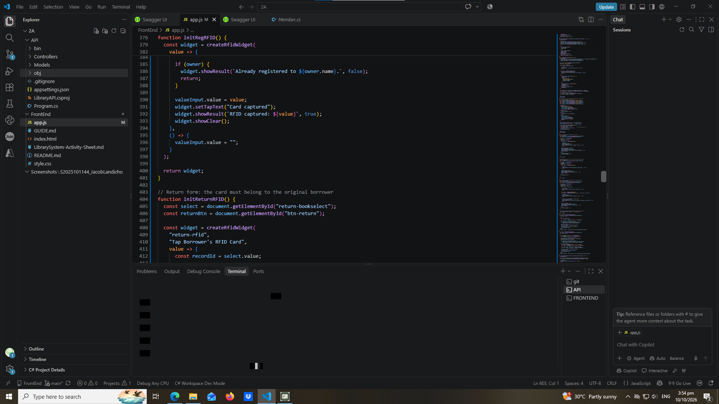
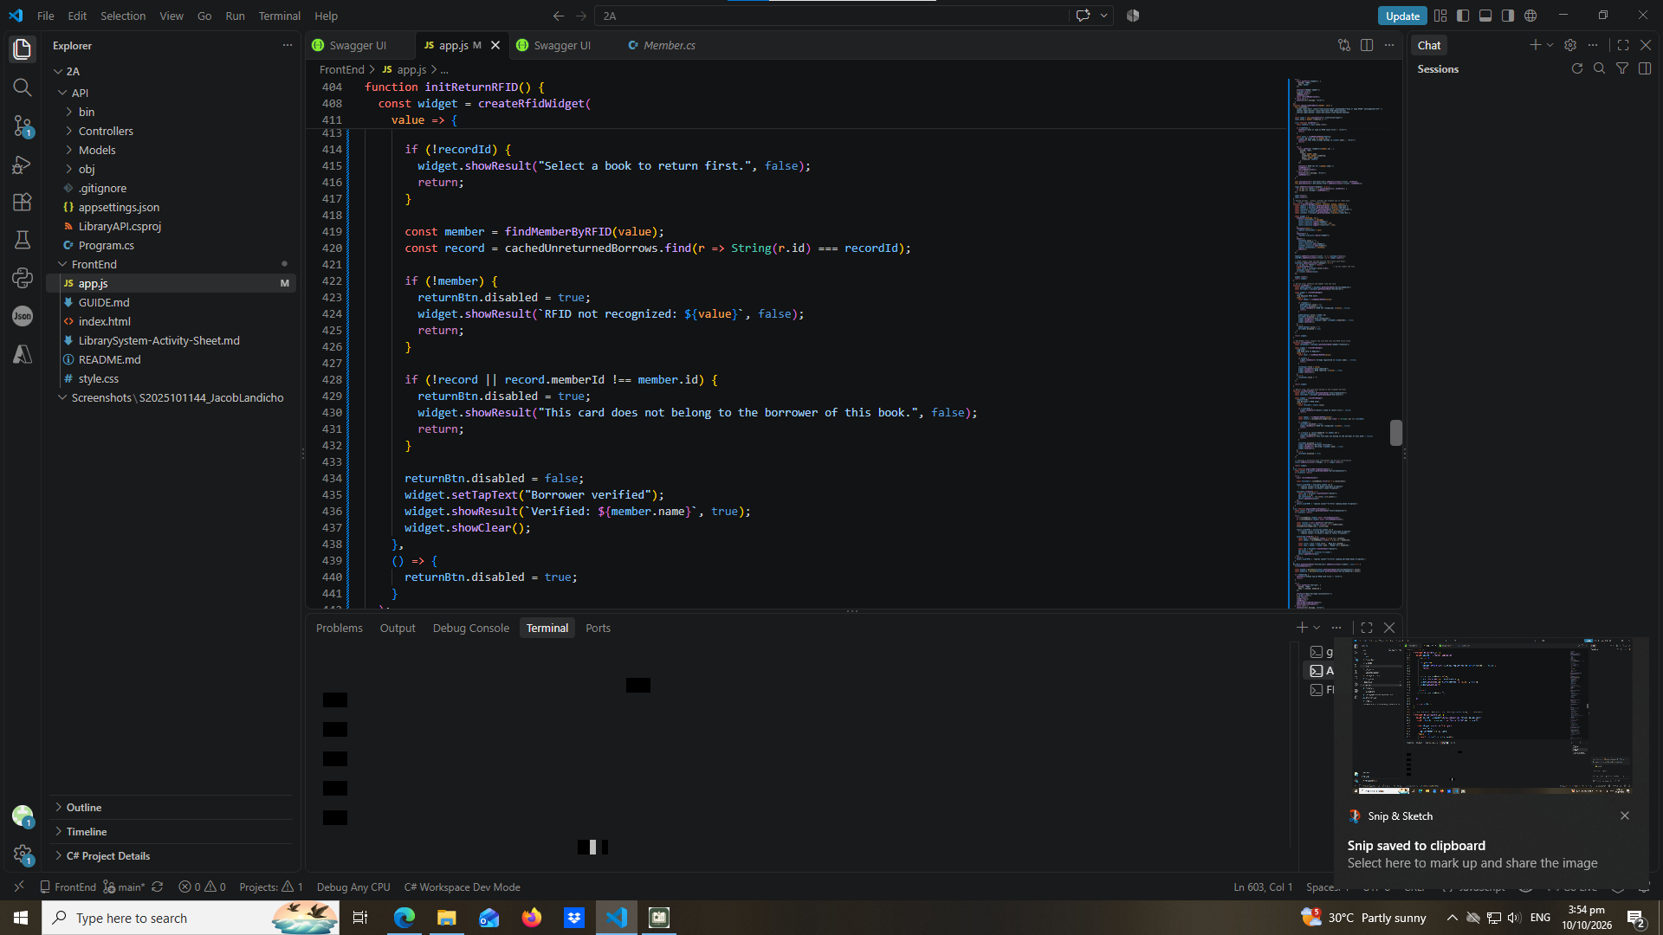

part-13-borrow-dropdown
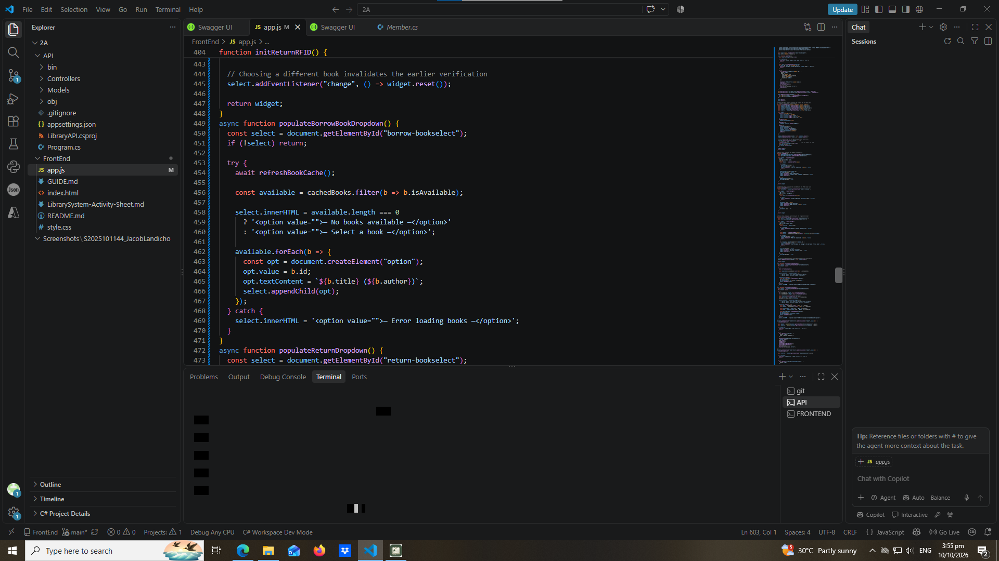

part-14-return-dropdown
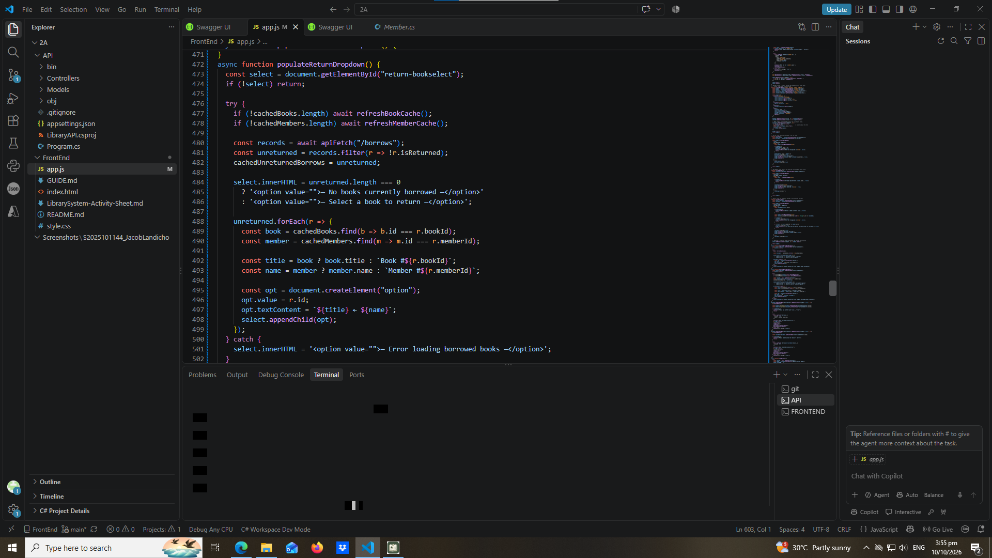

part-15-borrow
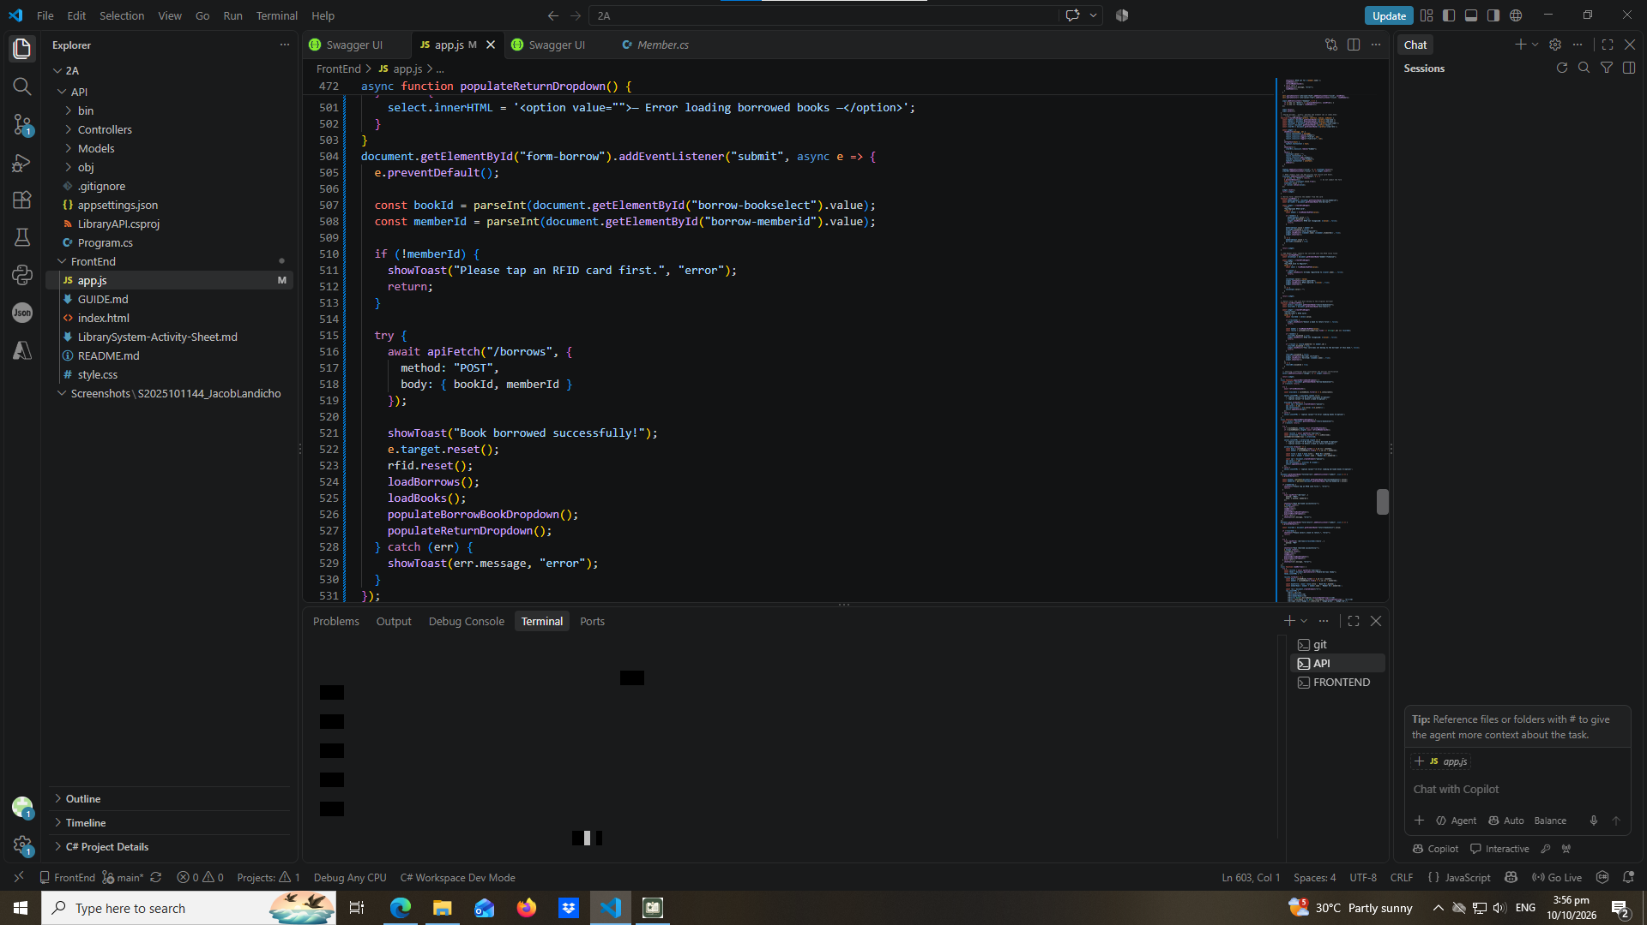

part-16-return
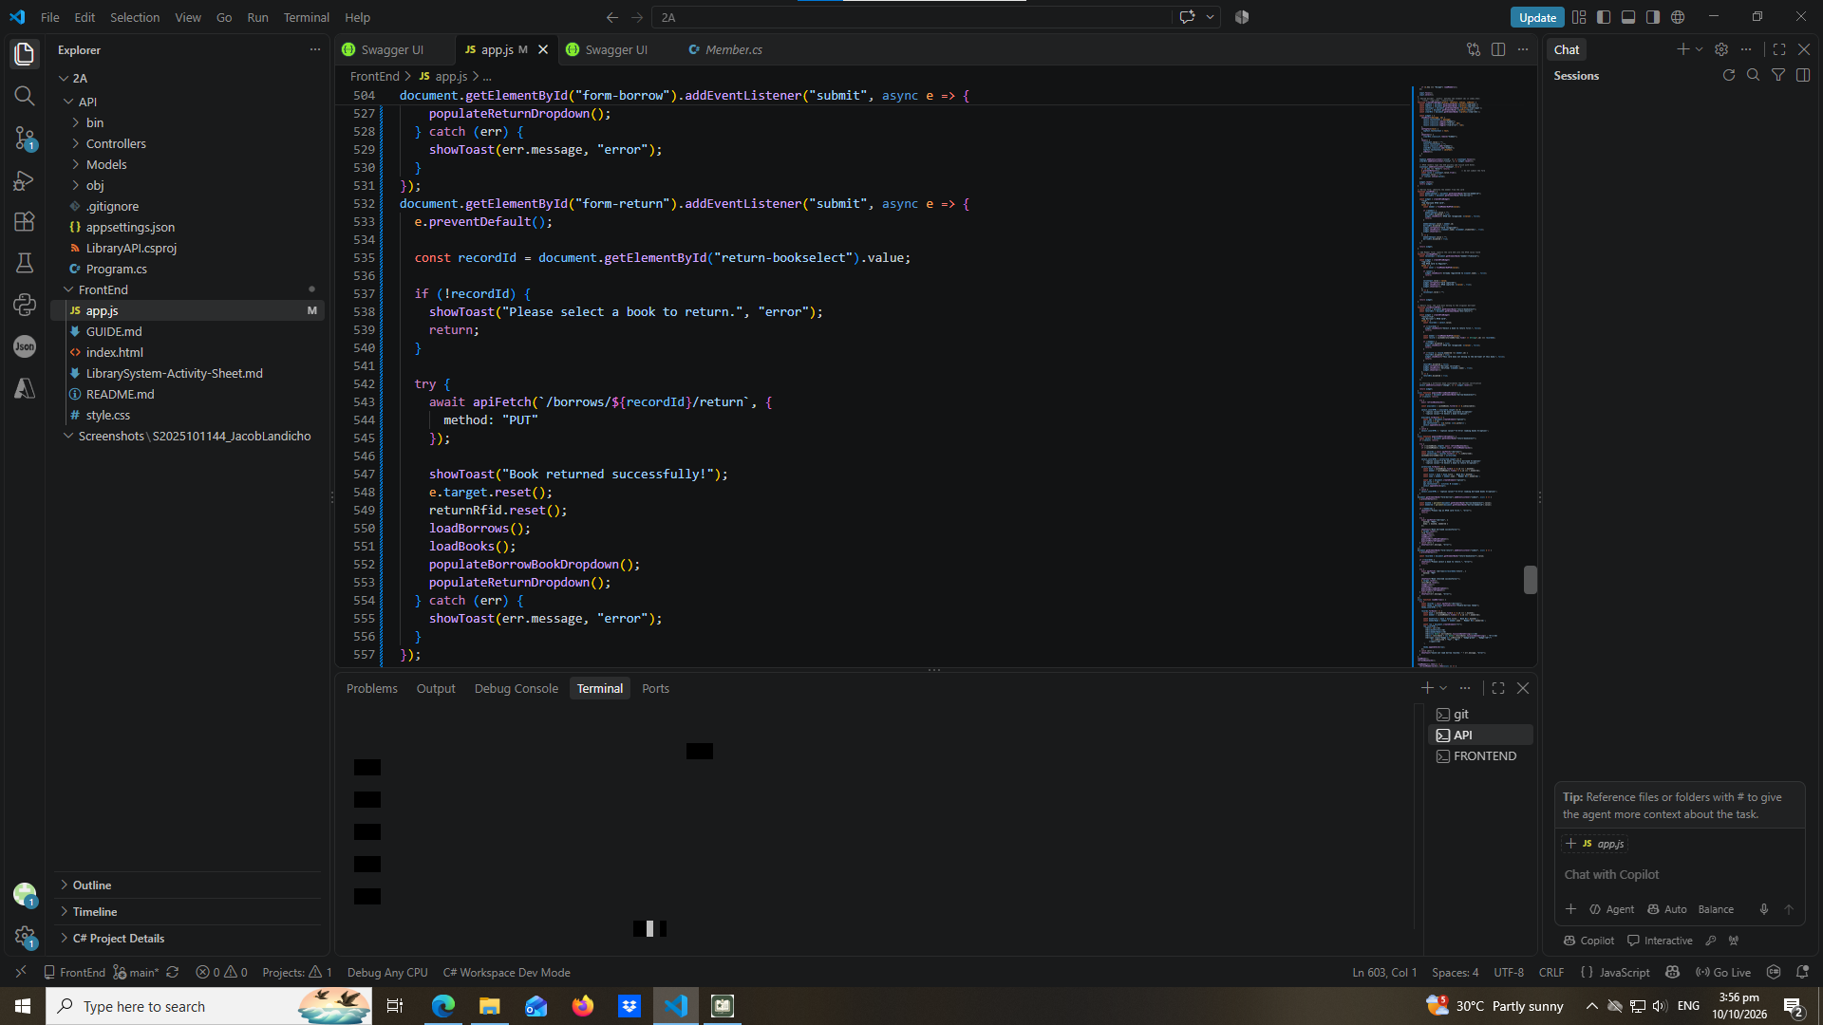

part-17-loadborrows
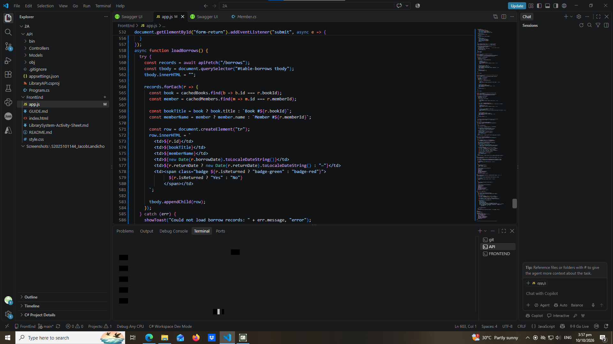

part-18-page-load
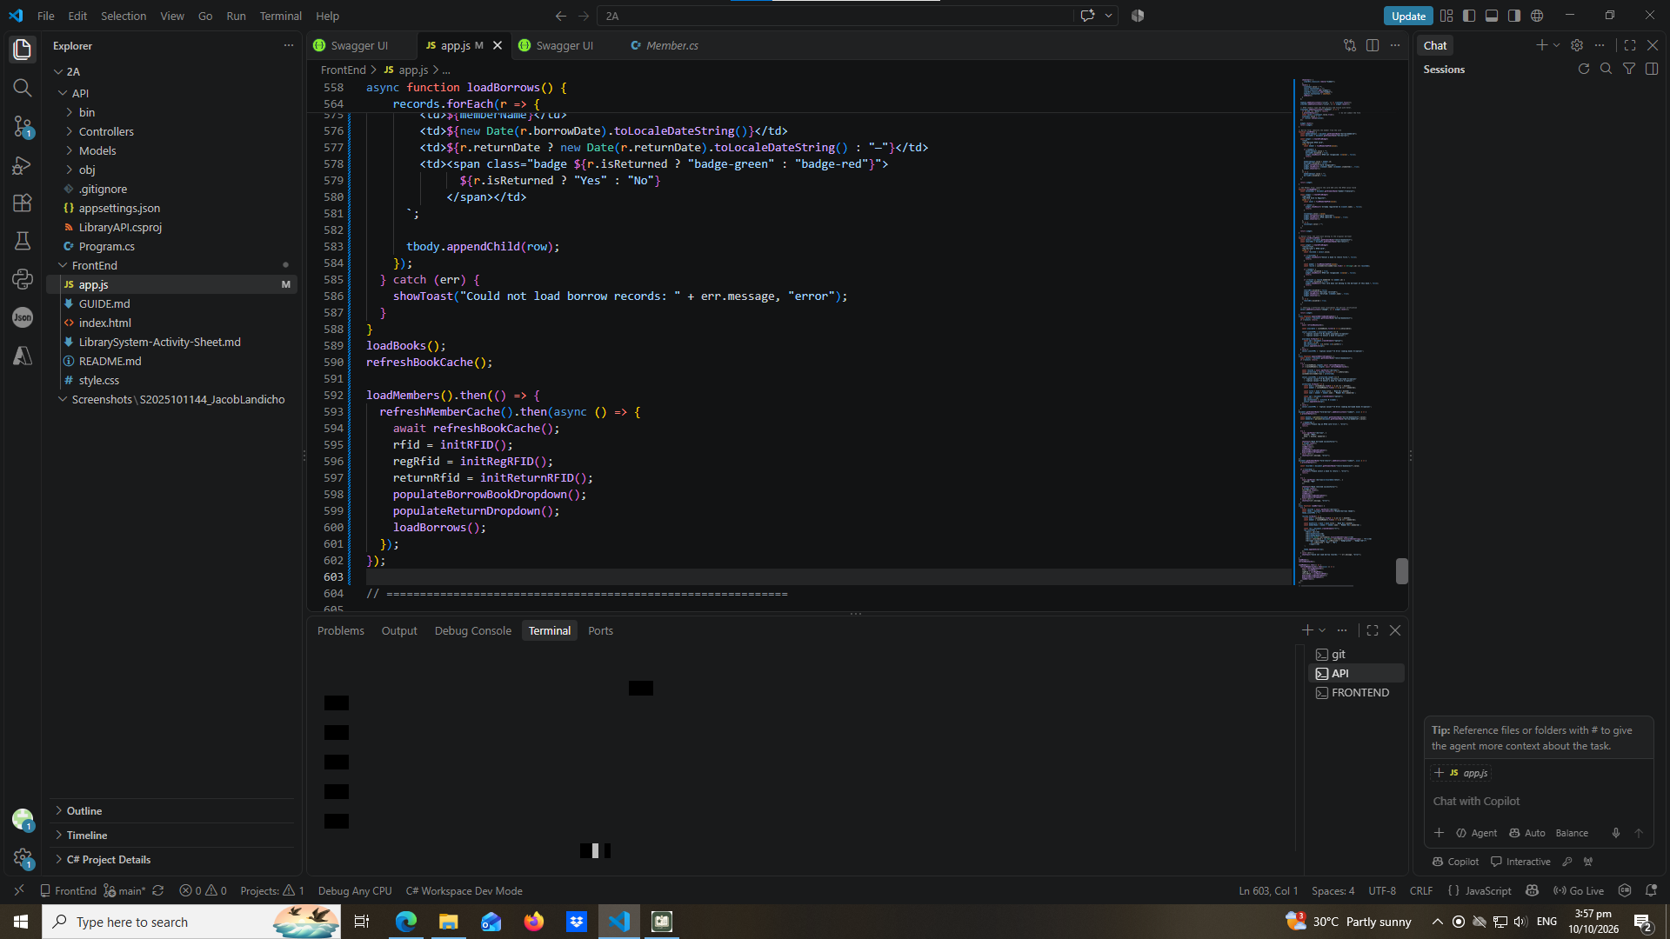

test-01-page-loaded
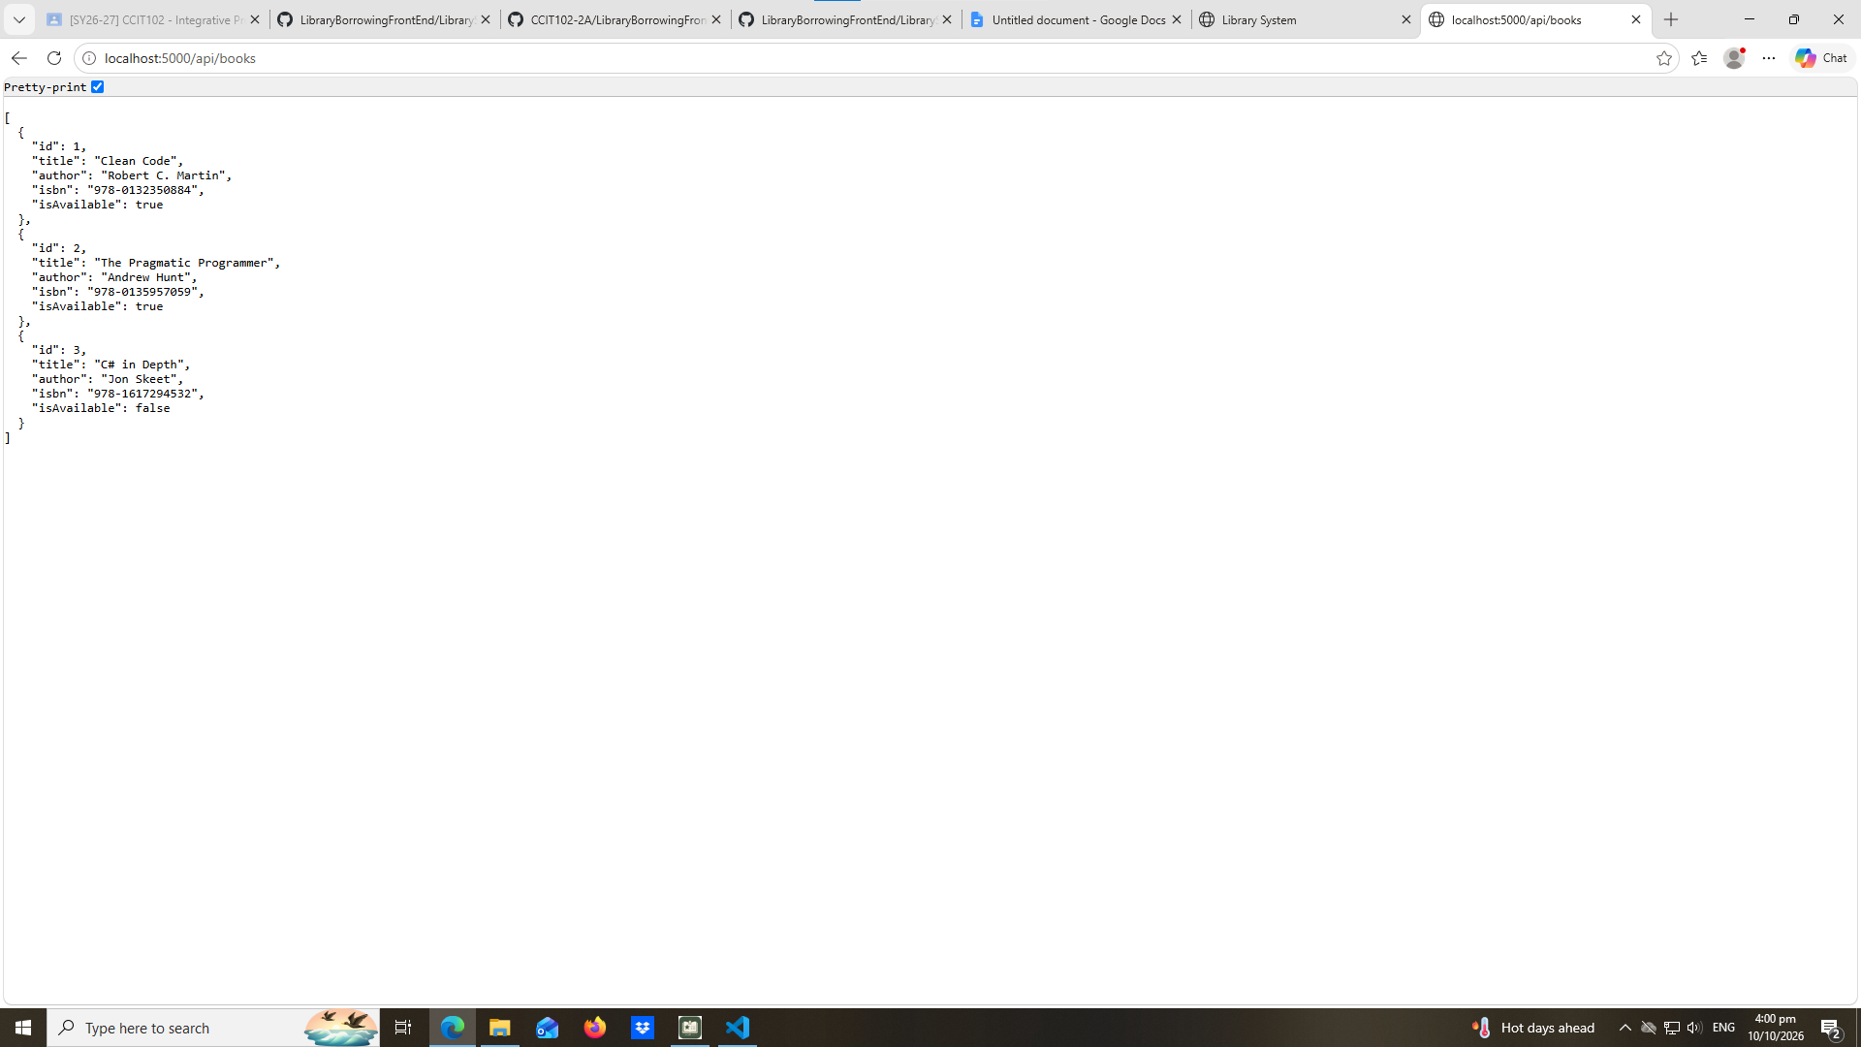

test-02-add-book
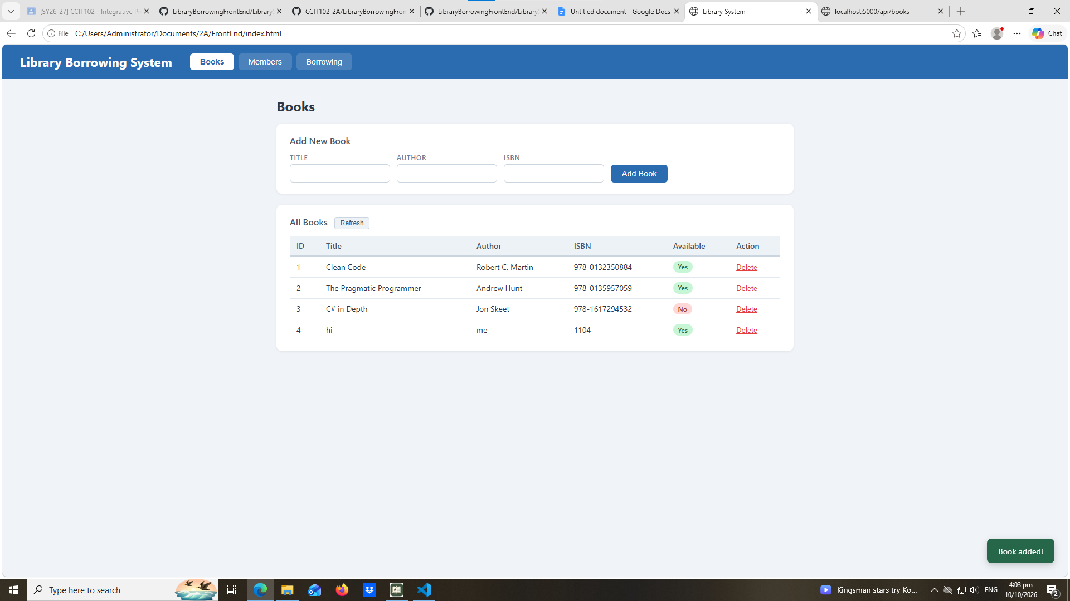

test-03-delete-book
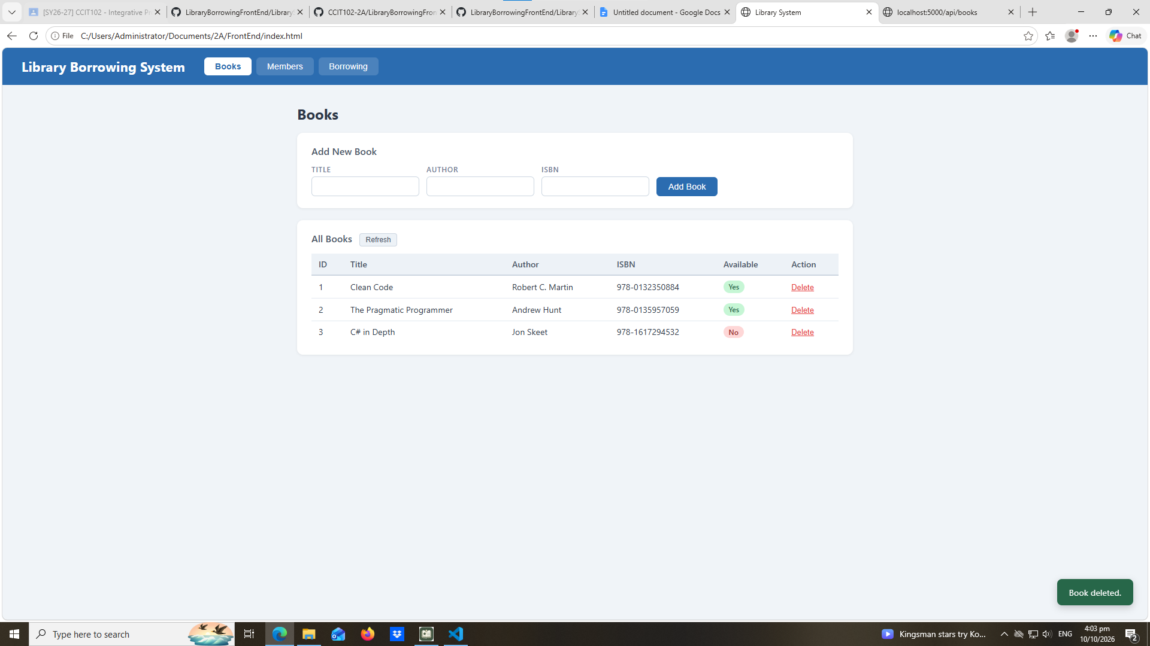

test-04-members-loaded
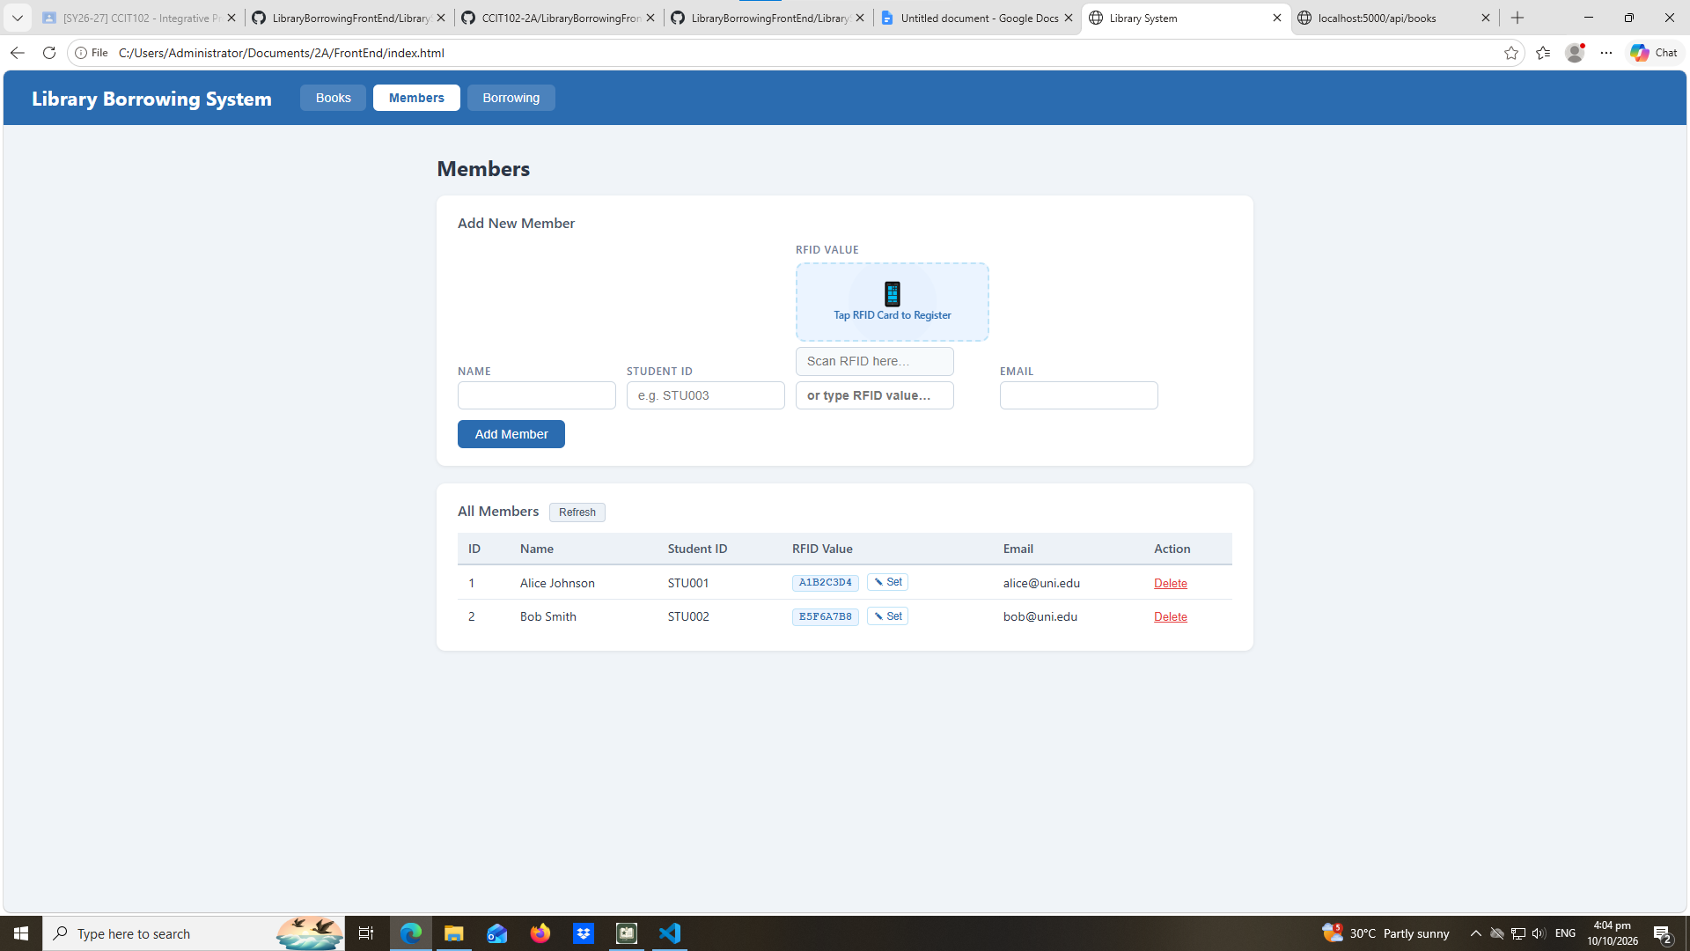
test-05-register-rfid

test-06-add-member
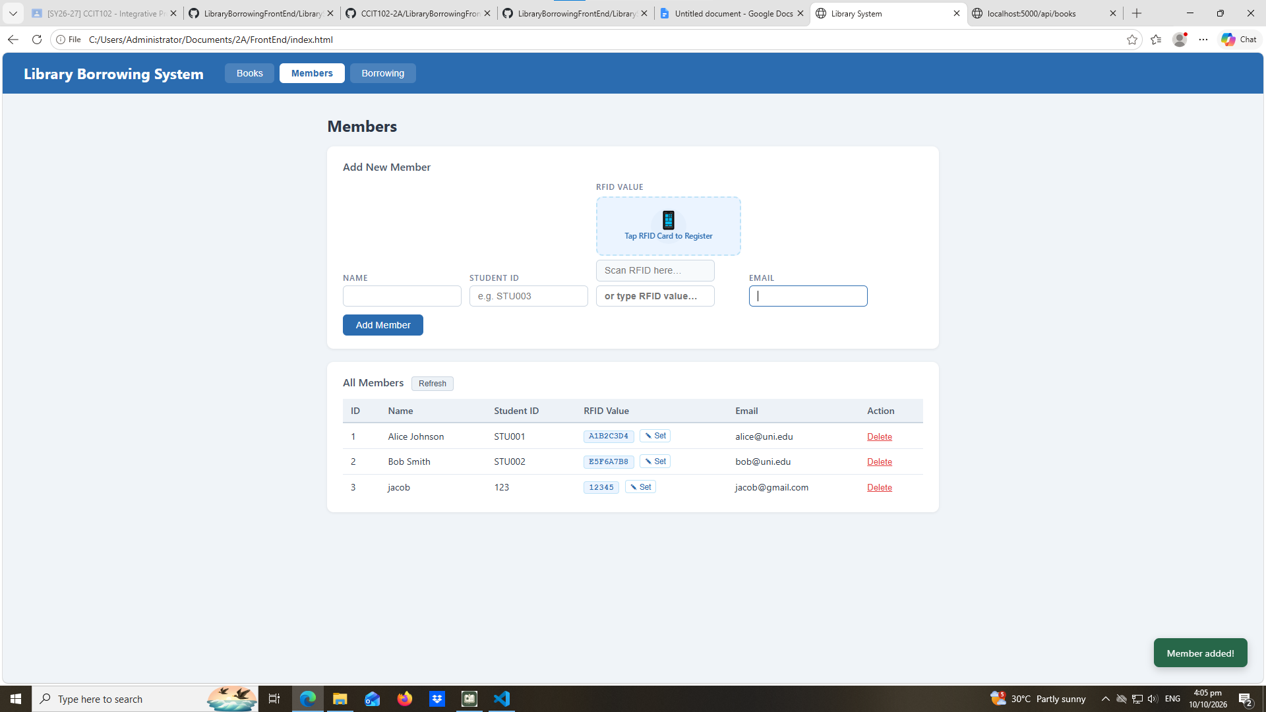

test-07-set-rfid-saved
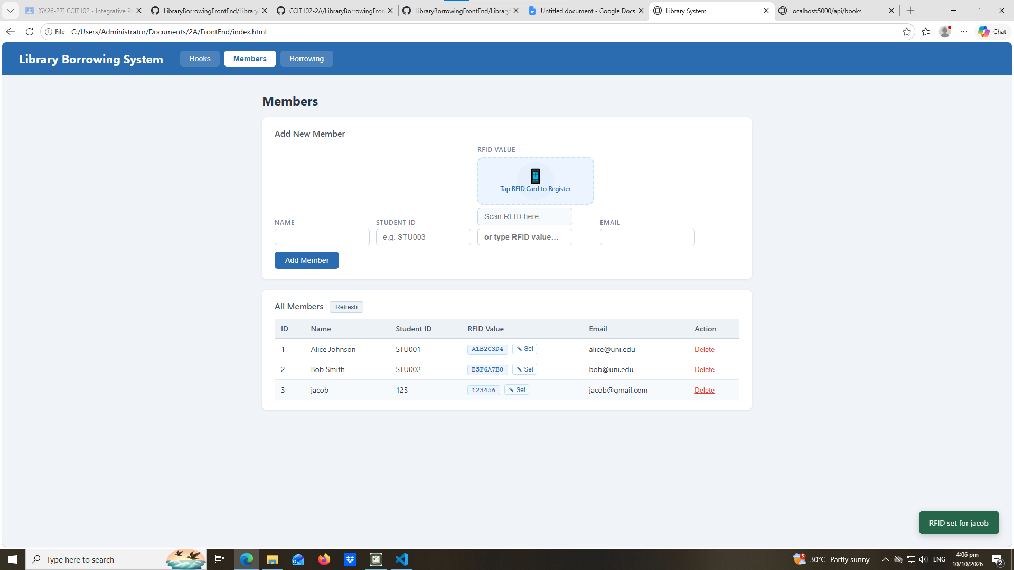
test-08-delete-member
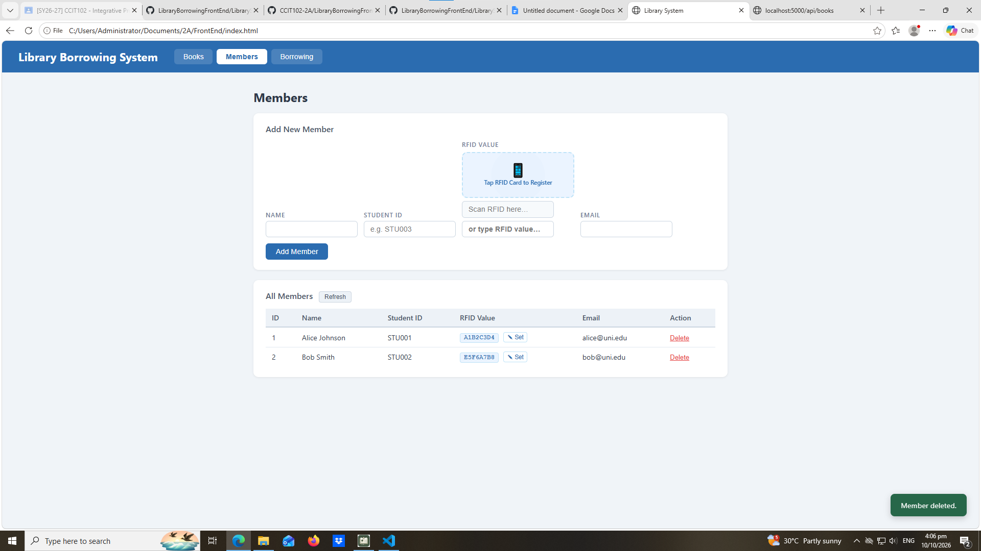

test-09-borrow-rfid-recognized
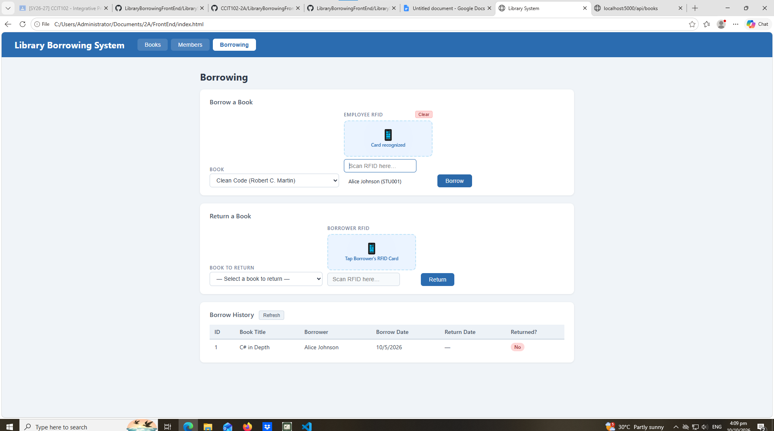
test-10-borrow-success
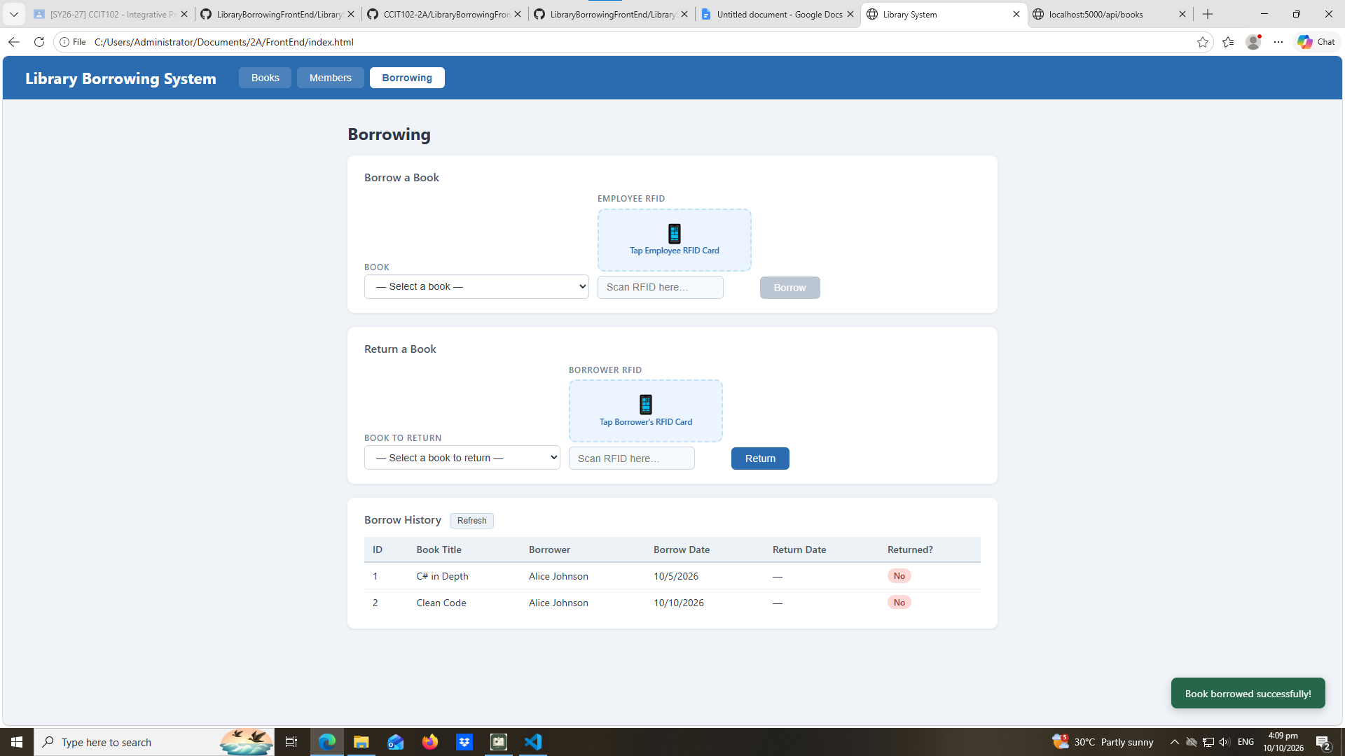

test-11-return-wrong-card
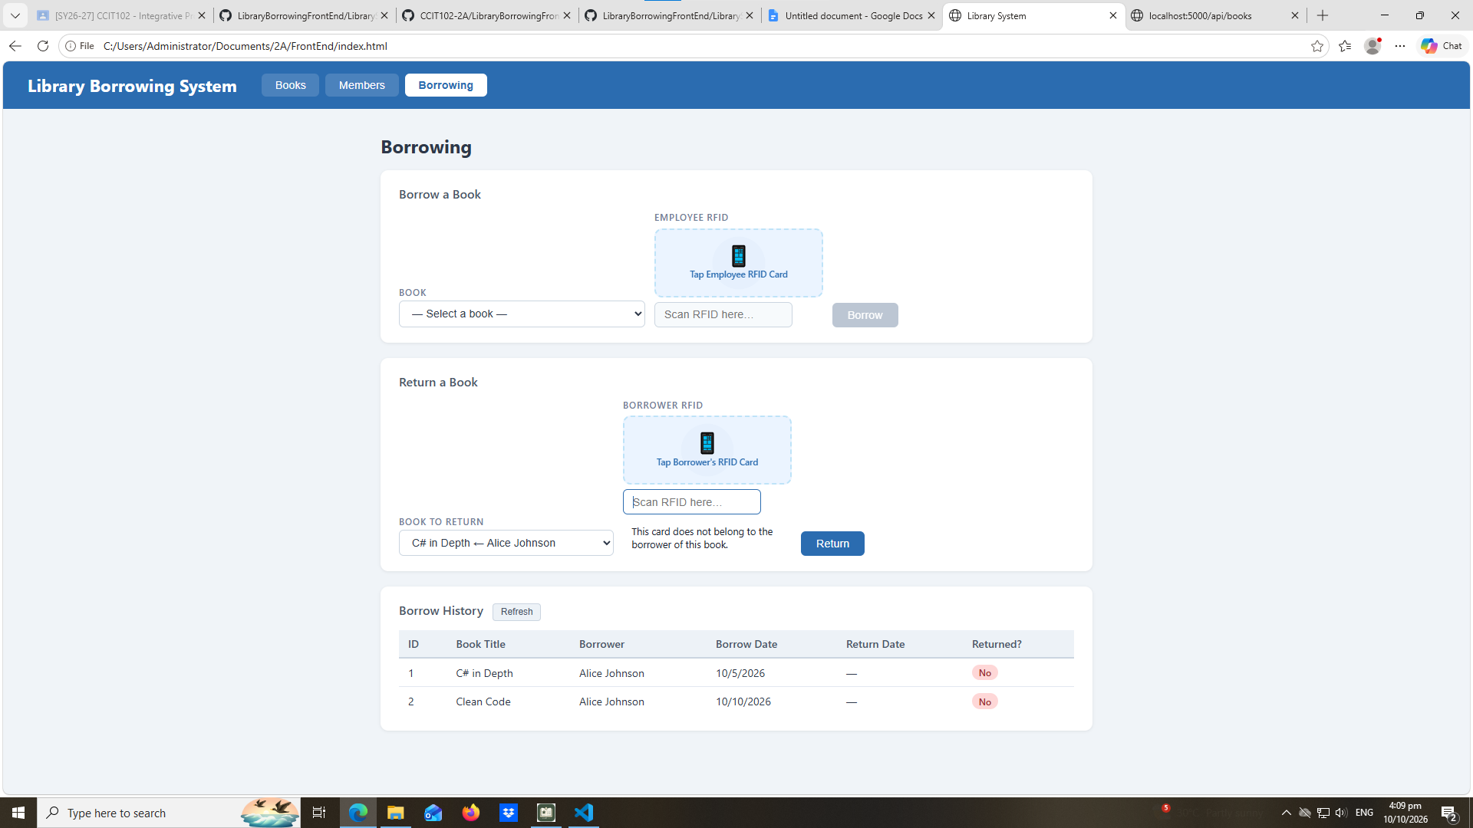
test-12-return-verified
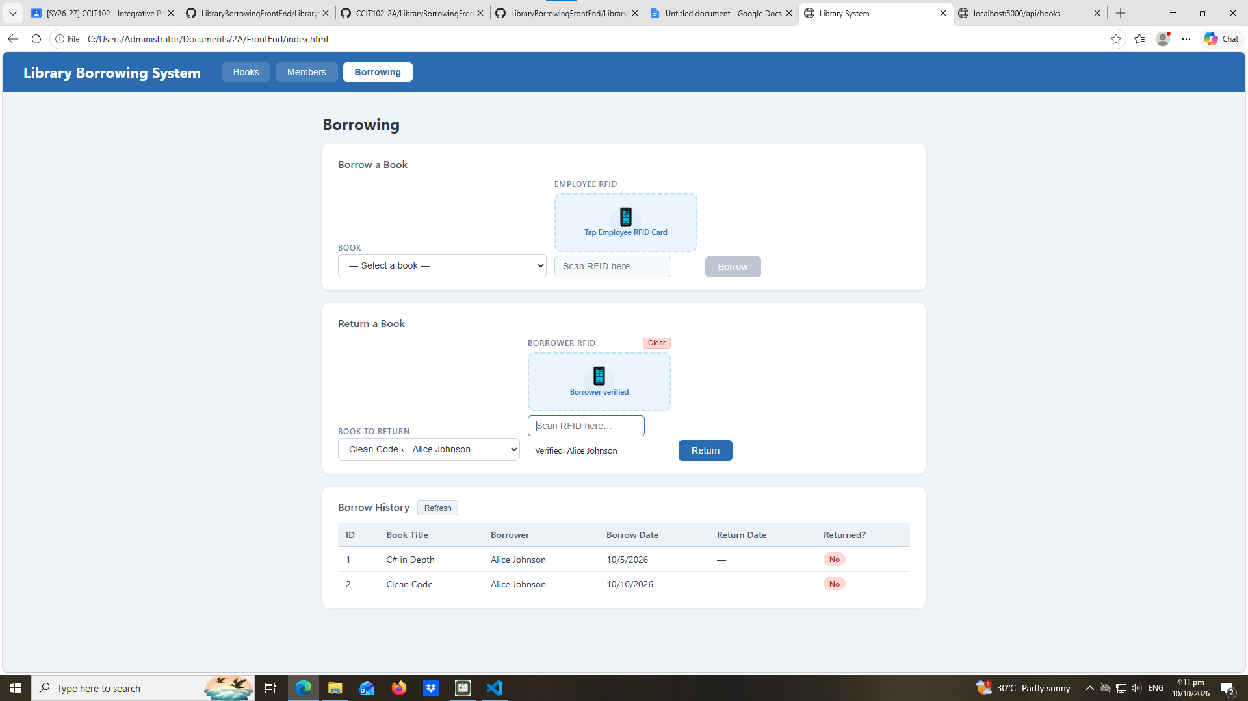

test-13-return-success
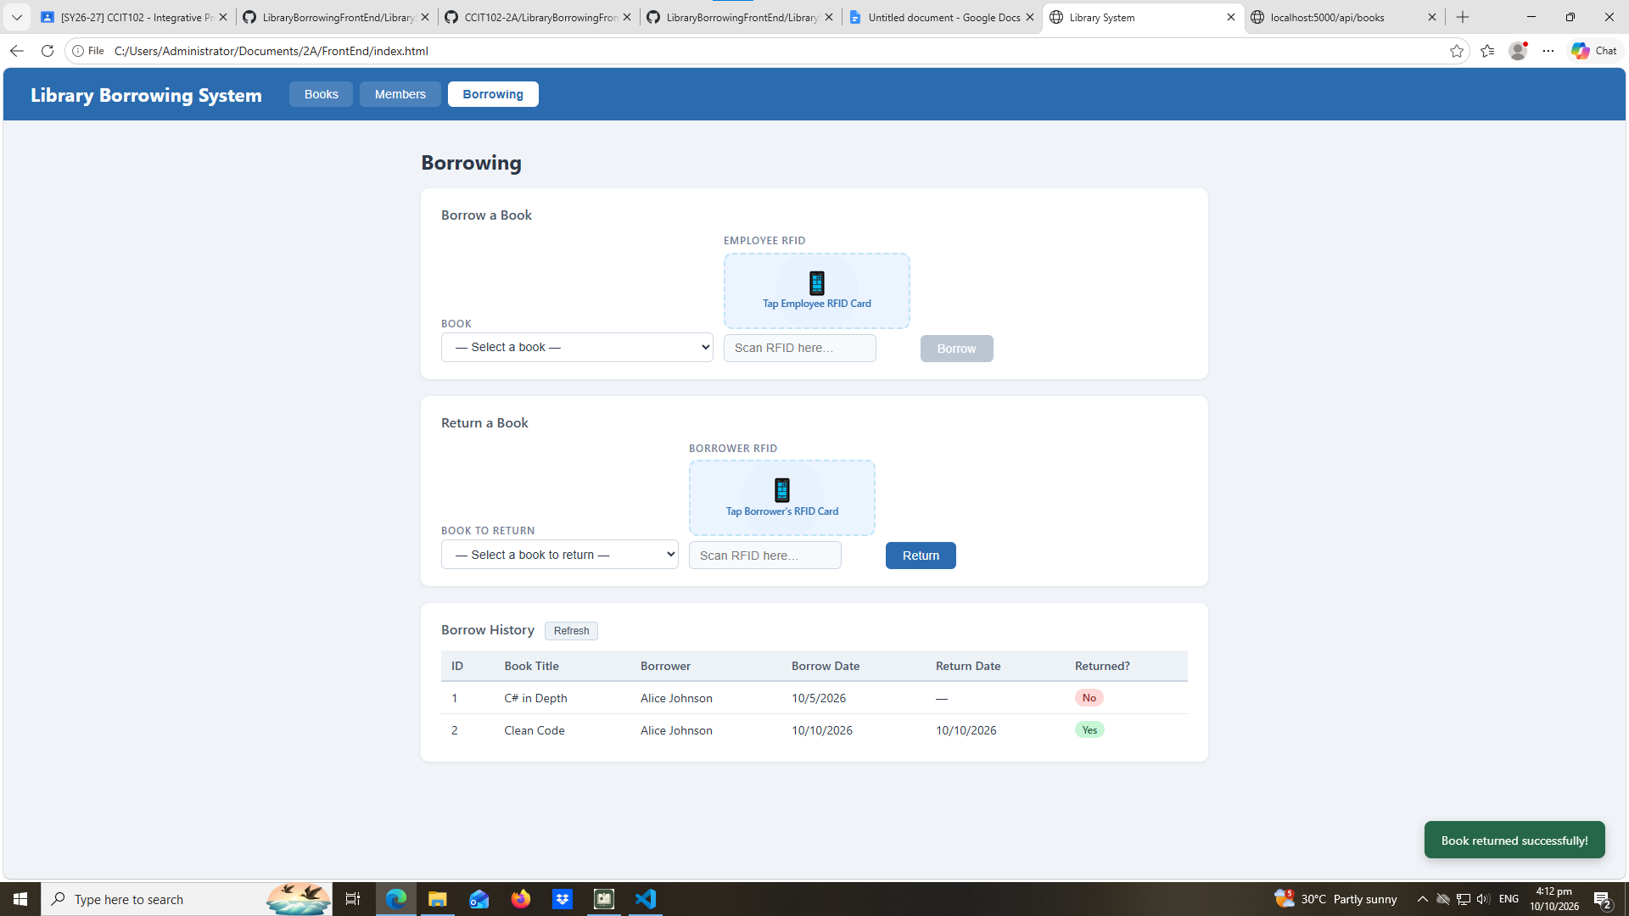

test-14-final-console
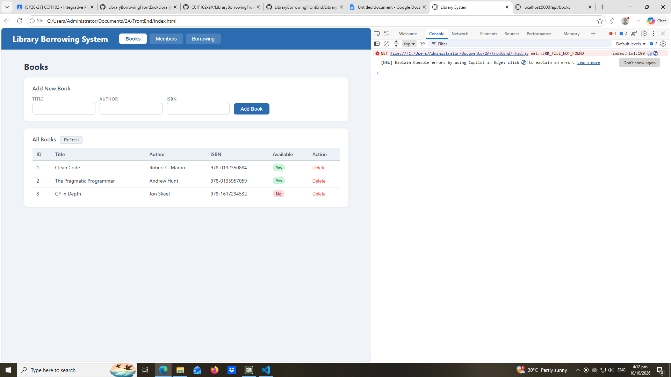

- What does apiFetch() do?
Sends request to an API and retrieves or sends data
- Why do we use try/catch around API calls?
To handle errors when API request fails
- What is the difference between POST and PUT?
Post is to create a new record, and Put is to update an existing record
- Why does RFID matching use rfidValue instead of studentId?
rfidValue is used to identify the RFID scanned by the reader, studentID identifies the student in the database.
- Why do we refresh tables after adding, deleting, borrowing, or returning?
So the information stays updated
- Why does the Return dropdown use borrow record ID instead of book ID?
borrowRecordId is for specific transactions and bookId identifies the book, using borrowRecordId ensures the correct transaction is returned.
- What happens if the same event listener is added to a form twice?
It can cause a duplicate of records.
- Why must the page-load code be at the bottom of the file?
Placing it at the bottom ensures that the functions and elements it depends on are defined before it runs.
- Why does an RFID reader need e.preventDefault() on the Enter key?
Stops enter key from performing its default action

