Part 1: Settings, Shared Variables and apiFetch()

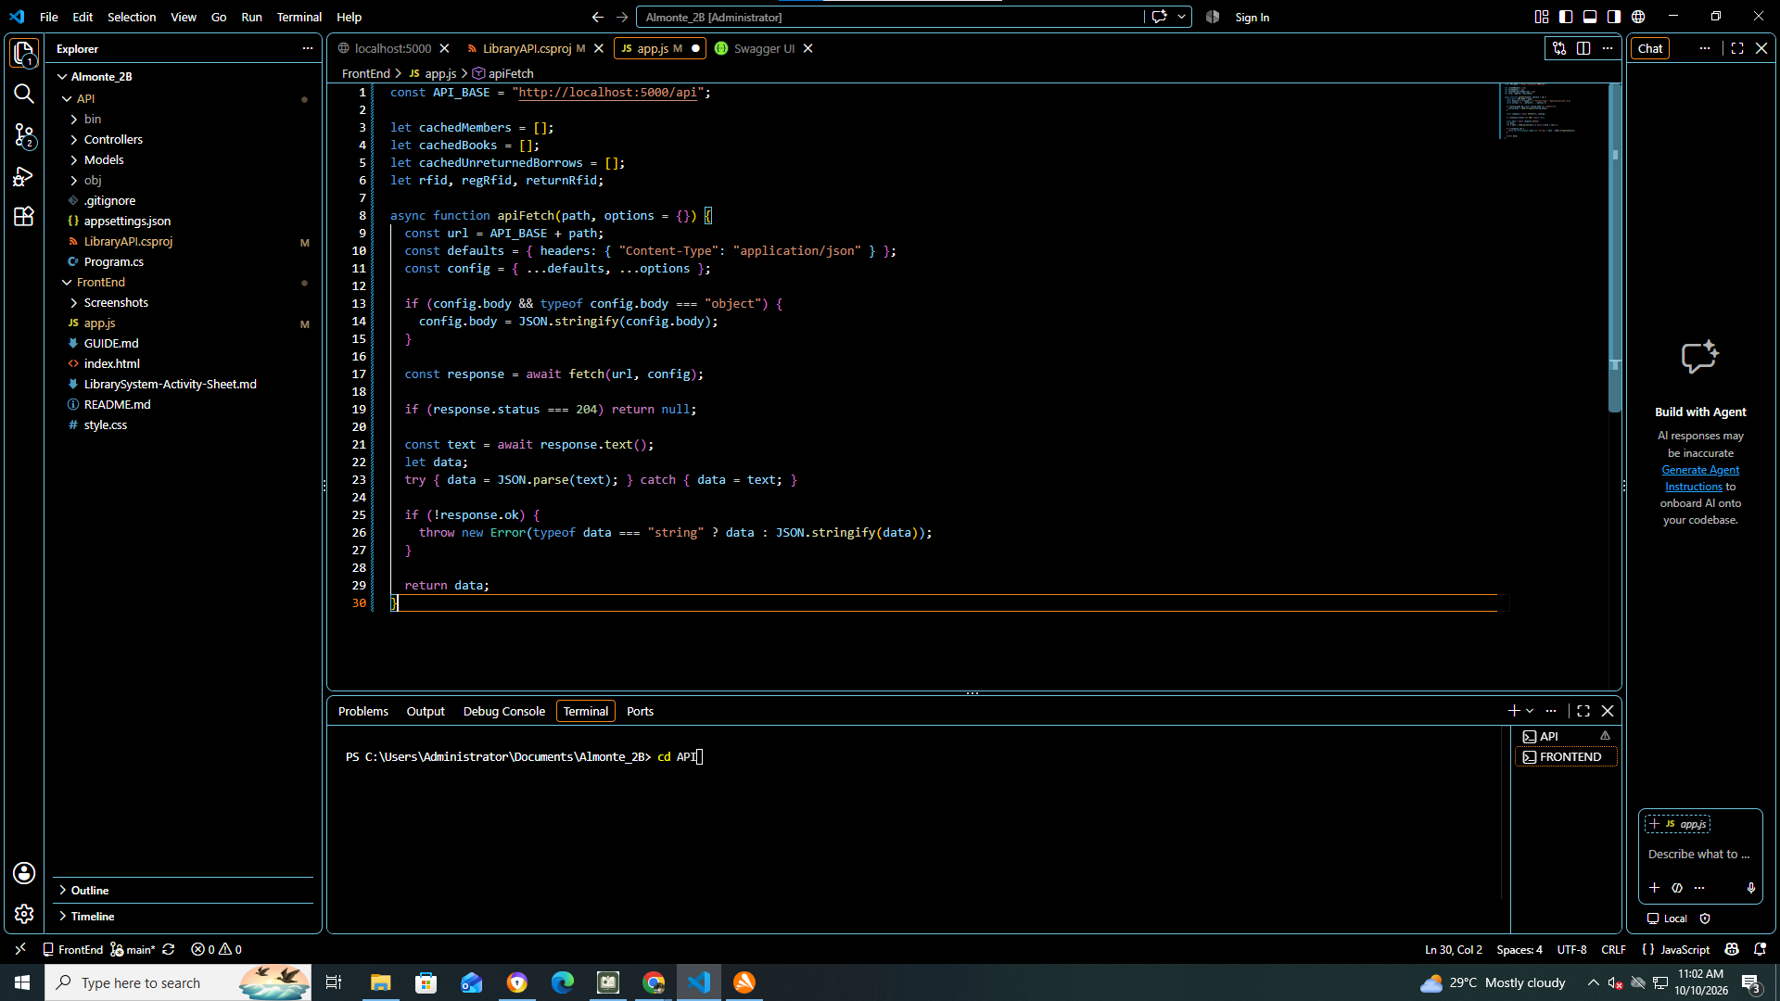

Part 2: Toast Messages

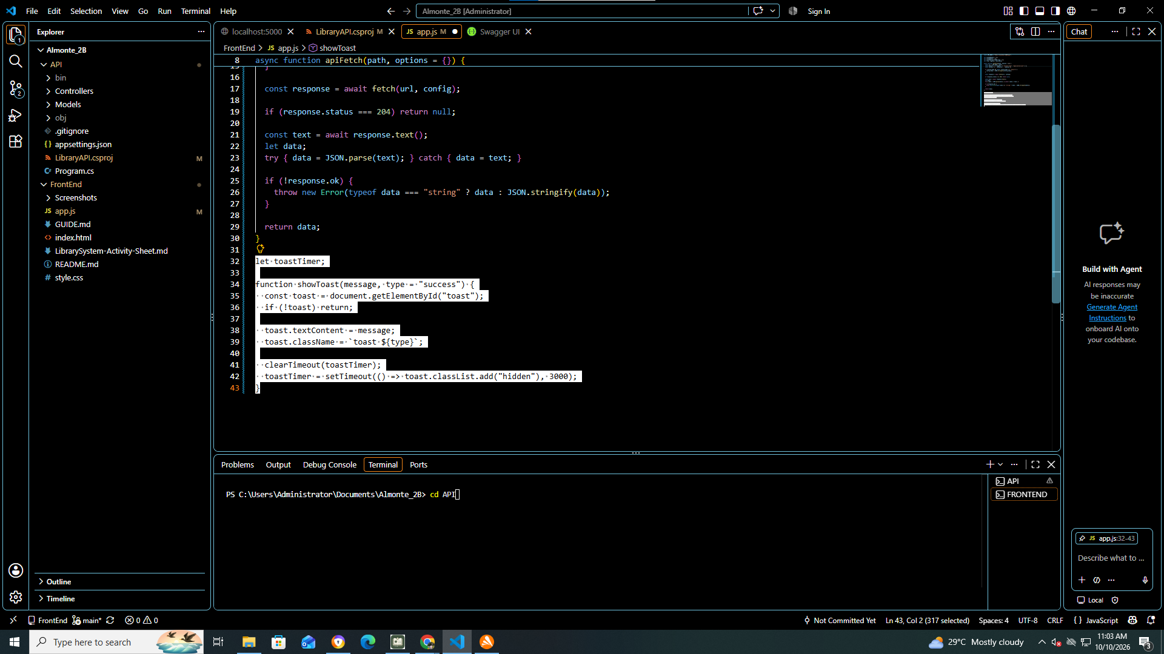

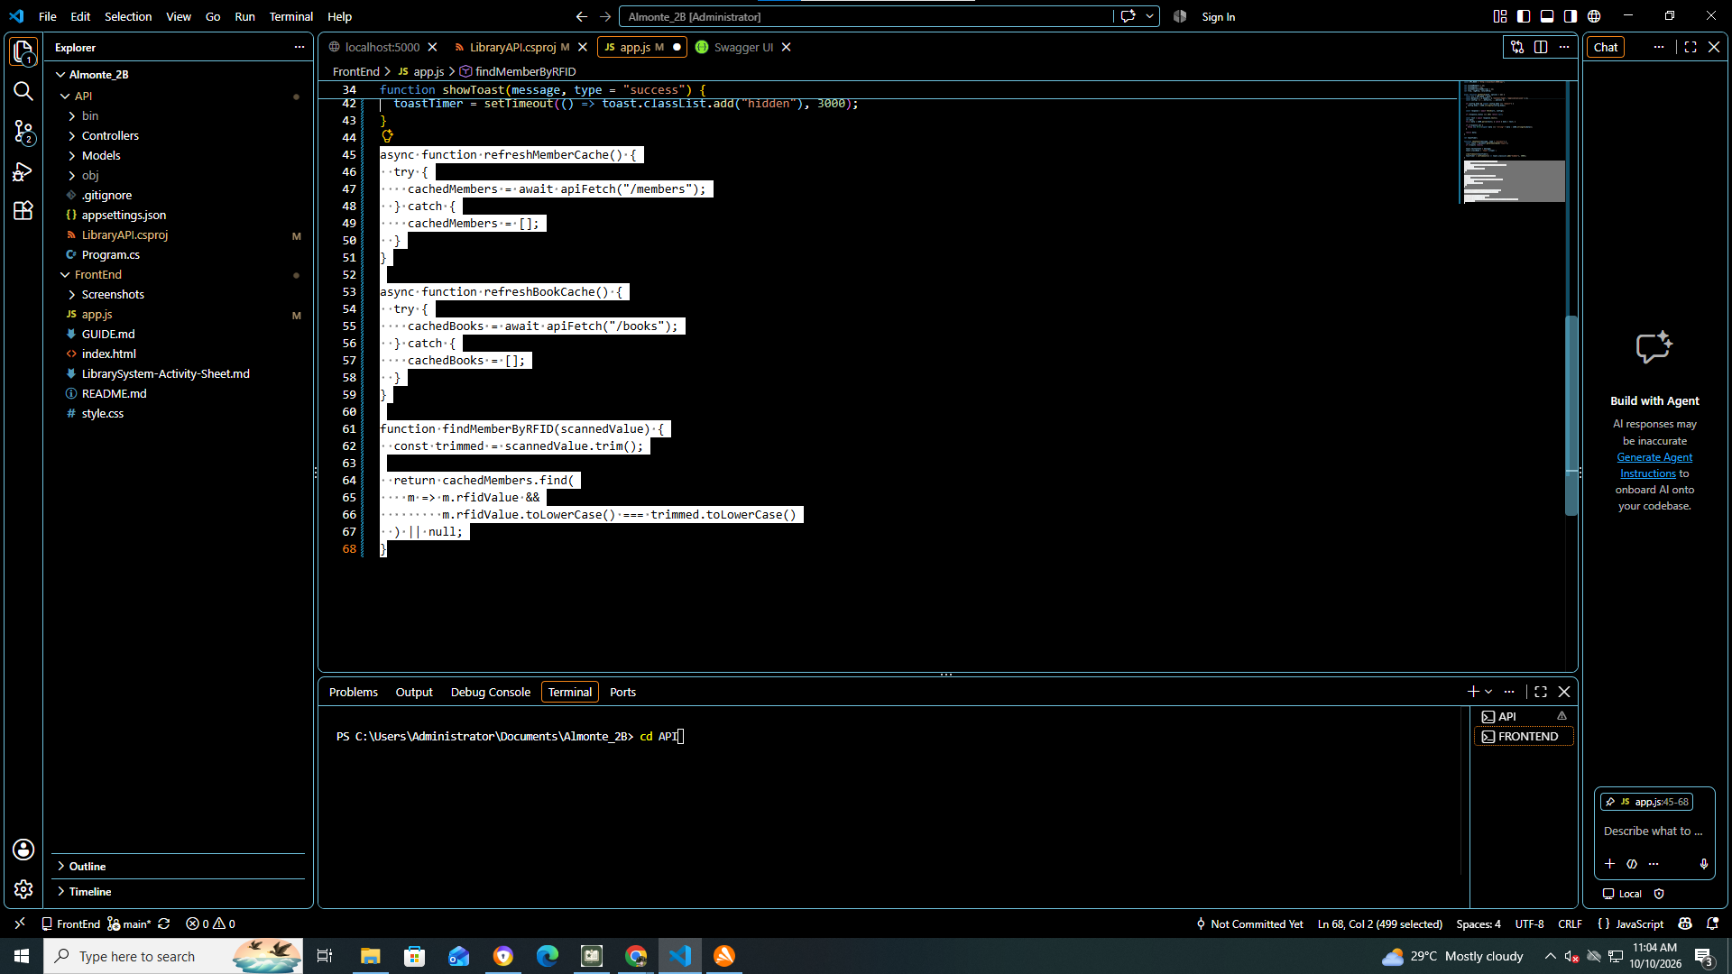

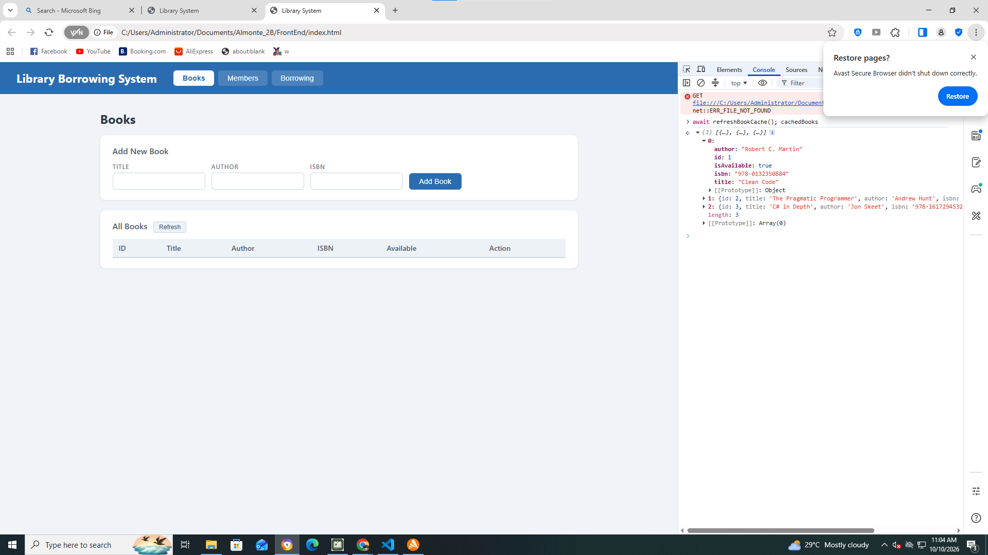

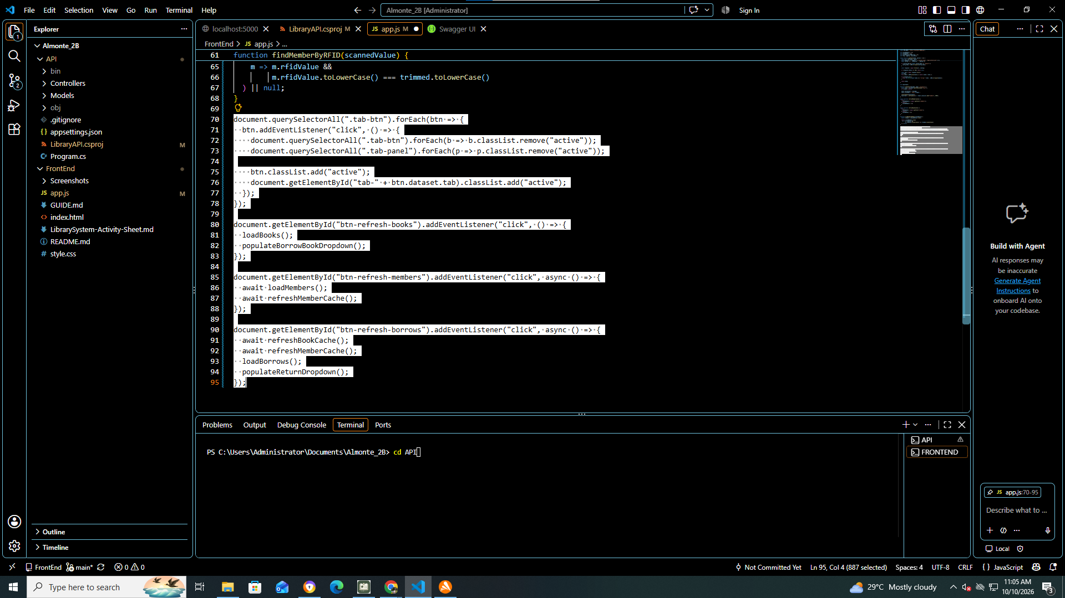

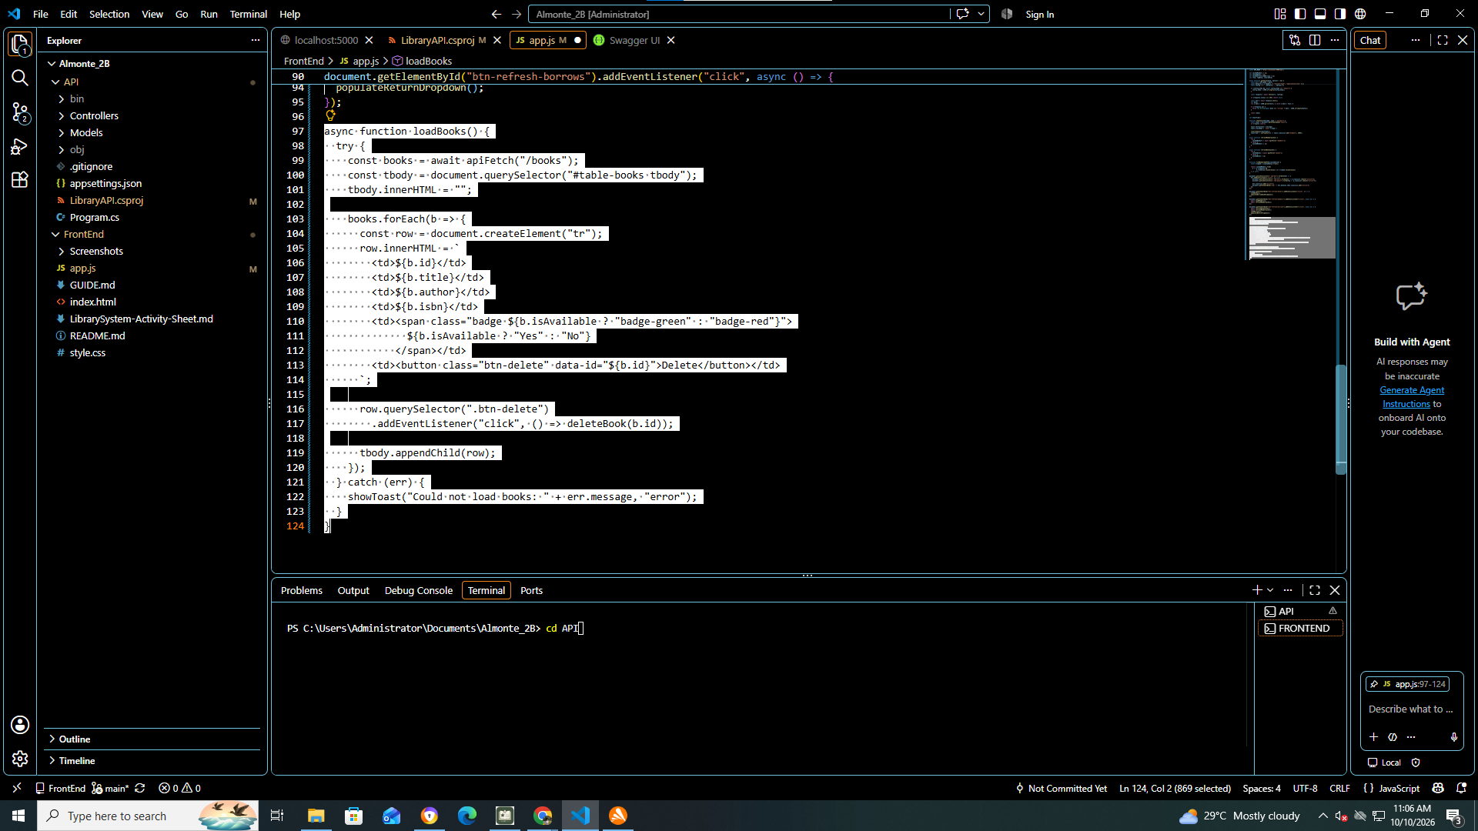

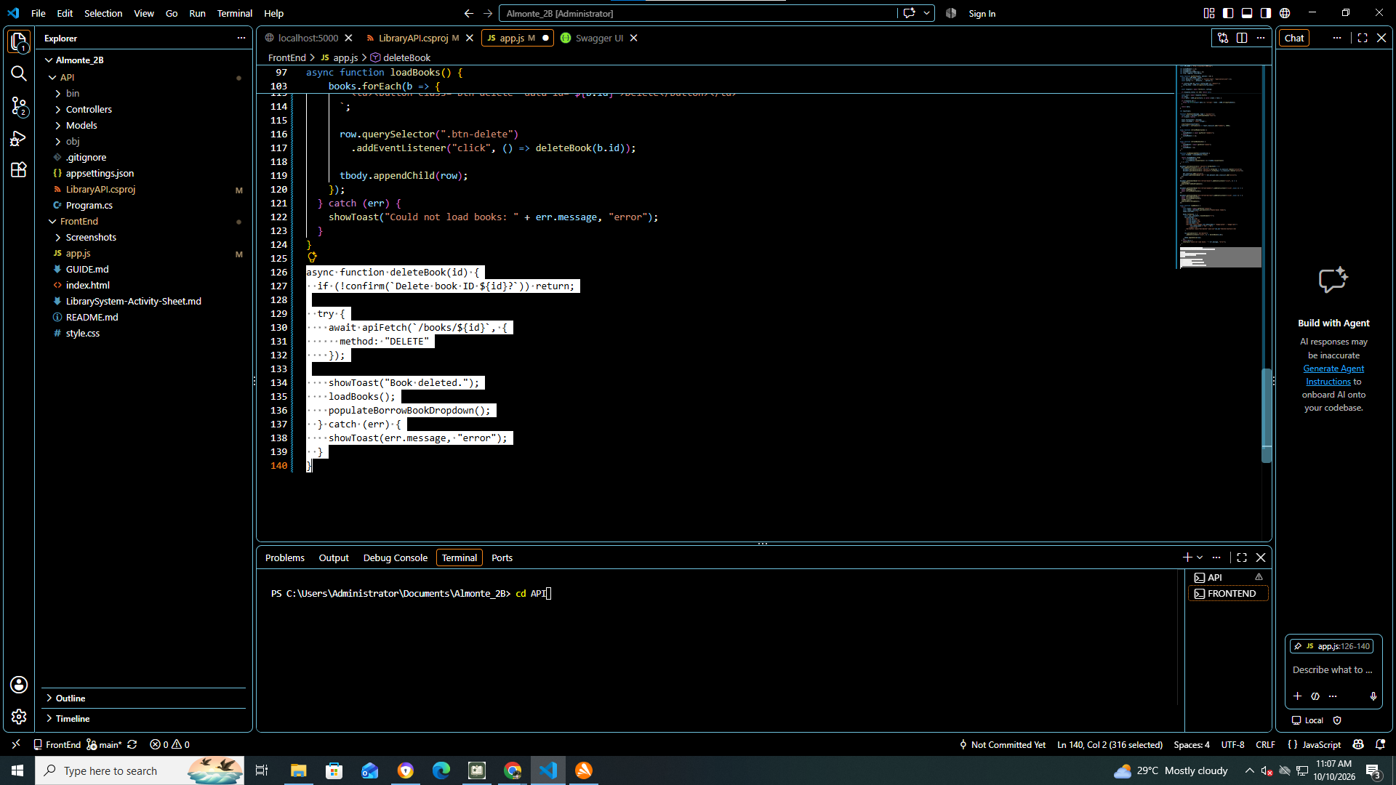

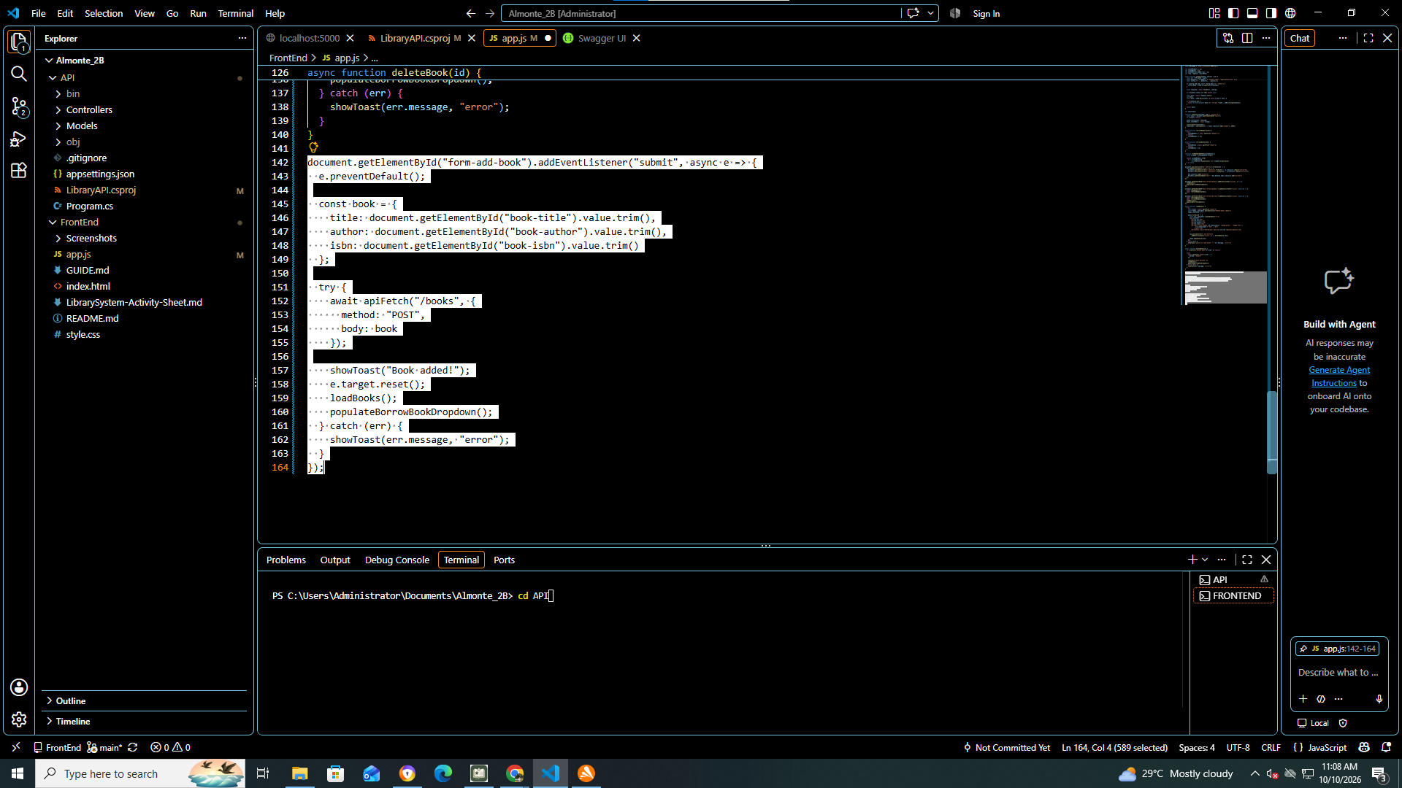

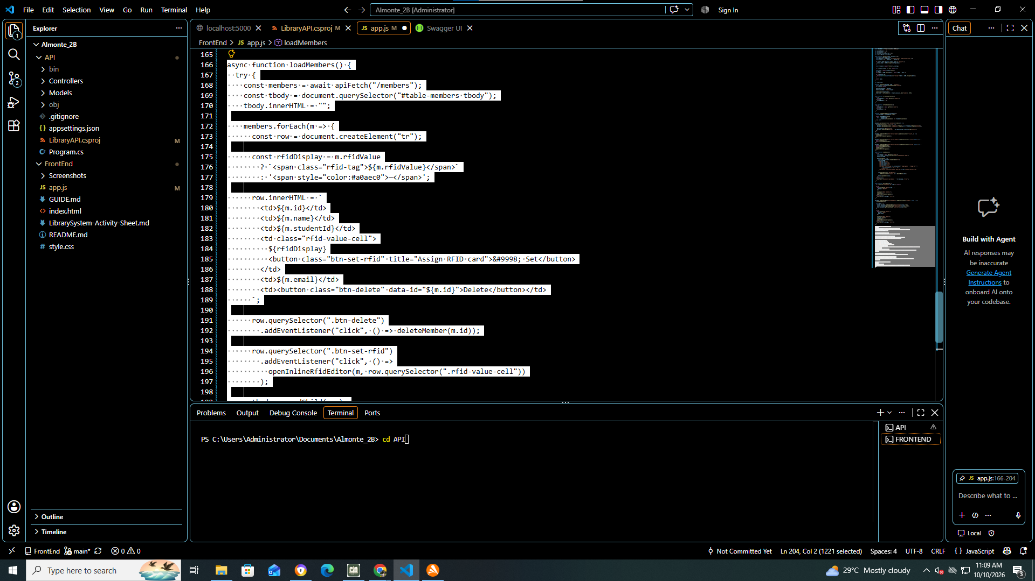

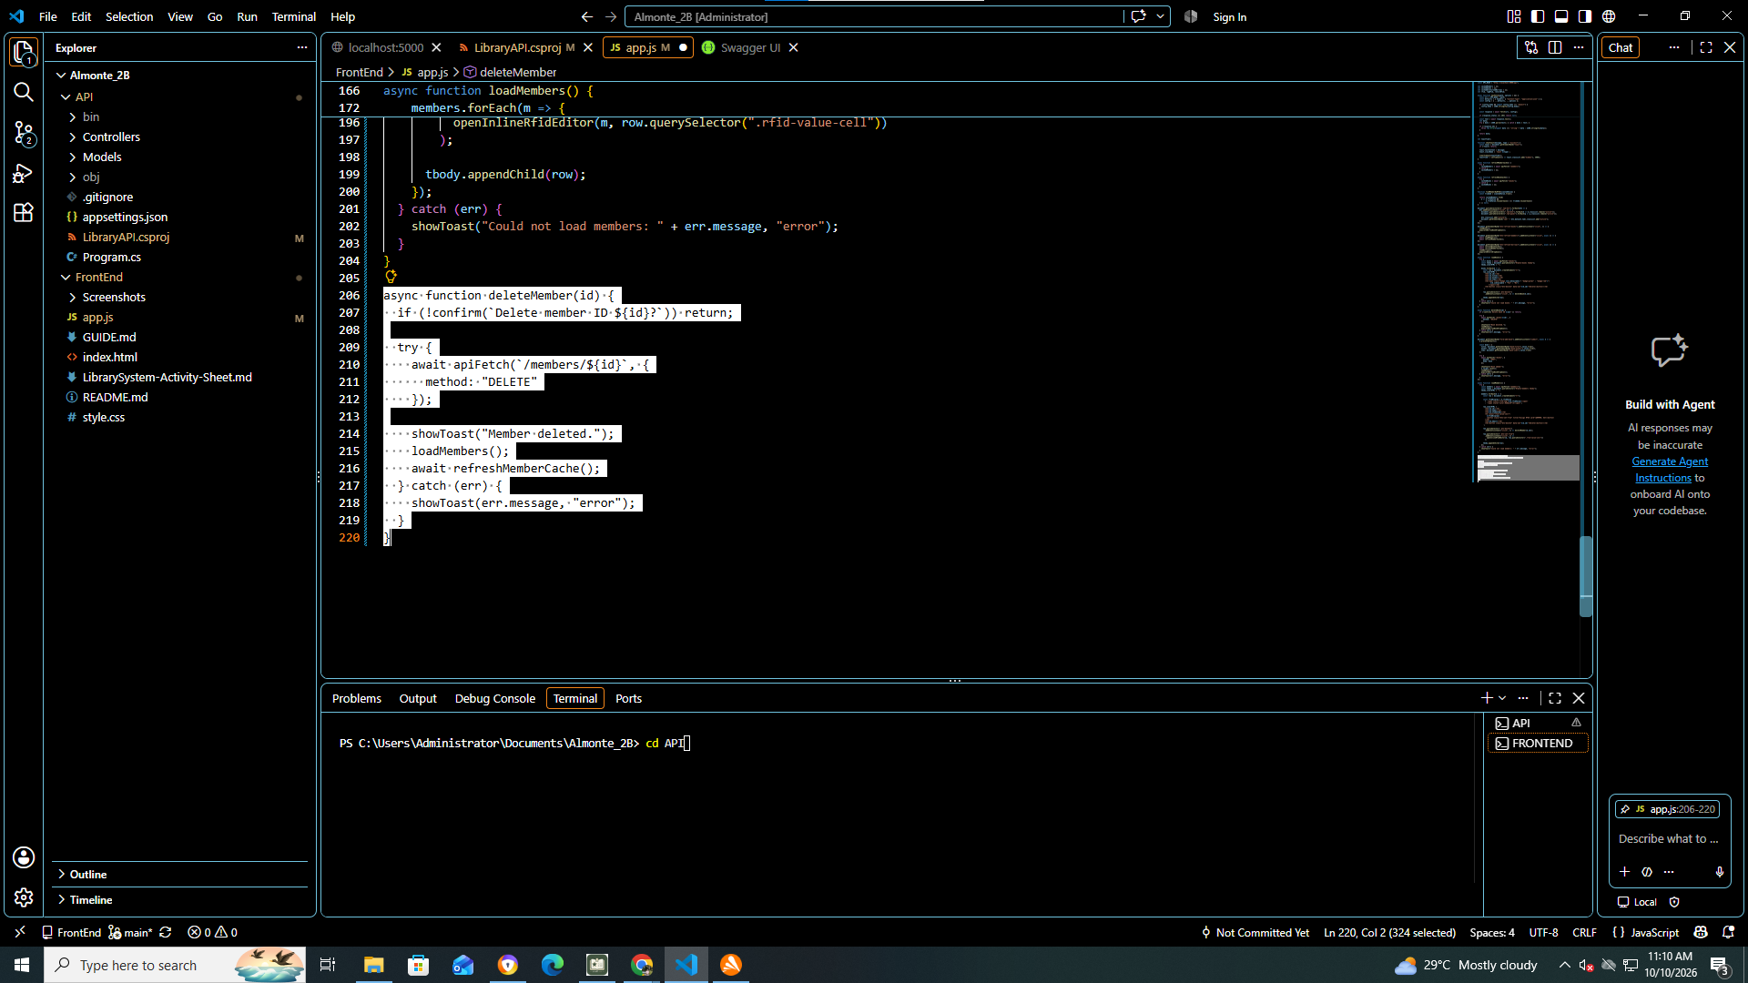

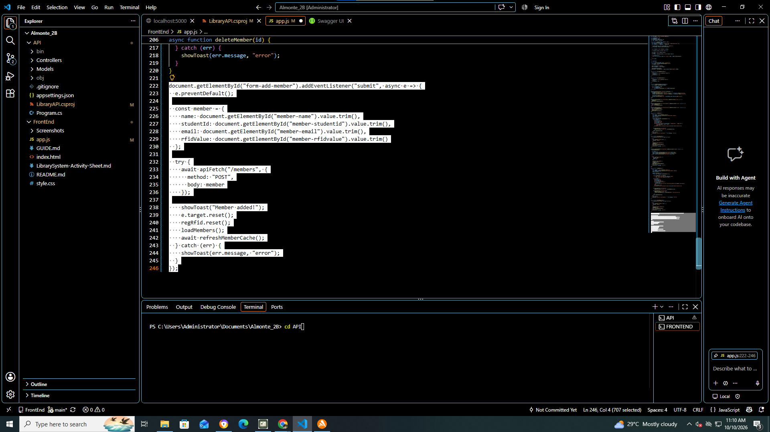

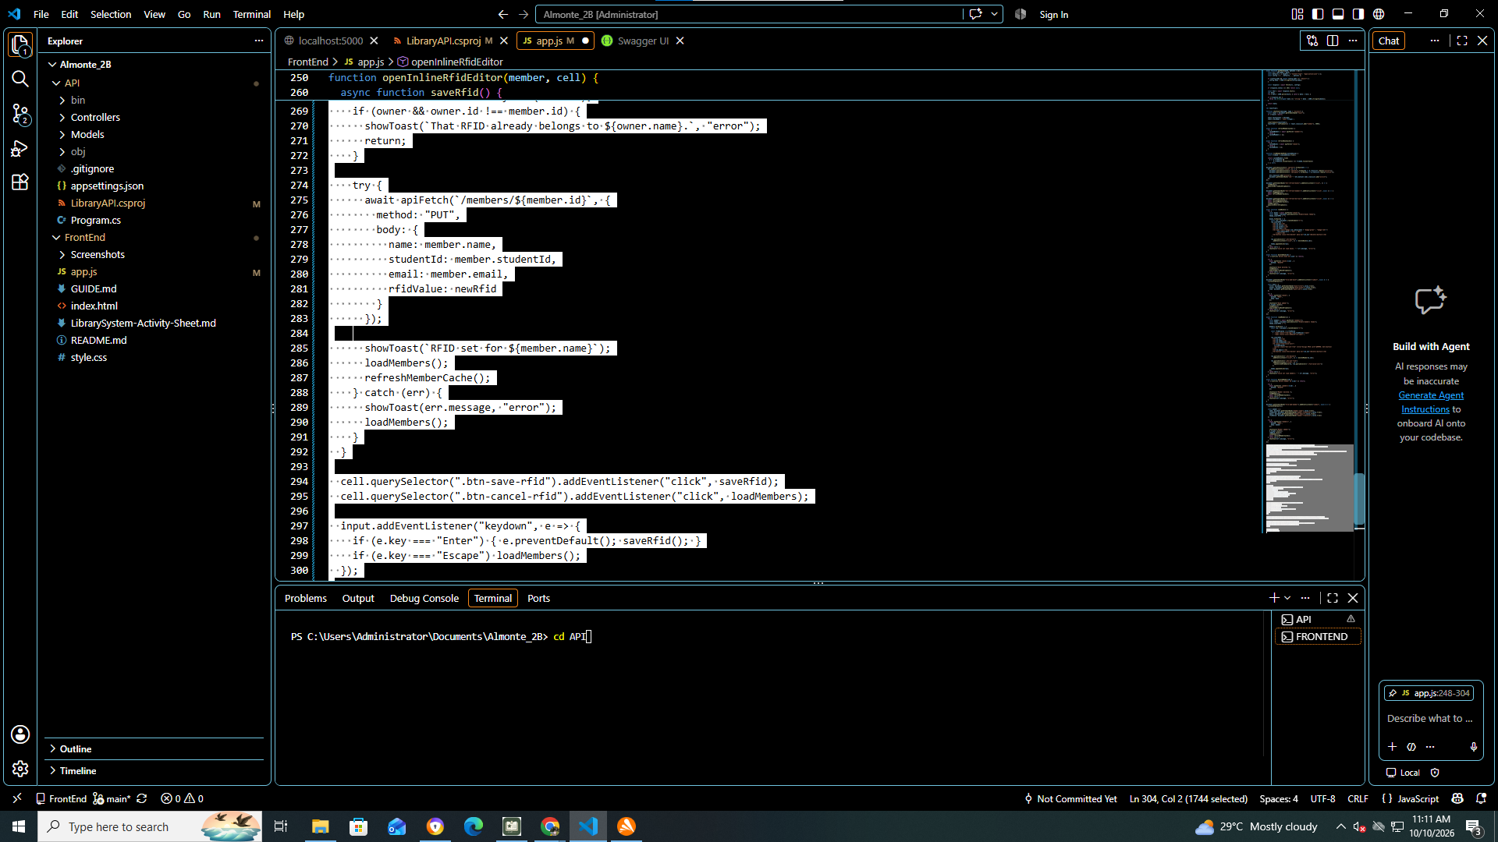

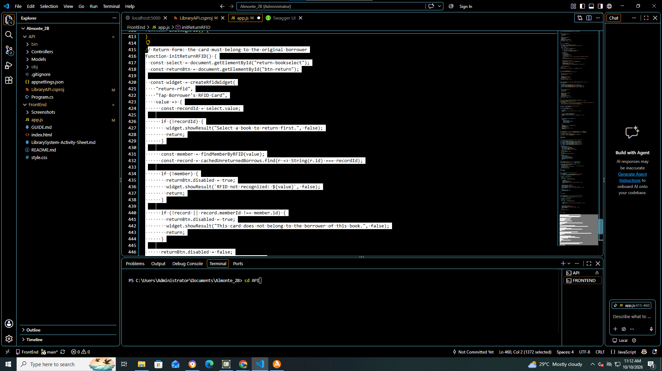

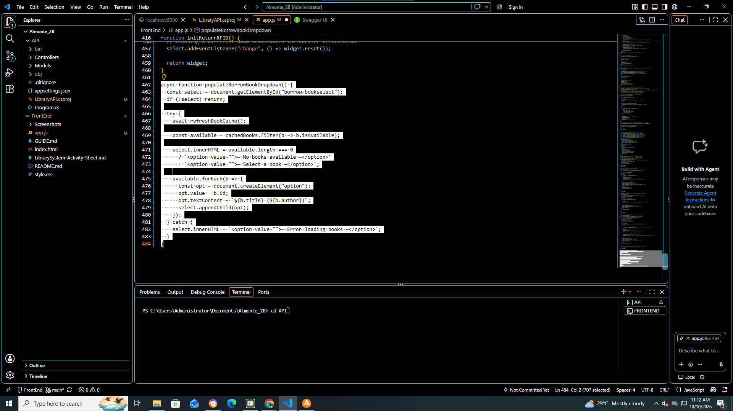

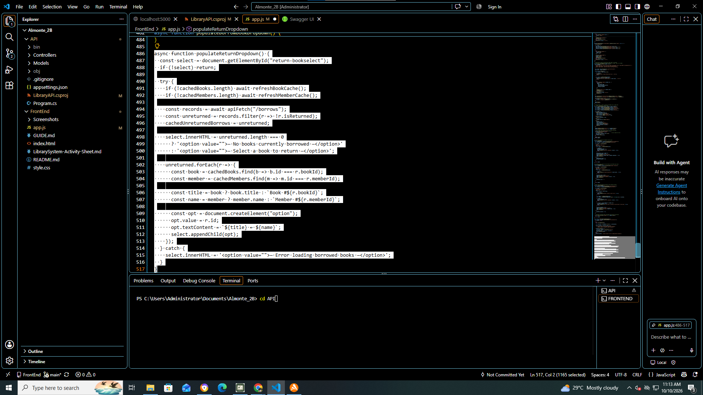

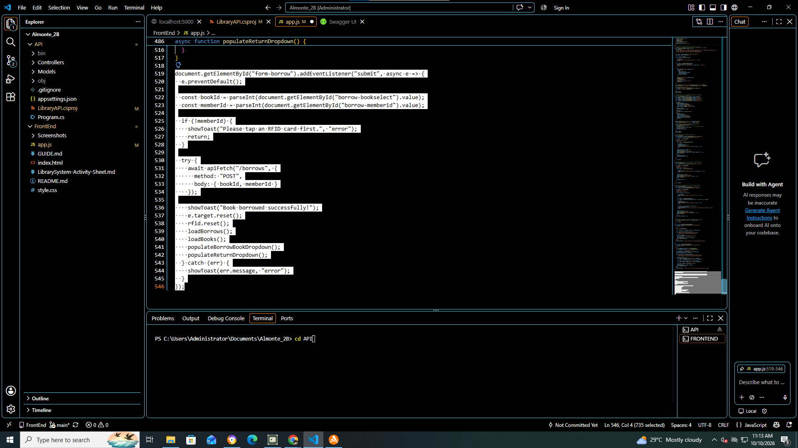

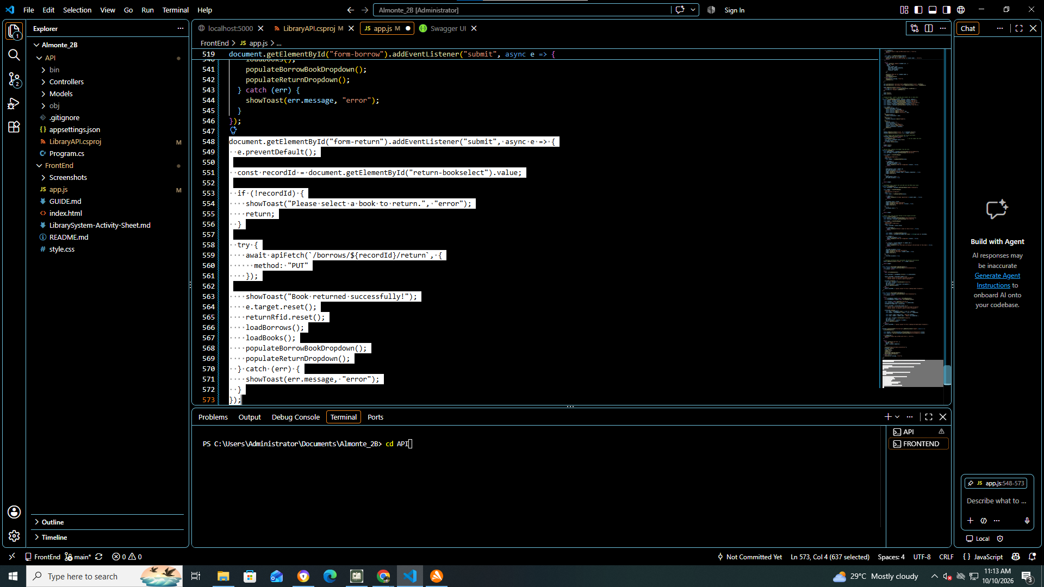

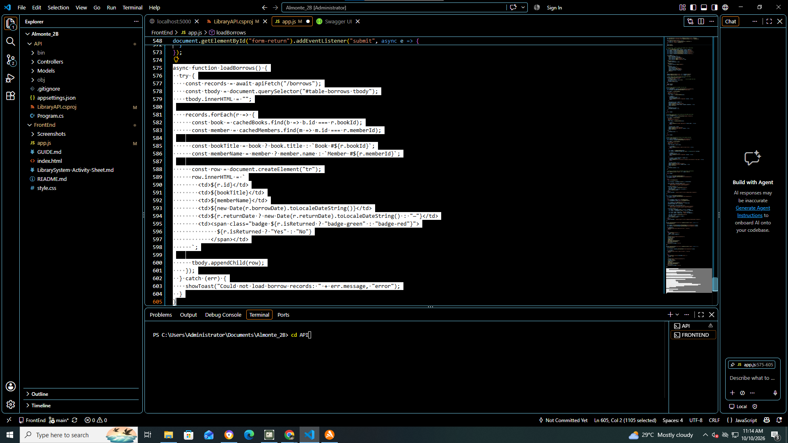

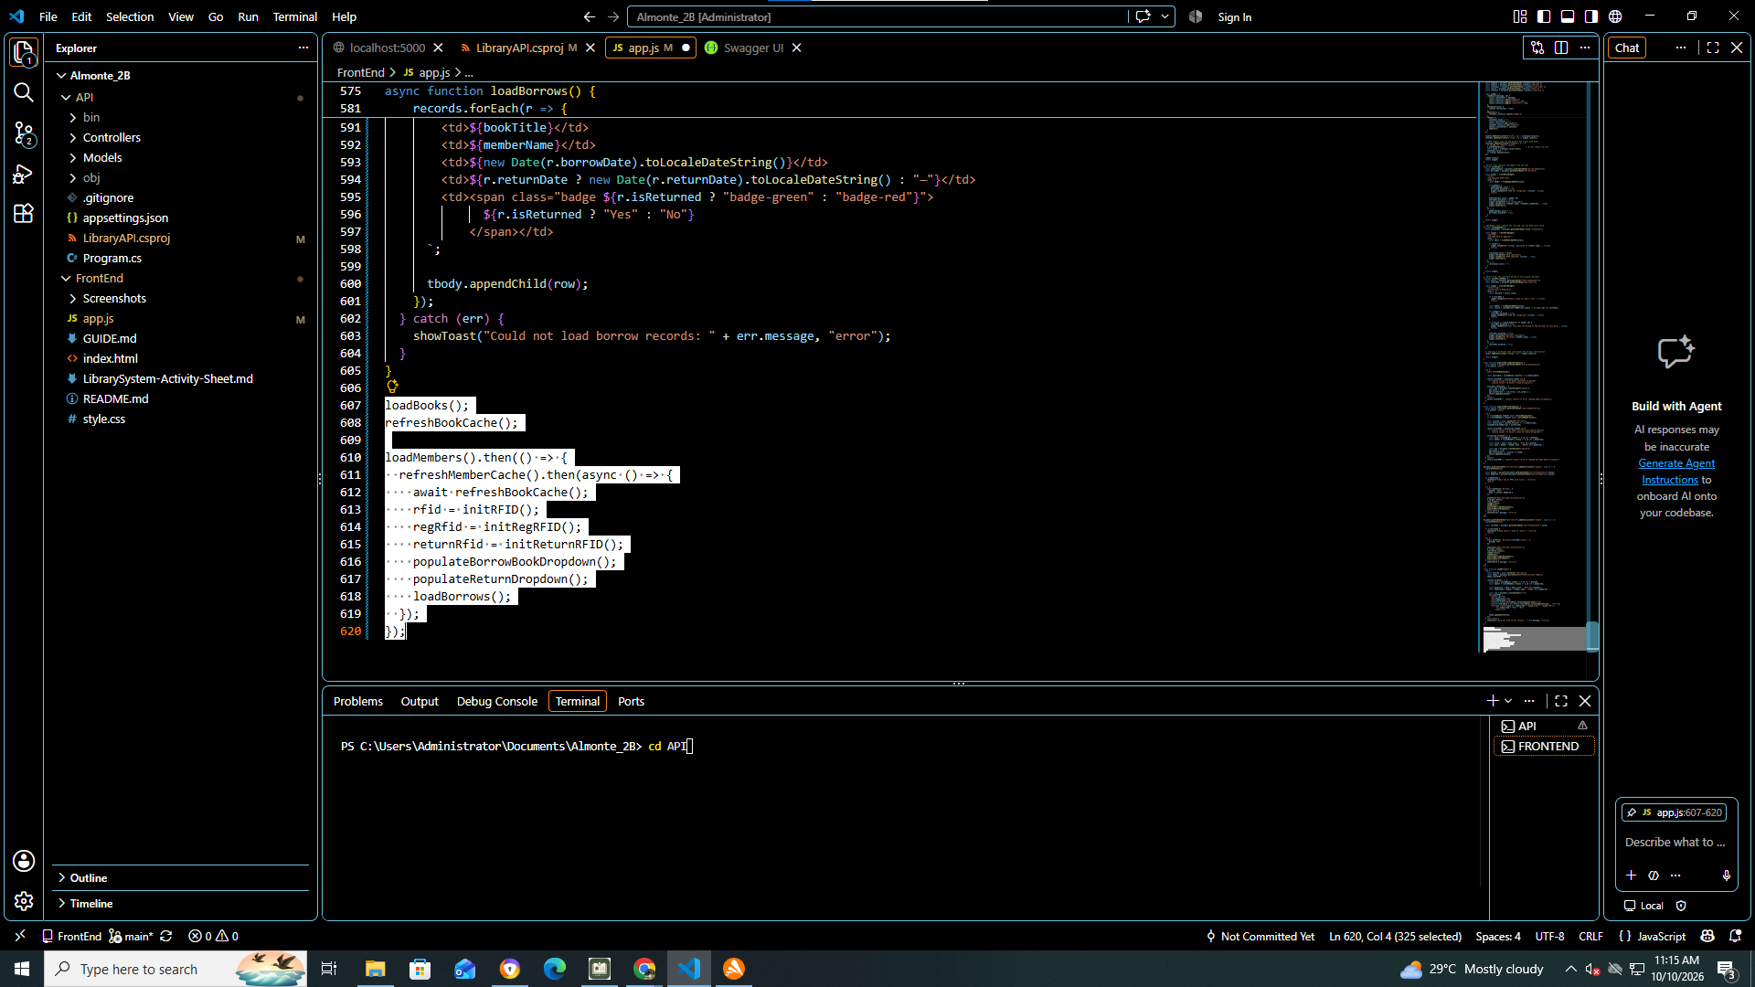

Test 2:
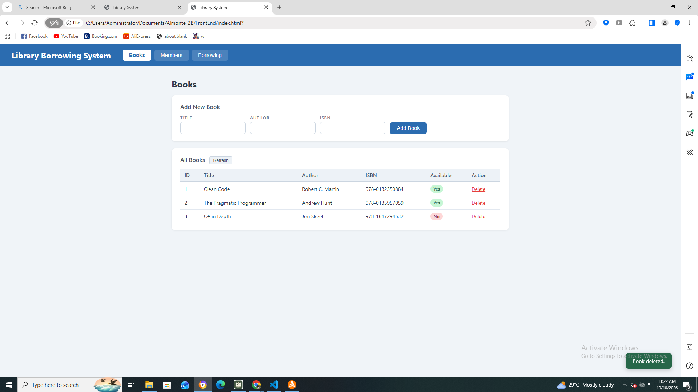

Test 3:\
DONE!

Test 4:
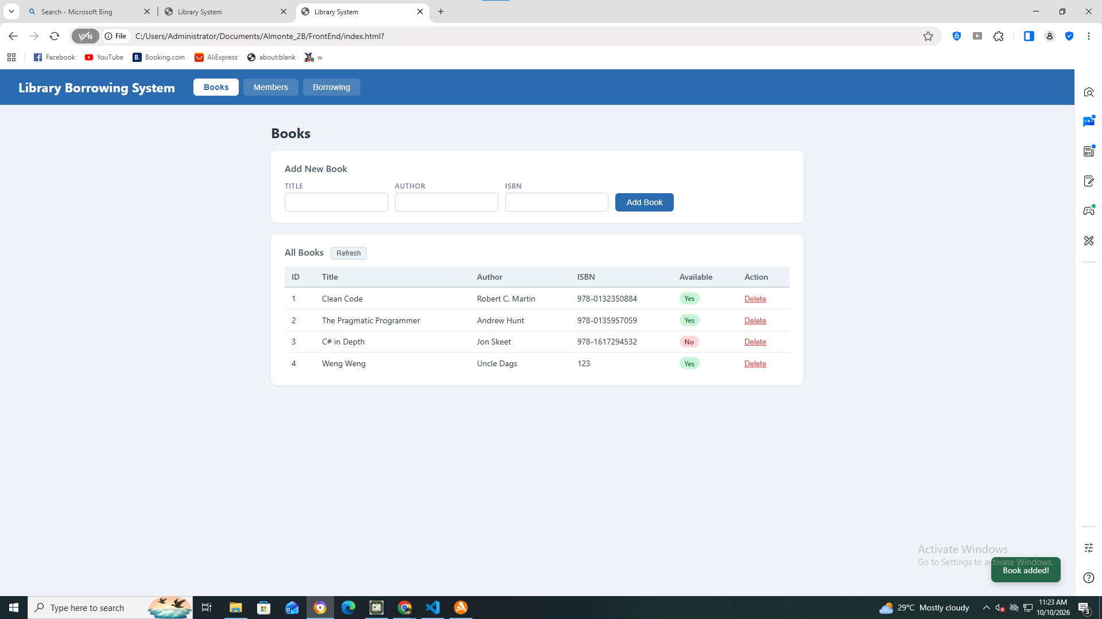

Test 5:
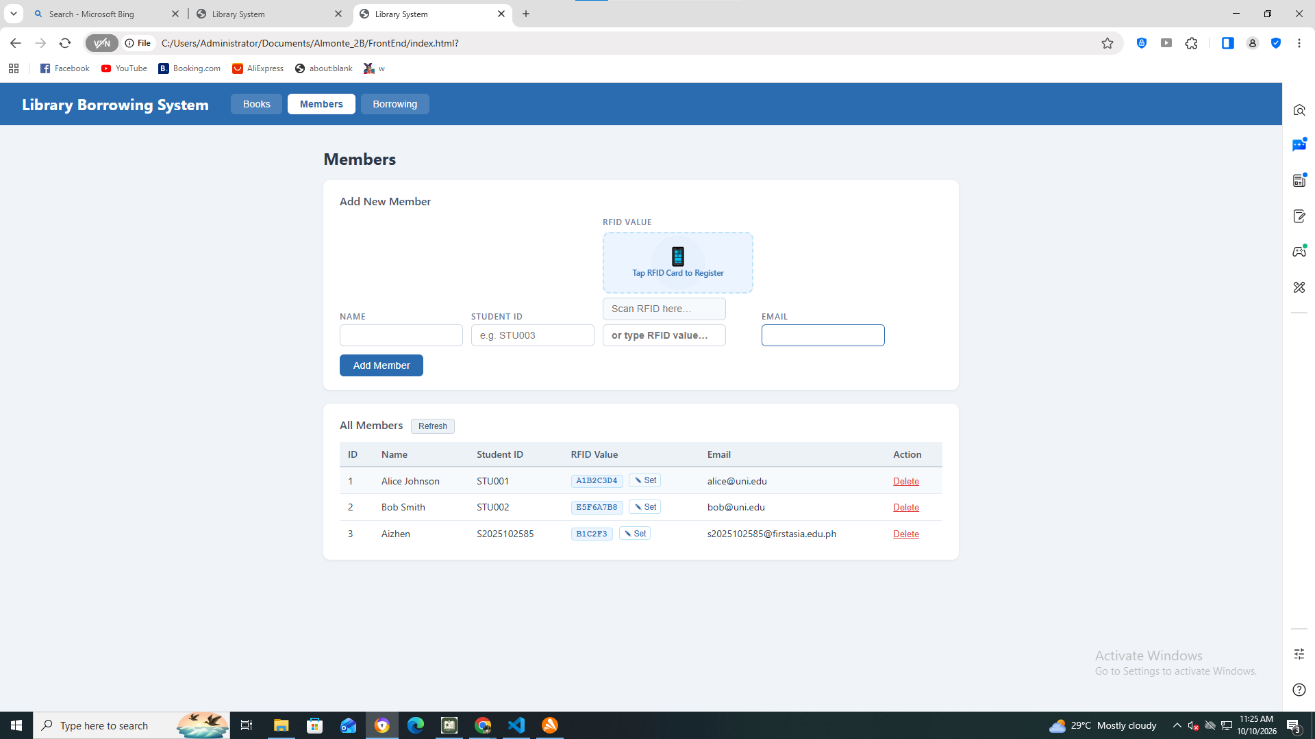

Test 6:
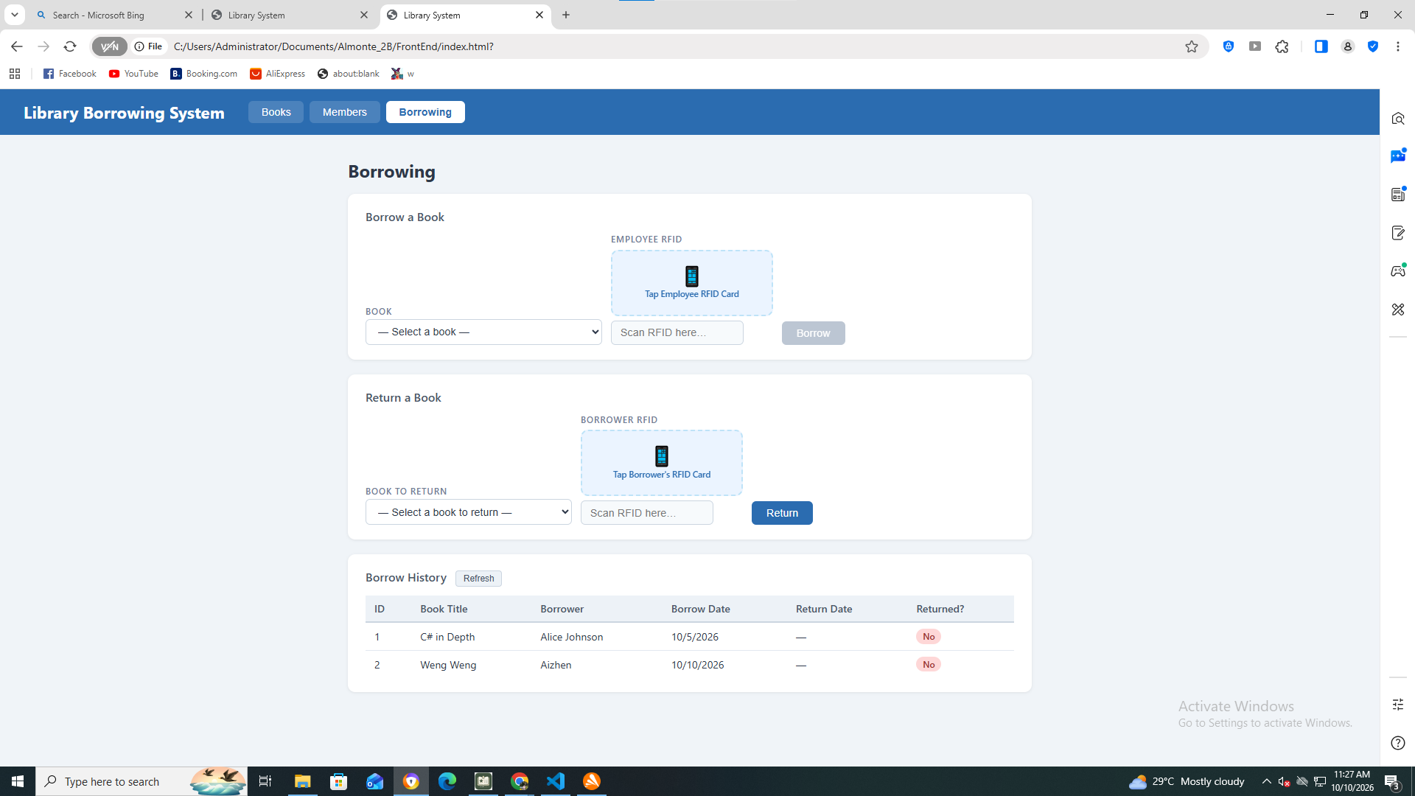

Test 7:
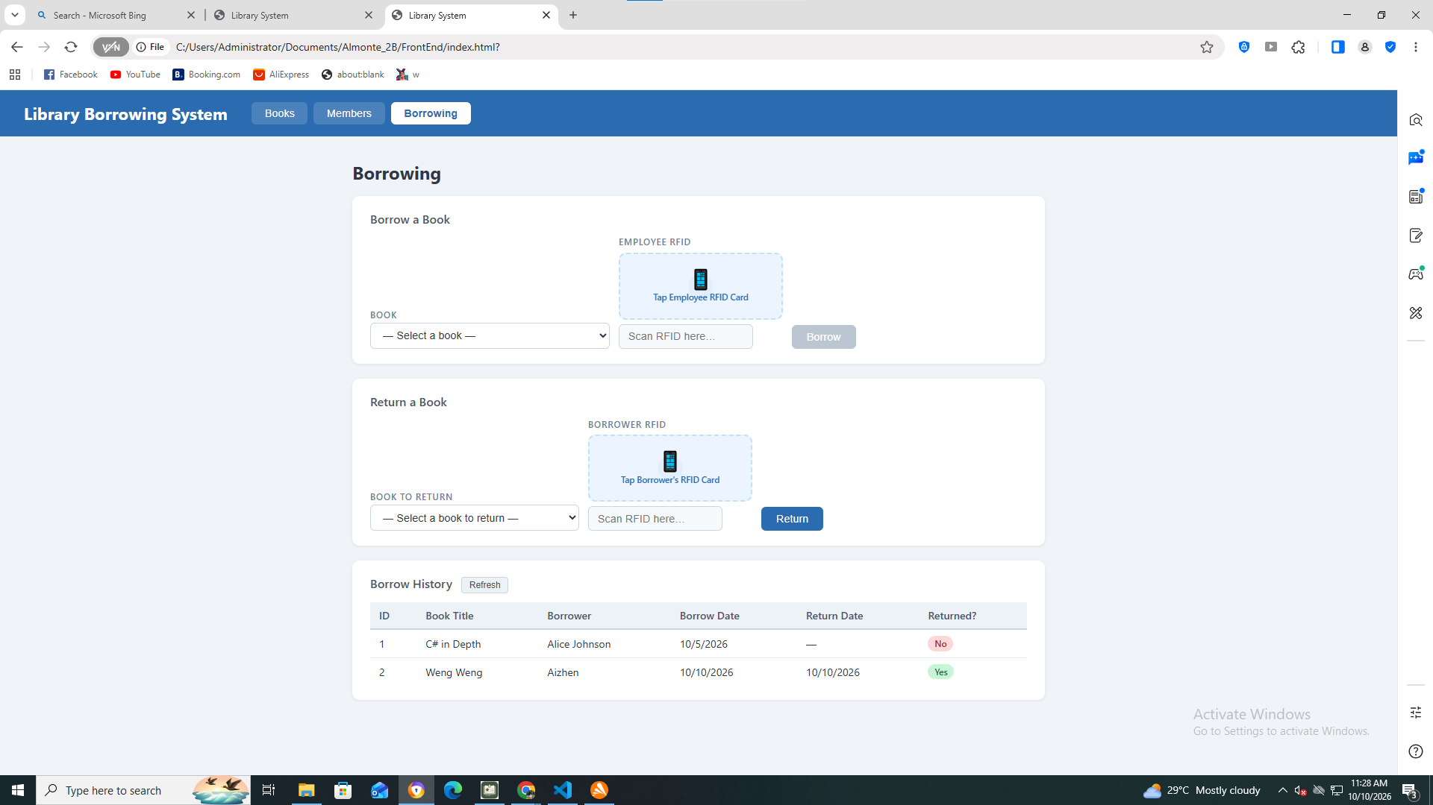

Test 8:
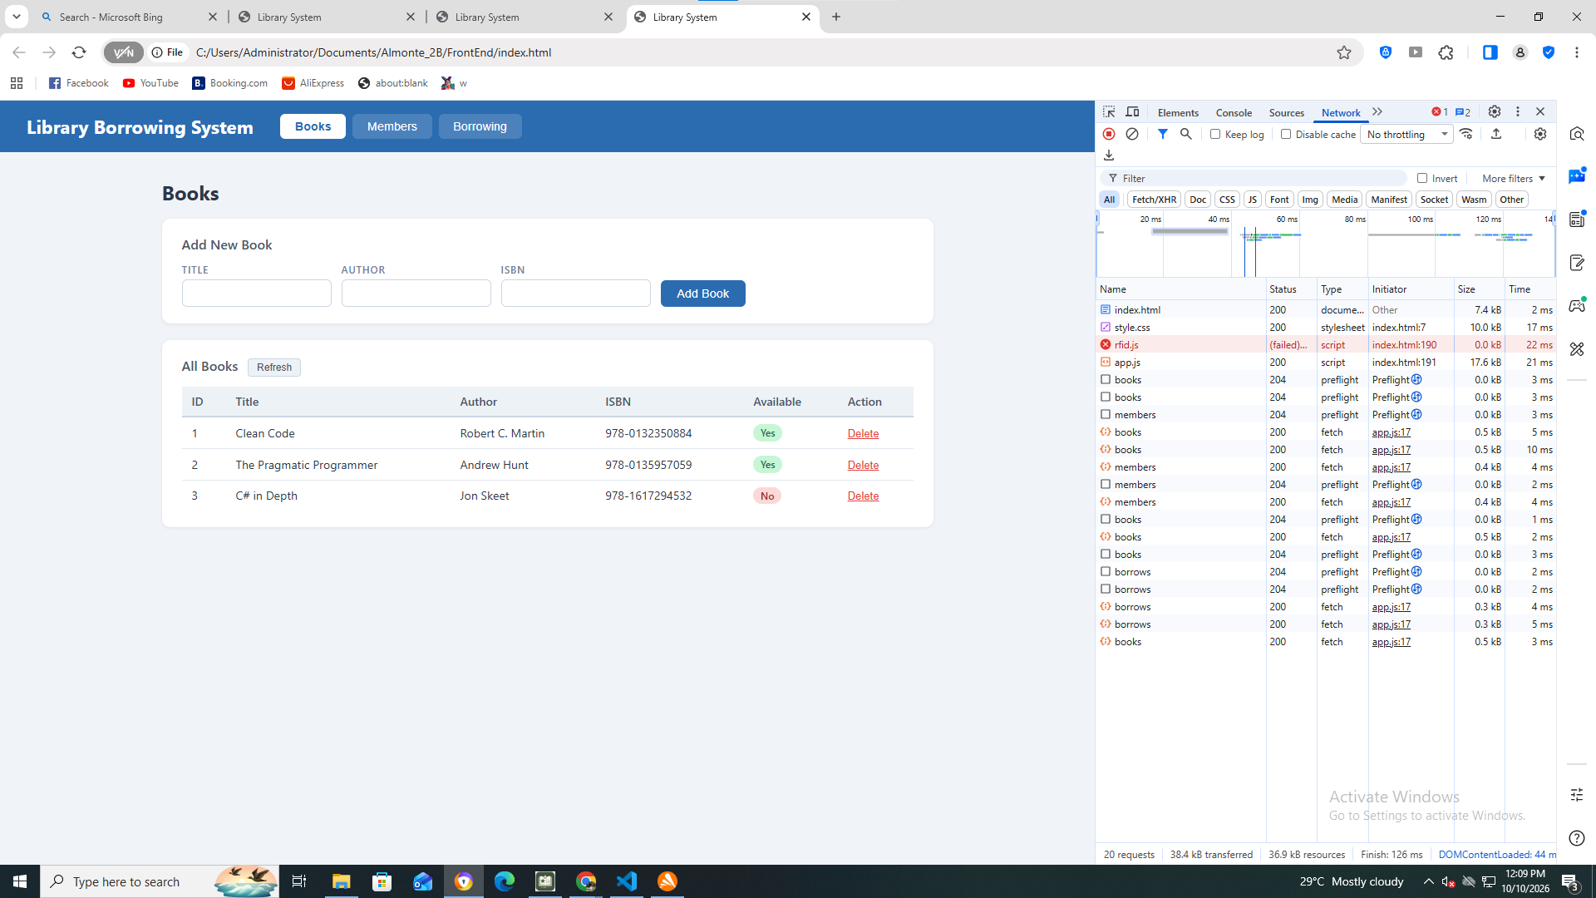

- What does apiFetch() do?
- apiFetch() is a helper function that sends requests to the API and handles responses, making it easier to communicate with the server without repeating code.
- Why do we use try/catch around API calls?
- We use try/catch to handle errors during API calls so the system can respond properly when a request fails.
- What is the difference between POST and PUT?
- POST is commonly used to create a new record, while PUT is used to create or replace a resource at a specific URL, often to update an existing record.
- Why does RFID matching use rfidValue instead of studentId?
- RFID matching uses rfidValue because it is the code scanned from the student's RFID card, which the system uses to identify the corresponding student.

- Why do we refresh tables after adding, deleting, borrowing, or returning?
- We refresh the tables to display the latest data and ensure that the information shown on the page matches the database.
- Why does the Return dropdown use borrow record ID instead of book ID?
- The Return dropdown uses the borrow record ID because it identifies the specific borrowing transaction that needs to be returned, while the book ID only identifies the book.
- What happens if the same event listener is added to a form twice?
- If duplicate event listeners are registered, the same action may execute more than once, potentially causing duplicate submissions or API requests.
- Why must the page-load code be at the bottom of the file?
- Page-load code is often placed at the bottom so the HTML elements are available before JavaScript tries to access them, preventing errors.
- Why does an RFID reader need e.preventDefault() on the Enter key?
- An RFID reader often sends an Enter key after scanning a card, so e.preventDefault() prevents the browser from submitting the form or performing another default action unintentionally.

