GIAN M. MANIMTIM
BSIT-2A

part-01-settings-apifetch

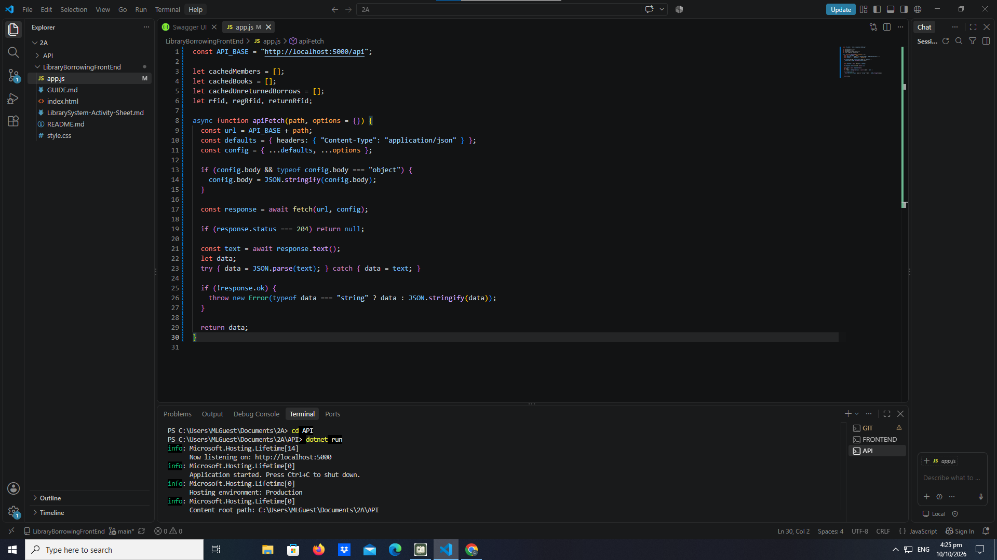

part-02-showtoast

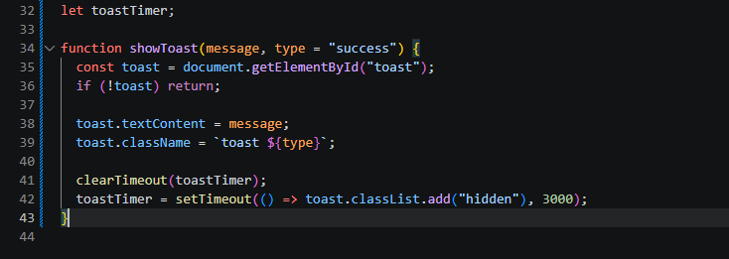

part-03-caches

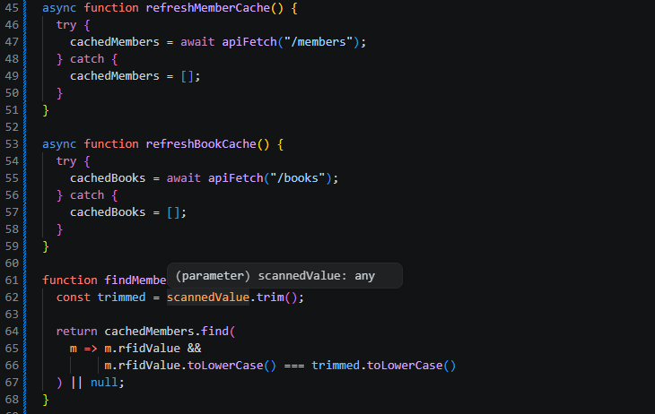

part-04-tabs-refresh
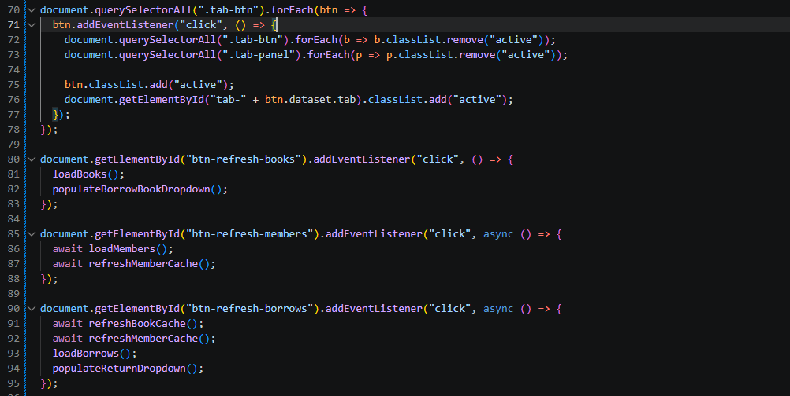

part-05-loadbooks
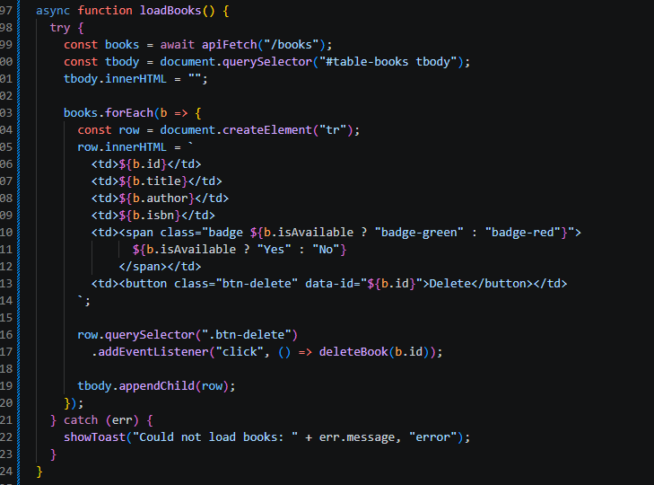

part-06-deletebook
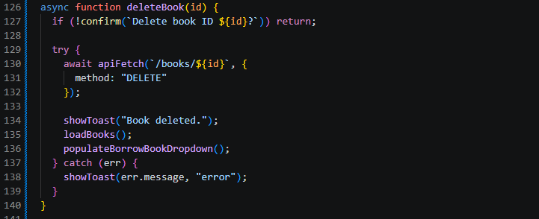

part-07-addbook
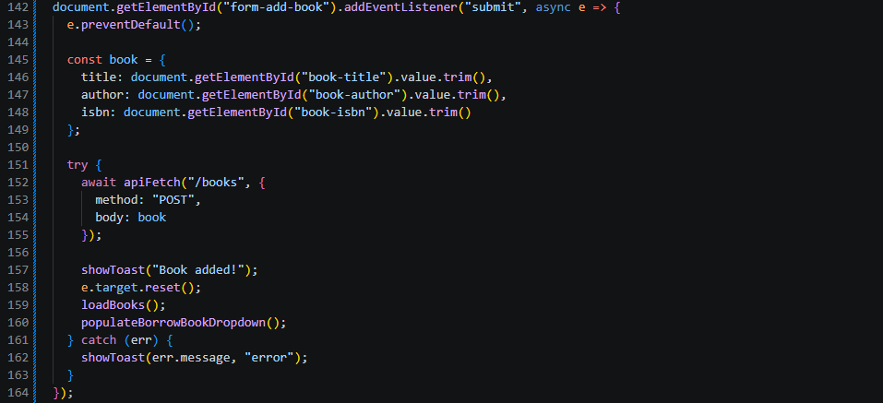

part-08-loadmembers
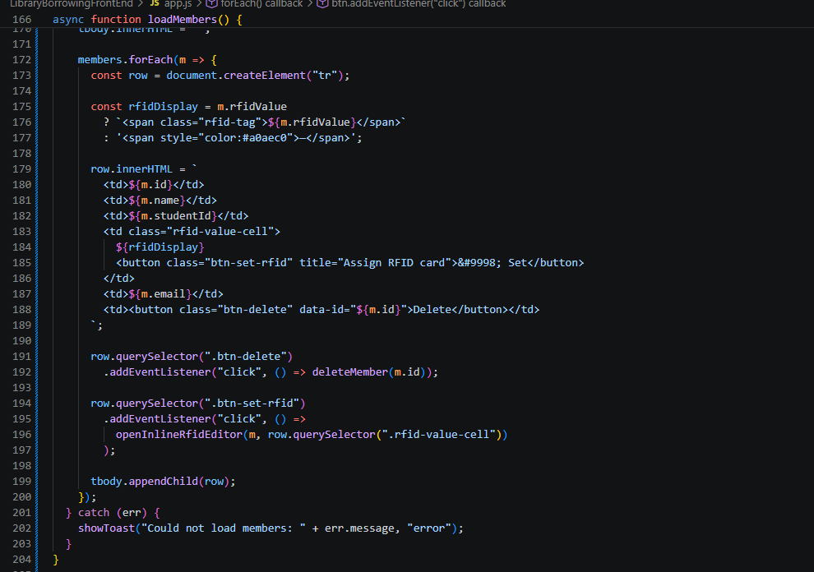

part-09-deletemember
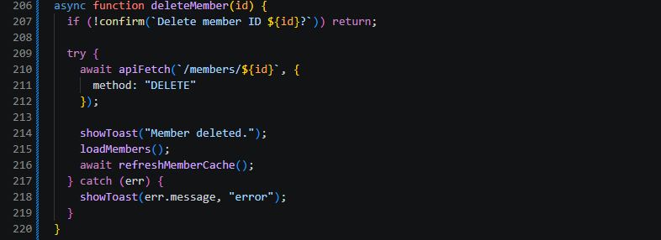

part-10-addmember
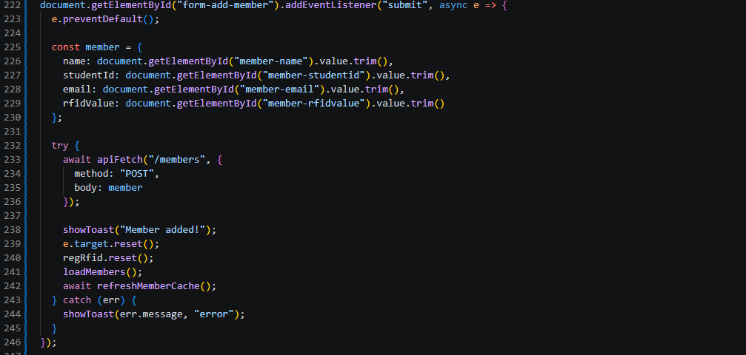

part-11-inline-rfid-editor
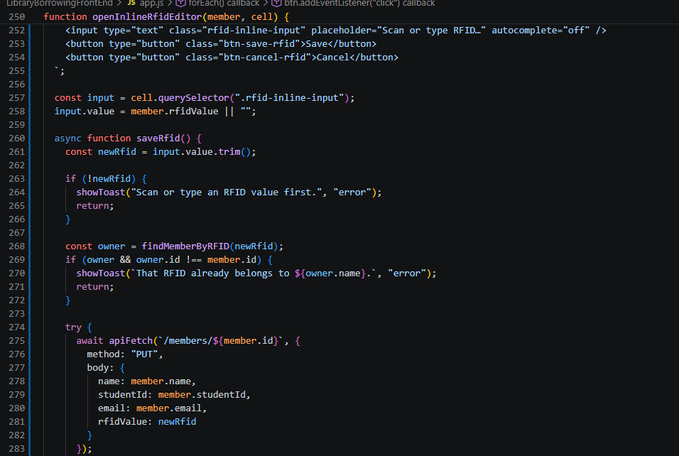

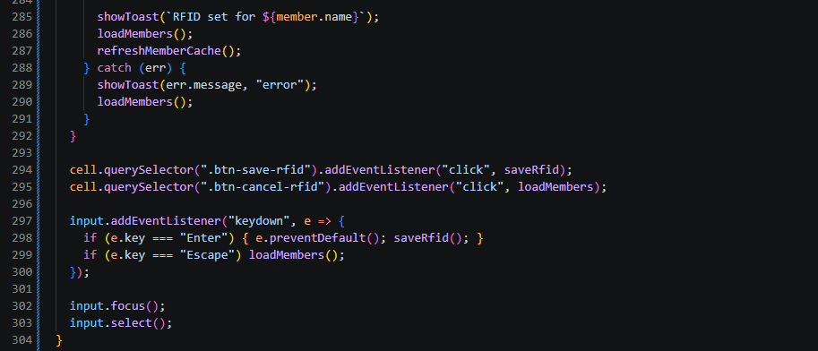

part-12a-rfid-widget-builder
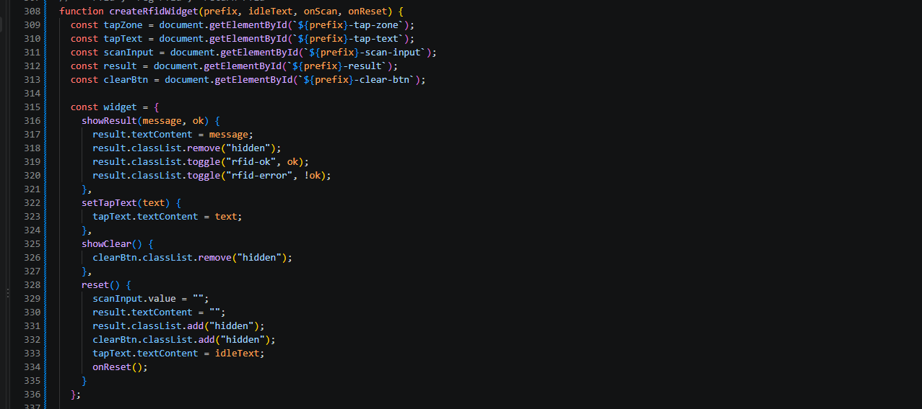

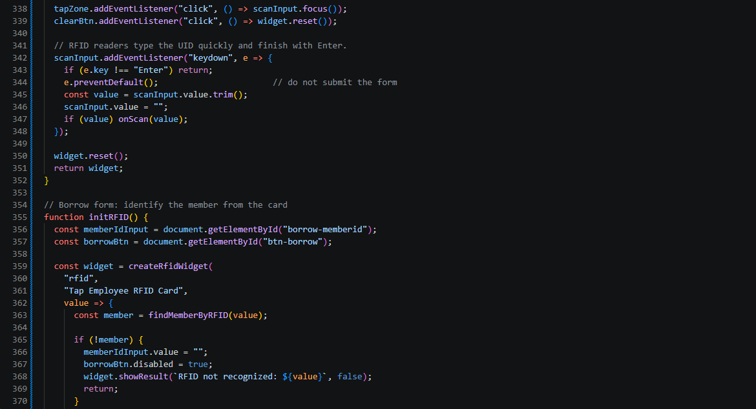

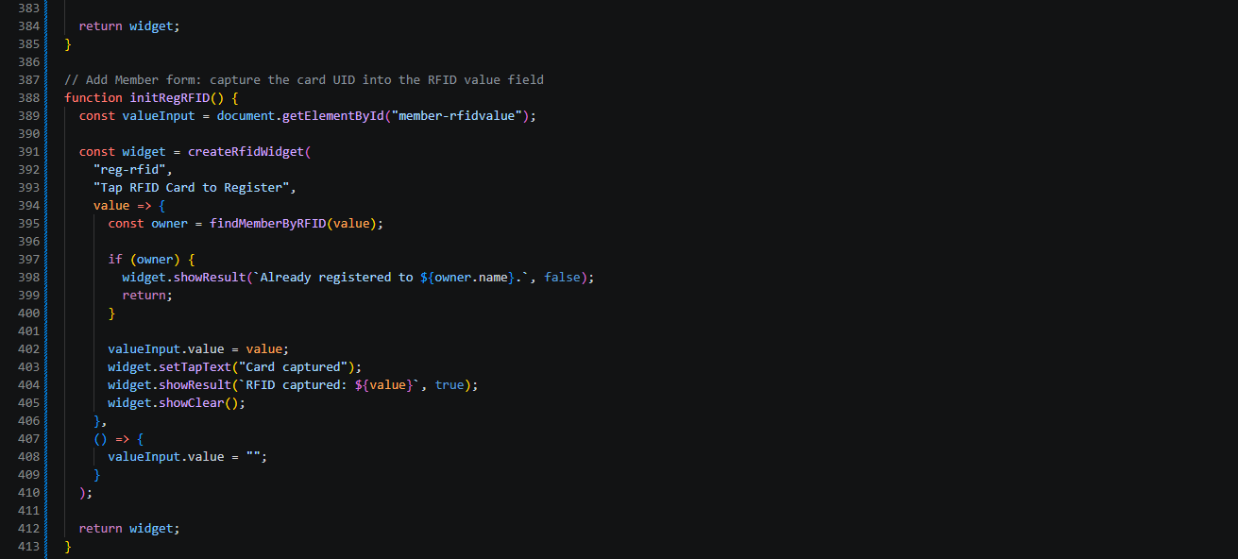

part-13-borrow-dropdown
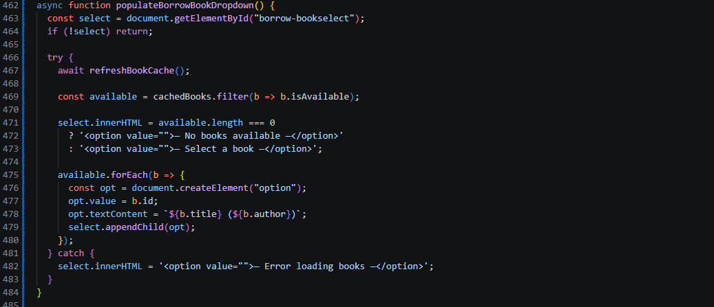

part-14-return-dropdown
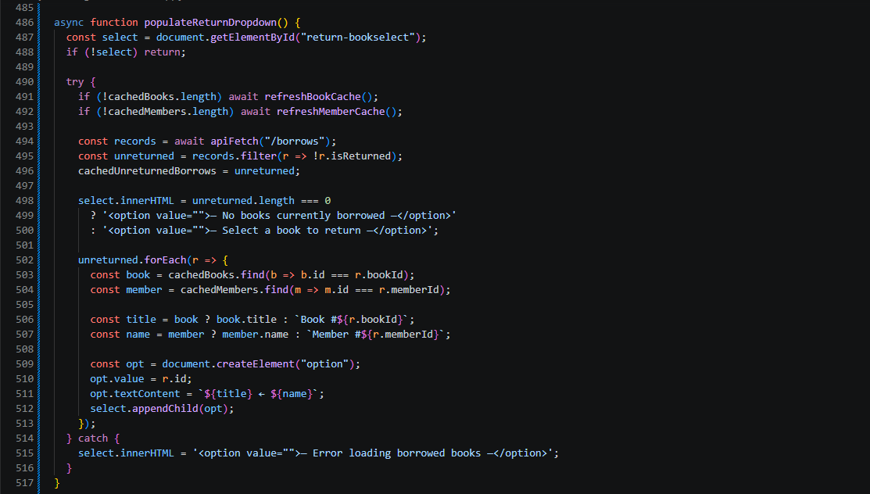

part-15-borrow
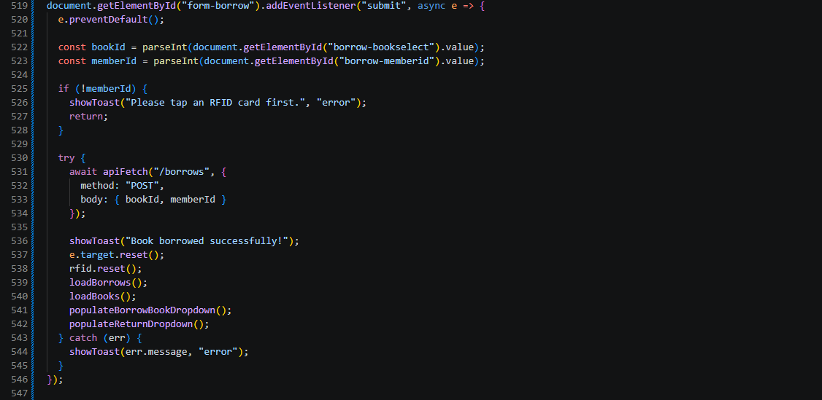

part-16-return
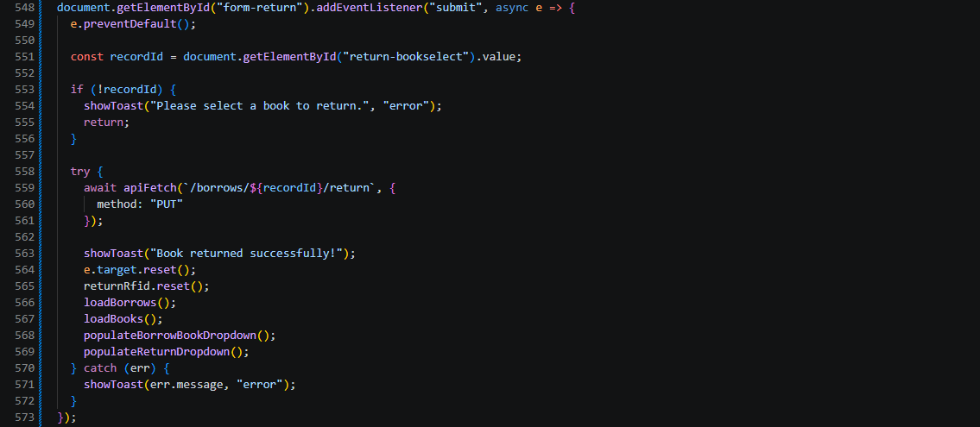

part-17-loadborrows
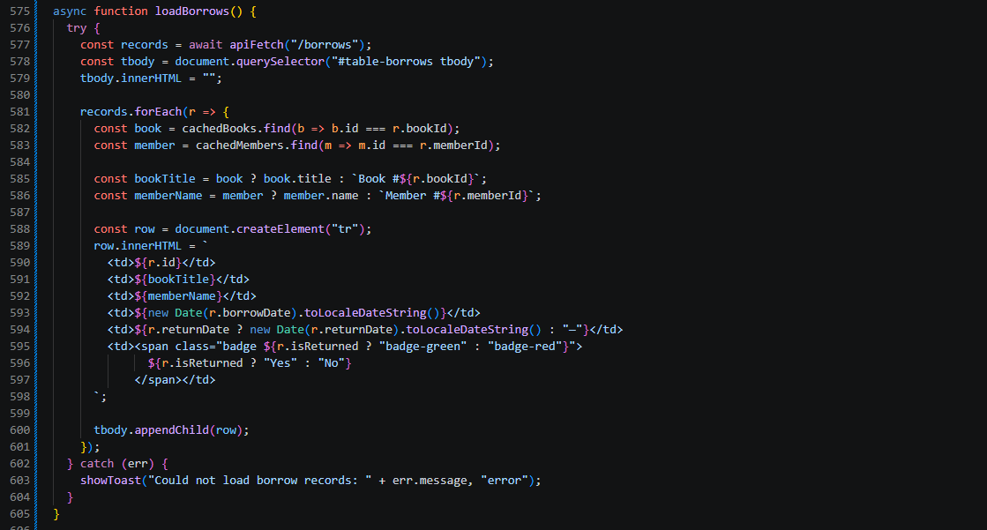

part-18-page-load
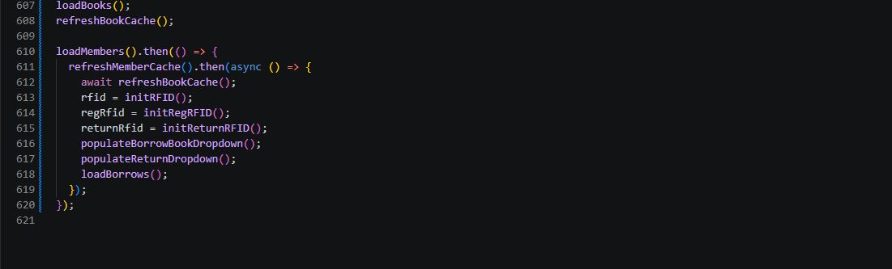

test-01-page-loaded

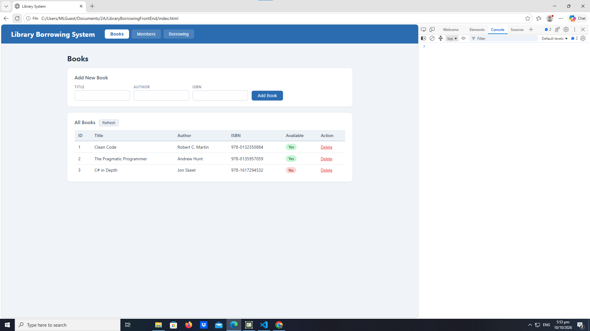

early-03-tabs
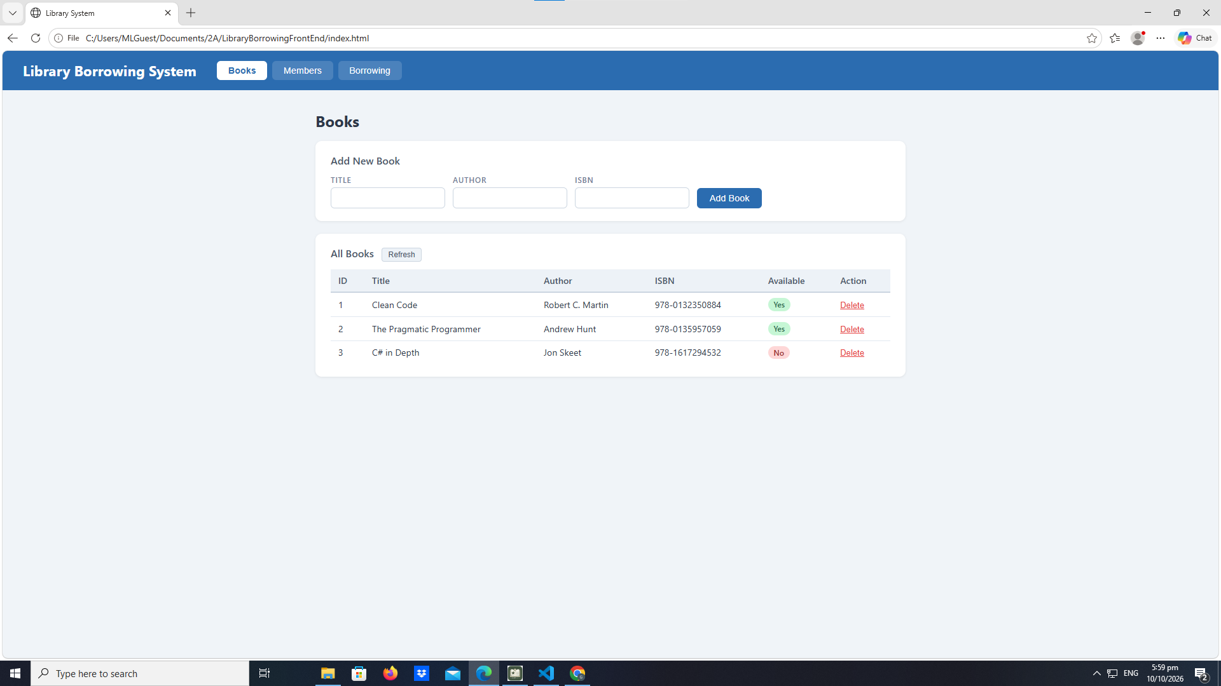

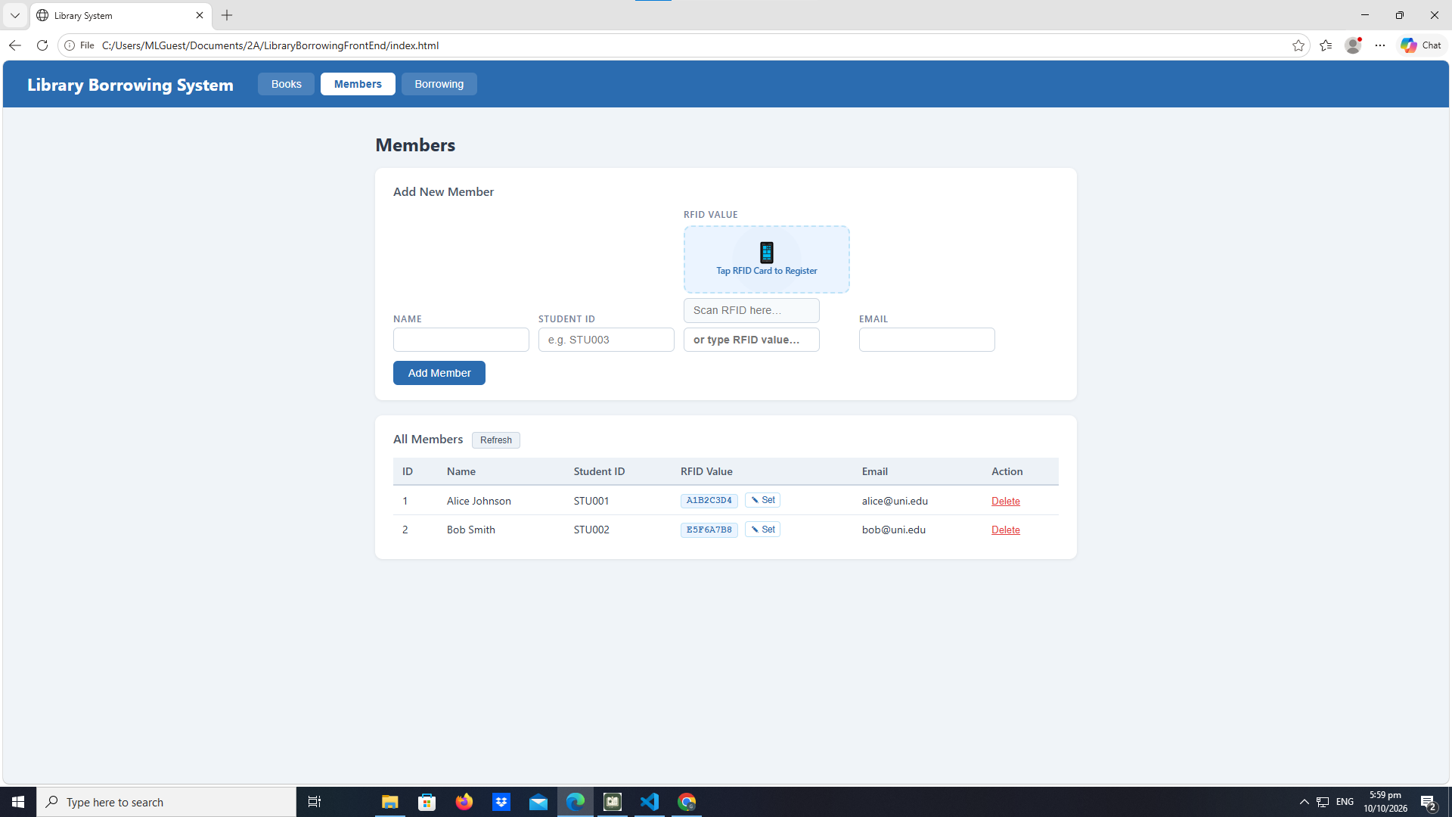

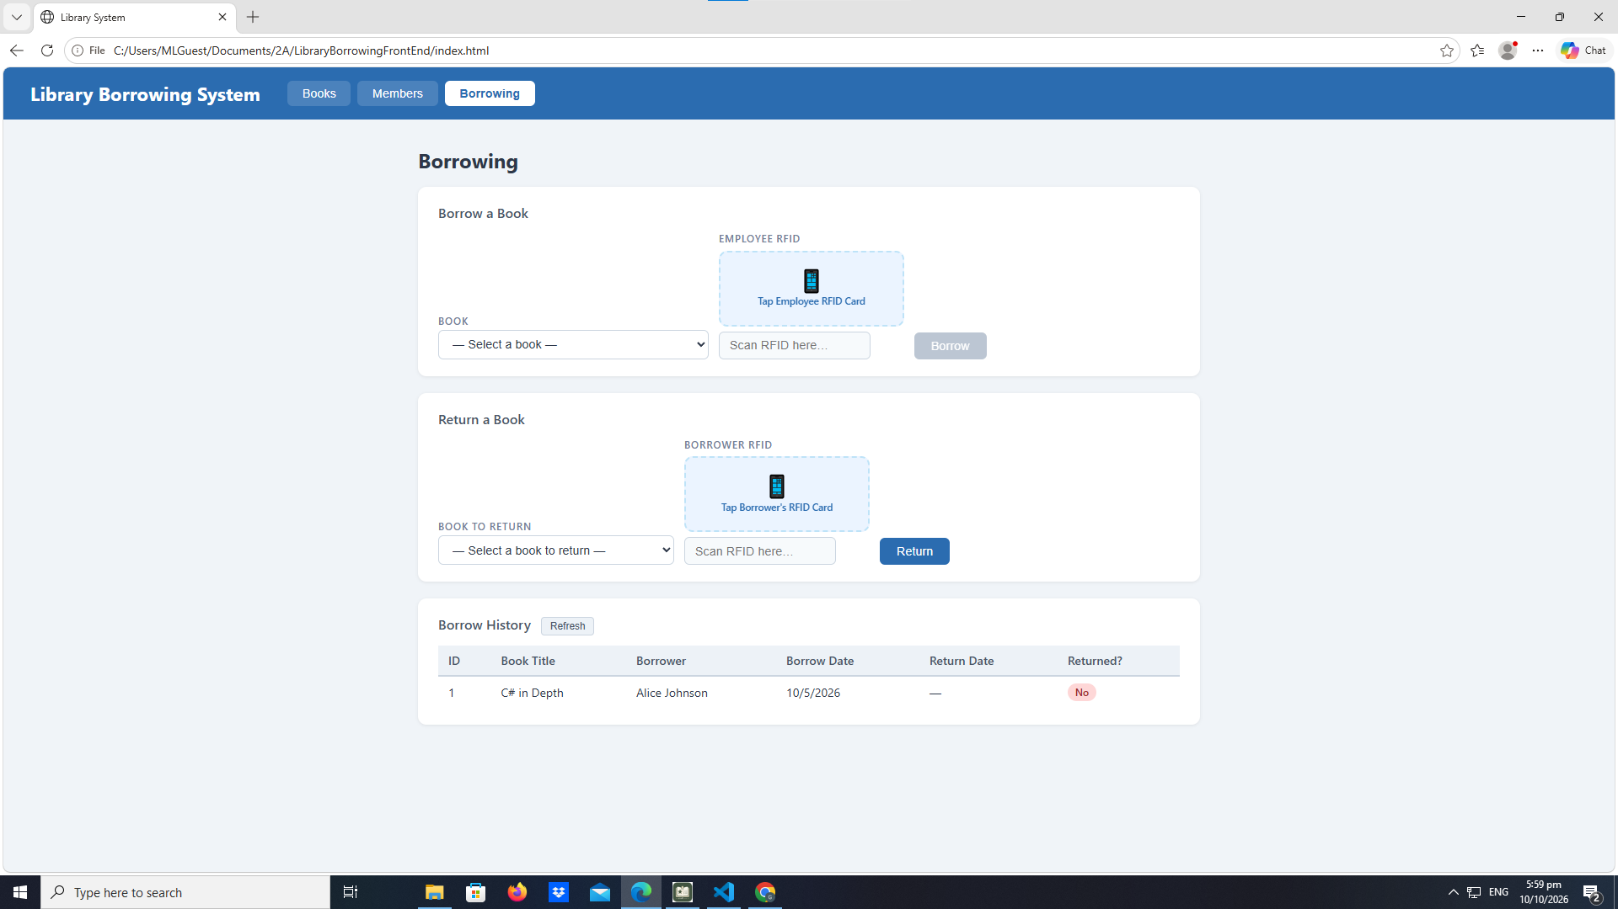

test-02-add-book

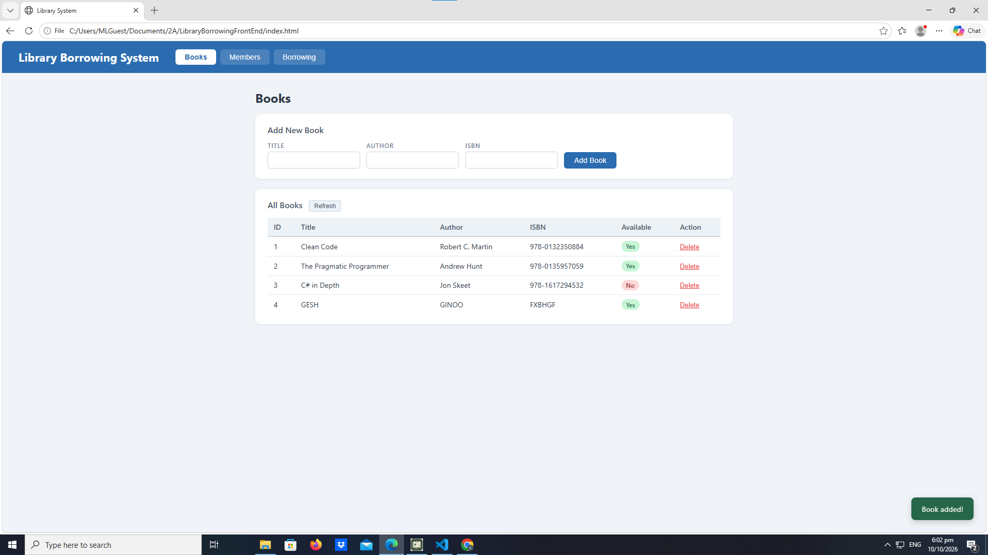

test-03-delete-book
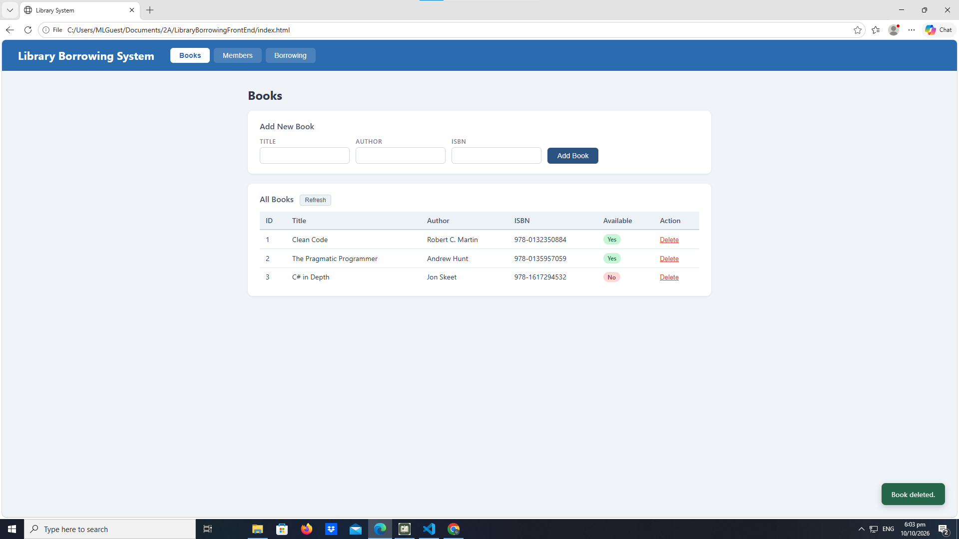

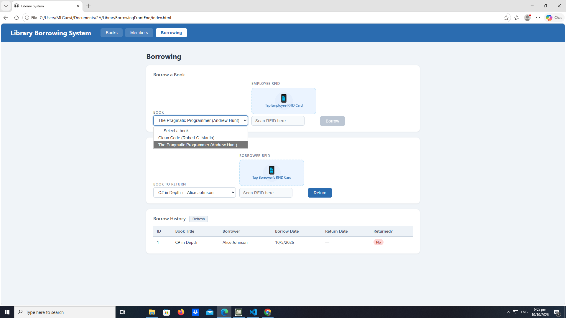

test-04-members-loaded

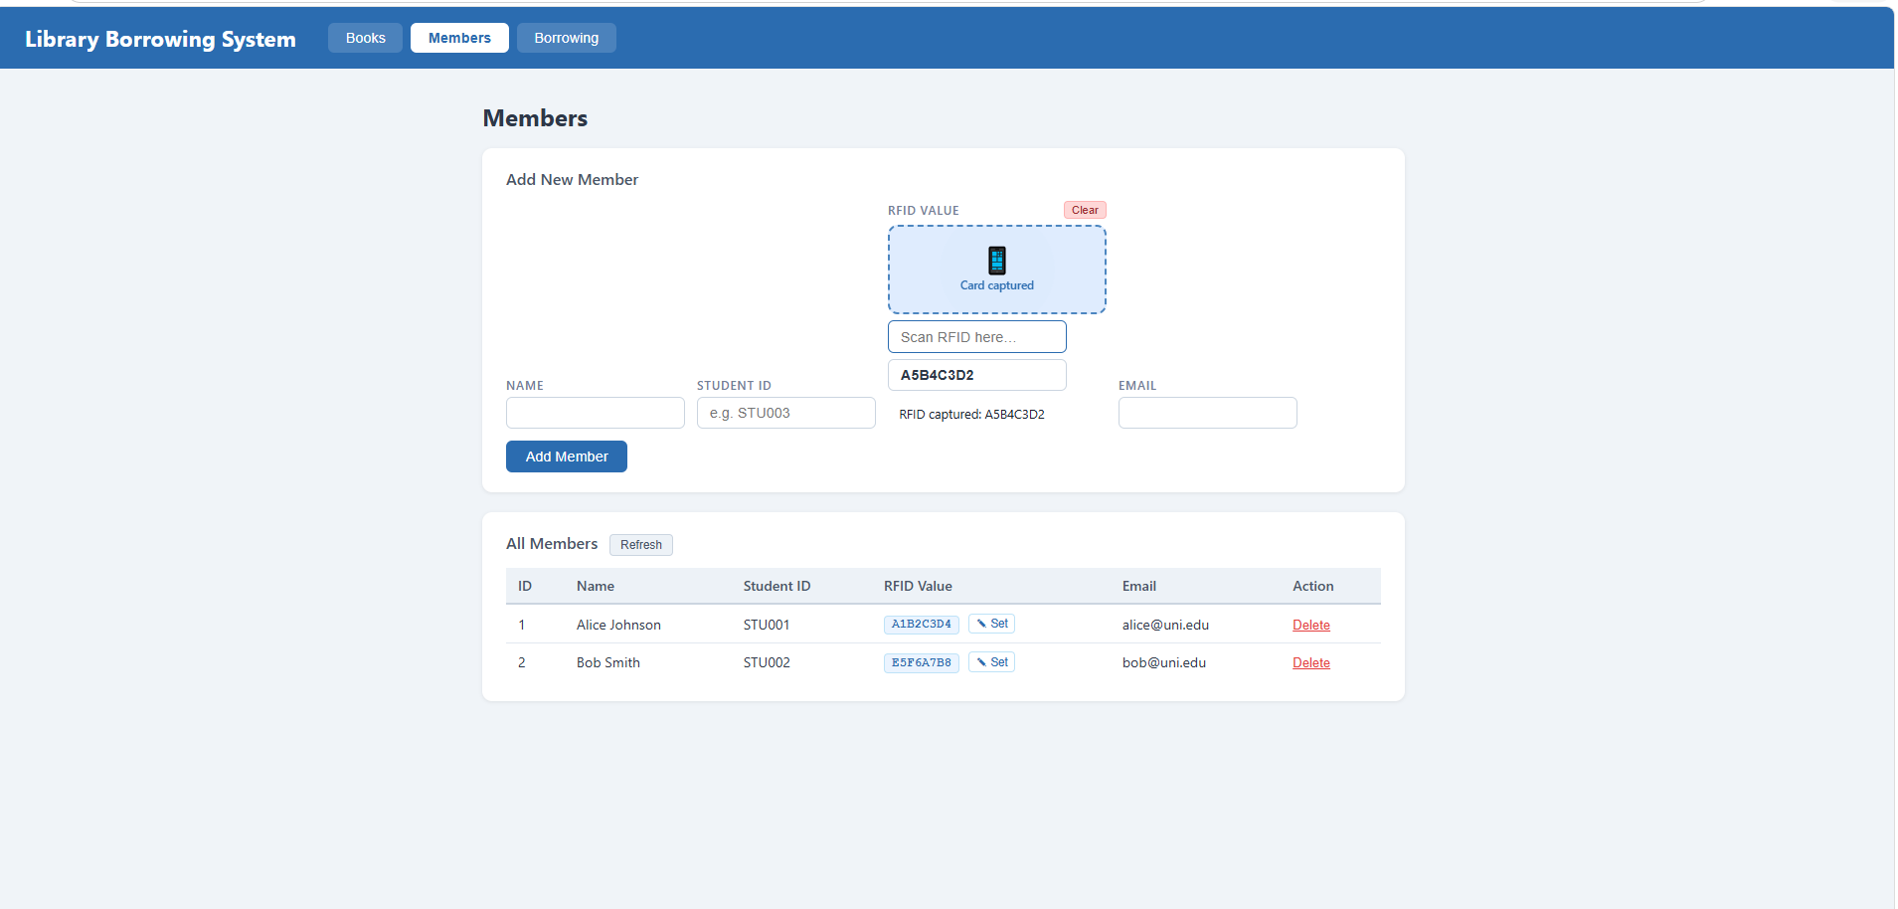
test-05-register-rfid 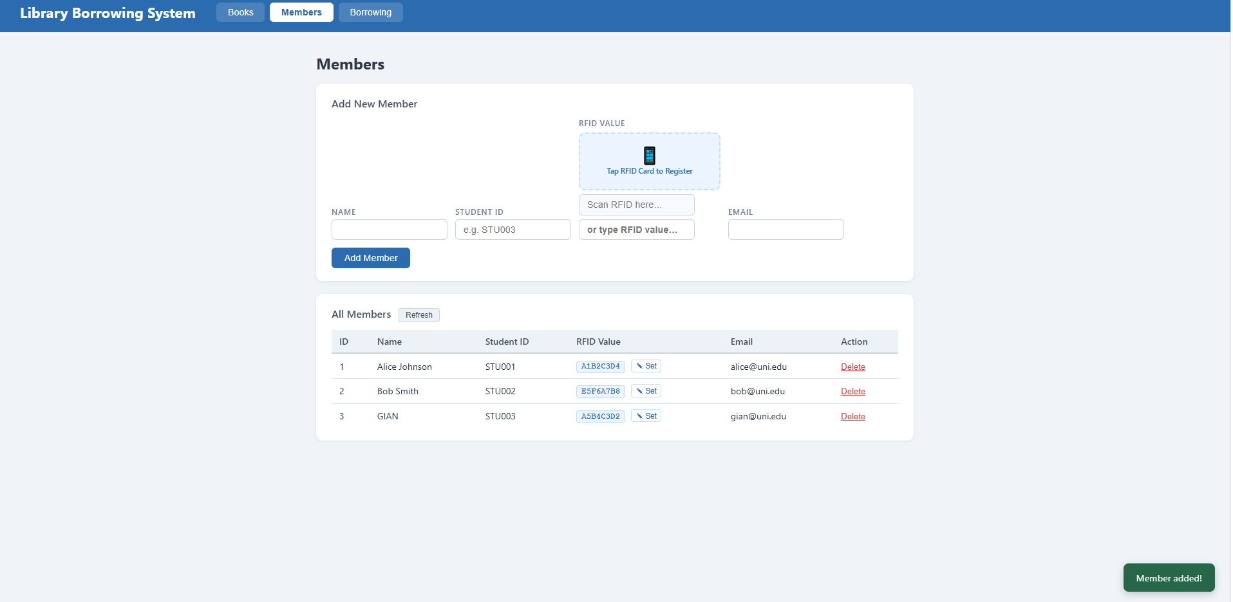
test-06-add-member
test-07-set-rfid-saved
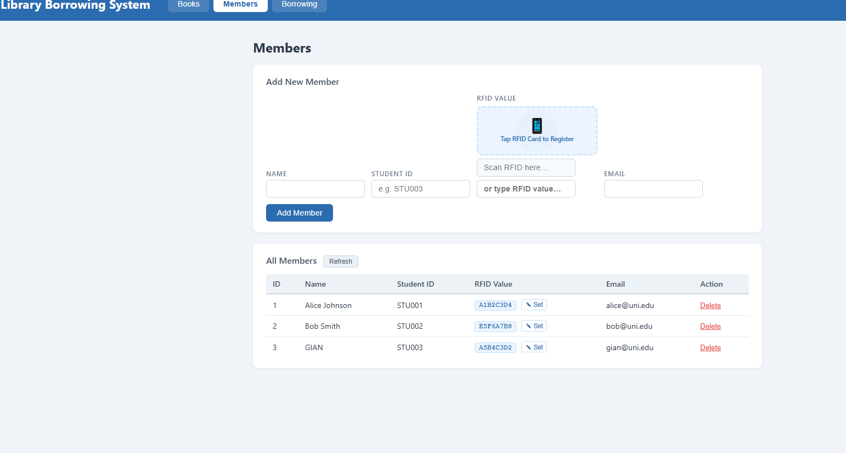
test-08-delete-member 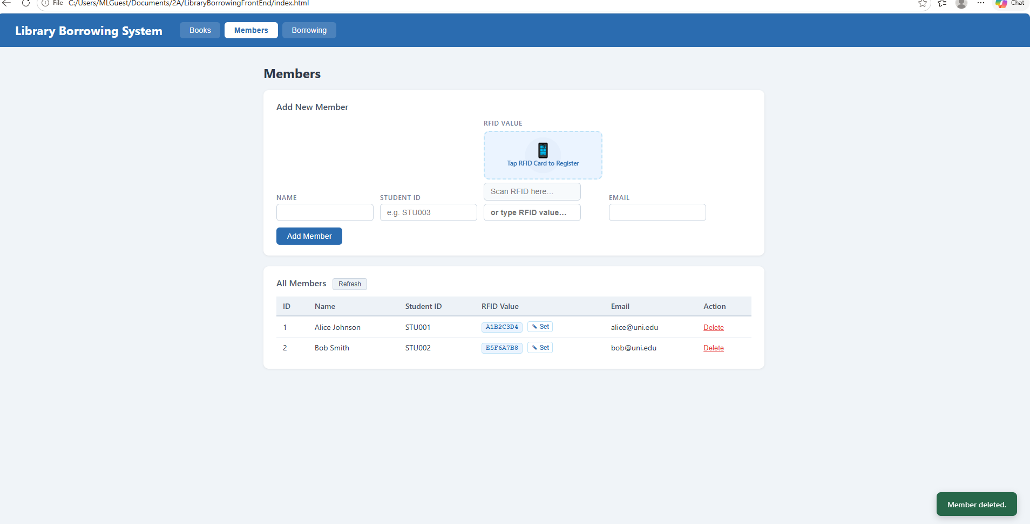
test-09-borrow-rfid-recognized
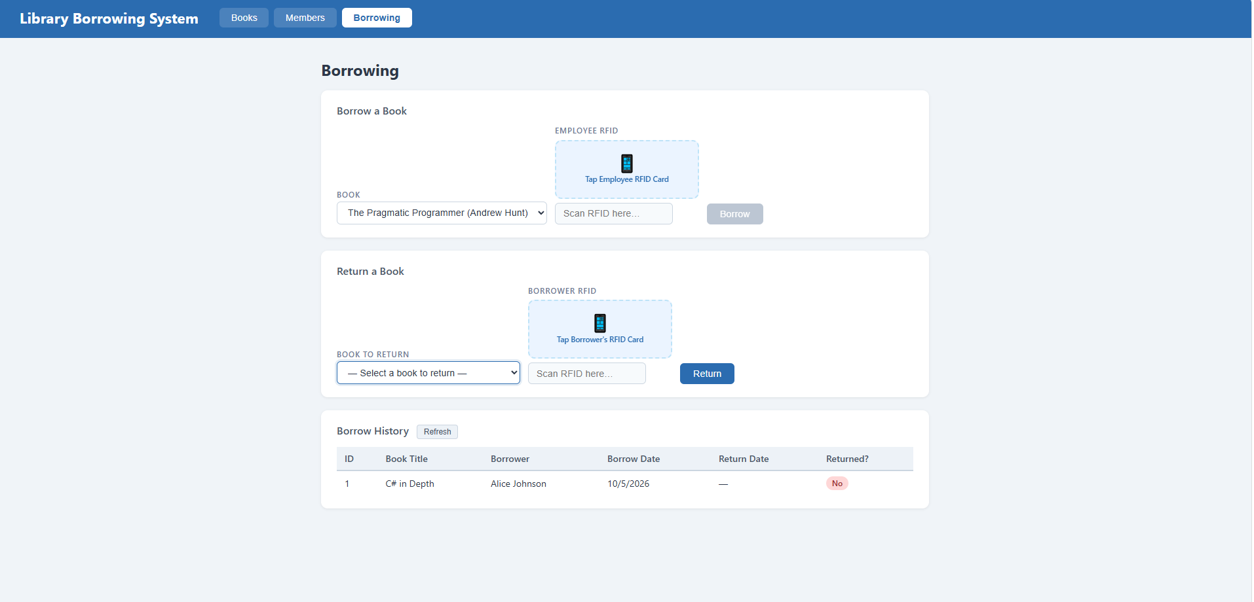
test-10-borrow-success
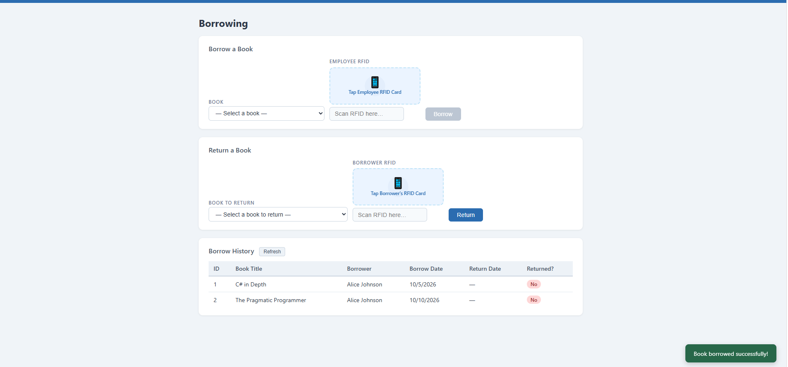
test-11-return-wrong-card
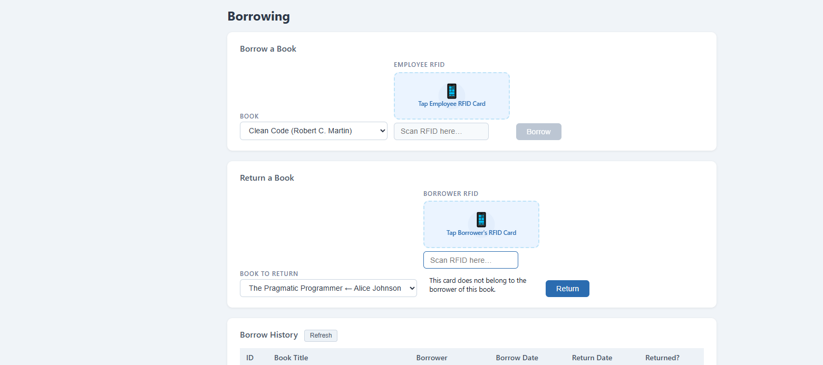
test-12-return-verified
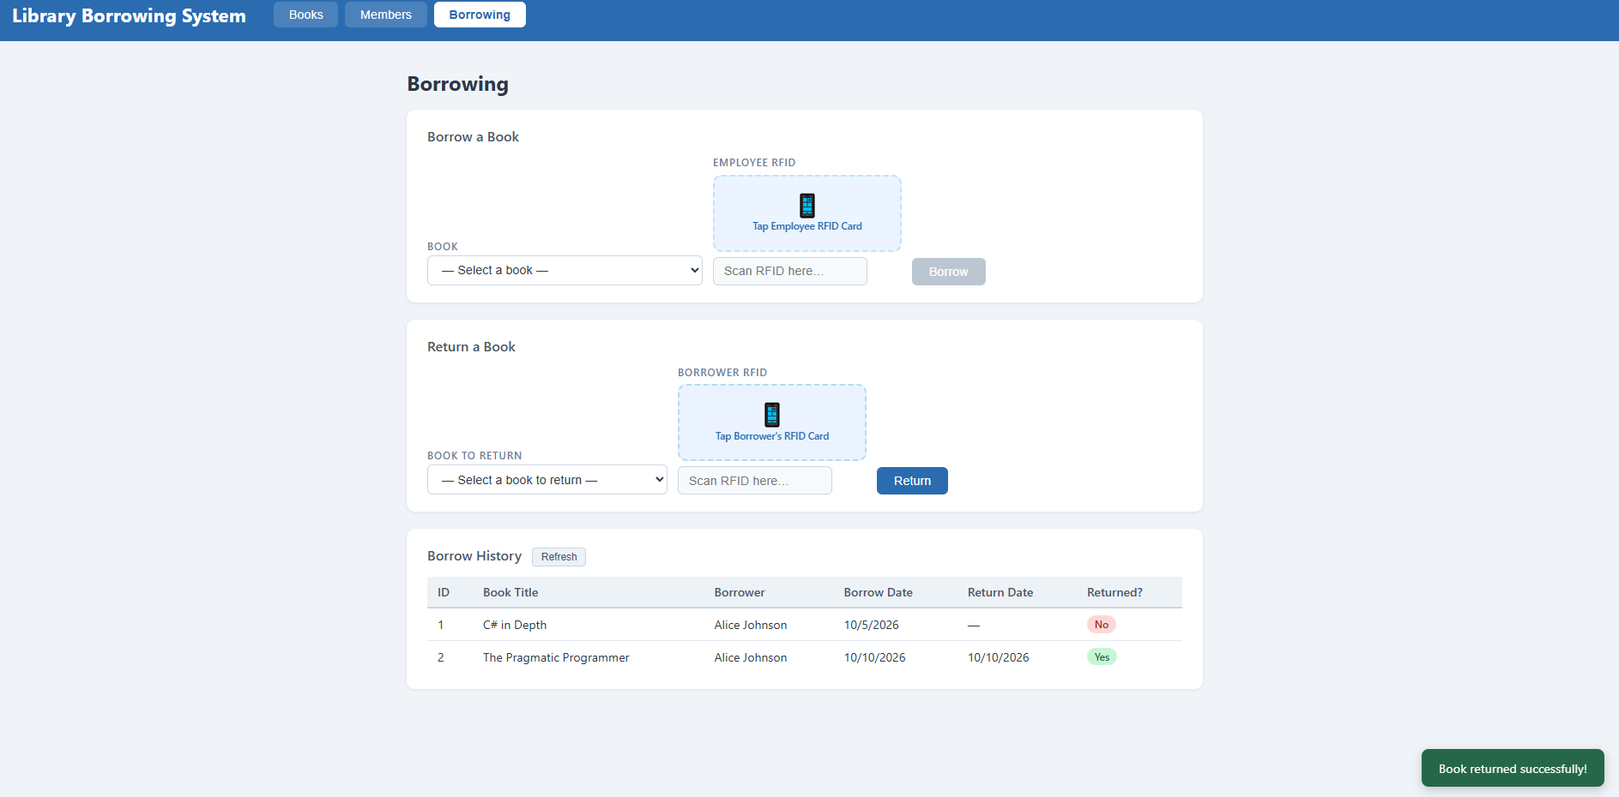
test-13-return-success
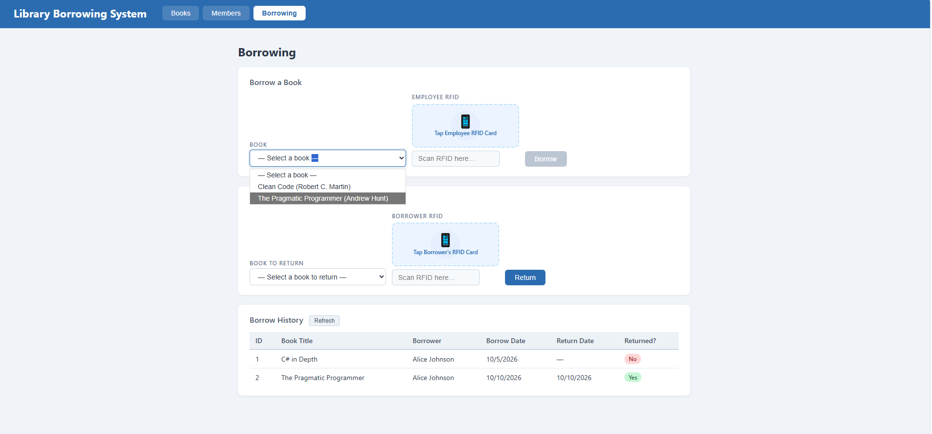
test-14-final-console 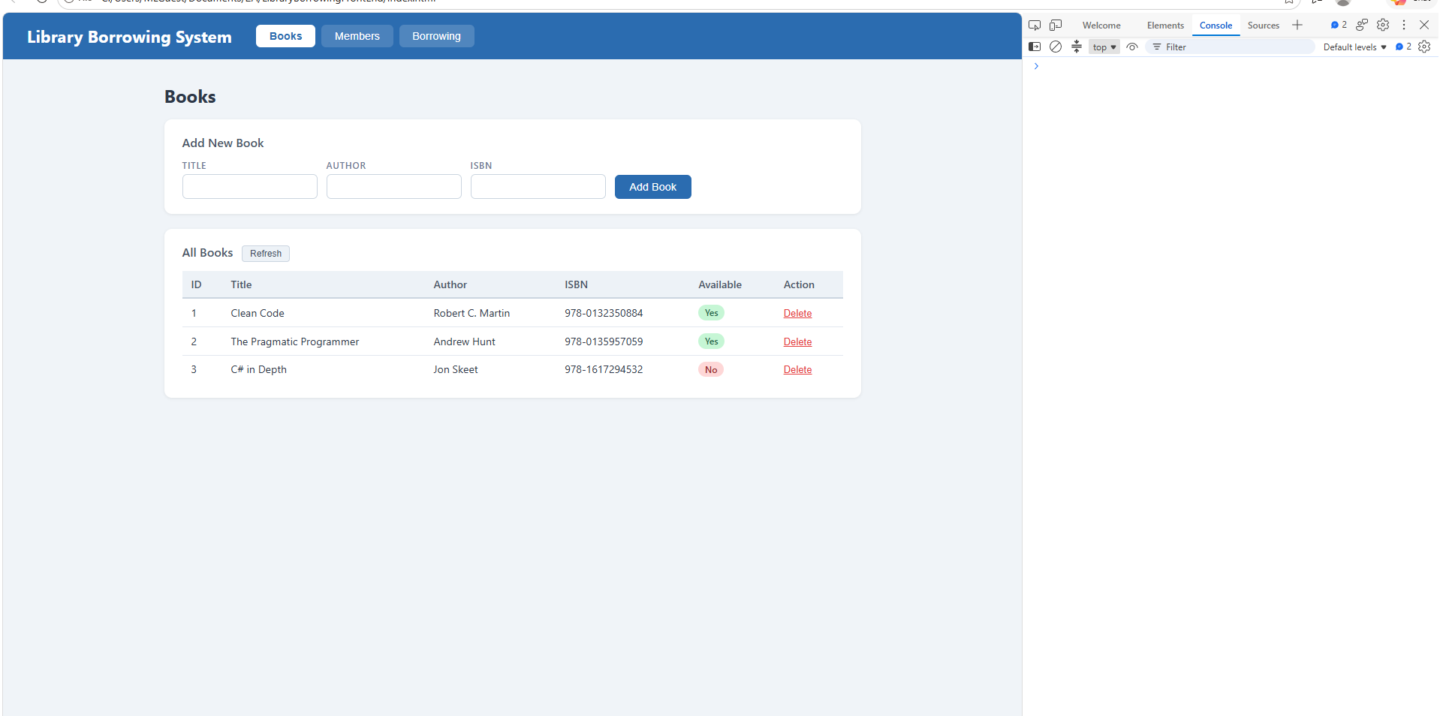

- What does apiFetch() do?
PREVENTS REPEATED CODE
- Why do we use try/catch around API calls?
PREVENTS APPLICATION
- What is the difference between POST and PUT?
POST CREATES NEW DATA, PUT UPDATES THE EXISTING DATA
- Why does RFID matching use rfidValue instead of studentId?
THE SCANNER READS THE CARD TAG AND NOT THE DATABASE ID
- Why do we refresh tables after adding, deleting, borrowing, or returning?
TO DISPLAY THE UP DATA DATE IN THE UI
- Why does the Return dropdown use borrow record ID instead of book ID?
TO KNOW SPECIFIC TRANSACTIONS
- What happens if the same event listener is added to a form twice?
WILL EXECUTE TWICE
- Why must the page-load code be at the bottom of the file?
MAKES SURE THAT THE HTML ELEMENT LOADS
- Why does an RFID reader need e.preventDefault() on the Enter key?

