Rob Martin C. Montesco
BSIT – 2B
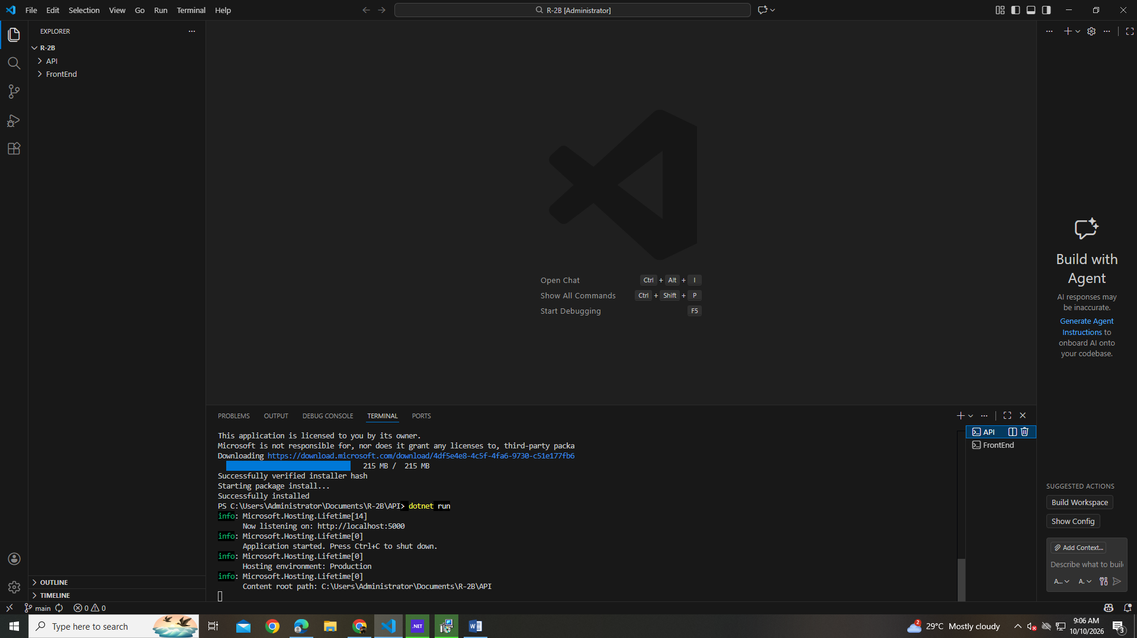

PART 1:
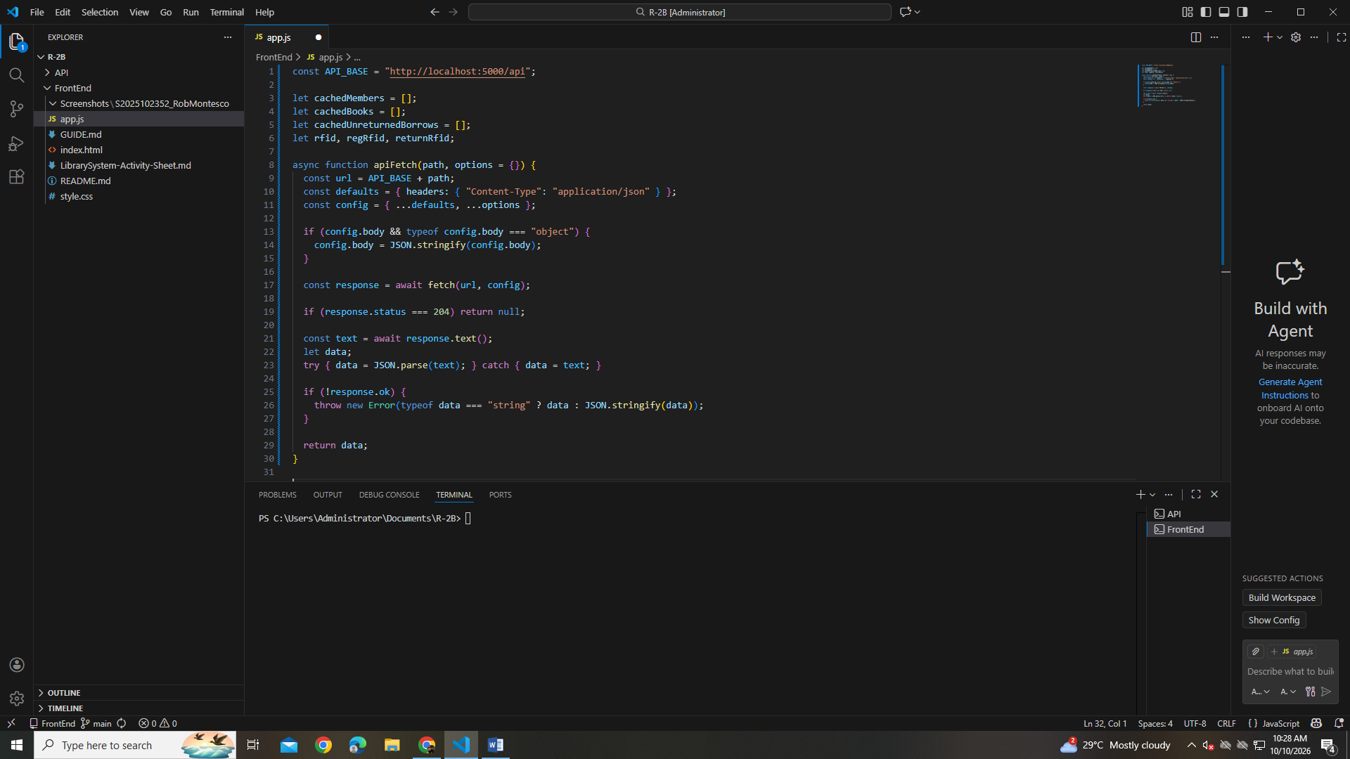
PART 2:
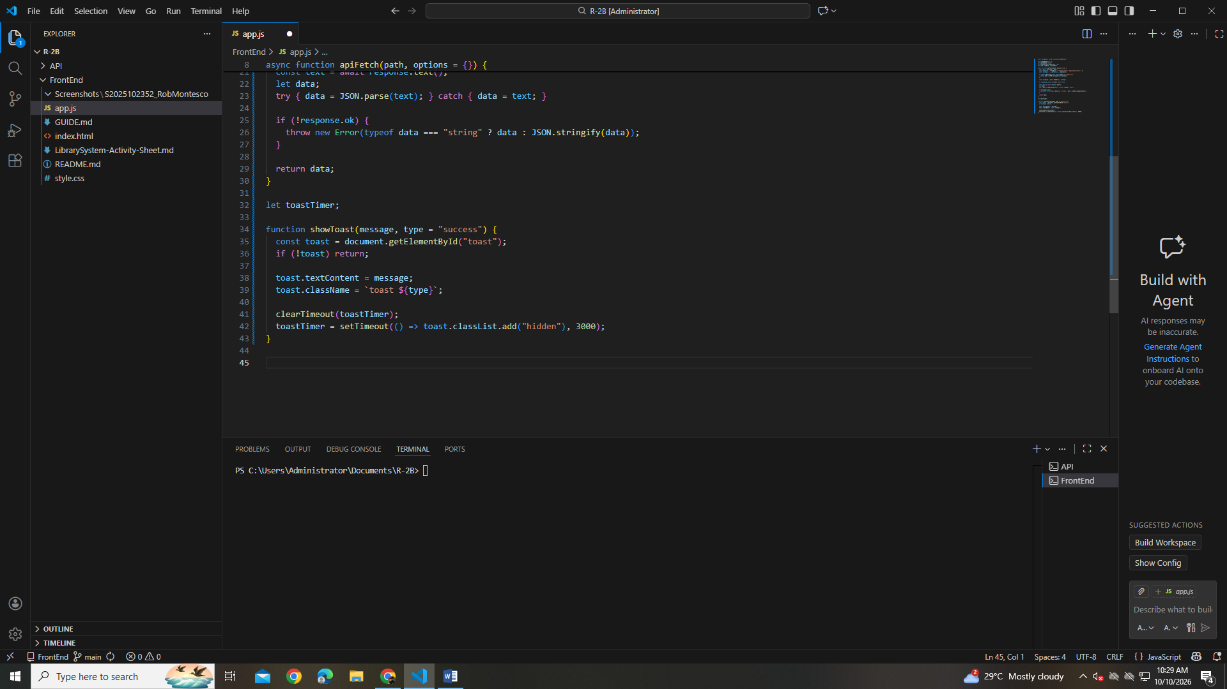
PART 3:
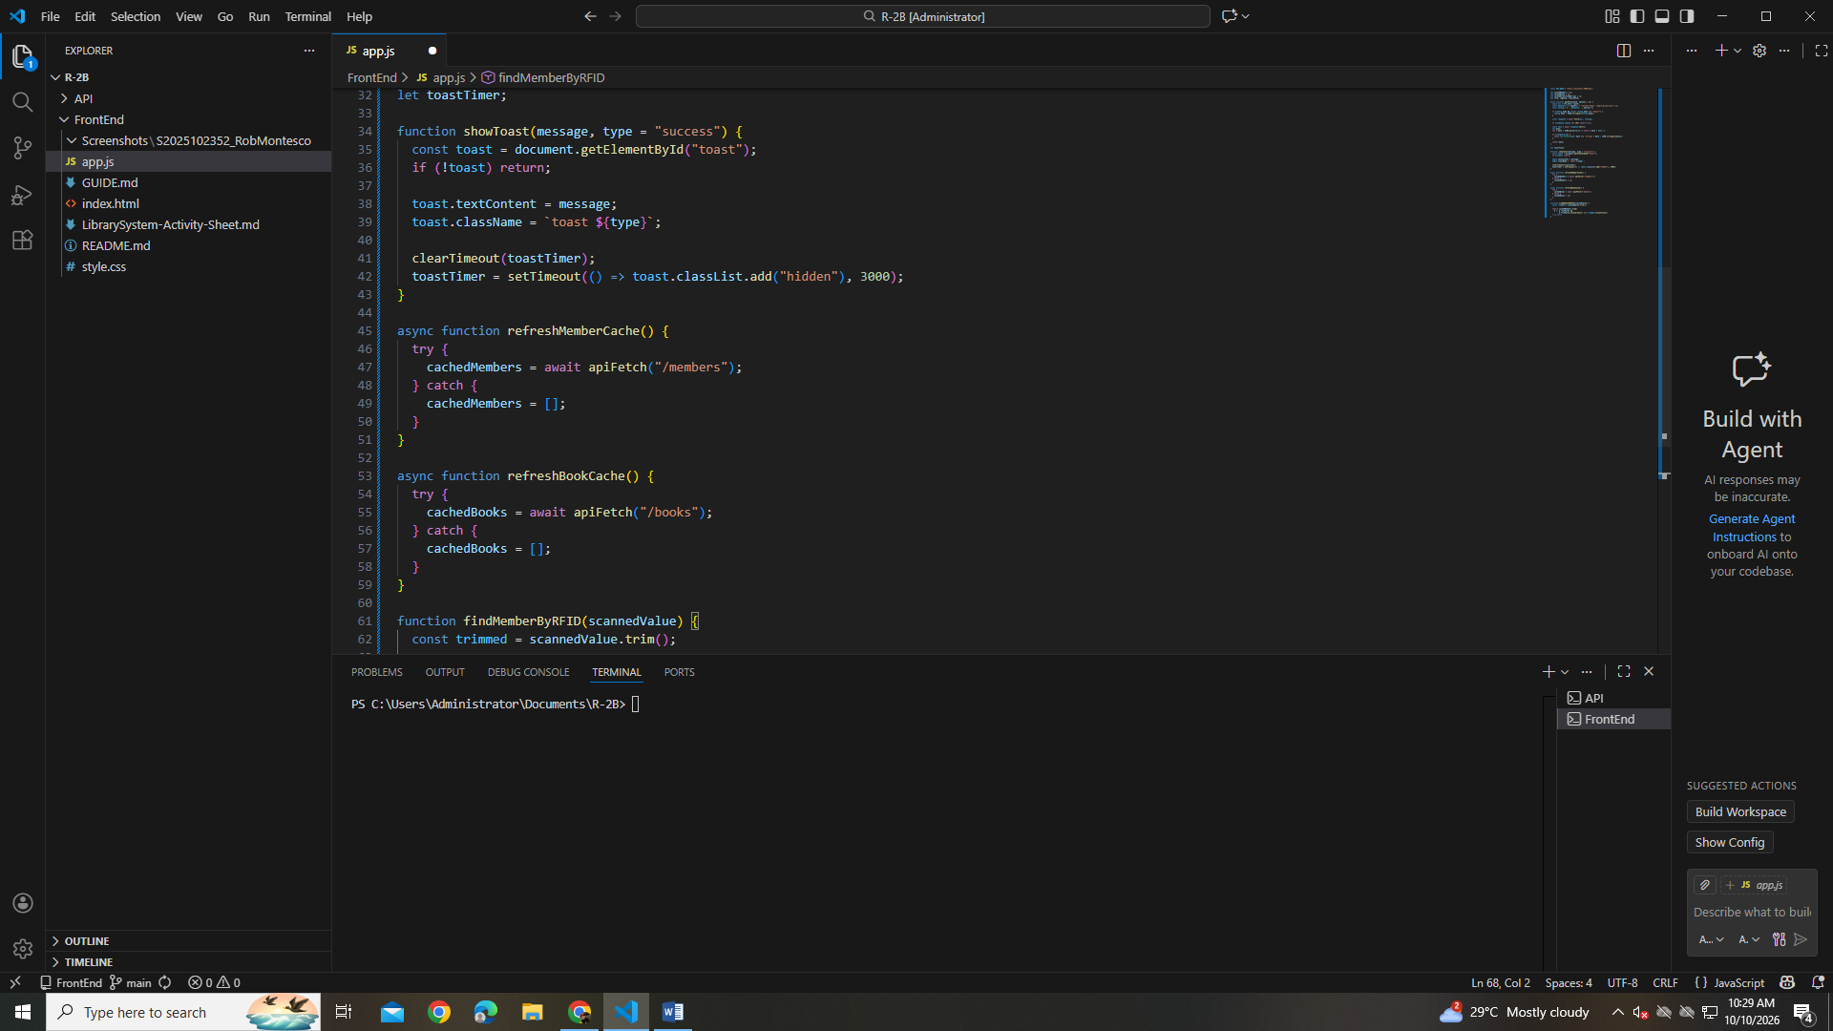

PART 4:
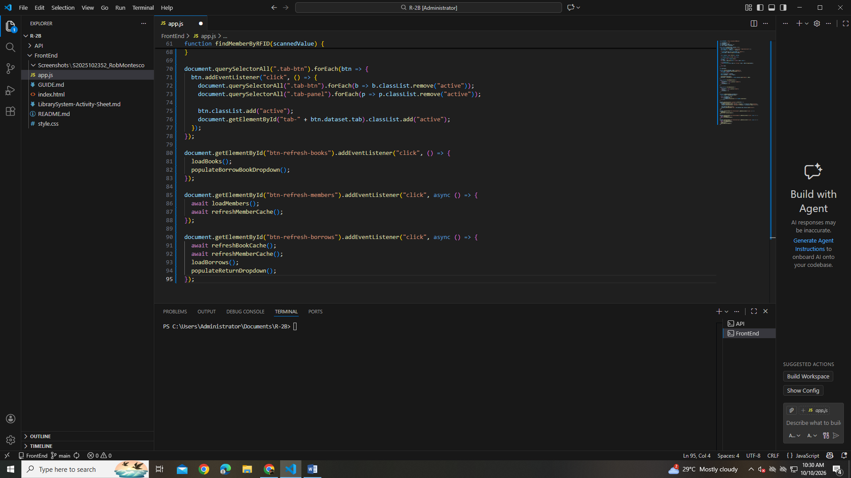

PART 5:
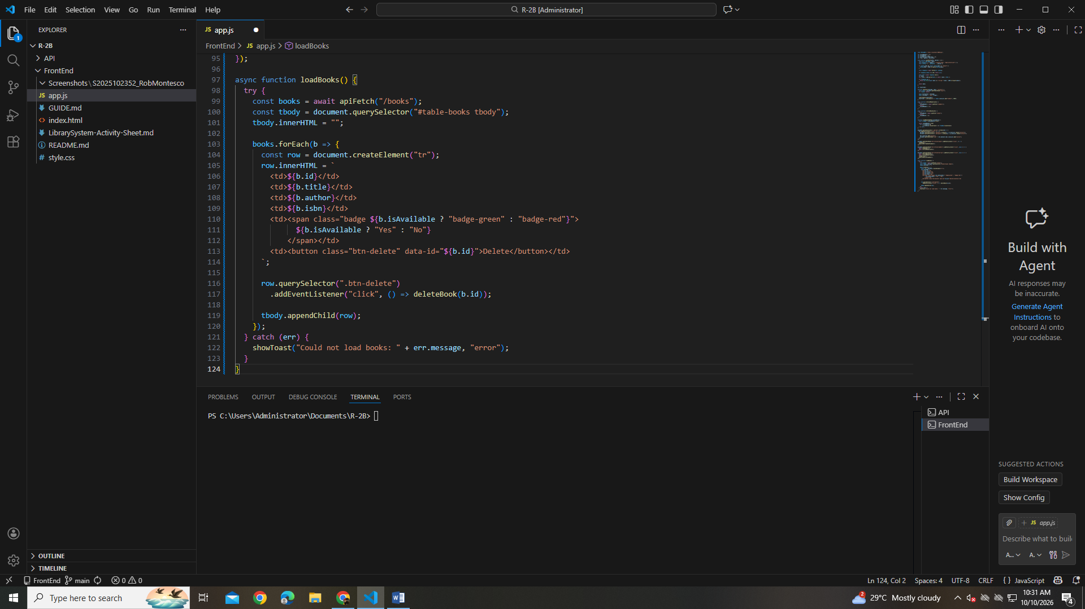

PART 6:
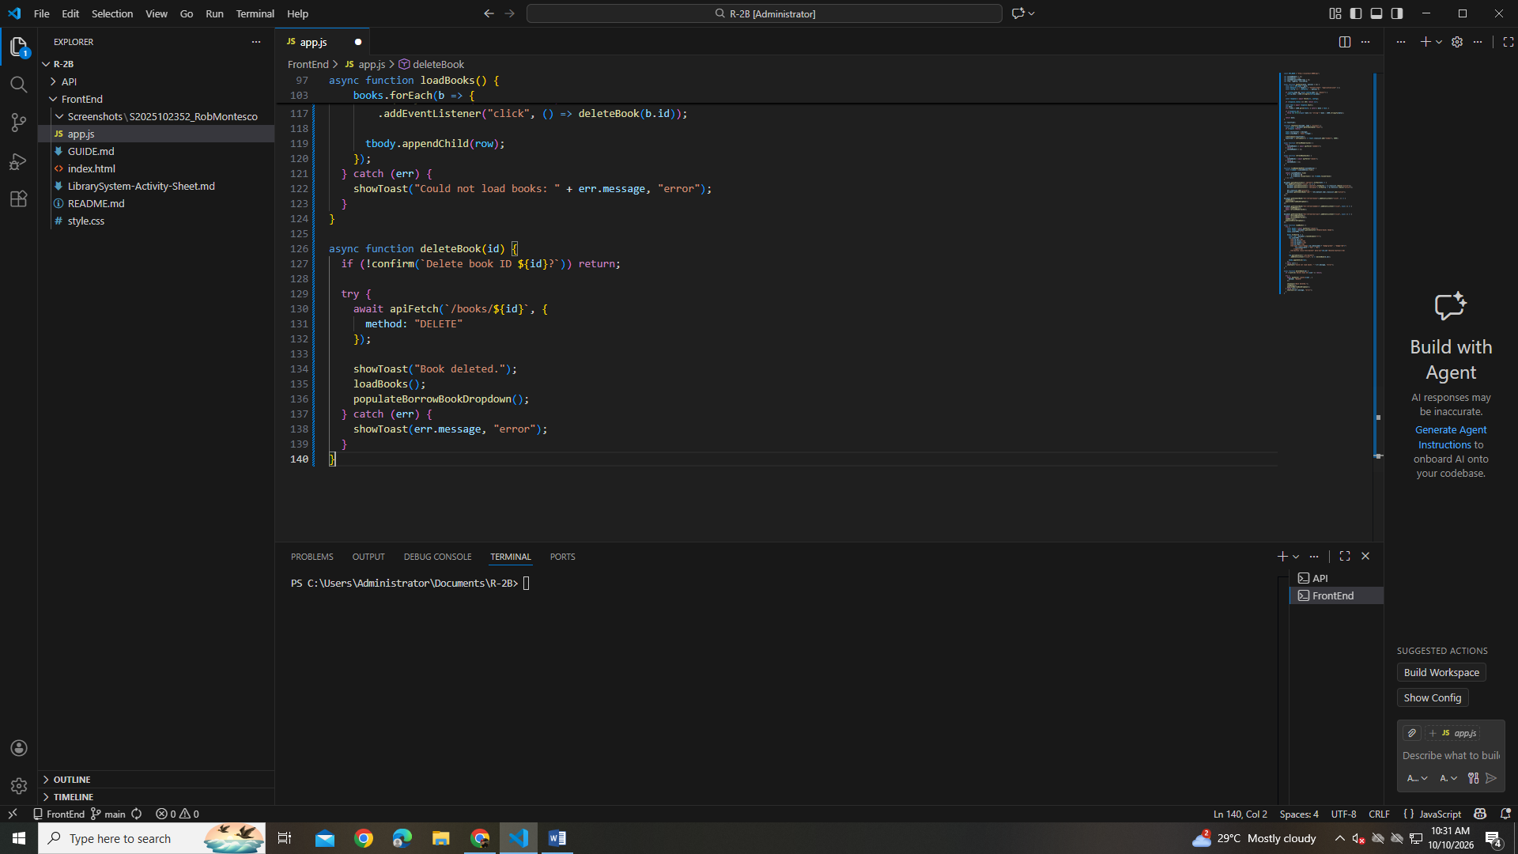

PART 7:
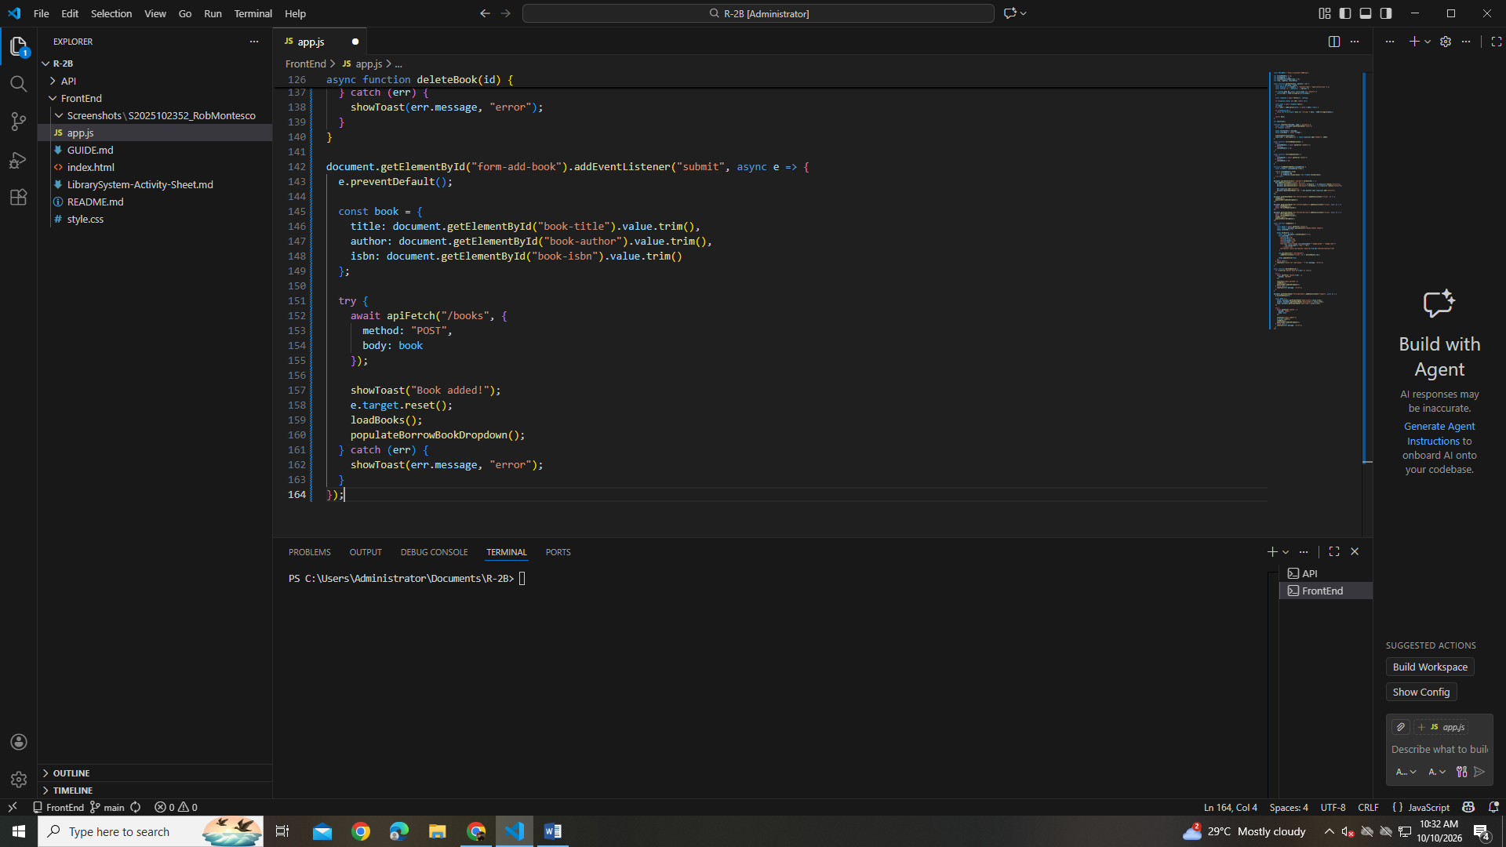

PART 8:
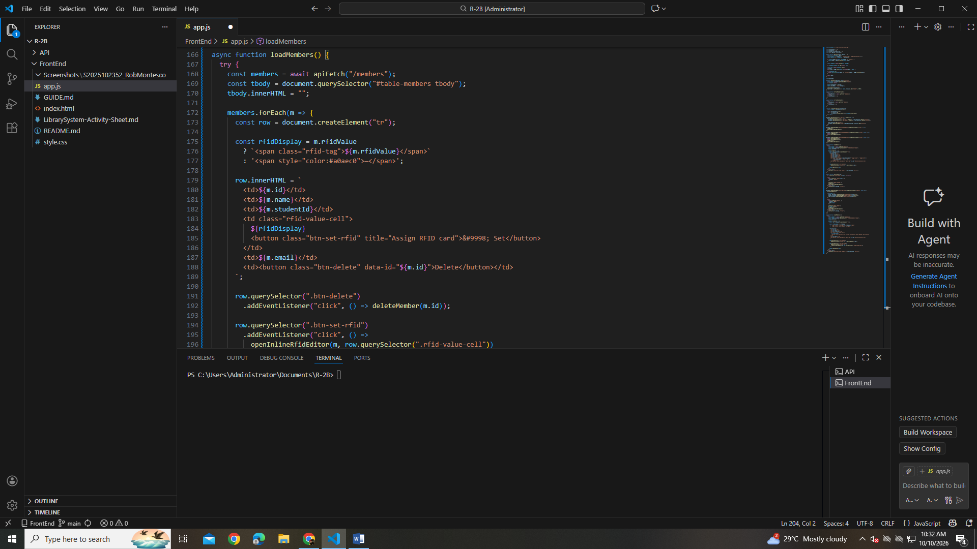

PART 9:
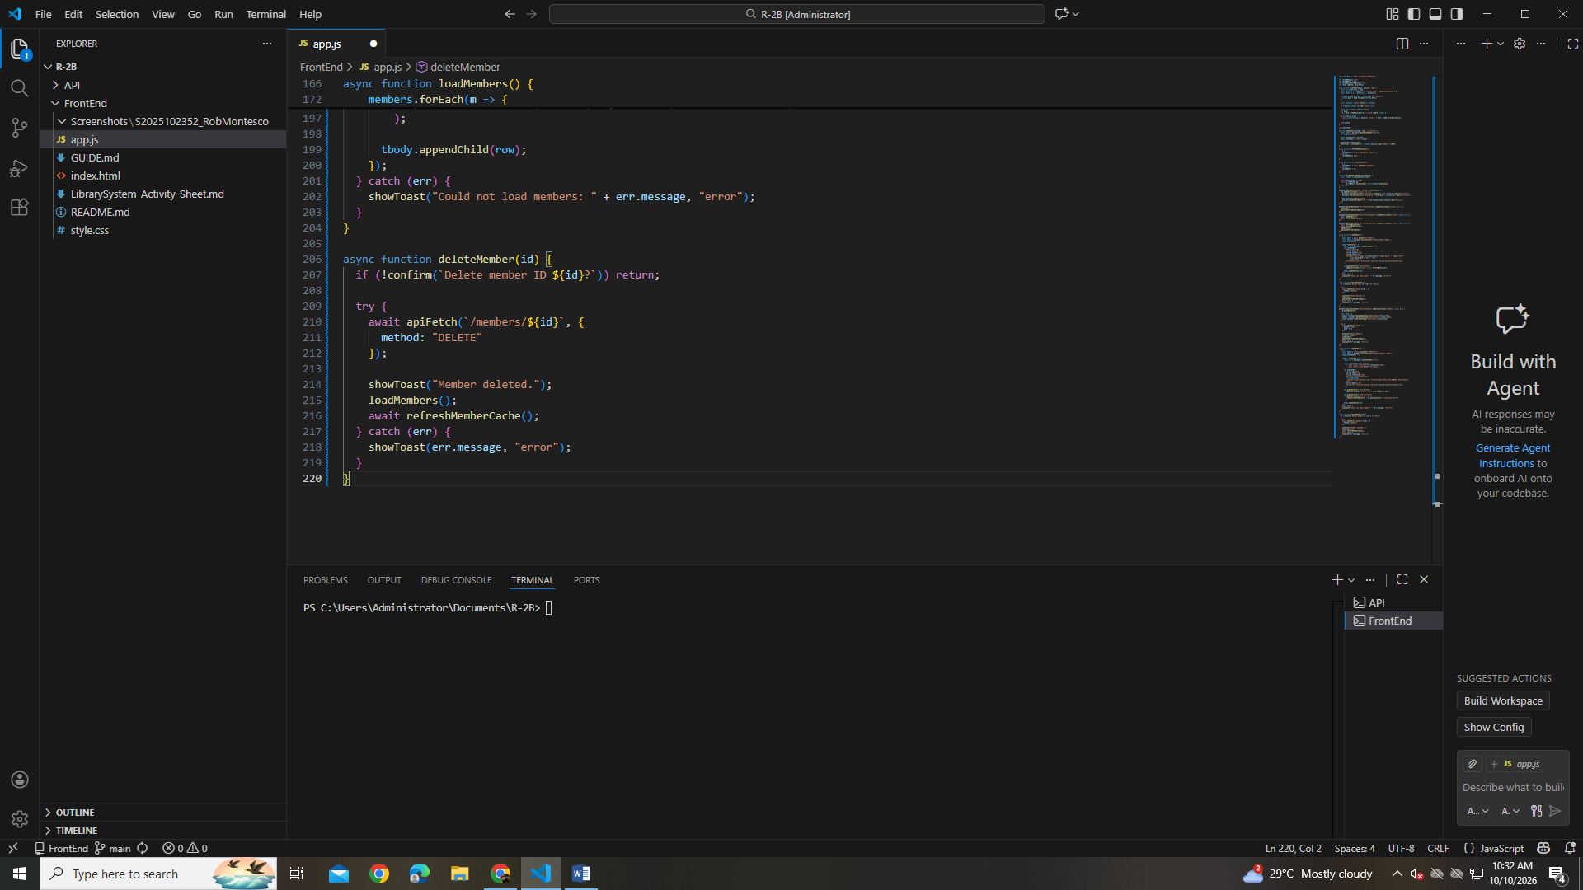

PART 10:
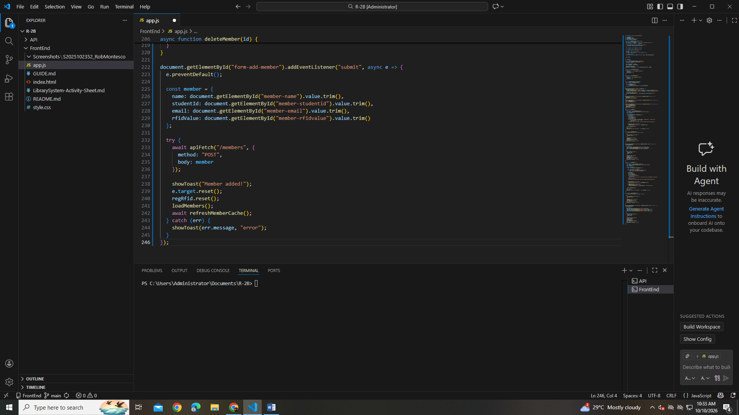

PART 11:
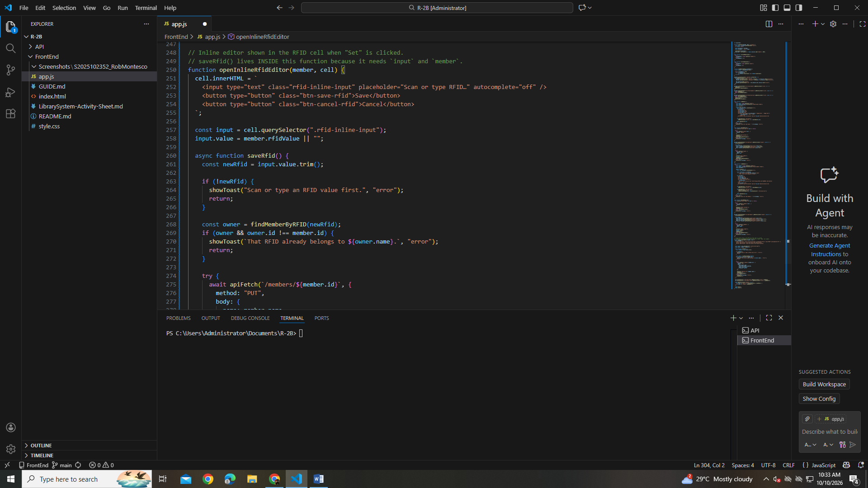

PART 12:
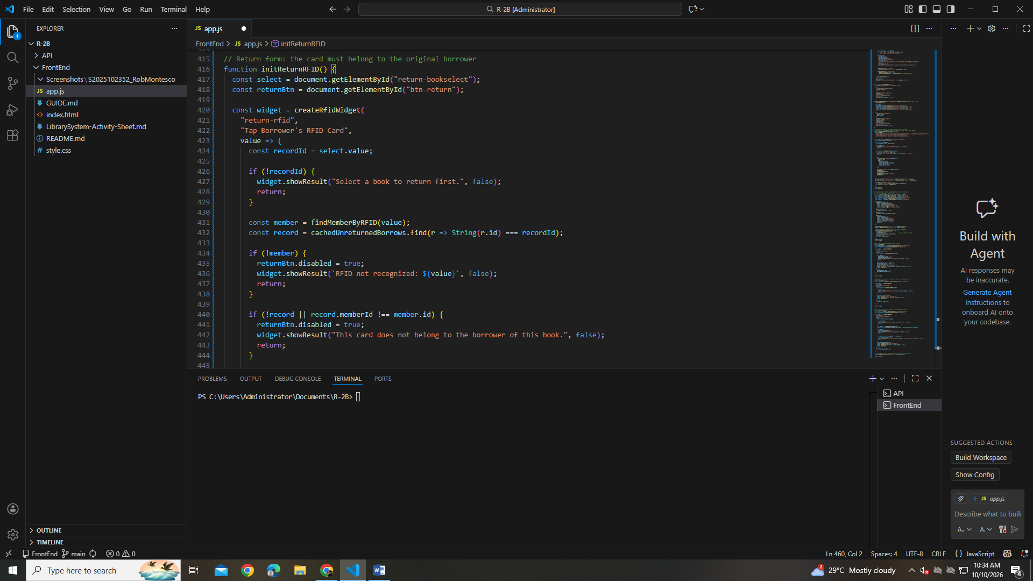

PART 13:
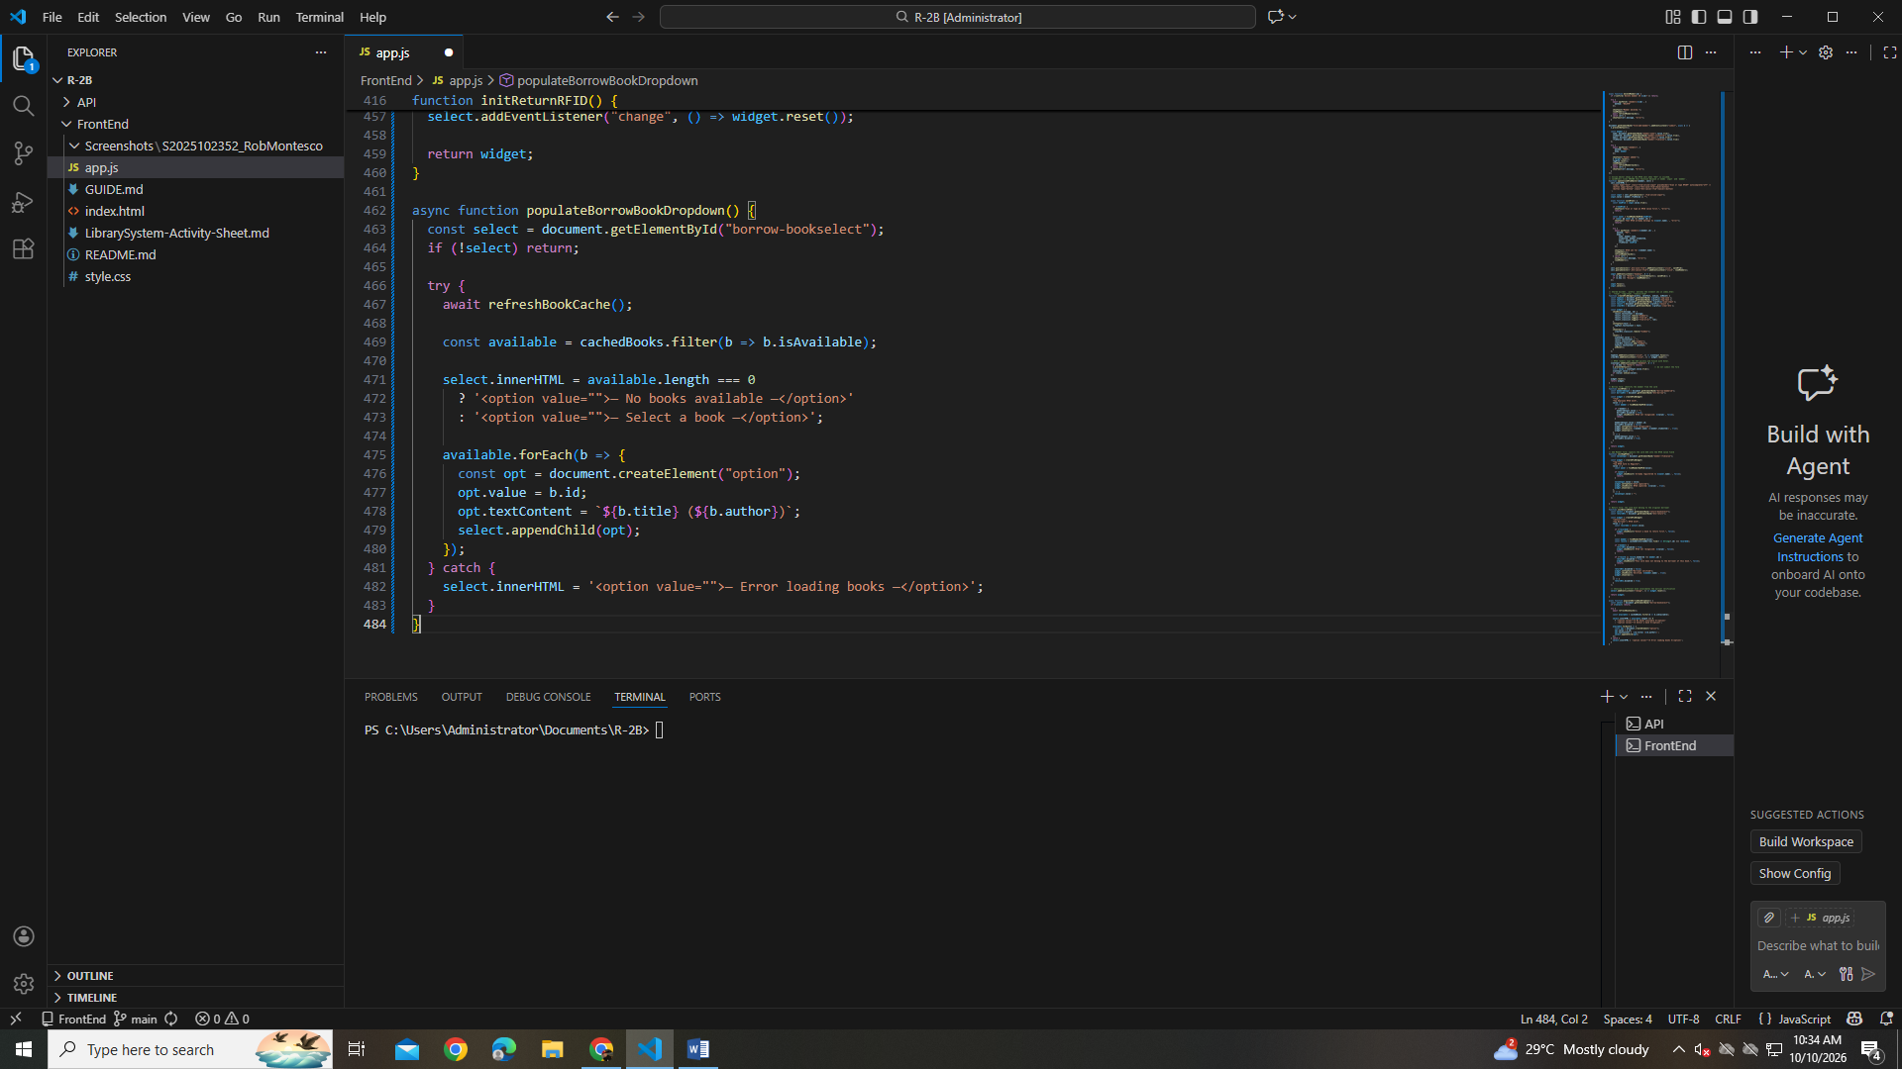

PART 14:
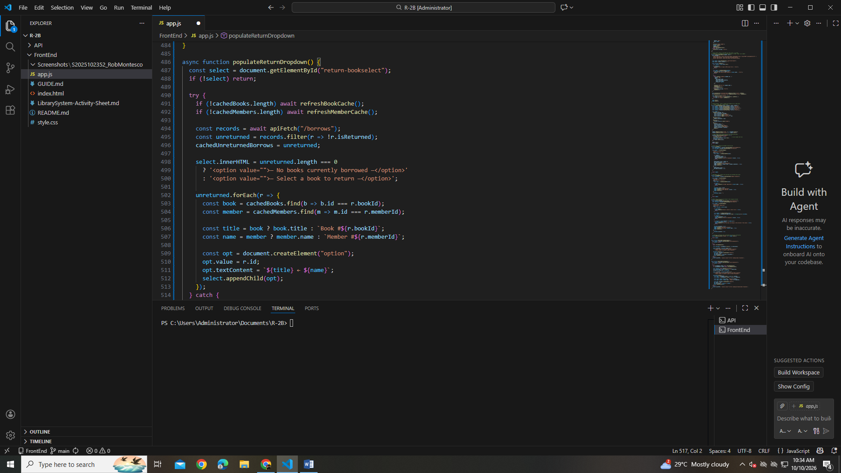
PART 15:
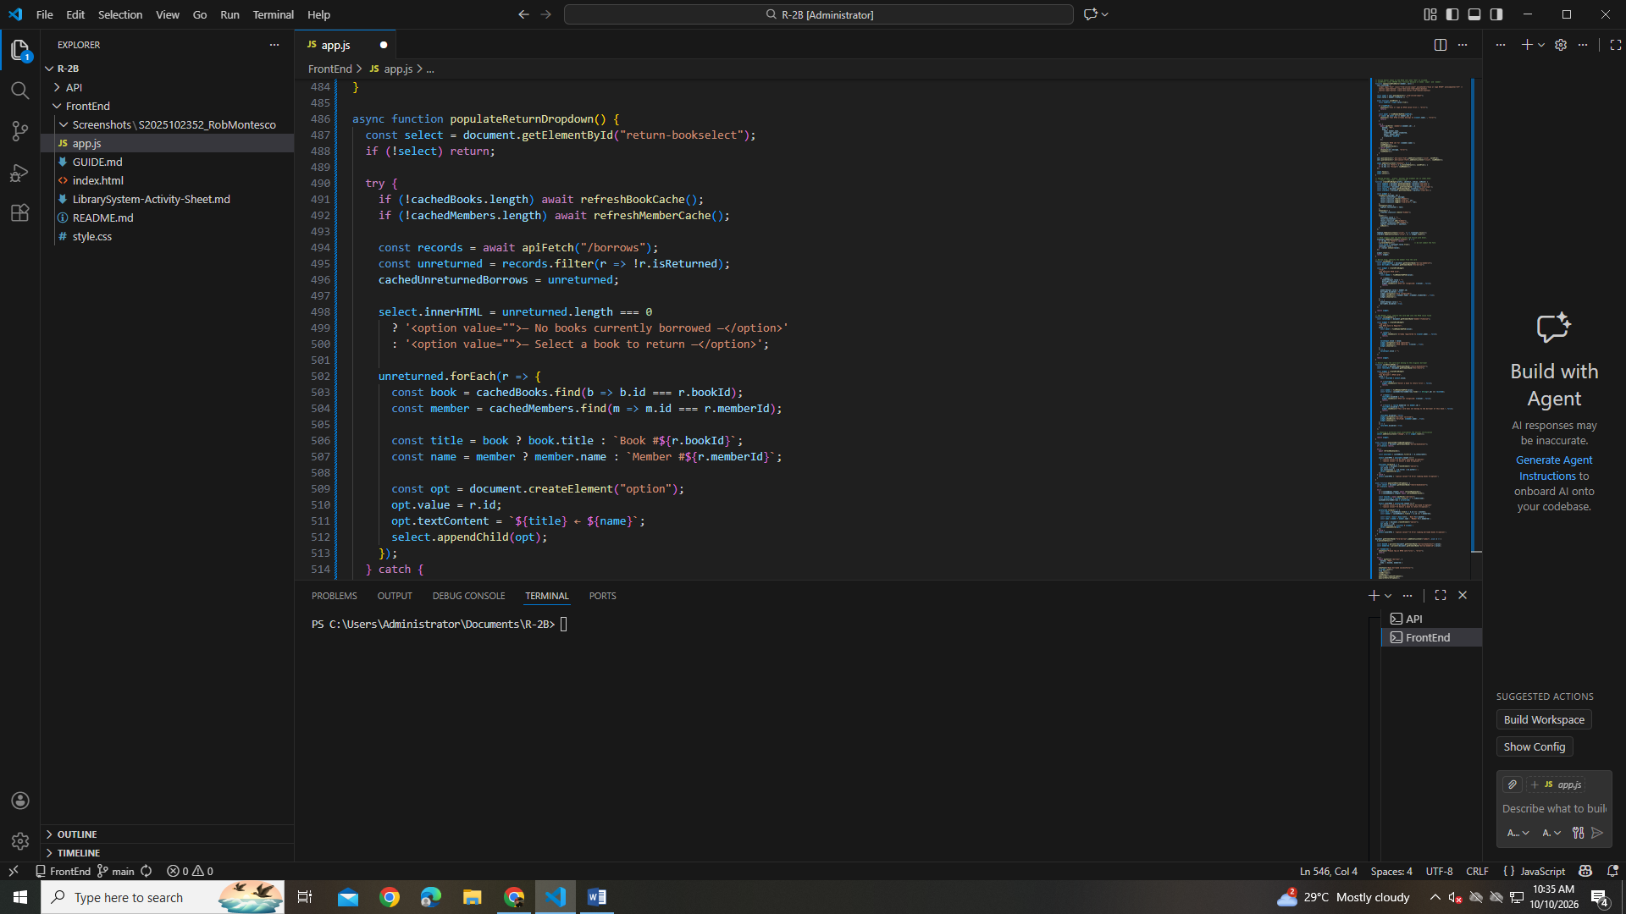

PART 16:
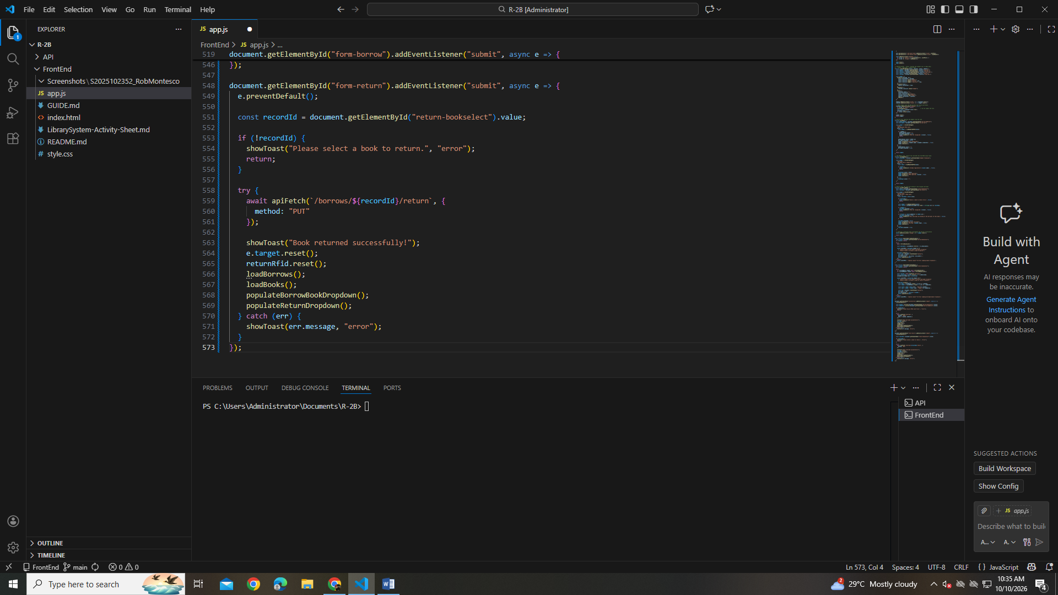

PART 17:
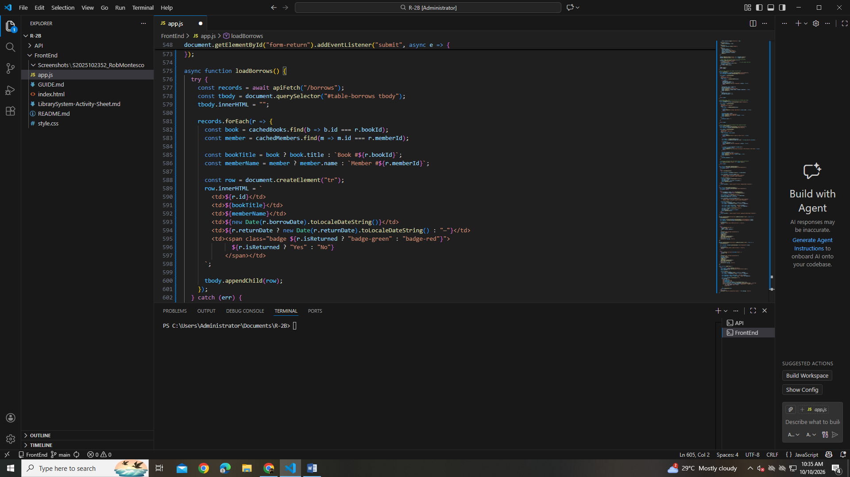

PART 18:
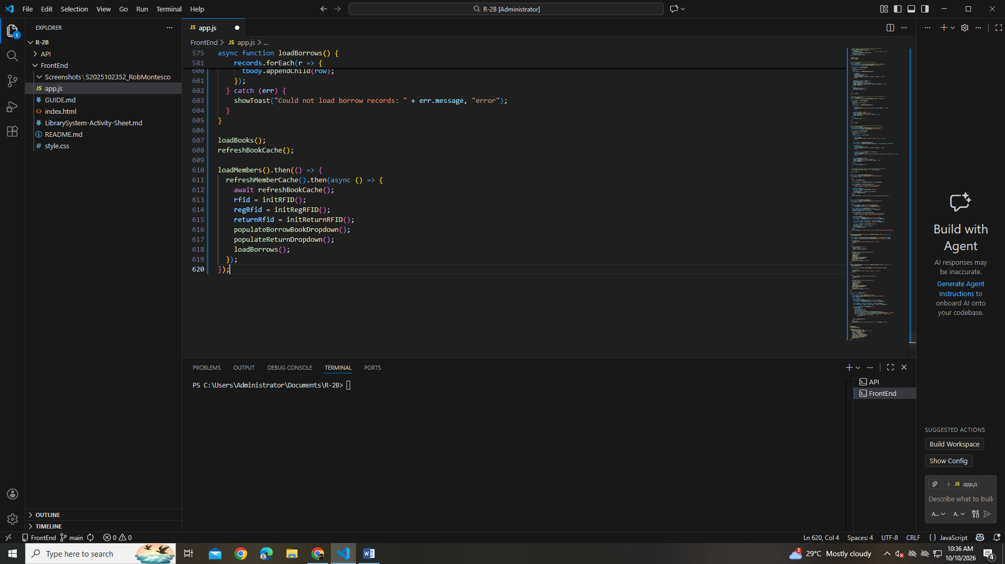
TEST THE TABS
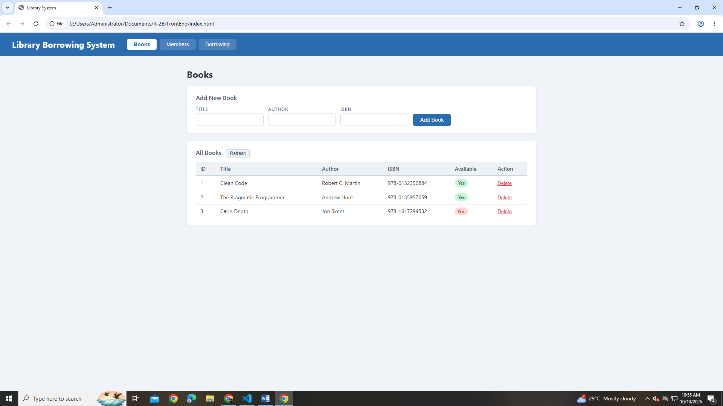

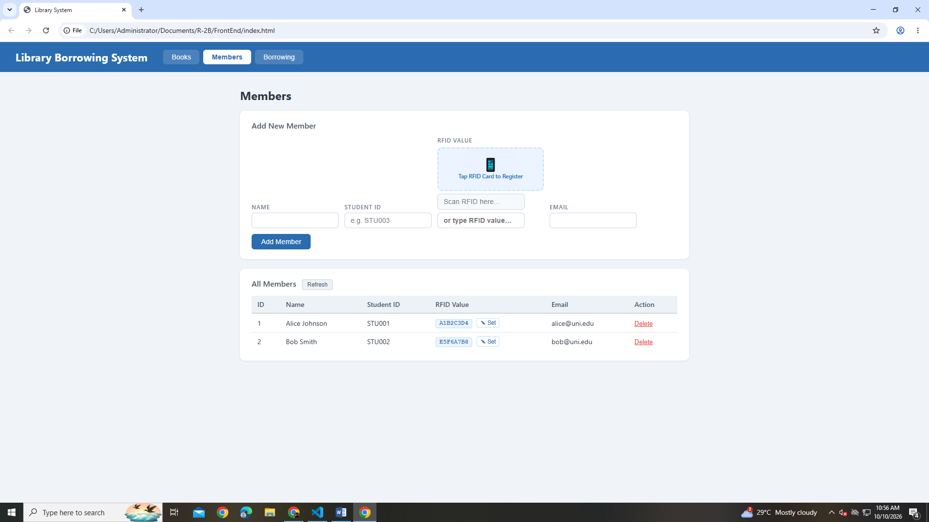

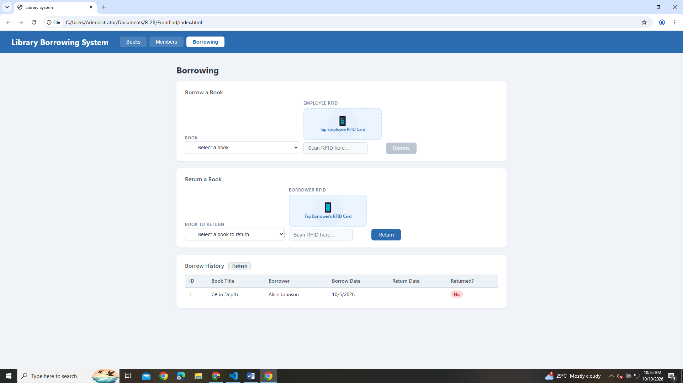

TEST BOOKS
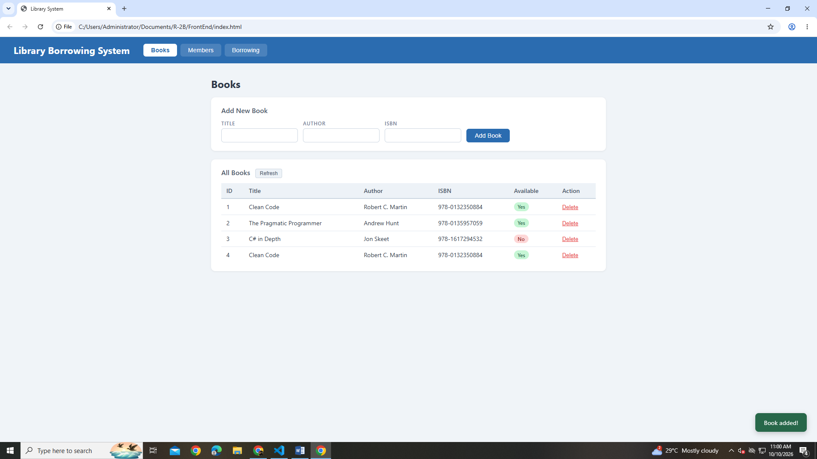

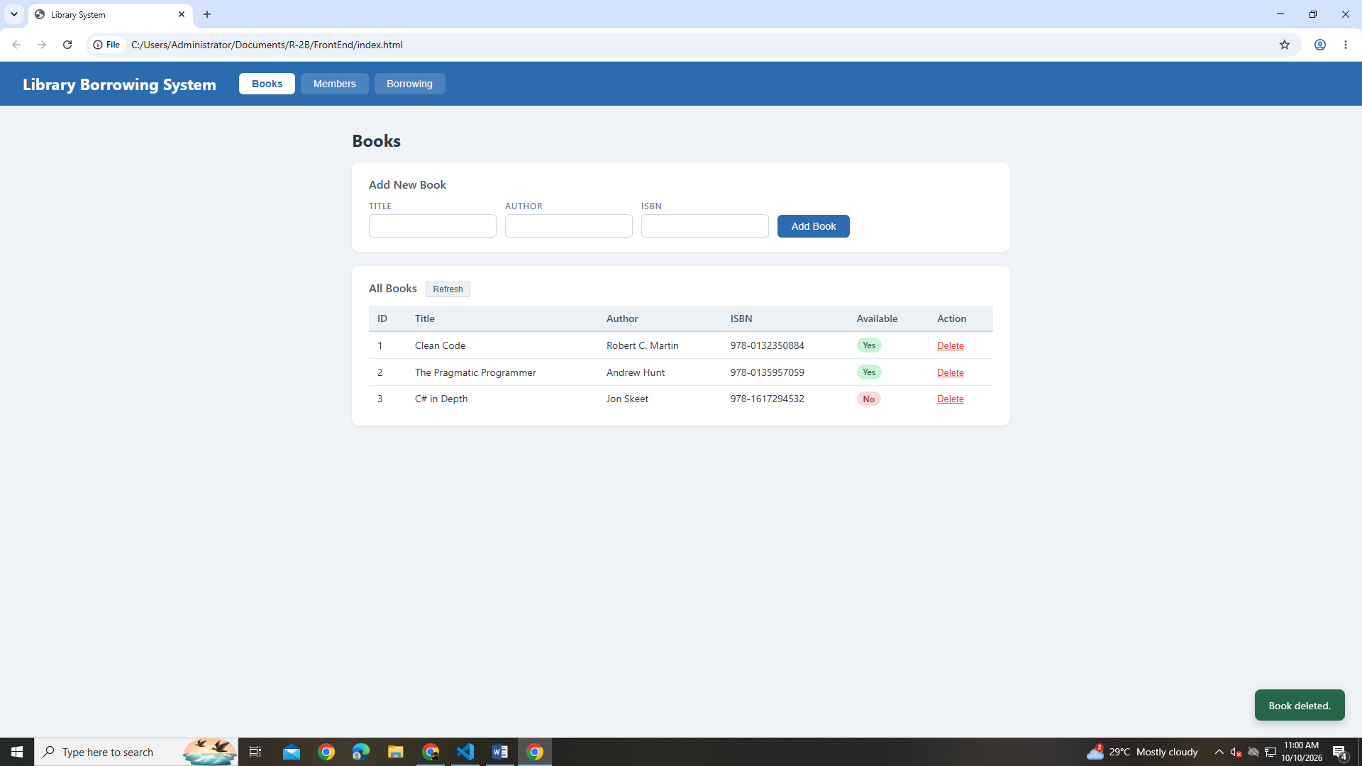

TEST MEMBERS
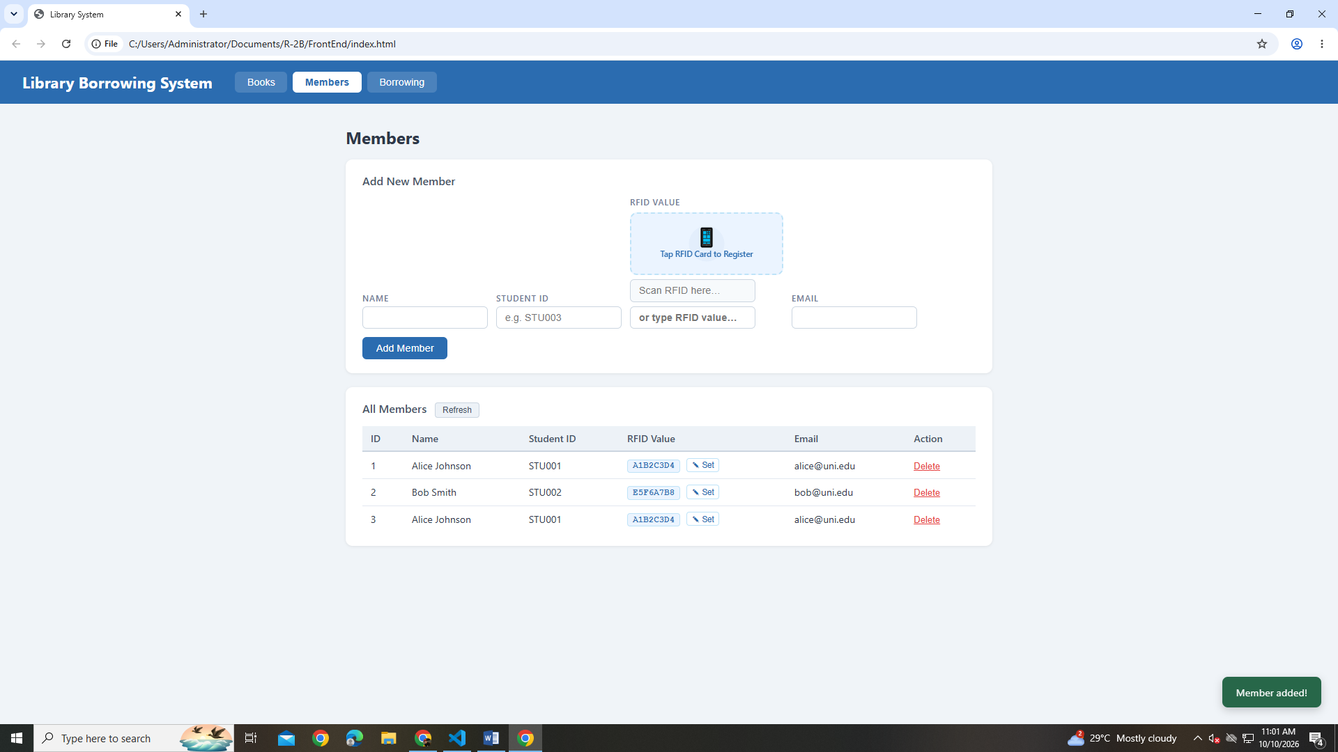

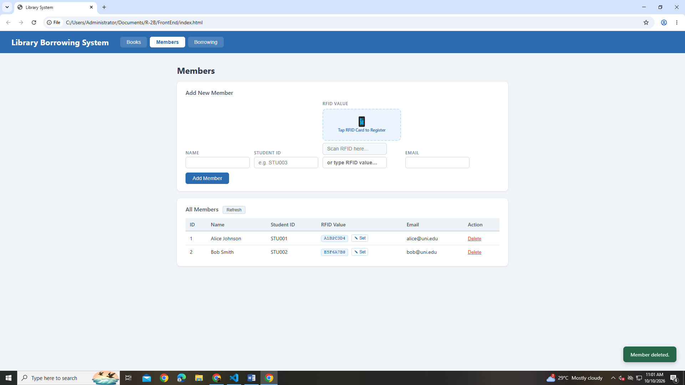

TEST BORROWING
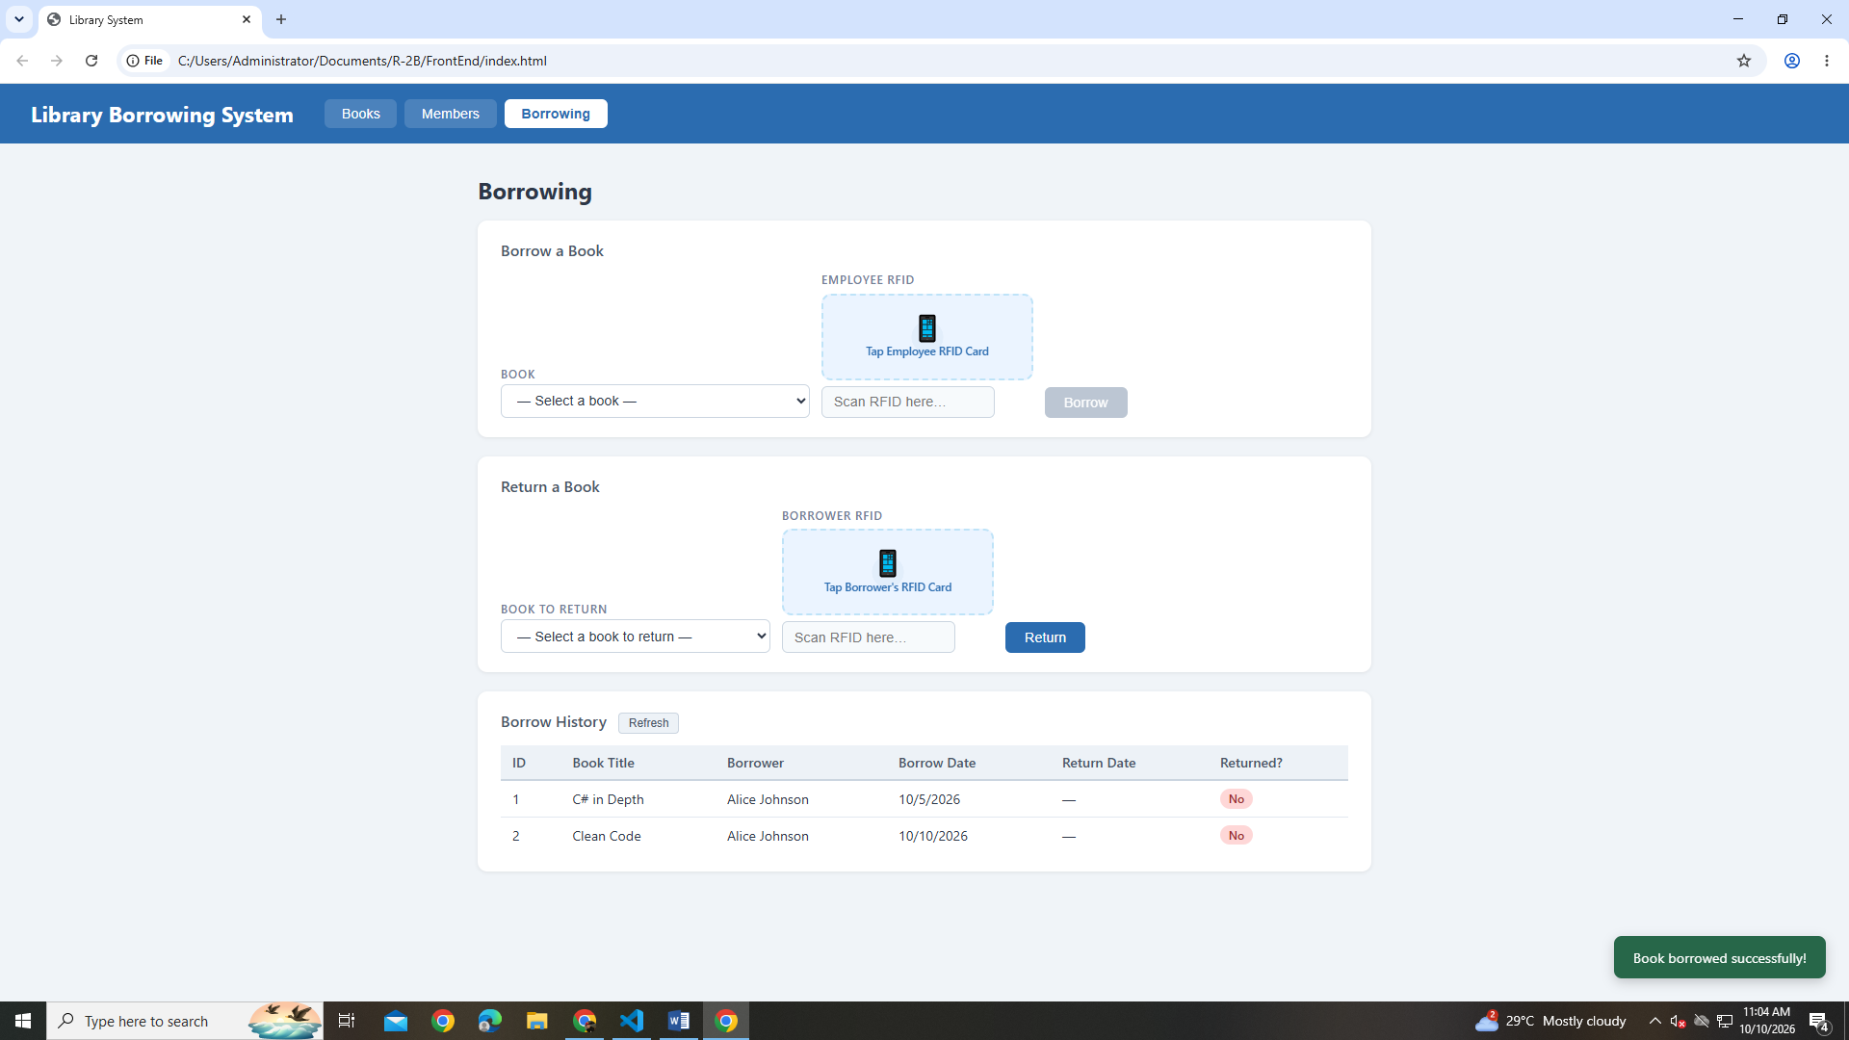

TEST RETURNING
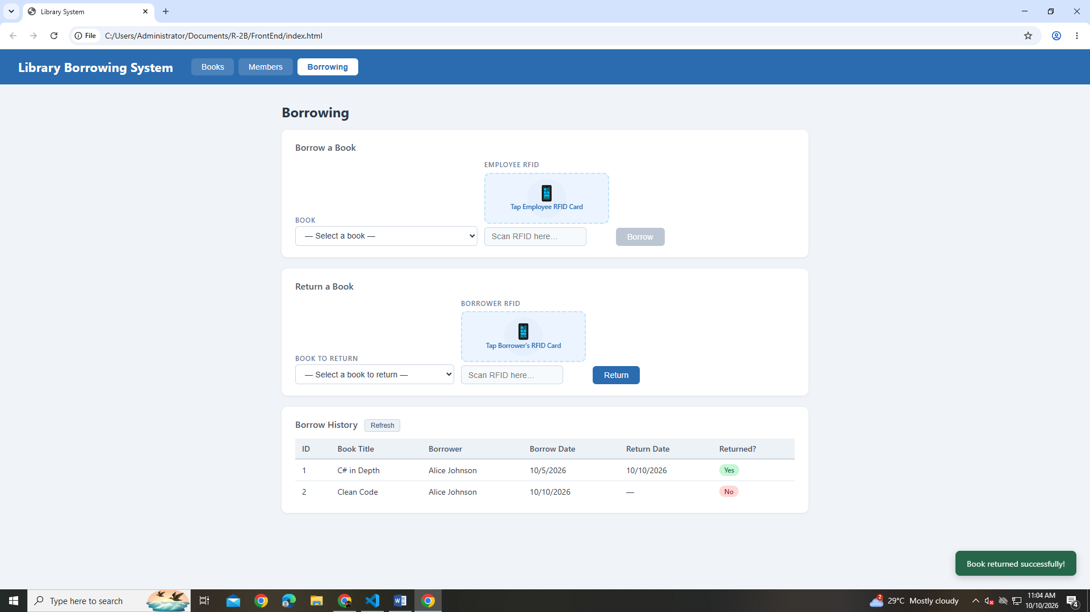

FINAL CONSOLE CHECK
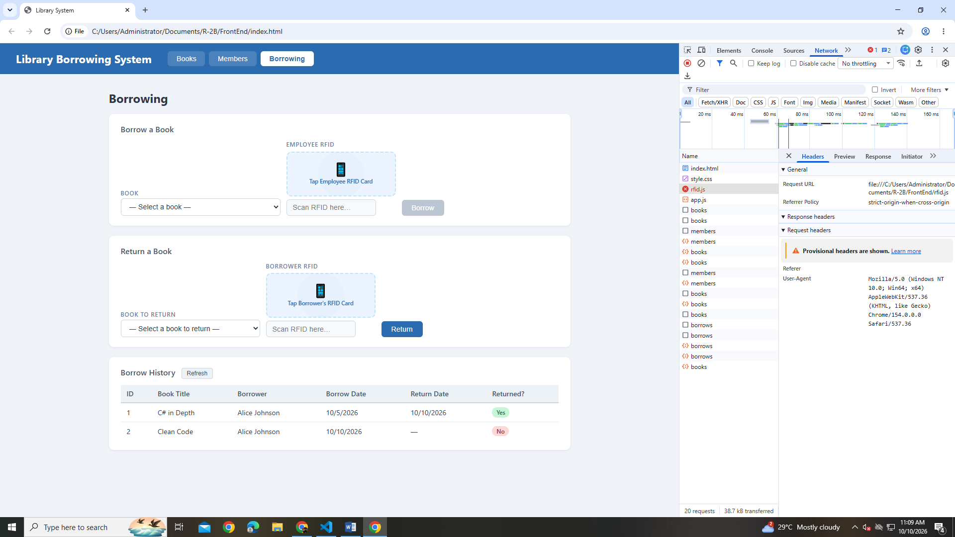

REFLECTION
- What does apiFetch() do?
  - It is a function that sends requests to the API to get or send data.
- Why do we use try/catch around API calls?
  - We use try/catch to handle errors and prevent the program from crashing.
- What is the difference between POST and PUT?
  - POST is used to add new data, while PUT is used to update existing data.
- Why does RFID matching use rfidValue instead of studentId?
  - Because rfidValue is the unique code stored on the RFID card used to identify the student.
- Why do we refresh tables after adding, deleting, borrowing, or returning?
  - We refresh the tables to show the latest data and keep the information updated.
- Why does the Return dropdown use borrow record ID instead of book ID?
  - Because the borrow record ID identifies the specific borrowing transaction that needs to be returned.
- What happens if the same event listener is added to a form twice?
  - The same action may happen twice when the form is submitted, causing duplicate actions.
- Why must the page-load code be at the bottom of the file?
  - So the HTML elements are loaded first before the JavaScript code uses them.
- Why does an RFID reader need e.preventDefault() on the Enter key?
  - To prevent the Enter key from submitting the form automatically before the RFID process is completed.

