+-
《Java程序设计》实验报告六

学生姓名：****** 班级：2015级计算机（*）班 学号：2015*********
实验地点：信息学院616室 指导教师：邢诒杏 13078970906
实验日期：2017-00-** 共2学时
实验环境：Windows 2000+JDK1.6/1.8+Jcreator+记事本+eclipse
实验报告命名规则如样例：完整学号+姓名_实验6.doc

- 实验目的
（1）了解面向对象程序设计；
（2）掌握类的创建、对象的实例化
（3）掌握数据域的封装
（4）掌握静态变量和实例变量的区别
（5）理解类的可见性修饰符的作用范围
（6）掌握 this指代调用对象自己
（7）掌握UML类图的画法

- 实验内容
注意：每个程序运行结果中要求加入学号+姓名
- 完成教材P305编程练习9.1题。另：width和height均为私有变量，请增加两个访问器访问这两个变量；并在Rectangle类中再增设一个公有静态整型变量numberOfObjects，用来统计该类所实例化的对象个数；
- 完成教材P306编程练习9.7题。
- 完成教材P307编程练习9.8题。
- 完成教材P308编程练习9.13题。

- 实验过程
实验内容（1）：
- 代码
public class homework_1{
public static void main(String[] args){

System.out.println("name:cck, number:20151681310210");
System.out.println("welcome to java");

rectangle first = new rectangle(4,40);
System.out.println("the width of the first is: "+first.width);
System.out.println("the height of the first is: "+first.height);
System.out.println("the area of the first is: "+first.getArea());
System.out.println("the perimeter of the first is: "+first.getPerimeter());
System.out.println("the number is: "+rectangle.count);
System.out.println();

rectangle second = new rectangle(3.5,35.9);
System.out.println("the width of the second is: "+second.width);
System.out.println("the height of the second is: "+second.height);
System.out.println("the area of the second is: "+second.getArea());
System.out.println("the perimeter of the second is: "+second.getPerimeter());
System.out.println("the number is: "+rectangle.count);
}
}

class rectangle{

double width;
double height;
static int count = 0;

rectangle(){
width = 1;
height = 1;
++count;
}

rectangle(double input_width, double input_height){
width = input_width;
height = input_height;
++count;
}

double getArea(){
double area = width*height;
return area;
}

double getPerimeter(){
double perimeter = 2*(width+height);
return perimeter;
}
}
- 结果截图
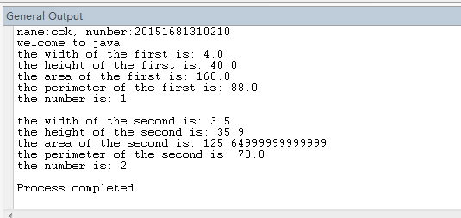
- 画UML类图

实验内容（2）：
- 代码
public class homework_7{
public static void main(String[] args){

System.out.println("name:cck, number:20151681310210");
System.out.println("welcome to java");

Account one = new Account(1122,20000);
one.set_annualInterestRate(4.5);
one.withDraw(2500);
one.deposit(3000);
System.out.println("the balance is: "+one.get_balance());
System.out.println("the monthlyInterest is: "+one.getMonthlyInterest()+"$");
System.out.println("the open_account_date is: "+one.get_dateCreated());
}
}

class Account{
private int id;
private double balance;
private double annualInterestRate;
private java.util.Date dateCreated;

Account(){
id = 0;
balance = 0;
annualInterestRate = 0;
dateCreated = new java.util.Date();
}

Account(int input_id, double input_balance){
id = input_id;
balance = input_balance;
annualInterestRate = 0;
dateCreated = new java.util.Date();
}

int get_id(){
return id;
}
void set_id(int change_id){
id = change_id;
}
double get_balance(){
return balance;
}
void set_balance(double change_balance){
balance = change_balance;
}
double get_annualInterestRate(){
return annualInterestRate;
}
void set_annualInterestRate(double change_annualInterestRate){
annualInterestRate = change_annualInterestRate;
}
java.util.Date get_dateCreated(){
return dateCreated;
}

double getMonthlyInterestRate(){
return annualInterestRate/12;
}
double getMonthlyInterest(){
return balance*1*getMonthlyInterestRate()/100;
}

void withDraw(double get_money){
balance -= get_money;
}

void deposit(double save_money){
balance += save_money;
}
}

- 结果截图
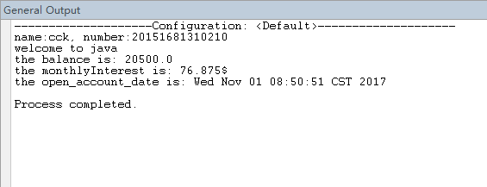
实验内容（3）：
- 代码
public class homework_8{
public static void main(String[] args){

System.out.println("name:cck, number:20151681310210");
System.out.println("welcome to java");

Fan one = new Fan();
one.set_speed(one.FAST);
one.set_radius(10);
one.set_color("yellow");
one.set_on(true);
System.out.println(one.fantoString());
System.out.println();

Fan two = new Fan();
two.set_speed(two.MEDIUM);
two.set_radius(5);
two.set_color("blue");
two.set_on(false);
System.out.println(two.fantoString());

}
}

class Fan{

final static int SLOW = 1;
final static int MEDIUM = 2;
final static int FAST = 3;

private int speed;
private boolean on;
private double radius;
String color;

Fan(){
speed = SLOW;
on = false;
radius = 5;
color = "blue";
}

int get_speed(){
return speed;
}
void set_speed(int change_speed){
speed = change_speed;
}
boolean get_on(){
return on;
}
void set_on(boolean change_on){
on = change_on;
}
double get_radius(){
return radius;
}
void set_radius(double change_radius){
radius = change_radius;
}
String get_color(){
return color;
}
void set_color(String change_color){
color = change_color;
}

String fantoString(){
if(on==false){
String result = "fan is off "+speed+" "+color+" "+radius+" ";
return result;
}else{
String result = " "+speed+" "+color+" "+radius+" ";
return result;
}
}

}
- 结果截图
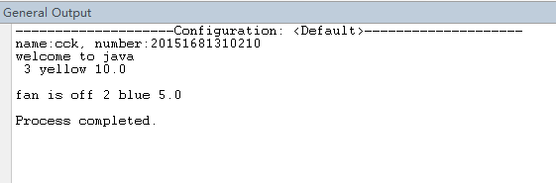
实验内容（4）：
- 代码

- 结果截图

实验内容（5）：
- 代码

- 结果截图

实验内容（6）：
- 代码

- 结果截图

实验内容（7）：
- 代码

- 结果截图

- 实验总结
写出实验中的心得体会。

