《Java程序设计》实验报告二

学生姓名：崔晨凯 班级：2015级计算机（二）班 学号：2015151681310210实验地点：信息学院616室 指导教师：邢诒杏 13078970906
实验日期：2017-9-27 共2学时
实验环境：Windows 2000+JDK1.6/1.8+Jcreator+记事本+eclipse
实验报告命名规则如样例：完整学号姓名_实验2.doc
- 实验目的
- 养成良好的编程风格；
- 掌握常用数学函数。
- 掌握字符数据类型及其运算；
- 掌握字符串的使用；
- 掌握格式化控制台输出。
- 实验内容
注意：每个程序运行结果中要求加入学号+姓名
- 完成教材P128编程练习4.6题。
- 完成教材P129编程练习4.8题。
- 完成教材P129编程练习4.11题。
- 完成教材P131编程练习4.23题。
- 完成教材P132编程练习4.25题。
- 请编写一个贷款计算器小程序，具体功能如下：用户通过控制台输入贷款利率（单位为%，例如输入5.6表示贷款利率为5.6%）、贷款金额（单位为万元，例如输入100表示贷款金额为100万）、贷款年限（单位为年，例如输入20表示贷款年限为20年）后，总还款金额（单位为万元，保留两位小数）和月还款金额（单位为元，保留两位小数）就会显示在屏幕上。(要求用对话框输入，对话框输出)。
提示：还款总金额=贷款金额*(1+贷款利率)^ 贷款年限

(7)课后练习P4.1、P4.14、P4.16、P4.20、P4.21、P4.22

- 实验过程
实验内容（1）：
- 代码
public class homework{
public static void main(String args[]){
System.out.println("welcome to java!");
System.out.println("number:20151681310210 name:崔晨凯");
double angle_one = (Math.random()*180);
double angle_two = (Math.random()*180);
double angle_three = 360 - angle_one - angle_two;
double result_angle_one = (180 - angle_three)/2 + (180 - angle_one)/2;
double result_angle_two = (180 - angle_three)/2 + (180 - angle_two)/2;
double result_angle_three = 180 - result_angle_one -result_angle_two;
System.out.println("the angle is " + result_angle_one +" " + result_angle_two + " " + result_angle_three);

}
}
- 结果截图
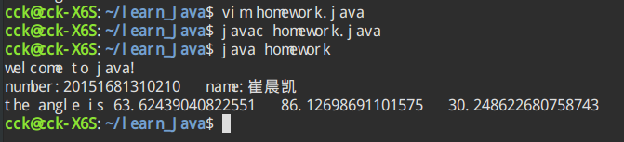
实验内容（2）：
- 代码

import java.util.Scanner;

public class homework{
public static void main(String args[]){
System.out.println("welcome to java!");
System.out.println("number:20151681310210 name:崔晨凯");

Scanner input = new Scanner(System.in);
System.out.println("Enter an ASCII code: ");
int number = input.nextInt();
char result = (char)(number);

System.out.println("The character for ASCII code " + number + " is " + result);

}
}
- 结果截图
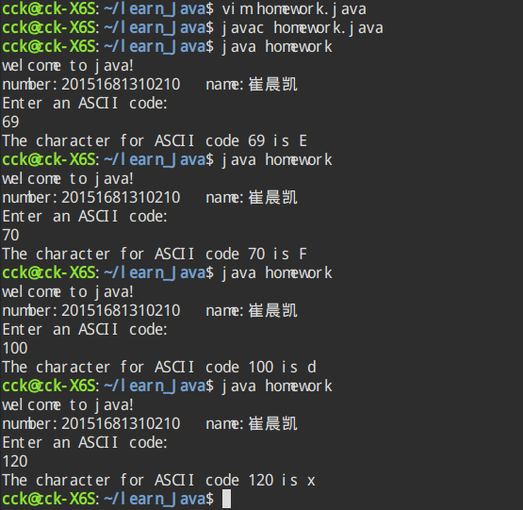
实验内容（3）：
- 代码

import java.util.Scanner;

public class homework{
public static void main(String args[]){
System.out.println("welcome to java!");
System.out.println("number:20151681310210 name:崔晨凯");

Scanner input = new Scanner(System.in);
System.out.println("Enter a decimal value(0 to 15): ");
int number = input.nextInt();
if(number>15||number<0){
System.out.println(number + " is an invalid input");
}else{
if(number<10){
System.out.println("The hex value is: " + number);
}else if(number==10){
System.out.println("The hex value is: A");
}else if(number==11){
System.out.println("The hex value is: B");
}else if(number==12){
System.out.println("The hex value is: C");
}else if(number==13){
System.out.println("The hex value is: D");
}else if(number==14){
System.out.println("The hex value is: E");
}else if(number==15){
System.out.println("The hex value is: F");
}
}
}
}
- 结果截图
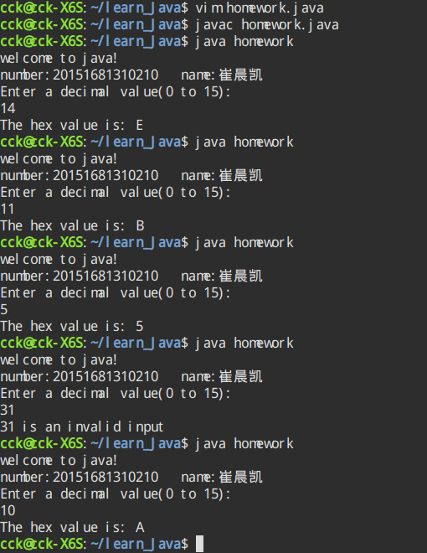
实验内容（4）：
- 代码

import java.util.Scanner;

public class homework{
public static void main(String args[]){
System.out.println("welcome to java!");
System.out.println("number:20151681310210 name:崔晨凯");

Scanner input = new Scanner(System.in);
System.out.println("Enter employee's name: ");
String name = input.nextLine();
System.out.println("Enter number of hours worked in a week: ");
double hours = input.nextDouble();
System.out.println("Enter hourly pay rate: ");
double pay_rate = input.nextDouble();
System.out.println("Enter federal tax withholding rate: ");
double federal_tax_rate = input.nextDouble();
System.out.println("Enter state tax withholding rate: ");
double state_tax_rate = input.nextDouble();

System.out.println("Employee Name: " + name);
System.out.println("Hours worked: " + hours);
System.out.println("Pay Rate: $" + pay_rate);
System.out.println("Gross Pay: $" + hours*pay_rate);
System.out.println("Deductions:");
System.out.println(" Federal Withholding (" + federal_tax_rate*100 +"%): $" + hours*pay_rate*federal_tax_rate);
System.out.println(" State Withholding (" + state_tax_rate*100 +"%): $" + hours*pay_rate*state_tax_rate);
System.out.println(" Total Deduction: $" + hours*pay_rate*(federal_tax_rate+state_tax_rate));
System.out.println("Net Pay: $" + hours*pay_rate*(1-federal_tax_rate-state_tax_rate));
}
}
- 结果截图
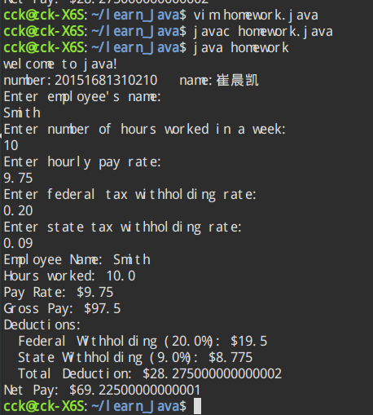

实验内容（5）：
- 代码

import java.util.Scanner;

public class homework{
public static void main(String args[]){
char[] car_number = new char[10];
int one = (int)(65+Math.random()*26);
car_number[0] = (char)one;
int two = (int)(65+Math.random()*26);
car_number[1] = (char)two;
int three = (int)(65+Math.random()*26);
car_number[2] = (char)three;
int four = (int)(48+Math.random()*10);
car_number[3] = (char)four;
int five = (int)(48+Math.random()*10);
car_number[4] = (char)five;
int six = (int)(48+Math.random()*10);
car_number[5] = (char)six;
int seven = (int)(48+Math.random()*10);
car_number[6] = (char)seven;
System.out.println(car_number);

}
}
- 结果截图
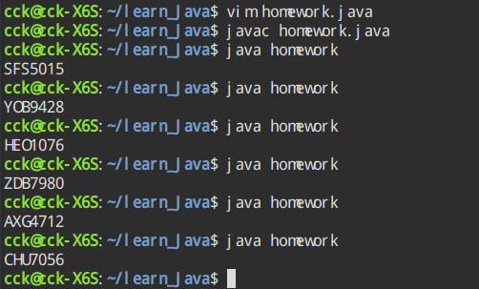

实验内容（6）：
- 代码
import java.util.Scanner;
import javax.swing.JOptionPane;
/**
* @(#)CCK_2.java
*
*
* @author
* @version 1.00 2017/9/27
*/

public class CCK_2 {

/**
* Creates a new instance of <code>CCK_2</code>.
*/
public CCK_2() {
}

/**
* @param args the command line arguments
*/
public static void main(String[] args) {
// TODO code application logic here
System.out.println("welcome to java");
System.out.println("number:20151681310210,name:崔晨凯");
String numberString = JOptionPane.showInputDialog(null,
"输入贷款利率: ",
"CCK_2", JOptionPane.QUESTION_MESSAGE);
double rate= Double.parseDouble(numberString)/100 ;

numberString = JOptionPane.showInputDialog(null,
"输入贷款金额: ",
"CCK_2", JOptionPane.QUESTION_MESSAGE);
double money = Double.parseDouble(numberString);

numberString = JOptionPane.showInputDialog(null,
"输入贷款年限: ",
"CCK_2", JOptionPane.QUESTION_MESSAGE);
int years = Integer.parseInt(numberString);

double all_return = money*(Math.pow((1+rate),years))/1.00;
double month_return = all_return/years/12*10000/1.00;
System.out.printf("总还款金额是: %6.2f万元 ,月还款金额是:%6.2f 元",all_return,month_return);

//JOptionPane.showMessageDialog(null," 总还款金额是: " + all_return + " 月还款金额是:" + month_return);
JOptionPane.showMessageDialog(null,String.format("总还款金额是: %6.2f万元 ,月还款金额是:%6.2f 元",all_return,month_return));

}
}
- 结果截图
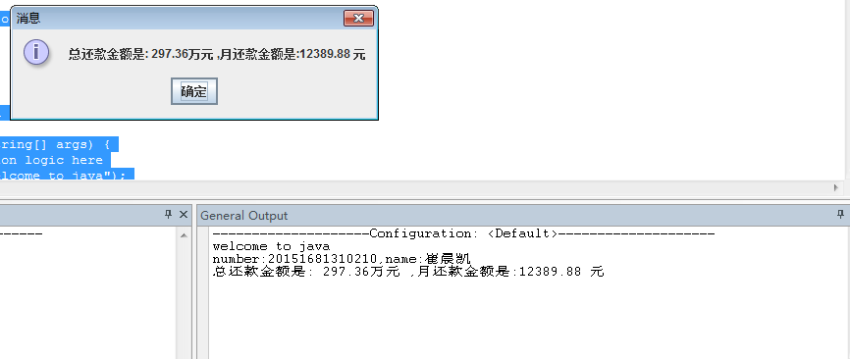

实验内容（7）：
- 代码

- 结果截图

- 实验总结
写出实验中的心得体会。

