+-
《Java程序设计》实验报告六

学生姓名：****** 班级：2015级计算机（*）班 学号：2015*********
实验地点：信息学院616室 指导教师：邢诒杏 13078970906
实验日期：2017-00-** 共2学时
实验环境：Windows 2000+JDK1.6/1.8+Jcreator+记事本+eclipse
实验报告命名规则如样例：完整学号+姓名_实验6.doc

- 实验目的
（1）了解面向对象程序设计；
（2）掌握类的创建、对象的实例化
（3）掌握数据域的封装
（4）掌握静态变量和实例变量的区别
（5）理解类的可见性修饰符的作用范围
（6）掌握 this指代调用对象自己
（7）掌握UML类图的画法

- 实验内容
注意：每个程序运行结果中要求加入学号+姓名
- 完成教材P305编程练习9.1题。另：width和height均为私有变量，请增加两个访问器访问这两个变量；并在Rectangle类中再增设一个公有静态整型变量numberOfObjects，用来统计该类所实例化的对象个数；
- 完成教材P306编程练习9.7题。
- 完成教材P307编程练习9.8题。
- 完成教材P308编程练习9.13题。

- 实验过程
实验内容（1）：
- 代码
public class homework_1{
public static void main(String[] args){

System.out.println("name:cck, number:20151681310210");
System.out.println("welcome to java");

rectangle first = new rectangle(4,40);
System.out.println("the width of the first is: "+first.width);
System.out.println("the height of the first is: "+first.height);
System.out.println("the area of the first is: "+first.getArea());
System.out.println("the perimeter of the first is: "+first.getPerimeter());
System.out.println("the number is: "+rectangle.count);
System.out.println();

rectangle second = new rectangle(3.5,35.9);
System.out.println("the width of the second is: "+second.width);
System.out.println("the height of the second is: "+second.height);
System.out.println("the area of the second is: "+second.getArea());
System.out.println("the perimeter of the second is: "+second.getPerimeter());
System.out.println("the number is: "+rectangle.count);
}
}

class rectangle{

double width;
double height;
static int count = 0;

rectangle(){
width = 1;
height = 1;
++count;
}

rectangle(double input_width, double input_height){
width = input_width;
height = input_height;
++count;
}

double getArea(){
double area = width*height;
return area;
}

double getPerimeter(){
double perimeter = 2*(width+height);
return perimeter;
}
}
- 结果截图
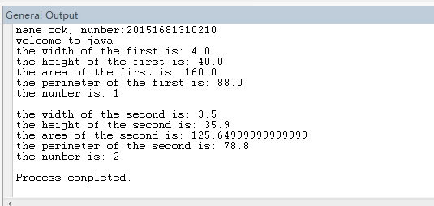
- 画UML类图

rectangle
-width:double
-heigth:double
-count:int
+rectangle()
+rectangle(input_width:double,input_heigth:double)
+getArea():double
+getPreimeter():double

实验内容（2）：
- 代码
public class homework_7{
public static void main(String[] args){

System.out.println("name:cck, number:20151681310210");
System.out.println("welcome to java");

Account one = new Account(1122,20000);
one.set_annualInterestRate(4.5);
one.withDraw(2500);
one.deposit(3000);
System.out.println("the balance is: "+one.get_balance());
System.out.println("the monthlyInterest is: "+one.getMonthlyInterest()+"$");
System.out.println("the open_account_date is: "+one.get_dateCreated());
}
}

class Account{
private int id;
private double balance;
private double annualInterestRate;
private java.util.Date dateCreated;

Account(){
id = 0;
balance = 0;
annualInterestRate = 0;
dateCreated = new java.util.Date();
}

Account(int input_id, double input_balance){
id = input_id;
balance = input_balance;
annualInterestRate = 0;
dateCreated = new java.util.Date();
}

int get_id(){
return id;
}
void set_id(int change_id){
id = change_id;
}
double get_balance(){
return balance;
}
void set_balance(double change_balance){
balance = change_balance;
}
double get_annualInterestRate(){
return annualInterestRate;
}
void set_annualInterestRate(double change_annualInterestRate){
annualInterestRate = change_annualInterestRate;
}
java.util.Date get_dateCreated(){
return dateCreated;
}

double getMonthlyInterestRate(){
return annualInterestRate/12;
}
double getMonthlyInterest(){
return balance*1*getMonthlyInterestRate()/100;
}

void withDraw(double get_money){
balance -= get_money;
}

void deposit(double save_money){
balance += save_money;
}
}

- 结果截图
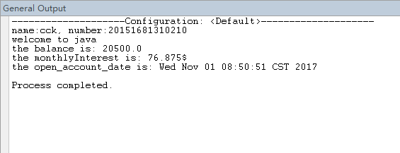
- 画UML类图
Account
-id:int
-balance:double
-annualInterestRate:double
-dateCreated:java.util.Date
+Account()
+Account(input_id:int,input_balance:double)
+get_id():int
+set_id(change_id:int):void
+get_balance():double
+set_balance(change_balance:double):void
+set _annualInterestRate(change_annualInterestRate:double):double
+get_dateCreated():java.util.Date
+ getMonthlyInterestRate():double
+ getMonthlyInterest():double
+ withdraw(get_money:double):void
+ deposit(save_monry:double):void

实验内容（3）：
- 代码
public class homework_8{
public static void main(String[] args){

System.out.println("name:cck, number:20151681310210");
System.out.println("welcome to java");

Fan one = new Fan();
one.set_speed(one.FAST);
one.set_radius(10);
one.set_color("yellow");
one.set_on(true);
System.out.println(one.fantoString());
System.out.println();

Fan two = new Fan();
two.set_speed(two.MEDIUM);
two.set_radius(5);
two.set_color("blue");
two.set_on(false);
System.out.println(two.fantoString());

}
}

class Fan{

final static int SLOW = 1;
final static int MEDIUM = 2;
final static int FAST = 3;

private int speed;
private boolean on;
private double radius;
String color;

Fan(){
speed = SLOW;
on = false;
radius = 5;
color = "blue";
}

int get_speed(){
return speed;
}
void set_speed(int change_speed){
speed = change_speed;
}
boolean get_on(){
return on;
}
void set_on(boolean change_on){
on = change_on;
}
double get_radius(){
return radius;
}
void set_radius(double change_radius){
radius = change_radius;
}
String get_color(){
return color;
}
void set_color(String change_color){
color = change_color;
}

String fantoString(){
if(on==false){
String result = "fan is off "+speed+" "+color+" "+radius+" ";
return result;
}else{
String result = " "+speed+" "+color+" "+radius+" ";
return result;
}
}

}
- 结果截图
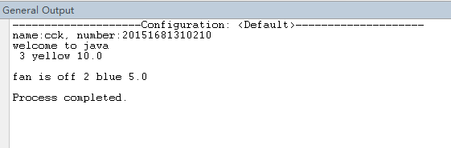
- 画UML类图
Fan
+SLOW:int
+MEDIUM:int
+FAST:int
-speed:int
-on:Boolean
-radius:double
+color:String
+Fan()
+get_speed():int
+set_speed(change_speed:int):void
+get_on():Boolean
+set_on(change_on:boolean):void
+get_radius():double
+set_radius(change_radius:double):void
+get_color():String
+set_color(change_color:String):void
+fantoString():String

实验内容（4）：
- 代码
import java.util.Scanner;

public class homework_13{
public static void main(String[] args){

System.out.println("name:cck, number:20151681310210");
System.out.println("welcome to java");

System.out.print("Enter the rows and columns in the array: ");
Scanner input = new Scanner(System.in);
int input_row = input.nextInt();
int input_column = input.nextInt();
double[][] array = new double[input_row][input_column];
System.out.println("Enter the array: ");
for(int i=0;i<input_row;++i){
for(int j=0;j<input_column;++j){
array[i][j] = input.nextDouble();
}
}

Location output = locateLargest(array,input_row,input_column);
System.out.println("The location of the largest element is "+output.maxValue+" at ("+output.row+","+output.column+")" );

}

public static Location locateLargest(double[][] a,int input_row,int input_column){
Location result = new Location();
result.row = 0;
result.column = 0;
result.maxValue = a[0][0];
for(int i=0;i<input_row;++i){
for(int j=0;j<input_column;++j){
if(a[i][j]>result.maxValue){
result.row = i;
result.column = j;
result.maxValue = a[i][j];
}
}
}
return result;
}
}

class Location{
int row;
int column;
double maxValue;
}

- 结果截图
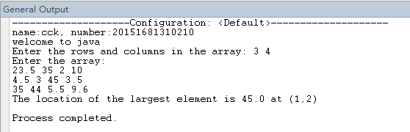
- 画UML类图

Location
+row:int
+column:int
+maxValue:double

- 实验总结
写出实验中的心得体会。

