Pandas’ library package is used to create data frame for the stocks for the column names such as Ticker, Portfolio weight, Annualized volatility, Beta against SPY, Beta against IWM, Beta against DIA, Average Weekly Drawdown, Maximum Weekly Drawdown, Total Return and Annualized Total Return. And created table for 7 stocks converted as data frame using below code.

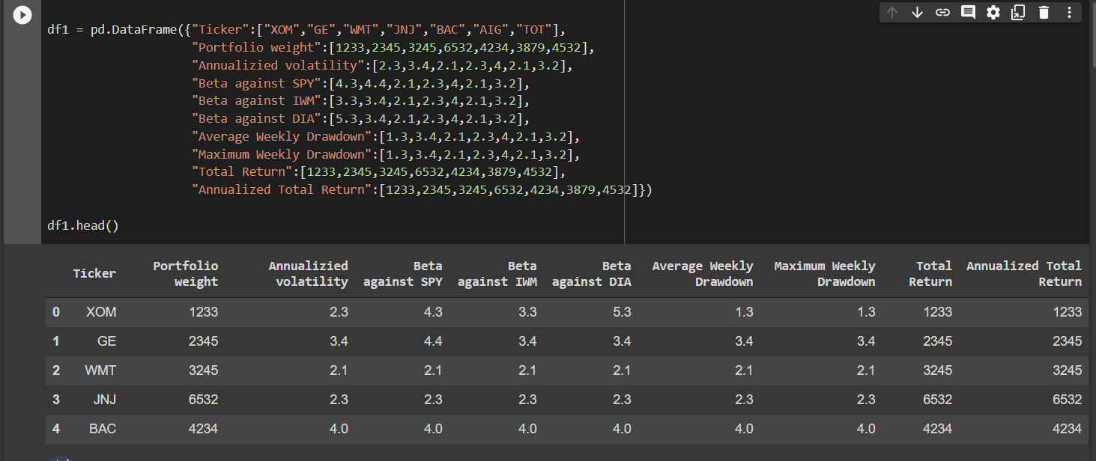

Figure.1

Data frame 2 is created using following columns such as ETF Ticker, Correlation against ETF, Covariance of Portfolio against ETF, Tracking Errors (using trailing 10-years), Sharpe Ratio (using current risk-free rate), Annualized Volatility (252 days) Spread (Portfolio Volatility – ETF Volatility. And created table for 7 stocks converted as data frame using below code.

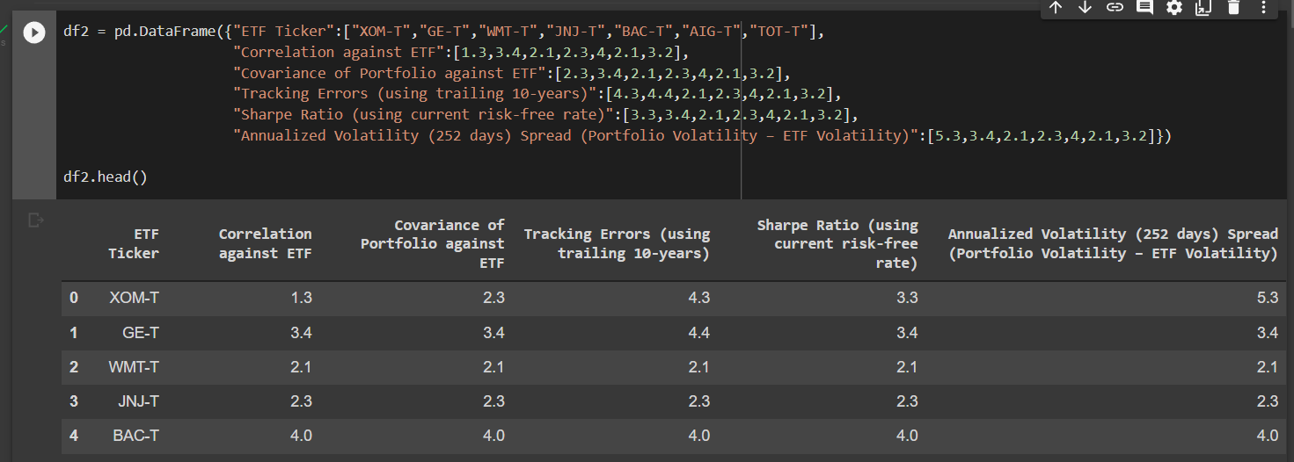

Figure.2

Merging of two data frames using below code,

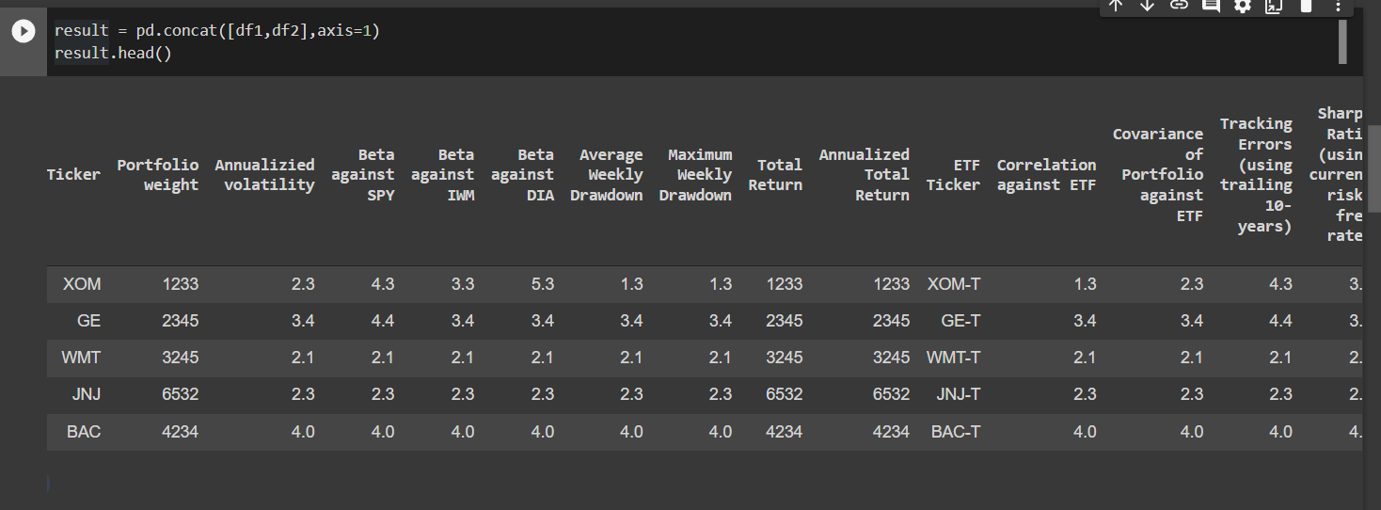

Figure.3

Correlation between two data frames is shown in below figure,

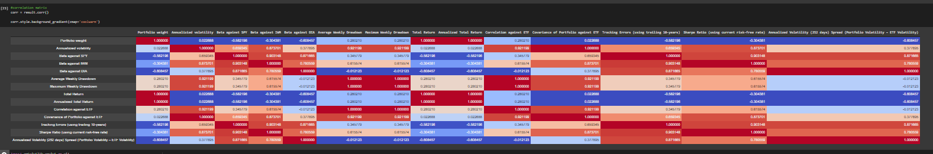

Converting Table 1 into pdf file 1,

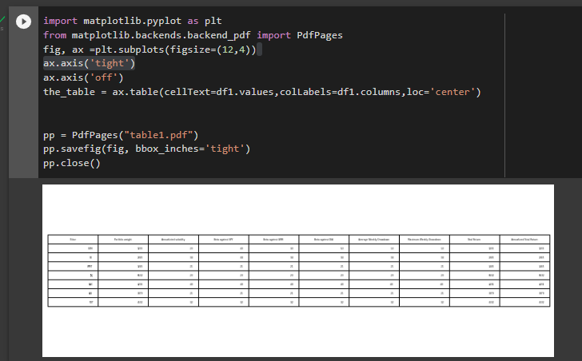

Converting Table 2 into pdf file 2,

