**Reframe the Question:** What are the key opportunities for improvement in this year's performance for our firm based on the available data?

**2) What do we need to know to answer 1?**

* **Key Metrics:** Identify key performance metrics for the firm, such as sales, profits, customer satisfaction, etc.
* **Historical Data:** Examine performance data from previous years for trends and patterns.
* **Customer Segments:** Understand the characteristics of different customer segments.
* **Product Performance:** Analyze the performance of different product categories.
* **Geographic Performance:** Assess performance variations across different regions, cities, and countries.

**3) Where can I find that information or collect that information?**

* **Data Sources:**
  + Utilize the Store, Customer, Product, Order.
  + Gather additional market data if necessary.
  + Conduct customer surveys or feedback analysis.

**4) Organize the Information:**

* **Create Relevant Views:** Develop SQL queries or views that aggregate data based on key metrics, customer segments, product categories, and geographic locations.
* **Data Visualization:** Use charts, graphs, and dashboards for a visual representation of trends and patterns.

**5) What steps are involved in answering or performing this task?**

1. **Data Retrieval:**
   * Extract relevant data from the SQL Server tables.
2. **Data Cleaning:**
   * Ensure data accuracy and address any missing or inconsistent data.
3. **Exploratory Data Analysis (EDA):**
   * Analyze key metrics and trends in historical data.
4. **Customer Segmentation Analysis:**
   * Identify characteristics of different customer segments.
5. **Product and Order Analysis:**
   * Evaluate the performance of products and orders.
6. **Geographic Analysis:**
   * Assess variations in performance across different regions.
7. **Recommendations:**
   * Based on the analysis, provide actionable recommendations for improving performance.

**Data Analysis and Visualization**

**Profit per Country**

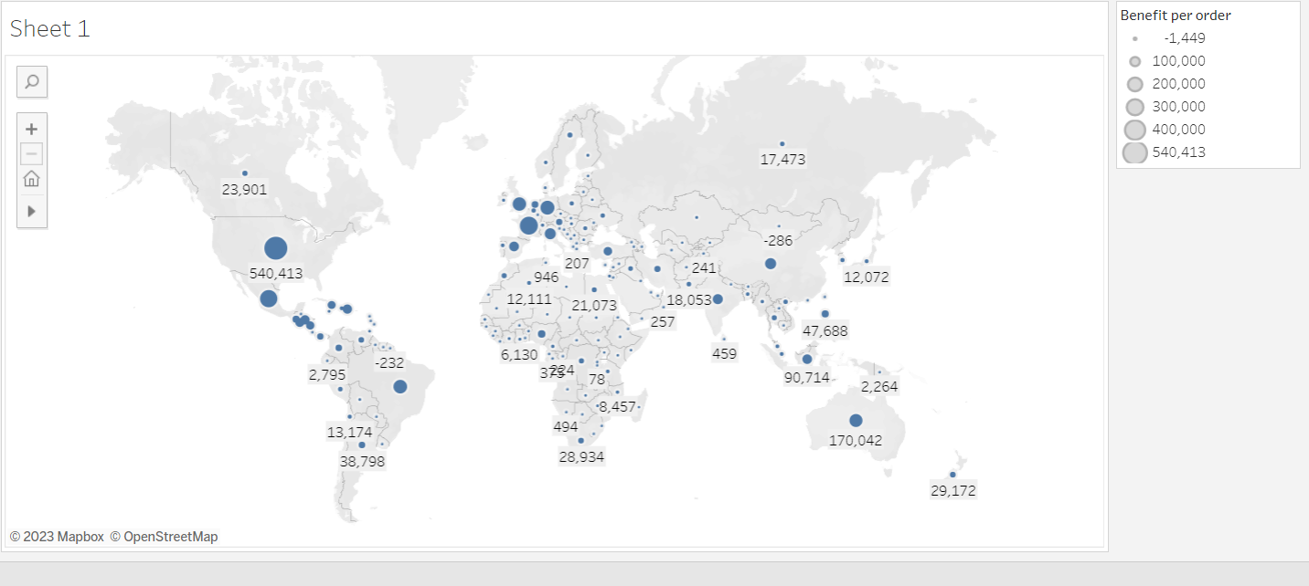

The United States has the largest amount of profit followed by France when it comes to profit by country.

**Countries with negative profits**

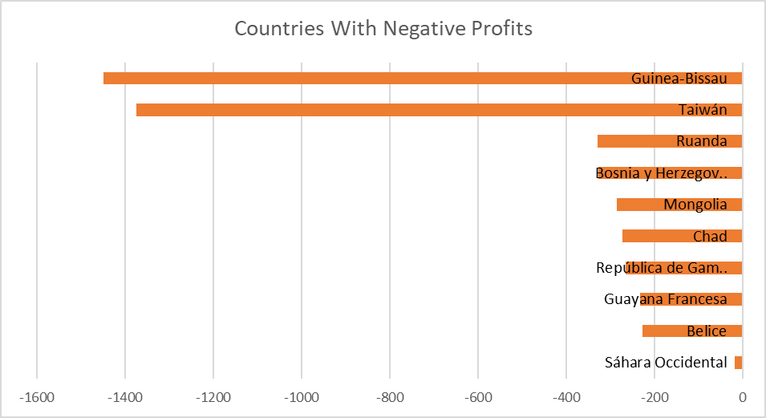

These are the top 10 countries with negative profit meaning money was lost serving these countries.

**Sales and Profit per Country**

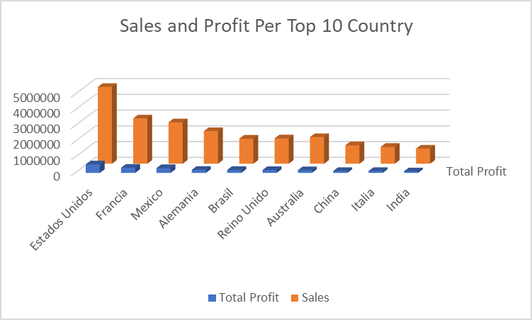

In terms of countries, the USA leads in sales to profit ratio meaning that money is being made from US sales than any other country comparatively.

**Top 10 countries with most customers**

United States has the highest number of customers, followed by France Mexico, Armenia, Australia, Brazil. The top 10 countries with the most customer is directly correlated with the top 10 countries for sales and profit.

**Top 10 Countries with the Highest Number of Negative Order Profit Per Order**

The USA has the highest number of orders with a negative profit. These countries also has some of the highest profits and number of order.

**Number of Sales and Profit per Region**

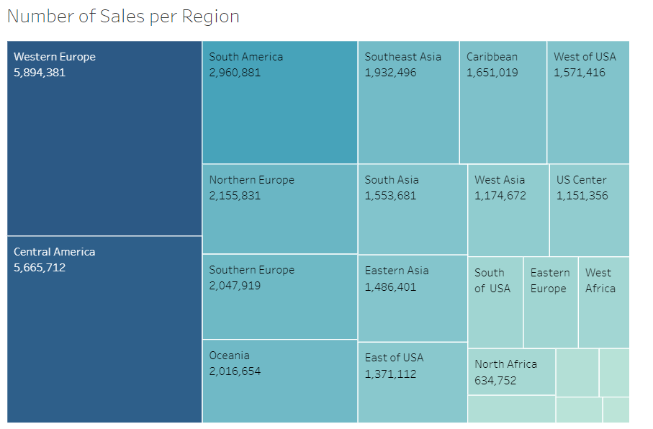

In terms of region, Western Europe is the leading region for the number of sales followed closely by Central America.

Just as Western Europe and Central America are close in number of sales, they are even closer in profitability.

**Number of Cancelled Orders in Each Region**

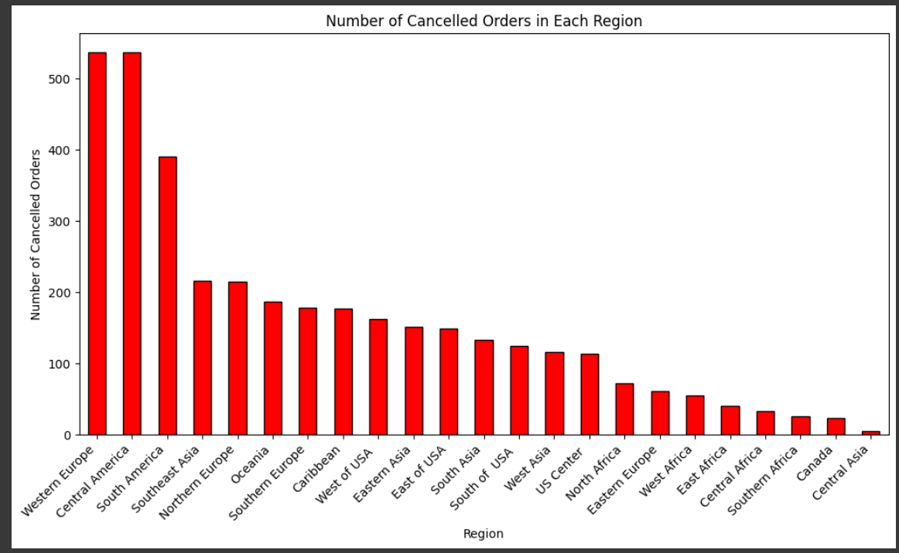

Western Europe has the highest number of cancelled orders of all the regions that we have data for. Central Asia had the least. The number of cancelled order is not correlated with number of sales in the region.

**Ratio of Completed vs Cancelled Orders in Each Region**

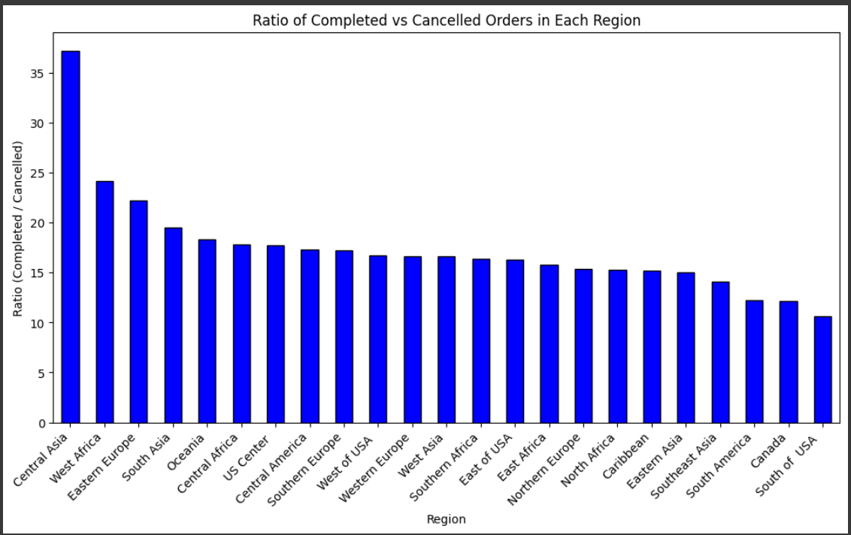

Central Asia has the largest ratio of completed orders vs cancelled orders. South USA has the lowest ratio.

**Top 10 products with positive Profit**

This chart identifies the products that are the largest contributors to overall profits.

**Top 10 cancelled products**

This chart identifies the products that are the largest contributors to cancelled orders.

**Recommendation**

Based on the analysis results, here are some recommendations:

1. **Focus on Profitable Markets:** Given that the United States and France are the top countries in terms of profit, consider allocating additional resources and marketing efforts in these regions to further capitalize on their profitability.
2. **Address Negative Profit in Some Countries:** Identify the countries with negative profits and investigate the root causes. Develop strategies to improve profitability in these regions, which may include adjusting pricing strategies, reducing costs, or reevaluating the product mix.
3. **Optimize Sales in Western Europe:** Since Western Europe has the greatest number of sales, it's crucial to optimize and enhance strategies in this region. Explore opportunities for further market penetration, customer retention, and potential product expansions.
4. **Customer Focus in Top Countries:** Given that the United States, France, Mexico, Armenia, Australia, and Brazil have the highest number of customers, prioritize customer satisfaction and retention strategies in these markets.
5. **Mitigate Cancelled Orders in Western Europe:** Since Western Europe has the highest number of cancelled orders, investigate the reasons behind cancellations and implement measures to mitigate them. This may involve improving customer service, streamlining order processes, or offering incentives to complete transactions.
6. Optimize Order Ratios in Different Regions: Analyze the order ratios in different regions, particularly focusing on Central Asia and South USA. Identify the factors contributing to the high ratio of completed orders in Central Asia and explore ways to replicate or adapt successful strategies in other regions.
7. **Address Negative Profit in the USA:** Given that the USA has the highest number of orders with negative profits, conduct a detailed analysis of the product mix, pricing strategies, and operational costs in this market. Implement changes to improve the overall profitability of orders.
8. **Product Profitability Analysis:** Using the insights gained from the profitability and cancellation or products, we might recommend focusing on expanding market share in profitable regions or using the strategies that work there as a model for other unprofitable regions. We can also consider discontinuing or re-pricing less profitable products and focus on promoting high-margin items.

Also looking at the three graphs on profitability and cancellation, we noticed that they include mostly the same products, in varying placement in each of the three graphs. This observation tells us that the reason for the cancellation is most likely due to inventory and supply chain inefficiencies or other similar issues related to pricing supply chain issues, strategy, or marketing.